‘Fidel the musical’ and hairdressers – turning research into impact.

Dr Denise Baden, Southampton Business School. dab@soton.ac.uk

Summary
Academia is often accused of focusing too much on theory and not doing enough to address real world challenges. Inspired by principle 4 of the UNPRME framework which claims that ‘we will engage in conceptual and empirical research that advances our understanding about the role, dynamics, and impact of corporations in the creation of sustainable social, environmental and economic value’, this paper describes two initiatives that in very different ways have addressed the challenge of turning research into impact. In the first I present an account of a high impact study using hairdressers to disseminate sustainable practices across the population. In the second I engaged with schools and colleges across the UK to ask students to write songs for a musical about Fidel Castro and the Cuban revolution.

Dissemination of sustainable practices using hairdressers

In this paper I present an account of a high impact study using hairdressers to disseminate sustainable practices across the population. The main focus of our work was on using hairdressers to promote more sustainable means of hair-care to their clients. I obtained funds from the ESRC for knowledge exchange activities to work with project partners (HABIA, VTCT, City & Guilds) and hairdressing colleges to train the trainers to integrate sustainability issues into the hairdressing curriculum and qualifications thus increasing impact still further. For example while one hairdresser can influence hundreds of customers, just one trainer can influence hundreds of hairdressers.
A key methodology of much social science research is the survey or questionnaire. The main purpose of such surveys is typically seen as providing information on attitudes, behaviours etc. of a certain population for the purpose of answering a specific research question. However we changed the focus, and instead designed these surveys to be as much about providing information to those completing the survey, as about providing information for us the researchers. For example the way we phrased the survey meant that as well as measuring existing attitudes, awareness and behaviours, we were at the same time raising levels of awareness. Our preliminary results indicate that this approach has already significantly impacted the awareness and intentions of trainee hairdressers.

Method
Online surveys were passed to UK hairdressing colleges and tutors were asked to distribute them to their trainees. We made it clear that the surveys were in themselves designed to be a useful learning tool for the students. The survey begins by asking about current awareness of the importance of hairdressing activities such as turning the tap off between washes, turning appliances off the moment they are no longer being used, and reducing colour waste. We then ask about their current behaviours relating to these activities. Following this is a section on their awareness of the benefits of various sustainable practices (see appendix 1)

Survey Results
Currently we have responses from 481 hairdressing students from 40 colleges across the UK. Questions were aimed at increasing awareness of benefits of various sustainable hair-care practices e.g.

“Up until this moment, how aware were you of the benefits that can arise if you recommend to clients that they use less shampoo at home? (i.e. use small amount, go longer between shampoos, and shampooing just once instead of twice) (1 = very aware 5 = very unaware).”

- M = 1.60 It saves on the cost of shampoo.
- M = 1.76 It can result in cost savings for the client as water usage is reduced.
- M = 1.77 It can result in cost savings for the client as electricity usage is reduced.
- M = 1.79 Reducing the amount/frequency of shampoo can be better for hair condition.
- M = 1.95 The reduction of electricity/water/product usage will appeal to eco-minded clients.
- M = 2.00 Reduced colour fade

Similarly “Dry shampoo is a product that can reduce the need for clients to wash their hair. Up until this moment, how aware were you of the following benefits that using dry shampoo can bring to clients who use the product at home (e.g. speed, convenience, styling, cost, eco)?”

In addition, we asked questions relating to sustainability–related activities at the beginning of the survey and then at the end. Preliminary results indicates that simply asking trainees to complete a survey about their awareness of the existence and benefits of more eco-friendly practices is enough to lead to increased intentions to engage in such practices.

Events
We held workshops with trainers across the UK and estimate we have reached about 1000 trainers. The results show that our presentation highlighting how to integrate sustainability into hairdresser training was successful in increasing the priority given to teaching sustainable practices

Motivators
It will also be of interest to those trying to foster more sustainable practices, what the most important motivations were. The key motivators are listed below in order of importance. The most difficult to motivate are those who do not have pre-existing environmental values, and so the most important motivators for those who scored low on pro-environmental values are indicated with *

1.52 Desire to hold high professional standards*
1.64 Dislike of waste
1.65 Effects on environment*
1.69 Positive effects on hair condition*
1.70 Complying with Habia standards and curriculum requirements
1.76 The cost savings
1.78 Feeling empowered to make a difference
1.81 Amount of impact I can have by influencing hairdressers
1.82 Health and safety aspects
1.89 Time-saving aspects (e.g. less rinsing time if use leave-in conditioner, or shampoo once rather than twice, speed of dry shampoo)
1.96 Amount of impact I can have by influencing hairdressers to influence clients hair care practices at home

Fidel the musical
I took up the challenge of disseminating my research on Cuba in an innovative fashion to engage with those who would be unlikely to read my papers published in academic journals. I was struck in my research trips to Cuba how much we could learn from the Cuban experience. Unfortunately the long-standing ideological conflict between Cuba and the US has meant that little accurate information is available on this unique island. This inspired me to look for ways to disseminate more widely some of the interesting and educational findings I uncovered by the unlikely means of a musical. Fidel Castro is one of the world’s longest standing leaders and led the Cuban Socialist revolution in the 1950s alongside Che Guevara and then led Cuba from 1959 to 2006, when he retired due to ill health. The story of the revolutionary war, and the subsequent hostile relationship with the US and events such as the Bay of Pigs invasion and Cuban Missile crisis in the 1960s mean that this is an exciting tale.

What we can learn from Cuba
Educationally the story of Fidel Castro and Cuba has a lot to teach us, from their vibrant music, dance and culture, to their historical and political role as a small island caught up in Cold War politics, as well as the ethical dilemmas of leadership. The dramatic ingredients of the Cuban tale, the larger than life characters and the unique Cuban culture and music involved means it is good material for a musical. Some of the issues covered in the songs are important issues for today. Cuba is on record as being the only sustainable country (WWF, 2006) and thus can serve as good role model for how to achieve high well-being scores with a minimum of resources. For example, despite a GDP a fraction of the US or UK, Cuba’s has scores of well-being, as rated by scores on aspects such as life-expectancy and literacy which are higher than the US (UN, 2014). Cuba’s role in the ideological conflicts of the Cold war also highlights issues relating to the trade-offs different countries have made with respect to values relating to human rights and individual freedoms versus values of equity, solidarity and social justice. The demonization of Fidel Castro by America has hindered any rational discussion about these issues, and this musical aims to address this by providing a more balanced view.

Process
In association with our music department we launched a UK wide competition for students to write songs for Fidel the Musical, and the best songs are chosen to be in the final musical. Most are starting this autumn term and the deadline for submission is 6th November. We already have over 250 schools/colleges signed up. It is mostly music teachers who have signed up, although some are working with students studying English, History or Politics to write the lyrics.

We have put together a website www.fidelthemusical.org which has a script, a plot outline and categories for 20 songs. Once the student chooses which song to work on, he/she will have access to a wealth of resources and information about that particular topic. They can choose just to read the broad outline, or they can dig deeper and follow the links to do more detailed research on a particular aspect. The task of selecting and condensing this information into lyrics enables students to develop useful skills in summarizing information, and also requires them to fully process the information, thus enabling deeper learning. Each student also submits a paragraph describing the rationale for their song and what it is intended to convey. This requires an element of reflection on behalf of the student which again enables deeper learning.

After submission we will ask educators and participating students to complete a feedback form to allow us to assess what they have gained from participating in this project and how it has affected their learning and understanding.

We have also involved art students in designing posters for the musical and will involve the public in helping to choose their favourite songs submitted. We will do this via our crowdfunding initiative which is raising money for the Mayflower Theatre Southampton to workshop the musical to help refine it https://southampton.hubbub.net/p/fidel-the-musical
Any who donate will be sent a link which will have several songs from a particularly song category and they can then rate each song. This helps to involve the public further in some of the issues, characters and events covered in the musical and also eases the burden of the professional judges who will choose from the finalists.

Unexpected impact
Fidel the musical has really taken off and attracted lots of interest from all directions. I have had unsolicited donations and repeated requests to extend the project beyond the educational sector and explore potential for a full-blown professional production, and even a film so watch this space!

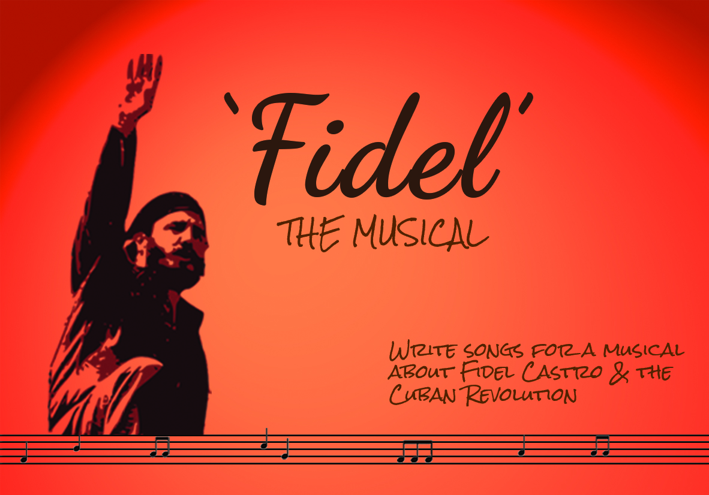

Conclusion and future directions

The challenge we face is that although we have successfully secured funds from an academic research centre to engage in the hairdressing project it is less clear what academic contribution this is making. We have benefitted from the credibility and impartiality that being a university project has given us. However in order to continue moving forward within the academic framework, we need to find ways to frame this project in more research-focussed terms.

Similar issues apply for the Fidel the musical project. Although this has raised great enthusiasm and interest, the research contribution is less clear. Such projects enable researchers to tick the ‘impact’ and ‘engagement’ and ‘dissemination’ boxes with great confidence, but the theoretical contribution is less obvious. We would welcome discussion on how such projects can be framed or adjusted in order to be able to meet the goals of both impact and research.

