Figure 1. Cross sectional view: fabrication flow diagrams of direct write dispenser printed three different functional layers on woven fabrics:
(a) cross sectional view of the untreated woven fabric;
(b) dispenser printing the interface layer on the untreated woven fabric substrate;
(c) UV curing to solidify the printed interface layer;
(d) dispenser printing the 1st functional layer on top;
(e) thermal curing to solidify the 1st functional layer;
(f) dispenser printing the 2nd functional layer on top;
(g) thermal curing to solidify the 2nd functional layer;
(h) dispenser printing the 3rd functional layer on top;
(i) thermal curing to solidify the 3rd functional layer on top and complete the example three layer device fabrication process.

- (b)
Figure 2 Schematic of direct write dispenser printing using (a) droplet mode and (b) filament mode.
Figure 3. Comparison between different dispensing gaps to help to choose the optimum dispensing gap for depostion.

- (b) (c)
Figure 4. Cross sectional and plan view of the schematic diagrams:
(a) Cross sectional view of a conventional electromagnetic speaker;
(b) Cross sectional view of a planar spiral speaker on a fabric substrate based on a conventional electromagnetic speaker;
(c) Plan view of a planar spiral speaker design;. the red area is an insulating layer above the bottom conductive track to act as a bridge allowing the top silver track to lead out for connection.

300 µm
300 µm
(a) (b)
Figure 5. Plan view of micrographs:
(a) Back Lighttex FR, a 100 % polyester woven fabric supplied by Berger;
(b) 65/35 polyester/cotton fabric supplied by Klopman International.

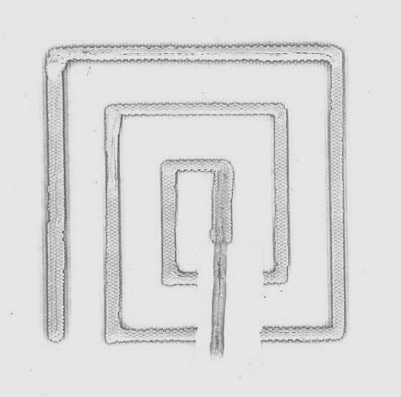
2 cm
- (b)
Figure 6 (a) Schematic cross section view of the spiral speaker on the woven fabric substrate, (b) Plan view of the dispenser printed spiral speaker on woven fabrics with dimension side length of 5 cm.

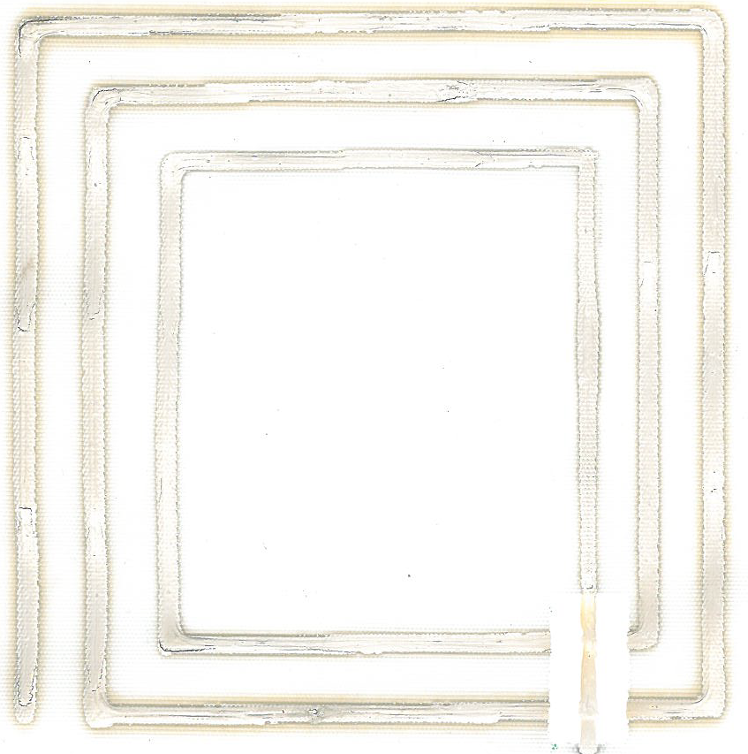
2 cm
2 cm
- (b)
Figure 7. An isometric view of the dispenser printed spiral speaker on woven fabric with dimension: (a) side length of 8 cm, and (b) side length of 10 cm.

Figure 8. Frequency reponse measurement set up diagram to measure the sound output level of the printed fabric speaker, iPhone 6 handset speaker and the Logitech H390 headphone.

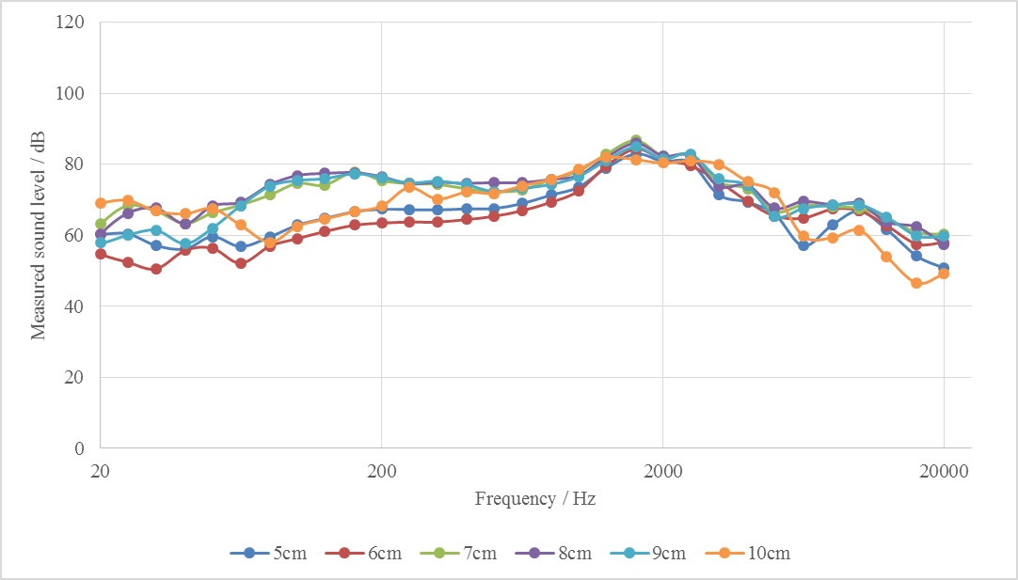
Figure 9. Measured sound output level of the dispenser printed fabric spiral speaker with different side length against the frequency response of the sine sweeping audio input in the frequency range of 20 to 20 kHz in log scale.

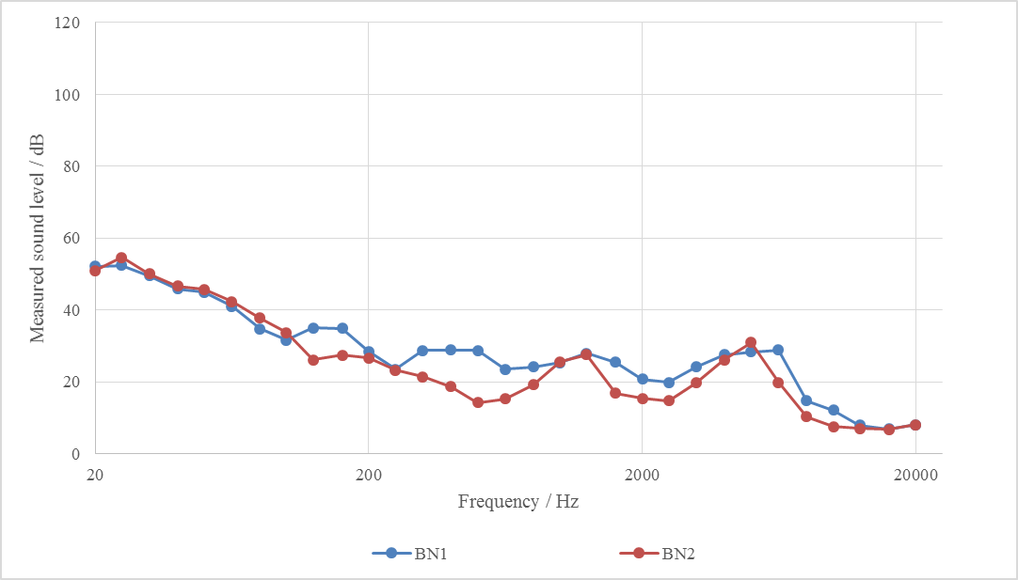
Figure 10. Measured background noise level of the testing environment against the frequency response of the sine sweeping audio input in the frequency range of 20 to 20 kHz in log scale.

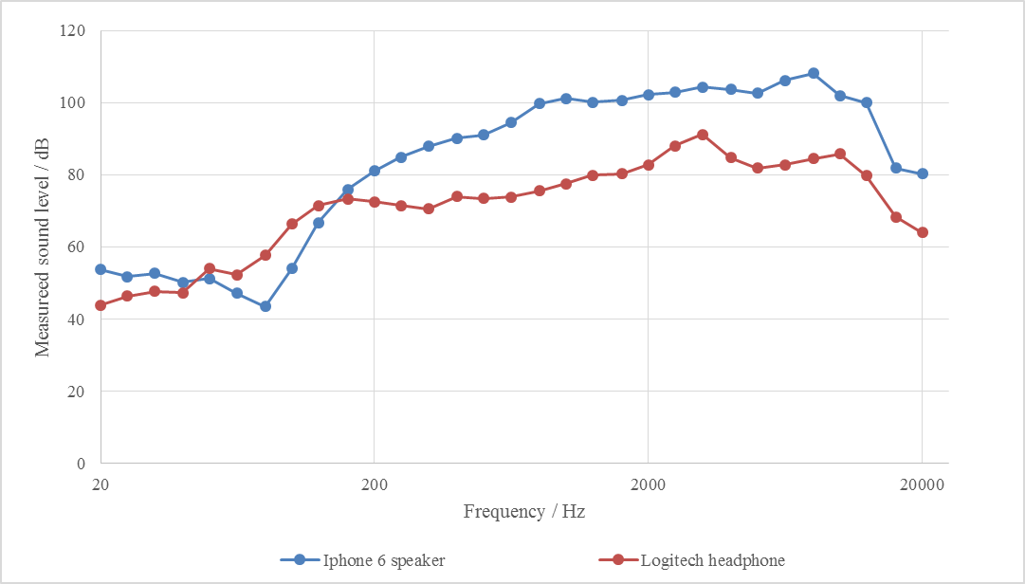
Figure 11. Measured sound output level of the Iphone 6 speaker and Logitech H390 headphones to compare with the frequency response of the printed fabric speakers when the sine sweeping audio input is used with a frequency range of 20 to 20 kHz in log scale.

