Running head: PREVALENCE IN VISUAL SEARCH

Understanding the Contribution of Target Repetition and Target Expectation to the Emergence of the Prevalence Effect in Visual Search

Hayward J. Godwin, Tamaryn Menneer, Charlotte A. Riggs, Dominic Taunton, Kyle R. Cave & Nick Donnelly

University of Southampton, UK

Author Note

Correspondence regarding this article should be addressed to Hayward J. Godwin, University of Southampton, School of Psychology, Highfield, Southampton, Hampshire, SO17 1BJ. Tel: +44(0)2380 595078; Email: hayward.godwin@soton.ac.uk.

Abstract
Behavior in visual search tasks is influenced by the proportion of trials on which a target is presented (the target prevalence). Previous research has found that when target prevalence is low (2% prevalence), participants tend to miss targets, compared with higher prevalence levels (e.g., 50% prevalence). There is an ongoing debate regarding the relative contribution of target repetition and the expectation that a target will occur in the emergence of prevalence effects. In order to disentangle these two factors, we went beyond previous studies by directly manipulating participants’ expectations regarding how likely a target was to appear on a given trial. This we achieved without using cues or feedback. Our results indicated both target repetition and target expectation contribute to the emergence of the prevalence effect.

Acknowledgements: This work was supported by funding from the Economic and Social Sciences Research Council (grant ref. ES/I032398/1). The authors wish to thank Fiona Smith for contributing to piloting work in relation to this project.
Keywords: visual search, target prevalence, eye-movement behavior, target repetition, target expectation
When engaged in a visual search–whether that be for the face of a friend in a crowd, or for a weapon in an X-ray of an airport passenger’s baggage–we seek to determine the presence or absence of a given set of targets. There is a substantial body of evidence demonstrating the importance of search history in shaping behavior (for a review, see Kristjánsson, 2008). One major route by which this occurs is via target prevalence. Target prevalence refers to the proportion of trials containing a target. When prevalence is low (<50% prevalence), participants are less likely to detect targets, and are also more rapid in their ‘target-absent’ responses (Wolfe, Horowitz, & Kenner, 2005), relative to higher-prevalence searches.
At a practical level, understanding prevalence effects is important for real-world searches, such as airport X-ray screening, in which targets rarely appear. At a theoretical level, understanding prevalence effects is important in understanding how visual searches are terminated; studying prevalence has resulted in the development of new models of search (Wolfe & Van Wert, 2010). Studying prevalence effects also provides valuable insights into how targets–even simple ones–are missed by searchers. Here, we manipulated target prevalence in terms of target expectation and target repetition to investigate the contributions of trial history and experience to the prevalence effect. As we describe below, these two factors have often been confounded in previous studies, and the goal here is to disentangle them.
It was initially argued that prevalence effects emerge due to motor priming of rapid target-absent responses (Fleck & Mitroff, 2007), but prevalence effects remain when motor priming is controlled for (Godwin, Menneer, Cave, Helman, et al., 2010). Instead, there is an emerging consensus that low-prevalence leads to a response bias favoring ‘absent’ responses and target misses (Godwin, Menneer, Cave, & Donnelly, 2010; Godwin, Menneer, Cave, Thaibsyah, & Donnelly, 2015; Wolfe & Van Wert, 2010).
In more recent work, researchers have used eye-tracking in order to determine how targets are missed when prevalence is low, thereby enabling a deeper understanding of the ways in which targets are represented and those representations are used to guide search. Eye-movements can provide an excellent index of online cognitive processing and allocation of overt attention (Liversedge & Findlay, 2000). Previous work has used eye-movement behavior to better understand how and why low-prevalence targets are missed, finding that participants primarily fail to detect low-prevalence targets because of failures in object identification. That is, participants fixate low-prevalence targets, but still fail to detect them (Godwin, Menneer, Riggs, Cave, & Donnelly, 2015). There is also evidence that participants are less likely to fixate low-prevalence targets (Hout, Walenchok, Goldinger, & Wolfe, in press). Here, we used eye-movements to gauge the speed of guidance towards targets, and the identification errors and time to response once targets are fixated.
When prevalence is reduced, the target appears less often in the sequence of trials, thereby leading to a reduction in bottom-up priming of the target object. Target repetition is known to have a powerful influence on the speed and accuracy of target detection (Kristjánsson, 2008). Separately from the effects of target repetition, participants may also form a top-down expectation of how likely it is that the target occurs on any given trial. We refer to these factors as target repetition and target expectation. Prevalence studies examining the contribution of top-down and bottom-up information have used various forms of cues and feedback about target presence (either before or after trials) to allow participants to form an impression of target prevalence: put simply, these studies sought to modulate top-down expectation of target prevalence, while holding bottom-up priming constant. Studies that provided participants with cues before trials regarding upcoming target prevalence found weak effects of top-down information. These cues included, for example, symbols presented before a trial (e.g., “*”) indicating the likelihood that a target would appear (Ishibashi, Kita, & Wolfe, 2012; Lau & Huang, 2010). However, these results conflict with those from other studies that provided participants with feedback after trials, including text informing participants of their accuracy on the previous trial. In these other studies, there were strong effects of post-trial feedback (Schwark, MacDonald, Sandry, & Dolgov, 2013). Overall, it appears that target expectation (or top-down information) plays a role in prevalence effects, though that role may be limited.
In the present study, we sought to disentangle the conflicting findings on the contribution of target repetition and target expectation to the prevalence effect (Ishibashi et al., 2012; Lau & Huang, 2010; Schwark et al., 2013). We reasoned that even when the cues and feedback are valid on every trial, they may have a weak influence on the prevalence effect because the search system might itself create its own estimate of target prevalence, based on direct experience, which cannot be over-ridden by cues/feedback, which are more indirect. With that in mind, we therefore developed a new paradigm wherein participants searched for a T-shape embedded in search arrays that alternated between high (95%) and low (5%) prevalence “slides” (see Figure 1) within a single trial. This allowed us to manipulate target expectation by direct experience, rather than indirectly via cues or feedback. The alternating prevalence levels between the slides enabled participants to form separate expectations of target likelihood for each type of slide. We engaged participants in two conditions: in the alternating-color condition, participants searched for a different color on each slide, with the target color for each slide fixed throughout the experiment; in the same-color condition, participants searched for the same color target throughout all slides.

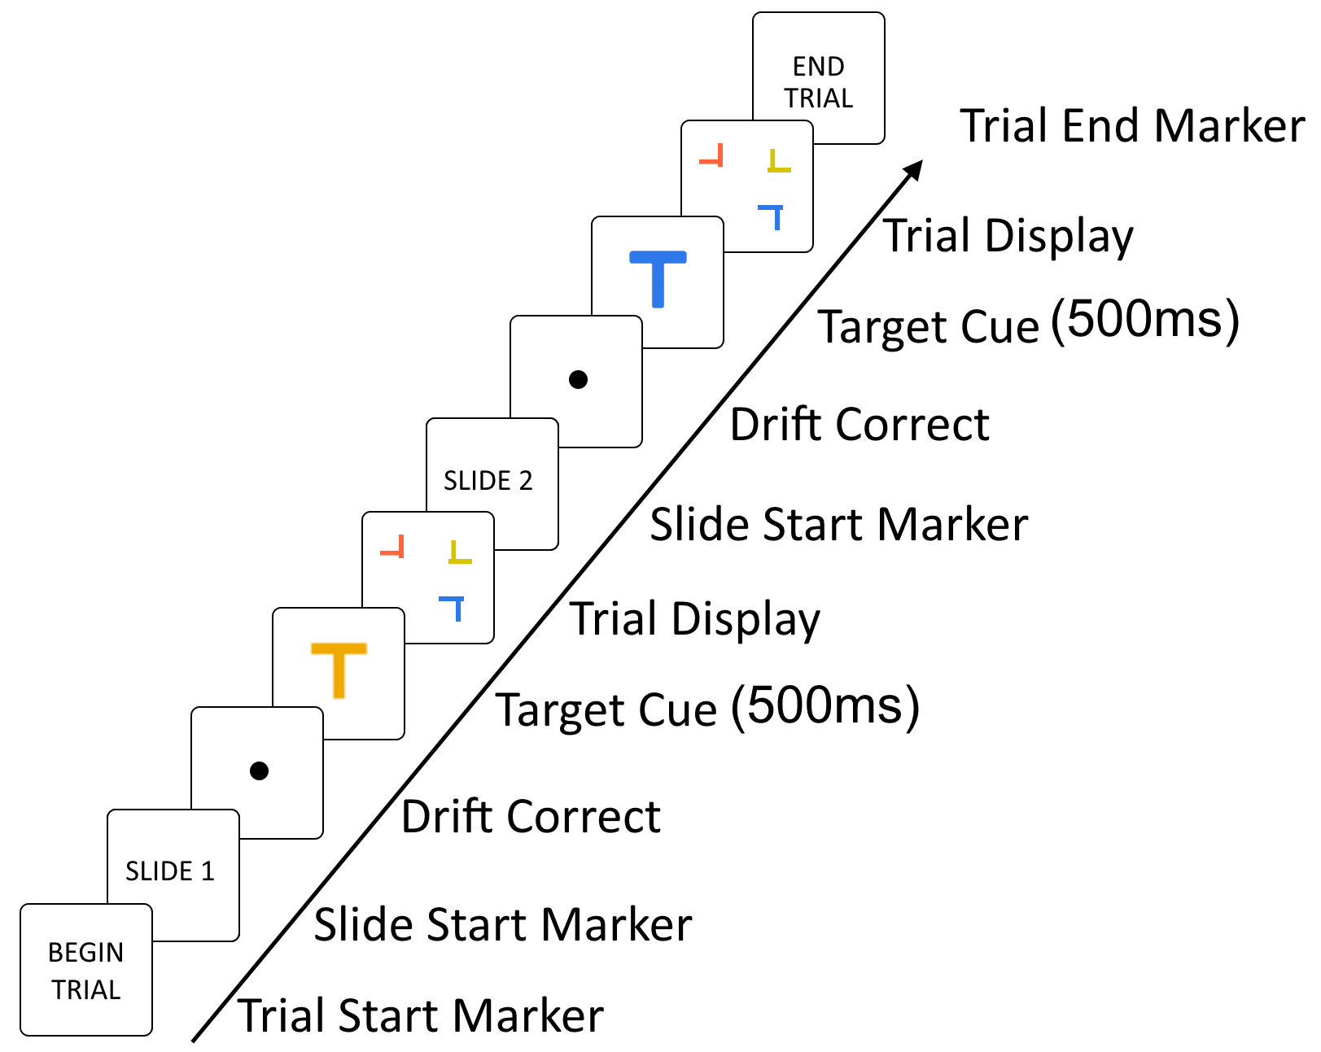
Figure 1. Schematic illustration of a trial sequence in the different-color condition. In order to encourage participants to develop an expectation of when a target would appear, we presented pairs of search arrays as ‘slides’ within a single ‘trial’. Participants were informed when each slide was to begin in an effort to encourage them to associate certain slides with their respective prevalence levels. For illustration purposes, objects have been increased in size. Actual search arrays contained sixteen objects. Participants made a response to each search slide, each of which was present until response.

Our design enabled us to tease apart the contribution of target expectation and target repetition in the emergence of the prevalence effect as follows. In both conditions, participants could form an expectation regarding target occurrence (either 95% or 5%, depending on the current slide). In the same-color condition, there will be many target repetitions from the high-prevalence slides, and any benefits to search that arise from these repetitions will benefit both the high- and low-prevalence slides. In the alternating-color condition, the target repetition from the high-prevalence slides will not benefit the low-prevalence target, which is a different color. The low-prevalence target is only repeated rarely, so any repetition priming benefits will be weaker for low-prevalence targets compared to the high-prevalence targets. Because target repetition effects will contribute to the prevalence effect only in the alternating-color condition, we therefore predicted a more substantial prevalence effect for the alternating-color versus same-color conditions. In short, target expectation was manipulated across the two slides, but held constant across the two color conditions, while target repetition was varied across the two color conditions.
Using the analytic approach from our previous study of prevalence effects (Godwin, Menneer, Riggs, et al., 2015), we examined how prevalence influences perceptual selection of targets by measuring the time taken to first fixate the targets. We previously found no differences across target prevalences for this measure, but participants could not form a direct expectation of which of two targets would appear on a given trial since trial order was randomized. We also examined perceptual identification of targets using two measures: the probability of identifying a target given that it was fixated, and the verification time, defined as the time taken to respond ‘present’ after first fixating a target. We previously found that increases in prevalence increased the probability of identifying a fixated target, so it is likely to do so again here. For verification time, we previously found that participants required more time to identify lower-prevalence targets than higher-prevalence targets, and it is likely to do so again here. For both of these measures,, if target repetition plays a role in the prevalence effect, rather target expectation alone, we expected a more substantial effect of prevalence for the alternating-color versus same-color conditions.

Method
Participants
Sixteen participants from the University of Southampton (mean age=20.3 years, SD=2.5) took part in the study. They reported normal or corrected-to-normal color vision.

Apparatus
We recorded eye-movement behavior using an Eyelink 1000 eye-tracker, set at 1000Hz. We used a nine-point calibration procedure that was accepted when average error was <0.5deg/visual angle, with no points having an error of >1deg/visual angle. Before each slide, a drift correct was performed. Participants viewed stimuli on a 21” ViewSonic P227f CRT monitor (refresh rate: 100Hz; resolution: 1024×768 pixels) seated at a distance of 71cm in a dimly-lit room. Participants gave target-present and target-absent responses using a response box. Following an incorrect response, a tone sounded, in line with our previous studies (e.g., Godwin, Menneer, Cave, & Donnelly, 2010), and to enable participants to build an awareness of target prevalence.

Design and Procedure
We encouraged participants to become aware of the alternating prevalence levels. Pairs of searches were presented to participants as belonging to a single over-arching ‘trial’, and individual search displays within each ‘trial’ comprised two ‘slides’ (see Figure 1). In fact, both slides were separate trials in the conventional sense of a search trial. For consistency with the experiment as experienced by the participants, we retain the terminology of referring to a “trial” as comprising two “slides”. Each slide began with the presentation of a gaze-contingent preview of the target (to serve as a reminder of the target color) for that slide for 500ms. This preview was presented at the center of the display to ensure that participants began their search in the same location on each trial.
The experiment comprised 320 trials, broken down into 640 slides, and was preceded by 10 practice trials. A target was presented on 50% of slides, with only a single target appearing in target-present slides. Slides consisted of an alternating sequence of high-prevalence (95%) and low-prevalence (5%) search arrays (the sequence was counterbalanced across participants).
Participants responded as to the presence or absence of a target in each slide. In the same-color condition, participants searched for the same target throughout all displays. In the alternating-color condition, the high-prevalence target and low-prevalence target were selected to be eight steps in color space away from each other.

Stimuli
Participants searched for a T-shape (designated as the target) amongst a set of offset L-shapes. The shapes subtended 1.5˚. All shapes (including targets) were randomly rotated (0˚, 90˚, 180˚, or 270˚) and placed at a random location on an invisible 5x5 grid, and jittered randomly (up to 2.5˚) within the bounds of their cells. Sixteen objects were presented on each slide. We selected object colors from a set of 16 colors used in previous experiments (Stroud, Menneer, Cave, & Donnelly, 2012). Equal numbers of distractors of each color were presented across the experiment, though, on any given slide, the set of distractor colors was randomly selected (note that distractors could be the same color as the target). Different participants were given different sets of target colors to search for in order to ensure that the results were not confined to a single set of colors.
Results
Analytic Approach
We began by determining whether we replicated standard effects of target prevalence. We then contrasted the influence of target repetition and expectation in relation to perceptual identification processes, using the probability that participants would fixate and identify targets, as well as the verification time for target objects, as our key measures. Details of eye-movement data processing are provided in the Supplementary Material.
Since previous work along these lines has found evidence of relatively subtle effects of expectation of target occurrence (Ishibashi et al., 2012; Lau & Huang, 2010), we used Linear Mixed Effects models (LMEs). LMEs are popular for examining eye-movement datasets since they offer increased power compared to standard statistical tests (Baayen, 2008). They are also suited to datasets with unbalanced cell counts, as is the case here. Binomial models (e.g., target-present versus target-absent responses) produce a z-score with an associated p-value. Non-binomial models (e.g, verification times) produce a t-value without an associated p-value, so we followed convention and treated any effect with a t-value of ±1.96 as ‘significant’.
For all measures, each model included Participant and Slide Number as random factors. Our model fitting began with a model containing the full set of interactions, including the full set of interactions as random slopes for each participant, and iterated through different variants until reaching the best-fitting model. Any models that failed to converge were excluded. Descriptive statistics for all measures are presented in Figure 2; the best-fitting models for all measures are presented in Table 1.
The fixed effects included in the models consisted of Prevalence (High, Low), Color Condition (Same-Color, Alternating-Color) and, where appropriate, Target Presence (Absent, Present). These fixed effects consisted of two-level categorical factors. As a result, the coefficients for the model fits presented in Table 1 can be interpreted in terms of the reference level for each factor. For the Prevalence factor, High-Prevalence was the reference level, so a negative coefficient indicates a decrease between the High-Prevalence condition and the Low-prevalence condition. For Color Condition, Same-Color was used as the reference level; and for Target Presence, Target-absent slides were used as the reference level.
Table 1.
Summaries of Linear Mixed Effects Models for Each Measure.
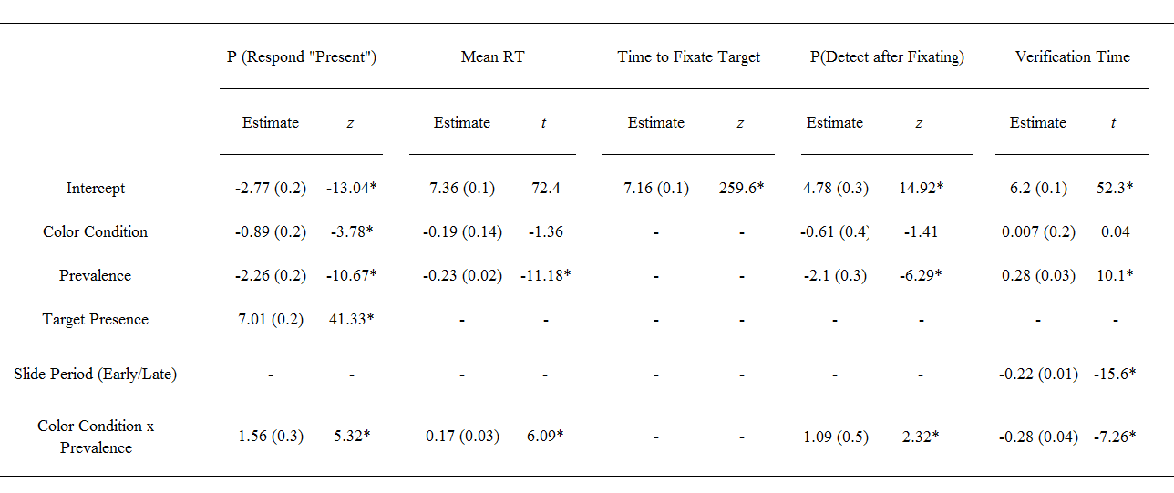
Note. Dashes are present for factors not included in the model for each particular measure. Standard errors of estimates are presented in parentheses. Asterisks signify a significant result for binomial models (p<.05) and highlight significant results for non-binomial models where the t value magnitude was ≥1.96.
Figure 2. Descriptive statistics for the different measures, broken down in terms of the different Color Conditions and Prevalence levels. Error bars represent SEM.

Replicating the Prevalence Effect
Probability of Responding ‘Present’
We began by examining the probability that participants would respond ‘present’ across target-present and target-absent slides. For target-present slides, this is equivalent to examining the hit rate whereas for target-absent slides, this is equivalent to examining the false alarm rate. We used a binomial LME model with a value of 1 for the dependent variable used for slides in which participants responded ‘present’ and a value of 0 for slides in which participants responded ‘absent’.
There was a main effect of Prevalence (see Table 1), and the negative estimate indicates that participants were less likely to respond ‘present’ in Low-Prevalence than High-Prevalence slides. Since there was an interaction between Color Condition and Prevalence (Table 1), we used post-hoc contrasts to examine the effects of Prevalence for each Color Condition. We found that the effect of Prevalence held in both Color Conditions, but the magnitude of the slope was larger for the alternating-color condition (Estimate=-2.25, SE=0.2, z=-10.67, p<.0001) than the same-color condition (Estimate =-0.7, SE=0.2, z=-3.39, p<.0001), in line with our predictions.
There was also a main effect of target Presence in the model. Since the effect estimate for Presence was negative, and Target-present slides were the reference level for this factor, this indicates that participants were less likely to respond ‘present’ in target-absent slides than target-present slides, as would be expected. However, for the best-fitting model shown in Table 1, this factor did not interact with either Prevalence or Color Condition. The lack of interaction with Prevalence shows that the effect of prevalence was the same for target-present and target-absent slides, suggesting target prevalence influenced responses in a similar manner regardless of whether the target was present or not.
Response Times
Following previous research (Godwin, Menneer, Riggs, et al., 2015), we examined RTs for correct-response slides, focusing on target-absent slides only. Here we also found a main effect of Prevalence and an interaction between Prevalence and Color Condition (Table 1). RTs were slower under High-Prevalence than Low. Post-hoc contrasts again revealed, as expected, that the magnitude of the Prevalence slope was greater for the Alternating-color condition (Estimate=-0.22, SE=0.02, z=-11.18, p<.001) than the Same-Color condition (Estimate=-0.05, SE=0.01, z=-2.73, p=.02). Overall, the behavioral measures showed the hallmarks of the prevalence effect.

Eye-Movement Analyses
Time to fixate target
We found no evidence that Prevalence or Color Condition influenced the time to first fixate targets (log-transformed prior to analyses); the best-fitting model contained no effects or interactions.
Probability of identifying after fixating
We next examined the influence of target expectation and target repetition effects on perceptual identification processes in the emergence of the prevalence effect. We began by examining the probability that participants would fixate and then correctly detect the target objects (occasions where participants would not fixate but still detect targets were vanishingly rare, so we excluded these from this analysis). Here we used a binomial LME, coding 1 for slides in which the target was fixated and detected and coding 0 for slides in which the target was fixated but not identified.
The best-fitting model contained a main effect of Prevalence, with a higher probability of detecting the target after fixating it in High than Low-prevalence, and an interaction between Prevalence and Color Condition (Table 1). Post-hoc contrasts revealed, in line with our expectations, that, although there was an effect of Prevalence for both Color Conditions, the effect of Prevalence had a larger slope in the alternating-color condition (Estimate=-2.08, SE=0.32, z=-6.3, p<.001) than the same-color condition (Estimate=-0.99, SE=0.33, z=-2.97, p=.015). The magnitude of the prevalence effect was larger (approximately double) for the alternating-color condition than the same-color condition. However, there was still an effect of prevalence, even when repetition effects were controlled for (same-color condition), suggesting that target expectation does play a role in successfully identifying a target.
Verification time
We examined verification time to determine whether target expectation and target repetition influenced perceptual identification processes when prevalence was varied. We examined verification time as a function of button-presses that occurred early versus late after the presentation of a search array, since fixation durations vary over the course of a search (Godwin, Menneer, Riggs, et al., 2015; Godwin, Reichle, & Menneer, 2014). The median number of fixations in target-present slides was 3, so we defined the first and second fixations as ‘early’, and the third fixation and beyond as ‘late’.
The LME model revealed a main effect of Slide Period, with the negative coefficient indicating that there was a general decrease in verification times for ‘late’ versus ‘early’ fixations, in line with our previous study. The model revealed a main effect of Prevalence and an interaction between Prevalence and Color Condition, as with the other measures described above. However, unlike the other measures, post-hoc contrasts revealed that verification times were longer for the Low-Prevalence targets versus the High-Prevalence targets in the Alternating-color condition only (Estimate =0.3, SE=0.1, z=10.2, p<.001: the positive estimate here indicates the lower verification times for Low compared to High-prevalence). There was no effect of Prevalence for the Same-Color condition (Estimate =-0.01, SE=0.1, z=-0.35, p=.98). The analyses of verification time therefore make it clear that target repetition contributes to shifts in verification time when prevalence is varied, but target expectation does not.

Discussion
The goal of the present study was to disentangle the effects of target repetition and target repetition in the emergence of the prevalence effect in visual search. Studying prevalence effects is important for a number of reasons. First, prevalence effects are important from a practical perspective since targets in a number of real-world searches appear very rarely, as in airport baggage screening. Second, prevalence effects are important from a theoretical perspective as they enable researchers to tap into the mechanisms governing search termination, as well as the processes that can lead to targets being missed (Wolfe & Van Wert, 2010). Previous research has used different methodologies and found differing results in terms of how target repetition and target expectation contribute to the emergence of the prevalence effect. In contrast to previous approaches that manipulated target expectation indirectly via cues or feedback, our design provided direct experience with a given prevalence level with which to form an expectation of a target occurring on any given slide. This direct manipulation of prevalence was coupled with a target color manipulation that separated target expectation from target repetition. One group of participants searched for the same-color target throughout to equate target repetition influences across the lower- and higher-prevalence targets. Another group searched for one target on high-prevalence slides and a different target on low-prevalence slides (the alternating-color condition), thereby receiving differential levels of target repetition across the lower- and higher-prevalence targets.
For the behavioral measures, there was an effect of prevalence, though it was weaker for the same-color versus alternating-color condition (as measured by the post-hoc contrasts comparing the magnitude of the slopes in the LME), suggesting that both target repetition and target expectation play a role in the prevalence effect. Turning to the eye-movement data, we found that targets were fixated with equal rapidity across all conditions, replicating Godwin, Menneer, Riggs, et al. (2015). In addition, targets were more likely to be identified after being fixated on high-prevalence slides than low-prevalence slides, again in line our previous study. Consistent with the behavioral analyses, the effect of target prevalence was greater for the alternating-color than the same-color condition. This finding was in line with our predictions, and demonstrates that expectation of target occurrence cannot fully account for the prevalence effect, and that differences in target repetition (alternating-colour only) are responsible a large proportion of the effect. Finally, we found that there was an effect of prevalence for verification time, but only for the alternating-color condition, suggesting that increased target repetition affords speeded decision-making. This novel finding demonstrates that prevalence affects verification times via target repetition, but not target expectation.
Taken together, our results clearly support the notion that both target expectation and target repetition contribute to the emergence of the prevalence effect. However, what is the magnitude of the contribution of both target expectation and target repetition? The size of the effects in this regard varied depending upon the measure being examined. If we focus upon the probability of fixating after identifying, which is the key measure in terms of participants missing low-prevalence targets, then the effect size of prevalence was doubled in the alternating-color condition relative to the same-color condition. This could suggest that target repetition and target expectation contribute equally to prevalence effects (since doubling of the effect size leaves half of the effect emerging due to target repetition and an additional half to target expectation). Still, there are a number of routes that future work could follow in order to disentangle the effects of target repetition from target expectation in more detail. This could include, for example, seeking to determine the influence of target repetition alone by randomly changing the target colors in each trial.
References
Baayen, R. H. (2008). Analyzing Linguistic Data A practical introduction to statistics. Cambridge: Cambridge University Press.
Fleck, M. S., & Mitroff, S. R. (2007). Rare targets are rarely missed in correctable search. Psychological Science, 18(11), 943–7. doi:10.1111/j.1467-9280.2007.02006.x
Godwin, H. J., Menneer, T., Cave, K. R., & Donnelly, N. (2010). Dual-target search for high and low prevalence X-ray threat targets. Visual Cognition, 18(10), 1439–1493. doi:doi:10.1080/13506285.2010.500605
Godwin, H. J., Menneer, T., Cave, K. R., Helman, S., Way, R. L., & Donnelly, N. (2010). The impact of relative prevalence on dual-target search for threat items from airport X-ray screening. Acta Psychologica, 134(1), 79–84. doi:doi:10.1016/j.actpsy.2009.12.009
Godwin, H. J., Menneer, T., Cave, K. R., Thaibsyah, M., & Donnelly, N. (2015). The effects of increasing target prevalence on information processing during visual search. Psychonomic Bulletin & Review, 22(2), 469–475. doi:10.3758/s13423-014-0686-2
Godwin, H. J., Menneer, T., Riggs, C. A., Cave, K. R., & Donnelly, N. (2015). Perceptual Failures in the Selection and Identification of Low-Prevalence Targets in Relative Prevalence Visual Search. Attention, Perception & Psychophysics, 77(1), 150–9. doi:10.3758/s13414-014-0762-8
Godwin, H. J., Reichle, E. D., & Menneer, T. (2014). Coarse-to-fine eye movement behavior during visual search. Psychonomic Bulletin & Review, 21(5), 1244–9. doi:10.3758/s13423-014-0613-6
Hout, M. C., Walenchok, S. C., Goldinger, S. D., & Wolfe, J. M. (in press). Failures of perception in the low-prevalence effect: Evidence from active and passive visual search. Journal of Experimental Psychology: Human Perception and Performance.
Ishibashi, K., Kita, S., & Wolfe, J. M. (2012). The effects of local prevalence and explicit expectations on search termination times. Attention, Perception, & Psychophysics, 74(1), 115–23. doi:10.3758/s13414-011-0225-4
Kristjánsson, Á. (2008). “I know what you did on the last trial” - a selective review of research on priming in visual search. Frontiers in Bioscience, 13, 1171–1181. doi:10.2741/2753
Lau, J. S.-H., & Huang, L. (2010). The prevalence effect is determined by past experience, not future prospects. Vision Research, 50(15), 1469–74. doi:10.1016/j.visres.2010.04.020
Liversedge, S. P., & Findlay, J. M. (2000). Saccadic eye movements and cognition. Trends in Cognitive Sciences, 4(1), 6–14. doi:10.1016/S1364-6613(99)01418-7
Schwark, J. D., MacDonald, J., Sandry, J., & Dolgov, I. (2013). Prevalence-based decisions undermine visual search. Visual Cognition, 21(5), 541–568. doi:10.1080/13506285.2013.811135
Stroud, M. J., Menneer, T., Cave, K. R., & Donnelly, N. (2012). Using the dual-target cost to explore the nature of search target representations. Journal of Experimental Psychology: Human Perception and Performance, 38(1), 113–122. doi:doi:10.1037/a0025887
Wolfe, J. M., Horowitz, T. S., & Kenner, N. M. (2005). Rare items often missed in visual searches. Nature, 435(May), 6–7. doi:10.1038/435439a
Wolfe, J. M., & Van Wert, M. J. (2010). Varying target prevalence reveals two dissociable decision criteria in visual search. Current Biology, 20(2), 121–4. doi:10.1016/j.cub.2009.11.066

Supplementary Materials

Eye-Movement Data Processing
Since different participants were asked to search for different colored targets, we collapsed across all target colors for the purposes of analysis. Within the eye-movement data, we removed outlier fixations that were longer than 1200ms or shorter than 60ms in duration, leading to the removal of approximately 4% of fixations. Fixations were treated as landing upon an object if they fell within 2.5deg/visual angle from the center of that object. After filtering, the final eye-movement dataset consisted of approximately 95,000 fixations, with approximately 12,000 landing upon target objects and used for the eye-movement analyses.

The authors would like to thank Michael C. Hout for his contribution to this idea.

