1

- Global coastal wetland change under sea-level rise and related
- stresses: the DIVA Wetland Change Model

4

- Thomas Spencera*, Mark Schürchb, Robert J. Nichollsc, Jochen Hinkeld, Daniel Lincked, A.T. Vafeidisb,
- Ruth Reefa, Loraine McFaddene, and Sally Brownc

7
- aCambridge Coastal Research Unit, Department of
- Geography, University of Cambridge, Downing Place,
- Cambridge CB2 3EN, UK
11
- bGeographisches Institut, Ludewig-Meyn-Str. 14
- 24098 Kiel, Germany
14
- cFaculty of Engineering and the Environment,
- University of Southampton, Highfield,
- Southampton SO17 1BJ, UK
18
- dGlobal Climate Forum e.V. (GCF)
- Neue Promenade 6
- 10178 Berlin, Germany
22
- eFlood Hazard Research Centre, Middlesex University,
- The Burroughs Hendon London NW4 4BT, UK
25
26
27
28
29 *Corresponding author 30 Tel: 0044 (0)1233 333399 31 Fax: 0044 (0)1223 333392
32 Email: ts111@cam.ac.uk (T. Spencer)
33

34 Abstract
35

- The Dynamic Interactive Vulnerability Assessment Wetland Change Model (DIVA_WCM) comprises

- a dataset of contemporary global coastal wetland stocks (estimated at 756 x103 km2 (in 2011)),

- mapped to a one-dimensional global database, and a model of the macro-scale controls on wetland

- response to sea-level rise. Three key drivers of wetland response to sea-level rise are considered: 1)

- rate of sea-level rise relative to tidal range; 2) lateral accommodation space; and 3) sediment

- supply. The model is tuned by expert knowledge, parameterised with quantitative data where

- possible, and validated against mapping associated with two large-scale mangrove and saltmarsh

- vulnerability studies. It is applied across 12,148 coastal segments (mean length 85 km) to the year

- 2100. The model provides better-informed macro-scale projections of likely patterns of future

- coastal wetland losses across a range of sea-level rise scenarios and varying assumptions about the

- construction of coastal dikes to prevent sea flooding (as dikes limit lateral accommodation space

- and cause coastal squeeze). With 50 cm of sea-level rise by 2100, the model predicts a loss of 46 –

- 59% of global coastal wetland stocks. A global coastal wetland loss of 78% is estimated under high

- sea-level rise (110 cm by 2100) accompanied by maximum dike construction. The primary driver for

- high vulnerability of coastal wetlands to sea-level rise is coastal squeeze, a consequence of long-

- term coastal protection strategies. Under low sea-level rise (29 cm by 2100) losses do not exceed

- ca. 50% of the total stock, even for the same adverse dike construction assumptions. The model

- results confirm that the widespread paradigm that wetlands subject to a micro-tidal regime are

- likely to be more vulnerable to loss than macro-tidal environments. Countering these potential

- losses will require both climate mitigation (a global response) to minimise sea-level rise and

- maximisation of accommodation space and sediment supply (a regional response) on low-lying

- coasts.

58

- Keywords: tidal wetlands, wetland vulnerability, wetland transitions, wetland loss, accommodation
- space, sea-level rise
61
62

63

1. Introduction

- Millennial, centennial and decadal records of changing patterns of coastal wetlands,

- including mangrove forests, saltmarshes, mudflats and associated habitats, show that they are

- particularly sensitive to environmental change (e.g. Morris et al., 2002; French, 2006; Fitzgerald et

- al., 2008; Mudd et al., 2009). More recent system changes also reflect the impacts of human

- activities superimposed on these natural dynamics, such as drainage and conversion to agriculture

- (e.g. Gedan et al., 2009) and aquaculture (e.g. Murdiyarso et al., 2015). There is concern, therefore,

- as to how near-future global environmental change will further modify these systems (e.g. Alongi,

- 2008; Kirwan et al., 2010; Fagherazzi et al., 2012).

- On contemporary timescales, tidal wetlands are biologically productive ecosystems of high

- biodiversity supplying multiple ecosystem services. At the same time they are subject to significant,

- and accelerating, rates of global coastal wetland loss due to natural and anthropogenic drivers (e.g.

- Adam, 2002; Millennium Ecosystem Assessment, 2005; Barbier et al., 2011; Nicholls et al., 2011).

- Davidson (2014) estimates that natural coastal wetlands have declined by 46–50% since the

- beginning of the 18th century and by 62–63% over the course of the 20th century and Leadley et

- al.’s (2014) Wetland Global Extent Index estimates an almost 50% decline between 1970 and 2008.

- Ecosystem services and loss rates have become linked over the last decade with the

- recognition of the role of low-lying wetlands in natural coastal protection (e.g. Shepard et al., 2012),

- following the interactions between mangrove ecosystems and the wave fields of the 2004 Asian

- tsunami (e.g. McIvor et al., 2012) and between coastal marshes and 2005 Hurricanes Katrina and

- Rita on the Gulf coast, USA (e.g. Barbier et al., 2013) amongst others. Much remains to be done,

- however, on identifying the exact linkages between mosaics of coastal habitat area and habitat

- fragmentation and the maintenance of a coastal protection function (e.g. Barbier et al., 2008; Koch

- et al., 2009; Loder et al., 2009; Gedan et al., 2011). Furthermore, these debates are embedded in a

- context where the knowledge of the general spatial distribution of coastal wetland ecosystems is

- currently poor, particularly for saltmarshes (e.g. Rebelo et al., 2009, Saintilan et al., 2009; Chmura,

- 2011). There are serious gaps in the information base and much of the data that has been collected

- has come from different sources and different time periods and at a range of scales (Friess and

- Webb, 2014). Indeed, Friess et al. (2012) goes as far as to argue that the under-reporting of

- saltmarsh from the tropics underpins the presumption that mangrove replaces saltmarsh in the

- tropical intertidal zone. These shortcomings have hampered the assessment of the extent and

- condition of wetlands and proper estimations of the rate of loss. Thus one review concludes ‘a

- number of prognostications have been made regarding the future of the world’s mangrove forests

- in the face of climate change with local, regional, and global forecasts ranging from extinction to no

- or little change in areal coverage’ (Alongi, 2008, 8).

- Accelerated sea-level rise is a major threat to wetland futures at regional to global scales.

100
However, most detailed studies on wetland vulnerability to accelerated sea-level rise have been

101
over small spatial scales and short timescales and most concentrate on the likelihood of vertical

102
drowning (Webb et al., 2013), when sediment accumulation on the platform cannot keep vertical

103
pace with sea-level rise. There has been less emphasis on rates of horizontal retreat, associated

104
with wave-induced marsh boundary erosion (Mariotti and Carr, 2014). Thus, for example, the

105
Surface Elevation Table – Marker Horizon (SET-MH) methodology has the necessary precision to

106
allow annual surface elevation change to be related to annual rates of sea level change (Cahoon et

107
al., 2002) although inter-site and inter-annual variations in surface response characteristics are high

108
(Cahoon et al., 2006). Historically, the SET-MH global network of sites has been patchy and not

109
focussed on those areas where wetland loss rates are thought to be particularly high (Webb et al.,

110
2013). However, there has been an expansion of sites globally in the last few years and it is

111
becoming possible to use this network to model larger scale patterns in wetland vulnerability, as

112
has been shown for Indo-Pacific mangrove SET sites (Lovelock et al., 2015). Furthermore, SET

113
datasets have been used as calibration datasets in other models of wetland change, most notably

114
the SLAMM model; we return to this usage below.

115
The generic problems of large-scale analysis have been addressed in part by the

116
development of macro-scale landscape models. These models vary in structure, complexity and the

117
ease with which they can be applied. The more sophisticated landscape models use geomorphic

118
and hydrologic sub-models to distribute fluxes of water, sediments and nutrients across a raster

119
grid (e.g. CELSS model: Sklar et al., 1985) to calculate likely changes in wetland type extent.

120
However, the data and computational requirements of such an approach largely preclude its

121
application as a broad-scale tool for wetland analysis (Martin et al., 2002; Reyes, 2009; Couvillion

122
and Beck, 2013). Simpler models, such as cellular automata (Ross et al., 2009), capture the key

123
characteristics of wetland dynamics empirically, require fewer data, and are easily applied, but the

124
ability to deal with low frequency, high magnitude impacts and the recognition of the interaction

125
and feedback of geo-morphological and ecological processes are missing (Kirwan and

126
Guntenspergen, 2009). Nevertheless, these approaches are useful for calibration purposes, as we

127
demonstrate below. Of this suite of large-scale models, the one that has been most widely applied

128
is the ‘Sea Level Affecting Marshes Model’ (SLAMM) (Clough et al., 2010). SLAMM is open source

129
and has a user-friendly interface for implementation; is based on empirical calculations so that

130
computation times are substantially less than those required for complex numerical models; and

131
implementation has low data demands.

132
The pioneering Global Vulnerability Assessment (GVA), and its subsequent revision, is a

133
macro-scale model which provided the first worldwide estimates of the impacts of accelerated sea-

134
level rise on coastal systems (Hoozemans et al., 1993; Nicholls et al., 1999). This included a first-

135
order perspective on coastal wetland loss. Subsequently, the data on coastal wetland stocks has

136
improved (e.g. Vafeidis et al., 2008; Spalding et al., 2010; Giri et al., 2011), and the understanding of

137
the main drivers of change, including sea-level rise, has increased (Nicholls, 2004; McFadden et al.,

138
2007; Nicholls et al., 2007). Hence, a re-evaluation of these earlier assessments of wetland

139
vulnerability is timely. This paper discusses the further development and application of a broad-

140
scale wetland change model: the Dynamic Interactive Vulnerability Assessment Wetland Change

141
Model (DIVA_WCM), originally developed within, and subsequently to, the European Community

142
DINAS-COAST Project. In this paper we show how a newly constituted database of contemporary

143
global coastal wetland extent can be linked to a revised conceptual model of the controls on

144
wetland health and resilience. In comparison to its previous version (McFadden et al., 2007), the

145
revised model has been parameterised with quantitative data where possible, calibrated by SLAMM

146
and other model outputs and validated by expert knowledge, including map-based approaches.

147
Thus, in its current form the model provides better-informed macro-scale projections of likely

148
future wetland extents than have been available previously.

149

Methods

150

2.1 The DIVA modelling framework

151
DIVA is an integrated, global modelling framework of coastal systems that assesses

152
biophysical and socio-economic consequences of sea-level rise and socio-economic development,

153
taking into account coastal erosion, coastal flooding, wetland change and salinity intrusion

154
(http://www.diva-model.net; Hinkel, 2005; Hinkel and Klein, 2009; Hinkel et al., 2010, 2013, 2014).

155
The DIVA data modelling framework divides the world’s coast (excluding Antarctica) into 12,148

156
variable length coastal segments (mean length: 85 km; range: 0.009 km to 5,213 km) and associates

157
up to 100 data values with each segment (Vafeidis et al., 2008). Each segment represents a

158
relatively homogenous unit based on geomorphology, population density and administrative

159
boundaries; there are a greater number of segments in the more populated areas. Only the DIVA

160
data associated with wetland change are considered in this paper.

161
DIVA is driven by climate and socio-economic scenarios. Using the HadGEM2-ES Earth

162
System model from Phase 5 of the Coupled Model Intercomparison Project (CMIP5), three sea-level

163
rise scenarios have been investigated in this paper, representing a subset of the scenarios described

164
by Hinkel et al. (2014). These scenarios consider three Representative Concentration Pathways (RCP)

165
- RCP2.6, RCP4.5, and RCP8.5. The RCPs correspond to different levels of greenhouse gas

166
concentration trajectories, ranging from a world of strong climate mitigation to one of increasing

167
emissions. A major uncertainty in projecting future sea-level rise is the contribution of land-based

168
ice. In Hinkel et al. (2014), each RCP scenario is associated with three levels of ice melt (low, median

169
and high) to create a ‘very likely’ range. The scenarios represent patterns of change (representing

170
thermal expansion and changes in ocean circulation, plus gravitational changes from ice sheets (the

171
contribution from ice caps is assumed to be uniform)) where some parts of the world have higher

172
or lower sea-level rise compared with the global mean. Projected global mean sea-level rise to the

173
year 2100 with respect to 1995 (mean sea level during 1985-2005 baseline period) for each of the

174
scenarios is given in Table 1 (median values, with 5% and 95% quantiles in parentheses; after Hinkel

175
et al., 2014). In this demonstration paper, we cover the widest range of sea-level rise scenarios,

176
from the lowest (5%) quantile of RCP2.6 (29 cm by 2100), through the median rate of sea-level rise

177
for RCP4.5 (50 cm), to the 95% quantile of RCP8.5 (110 cm). Finally, the sea-level rise scenarios are

178
downscaled to each DIVA database segment, including local land level change, following Peltier

179
(2000a, 2000b), and a 2 mm a-1 subsidence in deltas, reflecting natural sediment compaction.

180
Hence relative sea-level change varies from DIVA segment to segment.

181
For socio-economic scenarios, the Shared Socioeconomic Pathways (SSPs) are used. DIVA

182
considers population and gross domestic product (GDP) growth from the SSP2 scenario which sees

183
the trends typical of recent decades continuing, with moderate global population growth, some

184
progress toward achieving development goals and a slow decrease in the world’s dependency on

185
fossil fuels (IIASA, 2012). The socio-economic scenarios can influence the construction of dikes, and

186

187
hence the availability of accommodation space for wetlands, as explained below.

188

189
Table 1 near here

190
2.2. The Wetland Change Model (DIVA_WCM)

191

The DIVA_WCM is one module in the DIVA modelling framework (Version 5.1

192
(http://www.diva-model.net/)). DIVA_WCM comprises i) a newly constituted global database of

193
coastal wetlands built on the basis of the original DIVA database (Vafeidis et al., 2008) and ii) an

194
impacts algorithm for coastal wetlands. It improves upon the existing DIVA-WCM (McFadden et al.

195
2007) by extensive new parameterisation and calibration.

196
The coastal wetland database employed in this paper was derived, under licence, from

197
datasets held by the United Nations Environment Programme’s World Conservation Monitoring

198
Centre (UNEP-WCMC), the specialist biodiversity assessment arm of UNEP. A global layer of

199
mangrove forest data, revised after Giri et al. (2011), was augmented with a recently improved

200
saltmarsh data layer; both layers were imported into the DIVA database and assigned to the

201
appropriate coastal segment. Sub-sets of the data were checked to ensure that there was no

202
corruption of data in the transfer from the original files to the database. In the database, six

203
wetland types associated with coastline segments are considered: 1) coastal forest; 2) mangrove

204
forest; 3) freshwater marsh (of limited extent); 4) saltmarsh; and unvegetated sediments, which are

205
divided into 5) sabka and saline tidal flats (of very limited extent); and 6) mudflat/sand flat. The

206
distinction between these latter two types is based on climatic setting and elevation (derived from

207
the ETOPO2 (NGDC, 2001) dataset): type 5 is above (‘unvegetated high’) and type 6 is below

208
(‘unvegetated low’) Mean High Water Springs (MHWS), respectively. Data on unvegetated

209
sediments, freshwater marshes and coastal forested originate from the above mentioned GVA

210
(Hoozeman et al., 1993).

211
French (2006, 120) states that ‘… the existence and ecological function of tidally-dominated

212
saltmarshes are ultimately contingent upon the operation of hydrodynamic and sedimentary

213
processes within constraints imposed by the intertidal accommodation space and the sediment

214
supply’. The DIVA_WCM algorithm considers three key drivers that control wetland response to

215
sea-level rise: 1) local sea-level rise relative to tidal range; 2) lateral accommodation space; and 3)

216
sediment supply, following McFadden et al. (2007). A score of one to five is adopted to represent

217
present and future forcing levels for each of these drivers: one corresponds to the lowest forcing

218
and vice versa.

219
Wetlands respond to sea-level rise over different time horizons. Mangroves and coastal

220
forests respond more robustly to environmental change than the other wetland types because

221
slower growth rates across a wide range of environmental tolerance allows for survival under

222
moderate levels of stress (Ball, 1988). This is represented in the model by different response times

223
for these wetland types. Macro-scale landscape models, and specifically output derived from the

224
WARMER and SLAMM model applications, were used to characterise wetland resilience to sea-level

225
rise and other stresses where possible. Expert judgment, from peer-reviewed literature and

226
research project reports, was applied where necessary.

227
Figure 1 outlines the primary components of the DIVA_WCM, comprising four sets of

228
calculations:

229
- Assessment of the vulnerability of all wetlands to sea-level rise. This vulnerability score (VS)

230
depends upon sea-level rise, lateral accommodation space and sediment supply and is

231
universal. As the score is calculated segment-by-segment, it is described as the Coastal

232
Segment Vulnerability Score (CSVS);

233
- Conversion of the Coastal Segment Vulnerability Score into a wetland-specific Ecological

234
Sensitivity Score (ESS);

235
- Calculation of the proportion of wetland loss/change that is expected for each wetland type

236
based on the ESS score; and

237
- Calculation of wetland habitat successional changes and wetland loss to open water,

238

239
generating new wetland areas, through a habitat translation model.

240
Figure 1 near here

241
It is important to note that the DIVA-WCM is a wetland loss model for sea-level rise; we

242
acknowledge that near-future environmental change may also produce new areas of wetland in

243
particular landscape settings, but the generation of new wetland is not considered further in this

244
paper. The following sections detail each of these methodological steps. Further information is

245

246
given in the Supplementary Material.

247
    - Relative sea-level rise / tidal range

248
When relative sea-level rise is sudden and of high magnitude, as might result from tectonic

249
activity, the wetland surface may be abruptly submerged (e.g. Atwater, 1987). More frequently,

250
and the subject of concern here, coastal wetlands are subjected to slow, progressive relative sea-

251
level rise caused by the combination of eustatic factors and regional to local subsidence. This

252
process is reflected in the changing pattern of tidal submergence, or hydroperiod (Reed, 1995). If

253
sediment supply is sufficient, marsh surfaces will accrete vertically, rapidly at first but then slowing

254
over time as fewer tides inundate the progressively higher surface (Allen, 1990). Conversely, in

255
sediment-poor wetlands, subject to a rise in relative sea level without equal increases in wetland

256
surface elevation from sediment accretion, the duration and depth of tidal flooding will increase

257
over time. In this situation, wetland vegetation may revert to a community composition more

258
typical of lower elevations in the tidal frame (Huiskes, 1990; Mendelssohn and Morris, 2000).

259
No clear relationships have been found at the large-scale between accretion rates and tidal

260
range (Allen, 1990; French and Reed, 2001; Cahoon et al., 2006; Mossman et al., 2012). However,

261
Stevenson et al. (1986) showed accretion deficits (rate of sea-level rise minus rate of near-surface

262
accretion) to be greater in low tidal range saltmarshes than in higher tidal range marshes along the

263
eastern seaboard of the USA. This has been attributed to the expanded intertidal range that can be

264
occupied by vegetation (e.g. Day et al., 1995) and the increased flood-dominance, and thus

265
enhanced sediment supply (e.g. Friedrichs and Perry, 2001), of macrotidal (> 4 m spring tidal range)

266
marsh systems compared to meso-tidal (2-4 m tidal range) or micro-tidal (< 2 m tidal range)

267
systems (Kirwan et al., 2010; Fagherazzi et al., 2012). Furthermore, in micro-tidal settings the

268
expansion of the tidal prism on sea-level rise is disproportionately large, with increases in tidal

269
channel geometries leading to loss of wetland area (Kirwan and Guntenspergen, 2010).

270
The first environmental forcing factor captures this process through the dimensionless relative

271
sea-level rise term rslr_d, where the annual relative rise in sea level (RSLR) is scaled by the segment-

272
specific tidal range (Equation 1 in Supplementary Material; and see Table A1 for details of the tidal

273
range parameter). Unlike earlier applications of this approach (Nicholls et al., 1999), the

274
dimensionless RSLR is described as a power function with an exponent of 1.4, based on the

275
literature review described above and expert judgement. The scoring of rslr_d is based on fixed

276
class boundaries that are initialized before simulation. Assuming a current 3 mm a-1 global mean

277
sea-level rise rate (after Church et al., 2013), we subtract the segment-specific uplift (obtained from

278
http://www.atmosp.physics.utoronto.ca/~peltier/data.php), and calculate the 95th, 84th, 50th, and

279
16th percentiles of the cumulative distribution of the resulting rslr_d parameter to derive the class

280
boundaries of rslr_tidal_score, while only considering segments where wetlands are present (for

281
exact values see Supplementary Material, Table A2). During simulation, the rslr_d forcing factor is

282
updated and scored at every time step and, hence, is driven by the associated sea-level rise

283

284
scenario (see section 2.1 above and Table 1).

285
    - Lateral accommodation space

286
The notion of ‘accommodation space’ comprises two components defined by sea-level rise,

287
namely vertical wetland surface adjustment upwards and lateral habitat migration landwards

288
(Phillips, 1986; Allen, 1990). The characterisation of lateral accommodation space within the

289
DIVA_WCM is built on an assessment of the impact of two controlling factors: i) coastal slope

290
(Brinson et al., 1995); and ii) the presence or absence of dikes, which limits lateral accommodation

291
space (Feagin et al., 2010). Lateral accommodation space, aspace, is calculated recursively in the

292
model. The aspace value is initialised for each segment using the average topographic slope,

293
derived from the ETOPO2 (NGDC, 2001) dataset. Model categorisation of coastal slope, and

294
associated forcing scores, are given in the Supplementary Material Table A3. This initialized aspace

295
score is then updated based on the estimated sea-dike height at each time-step. If appropriate,

296
aspace is increased by 0.25 at each time step until the highest forcing score is obtained (Equation 2,

297
Supplementary Material). Thus, the loss of lateral accommodation space is a progressive process in

298
terms of stressing wetlands, being maintained at the highest vulnerability for the remainder of the

299
model run once aspace reaches the maximum score of five. Importantly, the model does not

300
simulate the impact of creating new lateral accommodation space.

301
The DIVA model considers dike construction, and dike upgrading, as an adaptation response

302
to coastal flooding (Hinkel et al., 2014). Three scenarios for dike construction are evaluated in this

303
paper. Two bounding cases of ‘no dikes’ (in which no coastal floodplains are protected) and

304
‘maximum dikes’ (in which all coastal floodplains are protected) are considered. In addition, dikes

305
built according to a ‘demand-for-safety’ function, assuming the SSP2 socio-economic scenario

306
(Hinkel et al., 2014), are also evaluated and termed ‘widespread dikes’. The driver aspace is not

307
influenced by dikes under ‘no dikes’; is most affected under ‘maximum dikes’; and is subject to an

308

309
intermediate effect under ‘widespread dikes’.

310
    - Sediment supply

311

It has been strongly argued that sediment starvation at the coast, associated with the human

312
management of river courses, deltas and erodible coastal cliffs, has had profound consequences for

313
the maintenance of coastal sediment systems (e.g. Syvitski et al., 2005, 2009; Stralberg et al., 2011).

314
The DIVA_WCM also characterises the ability of a wetland to keep pace with relative sea-level rise

315
through a third parameter, sediment supply sedsup. Following Stevenson et al. (1986), a widely

316
adopted methodological approach has been to compare the rate of vertical accretion to relative

317
sea-level rise and thus to calculate a wetland accretionary surplus or deficit. Such an approach

318
assumes that accretion is equal to wetland surface elevation change. This is now known to be a

319
simplification, as the relative balance between the in situ accumulation of organic sediments

320
(Cahoon and Reed, 1995; Middleton and McKee, 2001; Rooth et al., 2003) or external, inorganic

321
inputs (French and Spencer, 1993; Christiansen et al., 2000), or a combination of the two (Saintilan

322
et al., 2013), can affect this balance, as can subsurface processes occurring within the soil column,

323
including compaction, plant growth-decomposition and shrink-swell behaviour related to varying

324
water storage (Cahoon et al., 2011; Krauss et al., 2014). However, given the scale of the

325
DIVA_WCM, these relationships must be simplified for the purposes of modelling, with a distinction

326
between those settings and environmental histories that promote high sediment supply and those

327
that favour low sediment supply. The model therefore considers a combination of six contextual

328
physical and anthropogenic controlling factors – (1) tectonic context; (2) fluvial sediment inputs to

329
the coastal zone; (3) sediment availability from Quaternary glacial sediments; (4) coastal

330
geomorphic setting; (5) degree of coastal protection structures; and (6) timing of sediment supply

331
from historical land use practices – in assessing the impact of varying sediment supply on wetland

332
vulnerability. Each of these factors exhibits a range of values identified by a range in ‘forcing score’

333
across different categories (see Supplementary Material, Table A4). Furthermore, each factor is

334
multiplied by an internal weighting to reflect their relative significance within the sedsup parameter

335
(Equation 3, Supplementary Material). The respective weights are based on expert judgement,

336
derived from field experience and the published literature. It is recognised that sediment supply is

337
the most difficult forcing factor to understand and parameterise in the model, due both to its

338
localized and highly variable nature and to the lack of wetland datasets that specifically estimate

339

340
this parameter.

341
  - Coastal Segment Vulnerability Score (CSVS)

342
The Coastal Segment Vulnerability Score (CSVS) reflects the integrated response of a

343
wetland to relative sea level rise / tidal range, lateral accommodation space and sediment supply.

344
The influence of each of these parameters is reflected through the weighted sum of the forcing

345
factors, with the following weights: 0.5 for rslr d; 0.2 for aspace; and 0.3 for sedsup (and see

346
Equation 4, Supplementary Material). These relative weightings indicate the importance of each

347
parameter at the macro-scale, the values being derived from expert judgement, in turn based on

348
field experience and published references. For gaining a better understanding of how these weights

349
influence the model results, we performed a sensitivity analysis, comparing the model output of a

350

351
series of different weight combinations.

352
  - Ecological Sensitivity Score (ESS)

353

Ecological systems are characterised by varying reaction and relaxation times to

354
environmental perturbation. Many saltmarsh herbs, shrubs and grasses are very sensitive to

355
landform change. Thus, for example, manipulative experiments in freshwater marsh systems,

356
where inundation frequencies have been changed by transplanting marsh communities to lower (-

357
10 cm) levels have shown responses in plant stem density and biomass over periods as short as a

358
single growing season (McKee and Mendelssohn, 1989). By comparison, coastal forest trees show

359
slower responses to changing environmental conditions. Thus, cypress forests on the Gulf of

360
Mexico, USA have recorded 50% survival rates after 4 years of +120 cm and 18 years of + 60 – 300

361
cm increases in water levels respectively. Modelling of bottomland forest succession is typically

362
undertaken over 50 year timescales (summarised in Conner and Brody, 1989). However, resilience

363
characteristics are quite different from herbs and shrubs, showing permanence (if not

364
regeneration) until a threshold point is reached when the system collapses catastrophically, as in

365
the case of hurricane-impacted mangrove forest (e.g. Cahoon et al., 2003). Once such a threshold

366
has been crossed, system re-establishment may be difficult and long-delayed (for review see

367
Spencer and Möller, 2013). Lag weights for current and previous 5-year time steps of a model run

368
were applied to parameterize these habitat-specific response lags to changes in the environmental

369
forcing factors (Table A5, Supplementary Material). For ‘freshwater marsh’, ‘salt marsh’,

370
‘unvegetated low’, and ‘unvegetated high’, a response time of 5 years was assumed and for ‘coastal

371
forest’ and ‘mangrove forest’, a response time of 10 years. The resulting modification of the Coastal

372

373
Segment Vulnerability Score (CSVS) is termed the Ecological Sensitivity Score (ESS) (Fig. 1).

374
  - Habitat successional changes and wetland loss to open water

375
Most existing large-scale models of wetland response to accelerated sea-level rise (e.g. the

376
GVA and its subsequent revisions (Nicholls et al., 1999)) assume the conversion of vegetated

377
surfaces to open water and thus simply generate statistics on total loss of wetland area. Such

378
models are most appropriate where local rates of relative sea-level rise are high, such as in

379
subsiding, sediment-starved deltaic environments. However, under more moderate rates of sea-

380
level rise, and with an adequate sediment supply, ecosystem change may be i) slower than

381
predicted; and ii) involve change stepped across wetland types rather than outright loss, as

382
ecological tolerances of particular plant communities are exceeded in turn. DIVA_WCM assesses

383
both conversion to open water and transitions to other wetland types due to environmental change

384
through i) the construction of a series of wetland response curves, to define the proportion of

385
wetland expected to be lost; and ii) a model of wetland transitions, where losses are distributed

386
between different wetland types and open water.

387
During the first stage in the development of the habitat transition algorithm, a series of

388
habitat-specific response curves were estimated for total wetland loss as a function of Ecological

389
Sensitivity Score (ESS) (Fig. 1). These curves were approximated using the beta distribution (Fig. 2;

390
and see Equation 6, Supplementary Material) as this distribution can describe a wide range of

391
shapes within a constrained distribution (0% to 100% total wetland loss and 0.0 to 5.0 ESS value).

392
This is particularly useful for constructing habitat-specific response curves, reflecting different

393
resilience characteristics that were then calibrated using WARMER and SLAMM model outputs

394
(described in more detail below).

395
Figure 2 near here

396
Where there is wetland change or loss, Figure 3 outlines the model of transition that was

397
used within the DIVA_WCM. Except in the case of coastal forest, with low to moderate

398
environmental forcing (CSVS value < 4) wetland types are transformed not only into open water

399
(50%) but also into other wetland types which are found lower in the tidal frame (50%), created as

400
a result of losses of wetland that occupy higher elevations. Thus, ‘low unvegetated’ wetland (i.e.

401
mudflat-sandflat) can be created where it did not previously exist within a geographical location.

402
Under high levels of environmental forcing (CSVS value >= 4) the model converts all wetland types

403
to open water.

404

405

Figure 3 near here

406

407
  - Model calibration

408
In previous explorations of the DIVA_WCM model structure (McFadden et al., 2007), the

409
model was calibrated qualitatively against model predictions of large-scale wetland type transitions

410
in the Barataria and Terrebonne sub-basins of the Mississippi Delta Plain (Reyes et al., 2000).

411
However, such calibration is problematic because these simulations begin in the period well before

412
the 1985 – 2005 baseline used in this study. More recent scenario modelling in the same region,

413
associated with Louisiana’s 2012 Coastal Master Plan (Couvillion et al., 2013) does provide detailed

414
forecasting of wetland loss on a sub-basin by sub-basin basis, but only until 2060. As an alternative

415
way forward in this study, therefore, DIVA_WCM was calibrated against a set of six recent studies

416
of wetland change undertaken using the WARMER, and particularly, the SLAMM model (Table 2).

417
Table 2 near here

418
A number of difficulties were encountered in the inter-comparison of the DIVA_WCM with

419
WARMER and SLAMM model outputs. Firstly, in many of the SLAMM studies it was difficult to

420
extract the necessary comparative information required on the sea-level rise scenario that had

421
been applied (i.e. starting year, end year, sea-level rise function used (such as SRES, RCP, linear

422
models), total sea-level rise within the simulation period (with reference to starting year)). Where

423
scenarios referred to a SRES-scenario (IPCC SRES, 2000), but with user-defined amplitude, these

424
were calculated, on a globally uniform basis, with the SRES-scenarios supplied with DIVA. Other

425
scenarios were identified as being driven by a linear rate of sea-level rise and constructed

426
accordingly. Secondly, the definition of wetland habitat types differed between the six calibration

427
studies and introduced some additional wetland types not present in the DIVA typology. It was thus

428
necessary to re-classify the wetland descriptions into their equivalent DIVA categories. Thirdly, the

429
effect of sea-dikes were included in SLAMM – DIVA_WCM model comparisons where the SLAMM

430
studies made explicit reference that wetland loss had been affected by the presence of a dike.

431
However, it was not always very clear as to whether or not this had actually been the case. For

432
calibration, the DIVA_WCM model was run against the relevant WARMER and SLAMM model

433
output for each of the sea-level rise scenarios reported in the respective study, including dikes

434
where applicable. The results were aggregated to allow inter-model comparison, the form of

435
aggregation depending on whether the WARMER / SLAMM study area integrated several DIVA

436
coastal segments or, alternatively, the one DIVA segment integrated several WARMER / SLAMM

437
sites. All loss rates are reported as percent total wetland loss per 5 years. The error measure used

438
to evaluate the model performance with reference to the reported data is the relative mean

439
difference (RMD). The ‘Nelder-Mead simplex direct search’ algorithm (Lagarias et al., 1998) was

440
applied to search for the RMD closest to zero by varying the habitat-specific beta values (Fig. 2,

441
Equation 6 in Supplementary Material). This exercise was conducted without constraints regarding

442
the relationships between the different beta values. The resilience/sensitivity estimation of a

443
specific habitat (Fig. 2) thus usefully emerged as a result of the calibration exercise. Running the

444
DIVA_WCM with the optimized beta values (Equation 6, Supplementary Material) against the six

445
calibration studies produced a RMD value of 0.000227 with a mean difference of 0.00002% (loss per

446
5 years), indicating a close fit of model values with reported loss rates.

447

Fig. 4 shows the DIVA_WCM model outputs against the SLAMM and WARMER calibration

448
studies. Interestingly, the WARMER model, which is not a derivative of SLAMM but a numerical

449
saltmarsh model that includes biophysical feedbacks, performed in a very similar manner to the

450
SLAMM models when it came to comparisons with the DIVA_WCM model. Outliers relate to a small

451
number of particular DIVA segment comparisons across two SLAMM studies (Craft et al., 2009;

452
Geselbracht et al., 2011). It is clear that these examples of poor model fit are not related to

453
vegetated wetland habitats but rather to problems with estimating changes in ‘unvegetated low’

454
habitat (i.e. mudflat/sandflat). This raises the need for an improvement in model formulation

455
regarding the mechanisms in place when vegetated wetlands are drowning. Not considering the

456
site exposure to wave activity may partly explain the poor model representation of the

457
‘unvegetated low’ at these sites. While this comparison illustrates the difficulty of model

458
calibration, these results are calibrated to these more detailed simulations, improving on the earlier

459
methods of Hoozemans et al. (1983), Nicholls et al. (1999) and McFadden et al. (2007). Further

460
efforts at improved model calibration should receive high priority in future research efforts.

461

462

463
Figure 4 near here

464

465
466
  - Model validation

In order to undertake independent validation at a scale appropriate to the DIVA scale of

467
analysis, model outputs of the calibrated DIVA_WCM were compared with two broad-scale coastal

468
wetland vulnerability studies, one concerned with the modelled vulnerability of Indo-Pacific

469
mangrove forests to sea-level rise and one a qualitative assessment of wetland stability along the

470
US mid-Atlantic coast.

471
Lovelock et al. (2015) developed a model (hereafter referred to as the ‘Lovelock model’) to

472
predict the time to submergence of mangrove ecosystems subject to accelerated sea level rise

473
based on the concept of the loss of ‘elevation capital’, the potential of a mangrove ecosystem to

474
remain within a suitable inundation regime (between Highest Astronomical Tide (HAT) and Mean

475
Sea Level (MSL)). The key controlling parameters are the rate of sea level rise, the tidal range and

476
suspended sediment supply. Sites with a tidal range of 10 m need to lose 5m of elevation capital to

477
bring them to the critical survival threshold of MSL whereas sites with a tidal range of 1 m only have

478
to lose 0.5 m of elevation to bring them to this threshold. Thus the Lovelock model predicts that

479
sites with low tidal range are significantly more vulnerable to loss than those experiencing a high

480
tidal range. Loss of elevation capital can be offset by elevation gains from vertical accretion as sea

481
level rises. Thus mangrove forest sites with high sediment supply are less vulnerable to conversion

482
to open water than sites with low sediment supply. Total suspended matter in coastal waters was

483
acquired from remotely sensed imagery and converted to elevation gain through established

484
relationships between sea-level rise, suspended sediment concentrations and measured changes in

485
surface elevation from SET sites. The Lovelock model excludes consideration of an accommodation

486
space term but it does identify the importance of the relations between rates of sea level rise, tidal

487
range and sediment supply in determining mangrove forest vulnerability to sea-level rise in a similar

488
manner to the DIVA_WCM. The difference in model structure makes Lovelock et al. (2015) an

489
appropriate validation case for the DIVA_WCM. The two models cannot be compared directly

490
because i) the Lovelock model provides a binary survival or loss indicator whereas the DIVA_WCM

491
estimates percentage loss of mangrove forest over time; and ii) the Lovelock outputs are reported

492
on a 4 km resolution grid defined by the remotely sensed TSM data whereas the DIVA_WCM results

493
are mapped onto the variable length DIVA coastal segments. However, a qualitative assessment is

494
possible, for comparable sea level rise scenarios to 2100 (Fig. 5). The areas of mangrove

495
submergence predicted by the Lovelock model (Fig. 5b) map well onto the areas of highest coastal

496
wetland loss predicted by the DIVA_WCM (Fig. 5a). Apart from Australia and Brunei, of the top ten

497
areas of expected mangrove loss identified by the DIVA_WCM in the region shown in Figure 5, eight

498
areas are also highlighted by the Lovelock model: Cambodia (55% coastal wetland loss at country

499
level by 2100 in the DIVA_WCM); Philippines (50%); Sri Lanka (48%); Thailand (46%); Indonesia

500

501
(40%); Federated States of Micronesia (40%); Papua New Guinea (39%); and Solomon Islands (39%).

502

503
Figure 5 near here

504
A qualitative assessment of wetland stability on the eastern seaboard of the USA was

505
performed on behalf of the US Environmental Protection Agency (EPA) (Reed et al., 2008). As with

506
the first validation exercise, a direct comparison between the EPA assessment and the DIVA_WCM

507
output is not possible. This is partly because the DIVA_WCM segments along the eastern seaboard

508
do not allow the level of disaggregation seen in the EPA assessment and partly because Reed et al.

509
(2008) rely on a more qualitative, expert judgement approach. Nevertheless, validation at the level

510
of aggregation associated with the DIVA_WCM model was possible. Reed et al. (2008) assume a

511
current rate of sea-level rise of 3 mm a-1 and provide estimates for future wetland development for

512
three linear SLR scenarios: a continuation of the current rate of sea-level rise; the current rate plus

513
2 mm a-1 (i.e. 5 mm a-1); and the current rate plus 7 mm a-1 (i.e. 10 mm a-1) (Fig. 6a). The calibrated

514
DIVA_WCM was run for each of these three scenarios for each DIVA_WCM segment that falls

515
within this study area; it assumed that no dikes are present, since the primary driver analysed by

516
Reed et al. (2008) was wetland drowning due to insufficient vertical wetland growth. Percentage

517
wetland losses as predicted by the DIVA_WCM, and mapped into groups suggested by the Reed et

518
al. (2008) categories, are shown in Fig. 6b-6d for each of the three sea-level rise scenarios. The

519
categorical comparison shows that the DIVA_WCM reproduces the general patterns of increasing

520
wetland vulnerability with increasing rates of SLR. While Reed et al. (2008) conclude that most parts

521
along the US mid-Atlantic marshes are unlikely to be converted to open water under current rates

522
of SLR, modelled loss rates with DIVA_WCM for the linear 3 mm a-1 SLR are <50% in most coastal

523
segments of the study area. Following Reed et al. (2008), with 5 and 10 mm a-1 SLR rates wetlands

524
are expected to survive to a marginal extent only or completely disappear respectively. Equivalent

525
conclusions can be drawn from the model validation runs, indicating wetland loss rates between 50

526
and 75% and >90%, respectively.

527
While the general trend of modelled wetland loss rates compares well with the EPA

528
assessment, the spatial patterns in the area, as suggested by Reed et al. (2008), are poorly

529
represented in the model results. The most important reason for this is the relatively large length of

530
coastal segments in estuarine environments, smoothing estuarine gradient and neglecting local

531
variations in tidal range and sediment supply. This in turn highlights the spatial scale at which the

532
DIVA_WCM results have to be interpreted and the conclusions that can be drawn from them. The

533
model is suitable for identifying hotspot regions (~200 km coastline length) of coastal wetland loss

534

535
but is not applicable for sub-regional (< 100 km) scale analysis.

536

537
Figure 6 near here

538

539

Results

540
The DIVA database indicates a mapped total global coastal wetland stock (in 2011) of 756

541
x103 km2. This figure compares to the 302 x103 km2 reported by Hoozemans et al. (1993), for data

542
collected in the 1980s. Absolute and relative rates of global wetland loss between 1995 and 2100

543
are shown in Figure 6 for the high, medium and low scenarios of global sea-level rise and the three

544
dike scenarios, as outlined earlier (sections 2.1, 2.2.2. respectively). These combinations give

545
wetland loss by 2100 in the range from 281 to 592 x103 km2, or between 37 and 78 % of the total

546
stock of global coastal wetlands (Table 3). Total wetland loss from 1995 (mean sea level during

547
1985-2005 baseline period) to 2100 strongly varies with sea-level rise, with wetland losses being 27

548
- 31% lower for the lowest SLR scenario in comparison to the highest SLR scenario, independent of

549

550
the dike scenario (‘no dikes’, ‘widespread dikes’, ‘maximum dikes’) applied (Fig. 7, Table 3).

551

552
Figure 7 near here

553

554
Table 3 near here

555
In order to obtain a better understanding of which of the applied forcing factors are

556
primarily responsible for these wetland losses, we report the results of a sensitivity analysis for the

557

558
weights of the different forcing factors (see Supplementary Material Equation 4).

559
  - Global coastal wetland loss rates by weighting of environmental forcing factors under high sea-

560

561
level rise

562
Under the high sea-level rise scenario of 110 cm by 2100 (95% quantile, RCP8.5; Table 1)

563
and with no dike building, the DIVA_WCM model predicts a loss of between 392 and 578 x103 km2

564
of coastal wetlands worldwide by 2100 (Fig. 8a), or 52 - 76% of the total global stock, depending

565
upon the comparative weighting of the three environmental forcing factors (Table 4). The loss of

566
total global stock is 11 – 18% by the 2020s, 27 - 43% by the 2050s and 42 - 65% by the 2080s (Fig.

567

568
8a).

569

570
Figure 8 near here

571
A sensitivity analysis shows that, in the absence of dikes, the variation in loss rate is strongly

572
controlled by the influence of the accommodation space term. Where accommodation space has a

573
relatively high weighting (and wetlands can migrate inland over low coastal slopes), loss rates are at

574
the lower bound (Fig. 8a, Table 4(a)); where the influence of accommodation space is neglected by

575
the model, all combinatorial weightings of sea-level rise and sediment supply give rise to high rates

576

577
of total wetland loss by 2100 (Table 4(b)).

578
Table 4 near here

579

580
The importance of accommodation space points to the critical importance of dike

581
construction under the high sea-level rise scenario. Under the most extreme scenario of dike

582
building tested, ‘maximum dikes’, the DIVA_WCM is largely insensitive to any of the model

583
parameters (Fig. 8b, Table 5), as the benefit of accommodation space is lost (cf. Table 4(a)). Global

584

585
wetland loss rates are very high, at 574 – 619 x103 km2 of the total stock of 760 x103 km2 (Fig. 8b).

586

587
Table 5 near here

588
  - Global coastal wetland loss rates by weighting of environmental forcing factors under low sea-

589

590
level rise

591
Wetland loss rates are significantly less (Table 3) under the low sea-level rise scenario (5%

592
quantile, RCP2.6, Table 1) and there is less acceleration in the wetland loss rate towards 2100 (Fig.

593
7). With no dike building, the DIVA_WCM model predicts a loss of between 222 – 356 x103 km2 of

594
coastal wetlands worldwide by 2100, or 29 – 47% of the total global stock, depending upon the

595
comparative weighting of the three environmental forcing factors (Fig. 8c). The accommodation

596
space term remains an important discriminator within this range but the overall range in loss rate is

597
a third less than under the high sea level scenario (Fig. 8c, Table 6(a)). When the accommodation

598
space term is removed, it is clear that the main control on wetland loss is the sea-level rise / tidal

599
range term, rslr_d, (Table 6(b)) with lower loss rates where this term is high. Under the highest level

600
of dike construction (‘maximum dikes’), the envelope of loss rates narrows and rises but not

601
greatly, to between 312 – 418 x103 km2 of coastal wetlands worldwide by 2100, or 41 – 55% of the

602
total global stock (Fig. 8d). Similar to the results when accommodation space is neglected, the loss

603
rates are controlled by the slr / tidal weight, with lower loss rates when the slr / tidal weight is high

604

605
(Table 7).

606

607
Table 6 near here

608

609
Table 7 near here

610

611
  - Global patterns in predicted wetland loss rates

612
As well as the global estimates of wetland loss, the results can be disaggregated down to

613
individual segment level where wetlands have been recorded. It is thus possible to view both the

614
global pattern of potential absolute wetland loss (Fig. 9a) and relative wetland loss (Fig. 9b). These

615
plots assume ‘widespread dikes’ and the medium sea-level rise scenario (median, RCP4.5; Table 1).

616
In these contexts, the wetlands that appear most at risk are those characterised by micro-tidal

617

618
settings. Regional hotspots include the Mediterranean Sea, the Caribbean Sea and the Baltic Sea.

619
Figure 9a near here

620

621
Figure 9b near here

622

623

Discussion

624
These results show that coastal wetlands are sensitive to sea level rise and, based on

625
credible scenarios for the 21st century, there is a potential for considerable wetland loss at the

626
global scale. This will be exacerbated by coastal squeeze caused by the construction, and upgrading,

627
of dikes which, whilst providing flood defence to coastal populations and infrastructure, prevent

628
the onshore and upslope migration of wetlands. This model-based conclusion is consistent with

629
other assessments in the scientific literature (e.g. Nicholls et al., 2007; Wong et al., 2014). It is also

630
consistent with earlier global assessments. While considering a smaller global wetland stock,

631
Hoozemans et al. (1993) concluded that a 1 m sea-level rise might cause coastal wetland loss of 154

632
– 180 x103 km2, or 51 – 60% of total global stock, depending upon assumptions about development

633
and dike construction. For a similar sea-level rise scenario, Nicholls et al. (1999) estimated wetland

634
losses of up to 46% of global coverage. The losses associated with a 38 cm rise in sea level by the

635
2080s were estimated at 0 – 2% by the 2020s, 2 – 11% by the 2050s and 6 – 22% by the 2080s. In

636
this analysis, evaluating the contribution of lateral accommodation space and sediment supply

637
controls as well as sea-level rise, the most comparable sea-level rise scenario, the 5% quantile of

638
RCP2.6 (29 cm by 2100), gives loss rates of 10-11% by the 2020s, 23-28% by the 2050s and 32-40%

639
by the 2080s. However, under the 95% quantile of the RCP8.5 sea-level rise scenario (110 cm by

640
2100), the wetland loss rates rise to 14-15% in 2020s, 33-40% in the 2050s and 53-66% in the

641
2080s. Hence, in its current form the DIVA_WCM model shows higher sensitivity to sea-level rise

642
than these earlier analyses, and losses two or more times higher than these earlier estimates

643
appear possible.

644
However, this sensitivity may be reduced in future iterations if appropriate feedbacks from

645
changing plant physiology and tidal hydrodynamics can be included in the model structure. Thus,

646
for example, increased atmospheric CO2 and warmer temperatures, allied to mid-range rates of sea

647
level rise, may lead to increases in the rates of plant productivity and wetland accretion (Langley et

648
al., 2009; Cherry et al., 2009; Kirwan and Gutenspergen, 2012; Kirwan and Mudd, 2012), These

649
dynamics might be further reinforced by increased sediment supply to wetland surfaces with

650
greater tidal energetics under higher sea levels, albeit with limits to ‘ecogeomorphic’ adaptability at

651
higher rates of sea level rise (Kirwan et al., 2010).

652
These rates also need to be seen in the context of wetland losses resulting from

653
anthropogenic impacts. Thus, for example, Dodd and Ong (2008) have estimated that the coastal

654
populations of nation states with mangroves will rise by 50%, from 1.8 billion to 2.7 billion, in the

655
period between 2000 and 2025. Human pressures on mangroves include direct conversion to urban

656
use for industry, port development, and housing; conversion for aquaculture and agriculture;

657
timber extraction; and modification of hydrology and pollution, particularly oil pollution, nutrients

658
associated with agricultural intensification, and heavy metals contamination. These pressures will

659
be imposed upon mangrove systems (plus other wetlands) already suffering significant long-term

660
declines in extent (Spencer and Möller, 2013). Whilst the exact figure for loss may be debateable,

661
the general sentiment of Nicholls et al.’s (1999, S82) statement that ‘when combined with the

662
direct loss scenarios due to direct human destruction, in the worst case 36 % to 70 % of the world’s

663
wetlands (up to 210,000 km2) could be lost by the 2080s’ surely remains true (and with the total

664
global wetland area reported here the 70% would equate to 529 x103 km2).

665
This paper emphasises the importance of lateral accommodation space in mitigating high

666
rates of wetland loss under high rates of sea-level rise. Such a finding gives support to those

667
management strategies that aim to create or re-create space into which coastal wetlands can

668
retreat landwards under sea level forcing (e.g. UK: Rupp, 2010; Dawson et al., 2011; Canada: Djeza

669
et al., 2011; Australia: Abel et al., 2011). However, it is also clear that in many localities such set-

670
back is not possible, either because of existing human occupation and development (e.g. McLeod et

671
al., 2011) or because natural topographic settings are often not conducive to such migration. Thus,

672
for example, the rapid onshore steepening of coastal profiles inland from wetland fringes along

673
most of the Californian coast severely limits migration sites along this coast (Committee on Sea

674
Level Rise in California, Oregon and Washington, 2012).

675
The broad-scale nature of the model presents a major challenge to model calibration and

676
validation and this in turn depends on the development of more systematic national to regional

677
scale assessments of wetland behaviour. A key model output has been the derivation of a series of

678
habitat-specific wetland response curves describing the transition between different wetland types.

679
Based on recently published estimates for habitat-specific regional wetland change, the calibration

680
of these curves provides an important focus for the linking of regional scale assessments to global

681
scale wetland modelling. Similarly, such regional scale assessments, either empirical or modelled,

682
are necessary for model validation and, within this study, have been shown to give important

683
information on the temporal and spatial accuracy of the DIVA_WCM. An appropriate choice of

684
calibration and validation data smooths over the fine scale variability in wetland response to

685
environmental forcing which characterises the vegetation ‘mosaic’ of many wetlands and of which

686
there are many studies. Model validation should be taken over long timescales so as not to give

687
undue weight to the impacts of individual high-magnitude events or even long-term cycles in tidal

688
flooding regimes. However, this remains a considerable challenge because of the lack of suitable

689
large-scale data that explicitly address this question in a truly quantitative manner. Progress in

690
better understanding wetland response to sea-level rise requires continued improvement of the

691
underlying datasets, and studies across scales from local to global, with bridging regional

692

693
694
695
696
assessments as utilised in this study.

Conclusions

697
The DIVA_WCM has been developed to better identify the vulnerability of coastal wetlands

698
at the macro-scale, over a timescale of up to 100 years and at global, continental and national

699
scales spatial scales. The utility of the model is therefore directed towards decision-makers and

700
analysts interpreting and evaluating wetland vulnerability to climate change on these scales. It gives

701
a new and important perspective on coastal wetland behaviour at a spatial scale where existing

702
models are limited and data is surprisingly poor. Here we focus on the global results as a diagnostic

703
output.

704
The modelling approach described in this paper, which considers three environmental

705
factors, suggests that the potential rates of global coastal wetland loss over the coming decades to

706
2100 are substantial. Countering these potential losses will require both climate mitigation (a global

707
response) to minimise sea-level rise, and promotion of accommodation space and sediment supply

708
(a regional response) to promote wetland survival. Collectively, these measures could greatly

709
reduce losses if applied at a sufficient scale but some net loss appears inevitable given current

710
trends and lock-in to some sea-level rise. Given the now clear ecosystem service value of coastal

711
wetlands, and the magnitude of these long-term predicted losses, wetland management should

712
become an environmental policy priority, even in areas where the existing threat from sea-level rise

713
appears currently minimal. Results from DIVA_WCM suggest that developing a greater

714
understanding of the specific geomorphic natural slope settings which result in greatest levels of

715
forcing on wetland loss would be useful in developing coastal wetland protection policy.

716
Further development of the model is now needed to better assess the role of

717
ecogeomorphic feedbacks to see if the incorporation of these terms fundamentally affects model

718
outcomes (e.g. Kirwan et al., 2010; Shile et al., 2014). In addition, independent validation of the

719
results predicted by the DIVA_WCM, particularly across different geographical regions and

720
timeframes, remains an important but difficult task. It is hoped that this broad-scale modelling of

721
coastal wetlands will stimulate both the quantity and approach of field measurements, such that

722
the data required to validate this type of model become more widely available. Changes to coastal

723

724
725
wetlands need to be evaluated at multiple scales, including the macro-scale considered here.

726

Acknowledgements

727
The authors gratefully acknowledge funding from the European Union under contract

728
number EVK2-2000-22024. They thank all their partners in the DINAS-COAST project Dynamic and

729
Interactive Assessment of National, Regional and Global Vulnerability of Coastal Zones to Climate

730
Change and Sea-level rise. We are grateful to staff at UNEP-WCMC for generous access to evolving

731
databases on global coastal wetland extent: Jon Hutton, Hannah Thomas, Jan-Willem van Bochove,

732
Simon Blyth and Chris McOwen. Current wetland databases held at WCMC build upon the

733

734
735
736
737
738
739
740
741
742
743
744
745
746
747
748
749
pioneering efforts of Mark Spalding and Carmen Lacambra.

750
751
752

References

Abel, N., Gorddard, R., Harman, B., Leitch, A., Langridge, J., Ryan, A., Heyenga, S., 2011. Sea level

753
rise, coastal development and planned retreat: Analytical framework, governance principles and an

754
Australian case study. Environmental Science and Policy 14, 279-288.

755

756
doi: 10.1016/j.envsci.2010.12.002.

757
Adam, P., 2002. Saltmarshes in a time of change. Environmental Conservation 29, 39–61.

758

759
doi : 10.1017/S0376892902000048.

760
Akumu, C.E., Pathirana, S., Baban, S., Bucher, D., 2011. Examining the potential impacts of sea level

761
rise on coastal wetlands in north-eastern NSW, Australia. Journal of Coastal Conservation 15, 15-22.

762

763
doi: 10.1007/s11852-010-0114-3.

764
Alongi, D.M., 2008. Mangrove forests: Resilience, protection from tsunamis, and responses to

765
global climate change. Environmental Conservation 29, 331-349. doi:

766

767
10.1017/S0376892902000231.

768
Allen, J.R.L., 1990. Salt-marsh growth and stratification: a numerical model with special reference to

769
the Severn Estuary, southwest Britain. Marine Geology 95, 77-96. doi: 10.1016/0025-

770

771
3227(90)90042-I.

772
Atwater, B.F., 1987. Evidence for great Holocene earthquakes along the outer coast of Washington

773
State. Science 236, 942-944. doi: 10.1126/ science.236.4804.942.

774

775

776
Ball, M.C., 1988. Ecophysiology of mangroves. Trees 2, 129–142. doi: 10.1007/BF00196018.

777
Barbier, E.B., Koch, E.W., Silliman, B.R., Hacker, S.D., Wolanski, E., Primavera, J., Granek, E.F.,

778
Polasky, S., Aswani, S., Cramer, L.A., Stoms, D.M., Kennedy, C.J., Bael, D., Kappel, C.V., Perillo,

779
G.M.E., Reed, D.J., 2008. Coastal ecosystem-based management with nonlinear ecological functions

780

781
and values. Science 321, 319–323. doi: 10.1126/science.1150349.

782
Barbier, E.B., Hacke,r S.D., Kennedy, C., Koch, E.W., Stier, A.C., Silliman, B.R., 2011. The value of

783
estuarine and coastal ecosystem services. Ecological Monographs 81, 169–193. doi: 10.1890/10-

784

785
1510.1.

786
Barbier, E.B., Georgiou, I.Y., Enchelmeyer, B., Reed, D.J., 2013. The value of wetlands in protecting

787
Southeast Louisiana from hurricane storm surges. PLoS ONE 8(3), e58715. doi:

788

789
10.1371/journal.pone.0058715.

790
Brinson, M.M., Christian, R.R., Blum, L.K., 1995. Multiple states in the sea-level induced transition

791

792
from terrestrial forest to estuary. Estuaries 18, 648-659. doi: 10.2307/1352383.

793
Buchanan, P.A., Morgan, T.L., 2014. Summary of suspended-sediment concentration data, San

794
Francisco Bay, California, water year 2010: U.S. Geological Survey Data Series 808, 30 pp.

795

796
Available at: http://dx.doi.org/10.3133/ds808.

797
Cahoon, D.R., Reed, D.J., 1995. Relationships among marsh surface topography, hydroperiod and

798
soil accretion in a deteriorating Louisiana salt marsh. Journal of Coastal Research 11, 357-369. doi:

799

800
10.2112/JCOASTRES-D-11-00141.1.

801
Cahoon, D.R., Lynch, J., Hensel, P., Boumans, R., Perez, B., Segura, B., Day, J. Jr., 2002. High-

802
precision measurements of wetland sediment elevation: I recent improvements to the

803
sedimentation-erosion table. Journal of Sedimentary Research 72, 730–733. doi:

804

805
10.1306/020702720730.

806
Cahoon, D.R., Hensel, P., Rybczyk, J., McKee, K.L., Proffitt, C.E., Perez, B.A., 2003. Mass tree

807
mortality leads to mangrove peat collapse at Bay Islands, Honduras after Hurricane Mitch. Journal

808

809
of Ecology 91, 1093-1105. doi: 10.1046/j.1365-2745.2003.00841.x.

810
Cahoon, D.R., Hensel, P.F., Spencer, T., Reed, D.J., McKee, K.L., Saintilan, N., 2006. Coastal Wetland

811
Vulnerability to Relative Sea-Level Rise: Wetland Elevation Trends and Process Controls. In:

812
Verhoeven, J.T.A., Beltman, B., Bobbink, R., Whigham, D.F., (Eds.), Wetlands and Natural Resource

813

814
Management. Springer-Verlag, Berlin Heidelberg, pp. 271-292.

815
Cahoon, D.R., Perez, B.C., Segura, B.D., Lynch J.C., 2011. Elevation trends and shrink-swell response

816
of wetland soils to flooding and drying. Estuarine, Coastal and Shelf Science 91, 463-474. doi:

817

818
10.1016/j.ecss.2010.03.022.

819
Cherry, J. A., McKee, K. L., Grace, J. B., 2009. Elevated CO2 enhances biological contributions to

820
elevation change in coastal wetlands by offsetting stressors associated with sea-level rise. Journal

821

822
of Ecology 97, 67–77. doi: 10.1111/j.1365-2745.2008.01449.x.

823
Chmura, G.L., 2011. What do we need to assess the sustainability of the tidal salt marsh carbon

824

825
sink? Ocean and Coastal Management. doi: 10.1016/j.ocecoaman.2011.09.006

826
Christiansen T., Wiberg P.L., Milligan T.G., 2000. Flow and sediment transport on a tidal salt marsh

827

828

829
830
surface. Estuarine, Coastal and Shelf Science 50, 315-331. doi: 10.1006/ecss.2000.0548.

Church, J.A, Clark, P.U., Cazenave, A., Gregory, J.M., Jevrejeva, S., Levermann, A., Merrifield, M.A.,

831
Milne, G.A., Nerem, S., Nunn, P.D., Payne, A.J., Pfeffer, W.T., Stammer, D., Unnikrishnan, A.S., 2013.

832
Sea Level Change. In: Stocker, T.F., Qin, D., Plattner, G.K., Tignor, M., Allen, S.K., Boschung, J.,

833
Nauels, A., Xia, Y., Bex, V., Midgley, P.M., (Eds.), Climate Change 2013: The Physical Science Basis.

834
Contribution of Working Group I to the Fifth Assessment Report of the Intergovernmental Panel on

835

836
Climate Change. Cambridge University Press, Cambridge, pp. 1137-1216.

837
Clough, J.S., Park, R.A., Fuller, R., 2010. SLAMM 6 beta Technical Documentation, Release 6.0 beta.

838

839
Warren Pinnacle Consulting, Ine, USA.

840
Committee on Sea Level Rise in California, Oregon and Washington, 2012. Sea-level rise for the

841
coasts of California, Oregon, and Washington: Past, present, and future. The National Academies

842
Press, Washington, D.C.

843

844
Conner, W.H., Brody, M., 1989. Rising water levels and the future of Southeastern Louisiana swamp

845

846
forests. Estuaries 12, 318-323. doi: 10.2307/1351909.

847
Couvillion, B.R., Beck, H., 2013. Marsh collapse thresholds for coastal Louisiana estimated using

848
elevation and vegetation index data. Journal of Coastal Research, Special Issue 63, 58 – 67. doi:

849

850
10.2112/SI63-006.1.

851
Couvillion, B.R., Steyer, G.D., Wang, H., Beck, H.J., Rybczyk, J.M., 2013. Forecasting the effects of

852
coastal protection and restoration projects on wetland morphology in coastal Louisiana under

853
multiple environmental uncertainty scenarios. Journal of Coastal Research, Special Issue 67, 29 –

854

855
50. doi: 10.2112/SI_67_3.

856
Craft, C.B., Clough, J., Ehman, J., Joye, S.B., Park, R., Pennings, S.C., Guo, H., Machmuller, M., 2009.

857
Forecasting the effects of accelerated sea level rise on tidal marsh ecosystem services. Frontiers in

858

859
Ecology and the Environment 7, 73-78. doi: 10.1890/070219.

860
Davidson, N. C., 2014. How much wetland has the world lost? Long-term and recent trends in global

861

862
wetland area. Marine and Freshwater Research 65, 934-941. doi: 10.1071/MF14173

863
Dawson, R.J., Ball, T., Werritty, J., Werritty, A., Hall J.W., Roche, N., 2011. Assessing the

864
effectiveness of non-structural flood management measures in the Thames Estuary under

865
conditions of socio-economic and environmental change. Global Environmental Change 21, 628-

866
646. doi: 10.1016/j.gloenvcha.2011.01.013

867

868
Day, J.W., Pont, D., Hensel, P.F., Ibanez, C., 1995. Impacts of sea-level rise on deltas in the Gulf of

869
Mexico and Mediterranean: the importance of pulsing events to sustainability. Estuaries 18, 636-

870

871
647. doi: 10.2307/1352382.

872
Drejza, S., Bernatchez, P., Dugas, C., 2011. Effectiveness of land management measures to reduce

873
coastal georisks, eastern Québec, Canada. Ocean & Coastal Management 54, 290–301. doi:

874

875
10.1016/j.ocecoaman.2011.01.001.

876
Dodd, R.S., Ong, J.E., 2008. Future of mangrove ecosystems to 2025. In: Polunin, N.V.C., (Ed.),

877
Aquatic Ecosystems: Trends and Global prospects. Cambridge University Press, Cambridge, pp. 172-

878

879
187.

880
Fagherazzi, S., Kirwan, M.L., Mudd, S.M., Guntenspergen, G.R., Temmerman, S., D’Alpaos, A., van de

881
Koppel, J., Rybczyk, J.M., Reyes, E., Craft, C., Clough, J., 2012. Numerical models of salt marsh

882
evolution: Ecological, geomorphic, and climatic factors. Review of Geophysics 50, RG1002. doi:

883

884
10.1029/2011RG000359.

885
Feagin, R.A., Martinez, M.l., Mendoza-Gonzalez, G., Costanza, R., 2010. Salt marsh zonal migration

886
and ecosystem service change in response to global sea level rise: A case study from an urban

887
region. Ecology and Society 15, 14.

888

889

Available at: http://www.ecologyandscoiety.org/vol15/iss4/art14/

894
Friedrichs, C.T., Perry, J.E., 2001. Tidal salt marsh morphodynamics: A synthesis. Journal of Coastal

895

896
Research, Special Issue 27, 7-37.

897
Friess, D.A., Krauss, K.W., Horstman, E.M., Balke, T., Bouma, T.J., Galli, D., Webb, E.L., 2012. Are all

898
intertidal wetlands naturally created equal? Bottlenecks, thresholds and knowledge gaps to

899
mangrove and saltmarsh ecosystems. Biological Reviews 87, 346-366. doi: 10.1111/j.1469-

900

901
185X.2011.00198.x.

902
Friess, D.A., Webb, E.L., 2014. Variability in mangrove change estimates and implications for the

903
assessment of ecosystem service provision. Global Ecology and Biogeography 23, 715-725. doi:

904

905
10.1111/geb.12140.

906
French, J.R., 2006. Tidal marsh sediment trapping and resilience to environmental change:

907
exploratory modelling of tidal, sea-level and sediment supply forcing in predominantly

908

909
allochthonous systems. Marine Geology 235, 119-136. doi: 10.1016/j.margeo.2006.10.009.

910
French, J.R., Reed, D.J., 2001. Physical contexts for saltmarsh conservation. In: Warren, A., French,

911
J.R., (Eds.), Habitat conservation: Managing the physical environment. Chichester, John Wiley, pp.

912

913
179-228.

914

915

916

917

French, J.R., Spencer, T., 1993. Dynamics of sedimentation in a tide-dominated backbarrier salt marsh, Norfolk, UK. Marine Geology 110, 315-331. doi: 10.1016/0025-3227(93)90091-9 .

918
Gedan, K.B., Silliman, B.R., Bertness, M.D., 2009. Centuries of human change in salt marsh

919
ecosystems. Annual Review of Marine Science 1, 117-141. doi:

920

921
10.1146/annurev.marine.010908.163930.

922
Gedan, K.B., Kirwan, M.L., Wolanski, E., Barbier, E.B., Silliman, B.R., 2011. The present and future

923
role of coastal vegetation in protecting shorelines: answering recent challenges to the paradigm.

924

925
Climatic Change 106, 7–29. doi: 10.1007/s10584-010-0003-7.

926
Geselbracht, L., Freeman, K., Kelly, E., Gordon, D.R., Putz, F.E., 2011. Retrospective and prospective

927
model simulations of sea level rise impacts on Gulf of Mexico coastal marshes and forests in

928

929
Waccassa Bay, Florida. Climatic Change 107, 35–57. doi: 10.1007/s10584-011-0084-y.

930
Giri, C., Ochieng, E., Tieszen, L., Zhu, Z., Singh, A., Loveland, T., Masek, J., Duke, N., 2011. Status and

931
distribution of mangrove forests of the world using earth observation satellite data. Global Ecology

932

933
and Biogeography 20, 154-159. doi: 10.1111/J.1466-8283.2010.00584.

934
Glick, P., Clough, J., Polaczyk, A., Couvillion, B., Nunley, B., 2013. Potential effects of sea-level rise

935
on coastal wetlands in Southeastern Louisiana. Journal of Coastal Research, Special Issue 63, 211 –

936

937
233. doi: 10.2112/SI63-0017.1.

938
Heimann, D.C., Sprague, L.A., Blevins, D.W., 2011. Trends in suspended-sediment loads and

939
concentrations in the Mississippi River Basin, 1950–2009. U.S. Geological Survey Scientific

940

941
Investigations Report 2011–5200, 33 pp. Available at: http://pubs.usgs.gov/sir/2011/5200/

942
Hinkel, J. (2005). DIVA: an iterative method for building modular integrated models. In: Advances in

943

944
Geosciences, 4, 45–50.

945
Hinkel, J., Klein, R.J.T., 2009. The DINAS-COAST project: developing a tool for the dynamic and

946
interactive assessment of coastal vulnerability. Integrating knowledge to assess coastal vulnerability

947
to sea-level rise: The development of the DIVA tool. Global Environmental Change 19, 384-395. doi:

948

949
10.1016/j.gloenvcha.2009.03.002.

950
Hinkel, J., Nicholls, R. J., Vafeidis, A.T., Tol, R.S.J., Avagianou, T., 2010. Assessing risk of and

951
adaptation to sea-level rise in the European Union: an application of DIVA. Mitigation and

952

953
Adaptation Strategies for Global Change 15, 703-719. doi:10.1007/s11027-010-9237-y.

954
Hinkel, J., van Vuuren, D.P., Nicholls, R.J., Klein, R.J.T., 2013. The effects of mitigation and

955
adaptation on coastal impacts in the 21st century. Climatic Change 117, 783–794. doi:

956

957
10.1007/s10584-012-0564-8.

958
Hinkel, J., Lincke, D., Vafeidis, A.T., Perrette, M., Nicholls, R.J., Tol, R.S.J., Marzeion, B., Fettweis, X.,

959
Ionescu, C., Levermann, A., 2014. Coastal flood damage and adaptation cost under 21st century

960
sea-level rise. Proceedings of the National Academy of Sciences, USA. doi:

961
10.1073/pnas.1222469111.

962

963
Hoozemans, F.M.J., Marchand, M., Pennekamp, H.A., 1993. A Global Vulnerability Analysis:

964
Vulnerability Assessment for Population, Coastal Wetlands and Rice Production on a Global Scale,

965

966
2nd Edition. Delft Hydraulics, Delft and The Hague.

967
Howard, J.D., Frey, R.W., 1985. Physical and biogenic aspects of backbarrier sedimentary

968

969
sequences, Georgia coast, U.S.A. Marine Geology, 63, 77--127. doi: 10.1016/0025-3227(85)90080-5.

970
Huiskes, A.H.L., 1990. Possible effects of sea level changes on saltmarsh vegetation. In: Beukema,

971
J.J., Wolff, W.J., Brouns, J.J.W.M. (Eds.), Expected effects of climatic change on marine coastal

972

973
ecosystems. Kluwer Academic Publishers, Dordrecht. pp. 167–172.

974
IIASA (International Institute for Applied Systems Analysis) 2012 Shared Socioeconomic Pathways

975

976
Database. Available at: https://secure.iiasa.ac.at/web-apps/ene/SspDb.

977
IPCC SRES, 2000. Special Report on Emissions Scenarios: A special report of Working Group III of the

978
Intergovernmental Panel on Climate Change (Nakićenović, N., Swart, R., (eds.)) Cambridge

979

980
University Press, Cambridge.

981
Kirwan, M.L., Guntenspergen, G.R., 2009. Accelerated sea-level rise – a response to Craft et al..

982

983
Frontiers in Ecology and the Environment 7, 126–127. doi: 10.1890/09.WB.005.

984
Kirwan, M.L., Guntenspergen, G.R., 2010. Influence of tidal range on the stability of coastal

985
marshland. Journal of Geophysical Research 115, F02009. doi: 10.1029/2009JF001400.

986

987
Kirwan, M. L., Guntenspergen, G. R., 2012. Feedbacks between inundation, root

988
production, and shoot growth in a rapidly submerging brackish marsh. Journal of Ecology

989

990
100, 764–770. doi: 10.1111/j.1365-2745.2012.01957.x.

991
Kirwan, M.L., Guntenspergen, G.R., D’Alpaos, A., Morris J.T., Mudd, S.M., Temmerman, S., 2010.

992
Limits on the adaptability of coastal marshes to rising sea level, Geophysical Research Letters 37,

993

994
L23401. doi: 10.1029/2010GL045489.

995
Kirwan, M.L., Mudd, S.M., 2012. Response of salt-marsh carbon accumulation to climate change.

996

997
Nature 489, 550–553. doi: 10.1038/nature11440.

998
Koch, E.W., Barbier, E.B., Silliman, B.R, Reed, D.J., Perillo, G.M.E., Hacker, S.D., Granek, E.F.,

999
Primavera, J.H., Muthiga, N., Polasky, S., Halpern, B.S., Kennedy, C.J., Kappel, C.V., Wolanski, E.,

1000
2009. Non-linearity in ecosystem services: temporal and spatial variability in coastal protection.

1001

1002
Frontiers in Ecology and the Environment 7, 29–37. doi: 10.1890/080126.

1003
Krauss, K.W., McKee, K.L., Lovelock, C.E. , Cahoon, D.R., Saintilan, N., Reef, R., Chen, L., 2014. How

1004

1005
mangrove forests adjust to rising sea level. New Phytologist 202, 19–34. doi: 10.1111/nph.12605.

1006
Lagarias, J.C., Reeds, J.A., Wright, M.H., Wright, P.E., 1998. Convergence properties of the Nelder-

1007
Mead Simplex Method in low dimensions. SIAM Journal of Optimization 9, 112-147. doi: 10

1008

1009
.1137/S1052623496303470.

1010
Langley, J. A., McKee, K.L., Cahoon, D.R., Cherry, J.A., Megonigal, J.P., 2009. Elevated CO2 stimulates

1011
marsh elevation gain, counterbalancing sea‐level rise. Proceedings of the National Academy of

1012

1013
Sciences, USA 106, 6182–6186. doi: 10.1073/pnas.0807695106.

1014
Leadley, P. W., Krug, C. B., Alkemade, R., Pereira, H. M., Sumaila U. R., Walpole, M., Marques, A.,

1015
Newbold, T., Teh, L. S. L., van Kolck, J., Bellard, C., Januchowski-Hartley, S. R., Mumby, P. J., 2014.

1016
Progress towards the Aichi Biodiversity Targets: An assessment of biodiversity trends, policy

1017
scenarios and key actions (CBD Technical Series No. 78). Secretariat of the Convention on Biological

1018
Diversity, Montreal, Canada. Available at: http://www.cbd.int/doc/publications/

1019

1020
cbd-ts-78-en.pdf

1021
Loder, N.M., Irish, J.L, Cialone, M.A., Wamsley, T.V., 2009. Sensitivity of hurricane surge to

1022
morphological parameters of coastal wetlands. Estuarine Coastal and Shelf Science 84, 625–636.

1023

1024
doi: 10.1016/j.ecss.2009.07.036.

1025
Lovelock, C.E., Cahoon, D.R., Friess, D.A., Guntenspergen, G.R., Krauss, K.W., Reef, R., Rogers, K.,

1026
Saunders, M.L., Sidik, F., Swales. A., Saintilan. N., Thuyen, L.X., Triet, T., 2015. The vulnerability of

1027
Indo-Pacific mangrove forests to sea-level rise. Nature 526, 559-563

1028

1029
doi:10.1038/nature15538.

1030
Mariotti, G., Carr, J., 2014. Dual role of salt marsh retreat: Long-term loss and short-term resilience,

1031

1032
Water Resources Research 50, 2963–2974, doi: 10.1002/2013WR014676.

1033
Martin, J. F., Reyes, E., Kemp, G.P., Mashriqui, H., Day, J.W.Jr., 2002. Landscape modeling of the

1034
Mississippi Delta. Bioscience 52, 357-365.

1035

1036
doi: 10.1641/0006-3568(2002)052[0357:LMOTMD]2.0.CO;2

1037
McFadden, L., Spencer T., Nicholls, R.J., 2007. Broad-scale modelling of coastal wetlands: what is

1038

1039
required? Hydrobiologia 577, 5-15. doi: 10.1007/s10750-006-0413-8.

1040
McIvor, A.L., Spencer, T., Möller, I. and Spalding. M., 2012. Storm surge reduction by mangroves.

1041
Natural Coastal Protection Series: Report 2. Cambridge Coastal Research Unit Working Paper 41.

1042
Published by The Nature Conservancy and Wetlands International. 35 pages. ISSN 2050-7941.

1043
Available at: http://www.naturalcoastalprotection.org/documents/storm-surge-reduction-by-

1044

1045
mangroves.

1046
McKee, K.L., Mendelssohn, I. A., 1989. Response of a freshwater marsh plant community to

1047
increased salinity and increased water level. Aquatic Botany 34, 301-316. doi: 10.1016/0304-

1048

1049
3770(89)90074-0.

1050
McLeod, E., Chmura, G.L., Bouillon, S., Salm, R., Björk, M., Duarte, C.M., Lovelock, C. E., Schlesinger,

1051
W.H., Silliman, B.R., 2011. A blueprint for blue carbon: toward an improved understanding of the

1052
role of vegetated coastal habitats in sequestering CO2. Frontiers in Ecology and the Environment 9,

1053

1054
552–560. doi: 10.1890/110004.

1055
Mendelssohn I., Morris J.T., 2000. Ecophysiological controls on the growth of Spartina alterniflora.

1056
In: Weinstein, M.P., Kreeger, D.A., (Eds.), Concepts and controversies in tidal marsh ecology. Kluwer

1057

1058
Academic Publishers, Dordrecht, pp. 59-80.

1059
Middleton, B.A., McKee, K.L., 2001. Degradation of mangrove tissues and implications for peat

1060
formation in Belizean island forests. Journal of Ecology 89, 818-828. doi: 10.1046/j.0022-

1061

1062
0477.2001.00602.x.

1063
Millennium Ecosystem Assessment, 2005. Ecosystems and human well-being: wetlands and water

1064

1065
synthesis. World Resources Institute, Washington, DC.

1066
Morris, J.T., Sundareshwar, P.V., Nietch, C.T., Kjerfve, B., Cahoon, D.R., 2002. Responses of coastal

1067

1068
wetlands to rising sea-level. Ecology 83, 2869-2877. doi: 10.1890/0012-9658.

1069
Mossman, H.L., Davy, A.J., Grant, A., 2012. Quantifying local variation in tidal regime using depth-

1070
logging fish tags. Estuarine, Coastal and Shelf Science 96, 122-128. doi: 10.

1071

1072
.1016/j.ecss.2011.10.019.

1073
Mudd, S.M., Howell, S.M., Morris, J.T., 2009. Impact of dynamic feedbacks between sedimentation,

1074
sea-level rise, and biomass production on near-surface marsh stratigraphy and carbon

1075

1076
accumulation. Estuarine, Coastal and Shelf Science 82, 377-389. doi: 10.1016/j.ecss.2009.01.028.

1077
Murdiyarso, D., Purbopuspito,. J., Kauffman, J.B., Warren, M.W., Sasmito, S.D., Donato, D.C.,

1078
Manuri, S., Krishnawati, H., Taberima, S., Kurnjanto, S., 2015. The potential of Indonesian mangrove

1079
forest for global climate change mitigation. Nature Climate Change 5,1089-1092 doi:

1080

1081
10.1038/nclimate2734.

1082
NGDC (National Geophysical Data Centre), 2001. NGDC CD-ROM, ETOPO2 Global 2’ Elevations.

1083

1084
Available at: http://www.ngdc.noaa.gov/mgg/fliers/01mgg04.html

1085
Nicholls, R.J., 2004. Coastal flooding and wetland loss in the 21st century: changes under the SRES

1086
climate and socio-economic scenarios. Global Environmental Change 14, 69–86. doi:

1087

1088
10.1016/j.gloenvcha.2003.10.007.

1089
Nicholls, R.J., Hoozemans F.M.J., Marchand M., 1999. Increasing flood risk and wetland losses due

1090
to global sea-level rise: regional and global analyses. Global Environmental Change 9, S69-S87. doi:

1091

1092
10.1016/S0959-3780(99)00019-9.

1093
Nicholls, R.J., Wong, P.P., Burkett, V.R., Codignotto, J.O., Hay, J.E., McLean, R.F., Ragoonaden, S.,

1094
Woodroffe, C.D., 2007. Coastal systems and low-lying areas. In: Parry, M.L., Canziani, O.F.,

1095
Palutikof, J.P., van der Linden, P.J., Hanson, C.E., (Eds.), Climate Change 2007: Impacts, Adaptation

1096
and Vulnerability. Contribution of Working Group II to the Fourth Assessment Report of the

1097

1098
Intergovernmental Panel on Climate Change. Cambridge University Press, Cambridge, pp. 315-356.

1099
Nicholls, R.J., Woodroffe, C.D., Burkett, V., Hay, Wong, P., Nurse, L., 2011. Scenarios for coastal

1100
vulnerability assessment. In: van den Belt, M., Costanza, R., (Eds.), Treatise on Estuarine and Coastal

1101
Science, Volume 12: Ecological Economics of Estuaries and Coasts. Elsevier, Amsterdam, pp. 289-

1102
303.

1103

1104
Peltier, W.R., 2000a. Global glacial isostatic adjustment and modern instrumental records of

1105
relative sea level history. In: Douglas B.C., Kearney MS, Leatherman SP (Eds.) Sea level rise; history

1106

1107
and consequences. Academic Press, San Diego, pp. 65-95.

1108
Peltier, W.R., 2000b. ICE4G (VM2) glacial isostatic adjustment corrections. In: Douglas, B.C.,

1109
Kearney, M.S., Leatherman, S.P., (Eds.), Sea level rise; history and consequences. Academic Press,

1110

1111
San Diego, on CD.

1112
Phillips, J.D., 1986. Coastal Submergence and marsh fringe erosion. Journal of Coastal Research 2,

1113

1114
427-436.

1115
Rebelo, L.M., Finlayson, C.M., Nagabhatla, N., 2009. Remote sensing and GIS for wetland inventory,

1116
mapping and change analysis. Journal of Environmental Management 90, 2144–2153. doi:

1117

1118
10.1016/j.jenvman.2007.06.027.

1119
Reed, D.J., 1995. The response of coastal marshes to sea-level rise: survival or submergence? Earth

1120

1121
Surface Processes and Landforms 20, 39-45.

1122
Reed, D.J., Bishara, D.A., Cahoon, D.R., Donnelly, J., Kearney, M., Kolker, A.S., Leonard, L.L., Orson,

1123
R.A., Stevenson, J.C., 2008. Site-specific scenarios for wetlands accretion as sea-level rises in the

1124
Mid-Atlantic Region. Section 2.1. In: Titus, J.G., Strange, E.M., (Eds.), Background documents

1125
supporting climate change science program synthesis and assessment product 4.1 (EPA 430R07004).

1126

1127
United States Environmental Protection Agency (EPA), Washington, D.C.

1128
Reyes, E., 2009. Wetland landscape spatial models. In: Perillo, G.M.E., Wolanski, E., Cahoon, D.R.,

1129
Brinson, M.M., (Eds), Coastal Wetlands: An Integrated Ecosystem Approach. Elsevier Science,

1130

1131
Amsterdam, pp. 885-908.

1132
Reyes, E., White, J.L., Martin, J.F., Kemp, G.P., Day, J.W., Aravamuthan, W., 2000. Landscape

1133
modeling of coastal habit change in the Mississippi delta. Ecology 818, 2331-2349. doi:

1134

1135
10.2307/177118.

1136
Rooth, J.E., Stevenson, J.C., Cornwell, J.C., 2003. Increased sediment accretion rates following

1137

1138
invasion by Phragmites australis: The role of litter. Estuaries 26, 475-483. doi: 10.1007/BF02823724.

1139
Ross, M.S., O’Brien, J.J., Ford, R.G., Zhang, K., Morkill, A., 2009. Disturbance and the rising tide: the

1140
challenge of biodiversity management for low island ecosystems. Frontiers in Ecology and

1141

1142
Environment 7, 471-478. doi: 10.1890/070221.

1143
Rupp, S. G., 2010. The status and future of managed realignment of coastal flood plains in western

1144

1145
Europe: A comparative study. Unpublished PhD thesis, University of Southampton.

1146
Saintilan, N., Rogers, K., Mazumder, D., Woodroffe. C., 2013. Allochthonous and autochthonous

1147
contributions to carbon accumulation and carbon store in southeastern Australian wetlands.

1148

1149
Estuarine, Coastal and Shelf Science 128, 84–92. doi: 10.1016/j.ecss.2013.05.010.

1150
Saintilan, N., Rogers, K., McKee, K., 2009. Salt marsh-mangrove interactions in Australasia and the

1151
Americas. In: Perillo, G.M.E., Wolanski, E., Cahoon, D.R., Brinson, M. (Eds.), Coastal Wetlands: an

1152

1153
Integrated Approach. Elsevier Science, Amsterdam, pp. 855–884.

1154
Shepard, C.C., Crain, C.M., Beck, M.W., 2012. The protective role of coastal marshes: a systematic

1155

1156
review and meta-analysis. PLoS ONE 6, e27374. doi: 10.1371/journal.pone.0027374.

1157
Shile, L.M., Callaway, J.C., Morris, J.T., Stralberg, D., Parker, V.T., Kelly, M., 2014. Modelling tidal

1158
marsh distribution with sea-level rise: Evaluating the role of vegetation, sediment and upland

1159

1160
habitat in marsh resiliency. PLOS ONE, e88760. doi: 10.1371/journal.pone.0088760.

1161
Sklar, F.H., Costanza, R., Day, J.W. Jr., 1985. Dynamic spatial simulation modelling of coastal

1162

1163
wetland habitat succession. Ecological Modelling 29, 261-281. doi: 10.1016/0304-3800(85)90056-0.

1164

1165
Spalding, M., Mami K., Collins L., 2010. World Atlas of Mangroves. Earthscan, London.

1166
Spencer, T., Möller, I., 2013. Mangrove Systems. In: Shroder, J.F., (Ed.), Treatise on Geomorphology,

1167

1168
Volume 10, Academic Press, San Diego, pp. 360-391.

1169
Stevenson, J.C., Ward, L.G., Kearney, M.S., 1986. Vertical accretion in marshes with varying rates of

1170

1171
sea-level rise. In: Wolfe D.A., (Ed.), Estuarine variability. Academic Press, Orlando. pp.241-259.

1172
Stralberg, D., Brennan, M., Callaway, J.C., Wood, J.K., Schile, L.M., Jongsomjit, D., Kelly, M., Parker,

1173
V.T., Crooks, S., 2011. Evaluating tidal marsh sustainability in the face of sea-level rise: a hybrid

1174
modeling approach applied to San Francisco Bay. PloS ONE 6, e27388. doi:

1175

1176
10.1371/journal.pone.0027388.

1177
Syvitski, J.P.M., Vörösmarty, C.J., Kettner, A.J., Green, P., 2005. Impact of humans on the flux of

1178
terrestrial sediment to the global coastal ocean. Science 308, 376–380. Doi:

1179

1180
10.1126/science.1109454.

1181
Syvitski, J.P.M., Kettner, A.J., Overeem, I., Hutton, E.W.H., Hannon, M.T., Brakenridge, G.R., Day, J.,

1182
Vörösmarty, C., Saito, Y., Giosan, L., Nicholls, R.J., 2009. Sinking deltas due to human activities.

1183

1184
Nature Geoscience 2, 681 – 686. doi: 10.1038/ngeo629.

1185
Takekawa, J.Y., Thorne, K.M., Buffington, K.J., Spragens, K.A., Swanson, K.M., Drexler J.Z.,

1186
Schoellhamer, D.H., Overton, C.T., Casazza M.L., 2013. Final report for sea-level rise response

1187
modeling for San Francisco Bay estuary tidal marshes. U.S. Geological Survey Open File Report

1188

1189

1190
2012- 1081. U.S. Geological Survey, Reston, Virginia, U.S.A.

1191
Traill, L.W., Perhans, K., Lovelock, C.E., Prohaska, A., McFallan, S., Rhodes, J.R., Wilson, K.E., 2011.

1192
Managing for change: wetland transitions under sea-level rise and outcomes for threatened

1193

1194
species. Diversity and Distributions 17, 1225-1233. doi: 10.1111/j.1472-4642.2011.00807.

1195
Vafeidis, A.T., Nicholls, R.J., McFadden, L., Tol, R.S.J., Hinkel, J., Spencer, T., Grashoff, P.S., Boot, G.,

1196
Klein, R.J.T., 2008. A new global coastal database for impact and vulnerability analysis to sea-level

1197

1198
rise. Journal of Coastal Research 24, 917-924. doi: 10.2112/06-0725.1.

1199
Webb, E.L., Friess, D.A., Krauss, K.W., Cahoon, D.R., Guntenspergen, G.R., Phelps, J., 2013. A global

1200
standard for monitoring coastal wetland vulnerability to accelerated sea-level rise. Nature Climate

1201

1202
Change 3, 458-465. doi: 10.1038/nclimate1756.

1203
Wong, P.P., Losada, I.J., Gattuso, J.-P., Hinkel, H., Khattabi, A., McInnes, K.L., Saito, Y., Sallenger, A.,

1204
2014. Coastal systems and low-lying areas. In: Climate Change 2014: Impacts, Adaptation, and

1205
Vulnerability. Part A: Global and Sectoral Aspects. Contribution of Working Group II to the Fifth

1206
Assessment Report of the Intergovernmental Panel on Climate Change [Field, C.B. et al. (Eds)].

1207

1208
Cambridge University Press, Cambridge, pp. 361-409.

1209
You, L-Z., 2005. Fine sediment resuspension dynamics in a large semi-enclosed bay. Ocean

1210

1211

1212

1213

1214
Engineering 32, 1982-1993. doi: 10.1016/j.oceaneng.2005.01.006.

1215

1216

List of Figures

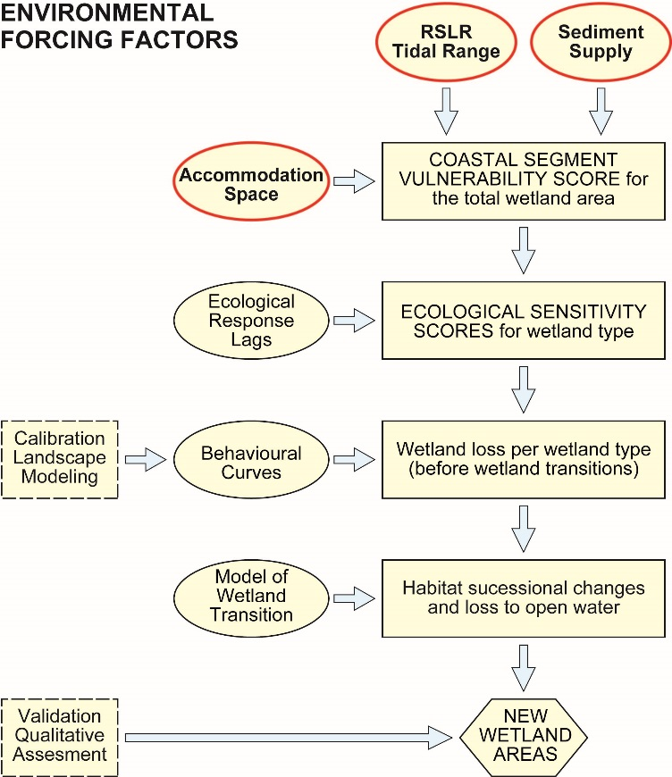

1217

1218

Fig. 1. Model structure in the revised DIVA_WCM wetland loss and transition algorithm.

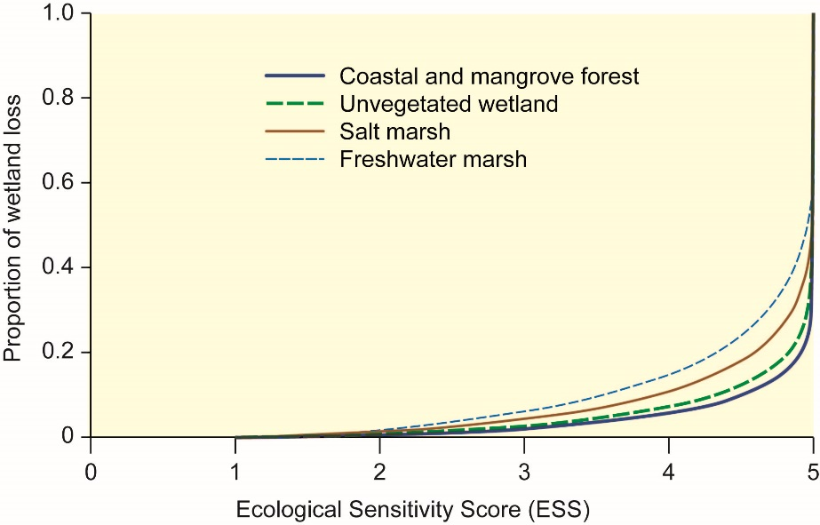

1219
Fig. 2. Proportion of wetland loss versus wetland sensitivity as measured by the Ecological

1220
Sensitivity Score (ESS; see text for definition). Values of beta: Unvegetated sediments (Sabka and

1221
Mudflat/Sandflat) (0.093); Freshwater Marsh (0.188); Saltmarsh (0.137); and Coastal Forest and

1222

1223
Mangrove Forest (0.074).

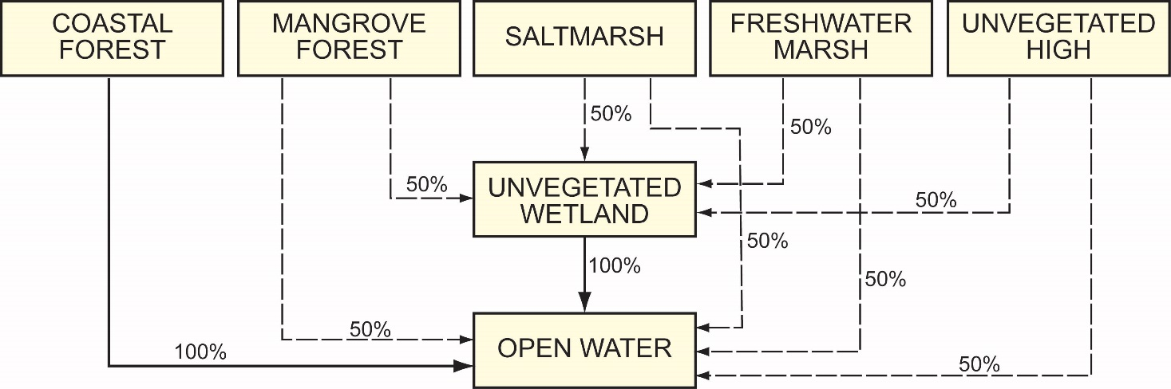

1224
Fig. 3. Model of wetland loss and transition between wetland types and open water for low to

1225
moderate environmental forcing (Vulnerability Score < 4). For high environmental forcing

1226

1227
(Vulnerability Score >= 4) all wetland areas are lost to open water.

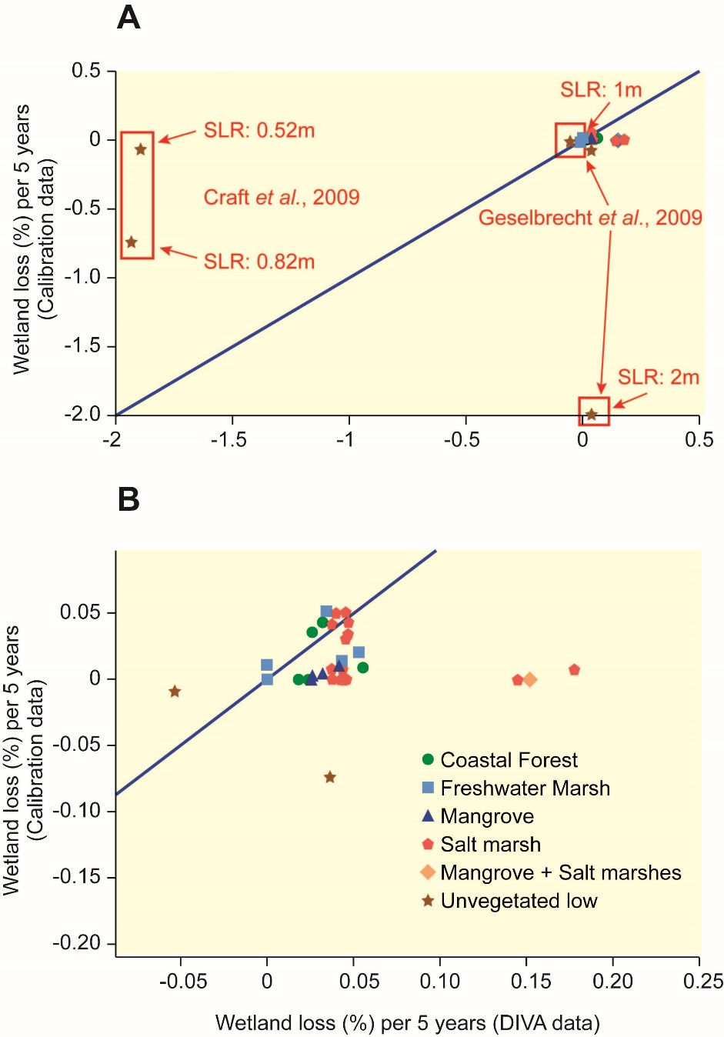

1228

Fig. 4. DIVA_WCM model outputs vs. wetland loss rates derived from the one WARMER and five

1229
SLAMM studies. In (a) all available data points are displayed (CSLID = DIVA segment number). In (b)

1230
only the central data points are shown. The blue line denotes the 1:1 line (perfect fit). Negative

1231
wetland losses (wetland gains), reported by the SLAMM studies were put to zero for all wetland

1232

1233
types, where no gain is possible (all habitat types except unvegetated low).

1234

Fig.5. Coastal wetland loss in the Indo-Pacific region. A: Predicted relative coastal wetland loss by

1235
DIVA segment. DIVA_WCM simulation with medium sea-level rise scenario (RCP4.5 median, 50 cm

1236
by year 2100) and SSP2 scenario with ‘widespread dikes’; B: Predicted loss of mangrove habitat

1237
under an RCP6 sea level rise scenario of 0.48 m by year 2100, as modelled by Lovelock et al. (2015).
Green indicates mangrove extent in 2011 (after Giri et al., (2011)) and red identifies areas of

1239

predicted mangrove habitat loss to sea level rise.

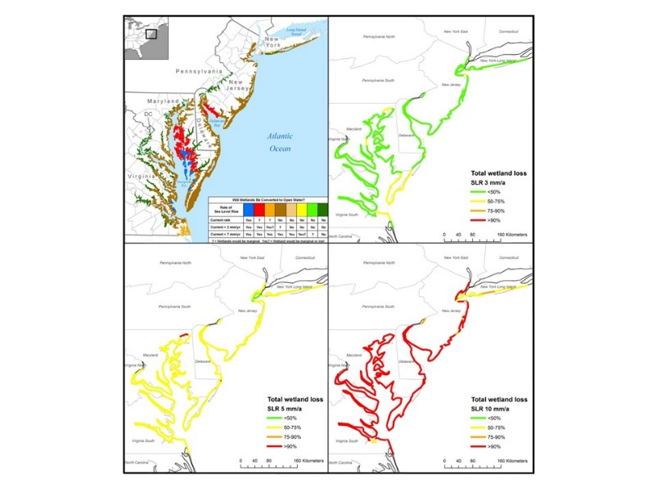

1240

Fig. 6. Comparison of the qualitative assessment by Reed et al. (2008) (a) with the outputs of the

1242
calibrated DIVA WCM for constant sea-level rise of 3 (b), 5 (c), and 10 (d) mm a-1. (a): Reed et al.

1243
(2008) assumes a current SLR rate of sea-level rise of 3 mm a-1. Future scenarios are a continuation

1244
of the current rate of sea-level rise; the current rate plus 2 mm a-1 (i.e. 5 mm a-1); and the current

1245
rate plus 7 mm a-1. Figures 6(b-d) can be compared to 6(a) as follows:

1246
%Total Loss < 50%: Wetlands will not be converted to open water (“No”)

1247
50%<%Total Loss < 75%: Wetlands will be marginal (“?”)

1248
75%<%Total Loss < 90%: Wetland will be marginal or lost (“Yes?”)

1249

1250
%Total Loss > 90%: Wetlands will be converted to open water (“Yes”)

1251

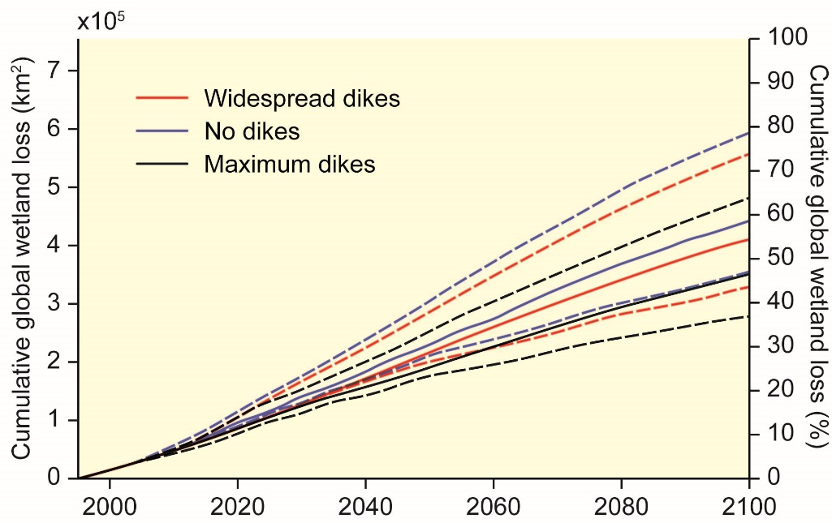

Fig. 7. Absolute and relative cumulative global coastal wetland loss from 1995 to 2100. Three

1252
scenarios describing the construction of sea dikes are considered: (i) ‘no dikes’; (ii) ‘widespread

1253
dikes’ built according to a ‘demand-for-safety function’, assuming an SSP2 scenario; (iii) ‘maximum

1254
dikes’. For each dike-scenario low (lower dashed), medium (full line) and high (upper dashed) sea-

1255
level rise scenarios are run: Low = RCP2.6 (5% quantile; 29 cm by 2100); medium = RCP4.5 (median;

1256

1257
50 cm); high = RCP8.5 (95% quantile; 110 cm).

1258
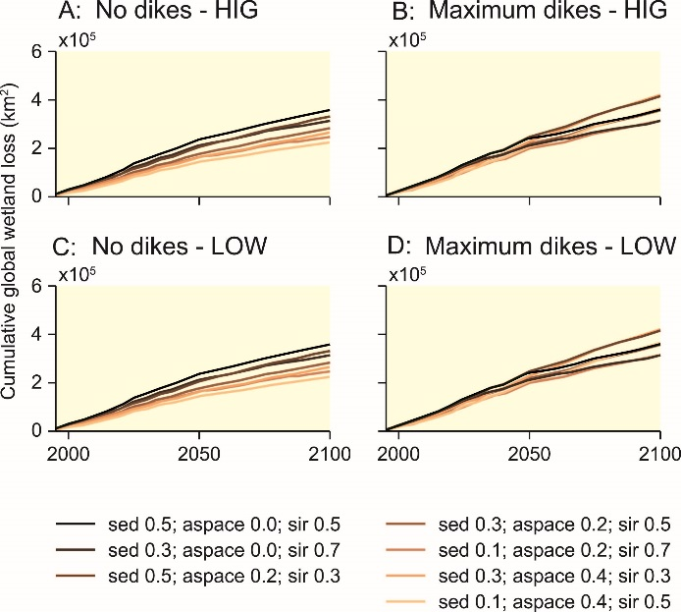

Fig. 8. Absolute cumulative global wetland loss from 1995 to 2100 for different combinations of

1259
weights for the three environmental forcing factors (sea-level rise / tidal range (rslr_tidal_score);

1260
sediment supply (sedsup); accommodation space (aspace). See Tables 4 – 7 for more details. Dark

1261
line colours represent low weights for accommodation space, whereas bright colours indicate

1262
higher weights for accommodation space. Sensitivity runs were conducted assuming A) ‘no dikes’

1263
and high sea level rise (HIG = 110 cm by year 2100); B: ‘maximum dikes’ and high sea level rise; C:

1264
‘no dikes’ and low sea level rise (LOW = 29 cm by year 2100); and D: ‘maximum dikes’ and low sea

1265

1266
level rise.

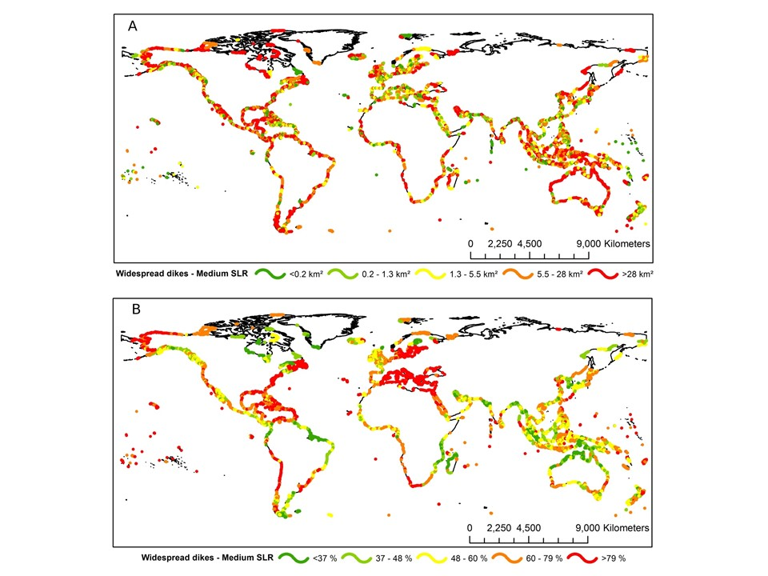

1267
Fig. 9. Global wetland loss by DIVA segment between 1995 and 2100. A: absolute loss; B: relative

1268
loss. DIVA_WCM simulation with medium sea-level rise scenario (RCP4.5 median, 50 cm by year

1269

1270

1271
1272
2100) and SSP2 scenario with ‘widespread dikes’.

1273

1274

List of Tables

1275
Table 1. Global mean sea-level rise in 2100 with respect to 1985-2005. Median values, with 5% and

1276
95% quantiles in parentheses. After Hinkel et al. (2014). The DIVA_WCM uses low sea-level rise =

1277
RCP2.6 (5% quantile; 29 cm by 2100); medium sea-level rise = RCP4.5 (median; 50 cm); high sea-

1278

1279
level rise = RCP8.5 (95% quantile; 110 cm).

Scenario | Model | Steric (cm) | Land-ice (cm) | Total (cm) | Acronym
RCP2.6 | HadGEM2-ES | 14 | 21 (16, 39) | 35 (29,52) | LOW
RCP4.5 | HadGEM2-ES | 18 | 32 (23, 56) | 50 (41,75) | MED
RCP8.5 | HadGEM2-ES | 29 | 44 (31, 81) | 72 (60,110) | HIG

1280

Table 2. Location, habitat, sea-level rise scenario and model characteristics for the six calibration

1281
studies used to calibrate the behavioural curves used in the DIVA_WCM. Tidal range data: in

1282
reference or for USA sites from NOAA Tides and Currents

1283
(https://tidesandcurrents.noaa.gov/stations.html?type=Datums).

1284
Suspended sediment concentrations: (1) 2011 annual mean of MERIS geophysical product Total

1285
Suspended Matter (TSM) in 0.017 degree resolution, northern NSW, Australia

1286
(http://hermes.acri.fr/); (2) Howard and Frey (1985); (3) Heimann et al., (2011); (4) Buchanan and

1287

1288
Morgan (2014); (5) You (2005).

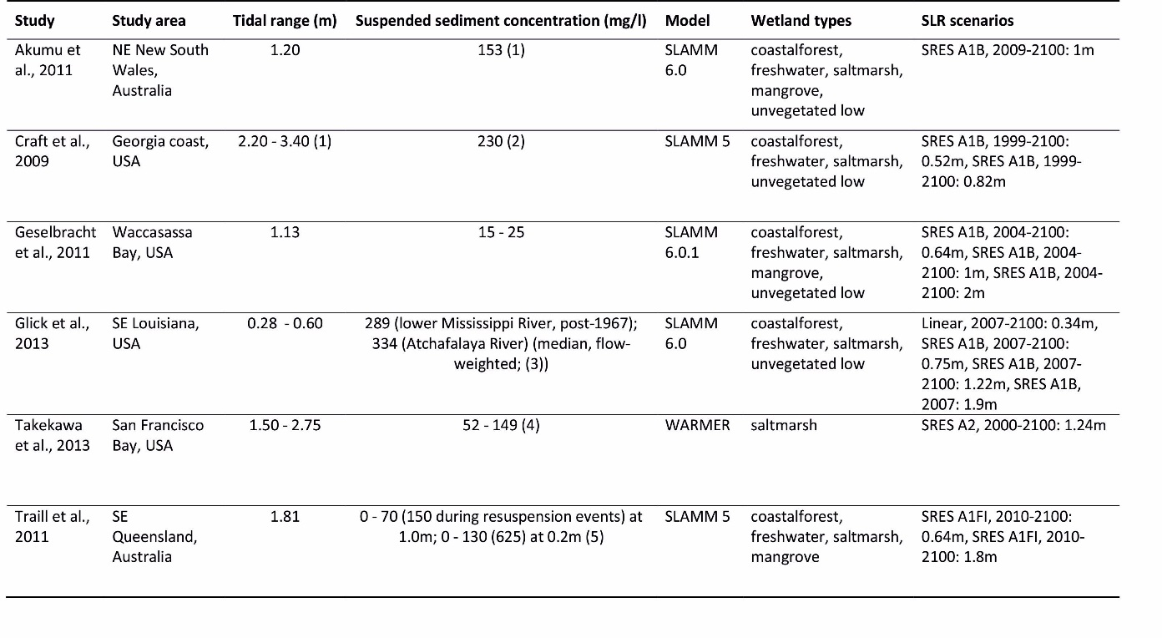

1289Table 3. Absolute global wetland loss (x103 km2) and relative loss of total global wetland stock (%)

1290
by 2100 under the diking and sea-level rise scenarios (see Table 1 and text for details on the

1291

1292
scenarios employed).

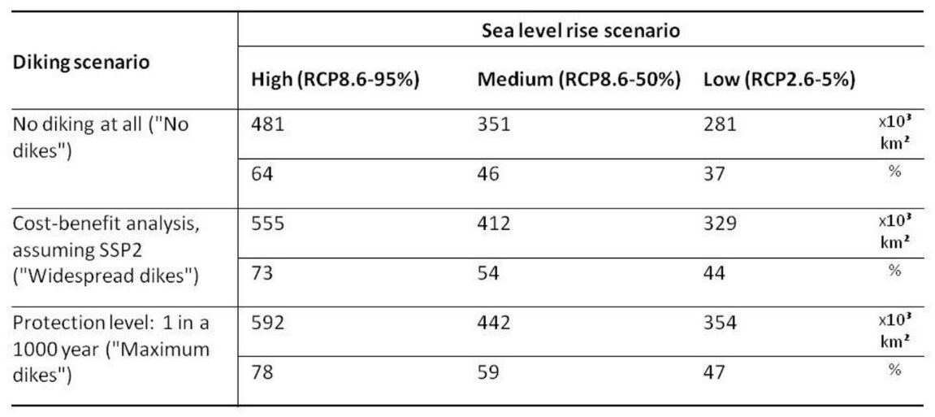

1293
Table 4. Percentage of total wetland area loss at 2100 under different weighting combinations of

1294
(a) three environmental forcing factors and (b) sea-level rise / tidal range and sediment supply only,

1295
given high sea-level rise scenario of 110 cm by 2100 (95% quantile, RCP8.5; Table 1) and ‘no dikes’.

1296
Shaded area = ‘standard’ DIVA_WCM output (see Equation 4, Supplementary Material for details).

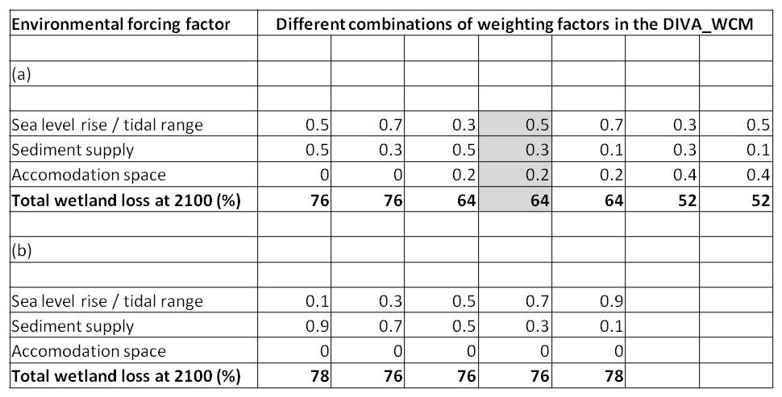
1297

1298
Table 5. Percentage of total wetland area loss at 2100 under different weighting combinations of

1299
the three environmental forcing factors given high sea-level rise scenario of 110 cm by 2100 (95%

1300
quantile, RCP8.5; Table 1) and ‘maximum dikes’. Shaded area = ‘standard’ DIVA_WCM output (see

1301

1302
1303
Equation 4, Supplementary Material for details).

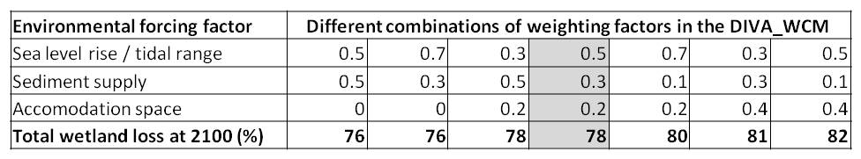

Table 6. Percentage of total wetland area loss at 2100 under different weighting combinations of

1304
(a) three environmental forcing factors and (b) sea-level rise / tidal range and sediment supply only,

1305
given low sea-level rise scenario of 29 cm by 2100 (5% quantile, RCP2.6; Table 1) and ‘no dikes’.

1306

1307
Shaded area = ‘standard’ DIVA_WCM output (see Equation 4, Supplementary Material for details).

1308
Table 7. Percentage of total wetland area loss at 2100 under different weighting combinations of

1309
the three environmental forcing factors given low sea-level rise scenario of 29 cm by 2100 (5%

1310

1311
1312
1313
1314
1315
1316
1317
1318
1319
1320
1321
quantile, RCP2.6; Table 1) and ‘maximum dikes’.

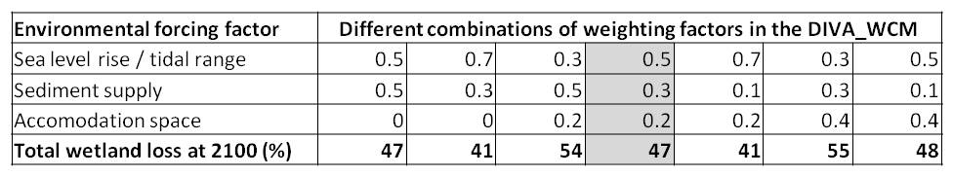
1324
1325
1326
1327
1328
1329
1330
1331
1332
1333
1334
1335
1336
1337

Supplementary Material

Background tables and equations used in the DIVA_WCM algorithm

- Relative sea-level rise and tidal range forcing

We first compute rslr_tidal as:

rslr_d = rslr_annual^1.4 / htidal Eq.1

where rslr_annual is the annual rise in relative sea level in metres, htidal is the tidal range in metres derived from the LOICZ typology (Maxwell and Buddemeier, 2002) as shown in Table A1.

Tidal Range classes from LOICZ typology | Tidal Range (metres), LOICZ typology | htidal (Tidal forcing score within the DIVA Wetland Change Model)
<2 | 0-2.5 | 0.25
2 | 2.5-3.5 | 1.25
3 | 3.5-5.0 | 3
4 | 5.0-6.5 | 6
5 | >6.5 | 9

1338
1339
1340
1341
1342
1343
1344
Table A1 Derivation of tidal forcing scores (representing tidal range) based on the tidal range classes from the LOICZ typology.

Then we convert rsrl_d into an rslr_tidal_score between 1 and 5 based on the 95, 84, 50, 16 percentiles of all rslr_d values where wetlands are reported (assuming a current global SLR of 3 mm a-1). Resulting class values are reported in the following table:

rslr_d | rslr_tidal_score
>=0.001121 | 5
>=0.000402 | 4
>=0.000178 | 3
>=0.000044 | 2
>0 | 1

1345
1346
1347
1348
1349
1350
1351
1352
1353
1354
Table A2: Assigning a forcing value to the impact of relative sea-level rise and tidal range on wetland vulnerability.

Lateral accommodation space

We initialize the forcing score for lateral accommodation space based on the coastal slope (degrees) using Table A3.

Average slope (slopecst, degrees) | Forcing score for lateral accommodation space (aspace)
>4.5 | 5
>1.5 < 4.5 | 4
> 0.5 < 1.5 | 3
> 0.25 < 0.5 | 2
<0.25 | 1

1359
1360
1361
1362
1363
1364
1365
1366
1367
1368
1369
1370
1371
1372
1373
1374
1375
1376
1377
1378
1379
1380
1381
1382
1383
1384
1385
1386
1387
1388
1389
1390
1391
1392
1393
1394
1395
1396
1397
Table A3: Forcing score used to represent the impact of coastal slope on wetland vulnerability. slopecst is the average topographic slope (in degrees) along the segments.

aspace value is initialised using the average topographic slope, derived from the ETOPO2 (NGDC, 2001) dataset. This initialized aspace score is then updated based on the actual computed dike height within each time-step using Equation 2. DIVA_WCM builds sea dikes along the entire coastal segment given sea level and socio-economic forcing following the demand function of safety given in Hinkel et al. (2014).

if (sdikehght > htidal/2 and aspace < 5): aspace = aspace + 0.25 Eq. 2

Where htidal/2 is a critical value of sdikehght defining its functioning as barrier to landward movement of wetland and to flooding. This threshold value is based on expert judgement.

Sediment supply

External of DIVA we calculate a constant sediment supply factor sedsup based on a variety of biophysical coastal properties.

sedsup = (t * tw) + ((dis + d_dis)/2) * fw) + (gl * glw) + (geo * gew) + (man * mw) + (his *hw)

Eq. 3

where:
t = Tectonic control parameter tw = Tectonic control weighting
dis = Annual river discharge parameter
d_dis = Distance from point of discharge parameter fw = Fluvial weighting
gl = Glacial limit parameter glw = Glacial limit weighting
geo = Geomorphic setting parameter gew = Geomorphic setting weighting
man = Management parameter (presence or absence of sea dikes) mw = Management weighting
his = History of resource exploitation parameter hw = History of resource exploitation weighting

In the DIVA database we have values of sedsup between 1.7 and 4.9.

1401
1402
Sediment Supply Factor | Description | Key data reference/source | Category | Forcing Score | Weighting Factor
Tectonic Context | Global tectonic setting | Inman and Nordstrom (1971) | Passive Margins | 1 | 0.07
 |  |  | Marginal Seas | 3
 |  |  | Active Margins | 5
Fluvial Context | Annual river discharge | Ludwig and Probst (1998) | >500 FTSS (1012 g/yr) | 1 | 0.2
 |  |  | 100-500 FTSS (1012 g/yr) | 2
 |  |  | 50-100 FTSS (1012 g/yr) | 3
 |  |  | 5-10 FTSS (1012 g/yr) | 4
 |  |  | <5 FTSS (1012 g/yr) | 5
 | Distance to the point of fluvial discharge | Calculated by GIS | 0-30km | 1
 |  |  | 30-70km | 2
 |  |  | 70-120km | 3
 |  |  | 120-180km | 4
 |  |  | >180km | 5
Glacial Context | Location relevant to maximum extent of last glaciation | Williams et al. (1991) | 100km-300km | 1 | 0.1
 |  |  | >300km | 3
 |  |  | <100km | 5
Geomorphic Context | Coastal geomorphic setting | McGill (1958) | Sheltered coast (Inlet/delta/estuary) | 1 | 0.03
 |  |  | Open coast | 5
Management Context | Degree of coastal protection | DIVA adaptation algorithm or user inputs (Tol et al., 2005) | Sea dike absent (< 0.5 m high) | 1 | 0.3
 |  |  | Sea dike present (> 0.5 m high) | 5
Historical Context | Timing of peak resource exploitation | Expert judgment | Classical | 1 | 0.3
 |  |  | Medieval | 2
 |  |  | Colonial | 3
 |  |  | 20th Century | 5

1403
1404
1405
1406
1407
1408
1409
1410
1411
1412
1413
1414
1415
1416
Table A4 Factors influencing sediment supply and their incorporation into the DIVA_WCM via forcing scores and weighting factors.

Coastal segment vulnerability score (csvs)

The above calculated three forcing scores are then combined into the coastal segment vulnerability score (csvs) following Equation (4)

csvs = rslr_tidal_score * 0.5 + aspace * 0.2 + sedsup * 0.3 Eq. 4

where rslr_tidal score is the relative sea-level rise and tidal range forcing (Equation 1), aspace the lateral accommodation space forcing score (Equation 2) and sedsup the sediment supply forcing score (Equation 3).

1421
1422
1423

1424
1425
1426
1427
1428
1429
1430
1431
1432
1433
1434
1435
1436

Ecological Sensitivity Score (ESS) by wetland type
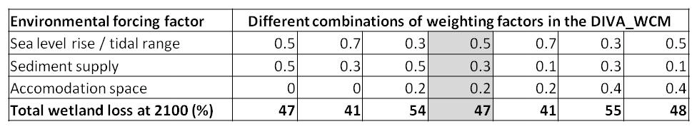

Finally, we compute the ecological sensitivity score (ess) by combining the csvs values of the current and last time step.

Eq. 5

where ESStype is the ecological sensitivity score for the given wetland type, csvscurrent is the coastal segment vulnerability score and csvslast is the value of this variable calculated within the previous time step, weight_currenttype is the lag weight associated to the current time step and weight_lasttype is the lag weight associated to the csvs value from the previous time step. The weights used are given in Table 4.

Wetland Type (type) | Previous 5 year lag weight (weight_lasttype) | Current 5 year lag weight (weight_currenttype) | Response time (yrs)
Coastal forest | 1 | 0 | 10
Freshwater marsh | 0 | 1 | <5
Saltmarsh | 0 | 1 | <5
Mangrove forest | 1 | 0 | 10
Unvegetated wetland | 0 | 1 | <5
Mudflat and sand flat | 0 | 1 | <5

1437
1438
1439
1440
1441
1442
1443
1444
1445
1446
1447
1448
Table A5: Response to environmental change by wetland type as modelled by relative importance of previous and current ecological state. Response time = 5 / Current 5 year lag weight.

Wetland response (Annual wetland loss rate)

The ess values are then translated into relative 5-years wetland loss rates (RLR5), which is the proportion of wetlands lost for a specific wetland type during a 5-year time step.

RLR5 = 1- (β +1) * (1 – ESStype/5) ^ β + β * (1 – ESStype/5) ^ (β + 1) Eq. 6

Values of beta:

1449 | 1. | Unvegetated high and low: 0.093
1450 | 2. | Freshwater Marsh: 0.188
1451 | 3. | Saltmarsh: 0.137
1452 | 4. | Coastal Forest and Mangrove Forest: 0.074.

1456
1457
1458
1459
1460
1461
1462
1463
1464
1465
1466
1467
1468
1469

Supplementary material references

Inman, D.L., Nordstrom, C.E., 1971. On the tectonic and morphologic classification of coasts. Journal of Geology 79, 1-21.

Ludwig, W., Probst, J.L., 1998. River sediment discharge to the oceans: present-day controls and global budgets. American Journal of Science 298, 265-295.

Maxwell, B.A., Buddemeier, R.W., 2002. Coastal typology development with heterogeneous data sets. Regional Environmental Change 3, 77-87.

McGill, J.T., 1958. Map of coastal landforms of the world. Geographical Review 48, 402- 405. NGDC (National Geophysical Data Centre), 2001. NGDC CD-ROM, ETOPO2 Global 2’

1470
Elevations. Available at: http://www.ngdc.noaa.gov/mgg/fliers/01mgg04.html

1471
1472
1473
1474
1475
1476
1477
1478
Nicholls, R.J., Tol, R.S.J., 2006. Impacts and responses to sea-level rise: A global analysis of
the SRES scenarios over the twenty-first century. Philosophical Transactions of the Royal Society of London 364A, 1073–1095.

Williams, M.A.J., Dunkerley, D.L., De Deckker, P., Kershaw, A.P., Stokes, T., 1991. Quaternary Environments. Edward Arnold, London.

