Thermal poling of silica optical fibers using novel liquid electrodes
F. De Lucia,¹ D.W. Keefer,² C. Corbari,³ P. J. A. Sazio^{1,*}
¹ Optoelectronics Research Centre, University of Southampton, SO17 1BJ, UK
² Department of Chemistry, Pennsylvania State University, University Park, PA 16802, USA
³ Renishaw plc, New Mills, Wotton-under-Edge, Gloucestershire, GL12 8JR, UK
* Corresponding author: pjas@soton.ac.uk
Received XX Month XXXX; revised XX Month, XXXX; accepted XX Month XXXX; posted XX Month XXXX (Doc. ID XXXXX); published XX Month XXXX

Thermal poling is a well-known technique for inducing second-order nonlinearities in centrosymmetric silica optical fibers. However, some 25 years since its discovery, there still remain a number of issues that prevent the realization of very long length, highly efficient all-fiber nonlinear device applications that includes frequency conversion or sources of polarization-entangled photon pairs. In this paper we report a thermal poling method that utilizes a novel range of liquid metal and aqueous electrodes embedded into the optical fibers. We demonstrate that it is possible to pole samples that are potentially meters in length, characterized by very low losses for efficient SHG processes. The maximum estimated effective value of χ⁽²⁾ (0.12 pm/V) obtained using Mercury electrodes is the highest reported in periodically poled silica fibers. © 2016 Optical Society of America
OCIS codes: (190.4370) Nonlinear optics, fibers; (230.4320) Nonlinear optical devices; (190.2620) Harmonic generation and mixing; (230.1150) All-optical devices.

Thermal poling is a well-established technique [1] used to generate effective second-order susceptibility in centro-symmetric materials such as bulk glasses by freezing a static electric field inside. The technique has been used in silica optical fibers [2] and improved in terms of nonlinear performance by Margulis et al. [3], who developed a cathode-less configuration to pole the samples. Despite these efforts, thermal poling is still compromised by issues which prevent the realization of long, low loss and efficient all-fiber nonlinear devices [4, 5]. Recently however, De Lucia et al. [6] developed a new technique to pole optical fibers by means of an electrostatic induction mechanism. This innovation overcomes some of the otherwise intractable fabrication issues encountered with creating electrodes inside silica fibers. Simple manual wire insertion methods for example, are both length restricted and unreliable, whereas molten metal filled fibers require a number of processing steps in order to establish direct electrical contact to the internal electrodes, which if left in-situ after poling, can result in very large optical absorption losses. In contrast, poling by induction [6] avoids any physical contact to the electrodes; these are typically comprised of conductive liquids for facile removal after poling has been completed to minimize optical loss. Not only does this advantageous combination allow for the poling of very long (meter scale) samples, but also within any complex geometry. This could include, for example, induction poling of microstructured optical fibers where contacting multiple internal electrodes would otherwise be a prohibitive challenge. In addition, selective filling of such geometries both radially and longitudinally will allow liquid electrodes to be inserted (and then removed) in any configuration in order to optimize the effective χ⁽²⁾ for novel device applications.
In this paper we employ the cathode-less [3] poling configuration in order to examine the performance of a number of different liquid electrodes. The resulting fiber devices were initially characterised in terms of their linear transmission losses and tested for evidence of depletion region formation. The effective second order nonlinearities were then evaluated by quasi-phase matching (QPM) a 1550nm laser pump wavelength via the UV erasure technique [7] and measuring the second harmonic generation (SHG) output power. By comparing these different electrode types and their respective optical fiber device performance parameters, we can identify new routes towards the realisation of highly efficient and robust χ⁽²⁾ fiber waveguides.
In order to ensure reproducibility, four identical, twin-hole Germania doped, fused silica fibers sourced from Acreo Fiberlab (OD = 125 μm, NA = 0.17, electrodes holes diameter = 30 μm, core diameter = 4 μm) were used. The schematic in Fig. 1 shows the experimental setup consisting of a metallic heater (which also acts as the electrical ground-plane for this poling configuration) on top of which is placed a 10mm thick borosilicate glass strip in order to ensure adequate electrical insulation between the electrodes embedded into the sample and the grounded surface of the hotplate whilst simultaneously maintaining a good thermal contact. This particular setup allows for thermal poling of samples up to 60 cm in length, but much longer lengths can easily be
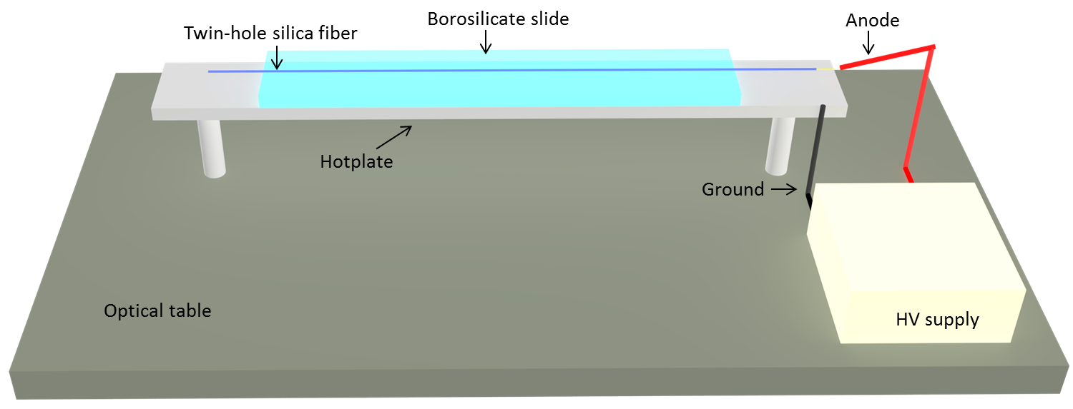
Fig. 1. Schematic of setup used for thermal poling of optical fibers with internal liquid electrodes.
accommodated using the Petri dish setup previously used in [6] provided the optimum poling temperature is maintained along the entire sample. The electrode liquids used to fill the twin-hole fiber samples were Gallium, Mercury, HCl solution diluted at 20% in DI water and finally ordinary tap water. The liquid metals were introduced into the samples using pressurization techniques [4] whereas the aqueous solutions could be inserted via normal capillary action. After filling, tungsten wires were inserted into the twin holes at one end of the samples, ensuring electrical contact with the liquid. Both ends were then sealed with epoxy or superglue and all four samples poled under the same experimental conditions, with an applied voltage of +5 kV, a hotplate temperature of 300 °C, a heating time of 120 mins followed by a cooling time of 45 mins to room temperature with the HV constantly applied. The second-order nonlinearity induced by thermal poling is defined by the following equation [1]:
$χ^{(2)}\sim {3χ}^{(3)}E_{rec}$ (1)
where χ⁽³⁾ is the third-order susceptibility, which is a property of the glass used to make the fiber and E_{rec} is the electric field frozen into the optical fiber due to space charge region formation. This effect arises due to electromigration of impurity ions already present in the glass, due to an applied electric field at elevated (~300 °C) temperatures [8]. This depletion region formation is strong evidence of an electric field frozen into the glass and thus of an effective second-order nonlinearity created in the fiber. A very useful method for direct visualization of the space charge region formation is the HF acid decorative etching technique [9]. In Fig. 2, micrograph cross-sections of the samples poled using these four different electrode types are shown after being etched for 1 min in HF buffered solution. These etched sections are taken from a region halfway along the length of each fiber. As expected, under the large applied bias and temperature of 300 °C, the non-volatile liquid metal electrodes generated depletion regions throughout the fiber samples as shown in Fig. 2. Remarkably, given these extreme conditions, the embedded aqueous electrodes also yielded well-defined depletion regions (shown in Fig. 2) throughout the entire 60 cm length of the test devices and to our knowledge, is the first time that optical fibers have been thermally poled using aqueous electrolytic electrodes. This highly counterintuitive result is currently under further investigation, as it is not yet fully understood how electrical continuity is maintained during poling while the fiber is held well above the boiling points of these aqueous solutions for extended periods. Depletion region formation throughout the entire sample is unequivocal evidence that electrical continuity was not compromised during the experiment.
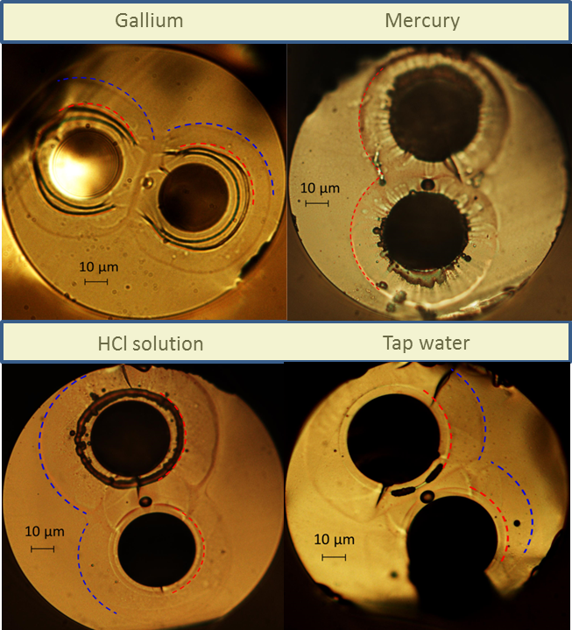
Fig. 2. Cross-sectional micrographs of the HF etched samples poled using novel liquid electrode types. The HF decorative etching process reveals the presence of depletion regions in all four twin-hole Ge-doped core, fused silica fibers. The observed dual concentric depletion region formation (highlighted by means of the red and blue dotted lines as a guide for the eye) is likely to be due to the Na⁺ and Li⁺ impurity charges involved in the electromigration process, typically characterized by differing ion mobilities in the glass [10].
Some insight can be gained into this unusual phenomenon by observing the fiber using a stereomicroscope during the heating phase of the poling, but before the application of the high voltage. The fiber was monitored both in the center and on each of the of the end caps created to seal the fiber. Each cap consists of a piece of silica capillary with an internal diameter larger than the OD of the fiber sample, into which the end of the fiber is partially inserted and filled with an epoxy resin. Once it had reached ~100 °C, some bubbles were observed in the center of the fiber which push the aqueous solution towards the ends. At 300 °C, before applying the external voltage, the fiber sample appears to be completely empty in the 60 cm of length placed on top of the hotplate, with some liquid remaining in the parts of the fiber located close to the end caps. We hypothesize that at high temperature, the aqueous solution is close to its supercritical fluid point (which for water, is at 374 °C and 221.1 Bar). Under these conditions, it is expected that the conductance of the fluid will rapidly increase [11] and indeed can exhibit conductance values orders of magnitude higher compared with standard temperature and pressure values. This near-critical operating point could therefore allow the high pressure/temperature/conductance fluid created within the twin-hole fiber to act as an efficient electrode. Electrical continuity is completed via the liquid regions located at the end caps and the tungsten wires inserted inside. Further investigations to confirm this hypothesis will be addressed in future work, focusing on in-situ optical spectroscopic studies [12] for which the optical fiber platform is inherently well suited.
As previously described, the HF decorative etching procedure [9] is strongly indicative, but not a rigorously quantitative measurement of the induced nonlinearity. In order to obtain a comprehensive evaluation of the induced χ⁽²⁾ value, the SHG response can be measured by modulating the nonlinearity via UV erasure techniques [7] which allows for quasi-phase matching [13] the phase velocity disparity in dispersive media present between the pump wavelength and the SHG. The relationship between the period of the grating written by UV erasure and the wavelength of the pump where the second harmonic is phase-matched (to first order of approximation) is expressed in Eq. 2:
$Λ_{QPM}=\frac{λ}{2\left(n_{eff}^{2ω}-n_{eff}^{ω}\right)}$ (2)
where $n_{eff}=n_{eff}\left(λ, NA, a\right)$ is the effective refractive index of the propagating modes and depends on the wavelength of the fundamental mode, the NA of the fiber and the diameter of the fiber core (a).
Prior to the grating writing process, it is necessary to completely remove the electrodes from the fiber samples in order to minimize linear loss. This is particularly true for the liquid metal electrodes as these exhibit very high optical absorption losses [6]. These metals (i.e., Gallium and Mercury) can be removed by using the same pressurization system initially used to fill the fibers [4]. However, we note that the samples poled by means of electrolytic solutions do not need to be purged and emptied as the aqueous electrodes at 300 °C in the part of the fibers located on top of the heater are already completely void once thermal poling is completed.
The experimental setup used to write the QPM gratings is the same as reported in [6], in which 355 nm laser radiation is delivered as a 200-kHz train of 8-ps pulses, focused to a 10 μm×100 μm spot size onto the fiber with a total fluence of 200 J/cm². The periodically poled samples were then characterized using the setup shown schematically in Fig. 3 and the resultant tuning curves of the fibers poled with metallic liquid electrodes are shown in Fig. 4, demonstrating the expected Sinc² transfer function, i.e. the Fourier transform of the square QPM grating. In order to provide a quantitative value for the χ⁽²⁾ values according to the analysis of Pruneri et al., [14] for a periodically poled fiber, the sample shown in 4(a), i.e. using Gallium electrodes, has a fabricated device length of 28.5 cm and a modal overlap area of 49.43 μm² at 1550 nm CW pump wavelength. In 4(b) the sample using Mercury electrodes has a device length of 20 cm and a modal overlap area of 49.43 µm² at 1550 nm CW pump wavelength.
The periodically poled silica fiber (PPSF) device itself consists of two SM980 Thorlabs fibers (manufacturer datasheet parameters; OD 125 µm, 5.3-6.4 µm mode field diameter@980 nm, NA = 0.13-0.15) spliced to either end of a PPSF to act as buffers that facilitate optical launch and pumping. An important aspect of the measured χ⁽²⁾ values, which as well as being dependent on the thermal poling conditions and the quality and accuracy of the QPM grating writing process, is the strong influence of the overall device insertion losses, which include the splice and transmission losses. Mercury electrodes tend to be superior to Gallium in this respect as they leave few residues after poling and purging, resulting in overall losses of the entire device of approximately 1 dB. To our knowledge, the effective χ⁽²⁾ of 0.12 pm/V shown in Fig. 4(b) is the highest value for a PPSF published to date. As a direct comparison, the two samples poled using aqueous electrodes, which as shown
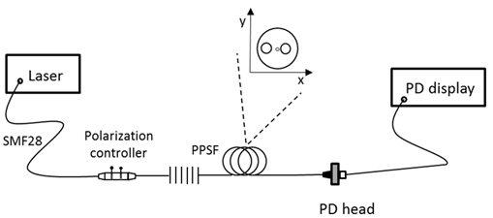
Fig. 3. Setup for SHG measurements for PPSF. The source is a tunable diode laser emitting at 1550 nm (Photonetics, model 3542 HE CL, linewidth (FWHM) = 100 kHz), CW power of 6 mW). The polarization controller allows for changing the polarization state of the pump radiation and a low-power calibrated photodiode sensor (Newport, model 918D-UV-OD3) is used to measure the SHG optical power. The inset shows the cross-section of the twin-hole silica fiber. The principal polarization axes of the fiber are assumed aligned along the two orthogonal axes $x$ and$y$, where $x$ is the direction of the frozen-in electric field.
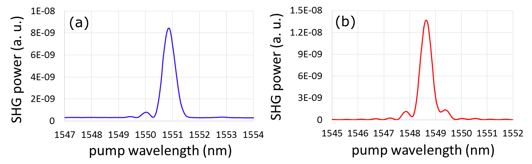
Fig. 4. Tuning curves of the two samples poled by means of metallic electrodes for (a) Gallium (insertion loss@1550 nm = 1.8 dB, χ⁽²⁾ estimated at 0.056 pm/V, Λ_{QPM} = 57.3072 µm) and (b) Mercury (insertion loss@1550 nm = 1 dB, χ⁽²⁾ estimated at 0.12 pm/V, Λ_{QPM} = 57.1937 µm) and characterized using the setup shown in Fig. 3. The curves represent the SHG power measured by a photodiode while the wavelength of the pump light emitted by the tunable narrowband CW source is changed step by step over a range centered at 1550 nm.
in Fig. 2 also yielded the well-defined depletion regions indicative of induced second order nonlinearity, were optically characterized with exactly the same setup used for the metallic electrode samples. In contrast however, the SHG power measured by the photodiode in Fig. 3 was too low to be accurately quantified in these samples using the low power CW pumping setup, as it could not be resolved from the noise floor of the photodiode sensor. In order to find conclusive evidence of SHG in these samples and exclude the possibility that the etched regions shown in Fig. 2 were due to some other unknown effect, the SHG of the aqueous electrode samples were characterized using the setup shown schematically in Fig. 5. Here, a high power laser (second harmonic of a mode-locked amplified Nd:YVO4 solid state laser, pulse duration 8 ps, repetition rate 250 kHz, average power 2.5 W), is used to pump an optical parametric generator (OPG), thus producing a high peak power broadband infrared idler output (3 dB bandwidth approx. 80 nm, average power of 50 mW) that is temperature tunable between 1100 and 2500 nm. A long-wave pass filter in the optical setup rejects all radiation below the cut-on wavelength (900 nm) associated with the source. This ensures that
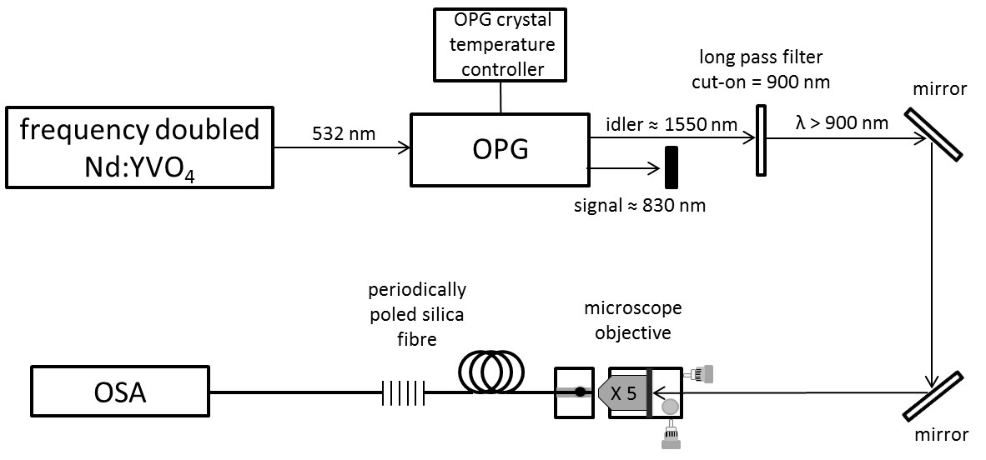
Fig. 5. High power pulsed laser pump setup for the nonlinear characterization of PPSF devices poled using aqueous electrodes.
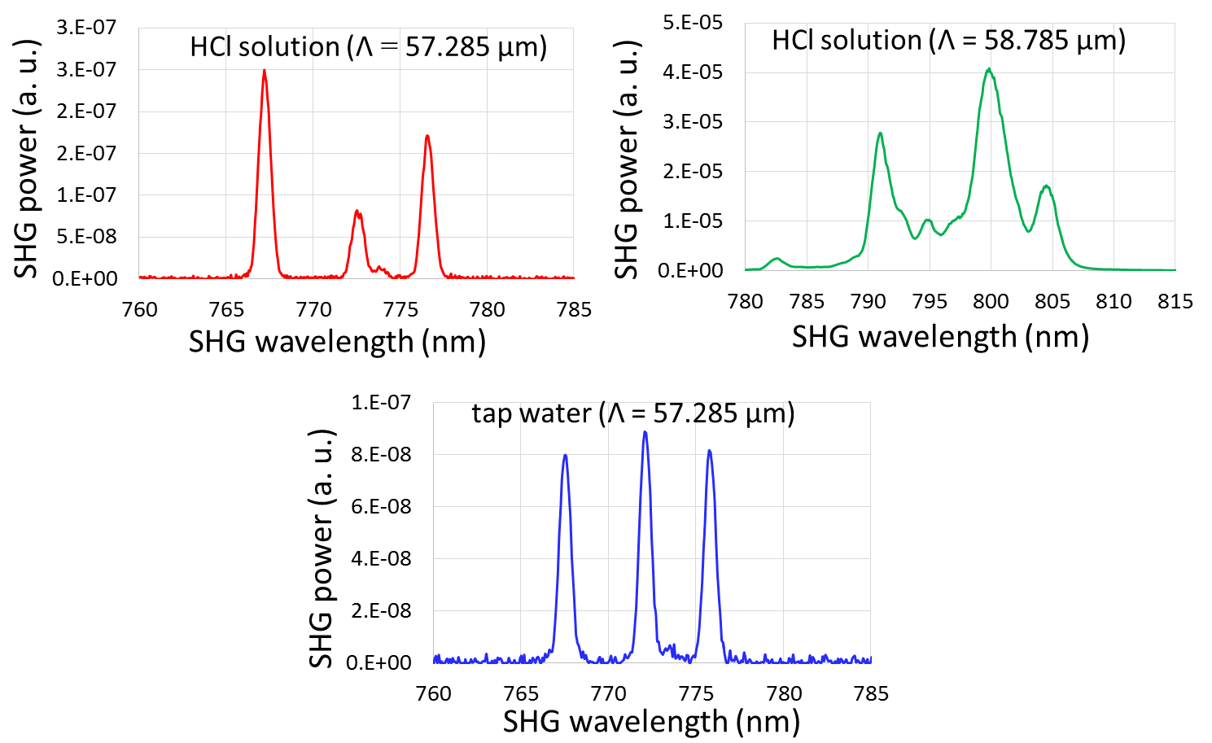
Fig. 6. SHG output spectra of optical fibers poled using HCl solution as well as ordinary tap water, characterized using the setup shown in Fig. 5. Insertion loss@1550nm = 0.7 dB for water and 0.5 dB for HCl solution. The induced χ⁽²⁾ for both aqueous solutions is estimated [14] at ≤0.001 pm/V, assuming a fabricated device length of 20 cm and a modal overlap area of 49.43 µm² at 1550 nm pump wavelength.
any spectra observed at wavelengths shorter than 900 nm is due only to nonlinear processes occurring within the PPSF. Fig. 6 shows the SHG spectra obtained for two samples poled under identical experimental conditions using HCl aqueous electrodes and with different grating periods. The spectrum of a sample poled using tap water electrodes is also shown. Here, each SHG spectrum consists of three peaks, corresponding to different combinations of the polarization states of the two pump photons producing the SHG. This degeneracy of the polarization is due to the birefringence of the fiber along the x and y axes [15]. The presence of the three peaks instead of just one observed in the SHG tuning curves shown in Fig. 4, is due to the fact that for the setup in Fig. 3, the CW pump output is linearly polarized and can be adjusted by means of a polarization controller to produce QPM of type I (XX –> X). In contrast, the pulsed high power pump used to characterize the samples poled using aqueous electrodes is not linearly polarized, so it always contains both components of polarization along the x and y axes. Nevertheless, the observation of distinct peaks at second harmonic wavelengths corresponding to two different QPM grating periods that accurately follow the linear relationship expressed in Eq. (2) provide convincing evidence of the formation of an effective χ⁽²⁾ in these novel aqueous electrode PPSFs, which exhibit very low optical insertion losses compared with the metallic liquid electrode samples. However, despite the potential improvement in nonlinear process efficiency conferred by this desirable characteristic, it comes at a cost, as the effective χ⁽²⁾ values in the aqueous electrode samples is clearly inferior to those with Galllium and Mercury. We believe this is due to higher resistivity of the electrolytic solutions compared with pure metals, thus potentially reducing the magnitude of electric field that can be frozen into the glass fiber, which in turn leads to a decrease in induced χ⁽²⁾ nonlinearity.
In summary, this work presents the first successful attempt at optical fiber thermal poling using non-metallic internal electrodes. This result, in combination with our induction poling technique demonstrated in [6], offers a significant advance towards the implementation of a generalized method for the thermal poling of any complex fiber geometry and length. This could include microstructured optical fibers that potentially allow up to four order of magnitude improvements of second order nonlinear processes compared with conventional twin-hole, step-index Germania doped fused silica fibers [16].

Funding. EPSRC EP/I035307/1

Acknowledgments. We thank Oleksandr Tarasenko and Walter Margulis from Acreo Fiberlab who manufactured the fiber periodically poled and Peter Kazansky for access to the necessary technical facilities. F. De Lucia thanks Andrea Ravagli for interesting discussions about the chemistry of superfluids. Under the EPSRC research data management scheme, datasets of the figures in this paper can be found at http://dx.doi.org/10.5258/SOTON/386825
References
- R. A. Myers, N. Mukherjee and S. R. J. Brueck, Opt. Lett. 16, 1732 (1991).
- D. Wong, W. Xu, S. Fleming, M. Janos and K-M Lo, Opt. Fib. Tech. 5, 235 (1999).
- W. Margulis, O. Tarasenko and N. Myrén, Opt. Exp. 17, 15534 (2009).
- M. Fokine, L.E. Nilsson, A.A. Claesson, D. Berlemont, L. Kjellberg, L. Krummenacher and W. Margulis, Opt. Lett. 27, 1643 (2002).
- A. Canagasabey, C. Corbari, A. V. Gladyshev, F. Liegeois, S. Guillemet, Y. Hernandez, M. V. Yashkov, A. Kosolapov, E. M. Dianov, M. Ibsen and P. G. Kazansky, Opt. Lett. 34, 2483 (2009).
- F. De Lucia, D. Huang, C. Corbari, N. Healy and P. Sazio, Opt. Lett. 39, 6513 (2014).
- A. Canagasabey, M. Ibsen, K. Gallo, A. V. Gladishev, E. M. Dianov, C. Corbari and P. G. Kazansky, Opt. Lett. 35, 724 (2010).
- N. Mukherjee, R. A. Myers and S. R. J. Brueck, J. Opt. Soc. Am. B 11, 665 (1994).
- T. G. Alley and S. R. J. Brueck, Opt. Lett. 23, 1170 (1998).
- T. G. Alley, S. R. J. Brueck, and M. Wiedenbeck, J. Appl. Phys. 86, 6634 (1999).
- W. L. Marshall, J. Chem. Eng. Data 32, 221 (1987).
- D. A. Masten, B. R. Foy, D. M. Harradine and R. B. Dyer, J. Phys. Chem. 97, 8557 (1993).
- J. A. Armstrong, N. Bloembergen, J. Ducuing and P. S. Pershan, Phys. Rev. 127, 1918 (1962).
- V. Pruneri, G. Bonfrate, P. G. Kazansky, D. J. Richardson, N. G. Broderick, J. P. de Sandro, C. Simonneau, P. Vidakovic and J. A. Levenson, Opt. Lett. 24, 208 (1999).
- E. Y. Zhu, L. Qian, L. G. Helt, M. Liscidini, J. E. Sipe, C. Corbari, A. Canagasabey, M. Ibsen and P. G. Kazansky, Opt. Lett. 35, 1530 (2010).
- T. M. Monro, V. Pruneri, N. G. R. Broderick, D. Faccio, P. G. Kazansky and D. J. Richardson, IEEE Photon. Tech. Lett. 13, 981 (2001).

References
- R. A. Myers, N. Mukherjee, and S. R. J. Brueck, “Large second-order nonlinearity in poled fused silica”, Opt. Lett. 16, no. 22 (1991): 1732 - 1734.
- D. Wong, W. Xu, S. Fleming, M. Janos, and K-M Lo, “Frozen-in electrical field in thermally poled fibers”, Opt. Fib. Tech. 5 (1999): 235 – 241.
- W. Margulis, O. Tarasenko and N. Myrén, “Who needs a cathode? Creating a second-order nonlinearity by charging glass fiber with two anodes”, Opt. Exp. 17, no. 18 (2009): 15534 – 15540.
- M. Fokine, L.E. Nilsson, A.A. Claesson, D. Berlemont, L. Kjellberg, L. Krummenacher and W. Margulis, “Integrated fiber Mach-Zehnder interferometer for electro-optic switching”, Opt. Lett. 27 (2002): 1643-1645.
- A. Canagasabey, C. Corbari, A. V. Gladyshev, F. Liegeois, S. Guillemet, Y. Hernandez, M. V. Yashkov, A. Kosolapov, E. M. Dianov, M. Ibsen and P. G. Kazansky, “High-average-power second-harmonic generation from periodically poled silica fibers.” Opt. Lett. 34, no. 16 (2009): 2483-2485.
- F. De Lucia, D. Huang, C. Corbari, N. Healy and P. Sazio, “Optical fiber poling by induction”, Opt. Lett. 39, no. 22 (2014): 6513-6516.
- A. Canagasabey, M. Ibsen, K. Gallo, A. V. Gladishev, E. M. Dianov, C. Corbari and P. G. Kazansky, “Aperiodically poled silica fibers for bandwidth control of quasi-phased-matched second-harmonic generation”, Opt. Lett. 35 (2010): 724-726.
- N. Mukherjee, R. A. Myers and S. R. J. Brueck, “Dynamics of second-harmonic generation in fused silica”, J. Opt. Soc. Am. B 11 (1994): 665-669.
- T. G. Alley and S. R. J. Brueck, “Visualization of the nonlinear optical space-charge region of bulk thermally poled fused-silica glass”, Opt. Lett. 23 (1998): 1170-1172.
- T. G. Alley, S. R. J. Brueck, and M. Wiedenbeck, “Secondary ion mass spectrometry study of space-charge formation in thermally poled fused silica”, J. Appl. Phys. 86 (1999): 6634-6640.
- W. L. Marshall, “Electrical conductance of liquid and supercritical water evaluated from 0 °C and 0.1 MPa to high temperatures and pressures. Reduced-sate relationships”, J. Chem. Eng. Data 32 (1987): 221-226.
- D. A. Masten, B. R. Foy, D. M. Harradine and R. B. Dyer, “In Situ Raman spectroscopy of reactions in supercritical water”, J. Phys. Chem. 97 (1993): 8557-8559.
- J. A. Armstrong, N. Bloembergen, J. Ducuing and P. S. Pershan, “Interactions between light waves in a nonlinear dielectric”, Physical Review 127 (1962): 1918-1939.
- V. Pruneri, G. Bonfrate, P. G. Kazansky, D. J. Richardson, N. G. Broderick, J. P. de Sandro, C. Simonneau, P. Vidakovic and J. A. Levenson, “Greater than 20% efficient frequency doubling of 1532 nm nanosecond pulses in quasi-phase-matched germanosilicate optical fibers”, Optics Letters 24 (1999): 208-210.
- E. Y. Zhu, L. Qian, L. G. Helt, M. Liscidini, J. E. Sipe, C. Corbari, A. Canagasabey, M. Ibsen and P. G. Kazansky, “Measurement of χ⁽²⁾ symmetry in a poled fiber”, Opt. Lett. 35 (2010): 1530-1532.
- T. M. Monro, V. Pruneri, N. G. R. Broderick, D. Faccio, P. G. Kazansky and D. J. Richardson, “Broad-Band Second-Harmonic Generation in Holey Optical Fibers”, IEEE Photon. Tech. Lett. 13, no. 9 (2001): 981-983.

