Supplemental Data
Combined genetic and splicing analysis of BRCA1 c.[594-2A>C; 641A>G] highlights the relevance of naturally occurring in-frame transcripts for developing disease gene variant classification algorithms.
de la Hoya et al.

8 Supplemental figures (pages 2-9)
3 Supplemental tables (pages 10-12)
References (page 13)

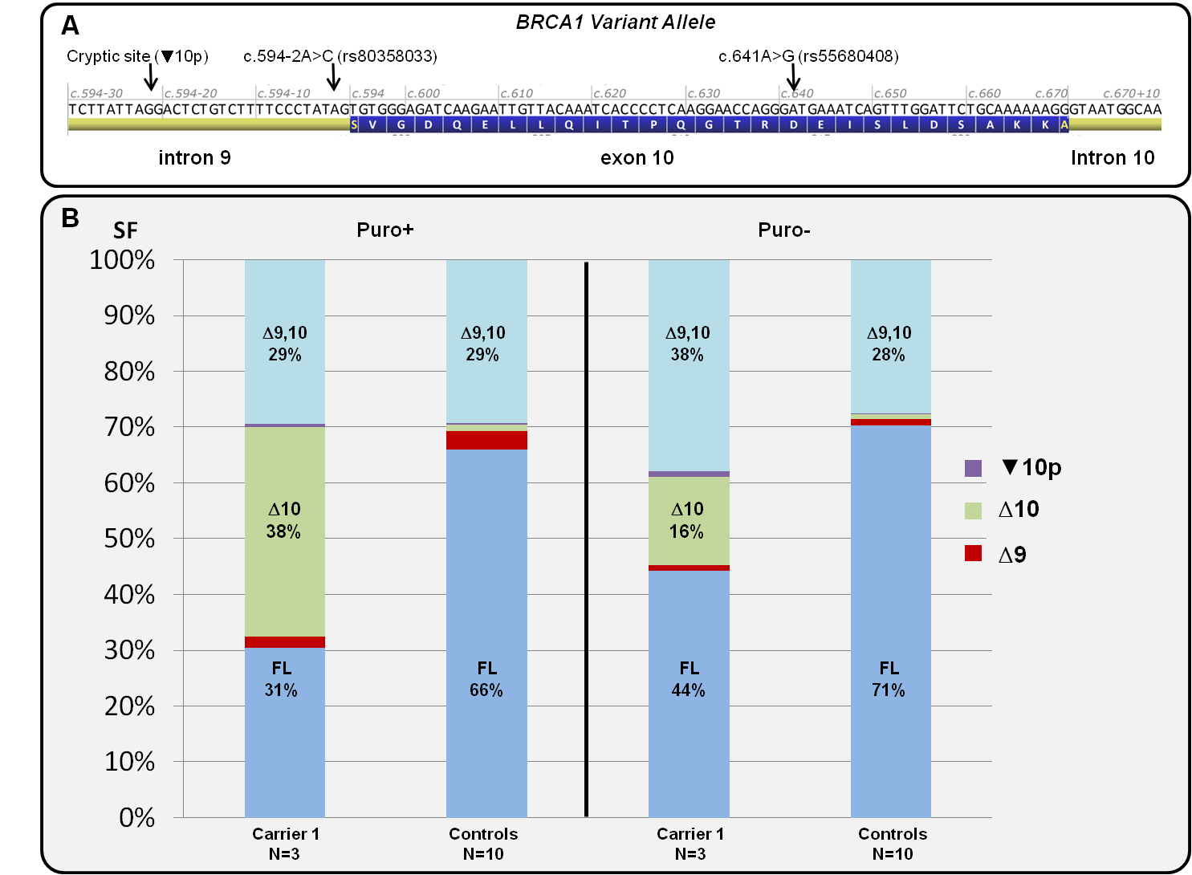

Supplemental Figure 1. BRCA1 alternative splicing landscape in LCLs from one BRCA1 c.[594-2A>C; 641A>G] carrier (Carrier 1) and 10 Controls. Panel A shows a schematic representation of the c.[594-2A>C; 641A>G] variant allele under investigation. Panel B Capillary electrophoresis analysis of RT-PCR products generated with the E8.2-E11q.2 assay (36 PCR cycles) detects up to five different alternative splicing events both in c.[594-2A>C; 641A>G] carriers and Controls, including 3 in-frame (Δ9,10, Full-length (FL) and ▼10p), and 2 out-of-frame (Δ9 and Δ10) events (see Figure 1). The charts represent the splicing fraction (SF) of these five splicing events (expressed as the % of the corresponding peak area to the Σ of all five peak areas) observed in Carrier 1 (average of 3 technical replicas) and Controls (average of 10 different samples). The analysis shows that increased Δ10^{SF} (and corresponding decrease of FL^{SF}) is the predominant effect observed in carriers. The data is compatible as well with ▼10p being up-regulated in carriers (as predicted by splicing reporter minigene experiments, Figure 3), but splicing fractions are too low both in Carrier 1 (0.6% in Puro+ and 1% in Puro- experiments) and controls (0.3% in Puro+ and 0,2% in Puro- experiments) to be reliable measured by capillary electrophoresis. Note that SFs observed in experiments performed with or without Puromycin are different, suggesting nonsense-mediate decay (NMD) of out-of-frame Δ9 and Δ10 transcripts in Puro- experiments. In the case of Controls, differences are subtle, since Δ9^{SF} (3,4% in Puro+ and 1,2% in Puro- experiments) and Δ10^{SF} (1,1% in Puro+ and 0,8% in Puro- experiments) are rather minor contributors to the overall expression level. However, differences in Carrier 1 are significant, due to the fact that Δ10 is a predominant contributor to the overall expression level in carriers (Δ10^{SF} of 38% in Puro+ experiments and 16% in Puro- experiments). The experiments summarized in this figure, as well as most experiments reported in the present study, restrict the characterization of BRCA1 alternative splicing landscape to the vicinity of BRCA1 exon 10 i.e. we have not characterized/isolated complete transcripts. For this reason, we refer throughout the text to alternative splicing events rather than to alternative splicing transcripts.

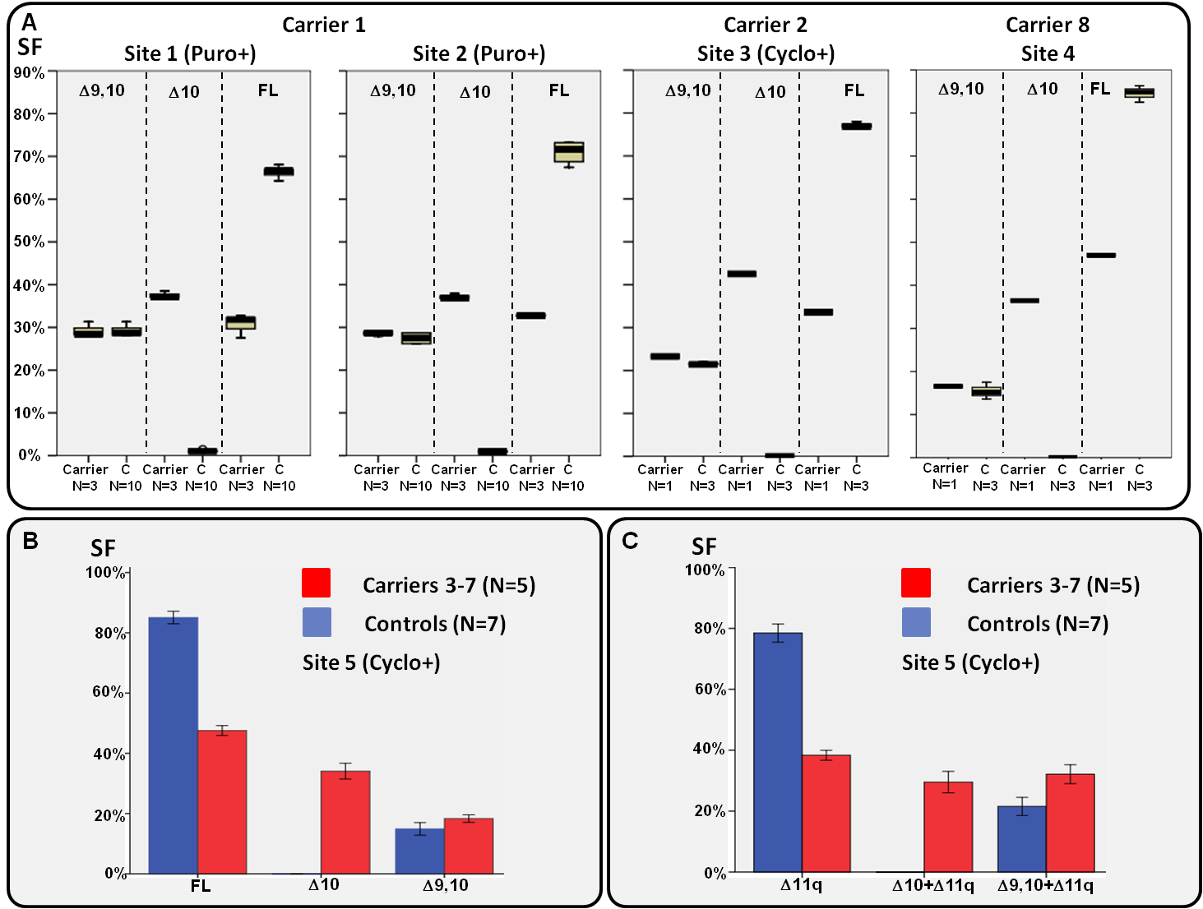
Supplemental Figure 2. Δ9,10 (and Δ9,10+Δ11q), Δ10 (and Δ10+Δ11q), FL and Δ11q SF determined by capillary electrophoresis in up to 8 independent c.[594-2A>C;641A>G] carriers. The boxplots in Panel A (displaying low, Q1, median, Q3, and high values) summarize experiments performed by four contributing laboratories (sites 1 to 4) in two independent LCL carriers named Carrier 1, and Carrier 2 , one fresh blood sample (PAXgene system for blood sampling, no puromycin/cycloheximide treatment) named Carrier 8, and its corresponding control. Note the high level of Δ10 transcripts in Carrier 8, despite the fact that NMD is not inhibited by the PAXgene system (C) samples. In the case of carriers, N represents the number of technical replicates. Site 1 data (the same data summarized in Supplemental Figure 1) was generated with the E8.2-E11q.2 RT-PCR assay (36 PCR cycles). Site 2 data was generated with the E8.1-E11q1 RT-PCR assay (36 PCR cycles). Site 3 data was generated with the E7-E11q.1 RT-PCR assay (40 PCR cycles). Finally, Site 4 data was generated with the E8.2-E11q.2 RT-PCR assay (30 PCR cycles). All RT-PCR assays are described in Supplemental Methods Table 1. Panel B summarizes experiments performed by site 5 in five independent leukocytes (LEU) carriers (Carriers 3 to 7) and seven controls. Data was generated with the E8.1-E11q1 RT-PCR assay (28 PCR cycles). Panel C summarizes experiments identical to those described in Panel B, except that the reverse primer mapped to exon 12 (E8.1-E12 RT-PCR assay). Note that in this case, the SF is not calculated relative to the “overall BRCA1 expression level”, but to the “overall BRCA1 Δ11q expression level”. Since BRCA1 exon11q (3309nt) is too long to be PCR amplified with standard protocols for short amplicons, this primer combination allowed us to analyse alternative splicing in the subpopulation of BRCA1 transcripts lacking exon 11q. Standard deviations are shown. When indicated, LCLs were treated with Puromycin (Puro+), or Cycloheximide (Cyclo+), prior to RNA extraction.
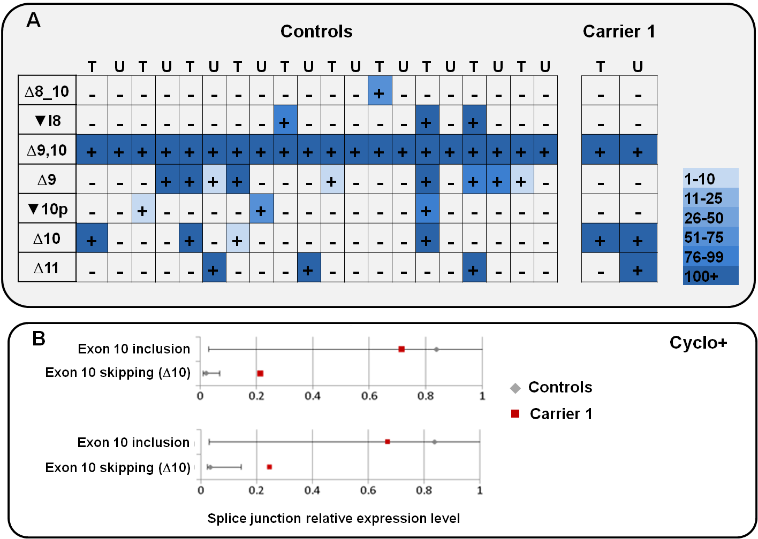
Supplemental Figure 3. RNAseq data in one BRCA1 c.[594-2A>C; 641A>G] carrier (Carrier 1) and Controls. Expression data were generated using the TruSeq Targeted RNA Expression platform (Illumina) and RNA from 11 LCLs (10 Controls and Carrier 1). Splice junction reads defining 47 different BRCA1 alternative splicing events were identified in at least one sample of the analyzed cohort. For simplicity, only BRCA1 splicing events involving exons 7 to 12 are shown in the heatmap (Panel A). The color key indicates the number of reads at exon-exon junctions defining each splicing event. Cyclo+ (T) and Cyclo – (U) experiments were performed. Experiments show the presence of ▼10p transcripts in Control samples, as well as absence of c.[594-2A>C; 641A>G] specific splice junctions, thus confirming capillary electrophoresis findings. Panel B shows the relative proportion of sequence reads for BRCA1 ∆10 (exons 9/11 junction) and exon 10 inclusion (exons 10/11 junction) relative to BRCA1 exons2/3 junction (upper chart), or BRCA2 exons 22/23 junction (bottom chart). Mean value and standard deviation for 10 Controls is indicated in grey. Only Cyclo+ experiments are shown.

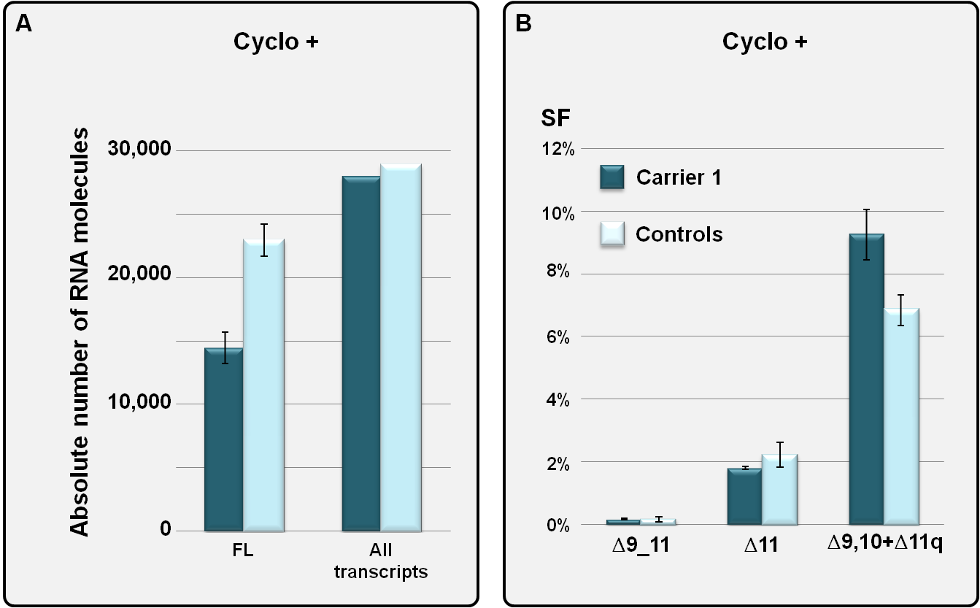
Supplemental Figure 4. qPCR analysis of BRCA1 alternative splicing landscape in LCLs from one BRCA1 c.[594-2A>C; 641A>G] carrier (Carrier 1) and 11 Controls. We performed several quantitative real-time PCR (qPCR) experiments with standard curves to determine the GADPH normalized absolute number of BRCA1 FL transcripts (exon 9 and exon 10 containing transcripts), as well as BRCA1 transcripts containing the following alternative splicing events : Δ9,10, Δ9, Δ10, Δ9_11, Δ11q, Δ11, and Δ9,10+Δ11q. The chart in Panel A displays the normalized absolute number of FL transcripts in Carrier 1 and 11 Controls (standard error of 3 experiments is shown), as well as the normalized absolute number of all BRCA1 transcripts (see supplemental methods for further details). The data indicate that the level of exons 9 and 10 containing transcripts drops in Carrier 1 if compared with healthy controls, but the overall BRCA1 expression level remains roughly constant. The Chart in Panel B shows Δ9_11^{SF}, Δ11^{SF}, and (Δ9,10+Δ11q)^{SF} estimated as the ratio between the GADPH normalized absolute number of transcripts containing the indicated alternative splicing event, and the GADPH normalized absolute number of all BRCA1 transcripts shown in Panel A (standard error of 3 experiments in shown). As already observed for Δ9,10^{SF} (see Figure 2), the (Δ9,10+Δ11q)^{SF} appears to be slightly increased in Carrier 1 if compared with healthy control samples.

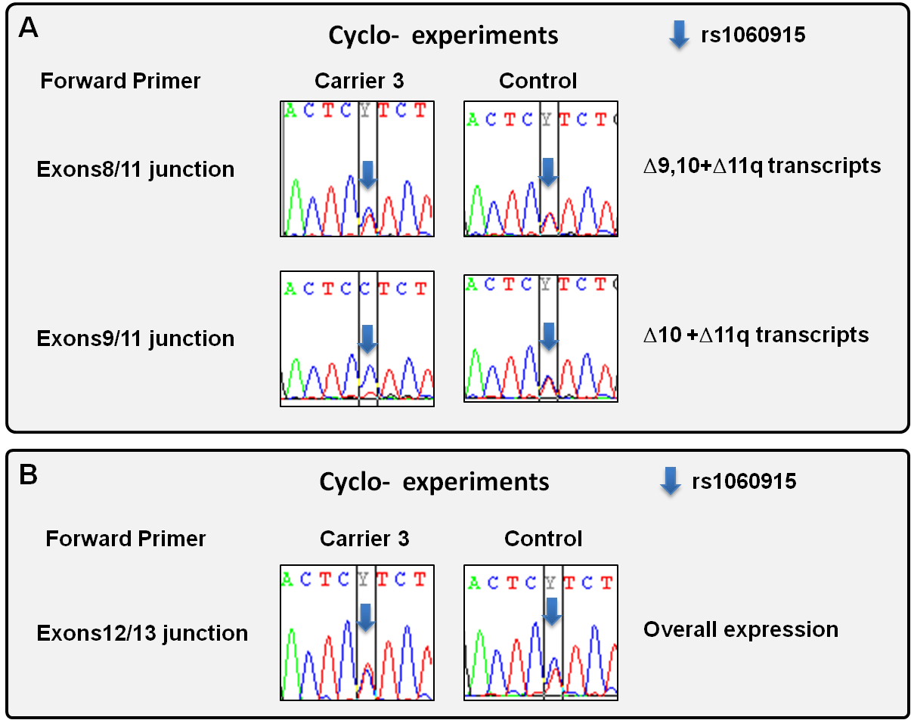

Supplemental Figure 5. Biallelic expression analyses in LEUs from one BRCA1 c.[594-2A>C; 641A>G] carrier (Carrier 3) and one Control. The figure shows representative examples of RT-PCR sequencing at the informative SNP rs1060915 (c.4308C>T, p.=), located in BRCA1 exon 13. RT-PCR amplifications were performed with a reverse primer located in BRCA1 exon 15, and different forward primers (left) designed to be specific for certain alternative splicing events. Since BRCA1 exon 11 is too long to be PCR amplified with our protocol, experiments shown in panel A are restricted to the subset of BRCA1 Δ11q transcripts, as indicated (right). A forward primer located in exons12/13 junction (panel B) is considered a proxy for overall expression. In Carrier 3, the rs1060615 C allele was demonstrated to be in cis with c.[594-2A>C;641A>G] (data not shown). Overall, data obtained with exons8/11 junction forward primer (panel A, top) shows that in carriers, both alleles contribute similarly to Δ9,10 overall expression level. A slight imbalance in favor of the variant allele (c.4308C) observed in Carrier 3 is compatible with other results suggesting that levels of Δ9,10 transcripts in c.[594-2A>C; 641A>G] carriers is in the upper limit of Control samples (Figure 2, Supplemental Figure 6). Data obtained with exons 9/11 junction forward primer (panel A, bottom) shows that Δ10 transcripts arise mostly from the variant allele. Panel B shows similar experiments performed with exons 12/13 forward primers, a proxy for overall expression level. The data suggests a slight imbalance in favor of the WT allele (c.4308T) in Carrier 3. The data is compatible with selective degradation of variant-derived Δ10 transcripts in the absence of a NMD inhibitor (Cyclo- experiments). Equivalent experiments performed with Carriers 4 and 5 showed almost identical results, including the slight imbalance observed with forward primers located in junctions for exons 8/11 and exons 12/13 (data not shown).

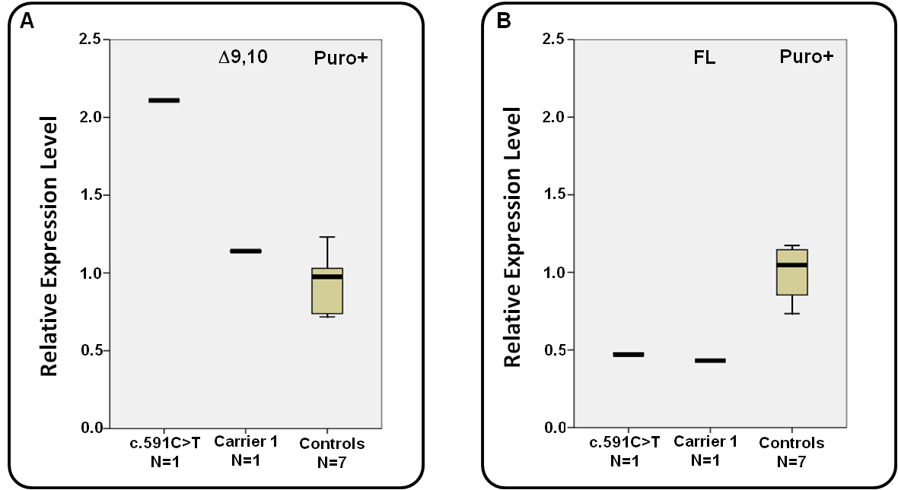

Supplemental Figure 6. dPCR relative quantification of Δ9,10 and FL in-frame transcripts in LCLs from one BRCA1 c.[594-2A>C; 641A>G] carrier (Carrier 1), one c.591C>T carrier, and 7 Controls. LCLs were treated with the NMD inhibitor Puromycin (Puro+ experiments) prior to RNA extraction and analysis. The boxplot in Panel A (displaying low, Q1, median, Q3, and high values) shows digital PCR measures of BRCA1 Δ9,10 relative expression level (exons8/10 junction), using BRCA2 as a reference). The data is expressed as the fold-increase relative to the average of 7 Controls. BRCA1 Δ9,10 relative expression level in Carrier 1 (2 technical replicates) is in the upper limit of control samples, while a >2-fold increase is observed in the c.591C>T carrier. The boxplot in Panel B (displaying low, Q1, median, Q3, and high values) shows digital PCR measures of BRCA1 FL relative expression level (exons 9/10 junction), using BRCA2 as a reference. The data is expressed as the fold-increase relative to the average of 7 Controls. A 50% decrease of BRCA1 FL relative expression is observed both in Carrier 1 (2 technical replicates) and c.591C>T carrier.

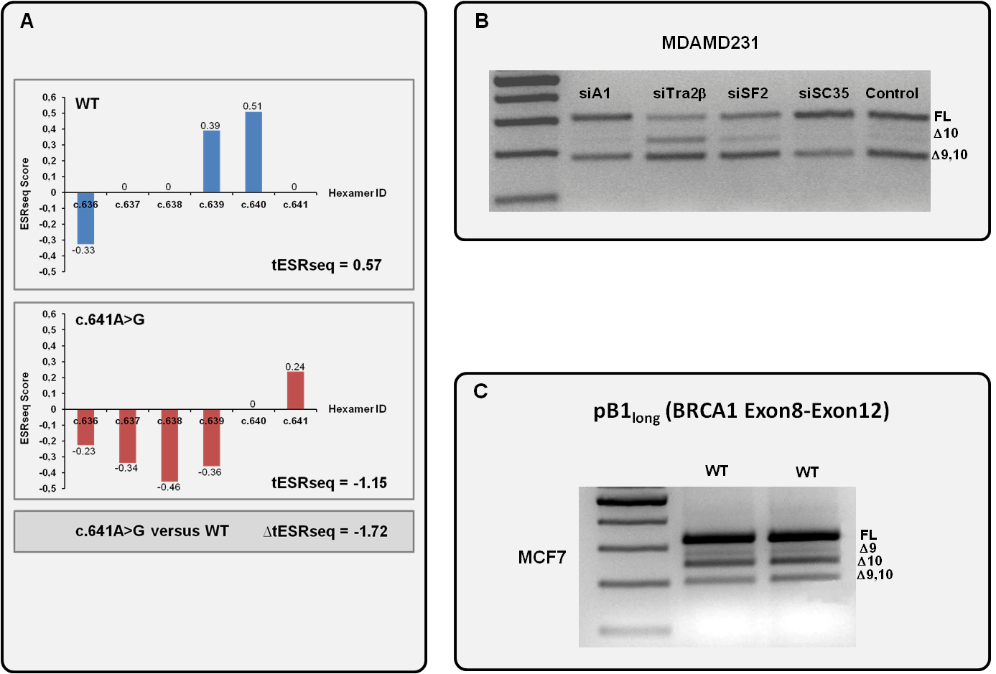
Supplemental Figure 7. BRCA1 c.641A>G is predicted to induce exon 10 skipping by altering potential splicing regulatory elements. Panel A displays results from a comparative in silico analysis of BRCA1 WT and BRCA1 c.641A>G based on ESRseq scores, which was performed as described under Supplemental Methods. The bars indicate the ESRseq scores of hexamer stretches starting at the positions indicated in the X-axis. All hexamer sequences overlapping the c.641 position were taken into account. Of note, positive ESRseq scores are indicative of potential exonic splicing enhancer elements (ESE) whereas negative ESRseq scores indicate potential exonic silencer elements (ESSs). The negative nature of the Change in Total ESRseq score produced by the variant relative to WT (ΔtESRseq=-1.72) is predictive of exon 10 skipping. Panel B shows a representative example of knockdown experiments performed in MDA-MD231 breast cancer cells demonstrating a positive role of Tra2β in BRCA1 exon10 inclusion. Panel C shows representative examples of pB1_{long}(WT) splicing reporter minigene experiments performed in MCF7 breast cancer cells. The pB1_{long}(WT) splicing reporter minigene is identical to pB1(WT) with the only exception that it includes the full intron 9 and intron 10 sequences. Even if extensive alternative splicing is observed for pB1_{long}(WT) in MCF7 cells, Δ10 appears to be the predominant alternative splicing event (and not Δ9,10, which is the predominant endogenous BRCA1 splicing event both in blood-related samples and in MDA-MD231 cells). pB1_{long}(WT) results are similar to those obtained with pB1(WT)(Figure 3B). These observations may reflect BRCA1 tissue-specific alternative splicing and/or a suboptimal capacity of splicing reporter minigenes to fully reproduce the alternative splicing pattern of the exon 8-exon 11 region.

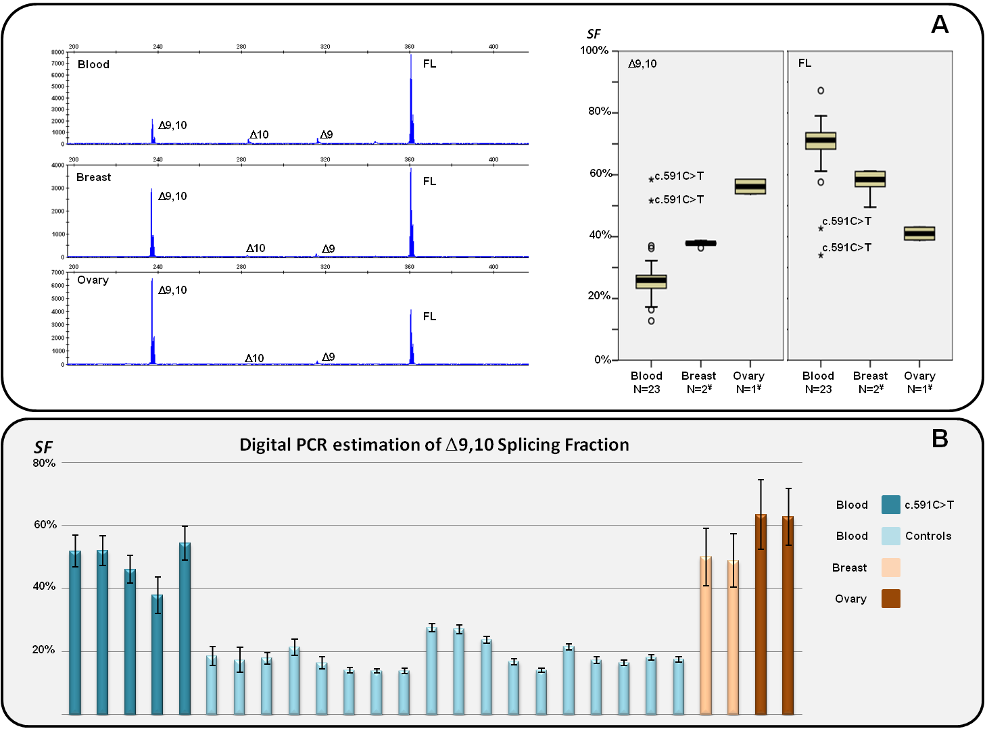
Supplemental Figure 8. BRCA1 alternative splicing landscape in blood, breast, and ovary related samples. Panel A (left) shows representative examples of capillary electrophoresis analysis o RT-PCR products generated with the E8.1-E11q.1 assay (33 cycle PCRCs) performed in fresh peripheral blood from healthy controls, non-malignant breast related samples, and non-malignant ovary related samples. The analyses detected full-length (FL), and up to four alternative splicing events, including two in-frame (Δ9,10 and ▼10p), and two out-of-frame (Δ9, and Δ10). ▼10p transcripts are not detected in the individual examples shown in panel A, but have been occasionally detected in blood and non-malignant breast samples (data not shown). The boxplots in Panel A (displaying low, Q1, median, Q3, and high values) represent Δ9,10^{SF} and FL^{SF} as determined with the E8-E11p capillary electrophoresis assay (expressed as the % of the corresponding peak area to the Σ of all peak areas). The chart displays the SF observed in 23 blood samples (fresh peripheral blood from healthy controls), non-malignant breast-related samples ¥(N=2 stands for a pool of 10 non-malignant breast tissues measured in duplicate, plus one commercial source of non-malignant breast tissue measured in triplicate), and non-malignant ovary-related samples ¥(N=1 stands for one commercial pool of 3 non-malignant ovary tissues measured in duplicate). Normal outliers (>1.5 inter quartile range, IQR) display a small circle. Extreme outliers (>3 IQR) display an asterisk. Note that two c.591C>T carriers, positive controls known to increment Δ9,10^{SF}, are correctly detected as extreme outliers in this assay. Panel B displays Δ9,10^{SF} as determined by digital PCR (using exon23-24 junction as a proxy for overall expression, see methods for further details). The precision of each measure (as determined by the QuantStudio 3D Analysis Cloud Software) is indicated. We included in the analysis fresh blood from 18 unrelated healthy controls, fresh blood from 5 positive controls (5 unrelated carriers of the BRCA1 c.591C>T variant), one commercial source of non-malignant breast tissue, and one commercial pool of 3 non-malignant ovary tissues. For breast and ovarian samples, two technical replicas are shown.

 |  |  |  | Supplementary Table 1: Characteristics of Carriers of BRCA1 c.594-2A>C identified in BCAC
Description of Studies with carriers identified |  |  |  |  |  |  |  |  | Characteristics of carriers identified
Study Acronym |  | Study Design |  |  | Country of Origin | BRCA1/2 Sequencing of cases in this study | n  Invasive Cases | n  Controls | Case-Control Status | Age  Interview/  Onset | Breast Tumour Pathology | Tumour Likelihood Ratio
BBCS |  | Cancer registry and National Cancer Research network based cases (including bilateral cases), population based controls |  |  | United Kingdom | none tested | 1446 | 1397 | case | 43 | Grade 3, ER-pos | 0,64
 |  |  |  |  |  |  |  |  | control | 58 | control | 1,00
BSUCH |  | Hospital based cases, blood donor controls |  |  | Germany | none tested | 815 | 954 | case | 40 | NA | 1,00
CGPS |  | Population-based cohort, nested case-control study |  |  | Denmark | none tested | 2811 | 4086 | case | 60 | Grade 2, ER-neg | 2,34
 |  |  |  |  |  |  |  |  | control | 28 | control | 1,00
KARBAC |  | Hospital-based familial and consecutive cases, geographically matched controls |  |  | Sweden | 100% tested** | 722 | 662 | control* | 61 | control | 1,00
MARIE |  | Population-based case-control study |  |  | Germany | none tested | 1656 | 1778 | control | 54 | control | 1,00
MBCSG |  | Clinic-based familial/early onset breast cancer cases, population-based controls |  |  | Italy | 100% tested** | 189 | 400 | control | 35 | control | 1,00
MCBCS |  | Hospital-based case-control study |  |  | USA | 4% tested** | 1546 | 1931 | control | 31 | control | 1,00
MCCS |  | Population-based prospective cohort study |  |  | Australia | none tested | 614 | 511 | case | 76 | Grade NA, ER-pos | 0,37
OFBCR |  | Population-based familial case-control study |  |  | Canada | 68% tested** | 1156 | 511 | case | 54 | Grade 2, ER-pos | 0,34
 |  |  |  |  |  |  |  |  | case*** | 41 | Grade 3, ER-neg | 3,16
pKARMA |  | Population-based cases, mammography screen study controls |  |  | Sweden | none tested | 4553 | 5537 | control | 46 | control | 1,00
SEARCH |  | Population-based case-control study |  |  | United Kingdom | none tested | 9097 | 8069 | case | 46 | Grade NA, ER-pos | 0,37
 |  |  |  |  |  |  |  |  | control | 70 | control | 1,00
 |  |  |  |  |  |  |  |  | control | 52 | control | 1,00
Totals |  |  |  |  |  |  | 24605 | 25836
 | For further details about participating BCAC studies, please see Michaelidou et al (1).
* Age data not available, mean diagnosis age for that study used for case-control likelihood analysis
** BCAC studies which had undergone genetic testing for BRCA1/2 variation, and were excluded from final analyses to determine causality based on case-control presentation.
*** Case determined to overlap with a CIMBA proband. No segregation data was available, and pathology information was included only once in multifactorial likelihood analysis.

Supplementary Table 2: Characteristic of carriers of BRCA1 c.594-2A>C identified in ENIGMA and CIMBA*
Consortium | Site | Country of Origin | Segregation Bayes Score for Family | Breast Tumour Pathology (age onset) for proband; other carrier relatives | Pathology LR
ENIGMA | Ambry Genetics | USA | Not informative | ER-pos (<50) | 0.32
ENIGMA | Ambry Genetics | USA | Not informative | ER-neg (<50) | 2.60
ENIGMA | Ambry Genetics | USA | Not informative | ER-pos (>50) | 0.37
ENIGMA | Ambry Genetics | USA | Not informative | ER-neg (<50) | 2.60
ENIGMA | Ambry Genetics | USA | Not informative | ER-pos (>50) | 0.37
ENIGMA | Ambry Genetics | USA | Not informative | ER-pos (>50) | 0.37
ENIGMA | Ambry Genetics | USA | Not informative | ER-neg (<50) | 2.60
ENIGMA/CIMBA | Embrace | UK | 1.64 | Grade 3, ER-pos (>50) | 0.90
ENIGMA/CIMBA | Embrace | UK | Not informative | Grade 1, ER NA (<50) | 0.13
ENIGMA | French Consortium | France | 0.73 | Grade 3, ER-pos (<50) | 0.64
ENIGMA | French Consortium | France | 0.83 | Grade NA, ER-neg (>50) | 3.31
ENIGMA | French Consortium | France | 1.00 | NA | 1.00
ENIGMA | GC-HBOC | Germany | 0.42 | NA | 1.00
ENIGMA | GC-HBOC | Germany | 0.55 | NA | 1.00
ENIGMA | GC-HBOC | Germany | 2.38 | Grade 3, ER-pos (<50); Grade 3, ER-pos (<50) | 0.41
ENIGMA/CIMBA | GC-HBOC | Germany | Not informative | Grade 3, ER-pos (<50) | 0.64
ENIGMA | GC-HBOC | Germany | Not informative | NA | 1.00
ENIGMA | GC-HBOC | Germany | Not informative | Grade 3, ER-pos (>50) | 0.90
ENIGMA | GC-HBOC | Germany | Not informative | Grade 3, ER-pos (>50) | 0.90
ENIGMA | GC-HBOC | Germany | Not informative | Grade 3, ER-pos (>50) | 0.90
ENIGMA | GC-HBOC | Germany | 6.85 | Grade 3, ER-pos (<50); Grade 3, ER-pos (>50); Grade 3, ER-pos (>50); Grade 3, ER-pos (>50) | 0.47
ENIGMA/CIMBA | kConFab | Australia | 4.37 | Grade 3, ER-pos (>50) | 0.90
ENIGMA/CIMBA | Leiden | Netherlands | 0.10 | NA | 1.00
ENIGMA | New Zealand Familial Breast Cancer Study | New Zealand | 0.65 | NA | 1.00
ENIGMA | Northshore | USA | 1.82 | Grade 1, ER-pos (>50); Grade NA, ER-pos (>50) | 0.04
ENIGMA/CIMBA | Northshore | USA | 0.02 | NA | 1.00
ENIGMA/CIMBA | Northshore | USA | 1.18 | NA | 1.00
ENIGMA | Adult Genetics Unit, South Australia | Australia | Not informative | Grade 2, ER-pos (>50) | 0.34
CIMBA | BCFR-AU | Australia | 1.96 | NA | 1.00
CIMBA | NIH | USA | Not informative | NA (ovarian cancer patient) | 1.00
CIMBA | MUV | Austria | Not informative | Grade 2, ER-pos (<50) | 0.21
* BRCA1 c.641 A>G (Asp214Gly) was reported to be present in all family probands. BRCA1 c.641 A>G was also observed in an additional 13 carriers of BRCA1 c.594-2A>C identified by Ambry Genetics, excluded from causality analysis because of unavailability of relevant information. NA=not available.

Supplemental Table 3: BRCA1 and BRCA2 exon boundary variants predicted/known to increase the level of naturally occurring in-frame RNA transcripts that may rescue gene functionality. Variants at these positions should be considered class 3 (uncertain) unless proven otherwise.*
Gene | Alternative Splicing Event | Variants Implicated | Rationale
BRCA1 | Δ8p | c.442-1 (IVS7-1)  c.442-2 (IVS7-2) | Exon 8 acceptor site is an experimentally validated tandem acceptor site (NAGNAG) subject to alternative splicing (2). c.442-1,-2 variants are predicted to inactivate the proximal (5’), but not the distal (3’) splice acceptor site, thus potentially producing Δ8p transcripts.
 | Δ9,10 | c.548-1 (IVS8-1)  c.548-2 (IVS8-2)  c.593 to non-G  c.593+1 (IVS9+1)  c.593+2 (IVS9+2)  c.594-1 (IVS9-1)  c.594-2 (IVS9-2)  c.670 to non-G  c.670+1 (IVS10+1)  c.670+2 (IVS10+2) | Carriers of these variants are predicted to produce normal (or increased) levels of BRCA1 Δ(9,10), a major in-frame alternative splicing event (2).  BRCA1 c.[594-2A>C; 641A>G] has been reported to demonstrate clinical characteristics inconsistent with a high risk of cancer expected for a pathogenic BRCA1 variant (3).
 | Δ13p | c.4186-1 (IVS12-1)  c.4186-2 (IVS12-2) | Exon 13 acceptor site is an experimentally validated tandem acceptor site (NAGNAG) subject to alternative splicing (2). c.4186-1,-2 variants are predicted to inactivate the proximal (5’), but not the distal (3’) splice acceptor site, potentially producing Δ13p transcripts.
 | Δ14p | c.4358-1 (IVS13-1)  c.4358-2 (IVS13-2) | Exon 14 acceptor site is an experimentally validated tandem acceptor site (NAGNAG) subject to alternative splicing (2). c.4358-1,-2 variants are predicted to inactivate the proximal (5´), but not the distal (3’) splice acceptor site, potentially producing Δ14p transcripts.
BRCA2 | Δ12 | c.6842-1 (IVS11-1)  c.6842-2 (IVS11-2)  c.6937 to non-G  c.6937+1 (IVS12+1)  c.6937+2 (IVS12+2) | Carriers of these variants are predicted to produce exon12 skipping. BRCA2 Δ12 is a naturally occurring in-frame splicing event (ENIGMA Splicing Working group, unpublished data). BRCA2 exon12 is functionally redundant (4).
* Reference sequences: BRCA1 cDNA U14680.1/genomic NC_000017.11/(exon numbering according to U14680.1); BRCA2 cDNA U43746.1/genomic NC_000013/(exon numbering according to U43746).

References

1 Michailidou, K., Hall, P., Gonzalez-Neira, A., Ghoussaini, M., Dennis, J., Milne, R.L., Schmidt, M.K., Chang-Claude, J., Bojesen, S.E., Bolla, M.K. et al. (2013) Large-scale genotyping identifies 41 new loci associated with breast cancer risk. Nat Genet, 45, 353-361, 361e351-352.
2 Colombo, M., Blok, M.J., Whiley, P., Santamarina, M., Gutierrez-Enriquez, S., Romero, A., Garre, P., Becker, A., Smith, L.D., De Vecchi, G. et al. (2014) Comprehensive annotation of splice junctions supports pervasive alternative splicing at the BRCA1 locus: a report from the ENIGMA consortium. Hum Mol Genet, 23, 3666-3680.
3 Rosenthal, E.T., Bowles, K.R., Pruss, D., van Kan, A., Vail, P.J., McElroy, H. and Wenstrup, R.J. (2015) Exceptions to the rule: Case studies in the prediction of pathogenicity for genetic variants in hereditary cancer genes. Clin Genet, in press.
4 Li, L., Biswas, K., Habib, L.A., Kuznetsov, S.G., Hamel, N., Kirchhoff, T., Wong, N., Armel, S., Chong, G., Narod, S.A. et al. (2009) Functional redundancy of exon 12 of BRCA2 revealed by a comprehensive analysis of the c.6853A>G (p.I2285V) variant. Human mutation, 30, 1543-1550.

