Supplementary data for

Complexes of Group 2 dications with soft thioether and selenoether-containing macrocycles

William Levason, David Pugh, Jamie M. Purkis and Gillian Reid

Dalton Transactions 2016, DOI: 10.1039/c6dt00808a.

Contents
[Mg(MeCN)6][BArF]2 2
[Ca(MeCN)8][BArF]2 4
[Sr(acacH)(MeCN)5][BArF]2 6
[Ba(acacH)(MeCN)5][BArF]2 8
[Mg(18-crown-6)(MeCN)2][BArF]2 10
[Mg([18]aneO4S2)(MeCN)2][BArF]2 12
[Mg([18]aneO2S4)(MeCN)2][BArF]2 14
[Mg([18]aneO4Se2)(MeCN)2][BArF]2 16
[Ca(18-crown-6)(MeCN)2][BArF]2 18
[Ca([18]aneO4S2)(MeCN)2][BArF]2 19
[Ca([18]aneO2S4)(MeCN)2][BArF]2 20
[Ca([18]aneO4Se2)(MeCN)2][BArF]2 21
[Sr(18-crown-6)(MeCN)2][BArF]2 22
[Sr([18]aneO4S2)(MeCN)2][BArF]2 24
[Sr([18]aneO2S4)(MeCN)2][BArF]2 26
[Sr([18]aneO4Se2)(MeCN)2][BArF]2 28
[Ba([18]aneO2S4)(acacH)(MeCN)][BArF]2 30
[Ba([18]aneO4Se2)(acacH)(MeCN)][BArF]2 32

[Mg(MeCN)6][BArF]2:
1H NMR spectrum (CD2Cl2, 298 K):
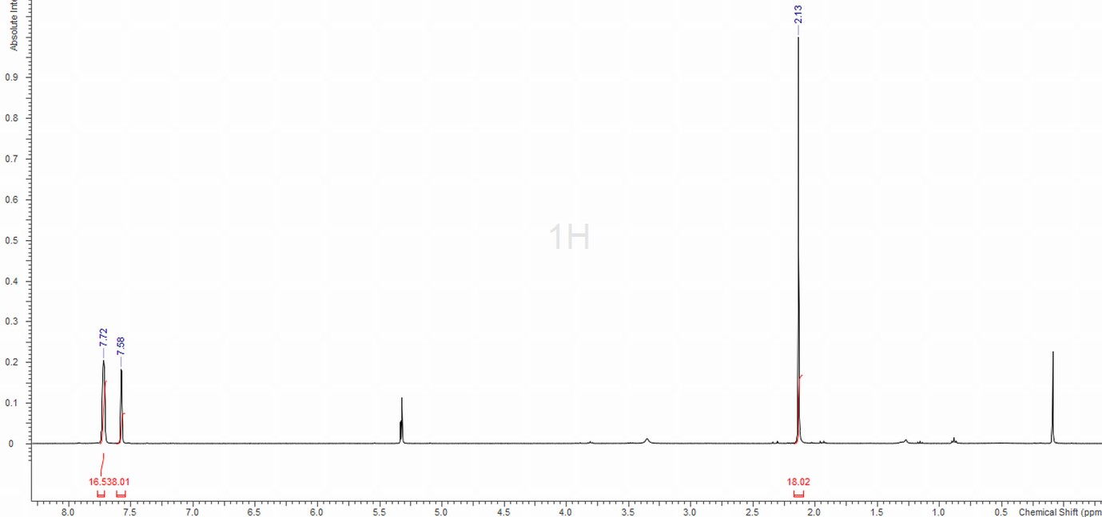

13C{1H} NMR spectrum (CD2Cl2, 298 K):

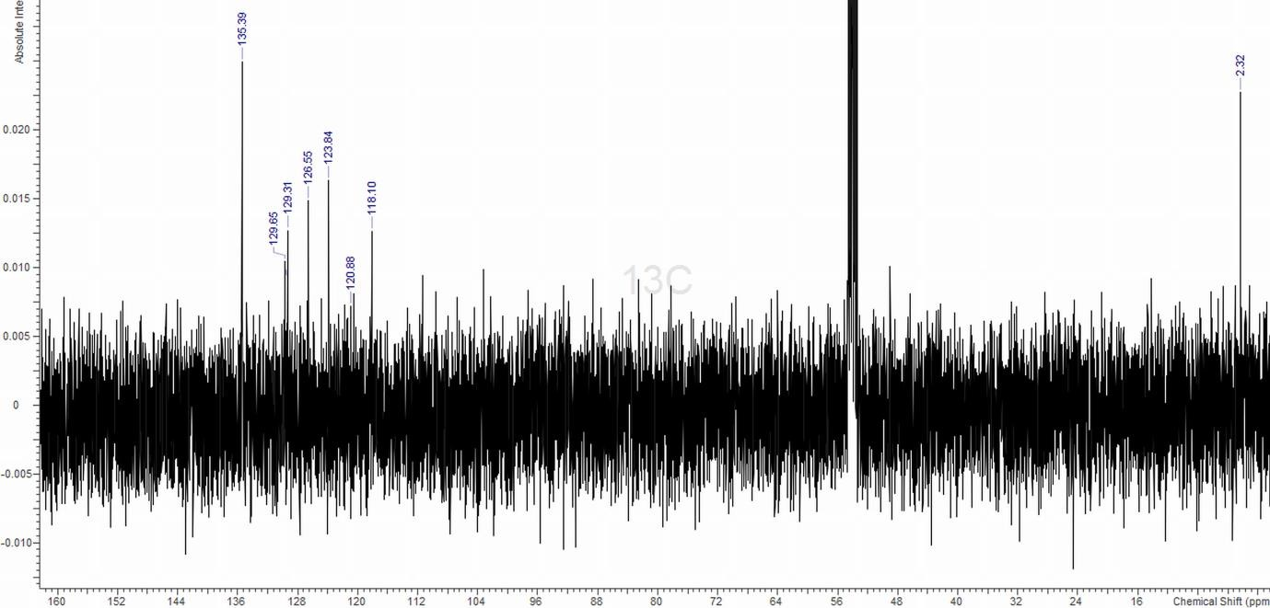

IR spectrum (Nujol):

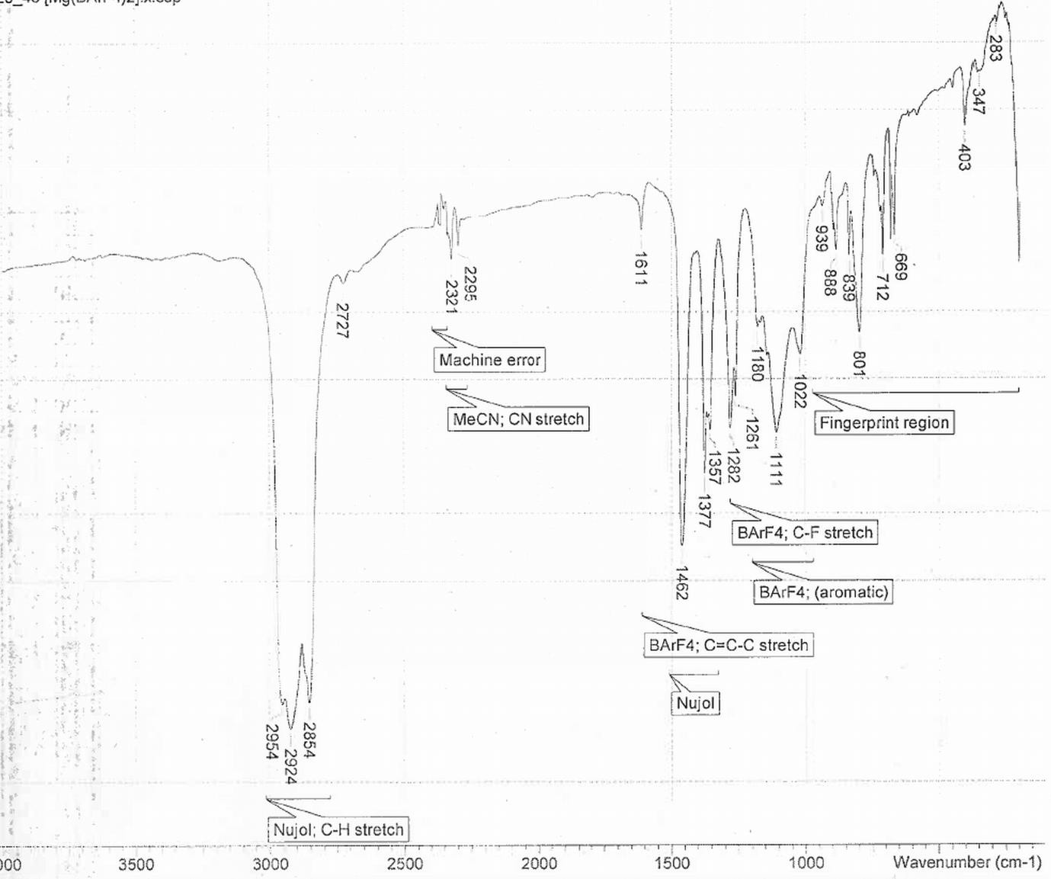

[Ca(MeCN)8][BArF]2:
1H NMR spectrum (CD2Cl2, 298 K):

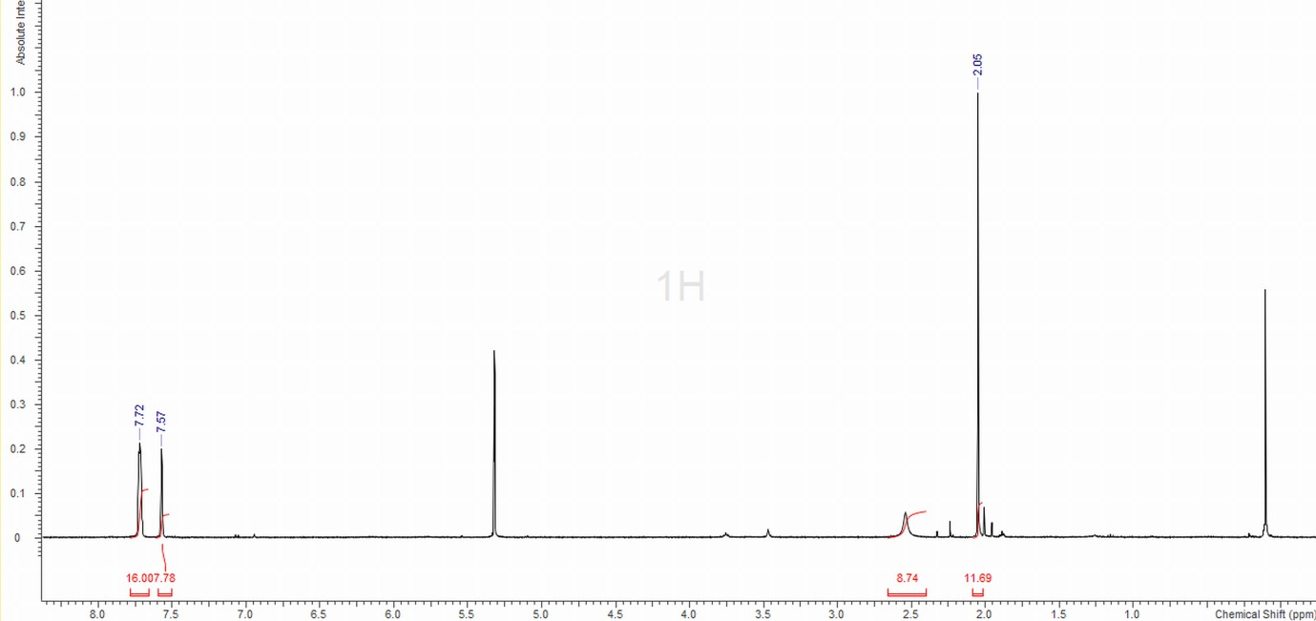

13C{1H} NMR spectrum (CD2Cl2, 298 K):

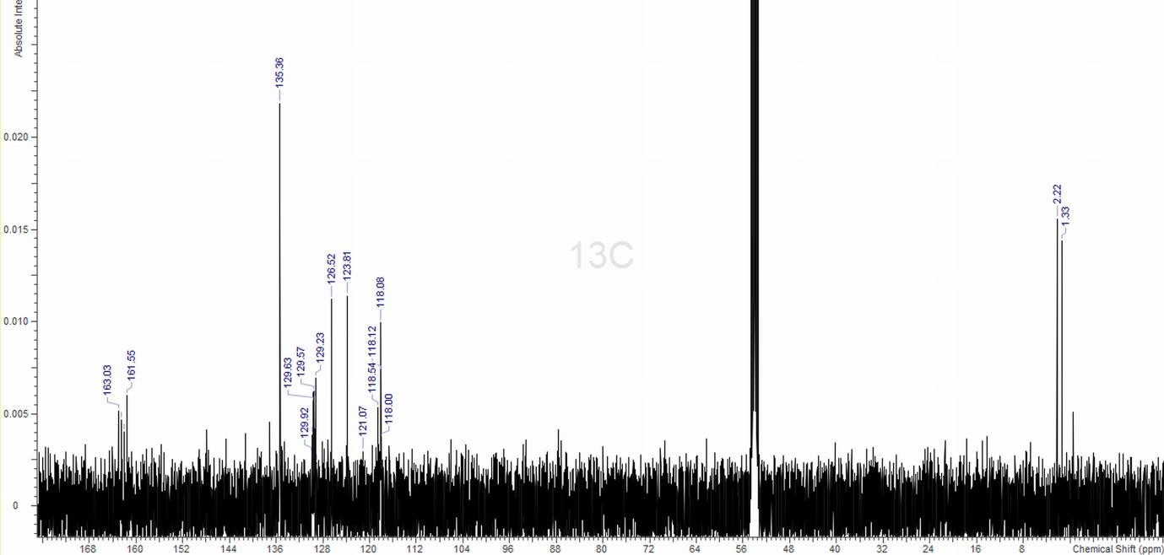

[Sr(acacH)(MeCN)5][BArF]2:
1H NMR spectrum (CD2Cl2, 298 K):
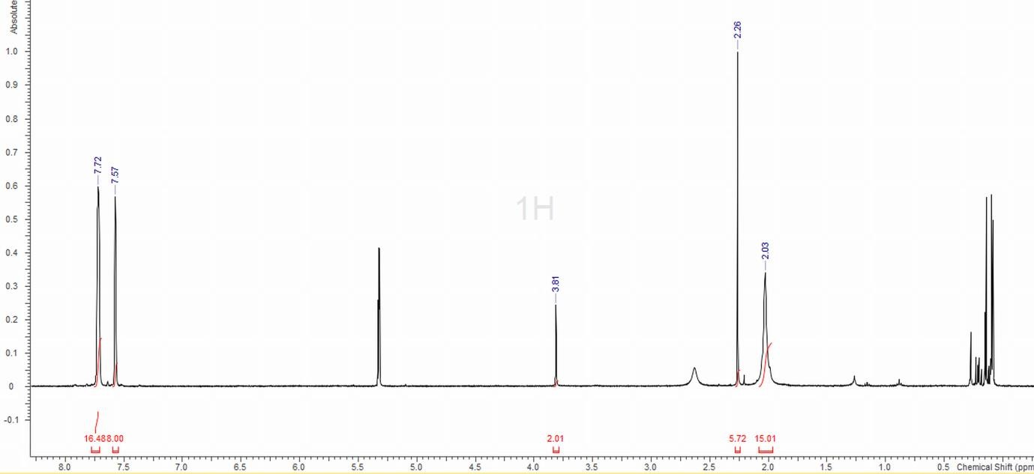

13C{1H} NMR spectrum (CD2Cl2, 298 K):
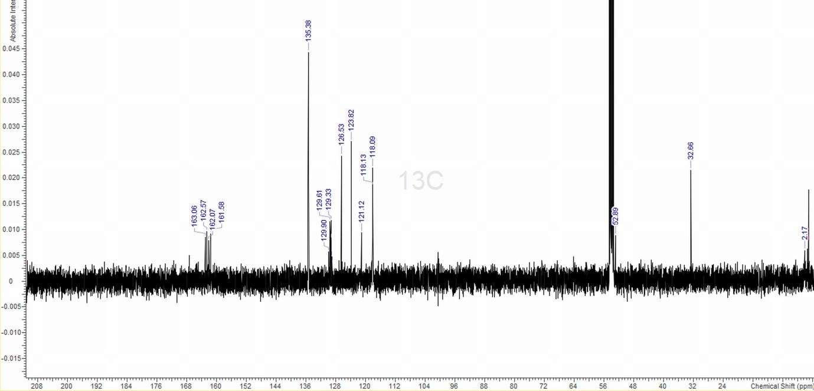

DEPT-135 NMR spectrum (CD2Cl2, 298 K):
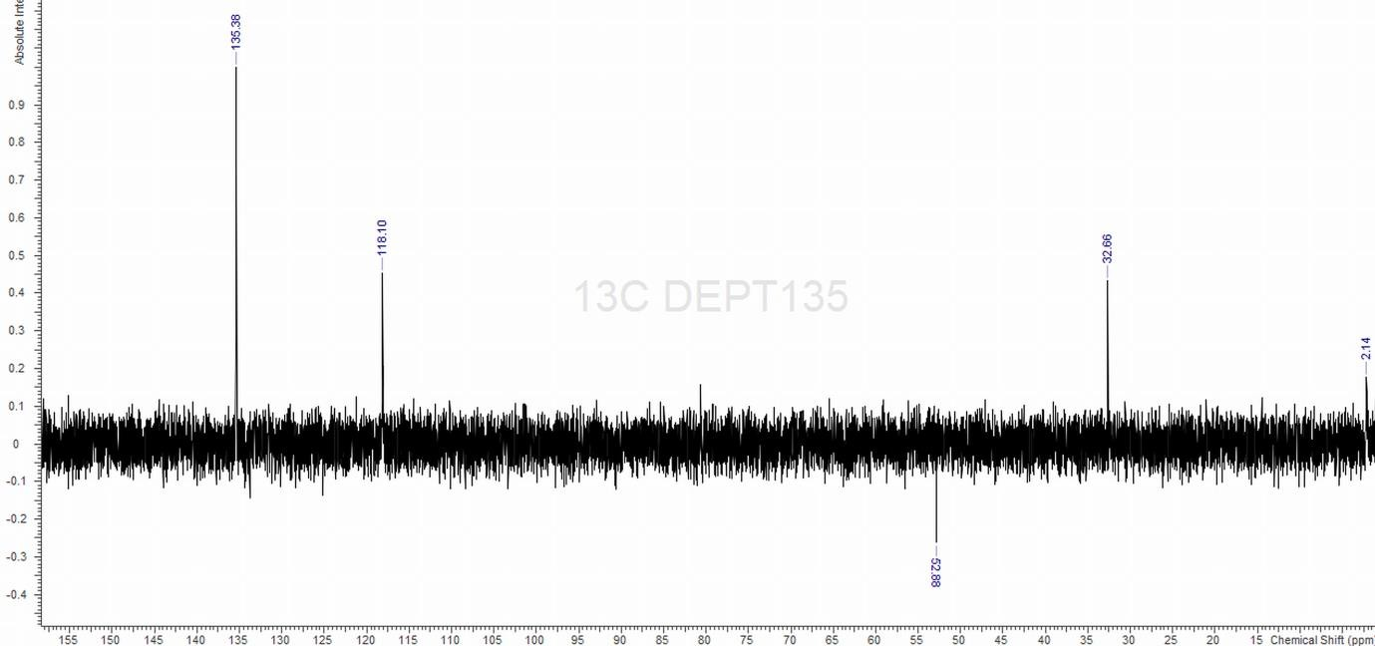

IR spectrum (Nujol):
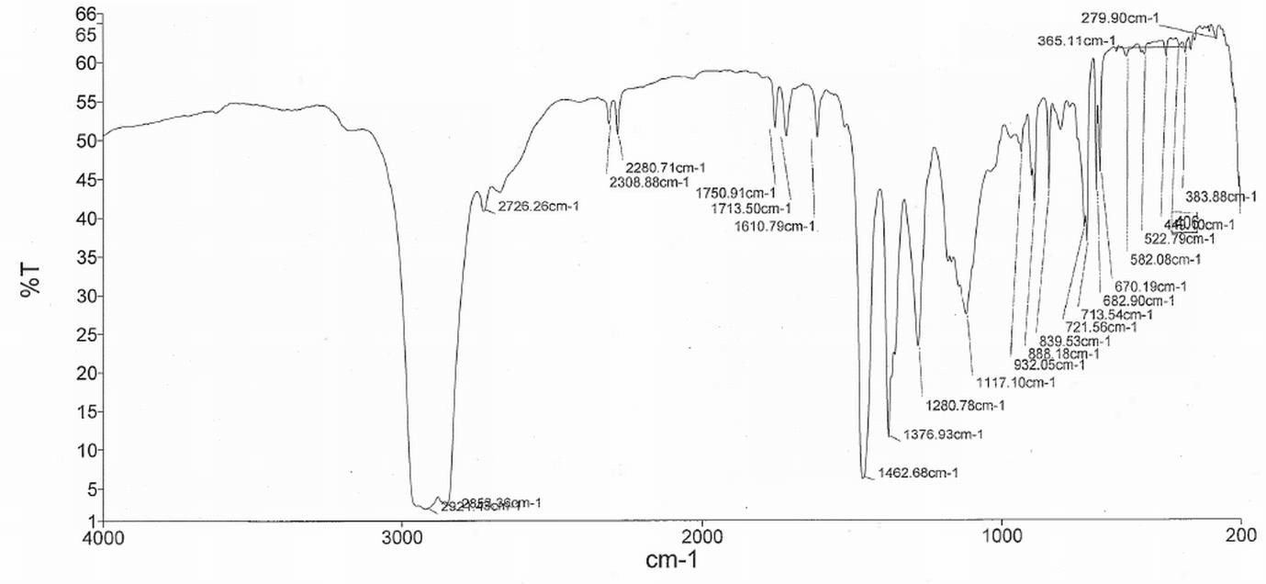

[Ba(acacH)(MeCN)5][BArF]2:
1H NMR spectrum (CD2Cl2, 298 K):
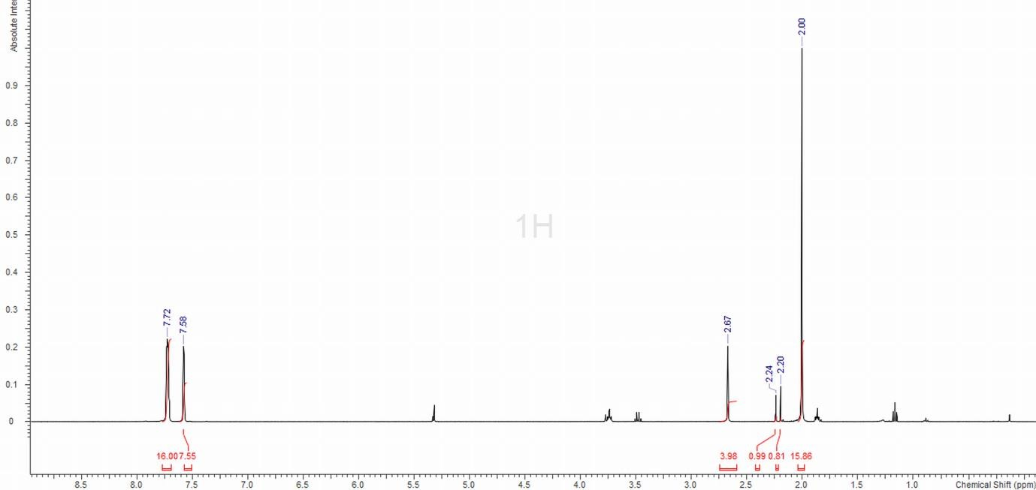

13C{1H} NMR spectrum (CD2Cl2, 298 K):
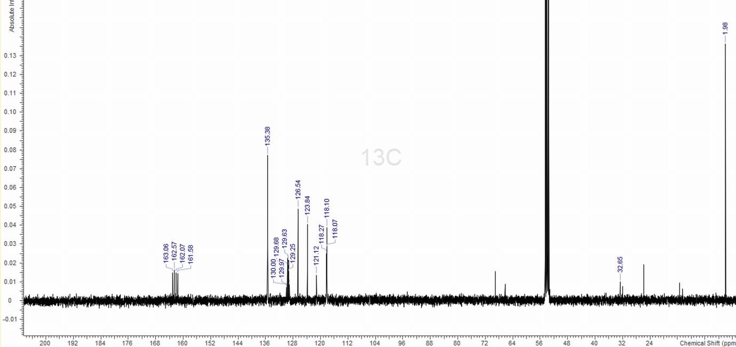

DEPT-135 NMR spectrum (CD2Cl2, 298 K):
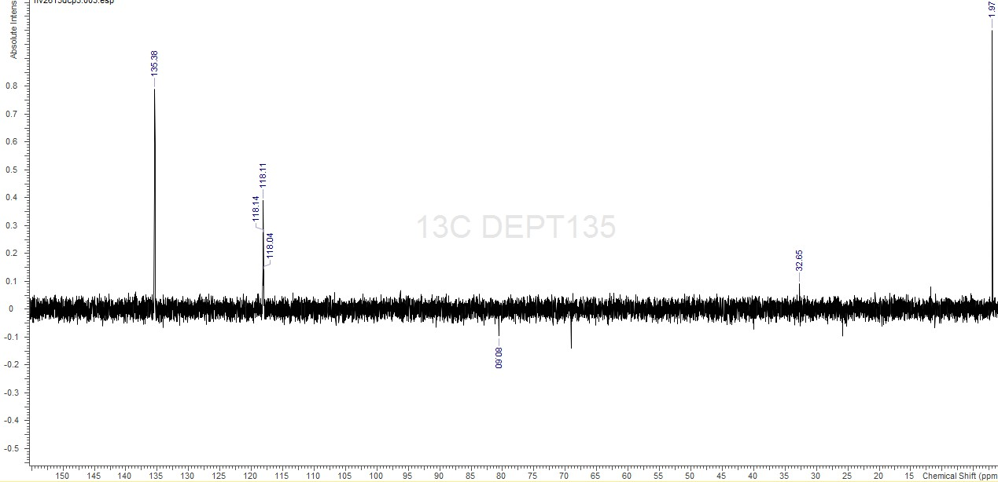

IR spectrum (Nujol):

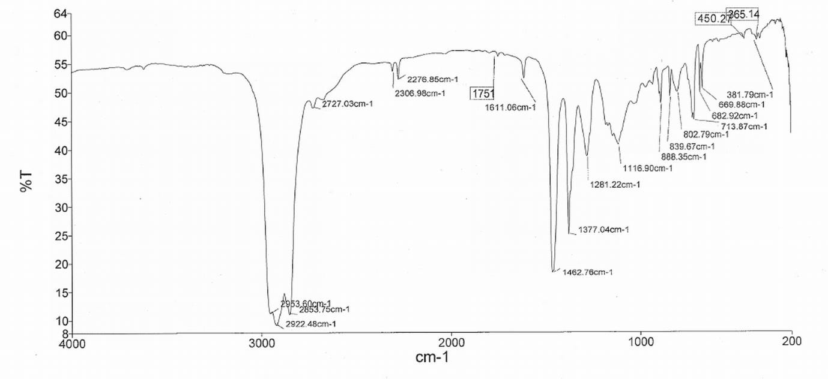

[Mg(18-crown-6)(MeCN)2][BArF]2:
1H NMR spectrum (CD2Cl2, 298 K):
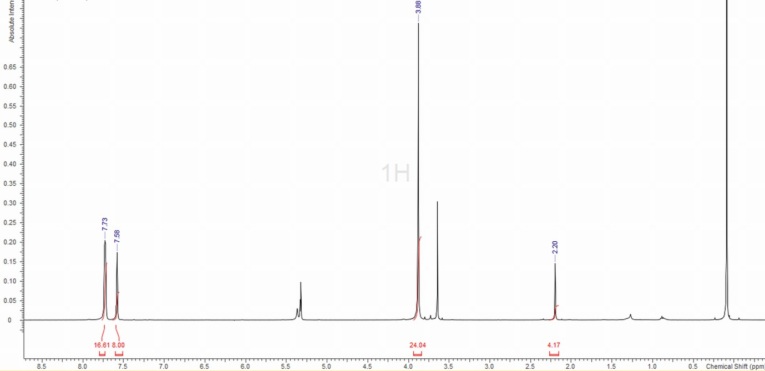

13C{1H} NMR spectrum (CD2Cl2, 298 K):

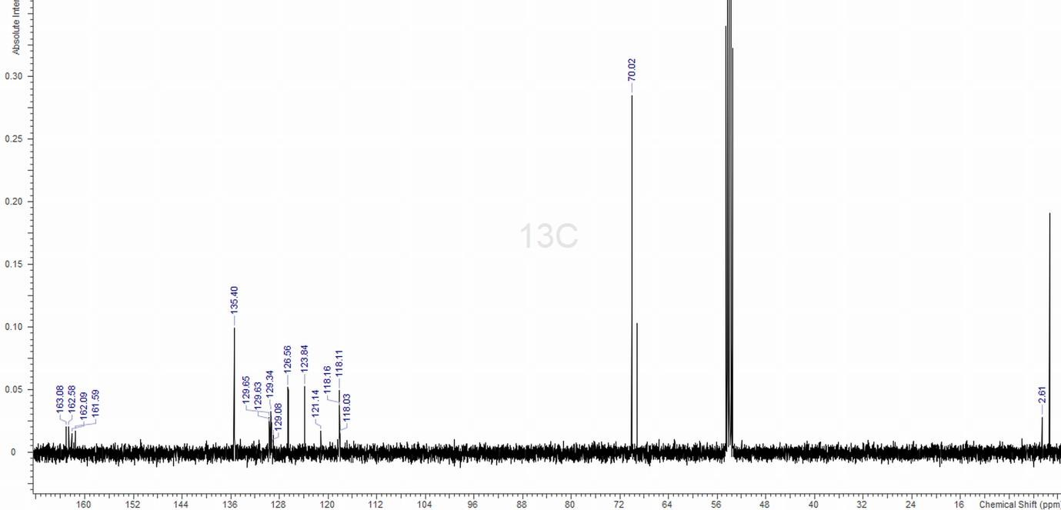

IR spectrum (Nujol):

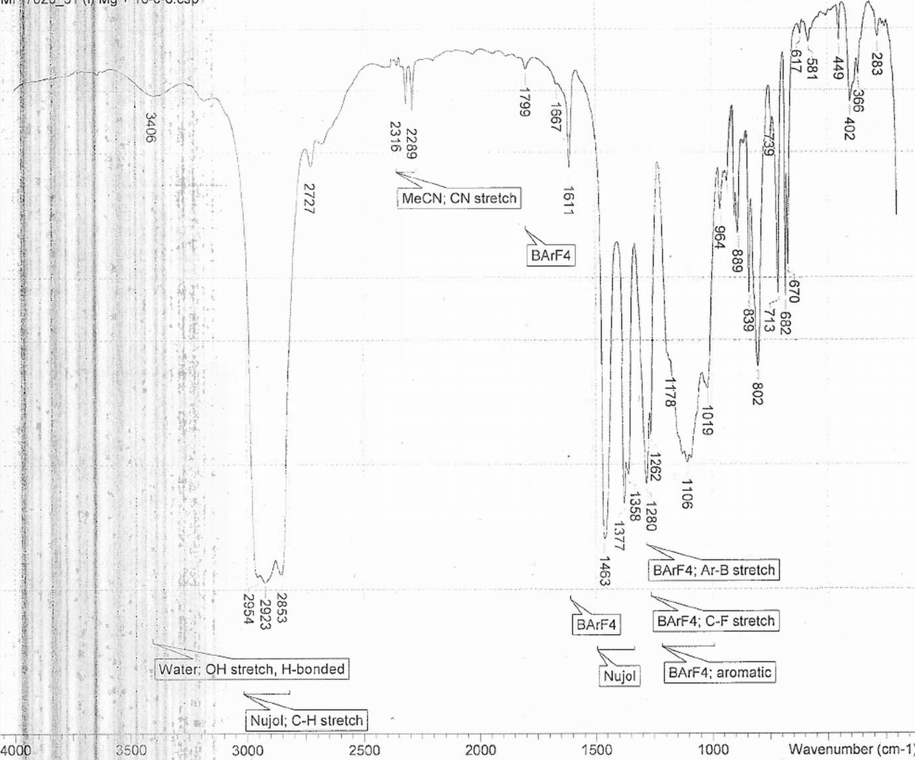

[Mg([18]aneO4S2)(MeCN)2][BArF]2:
1H NMR spectrum (CD2Cl2, 298 K):
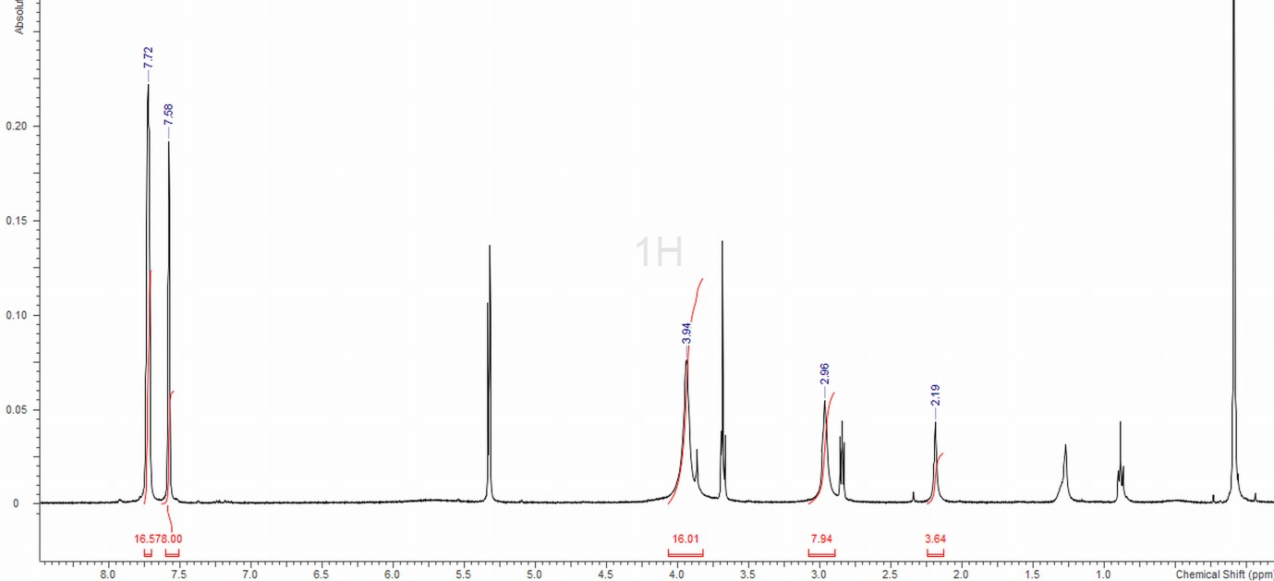

13C{1H} NMR spectrum (CD2Cl2, 298 K):
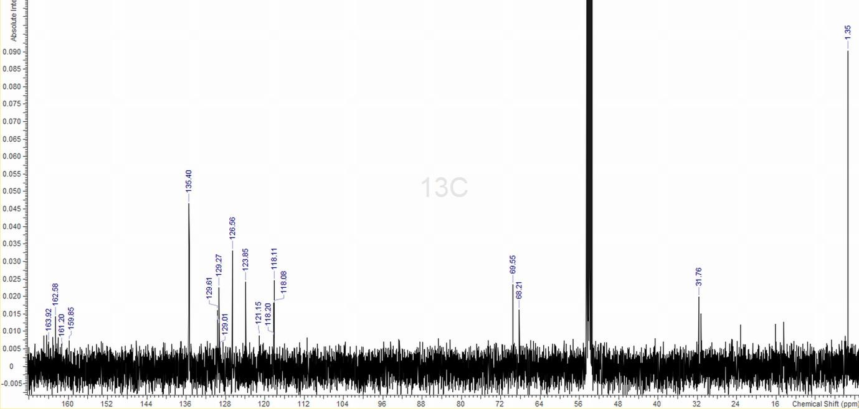

[Mg([18]aneO2S4)(MeCN)2][BArF]2:
1H NMR spectrum (CD2Cl2, 298 K):
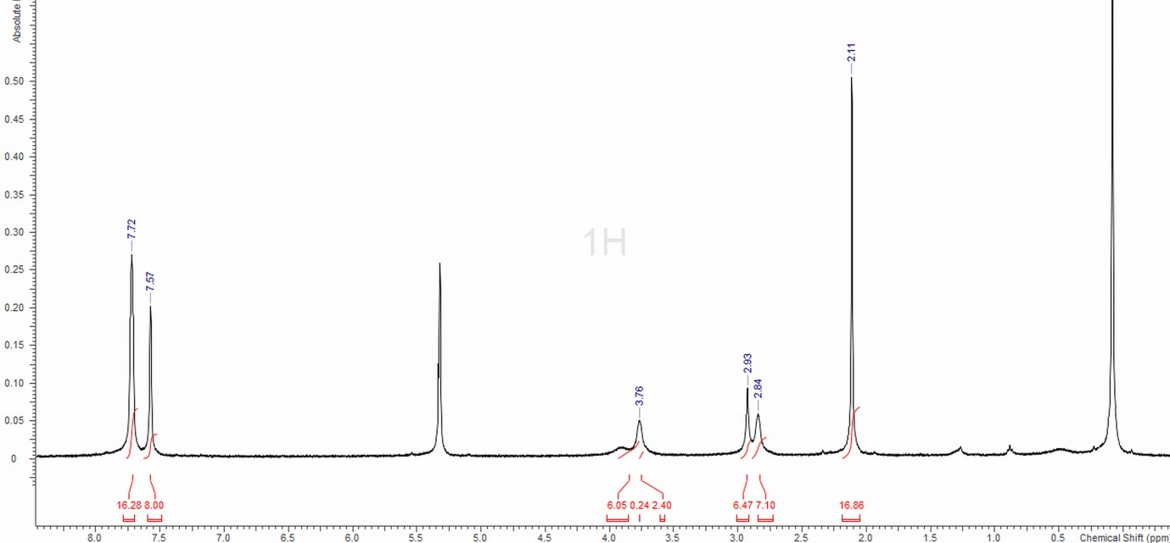

13C{1H} NMR spectrum (CD2Cl2, 298 K):
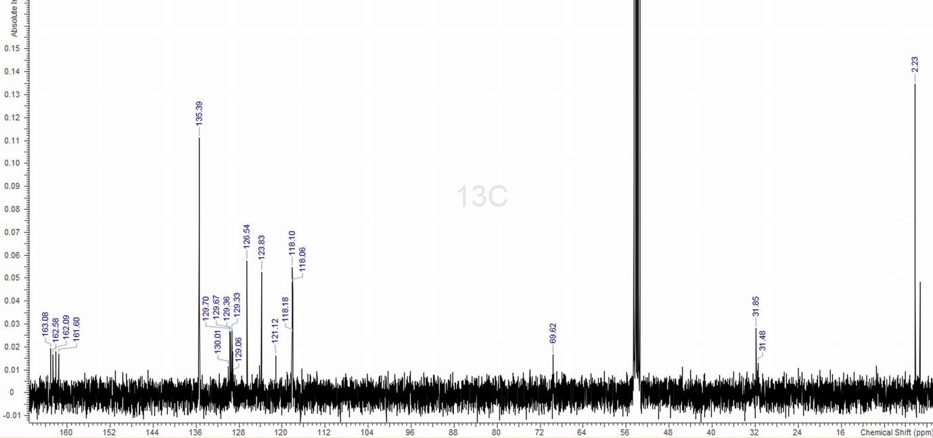

IR spectrum (Nujol):

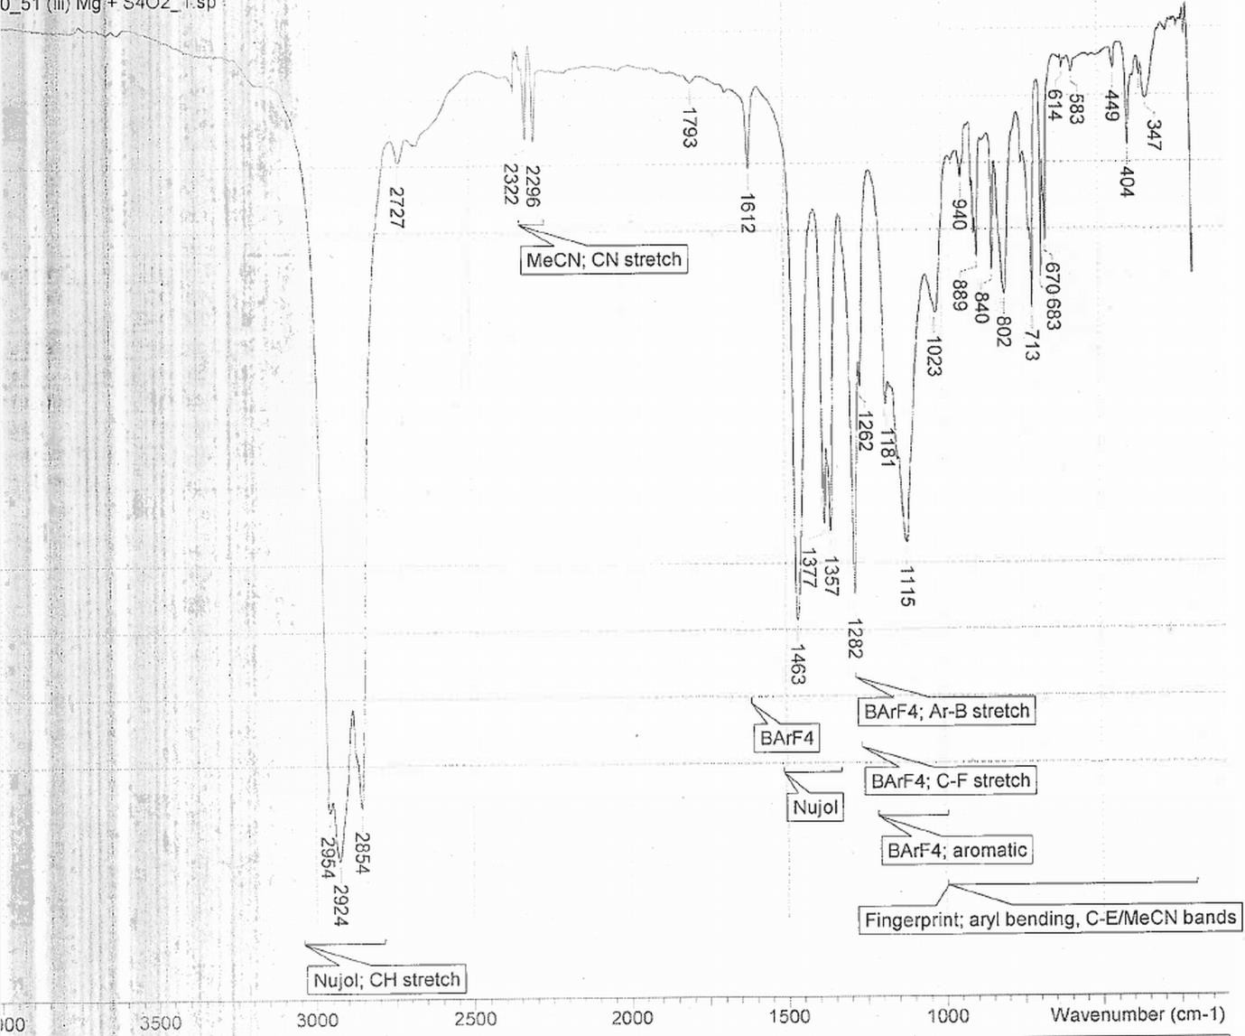

[Mg([18]aneO4Se2)(MeCN)2][BArF]2:
1H NMR spectrum (CD2Cl2, 298 K):
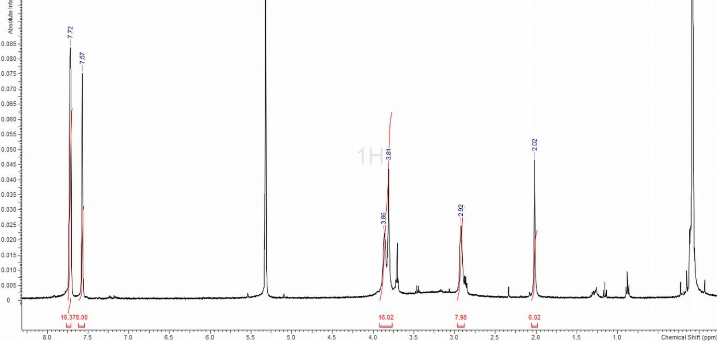

13C{1H} NMR spectrum (CD2Cl2, 298 K):

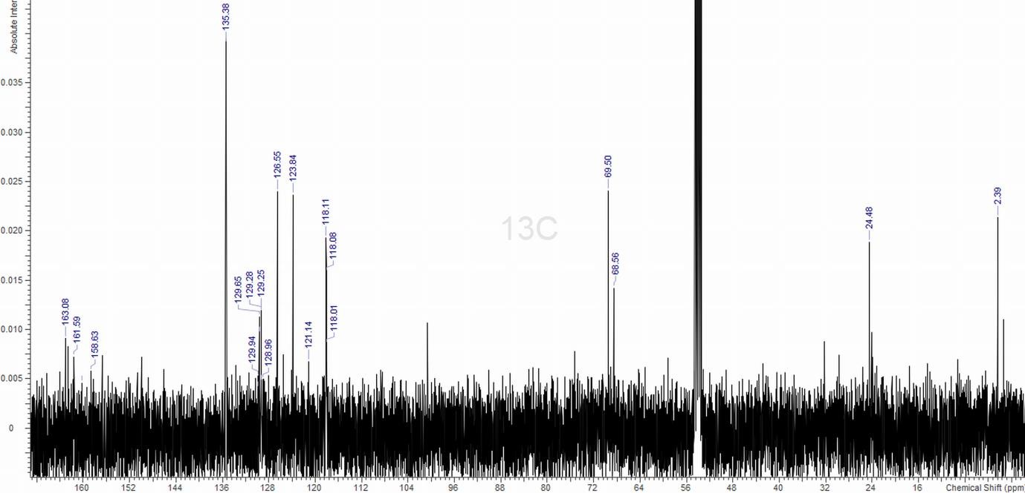

[Ca(18-crown-6)(MeCN)2][BArF]2:
1H NMR spectrum (CD2Cl2, 298 K):
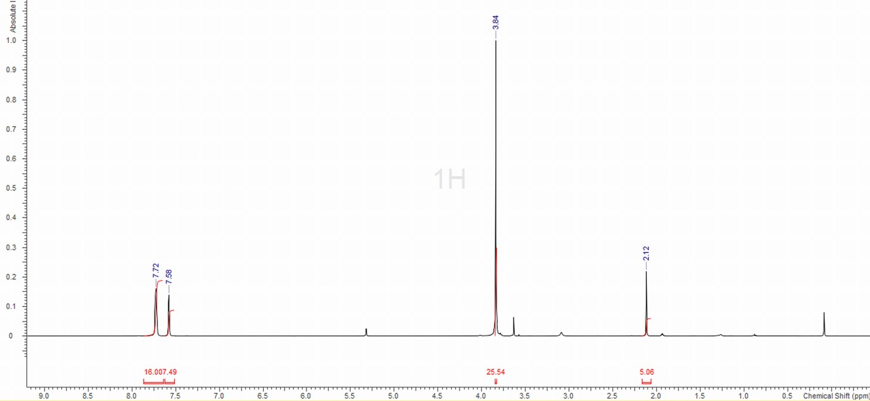

13C{1H} NMR spectrum (CD2Cl2, 298 K):
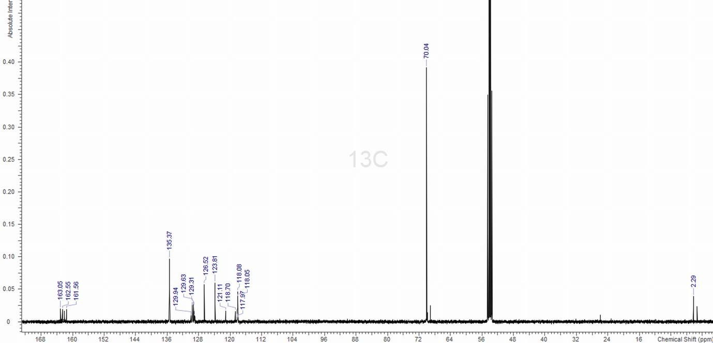

[Ca([18]aneO4S2)(MeCN)2][BArF]2:

1H NMR spectrum (CD2Cl2, 298 K):

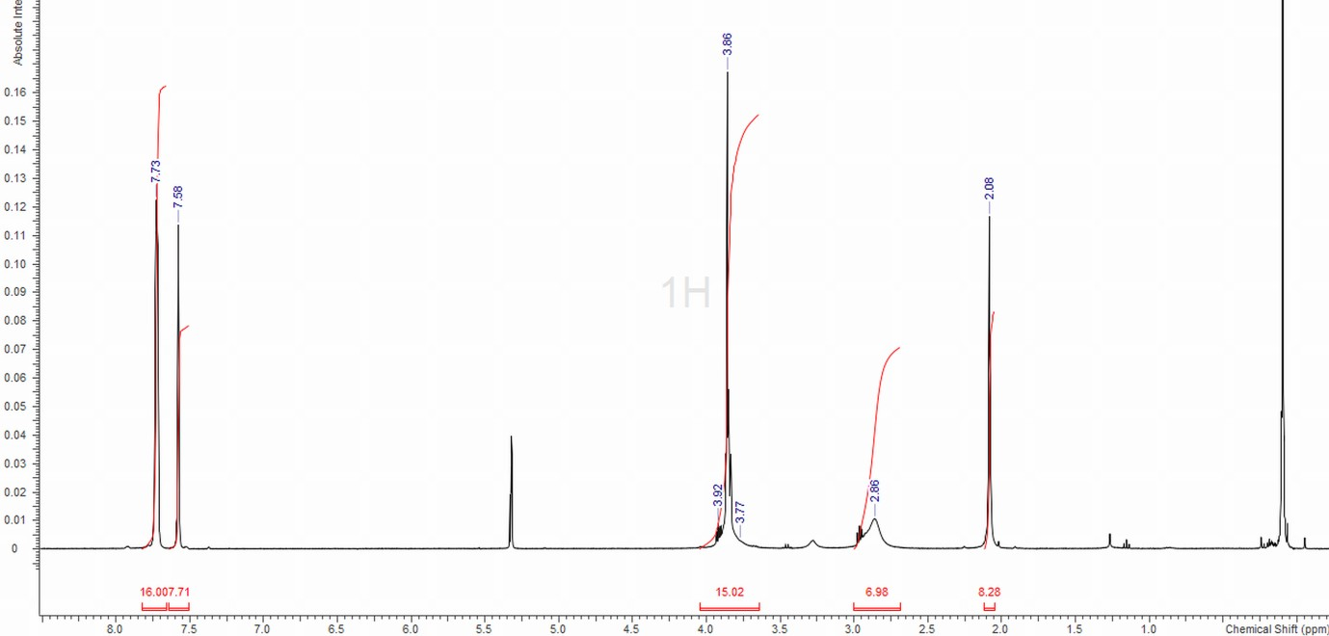

13C{1H} NMR spectrum (CD2Cl2, 298 K):

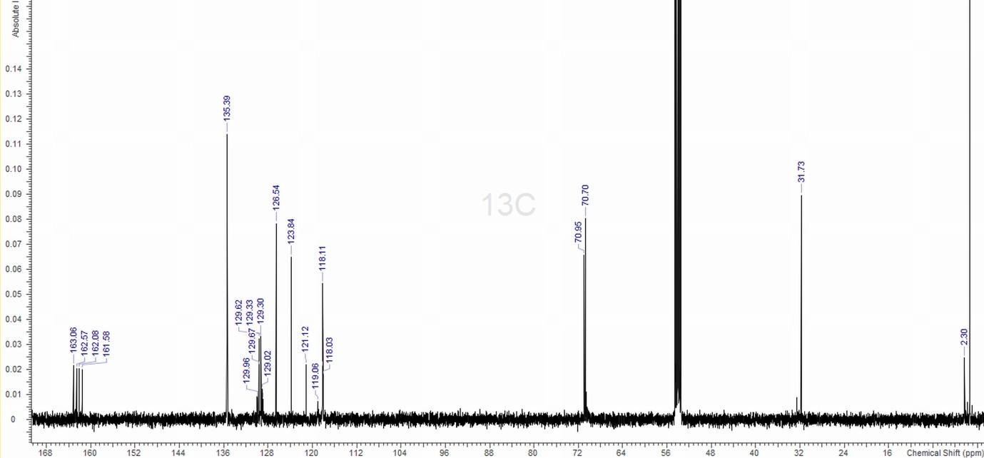

[Ca([18]aneO2S4)(MeCN)2][BArF]2:
1H NMR spectrum (CD2Cl2, 298 K):

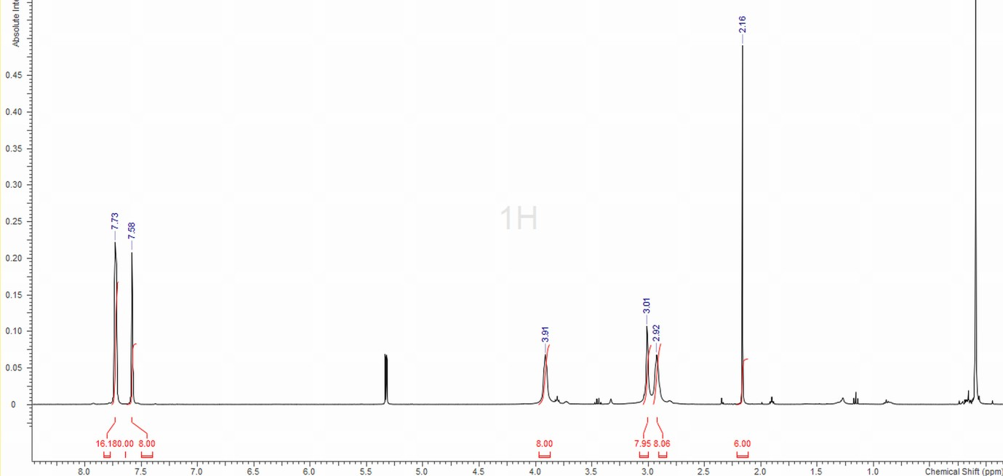

13C{1H} NMR spectrum (CD2Cl2, 298 K):
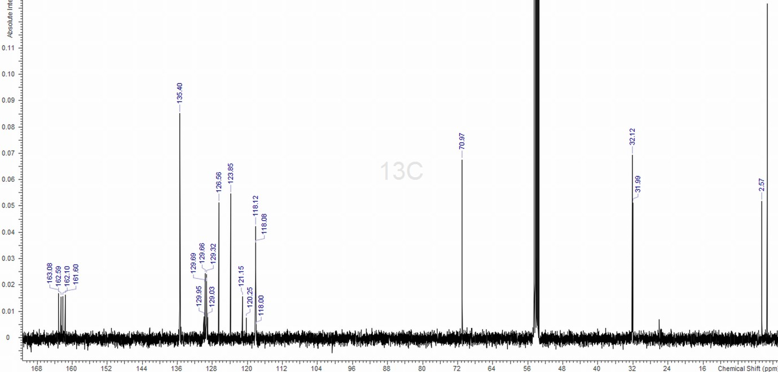

[Ca([18]aneO4Se2)(MeCN)2][BArF]2:
1H NMR spectrum (CD2Cl2, 298 K):
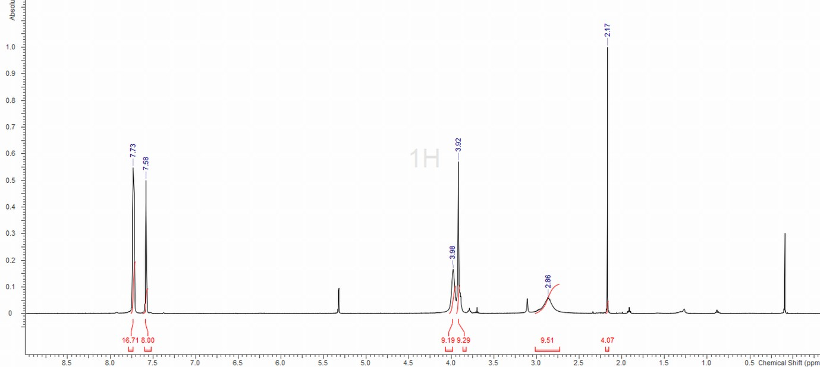

13C{1H} NMR spectrum (CD2Cl2, 298 K):
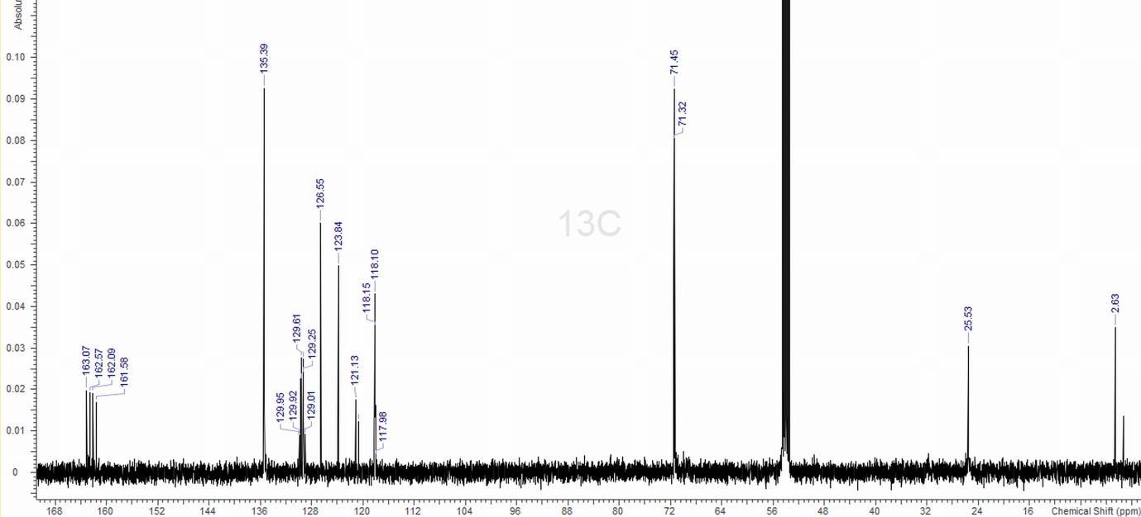

[Ca([18]aneO4S2)(2,2’-bipyridyl)][BArF]2:

1H NMR spectrum (CD2Cl2, 298 K):
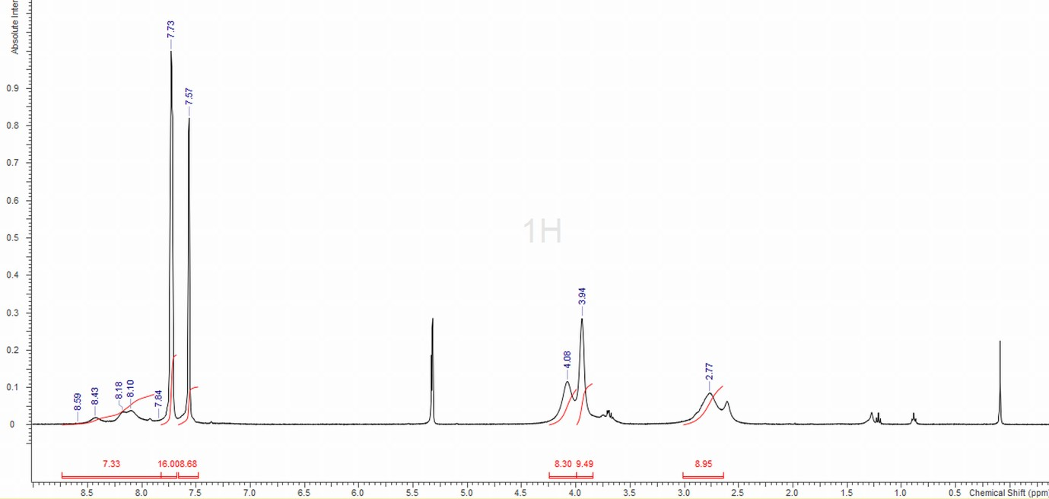

13C{1H} NMR spectrum (CD2Cl2, 298 K):

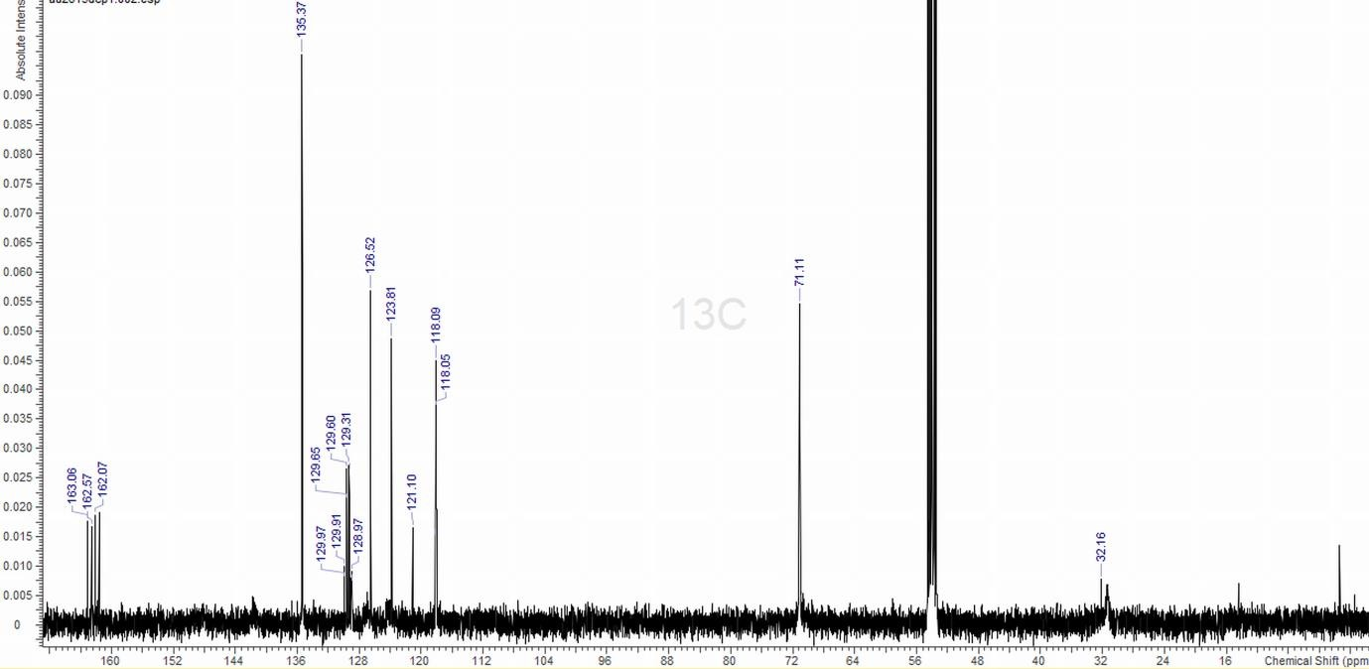

[Sr(18-crown-6)(MeCN)2][BArF]2:

1H NMR spectrum (CD2Cl2, 298 K):
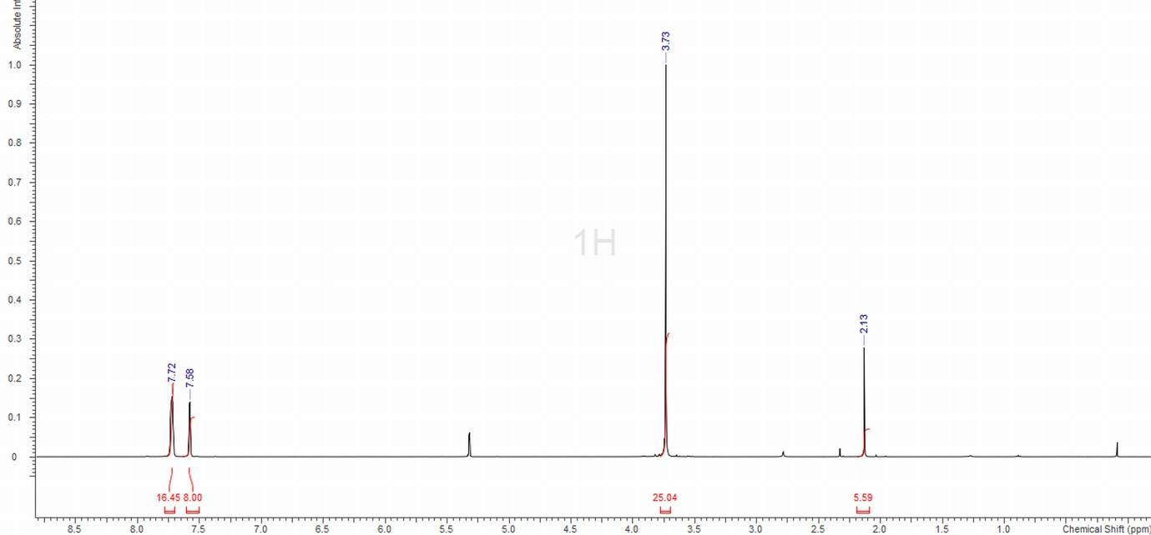

13C{1H} NMR spectrum (CD2Cl2, 298 K):
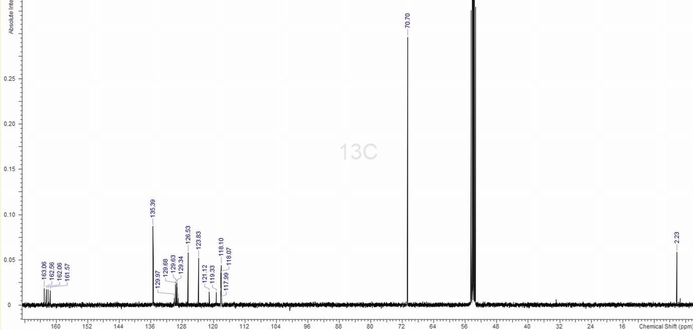

IR spectrum (Nujol):

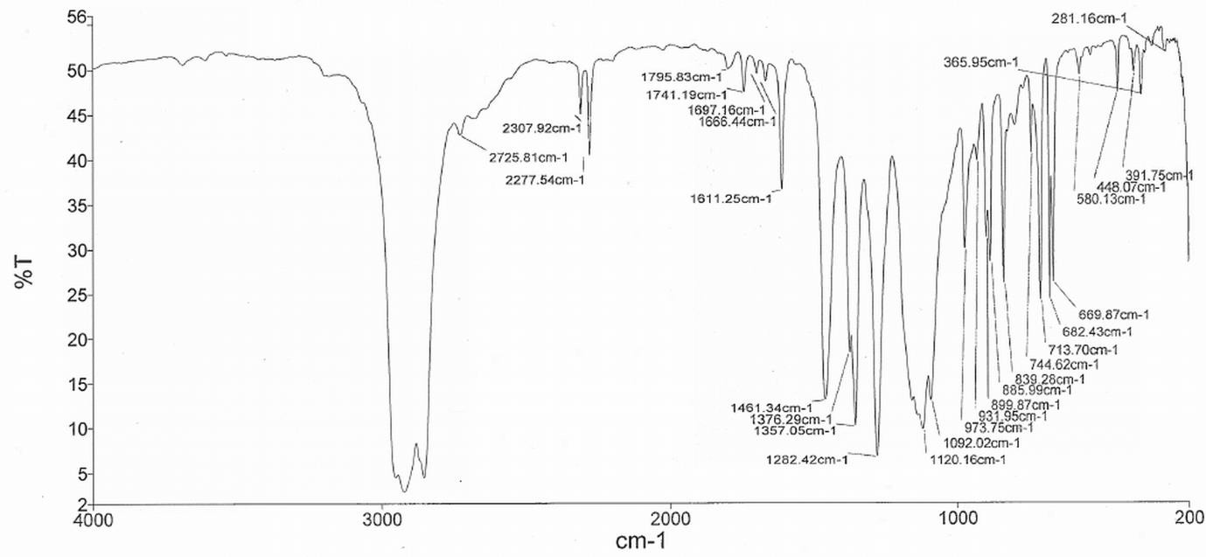

[Sr([18]aneO4S2)(MeCN)2][BArF]2:
1H NMR spectrum (CD2Cl2, 298 K):
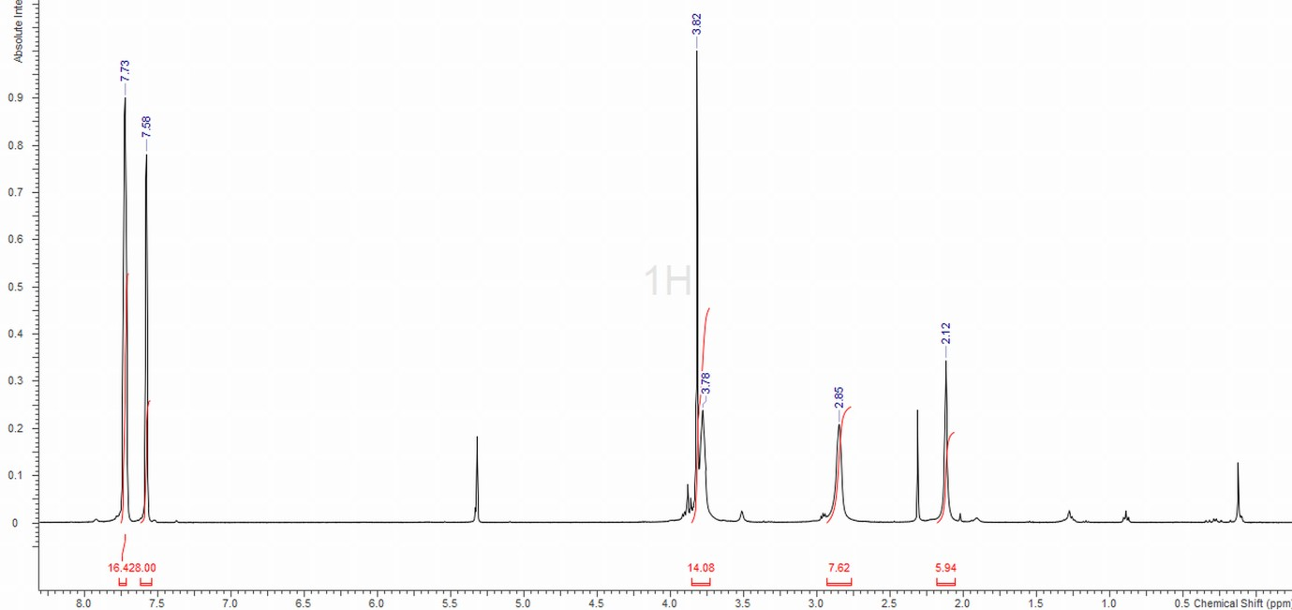

13C{1H} NMR spectrum (CD2Cl2, 298 K):
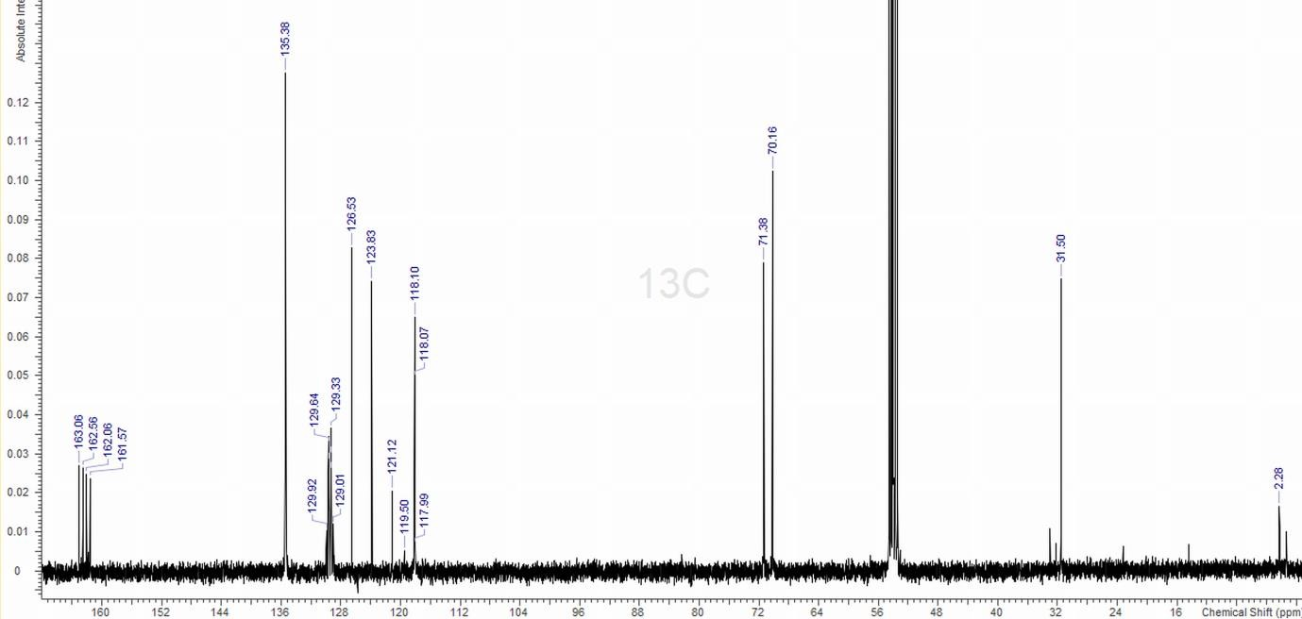

IR spectrum (Nujol):
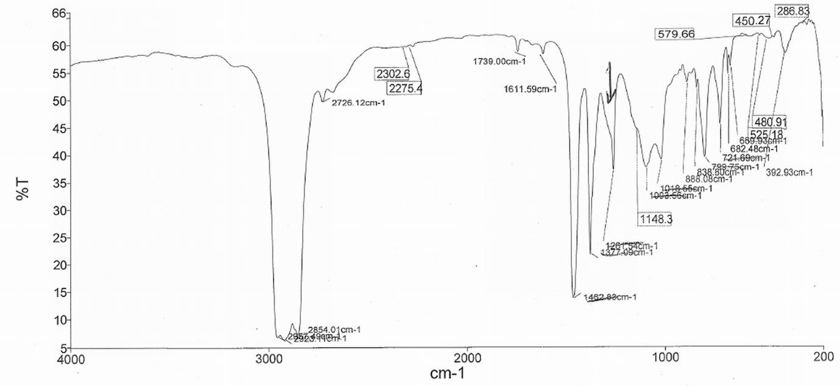

[Sr([18]aneO2S4)(MeCN)2][BArF]2:
1H NMR spectrum (CD2Cl2, 298 K):
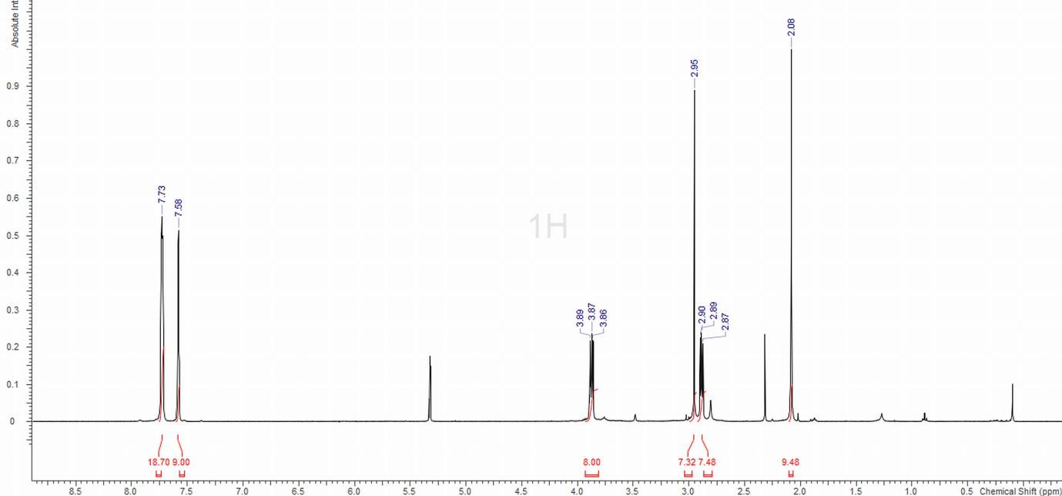

13C{1H} NMR spectrum (CD2Cl2, 298 K):
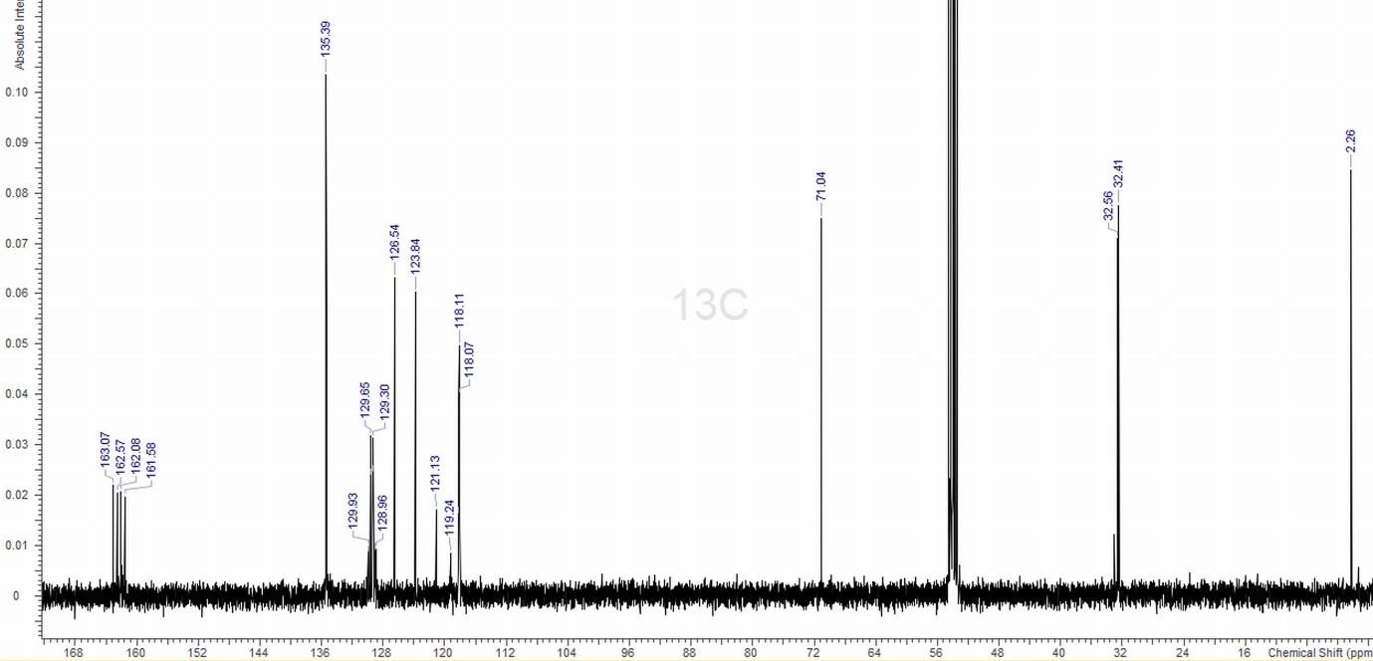

IR spectrum (Nujol):
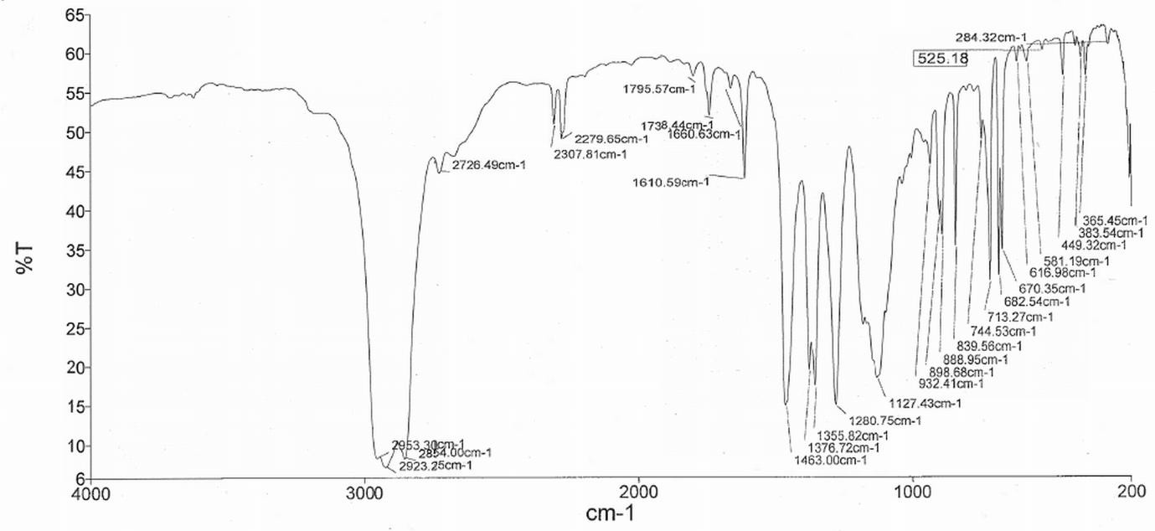

[Sr([18]aneO4Se2)(MeCN)2][BArF]2:
1H NMR spectrum (CD2Cl2, 298 K):
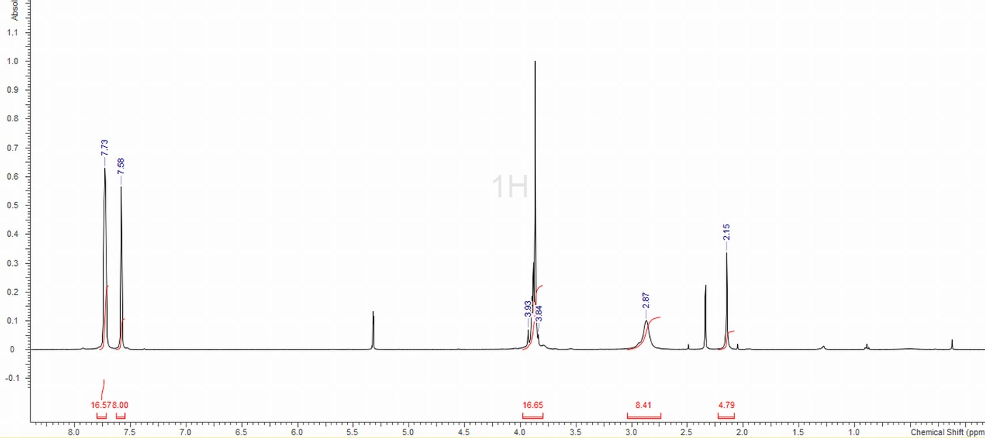

13C{1H} NMR spectrum (CD2Cl2, 298 K):
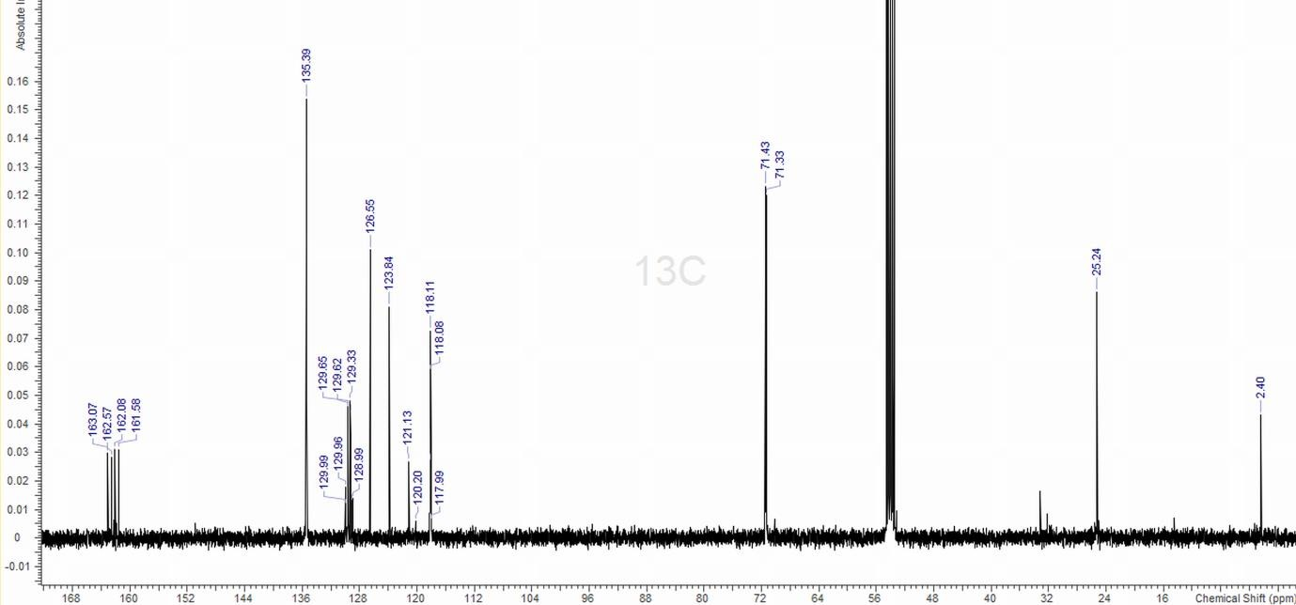

IR spectrum (Nujol):
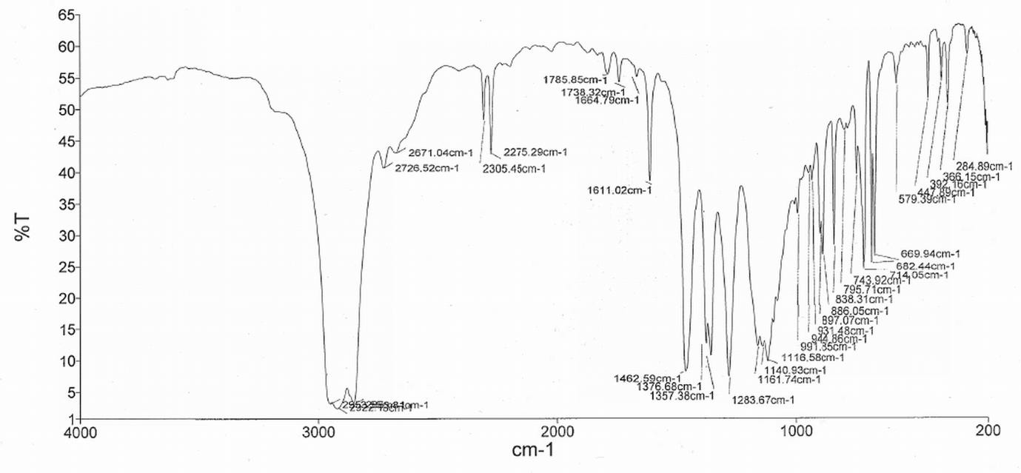

[Ba([18]aneO2S4)(acacH)(MeCN)][BArF]2:
1H NMR spectrum (CD2Cl2, 298 K):
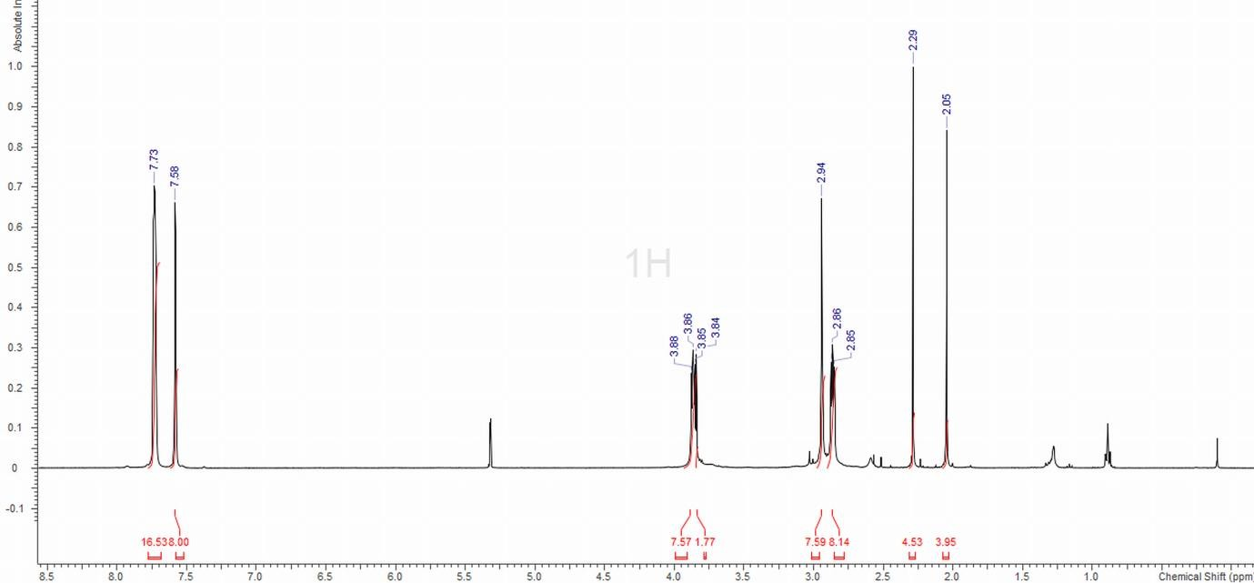

13C{1H} NMR spectrum (CD2Cl2, 298 K):

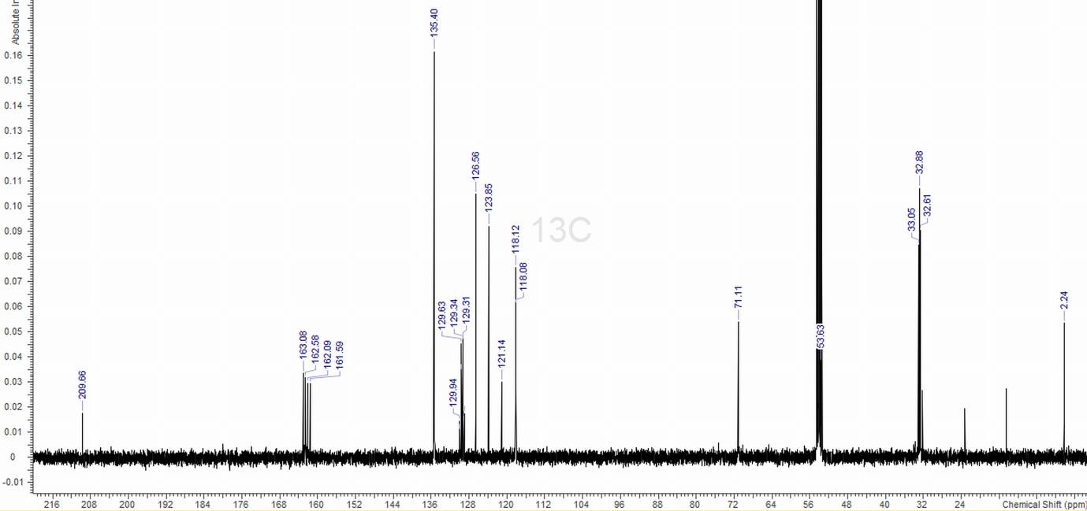

DEPT-135 NMR spectrum (CD2Cl2, 298 K):

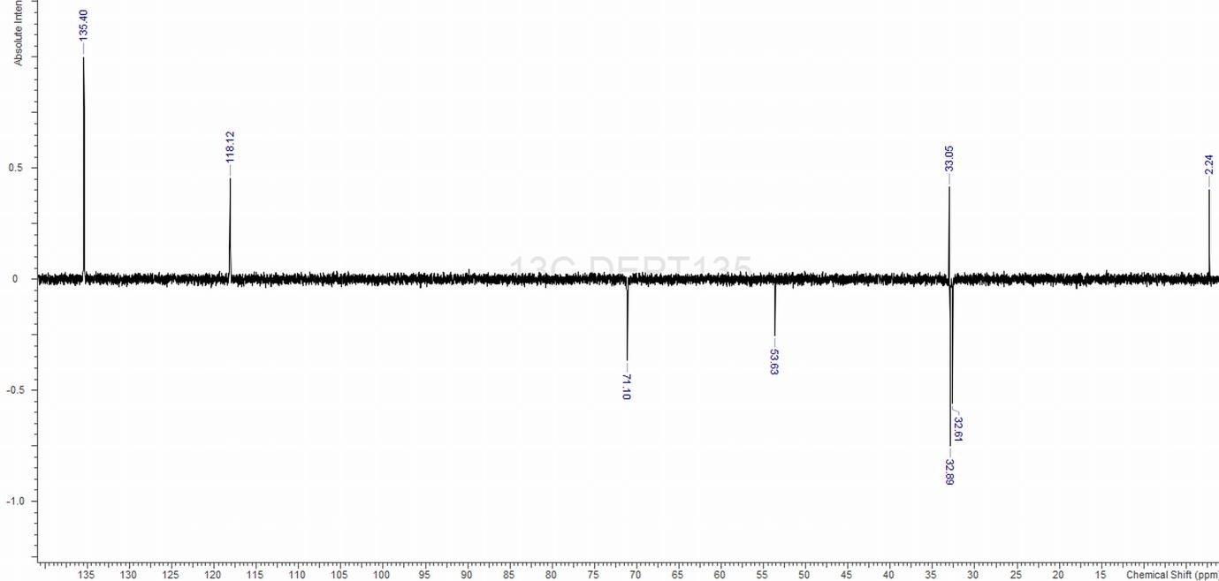

IR spectrum (Nujol):

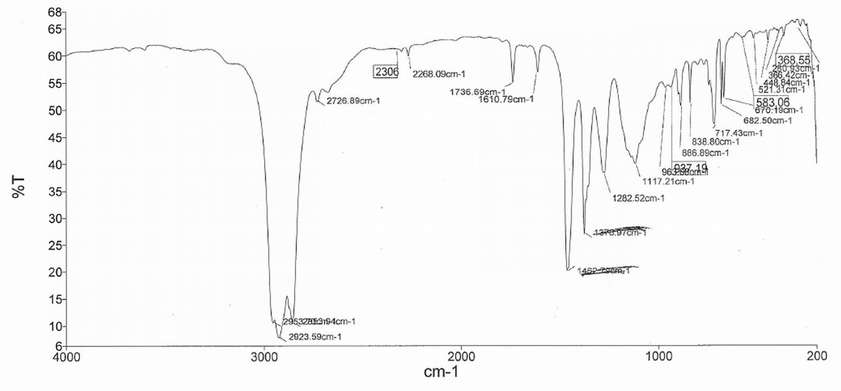

[Ba([18]aneO4Se2)(acacH)(MeCN)][BArF]2:
1H NMR spectrum (CD2Cl2, 298 K):
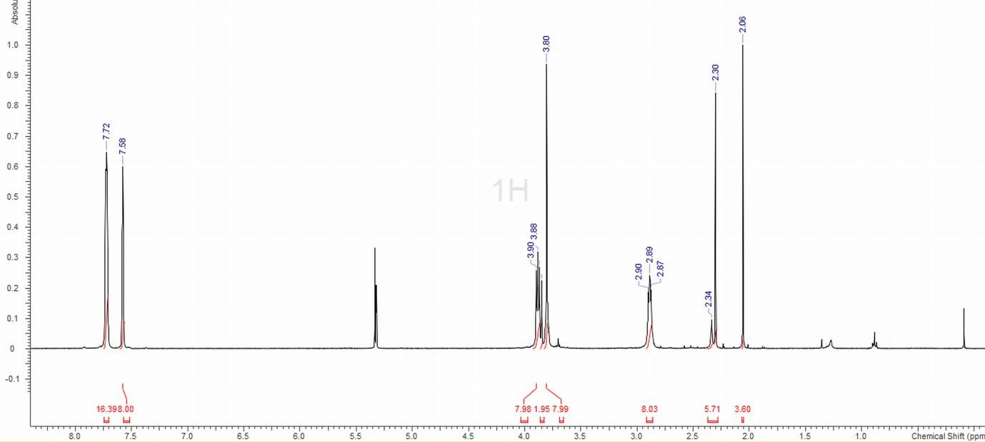

13C{1H} NMR spectrum (CD2Cl2, 298 K):
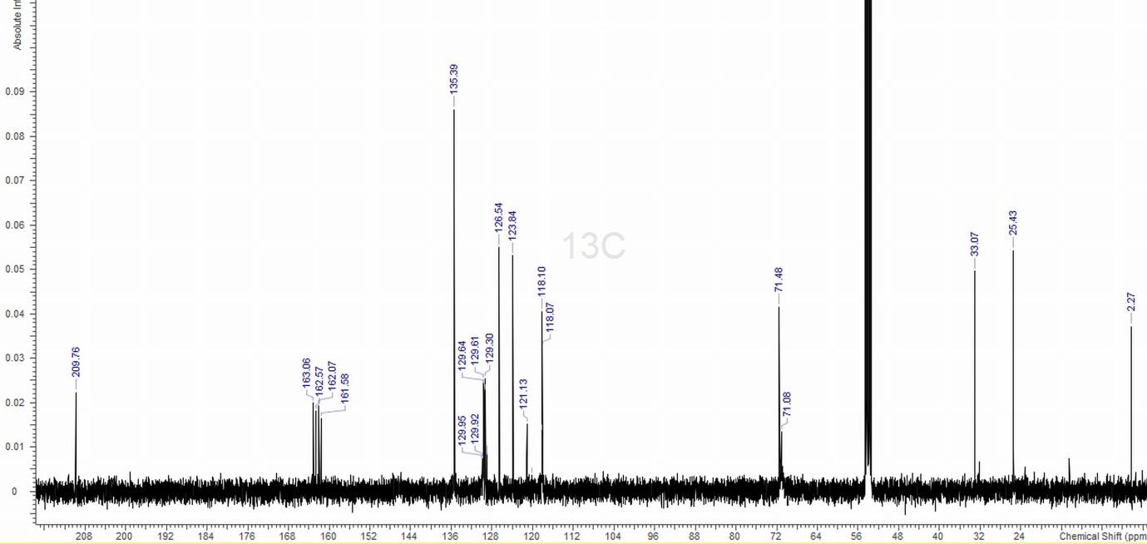

DEPT-135 NMR spectrum (CD2Cl2, 298 K):
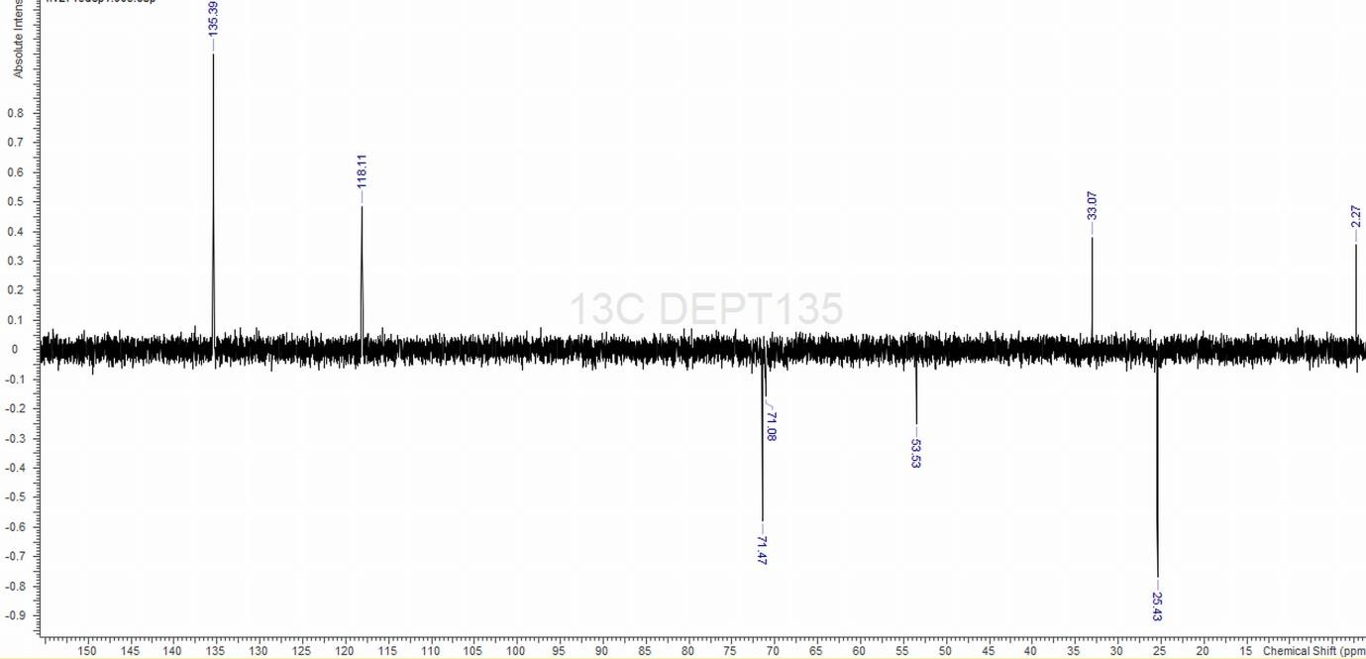

IR spectrum (Nujol):

