**Thomaes, S., Sedikides, C., Reijntjes, A., Brummelman, E., & Bushman, B. J. (in press). Emotional contrast or compensation? How support reminders influence the pain of acute peer disapproval in preadolescents. *Developmental Psychology*.**

Emotional Contrast or Compensation?

How Support Reminders Influence the Pain of Acute Peer Disapproval in Preadolescents

Sander Thomaes

University of Southampton, Utrecht University

Constantine Sedikides

University of Southampton

Albert Reijntjes and Eddie Brummelman

Utrecht University

Brad Bushman

The Ohio State University

Abstract

When children experience habitual peer difficulties, adults often remind them that many people care about them. How do such reminders of support impact children’s emotional responses to acute experiences of peer disapproval? Intuitively, support reminders would exert compensatory effects attenuating the emotional impact of acute disapproval. Theory suggests, however, that support reminders might also lead to contrast effects magnifying the emotional impact of acute disapproval, especially among socially vulnerable children. These opposing perspectives were pitted against each other. In two experiments, children (aged 9-13, *M*age = 11.5) were randomly assigned to reflect on their relationships with either supportive others (support condition) or mere acquaintances (control condition). Children experienced acute peer disapproval immediately after (Experiment 1) or before (Experiment 2) the manipulated support reminder. Among children who experienced higher levels of peer difficulties in their daily life, the support reminder increased externalized emotional reactivity and decreased internalized emotional recovery following disapproval. Thus, consistent with emotional contrast theory, support reminders magnified the disapproval-based emotional responses of socially vulnerable children.

*Keywords*: peer disapproval, negative emotion, peer difficulties, social support

Emotional Contrast or Compensation?

How Support Reminders Influence the Pain of Acute Peer Disapproval in Preadolescents

Children’s social lives can be emotionally challenging. Adults often seek to provide children with reassurance by reminding them of their supportive interpersonal bonds (e.g., “Remember that many people care deeply about you”) (Sawyer, Mishna, Pepler, & Wiener, 2011). Similarly, clinicians often encourage children who suffer peer difficulties to count their social blessings and to reflect on their supportive relationships or positive social interactions (Kendall, Kortlander, Chansky, & Brady, 1992). Conventional wisdom, then, suggests that support reminders help children cope with peer adversity.

Yet, empirical research on how support reminders impact children’s negative emotional experiences following acute peer adversity, and their recovery from them, is lacking. A large body of work shows that feeling supported and cared for is key to children’s well-being (Barber, Stolz, & Olson, 2005; Rohner, 2004; Sandler, Miller, Short, & Wolchik, 1989)—that is not in question. The question instead is how *reminders* of support—which seek to temporarily activate representations of supportive others—buffer the emotional impact of acute adversity, especially among children who experience difficult peer relationships. The present research examines how experimentally induced reminders of support affect emotional reactivity (Experiment 1) and emotional recovery (Experiment 2) following acute peer disapproval. In particular, the research examines perceived peer difficulty factors that might moderate how support reminders influence emotional responses: perceived peer victimization and perceived lack of closeness to friends.

**Peer Difficulties: Perceived Victimization and Lack of Closeness to Friends**

Children’s peer difficulties can take multiple forms. They can result from intentional malevolent actions by others, such as when children are exposed to peer harassment, aggression, or rejection. These abusive behaviors are collectively labeled peer victimization (Juvonen & Graham, 2014; Kochenderfer-Ladd & Ladd, 2001). Peer difficulties, however, can also emerge in the absence of blatant hostility, such as when children feel incapable of establishing close and mutually supportive bonds with friends (Armsden & Greenberg, 1987; Gullone & Robinson, 2005; Nickerson & Nagle, 2005). Notwithstanding differences in form, peer victimization and lack of closeness to friends—and in particular children’s subjective experiences thereof—are similar in that they both threaten the fundamental need for belonging and relatedness (Baumeister & Leary, 1995; Deci & Ryan, 2000). As a result, they both put children at risk for internalizing (e.g., social anxiety, loneliness) and externalizing (e.g., hostility, deviant peer affiliation) adjustment problems (Gullone & Robinson, 2005; Hawker & Boulton, 2000; Muris, Meesters, Van Melick, & Zwambag, 2001; Reijntjes, Kamphuis, Prinzie, & Telch, 2010; Rudolph et al., 2014).

Although children can experience peer victimization and lack of closeness to friends at earlier ages, both forms of peer difficulties become increasingly painful and common from middle to late childhood, when children come to attach more gravitas to their relations with peers (Bierman, 2004; Nickerson & Nagle, 2005; Rubin, Bukowski, & Parker, 2006). At the same time, children become savvier in their attempts to hurt others, and are less concerned about the pain they might inflict on others (Crick et al., 2001; Rigby & Slee, 1991). Together, these developments make late childhood a critical time when children are left vulnerable to experiencing peer victimization and lack of closeness to friends.

The suffering from peer difficulties has a powerful influence on how children perceive their social worlds (Dweck & London, 2004; Ladd, Ettekal, Kochenderfer-Ladd, Rudolph, & Andrews, 2014). Children gradually internalize recurrent social experiences to form generalized representations of the quality of their social relationships, which subsequently inform their interpretations of others’ behavior (Crick & Dodge, 1994; Dweck & London, 2004; Main, Kaplan, & Cassidy, 1985). Accordingly, when children experience repeated peer victimization or lack of closeness to friends, they will likely form negative views of their social relationships. These views will constitute the lens through which they will perceive and experience ongoing social interactions (Ladd et al., 2014; London, Downey, Bonica, & Paltin, 2007; Rudolph, Troop-Gordon, & Flynn, 2009).

**Support Reminders and Emotional Responses to Acute Peer Disapproval**

How do support reminders influence children’s emotional responses in the face of acute peer disapproval? We consider two possibilities. The first, arguably most intuitive, possibility emphasizes the *compensatory effects* that support reminders may exert. It is plausible that support reminders will attenuate the emotional impact of acute peer disapproval on socially vulnerable children. Support reminders may compensate for children’s existing views of their social relationships. Even if these views are based on a history of social experiences, support reminders—which are salient and meaningful in the present—may allow children to be mindful that several people do care about them. Acute peer disapproval, then, may become less emotionally painful to socially vulnerable children, because they will feel that they have alternative sources of support on which to rely.

Empirical research on the compensatory effects of support reminders is lacking. Yet, one line of related research involving adults is relevant. This research showed that the momentary activation of mental representations of attachment figures, such as when participants are subliminally exposed to attachment-related words or think back of a scenario in which they felt securely attached, (a) temporarily overrides chronically accessible representations, and (b) influences even socially vulnerable individuals to form more positive expectations of the care and closeness they will experience from others (Mikulincer & Shaver, 2007; Rowe & Carnelley, 2003). Moreover, these momentarily activated representations of attachment figures help individuals to recover from negative mood following distressing events. However, mood recovery is weakened or absent among those individuals who are consciously aware of the attachment prime or perceive as negative the quality of their relationships (Mikulincer, Hirschberger, Nachmias, Gillath, 2001; Selcuk, Zayas, Günaydin, Hazan, & Kross, 2012). Thus, compensatory effects of support reminders are not necessarily self-evident.

The second possibility emphasizes the *contrast effects* that support reminders may produce in the face of acute peer disapproval. Emotional contrasts arise when the valence or meaning of an emotional stimulus event (e.g., experiencing peer disapproval) conflicts with one’s current psychological state (e.g., experiencing social support; Bacon, Rood, & Washburn, 1914; Frijda, 1988; Solomon, 1980). Emotional contrasts often potentiate the psychological impact of the emotional stimulus event. Much like seawater can feel excruciatingly cold on a hot summer day but surprisingly mild in winter, it is possible that children’s “sweet” thoughts of experiencing support will make the “bitter” reality of experiencing peer disapproval painfully salient. Why do emotional contrasts arise? Based on their current psychological state, individuals form expectations for what is likely to happen in their future interactions (e.g., “I will probably be liked by peers”). Subsequently, the degree to which these interactions are (in)consistent with expectations influences their emotional impact. Thus, according to the emotional contrast perspective, support reminders may provide a frame of positive expectancy that conflicts with the reality of acute peer disapproval. Support reminders will then increase (rather than decrease) children’s emotional responses following such disapproval.

Importantly, although contrasts between activated representations of support and acute peer disapproval may in theory be aversive to all individuals, they should be especially aversive to socially vulnerable children. Among these children, the emotional contrast touches on a painful psychological reality and may make salient the peer difficulties that they experience. By contrast, among less socially vulnerable children, the disapproval is more likely experienced as incidental because it has little bearing on their routine peer interactions or relationships. Accordingly, the averseness of disapproval-based emotional contrasts should be less strong in these children.

Although the emotional compensation and contrast perspectives offer diverging predictions on how support reminders will influence children’s emotional responses to acute peer disapproval, they are in agreement that both emotional reactivity (i.e., initial increases in emotional arousal directly following a stimulus event) and emotional recovery (i.e., subsequent decreases in emotional arousal in the aftermath of a stimulus event) will be affected. Emotional reactivity may be affected, because support reminders shape the psychological state children experience when they face acute peer disapproval. This psychological state will influence how the peer disapproval is experienced either by allowing children to realize that they have alternative sources of support on which to rely (compensation perspective) or by leading children to anticipate approval which is then painfully dashed (contrast perspective). Emotional recovery may be affected, because support reminders place the preceding experience of peer disapproval in a different light either by redirecting attentional resources away from the disapproval towards soothing representations of support (compensation perspective) or by making salient how unfavorably the painful social reality of the moment conflicts with experiencing support (contrast perspective).

A further distinction can be drawn about the nature of the negative emotions that children experience following acute disapproval. Both internalized emotional responses (by which the pain of disapproval is turned inwards, such as when one feels worthless or inferior) and externalized emotional responses (by which the pain of disapproval is turned outwards, such as when one feels hostile or angry) are common following peer disapproval (Downey, Lebolt, Rincón, & Freitas, 1998; Leary, 2004; Leary, Koch, & Hechenbleikner, 2001). Although the compensation and contrast perspectives do not make strong differential predictions regarding how support reminders may affect internalized versus externalized emotional responses, this research was designed to explore such possible differential effects.

**Overview**

We examined how experimentally manipulated reminders of support impact children’s negative emotional reactivity and recovery in the face of acute peer disapproval. When the support reminder is timed before the peer disapproval experience, it may primarily influence emotional reactivity (i.e., change in emotion from immediately before to immediately after disapproval). However, when the support reminder is timed after the disapproval experience, it may influence emotional recovery (i.e., change in emotion from immediately after disapproval to shortly thereafter).

Participants were 9 to 13 years old. We studied children of this age, because late childhood is a time when children become increasingly concerned about being socially evaluated (Harter, 2012). In addition, late childhood is a time when peer difficulties are relatively aversive and common (Bierman, 2004; Rubin et al., 2006).

We conducted two between-subjects experiments (see research design in Figure 1). We measured level of peer difficulties (i.e., perceived peer victimization, perceived lack of closeness to friends) in an in-class survey. By measuring both perceived peer victimization and perceived lack of closeness to friends, we could test how the impact of the support reminder would generalize across multiple forms of peer difficulties. A few days later, participants took part in the experiment proper. They competed in an ostensible Internet popularity game and received negative peer feedback (Reijntjes, Stegge, Meerum Terwogt, Kamphuis, & Telch, 2006b; Thomaes, Reijntjes, Orobio de Castro, & Bushman, 2009). In the support condition, participants thought and wrote about caring, supportive others. In the control condition, participants thought and wrote about acquaintances. In Experiment 1, we timed the support reminder manipulation prior to peer disapproval, which allowed us to examine its influence on disapproval-based emotional reactivity. In Experiment 2, we timed the support reminder manipulation after peer disapproval, which allowed us to examine its influence on disapproval-based emotional recovery. In both experiments, we assessed negative emotion at baseline (Time 1), immediately after the support reminder manipulation (Time 2 in Experiment 1; Time 3 in Experiment 2), and immediately after the delivery of peer disapproval (Time 3 in Experiment 1; Time 2 in Experiment 2).

We pitted the emotional compensation perspective (support reminders will decrease disapproval-based emotional reactivity and increase disapproval-based emotional recovery, an effect that should be magnified among socially vulnerable children) against the emotional contrast perspective (support reminders will increase disapproval-based emotional reactivity and decrease disapproval-based emotional recovery, an effect that should be magnified among socially vulnerable children).

**EXPERIMENT 1**

**Method**

**Participants**

Participants were 202 children (57% girls) aged 9-13 years (*M*=11.3, *SD*=0.7). They were recruited from four primary schools serving middle class neighborhoods in The Netherlands. Parental consent rate was 82%, and child assent rate was 100%. Most participants were of Dutch origin (93%).

**Measures**

A few days (range = 3-10) prior to the experiment proper, participants completed measures of perceived peer victimization and perceived lack of closeness to friends in their classrooms.

We measured *perceived peer victimization* with a 4-item self-report scale (Ladd & Kochenderfer-Ladd, 2002). This scale assesses how often (0=*never*, 3=*a lot*) children perceive themselves to be victim of four types of peer harassment: physical (“[When in school, does anyone in your class] hit or kick you?”), direct verbal (“[…] say mean things to you?”), indirect verbal (“[…] say bad things about you to other kids?”), and general (“[…] pick on you?”). We averaged responses, with higher scores indicating higher levels of perceived peer victimization (Cronbach α=.80).

We measured *perceived lack of closeness to friends* using the 12-item version of the peer attachment scale of the Inventory of Parent and Peer Attachment—Revised for Children (IPPA-R; Gullone & Robinson, 2005; Raja, McGee, & Stanton, 1992). This scale assesses youths’ trust in the supportiveness of friends, the perceived quality of their communication with friends, and their experiences of alienation from friends (e.g., “My friends care about the way I feel,” and “My friends are good friends;” 0=*almost never or never*, 3=*almost always or always*). We reverse-coded positive items and averaged responses. Higher scores indicated higher levels of perceived lack of closeness to friends (Cronbach α=.80).

**Experimental Procedure**

We tested children individually in a quiet room at their school. First, we measured baseline emotion (Time 1) using adjectives that assessed internalized negative emotion (*insecure, worthless, hurt, inferior, ashamed*) and externalized negative emotion (*hostile, angry, mad*). We selected these particular adjectives to tap the key affective manifestations of devaluation and dysphoria (internalized negative emotion) and hostility and anger (externalized negative emotion; for phenomenological analyses of emotional reactions following disapproval, see: Leary, 2004; Leary et al., 2001). We presented emotion items in fixed order, with internalized emotion items randomly interspersed with externalized emotion items. Participants rated how they felt “right now, at the present time” (0=*not at all*, 6=*extremely*). As before, we averaged responses (Cronbach α for internalized and externalized negative emotion at Time 1=.81 and .94, respectively).

Next, we randomly assigned participants either to the support or control condition. In the support condition, we instructed them to name and think of those people “who care deeply about you and support you,” and to recall and write about “an event or moment when you felt strongly that (one of) these people cared deeply about you and supported you.” In the control condition, we instructed participants to name and think of people “whom you know but with whom you do not have a close relationship,” and to recall and write about “an ordinary interaction with (one of) these people.” Participants returned their work in a sealed envelope. The assignments took 5-10 minutes to complete.

As a fidelity check, three graduate students read children’s writings and independently coded how well the children had adhered to the assignment instructions (0=*not good* to 2=*good*). Fidelity was obtained when at least two of the three coders considered instruction adherence to be “good” and none considered instruction adherence to be “not good.” The writings of 35 participants (17%) did not meet fidelity criteria. We excluded these children from analyses, yielding a final sample of *N*=167. Excluded participants did not differ from included ones on any of the study variables.

In the support condition, all participants named at least two individuals (*M*mentioned individuals=5.9, *SD*=1.8). Virtually all participants named their mothers (98%) and fathers (95%), and most named close friends (89%) as well. The majority of participants then wrote about an event that involved at least one of their parents (60%), whereas others mainly wrote about an event involving a close friend (21%). In the control condition, all participants named at least one individual (*M*mentioned individuals=2.7, *SD*=1.9). Most often these individuals were peers (68%) or adult acquaintances (47%), and participants also mainly wrote about events involving peers (62%) or adult acquaintances (32%).

As a manipulation check, the coders independently coded children’s writings in terms of the extent to which they thought the writings reflected *support* and *love* (0=*no*, 2=*yes*; kappa=.80 and .83 for support and love, respectively). We averaged observer ratings. Compared to control writings (*M*support=0.05, *SD*=0.23; *M*love=0.00), writings in the support condition reflected more support (*M*support=1.43, *SD*=0.80) and love (*M*love=0.54, *SD*=0.77), *p*s<.001, partial eta squared=.56 and .19, respectively. The manipulation was effective at activating representations of supportive, caring others.

Immediately following the manipulation, we measured internalized and externalized emotion again (Cronbach α at Time 2=.70 and .88, respectively). Next, participants competed with four opponents in a (bogus) Internet popularity contest called “Survivor Game,” in which the least liked person is voted out of the group by a panel of peer judges. Participants completed a personal profile so that the peer judges could ostensibly learn more about them. Participants were told that their personal profile and their picture would be posted on the Survivor Game webpage to be evaluated by the peer judges. After a brief waiting period, participants were evaluated by the judges. All participants received negative feedback and were evaluated as “least likeable” by the judges (Reijntjes et al., 2006b). We then measured, for one final time, internalized and externalized emotion (Cronbach α at Time 3=.87 and .89, respectively). Finally, we thoroughly debriefed participants. (For a detailed description of Survivor Game debriefing procedures and ethical considerations, see Thomaes et al., 2010.)

**Results**

**Preliminary Analyses**

Table 1 presents descriptive statistics and zero-order correlations for Experiment 1 variables.

**Emotion ratings and treatment of outliers.**Because the distribution of emotion ratings was not normal, with skewness and kurtosis for all emotion assessments well outside the range of normality (Curran, West, & Finch, 1996), we log transformed the emotion ratings. Next, we excluded data from one participant who scored > 5 *SD*s above the mean on baseline internalized and externalized negative emotion. Inclusion of these data yielded virtually identical results.

Principal Component Analysis with varimax rotation confirmed that at all three measurements, children’s emotion ratings loaded onto two factors: internalized and externalized negative emotion. At the measurement when emotional intensity was highest, immediately after disapproval (Time 3), loadings for the internalized negative emotion factor were >.42, and loadings for the externalized negative emotion factor were >.88.

**Sex differences and age.**Girls tended to report higher levels of internalized negative emotion (*p*s between .02 and .06), but not externalized negative emotion (*p*s between .07 and .90), across time-points. We obtained no sex differences for perceived peer victimization or lack of closeness to friends (*p*s>.48), nor did we obtain age effects for any of the study variables (*p*s>.11). Because sex or age did not moderate the main and interactive effects in the reported analyses (*p*s>.12), we combined the data for girls and boys of all ages.

**Equivalence of experimental conditions.** Perceived peer victimization, perceived lack of closeness to friends, Time 1 internalized and externalized negative emotion, and age did not differ between experimental conditions (*p*s>.08). Moreover, the distribution of boys and girls did not differ between conditions (*p*=.87, 58% girls in the support condition, 57% girls in the control condition). Thus, random assignment to support and control conditions was effective.

**Negative emotion change following the support versus control reminder (i.e.,**

**from Time 1 to Time 2).** In both the support and control conditions, internalized (but not externalized) negative emotion increased from Time 1 to Time 2 (*p*s<.01, partial eta squared=0.11, in both conditions). This result replicates previous findings showing that the anticipation of being evaluated by peers in the Survivor Game induces some (internalized) negative emotion in children (Thomaes et al., 2009). Importantly, however, change in internalized and externalized negative emotion from Time 1 to Time 2 (i.e., prior to peer disapproval) was affected neither by a main effect for condition (*p*s>.41), nor by an interaction between condition and the perceived peer difficulty variables (*p*s>.27). Thus, the support reminder in and of itself did not impact on participants’ negative emotion.

**Negative emotion change following acute peer disapproval (i.e., from Time 2 to Time 3).** The Survivor Game peer disapproval induction was effective in augmenting mildly negative emotion. Collapsing across support and control conditions, participants’ internalized and externalized negative emotion increased significantly from Time 2 to Time 3 (*p*s<.001, partial eta squared= 0.19 and 0.06, respectively).

**Primary Analyses**

We conducted a series of hierarchical multiple regression analyses. In the first set of analyses, the dependent variable was residualized change in internalized negative emotion from Time 2 to Time 3 (i.e., following peer disapproval). We entered baseline internalized negative emotion (Time 1), sex, and age as covariates in Step 1. We entered support condition (1=*support reminder*, 0=*control*) in Step 2, along with either perceived peer victimization or perceived lack of closeness to friends. We tested the two indices of peer difficulties in separate regressions to avoid multicollinearity. We centered continuous predictors (Aiken & West, 1991). We entered the two-way interaction between the factors (i.e., support condition and perceived peer victimization or perceived lack of closeness to friends) in Step 3. The second set of analyses was identical, but here the externalized negative emotion variables replaced the internalized negative emotion variables.

**Internalized negative emotion.**We obtained a main effect of perceived lack of closeness to friends: Children who experienced less closeness reported a greater increase in internalized negative emotion following peer disapproval (*t*=2.30, *p*=.03, *b*=0.43). We obtained no other main effects or interactions. Thus, regardless of children’s peer difficulties, the support reminder, relative to the control reminder, did not influence the level of change in internalized negative emotion following peer disapproval.

**Externalized negative emotion.**A different pattern of results emerged for externalized negative emotion. We obtained no main effects. However, the effect of the support reminder was contingent upon degree of peer difficulties that children experienced: Both perceived peer victimization (*t*=1.97, *p*=.05, *b*=0.56, *R²=*.049, Δ*R²=*.023) and perceived lack of closeness to friends (*t*=2.68, *p*<.01, *b*=0.94, *R²=*.070, Δ*R²=*.042) moderated the effect of the support reminder (Figure 2). We used simple slopes analysis (Aiken & West, 1991) to interpret the interactions. Results indicated that, for children experiencing elevated levels of peer difficulties, the support reminder exerted a contrast effect. Relative to the control reminder, the support reminder increased externalized emotional reactivity among children who experienced higher levels of peer difficulties (1 *SD* above the mean on perceived peer victimization and perceived lack of closeness to friends; *t*=1.99, *p*=.05, *b*=.42, and *t*=2.65, *p*=.01, *b*=.56, respectively). By contrast, the support reminder was unrelated to externalized emotional reactivity among children who experienced moderate levels of peer difficulties (at the mean on perceived peer victimization and perceived lack of closeness to friends; *t*=0.78, *p*=.43, *b*=.11, and *t*=0.98, *p*=.32, *b*=.14, respectively) or lower levels of peer difficulties (1 *SD* below the mean on perceived peer victimization and perceived lack of closeness to friends; *t*=-0.96, *p*=.33, *b*=-.20, and *t*=-1.32, *p*=.18, *b*=-.28, respectively). Region of significance analysis (Preacher, Curran, & Bauer, 2006; α=.05, two-tailed) showed that the support reminder, relative to the control reminder, significantly increased externalized emotional reactivity among children who scored >0.95*SD* and >0.39*SD* above the mean on perceived peer victimization and perceived lack of closeness to friends, respectively.

To explore the interaction pattern even further, we tested the associations between peer difficulties and externalized emotional reactivity for the two conditions separately. In the support condition, peer difficulties were marginally (for peer victimization; *t*=1.71, *p*=.09, *b*=0.32) to significantly (for lack of closeness to friends; *t*=2.57, *p*=.02, *b*=0.65) associated with higher levels of externalized emotional reactivity. In the control condition, peer difficulties were not associated with externalized emotional reactivity (*p*s>.37).

**Discussion**

Support reminder increased externalized (but not internalized) emotional reactivity among children encumbered with peer difficulties. These results are consistent with the perspective that support reminders may exert emotional contrast effects. In addition, the results reveal boundary conditions: The effects are specific to the externalized emotional reactivity of socially vulnerable children.

**EXPERIMENT 2**

Experiment 2 differs in one critical respect from Experiment 1: The support reminder manipulation was timed after, rather than before, the experience of peer disapproval. This allowed us to examine how the support reminder influences children’s recovery from negative emotion following a preceding experience of peer disapproval. Again, we pitted the emotional compensation perspective (predicting that the support reminder will facilitate disapproval-based emotional recovery, especially among socially vulnerable children) against the emotional contrast perspective (predicting that the support reminder will hamper the disapproval-based emotional recovery, especially among these children).

**Method**

**Participants**

Participants were 167 children (44% girls) aged 9-13 years (*M*=11.7, *SD*=0.8), and recruited from four primary schools that served middle and upper class neighborhoods in The Netherlands. The schools in Experiment 2 were different from those in Experiment 1. Parental consent rate was 75%, and child assent rate was 99%. Most participants were of Dutch origin (90%), and the majority of the remaining ones had mixed cultural or ethnic origins.

**Measures**

Participants completed the same perceived peer victimization (Cronbach α=.81) and perceived lack of closeness to friends (Cronbach α=.83) measures in their classrooms as in Experiment 1.

**Experimental Procedure**

The procedures and measures of Experiment 2 were identical to those of Experiment 1, with one exception. In Experiment 2, we timed the support reminder manipulation after participants received peer disapproval. We measured internalized and externalized negative emotion again at three time points: at baseline (Cronbach α=.81 and .74; Time 1), immediately after the peer disapproval induction (Cronbach α=.91 and .87; Time 2) and immediately after the support reminder manipulation (Cronbach α=.81 and .74; Time 3).

The fidelity check, conducted by the same coders and using the same procedures as in Experiment 1, showed that the writings of 22 participants (13%) did not meet fidelity criteria. We excluded their data from analyses, yielding a final sample of *N*=145. Excluded children did not differ from included ones on the study variables. The manipulation check produced similar results as in Experiment 1. All participants in the support condition named at least one individual, although most named considerably more (*M*mentioned individuals=6.2, *SD*=2.1). Participants typically named their mothers (99%) and fathers (94%), and most participants named their close friends as well (82%). Participants mainly wrote about an event involving at least one of their parents (58%) or a close friend (24%). All participants in the control condition also named at least one individual (*M*mentioned individuals=2.1, *SD*=1.0), most often peers (68%) or adult acquaintances (55%), and they mainly wrote about an event that involved peers (59%) or adult acquaintances (34%).

The same coders also coded the Experiment 2 writings in terms of *support* and *love* using the same 3-point scale(kappa=.76 and .80 for support and love, respectively). Compared to control writings (*M*support=0.10, *SD*=0.36; *M*love=0.01, *SD*=0.08), writings in the support condition reflected more support (*M*support=1.25, *SD*=0.84) and love (*M*love=0.56, *SD*=0.74), *p*s<.001, partial eta squared=.44 and .21, respectively. Hence, the manipulation was effective. We found no indication that participants completed the manipulation assignments differently now that the assignments followed (rather than preceded) peer disapproval.

**Results**

**Preliminary Analyses**

Table 2 presents descriptive statistics and zero-order correlations for Experiment 2 variables.

**Emotion ratings and treatment of outliers.**As in Experiment 1, the distribution of emotion ratings was not normal, and so we performed a log transformation. We excluded data from one participant who scored >5*SD*s above the mean on baseline internalized emotion. Inclusion of these data yielded virtually identical results.

We used Principal Component Analysis with varimax rotation to test the factor structure of children’s emotion ratings. Again, we obtained a two-factor structure of internalized and externalized negative emotion at all three measurements. At the measurement of highest emotional intensity, immediately after the disapproval (Time 2), loadings for the internalized negative emotion factor were >.73, and loadings for the externalized negative emotion factor were >.81.

**Sex differences and age.**Again, girls reported higher levels of internalized negative emotion (*p*s between .001 and .05), but not externalized negative emotion (*p*s between .13 and .59), across time-points. We obtained no sex differences for perceived peer victimization or lack of closeness to friends (*p*s>.29). Older children tended to report lower levels of internalized negative emotion (*p*s between .04 and .07) across time-points, but we obtained no age effects for externalized negative emotion (*p*s between .76 and .96), nor for perceived peer victimization of lack of closeness to friends (*p*s>.20). We combined the data for girls and boys given the absence of interactions involving sex or age (*p*s>.31).

**Equivalence of experimental conditions.** Perceived peer victimization, perceived lack of closeness to friends, Time 1 internalized and externalized negative emotion, age, and sex distribution (45% girls in the support condition, 43% girls in the control condition) did not differ between experimental conditions (*p*s>.10). Random assignment to support and control conditions was effective.

**Emotion change following acute peer disapproval (i.e., from Time 1 to Time 2).** The Survivor Game peer disapproval induction elicited mild negative emotion. Both internalized and externalized negative emotion increased significantly from Time 1 to Time 2, *p*s<.001 and .02, partial eta squared=.17 and .04, respectively.

**Emotion change following the support versus control reminder (i.e., from Time 2 to Time 3).** Collapsing across conditions, both internalized and externalized negative emotion decreased significantly from Time 2 to Time 3, *p*s<.001, partial eta squared=.24 and .10, respectively. Thus, children’s disapproval-based negative emotion generally decreased over the post-disapproval course of the experimental session.

**Primary Analyses**

As in Experiment 1, we conducted a series of hierarchical multiple regression analyses. The dependent variable was residualized change in internalized negative emotion (first set of analyses) and externalized negative emotion (second set of analyses) from Time 2 to Time 3 (i.e., following the support reminder manipulation). We entered baseline internalized or externalized negative emotion (Time 1), sex, and age as covariates in Step 1. We entered support condition (1=*support reminder*, 0=*control*) in Step 2, along with either perceived peer victimization or perceived lack of closeness to friends (centered). Finally, we entered the two-way interaction between these factors (i.e., support condition and perceived peer victimization or perceived lack of closeness to friends) in Step 3.

**Internalized negative emotion.**We obtained no main effects. Thus, neither the support reminder nor the degree of peer difficulties that children experienced independently contributed to emotional recovery following peer disapproval. However, both perceived peer victimization (*t*=3.67, *p*<.001, *b*=0.94, *R²=*.204, Δ*R²=*.078) and perceived lack of closeness to friends (*t*=3.13, *p*=.01, *b*=0.93, *R²=*.152, Δ*R²=*.058) significantly moderated the effect of the support reminder (Figure 3). Simple slopes analysis showed that, relative to the control reminder, the support reminder *decreased* internalized negative emotional recovery among children who experienced higher levels of peer difficulties (1*SD* above the mean on perceived peer victimization and perceived lack of closeness to friends; *t*=2.58, *p*<.02, *b*=0.55, and *t*=2.22, *p*=.03, *b*=0.47, respectively). By contrast, the support reminder did not affect internalized negative emotional recovery among children who experienced moderate levels of peer difficulties (at the mean on perceived peer victimization and perceived lack of closeness to friends; *t*=-0.14, *p*=.88, *b*=-0.02, and *t*=0.00, *p*=.99, *b*=0.00, respectively). Also, the support reminder *increased* internalized negative emotional recovery among children who experienced lower levels of peer difficulties (1*SD* below the mean on perceived peer victimization and perceived lack of closeness to friends; *t*=-2.76, *p*<.01, *b*=-0.59, and *t*=-2.22, *p*=.03, *b*=-0.47, respectively). Region of significance analysis (α=.05, two-tailed) showed that the support reminder, relative to the control reminder, significantly decreased internalized negative emotional recovery among children who scored >0.64*SD* and >0.79*SD* above the mean on perceived peer victimization and perceived lack of closeness to friends, respectively. Conversely, the support reminder increased internalized negative emotional recovery among children who scored >0.54*SD* and >0.79*SD* below the mean on perceived peer victimization and perceived lack of closeness to friends.

Finally, we also explored the associations between peer difficulties and internalized emotional recovery for the two conditions separately, and one unexpected finding emerged. Not only were peer difficulties associated with decreased internalized negative emotional recovery in the support condition (*t*=2.56, *p*=.02, *b*=0.44 and *t*=2.55, *p*=.02, *b*=0.57 for peer victimization and lack of closeness to friends, respectively), but for peer victimization (but not lack of closeness to friends) we also obtained a significant opposite effect in the control condition. Here, perceived peer victimization was associated with increased internalized negative emotional recovery (*t*=-2.37, *p=*.03, *b*=-0.53; and *t*=-1.33, *p=*.18, *b*=-0.29 for lack of closeness to friends).

**Externalized negative emotion.**Children who experienced less closeness to friends showed decreased externalized emotional recovery following peer disapproval, *t*=-2.24, *p*=.03, *b*=-0.35*.* We obtained no other main or interactive effects. Hence, regardless of how much peer difficulties children experienced, support reminders did not influence externalized negative emotional recovery relative to control reminders.

**Discussion**

Experiment 2 found that the influence of the support reminder on internalized (but not externalized) emotional recovery depended upon the degree to which children perceived peer difficulties. The support reminder sustained disapproval-based internalized emotion among children who perceive elevated levels of peer difficulties. Again, this result supports the perspective that support reminders may exert emotional contrast effects, while also demonstrating important boundary conditions. Emotional contrast effects specifically hampered the internalized emotional recovery of children high in peer difficulties. In fact, the support reminder facilitated internalized emotional recovery of children low in peer difficulties. Thus, depending on how children perceive their social worlds, both contrast and compensatory effects may explain how support reminders influence children’s disapproval-based internalized emotional recovery.

**GENERAL DISCUSSION**

Peer relational difficulties are aversive, damaging, and relatively commonplace, especially among older children (Bierman, 2004; Juvonen & Graham, 2014; Rubin et al., 2006). Adults often seek to provide support by reminding socially vulnerable children of their bonds with supportive others (Sawyer et al., 2011). The present work explored, for the first time, how support reminders impact children’s emotional reactivity and recovery following acute peer disapproval. In two experiments, we obtained converging evidence that support reminders magnify socially vulnerable children’s disapproval-based emotional responses. Specifically, among children who experience relatively high levels of peer difficulties in daily life, support reminders increased externalized emotional reactivity following acute peer disapproval (Experiment 1), and decreased internalized emotional recovery following acute peer disapproval (Experiment 2). Among children who experience relatively low levels of peer difficulties in daily life, support reminders facilitated internalized emotional recovery. The findings illustrate how support reminders have different emotional consequences among children with distinct outlooks on their social lives.

Intuitively, these effects might seem surprising. Shouldn’t support reminders reduce the sting of negative social experience rather than, among socially vulnerable children, “making it worse”? Our findings can be understood from the vantage point of emotional contrast theory. Emotional intensity is not simply dictated by the nature of its eliciting event, but rather follows the “law of comparative feeling” (Frijda, 1988): Emotions are often experienced more intensely to the extent that their eliciting event deviates more strongly from one’s prevailing psychological state. Thus, negative emotion-eliciting events can feel particularly painful when their valence or meaning is at odds with how one thinks or feels in the moment. Turning to our results, children’s reflection on their supportive relationships likely activated representations of support and associated expectancies regarding how they are seen by other people, within which the aversive experience of being disapproved by peers felt—at least to some children—particularly bleak. Children’s peer difficulties served as a diathesis, such that emotional contrasts were only aversive to children who experienced high levels of peer difficulties. Among these children, the emotional contrast between positive relational expectations and acute disapproval may have made salient the painful reality of the peer difficulties they experience in daily life, amplifying their negative emotions.

Although disapproval-based negative emotions may be aversive, they are not necessarily maladaptive. Functionalist perspectives cast emotions in terms of how they benefit individuals and their relationships (Barrett & Campos, 1987; Keltner & Kring, 1998). For example, disapproval-based externalized emotions, such as anger, may contribute to the restoration of justice in relationships (Goodman & Southam-Gerow, 2010; Keltner & Kring, 1998). Similarly, disapproval-based internalized emotions, such as shame, motivate individuals to behave in ways that are socially valued (Barrett, 1995). The functionality of the disapproval-based negative emotions that support-reminded children may experience remains to be tested. However, interpretations of the research findings in terms of the problematic nature of negative emotions would be premature.

Moreover, a body of research involving adult participants suggests that the act of reflecting on the support and love one receives from close others has multiple unequivocal benefits, which were not tested in the present research. For example, when reminded of attachment figures, individuals not only come to hold more positive social expectations, but they also experience feelings of security, energy, and exploration, they become more compassionate and helpful, and they become less prone to defensive enhancement of self-esteem (Luke, Sedikides, & Carnelley, 2012; Mikulincer & Shaver, 2007; Sedikides et al., 2015). The evidence from the present research alone should not be taken to discourage parents from reminding their children of their supportive bonds.

Some of our findings were unexpected. Although we predicted that the effects of support reminders on emotional reactivity and recovery would be strongest for children with elevated levels of peer difficulties, we did not predict that main effects of the support reminder would be absent altogether. Note that our induction of peer disapproval led to mild increases in negative emotion. One explanation for the lack of main effects of the support reminder is that, among children with low-to-moderate levels of peer difficulty, the emotional valence of acute disapproval deviated not sufficiently from the valence of the support reminder for emotional contrast effects to occur. Within ethical boundaries, future research could test the generality of support reminder-induced emotional contrast effects using a more powerful peer stressor.

We did not anticipate discrepancies between internalized and externalized emotional outcomes. Why did the temporal order of emotional stimulus event (i.e., peer disapproval) and induced psychological state (i.e., support vs. control), which varied between experiments, influence the phenomenology of the emotional contrast that was evoked in socially vulnerable children? In Experiment 1, the support reminder preceded peer disapproval, which may have led children temporarily to adopt a positive outlook on their social relationships, and to expect approval rather than disapproval from peers (cf. Rowe & Carnelley, 2003). Among socially vulnerable children, this led to frustrated anger possibly because expectancy-violation occurred (Leary, Springer, Negel, Ansell, & Evans, 1998; Lewis, 2000) and their hopes were dashed by the subsequent peer disapproval. By contrast, in Experiment 2, the support reminder followed peer disapproval. Thus, the support reminder was embedded in an emotional context in which, so the data show, children mainly experienced internalized emotions. As expected from emotional contrast theory, the support reminder made salient the aversive nature of disapproval and thus sustained the (internalized) emotions that children were already experiencing. Again, this effect specifically occurred among socially vulnerable children, for whom the emotional contrast highlighted the problematic nature of their habitual peer interactions.

One might suspect perhaps that the emotional responses of socially vulnerable and support-reminded participants were magnified, simply because these participants reflected on more negatively charged interactions with supportive others (e.g., interactions in which they “needed comfort”). The data, however, refute this alternative explanation. Experiment 1 allowed us to examine emotional reactions to the support reminder in the absence of peer disapproval. The support reminder by itself did not cause socially vulnerable children to experience more negative emotion than others. Rather, the support reminder increased socially vulnerable children’s emotional reactivity to subsequent peer disapproval. Similarly, one might question whether socially vulnerable children were less able to generate mental representations of support, perhaps because thoughts of incidental support might prompt associated thoughts of how the support one generally receives is insufficient, thus causing attention to shift towards negative representations (cf. Mikulincer, Shaver, & Rom, 2011). However, perceived victimization and lack of closeness to friends were unrelated to the number of supportive individuals mentioned in the support condition, and to the support and love that was evident from children’s writings. Thus, alternative explanations of the findings in terms of ‘what’ or ‘whom’ children who perceive different levels of peer difficulties reflected on are not buttressed by the data.

**Strengths, Limitations, and Future Research**

To our knowledge, this is the first investigation into the emotional consequences of activating representations of support among children. In doing so, the investigation challenges intuitive perspectives on the influence of support reminders while illustrating, also for the first time, the workings of emotional contrasts in the context of children’s social interaction.

This investigation also has practical value. Not many parents, teachers, or others will be aware that, when they remind socially vulnerable children of their supportive relationships, they may actually make them more emotionally sensitive, at least in the short run, to acute peer disapproval. We obtained these findings (a) in controlled research settings, (b) using experimental methods which allowed for a causal interpretation of research findings, and (c) in the context of an *in vivo* induction of peer disapproval.

We also acknowledge several limitations. Our research design allowed children to choose freely the supportive (vs. control) individuals upon whom to reflect. Given that children rely on different sources of support (e.g., parents, friends, siblings, grandparents), we maximized the possibility that participants would be able to think of individuals from whom they actually experience support. A remaining question, however, is whether the effects of the support reminder are dependent upon the source of support children reflected on (e.g., supportive parents versus friends). We could not address this question in the present work, because participants typically reflected on multiple sources of support. Future research can address this question by manipulating the source of support that children reflect upon.

We included a “social” control condition, and asked children to reflect on an ordinary interaction with individuals with whom they do not have a close relationship. The inclusion of a social control condition was important, in that it allowed us to rule out alternative explanations for the findings, such as that it is merely reflecting on social relationships in general, rather than on supportive relationships per se, that drives the effects of support reminders. Still, one might argue that the control condition was not necessarily emotionally “neutral;” reflections on ordinary interactions with acquaintances might also influence feelings of relatedness and emotionality. Interestingly, in the control condition of Experiment 2, perceived peer victimization was associated with *increased* internalized emotional recovery—an effect exactly opposite to what was found in the support condition. It is possible that the act of reflecting on interactions with mere acquaintances actually contributed to the emotional recovery of children who experience peer victimization. To explore the potential benefits of “acquaintance reminders” further, follow-up work should test the emotional consequences of support and acquaintance reminders against a non-social, emotionally neutral control condition.

Finally, our explanation of why disapproval-based emotional contrasts are aversive specifically among socially vulnerable children needs further empirical study. We have proposed that the emotional contrast made salient the peer difficulties that socially vulnerable children suffer in their daily life: They are unlikely to interpret the disapproval as incidental given the adversity they habitually experience. An alternative explanation, however, is that the negative expectations that socially vulnerable children typically hold serve a regulatory function in harnessing against potential adversity (“If I see it coming, it won’t hurt as bad”). When that putative function of negative expectations is disabled by a support reminder, this might leave them emotionally vulnerable to disapproval.

**Coda**

When children who suffer peer difficulties are reminded of their supportive relationships, they become emotionally sensitized to acute peer disapproval. It is critical for children’s psychological health and resilience to feel supported and cared for by important others (Barber et al., 2005; Sandler et al., 1989). However, the intuitive presumption that *reminding* children of their social support will bolster their emotional equanimity needs to be called in question. At least in the short run, support reminders might render the lives of socially vulnerable children even more emotionally arousing than they normally are.

References

Aiken, L. S., & West, S. G. (1991). *Multiple regression: Testing and interpreting*

*interactions.* Newbury Park, CA: Sage.

Armsden, G. C., & Greenberg, M. T. (1987). The Inventory of Parent and Peer Attachment:

Individual differences and their relationship to psychological well-being in

adolescence. *Journal of Youth and Adolescence, 16,* 427-454. doi:

10.1007/BF02202939

Bacon, M. M., Rood, E. A., & Washburn, M. F. (1914). A study of affective contrast.

*American Journal of Psychology, 25,* 290-293. doi: 10.2307/1413417

Barrett, K. C. (1995). A functionalist approach to shame and guilt. In J. P. Tangney & K. W.

Fischer (Eds.), *Self-conscious emotions: Shame, guilt, embarrassment, and pride* (pp. 25-63). New York, NY: Guilford.

Barrett, K., & Campos, J. (1987). Perspectives on emotional development: II. A functionalist

approach to emotions. In J. Osofsky (Ed.), *Handbook of infant development* (pp. 555-578). New York, NY: Wiley.

Barber, B. K., Stolz, H. E., & Olsen, J. A. (2005). Parental support, psychological control, and

behavioral control: Assessing relevance across time, method, and culture. *Monographs of the Society for Research in Child Development, 70,* No. 4.

Baumeister, R. F., & Leary, M. R. (1995). The need to belong: Desire for interpersonal

attachments as a fundamental human motivation. *Psychological Bulletin, 117*, 497-

529. doi: 10.1037/0033-2909.117.3.497

Bierman, K. L. (2004). *Peer rejection: Developmental processes and intervention strategies*.

New York, NY: Guilford.

Crick, N. R., & Dodge, K. A. (1994). A review and reformulation of social information-

processing mechanisms in children’s social adjustment. *Psychological Bulletin, 115,* 74-101. doi: 10.1037/0033-2909.115.1.74

Crick, N. R., Nelson, D. A., Morales, J. R., Cullerton-Sen, C., Casas, J. F., & Hickman, S. E.

(2001). Relational victimization in childhood and adolescence: I hurt you through the grapevine. In J. Juvonen & S. Graham (Eds.), *Peer harassment in school: The plight of the vulnerable and victimized* (pp. 196-214). New York, NY: The Guilford Press.

Curran, P. J., West, S. G., & Finch, J. F. (1996). The robustness of test statistics to

nonnormality and specification error in confirmatory factor analysis. *Psychological Methods,* *1*, 16-29. doi: 10.1037/1082-989X.1.1.16

Deci, E. L., & Ryan, R. M. (2000). Self-determination theory and the facilitation of intrinsic

motivation, social development, and well-being. *American Psychologist, 55,* 68-78.

doi: 10.1037/0003-066X.55.1.68

Downey, G., Lebolt, A., Rincón, C., & Freitas, A. L. (1998). Rejection sensitivity and

children’s interpersonal difficulties. *Child Development, 69,* 1074-1091. doi:

10.1111/j.1467-8624.1998.tb06161.x

Dweck, C. S., & London, B. E. (2004). The role of mental representation in social

development. *Merrill-Palmer Quarterly, 50,* 428-444. doi: 10.1353/mpq.2004.0029

Frijda, N. H. (1988). The laws of emotion. *American Psychologist, 43,* 349-358. doi:

10.1037/0003-066X.43.5.349

Goodman, K. L., & Southam-Gerow, M. A. (2010). The regulating role of negative emotions

in children’s coping with peer rejection. *Child Psychiatry and Human Development,* *41*, 515-534. doi: 10.1007/s10578-010-0185-2

Gullone, E., & Robinson, K. (2005). The Inventory of Parent and Peer Attachment -

Revised (IPPA-R) for children: A psychometric investigation. *Clinical Psychology*

*and Psychotherapy, 12,* 67-79. doi: 10.1002/cpp.433

Harter, S. (2012). *The construction of the self: Developmental and sociocultural*

*foundations.* New York, NY: Guilford.

Hawker, D. S. J., & Boulton, M. J. (2000). Twenty years’ research on peer victimization and

psychosocial maladjustment: A meta-analytic review of cross-sectional studies. *Journal of Child Psychology and* *Psychiatry and Allied Disciplines*, *41*, 441-455. doi: 10.1111/1469-7610.00629

Juvonen, J., & Graham, S. (2014). Bullying in schools: The power of bullies and the plight of victims. *Annual Review of Psychology, 65*, 159-158. doi: 10.1146/annurev-psych-010213-115030

Keltner, D., & Kring, A. M. (1998). Emotion, social function, and psychopathology. *Review of*

*General Psychology,* 2, 320-342. doi: 10.1037/1089-2680.2.3.320

Kendall, P. C., Kortlander, E., Chansky, T. E., & Brady, E. U. (1992). Comorbidity of Anxiety and Depression in Youth: Treatment Implications. *Journal of Consulting and Clinical Psychology, 60*, 869-880. doi: 10.1037/0022-006X.60.6.869

Kochenderfer-Ladd, B., & Ladd, G. W. (2001). Variations in peer victimization: relations to

children’s maladjustment. In J. Juvonen & S. Graham (Eds.), *Peer harassment in school: The plight of the vulnerable and the victimized* (pp. 25-48). New York, NY: Guilford.

Ladd, G. W., Ettekal, I., Kochenderfer-Ladd, B., Rudolph, K. D., & Andrews, R. K. (2014).

Relations among chronic peer group rejection, maladaptive behavioral dispositions, and early adolescents' peer perceptions. *Child Development, 85,* 971-988.

Ladd, G. W., & Kochenderfer-Ladd, B. (2002). Identifying victims of peer aggression from

early to middle childhood: Analysis of cross-informant data for concordance, estimation of relational adjustment, prevalence of victimization, and characteristics of identified victims. *Psychological* *Assessment, 14,* 74-96. doi: 10.1037/1040-3590.14.1.74

Leary, M. R. (2004). Digging deeper: The fundamental nature of “self-conscious”

emotions. *Psychological Inquiry,* *15*, 129-131.

Leary, M. R., Koch, E. J., & Hechenbleiker, N. R. (2001). Emotional responses to

interpersonal rejection. In M. R. Leary (Ed.), *Interpersonal rejection* (pp. 145-166).

New York, NY: Oxford University Press.

Leary, M. R., Springer, C., Negel, L., Ansell, E., & Evans, K. (1998). The causes,

phenomenology, and consequences of hurt feelings. *Journal of Personality and Social Psychology, 74,* 1225-1237. doi: 10.1037/0022-3514.74.5.1225

Lewis, M. (2000). The emergence of human emotions.In M. Lewis & J. M. Haviland-Jones

(Eds.), *Handbook of Emotions* (2nd ed., pp. 265-280). New York: Guilford.

London, B., Downey, G., Bonica, C., & Paltin, I. (2007). Social causes and consequences of

rejection sensitivity. *Journal of Research on Adolescence, 17,* 481-506. doi:

10.1111/j.1532-7795.2007.00531.x

Luke, M. A., Sedikides, C., & Carnelley, K. (2012). Your love lifts me higher! The energizing

quality of secure relationships. *Personality and Social Psychology Bulletin, 38*, 721-

733. [doi:10.1177/0146167211436117](http://dx.doi.org/10.1177/0146167211436117)

Main, M., Kaplan, N., & Cassidy, J. (1985). Security in infancy, childhood, and adulthood: A

move to the level of representation. *Monographs of the Society for Research in Child Development, 50,* 66-104.

Mikulincer, M., Hirschberger, G., Nachmias, O. & Gillath, O. (2001). The affective

component of the secure base schema: Affective priming with representations of proximity maintenance. *Journal of Personality and Social Psychology, 81,* 305-321. doi: 10.1037/0022-3514.81.2.305

Mikulincer, M., & Shaver, P. R. (2007). Boosting attachment security to promote mental

health, prosocial values, and inter-group tolerance. *Psychological Inquiry, 18,* 139-156. doi: 10.1080/10478400701512646

Mikulincer, M., Shaver, P. R., & Rom, E. (2011). The effects of implicit and explicit security

priming on creative problem solving. *Cognition and Emotion, 25,* 519-531. doi:

10.1080/02699931.2010.540110Muris, P., Meesters, C., Melick, M. van, & Zwambag, L. (2001). Self-reported attachment

style, attachment quality, and symptoms of anxiety and depression in young adolescents. *Personality* *and Individual Differences,* *30,* 809-818. doi: 10.1016/S0191-8869(00)00074-X

Nickerson, A. B., & Nagle, R. J. (2005). Parent and peer attachment in late childhood and

early adolescence. *Journal of Early Adolescence, 25,* 223-249. doi:

10.1177/0272431604274174

Preacher, K. J., Curran, P. J., & Bauer, D. J. (2006). Computational tools for probing

interaction effects in multiple linear regression, multilevel modeling, and latent curve analysis. *Journal of Educational and Behavioral Statistics, 31,* 427-448. doi: 10.3102/10769986031004437

Raja, S., McGee, R., & Stanton, W. R. (1992). Perceived attachments to parents and peers

and psychological well-being in adolescence. *Journal of Youth and Adolescence, 21,*

471-485. doi: 10.1007/BF01537898

Reijntjes, A., Kamphuis, J. H., Prinzie, P., & Telch, M. J. (2010). Peer victimization and

internalizing problems in children: A meta-analysis of longitudinal studies. *Child Abuse and Neglect, 34,* 244-252. doi: 10.1016/j.chiabu.2009.07.009

Reijntjes, A., Stegge, H., Meerum Terwogt, M., Kamphuis, J. H., & Telch, M. J. (2006a).

Emotion regulation and its effects on mood improvement in response to an in vivo peer rejection challenge. *Emotion, 6*, 543-552. doi: 10.1037/1528-3542.6.4.543

Reijntjes, A., Stegge, H., Meerum Terwogt, M., Kamphuis, J. H., & Telch, M. J. (2006b).

Children’s coping with in vivo peer rejection: An experimental investigation. *Journal of Abnormal Child Psychology, 34,* 877-889. doi: 10.1007/s10802-006-9061-8

Rigby, K., & Slee, P. T. (1991). Bullying among Australian school children: Reported behavior and attitudes toward victims. *Journal of Social Psychology, 131,* 615-627. doi: 10.1080/00224545.1991.9924646

Rohner, R. P. (2004). The parental “acceptance-rejection syndrome”: Universal correlates of

perceived rejection. *American Psychologist, 59,* 830-840. doi: 10.1037/0003-

066X.59.8.830

Rubin, K. H., Bukowski, W. M., & Parker, J. G. (2006). Peer interactions, relationships, and

groups. In N. Eisenberg (Ed.), *Handbook of child psychology: Vol. 3. Social,*

*emotional, and personality development* (pp. 571-645). New York, NY: Wiley.

Rudolph, K. D., Lansford, J. E., Agoston, A. M., Sugimura, N., Schwartz, D., Dodge, K. A.,

Pettit, G. S., & Bates, J. E. (2014). Peer victimization and social alienation: Predicting deviant peer affiliation in middle school. *Child Development, 85,*124-139. doi: 10.1037/a0014858

Rudolph, K. D., Troop-Gordon, W., & Flynn, M. (2009). Relational victimization predicts

children’s social-cognitive and self-regulatory responses in a challenging peer context. *Developmental Psychology, 45,* 1444-1454. doi: 10.1037/a0014858

Sandler, I. N., Miller, P., Short, J., & Wolchik, S. A. (1989). Social support as a protective

factor for children in stress. In D. Belle (Ed.), *Children’s* *social networks and social supports* (pp. 277-307). New York, NY: Wiley.

Sawyer, J. L., Mishna, F., Pepler, D., & Wiener, J. (2011). The missing voice: Parents’

perspectives of bullying. *Children and Youth Services Review, 33,* 1795-1803. doi:

10.1016/j.childyouth.2011.05.010

Sedikides, C., Wildschut, T., Routledge, C., Arndt, J., Hepper, E. G., & Zhou, X. (2015). To

nostalgize: Mixing memory with affect and desire. *Advances in Experimental Social*

*Psychology, 51*, 189-273. doi: 10.1016/bs.aesp.2014.10.001

Selcuk, E., Zayas, V., Günaydin, G., Hazan, C., & Kross, E. (2012). Mental representations

of attachment figures facilitate recovery following upsetting autobiographical memory

recall. *Journal of Personality and Social Psychology*, *103*, 362-378. doi:

10.1037/a0028125

Solomon, R. L. (1980). The opponent-process theory of acquired motivation: the costs of

pleasure and the benefits of pain. *American psychologist, 35,* 691-712.

Thomaes, S., Reijntjes, A., Orobio de Castro, B., & Bushman, B. J. (2009). Reality bites—or

does it? Realistic self-views buffer negative mood following social threat. *Psychological Science, 20,* 1079-1080. doi: 10.1111/j.1467-9280.2009.02395.x

Thomaes, S., Reijntjes, A., Orobio de Castro, B., Bushman, B. J., Poorthuis, A., & Telch, M.

J. (2010). I like me if you like me: On the interpersonal modulation and regulation

of preadolescents’ state self-esteem. *Child Development, 81,* 811-825. doi:

10.1111/j.1467-8624.2010.01435.x

Table 1

*Descriptive Statistics and Zero-Order Correlations for the Experiment 1 Variables*

|  |  |  |  |  |  |  |  |  |  |  |  |  |  |
| --- | --- | --- | --- | --- | --- | --- | --- | --- | --- | --- | --- | --- | --- |
|  |  | | | Zero-Order Correlations | | | | | | | | | |
|  | Range | *M* | *SD* | |  |  |  |  |  |  |  |  |  |
| 1. Perceived peer victimization | 0.00-2.75 | 0.61 | 0.56 | | - | .35** | .25** | .29** | .19* | .33** | .20** | .24** | .03 |
| 2. Perceived lack of closeness to friends | 0.00-2.75 | 0.83 | 0.45 | | - | - | .33** | .21** | .27** | .27** | .28** | .21** | -.09 |
| 3. Internalized negative emotion (Time 1; log transformed ) | 0.00-0.62 | 0.06 | 0.11 | | - | - | - | .58** | .78** | .61** | .51** | .36** | .12 |
| 4. Externalized negative emotion (Time 1; log transformed) | 0.00-0.85 | 0.06 | 0.15 | | - | - | - | - | .51** | .88** | .36** | .52** | -.02 |
| 5. Internalized negative emotion (Time 2; log transformed ) | 0.00-0.56 | 0.09 | 0.12 | | - | - | - | - | - | .58** | .73** | .38** | .08 |
| 6. Externalized negative emotion (Time 2; log transformed) | 0.00-0.85 | 0.06 | 0.14 | | - | - | - | - | - | - | .43** | .62** | -.01 |
| 7. Internalized negative emotion (Time 3; log transformed) | 0.00-0.76 | 0.15 | 0.17 | | - | - | - | - | - | - | - | .60** | .03 |
| 8.Externalized negative emotion (Time 3; log transformed) | 0.00-0.85 | 0.09 | 0.16 | | - | - | - | - | - | - | - | - | -.09 |
| 9. Age | 9.3-13.1 | 11.3 | 0.7 | | - | - | - | - | - | - | - | - | - |

\*\**p* < .01 \**p* < .05

Table 2

*Descriptive Statistics and Zero-Order Correlations for the Experiment 2 Variables*

|  |  |  |  |  |  |  |  |  |  |  |  |  |  |
| --- | --- | --- | --- | --- | --- | --- | --- | --- | --- | --- | --- | --- | --- |
|  | | | | | Zero-Order Correlations | | | | | | | | |
|  | Range | *M* | *SD* | 1. | | 2. | 3. | 4. | 5. | 6. | 7. | 8. | 9. |
| 1. Perceived peer victimization | 0.00-2.75 | 0.73 | 0.61 | - | | .45** | .36** | .14 | .35** | .13 | .38** | .12 | -.04 |
| 2. Perceived lack of closeness to friends | 0.00-2.42 | 0.91 | 0.52 | - | | - | .29** | .07 | .25** | .23** | .30** | .04 | -.11 |
| 3. Internalized negative emotion (Time 1; log transformed) | 0.00-0.53 | 0.10 | 0.12 | - | | - | - | .50** | .54** | .23** | .63** | .27** | -.17* |
| 4. Externalized negative emotion (Time 1; log transformed ) | 0.00-0.60 | 0.07 | 0.13 | - | | - | - | - | .26** | .26** | .39** | .40** | .03 |
| 5. Internalized negative emotion (Time 2; log transformed) | 0.00-0.79 | 0.17 | 0.19 | - | | - | - | - | - | .56** | .79** | .41** | -.16 |
| 6. Externalized negative emotion (Time 2; log transformed) | 0.00-0.75 | 0.11 | 0.17 | - | | - | - | - | - | - | .47** | .66** | -.01 |
| 7. Internalized negative emotion (Time 3; log transformed) | 0.00-0.64 | 0.11 | 0.14 | - | | - | - | - | - | - | - | .49** | -.15 |
| 8. Externalized negative emotion (Time 3; log transformed) | 0.00-0.64 | 0.07 | 0.13 | - | | - | - | - | - | - | - | - | .01 |
| 9. Age | 9.5-13.3 | 11.7 | 0.7 | - | | - | - | - | - | - | - | - | - |

\*\**p* < .01 \**p* < .05

**Figure Captions**

*Figure 1.* Research Design of Experiment 1 (Panel A) and Experiment 2 (Panel B).

*Figure 2.* Experiment 1: Externalized Negative Emotion Change from Time 2 to Time 3 (Following Peer Disapproval) for Children at High (1 *SD* Above the Mean), Moderate (at the Mean), and Low (1 *SD* Below the Mean) Levels of Perceived Peer Victimization (Panel A) and Perceived Lack of Closeness to Friends (Panel B). Results are Shown Separately for the Support Reminder and Control Conditions.

*Figure 3.* Experiment 2: Internalized Negative Emotion Change from Time 2 to Time 3 (Following the Support Reminder Manipulation) for Children at High (1 *SD* Above the Mean), Moderate (at the Mean), and Low (1 *SD* Below the Mean) Levels of Perceived Peer Victimization (Panel A) and Perceived Lack of Closeness to Friends (Panel B). Results are Shown Separately for the Support Reminder and Control Conditions.

F:\Sander\Papers\Attachment security prime\DP2\revision 1\Figuur (2).tif

Panel A: Experiment 1 results for peer victimization

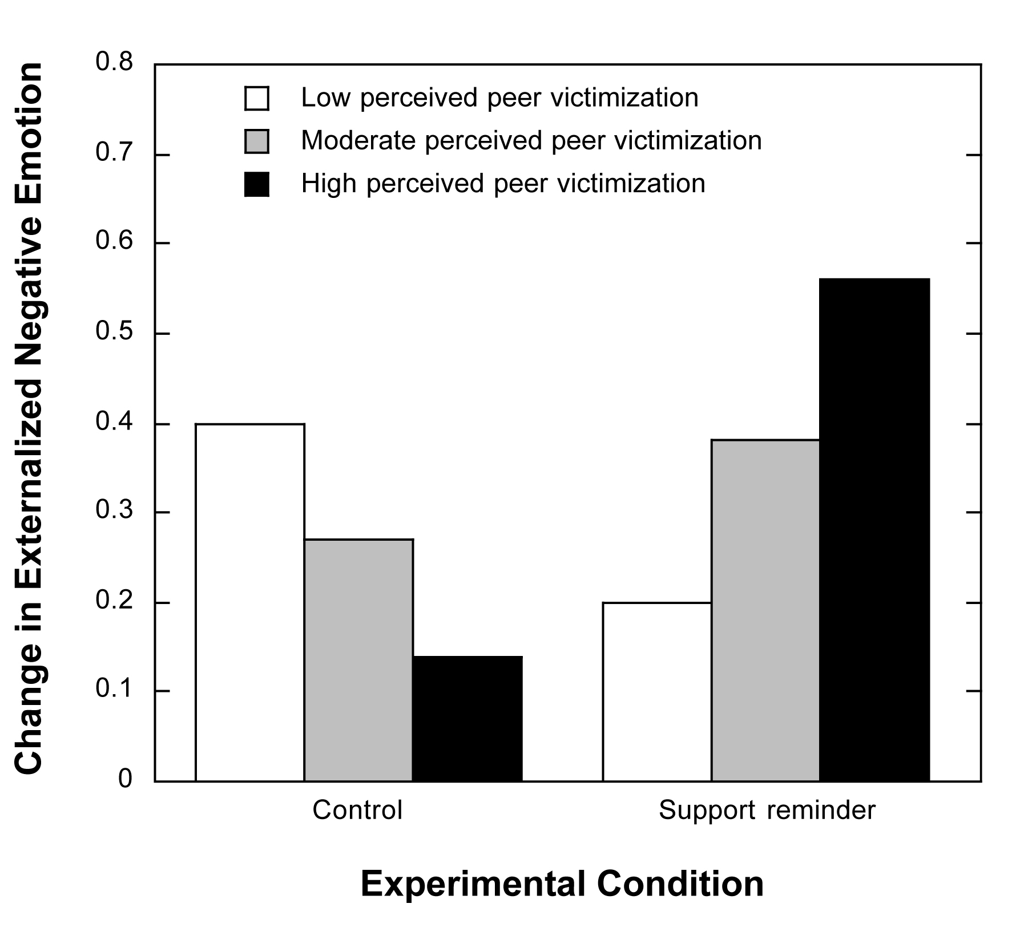

Panel B: Experiment 1 results for lack of closeness to friends

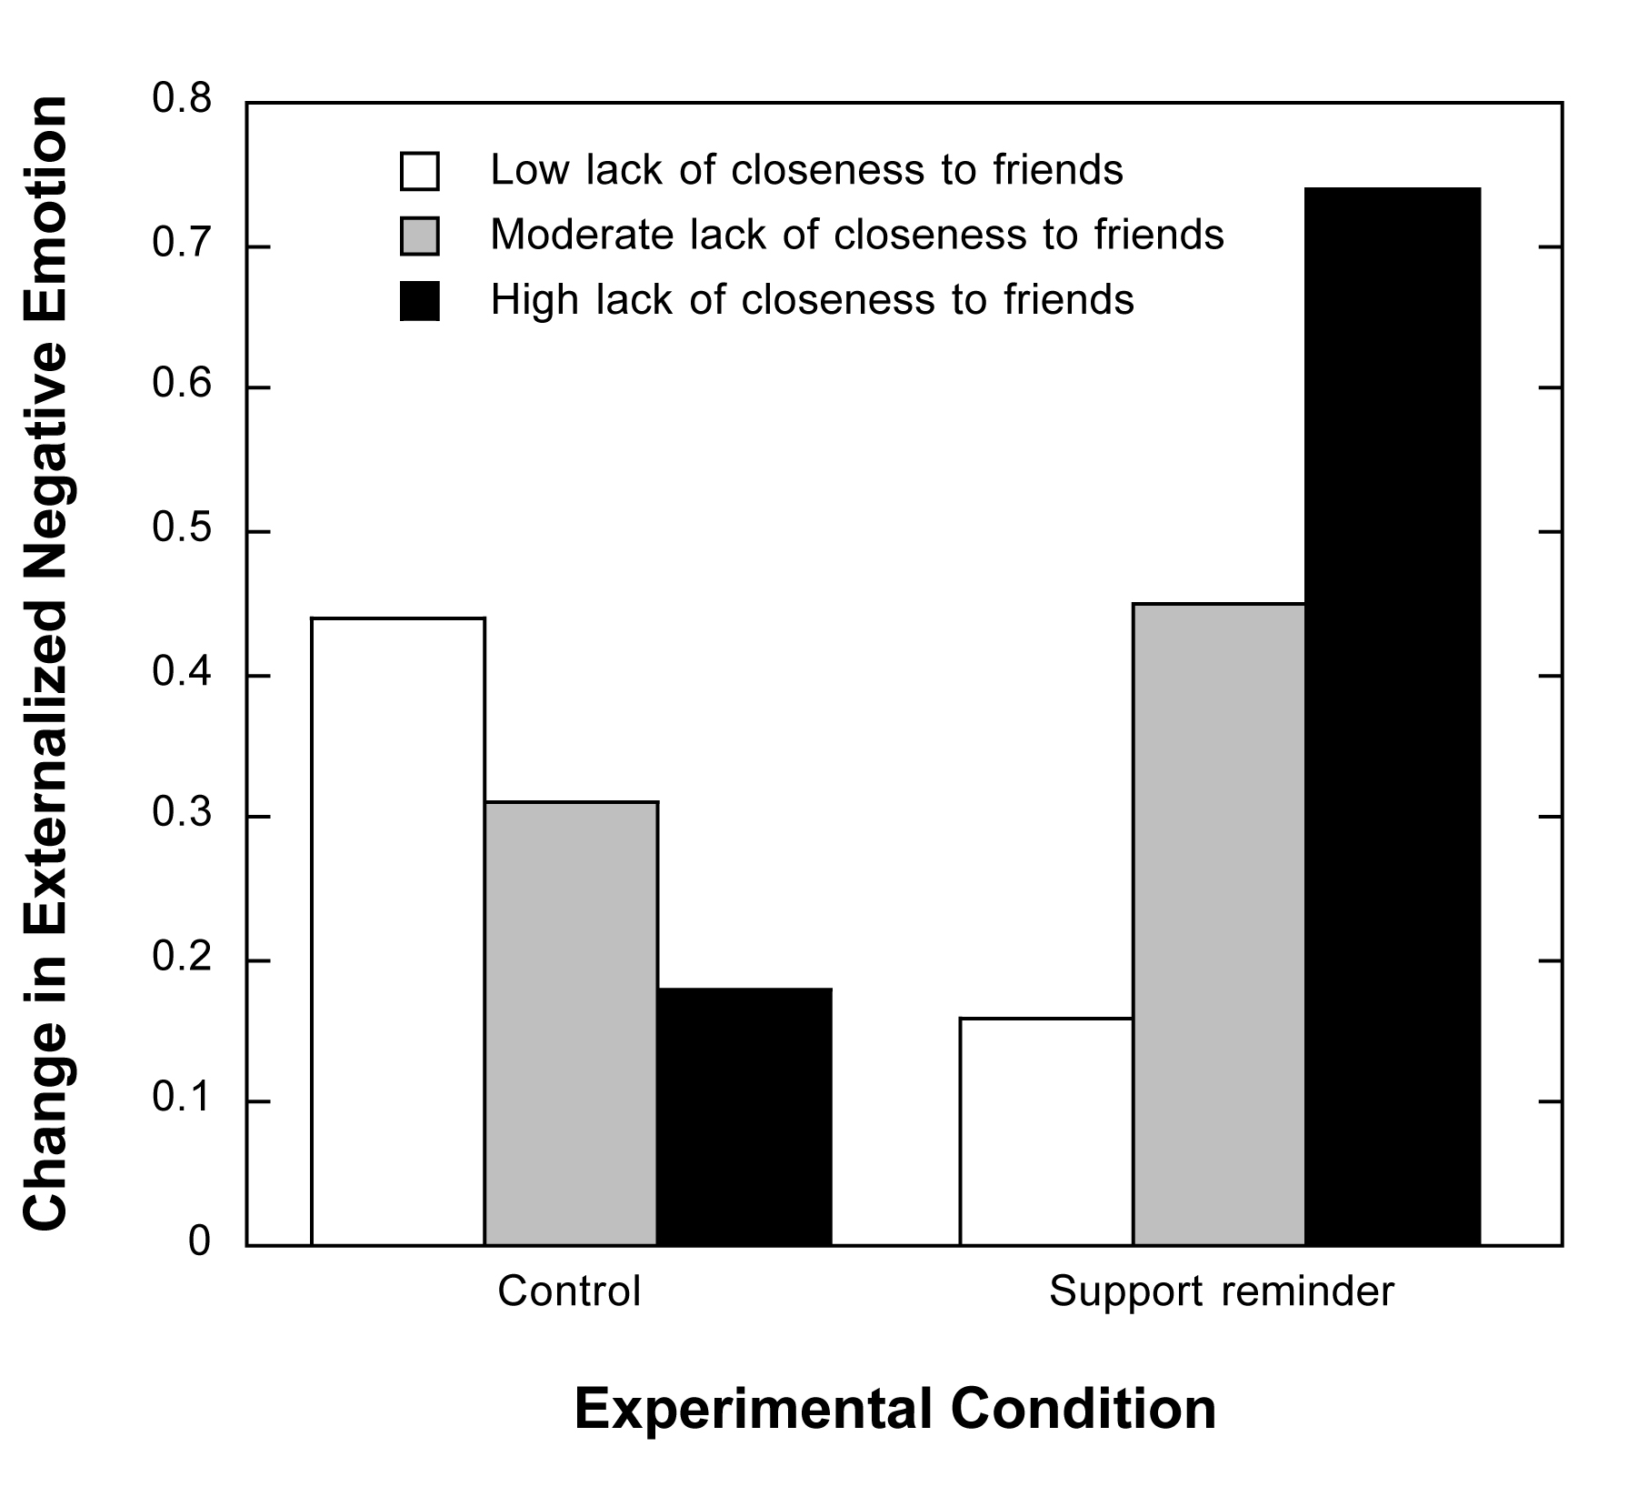

Panel A: Experiment 2 results for peer victimization

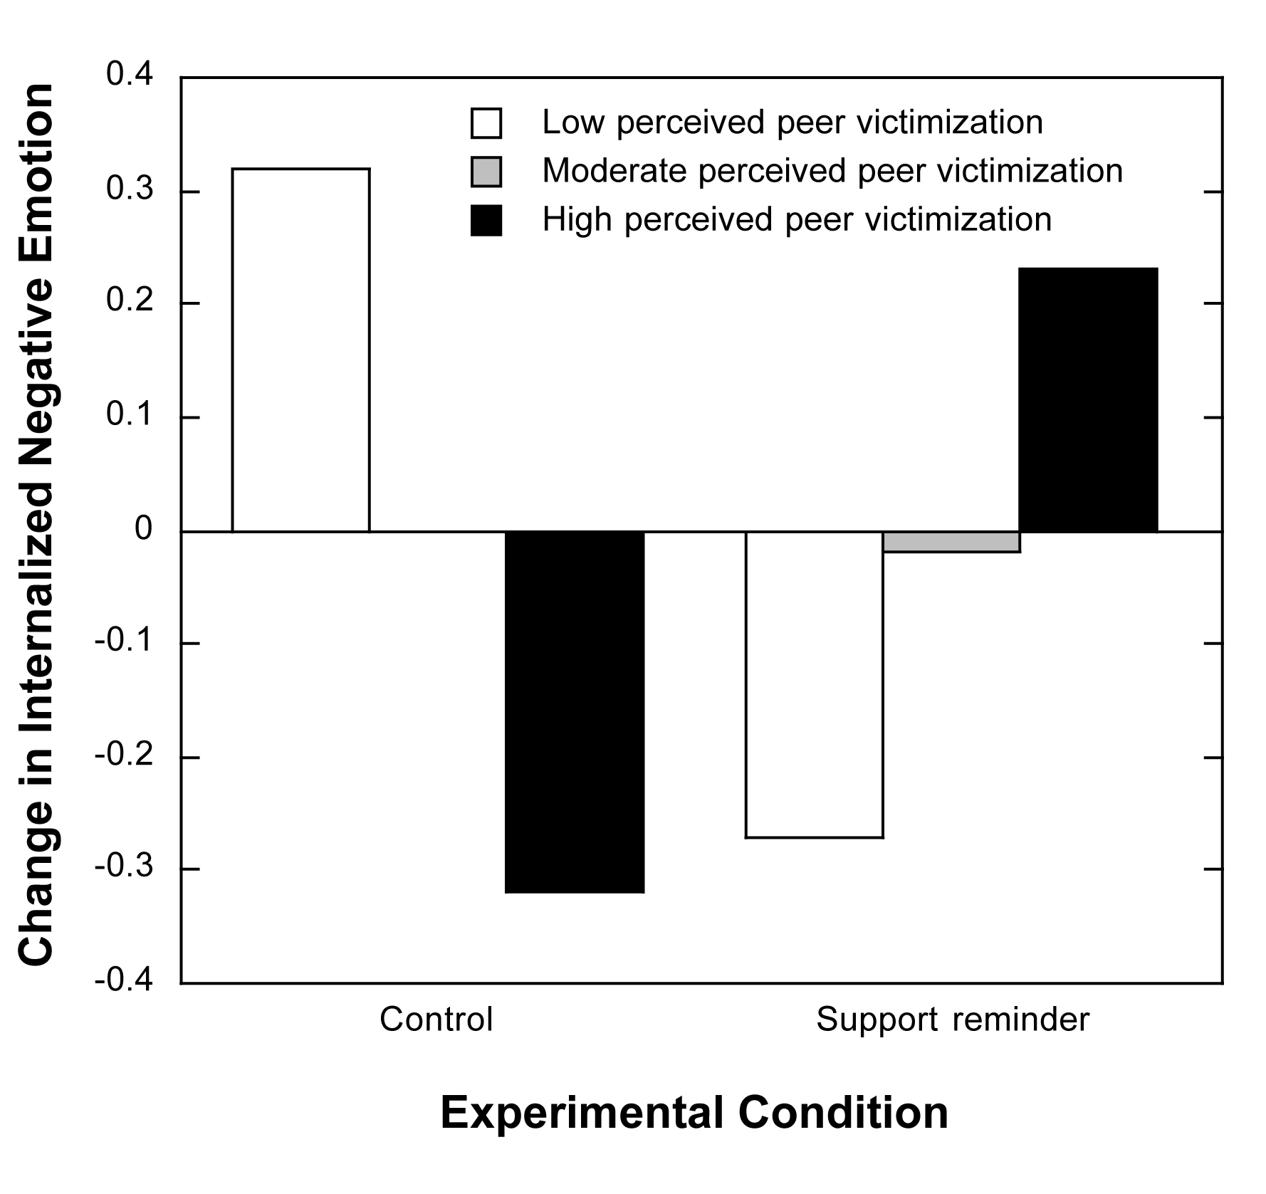

Panel B: Experiment 2 results for lack of closeness to friends

