Tungsten dichalcogenide lubricant nanoadditives for demanding applications
Vlad Bogdan Niste¹ and Monica Ratoi¹*
¹Faculty of Engineering and the Environment, University of Southampton
Highfield Campus, Southampton SO17 1BJ, United Kingdom

Abstract
Tungsten dichalcogenides such as WS₂ and WSe₂ have remarkable friction reducing properties in tribological applications due to their layered structure which exfoliates easily under shear. 2H-WS₂ nanoparticles (NPs) have recently been shown to possess excellent antiwear properties in high temperature applications due to their ability to react with the steel substrate and generate a chemical tribofilm with very good mechanical properties. Moreover, 2H-WS₂ sheets can adhere to the chemical tribofilm and thus also reduce boundary friction.
This study investigated the tribological properties of tungsten dichalcogenide NPs with different morphologies (IF and 2H) in high temperature, high pressure test conditions, the aim being to identify their mechanism of action and the differences in their performance. Tribological tests and analysis of tribofilms on the wear tracks revealed that the three additives show a similar mechanism of action based on their chemical reaction with the wear track. However, 2H-WS₂ NPs have superior friction reducing and antiwear properties due to their increased reactivity, resulting in a tribofilm that grows faster, thicker, more uniform and richer in tungsten compounds.

Introduction
Tungsten dichalcogenide NPs such as WS₂ and WSe₂ have received increasing interest in published research due to their ability to significantly reduce friction between moving components, especially in high pressure contacts [1-7]. This effect is ascribed to both their small size and their layered structure with weak interlayer shear strength. These physical properties make tungsten dichalcogenide NPs exert a smoothing effect on the wear tracks by penetrating tribological contacts and filling the gaps between surface asperities, where they can exfoliate under pressure and lead to very small coefficients of friction (COF). Tungsten dichalcogenides also have a series of other properties which make them well suited for the demanding conditions encountered in tribological contacts. They are inert, non-toxic, non-magnetic and have high resistance to oxidation and thermal degradation [8, 9]. The absence of reactive metals (tungsten compounds are very inert) and organic S or P in the structure make these NPs and their by-products more environmentally-friendly and easier to dispose of than conventional zinc dialkyldithiophosphate (ZDDP) antiwear additives.
Two types of tungsten dichalcogenide NPs have been employed so far in tribological applications: 2H (flat sheets) and IF (inorganic fullerene-like). 2H-WS₂ NPs have a layered structure, with W atoms confined in a trigonal prismatic coordination sphere. In an acidic environment, each of the sulphur atoms at the edges of these layers has one hydrogen atom bonded (so called ‘dangling bond’) and are subject to oxidation. For this reason, this structure has been named 2H-WS₂. This structure is maintained regardless of the size of the particle and is responsible for very low friction coefficients (e.g. 0.002-0.05 in dry lubrication and 0.06 in boundary lubrication [10, 11]).
IF-WS₂ NPs are hollow, multi-layered spherical particles that do not have ‘dangling bonds’ [1, 12]. In this case, the layers are rounded up to form closed ‘onion-like’ cages [13] and edge effects are no longer present, making the particles more inert to chemicals [11]. Several mechanisms of action have been proposed in the literature, such as the ability of the NPs to infiltrate tribological contacts, fill the gaps between asperities and decrease surface roughness [7], the ability of the NPs to reduce rolling friction by acting as nano ball bearings [14, 15], and the exfoliation of WS₂ layers under shear in a similar manner to 2H-WS₂, with the formation of a tribofilm on the wear track [2, 5].
Previous research has also shown that 2H-WS₂ NPs possess superior antiwear (AW) properties due to their ability to react with the steel substrate at high temperatures and generate a complex layered chemical tribofilm with very good mechanical properties [16-18]. These properties are explained by the presence of elemental tungsten and tungsten trioxide, which enhance its hardness and elastic modulus values [15, 16]. Unreacted 2H-WS₂ sheets cover the chemical tribofilm and reduce the friction in steel contacts. The complex structure and composition of this tribofilm give the NPs both an excellent ability to decrease friction in the boundary regime and antiwear/extreme pressure (AW/EP) properties.
The tribological properties of 2H-WS₂ nanoadditive dispersions in PAO have been compared to mixtures of ZDDP AW additives and organic friction modifiers (OFMs) [17]. It was shown that in high temperature, high pressure contacts 2H-WS₂ induces a very low COF in the boundary lubrication regime and comparable AW/EP behaviour to ZDDP formulations.
IF-WSe₂ NPs have also been synthesized and show a similar layered morphology to IF-WS₂ NPs [19, 20], with low shear strength between individual sheets, suggesting they have similar tribological properties. However, the larger Se atom induces higher strain in the IF structure. Furthermore, Se is less reactive than S and therefore, the synthesis of IF-WSe₂ NPs is slower and allows the formation of more dislocations in the NPs [19]. For these reasons, the IF structures have a faceted shape compared to the smoother shape of the IF-WS₂ NPs. These defects in the structure, along with the low reactivity of WSe₂ could influence the tribological properties of the NPs, but few studies have investigated them and only at room temperature [21, 22]. The efficiency of the NPs was attributed to their ability to form a physically adhered tribofilm on the wear track and the low shear strength between individual sheets. The present study has investigated the tribological properties of IF-WSe₂ NPs and compared them to 2H-WS₂ and IF-WS₂ NPs with the aim of exploring the potential of these nanoadditives to replace conventional lubricant additives.
The research methodology employed high resolution transmission electron microscopy (HRTEM) and dynamic light scattering (DLS) techniques to characterize the morphology, size and particle size distribution of the WS₂ and WSe₂ NPs. Tribological tests were conducted in a Mini Traction Machine in a non-polar synthetic polyalphaolefin (PAO) base oil in order to reduce the influence of the base oil on the affinity of the NPs for the steel substrate, as discussed in the literature [16]. The steel wear tracks were analysed using Alicona profilometry and X-ray photoelectron spectroscopy.

Materials and methods
The 2H-WS₂ NPs were purchased from M K IMPEX Canada as a silvery-grey powder with a stated average size of 90 nm. The IF-WS₂ and IF-WSe₂ NPs were synthesized by a chemical vapour condensation method in a quartz tube. A detailed description of the synthesis is found elsewhere [20, 23].
The base oil is a synthetic polyalphaolefin (PAO) from Mobil (SpectraSyn Plus 6) with a density of 830 kg/m³ and viscosity of 30.3 cSt at 40ºC and 5.9 cSt at 100ºC.
The tribological tests were run at 100ºC, as previous studies on 2H-WS₂ NPs have shown that high temperatures promote the reaction of the particles with the wear track [16-18]. The concentration of NPs in the oil was 1 % w/w as recommended in published research, which showed that this is optimal for tribological applications [4]. To avoid any competition for the additive to adhere/adsorb/react on the lubricated metal surface, no surfactant/dispersant was used to stabilize the dispersions.
The shape and morphology of the NPs were investigated using a Hitachi H-9000UHR (Toray Research Center, Japan) and a JEOL ARM-200F (Oxford Materials, UK). The NPs were initially dispersed in acetone and added in drops onto TEM copper grids covered with a ‘holey’ amorphous carbon film. TEM measurements of the 2H-WS₂ NPs on the Hitachi H-9000UHR were made by Toray Research Center in bright field (BF) and High Angle Annular Dark Field (HAADF) modes at 300 kV. STEM images of IF-WS₂ and IF-WSe₂ were recorded on the JEOL ARM-200F at 200 kV in HAADF modes.
NPs were dispersed in the PAO oil using a sonication probe and the particle size distribution (PSD) was characterized immediately in a Malvern ZetaSizer Nano ZS. The measurements were carried out in a standard cell at ambient temperature (23°C).
Tribological tests using the NP dispersions were carried out in a Mini Traction Machine (MTM2, PCS Instruments) in a sliding-rolling ball-on-disc setup (Figure 1). This features a 19 mm diameter ball and a 46 mm diameter disc, both made of AISI 52100 steel (hardness 750-770 HV). The root-mean-square roughness of both balls and discs is 11 ± 3 nm, resulting in a composite surface roughness of approximately 16 nm. New specimens (balls and discs) were used for each test and were cleaned with solvents (toluene followed by isopropanol) in an ultrasonic bath for 10 minutes prior to the test.
Throughout the test the temperature was kept constant at 100ºC and the applied load was 30 N, corresponding to an initial mean Hertzian pressure of 0.94 GPa. The slide-roll ratio (SRR), calculated as the ratio of the sliding speed (u_{b}-u_{d}) to the entrainment speed (u_{b}+u_{d})/2 (where u_{b} and u_{d} are the speed of the ball and the disc respectively, with respect to the contact) was 150%. This slide-roll ratio value has been shown in previously reported research to accelerate the generation of the chemically reacted tribofilm, which is known to depend on the severity of the rubbing conditions [24-26]. During the test, the NP dispersion was stirred continuously and vigorously by the rotating movements of the disc and ball. Therefore, even in the absence of a surfactant, the NPs were maintained well dispersed and only a small number sedimented to the bottom of the lubricant chamber at the end of the three hour test.
The MTM2 is fitted with the 3D Spacer Layer Imaging Method (SLIM) attachment, which enables in situ capture of optical interference images of the tribofilms on the steel ball using a high resolution RGB colour camera as shown in Figure 1 [27]. The analysis software (PCS Instruments 3D-SLIM) matches colours in the image to a calibration file in order to determine the film thickness of every point in the image. Using the thickness map obtained, the thickness of the tribofilm in each image was calculated as the average value inside a circular area taken across the entire width of the wear track.
The tribological tests followed a routine which can be divided in three alternating stages repeated at fixed time intervals. The first stage was the ‘conditioning phase’, when the ball and disc were rubbed together at a fixed slow entrainment speed in mixed lubrication film conditions to generate a tribofilm on the ball and disc wear tracks. The following stage consisted of the ‘Stribeck curve’ acquisition, in which friction was measured over a range of entrainment speeds at a fixed SRR. The acquisition of data for the Stribeck curve started at the highest speed (1.5 m/s) and continued towards the lowest speed (10 mm/s) value, to protect the tribofilm formed by avoiding its damage at low speeds in the boundary regime. This stage is automated and lasts about 1 minute. The third stage was the ‘tribofilm measurement’, when the motion was halted, the spacer layer-coated window was loaded against the ball track and an image was captured. This stage is also automated and lasts 5-10 s. Table 1 summarizes the conditions used for the MTM2-SLIM tests in this study.
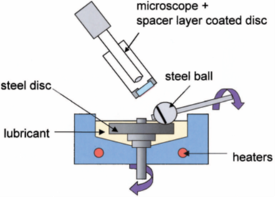
Figure 1 Diagram of the MTM2-SLIM setup [27]
Table 1 MTM2 – SLIM test conditions
Conditioning phase
Temperature 40°C, 100°C
Load 30 N
Mean Hertzian pressure 0.94 GPa
Entrainment speed 0.1 m/s
Slide-roll ratio, SRR 150 %
Stribeck curve phase
Temperature 40°C, 100°C
Load 30 N
Mean Hertzian pressure 0.94 GPa
Entrainment speed 1.5 to 0.01 m/s
Slide-roll ratio, SRR 150 %

At the end of the three hour MTM tests, the wear tracks/tribofilms on the discs were analysed with Alicona profilometry. The Alicona Infinite Focus generates a 3-D surface profile of the wear track that can be analysed with the Alicona IFM software supplied. Multiple surface profiles were measured for each tribofilm image at 20x magnification and the average height values were calculated. The measurements were conducted only on the disc specimens due to their flat geometry. The contact specimens (ball and disc) were made of the same material (AISI 52100) and have similar roughness values. Therefore, it is expected that both contact surfaces form tribofilms of very similar composition and thickness values.
XPS analysis of the MTM discs was performed on a Thermo Scientific K-Alpha spectrometer (East Grinstead, UK) with a 1486.6 eV microfocused monochromatic Al (Kα) X-ray source. The spot size was 200x400 μm² (ellipse shape). The pass energy was 200 eV for the wide (survey) spectra and 40 eV for the high resolution regions (narrow spectra). The instrument features an argon gun, which was used to clean the samples by sputtering. The raster size for the sputtering was 1x2 mm², using the Ar gas cluster ion beam (GCIB) mode at 6 keV with 1000 atoms for 60 s.

Results and discussion
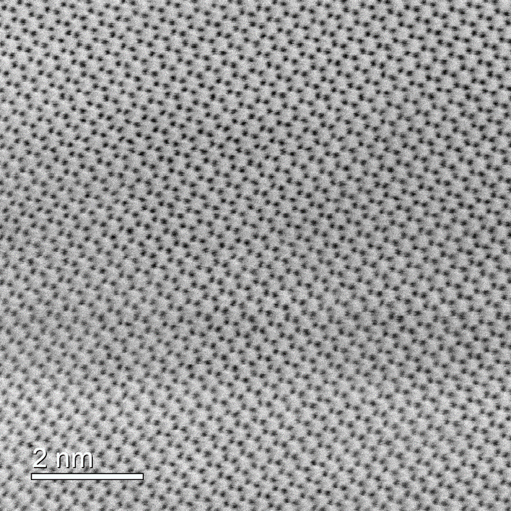
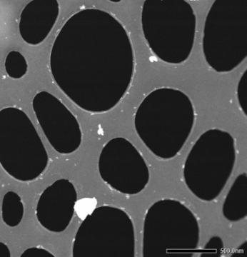
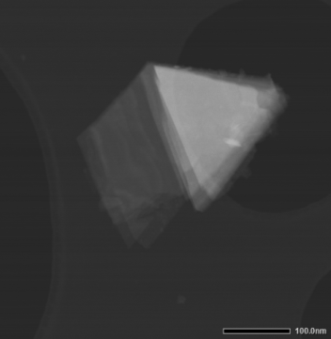
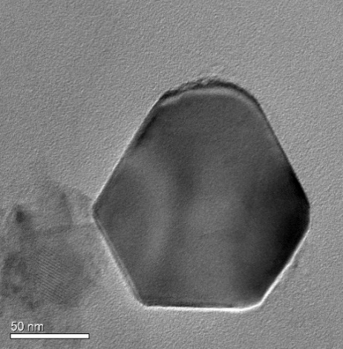
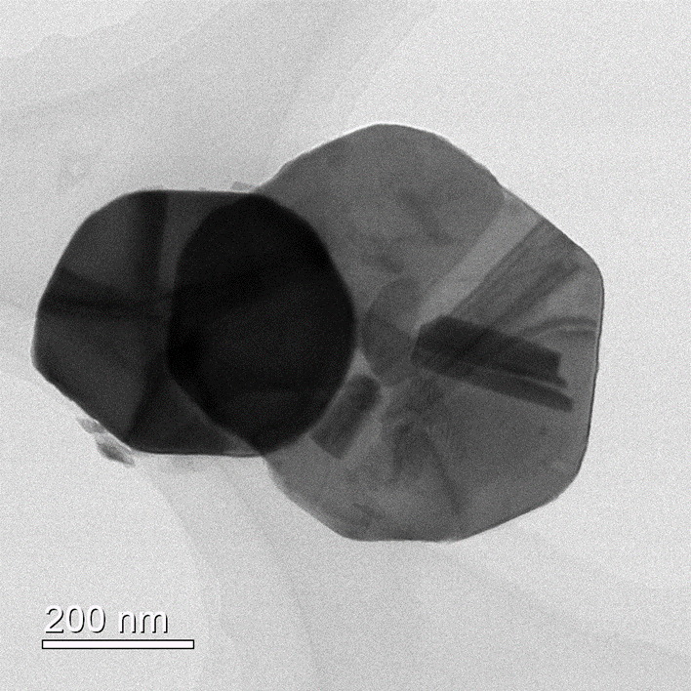
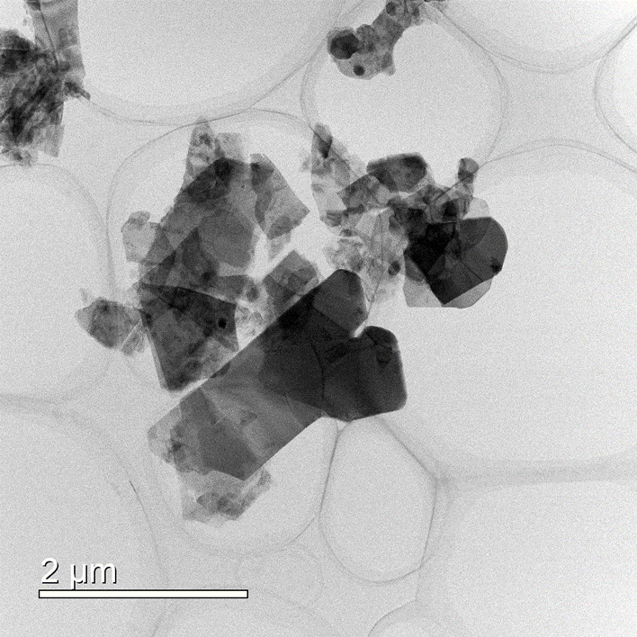
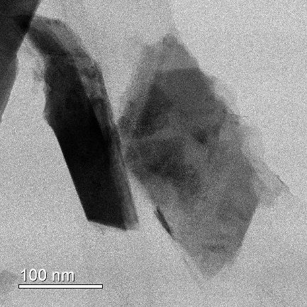
b)
500 nm
100 nm
50 nm
e)
f)
d)
a)
g)
h)
c)
4 nm
20 nm
i)
2 nm

Figure 2 TEM images showing: a) and b) a general view of the two different 2H-WS₂ NP populations; c), d), e) and f) large 2H-WS₂ plate-like NPs; g) a small, irregular 2H-WS₂ NP; h) atomic structure of the 2H-WS₂ sheet and profile of a thin WS₂ NP with several layers and i) hexagonal arrangement of atoms in a 2H-WS₂ sheet. Pictures a), c), d), f) and i) show BF images, while b), e), g) and h) are HAADF images.

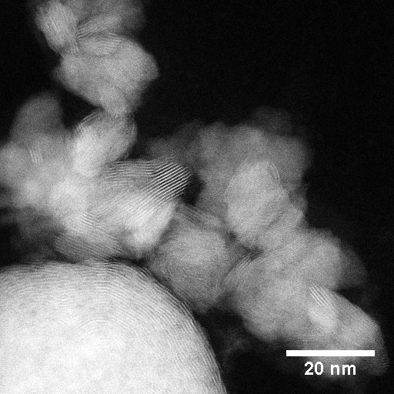
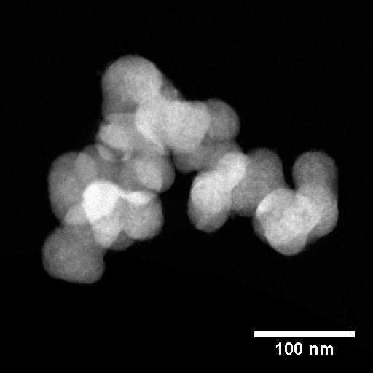
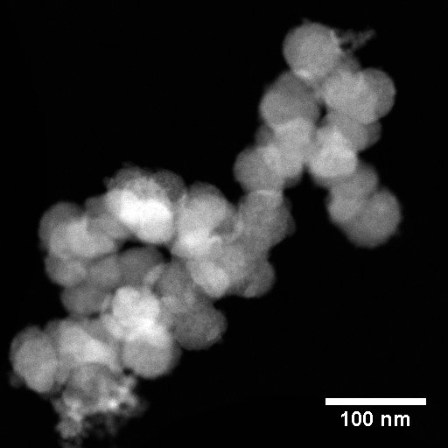
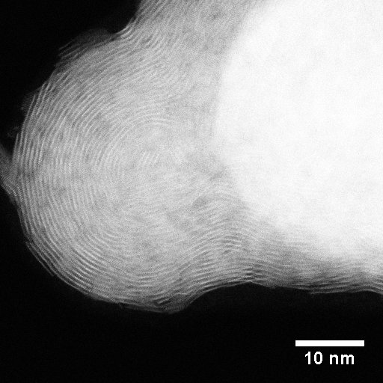
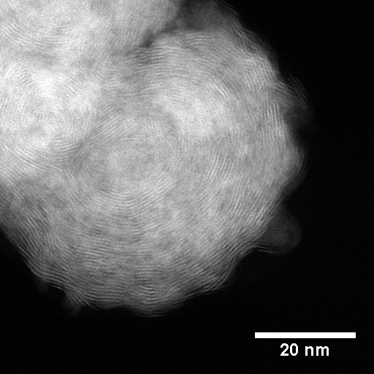
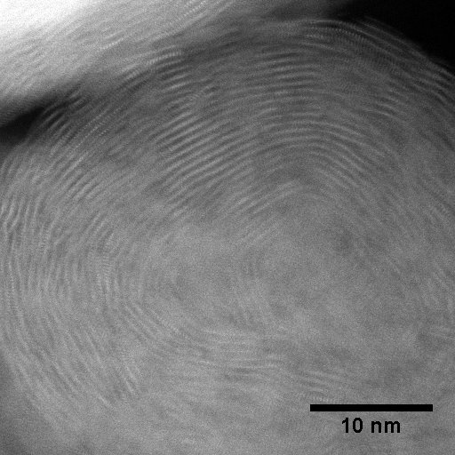
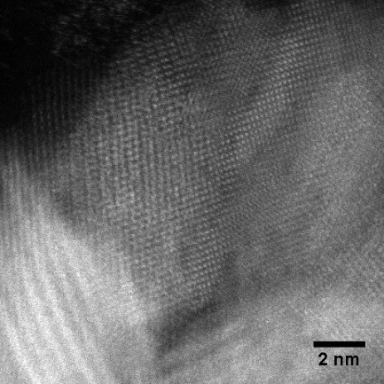
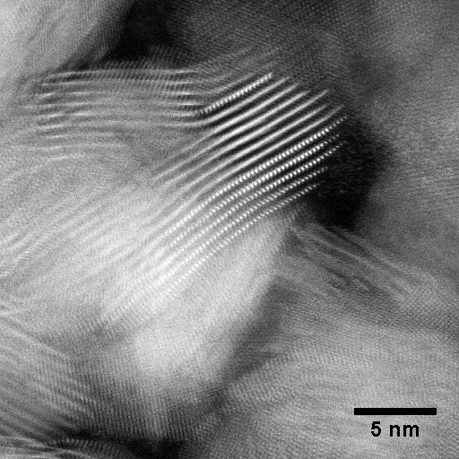
a)
b)
c)
d)
e)
f)
i)
5 nm
h)
g)

Figure 3 HAADF STEM images of IF-WS₂ NPs: a), b) and c) low-magnification images showing the size, size distribution and morphology, d), e) and f) HRSTEM images showing single spherical NPs with a very high percentage of multi-layered structure g), h) and i) WS₂ nonspherical multilayer structures

Transmission electron microscopy was used to investigate the shape and morphology of the tungsten dichalcogenide NPs. The 2H-WS₂ NPs were imaged with the Hitachi H-9000UHR. The low-magnification TEM images shown in Figure 2 (a) and (b) depict 2H-WS₂ NPs of two distinct size ranges. This implies that the 90 nm size of the 2H-WS₂ stated by the manufacturer is an average of the two populations.
The trigonal prismatic geometry of the 2H-WS₂ crystal structure is reflected in the triangular and hexagonal shapes of the large NPs (Figure 2 (c), (e) and (f)). Smaller NPs are irregular in shape, probably the result of fracture during the fabrication process (Figure 2 (g)). The layered structure can be seen in Figures 2 (d) and (h). The 2H-WS₂ NPs consist of a small number of individual sheets (up to about 10 layers can be seen in the high resolution image in Figure 2 (h) and a larger number in the lower resolution picture in Figure 2 (d)). The average interlayer spacing determined from the raw image file by FFT filtering is 0.63 ± 0.01 nm, as reported in the literature [8, 23, 28-32]. Figure 2 (i) shows a HRTEM image of the hexagonal arrangement of atoms in an individual 2H-WS₂ sheet.
TEM images of the IF NPs were acquired with the JEOL ARM-200F and are shown in Figure 3 (IF-WS₂) and Figure 4 (IF-WSe₂). Low-magnification images (Figures 3 (a), (b) and (c)) show that the IF-WS₂ NPs generally have a spherical shape and an average size between 15-80 nm. Most IF particles have a closed structure, as shown in Figures 3 (d), (e) and (f), but some are only partially closed (Figures 3 (g) and (i)). This may be due to the manufacturing process, as temperature has been reported to influence the formation of the closed IF structures [15, 23, 30, 36]. The layered structure visible in the high resolution images has an interlayer spacing of ~0.65 nm, in accordance with other values previously reported in the literature [8, 15, 23, 36-39].
The low magnification images of the IF-WSe₂ NPs (Figures 4 (a) and (b)) show a very narrow size distribution, with most of the particles displaying a fairly spherical shape and an average size of 20-30 nm. However, the high resolution images (Figures 4 (c) and (d)) indicate that most of the IF structures are only partially closed. This may be again ascribed to the effect of temperature during the manufacturing process or due to the larger size of the Se atom, which induces higher strain in the layers and flattens the structure [19]. The interlayer spacing for the IF-WSe₂ NPs was measured to be 0.65 ± 0.01 nm, similar to other results published in the literature [19, 20].
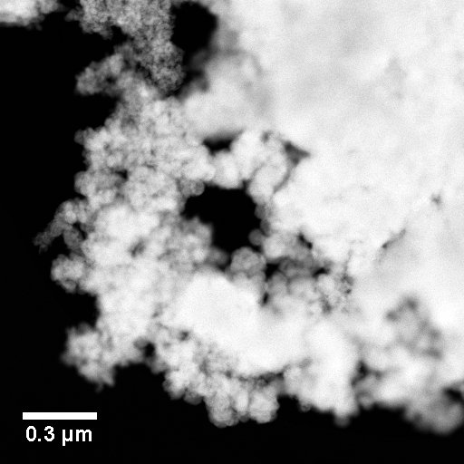
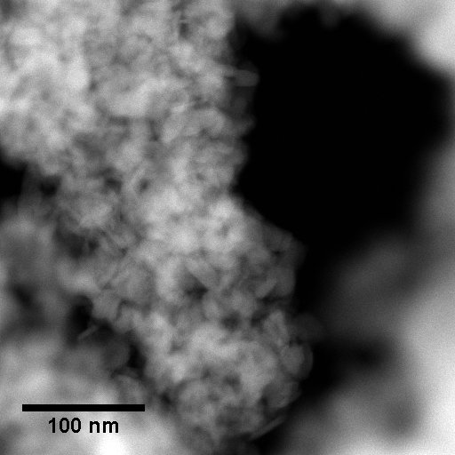
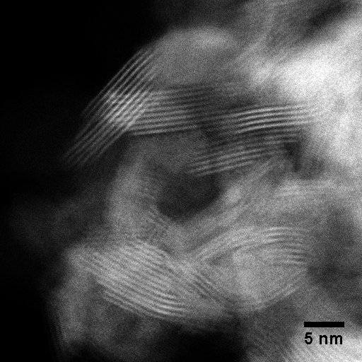
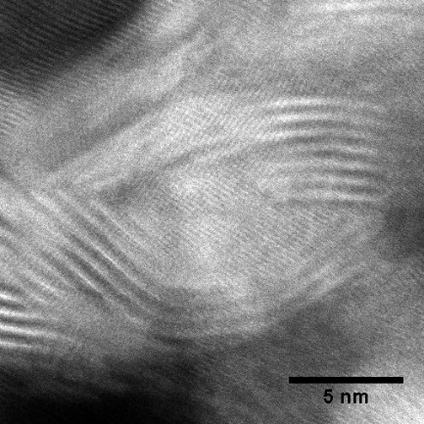
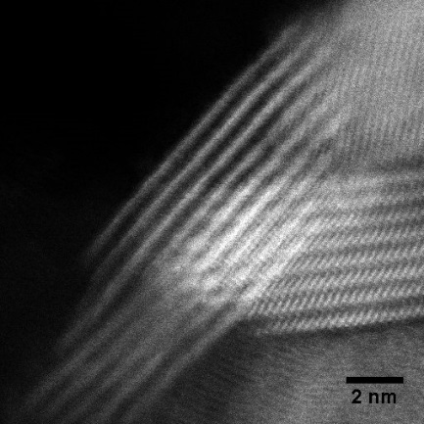
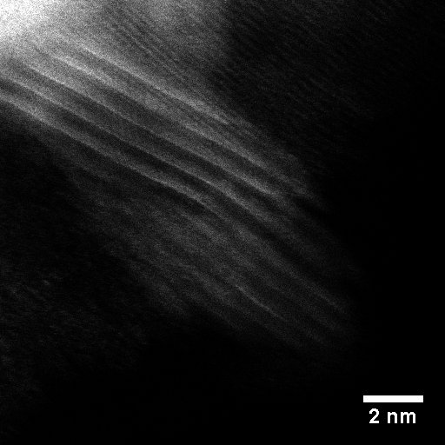
a)
b)
c)
d)
e)
f)

Figure 4 HAADF STEM images of IF-WSe₂ NPs: a) and b) low-magnification images showing the size, size distribution and morphology, c) HRSTEM image showing their partially closed structure, d), e) and f) HRSTEM images of single IF-WSe₂ NPs showing their nonspherical multilayer structure

Figure 5 shows the PSD of the NPs dispersed in PAO oil measured with the Malvern Zetasizer at room temperature immediately after preparation.

Figure 5 Size and particle size distribution of the NPs

The intensity distribution of the 2H-WS₂ NPs shows two narrow peaks, which confirms the presence of two distinct NP size populations: one with an average size of 30-40 nm and the other of approximately 250 nm. These results are in agreement with the TEM images discussed above (Figure 2). This particular size distribution could be beneficial for tribological applications, conferring the nanoadditive the ability to penetrate contacts and fill asperity gaps of different sizes in order to limit the adhesion of contact surfaces and ultimately reduce friction. The PSD of the IF NPs are quite similar and show only one narrow peak. The size distribution is slightly wider for IF-WS₂ (with an average size of ~340 nm) than for IF-WSe₂ (average size ~300 nm). As the TEM images in Figures 3 and 4 show the majority of IF NPs to be under 100 nm, these PSD results imply that when NPs are dispersed in oils they form agglomerates with sizes between 250-550 nm.
Stribeck curves for PAO base oil and tungsten dichalogenide NP dispersions tested at 100ºC are shown in Figure 6.
All NPs display superior tribological properties in the boundary regime compared to the PAO base oil, reducing the COF to 0.05-0.12 at low speeds.
In the mixed lubrication regime, a significant feature of all Stribeck curves is the increase of friction with rubbing time. This type of behaviour is typical of antiwear additives such as ZDDP, which are known to generate a rough chemical tribofilm of considerable thickness (100 nm+) on the wear track. The largest friction increase in the mixed regime is recorded with 2H-WS₂. If the increase in friction is due to the formation of the tribofilm, then the tribofilm growth rate is smaller for IF NPs. This can be explained by the higher inertness of the IF structures and the lower affinity for the steel surface.

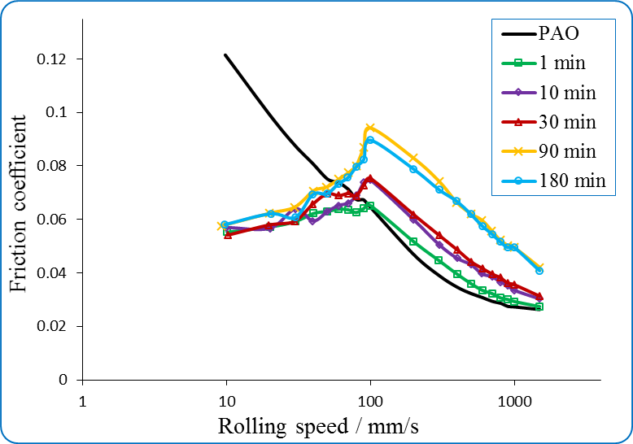
a)

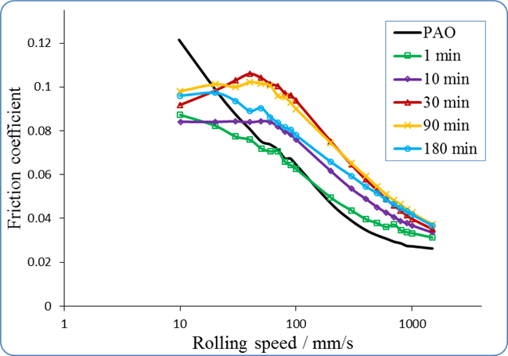
b)

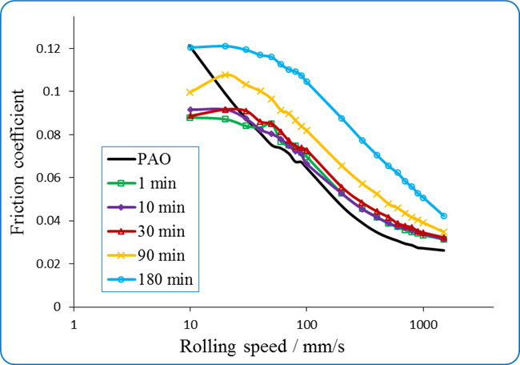
c)

Figure 6 Stribeck curves for 1 % w/w dispersions of a) 2H-WS₂ NPs [adapted from 16], b) IF-WS₂ NPs and c) IF-WSe₂ NPs in PAO at 100ºC

The Stribeck curves for 2H-WS₂ in Figure 6 (a) show a distinct pattern throughout the test: they reach a peak COF value at ~100 mm/s, followed by a sharp and constant decrease all the way into the boundary lubrication regime. The highest COF value (0.09) was reached after 90 minutes of rubbing and remained constant until the end of the test. If the increase in COF in the mixed regime is similar to that of antiwear additives, the sharp decrease in the boundary regime to values of 0.05-0.06 early in the experiment and the persistence at this value for the rest of the test is reminiscent of the behaviour of some of the most efficient friction modifiers [33].
The Stribeck curves for the IF dispersions (WS₂ and WSe₂) are shown in Figure 6 (b) and (c). Both NPs increase friction with rubbing time throughout all lubricating regimes, possibly indicating tribofilm generation on the wear track. Similarly to 2H-WS₂, the friction increased rapidly (from the first 10 minutes of rubbing) for IF-WS₂ but more slowly for IF-WSe₂, where a significant increase is only seen after 90 minutes. The high COF showed by the IF-WSe₂ at the end of the test probably indicates the generation of a very patchy and therefore rough tribofilm. As the speed is reduced during the Stribeck curve measurement below 0.1 m/s, the COF continues to increase for the IF dispersions and only levels out at speeds below 50 mm/s.
In the case of IF-WS₂, the Stribeck curve measured at the end of the three hour test is characterized by lower COF values than the curves measured at 30 and 90 minutes. This may be because the tribofilm generated is rubbed off and becomes smoother and eventually thinner.
Figure 7 shows a comparison of the friction results for 2H-WS₂, IF-WS₂ and IF-WSe₂ NPs. The variation of the COF with time during the conditioning phases of the tests shown in Figure 7 (a) can give extra information about the difference between the mechanisms of action of the three nanoadditives. 2H-WS₂ is a superior FM in the first half of the test, while in the second part friction increases due to its ability to build a chemical tribofilm. A distinctive feature of the friction induced by 2H-WS₂ consists of pronounced dips, which correspond to the moments when the conditioning phase was resumed after the measurement of the Stribeck curves. The higher reactivity of the 2H-WS₂ NPs can also be inferred from the presence of these dips. During the Stribeck curve phase, the speed was reduced until mixed and boundary conditions were achieved. When the conditioning phase resumes in the mixed regime (i.e. at 100 mm/s) the tribofilm offers extra protection for the first few minutes, before friction returns to its previous value. However, the IF-WS₂ and IF-WSe₂ NPs do not show this type of behaviour to the same extent. As shown in Figure 6, 2H-WS₂ acts as a better FM in these regimes and significantly lowers the COF.
A comparison between the Stribeck curves of the base oil and the three nanoadditive dispersions after three hours of rubbing in the conditioning phase is shown in Figure 7 (b). The tribofilms generated by the NPs on the wear tracks have a markedly different behaviour. The 2H-WS₂-generated film displays a high COF in the mixed regime (i.e. above 100 mm/s), but friction decreases sharply at lower speeds to values much smaller than for IF-WS₂ and IF-WSe₂. These results indicate that 2H-WS₂ is the most efficient boundary FM of the three nanoadditives.

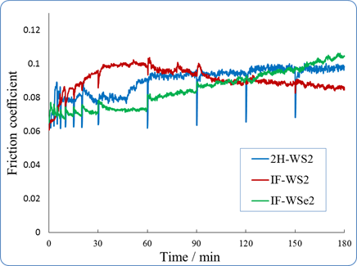
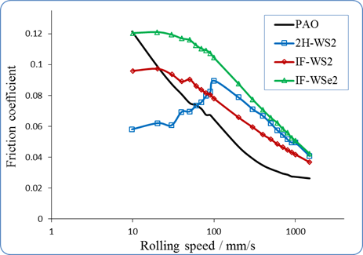
b)
a)

Figure 7 Comparison between 2H-WS₂, IF-WS₂ and IF-WSe₂ NPs in PAO at 100ºC: a) the variation of the COF with time during the conditioning phases; b) Stribeck curves after 3h

Figure 8 shows SLIM interferometry images recorded at the end of the tests on the ball wear tracks. The images are taken only after the entire duration of the test and after washing with solvent, as the NPs agglomerate and adhere onto the glass window, obstructing the imaging of the contact during the test.
The tribofilms generated by the IF-WS₂ and IF-WSe₂ NPs on the ball are thinner and less uniformly distributed compared to the 2H-WS₂ NPs. These results complement the friction values of the Stribeck curves and may be explained by the reduced reactivity inherent to the IF structures. The thickness values of the tribofilms as calculated by the SLIM software are 98 ± 7 nm for 2H-WS₂, 61 ± 5 nm for IF-WS₂ and 46 ± 8 nm for IF-WSe₂ (Table 2). The standard deviation of the results is large due to the patchy, rough nature of the tribofilms formed.
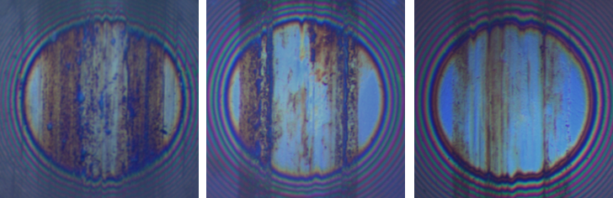
c)
b)
a)

Figure 8 3D SLIM interferometry images of the tribofilm on the ball generated by a) 2H-WS₂ NPs [adapted from 16], b) IF-WS₂ NPs and c) IF-WSe₂ NPs

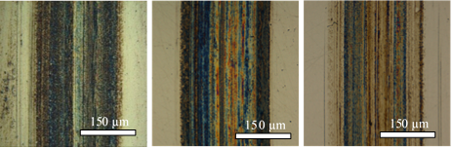
b)
c)
a)

Figure 9 Alicona images of the tribofilm on the disc generated by a) 2H-WS₂ NPs [adapted from 16], b) IF-WS₂ NPs and c) IF-WSe₂ NPs

Figure 9 shows Alicona optical images of the disc wear tracks formed by the three nanoadditives. These images were acquired at 20x magnification before the wear tracks were cleaned with solvents. The tribofilms appear non-uniform and their thickness measured across the wear track was found to be 109 ± 10 nm for 2H-WS₂, 121 ± 12 nm for IF-WS₂ and 72 ± 15 nm for IF-WSe₂. These values were higher than the SLIM measurements taken on the ball because in the SLIM technique, the wear tracks had to be cleaned with solvents to enable the visualization and measurement of the tribofilms. To make a comparison between the SLIM and Alicona results, the thickness of the films was also measured with Alicona after the wear tracks on the disc were cleaned with solvents (Table 2). These thickness values were slightly higher than those measured in situ on the ball with SLIM. This could be the consequence of the tip asperities being flattened during the SLIM analysis under the high contact pressure (0.94 GPa).
The difference in thickness between the tribofilms measured before and after cleaning of the discs can be due to a large number of NPs adhered to the wear track, but which are removed during gentle cleaning with solvents. This difference is largest for IF-WS₂ and lowest for 2H-WS₂ NPs. The results can be interpreted as either the 2H-WS₂ tribofilm being smoother and more uniform, and therefore able to harbour fewer NPs, or that the IF NPs are more likely to burrow in the asperities of the chemically reacted tribofilm. A combination of both situations is also possible. However, meaningful conclusions on the roughness of the chemical tribofilms and ability of the NPs to adhere to it cannot be drawn from these results because the extent of particle removal by solvent cleaning is difficult to quantify.

Table 2 Average film thickness measured using Alicona profilometry and SLIM
 | Measured values of tribofilm thickness and SD (nm)
 | 2H-WS₂ | IF-WS₂ | IF-WSe₂
SLIM after cleaning | 98 ± 7 | 61 ± 5 | 46 ± 8
Alicona before cleaning | 109 ± 10 | 121 ± 12 | 72 ± 15
Alicona after cleaning | 100 ± 9 | 73 ± 16 | 42 ± 11

The width of the tribofilms on the discs was measured from the Alicona profiles taken across the wear tracks. The width values were similar for the IF nanoadditives (300 µm) and slightly higher than the value measured for 2H-WS₂ NPs (290 µm). Wear loss measurements were not possible because during the tests, the tribofilms formed above the surface level of the substrate, implying negative loss. In order to measure wear loss, the tests would need to be carried out for longer. An important factor which can influence the wear loss is the hardness of the film. The mechanical properties of the 2H-WS₂ tribofilms have been previously investigated by nanoindentation and compared to the results of the tribofilms generated in similar tribological conditions by conventional additives such as antiwear ZDDP and the mixture of ZDDP and an OFM [16, 17]. It was found that the 2H-WS₂ tribofilm has superior mechanical properties (higher hardness and elastic modulus), which may ultimately confer better antiwear behaviour to the tribofilm. Nanoindentation of the IF tribofilms was not possible because they were significantly thinner and the results would be influenced by the substrate.
In the absence of the mechanical properties for the three tribofilms it was very important to determine how their chemical composition compares.
Table 3 shows the composition of the top section of the 2H-WS₂, IF-WS₂ and IF-WSe₂ tribofilms, as measured by XPS, while Figures 10, 11 and 12 depict the spectra of the important elements.
 | Table 3 Composition of the 2H-WS₂, IF-WS₂ and IF-WSe₂ NP-generated tribofilms
Composition (at %) |  | W 4f  W⁰ W⁴⁺ W⁶⁺ | S 2p | Se 2p | Fe 2p | O 1s | C 1s
2H-WS₂ |  | 11.2 - 5 | 8.6 |  | 45.5 | 16.1 | 13.6
IF-WS₂ |  | - 1.3 14.5 | 2.95 |  | 11.68 | 53.73 | 15.84
IF-WSe₂ |  | - 0.3 7.3 |  | 14.89 | 15.18 | 51.85 | 10.51

The presence of carbon (impurities) in all tribofilms is attributed to oxidized oil molecules. The W:Se atomic ratio is ~1:2 as in the WSe₂ structure, but the W:S ratios are much larger indicating a nonstoichiometric distribution of tungsten and sulphur in the tribofilms. Previous research [14] indicated that this is due to the chemical reaction between the WS₂ NPs with the steel substrate. The current distribution suggests that WSe₂ NPs are less reactive compared to WS₂ NPs.
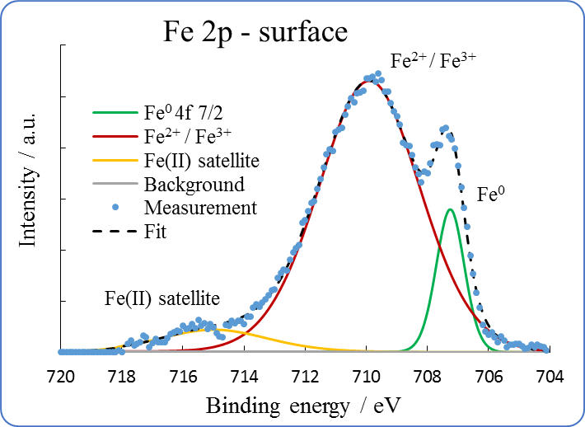
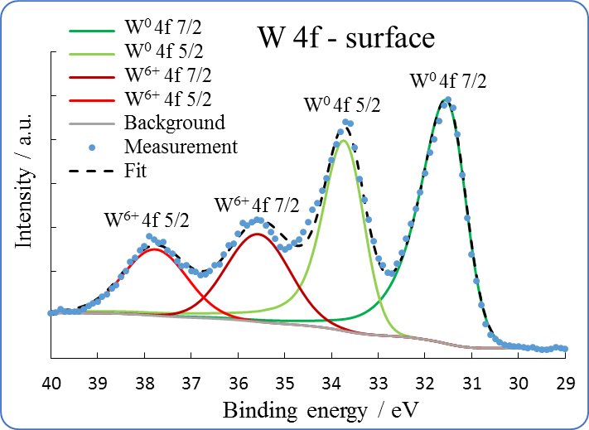
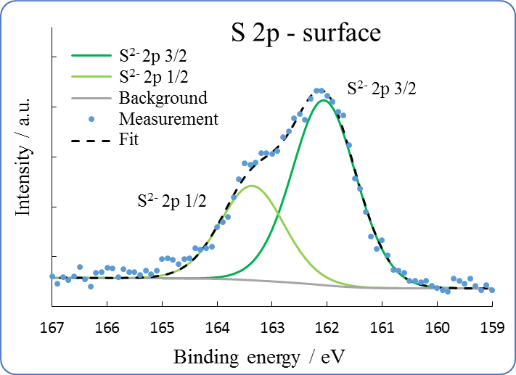
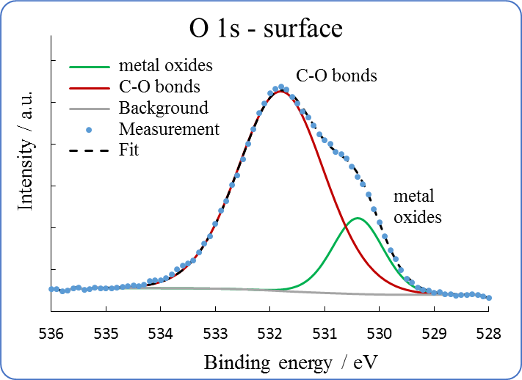
b)
a)

d)
c)

Figure 10 a) XPS narrow spectra on the tribofilm generated by 2H-WS₂ at 100°C showing a) W 4f [adapted from 14], b) S 2p, c) Fe 2p and d) O 1s signals

Figure 10 (a) shows the narrow spectra for W in the 2H-WS₂ tribofilm. The W 4f signal appears as a doublet (i.e. two separate peaks with proportional intensities: 4f 7/2 and 4f 5/2) with an energy gap of ~2.15 eV. The position of the signal is a direct indication of the chemical state of the element. For tungsten, W⁰ (elemental W) is expected at ~31 eV, W⁴⁺ (in WS₂) at ~33 eV and W⁶⁺ (in WO₃) at ~35.5 eV [9, 11, 34, 35].
The main signals recorded in the sample are for W⁶⁺, specific to WO₃ (35.6 eV), and for W⁰ (31.5 eV). The presence of elemental W and WO₃ in the tribofilm are an indication of the chemical reaction between the 2H-WS₂ NPs with the steel substrate, with the generation of W, WO₃ and various iron oxides and sulphides. The quantification of the XPS narrow spectra, performed by fitting the recorded signals and integrating the area under the curves, indicates that the atomic W⁰/W⁶⁺ ratio is ~2, implying a large concentration of elemental tungsten in the tribofilm.
Figure 10 (b) shows the XPS signal measured for iron. The Fe 2p signal appears as a doublet, 2p 3/2 and 2p 1/2, with an area ratio of 2:1 and 13.1 eV energy gap. Fe⁰ is expected at ~707 eV, while Fe²⁺/Fe³⁺ species (oxides, sulphides etc.) are normally found at higher values. In the present sample signals were recorded for Fe⁰ at 707.3 and 720.4 eV.
Aside from Fe⁰, iron has a complex signal and the spectra are usually difficult to fit. Fitting was performed for Fe 2p 3/2 by considering all Fe²⁺/Fe³⁺ contributions into a single signal at 709.9 eV. An additional signal was added at 715 eV. This ‘Fe(II) satellite’ is a specific signal due to a degree of covalence in Fe²⁺ compounds. A ‘Fe(III) satellite’ could also be present at ~720 eV, but this is difficult to confirm due to the overlapping with the Fe⁰ 2p 1/2 signal. The spectrum indicates that the surface of the tribofilm contains little elemental iron compared to the oxide and sulphide iron species (~1:11).
Figure 10 (c) shows the S 2p signal, which appears as a doublet at 161.9 and 163.1 (ΔE = 1.2 eV). Sulphur is found in relatively large amounts in the tribofilm (~9 %). The position of the signal indicates that S is in the form of sulphides, while the lack of a visible W⁴⁺ signal corresponding to WS₂ in Figure 10 (a) implies that they must be iron sulphides (as shown by the Fe 2p signal in Figure 10 (b)). Such compounds should be formed by the chemical reaction of 2H-WS₂ NPs with the metal substrate.
As seen in Figure 10 (d), the signals recorded for oxygen were assigned to metal oxides (530.5 eV) and a large contribution from C-O bonds from oxidized oil molecules (531.7 eV).
The XPS results suggest that the 2H-WS₂ NPs react with the steel substrate at high temperatures and generate a chemical tribofilm rich in iron sulphides/oxides, WO₃ and elemental tungsten and iron. These results are in agreement with previous studies employing 2H-WS₂ NPs in high temperature high pressure contacts [16-18]. XPS was also performed outside of the wear track but only Fe, O and C were found. This demonstrates that the tribofilm is only generated on the wear track and that apart from high temperature, it requires high pressure and possibly shear (high SRR) to form.
Figure 11 shows the narrow XPS spectra for elements in the IF-WS₂ tribofilm. W signals were found at 32.5 eV for W⁴⁺ in WS₂ and at 35.4 eV for W⁶⁺ in WO₃ (Figure 11 (a)). As the samples were cleaned with solvents before the XPS analysis it was expected that there would be only a very small amount of IF-WS₂ NPs on the tribofilm (the W⁴⁺/W⁶⁺ ratio is ~1:11.5). However, unlike the 2H-WS₂ tribofilm where the signals for elemental tungsten were dominant, the IF-WS₂ tribofilm does not show any. The absence of elemental W in the IF-WS₂ tribofilm implies that the film may have inferior mechanical properties.
The sulphur signal is shown in Figure 11 (b). In addition to the sulphide doublet at 162 eV, there is an additional signal corresponding to sulphur oxides (168.8 eV). These are likely due to the oxidation of the exterior surface of the IF-WS₂ NPs or exfoliated WS₂ sheets (i.e. in relation to the entire composition of the tribofilm, the W⁴⁺ and S_{oxides} signals amount for ~1.4 % and 0.9 % respectively).
Figure 11 (c) shows a small amount of C-O bonds present relative to the entire O 1s signal. This can indicate that a large quantity of the C and O impurities have been removed from the surface of the tribofilm by the initial sputtering process. The remaining signal (530.6 eV) is assigned to iron and tungsten oxides.
The XPS analysis shows that the IF-WS₂ NPs generate a chemical tribofilm which contains iron sulphides and metal (iron and tungsten) oxides. The absence of elemental tungsten in the composition of tribofilm represents a significant difference to the 2H-WS₂ tribofilm and can be explained by the reduced reactivity associated with the IF morphology. A consequence of this difference may be displayed as inferior mechanical properties of the film.
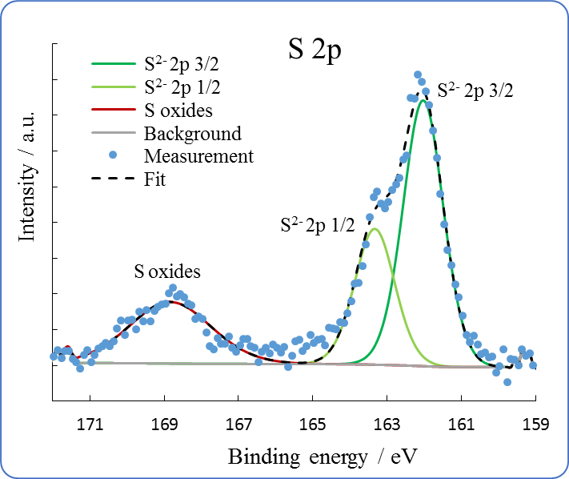
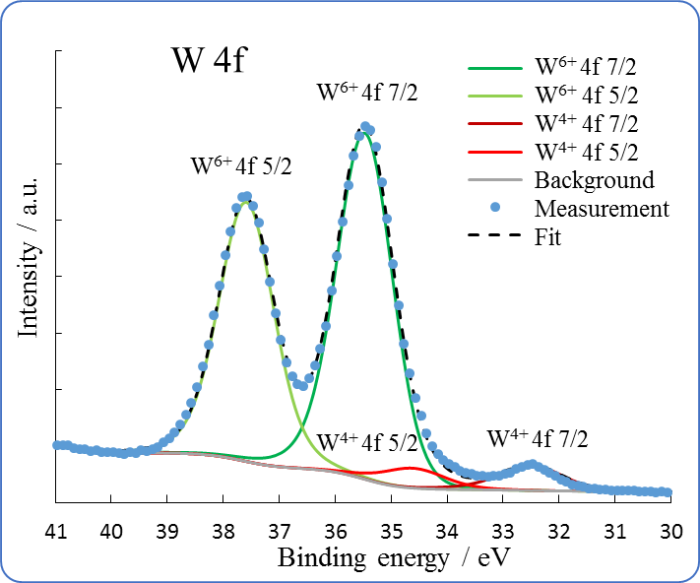
b)
a)

c)
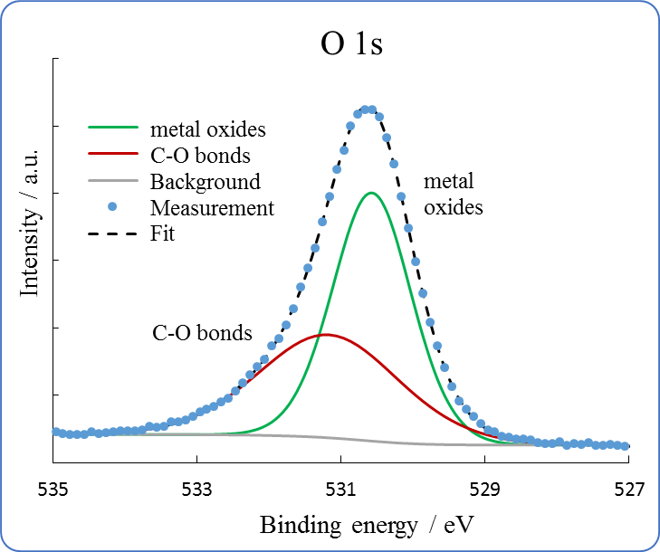

Figure 11 XPS narrow spectra recorded on the tribofilm generated by IF-WS₂ at 100°C, showing a) W 4f, b) S 2p and c) O 1s signals

The narrow XPS spectra for elements in the IF-WSe₂ tribofilm are shown in Figure 12. The signals for W⁴⁺ and W⁶⁺ were found at 31.9 and 35.5 eV (Figure 12 (a)). The ratio of the two chemical species is ~1:30. As in the case of the IF-WS₂ tribofilm, solvent cleaning prior to the analysis has removed WSe₂ NPs (in the form of W⁴⁺) adhered to the track. The W⁶⁺ signal indicates the presence of WO₃, but only in half the concentration found in the WS₂ tribofilms.
Figure 12 (b) shows the narrow spectra for Se 3d. The doublet signals at 54.4 and 56 eV are assigned to Se⁴⁺ and Se oxides. The formation of Se oxides is likely determined by the oxidation of the NPs. The presence of a very small amount of W⁴⁺ on the wear track indicates that the Se⁴⁺ signal is probably given by iron selenides rather than WSe₂.
The narrow spectra for O 1s are shown in Figure 12 (c). The two signals are assigned to metal oxides (530.3 eV) and C-O bonds from impurities (531.4 eV).
The XPS results indicate that the IF-WSe₂ tribofilm is made of WO₃ and iron selenides, but as in the case of the IF-WS₂ NPs, no elemental W was detected.

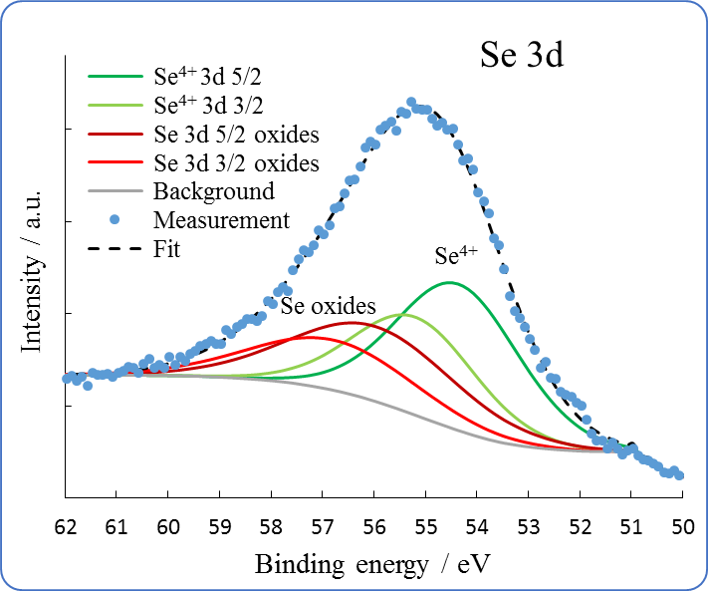
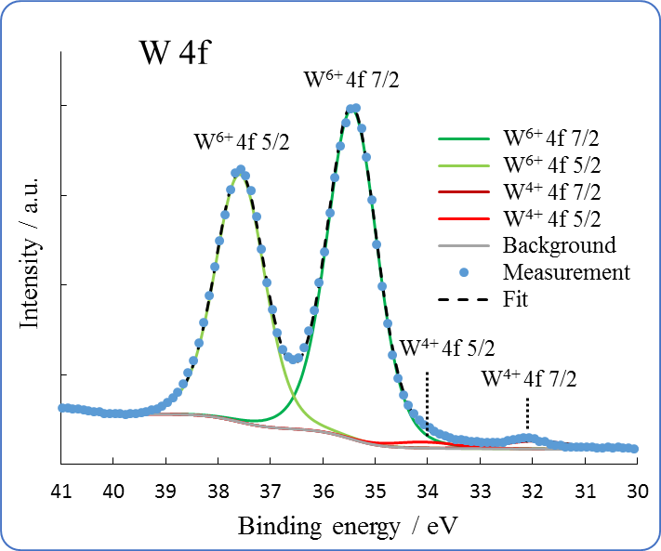
b)
a)

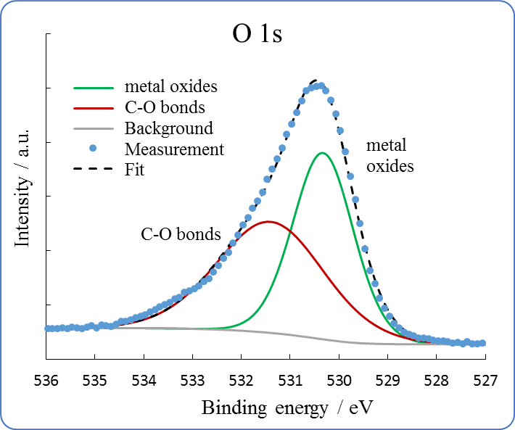
c)

Figure 12 XPS narrow spectra recorded on the tribofilm generated by IF-WSe₂ at 100°C, showing a) W 4f, b) Se 3d and c) O 1s signals

The presence of tungsten trioxide and iron suphides/selenides in the 2H-WS₂, IF-WS₂ and IF-WSe₂ tribofilms are evidence of a similar mechanism of action based on the chemical reaction of the NPs with the wear track. However, the absence of elemental W in the IF-WS₂ and IF-WSe₂ tribofilms is an indication of the lower reactivity of the IF NPs.
The tribofilms generated by the three dichalcogenide NPs show significant differences that reflect their ability to chemically react with the steel wear track. 2H-WS₂ NPs have high reactivity and generate 100 nm+ layered chemical tribofilms containing large amounts of W species, particularly elemental tungsten (W⁰). This composition can also explain the excellent AW properties displayed by 2H-WS₂ nanoadditive dispersions. Due to their reduced reactivity with the steel wear track, IF-WS₂ and IF-WSe₂ NPs generate thinner films composed of iron and tungsten oxides and iron sulphides/selenides. The lack of the signal corresponding to elemental tungsten indicates that these tribofilms may have inferior AW properties compared to the tribofilm generated by 2H-WS₂ NPs.

Conclusions
In previous studies we have reported that 2H-WS₂ NPs react with the steel substrate at high temperatures (100ºC) and pressures (1 GPa) to form 100+ nm chemical tribofilms with excellent tribological properties. This ability to form tribofilms with special antiwear and friction reducing properties make 2H-WS₂ NPs strong candidates for the replacement of conventional additives which have various shortcomings.
In view of these findings, the present research has employed similar testing conditions to investigate the tribological behaviour of other types of tungsten dichalcogenide NPs such as IF-WS₂ NPs and IF-WSe₂ NPs. The study aimed to identify the mechanism of action of IF tungsten dichalcogenide NPs and compare their tribological performance with 2H-WS₂.
The FM properties of the nanoadditives were investigated by monitoring the variation of the Stribeck curves with rubbing time. The 2H-WS₂ NP dispersions had an immediate and stable effect on reducing the COF in the boundary lubrication regime (~0.06 in PAO). In the mixed lubrication regime the COF gradually increased with rubbing time, indicating the formation of a chemical tribofilm on the wear track. This specific behaviour that is unique to 2H-WS₂ nanoadditives combines the action of antiwear and friction modifier additives.
The Stribeck curves generated by IF-WS₂ and IF-WSe₂ NPs were characterized by a higher COF in the boundary regime than 2H-WS₂. The COF after three hours of rubbing was ~0.1 for IF-WS₂ and ~0.12 for IF-WSe₂. In the mixed regime, the slower increase of friction with rubbing time as compared to the 2H-WS₂ NPs is related to the reduced film growth.
The thickness of the tribofilms was investigated with SLIM interferometry and Alicona profilometry and found to be thicker (100+ nm) and more uniform for 2H-WS₂ NPs than for the IF tungsten dichalcogenides.
To investigate the mechanism of action of the 2H- and IF tungsten dichalcogenide NPs and to explain the difference between their tribological performance, XPS analysis was performed on the wear tracks. The results showed that all NPs generated chemically reacted tribofilms, but there are distinct differences in their composition. The 2H-WS₂ tribofilms contain large amounts of tungsten compounds such as elemental tungsten and tungsten oxides (W⁰/W⁶⁺~2), along with iron sulphides and oxides. This chemical composition is responsible for the superior mechanical properties of the tribofilm. As expected from their morphology, IF tungsten dichalcogenides such as IF-WS₂ and IF-WSe₂ are more chemically inert than 2H-WS₂ NPs and generate thinner/uneven films composed mainly of tungsten/iron oxides and iron sulphides/selenides, but lacking elemental W. This difference in the chemical composition, along with the reduced thickness of the IF tribofilms can influence their AW properties, which are expected to be inferior to the 2H-WS₂ tribofilms. As such, in this study 2H-WS₂ NPs were found to generate a slightly narrower wear track (290 µm) compared to the IF NPs (300 µm) after three hour of rubbing.
In high temperature high pressure tribological contacts the three types of tungsten dichalcogenide NPs have been found to reduce friction and wear by a similar mechanism of action based on their chemical reaction with the steel wear track. However, the increased reactivity of the 2H-WS₂ results in the generation of a tribofilm characterized by a faster growth rate, superior thickness, a more uniform wear track coverage and a high concentration of tungsten compounds (particularly W⁰), which can improve the mechanical properties of the film. 2H-WS₂ also shows a superior tribological performance in the boundary regime, where the flat, layered 2H-WS₂ NPs adhered on the surface of the chemical tribofilm can exfoliate easily and can significantly lower friction when mostly needed.

Acknowledgements

Vlad Niste PhD was funded by EPSRC DTP. The authors would like to acknowledge EPSRC and Dr Naoko Sano from Newcastle University for sponsoring and carrying out the XPS analysis and The South of England Analytical Electron Microscope (EPSRC grant EP/K040375/1) for access to ATEM.
We also express our gratitude to Dr Ekaterina Vasilyeva for providing the IF-WS₂ and IF-WSe₂ NPs used in the current study.

References
[1] R. Tenne, M. Redlich, Recent progress in the research of inorganic fullerene-like nanoparticles and inorganic nanotubes, Chem. Soc. Rev., 2010, 39(5), 1423-1434.
[2] L. Rapoport, V. Leshchinsky, I. Lapsker, Yu. Volovik, O. Nepomnyashchy, M. Lvovsky, R. Popovitz-Biro, Y. Feldman, R. Tenne, Tribological properties of WS₂ nanoparticles under mixed lubrication, Wear, 2003, 255(7-12), 785-793.
[3] R. Greenberg, G. Halperin, I. Etsion, R. Tenne, The effect of WS2 nanoparticles on friction reduction in various lubrication regimes, Tribol. Lett., 2004, 17(2), 179-186.
[4] F. Abate, V. D’Agostino, R. Di Giuda, A. Senatore, Tribological behaviour of MoS2 and inorganic fullerene-like WS2 nanoparticles under boundary and mixed lubrication regimes, Tribology, 2010, 4(2), 91-98.
[5] L. Joly-Pottuz, F. Dassenoy, M. Belin, B. Vacher, J. M. Martin, N. Fleischer, Ultralow-friction and wear properties of IF-WS2 under boundary lubrication, Tribol. Lett., 2005, 18(4), 477-484.
[6] L. Rapoport, N. Fleischer, R. Tenne, Fullerene-like WS₂ nanoparticles: superior lubricants for harsh conditions, Adv. Mater., 2003, 15(7-8), 651-655.
[7] L. Rapoport, O. Nepomnyashchy, I. Lapsker, A. Verdyan, A. Moshkovich, Y. Feldman, R. Tenne, Behaviour of fullerene-like WS₂ nanoparticles under severe contact conditions, Wear, 2005, 259(1-6), 703-707.
[8] L. Chang, H. Yang, W. Fu, N. Yang, J. Chen, M. Li, G. Zou, J. Li, Synthesis and thermal stability of W/WS₂ inorganic fullerene-like nanoparticles with core-shell structure, Mater. Res. Bull., 2006, 41, 1242-1248.
[9] B. Spath, F. Kopnov, H. Cohen, A. Zak, A. Moshkovich, L. Rapoport, W. Jagermann, R. Tenne, X-ray photoelectron spectroscopy and tribology studies of annealed fullerene-like WS₂ nanoparticles, Phys. Status Solidi B, 2008, 245(9), 1779-1784.
[10] A. Erdemir, Solid lubricants and self-lubricating films, In Modern Tribology Handbook, Two Volume Set, ed. B. Bhushan, CRC Press, 2000.
[11] J. M. Martin, N. Ohmae, Nanoparticles made of metal dichalcogenides, In Nanolubricants; Volume 13 of Tribology in Practice Series, John Wiley & Sons, Chichester, 2008.
[12] V. N. Bakunin, A. Y. Suslov, G. N. Kuzmina, O. P. Parenago, Synthesis and application of inorganic nanoparticles as lubricant components – a review, J. Nanopart. Res., 2004, 6(2), 273-284.
[13] L. Rapoport, Yu. Bilik, Y. Feldman, M. Homyonfer, S. B. Cohen, R. Tenne, Hollow nanoparticles of WS₂ as potential solid-state lubricants, Nature, 1997, 387, 791-793.
[14] L. Rapoport, Y. Feldman, M. Homyonfer, H. Cohen, J. Sloan, J. L. Hutchinson, R. Tenne, Inorganic fullerene-like material as additives to lubricants: structure-function relationship, Wear, 1999, 225-229(2), 975-982.
[15] O. Tevet, P. Von-Huth, R. Popovitz-Biro, R. Rosentsveig, H. D. Wagner, R. Tenne, Friction mechanism of individual multi-layered nanoparticles, Proc. Natl. Acad. Sci. U. S. A., Early Ed., 2011, 108(50), 19901-19906.
[16] M. Ratoi, V. B. Niste, J. Walker, J. Zekonyte, Mechanism of action of WS₂ lubricant nanoadditives in high-pressure contacts, Tribol. Lett., 2013, 52(1), 81–91.
[17] M. Ratoi, V. B. Niste, J. Zekonyte, WS₂ nanoparticles – potential replacement for ZDDP and friction modifier additives, RSC Adv., 2014, 4(41), 21238-21245.
[18] V. B. Niste, H. Tanaka, M. Ratoi, J. Sugimura, WS₂ nanoadditized lubricant for applications affected by hydrogen embrittlement, RSC Adv., 2015, 5(51), 40678-40687.
[19] T. Tsirlina, Y. Feldman, M. Homyonfer, J. Sloan, J. L. Hutchinson, R. Tenne, Synthesis and characterization of inorganic fullerene-like WSe₂ material, Fullerene Sci. Technol., 1998, 6(1), 157-165.
[20] E. Vasilyeva, A. G. Nasibulin, M. Maximov, O. Tolochko, A. Sachdev, X. Xiao, Synthesis of tungsten diselenide nanoparticles by chemical vapor condensation method, Materials Science, 2015, 21(3), 339-342.
[21] W. Li, L. Hu, M. Wang, H. Tang, C. Li, J. Liang, Y. Jin, D. Li, Synthesis and tribological properties of Mo-doped WSe2 Nanolamellars, Cryst. Res. Technol., 2012, 47(8), 876–881.
[22] K. Zhang, H. P. Li, Q. Shi, J. Xu, H. T. Zhang, L. Chen, C. S. Li, Synthesis and tribological properties of Ti-doped WSe2 nanoflakes, Chalcogenide Letters, 2015, 12(2), 51-57.
[23] E. S. Vasilyeva, O. V. Tolochko, B. K. Kim, D. W. Lee, D. S. Kim, Synthesis of tungsten disulphide nanoparticles by the chemical vapor condensation method, Microelectron. J., 2009, 40, 687-691.
[24] M. Ratoi, R. C. Castle, C. H. Bovington, H. A. Spikes, The influence of soot and dispersant on ZDDP film thickness and friction, Lubr. Sci., 2004, 17(1), 25–43.
[25] M. Aktary, M. T. McDermott, G. A. McAlpine, Morphology and nanomechanical properties of ZDDP antiwear films as a function of tribological contact time, Tribol. Lett., 2001, 12(3), 155–162.
[26] M. Ratoi, V. B. Niste, H. Alghawel, A. Suen, K. Nelson, The impact of organic friction modifiers on engine oil tribofilms, RSC Adv., 2014, 4, 4278-4285.
[27] PCS Instruments. MTM2 Mini-Traction Machine, Retrieved: August 2015, http://www.pcs-instruments.com/brochures/brochures.shtml.
[28] J. F. Wu, W. S. Zhai, G. F. Jie, Preparation and tribological properties of WS₂ nanoparticles modified by trioctylamine, Proc. Inst. Mech. Eng., Part J, 2009, 223(4), 695-703.
[29] W. Jifen, Z. Wensheng, J. Guifen, Preparation and tribological properties of tungsten disulfide hollow spheres assisted by methyltrioctylammonium chloride, Tribol. Int., 2010, 43(9), 1650-1658.
[30] D. Vollath, D. V. Szabo, Synthesis of nanocrystalline MoS2 and WS2 in a microwave plasma, Mater. Lett., 1998, 35, 236-244.
[31] C. Shahar, D. Zbaida, L. Rapoport, H. Cohen, T. Bendikov, J. Tannous, F. Dassenoy, R. Tenne, Surface functionalization of WS₂ fullerene-like nanoparticles, Langmuir, 2010, 26(6), 4409-4414.
[32] H. A. Therese, J. Li, U. Kolb, W. Tremel, Facile large scale synthesis of WS₂ nanotubes from WO₃ nanorods prepared by a hydrothermal route, Solid State Sci., 2005, 7(1), 67-72.
[33] M. Ratoi, C. H. Bovington, H. A. Spikes, In situ study of metal oleate friction modifier additives, Tribol. Lett., 2003, 14(1), 33-40.
[34] F. Y. Xie, L. Gong, X. Liu, Y. T. Tao, W. H. Zhang, S. H. Chen, H. Meng, J. Chen, XPS studies on surface reduction of tungsten oxide nanowire film by Ar⁺ bombardment, J. Electron Spectrosc. Relat. Phenom., 2012, 185(3-4), 112-118.
[35] J. F. Moulder, W. F. Stickle, P. E. Sobol, K. D. Bomben, Handbook of X-ray Photoelectron Spectroscopy: A Reference Book of Standard Spectra for Identification and Interpretation of XPS Data, Physical Electronics Inc, 1995.
[36] A. Margolin, F. L. Deepak, R. Popovitz-Biro, M. Bar-Sadan, Y. Feldman, R. Tenne, Fullerene-like WS₂ nanoparticles and nanotubes by vapor-phase synthesis of WCl_{n} and H₂S, Nanotechnology, 2008, 19(9), 095601.
[37] S. M. Ghoreishi, S. S. Meshkat, A. A. Dadkhah, IF-WS₂ nanoparticles size design and synthesis via chemical reduction, Mater. Res. Bull., 2010, 45, 584-588.
[38] Y. Q. Zhu, T. Sekine, Y. H. Li, W. X. Wang, M. W. Fay, H. Edwards, P. D. Brown, N. Fleischer, R. Tenne, WS₂ and MoS₂ inorganic fullerenes – super shock absorbers at very high pressures, Adv. Mater., 2005, 17(12), 1500-1503.
[39] O. Tevet, O. Goldbart, S. R. Cohen, R. Rosentsveig, R. Popovitz-Biro, H. D. Wagner, R. Tenne, Nanocompression of individual multilayered polyhedral nanoparticles, Nanotechnology, 2010, 21(36), 365705.

