Near- and mid- infrared group IV photonics
Callum G. Littlejohns^{1,2}, Mohamed Saïd Rouifed¹, Haodong Qiu¹, Tina Guo Xin¹, Ting Hu¹, Thalia Dominguez Bucio², Milos Nedeljkovic², Goran Z. Mashanovich², Graham T. Reed², Frederic Y. Gardes², Hong Wang¹.
¹Novitas, Nanoelectronics Centre of Excellence, Nanyang Technological University, 50 Nanyang Avenue, Singapore, 639798.
Email: clittlejohns@ntu.edu.sg, Website: www.sicoe.ntu.edu.sg
²Optoelectronics Research Centre, Building 53, University of Southampton, Southampton, SO17 1BJ, UK.
Silicon photonics is seen by many to be the solution to the capacity crunch faced by the communications industry. Global sales of silicon photonics products are predicted to be reach US$1 billion by 2020 [1]. The key factors in the predicted success of this technology are integration, and the ability to mass produce products at a low cost, due to its compatibility with CMOS electronics technology. Silicon photonics circuits typically operate at a wavelength of 1.55 µm due to the low loss of optical fibres at this wavelength. To this end, this presentation discusses a novel method of growing single crystal, tuneable composition silicon-germanium-on-insulator by rapid melt growth, with the aim of fabricating extremely low power electro-absorption modulators at a range of wavelengths close to 1.55 µm, enabling dramatic expansion of datalink capacity through the use of wavelength division multiplexing (WDM) [2]. The range of localised uniform composition SiGe layers are formed using only a single growth and single anneal step, as shown in Fig. 1.
Additionally, the extension of silicon photonics into the mid-infrared wavelengths (2 µm and beyond) is discussed. Some basic passive components required for optical circuits are demonstrated, including multi-mode interferometers (MMI), as shown in Fig. 2. Furthermore, the feasibility of fabricating active devices in a Ge-on-Si platform is discussed [3].
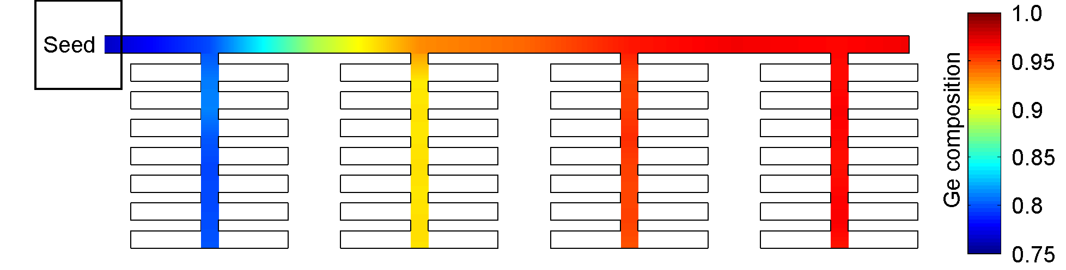
Fig 1. SiGe composition profile of a tailored structure formed by rapid melt growth, showing the ability to produce multiple uniform composition SiGe strips, each of a different composition.
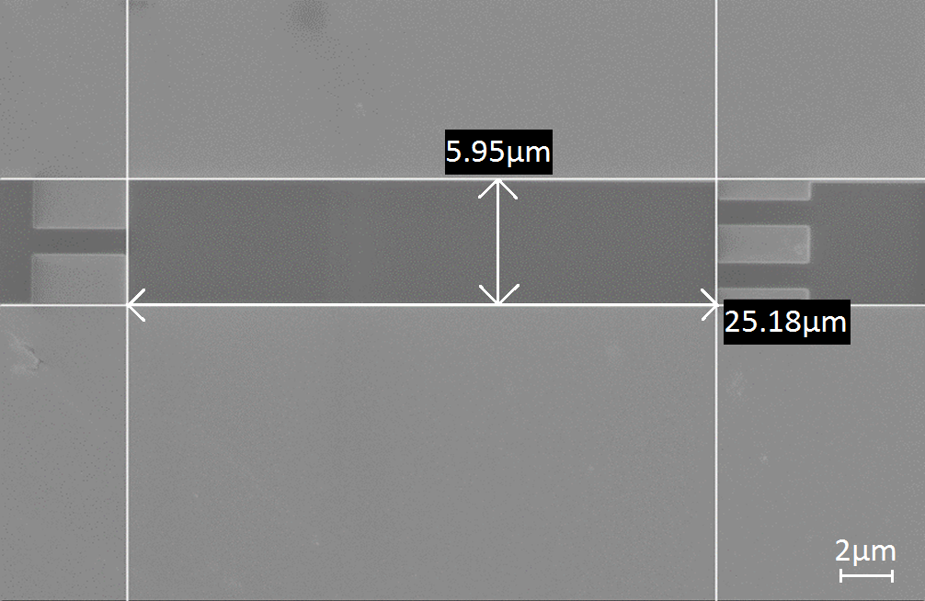
Fig 2. SEM image of an MMI structure with an operating wavelength of λ = 2 µm.
References
[1] LightCounting, "Quarterly market update: December 2015," http://www.lightcounting.com/marketupdate.cfm2015.
[2] C. G. Littlejohns, T. Dominguez Bucio, M. Nedeljkovic, H. Wang, G. Z. Mashanovich, G. T. Reed, et al., "Towards a fully functional integrated photonic-electronic platform via a single SiGe growth step," Scientific Reports, vol. 6, p. 19425, 2016.
[3] M. S. Rouifed, H. Ting, C. G. Littlejohns, L. Chongyong, and W. Hong, "Towards MZI modulator in GeOI and SOI waveguide platforms for mid-infrared wavelengths," in Photonics Conference (IPC), pp. 345-346, 2015.
Presentation Method (Invited/Regular Oral/Poster): Invited

