**Improving the effect of shear on skin viability with wound dressings**

L.A. de Wert1,2, L. Schoonhoven3,4, J.H.C.H. Stegen2,5, A.A. Piatkowski6, R.R. van der Hulst6, M. Poeze1,2, N.D. Bouvy1,2

1. Department of General Surgery, Maastricht University Medical Centre (MUMC+), Maastricht, The Netherlands
2. NUTRIM School of Nutrition and Translational Research in Metabolism, Maastricht University, The Netherlands
3. Faculty of Health Sciences, University of Southampton, Southampton, United Kingdom
4. Radboud University Medical Center, Radboud Institute for Health Sciences, Scientific Institute for Quality of Healthcare, Nijmegen, The Netherlands
5. Department of Human Biology, Maastricht University, The Netherlands
6. Department of Plastic and Reconstructive Surgery, Maastricht University Medical Centre (MUMC+), Maastricht, The Netherlands

**Corresponding author:** Luuk A. de Wert, Department of General Surgery, NUTRIM School of Nutrition and Translational Research in Metabolism, Maastricht University, Universiteitssingel 50, P.O. Box 616, 6200 MD Maastricht. Tel. +31 433882125 Fax +31 433884154, E-mail: [l.dewert@maastrichtuniversity.nl](mailto:l.dewert@maastrichtuniversity.nl)

Key words: Pressure ulcer, wound dressing, shear, IL-1α, reactive hyperaemia

**Highlights**

* Foam dressings protect the skin against the effect of pressure in combination with shear *in vivo*
* Foam dressings reduce IL-1α release and post- load reactive hyperaemia after a combined loading of pressure and shear on skin in humans
* The Mepilex® Border and AquacelTM  foam dressing have better shear relieving capacities than the Allevyn Adhesive dressing

**Abstract**

*Background*

Pressure ulcers are a major healthcare problem and caused by pressure and shear-forces. Although shear-force is understood to be a major contributing factor, no preventive interventions are specifically aimed at relieving the effect of shear on skin to improve skin viability.

*Methods*

A physical model was used to apply a combined loading of 2.4kPa pressure and 14.5 N shear-force on skin in humans. Loading was applied on the volar aspect of both forearms for 30 minutes in ten healthy volunteers. One arm received loading on skin with a wound dressing, the other arm (control) received loading directly on skin. The following parameters were determined before and after loading: IL-1α/Total Protein-ratio (used as a measure of skin damage); Cutaneous blood cell flux ((CBF) measure of reactive hyperaemia); Lactate concentration (measure of tissue ischemia).

Three different dressings were tested on three different days. The order of dressing application, dressing arm and start of the intervention were randomized.

*Results*

Participants mean (SEM) age was 22.5 ±1.6 year with a BMI of 22.3 ±2.4 kg/m2. IL-1α/Total Protein-ratio of the skin was significantly lower after the application of pressure and shear when the Mepilex® (P<0.01), Allevyn (P<0.05) or AquacelTM dressing (P<0.01) was used compared with the control measurement. The Mepilex® dressing was more effective in reducing post-load IL-1α/Total Protein- ratio compared to the Allevyn dressing (P<0.01).

Post- load CBF was significantly lower when the Mepilex® or Aquacel dressing was used (P<0.001). Both dressings induced significantly less post- load CBF than the Allevyn dressing (P<0.01 and P<0.001, respectively).

The concentration of lactate was not significantly increased after the application of pressure and shear and could not be used as a measure with this model.

**Conclusion**

This is the first *in vivo* study to demonstrate that the effects of pressure in combination with shear on skin viability can be improved with foam dressings. In this study, the multi- layered dressings perform better than the single- layered dressing.

1. **Introduction**

A pressure ulcer occurs as a result of prolonged mechanical loading of the skin and underlying tissue. Persons who are bound to a bed or (wheel)chair are at particularly high risk, as pressure ulcers are most likely to develop in areas that are exposed to pressure or pressure in combination with shear, usually at the interface of a supporting surface and the skin over a bony prominence (EPUAP/NPUAP Guidelines 2014). With prevalence rates reported up to 12% in hospitals (Petzold, Eberlein-Gonska et al. 2014), adverse health outcomes and high treatment costs (Schuurman, Schoonhoven et al. 2009, Filius, Damen et al. 2013), it remains a frequent and significant problem. As it is seen as an important quality indicator as well (Lyder, Grady et al. 2004), many efforts are made to reduce the development of pressure ulcers.

Traditionally, pressure ulcer preventive strategies include periodic repositioning (Gillespie, Chaboyer et al. 2014) and reduction of pressure. Although shear is seen as an important contributory factor as well (Reichel 1958, Dinsdale 1974, Bennett, Kavner et al. 1979, Goossens, Zegers et al. 1994, Linder-Ganz and Gefen 2007), preventive interventions are particularly aimed at pressure redistribution and many pressure relieving devices have been developed to accomplish this (McInnes, Jammali-Blasi et al. 2015).

Shear forces are forces that acts parallel on an area of the skin at the interface of a support surface, such that there will be deformation of tissue in parallel and perpendicular planes. Shear forces can become quite high (up to 40 N) in patients, especially at the sacral area when the head of the patient’s bed is elevated (Mimura, Ohura et al. 2009, Gefen, Farid et al. 2013).

To prevent the development of pressure ulcers, the prophylactic application of foam dressings is recommended to areas of the skin exposed to shear, such as the sacral area or heels (Black, Clark et al. 2015). These dressings can possibly relieve the harmful effects of shear on the skin and protects the skin against breakdown. However, this is only supported by *ex vivo* laboratory test results (Ohura, Ichioka et al. 2005, Ohura, Takahashi et al. 2008, Call, Pedersen et al. 2015). Therefore, it remains unclear if foam dressings can actually improve skin viability by reducing the effect of shear on the skin in humans and if so, what type of foam dressing performs best.

In a previous study (de Wert, Bader et al. 2015) we described a novel method which enables us to evaluate the effects of both pressure and shear in healthy volunteers. After a combined loading of both pressure and shear for 30 minutes on the skin in humans, a higher increase in IL-1α/Total protein- ratio and reactive hyperaemia was measured compared to the response of applied pressure alone. Consequently, this method provides us the opportunity to evaluate foam dressings aimed at relieving the effect of shear on skin *in vivo.*

Therefore, the aim of this study was to investigate if wound dressings are capable of improving the effect of shear on skin viability in humans. Furthermore, we wanted to investigate if multi- layered foam dressings perform better than a single layered foam dressing. To accomplish this, we investigated the response of the skin in healthy participants after a combined loading of pressure and shear in the absence or presence of three commercially available foam dressings.

1. **Methods**

*2.1 Ethical considerations*

The study was approved by the medical ethics committee of the Maastricht University medical Centre. The research protocol was registered in the clinicaltrials.gov database as number NCT02348671. The study was conducted in compliance with ethical rules for human experimentation that are stated in the Declaration of Helsinki and monitored according to the principles of Good Clinical Practice. Written informed consent was obtained of all participants.

* 1. *Physical model*

A sphysical model was used as previously described (de Wert, Bader et al. 2015). Briefly, this model included an identer: an anti-slipmat (Digibuddy, Onni-tec GmbH, Germany) of 50 X 50 mm, which was placed on the volar aspect of the forearm and loaded with a 1 kg lead. A 1.7 kg mass was connected with a line to produce shear on skin. Due to friction in the pulley and an angle of 15°, the actual shear was 14.5 N (measured with a spring balance) with a pressure of 2.4 kPa. A picture of the physical model is presented in figure 1.

*2.3 Participants and procedures*

Inclusion criteria were: healthy male volunteer, age between 20- 30 years and a Body Mass Index (BMI) ranged between 20- 30 kg/m2. Participants were not able to participate if they had any active skin diseases. In addition, other exclusion criteria were: Diabetes Mellitus, trauma at the volar aspect of their forearms, muscular dystrophy, malignancy and non- steroidal anti- inflammatory drugs intake the last seven days. Participants were not allowed to drink caffeine/ alcohol or smoke before the experiment on a test day.

Three commercially available wound dressings were tested (Figure 1 and table 1) in all participants on three separate test days. Age, height, weight, BMI, and blood pressure of all participants were recorded.

On a test day, the participants were asked to relax both their arms on a support cushion for a acclimatisation period of 20 minutes at room temperature (21°C + 0.4). The borders of a 50 mm x 50 mm area (equivalent to the area of the shear pad) on the volar aspect of both forearms at 2 cm of the centre of the cubital fossa were marked with a permanent marker. Baseline measurements of the unloaded skin of both forearms (dressing arm and control arm) were performed, incorporating: collection of IL-1α, Total Protein and lactate acid from the skin with the placement of a Sebutape sample (Cuderm Corp, Dallas, TX) in the centre of the marked area for two minutes, and cutaneous blood cell flux measurement performed with a Laser Doppler imaging system (MoorLDI2- Burn Imager, Moor Instruments Ltd, Axminster, United Kingdom).

We used the physical model as previously described. The identer of the shear model was placed over the marked area to apply a combined loading of 2.4kPa in combination with 14.5 N shear on the skin. One arm received loading on the skin with a dressing between the shear model and the skin (dressing arm). The other arm served as a control and received loading directly on the skin (control arm). After 30 minutes of loading, the measurements with the Sebutape and Laser Doppler were repeated and these represent the post- load measurements (see Figure 3). Every Sebutape was placed in a vial and stored in a -80°C freezer until further processing.

The test protocol was repeated at two other test days in every participant to investigate the other dressings. For every participant, at least 24 hours was between each test day to make sure that cutaneous blood flow and IL-1α concentrations returned to normal baseline levels before the test protocol was repeated.

The order of dressing application, the site of dressing application (left or right arm) and the start of the intervention with or without dressing (control measurement) were randomized for each participant.

*2.4 Biochemical analysis*

A Sebutape sample, whichrepresents **a small adhesive patch, was** used to absorb proteins and lactate from the skin in a non-invasive manner. Two millilitre (ml) of Phosphate Buffered Saline was added to each Sebutape sample and then sonicated for ten minutes and vortexed for a further two minutes. The extraction of proteins and metabolites from the Sebutape was based on a study by Perkins et al(Perkins, Osterhues et al. 2001).

Lactate concentration in the samples was enzymatically analysed using the Cobas Fara Centrifugal Spectrophotometer (Roche Diagnostica, Basel, Switzerland).

IL-1α concentration in the samples was measured by a commercially available human IL-1α/ IL1F1 enzyme-linked immunosorbent assay (ELISA)kit (DuoSet R&D system) with a detection range of 3.9- 250 pg/ml. To correct for differences in sebum uptake during each collection period, IL-1α concentration was divided by the total protein (TP) concentration (µg/ml) measured in the samples to calculate the IL-1α/ TP- ratio. To measure the amount of total protein, the Thermo Scientific TM Micro BCA Protein Assay Kit (Pierce Biotechnology) was used with a detection range of 0.5- 20 µg/ml.

*2.5 Biophysical analysis*

Cutaneous blood flow measurements were performed with the Moor LDI2 burn imager. A single point laser beam scanned the skin back and forth creating a cutaneous blood cell flux map to measure the mean velocity of the red blood cells. The laser (infra-red, 785 nm wavelength) probed the full dermal thickness, approximately 1-2 mm into the skin. The acquisition depth of the laser is tissue dependent and influenced by the amount of pigmentation. A region of interest (ROI) of 30 mm x 30 mm was selected in the cutaneous blood cell flux map and the mean cutaneous blood cell flux of the ROI was calculated with the Moor software version 5.3.

*2.6 Statistical methods*

GraphPad Prism 5 (GraphPad Software Inc. San Diego, CA) and SPSS statistics version 20 (SPSS Inc, Chigaco,IL) for Windows were used to analyse the data.

Normality was tested with the D’Agostino Pearson Omnibus test. A parametric test was used when data was distributed normally, or a non- parametric test for a non-normal distribution. The non-parametric Wilcoxon signed rank test was used to determine significance between paired comparisons.

To determine which dressing was most effective, the increase compared with baseline values was calculated for control (without dressing) and dressing values. These calculated values were used to determine the relative change (in %) between the dressing and their subsequent control value to compensate for intra- individual variability. The non-parametric Friedmann test followed by Dunn’s multiple comparison test was used to determine statistically significant differences in the increase (in %) between the three dressings. Data are expressed as mean ± standard deviation or median + interquartile range. For graphical purposes, the results are presented as means ± standard error of mean (SEM). A statistical significance level of 5% was prescribed (P<0.05).

1. **Results**

Ten healthy male Caucasian volunteers were included in this study. Every volunteer finished the three test days with no drop- outs or missing data reported. Mean (SEM) age was 22.5 ±1.6; mean height was 1.87 ±0.1 metres; mean weight was 78.0 ±11.8 kg with a BMI of 22.3 ±2.4 kg/m2.

*3.1 IL-1α/TP- ratio*

The IL-1α/TP- ratio after the application of pressure and shear was significantly lower when the dressings were attached to the skin compared with their own control measurement (Fig. 4A, B and C). When the three dressings were compared to each other, the calculated change in IL-1α/TP (in %) was statistically lower when the Mepilex® border dressing was used compared to the Allevyn Adhesive dressing (Fig. 7A, P<0.01), but was not statistically different compared to the Aquacel™ foam dressing (Fig. 2D, P>0.05). No statistically significant differences were found between the Allevyn Adhesive and the Aquacel™ foam dressing (Fig. 7A, P>0.05).

*3.2 Cutaneous blood cell flux*

Typical perfusion images are presented in figure 5. When a combined loading of pressure and shear was applied to the skin, the cutaneous blood cell flux was significantly lower when the Mepilex® border dressing or the Aquacel™ foam dressing was attached to the skin compared to the control measurement without a dressing (Fig. 6A and B, P<0.001). Although the Allevyn Adhesive dressing reduces the amount of post- load reactive hyperaemia too, the mean difference of 114.6 ±173.1 arbitrary units (AU) was not significantly lower compared to its own control measurement (Fig. 6C. P>0.05). Relative change in cutaneous blood cell flux (in %) was not statistically different between the Mepilex® border dressing and Aquacel™ foam dressing. However, both dressings induced significantly less post- load cutaneous blood cell flux than the Allevyn Adhesive dressing (Fig. 7B. P<0.01 and P<0.001, respectively).

­­

*3.3 Lactate*

No statistically significant increase in lactate concentration was measured when pressure and shear was applied to the skin for 30 minutes compared with baseline measurement (28.8 ±18.0 µmol/L vs 37.3 ±25.1 µmol/L, P=0.07). Therefore, lactate could not be used as a measure to evaluate shear relieving capacities of dressings with this model.

1. **Discussion**

The factor shear has been known to play an important role in the development of pressure ulcers for a long time (Reichel 1958, Dinsdale 1974, Bennett, Kavner et al. 1979). With the help of a new validated shear model (de Wert, Bader et al. 2015) we were able to evaluate the protective effect of three commercially available foam dressings against a combined loading of pressure and shear. The Mepilex® border, Allevyn Adhesive and Aquacel™ foam dressings were chosen, because the manufacturers claim that these dressings can relieve the amount of shear on the skin and can be used as an addition to pressure ulcer preventive strategies. Indeed, this study demonstrated that all three foam dressings reduced epidermal IL-1α release and two foam dressing induced less post-load reactive hyperaemia in reaction to pressure and shear loading on the skin in healthy participants. Therefore, this study is the first to demonstrate that foam dressings can relieve the effects of pressure in combination with shear *in vivo.*

The increase in IL-1α/TP- ratio was used as a measure of skin damage after loading on the skin (D , Lee, Briggs et al. 1997, Bronneberg, Spiekstra et al. 2007, Cornelissen, Bronneberg et al. 2009). IL-1α is a damage-associated molecular pattern and stored in in the healthy keratinocytes, there it will be rapidly released in the extracellular matrix when the keratinocytes becomes mechanically damaged (Wood, Elias et al. 1996, Lee, Briggs et al. 1997, Cornelissen, Bronneberg et al. 2009). In the previous study (de Wert, Bader et al. 2015), the IL-1α response was particularly pronounced after 30 minutes of pressure and shear loading. Once released in the extracellular matrix, it induces the production and secretion of other cytokines which are essential in the process of wound healing. Although IL-1α is just a single measure of the inflammatory reaction to skin damage, it seems an excellent way to measure predominant damage in epithelial cells (Suwara, Green et al. 2014). Furthermore, Wood and colleagues (Wood, Elias et al. 1996) demonstrated that IL-1α is immediately released from keratinocytes when the skin barrier is disrupted. Clearly, the results of the present study shows that foam dressings protects the skin against direct damage caused by pressure in combination with shear, because all three foam dressings were capable to reduce the post-load IL-1α release.

Another important finding was the reduction of post- load reactive hyperaemia when the Mepilex® border dressing or Aquacel™ foam dressing were applied to protect the skin. In the present study, the reactive hyperaemic response was measured with a Laser Doppler Flowmeter and expressed in cutaneous blood cell flux (in arbitrary units). Post- load reactive hyperaemia is the increase in cutaneous blood flow and normally appears as an reaction on tissue hypoxia and tissue deformation (Bliss 1998, Liao, Burns et al. 2013, Iredahl, Lofberg et al. 2015). It is interesting to note that the concentration of lactate, which was used as a measure for tissue hypoxia, was not significantly higher after a combined loading of pressure and shear for 30 minutes compared with baseline measurements. Therefore, it is likely that the reduction in reactive hyperaemia after the application of the Mepilex® border dressing and Aquacel™ foam dressing was mainly caused by protection against tissue deformation rather than protection against tissue ischemia.

Normally, two pathophysiological pathways are responsible for cell damage caused by mechanical loading (Stekelenburg, Gawlitta et al. 2008). First, mechanical loading can activate a slow process by compressing blood and lymph vessels. Consequently, tissue becomes ischaemic, metabolic waste products (for example lactate) will accumulate and the interstitial pH will decrease. However, the first signs of histological cellular damage will only be visible after a couple of hours (Gawlitta, Li et al. 2007, Stekelenburg, Strijkers et al. 2007).

Second, a much faster process may occur when mechanical loading on the skin becomes high. In this case, the cellular membrane and cytoskeleton becomes disrupted and the first signs of cellular damage are already visible within 10 minutes (Oomens, Bader et al. 2014). This could explain why the concentration of lactate was not significantly increased within 30 minutes, as it is associated with slow ischaemic damage. In contrast, the IL-1α response is more likely to be associated with the faster direct deformation damage.

In the present study, the Mepilex® border dressing and Aquacel™ foam dressing performed better than the Allevyn Adhesive dressing. A possible explanation could be the fact that the the Mepilex® border dressing and Aquacel™ foam dressing are both multi- layered foam dressings compared with the single- layered Allevyn Adhesive dressing. This is in line with an earlier observation based on a theoretical finite element model of Levy and colleagues (Levy, Frank et al. 2015). They reported a higher decrease in tissue strains when a multi- layered dressing was used compared with a single layered dressing, because the internal deformation in the dressing becomes higher when a multi-layered dressing is used. However, because of the heterogeneous nature (different material combinations, geometry not fully comparable) of the dressings used in the present study, it is difficult to determine the Mepilex® border and Aquacel™ foam dressing were more effective in improving the effect of shear on skin viability due to their multi- layered foam design. Many other aspects other aspects like material stiffness, material thickness, chemistry of skin contact layer may have influence on the shear absorbing capacities of dressings as well.

Recently, some clinical evidence shows that wound dressings can reduce the incidence of pressure ulcers when used as an adjunct to pressure ulcer prevention strategies (Brindle and Wegelin 2012, Chaiken 2012, Santamaria, Gerdtz et al. 2015). Unfortunately, these studies had a high risk of bias and firm conclusions should not be drawn from these trials (Moore and Webster 2013, Clark, Black et al. 2014).

Several *ex vivo* studiesevaluated the shear reducing capacities of different types of dressings (Ohura, Ichioka et al. 2005, Ohura, Takahashi et al. 2008, Call, Pedersen et al. 2015). Ohura and colleagues (Ohura, Takahashi et al. 2008) were the first to investigate the shear relieving capacities of wound dressings. In their study, shear was applied over an excised piece of porcine skin with a sensor placed underneath it. A lower amount of shear force was measured when different types of wound dressing were applied over the porcine skin. A more recent study performed by Call and colleagues (Call, Pedersen et al. 2015) demonstrated in a laboratory bench setting the potential shear reducing capacities of different types foam dressings as well. Although, both studies demonstrated that dressings are capable in reducing the amount of shear, they did not investigate if foam dressings could improve the effect of shear on skin viability.

Derler and colleagues (Derler, Rotaru et al. 2014) demonstrated that the friction coefficient between the skin interface and textile can be reduced with a novel medical bed sheet in comparison with a normal hospital bed sheet especially under wet conditions. Skin moisture represents an important extrinsic factor in the development of pressure ulcers. When skin becomes wet, the friction coefficient increases, which in turn, could lead to larger shear strains on the skin surface and deeper skin layers. Moreover, moisture uptake by the skin induces skin softening and smoothening which makes the skin particularly for skin barrier damage (Gerhardt, Strassle et al. 2008), so foam dressings should be able to handle moisture (in the form of sweat) before they are used as a preventive measure. Although the fluid- handling capacity of the foam dressings was not investigated in the present study, several other studies demonstrated that foam dressings have good fluid handling properties (Young S 2007, Thomas and Young 2008, Thomas 2010).

In the previous study (de Wert, Bader et al. 2015), the pressure of 2.5 kPa and shear of 14.5 N produced significant changes on the robust parameters derived from the measurement techniques after only 30 minutes of loading. In addition, it is a realistic representation of the clinical setting where patients are exposed to a mean physiological shear between 5-20 N and a mean pressure between 2.5- 8.0 kPa on a standard support mattress (Mimura, Ohura et al. 2009). However, the results of the present study cannot be directly translated to patients at risk for pressure ulcers, who are normally critically ill, have multiple co-morbidities, high age, and/or other underlying diseases. Another limitation is the short loading period of 30 minutes, because loading periods could be much longer (up to several hours) in a clinical setting. However, such a long period of loading was undesirable, to avoid severe skin damage in the human volunteers. The relatively short loading period of only 30 minutes was possibly the main reason that lactate could not be used as a measure for pressure and shear in this study. In addition, the type of loading included only continuous loading whereas loading in a clinical setting loading includes alternating short-term loading too.

Another comment needs to be placed on the fixation strength of the Aquacel™ foam dressing. The dressings did not remain in place when they were loaded with the prescribed amount of pressure and shear, because only the borders adhere to the skin to reduce pain and trauma upon removal. In a clinical setting, the use of this dressing could lead to problems if not fixated properly.

Recommendations for optimisation of dressings design should include a multi-layered composition a low friction coefficient of the outer layer and good fluid handling capacities. However, to investigate if multi-layered dressings are indeed better in absorbing shear in comparison with single-layered dressings, future research should include dressings made out of exactly the same materials (i.e. foam, skin contact layer and backings) with only different numbers of foam layers. Unfortunately, these dressing are currently not commercially available.

In conclusion, this is the first *in vivo* study to demonstrate that foam dressings can improve the effects of shear on skin viability in humans. Therefore, they might be useful in pressure ulcer preventive strategies. Secondly, the multi- layered foam dressings performed better in improving the effects of shear on skin viability when compared to a single-layered foam dressing in this study.

**Acknowledgement**

This study was funded with a Kootstra Talent Fellowship (Maastricht University Medical Centre). The authors have no conflict of interest and nothing to disclose. The dressings were ordered online by the research team. The manufacturers of the dressings did not know that the study was carried out. Therefore, they had no role in the design of the study, acquisition of subjects, acquisition of data, analysis/ interpretation of data and preparation of the manuscript.

**References**

Bennett, L., et al. (1979). "Shear vs pressure as causative factors in skin blood flow occlusion." Arch Phys Med Rehabil 60(7): 309-314.

Black, J., et al. (2015). "Dressings as an adjunct to pressure ulcer prevention: consensus panel recommendations." Int Wound J 12(4): 484-488.

Bliss, M. R. (1998). "Hyperaemia." J Tissue Viability 8(4): 4-13.

Brindle, C. T., et al. (2012). "Prophylactic dressing application to reduce pressure ulcer formation in cardiac surgery patients." J Wound Ostomy Continence Nurs 39(2): 133-142.

Bronneberg, D., et al. (2007). "Cytokine and chemokine release upon prolonged mechanical loading of the epidermis." Exp Dermatol 16(7): 567-573.

Call, E., et al. (2015). "Enhancing pressure ulcer prevention using wound dressings: what are the modes of action?" Int Wound J 12(4): 408-413.

Chaiken, N. (2012). "Reduction of sacral pressure ulcers in the intensive care unit using a silicone border foam dressing." J Wound Ostomy Continence Nurs 39(2): 143-145.

Clark, M., et al. (2014). "Systematic review of the use of prophylactic dressings in the prevention of pressure ulcers." Int Wound J 11(5): 460-471.

Cornelissen, L. H., et al. (2009). "The transport profile of cytokines in epidermal equivalents subjected to mechanical loading." Ann Biomed Eng 37(5): 1007-1018.

D, B. "In vivo detection of grade I pressure ulcers."

de Wert, L. A., et al. (2015). "A new method to evaluate the effects of shear on the skin." Wound Repair Regen.

Derler, S., et al. (2014). "Microscopic contact area and friction between medical textiles and skin." J Mech Behav Biomed Mater 38: 114-125.

Dinsdale, S. M. (1974). "Decubitus ulcers: role of pressure and friction in causation." Arch Phys Med Rehabil 55(4): 147-152.

Filius, A., et al. (2013). "Cost analysis of surgically treated pressure sores stage III and IV." J Plast Reconstr Aesthet Surg 66(11): 1580-1586.

Gawlitta, D., et al. (2007). "The relative contributions of compression and hypoxia to development of muscle tissue damage: an in vitro study." Ann Biomed Eng 35(2): 273-284.

Gefen, A., et al. (2013). "A review of deep tissue injury development, detection, and prevention: shear savvy." Ostomy Wound Manage 59(2): 26-35.

Gerhardt, L. C., et al. (2008). "Influence of epidermal hydration on the friction of human skin against textiles." J R Soc Interface 5(28): 1317-1328.

Gillespie, B. M., et al. (2014). "Repositioning for pressure ulcer prevention in adults." Cochrane Database Syst Rev 4: CD009958.

Goossens, R. H., et al. (1994). "Influence of shear on skin oxygen tension." Clin Physiol 14(1): 111-118.

Iredahl, F., et al. (2015). "Non-Invasive Measurement of Skin Microvascular Response during Pharmacological and Physiological Provocations." PLoS One 10(8): e0133760.

Lee, R. T., et al. (1997). "Mechanical deformation promotes secretion of IL-1 alpha and IL-1 receptor antagonist." J Immunol 159(10): 5084-5088.

Levy, A., et al. (2015). "The biomechanical efficacy of dressings in preventing heel ulcers." J Tissue Viability 24(1): 1-11.

Liao, F., et al. (2013). "Skin blood flow dynamics and its role in pressure ulcers." J Tissue Viability 22(2): 25-36.

Linder-Ganz, E., et al. (2007). "The effects of pressure and shear on capillary closure in the microstructure of skeletal muscles." Ann Biomed Eng 35(12): 2095-2107.

Lyder, C. H., et al. (2004). "Preventing pressure ulcers in Connecticut hospitals by using the plan-do-study-act model of quality improvement." Jt Comm J Qual Saf 30(4): 205-214.

McInnes, E., et al. (2015). "Support surfaces for pressure ulcer prevention." Cochrane Database Syst Rev 9: CD001735.

Mimura, M., et al. (2009). "Mechanism leading to the development of pressure ulcers based on shear force and pressures during a bed operation: influence of body types, body positions, and knee positions." Wound Repair Regen 17(6): 789-796.

Moore, Z. E., et al. (2013). "Dressings and topical agents for preventing pressure ulcers." Cochrane Database Syst Rev 8: CD009362.

Ohura, N., et al. (2005). "Evaluating dressing materials for the prevention of shear force in the treatment of pressure ulcers." J Wound Care 14(9): 401-404.

Ohura, T., et al. (2008). "Influence of external forces (pressure and shear force) on superficial layer and subcutis of porcine skin and effects of dressing materials: are dressing materials beneficial for reducing pressure and shear force in tissues?" Wound Repair Regen 16(1): 102-107.

Oomens, C. W., et al. (2014). "Pressure Induced Deep Tissue Injury Explained." Ann Biomed Eng.

Perkins, M. A., et al. (2001). "A noninvasive method to assess skin irritation and compromised skin conditions using simple tape adsorption of molecular markers of inflammation." Skin Res Technol 7(4): 227-237.

Petzold, T., et al. (2014). "Which factors predict incident pressure ulcers in hospitalized patients? A prospective cohort study." Br J Dermatol 170(6): 1285-1290.

Reichel, S. M. (1958). "Shearing force as a factor in decubitus ulcers in paraplegics." J Am Med Assoc 166(7): 762-763.

Santamaria, N., et al. (2015). "A randomised controlled trial of the effectiveness of soft silicone multi-layered foam dressings in the prevention of sacral and heel pressure ulcers in trauma and critically ill patients: the border trial." Int Wound J 12(3): 302-308.

Schuurman, J. P., et al. (2009). "Economic evaluation of pressure ulcer care: a cost minimization analysis of preventive strategies." Nurs Econ 27(6): 390-400, 415.

Stekelenburg, A., et al. (2008). "Deep tissue injury: how deep is our understanding?" Arch Phys Med Rehabil 89(7): 1410-1413.

Stekelenburg, A., et al. (2007). "Role of ischemia and deformation in the onset of compression-induced deep tissue injury: MRI-based studies in a rat model." J Appl Physiol (1985) 102(5): 2002-2011.

Suwara, M. I., et al. (2014). "IL-1alpha released from damaged epithelial cells is sufficient and essential to trigger inflammatory responses in human lung fibroblasts." Mucosal Immunol 7(3): 684-693.

Thomas, S. (2010). "Laboratory findings on the exudate-handling capabilities of cavity foam and foam-film dressings." J Wound Care 19(5): 192, 194-199.

Thomas, S., et al. (2008). "Exudate-handling mechanisms of two foam-film dressings." J Wound Care 17(7): 309-315.

Wood, L. C., et al. (1996). "Barrier disruption stimulates interleukin-1 alpha expression and release from a pre-formed pool in murine epidermis." J Invest Dermatol 106(3): 397-403.

Young S, B. A., Milne J (2007). "Use of ultrasound to characterise the fluid-handling characteristics of four foam dressings." Journal of Wound Care 425(8): 430-431.

**Tables and figures**

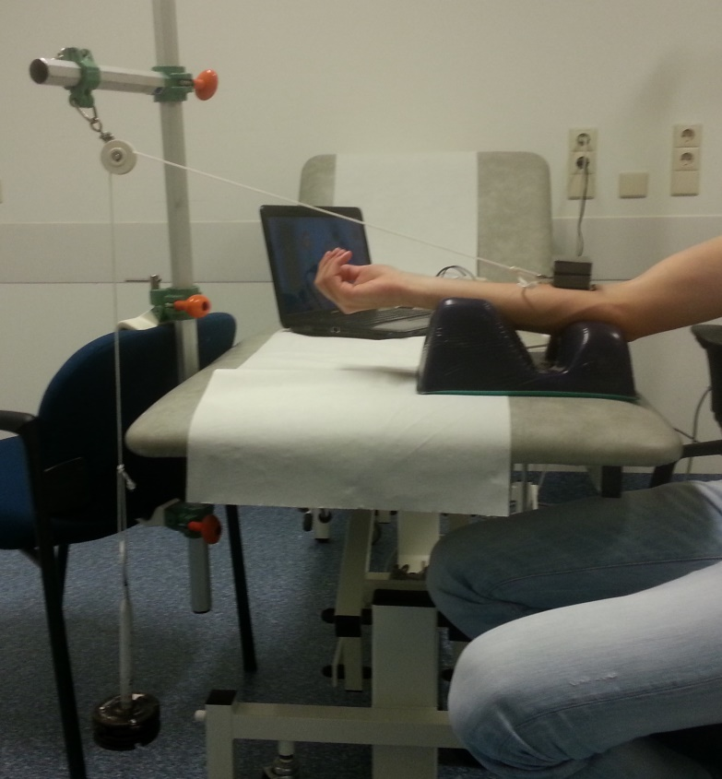

**Figure 1.** Physical model. An antislip mat (50 mm X 50 mm) was placed at the volar aspect of the forearm and exposed to a 1 kg lead. To ensure stability of the lead weight, the line was set at a 15° angle.

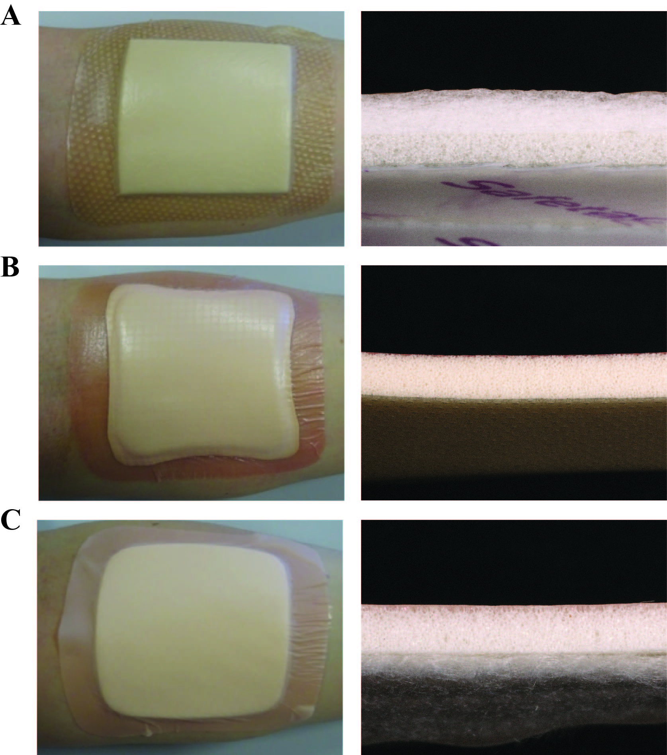

**Figure 2.** Photographs of the dressings and cross-sectional views through the dressing. A= Mepilex® Border dressing, B= Allevyn Adhesive dressing, C= AquacelTM Foam dressing.

**Table 1.** Dressings used in this study

|  |  |  |  |  |  |  |
| --- | --- | --- | --- | --- | --- | --- |
| Brand name | Materials | Foam layers | Skin contact layer | Size | Thickness | Manufacturer |
| Mepilex® Border | Polyurethane foam, non- woven spreading layer, polyacrylate fibres | 3 | Silicon adhesive | 10 cm x 10 cm | 4 mm | Mölnlycke Healthcare AB,  Göteborg, Sweden |
| Allevyn Adhesive | Hydrocellular foam | 1 | Silicon adhesive | 10 cm x 10 cm | 4mm | Smith & Nephew, London, England |
| Aquacel™ Foam | Polyurethane foam, hydrofiber | 2 | Border: silicon adhesive, centre: hydrofiber | 10 cm x 10 cm | 4mm | Convatec inc, Skillman, USA |

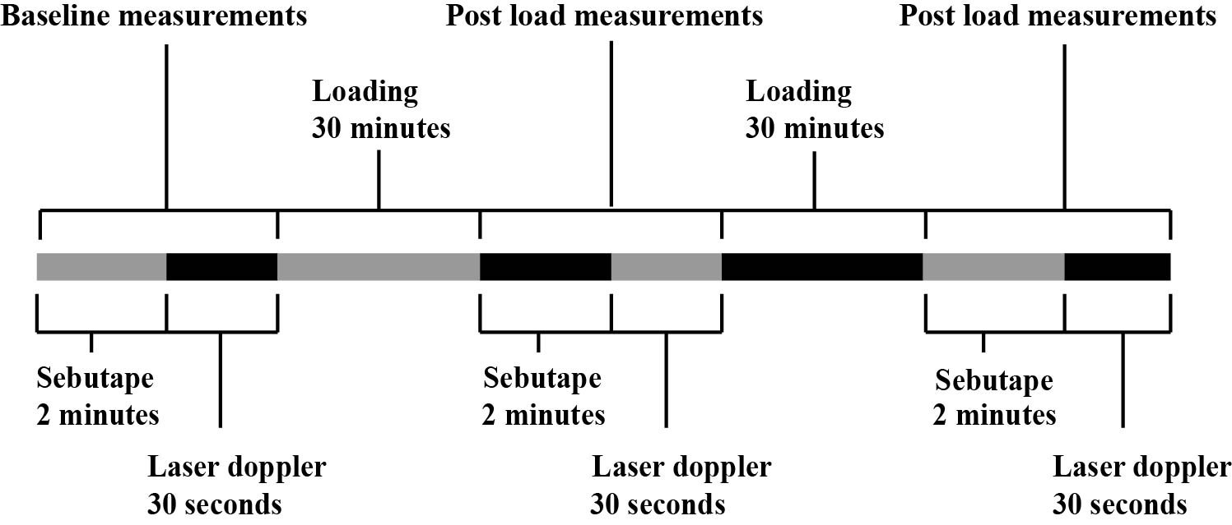

**Figure 3.** Experimental design. Baseline measurements were performed at the same time on both arms. Loading was applied on the skin of the dressing arm or control arm followed by a post-load measurement with the Sebutape and Laser Doppler. Then loading was applied on the skin of the other arm (dressing arm or control arm) followed by a post- load measurement with the Sebutape and Laser Doppler. Dressing arm (left or right) and start of the intervention (with or without dressing) were randomized.

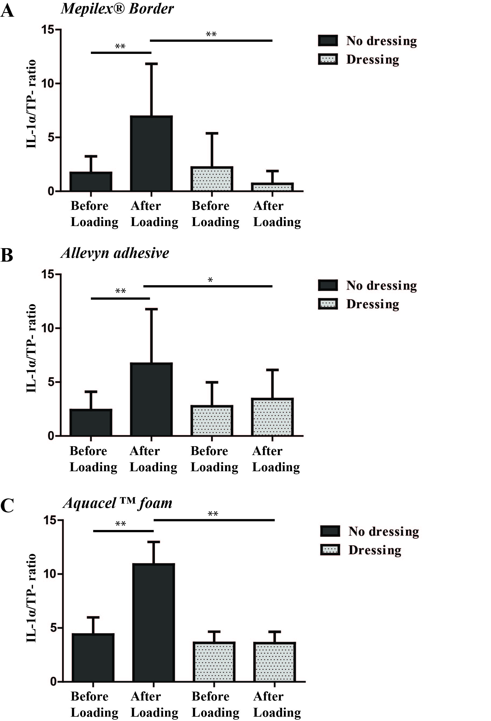

**Figure 4.** IL-1α/TP-ratio (x 10-6). presented as mean (SEM). ** indicates P< 0.001 (Wilcoxon signed rank test). * indicates P<0.05, ** indicates P< 0.01 (Wilcoxon signed rank test).

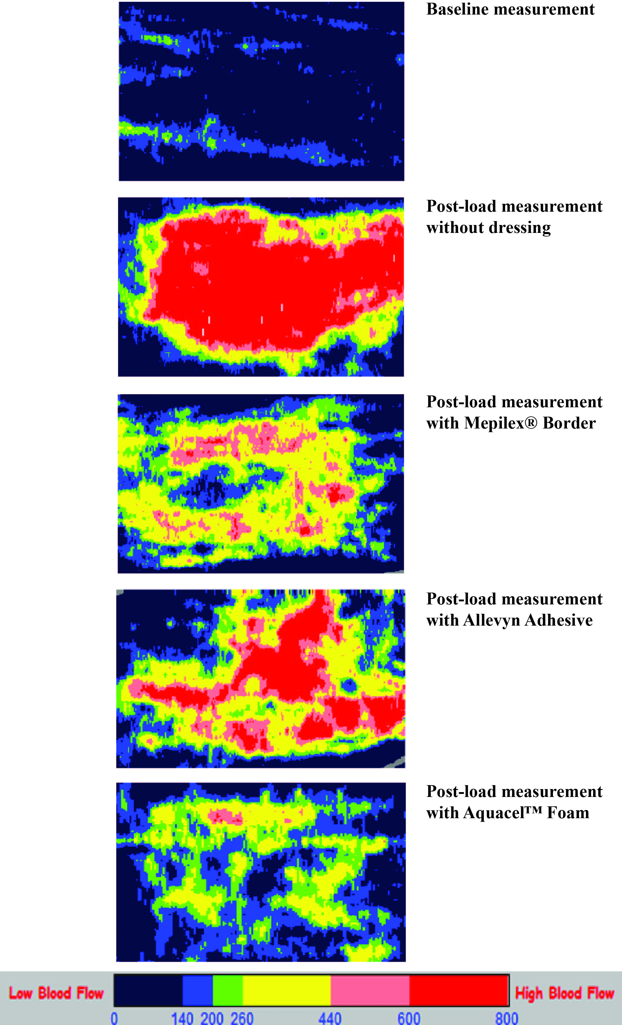

**Figure 5.** Cutaneous Blood cell flux images created with the Moor LDI2- burn imager.

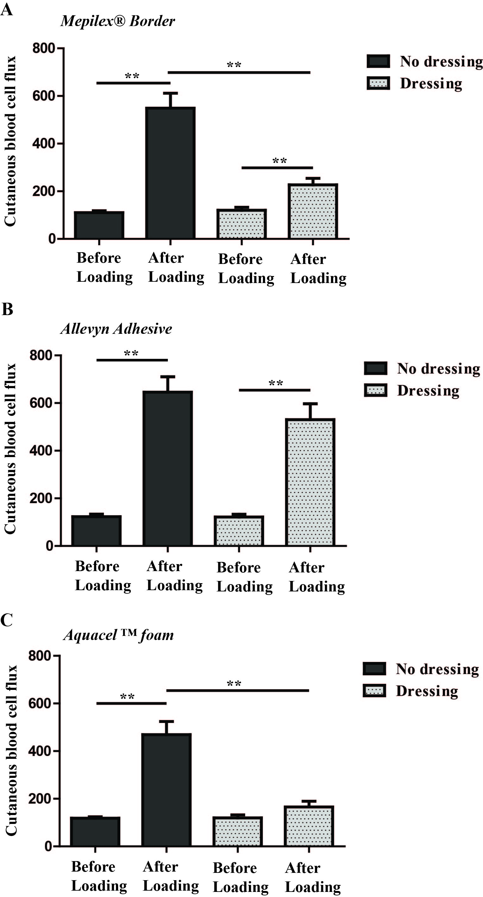

**Figure 6.** Cutaneous Blood Cell Flux (in arbitrary units) presented as mean (SEM). ** indicates P< 0.001 (Wilcoxon signed rank test).

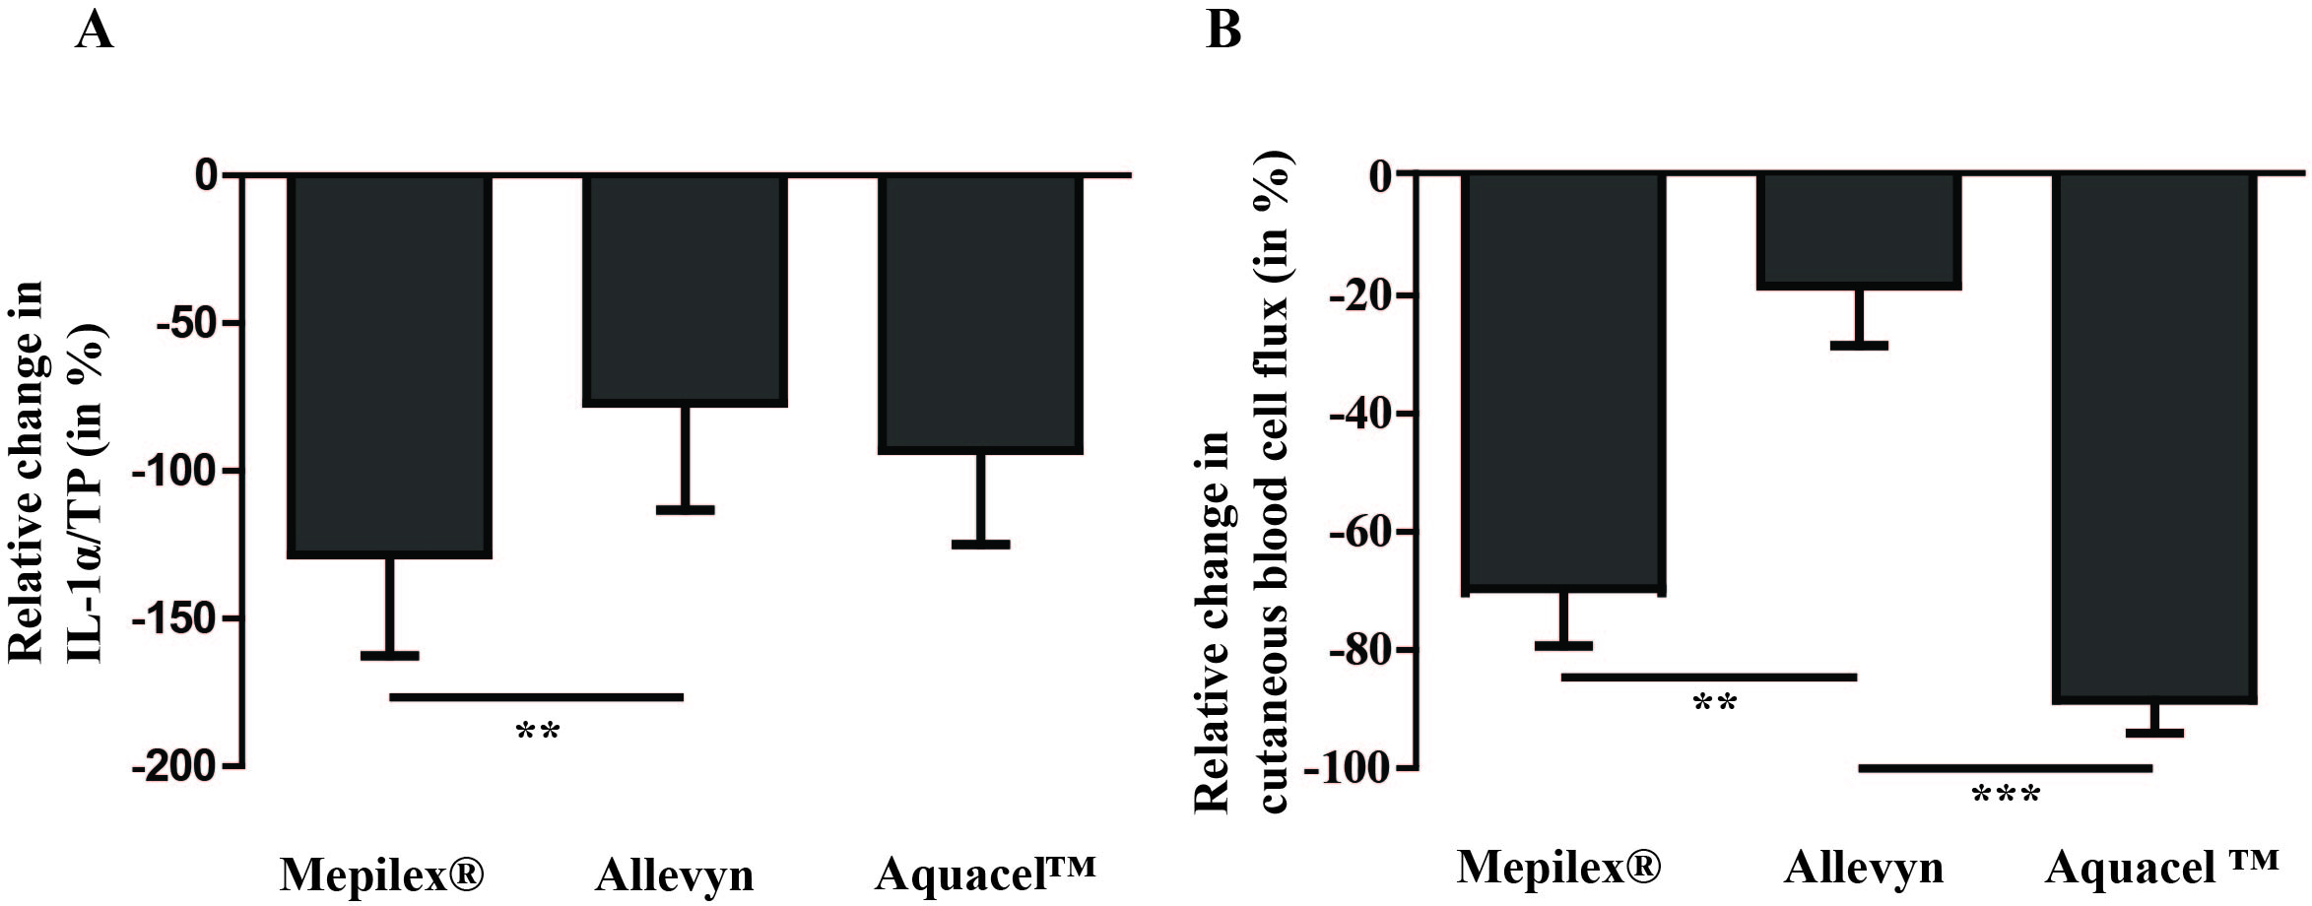

**Figure 7.** Effectiveness of the dressings compared to each other. The increase compared with baseline values was calculated for control (without dressing) and dressing values. These calculated values were used to determine the relative change (in %) between the dressing and their subsequent control value to compensate for intra- individual variability. A. IL-1α/TP increase in percentage. B. Cutaneous blood cell flux increase in percentage.

** Indicates P<0.01, *** indicates P<0.001 (Friedmann test with Dunn’s multiple comparison test).