G-quadruplexes mediate local translation in neurons
AUTHORS: James Schofield, Joanne Cowan and Mark Coldwell
KEY WORDS: mRNA, translation, G-quadruplex, FMRP, Pur-α, hnRNP A2
ABBREVIATIONS: UTR, untranslated region; NRAS, Neuroblastoma RAS viral (v-ras) oncogene homolog; mRNP, messenger ribonucleoprotein particles; FMRP, fragile X mental retardation protein; RBP, RNA-binding protein; FXTAS, fragile X-associated tremor/ataxia syndrome; PSD-95, postsynaptic density protein 95; CaMKIIα, calcium-binding protein calmodulin (CAM)-dependent kinase IIα; mGluR, metabotropic glutamate receptor

Abstract
There has recently been a huge increase in interest in the formation of stable G-quadruplex structures in mRNAs, and their functional significance. In neurons, local translation of mRNA is essential for normal neuronal behaviour. It has been discovered that local translation of specific messenger RNAs (mRNAs) encoding some of the best known synaptic proteins is dependent on the presence of a G-quadruplex . The recognition of G-quadruplexes in mRNAs, through the transport as repressed complexes, and the control of their translation at their subcellular destinations involves a diversity of proteins, including those associated with disease pathologies. This is an exciting field, with rapid improvements to our knowledge and understanding. Here, we discuss some of the recent work on how G-quadruplexes mediate local translation in neurons.

Introduction
The translation of specific mRNA at distinct subcellular localisations allows modification of the local proteome, independent of general translation in the cell. Environmental cues lead to rapid changes in discrete local proteomes, and the complex regulation of local translation involves controlled mRNA targeting and transport as well as stimulus-controlled translation of the message. Spatially differentiated translation of mRNA allows dynamic regulation of the local proteome, and neurons make use of complex, poorly understood mechanisms for controlling the packaging, targeting and controlled local translation of specific mRNAs. Aberrations in these processes are responsible for neurological diseases [1–4].

G-quadruplex secondary structures in mRNA
Unstructured mRNA molecules are single stranded, however, specific sequences cause conformational changes into stable secondary structures. While formation of hairpin structures in G-C rich sequences, is widely understood, less well studied are Guanine-rich nucleotide sequences, which can form stable G-quadruplex structures. Guanine nucleotides adopt a planar tetrad via hydrogen bonds; each guanine nucleotide donates and accepts two electrons (Figure 1a). These tetrads stack (Figure 1b), promoted by monovalent cations, particularly K⁺, to form increasingly stable G-quadruplexes [5].
The C2’ hydroxyl groups of ribose in RNA forms additional intramolecular hydrogen bonds, yielding more stable G-quadruplexes than in DNA [6].DNA quadruplexes have been shown to exist as parallel or antiparallel structures. RNA G-quadruplexes predominately form parallel quadruplexes due to alterations in the phosphate backbone resulting from the orientation of the C2’ hydroxyl groups of ribose in RNA [7]. There are many bioinformatics tools available for the identification of potential G-quadruplex-forming nucleotide sequences, including Quadruplex forming G-Rich Sequences (QGRS) Mapper [8].

Cis-acting G-quadruplex RNA structures regulate translation of mRNA
Predicted G-quadruplex structures are common in 5’ untranslated regions (UTRs) of mRNAs. A recent study estimates ~3000 human mRNA 5’ UTRs contain predicted quadruplex-forming sequences [9]. G-quadruplexes in the 5’ UTR of mRNAs have been shown to regulate translation initiation rates by limiting the binding of the 43S pre-initiation ribosomal complex or slowing the migration of the 48S scanning ribosome. The 5’ UTR G-quadruplex of the proto-oncogene, Neuroblastoma RAS viral (v-ras) oncogene homolog (NRAS), was shown to inhibit protein expression by ~80% in vitro [9]. The NRAS G-quadruplex must be within ~50-100 nucleotides of the 5’ m⁷G cap structure to inhibit in vitro translation, suggesting an inhibitory effect on eIF4E binding of the cap [10]. G-quadruplex-mediated repression of translation has also been shown in vivo, with the 5’ UTR of Zic-1 containing a G-quadruplex forming sequence, which inhibits protein synthesis by ~80% in Hela cells [11]. The authors showed that mutation of the sequence to a non-quadruplex-forming sequence removed protein synthesis inhibition, and used RT-PCR to demonstrate the effect was inhibition of translation and not transcription.

Delivery of mRNA to synaptic spines for controlled local protein synthesis is mediated by G-quadruplex signals for trans-acting RNA-binding proteins

Neurons are highly polarised with distal axonal tips reaching up to a metre from the cell body. Initially sparking interest in local translation, polyribosomes were shown to be found in high density clusters at dendritic spines, the sites of excitatory synapses [12]. Local translation has now been shown as prolific across cell types and with a diversity of mRNAs, affecting various behaviours. The conserved significance of local translation is well illustrated by the distribution pattern of local distinct transcriptomes shown in neurons [13 – 18] as well as migrating fibroblasts [19-20]. Neurons possess spatially distinct subcellular compartments and have been used as a model for investigating local translation of mRNA. Translation of specific mRNA away from the soma, in axons or dendrites, allows dynamic regulation of the proteome local to synapses or axonal growth cones.

Cis-acting localisation signals are contained within the mRNA, either as a specific primary nucleotide sequence, or as a secondary structure. The advantages of differential mRNA targeting for local translation over targeting of proteins are numerous. Multiple copies of a protein may be locally synthesised from a single copy of mRNA. mRNA localisation signals are most commonly found in the untranslated regions (UTR) of an mRNA, therefore not compromising the coding sequence responsible for the peptide sequence of the synthesised protein. The translation of multiple mRNAs can be regulated together in discrete messenger ribonucleoprotein particles (mRNPs), responsive to cell extrinsic or intrinsic signals, allowing rapid modification of the local proteome.
Subramanian et al., 2011 [21] found that of the known dendritic mRNAs, approximately 30% had sequences in their 3’ UTRs predicted to form a G-quadruplex. They used RNA structure probing to show G-quadruplex structures in the 3’-UTRS of the mRNAs of postsynaptic density protein 95 (PSD-95) and calcium-binding protein calmodulin (CAM)-dependent kinase, CaMKIIα; important postsynaptic proteins. Mutation of these mRNAs showed delivery of PSD-95 and CaMKIIα to neurites of cultured primary cortical neurons was dependent on the presence of the G-quadruplex-forming sequence within their 3’ UTRs. The importance of dendritic mRNA localization and local translation was demonstrated in an earlier study by Miller et al., (2002) [22]. A mutant mouse was generated with the 3’ UTR from the mRNA of CaMKIIα deleted. In situ hybridisation analyses of the mutant mice brains showed that CaMKIIα mRNA did not localise to dendrites. The mice displayed reduced late-phase long-term potentiation (LTP) as well as impairments to memory consolidation.
Trans-acting RNA-binding proteins (RBPs) control translation and mediate mRNA targeting. mRNAs are transported and stored in large ribonucleoprotein (mRNP) complexes; specific mRNAs are transported to distinct subcellular compartments in neurons as neuronal RNPs. RBPs bind motor proteins for ATP-dependent transport of neuronal RNPs along microtubules. The most comprehensively studied of the G-quadruplex-binding RBPs is fragile X mental retardation protein FMRP, a protein whose mutation causes fragile X syndrome (FXS), the most common cause of mental retardation. The use of RNA selection suggested a motif within FMRP named the RGG box binds G-quadruplex structures in their target mRNAs [23]. Furthermore, it has been shown that the FMRP protein binds a G-quadruplex structure in the coding region of its own mRNA [24]. However, a later study [25], found no enrichment of G-quadruplex-forming sequences in the mRNAs bound by FMRP; indeed, they found no conserved RNA sequences whatsoever. This suggests a complexity to the formation, trafficking and controlled translation of neuronal RNPs which is presently poorly understood. The cause of fragile X-associated tremor/ataxia syndrome (FXTAS) is an expansion of the CGG repeats in the 5’ UTR of fragile x mental retardation-1 (Fmr1), the gene coding for FMRP. CGG repeats form G-quadruplex structures [26]. Expansions of this trinucleotide repeat have been shown to cause translation of out-of frame polyglycine or polyalanine peptides whose aggregation is suggested to contribute to FXTAS disease pathologies [27]. However, it is unclear how much of FXTAS is due to RNA-mediated toxicity and how much may be due to protein inclusions. FXTAS is also characterised by the accumulation of mRNA extremely rich in CGG repeats. The toxicity of this mRNA may lie in its sequestration of RBPs away from their normal duties of mediating the trafficking of dendritically-targeted mRNAs. Disruption of this kind would prevent the dendritic localisation of fmr1 mRNA, and therefore local synthesis of the FMRP protein. FMRP is required for normal dendritic spine morphology [28]. In a model of the effects of CGG repeat mRNA overexpression, a (CGG)₂₄ repeat was inserted into the 5’ UTR of the non-dendritically localised α-tubulin mRNA and caused localisation to dendritic spines, whilst a (CCC)₂₄ repeat did not cause dendritic localisation [29].
High-throughput sequencing of RNA isolated by crosslinking immunoprecipitation (HITS-CLIP) was used to generate a protein-RNA interaction map for FMRP [25]. It was found that FMRP interacts with the coding region of mRNAs of pre and postsynaptic proteins. Release of dendritic mRNAs from neuronal RNPs for local translation occurs due to stimulation at activated synapses. In vitro translation assays suggested FMRP stalls translating ribosomes on bound mRNAs, inhibiting elongation. Synaptic activation by metabotropic glutamate receptor (mGluR) signalling is suggested to be the cause of FMRP dephosphorylation by S6 kinase-1 (S6K1) (Fig. 2). Phosphorylated FMRP has been shown to promote the association of PSD-95 mRNA with Ago2-miR-125a, preventing translation of PSD-95. In contrast, dephosphorylated FMRP promotes translation of PSD-95 [30, 31].
The composition of neuronal RNPs associated with KIF5, a kinesin-1 motor protein, characterised as trafficking RNPs along neuronal microtubules, was investigated [32]. A proteomic screen of KIF5-associated proteins [33] identified known RBPs such as FMRP and Pur-α, as well as some not previously identified as being important in neuronal trafficking including hnRNPU and polypyrimidine tract binding protein (PTB). Many of the hnRNP proteins identified in this study were also shown to amass at activated postsynaptic sites [33].The heterogeneous nuclear ribonucleoprotein A2 (hnRNP A2) complexes with key synaptic mRNAs in neuronal RNPs. hnRNP A2 has been shown to bind CGG repeat RNA [34] which suggests a role for the CGG-quadruplex-forming sequence in assigning mRNAs to neuronal RNPs containing hnRNP A2. Muslimov et al., (2011) [29] demonstrated that G-quadruplex-forming RNAs with CGG triplet repeat expansions bind to hnRNP A2 and prevent dendritic localisation of normally dendritically localised mRNAs. The role of hnRNP A2 once bound to G-quadruplex mRNA is poorly understood, but has been shown to relieve translational inhibition caused by 5’ UTR G-quadruplexes in non-neuronal cell culture. Khateb et al., (2007) [35] showed that hnRNP A2 binds G-quadruplex mRNA in transfected HEK293 human cells, and relaxes translational inhibition caused by 5’ UTR G-quadruplexes. The relief of translational inhibition may be due to unwinding of the quadruplex resulting from binding of hnRNP A2, or it may be due to the association of the hnRNP A2 – mRNA complex with interacting proteins, potentially with helicase activities. hnRNP A2 may act as a general scaffold protein, recruiting CGG repeat mRNA to protein complexes, including neuronal RNPs in neurons.
The purine rich element binding protein α (Pur- α) is found in neuronal RNPs with FMRP (Chen, Onisko and Napoli 2008). Pur-α specifically binds to G-quadruplex-forming mRNA sequences, and has been found at sites of local translation in dendrites. It has been suggested that Pur-α is required for the dendritic delivery of specific mRNAs to sites of dendritic translation [36]. Pur-α was found in the neuronal inclusions characteristic of FXTAS patients, which gave rise to the investigation of the role of Pur-α in regulation of CGG repeat mRNA. It was found that Pur-α specifically binds mRNA CGG repeats in Drosophila and mammals [37] and over-expression of Pur-α in Drosophila prevented neurodegeneration mediated by CGG repeat mRNA. Pur-α therefore plays an important role in normal formation and targeting of neuronal RNPs, possibly through its recognition of G-quadruplex-forming sequences in mRNAs.

Discussion
Guanine-rich sequences in mRNA can readily form strong G-quadruplex structures, and these have been shown to significantly affect the rates of translation initiation of an mRNA. Local translation is essential for normal neuronal behaviours and some of the most important synaptic proteins are subject to G-quadruplex mediated transport in neuronal RNPs, including PSD-95, CaMKIIα and FMRP. Many of the principle RBPs responsible for assembly and delivery of RNPs for controlled local translation of constituent mRNAs have been characterised as G-quadruplex-specific in their binding activity, including FMRP, hnRNP A2 and Pur α. Disruption to the normal expression profiles of these G-quadruplex-binding RBPs causes dysregulation of local protein synthesis and have also been shown to cause significant neurological dysfunction. Significant efforts are needed to elucidate the complex mechanisms of local translation in neurons, however, this field promises to greatly enhance our understanding of neurological behaviours and identify potential targets for therapeutics.

Figure 1 Guanine-rich nucleotide sequences form stable G-quadruplex structures. (a) Guanines accept and donate two electrons with proximal guanines in a planar tetrad. Hydrogen bonds shown with dotted lines. These G-quadruplexes, are stabilised by monovalent cations (shown as M⁺), predominantly K⁺. (b) Guanine tetrads stack to form four-stranded secondary structures, and can form multiple structures depending on the number of stacking guanines and the length and orientation of the intervening loops.

Figure 2 (i) In the nucleus, RBPs such as FMRP bind G-quadruplex structures. (ii) The assembled neuronal RNP binds motor proteins for ATP-dependent transport of neuronal RNPs along microtubules. (iii) The neuronal RNP disassembles in response to synaptic activation by mGluR-signalling the dephosphorylation by S6 kinase-1 of FMRP, allowing the translation of the mRNA.

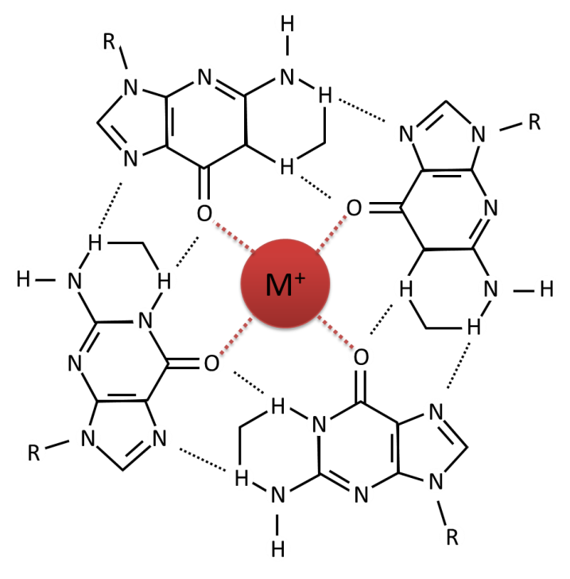
(a)

(b)

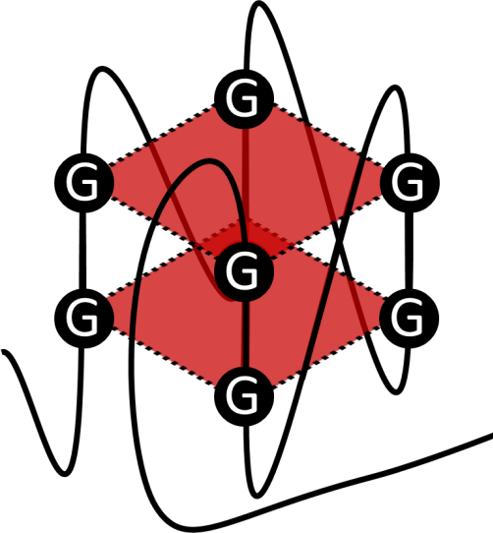

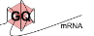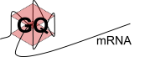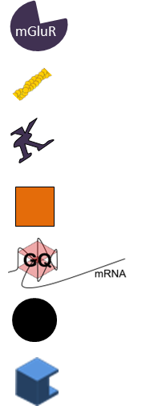

43S

60S
mGluR

80S

(iii)

(i)
(ii)
nucleus
Motor protein
Microtubule
mGluR
Glutamate
FMRP
Ribosomal subunit
G-quadruplex mRNA
synapse

FUNDING
James Schofield is supported by a PhD Studentship from the Gerald Kerkut Charitable Trust. Work in the MJC lab is also supported by the BBSRC.
Figure 2 (i) In the nucleus, RBPs such as FMRP bind G-quadruplex structures. (ii) The assembled neuronal RNP binds motor proteins for ATP-dependent transport of neuronal RNPs along microtubules. (iii) The neuronal RNP disassembles in response to synaptic activation by mGluR-signalling the dephosphorylation by S6 kinase-1 of FMRP, allowing the translation of the mRNA.

REFERENCES
1 Kelleher, R. J. and Bear, M. F. (2008) The autistic neuron: troubled translation? Cell. 135, 401-406
2 Jung, H., Yoon, B. C. and Holt, C. E. (2012) Axonal mRNA localization and local protein synthesis in nervous system assembly, maintenance and repair. Nature Reviews Neuroscience. 13, 308-324
3 Ramaswami, M., Taylor, J. P. and Parker, R. (2013) Altered ribostasis: RNA-protein granules in degenerative disorders. Cell. 154, 727-736
4 Wang, G.-S. and Cooper, T. A. (2007) Splicing in disease: disruption of the splicing code and the decoding machinery. Nature Reviews Genetics. 8, 749-761
5 Joachimi, A., Benz, A. and Hartig, J. S. (2009) A comparison of DNA and RNA quadruplex structures and stabilities. Bioorganic & medicinal chemistry. 17, 6811-6815
6 Bugaut, A. and Balasubramanian, S. (2012) 5′-UTR RNA G-quadruplexes: translation regulation and targeting. Nucleic acids research. 40, 4727-4741
7 Collie, G. W. and Parkinson, G. N. (2011) The application of DNA and RNA G-quadruplexes to therapeutic medicines. Chemical Society Reviews. 40, 5867-5892
8 Kikin, O., D'Antonio, L. and Bagga, P. S. (2006) QGRS Mapper: a web-based server for predicting G-quadruplexes in nucleotide sequences. Nucleic acids research. 34, W676-W682
9 Kumari, S., Bugaut, A., Huppert, J. L. and Balasubramanian, S. (2007) An RNA G-quadruplex in the 5′ UTR of the NRAS proto-oncogene modulates translation. Nature chemical biology. 3, 218-221
10 Kumari, S., Bugaut, A. and Balasubramanian, S. (2008) Position and Stability Are Determining Factors for Translation Repression by an RNA G-Quadruplex-Forming Sequence within the 5′ UTR of the NRAS Proto-oncogene†. Biochemistry. 47, 12664-12669
11 Arora, A., Dutkiewicz, M., Scaria, V., Hariharan, M., Maiti, S. and Kurreck, J. (2008) Inhibition of translation in living eukaryotic cells by an RNA G-quadruplex motif. Rna. 14, 1290-1296
12 Steward, O. and Fass, B. (1983) Polyribosomes associated with dendritic spines in the denervated dentate gyrus: evidence for local regulation of protein synthesis during reinnervation. Progress in brain research. 58, 131-136
13 Andreassi, C., Zimmermann, C., Mitter, R., Fusco, S., De Vita, S., Saiardi, A. and Riccio, A. (2010) An NGF-responsive element targets myo-inositol monophosphatase-1 mRNA to sympathetic neuron axons. Nature neuroscience. 13, 291-301
14 Cajigas, I. J., Tushev, G., Will, T. J., tom Dieck, S., Fuerst, N. and Schuman, E. M. (2012) The local transcriptome in the synaptic neuropil revealed by deep sequencing and high-resolution imaging. Neuron. 74, 453-466
15 Gumy, L. F., Yeo, G. S., Tung, Y.-C. L., Zivraj, K. H., Willis, D., Coppola, G., Lam, B. Y., Twiss, J. L., Holt, C. E. and Fawcett, J. W. (2011) Transcriptome analysis of embryonic and adult sensory axons reveals changes in mRNA repertoire localization. Rna. 17, 85-98
16 Minis, A., Dahary, D., Manor, O., Leshkowitz, D., Pilpel, Y. and Yaron, A. (2014) Subcellular transcriptomics—Dissection of the mRNA composition in the axonal compartment of sensory neurons. Developmental neurobiology. 74, 365-381
17 Taylor, A. M., Berchtold, N. C., Perreau, V. M., Tu, C. H., Jeon, N. L. and Cotman, C. W. (2009) Axonal mRNA in uninjured and regenerating cortical mammalian axons. The Journal of Neuroscience. 29, 4697-4707
18 Zivraj, K. H., Tung, Y. C. L., Piper, M., Gumy, L., Fawcett, J. W., Yeo, G. S. and Holt, C. E. (2010) Subcellular profiling reveals distinct and developmentally regulated repertoire of growth cone mRNAs. The Journal of Neuroscience. 30, 15464-15478
19 Lawrence, J. B. and Singer, R. H. (1986) Intracellular localization of messenger RNAs for cytoskeletal proteins. Cell. 45, 407-415
20 Mili, S., Moissoglu, K. and Macara, I. G. (2008) Genome-wide screen reveals APC-associated RNAs enriched in cell protrusions. Nature. 453, 115-119
21 Subramanian, M., Rage, F., Tabet, R., Flatter, E., Mandel, J. L. and Moine, H. (2011) G–quadruplex RNA structure as a signal for neurite mRNA targeting. EMBO reports. 12, 697-704
22 Miller, S., Yasuda, M., Coats, J. K., Jones, Y., Martone, M. E. and Mayford, M. (2002) Disruption of dendritic translation of CaMKIIα impairs stabilization of synaptic plasticity and memory consolidation. Neuron. 36, 507-519
23 Darnell, J. C., Jensen, K. B., Jin, P., Brown, V., Warren, S. T. and Darnell, R. B. (2001) Fragile X mental retardation protein targets G quartet mRNAs important for neuronal function. Cell. 107, 489-499
24 Schaeffer, C., Bardoni, B., Mandel, J. L., Ehresmann, B., Ehresmann, C. and Moine, H. (2001) The fragile X mental retardation protein binds specifically to its mRNA via a purine quartet motif. The EMBO Journal. 20, 4803-4813
25 Darnell, J. C., Van Driesche, S. J., Zhang, C., Hung, K. Y. S., Mele, A., Fraser, C. E., Stone, E. F., Chen, C., Fak, J. J. and Chi, S. W. (2011) FMRP stalls ribosomal translocation on mRNAs linked to synaptic function and autism. Cell. 146, 247-261
26 Malgowska, M., Gudanis, D., Kierzek, R., Wyszko, E., Gabelica, V. and Gdaniec, Z. (2014) Distinctive structural motifs of RNA G-quadruplexes composed of AGG, CGG and UGG trinucleotide repeats. Nucleic acids research. 42, 10196-10207
27 Todd, P. K., Oh, S. Y., Krans, A., He, F., Sellier, C., Frazer, M., Renoux, A. J., Chen, K.-c., Scaglione, K. M. and Basrur, V. (2013) CGG repeat-associated translation mediates neurodegeneration in fragile X tremor ataxia syndrome. Neuron. 78, 440-455
28 Comery, T. A., Harris, J. B., Willems, P. J., Oostra, B. A., Irwin, S. A., Weiler, I. J. and Greenough, W. T. (1997) Abnormal dendritic spines in fragile X knockout mice: maturation and pruning deficits. Proceedings of the National Academy of Sciences. 94, 5401-5404
29 Muslimov, I. A., Patel, M. V., Rose, A. and Tiedge, H. (2011) Spatial code recognition in neuronal RNA targeting: Role of RNA–hnRNP A2 interactions. The Journal of cell biology. 194, 441-457
30 Edbauer, D., Neilson, J. R., Foster, K. A., Wang, C.-F., Seeburg, D. P., Batterton, M. N., Tada, T., Dolan, B. M., Sharp, P. A. and Sheng, M. (2010) Regulation of synaptic structure and function by FMRP-associated microRNAs miR-125b and miR-132. Neuron. 65, 373-384
31 Muddashetty, R. S., Nalavadi, V. C., Gross, C., Yao, X., Xing, L., Laur, O., Warren, S. T. and Bassell, G. J. (2011) Reversible inhibition of PSD-95 mRNA translation by miR-125a, FMRP phosphorylation, and mGluR signaling. Molecular cell. 42, 673-688
32 Kanai, Y., Dohmae, N. and Hirokawa, N. (2004) Kinesin transports RNA: isolation and characterization of an RNA-transporting granule. Neuron. 43, 513-525
33 Zhang, Y., Matt, L., Patriarchi, T., Malik, Z. A., Chowdhury, D., Park, D. K., Renieri, A., Ames, J. B. and Hell, J. W. (2014) Capping of the N‐terminus of PSD‐95 by calmodulin triggers its postsynaptic release. The EMBO Journal. 33, 1341-1353
34 Sofola, O. A., Jin, P., Qin, Y., Duan, R., Liu, H., de Haro, M., Nelson, D. L. and Botas, J. (2007) RNA-binding proteins hnRNP A2/B1 and CUGBP1 suppress fragile X CGG premutation repeat-induced neurodegeneration in a Drosophila model of FXTAS. Neuron. 55, 565-571
34 Muslimov, I. A., Patel, M. V., Rose, A. and Tiedge, H. (2011) Spatial code recognition in neuronal RNA targeting: Role of RNA–hnRNP A2 interactions. The Journal of cell biology. 194, 441-457
35 Khateb, S., Weisman-Shomer, P., Hershco-Shani, I., Ludwig, A. L. and Fry, M. (2007) The tetraplex (CGG) n destabilizing proteins hnRNP A2 and CBF-A enhance the in vivo translation of fragile X premutation mRNA. Nucleic acids research. 35, 5775-5788
36 Johnson, E. M., Kinoshita, Y., Weinreb, D. B., Wortman, M. J., Simon, R., Khalili, K., Winckler, B. and Gordon, J. (2006) Role of Purα in targeting mRNA to sites of translation in hippocampal neuronal dendrites. Journal of neuroscience research. 83, 929-943
37 Jin, P., Duan, R., Qurashi, A., Qin, Y., Tian, D., Rosser, T. C., Liu, H., Feng, Y. and Warren, S. T. (2007) Pur α binds to rCGG repeats and modulates repeat-mediated neurodegeneration in a Drosophila model of fragile X tremor/ataxia syndrome. Neuron. 55, 556-564

