Measured V̇O₂peak (ml.kg^{-1.}min⁻¹)
c
a
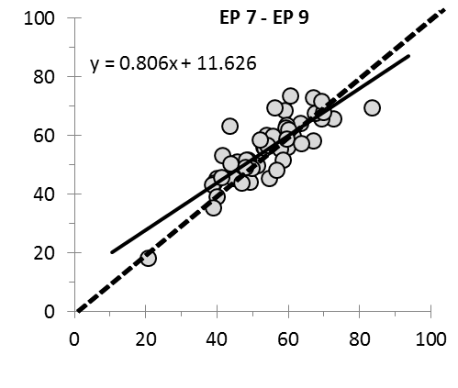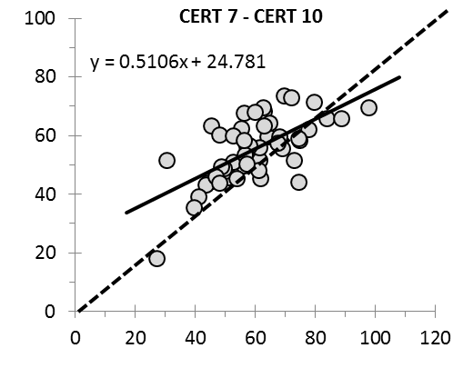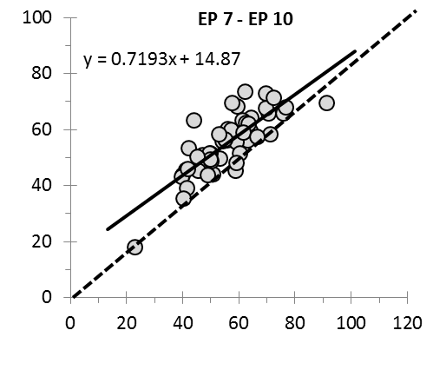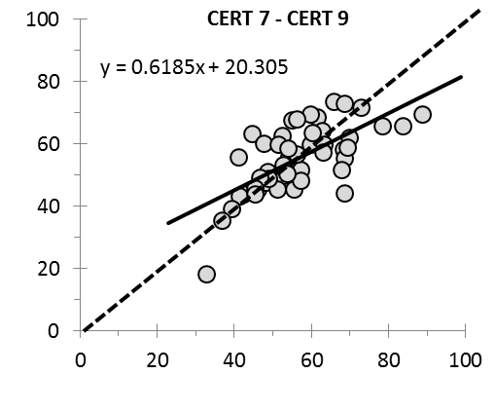
Fig. 1
Measured V̇O₂peak (ml.kg^{-1.}min⁻¹)
d
b
Predicted V̇O₂peak (ml.kg^{-1.}min⁻¹)
Predicted V̇O₂peak (ml.kg^{-1.}min⁻¹)

