Running Head: RELIGIOSITY AS SOCIAL VALUE

In press, Journal of Personality and Social Psychology

Religiosity as Social Value: Replication and Extension

Jochen E. Gebauer  University of Mannheim | Constantine Sedikides  University of Southampton
Felix D. Schönbrodt  Ludwig-Maximilians-Universität München | Wiebke Bleidorn  University of California, Davis  and Tilburg University
Peter J. Rentfrow  University of Cambridge | Jeff Potter  Cambridge, Massachusetts
Samuel D. Gosling
University of Texas at Austin
and University of Melbourne

We thank Katharina Demin for help with coding of Study 3ʼs zip codes. We also acknowledge support from the German Research Foundation (DFG; GE 2515/2-1 & GE 2515/3-1). Corresponding author: Jochen Gebauer, Mannheim Centre for European Social Research, University of Mannheim, A5, 6, D-68159 Mannheim, Germany; email: mail@JochenGebauer.info
ABSTRACT
Are religious people psychologically better or worse adjusted than their non-religious counterparts? Hundreds of studies have reported a positive relation between religiosity and psychological adjustment. Recently, however, a comparatively small number of cross-cultural studies has questioned this staple of religiosity research. The latter studies find that religious adjustment benefits are restricted to religious cultures. Gebauer, Sedikides, and Neberich (2012b) suggested the religiosity-as-social-value hypothesis (RASV) as one explanation for those cross-cultural differences. RASV states that, in religious cultures, religiosity possesses much social value, and, as such, religious people will feel particularly good about themselves. In secular cultures, however, religiosity possesses limited social value, and, as such, religious people will feel less good about themselves, if at all. Yet, previous evidence has been inconclusive regarding RASV and regarding cross-cultural differences in religious adjustment benefits more generally. To clarify matters, we conducted three replication studies. We examined the relation between religiosity and self-esteem (the most direct and appropriate adjustment indicator, according to RASV) in a self-report study across 65 countries (N = 2,195,301), an informant-report study across 36 countries (N = 560,264), and another self-report study across 1,932 urban areas from 243 federal states in 18 countries (N = 1,188,536). Moreover, we scrutinized our results against seven, previously untested, alternative explanations. Our results fully and firmly replicated and extended prior evidence for cross-cultural differences in religious adjustment benefits. These cross-cultural differences were best explained by the RASV hypothesis.

Keywords: religiosity; psychological adjustment; culture.

Religiosity as Social Value: Replication and Extension
According to one recent estimate, 68% of people worldwide consider religion to be “an important part of their daily lives” (Diener, Tay, & Myers, 2011, p. 1280). Estimates like this suggest that religiosity plays a key role in the way people carry themselves in their social environment and are influenced by it (Baumeister, 2002). Thus, it is not surprising that religiosity has become a major research topic in personality and social psychology (Saroglou, 2014; Sedikides, 2010). By far, the most widely studied research question concerns the religiosity-adjustment relation, with several hundred studies concluding that religiosity is related to better psychological adjustment (for reviews see: Koenig, King, & Carson, 2012; Smith, McCullough, & Poll, 2003). Yet, this staple of religiosity research has been challenged by a small literature suggesting that religious adjustment benefits may be limited to religious cultures (Diener et al., 2011; Stavrova, Fetchenhauer, & Schlösser, 2013; see below for a full review).
The religiosity-as-social-value hypothesis (RASV; Gebauer et al., 2012b) provides one explanation for cross-cultural differences in religious adjustment benefits.¹ According to RASV, religiosity is the defining social value in religious cultures, and so those who meet that social value (i.e., religious persons) will feel particularly good about themselves. Religiosity, however, is an inconsequential social value in secular cultures, and so religious persons will feel less good about themselves, if at all. Conclusive evidence for RASV, and for cross-cultural differences in the religiosity-adjustment relation more generally, would be a key step in understanding the origin and nature of religious adjustment benefits. However, the existing evidence is inconclusive in regards to both RASV and cross-cultural differences in the religiosity-adjustment relation. In particular, the evidence is (a) rather indirect, (b) partly inconsistent, and (c) liable to alternative explanations.
In this article, we seek to address all three issues. In brief, we re-examine cross-cultural differences in the religiosity-adjustment relation from a RASV perspective. According to RASV, global self-esteem is the most direct and appropriate indicator of psychological adjustment (Judge, Erez, Bono, & Thoresen, 2002; Taylor & Brown, 1988; Watson, Suls, & Haig, 2002), and so it is the one we use. Moreover, we draw on three very large samples in an effort to clarify previous inconsistencies (560,264 ≤ Ns ≤ 2,195,301). Finally, we address seven alternative explanations that challenged past research (described in detail in the Seven Alternative Explanations section). In brief, those alternatives are: (1) the sociocultural motives perspective on personality, (2) country-level covariates, (3) spatial dependence, (4) masked curvilinearity, (5) self-presentation, (6) self-report bias, and (7) interpersonal contact.
In the remainder of this Introduction, we elaborate on RASV, review prior cross-cultural research on the religiosity-adjustment relation, and provide more detail on the seven untested alternative explanations. In the empirical part of the article, we examine the relation between religiosity and global self-esteem in a self-report study across 65 countries (N = 2,195,301), an informant-report study across 36 countries (N = 560,264), and another self-report study across 1,932 urban areas from 243 federal states in 18 countries (N = 1,313,474).
Religiosity as Social Value
RASV states that personal religiosity makes people feel good about themselves to the extent that religiosity is culturally valued. More precisely, if culture embraces religiosity as a social value, religious people will take pride in living up to this value, resulting in adjustment benefits. If, on the other hand, culture considers religiosity a peripheral value, religious people will derive little pride from it, resulting in minimal adjustment benefits (at best). Overall, religious people will derive considerable adjustment benefits in religious cultures, but they will derive little (if any) adjustment benefits in secular cultures. One key point to note is that religiosity is rarely devalued in secular cultures; even the world’s least religious countries institutionally support religious liberty (Alwall, 2000; Gill, 2008). For that reason, RASV predicts an asymmetry in religious adjustment benefits: Those benefits will be plentiful in religious cultures, but diminished or null (but not negative) in secular cultures.
RASV is tightly grounded in the psychological and sociological literatures on the self-concept. Both literatures advocate that psychological adjustment—and in particular global self-esteem—originates to a great degree from living up to social values. William James (1907) was the first to recognize, or at least formalize, this principle. Morris Rosenberg (1965; Rosenberg & Pearlin, 1978) elaborated on it and called it the “psychological centrality principle.” He reasoned that global self-esteem derives from living up to values that are psychologically central to the individual. He further assumed that people typically regard culturally prominent values as psychologically central (Rosenberg, 1979). Similarly, Rokeach (1973, p. 15) maintained that values are “in the final analysis the conceptual tools and weapons that we all employ in order to maintain and enhance self-esteem.”
Contemporary self-concept theories, too, endorse the psychological centrality principle. For example, the Self-Concept Enhancing Tactician Model (Sedikides & Strube, 1997) posits that “people are highly skilled in recognizing culturally sanctioned roles and strive to fulfill these roles ... [in an effort to] evaluate themselves positively” (Sedikides, Gaertner, & Toguchi, 2003, p. 63). Terror Management Theory (Pyszczynski, Greenberg, Solomon, Arndt, & Schimel, 2004) defines global self-esteem as “a culturally based construction that consists of viewing oneself as living up to specific contingencies of value ... that are derived from the culture at large” (p. 437). Finally, the Contingencies of Self-Worth Model (Crocker & Wolfe, 2001) postulates that “the impact of events and circumstances on self-esteem depends on the perceived relevance of those events to one’s contingencies of self-worth” and “contingencies of self-worth develop over the course of time in response to many forms of socialization and social influence” (pp. 594-595).
In all, RASV can be regarded a religiosity-specific instantiation of the psychological centrality principle. Outside of the religiosity domain there is plenty of evidence for this principle (Becker et al., 2014; Fulmer et al., 2010; Gebauer, Wagner, Sedikides, & Neberich, 2013d; Goodwin et al., 2012; Lönnqvist et al., 2009; Sedikides, Gaertner, & Vevea, 2005). From a self-concept perspective, that evidence attests a priori to the validity of RASV. In fact, a self-concept perspective would predict particularly strong effects of the psychological centrality principle in the religiosity domain, because long lists of religious values, norms, and commandments are an inherent part of religiosity (Schwartz & Huismans, 1995). Hence, a religious person in a religious culture should not only enjoy adjustment benefits from living up to the social value of religious belief itself, but that person should also enjoy adjustment benefits from living up to all those religiosity-specific values, norms, and commandments (e.g., religious dietary rules). From a self-concept perspective, then, RASV should account for much of the relation between religiosity and psychological adjustment—and, in particular, for one key aspect of psychological adjustment: global self-esteem.
The Cross-Cultural Literature on the Religiosity-Adjustment Relation
Twelve studies have examined cross-cultural differences in the religiosity-adjustment relation as a function of religiosity at the sociocultural level. Those studies can be sorted into three categories, based on their data-source. Six studies rely on data from the World Values Survey (WVS; Eichhorn, 2012; Lun & Bond, 2013; Okulicz-Kozaryn, 2010; Snoep, 2008; Stavrova, 2015‒Study 1; Stavrova et al., 2013). Those studies found a positive relation between religiosity and psychological adjustment in religious countries, but a null-relation in secular countries. Additionally, two studies are based on data from the European Social Survey (ESS; Clark & Lelkes, 2009; Pirutinsky, 2013). In sharp contrast to the WVS studies, the ESS studies found no moderating effect of sociocultural religiosity on the relation between personal religiosity and better psychological adjustment.
Finally, four studies rely on datasets that are not publically available. Lavrič and Flere (2008) collected student data from universities in five countries and found that religious adjustment benefits were restricted to religious countries. In contrast, Leurent et al. (2013) collected patient data from general practices in seven countries and found no moderating effect of sociocultural religiosity on the religiosity-adjustment relation. Finally, Diener et al. (2011) and Gebauer et al. (2012b) used datasets that were comparable in size with the WVS and the ESS. In particular, Diener et al. used data from the Gallup World Poll and Gebauer et al. used data from a European online-dating platform. In both investigations, religious adjustment benefits were restricted to religious countries.
Together, most of the evidence is consistent with RASV, but there are also some noteworthy inconsistencies—especially the ESS results. From a RASV perspective, there are several reasons for those inconsistencies. For one, global self-esteem is the most direct and appropriate adjustment indicator in the present context, but surprisingly, global self-esteem has not been implicated in relevant studies. Gebauer et al. (2012) assessed social self-esteem and found support for RASV. It is possible that prior research would have found more consistent cross-cultural differences in religious adjustment benefits, if it had used self-esteem as an adjustment indicator. Furthermore, most previous data (WVS, ESS, and Gallup) were collected via interviewers, a method that has benefits but also costs, such as interviewer-effects (Hox, de Leeuw, & Kreft, 1991). Hence, one goal of our research was to test again for cross-cultural differences in religious adjustment benefits, but this time using global self-esteem as our adjustment indicator and ruling out interviewer-effects as confounds. Another goal was to test seven alternative explanations to RASV and, more generally, for cross-cultural differences in religious adjustment benefits.
Seven Alternative Explanations
(1) Sociocultural motives perspective. According to the sociocultural motives perspective on personality, personality effects vary across sociocultural contexts as a function of ambient sociocultural norms (Gebauer, Leary, & Neberich, 2012a; Gebauer, Paulhus, & Neberich 2013c). For example, agreeableness and conscientiousness are associated with a tendency to swim with the sociocultural tide. Hence, these Big Five traits predict religiosity strongly in religious countries and weakly in secular countries (Gebauer et al., 2014b). Stated another way, the relations between religiosity and those two Big Five traits vary across countries in the same way that the religiosity-adjustment relation varies. At the same time, agreeableness and conscientiousness both correlate with psychological adjustment, including self-esteem (Gebauer et al. 2015; Robins, Tracy, Tresniewski, Potter, & Gosling, 2001).² Hence, cross-cultural differences in the religiosity-adjustment relation may be spurious, accounted for by the sociocultural motives perspective.
(2) Country-level covariates. Correlates of sociocultural religiosity may drive cross-cultural differences in the religiosity-adjustment relation. One such correlate is collectivism (Gebauer et al., 2013c). Collectivist countries place premium value on group membership (Sedikides, Gaertner, & Cai, 2015). Religiosity generally is a social phenomenon, practiced within groups (Ysseldyk et al., 2010), and so religious group membership should be particularly rewarding in collectivist countries. Another correlate of sociocultural religiosity is GDP per capita (Oishi & Diener, 2014). Personal religiosity may be psychologically most beneficial in poor countries, because it buffers against financial hardship (Gebauer, Nehrlich, Sedikides, & Neberich, 2013b). A final correlate of sociocultural religiosity is pathogen prevalence (Fincher & Thornhill, 2012). Religiosity protects believers from pathogens (e.g., via restrictive food norms; Fincher & Thornhill, 2012). In pathogen-rich countries, religious believers should be physically healthier than non-believers (cf. Stavrova 2015), and these physical health benefits may translate into psychological adjustment benefits.
(3) Spatial dependence. Cross-cultural research on the religiosity-adjustment relation has typically used mixed-effects modeling (Snijders & Bosker, 2012). Mixed-effects models account for the statistical dependence of level-1 units (here: participants) when they share the same level 2 units (here: cultures). One assumption of mixed-effects modeling is that level-2 residuals are independent (Snijders & Bosker, 2012). Strictly speaking, however, this assumption is violated when spatial/geographic units are used at level 2 (here: cultures; Ward & Gleditsch, 2008). All literature on cross-cultural differences in the religiosity-adjustment relation has overlooked this issue of spatial dependence. Thus, prior results may be partly due to spatial dependence (Webster & Duffy, 2016). Fortunately, it is possible to statistically control for spatial dependence between level-2 units. Hence, we directly test whether controlling for spatial dependence diminishes RASV evidence.
(4) Masked curvilinearity. RASV makes linear predictions regarding the religiosity-adjustment relation and the effect of sociocultural religiosity on that relation. Nonetheless, linear analyses may mask, or even ride on, curvilinear relations (e.g., reverse-U-shaped relations) that are not predicted by the model (Cronbach, 1958; Ganzach, 1997). Therefore, it is important to test whether inclusion of those curvilinear effects leads to results that are inconsistent with RASV.
(5) Self-presentation. High self-presenters are particularly keen to impress others (Sedikides, Gregg, & Hart, 2007; Sedikides, Hoorens, & Dufner, 2015). Hence, they exaggerate their desirable attributes when others are present. As described earlier, almost all data on the cross-cultural benefits of religiosity have been collected by interviewers (WVS, ESS, Gallup World Poll). This renders self-presentation a plausible alternative explanation. Specifically, religiosity and psychological adjustment may be linked in religious cultures only, because claiming high religiosity conveys a good impression only in those cultures (and claiming high well-being conveys a good impression in all cultures; Okulicz-Kozaryn, 2010; Pirutinsky, 2013).
(6) Self-report bias. All prior cross-cultural research on the religiosity-adjustment relation used self-report data. As such, prior research is subject to self-report bias (Paulhus & Vazire, 2007). The value of that research will increase, if replicated using informant-reports.
(7) Interpersonal contact. The final alternative is a competing model for cross-cultural differences in religious adjustment benefits. Specifically, some researchers have drawn on an interpersonal contact explanation to account for those differences (Diener et al., 2011; Lavrič & Flere 2008; Snoep, 2008; Stavrova et al., 2013). According to this explanation, religious people enjoy more supportive interpersonal contact with fellow believers in religious, compared to secular, cultures. Such contact, then, would account for the stronger relation between religiosity and psychological adjustment in religious cultures.³ The interpersonal contact explanation has received empirical support, but that explanation alone is not sufficient to account for all cross-cultural differences in the religiosity-adjustment relation. This is so, because measures of interpersonal contact have only partially explained cross-cultural differences in the religiosity-adjustment relation (Diener et al., 2011; Stavrova et al., 2011). Thus, it is important to test whether RASV can account for additional cross-cultural benefits of religiosity after controlling for the potential impact of interpersonal contact.
All seven alternatives raise questions about the validity of previous RASV evidence and the role of sociocultural religiosity for religious adjustment benefits more generally. To address these questions, we conducted the three studies described below. These studies examined the replicability of previous evidence for RASV and for cross-cultural differences in the religiosity-adjustment relation. The studies also examined the robustness of our results against the backdrop of the seven alternative explanations.
Overview
Study 1 re-examined the religiosity-adjustment relation using the same assessment method as all previous studies—the self-report method (Paulhus & Vazire, 2007). In doing so, the study capitalized on the most appropriate adjustment indicator in the RASV context, global self-esteem (Gebauer et al., 2012b; Rosenberg, 1965; Sedikides et al., 2015). We expected a positive relation between personal religiosity and self-esteem in religious cultures, but we also expected this relation to diminish with decreasing sociocultural religiosity and cease to exist in the most secular cultures. The study relied on 2,195,301 respondents across 65 countries and, thus, constitutes the largest study on religious adjustment benefits to date. Moreover, our study tested five of the alternative explanations described above: Sociocultural motives perspective, country-level covariates, spatial dependence, masked curvilinearity, and self-presentation.
Study 2 also tested for cross-cultural differences in the relation between personal religiosity and global self-esteem. However, Study 2 capitalized on informant-reports, allowing us to test self-report bias as an alternative explanation of the results. Informant-reports have never been used in prior research on cross-cultural differences in the religiosity-adjustment relation (including our Study 1). As such, Study 2 is an important complement to the literature. Our study relied on 560,264 respondents across 36 countries. In addition to testing self-report bias as an alternative, the study addressed three other alternatives: Sociocultural motives perspective, masked curvilinearity, and self-presentation.
Study 3 moved beyond country-level religiosity and examined the religiosity-esteem relation among 1,188,536 respondents from 1,932 urban areas (usually cities including their metropolitan regions). The urban areas were nested in 243 federal states, which were nested in 18 countries. The ensuing four-level hierarchical model allowed us to examine the unique influences of area-level religiosity, state-level religiosity, and country-level religiosity on the religiosity-esteem relation. Sedikides and Gebauer (2010) found in a meta-analysis that within-country differences in sociocultural religiosity (i.e., religious vs. secular universities) moderated the relation between religiosity and self-enhancement (a close correlate of psychological adjustment—and of self-esteem in particular; Alicke & Sedikides, 2009; Sedikides, Rudich, Gregg, Kumashiro, & Rusbult, 2004). On that basis, we predicted that the religiosity-esteem relation would be concurrently moderated by sociocultural religiosity at the area-level, state-level, and country-level. Evidence for this prediction would strongly suggest that the literature on cross-cultural differences in the religiosity-adjustment relation has underestimated the importance of culture, given that this literature focused on a single sociocultural level. Moreover, Study 3 tested four alternative explanations: Sociocultural motives perspective, masked curvilinearity, self-presentation, and interpersonal contact.
STUDY 1: SELF-REPORTS ACROSS 65 COUNTRIES
In religious countries, personal religiosity correlates with psychological adjustment in the range of .10-.20 (Diener et al., 2011; Gebauer et al., 2012b; Lavrič & Flere, 2008; Snoep, 2008). Based on that evidence, we predicted that personal religiosity will correlate with self-esteem at a similar range in the current sample’s religious countries. Crucially, on the basis of RASV, we predicted that the religiosity-esteem relation will wane with decreasing sociocultural religiosity and will cease to exist in the most secular countries. We further predicted that the evidence for RASV holds even after accounting for five of the above-described alternative explanations: Sociocultural motives perspective, country-level covariates, spatial dependence, masked curvilinearity, and self-presentation.
Method
Respondents
The study used data from 2,195,301 respondents across 65 countries (62.4% female, 37.6% male; M_{age} = 25.39 years, SD_{age} = 10.67). Data were collected online from March 2001 to December 2009 at www.outofservice.com (OOS), an Internet website hosting online-studies (Gosling, Vazire, Srivastava, & John, 2004; for a complete list of previously published OOS research, see http://www.thebigfiveproject.com/published-papers/). Thus, none of the original RASV authors were involved in the data collection process (or the questionnaire design). This is one reason why the present replication effort should be considered independent of the original RASV research; another reason is that Felix Schönbrodt joined the research team to provide independent expert advice on the appropriate statistical tests.
Respondents learned about the study via Internet search engines, newspaper articles on previous studies, or word of mouth. As such, participants were not representatively sampled. Importantly, the ensuing sampling bias does not provide a plausible alternative explanation for our expected results. If anything, such a sampling bias should work against RASV, because online-study participants in highly religious countries typically affiliate with secular subcultures (Diener et al., 2011). Hence, online-studies underestimate cross-cultural differences in religiosity. Such underestimation, in turn, should attenuate cross-cultural differences in the religiosity-esteem relation, impeding the expression of evidence for RASV and resulting in underestimates of the influence of RASV.
We derived the sample by applying three selection criteria to the multi-study OOS dataset. We decided a priori on those criteria. In fact, those exact criteria have been used on the OOS dataset before (Gebauer et al., 2014b). The (re-)use of those selection criteria is another reason why the present replication effort should be considered independent of the original RASV research. First, we excluded respondents who reported residing concurrently in a US state and a country outside the US. Second, we excluded respondents who completed an irrelevant OOS study (i.e., one that did not feature our focal constructs, religiosity and self-esteem) or failed to complete any of our focal measures. Finally, we excluded respondents from countries with less than 1,000 cases to ensure measurement precision within each country. A minimum n of 1,000 per country is a conservative criterion (Bleidorn et al., 2016; Schönbrodt & Perugini, 2013), but it is frequently used in large-scale, cross-cultural research (Diener et al., 2011; Gebauer et al., 2014b). Table 1 lists all 65 countries and their demographic composition.
Procedure
Language-options for the study were English (used by 75.7% of respondents), Spanish (16.8%), German (4.3%), and Dutch (3.2%). Respondents provided informed consent and completed measures of Big Five personality, self-esteem, personal religiosity, and demographics (in that order). Finally, they received customized personality feedback and general information on personality psychology.
Measures
All measures involved rating scales ranging from 1 (strongly disagree) to 5 (strongly agree).
Big Five personality. Big Five personality was assessed with the Big Five Inventory (BFI; English version: John, Donahue, & Kentle, 1991; Spanish: Benet-Martínez & John, 1998; German: Rammstedt, 1997; Dutch: Denissen et al., 2008). All five BFI scales have adequate psychometric properties within the OOS dataset, including appropriate alpha coefficients and satisfactory levels of measurement invariance across countries (see Table 2 in Gebauer et al., 2015).⁴
Self-esteem. Self-esteem was assessed with a variant of the Single-Item Self-Esteem Scale (SISE; Robins, Hendin, & Trzesniewski, 2001): “I see myself as someone who has high self-esteem.” The SISE possesses high test-retest reliability (r = .75) and high correlations with Rosenberg’s (1965) Self-Esteem Scale (.72 < r < .76; Robins et al., 2001). Correcting those correlations for attenuation due to unreliability yields true score correlations of .89 < r < .94. The size of these correlations indicates that the two scales assess the same construct (Kline, 1998). The Self-Esteem Scale is the gold standard of global self-esteem assessment, and so these correlations support the validity of the SISE.
Personal religiosity. Personal religiosity was assessed with a variant of the Single-Item Religiosity Scale (SIRS; Norenzayan & Hansen, 2004): “I see myself as someone who is very religious.” Single-item measures are suitable for the assessment of global religiosity, as they have adequate reliability and validity (Gebauer & Maio, 2012). In large-scale studies, religiosity is usually assessed with single-item measures (Hill & Pargament, 2003). The SIRS loads strongly (.88) on the same factor as established multi-item measures of global religiosity (Gebauer et al., 2013c).
Country-level religiosity. Country-level religiosity was assessed by averaging respondents’ answers to the personal religiosity measure within each country. This is the standard approach to assess country-level religiosity (Diener et al., 2011). Table 1 presents our country-level index. The validity of this index was supported by its strong correlations with parallel indices from the Gallup World Poll (r = .86, p < .001; Diener et al., 2011) and the WVS (r = .80, p < .001; Fincher & Thornhill, 2012).
Country-level covariates. Collectivism was assessed with a meta-analytic update of Hofstede’s (1991) individualism index (reverse-coded; Taras, Steel, & Kirkman, 2011; see their Table 1 “Mean Individualism”). GDP per capita was assessed with the International Monetary Fund’s index (World Economic Outlook Database, 2014). Pathogen prevalence was assessed with Fincher and Thornhill’s (2012) Nonzoonotic Parasite Prevalence index.

Statistical Modeling
We used linear mixed-effects models to account for the nested data structure (respondents nested in countries). We computed the models using the statistical software R (R Development Core Team, 2014) with its mixed-effects models package lme4 (Bates, Maechler, Bolker, & Walker, 2014). We z-standardized all variables in order to obtain standardized coefficients (Snijders & Bosker, 2012, p. 53) and group-mean centered all level-1 predictors in order to interpret unambiguously cross-level interactions (Endres & Tofighi, 2007). Our models included random intercepts and random slopes for all level-1 predictors (Barr, Levy, Scheepers, & Tily, 2013).
As an example of our modeling choices, our basic model (i.e., without covariates) was specified as follows: We regressed self-esteem (level 1, z-standardized) on personal religiosity (level 1, z-standardized, group-mean centered, random slope included), country-level religiosity (level 2, z-standardized and, hence, group-mean centered), and their cross-level interaction.
The Supplemental Materials include tables with Pearson correlations between all Study 1 variables at the participant level (Table S1) and between all Study 1 variables at the country level (Table S2).
Results
Our basic model rests on the assumption that the religiosity-esteem relation varies significantly across countries. We obtained strong support for this assumption: A “main-effects-only” model (personal religiosity and country-level religiosity on self-esteem) fitted the data much better when the religiosity-esteem relation was allowed to vary rather than remained fixed across countries (∆AIC = 2,142.23; ∆χ² = 2,146.23, p < .001). We proceeded with basic model testing.⁵
Basic Model
Conceptually, the basic model examined the RASV prediction that personal religiosity is strongly related to self-esteem in religious countries, but that this relation wanes with decreasing country-level religiosity and ceases to exist in the most secular countries. Table 2’s first data-row includes the basic model results. The left-hand panel shows a significant main effect of personal religiosity on self-esteem. The point estimate (PE) of the coefficient was .12 with the following 95% confidence interval: [.11, .13]. Given that we z-standardized all variables in the model, this point estimate indicates a small (Cohen, 1988) positive relation between personal religiosity and self-esteem. Table 2’s left-hand panel further shows a significant main effect of country-level religiosity on self-esteem, PE = .12 [.09, .15].⁶ More important, however, Table 2’s left-hand panel shows a significant cross-level interaction between personal religiosity and country-level religiosity, PE = .04 [.03, .05]. As predicted, the relation between personal religiosity and self-esteem was highest in religious countries and lowest in secular countries. But how high and how low? To answer this question we decomposed the cross-level interaction, conducting simple slope analyses (Aiken & West, 1991; Preacher, Curran, & Bauer, 2006).
Simple slope analyses. RASV calls for comparing the religiosity-esteem relation in the most and least religious sociocultural contexts. We first re-centered country-level religiosity, so that its null-point lined up with the most religious country (1.77 SD above M). Next, we repeated our basic analysis.⁷ Table 2’s right-hand panel (first data-row) shows that the PE of the religiosity-esteem relation was .20 [.18, .21] at the highest point of country-level religiosity.⁸ We tested for the same relation at the lowest point of country-level religiosity (1.83 SD below M). After re-centering, we repeated the basic analysis once more. Table 2’s right-hand panel (data-row 1) shows that the PE of the religiosity-esteem relation was .04 [.03, .06] at the lowest point of country-level religiosity. Figure 1 depicts the cross-level interaction, including the simple slopes reported here. The shape of Figure 1 fits well with RASV.⁹ Figure 2 provides a complementary display of the same cross-level interaction (Gebauer et al. 2014b), depicting each country’s religiosity-esteem relation as a function of its country-level religiosity. This figure shows that our results are not merely driven by the religiosity-esteem relations within a few extreme countries. Instead, the religiosity-esteem relation in all 65 countries fits well with RASV predictions. A ∆R²-test (Snijders & Bosker, 2012) revealed that country-level religiosity explained 76.15% of the cross-cultural variation in the religiosity-esteem relation.
Alternative Explanations
Sociocultural motives perspective. Our results could be spuriously caused by cross-cultural differences in the agreeableness-religiosity relation and the conscientiousness-religiosity relation. Hence, we repeated our basic analysis, but included agreeableness, conscientiousness, and their cross-level interactions with country-level religiosity. Table 2’s second data-row shows that the cross-level interaction between personal religiosity and country-level religiosity remained intact: The religiosity-esteem relation was three times larger at the highest point, PE = .12 [.11, .13], compared to the lowest point, PE = .04 [.04, .05], of country-level religiosity. Still, the control variables reduced our effects (without controls the religiosity-esteem relation was five times larger at the highest vs. lowest point of country-level religiosity). The reduction, however, is unsurprising. Agreeableness and conscientiousness are highly conservative controls: They partly reflect self-enhancement (Gebauer et al., 2012c), and self-enhancement is a vital part of self-esteem (Sedikides & Gregg, 2008; Sedikides et al., 2004). Hence, controlling for those traits effectively controls for valid variance in self-esteem.
Country-level covariates. Replicating prior findings, country-level religiosity was strongly related to country-level collectivism, r(61) = .75 [.49, 1.00], GDP per capita, r(64) = -.66 [-.91, -.41], and pathogen prevalence, r(64) = .71 [.46, .96]. Thus, the moderating effect of country-level religiosity on the religiosity-esteem relation could be due to these factors. We repeated our basic analysis three times. Each time, we added another country-level covariate to the model, modeling their main effect and their cross-level interactions with personal religiosity. Table 2 shows that the results of our basic model held when controlling for collectivism (third data-row), GDP per capita (fourth data-row), and pathogen prevalence (fifth data-row). In contrast, the three alternative cross-level interactions on self-esteem were all non-significant (personal religiosity × collectivism: PE = .004 [-.007, .01]; personal religiosity × GDP per capita: PE = .006 [-.004, .01]; personal religiosity × pathogen prevalence: PE = .005 [-.004, .02]).¹⁰
Spatial dependence. Multiple approaches can be taken to account for spatial dependence between geographic units (Ward & Gleditsch, 2008). One widely used approach corrects for spatial dependence by adding a covariate, which de-biases the spatially dependent predictor (here: country-level religiosity). This covariate is typically called “spatial lag.” Following Webster and Duffy (2016), we calculated a spatial lag score for a given country by averaging the religiosity of all countries in our study that share a land-border with that country. For example, Belgium shares a land-border with France, Germany, Luxembourg, and the Netherlands (http://country-facts.findthedata.com). France, Germany, and the Netherlands are also part of this study (Table 1). Thus, we averaged the religiosity of those three countries (i.e., [1.94 + 2.02 + 1.95] / 3 = 1.97). The resultant value became the spatial lag score for Belgium. We were able to calculate spatial lag scores for 55 of our 65 countries. The remaining 10 countries were either islands and, thus, had no land-borders (ABC Islands, Australia, Japan, New Zealand, Singapore, Taiwan, The Philippines,) or there were no neighboring countries in our dataset (Dominican Republic, South Africa, South Korea). The spatial lag variable was related to country-level religiosity, r(55) = .67 [.40, .94]. Thus, the moderating effect of country-level religiosity on the religiosity-esteem relation may be due to spatial lag. Hence, we repeated our basic analysis, but included the spatial lag variable and its cross-level interaction with personal religiosity. Table 2’s sixth data-row shows that the results of this analysis were virtually identical to the results of the basic analysis. Thus, spatial dependence cannot account for our results.
Masked curvilinearity. Do the conclusions of the basic model change when we allow its relations to be curvilinear? We repeated our basic analysis once more, including the polynomials (i.e., quadratic terms) of personal religiosity and country-level religiosity (Cronbach, 1958). The joint contribution of the polynomials was miniscule (∆$R_{marginal}^{2}$ = 0.02%; Nakagawa & Schielzeth, 2013), and inclusion of them did not alter our results (Table 2’s final data-row).
Self-presentation. Our participants completed an anonymous online-questionnaire. No interviewers were involved. Thus, self-presentation cannot account for our results, because the presence of other people (in previous research: interviewers) is necessary for self-presentation effects to occur.
Discussion
Study 1 was a direct replication of previous cross-cultural research on the religiosity-adjustment relation. Yet, this study differed from previous research in three important ways. First, previous research operationalized psychological adjustment as life satisfaction (Stavrova et al., 2013), subjective well-being (Diener et al., 2011), depression (Leurent et al., 2013), or social self-esteem (Gebauer et al., 2012b). From an RASV perspective, however, global self-esteem is the most appropriate adjustment indicator. Thus, we were fortunate that the OOS dataset contained global self-esteem, which we duly used. Second, the present study is the largest study of cross-cultural differences in the religiosity-adjustment relation to date; it includes data from over 2 million people across 65 countries. Thus, we were able to estimate all relations with high precision. Finally, we examined RASV predictions against the backdrop of five alternative explanations: Sociocultural motives perspective, country-level covariates, spatial dependence, masked curvilinearity, and self-presentation. Together, Study 1 offered a highly diagnostic test of RASV and, more generally, of cross-cultural differences in the religiosity-adjustment relation.
The results of this test were consistent with RASV and cross-cultural differences in religious adjustment benefits. Specifically, we obtained a comparatively strong relation between personal religiosity and self-esteem in religious countries. The size of this relation (.20) was very similar to the size of the average relation in personality and social psychology (.21; Richard, Bond, & Stokes-Zoota, 2003). Moreover, the religiosity-esteem relation weakened as a function of decreasing country-level religiosity. In the least religious countries the relation was reduced by a factor of five, and in absolute terms it was very small (.04; Cohen, 1988). ¹¹
STUDY 2: INFORMANT-REPORTS ACROSS 36 COUNTRIES
Study 1 used self-report data as did all prior research on cross-cultural differences in religious adjustment benefits. Self-report data are valuable, but amenable to self-report biases (Paulhus & Vazire, 2007). As such, their value increases when they are replicated by informant-reports. In Study 2, we used informant-reports to test RASV. Yet, not all biases associated with self-reports should be controlled for. Self-deceptive enhancement (Paulhus & Reid, 1991), for example, is one such bias that contributes valid variance to psychological adjustment (Taylor & Brown, 1988). This is one reason why informant-reports, which bypass self-deceptive enhancement, can be too conservative (Paulhus & Reid, 1991). Another reason pertains to the inherent subjectivity of self-esteem (Baumeister, Campbell, Krueger, & Vohs, 2003). Respondents typically have better insight into inherently subjective attributes than do informants (Vazire, 2010), and this insight may render self-reported self-esteem more valid than informant-reported self-esteem. In all, self-reports and informant-reports have different strengths and weaknesses, and thus complement each other.
To complicate matters, informant-reports can also be biased. Therefore, it is helpful to control for informants’ self-ratings on the same dimensions on which informants rate the target persons (Gebauer et al., 2014b, 2015). Doing so can combat three sources of bias. The first is self-projection (Wood, Harms, & Vazire, 2010): informants may project their own religiosity and self-esteem onto the target person. The second source is in-group bias: religious informants may overestimate desirable traits in religious targets, including self-esteem (Galen, 2012). Finally, controlling for informantsʼ self-reports can help to adjust for biases in general scale use, such as acquiescence (Zuckerman et al., 1995) and extreme responding (Hui & Triandis, 1989). Therefore, in Study 2, we controlled for informants’ own self-reported religiosity and for their own self-esteem. Controlling for informants’ traits is a conservative practice, because there is also valid co-variation between informants’ and targets’ traits due to assortative pairing (Luo & Klohnen, 2005), genetic overlap (Bouchard, 2004), and shared environments (Caspi, Herbener, & Ozer 1992). Finally, Study 2 sought to replicate RASV evidence against the backdrop of three alternative explanations: Sociocultural motives perspective, masked curvilinearity, and self-presentation.
Method
Respondents
The study used data from 560,264 respondents across 36 countries (65.2% female, 34.8% male; M_{age} = 25.56 years, SD_{age} = 10.69). As in Study 1, we drew from the OOS dataset (from March 2001 to December 2009). To derive our sample, we applied three selection-criteria to the full OOS dataset, which paralleled those of Study 1. We excluded respondents who (1) reported residing concurrently in a US state and a country outside the US, (2) completed an irrelevant OOS study or did not fill out our measures, and (3) were from countries with N < 1,000. Table 3 lists all 36 countries along with demographic information.
Procedure and Measures
Procedure and measures were identical to Study 1’s. However, respondents provided informant-reports in addition to their self-reports. Each item was accompanied by two rating scales (1 = strongly disagree, 5 = strongly agree). Respondents supplied self-reports on the first rating-scale (labeled “myself”) and informant-reports on the second rating-scale (labeled “other”). Informant-report instructions were: “Try to rate someone whom you know well, such as a close friend, coworker, or family member.” Prior research has supported the validity of informant-reports from close friends (Funder & Colvin, 1988), coworkers (Hogan, Hogan, & Roberts, 1996), and family members (Vazire & Mehl, 2008). Of respondents, 45.7% completed the study in English, 39.1% in Spanish, 7.4% in German, and 7.8% in Dutch.
Country-level religiosity. Parallel to Study 1, country-level religiosity was assessed by averaging respondents’ informant-reports of the personal religiosity measure within each country. Table 3 includes the resultant index. Its validity was supported by its strong associations with the indices from Study 1 (r = .99, p < .001), the Gallup World Poll (r = .95, p < .001), and the WVS (r = .86, p < .001).

Statistical Modeling
Our modeling strategy was similar to Study 1’s, except for the use of informant-reports. We decided a priori not to control for country-level covariates (collectivism, GDP per capita, pathogen prevalence, spatial lag) because the number of countries (n = 36) was not sufficiently large to control for covariates at that level (Farrar & Glauber, 1967).
The Supplemental Materials include tables with Pearson correlations between all Study 2 variables at the participant level (Table S3) and between all Study 2 variables at the country level (Table S4).
Results
As in Study 1, we first tested our basic model’s assumption that the religiosity-esteem relation varies significantly across countries. In contrast to Study 1, our tests used informant-reports of religiosity and self-esteem. Despite that difference, we again found significant variation in the religiosity-esteem relation across countries (∆AIC = 500.13; ∆χ² = 504.13, p < .001).
Basic Model
We further followed Study 1’s analysis strategy, but this time we used informant-reports. We engaged in a conceptual replication of RASV’s prediction that personal religiosity is relatively strongly related to self-esteem in religious countries, but that this relation wanes with decreasing country-level religiosity and becomes attenuated, even non-existent, in highly secularized countries. As Table 4 (first data-row) indicates, we replicated Study 1’s results with informant-reports.
Simple slope analyses. We examined the religiosity-esteem relation at the highest point (1.69 SD above M) and at the lowest point (1.67 SD below M) of country-level religiosity. Given that informant-reports of self-esteem have somewhat compromised validity, the simple slopes between religiosity and self-esteem may well be lower than in Study 1. Table 4’s right-hand panel (first data-row) shows that, at the highest point of country-level religiosity, the PE of the religiosity-esteem relation was .14 [.12, .15]. Table 4’s right-hand panel (first data-row) shows that, at the lowest point of country-level religiosity, the PE of the same relation was -.01 [-.03, .004]. Figure 3 depicts the cross-level interaction, including the simple slopes. Figure 4 provides a complementary display of the same cross-level interaction, depicting each country’s religiosity-esteem relation as a function of its country-level religiosity. The religiosity-esteem relation in all 36 countries was consistent with RASV. As a ∆R²-test indicated, country-level religiosity explained 84.55% of the cross-cultural variation in the religiosity-esteem relation.
Alternative Explanations
Sociocultural motives perspective. We tested whether our results held after controlling for informant-reported agreeableness, informant-reported conscientiousness, and the cross-level interactions of these two Big Five traits with country-level religiosity. That test is even more conservative than the corresponding test in Study 1, because it relied on informant-reports. The results revealed that the cross-level interaction between personal religiosity and country-level religiosity was weakened, but remained significant (Table 4’s second data-row). RASV was upheld.
Masked curvilinearity. We tested whether our results changed following inclusion of the main effects’ polynomials. Table 4 (third data-row) indicates that the joint contribution of the polynomials was very small (∆$R_{marginal}^{2}$ = 0.14%). Inclusion of the polynomials did not change our results.
Self-presentation. On first sight, informant-report studies may generally appear robust against self-presentation. However, this is not necessarily the case. Specifically, informants, too, may be motivated to impress audiences, including interviewers. For example, informants may describe target persons in flattering ways to avoid the impression that one is overly critical about close others. Our study, however, is not amenable to self-presentation effects, because informants responded anonymously and interviewers were absent.
Biases in informant-reports. To account for potential informant-report biases, we controlled for informants’ self-reported self-esteem, their self-reported personal religiosity, and the cross-level interaction between informants’ personal religiosity and country-level religiosity. The resultant model provides a highly conservative test, because these controls partly restrict valid co-variation between informants’ self-reports and informant-reports. Table 4 (final data-row) indicates that the basic model’s effects were reduced but remained significant, further bolstering RASV.
Discussion
The literature on cross-cultural differences in the religiosity-adjustment relation has relied exclusively on self-reports. In Study 2, we capitalized on informant-reports. Further, we used a large sample and rigorous controls (agreeableness and conscientiousness, polynomial relations, informant reporters’ own religiosity and their own self-esteem). The results replicated and fortified previous RASV evidence as well as previous evidence for cross-cultural differences in religious adjustment benefits more generally.
The absolute size of the religiosity-esteem relation was smaller in Study 2 than in Study 1. This was the case in the most religious countries (Study 1: .20; Study 2: .14) and in the least religious countries (Study 1: .04; Study 2: -.01). The weaker relations may be due to validity deficits that characterize informant-reported self-esteem (Baumeister et al. 2003; Paulhus & Reid, 1991). Hence, it may not be particularly useful to compare the absolute size of the religiosity-esteem relation between the two assessment methods. Another comparison may be more relevant. The difference between the religiosity-esteem relation in Study 2’s most religious countries and its least religious countries was .15 (.14 - [-.01]). That difference is very similar to the corresponding difference in Study 1: .16 (.20 - .04).
STUDY 3: SELF-REPORTS ACROSS 1,932 URBAN AREAS,
243 FEDERAL STATES, AND 18 COUNTRIES
Studies 1-2 affirmed the relevance of culture for the religiosity-adjustment relation. These findings, however, might underestimate the contribution of culture. According to RASV, the country-level is not the only sociocultural level relevant for the religiosity-adjustment relation (Sedikides & Gebauer, 2010). Study 3 focused on the urban area and federal state levels in addition to the country level. RASV predicts that the religiosity-esteem relation will be concurrently moderated by all three sociocultural levels. We should then find a particularly strong religiosity-esteem relation in the most religious urban areas from the most religious federal states of the most religious countries. Conversely, we should find a particularly weak religiosity-esteem relation in the least religious urban areas from the least religious federal states of the least religious countries.
As in Studies 1-2, we tested RASV against the backdrop of the sociocultural motives perspective, masked curvilinearity, and self-presentation. Additionally and for the first time, we tested RASV against another alternative: Religious people may enjoy more supportive interpersonal contact with fellow believers in religious, compared to secular, countries. Such contact, in turn, may account for the stronger relation between religiosity and psychological adjustment in religious countries (Diener et al., 2011; Stavrova et al., 2013). Study 3’s four-level hierarchical model allowed us to test RASV, controlling for possible effects of interpersonal contact. Specifically, the interpersonal benefits of religiosity should be largely a function of urban area-level religiosity, because most of the supportive interpersonal contact among religious believers likely takes place within their religious congregations and those congregations are typically situated at the urban-area level (i.e., one’s city, including its metropolitan regions). However, if state- and country-level religiosity moderated the religiosity-esteem relation after controlling for urban area-level religiosity, the results would suggest an independent contribution of RASV.
Method
Respondents
The study used data from 1,188,536 respondents across 1,932 urban areas, which were located in 243 federal states, which were part of 18 countries (63.8% female, 36.2% male; M_{age} = 25.77 years, SD_{age} = 10.94). As in Studies 1-2, we drew from the OOS dataset (from March 2001 to December 2009). We derived our sample by applying five selection-criteria to the full OOS dataset.
First, to sort respondents into urban areas and federal states, we relied on their zip-codes; so we excluded all respondents who did not report their zip code. Second, for each country, we needed to assure a sufficiently large number of respondents per federal state and urban area. Therefore, we only coded the zip-codes of respondents from countries with at least 8,000 cases. Twenty-two countries met that criterion. We used the worldwide GeoPostcodes database (version 1.1) to sort respondents into their federal states and urban areas. The GeoPostcodes database is the most complete database of worldwide postcodes, allowing us to determine respondentsʼ federal states and urban areas from 18 of the 22 initial countries. Third, we excluded respondents who reported residing concurrently in a US state and a country outside the US. Fourth, we excluded respondents who completed an irrelevant OOS study or did not fill out our measures. Finally, we excluded respondents from urban areas with less than 100 cases. We chose this cut-off point in order to assure reasonably accurate estimation of urban area-level religiosity (Snijders & Bosker, 2012). Table 5 lists all 18 countries along with demographic information.
Procedure and Measures
Procedure and measures were identical to Study 1’s. The only addition was the use of state-level and urban area-level religiosity. Of respondents, 83.2% completed the measures in English, 9.7% in Spanish, 3.6% in German, and 3.6% in Dutch.
Sociocultural religiosity. Parallel to Study 1, sociocultural religiosity was assessed by averaging respondents’ personal religiosity within each country (country-level index), each state (state-level index), and each urban area (area-level index). We present the country-level index in Table 5. As in Studies 1-2, that index was strongly related to indices from the Gallup World Poll (r = .96, p < .001) and the WVS (r = .92, p < .001). There are no external state- and area-level indices available for the 18 countries.

Statistical Modeling
We extended Study 1’s linear mixed-effects models to account for the four-level data structure (respondents nested in urban areas, in federal states, in countries). Specifically, we z-standardized all variables, centered all level-1, level-2, and level-3 predictors around their mean at the next higher level (e.g., we centered participants’ personal religiosity around their urban-area mean), and included random intercepts and random slopes for all level-1, level-2, and level-3 predictors. The resultant four-level models were too complex to converge. To reduce model complexity, we followed recommendations by Bates, Kliegl, Vasishth, and Baayen (2015) and specified all random effects as uncorrelated.
The Supplemental Materials include tables with Pearson correlations between all Study 2 variables at the participant level (Table S5) and between all Study 2 variables at the three sociocultural levels (area: Table S6, federal state: Table S7, country: Table S8).
Results
We tested whether the religiosity-esteem relation varies significantly across all three sociocultural contexts. This was the case at the country level (∆AIC = 116.76; ∆χ²[1] = 118.76, p < .001), the federal state level (∆AIC = 120.35; ∆χ²[1] = 122.35, p < .001), and the urban area level (∆AIC = 49.36; ∆χ²[2] = 53.36, p < .001). There was considerably more variance in the religiosity-esteem relation at the country level (.002), compared to the federal state level (.0005) and the urban area level (.0006).
Basic Model
As in Studies 1-2, we began by testing the basic model. We focused not only on country-level religiosity (as in Studies 1-2), but also on state-level religiosity within the countries and on area-level religiosity within the states. Crucially, we examined the role of country-level, state-level, and area-level religiosity simultaneously within a single, four-level mixed-effects model. Therefore, the effect of each sociocultural level is independent of the other two sociocultural levels. Table 6’s data-rows 1 to 3 present the results of the basic model. The first data-row shows that country-level religiosity moderated the religiosity-esteem relation, and that the precise pattern of the moderation effect followed RASV. We replicated once more the findings from Studies 1-2.¹² This was a conservative replication, given that the analysis controlled for state-level and area-level religiosity.
The second data-row of Table 6 shows that state-level religiosity also moderated the religiosity-esteem relation. This interaction followed RASV, offering another replication at a more refined sociocultural level. Importantly, the effects emerged independent of the country-level effects described above. Finally, the third data-row of Table 6 shows that area-level religiosity also moderated the religiosity-esteem relation. Once more, that interaction followed RASV, providing the fourth replication of Study 1’s results. As before, that interaction emerged independent of country-level effects and of state-level effects.¹³
Simple slope analyses. Similar to Studies 1-2, we focused on the religiosity-esteem relation at the highest and lowest points of sociocultural religiosity. However, unlike the previous studies, we examined not only the simple slopes at (a) the point of highest country-level religiosity and (b) the point of lowest country-level religiosity, but also at (c) the point of highest state-level religiosity within the most religious country, (d) the point of lowest state-level religiosity within the least religious country, (e) the point of highest area-level religiosity within the most religious state of the most religious country, and (f) the point of lowest area-level religiosity within the least religious state of the least religious country. What are the standardized coefficients for those six simple slopes (a-f)?
The first three data-rows of Table 6’s right-hand panel show simple slopes a-f. In line with RASV, slope f (PE = -.02 [-.05, .01]; lowest country-, state-, and area-level religiosity) was smaller than slope d (PE = .02 [-.01, .05]; lowest country- and state-level religiosity, average area-level religiosity), which was smaller than slope b (PE = .06 [.03, .09]; lowest country-level religiosity, average state-and area-level religiosity). Furthermore, slope e (PE = .31 [.27, .36]; highest country-, state-, and area-level religiosity) was larger than slope c (PE = .23 [.19, .27]; highest country- and state-level religiosity, average area-level religiosity), which was larger than slope a (PE = .19 [.16, .23]; highest country-level religiosity, average state- and area-level religiosity). Figure 5 depicts the three cross-level interactions, including the simple slopes a-f. ∆R²-tests revealed that sociocultural religiosity explained a substantial amount of the cross-cultural variation in the religiosity-esteem relation: 23.12% of the urban area-level variation, 64.34% of the federal state-level variation, and 64.22% of the country-level variation.
Alternative Explanations
Sociocultural motives perspective. As in Studies 1-2, we tested whether our results held after controlling for agreeableness, conscientiousness, and the interactions of those two Big Five traits with country-, state-, and area-level religiosity. In Study 1, we described how conservative that test is, given that it partly controls for valid variance in self-esteem. The same argument applies to Study 3 and even more so, because the test involved fitting nine cross-level interactions (personal religiosity, agreeableness, and conscientiousness × area-, state-, and country-level religiosity). Table 6’s data-rows 4-6 include those results. Similar to Studies 1-2, the cross-level interactions between personal and sociocultural religiosity were weakened when controlling for agreeableness and conscientiousness. Importantly, however, all those cross-level interactions remained intact.
Masked curvilinearity. As in Studies 1-2, we tested whether our results change after inclusion of the main effects’ polynomials (at all four levels).¹⁴ Table 6’s data-rows 7-9 present the new results. The four polynomials did not explain any additional variance in self-esteem. In fact, the reverse was the case. Our basic model explained somewhat more variance than the model with the polynomials (∆$R_{marginal}^{2}$ = .07%). As in Studies 1-2, inclusion of the polynomials did not change our results.
Self-presentation. As in Studies 1-2 respondents completed an anonymous online-questionnaire; no interviewers were involved. Thus, self-presentation cannot account for our results.
Interpersonal contact. Study 3’s basic results offer good reasons to endorse RASV over and above the interpersonal contact explanation. The results yielded cross-level interactions including country-level religiosity and state-level religiosity even after accounting for urban area-level religiosity (i.e., the sociocultural context at which direct interpersonal contact typically takes place). Furthermore, the cross-level interaction involving urban area-level religiosity is consistent with both RASV and the interpersonal contact explanation. Moreover, people typically over-rely on their immediate sociocultural context (here: the urban area level) to form norms about broader contexts (here: country- and state-level religiosity; Fiedler, 2000; Galesic, Olsson, & Rieskamp, 2012). That is, people may derive self-esteem from living up to the urban area-level religiosity norm in part because they believe that this norm reflects the religiosity norms of the country- or state-levels.
Discussion
The literature on the cross-cultural benefits of religiosity has relied on a single sociocultural level. In contrast, Study 3 focused concurrently on three sociocultural levels: urban area, federal state, and country. Consistent with RASV, sociocultural religiosity at all three levels proved uniquely relevant for the religiosity-esteem relation. Hence, past research has underestimated the importance of sociocultural religiosity. This conclusion is underscored by a comparison of the religiosity-esteem relation in (1) the most religious urban area of the most religious federal state from the most religious country with (2) the least religious urban area of the least religious federal state from the least religious country. In the former, the most religious place, the religiosity-esteem relation (.31) clearly exceeded the size of the average relation in personality and social psychology (.21; Richard et al., 2003). In the latter, the least religious place, however, the same relation was miniscule and not significant (-.02). Finally, state- and country-level religiosity moderated the religiosity-esteem relation independently of the moderating effect of area-level religiosity. Thus, in all likelihood, the evidence for RASV is not reducible to direct interpersonal benefits of religiosity.
GENERAL DISCUSSION
The relevance of religiosity was long overlooked in personality and social psychology (Baumeister, 2002; Emmons, 1999), but in recent years this omission has begun to be rectified; in fact, religiosity is rapidly becoming a mainstream topic (Saroglou, 2014; Sedikides, 2010). By far, the most frequently studied question in this topic concerns the relation between religiosity and psychological adjustment. Hundreds of studies have shown that religious people are psychologically better off than their non-religious counterparts (Koenig et al., 2012; Smith et al., 2003). Recently, however, a handful of studies questioned that staple of religiosity research, suggesting that religious adjustment benefits may be limited to religious cultures (Diener et al., 2011; Stavrova et al., 2013).
RASV (Gebauer et al., 2012b) offered one theoretical explanation for those cross-cultural differences in the religiosity-adjustment relation. Essentially, RASV is a religiosity-specific instantiation of the psychological centrality principle (James, 1907; Rosenberg, 1965), a cornerstone in the self-concept literature (Crocker & Wolfe, 2001; Fulmer et al., 2010; Gebauer et al., 2013d; Pyszczynski et al., 2003; Sedikides & Strube, 1997). RASV states that religious people will take particular pride in their religiosity, if ambient culture cherishes religiosity as a social value. In effect, religious people will feel particularly good about themselves, if they live in religious cultures. It further follows from RASV that religious people will not take particular pride in their religiosity, if ambient culture does not cherish religiosity as a social value. Thus, religious people will enjoy little (or no) self-esteem benefits, if they live in secular cultures.
Yet, previous evidence has not been conclusive regarding RASV and regarding cross-cultural differences in religious adjustment benefits more generally. More precisely, the pertinent evidence has been indirect, inconsistent, and vulnerable to alternative explanations. Our research sought to clarify matters.
Summary of Results
Study 1 focused on self-reports to examine cross-cultural differences in the religiosity-esteem relation. The study used a very large dataset (N = 2,195,301 from 65 countries). The results were fully consistent with RASV: In the most religious countries, the size of the religiosity-esteem relation (.20) was similar to the average effect size in personality and social psychology (.21; Richard et al., 2003). Moreover, this relation weakened with decreasing country-level religiosity. In the least religious countries, the size of the relation was reduced by a factor of five (.04; Cohen, 1988).
Study 2 (N = 560,264 from 36 countries) was the first informant-report investigation into cross-cultural differences in the benefits of religious adjustment. Self-report findings are most informative when supported by informant-reports, because the latter can circumvent biases inherent in the former (Paulhus & Vazire, 2007). As such, Study 2 is a vital complement to the literature on cross-cultural differences in religious adjustment benefits, including our Study 1. Again, the results were perfectly in line with RASV.
Study 3 extended research on cross-cultural differences in religious adjustment benefits to three cultural levels: urban area, federal state, and country. Study 3 also relied on a large sample (N = 1,188,536 across 1,932 urban areas from 243 federal states in 18 countries). Sociocultural religiosity at all three levels independently moderated the religiosity-esteem relation, suggesting that the literature had underestimated the contribution of the sociocultural context for the religiosity-adjustment relation. We estimated a strong religiosity-esteem relation (.31) in the most religious urban area of the most religious federal state from the most religious country, but a non-significant religiosity-esteem relation (-.02) in the least religious urban area of the least religious federal state from the least religious country. The difference between those two relations (∆ = .33) exceeded the average effect size in personality and social psychology. The cumulative results provide unequivocal support for RASV and for cross-cultural differences in the religiosity-adjustment relation.
Alternative Explanations
The literature on cross-cultural differences in the religiosity-adjustment relation is subject to alternative explanations. We describe seven alternatives and how we addressed them. We also discuss three alternatives that future research might address.
Seven Addressed Alternative Explanations
Sociocultural motives perspective. Religiosity’s relations with agreeableness and conscientiousness differ across sociocultural contexts in much the same way as religiosity’s relation with self-esteem does (Gebauer et al. 2014b). Agreeableness and conscientiousness are zero-order correlates of self-esteem (Gebauer et al. 2015; Robins et al., 2002). Thus, we examined whether our results held after controlling for agreeableness, conscientiousness, and their interactions with sociocultural religiosity. Given that those controls are highly conservative, they reduced the effect sizes. Nonetheless, all results remained significant. The sociocultural motives perspective cannot account for the current findings.
Country-level covariates. At the country level, collectivism, GDP per capita, and pathogen prevalence are correlates of religiosity. Thus, the moderating effect of country-level religiosity on the religiosity-esteem relation could be accounted for by country-level collectivism, GDP per capita, or pathogen prevalence. Hence, we tested whether the results held after controlling for each of these country-level covariates and their interactions with personal religiosity. They did.
Spatial dependence. Geographical units (e.g., countries) are spatially ordered and, thus, they are not totally independent from each other (Ward & Gleditsch, 2008). Strictly speaking, then, all prior mixed-effects models on cross-cultural differences in the religiosity-adjustment relation violated the assumption of independence between level-2 units (e.g., countries). We statistically controlled for this dependence, using the spatial lag method. Controlling for spatial lag did not change our results at all. Thus, we conclude that spatial dependence does not threaten the validity of RASV and―in all likelihood―of previous evidence for cross-cultural differences in the religiosity-adjustment relation.
Masked curvilinearity. We predicted a linear relation between personal religiosity and self-esteem, and a linear change of this relation as a function of sociocultural religiosity. However, our linear tests may have masked some curvilinear relations, and the latter may have been responsible for our findings (Cronbach, 1958). This alternative explanation did not apply either: adding curvilinear effects to our models did not undermine support for RASV.
Self-presentation. High self-presenters are keen to impress other people and, thus, exaggerate their desirable attributes in the presence of others (Sedikides et al., 2007, 2015). Most cross-cultural data on the religiosity-adjustment relation have been collected by interviewers (WVS, ESS, Gallup World Poll), rendering self-presentation a plausible alternative explanation. In our studies, however, self-presentation is not a valid alternative explanation, because participants responded to an anonymous online questionnaire.
Self-report biases. All prior research on cross-cultural differences in the religiosity-adjustment relation relied exclusively on self-reports. Hence, self-report biases may have driven prior results (Paulhus & Vazire, 2007). We complemented our self-report data with informant-report data, and we obtained highly similar results. The consistency across reporting methods buttresses RASV.
Informant-reports too can be biased (Vazire, 2010). An effective way to correct for such biases is to control for informants’ self-reports on the same dimensions on which the informants judge the targets (Gebauer et al. 2014b 2015). Our informant-report study controlled for informants’ religiosity, their self-esteem, and the interaction between informants’ religiosity and country-level religiosity. RASV evidence held despite these highly conservative controls (Bouchard, 2004; Caspi et al., 1992; Luo & Klohnen, 2005).
Interpersonal contact. Religious contexts may confer interpersonal benefits to religious individuals, and those benefits, in turn, may lead to better psychological adjustment (Diener et al. 2011; Stavrova et al. 2013). Study 3’s four-level hierarchical model afforded us the opportunity to control for this interpersonal contact explanation. RASV evidence would be strong, if state- and country-level religiosity moderated the religiosity-esteem relation even after controlling for the most “interpersonal level”―that is, the urban area level (cities, including their metropolitan regions). Indeed, we found precisely that pattern of results, obtaining strong RASV evidence over and above potential interpersonal effects.
Three Unaddressed Alternative Explanations
Causality. Almost all large-scale, cross-cultural research in the social sciences is correlational. The same is true for our research. Consequently, RASV’s causal assumptions remain untested. This calls for experiments that heighten (vs. not) believers’ perception of the prevalence of religiosity in their culture. RASV would predict self-esteem benefits for believers who learn that religiosity is culturally common compared to those who learn that religiosity is culturally uncommon. However, newly acquired beliefs may become sufficiently effective only once they have had the time to “sink in” and get integrated in one’s broader belief network (Batson, Schoenrade, & Ventis, 1993). Hence, experiments may require long delays (perhaps days or weeks) between the commonness manipulation and self-esteem assessment. Such experiments may not be feasible for ethical reasons.
Religious denominations. We had no knowledge of respondents’ religious denomination. Hence, our RASV evidence may have been in part driven by specific religious denominations. Diener et al. (2011) and Stavrova et al. (2013) examined cross-cultural differences in religious adjustment benefits across various religious denominations and found no sizable differences among different religions. What has not yet been examined, however, are religious adjustment benefits for believers who live in a country where a different religion is dominant. RASV would predict that personal religiosity is only beneficial, if it matches the predominant religion in the sociocultural context (see also Rosenberg, 1965). This would also mean that our research has underestimated the relevance of sociocultural religiosity for the religiosity-esteem relation, because we were unable to account for religious persons living in a religious country where the majority identifies with a different faith.
Subtypes of religiosity. Evidence indicates that religious cultures value intrinsic religiosity (e.g., “If I were to join a church group I would prefer to join a Bible study group rather than a social fellowship;” Allport & Ross, 1967), but devalue extrinsic religiosity (e.g., “The church is most important as a place to formulate good social relations;” Allport & Ross, 1967) (Sedikides & Gebauer, 2010). Hence, RASV predicts that higher sociocultural religiosity is associated with steep increases in intrinsic religiosity’s benefits, but with decreases in extrinsic religiosity’s benefits. We were unable to examine those predictions, because our studies included a measure only of global religiosity. Arguably, however, support for RASV would have been even stronger had we disentangled the opposing effects of intrinsic and extrinsic religiosity.¹⁵ Future research would do well to address this issue.
Conclusion
Does the religiosity-adjustment relation vary across cultures? If so, does RASV offer a viable explanation for those cross-cultural differences? Previous research on cross-cultural differences in the religiosity-adjustment relation has been comparatively sparse, and the few cross-cultural studies that do exist have been far from conclusive. From a RASV perspective, previous studies have been indirect (i.e., global self-esteem has not been assessed). Past research has also been inconsistent (e.g., sociocultural religiosity moderated the religiosity-adjustment relation in the WVS, but not in the ESS) and liable to alternative explanations.
Our three studies sought to address many of those issues. Among other things, we used global self-esteem as our adjustment indicator. We drew on the largest samples to date (560,264 ≤ Ns ≤ 2,195,301). We included many relevant covariates at the individual level (agreeableness, conscientiousness) and the sociocultural level (collectivism, GDP per capita, and pathogen prevalence, spatial dependence), thereby ruling out alternative explanations. We conducted the first informant-report study in this research area. Finally, we were the first to examine the relevance of sociocultural religiosity at multiple levels (i.e., urban area level, federal state level, and country level).
Our confidence in the RASV grew as a result of this undertaking. Study 3’s key result is perhaps most telling in this regard. We compared the religiosity-esteem relation in the most religious place (i.e., highest country-, state-, and area-level religiosity) with the same relation in the least religious place (i.e., lowest country-, state-, and area-level religiosity). We found a medium-sized religiosity-esteem relation in the most religious place (.31 [.27, .36]), but no relation whatsoever in the least religious place (-.02 [-.05, .01]). Evidently, then, the power of sociocultural religiosity for the religiosity-esteem relation exceeds the average effect size in personality and social psychology by clear margin (.21; Richard et al., 2003). The psychological benefits of religiosity are contingent on sociocultural religiosity, and RASV provides a compelling theoretical explanation for that contingency.

REFERENCES
Aiken, L. S., & West, S. G. (1991). Multiple regression: Testing and interpreting interactions. Newbury Park, CA: Sage.
Alicke, M. D., & Sedikides, C. (2009). Self-enhancement and self-protection: What they are and what they do. European Review of Social Psychology, 20, 1-48.
Allport, G. W., & Ross, J. M. (1967). Personal religious orientation and prejudice. Journal of Personality and Social Psychology, 5, 432-443.
Alwall, J. (2000). Religious liberty in Sweden: An overview. Journal of Church and State, 15,147-171.
Barr, D. J., Levy, R., Scheepers, C., & Tily, H. J. (2013). Random effects structure for confirmatory hypothesis testing: Keep it maximal. Journal of Memory and Language, 68, 255-278.
Bates, D., Kliegl, R., Vasishth, S., & Baayen, H. (2015). Parsimonious mixed models. Retrieved from http://arxiv.org/abs/1506.04967
Bates, D., Maechler, M., Bolker, B., & Walker, S. (2014). lme4: Linear mixed-effects models using Eigen and S4. R package version 1.0-6 [Computer software]. Retrieved from http://CRAN.R-project.org/package=lme4
Batson, C. D. (1976). Religion as prosocial: Agent or double agent? Journal for the Scientific Study of Religion, 15, 29-45.
Batson, C. D., Schoenrade, P., & Ventis, W. L. (1993). Religion and the individual: A social-psychological perspective. New York, NY: Oxford University Press.
Baumeister, R. F. (2002). Religion and psychology: Introduction to the special issue. Psychological Inquiry, 13, 165-167.
Baumeister, R. F., Campbell, J. D., Krueger, J. I., & Vohs, K. D. (2003). Does high self-esteem cause better performance, interpersonal success, happiness or healthier lifestyle? Psychological Science in the Public Interest, 4, 1-44.
Becker, M., Vignoles, V. L., Owe, E., Easterbrook, M. J., Brown, R., Smith, P. B., ... & Koller, S. H. (2014). Cultural bases for self-evaluation: Seeing oneself positively in different cultural contexts. Personality and Social Psychology Bulletin, 40, 657-675.
Benet-Martínez, V., & John, O. P. (1998). Los Cinco Grandes across cultures and ethnic groups: Multitrait-multimethod analyses of the Big Five in Spanish and English. Journal of Personality and Social Psychology, 75, 729-750.
Bleidorn, W., Arslan, R. C., Denissen, J. J. A., Rentfrow, Gebauer, J. E., P. J., Potter, J., & Gosling, S. D. (2016). Age and gender differences in self-esteem—A cross-cultural window. Journal of Personality and Social Psychology. Advance online publication. doi:10.1037/pspp0000078
Bond, M. H., Lun, V. M. C., & Li, L. M. (2012). The roles of secularism in values and engagement in religious practices for the life satisfaction of young people: The moderating role of national-societal factors. In G. Trommsdorff & X.Y. Chen (Eds.), Values, religion and culture in adolescent development (pp. 123-145). New York, NY: Cambridge University Press.
Bouchard, T. J. (2004). Genetic influence on human psychological traits: A survey. Current Directions in Psychological Science, 13, 148-151.
Brewer, M. B., Manzi, J. M., & Shaw, J. S. (1993). In-group identification as a function of depersonalization, distinctiveness, and status. Psychological Science, 4, 88-92.
Caspi, A., Herbener, E. S., & Ozer, D. J. (1992). Shared experiences and the similarity of personalities: A longitudinal study of married couples. Journal of Personality and Social Psychology, 62, 281-291.
Clark, A.E., & Lelkes, O. (2009). Let us pray: Religious interactions in life satisfaction. PSE Working Papers 2009, PSE (École normale supérieure).
Cohen, J. (1988). Statistical power analysis for the behavioral sciences (2nd ed.). Hillsdale, NJ: Erlbaum.
Cohen, J., & Cohen, P. (1983). Applied multiple regression/correlation analysis for the behavioral sciences (2nd ed.). Hillsdale, NJ: Erlbaum.
Crocker, J., & Wolfe, C. T. (2001). Contingencies of self-worth. Psychological Review, 108, 593-623.
Cronbach, L. J. (1958). Proposals leading to analytic treatment of social perception scores. In R. Tagiuri & L. Petrullo (Eds.), Person perception and interpersonal behavior (pp. 353-379). Stanford, CA: Stanford University Press.
Denissen, J. J. A., Geenen, R., van Aken, M. A. G., Gosling, S. D., & Potter, J. (2008). Development and validation of a Dutch translation of the Big Five Inventory (BFI). Journal of Personality Assessment, 90, 152-157.
Diener, E., Tay, L., & Myers, D. G. (2011). The religion paradox: If religion makes people happy, why are so many dropping out? Journal of Personality and Social Psychology, 101, 1278-1290.
Donahue, M. J. (1985). Intrinsic and extrinsic religiousness: The empirical research. Journal for the Scientific Study of Religion, 24, 418-423.
Eichhorn, J. (2012). Happiness for believers? Contextualizing the effects of religiosity on life-satisfaction. European Sociological Review, 28, 583-593.
Emmons, R. A. (1999). Religion in the psychology of personality: An introduction. Journal of Personality, 67, 874-888.
Enders, C. K., & Tofighi, D. (2007). Centering predictor variables in cross-sectional multilevel models: A new look at an old issue. Psychological Methods, 12, 121-138.
Farrar, D. E., & Glauber, R. R. (1967). Multicollinearity in regression analysis: The problem revisited. The Review of Economics and Statistics, 49, 92-107.
Fiedler, K. (2000). Beware of samples! A cognitive-ecological sampling approach to judgment biases. Psychological Review, 107, 659-676.
Fincher, C. L., & Thornhill, R. (2012). Parasite-stress promotes in-group assortative sociality: The cases of strong family ties and heightened religiosity. Behavioral and Brain Sciences, 35, 61-79.
Fulmer, C. A., Gelfand, M. J., Kruglanski, A. W., Kim-Prieto, C., Diener, E., Pierro, A., & Higgins, E. T. (2011). On “feeling right” in cultural contexts: How person-culture match affects self-esteem and subjective well-being. Psychological Science, 21, 1563-1569.
Funder, D. C., & Colvin, C. R. (1988). Friends and strangers: Acquaintanceship, agreement, and the accuracy of personality judgment. Journal of Personality and Social Psychology, 55, 149-158.
Galen, L. W. (2012). Does religious belief promote prosociality? A critical examination. Psychological Bulletin, 138, 876-906.
Galesic, M., Olsson, H., & Rieskamp, J. (2012). Social sampling explains apparent biases in judgments of social environments. Psychological Science, 23, 1515-1523.
Ganzach, Y. (1997). Misleading interaction and curvilinear terms. Psychological Methods, 2, 235-247.
Gebauer, J. E., Bleidorn, W., Gosling, S. D., Rentfrow, P. J., Lamb, M. E., & Potter, J. (2014b). Cross-cultural variations in Big Five relationships with religiosity: A sociocultural motives perspective. Journal of Personality and Social Psychology, 107, 1064-1091.
Gebauer, J. E., & Maio, G. R. (2012). The need to belong can motivate belief in God. Journal of Personality, 80, 465-501.
Gebauer, J. E., Nehrlich, A. D., Sedikides, C., & Neberich, W. (2013b). The psychological benefits of income are contingent on individual-level and culture-level religiosity. Social Psychological and Personality Science, 4, 569-578.
Gebauer, J. E., Paulhus, D. L., & Neberich, W. (2013c). Big Two personality and religiosity across cultures: Communals as religious conformists and agentics as religious contrarians. Social Psychological and Personality Science, 4, 21-30.
Gebauer, J. E., Sedikides, C., Lüdtke, O., & Neberich, W. (2014c). Agency-communion and interest in prosocial behavior: Social motives for conformity and deviance explain socio-contextual inconsistencies. Journal of Personality, 82, 452-466.
Gebauer, J. E., Sedikides, C., Wagner, J., Bleidorn, W., Rentfrow, P. J., Potter, J., & Gosling, S. D. (2015). Cultural norm-fulfillment, interpersonal-belonging, or getting-ahead? A large-scale cross-cultural test of three perspectives on the function of self-esteem. Journal of Personality and Social Psychology, 109, 526-548.
Gebauer, J. E., Leary, M. R., & Neberich, W. (2012a). Big Two personality and Big Three mate preferences: Similarity attracts, but country-level mate preferences crucially matter. Personality and Social Psychology Bulletin, 38, 1579-1593.
Gebauer, J. E., Sedikides, C., & Neberich, W. (2012b). Religiosity, self-esteem, and psychological adjustment: On the cross-cultural specificity of the benefits of religiosity. Psychological Science, 23, 158-160.
Gebauer, J. E., Wagner, J., Sedikides, C., & Neberich, W. (2013d). Agency-communion and self-esteem relations are moderated by culture, religiosity, age, and sex: Evidence for the “Self-Centrality Breeds Self-Enhancement” principle. Journal of Personality, 81, 261-275.
Gill, A. (2008). Secularization and the state: The role government plays in determining social religiosity. In D. Pollack & D. V. A. Olson (Eds.), The role of religion in modern societies (pp. 115-140). New York, NY: Routledge.
Goodwin, R., Marshall, T., Fulop, M., Adonu, J., Spiewak, S., Neto, F., & Hernandez Plaza, S. (2012). Mate value and self-esteem: Evidence from eight cultural groups. PLoS ONE, 7, e36106.
Gosling, S. D., Vazire, S., Srivastava, S., & John, O. P. (2004). Should we trust Web-based studies? A comparative analysis of six preconceptions about Internet questionnaires. American Psychologist, 59, 93-104.
Hayes A. F. (2006). A primer on multilevel modeling. Human Communication Research, 32, 385-410.
Hedges, L. V., & Olkin, I. (1985). Statistical methods for meta-analysis. New York, NY: Academic Press.
Hill, P. C., & Pargament, K. I. (2003). Advances in the conceptualization and measurement of religion and spirituality. American Psychologist, 58, 64-74.
Hofstede, G. (1991). Cultures and organizations: Software of the mind. Cambridge, UK: McGraw-Hill.
Hogan, R., Hogan, J., & Roberts, B. W. (1996). Personality and employment decisions. American Psychologist, 51, 469-477.
Horn, J. L., & McArdle, J. J. (1992). A practical and theoretical guide to measurement invariance in aging research. Experimental Aging Research, 18, 117-144.
Hui, C. H., & Triandis, H. C. (1989). Effects of culture and response format on extreme response style. Journal of Cross-Cultural Psychology, 20, 296-309.
Hox, J. J., de Leeuw, E. D., & Kreft, I. G. G. (1991). The effect of interviewer and respondent characteristics on the quality of survey data: a multilevel model. In P. P. Biemer, R. M. Groves, L. E. Lyberg & N. A. Mathiowetz (Eds.), Measurement Errors in Surveys (pp. 439-461). New York, NY: Wiley.
James, W. (1907). The principles of psychology (Vol. 1). New York, NY: Holt.
John, O. P., Donahue, E. M., & Kentle, R. L. (1991). The Big Five Inventory—Versions 4a and 54. Berkeley: University of California at Berkeley, Institute of Personality and Social Research.
Judge, T. A., Erez, A., Bono, J. E., & Thoresen, C. J. (2002). Are measures of self-esteem, neuroticism, locus of control, and generalized self-efficacy indicators of a common core construct? Journal of Personality and Social Psychology, 83, 693-710.
Kline, R. B. (1998). Principles and practice of structural equation modeling. New York, NY: Guilford Press.
Koenig, H. G., King, D. E., & Carson, V. B. (2012). Handbook of religion and health (2nd ed.). New York, NY: Oxford University Press.
Kreft, I. G. G., & de Leeuw, J. (1998). Introducing multilevel modeling. Thousand Oaks, CA: Sage.
Lavrič, M., & Flere, S. (2008). The role of culture in the relationship between religiosity and psychological well-being. Journal of Religion and Health, 47, 164-175.
Leurent, B., Nazareth, I., Bellon-Saameno, J., Geerlings, M-I., Maaroos, H., Saldivia, S., Svab, I., Torres-Gonzalez, F., Xavier, M., & King, M. (2013). Spiritual and religious beliefs as risk factors for the onset of major depression: an international cohort study. Psychological Medicine, 43, 2109-2120.
Lipsey, M. W., & Wilson. D. B. (2001). Practical meta-analysis. Thousand Oaks, CA: Sage.
Lönnqvist, J. E., Verkasalo, M., Helkama, K., Andreyeva, G. M., Bezmenova, I., Rattazzi, A. M. M., ... & Stetsenko, A. (2009). Self‐esteem and values. European Journal of Social Psychology, 39, 40-51.
Lun, V., & Bond, M. H. (2013). Examining the relation of religion and spirituality to subjective well-being across national cultures. Psychology of Religion and Spirituality, 5, 304-325.
Luo, S., & Klohnen, E. C. (2005). Assortative mating and marital quality in newlyweds: A couple-centered approach. Journal of Personality and Social Psychology, 88, 304-326.
Maas, C. J. M., & Hox, J. J. (2004). Robustness issues in multilevel regression analysis. Statistica Neerlandica, 58, 127-137.
Nakagawa, S., & Schielzeth, H. (2013). A general and simple method for obtaining R2 from generalized linear mixed-effects models. Methods in Ecology and Evolution, 4, 133–142.
Nezlek, J. B. (2008). An introduction to multilevel modeling for Social and Personality Psychology. Social and Personality Psychology Compass, 2, 842-860.
Norenzayan, A., & Hansen, I. G. (2006). Belief in supernatural agents in the face of death. Personality and Social Psychology Bulletin, 32, 174-187.
Oishi, S., & Diener, E. (2014). Residents of poor nations have more meaning in life than residents of wealthy nations. Psychological Science, 25, 422-430.
Okulicz-Kozaryn, A. (2010). Religiosity and life satisfaction across nations. Mental Health, Religion & Culture, 13, 155-169.
Paulhus, D. L., & Reid, D. B. (1991). Enhancement and denial in socially desirable responding. Journal of Personality and Social Psychology, 60, 307-317.
Paulhus, D. L., & Vazire, S. (2007). The self-report method. In R. W. Robins, R. C. Fraley, & R. Krueger (Eds.), Handbook of research methods in personality psychology (pp. 224–239). New York, NY: Guilford Press.
Pirutinsky, S. (2013). Is the connection between religiosity and psychological functioning due to religion’s social value? A failure to replicate. Journal of Religion and Health, 52, 782-784.
Preacher, K. J., Curran, P. J., & Bauer, D. J. (2006). Computational tools for probing interactions in multiple linear regression, multilevel modeling, and latent curve analysis. Journal of Educational and Behavioral Statistics, 31, 437-448.
Pyszczynski, T., Greenberg, J., Solomon, S., Arndt, J., Schimel, J. (2004). Why do people need self-esteem? A theoretical and empirical review. Psychological Bulletin, 130, 435-468.
R Development Core Team. (2014). R: A language and environment for statistical computing. R Foundation for Statistical Computing, Vienna, Austria, http://www.R-project.org.
Rammstedt, B. (1997). Die deutsche Version des Big Five Inventory (BFI): Übersetzung und Validierung eines Fragebogens zur Erfassung des Fünf-Faktoren-Modells der Persönlichkeit. [The German version of the Big Five Inventory (BFI): Translation and validation of a questionnaire assessing the Five Factor Model of personality]. Unpublished diploma thesis. University of Bielefeld, Germany.
Richard, F. D., Bond Jr, C. F., & Stokes-Zoota, J. J. (2003). One hundred years of social psychology quantitatively described. Review of General Psychology, 7, 331-363.
Robins, R. W., Hendin, H. M., & Trzesniewski, K. H. (2001). Measuring global self-esteem: Construct validation of a single-item measure and the Rosenberg Self-Esteem Scale. Personality and Social Psychology Bulletin, 27, 151-161.
Robins, R. W., Tracy, J. L., Trzesniewski, K., Potter, J., & Gosling, S. D. (2001). Personality correlates of self-esteem. Journal of Research in Personality, 35, 463-482.
Rokeach, M. (1973). The nature of human values. New York, NY: Free Press.
Rosenberg, M. (1965). Society and the adolescent self-image. Princeton, NJ: Princeton University Press.
Rosenberg, M. (1979). Conceiving the self. New York, NY: Basic Books.
Rosenberg, M., & Pearlin, L. I. (1978). Social class and self-esteem among children and adults. American Journal of Sociology, 84, 53-77.
Saroglou, V. (Ed.) (2014). Religion, personality, and social behavior. New York, NY: Psychology Press.
Schönbrodt, F. D. (2015). RSA: Response surface analysis. R package version 0.9.6 [Computer software]. Retrieved from http://cran.r-project.org/web/packages/RSA
Schönbrodt, F. D., & Perugini, M. (2013). At what sample size do correlations stabilize? Journal of Research in Personality, 47, 609-612.´
Schwartz, S. H., & Huismans, S. (1995). Value priorities and religiosity in four western religions. Social Psychology Quterly, 58, 88-107.
Sedikides, C. (2010). Why does religiosity persist? Personality and Social Psychology Review, 14, 3-6.
Sedikides, C., Gaertner, L., & Cai, H. (2015). On the panculturality of self-enhancement and self-protection motivation: The case for the universality of self-esteem. In A. J. Elliot (Ed.), Advances in Motivation Science (Vol. 2, pp. 185-241). San Diego, CA: Academic Press.
Sedikides, C., Gaertner, L., & Toguchi, Y. (2003). Pancultural self-enhancement. Journal of Personality and Social Psychology, 84, 60-79.
Sedikides, C., Gaertner, L., & Vevea, J. L. (2005). Pancultural self-enhancement reloaded: A meta-analytic reply to Heine (2005). Journal of Personality and Social Psychology, 89, 539-551.
Sedikides, C., & Gebauer, J. E. (2010). Religiosity as self-enhancement: A meta-analysis of the relation between socially desirable responding and religiosity. Personality and Social Psychology Review, 14, 17-36.
Sedikides, C., & Gebauer, J. E. (2013). Religion and the self. In V. Saroglou (Ed.), Religion, personality, and social behavior (pp. 46-70). New York, NY: Psychology Press.
Sedikides, C., & Gregg, A. P. (2008). Self-enhancement: Food for thought. Perspectives on Psychological Science, 3, 102-116.
Sedikides, C., Gregg, A. P., & Hart, C. M. (2007). The importance of being modest. In C. Sedikides & S. Spencer (Eds.), The self: Frontiers in social psychology (pp. 163-184). New York, NY: Psychology Press.
Sedikides, C., Hoorens, V., & Dufner, M. (2015). Self-enhancing self-presentation: Interpersonal, relational, and organizational implications. In F. Guay, D. M. McInerney, R. Craven, & H. W. Marsh (Eds.), Self-concept, motivation and identity: Underpinning success with research and practice. International Advances in Self Research (Vol. 5, pp. 29-55). Charlotte, NC: Information Age Publishing.
Sedikides, C., Rudich, E. A., Gregg, A. P., Kumashiro, M., & Rusbult, C. (2004). Are normal narcissists psychologically healthy? Self-esteem matters. Journal of Personality and Social Psychology, 87, 400-416.
Sedikides, C., & Strube, M. J. (1997). Self-evaluation: To thine own self be good, to thine own self be sure, to thine own self be true, and to thine own self be better. Advances in Experimental Social Psychology, 29, 209-269.
Smith, T. B., McCullough, M. E., & Poll, J. (2003). Religiousness and depression: Evidence for a main effect and the moderating influence of stressful life events. Psychological Bulletin, 129, 614-636.
Snoep, L. (2008). Religiousness and happiness in three nations: A research note. Journal of Happiness Studies, 9, 207-211.
Snijders, T. A. B., & Bosker, R. J. (2012). Multilevel analysis: An introduction to basic and advanced multilevel modeling (2nd ed.). Thousand Oaks, CA: Sage.
Stavrova, O. (2015). Religion, self-rated health, and mortality: Whether religiosity delays death depends on the cultural context. Social Psychological and Personality Science, 6, 911-922.
Stavrova, O., Fetchenhauer, D., & Schlösser, T. (2013). Why are religious people happy? The effect of the social norm of religiosity across countries. Social Science Research, 42, 90-105.
Taras, V., Steel, P., & Kirkman, B. L. (2012). Improving national cultural indices using a longitudinal meta-analysis of Hofstede's dimensions. Journal of World Business, 47, 329-341.
Taylor, S. E., & Brown, J. D. (1988). Illusion and well-being: a social psychological perspective on mental health. Psychological Bulletin, 103, 193-210.
Twenge, J. M., & Crocker, J, (2002). Race and self-esteem: Meta-analyses comparing Whites, Blacks, Hispanics, Asians, and American Indians and comment on Gray-Little and Hafdahl (2000). Psychological Bulletin, 128, 371-408.
Vazire, S. (2010). Who knows what about a person? The self-other knowledge asymmetry (SOKA) model. Journal of Personality and Social Psychology, 98, 281-300.
Vazire, S., & Mehl, M. R. (2008). Knowing me, knowing you: The accuracy and unique predictive validity of self-ratings and other-ratings of daily behavior. Journal of Personality and Social Psychology, 95, 1202-1216.
Ward, M. D., & Gleditsch, K. S. (2008). Spatial regression models. Los Angeles: Sage.
Watson, D., Suls, J., & Haig, J. (2002). Global self-esteem in relation to structural models of personality and affectivity. Journal of Personality and Social Psychology, 83, 185-197.
Webster, G. D., & Duffy, R. D. (2016). Losing faith in the intelligence-religiosity link: New evidence for a decline effect, spatial dependence, and mediation by education and life quality. Intelligence, 55, 15-27.
Wood, D., Harms, P., & Vazire, S. (2010). Perceiver effects as projective tests: What your perceptions of others say about you. Journal of Personality and Social Psychology, 99, 174-190.
World Economic Outlook Database, April 2014, International Monetary Fund. Database updated on 8 April 2014. Accessed on 10 April 2014.
Ysseldyk, R., Matheson, K., & Anisman, H. (2010). Religiosity as identity: Toward an understanding of religion from a social identity perspective. Personality and Social Psychology Review, 14, 60-71.
Zuckerman, M., Knee, C. R., Hodgins, H. S., & Miyake, K. (1995). Hypothesis confirmation: The joint effect of positive test strategy and acquiescence response set. Journal of Personality and Social Psychology, 68, 52-60.

NOTES
¹The term “religiosity-as-social-value hypothesis” is not meant to imply that religiosity is equivalent with social value. Religiosity has many functions (Sedikides & Gebauer, 2013), and so the hypothesis simply states that one function of religiosity is to provide social value. Similar terminology has been used to characterize other aspects of religiosity (e.g., religion-as-prosocial; Batson, 1976).
²Conscientiousness is a stronger correlate of self-esteem than is agreeableness (Gebauer et al., 2015; Robins et al., 2002).
³There is reason to question the interpersonal contact explanation. In-group ties are typically stronger in minority, compared to majority, groups (Brewer, Manzi, & Shaw, 1993). Accordingly, interpersonal contact among religious believers should be particularly supportive in secular countries, where religious in-groups are minority groups. Consequently, interpersonal contact among religious believers should engender adjustment benefits in secular, not in religious, countries. In line with this reasoning, Bond, Lun, and Li (2012) found a stronger relation between religious participation and psychological adjustment when the sociocultural context was hostile towards religious group members. They suggested that external threat may have strengthened social support among religious group-members, thus boosting their psychological adjustment.
⁴By a “satisfactory” level of measurement invariance, we refer to metric invariance. We compared Big Five relations with self-esteem across countries, and metric invariance is necessary and sufficient for that type of cross-cultural analysis (Horn & McArdle, 1992).
⁵The country-level accounted for little variance in self-esteem; the intra-class correlation (ICC) was .03. Such low ICCs are often used to justify omission of mixed-effects analyses. As Nezlek (2008, p. 857) argued, however, “even if there is no between-group variance for all of the measures of interest, it cannot be assumed that relationships between or among these measures do not vary across groups.” Nezlek advocated the use of mixed-effects analyses whenever the data are nested. Additionally, mixed-effects analyses are never disadvantageous (even when ICCs are zero; Hayes, 2006), and small ICCs can still bias results when mixed-effects analyses are omitted (Kreft & de Leeuw, 1998, p. 9-10). Thus, we used mixed-effects analyses in Study 1, Study 2 (ICC = .02), and Study 3 (ICC_{country} = .04, ICC_{state} = .002, ICC_{area} = .005). The small self-esteem ICCs raise the question of whether religiosity ICCs are similarly small. If the religiosity ICCs were substantially smaller than .01, the variability of sociocultural religiosity may not be meaningful. Hence, we examined all religiosity ICCs in Studies 1-3 and the results eliminated those concerns. Specifically, the religiosity ICCs were always considerably larger than .01: Study 1 (ICC = .10), Study 2 (ICC = .10), and in Study 3 (ICC_{country} = .13, ICC_{state} = .02, ICC_{area} = .02).
⁶In previous research, people from religious (vs. secular) countries reported lower subjective well-being (Diener et al., 2011; Stavrova et al., 2013). That negative effect of country-level religiosity on well-being is driven by poorer living conditions in religious countries (e.g., lower GDP per capita; Stavrova et al., 2013). In contrast, we found a positive effect of country-level religiosity on self-esteem. The nature of global self-esteem can explain that difference. As described in the Introduction, self-esteem originates from living up to ambient social values within one’s social group (here: the country at large), but it originates much less from the standing of one’s social group relative to other social groups (here: the relative standing of one’s country on GDP per capita). To illustrate, Blacks in the US are disadvantaged compared to Whites, but Blacks possess higher self-esteem (Twenge & Crocker, 2002). Further supporting this reasoning, country-level religiosity also predicted higher social self-esteem in Gebauer et al.’s (2012b) original RASV data.
⁷In single-level regression, it is sometimes cautioned to refrain from testing simple slopes at values more extreme than M +/- 1SD because the researcher runs the risk of testing the slopes for a very small number of “outliers.” Another view states that simple slopes can be tested at any value, as long as this value lies within the theoretically possible scale range (Cohen & Cohen, 1983; Preacher et al., 2006). Our decision to test simple slopes at the points of the most religious country and the most secular country (i.e., the most extreme countries) is independent of this controversy. We have no reason to expect anything special or even undesirable among respondents from those countries. To the contrary, the high rank-order similarity between our country-level religiosity index and representative indices (Diener et al., 2011; Fincher & Thornhill, 2012) indicates that our respondents’ religiosity is representative of their countries.
⁸Snijders and Bosker (2012) argued that z-standardizing variables in multilevel analysis produces standardized coefficients that are conceptually comparable to beta coefficients in single-level regression. However, given that the field has not reached consensus on this issue, we compared the results of our simple slope analyses with the zero-order correlations between religiosity and self-esteem in very religious and very secular countries. Table 1 presents these correlations within each country. We calculated the weighted mean religiosity-esteem correlations for the five most religious countries, r(28,868) = .19 [.18, .21], and the five most secular countries, r(148,098) = .06 [.06, .07]. These results are consistent with our simple slope analyses.
⁹The figure was generated with the R package RSA (Schönbrodt, 2015). The surface of the figure captures the full range of observed responses (no extrapolation to theoretically possible, but empirically unobserved, responses).
¹⁰We checked whether our results replicate when replacing our country-level religiosity index with the Gallup World Poll index. The interaction between personal religiosity and country-level religiosity held, despite controlling for collectivism, GDP, and pathogen prevalence (including their interactions with personal religiosity).
¹¹In this study, 49 countries (75%; N = 2,060,405) had a Judeo-Christian background and 16 countries (25%; N = 134,896) had a non-Judeo-Christian background (i.e., another religion was primary in those 16 countries). To test for RASV’s generalizability, we repeated our basic analysis separately for the 49 Judeo-Christian countries and the 16 non-Judeo-Christian countries. We found evidence for RASV in both analyses. In the Judeo-Christian countries, country-level religiosity moderated the religiosity-esteem relation, PE = .04 [.04, .05]. Simple slope analyses revealed that this relation was comparatively strong at the highest point of country-level religiosity, PE = .20 [.18, .21], and four times weaker at the lowest point of country-level religiosity, PE = .05 [.03, .06]. In the non-Judeo-Christian countries, country-level religiosity also moderated the religiosity-esteem relation, PE = .04 [.02, .05], and this relation was once more stronger at the highest point of country-level religiosity, PE = .17 [.15, .20], compared to the lowest point of country-level religiosity, PE = .07 [.04, .09].
¹²These results involve a comparatively small number of countries (n = 18). Some simulation studies have suggested that results based on data with less than n = 30 higher-level units should be treated with caution (Maas & Hox, 2004). We have confidence in our findings for three reasons. First, the number of respondents within countries was very large, resulting in precise estimates of within-country relations between personal religiosity and self-esteem. Such estimates increase the precision of cross-level interactions (Gebauer, Sedikides, Lüdtke, & Neberich, 2014c). Second, we complemented our mixed effects analysis with a meta-analytic analysis. We treated each country as a separate sample, resulting in a “meta-analysis” with 18 samples. A homogeneity test (Hedges & Olkin, 1985) yielded significant heterogeneity in the religiosity-esteem relation between those samples, Q(17) = 55.06, p < .0001. A meta-regression analysis (FIML estimation; Lipsey & Wilson, 2001) further revealed that country-level religiosity partly explained that heterogeneity: the religiosity-esteem relation was significantly larger in religious countries, compared to non-religious countries, B = .08, SE = .01, p < .0001. Thus, the meta-analytic results replicated the mixed-effects results. Finally, the present study’s mixed-effects results are credible, because they replicated conceptually the findings from Studies 1-2.
¹³As described in this study’s Statistical Modeling section, we had to reduce model complexity of our four-level model in order to achieve convergence. Hence, we specified all random effects as uncorrelated (Bates et al., 2015). In reality, however, our random effects are probably correlated. Hence, this note describes the results of a complementary strategy to reduce model complexity without having to specify our random effects as uncorrelated. Specifically, we computed two additional three-level models and both models allowed their random effects to correlate. In the “states-ignored model,” participants were nested in areas and areas were nested in countries. In the “areas-ignored model,” participants were nested in federal states and federal states were nested in countries. The results of both models were fully in line with RASV predictions. In the states-ignored model, there was a positive relation between personal religiosity and self-esteem and this relation was concurrently exacerbated with increasing area-level religiosity, PE = .02 [.01, .03], and with increasing country-level religiosity, PE = .04 [.03, .06]. In the areas-ignored model, there was also a positive relation between personal religiosity and self-esteem and this relation was concurrently exacerbated with increasing state-level religiosity, PE = .03 [.02, .04], and with increasing country-level religiosity, PE = .04 [.03, .05]. These findings suggest that the results from Study 3 are not artificially caused by forcing random slopes to be uncorrelated.
¹⁴The model did not converge when we specified the polynomials as random effects. Thus, we specified them as fixed effects. This is not a problem in our case, because the point estimates are unaffected by this specification decision and the confidence intervals (which become too narrow) are not relevant for our ∆$R_{marginal}^{2}$ tests.
¹⁵One might wonder why we obtained evidence for RASV at all, given that global religiosity includes intrinsic as well as extrinsic religiosity and given that these two religiosity facets are presumed to have opposing influences. The answer is straightforward and meta-analytically supported. Intrinsic (compared to extrinsic) religiosity is a much more focal and dominant facet of global religiosity (Donahue, 1985).
Table 1. Study 1’s countries (sorted by country-level religiosity; high to low), within-country descriptive statistics, and within-country zero-order correlations between personal religiosity and self-esteem

Country | N | age (years) | % women | %  men | country-level  religiosity | correlation:  personal religiosity  & self-esteem
Pakistan | 4,024 | 23.16 | 53.40 | 46.60 | 3.33 | .17***
Philippines | 18,605 | 21.38 | 75.00 | 25.00 | 3.27 | .20***
Egypt | 2,205 | 23.19 | 67.90 | 32.10 | 3.24 | .18***
Saudi Arabia | 1,179 | 25.72 | 53.30 | 46.70 | 3.20 | .17***
Indonesia | 2,855 | 24.21 | 58.30 | 41.70 | 3.19 | .21***
India | 20,836 | 24.80 | 48.80 | 51.20 | 3.18 | .15***
Dominican Republic | 4,036 | 23.04 | 75.80 | 24.20 | 3.15 | .15***
Panama | 1,571 | 24.70 | 70.80 | 29.20 | 3.10 | .18***
El Salvador | 2,222 | 23.58 | 68.30 | 31.70 | 3.07 | .19***
Nicaragua | 1,280 | 24.56 | 74.40 | 25.60 | 3.03 | .14***
Malaysia | 8,788 | 23.29 | 66.10 | 33.90 | 3.02 | .20***
Honduras | 1,450 | 24.40 | 73.00 | 27.00 | 3.02 | .13***
United Arab Emirates | 3,748 | 26.84 | 57.60 | 42.40 | 3.00 | .20***
South Africa | 5,380 | 28.23 | 63.00 | 37.00 | 3.00 | .14***
Paraguay | 1,849 | 23.75 | 69.90 | 30.10 | 2.99 | .11***
Lebanon | 1,141 | 23.50 | 59.30 | 40.70 | 2.96 | .12***
Guatemala | 3,340 | 23.81 | 67.50 | 32.50 | 2.95 | .16***
Venezuela | 13,297 | 22.66 | 74.30 | 25.70 | 2.93 | .16***
Bolivia | 3,732 | 23.12 | 66.10 | 33.90 | 2.88 | .13***
Peru | 13,493 | 23.44 | 68.40 | 31.60 | 2.83 | .15***
Ecuador | 4,051 | 23.99 | 68.00 | 32.00 | 2.82 | .14***
Colombia | 21,478 | 22.56 | 71.10 | 28.90 | 2.82 | .15***
Costa Rica | 3,663 | 23.90 | 68.70 | 31.30 | 2.76 | .14***
Thailand | 1,940 | 25.79 | 60.10 | 39.90 | 2.74 | .14***
ABC-Islands | 1,080 | 28.08 | 72.70 | 27.30 | 2.71 | .21***
United States | 1,162,493 | 25.64 | 62.10 | 37.90 | 2.70 | .15***
Singapore | 10,237 | 22.37 | 62.30 | 37.70 | 2.66 | .13***
Chile | 32,737 | 23.33 | 73.00 | 27.00 | 2.62 | .11***
Brazil | 3,461 | 29.44 | 40.30 | 59.70 | 2.57 | .19***
Taiwan | 1,230 | 26.42 | 61.10 | 38.90 | 2.54 | .11***
Romania | 3,107 | 23.42 | 64.00 | 36.00 | 2.50 | .11***
Mexico | 82,190 | 22.80 | 66.20 | 33.80 | 2.50 | .11***
Iran | 1,017 | 25.58 | 57.00 | 43.00 | 2.47 | .11***
South Korea | 2,329 | 27.38 | 43.00 | 57.00 | 2.44 | .08***
Turkey | 1,489 | 25.72 | 53.90 | 46.10 | 2.41 | .11***
Croatia | 1,726 | 23.53 | 62.00 | 38.00 | 2.41 | .07**
Hong Kong | 4,220 | 25.99 | 66.40 | 33.60 | 2.38 | .09***
Argentina | 69,404 | 23.39 | 73.30 | 26.70 | 2.38 | .07***
China | 6,454 | 27.63 | 61.50 | 38.50 | 2.37 | .07***
Serbia-Montenegro | 1,392 | 24.59 | 58.00 | 42.00 | 2.33 | .07*
Russia | 1,197 | 25.32 | 63.40 | 36.60 | 2.27 | .07*
Italy | 4,343 | 29.70 | 55.20 | 44.80 | 2.25 | .07***
Greece | 2,910 | 25.86 | 63.50 | 36.50 | 2.24 | .09***
Japan | 3,818 | 26.85 | 56.40 | 43.60 | 2.24 | .12***
Uruguay | 4,460 | 24.15 | 73.50 | 26.50 | 2.19 | .07***
Canada | 108,693 | 24.64 | 60.40 | 39.60 | 2.19 | .10***
Ireland | 10,728 | 24.36 | 58.60 | 41.40 | 2.18 | .11***
Poland | 2,535 | 23.99 | 53.10 | 46.90 | 2.17 | .03
New Zealand | 14,298 | 26.64 | 63.20 | 36.80 | 2.13 | .09***
Australia | 51,017 | 25.47 | 59.70 | 40.30 | 2.12 | .09***
Austria | 9,070 | 26.86 | 59.70 | 40.30 | 2.11 | .07***
Hungary | 1,206 | 26.17 | 58.00 | 42.00 | 2.10 | .01
Switzerland | 13,278 | 29.08 | 56.10 | 43.90 | 2.08 | .07***
Germany | 80,115 | 28.15 | 57.40 | 42.60 | 2.02 | .06***
Portugal | 1,940 | 25.37 | 50.40 | 49.60 | 1.97 | .10***
Israel | 2,479 | 27.30 | 56.60 | 43.40 | 1.97 | .05*
Netherlands | 72,735 | 29.85 | 62.40 | 37.60 | 1.95 | .03***
Finland | 7,757 | 24.45 | 60.50 | 39.50 | 1.95 | .06***
France | 5,116 | 27.72 | 55.60 | 44.40 | 1.94 | .11***
United Kingdom | 118,779 | 25.02 | 55.30 | 44.70 | 1.91 | .09***
Spain | 104,524 | 23.57 | 70.20 | 29.80 | 1.90 | .06***
Denmark | 4,909 | 27.49 | 47.00 | 53.00 | 1.76 | .02
Belgium | 14,230 | 26.54 | 59.60 | 40.40 | 1.76 | .09***
Norway | 12,509 | 27.49 | 57.30 | 42.70 | 1.69 | .06***
Sweden | 11,926 | 27.51 | 55.60 | 44.40 | 1.67 | .05***
Note. *** p < .001, ** p < .01, * p < .05.
Table 2. Study 1’s results

 |  | linear mixed-effects analyses |  |  |  |  |  |  |  |  |  |  |  |  | simple slope analyses
 |  | personal  religiosity |  |  |  | country-level religiosity |  |  |  | cross-level interaction |  |  |  |  | high county-level religiosity |  |  |  | low county-level religiosity
 |  |  |  |  |  |  |  |  |  |  |  |  |  |  | (1.77 SD above M) |  |  |  | (1.83 SD below M)
model |  | PE | ↓CI | ↑CI |  | PE | ↓CI | ↑CI |  | PE | ↓CI | ↑CI |  |  | PE | ↓CI | ↑CI |  | PE | ↓CI | ↑CI
basic |  | .12 | .11 | .13 |  | .12 | .09 | .15 |  | .04 | .03 | .05 |  |  | .20 | .18 | .21 |  | .04 | .03 | .06
basic + A & C |  | .08 | .07 | .09 |  | .12 | .09 | .15 |  | .02 | .02 | .03 |  |  | .12 | .11 | .13 |  | .04 | .03 | .05
basic + spatial lag |  | .12 | .11 | .13 |  | .12 | .08 | .16 |  | .04 | .03 | .05 |  |  | .20 | .17 | .22 |  | .04 | .02 | .06
basic + collectivism |  | .12 | .11 | .13 |  | .12 | .08 | .17 |  | .04 | .03 | .05 |  |  | .19 | .17 | .21 |  | .05 | .03 | .07
basic + GDP |  | .12 | .11 | .13 |  | .12 | .08 | .16 |  | .05 | .04 | .05 |  |  | .20 | .18 | .22 |  | .04 | .02 | .06
basic + pathogens |  | .12 | .11 | .13 |  | .11 | .07 | .15 |  | .04 | .03 | .05 |  |  | .19 | .17 | .21 |  | .05 | .03 | .07
basic + polynomials |  | .12 | .11 | .12 |  | .12 | .09 | .15 |  | .05 | .04 | .06 |  |  | .20 | .19 | .22 |  | .03 | .01 | .04
Note. PE = point estimate of standardized coefficient, ↓CI = lower bound of 95% confidence interval, ↑CI = upper bound of 95% confidence interval, A = Agreeableness, C = Conscientiousness.
Table 3. Study 2’s countries (sorted by country-level religiosity), within-country descriptive statistics, and within-country zero-order correlations between personal religiosity and self-esteem

country | N | age (years) | % women | %  men | socio-cultural  religiosity | correlation:  personal religiosity  & self-esteem
Philippines | 3,295 | 21.68 | 73.80 | 26.20 | 3.24 | .14***
India | 3,878 | 24.57 | 49.60 | 50.40 | 3.11 | .09***
Dominican Republic | 2,438 | 22.66 | 76.40 | 23.60 | 3.11 | .13***
El Salvador | 1,412 | 23.45 | 69.20 | 30.80 | 3.07 | .13***
Paraguay | 1,145 | 23.34 | 69.60 | 30.40 | 3.00 | .02
Malaysia | 1,547 | 23.20 | 66.10 | 33.90 | 2.97 | .08***
Guatemala | 2,037 | 23.68 | 68.20 | 31.80 | 2.95 | .10***
Venezuela | 7,648 | 22.35 | 74.90 | 25.10 | 2.94 | .11***
Peru | 8,077 | 23.13 | 68.70 | 31.30 | 2.91 | .14***
Colombia | 13,735 | 22.20 | 71.30 | 28.70 | 2.90 | .10***
Ecuador | 2,410 | 23.49 | 69.40 | 30.60 | 2.90 | .11***
Bolivia | 2,421 | 22.74 | 67.40 | 32.60 | 2.88 | .10***
Costa Rica | 2,204 | 23.77 | 69.50 | 30.50 | 2.82 | .12***
Singapore | 1,969 | 22.33 | 63.90 | 36.10 | 2.74 | .09***
Chile | 19,252 | 22.83 | 72.90 | 27.10 | 2.70 | .08***
United States | 189,060 | 26.47 | 63.40 | 36.60 | 2.64 | .08***
Mexico | 52,575 | 22.74 | 66.00 | 34.00 | 2.63 | .07***
Argentina | 42,569 | 23.19 | 73.20 | 26.80 | 2.43 | .04***
China | 1,317 | 27.63 | 63.20 | 36.80 | 2.41 | .07*
Italy | 1,115 | 29.22 | 59.10 | 40.90 | 2.35 | .06*
Uruguay | 2,685 | 23.72 | 73.60 | 26.40 | 2.25 | .03
Canada | 17,157 | 25.89 | 62.20 | 37.80 | 2.23 | .04***
Ireland | 1,646 | 24.84 | 61.70 | 38.30 | 2.22 | .01
Australia | 7,620 | 26.84 | 60.40 | 39.60 | 2.18 | .03*
Switzerland | 5,266 | 29.58 | 56.90 | 43.10 | 2.13 | .01
Austria | 3,699 | 27.28 | 61.60 | 38.40 | 2.13 | .01
France | 1,074 | 28.45 | 61.60 | 38.40 | 2.08 | .05
New Zealand | 3,087 | 26.57 | 65.10 | 34.90 | 2.08 | .02
Finland | 1,429 | 24.52 | 65.80 | 34.20 | 2.07 | .00
Germany | 33,295 | 28.65 | 59.90 | 40.10 | 2.04 | .00
The Netherlands | 40,357 | 31.03 | 64.20 | 35.80 | 2.01 | -.01**
Spain | 54,305 | 23.45 | 69.50 | 30.50 | 2.00 | .03***
United Kingdom | 18,990 | 25.69 | 55.50 | 44.50 | 1.95 | .05***
Norway | 1,255 | 28.30 | 52.50 | 47.50 | 1.87 | -.05
Belgium | 6,442 | 27.53 | 63.80 | 36.20 | 1.83 | .04**
Sweden | 1,853 | 28.56 | 54.70 | 45.30 | 1.74 | -.05*
Note. *** ⬄ p < .001, ** ⬄ p < .01, * ⬄ p < .05.
Table 4. Study 2’s results

 |  | linear mixed-effects analyses |  |  |  |  |  |  |  |  |  |  |  |  | simple slope analyses
 |  | personal religiosity |  |  |  | country-level religiosity |  |  |  | cross-level interaction |  |  |  |  | high country-level religiosity |  |  |  | low country-level religiosity
 |  |  |  |  |  |  |  |  |  |  |  |  |  |  | (1.69 SD above M) |  |  |  | (1.67 SD below M)
model |  | PE | ↓CI | ↑CI |  | PE | ↓CI | ↑CI |  | PE | ↓CI | ↑CI |  |  | PE | ↓CI | ↑CI |  | PE | ↓CI | ↑CI
basic |  | .06 | .05 | .07 |  | .10 | .07 | .13 |  | .04 | .04 | .05 |  |  | .14 | .12 | .15 |  | -.01 | -.03 | .004
basic + A & C |  | .04 | .03 | .04 |  | .10 | .06 | .13 |  | .03 | .02 | .04 |  |  | .09 | .08 | .10 |  | -.02 | -.03 | -.004
basic + polynomials |  | .05 | .04 | .06 |  | .10 | .07 | .13 |  | .06 | .05 | .07 |  |  | .15 | .13 | .17 |  | -.05 | -.06 | -.03
basic + self-reports |  | .02 | .01 | .03 |  | .09 | .06 | .12 |  | .04 | .03 | .05 |  |  | .08 | .07 | .09 |  | -.05 | -.06 | -.03
Note. PE = point estimate of standardized coefficient, ↓CI = lower bound of 95% confidence interval, ↑CI = upper bound of 95% confidence interval, A = informant-reported Agreeableness, C = informant-reported Conscientiousness.

Table 5. Study 3’s countries (sorted by country-level religiosity), within-country descriptive statistics, and within-country zero-order correlations between personal religiosity and self-esteem
country | N  respondents | N  urban areas | N  states | age  (years) | %  women | %  Men | country-level religiosity | correlation:  personal religiosity  & self-esteem
Philippines | 9,699 | 19 | 12 | 21.34 | 75.60 | 24.40 | 3.28 | .20***
India | 7,270 | 24 | 13 | 24.82 | 48.50 | 51.50 | 3.19 | .14***
Malaysia | 2,092 | 7 | 3 | 23.08 | 69.10 | 30.90 | 2.92 | .20***
Venezuela | 4,606 | 10 | 7 | 23.28 | 72.40 | 27.60 | 2.90 | .17***
Singapore | 1,838 | 13 | 4 | 21.32 | 63.80 | 36.20 | 2.71 | .12***
United States | 898,471 | 1,163 | 53 | 25.85 | 63.40 | 36.60 | 2.67 | .15***
Chile | 881 | 5 | 5 | 21.46 | 74.00 | 26.00 | 2.61 | .12***
Mexico | 35,096 | 98 | 32 | 23.24 | 66.60 | 33.40 | 2.48 | .11***
Canada | 28,453 | 41 | 2 | 24.62 | 62.50 | 37.50 | 2.20 | .11***
Australia | 18,047 | 87 | 7 | 25.53 | 62.00 | 38.00 | 2.13 | .09***
Switzerland | 6,175 | 27 | 11 | 29.62 | 56.20 | 43.80 | 2.05 | .07***
Germany | 38,019 | 141 | 15 | 28.74 | 59.20 | 40.80 | 2.04 | .06***
The Netherlands | 44,876 | 145 | 12 | 29.76 | 64.10 | 35.90 | 1.95 | .03***
United Kingdom | 14,213 | 84 | 31 | 24.26 | 61.70 | 38.30 | 1.93 | .12***
Spain | 72,288 | 43 | 18 | 23.38 | 70.90 | 29.10 | 1.89 | .06***
Belgium | 3,358 | 11 | 5 | 27.16 | 61.20 | 38.80 | 1.77 | .11***
Norway | 1,459 | 7 | 7 | 25.92 | 59.90 | 40.10 | 1.69 | .09***
Sweden | 1,695 | 7 | 6 | 27.24 | 60.40 | 39.60 | 1.62 | .03

Note. *** ⬄ p < .001, ** ⬄ p < .01, * ⬄ p < .05. There are 53 “states” in the US, because, in addition to the 50 US states, the GeoPostcodes database also places Washington DC, Puerto Rico, and Guam at that sociocultural level.
Table 6. Study 3’s results

 |  | linear mixed-effects analyses |  |  |  |  |  |  |  |  |  |  |  |  | simple slope analyses
 |  | personal religiosity |  |  |  | sociocultural religiosity |  |  |  | cross-level interaction |  |  |  |  | high sociocultural religiosity |  |  |  | low sociocultural religiosity
 |  |  |  |  |  |  |  |  |  |  |  |  |  |  | (l. 4: 1.84 SD above M) |  |  |  | (l. 4: 1.33 SD below M)
 |  |  |  |  |  |  |  |  |  |  |  |  |  |  | (l. 3: 1.06 SD above M) |  |  |  | (l. 3: 1.19 SD below M)
 |  |  |  |  |  |  |  |  |  |  |  |  |  |  | (l. 2: 3.46 SD above M) |  |  |  | (l. 2: 1.55 SD below M)
model |  | PE | ↓CI | ↑CI |  | PE | ↓CI | ↑CI |  | PE | ↓CI | ↑CI |  |  | PE | ↓CI | ↑CI |  | PE | ↓CI | ↑CI
basic (fl.: 1 & 4) |  | .12 | .10 | .13 |  | .13 | .07 | .20 |  | .04 | .02 | .06 |  |  | .19 | .16 | .23 |  | .06 | .03 | .09
basic (fl.: 1 & 3) |  | .12 | .10 | .13 |  | .05 | .004 | .11 |  | .04 | .03 | .05 |  |  | .23 | .19 | .27 |  | .02 | -.01 | .05
basic (fl.: 1 & 2) |  | .12 | .10 | .13 |  | .04 | -.01 | .10 |  | .02 | .02 | .03 |  |  | .31 | .27 | .36 |  | -.02 | -.05 | .01
A, C (fl.: 1 & 4) |  | .08 | .07 | .09 |  | .14 | .07 | .21 |  | .02 | .005 | .03 |  |  | .11 | .08 | .13 |  | .05 | .03 | .07
A, C (fl.: 1 & 3) |  | .08 | .07 | .09 |  | .05 | .003 | .11 |  | .02 | .01 | .03 |  |  | .13 | .10 | .16 |  | .03 | .006 | .05
A, C (fl.: 1 & 2) |  | .08 | .07 | .09 |  | .04 | -.01 | .10 |  | .02 | .01 | .02 |  |  | .19 | .16 | .23 |  | .001 | -.02 | .02
poly (fl.: 1 & 4) |  | .11 | .10 | .13 |  | .12 | .04 | .20 |  | .04 | .03 | .06 |  |  | .19 | .16 | .23 |  | .06 | .03 | .08
poly (fl.: 1 & 3) |  | .11 | .10 | .13 |  | .05 | .001 | .11 |  | .04 | .03 | .05 |  |  | .23 | .20 | .27 |  | .01 | -.02 | .04
poly (fl.: 1 & 2) |  | .11 | .10 | .13 |  | .04 | -.02 | .10 |  | .03 | .02 | .03 |  |  | .32 | .28 | .36 |  | -.03 | -.06 | .004
Note. PE = point estimate of standardized coefficient, ↓CI = lower bound of 95% confidence interval, ↑CI = upper bound of 95% confidence interval, basic = basic model, “A, C” = basic model + Agreeableness and Conscientiousness, poly = basic model + polynomials, fl = focal level, l. 1 = respondent level, l. 2 = urban area level, l. 3 = state level, l. 4 = country level.
Figure 1. Study 1’s basic model, depicting the relation between personal religiosity and self-esteem as a function of country-level religiosity.
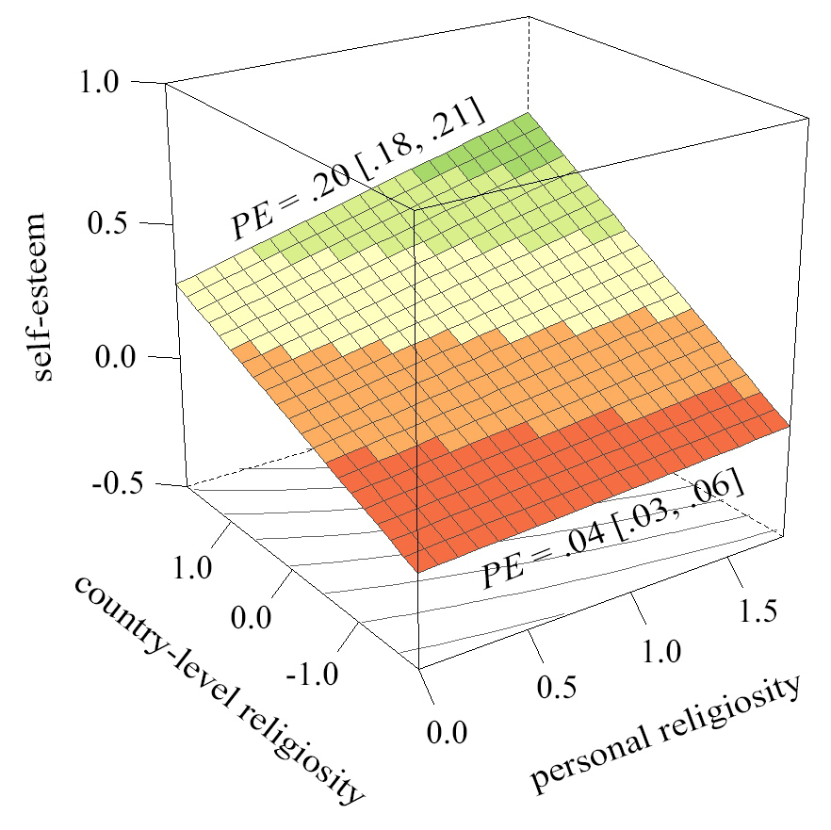

Note. The most religious countries in the sample are displayed at the left endpoint of the country-level religiosity axis (1.77 SD above M). The least religious countries in the sample are displayed at the right endpoint of the country-level religiosity axis (1.83 SD below M). PE = point estimate of standardized coefficient, including its 95% confidence interval.

Figure 2. Zero-order correlations between personal religiosity and self-esteem for each country in Study 1 as a function of country-level religiosity.

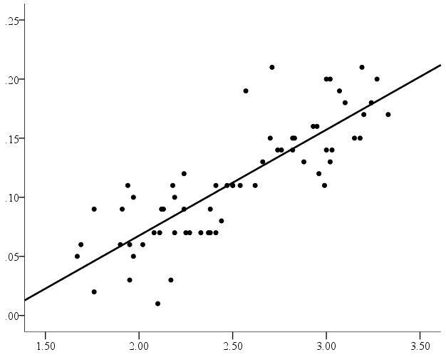
religiosity-esteem relation

country-level religiosity

Note. = Each country’s religiosity-esteem relation, including the best fitting regression line over all countries ().

Figure 3. Study 2’s basic informant-report model, depicting the relation between personal religiosity and self-esteem as a function of country-levels religiosity.

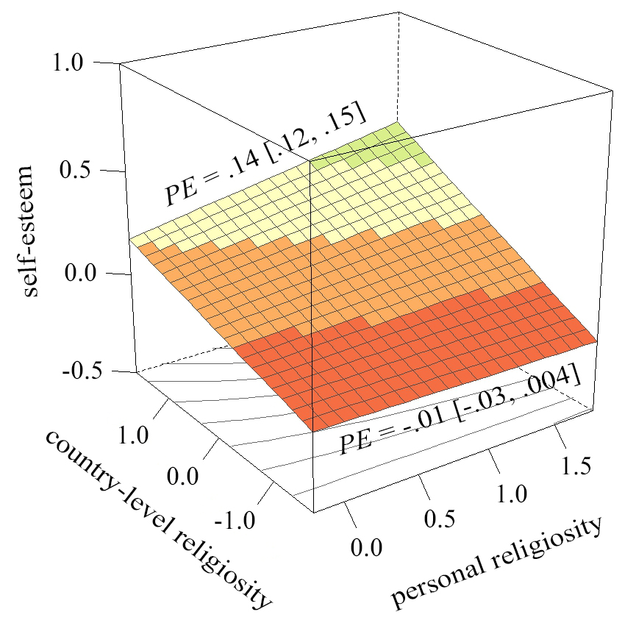
Note. The most religious countries in the sample are displayed at the left endpoint of the country-level religiosity axis (1.69 SD above M). The least religious countries in the sample are displayed at the right endpoint of the country-level religiosity axis (1.67 SD below M). PE = point estimate of standardized coefficient, including its 95% confidence interval.
Figure 4. Zero-order correlations between informant-reported personal religiosity and informant-reported self-esteem for each country in Study 2 as a function of country-level religiosity.

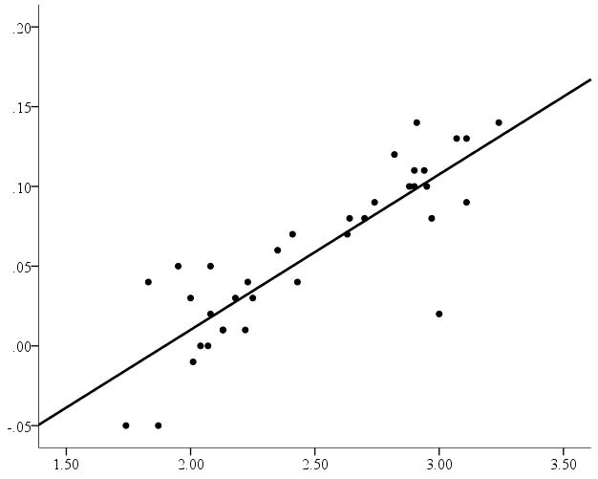
religiosity-esteem relation
(based on informant-reports)

country-level religiosity

Note. = Each country’s religiosity-esteem relation (based on informant-reports), including the best fitting regression line over all countries ().

Figure 5. Study 3’s basic model, depicting the relation between personal religiosity and self-esteem as a function of sociocultural religiosity at the country level (Figure 5.1), at the federal state level (Figure 5.2), and at the urban area level (Figure 5.3).

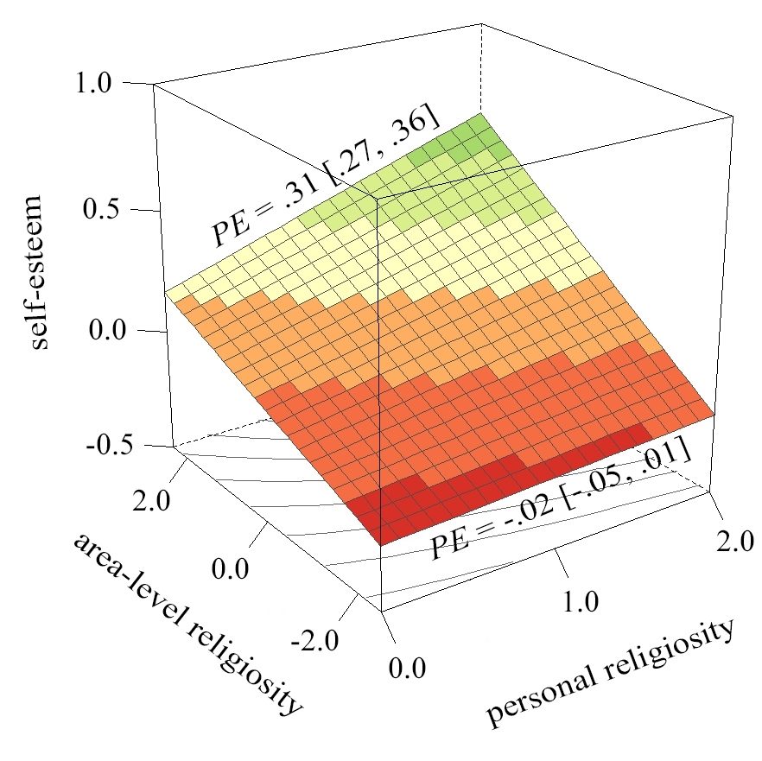
Figure 5.2. State-level religiosity
Figure 5.3. Area-level religiosity
Figure 5.1. Country-level religiosity
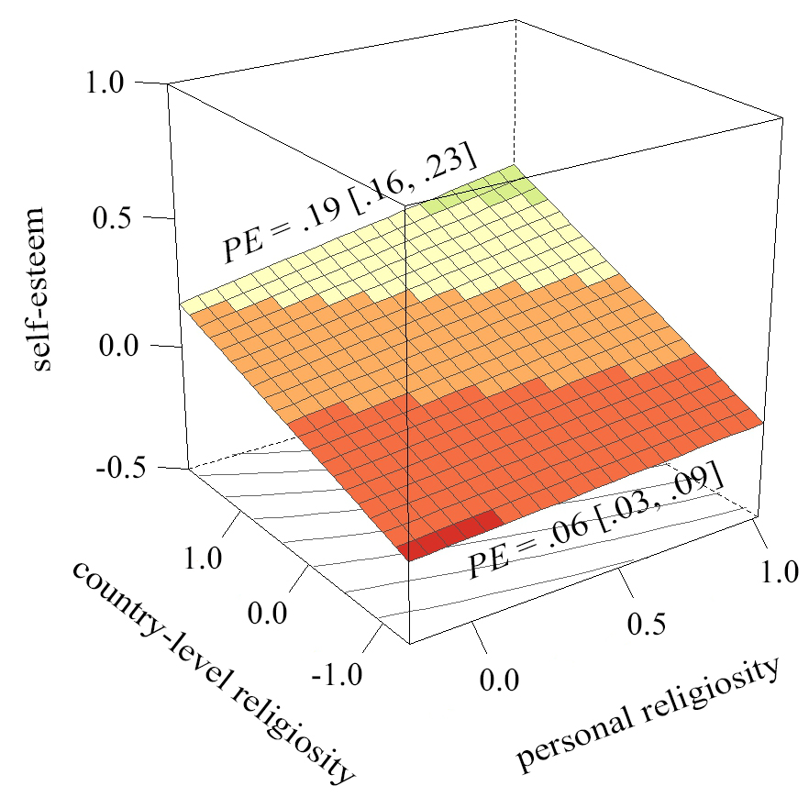
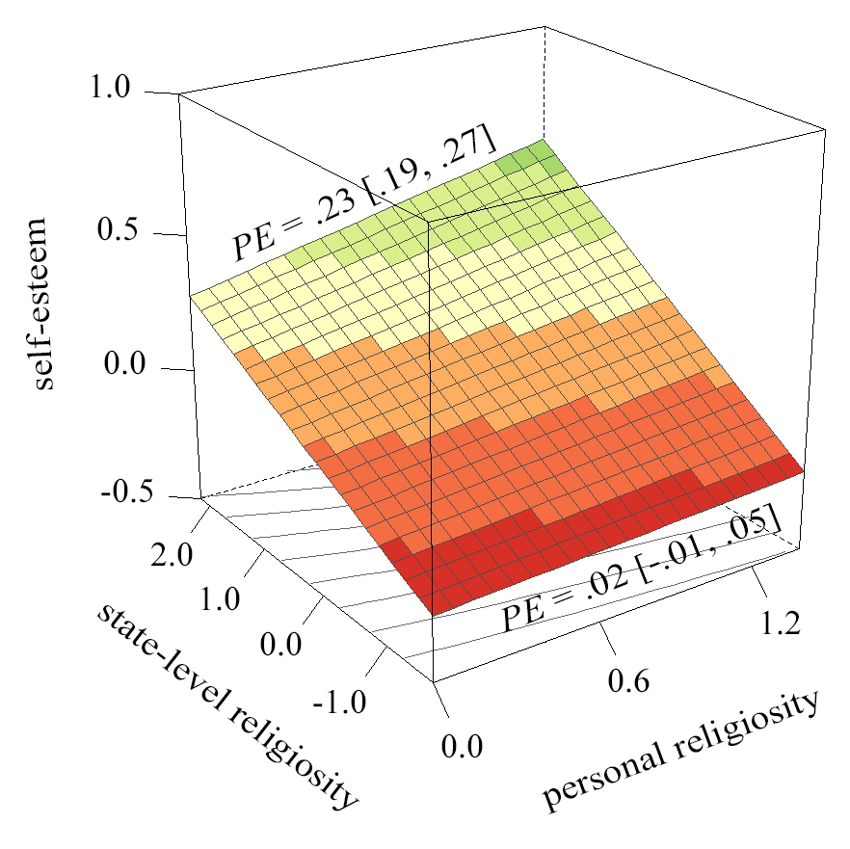

Note. Figure 5.1 is based on a two-level model, in which respondents are nested in countries. Figure 5.2 is based on a two-level model, in which respondents are nested in federal states. Figure 5.3 is based on a two-level model, in which respondents are nested in urban areas. The simple slopes are from the four-level model described in the text. PE = point estimate of standardized coefficient, including its 95% confidence interval.
SUPPLEMENTAL MATERIALS
Table S1. Pearson correlations between all level-1 variables (i.e., participant-level variables) in Study 1
N = 2,195,301 | se | agr | cns
rel | .121 | .173 | .128
 | [.120, .122] | [.172, .175] | [.127, .129]
se | -- | .145 | .255
 |  | [.144, .147] | [.254, .256]
agr |  | -- | .280
 |  |  | [.279, .281]
Note. rel = religiosity, se = self-esteem, agr = agreeableness, cns = conscientiousness. It is inaccurate to calculate Pearson correlations across the complete data set, because such a practice ignores the nested data structure. To account for this problem, we borrowed four common steps from meta-analysis: (1) We calculated the Pearson correlations for all 65 countries separately, (2) we transformed all those correlations to Fisher’s z-scores (Rosenthal & Rubin, 1982), (3) we averaged the corresponding z-scores across all countries, while weighting them by their inverse variance weight (Hedges & Olkin, 1985), (4) we back-transformed the resultant omnibus-z-scores into omnibus Pearson correlations.

Table S2. Pearson correlations between all level-2 variables (i.e., country-level variables) in Study 1
N = 65 | se | agr | cns | col | gdp | path
rel | .732 | .120 | .070 | .751 | -.656 | .709
 | [.594, .828] | [-.128, .354] | [-.177, .309] | [.616, .843] | [-.777, -.489] | [.561, .813]
se | -- | .223 | .350 | .532 | -.484 | .555
 |  | [-.022, .443] | [.116, .547] | [.324, .691] | [-.652, -.270] | [.358, .705]
agr |  | -- | .318 | -.220 | .185 | -.105
 |  |  | [.080, .521] | [-.447, .034] | [-.064, .412] | [-.342, .145]
cns |  |  | -- | -.227 | .004 | .018
 |  |  |  | [-.453, .026] | [-.242, .250] | [-.229, .263]
col |  |  |  | -- | -.653 | .652
 |  |  |  |  | [-.777, -.480] | [.479, .776]
gdp |  |  |  |  | -- | -.681
 |  |  |  |  |  | [-.794, -.523]
Note. rel = religiosity, se = self-esteem, agr = agreeableness, cns = conscientiousness, col = collectivism, gdp = gross domestic product (per capita), path = pathogen prevalence.

Table S3. Pearson correlations between all level-1 variables (i.e., participant-level variables) in Study 2
N = 560,264 | informant-rated se | informant-rated agr | informant-rated cns | informants’ self-rated rel | informants’ self-rated se | informants’ self-rated agr | informants’ self-rated cns
informant-rated rel | .056 | .095 | .091 | .518 | .071 | .052 | .057
 | [.054, .059] | [.092, .097] | [.088, .094] | [.516, .520] | [.068, .073] | [.050, .055] | [.054, .059]
informant-rated se | -- | .116 | .183 | .073 | .322 | .097 | .110
 |  | [.114, .119] | [.180, .185] | [.070, .075] | [.320, .325] | [.095, .100] | [.107, .112]
informant-rated agr |  | -- | .290 | .067 | .087 | .312 | .155
 |  |  | [.288, .293] | [.064, .069] | [.084, .090] | [.310, .315] | [.152, .158]
informant-rated cns |  |  | -- | .078 | .111 | .203 | .301
 |  |  |  | [.075, .080] | [.108, .113] | [.200, .205] | [.299, .304]
informants’ self-rated rel |  |  |  | -- | .097 | .159 | .117
 |  |  |  |  | [.094, .099] | [.157, .162] | [.114, .120]
informants’ self-rated se |  |  |  |  | -- | .132 | .230
 |  |  |  |  |  | [.129, .134] | [.228, .233]
informants’ self-rated agr |  |  |  |  |  | -- | .236
 |  |  |  |  |  |  | [.234, .239]
Note. rel = religiosity, se = self-esteem, agr = agreeableness, cns = conscientiousness. It is inaccurate to calculate Pearson correlations across the complete data set, because such a practice ignores the nested data structure. To account for this problem, we borrowed four common steps from meta-analysis: (1) We calculated the Pearson correlations for all 65 countries separately, (2) we transformed all those correlations to Fisher’s z-scores (Rosenthal & Rubin, 1982), (3) we averaged the corresponding z-scores across all countries, while weighting them by their inverse variance weight (Hedges & Olkin, 1985), (4) we back-transformed the resultant omnibus-z-scores into omnibus Pearson correlations.

Table S4. Pearson correlations between all level-2 variables (i.e., country-level variables) in Study 2
N = 36 | informant-rated se | informant-rated agr | informant-rated cns | informants’ self-rated rel | informants’ self-rated se | informants’ self-rated agr | informants’ self-rated cns
informant-rated rel | .742 | -.328 | -.415 | .993 | .699 | -.142 | -.138
 | [.547, .861] | [-.593, .001] | [-.654, -.100] | [.986, .996] | [.481, .836] | [-.450, .196] | [-.446, .200]
informant-rated se | -- | -.276 | -.019 | .735 | .938 | -.11 | .153
 |  | [-.554, .058] | [-.345, .311] | [.536, .857] | [.881, .968] | [-.423, .227] | [-.185, .458]
informant-rated agr |  | -- | .336 | -.267 | -.123 | .888 | .068
 |  |  | [.008, .598] | [-.548, .067] | [-.434, .214] | [.790, .942] | [-.266, .388]
informant-rated cns |  |  | -- | -.388 | .107 | .399 | .848
 |  |  |  | [-.636, -.068 | [-.230, .421] | [.081, .643] | [.720, .920]
informants’ self-rated rel |  |  |  | -- | .709 | -.067 | -.109
 |  |  |  |  | [.496, .842] | [-.387, .267] | [-.422, .228]
informants’ self-rated se |  |  |  |  | -- | .072 | .218
 |  |  |  |  |  | [-.263, .391] | [-.119, .510]
informants’ self-rated agr |  |  |  |  |  | -- | .238
 |  |  |  |  |  |  | [-.098, .525]
Note. rel = religiosity, se = self-esteem, agr = agreeableness, cns = conscientiousness.

Table S5. Pearson correlations between all level-1 variables (i.e., participant-level variables) in Study 3
N = 1,188,536 | se | agr | cns
rel | .134 | .185 | .139
 | [.132, .136] | [.184, .187] | [.137, .140]
se | -- | .163 | .264
 |  | [.161, .165] | [.263, .266]
agr |  | -- | .292
 |  |  | [.290, .294]
Note. rel = religiosity, se = self-esteem, agr = agreeableness, cns = conscientiousness. It is inaccurate to calculate Pearson correlations across the complete data set, because such a practice ignores the nested data structure. To account for this problem, we borrowed four common steps from meta-analysis: (1) We calculated the Pearson correlations for all 65 countries separately, (2) we transformed all those correlations to Fisher’s z-scores (Rosenthal & Rubin, 1982), (3) we averaged the corresponding z-scores across all countries, while weighting them by their inverse variance weight (Hedges & Olkin, 1985), (4) we back-transformed the resultant omnibus-z-scores into omnibus Pearson correlations.

Table S6. Pearson correlations between all level-2 variables (i.e., area-level variables) in Study 3
N = 1,932 | se | agr | cns
rel | .504 | .546 | .455
 | [.470, .537] | [.514, .577] | [.419, .490]
se | -- | .257 | .342
 |  | [.215, .298] | [.302, .381]
agr |  | -- | .601
 |  |  | [.572, .629]
Note. rel = religiosity, se = self-esteem, agr = agreeableness, cns = conscientiousness.

Table S7. Pearson correlations between all level-3 variables (i.e., state-level variables) in Study 3
N = 243 | se | agr | cns
rel | 0.709 | 0.292 | 0.15
 | [.640, .766] | [.172, .403] | [.025, .271]
se | -- | 0.178 | 0.366
 |  | [.053, .297] | [.252, .470]
agr |  | -- | 0.423
 |  |  | [.314, .521]
Note. rel = religiosity, se = self-esteem, agr = agreeableness, cns = conscientiousness.

Table S8. Pearson correlations between all level-4 variables (i.e., country-level variables) in Study 3
N = 18 | se | agr | cns
rel | .674 | .036 | -.344
 | [.302, .868] | [-.438, .495] | [-.699, .146]
se | -- | .170 | .194
 |  | [-.322, .590] | [-.300, .606]
agr |  | -- | .194
 |  |  | [-.300, .606]
Note. rel = religiosity, se = self-esteem, agr = agreeableness, cns = conscientiousness.

REFERENCES
Hedges, L. V., & Olkin, I. (1985). Statistical methods for meta-analysis. Orlando, FL: Academic Press.
Rosenthal, R., & Rubin, D. B. (1982). Comparing effect sizes of independent studies. Psychological Bulletin, 92, 500-504.

