Received 00th January 20xx,
- ª School of Chemistry, University of Southampton, Southampton, UK, SO17 1BJ. E-mail: iris@soton.ac.uk; Fax: +44 (0)2380593781; Tel: +44 (0)2380 596877.
† Footnotes relating to the title and/or authors should appear here.
Electronic Supplementary Information (ESI) available: [details of any supplementary information available should be included here]. See DOI: 10.1039/x0xx00000x
Accepted 00th January 20xx
DOI: 10.1039/x0xx00000x
www.rsc.org/
Facile production of thermoelectric bismuth telluride thick films in the presence of Polyvinyl alcohol
C. Lei,ª M. R. Burtonª and I. S. Nandhakumar*ª
Bismuth telluride is currently the best performing thermoelectric material for room temperature operations in commercial thermoelectric devices. We report the reproducible and facile production of 600 micron thick bismuth telluride (Bi₂Te₃) layers by low cost and room temperature pulsed and potentiostatic electrodeposition from a solution containing bismuth and tellurium dioxide in 2M nitric acid onto nickel in the presence of Poly vinyl alcohol (PVA). This was added to the electrolyte to promote thick layer formation and its effect on the structure, morphology and composition of the electrodeposits was investigated by SEM and EDX. Well adherent, uniform, compact and stoichiometric n-type Bi₂Te₃ films with a high Seebeck coefficient of up to -200 μV K⁻¹ and a high electrical conductivity of up to 400 S cm⁻¹ resulting in a power factor of 1.6 x 10⁻³ W m⁻¹ K⁻² at film growth rates of 100 μm h⁻¹ for potentiostatic electrodeposition were obtained. The films also exhibited a well defined hexagonal structure as determined by XRD.
The world’s energy consumption is reaching 16 terawatts and is predicted to triple by 2050¹. This trend along with rising concerns about carbon emission from fossil fuel-based energy sources has stimulated the search for cleaner and renewable energy sources. High efficiency thermoelectric (TE) materials are an important material system for power generation that can directly convert thermal waste heat into electrical energy based on the Seebeck effect^{2,3}. In this respect the potential for TE materials in sustainable waste-heat-recovery systems such as TE generation is huge and plays a key role in our current challenge to develop alternative energy technologies to reduce our dependence on fossil fuels and to reduce greenhouse gas emissions. TE generators are solid-state devices that operate silently and reliably and virtually maintenance free with long operating lifetimes without releasing toxic emissions. Despite these merits TE devices have only found application in niche markets such as e.g. space power generation which is mainly due to the low conversion efficiency of existing TE materials⁴. Bismuth telluride is the highest performing n-type material for Peltier coolers and TE devices operating near room temperature⁵.
Electrochemical deposition is promising for fabricating high quality bismuth telluride films that can be incorporated into practical TE devices with promising thermoelectric properties⁶ that offer several advantages over other methods such as molecular organic chemical vapour deposition (MOCVD)⁷ or molecular beam epitaxy (MBE)⁸. These include low cost, room temperature fabrication and scalability. However to achieve useful levels of performance in effective vertical TE designs¹, such as e.g. TE devices applied on vehicle exhaust pipes they are required in the form of layers that are several micron to mm in thickness⁹⁻¹¹. This however is challenging due to the built-up of internal stresses at the substrate-film interface and within the film itself as the film thickness increases which often results in cracking of the deposits. Often this is accompanied by a non-uniform stoichiometry throughout the thickness of the film due to the depletion of bismuth and tellurium ions as electrodeposition progresses, which adversely affects the thermoelectric properties of the material. Traditionally a nickel diffusion barrier is always used as a diffusion barrier in commercial TE devices to prevent diffusion of tin from the solder and copper from the electrodes into the p- and n-type TE legs³. There are not many studies in the literature that report the electrodeposition of thick bismuth telluride layers ¹¹⁻¹³ with even fewer reports focusing on the electrodeposition onto nickel^{14,15}. Even though organic additives such as e.g. sodium lignosulfonate acid^{16,17} and ethylene glycol^{11,18} have been shown to improve the quality of electrodeposited bismuth telluride films in terms of brightness, smoothness, hardness and ductility none of them have demonstrated a significant impact on the thermoelectric properties of the deposits. In the present study we have investigated the electrodeposition of bismuth telluride thick films onto nickel in the presence of polyvinyl alcohol (PVA) targeted at commercial TE devices operating around room temperature. PVA has been used in the electrochemical preparation of ZnO-polymer hybrid films¹⁹ resulting in electrically conducting and well-crystallized ZnO which displayed enhanced luminescence at high PVA concentrations due to a better stoichiometry of ZnO. The most pronounced effect of the PVA additive in our study is the observation that the adherence of gas bubbles was noticeably reduced during electrodeposition which may be attributed to a reduction in surface tension of the electrolyte solution resulting in more uniform and pit free surfaces. In contrast to other electroplating bath additives we also found that PVA not only had an influence on the structure, morphology and composition but significantly improved the thermoelectric properties of the electrodeposited bismuth telluride films.

We herein report the reproducible and facile formation of up to 600 micron thick layers of n-type stoichiometric bismuth telluride films (Bi₂Te₃) by either pulsed or potentiostatic electrodeposition from 2M nitric acid electrolyte baths containing 52.5 mM Bi³⁺ and 70 mM TeO₂ in the presence of PVA. The films were found to be well-adherent, uniform, compact and exhibited excellent thermoelectric properties.

All solutions were prepared using water from a Purite Select Fusion 160 (Ondeo) water purification system (resistivity 18.2 MΩ cm). Bi powder (Alfa Aesar, 99.5%), TeO₂ powder (Alfa Aesar, 99.99%), Polyvinylalcohol (PVA) (Sigma-Aldrich, Mw 85,000-124,000, 99+% hydrolyzed), Ni foil (Alfa Aesar, 0.127mm thick, 99+%) and HNO₃ (Fisher, 70%) were used as received. The electrolyte solution consists of 52.5 mM Bi³⁺ and 70 mM TeO₂ dissolved in 2M HNO₃. PVA was added to the electrolyte at a series of concentrations from 0.01 to 0.15 wt%. The electrolyte was stirred with a magnetic stirring bar at 500-600 rpm to increase the mass transfer rate during electrodeposition.

A conventional three-electrode set-up was used for performing all electrochemical deposition experiments: a large area platinum grid electrode served as a counter electrode whilst a calomel electrode (SCE) was employed as a reference electrode. A bismuth telluride chip directly attached to the platinum counter electrode was used as a sacrificial anode to replenish the electrolyte with bismuth and tellurium ions during electrodeposition. Electrodposition was carried out using a computer controlled Ivium technology potentiostat/galvanostat at room temperature. A 1 cm² etched nickel sheet was used as the working electrodes which was masked with polyimide tape to avoid edge effects. Etching of the Ni substrate (HCl solution for 1min, followed by anodic etching in 1M HNO₃ at a potential of +0.15 V vs SCE for 30 seconds) prior to electrodeposition was found to significantly improve the adhesion of the bismuth telluride films, so that the deposit does not peel off when the thickness increases to above 100 μm. Post-deposition treatment of all deposited films involved thorough rinsing in deionized water which was followed by drying in air. The surface morphology of the electrodeposited bismuth telluride films was investigated by scanning electron microscopy (JEOL JSM 5910) which was equipped with an energy-dispersive X-ray spectrometer (EDX, Oxford Inca 300) for compositional analysis with an accuracy of 5%.

Figure 1 shows representative cyclic voltammograms for the electrodeposition of bismuth telluride in the absence and presence of different amounts of PVA recorded at a 1 cm² Ni working electrode. The electrolyte solution was composed of 52.5 mM Bi³⁺, 70 mM TeO₂ in 2M HNO₃, with PVA added at 0, 0.01, 0.03, 0.05, 0.07 and 0.09 wt%. The potential was swept between the limits +0.4V to -0.5V vs. SCE. A single reduction peak can be observed at a potential of around -0.07 V vs SCE for electrolytes without PVA which is shifted to -0.1 V vs SCE when PVA is added. The reduction peak is attributed to the formation of bismuth telluride (Bi₂Te₃) in accordance with the literature¹⁸ whilst the observed negative shift may be attributable to complexation of the precursor ions (Bi³⁺, HTeO₂⁺) with PVA. Stoichiometric Bi₂Te₃ films can be deposited at potentials between 0 V and -0.12 V vs SCE for varying PVA contents, and using a wide range of [Bi³⁺]/[TeO₂] ratios. However, a small [Bi³⁺]/[TeO₂] ratio as employed here was found to produce Bi₂Te₃ films with higher brightness.

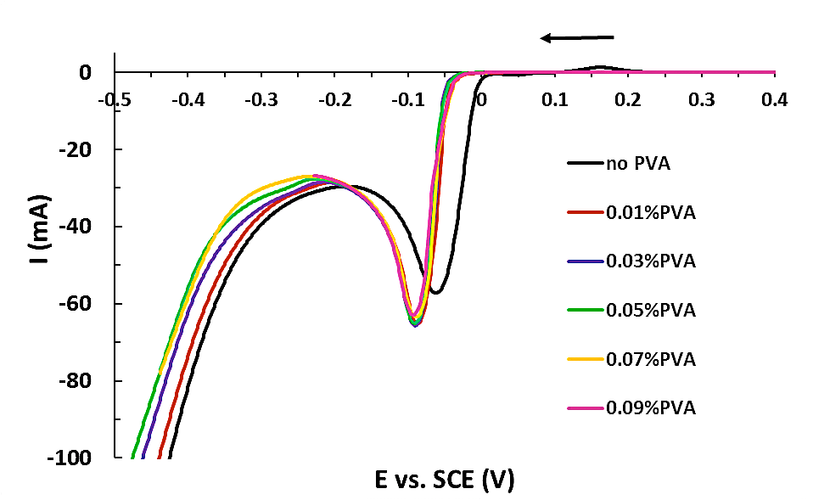

Figure 1. Cyclic voltammogram of 1 cm² Ni working electrode immersed in 2M HNO₃ + 70 mM HTeO₂ + 52.5m M Bi³⁺ in the absence and presence of PVA of 0 ~ 0.09 wt% recorded at a scan rate of 20 mV/s

To produce high quality Bi₂Te₃ films, pulsed electrodeposition was performed involving the application of zero current for 4s followed by 10 ms deposition at a potential between -0.01 V and -0.06 V vs. SCE. Potentiostatic electrodeposition was conducted at a constant potential between -0.01V and -0.06V vs. SCE. The obtained deposits exhibited a metallic luster to the naked eye, when PVA was added.

Figure 2. shows representative topographical SEM images of 600 μm thick bismuth telluride deposits that were deposited in the presence of 0.01 wt% PVA by (a) potentiostatic and (b) pulsed electrodeposition. Fig 1(c) and (d) show representative cross-sectional images of the films in (a) and (b).
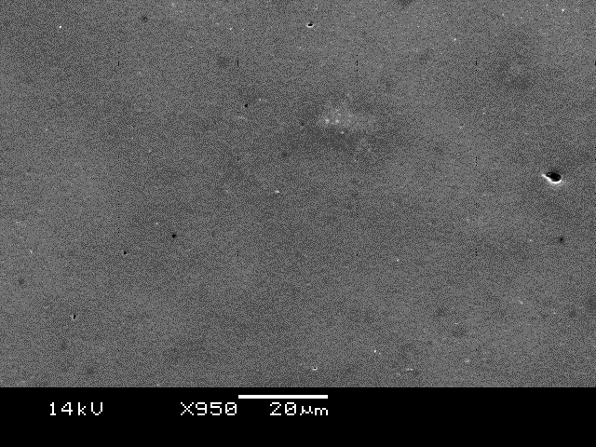
(b)
20μm
(a)
20μm

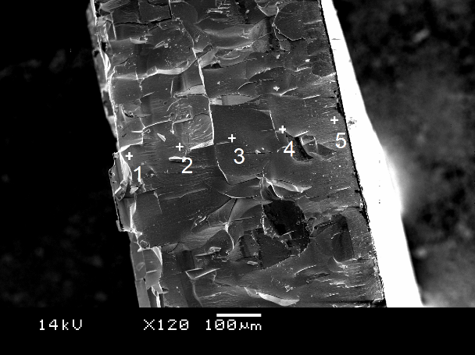
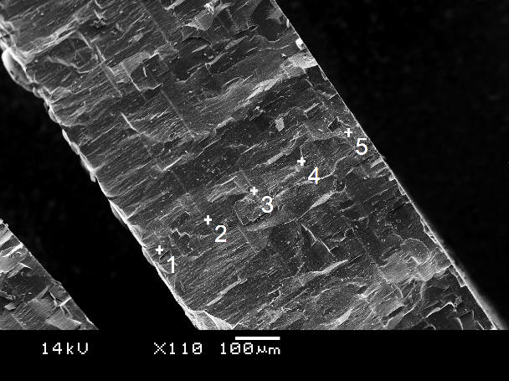
100μm
(d)
(c)
100μm

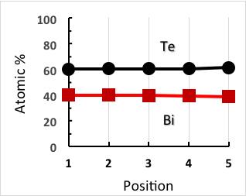
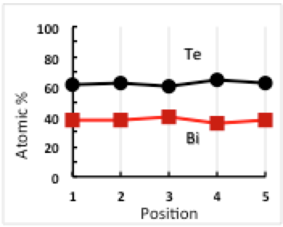
(e)
(f)

Figure 2: SEM image of 600 μm thick Bi₂Te₃ film: surface (a,b) and cross-sectional images (c,d), deposited by potentiostatic (a, c) and pulsed (b, d) deposition at -30mV. Electrolyte: 52.5 mM Bi³⁺,70m M TeO₂, 0.01 wt% PVA, in 2M HNO₃. (e) and (f) represent an EDX analysis corresponding to (c) and (d) respectively along the marked positions.

The film morphology produced by potentiostatic electrodeposition exhibits a flat and smooth surface with the appearance of some protrusions whilst pulsed electrodeposition shows a very flat surface without any protrusions. In both cases, the surfaces are pit-free. It is also noteworthy that at a film growth speed of ~100 μm h⁻¹ for potentiostatic deposition, the film surface would be full of pits and dendritic above ~300 μm thick as commonly observed in high speed deposition processes, if PVA was not added. The PVA additive in the electrolyte has not only reduced the surface tension of the solution but also makes the ion distribution uniform in front of the growing surface, so that higher thicknesses can be obtained. The cross-sectional images reveal that in both cases the deposited films exhibit an equiaxed grain structure, in contrast to the columnar structure usually observed in electrodeposited Bi₂Te₃ materials without the PVA additive^{14,15}. This results in a block structure and gives rise to a very compact and uniform appearance. Figure 1 (e,f) shows the corresponding EDX analysis of the cross-sectional films produced in Fig.1 (c) and (d) at the indicated positions which clearly demonstrates that the elemental composition is stoichiometric and uniform for both potentiostatic and pulsed electrodeposition throughout the entire film thickness. Film growth rates were determined to be 50 microns per hour for pulsed electrodeposition, and 100 microns per hour for potentiostatic electrodeposition. Figure 3 shows an SEM image of the bottom side (in contact with Ni substrate) of the deposit consisting of packed up irregular trilateral (arrow 1), quadrilateral (arrow 2) or pentagonal (arrow 3) blocks.
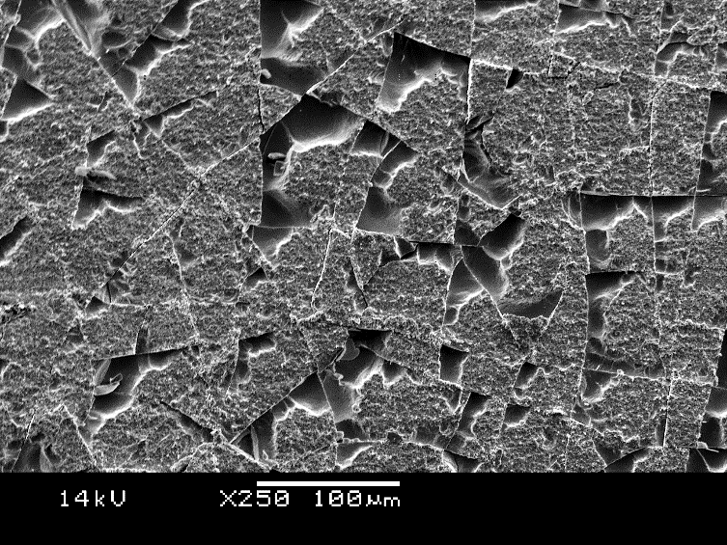
1
2
3

Figure 3 SEM image of bottom film surface of 600 μm thick bismuth telluride after removal from Ni substrate.

Figure 4 shows a typical XRD pattern recorded for electrodeposited Bi₂Te₃ films by potentiostatic (a) and pulsed electrodeposition (b) in the presence of 0.01 wt% PVA. In both cases a very intense and prominent (110) peak is visible which indicates that the bismuth telluride deposits are preferentially oriented in the (110) direction parallel to the substrate. All of the detected XRD peaks can be indexed according to the standard ICDD card (PDF-2/release 2012 RDB) as belonging to rhombohedral Bi₂Te₃ with a space group of R3m and a hexagonal crystal structure. The average crystallite size as calculated by the Debye-Scherrer equation was

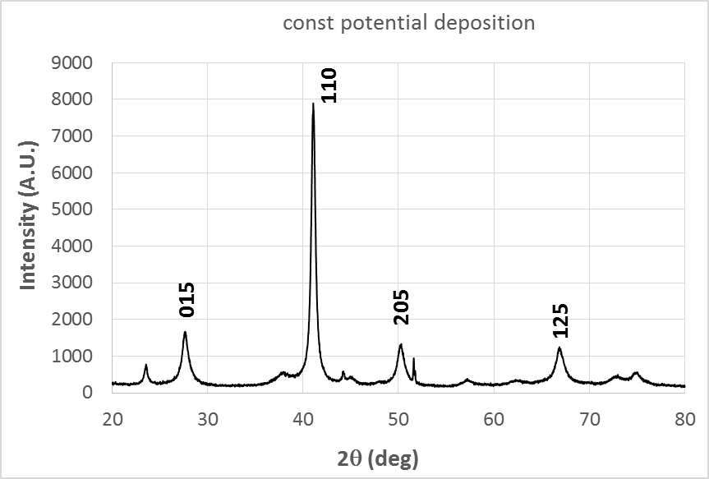
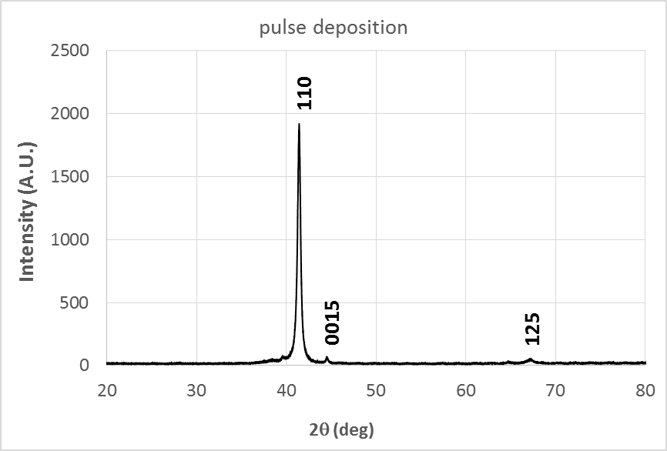
(a)
(b)

Figure 4: XRD patterns of the deposited films by potentiostatic (a) and pulsed deposition (b), obtained on a Rigaku SmartLab diffractometer using Cu-K_{α} radiation (λ = 1.5406Å) in the presence of 0.01 wt% PVA.
15 nm for potentiostatic deposition and 43 nm for pulsed deposition. This is in agreement with the observation that for pulsed deposition there are noticeably fewer peaks present besides the main (110) diffraction peak indicating that pulsed deposition produces larger crystallite sizes and more highly oriented films. Different PVA concentrations ranging from 0.01 to 0.15 wt% had similar effects on the structure, morphology and compositional stoichiometry of the deposited films and representative results have therefore been only shown for 0.01 wt% PVA. The transport properties of the deposited films were measured along the film plane using the standard van der Pauw technique with a direct current (DC) of 19 mA and a permanent magnetic field of 0.37 T at room temperature using a commercial Hall effect measurement system (HMS 300 from Ecopia). Prior to Hall effect measurements, each deposit was delaminated from the Ni substrates onto a glass slide using epoxy resin (circuitworks), in order to prevent electrical short circuiting and interference of magnetic fields by the metal substrate. The Seebeck coefficient S (μV K⁻¹) was determined using a custom-made Seebeck measurement unit, which was calibrated against a polycrystalline Bi foil reference standard. Seebeck coefficients of stoichiometric Bi₂Te₃ thick films were measured to be up to -200 μV K⁻¹ for samples deposited by pulsed electrodeposition whilst potentiostatic deposition yielded Seebeck coefficients of up to -100 μV K⁻¹. In the absence of PVA 600 micron thick bismuth telluride films yielded an average Seebeck coefficient of -80 μV K⁻¹ which is lower than that obtained with PVA as an additive. All deposited stoichiometric films in the presence of PVA showed n-type conductivity with a Hall mobility of up to ∼230 cm² (Vs)⁻¹, a carrier concentration of ~3.0x10¹⁹ cm⁻³ for potentiostatic deposition and 4.9 x 10¹⁷ cm⁻³ for pulsed deposition and a high electrical conductivity of up to 400 S cm⁻¹ resulting in a power factor of 1.6 x 10⁻³ W m⁻¹ K⁻². These values are high in comparison to previously reported Seebeck coefficients and transport properties for n-type electrodeposited Bi₂Te₃ films ^{11, 12, 18} which are in the region of -60 to – 100 μV K⁻¹ (even in the presence of additives) as well as for Bi₂Te₃ films fabricated by other methods such as MBE²⁰, MOCVD²¹ and LPCVD²².

Conclusions

We have demonstrated that electrodeposition in combination with PVA as an additive is a facile route for the production of 600 micron thick layers of n-type stoichiometric Bi₂Te₃ films on nickel which were found to be well adherent, uniform, compact and exhibited excellent thermoelectric properties that exceeded those of other fabrication methods. In addition film growth rates of up to 100 microns per hour were achieved for pulsed electrodeposition.
.

Acknowledgements
We are grateful to Innovate UK for the award of a TSB grant (TS/L008157/1) and to European Thermodynamics and Scionix for their support throughout this project.

References
- T. C. Monson, M. T. Lloyd, D. C. Olson, Y. J. Lee and J. W. P. Hsu, Adv. Mater.2008, 20, 4755.
- L. E. Bell, Science, 2008, 321,1457.
- D.M. Rowe, Ed. In CRC Handbook of Thermoelectric; CRC Press: New York, 1995
- P. Pichanusakorn, P. Bandaru, Mater. Sci. Eng., 2010, R 67, 19.
- T.M. Tritt, Science, 1999, 283, 804.
- M. S. Martin-Gonzalez, A. L. Prieto, R. Gronsky, T. Sands and A. M. Stacy, J. Electrochem. Soc., 2002, 149, C546.
- R. Venkatasubramanian, T. Colpitts, B. O’Quinn, S. Liu, N. El-Masry, and M. Lamvik, Appl. Phys. Lett., 1999, 75, 1104.
- A. Mzerd, D. Sayah, G. Brun, J. C. Tedenac, and A. Boyer, J. Mater. Sci. Lett., 1995, 14, 194.
- W. Glatz, S. Muntwyler, C. Hierold, Sensor. Actuat. A-Phys., 2006, 132, 337.
- W. Glatz, E. Schwyter, L. Durrer, and C. Hierold, J. Microelectrom. Sys. 2009, 18, 763.
- S. Li, M.S. Toprak., H.A.M. Soliman, J. Zhou, M. Muhammed, D. Platzek and E. Müller, Chem. Mater., 2006, 18, 3627.
- W. Glatz, L. Durrer, E. Schwyter and C, Hierold, Electroch. Acta, 2008, 54, 755.
- M. Maas, S. Diliberto, C. de Vaulx, K. Azzouz and C. Boulanger, J. Electron. Mater. 2014, 43, 3857.
- K. Tittes, A. Bund, W. Plieth, A. Bentien, S.Paschen, M.Plotner, H. Gräfe and W.Fischer, J. Solid State Electrochem., 2003, 7, 714.
- H. Xu, W. Wang, Int. J. Electrochem. Sci., 2013, 8, 6686.
- J. Kuleshova, E. Koukharenko, X. Li, N. Frety, I.S. Nandhakumar, J. Tudor, S.P.Beeby, N.M. White, Langmuir, 2010, 26, 16980.
- O. Caballero-Calero, P. Díaz-Chao, B. Abad, C.V. Manzano, M.D. Ynsa, J.J. Romero,M. Munoz Rojo, M.S. Martín-González, Electrochimica Acta, 2014, 123, 117.
- C. J. Boulanger, J. Electron. Mater. 2010, 39, 1818.
- Th. Pauporte, Cryst Growth & Design., 2007, 7, 2310.
- N. Peranio, M. Winkler, Z. Aabdin, J. König, H. Böttner, and O. Eibl, physica status solidi (a), 2012, 209, 289.
- A. Boulouz, S. Chakraborty, A. Giani, F.P. Delannoy, A. Boyer, J. Schumann, J. Appl. Phys., 2001, 89, 5009.
- S.L. Benjamin, C.K. de Groot, C. Gurnani, A.L. Hector, R. Huang, E. Koukharenko, W. Levason, and G. Reid, J. Mater. Chem. A, 2014,2, 4865.

