Rediscovering and Modernising the Digital Old Minster of Winchester

Paul Reilly¹, Stephen Todd², Andy Walter³
¹ Corresponding author p.reilly@soton.ac.uk, Visiting Fellow, Archaeological Computing Research Group, Faculty of Humanities, University of Southampton, Avenue Campus, Highfield, Southampton, SO17 1BF. orcid.org/0000-0002-8067-8991
² Visiting Professor, Goldsmiths, University of London, email: Stephentodd@gmail.com
³ Independent Researcher, email: m.agn@uwclub.net

Abstract
The models and animations of the Old Minster, Winchester were remarkable in 1984-6 for producing the earliest animated tour of a virtual archaeological monument. Thought to be lost, thirty years on the original model files were rediscovered buried under layers of now unsupported code and recovered.
This paper describes how the models were initially developed in the 1980s and then subsequently retrieved, restored and re-purposed in 2015. The original project is re-evaluated in the light of contemporary best practice. In modernising the digital Old Minster this virtual model has also been translated into a material one in the form of a 3D-print. This physical instantiation of the model challenges conventional understandings of, and blurs the boundary between, real and virtual heritage. We contend that left unaddressed this lack of clarity is set to radically disrupt current best practice in the discipline.
Keywords: 3D printing, virtual heritage, archaeological visualisation

Highlights
- World first Virtual Archaeology model and animation rediscovered
- Original model transcoded into modern open source format for digital curation
- Virtual archaeological monument 3D-printed

Acknowledgements
We would like to thank Michael Carter, Costis Dallas, Hugh Denard, Jeremy Huggett, Yannis Kourtzellis, Heike Messemer and Kate Rogers for their comments on an earlier draft of this paper. This research received no specific grant from any funding agency in the public, commercial, or not-for-profit sectors.

“Aethelwold also rebuilt the building of the Old Minster with lofty walls and new roofs, strengthening it on its southern and northern sides with solid side chapels and arches of various kinds. Similarly he added numerous chapels to house holy altars; these disguise the entrance to the main doorway so that if someone were to walk through the interior of the church with unfamiliar steps, he would not know whence he came, nor how to retrace his steps… On the Structure of the Tower. It has five stories fenestrated with open belfry windows, and it opens out in all four directions”.
Wulfstan of Winchester, Narratio metrica de S. Swithun, c.CE 996
(Translation Lapidge 2003, 376-7)

Introduction
The models and animations of the Old Minster, Winchester were remarkable in 1984-6 for producing the earliest animated virtual tour of a computer-generated interpretive visualisation of lost cultural heritage using experimental solid modelling software called Winsom (Burridge et al 1989, Reilly 1989; 1992 pp 152-155). They were not the first models of their kind. A computer model of the Romano-British temple of Sulis Minerva in Bath was probably the first solid model of an archaeological reconstruction (Smith 1985, Lavender et al 1990, Woodwark 1991). A pseudo-tour consisting of a sequence of key views was produced but it was not animated (see Reilly 1992; 1996 for an outline of several early solid-modelling projects in archaeology).
In hindsight, the Old Minster project might be seen as the spark that ignited an explosion of creativity in producing and presenting hypothetical interpretations and reconstructions of cultural heritage to a broad-based, international audience in a virtual format. The combination of an internationally significant archaeological and historical site associated with the application of the latest ‘high-technology’, promoted by a professional corporate communications officer at IBM, ensured this project made a huge, if temporary, impact. Certainly it was very successful in garnering the attention of a large, international, broad-based audience through broadcasters (e.g. BBC South Today, 1986), the press (e.g. Reilly and Weber 1991), industry periodicals (e.g. Jones 1988) and popular scientific magazines (Anon. 1987), museum exhibitions (e.g. British Museum 1986-7) as well as academic audiences in conferences and specialist publications (e.g. Reilly 1989, Reilly 1992, pp 152-154).
Of late, we have detected a marked and growing interest in taking stock of the early days of 3D modelling of cultural heritage (e.g. Wittur 2013, Messemer 2015). In recent years one of the authors (Reilly) had received several unfulfilled requests for copies of the Old Minster models which were thought lost. A chance discussion between Stephen Todd and Andrew Walter, precipitated by a request to Paul Reilly for an historical account of the project, led in April 2015 to the rediscovery of the models which had astonishingly survived. Encapsulated as test models in another research extension to the original Winsom software called ESME (Burridge et al 1989, 550) they had endured the many radical technology changes of the intervening decades. The historical significance of this collection, together with the emergence of specialist online journals to curate and provide access to such models, persuaded us to assemble as much as possible of the models and associated intellectual capital (code, manuals, definition files, images, correspondence, patents), and port them with an account of their history into an open, stable and secure digital environment, in order to make them available for historians of digital cultural heritage and other interested parties.

Setting the Scene
Crucial to its success, but hidden behind the screens, the 'minster movie' project was a unique intersection of archaeologists, computer scientists and engineers specialising in 3D computer modelling and graphics systems. In fact, this first-of-a-kind status of the minster movie in archaeology was the product of an innovative collaboration environment fostered within an international network of IBM scientific centres (Kolsky and MacKinnon 1989). The IBM UK Scientific Centre (UKSC) focussed on human computer interfaces which, at the time, meant graphics, databases, image-processing and speech synthesis, and happened to be located in Winchester. It attracted independent visiting domain specialists, who while experts in their field sometimes had very limited knowledge or experience of computer applications. There were also a small cadre of post-doctoral research fellows who came to the scientific centre from such diverse fields as chemistry, physics, visual arts and archaeology (e.g. Colley and Todd 1985) for two or three years with both domain expertise and considerable experience in computer applications. Research fellows were embedded in multidisciplinary teams supported by some of IBM’s best technology and eminent researchers, supplemented by an annual intake of talented university students gaining work experience. Research fellows, or visiting scientists, would identify significant challenges in their particular realm of expertise, and the broader team would be aligned to help them overcome them. Application development was multidisciplinary, project driven and dynamic; a forerunner to the ‘continuous beta’ model in widespread favour with software developers today.
Against this background, archaeologists Birthe Kjølbye-Biddle and Martin Biddle approached IBM UKSC in 1984 with the challenge of presenting the results of their investigations into the development of the Anglo-Saxon priory cathedral of Winchester, conducted in the 1960s, to the general public in an easily accessible way. Possibly the most imposing building in pre-Norman Britain, the only trace of the Old Minster on the ground today is the footprint of the building’s final phase laid out in bricks marking the robber trenches left from its demolition in c.1093/4 to the north of the present Norman cathedral.

Making the Digital Old Minster

Motivation
In 1984, three-dimensional computer graphics seemed to archaeologists an exciting and appropriate way to illustrate and convey a sense of the scale of these now lost medieval ecclesiastical edifices in a stimulating new format. For the IBM researchers, the project would help to promote both their own and the company’s technical prowess and relevance to the scientific community, and drive technical advances in their experimental 3D modelling technology called Winsom.

The Winchester Solid Modeller (Winsom)
Winsom was based on the principles of Constructive Solid Geometry (CSG), using basic boolean operators (i.e. add, subtract, union, difference, intersection) to build complex objects from combinations of simple ones (namely half plane, cube, sphere, cone, and torus). Originally built to make orthogonal images of complex molecules such as insulin, in its day Winsom’s solid modelling technology was cutting edge (Quarendon 1984, Burridge et al 1989). However, an ever expanding field of application areas meant that additional requirements were constantly being generated. Winsom was therefore an organic research vehicle, which produced its own set of challenges. As we shall see later on, although the models might be unchanged, radically new views of same model could and did ‘evolve’ with new implementations of specific functions.

Constructing the Models
Kjølbye-Biddle provided a set of drawings, plans, sections and all other then known evidence, such as pictures of architectural parallels surviving elsewhere in Europe, insights distilled from historical descriptions (Kjølbye-Biddle 1986, Kjølbye-Biddle and Biddle forthcoming). She also worked closely with the technical team to ensure the models they built conformed to her expert opinion. It is important to recognise that there was much less awareness of computer techniques in the archaeological community at that time, and computer interfaces were also much more basic. In practice much of the work of inputting and editing the models was done over many weeks by a team of student interns overseen by Andy Walter. Winsom was not an interactive program, and initially there was no real-time wire-frame or other tool available to help, so the model development process required text changes to be made in the model file, and then resubmitting the model to be rendered by Winsom to generate a new single static image. Even when we had one of the regular review sessions with Dr Kjølbye-Biddle at the computer terminal, it was always one of the computer specialists who typed the instructions to advance the interaction into the computer and make any adjustments to the models; we called this ‘chauffeur-driven mode’.
Six models were developed in Winsom and rendered to show the general external appearance of the buildings. Five of the original interpretive models produced to illustrate the development of the Old Minster are positioned over their archaeological footprints in Fig. 1. The models are rather modest in their appearance. Although supported, and used on other heritage models such as the medieval Westgate of Winchester, texture-mapping was never used on the Old Minster models. No knowledge of the material or structural properties of the Old Minster were considered, and no attempt was made to conduct any kind of viability assessment, such as stress analysis. The emphasis was on geometry, explaining the layout and conveying the scale of construction of the different phases.
The models of the later phases were large and complex. In order to make them simpler to manipulate and parameterise they were developed in a modular fashion, using a series of sub-model files, each one representing a different component of the minster (e.g., aussencrypta.model, tower.model, and altar.model). A master model file brought together the required components associated with a particular view-point or indeed the entire minster. In so doing the project had achieved a rudimentary form of virtual anastylosis, whilst simultaneously promoting efficiency by reducing to a minimum the number of components required to be rendered from any given viewpoint. Having made the models and rendered a number of high resolution views the ambitious decision was made to produce an animated tour of the digital Old Minster of Winchester.
This would involve considerable effort and the mobilisation of, by the standards of the day, colossal resources. Ideally, every second of animation requires 25 images. Ultimately, time, CPU and disk space constraints meant the conventional 25 frames per second could not be achieved. Instead each frame was duplicated to achieve the necessary animation frame rate (I.e., 2x12.5 frames per second). Each 512x512 8-bit image generated by Winsom for the animation was a single run of the program requiring 1 hour of CPU time on an IBM 4381 mainframe. There was no animation facility, which meant that every frame of the movie had to have its own viewpoint and camera details specified afresh. Clearly this needed to be automated, and a splining program was written which generated a smooth path through any number of given keypoints. About 25 keypoints (or keyframes) were used in the movie, and each keypoint had its own x,y,z, direction-of-view, field-of-view, and other parameters such as depth-cueing value, intensity of lights etc. The program that performed this task was written an interpreted language called Rexx. It would not be hard to recreate this work or something close to it in comparable current languages such as Python or JavaScript.
Winsom was capable of producing 2048x2048 images and some static images were generated at this resolution for 35mm slide projection. Our usual working high-quality resolution was 1024x1024 but this resulted in images too large to be transferred onto U-matic tape (768x576 max), taking up to four times longer to render than 512x512 images, and so was not used. In developing the minster movie, our usual process was to start by rendering images at much lower resolution (e.g. 64x64 pixels) taking around a minute to calculate, but sufficient to show whether the composition or bug fixes had worked or not. Test runs of new movie paths using this code typically generated 64 images of 64x64 resolution; this would also take about an hour. Frequently, we discovered that our path disappeared through an inconvenient wall, or the camera-specification meant we clipped a nearby object, necessitating a keypoint change. Gradually, the animation was developed over many overnight batch-mode runs. With each successive iteration, new frames representing the view at the middle position between the existing frames would be rendered. By this means we incrementally smoothed out the intervening visual flow.
The first full ‘high-resolution’ animation was completed early in 1985. By now it had earned the sobriquet of Monster Minster Movie in recognition of the extraordinary amount of effort and resources invested into its making. Unfortunately, with the exception of one frame captured on 35mm film (Fig. 2), the original images do not survive, nor do the control files used. It was impossible to store all the images for the movie on the extremely limited and prohibitively expensive disk space available to us at the time. Images had to be dropped onto tape as they were rendered, and then deleted from disk. However, a copy of the original animation was preserved on a VHS tape, copied from a higher resolution but much less available U-matic video. The quality is therefore not the best it could have been. Incidentally, the production of the master tapes for the animations also involved considerable effort. Dropouts (i.e. missing frames) in transferring images to the U-matic recording systems of the day meant that recording movies was a somewhat hit-and-miss process, each frame taking about 10-20 seconds to be recorded to tape; any dropout meant re-starting this process at whatever point the glitch occurred.

The First Minster Movie
The key technical improvement to Winsom in the The Old Minster, Winchester project would be the development of accurate and predictable perspective with improved view control (Quarendon and Todd 1994). However, that control was not fully available for the first minster movie. This shortcoming, and other technical flaws, created a number of visual anomalies and other bugs, requiring some very judicious compromises and work-arounds that had significant side effects on the final composition and overall aesthetics of the first animation that emerged. For example, initially we tried to re-imagine the view a person might have seen walking around outside and looking up at this once impressive building. Unfortunately, with limited control over the camera’s geometry, the combination of tilting the view and applying perspectives, while acceptable for static images, produced unwanted aliasing (i.e. staircasing or jaggies); ‘darting mice’ seemed to appear wherever the surface of any object in the model was not perfectly horizontal or vertical to the virtual camera in adjacent frames. To minimise these mesmerising but unwanted effects, the camera had to be kept as level as possible, and images were post processed to remove conspicuous pixels. Even so, the images that were taken at eye-level would have half the frame filled with unalleviated 8-bit green grass which, frankly, looked awful. The solution to this particular dilemma was to simulate a stable fly-round at a suitable height; the animation therefore started with a long shot of the entire model using a slightly downward-tilting virtual camera. Throughout the following spiral tracking shot, in which the viewer is transported ever closer to the exterior of the model, the camera is adjusted so as to level-off perfectly at eye-height by the time it enters the west door. On the way down the viewer sees not only the building’s external architectural features (e.g. tower, transepts, apses, etc) but also a number of recumbent slabs marking graves uncovered during the excavations, and is teased by brief glimpses of the interior through the windows.
The gloomy atmospheric feel once inside the model, which incidentally we consider as authentically fair, was a serendipitous by-product of the technical challenges we encountered with Winsom (See Exhibit 1). To produce the impression a person might experience when entering and exploring the Anglo-Saxon priory cathedral required the application of a lot of perspective distortion using a viewpoint set to something like a wide-angle 35mm camera. Almost predictably, another technical issue with the geometry involved in this surfaced. Winsom had originally been designed to render an orthogonal view of objects placed inside a unit-cube volume; rendering the contents of this unit cube as if viewed from an infinitely far away viewpoint via an infinite zoom-lens. But once perspective distortions were applied to obtain the desired human-scale internal views, parts of the model became extended far beyond the back face of the unit cube, whereupon Winsom simply truncated the rendering at that point, leaving disconcerting views to the outside. The only readily available workaround to this perspective depth limitation was to use depth-cueing; the effect whereby the further an object is from the viewpoint, the darker they become. We reduced the brightness of everything to zero before the depth exceeded the back face of the unit cube. This extreme depth-cueing meant that visually this first movie began outside the minster in bright light, but the moment the viewer entered the west-end doorway a dramatic change occurred. As the viewer stepped a short distance into the nave, and turned sharp right to explore a south aisle, the lighting effect of the depth-cueing was that of a night scene, with only a faint candle to light your way (see Fig. 2). Arches seemed to loom out of the stygian darkness and nothing was visible through the windows (because the blue sky background was replaced with black so that those parts of the model that were not rendered due to the unit-cube limitation merged invisibly with the depth-cued elements). The meandering path taken during the first full version of the animation was inspired by the rather lavish description by Cantor Wulfstan (of Winchester) in his Narratio metrica de S. Swithun recorded around 996 CE which mentions the need for guides to lead visitors back to the main entrance, apparently because the unfamiliar could become disorientated as they wandered hither and thither around the cathedral (Lapidge 2003, 376-379). Wulfstan’s poetic accounts also informed many important elements incorporated into the re-imagined tour (e.g. the ornate tomb of St Swithun, the crypts, the number of floors and windows in the tower, and the high vault of the ceiling).

The Second Minster Movie
Despite its flaws the animation was good enough to generate a request from the British Museum to produce a second version for inclusion in their Archaeology in Britain: new views of the past exhibition from 3 July 1986 to 15 Feb 1987. It was an opportunity to improve the quality of the visualisation, with much improved perspective as the main gain. This second version of the movie employed 32 images in each keypoint-interval, at 512x512 resolution which, with 25 intervals, resulted in 800 images being recorded to tape. Again not having the time to compute the standard 25 frames per second, each frame was recorded to tape twice, resulting in a slightly jerky animation. By this time the U-matic recording system had been replaced with one that used Sony Betacam broadcast-quality tape, dropouts had become a thing of the past, and analogue quality was much better, though it was still a slow process to record each frame due to the tape rewind-wind-forwards-synchronise-dropin-rewind mechanical process.
The duration of the animated sequence was just over one minute, but the finished exhibit with introductory phase, captions and credits was 2 minutes 30 seconds, according to a stopwatch used by the British Museum team (Exhibit 2). This version of the movie begins with the opening title ‘The Old Minster, Winchester’ accompanied by the subtitle ‘Growth of the building through four centuries of Royal Patronage’. There follows a sequence of static images, each depicting a major building phase shown in relation to the ground plan of the excavated robber trenches. Succeeding phases are introduced with concise explanatory captions developed by the British Museum (i.e. ‘About 648 AD. King Cenwalh's church’, ‘700-800 AD St. Martin's tower gatehouse built’, ‘903-71 AD. Facade and chapels built’, ‘971-4 AD. Great apses link the church and St Martin's tower’, and ‘974-93 AD. West end remodelled with extensions eastwards’). The actual animation is introduced with the caption ‘A tour of the OLD MINSTER about 1000 AD moving inside from the west door past St Swithun’s tomb and east to the high altar and crypt entrance’. This tour, played on a large TV monitor in continuous loop, was much brighter and less convoluted than that adopted for the first movie. With no depth-cueing the interior has a much lighter, less claustrophobic feel compared to the first movie. After the fly-round, the viewer experiences a level glide down the nave towards, and then around, the high altar, requiring a subtle upwards tilt of the camera, before executing a smooth pan back to view the crypt entrance with the west door framed by the canopy of the high altar. The final, static, image before the credits (Fig. 1) has the caption: ‘About 648-1000 AD. Main building phases over foundation plan’.
The original TIFF images for this version of the movie still exist, and have been concatenated and remastered into an Mpeg-2 movie, resulting in better visual quality and less jitter, colour-bleed and so on.
After a relatively short period of acclaim, the models and animations of the Old Minster slipped unremarked into the background as the field of virtual heritage embraced the increasingly sophisticated modelling and rendering technologies available in common off-the-shelf packages.

Modernising The Old Minster, Winchester
Winsom was a research application and while the code became defunct long ago, many of its technical breakthroughs were published, or patented (e.g. Todd 1990, Gray, Halbert and Todd 1992, Todd 1992, Quarendon and Todd 1994) and then licensed into other commercial offerings. Crucially, the principles of CSG modelling remain unchanged from 1984 which, in practice, means that the model definition files are relatively easy to translate into a modern open source modeller such as OpenSCAD which is remarkably close to Winsom in concept and syntax (See Fig. 3).
The Winsom model files of all six major building phases of the Old Minster have therefore been converted into OpenSCAD using the expedient of cut-and-paste and simple editing (e.g. Fig. 4). The emergence of powerful and affordable graphics cards means that open source programs such as OpenSCAD can render these once seemingly complex and fairly intractable models at several frames a second at very high resolution, and the interactive GUI allows model files to be tested instantly. Productivity now has improved astonishingly, with work that once took several people several days to complete now possible by a single person in just a few hours. We have exported the OpenSCAD model as a mesh and made it available as a web version for better general availability (Exhibit 3: http://programbits.co.uk/minster/minst.html). This also permits the user to change views using conventional interactive camera controls. It would have been awkward to render the movie in OpenSCAD, not least because the software has some technical issues very like those of the early Winsom when rendering interior views of an object looking outwards. However, this is easier on the web; we have also prepared a new web version incorporating a close approximation to the original fly-thorough.

Winchester’s Old Minster in the light of London and Seville
Although it is now much simpler to share virtual models with open source code, and whilst there is no comparison between using Winsom in 1984 and OpenSCAD in 2015, the need to mentally grasp the models, envision, construct, decompose, and decide just how to assemble and structure the construction of the model is unchanged. In the 1980’s access to solid modelling technology was restricted to a rare few computer-literate archaeologists with access to experimental modelling software. The project team who performed this crucially important task was composed of expert archaeologists and computer scientists, the former doubling up as directors and the latter as producers. Later projects started to employ creative artistic direction and CGI professionals. After which it was not long before some practitioners worried that the role of the archaeologist or cultural historian in presenting, and shaping awareness and impressions of, the past in the present might be usurped by faceless technocrats, producers, or graphic designers, who could bend public perception with overpoweringly realistic and influential but, perhaps, uncritical visualisations (e.g. Miller and Richards 1995).
Today, we perhaps take for granted the echelons of tech-savvy archaeologists and digital culture experts internationally. This expertise originates in a plethora of well-established postgraduate courses on, for example, Virtual Pasts, Virtual Archaeology and Digital Heritage. It is then honed within an industry served with international organisations, frequent, large, and well attended, conferences, SIGs, workshops and specialist journals. Since 2006 we also have the six internationally-recognised principles of ‘intellectual transparency’ enshrined in the London Charter to guide the production and documentation of computer-based visualisation projects across the broad spectrum of cultural heritage: implementation; aims and methods; research resources; documentation; sustainability; access (see Beacham et al 2006, Denard 2012). In addition the eight principles of the Seville Charter offer robust, consensus-based guidance on best practice for specifically archaeological heritage visualisation projects. These Seville principles address: interdisciplinarity; purpose; complementarity; authenticity; historical rigour; efficiency; scientific transparency; training and evaluation (see Lopez-Menchero 2013).
The Old Minster project anticipated many of the fundamental conceptual and methodological principles of contemporary Virtual Heritage and Virtual Archaeology. As the models are again in circulation it is worthwhile evaluating how they stack up to current standards. In looking back through the lenses of the London and Seville charters, we must acknowledge that at this distance in time the rationalised, dispassionate, voice of hindsight contrasts with the heady intellectual stimulation the project team experienced at the time.
To begin, it is apparent that the project established “a robust, structured, visualization methodology” underscoring the first principle of the London Charter. Also exemplifying the Seville Charter’s first principle of interdisciplinarity, the original excavation leaders, eminent in their field, had a clear purpose (in Seville Charter terminology), or aim (in London Charter parlance), to share their expert interpretation of the architecture of the Anglo-Saxon Minster of Winchester in a form that a wide general public could readily understand. A purist might argue that the project stumbles at the caveat in the London Charter’s second principle stressing that computer visualisation should only be used “when it is the most appropriate available method for that purpose”. Considering the ephemeral traces of the Old Minster, and given the obvious potential of advanced visualisation engines then emerging, not to mention the opportunity to shape the development of those modelling systems for archaeological purposes, it was entirely reasonable in the mid to late 1980s to want to experiment with several techniques in order to help the general public ‘make sense’ of what experts in their field had discovered in an engaging way.
Unashamedly hypothetical and impressionistic, and exhibiting what Jeremy Huggett (Huggett forthcoming) commends as “a degree of unrealism”, the Old Minster animations do not fit that category of representation “that could so beguiling elide distinctions between information and speculation” (Denard 2012). Indeed the reconstructions were necessarily speculative and incomplete, but still not false as they were also informed with the excellent scholarship, detailing research resources and documentation published to the highest academic standards (Kjølbye-Biddle 1986, Kjølbye-Biddle and Biddle forthcoming). The project also satisfies the terms of the third, fourth and fifth Seville principles: complementarity is demonstrated in the visual link connecting the models’ foundation plans and the physical brick footprint delineating the Norman robber trenches in the Minster Close today; the same visual link underpins the principle of authenticity, which is captured by each major phase of the building ‘floating’ over the relevant part of the foundations plan; which also reflects the principle of historical rigour inherent in the modelling and captions that were applied (see Fig. 1).
The London Charter recognises that its final two principles of sustainability and access “raise all kinds of challenging issues”. It therefore comes as no surprise that it is here that we detect some discordance. To be categorically clear, the Old Minster project was not “planned and implemented to ensure the long term-term sustainability of cultural heritage-related computer-based visualisation outcomes and documentation”. This was not a priority in the 1980s. In that sense the project might also not comply with the Seville Charter principle of efficiency. The reality is, however, that in practice when working at the cutting edge of a new research area there will always be a tension between creative departures and conforming to orthodox best practice. Being first-of-a-kind often means being one-of-a-kind. That said, the models were reused, unchanged, across several versions of Winsom, and later with the ESME and Fastdraw applications (see Fig. 6). In addition, the outputs, at least from the second version of the minster movie, were certainly packaged and safeguarded on CD-ROMs, accounts of their making published (e.g. Reilly 1992) and registered with archives such as 3DVisA. The technology base (i.e. hardware, operating system, proprietary programming dialects, and custom-built application code and model files) was from the outset erected on the uncertain foundations of evolving technologies. The remorseless march of progress with its inbuilt, self-fulfilling processes of obsoletion continues to deposit many more digital artefacts in deep and complex digital strata, or “layers of opacity” (Huggett 2004, 84), containing the traces of innumerable technological extinctions. In fact, there was no remit for preservation or remediation of the models. In any case, the evidence which formed the basis of these ‘theoretical reconstructions’ was independent of the models, and equally susceptible to upgrades and changes. The published images therefore reverberate with the voice of the technology of the day. It was implicitly understood that better models could be instantiated as archaeological insights improved through further research and as technology continued to advance. The notion that the models themselves constitute part of our common human intellectual, social, economic and cultural heritage in their own right took another two decades to emerge as an issue.
Access, however, even in the 1980s, was already a thorny and vexing problem. This principle, the sixth and final one in the London Charter, declares that computer visualisations “can enhance access to cultural heritage that is otherwise inaccessible due to health and safety, disability, economic, political, or environmental reasons, or because the object of visualisation is lost, endangered, dispersed, or has been destroyed, restored or reconstructed.” We should remember though that access to those very ‘insights’ that visualisation offers is also restricted by the very same set of criteria. In short, people also need the education, training and wherewithal to negotiate with visualisations, something already demanding attention in the 1990’s (see Reilly 1996). In the case of The Old Minster, Winchester, interpreting (or apprehending) the animation would not be intellectually demanding to people familiar with the visual tropes of TV, film and gaming. Access to the models themselves, however, was impossible except for the tutored hands (and visual systems) of the research team who had direct access to the underlying technology, and provided the excavators of the Old Minster chauffeur mode access to the model files. Access to the outputs was easier but nevertheless still severely restricted, both in terms of circulation and with regards to which parts of the model were made available to the passive viewer. First and foremost, the images and tours of the models were ‘canned’, predetermined explorations. Next, they were distributed through an invisible loose network of personal professional associations, using the lowest common denominator technology available, namely 35mm slides (often screenshots) for the stills, and VHS cassettes for the animations. Later on, Betacam enabled broadcast quality versions to engage larger audiences via TV broadcasts and at exhibitions. Admittedly, remastering the TIFF files allowed a second generation of backups onto CDs and other digital media. All these media are of course perishable. Going forward, web-based storage may offer a better solution to the longevity of the digital outputs, but as Jennifer Edmond (2015) notes “needy digital objects and projects stand in direct opposition to the dominant funding model for their creation, which is based on limited term funding to create, but not maintain, the research output”.
To sum up, the disciplinary standards that the London and Seville charters seek to promote today were already subconsciously recognised and had some traction in the protohistoric period of data visualisation in archaeology, and the prehistory of Virtual Heritage. The disciplined approach taken in the 1980s, and some subsequent good fortune, meant that the models were still usable when they rematerialised three decades later. Their continued viability is now contingent on the conscious provision of on-going access and sustainability strategies.

Re-engaging with a needy digital object
The principles of access and sustainability continue to pose severe challenges more generally across the current virtual heritage paradigm (e.g. Frischer 2006, Koller, Frischer and Humphrey 2009) which, we would argue, will be put under further strain as radical alternatives to screen-based visualisations are increasingly adopted by a multiplicity of stakeholders and publics with their many diverse and conflicting claims on heritage and heritage management. One such alternative is to (re)materialise virtual models as materially vibrant physical objects using modern additive manufacturing technology, an approach we might characterise as Additive Heritage or Additive Archaeology (Beale and Reilly 2015, Reilly 2015b). Deriving 3D printed instantiations of the virtual models may also offer improved longevity for the models in a form that we might recast as material supplements to the previous digital documents. Exploration of this new avenue of research is in its infancy.
Once the Old Minster solid models had been re-implemented in the OpenSCAD scripting language it became a simple matter to export them in STL (Surface Tessellation Language), or the more advanced AMF (Additive Manufacturing File), format for interactive graphical display using, for example, WebGL (Exhibit 3) and for use by 3D printers and other fabrication technologies. A preliminary foray into this additive manufacturing technology translated a longitudinal half-section of the modernised virtual CSG model into a small-scale physical manifestation of the same geometric shape. The miniature white plastic monument shown in Figure 5 is, in fact, the first 3D printed materialisation of the Old Minster of Winchester. This latest materialisation enables the ‘set’ to be moved off the screen and onto the stage as it were, albeit a dioramic one. Seemingly a small step, what we are actually witnessing is the beginnings of a more profound shift towards large-scale multisensorial, multimodal, and embodied experiences with tangible objects offering increased cognitive depth (see Neumüller et al 2014, Di Giuseppantonio di Franco et al 2015, Reilly 2015a).

Implications and some possible next steps
Digital assemblages and objects like their physical counterparts gather histories around themselves as they accumulate new significance, connections and meaning throughout their existence (see, for example, Reilly 2015c). The biography of the digital Old Minster, Winchester is a case in point. The rediscovery in April 2015 of model definition files, previously thought lost, led to the recovery of the original solid models’ exact geometry. This, in turn, enabled them to be transcoded and then re-presented graphically. Advances in additive manufacturing technology now enable new kinds of intra-actions with these models, and allows nascent objects, such as cut-away models, inherent in the model files to be instantiated as physical outputs in a variety of different materials and scales (i.e. 3D printed Virtual Heritage ) for further multimodal exploration.
Currently, this apparent potential to align virtual and physical heritage appears to be under-theorised and, if left unaddressed, is set to radically disrupt current best practice in the discipline. Increasingly affordable additive manufacturing represents both an opportunity and a challenge to virtual heritage. On the one hand, 3D printed heritage exhibits the attractive qualities of tangibility and durability, and is amenable to the well-rehearsed processes for curating physical objects. On the other, material instantiations of ‘virtual’ heritage may reintroduce intellectual opaqueness into the models once they are decoupled from the metadata and paradata that previously accorded them the status of being scientifically transparent (see Bentkowska-Kafel, Denard and Baker 2012). What is at issue here is that like all 3D printable objects, heritage assemblages can be reiterated and, crucially, re-contextualised by anyone, anywhere in the world with access to the web. In such circumstances, how can virtual heritage practitioners adhere to the central principle of accurately conveying to users the status of the knowledge that these new objects represent, such as distinctions between evidence and hypothesis, and between different levels of probability? There is a manifest need for an implementation of the London Charter guidelines focussed on virtual-material heritage outputs. Clearly, this warrants extensive and critical discussion within the expert community to establish new de facto standards to which such virtual-material outputs should be held accountable.
In the course of this rediscovery project we learned first-hand that 3D computer-based archaeological and cultural heritage models, built with emerging technology, have a very limited shelf-life unless exceptional measures are put in place to sustain them. Consequently, identifying and curating the many landmark virtual objects which have been developed on a huge array of technology bases over the last 30 years will be a weighty challenge for historians and curators wishing to take stock of the inception, early years and key developments in virtual heritage.
Finally, returning to the Old Minster, this virtual heritage model is once again a ‘needy digital object’ calling for an appropriate access and sustainability strategy to be developed. The project has returned to the status of a ‘work in progress’. Moving forward, a number of areas within the model that were originally incomplete (because the virtual tour never visited them) can be developed to agree with the evidence available from the original archaeological, historical and comparative research. In addition to extending the biographical threads pertaining to the Old Minster models, the entangled biographical threads of the modelling technology used to instantiate these geometrically-defined hypotheses are also being drawn out (see Fig. 6). For example, the Old Minster models are implicated in the development of another reincarnation of Winsom called GOW (Grandson of Winsom) which, hopefully, will soon be released as open source.

References

Beacham, R., Denard, H. and Niccolucci, F. 2006. An Introduction to the London Charter, in: Ioannides, M. et al. (eds), The e-volution of Information Communication Technology in Cultural Heritage: where hi-tech touches the past: risks and challenges for the 21st century, Short papers from the joint event CIPA/VAST/EG/EuroMed, Budapest: Archaeolingua.
Bentkowska-Kafel, A., Baker, D. and Denard, H. (eds) 2012. Paradata and Transparency in Virtual Heritage, Digital Research in the Arts and Humanities Series. Farnham: Ashgate.
Burridge, J.M. et al 1989. The Winsom solid modeller and its application to data visualization, IBM Systems Journal, 28 (4), 548-568.
Colley, S. and Todd, S. 1985. Archaeological Computing at the IBM UK Scientific Centre, Archaeological Computing Newsletter, 4, 3-8.
Denard, H. 2012. A New Introduction to the London Charter, in: Bentkowska-Kafel, A., Baker, D. and Denard, H. (eds), Paradata and Transparency in Virtual Heritage, Digital Research in the Arts and Humanities Series. Farnham: Ashgate, 57-71.
Di Giuseppantonio di Franco, P, Camporesi, C, Galeazzi, F. and Kallman, M. 2015, 3D Printing and Immersive Visualization for Improved Perception of Ancient Artifacts, Presence, 24 (3), 243–264 doi:10.1162/PRES_a_00229.
Edmond, J. 2015. Collaboration and Infrastructure, in: Schreibman, S., Siemens, R. and Unsworth, J. (eds), A New Companion to Digital Humanities. Chichester: John Wiley & Sons, Ltd. DOI: 10.1002/9781118680605.ch4.
Frischer, B. 2006. New Directions for Cultural Virtual Reality. A Global Strategy for Archiving, Serving and Exhibiting 3D Computer Models of Cultural Heritage Sites, in: Vergnieux, R. and Delevoie, C. (eds), Virtual Retrospect 2005, Archaeovision, 168-175. Available: http://archeovision.cnrs.fr/pdf/vr05_pdf/05_frischer.pdf.
Gray, M.A., Halbert, A.R. and Todd, S.J.P. 1992. Solid modelling system with logic to discard redundant primitives, US Patent 5086495.
Huggett, J. 2004. Archaeology and the new technological fetishm, Archeologia e Calcolatori, 15, 81-92.
Huggett, J. (Forthcoming). Virtually Real or Really Virtual: towards a Heritage Metaverse.
Jones, M. 1988. Windows on the Past, CADCAM International, August, 30-33.
Kjølbye-Biddle, B. 1986. The 7th century minster at Winchester interpreted, in: Butler, L.A.S. and Morris, R.K. (eds), The Anglo-Saxon Church: Papers on History, Architecture and Archaeology in Honour of Dr. H.M. Taylor, Council for British Archaeology Research Report 60. London: CBA, 196-209.
Kjølbye-Biddle, B. and Biddle, M. Forthcoming. The Anglo-Saxon Minsters, Winchester Studies, 4.i. Oxford: OUP.
Koller, D., Frischer, B. and Humphreys, G. 2009. Research Challenges for Digital Archives of 3D Cultural Heritage Models,” Journal on Computing and Cultural Heritage, 2 (3), 7:1-7:17. DOI: 10.1145/1658346.1658347.
Kolsky, H.G. and MacKinnon. R.A. 1989. History and contributions of the IBM Scientific Centers, IBM Systems Journal, 28 (4), 502-524.
Lapidge, M. 2003. The Cult of St Swithun. The Anglo-Saxon Minsters of Winchester, Winchester Studies 4.ii, Oxford: Clarendon Press.
Lavender, D., Wallis, A., Bowyer, A. and Davenport, P. 1990. Solid Modelling of Roman Bath, Science and Archaeology, 32, 15-19.
Lopez-Menchero, V.M. 2013. International Guidelines for Virtual Archaeology: The Seville Principles, in: Corzi, C., Slapšak, B. and Vermeulen, F. (eds), Good Practice in Archaeological Diagnostics: Non-invasive Survey of Complex Archaeological Sites. Springer International Publishing, 269-283. DOI: http://dx.doi.org/10.1007/978-3-319-01784-6_16.
Messemer, H. 2015. The Beginnings of Digital Visualization of Historical Architecture in the Academic Field, in: Hoppe, S. and Breitling, S. (eds), with the assistance of Heike Messemer, Virtual Palaces, Part II. Lost Palaces and their Afterlife. Virtual Reconstruction between Science and Media. München: Palatium e-Publications.
Miller, P. and J. Richards 1995. The Good, the Bad, and the Downright Misleading: Archaeological Adoption of Computer Visualisation, in: Huggett, J. and Ryan, N. (eds), CAA94. Computer Applications and Quantitative Methods in Archaeology 1994 (BAR International Series 600). Oxford: Tempus Reparatum, 19-22.
Neumüller, M., Reichinger, A., Rist,F. and Kern, C. 2014. 3D Printing for Cultural Heritage: Preservation, Accessibility, Research and Education, in: Ioannides, M. and Quak, S. (eds), 3D Research Challenges, LNCS 8355. Berlin: Springer-Verlag, 119-134.
Quarendon, P. 1984. Winsom User Guide, IBM UK Scientific Centre Report 123. Winchester, IBM UK.
Quarendon, P. and Todd, S.J.P. 1994. Method of and system for generating images of object transforms, US Patent 5283859.
Reilly, P. 1989. Data Visualization in Archaeology, IBM Systems Journal, 28 (4), 569-579.
Reilly, P. 1992. Three-dimensional modelling and primary archaeological data. In: Reilly, P. and Rahtz, S. (eds), Archaeology in the Information Age: A global perspective. London: Routledge, 145-173.
Reilly, P. 1996. Access to Insights: stimulating archaeological visualisation in the 1990s. In: Gedai, I. (Ed.), The Future of Our Past '93-'95. Budapest: Hungarian National Museum.
Reilly, P. and Weber, F. 1991. Computer-Reisen in die Vergangenheit, Die Weltwoche, 43, 24 Oktober, 53 & 55.
Reilly, P. 2015a. Putting the Materials Back into Virtual Archaeology, in: Hookk, D. (Ed.), Virtual Archaeology (Methods and Benefits). St. Petersburg: The State Hermitage Publishers, 2015, 12-21.
Reilly, P. 2015b. Additive Archaeology: An Alternative Framework for Recontextualising Archaeological Entities, Open Archaeology, 1 (1), ISSN (Online) 2300-6560, DOI: 10.1515/opar-2015-0013, October 2015.
Reilly, P. 2015c. Palimpsests of Immaterial Assemblages Taken out of Context: Tracing Pompeians from the Void into the Digital, Norwegian Archaeological Review, DOI: 10.1080/00293652.2015.1086812
Smith, I. 1985. Sid and Dora’s Bath show pulls the crowd, Computing, 27th June, 7-8.
Todd, S.J.P. 1990, Image processor for processing source pixel intensity values, US Patent 5170443.
Todd, S.J.P. 1992, Image processor and method for processing pixel data, US Patent 5301038.
Wittur, J. 2013. Computer-generated 3D-visualisations in Archaeology: Between Added Value and Deception, BAR International Series 2463. Oxford: Archaeopress.
Woodwark, J.R. 1991. Reconstructing history with computer graphics, IEEE Computer Graphics and Applications, January, 18-20.

List of Figures
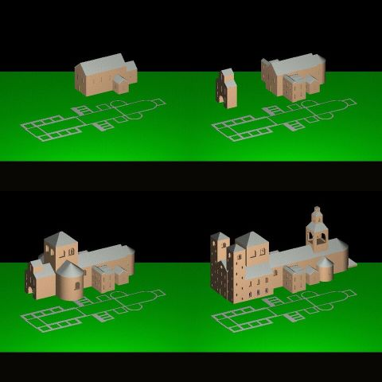
Figure 1: Original Winsom models depicting key phases in the evolution of The Old Minster, Winchester in relation to the foundation plan

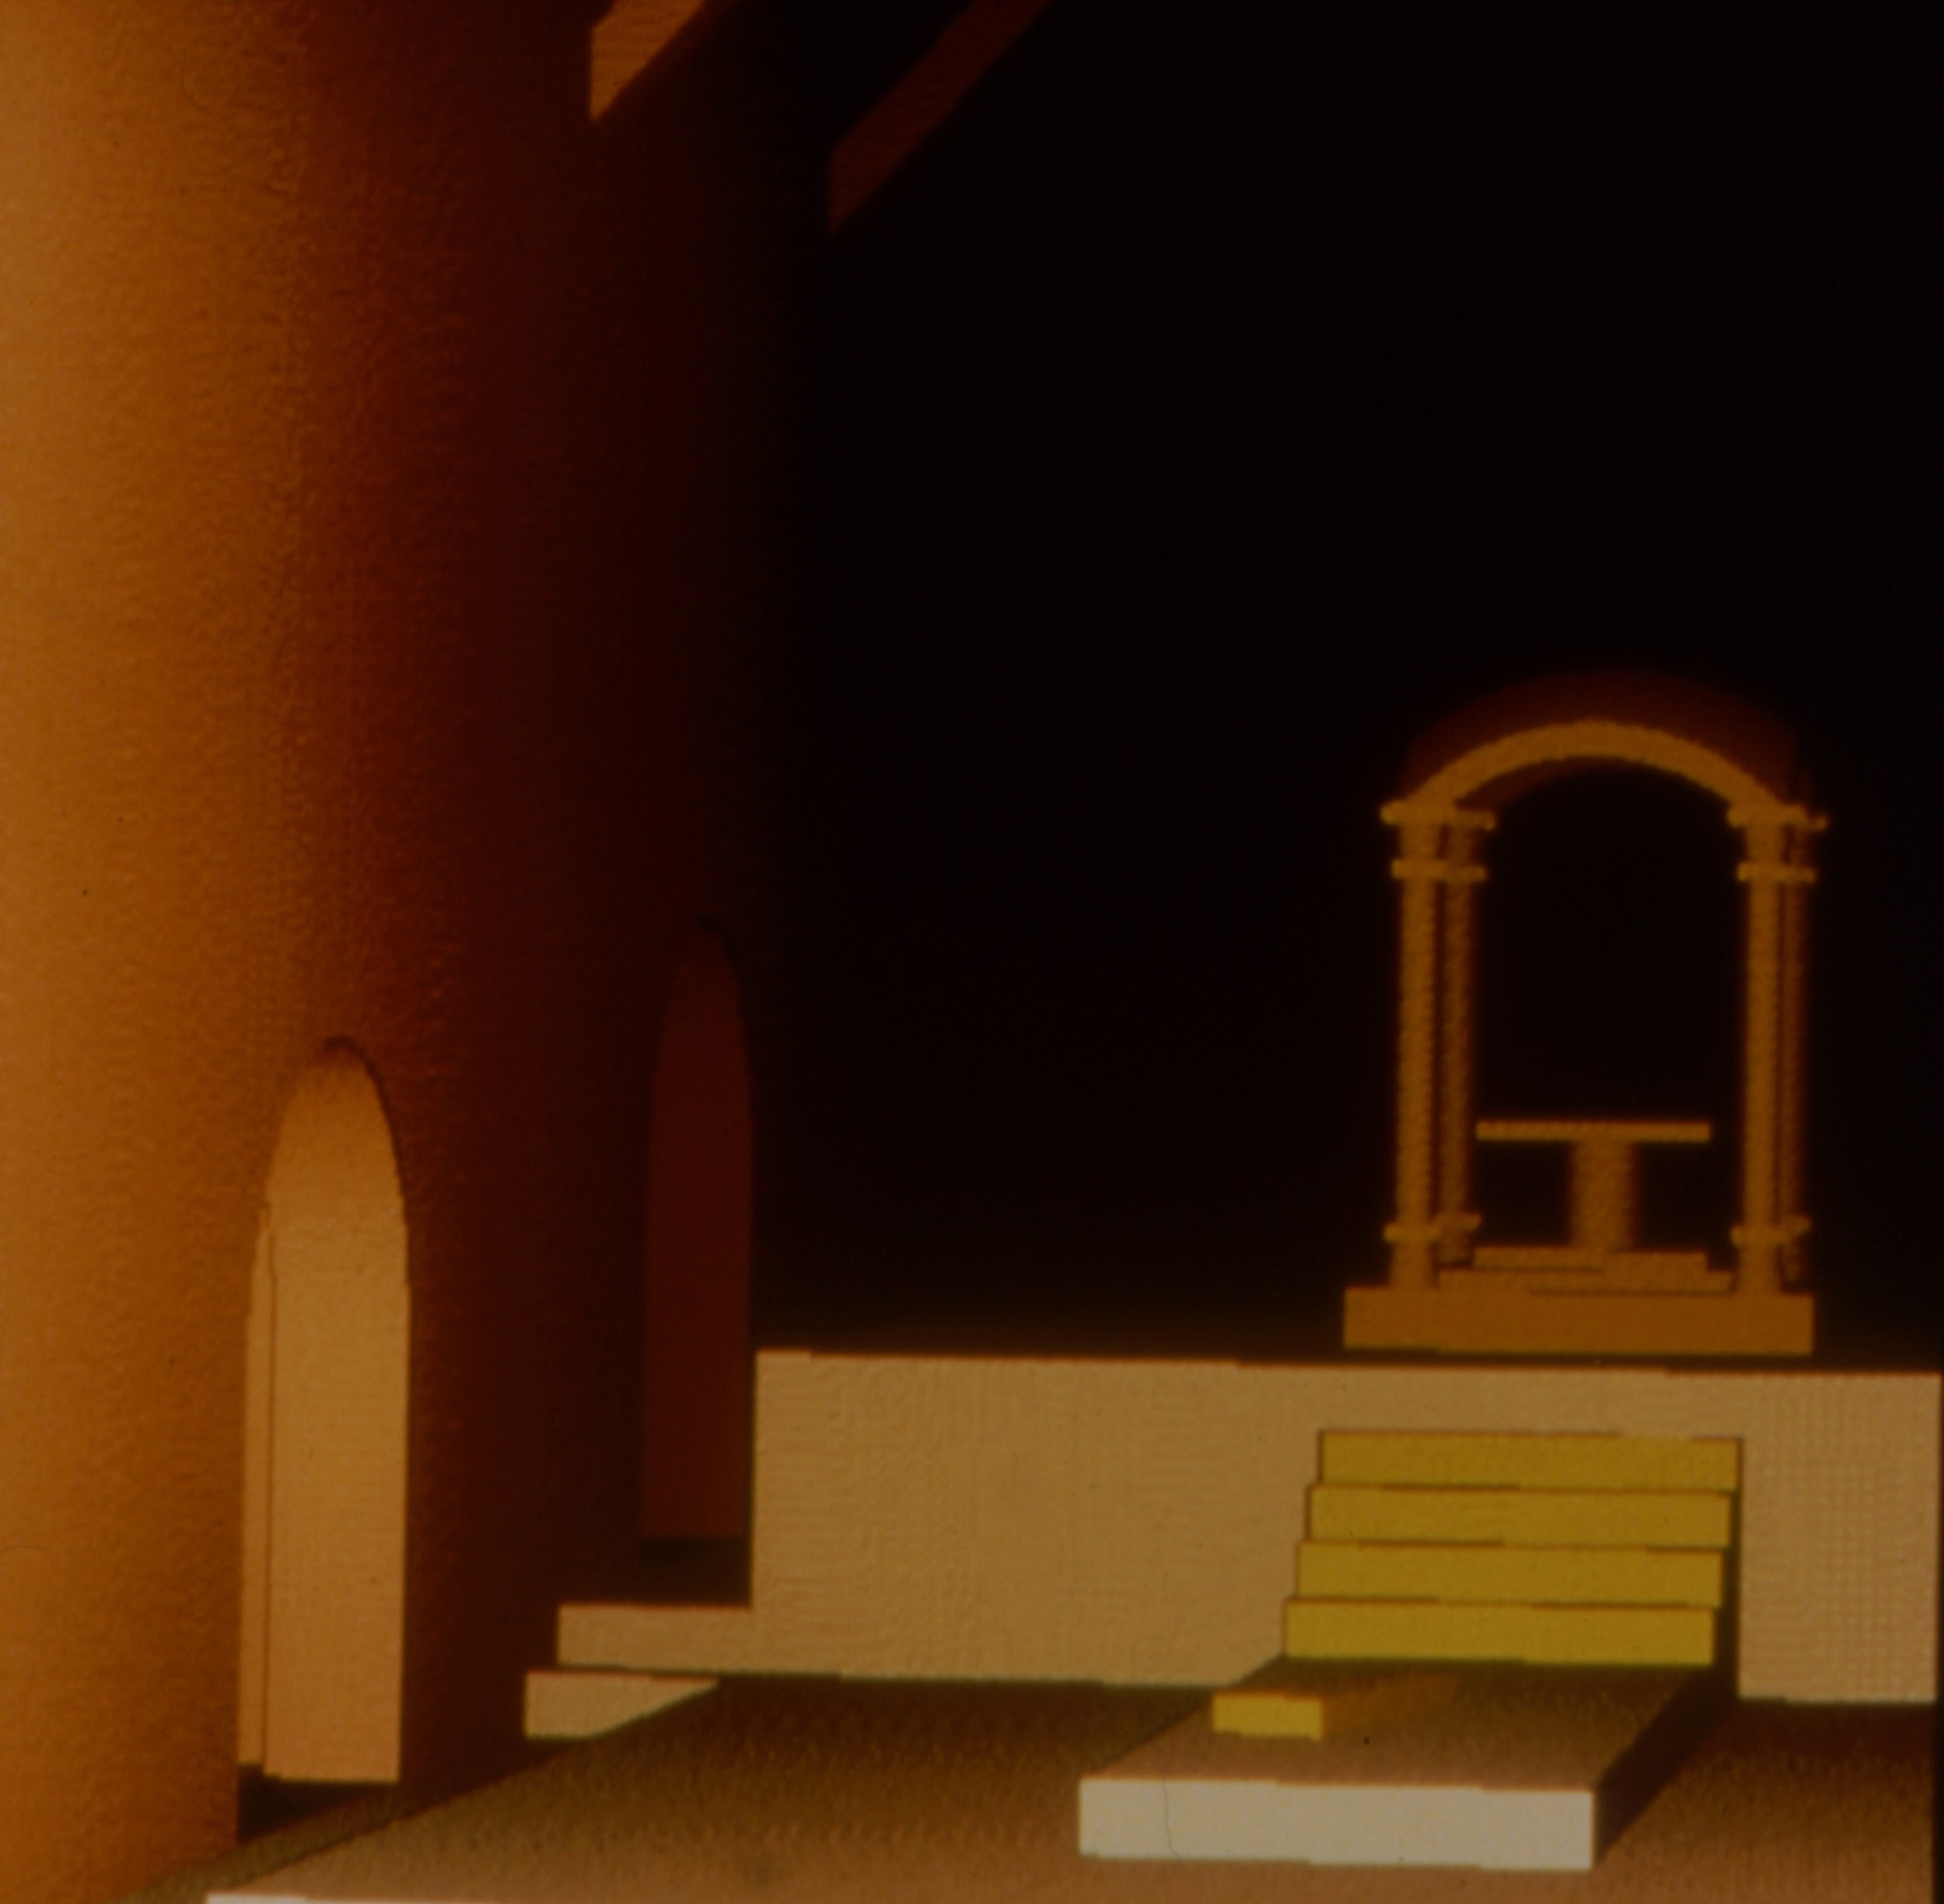
Figure 2: Interior view from the first Old Minster, Winchester movie illustrating the gloomy, atmospheric effects produced by pronounced depth-cueing, and the frustrating “stair-casing” produced by the combination of resolution and camera tilt.

---------------------------------------------------------------------------------------------------------------------------
Winsom definition:
'(HOUSE(0.66, 21.5, 10.34, 11, 4.55, std) AT (758.4, 0, 500.2))'
'UNION (HOUSE(0.66, 7, 6.75, 7, 3, std) AT (779.9, 0, 500.305))'

OpenSCAD definition:
union() {
translate([758.40, 0, 500.2])
house(0.66, 21.5, 10.34, 11, 4.55);
translate([779.9, 0, 500.305])
house(0.66, 7, 6.75, 7, 3);
}
---------------------------------------------------------------------------------------------------------------------------
Figure 3. Comparison of Winsom and OpenSCAD syntax for phase 1 nave and east-end apse

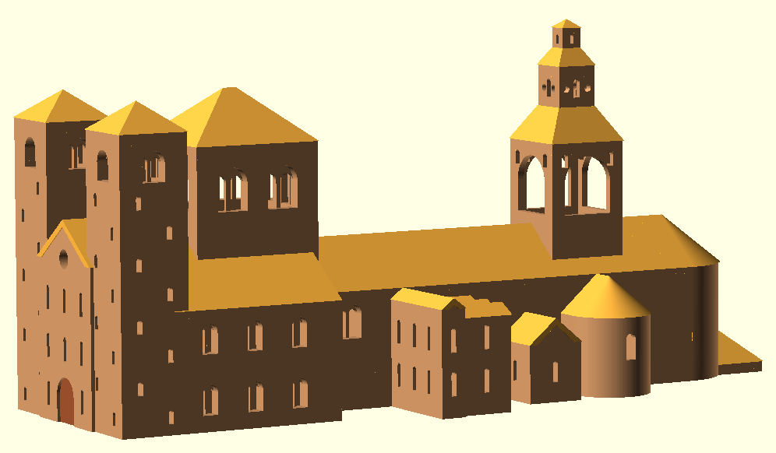
Figure 4. The Old Minster, Winchester transcoded and rendered with OpenSCAD

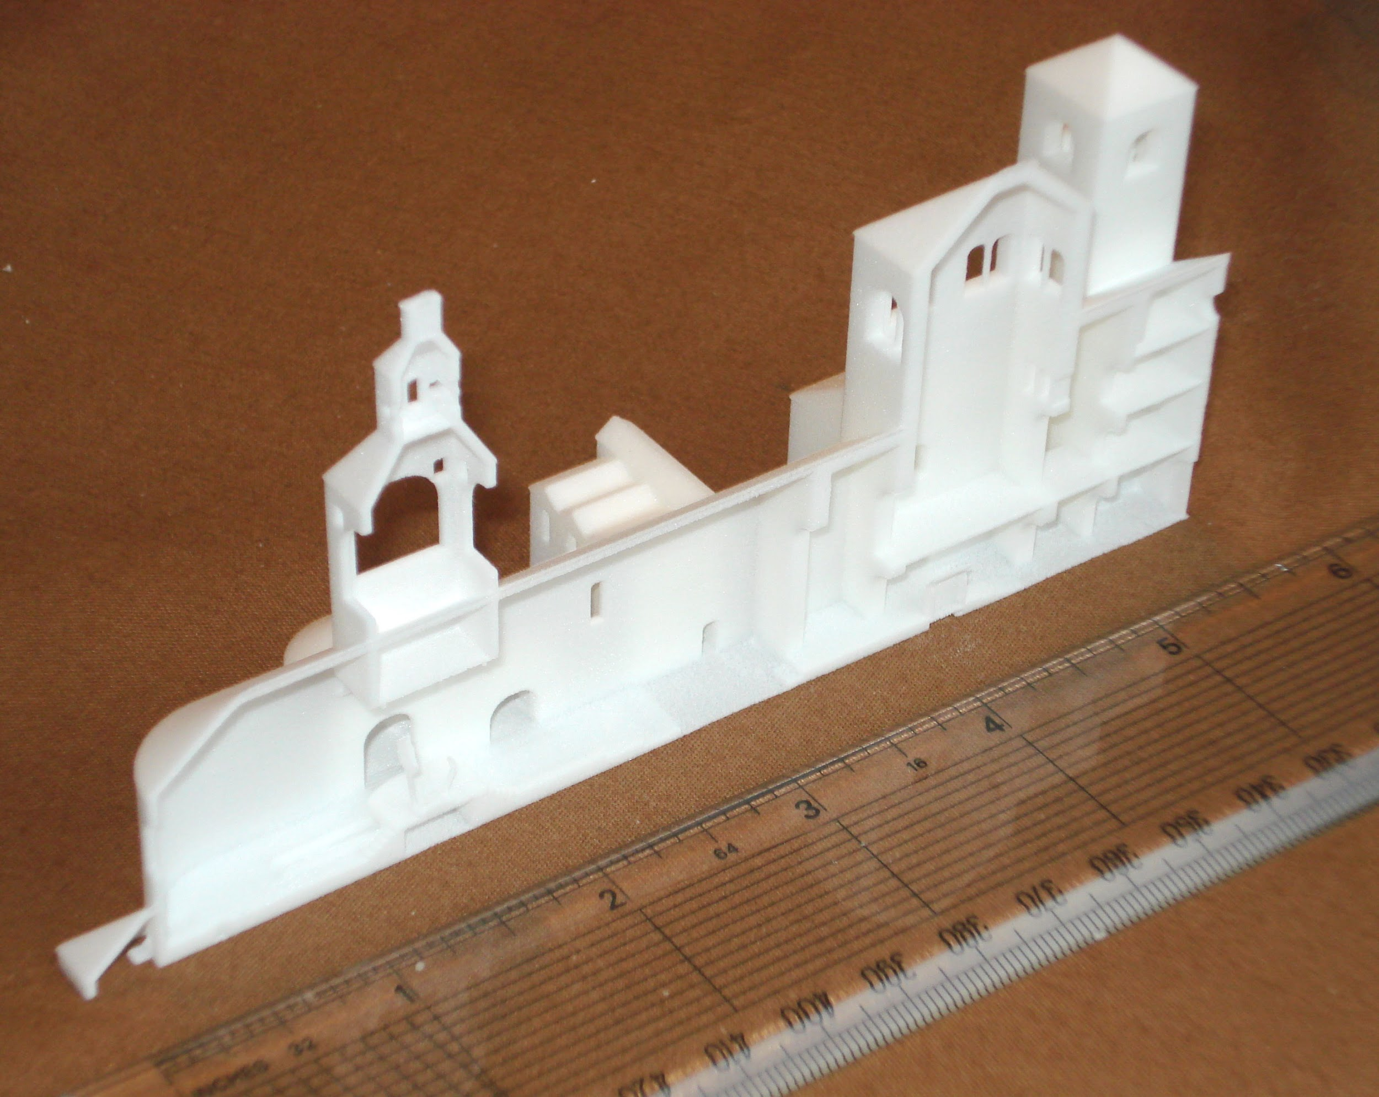
Figure 5: 2015 impressionistic 3D print of the first (1984) hypothetical CSG model of the final phase of the Old Minster, Winchester, demolished in 1093/4.

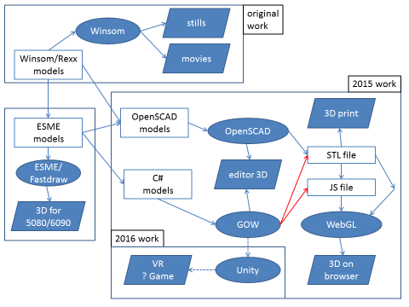

Figure 6. Re(dis)covering The Old Minster, Winchester model 1984-2016

List of Exhibits
Exhibit 1: MPEG animation of first Old Minster, Winchester (captured from VHS copy of U-matic video tape c.1984)
Exhibit 2: Remastered MPEG animation of second Old Minster, Winchester developed for British Museum’s Archaeology in Britain: new views of the past exhibition, 1986)
Exhibit 3: WebGL rendering of half section of final phase of Old Minster, Winchester re-imagined prior to being demolished in CE 1093/5 (http://programbits.co.uk/minster/minst.html)

With stable code and definition files, much of the leg-work was done by summer students (Mike Stanley, Alison Bradley, Phil Barlow and Stephen Watt), with a layer of supervision and control from the permanent staff, who fed any technical problems to the authors of the software led by Peter Quarendon for their attention.
Images showing wireframes of the Old Minster models were eventually produced using Fastdraw, another research application extension to Winsom built after the minster movie (Burridge et al 1989). See also Figure 6.
Link to http://www.openscad.org.
Link to http://www.londoncharter.org/.
Link to http://www.sevilleprinciples.com/

