Tables and Figures

Table 1. Recommended annual frequency of eGFR testing in people with CKD (number of tests)
 |  | ACR categories (mg/mmol)
 |  | A1  (<3) | A2  (3-30) | A3  (>30)
eGFR categories (ml/min/1.73m²) | G1 (≥90) | 1 if CKD | 1 | 2
 | G2 (60-89) | 1 if CKD | 1 | 2
 | G3a (45-59) | 1 | 2 | 3
 | G3b (30-44) | 2 | 3 | 3
 | G4 (15-29) | 3 | 3 | 4+
 | G5 (<15) | 4+ | 4+ | 4+

Table footnotes: Green: low risk (if no other markers of kidney disease, no CKD); Yellow: moderately increased risk; Orange: high risk; Red, very high risk. Reproduced with permission from: Kidney Disease: Improving Global Outcomes (KDIGO) CKD Work Group. KDIGO 2012 Clinical Practice Guideline for the Evaluation and Management of Chronic Kidney Disease. Kidney inter., Suppl. 2013; 3: 1-150.

Table 2. KDIGO recommended BP targets for people with CKD
 |  |  | ACR categories (mg/mmol)
 |  |  | A1  (<3) | A2  (3-30) | A3  (>30)
Diabetes status | Diabetes | Systolic | ≤140 | ≤130 | ≤130
 |  | Diastolic | ≤90 | ≤80 | ≤80
 | No diabetes | Systolic | ≤140 | ≤130 | ≤130
 |  | Diastolic | ≤90 | ≤80 | ≤80

Figures

Figure 1. Prognosis of CKD by GFR and albuminuria category
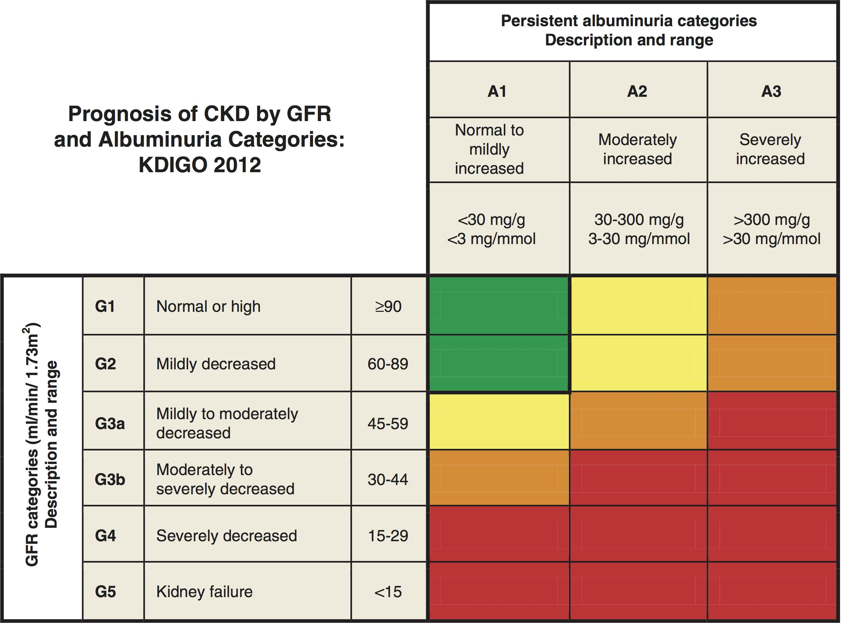

Figure footnotes: Green: low risk (if no other markers of kidney disease, no CKD); Yellow: moderately increased risk; Orange: high risk; Red, very high risk. Figure reproduced with permission from: Kidney Disease: Improving Global Outcomes (KDIGO) CKD Work Group. KDIGO 2012 Clinical Practice Guideline for the Evaluation and Management of Chronic Kidney Disease. Kidney inter., Suppl. 2013; 3: 1-150.

Figure 2. Clinical decision pathway in CKD diagnosis in relation to eGFR.
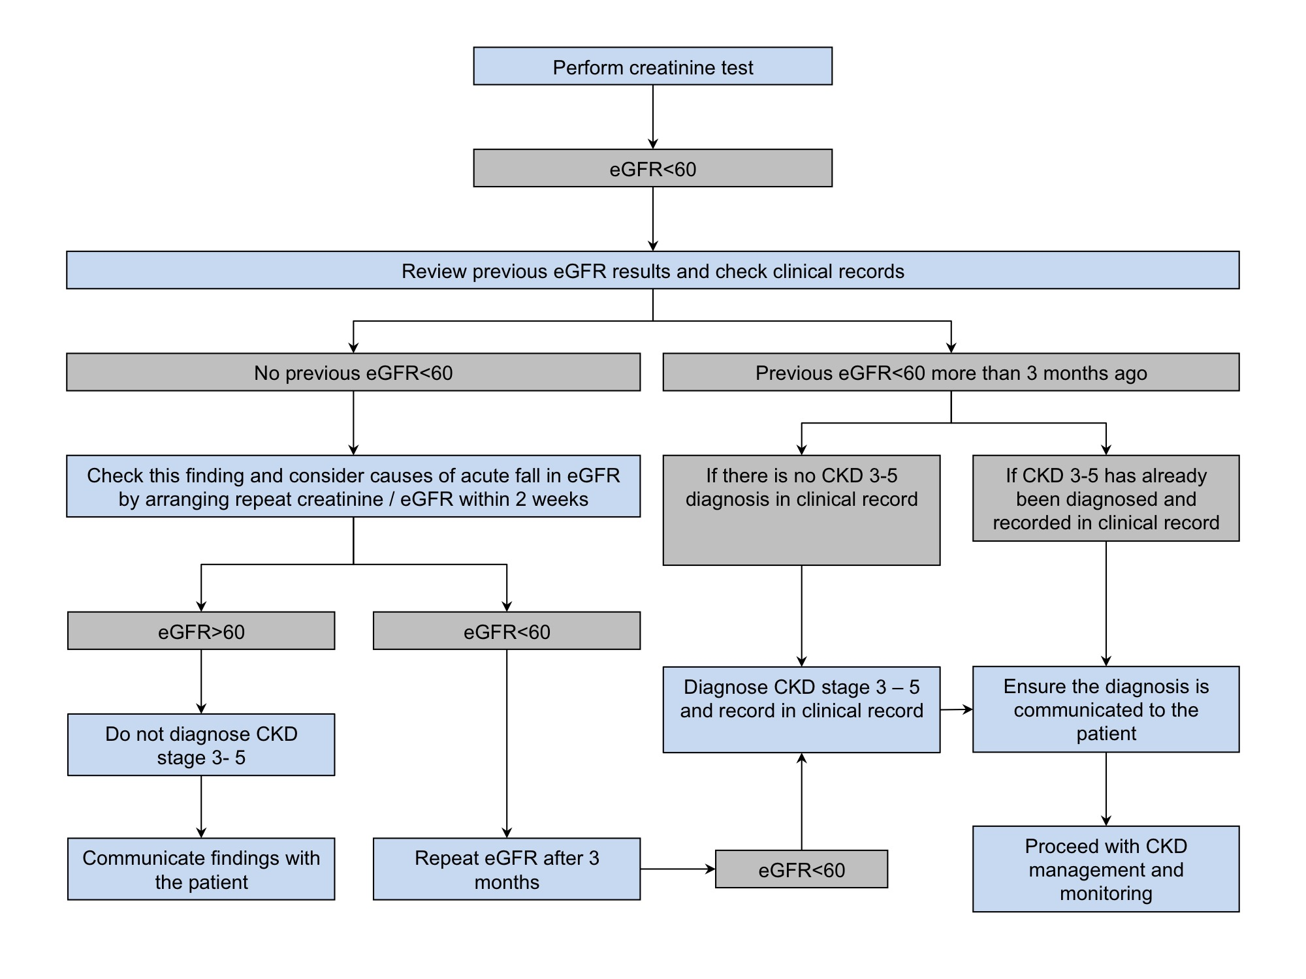
Figure footnotes: Blue boxes represent clinical actions, grey boxes represent findings.

