“Analytical Biotechnology” thematic issue on stable isotope probing
Current Opinion in Biotechnology, 2016

RNA-stable isotope probing: from carbon flow within key microbiota to targeted transcriptomes

Tillmann Luedersª, Marc G. Dumont^{b}, Lauren Bradfordª, Mike Manefield^{c}

ª Helmholtz Zentrum München – German Research Center for Environmental Health, Institute for Groundwater Ecology, Neuherberg, Germany
^{b} Centre for Biological Sciences (CfBS), University of Southampton, Southampton, United Kingdom
^{c} Centre for Marine Bioinnovation, School of Biotechnology and Biomolecular Sciences, University of New South Wales, Sydney, Australia

Correspondence: Tillmann Lueders, Helmholtz Zentrum München (GmbH), Institute of Groundwater Ecology, Ingolstädter Landstr. 1, 85764 Neuherberg, Germany.
E-Mail: tillmann.lueders@helmholtz-muenchen.de

Highlights
- RNA-SIP allows for a labelling-based detection of process-relevant microbes independent of cellular replication or growth.
- Recent RNA-SIP based advances in our understanding of carbon flow in complex natural microbiota, of organismic interactions and in environmental biotechnology are summarized.
- The combination of RNA-SIP and next-generation sequencing is a promising strategy for targeted environmental transcriptomics.

Graphical abstract
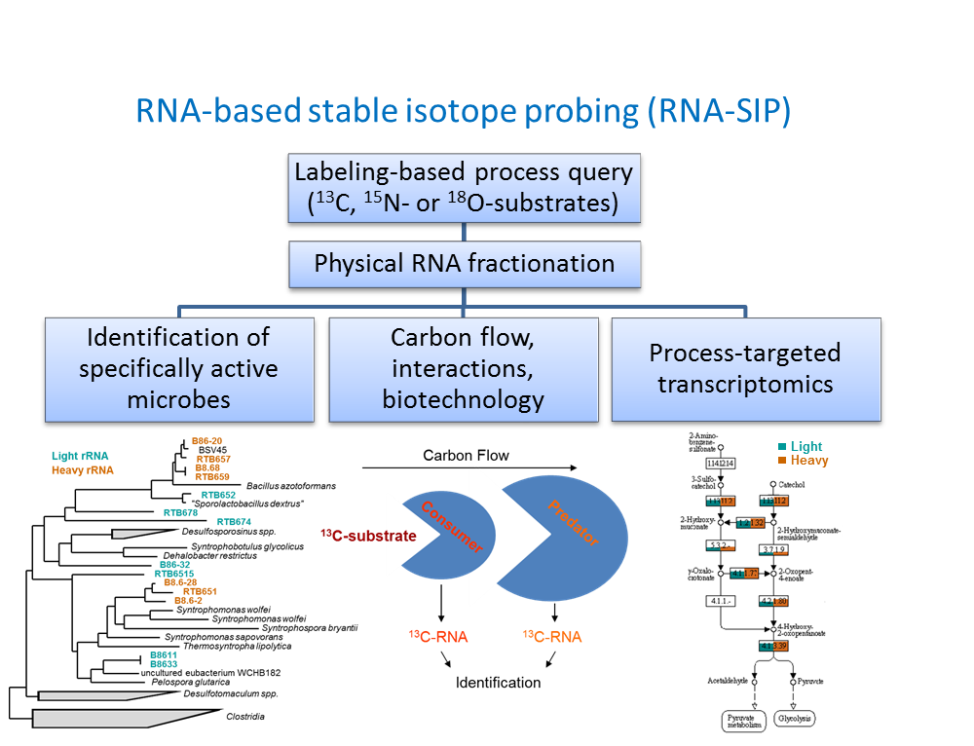

Abstract
Stable isotope probing of RNA has enthused researchers right from its first introduction in 2002. The concept of a labelling-based detection of process-targeted microbes independent of cellular replication or growth has allowed for a much more direct handle on functionally relevant microbiota than by labelling of other biomarkers. This has led to a widespread application of the technology, and breakthroughs in our understanding of carbon flow in natural microbiomes, autotrophic and heterotrophic physiologies, microbial food webs, host-microbe interactions and environmental biotechnology. Recent studies detecting labelled mRNA demonstrate that RNA-SIP is not limited to the analysis of rRNA, but is currently developing towards an approach for accessing targeted transcriptomes. In combination with next-generation sequencing and other methodological advances, RNA-SIP will continue to deliver invaluable insights into the functioning of microbial communities.

Introduction
Microorganisms that utilize a specific growth substrate can be identified in a sample by stable isotope probing (SIP). A substrate artificially labelled with a rare stable isotope (e.g. ¹³C, ¹⁵N, ¹⁸O) is provided as smart tracer, which becomes assimilated into the biomolecules of target organisms. Methods are available to analyse the incorporation of label into various biomarkers, including phospholipid fatty acids (PLFAs), DNA, RNA, proteins and entire cells. Each of these is discussed within this themed issue. Here we focus on recent advances in the development and application of RNA-SIP (Fig. 1).
For both DNA- and RNA-SIP, labelled nucleic acids are physically separated by isopycnic gradient centrifugation. Gradients of cesium chloride (CsCl) are used [1][2] for DNA, whereas cesium trifluoroacetate (CsTFA) amended with a small percentage of formamide are used for RNA [3]. Fractionation of SIP gradients was first introduced for RNA, an important advance compared to ethidium bromide-based band detection. Fractionation allows access to the full range of buoyant densities resolved in gradients, including only partially labelled nucleic acids. In combination with quantitative analyses of gradient fractions, the distribution of specific RNA-populations across gradient fractions can be compared [4].
Most of the RNA-SIP studies to date have targeted rRNA, generating taxonomic information on the microbes involved in label assimilation. This is undoubtedly where the approach has had its greatest appeal in tracing lineage-specific carbon flow within complex microbial communities. However, Huang et al. [5] noted that labelled mRNA transcripts can also be detected in gradient fractions. Dumont and colleagues [6] compared the results of labelling methanotrophs with ¹³CH₄ in lake sediment by targeting 16S rRNA and pmoA markers by both DNA- and RNA-SIP and showed that the labelling of pmoA transcripts was more rapid than that of pmoA genes. This study laid the foundation for the combination of SIP with next-generation sequencing-based metatranscriptomics [7]. This emerging approach to target specific microbial transcriptomes has the potential to alleviate some of the most fundamental limitations of non-targeted ‘omics [8] in complex systems. Considerable advances can be expected from the implementation of this novel strategy in different research fields.

RNA-SIP: strengths and limitations
RNA and DNA are the preferred biomarkers for taxonomic identification of labelled microbes (Table 1). RNA labelling, unlike DNA, is independent of cellular replication, making RNA-SIP more sensitive [3,6]. A community’s metagenome may remain static over time scales where its transcriptome dynamically responds to environmental change. Moreover, the targeted microbes might be slow growing. For example, in a study on autotrophic ammonia-oxidizing archaea (AOA) in an agricultural soil, labelled AOA were only detectable by RNA-SIP, suggesting that they did not replicate sufficiently for DNA labelling [9]. Similarly, ¹³C-acetate assimilation by putative mixotrophic atmospheric methane oxidizers in a forest soil was apparent after 3 weeks in labelled mRNA but not in DNA [10]. On the other hand, work with RNA requires caution, as it is less stable than DNA. This is especially true for mRNA. Thus optimized laboratory routines are required to mitigate these issues. The prolonged ultracentrifugation times at room temperature required for RNA-SIP are fortunately not of concern because of the RNase-inhibitory function of CsTFA, a chaotropic salt [6].
Protein-SIP, the youngest amongst the different strategies to detect biomarker labelling, allows for the most direct indication of specific metabolic activities by a given microbial population [11]. However, it requires a considerable depth of à-priori (meta)genomic information in order to phylogenetically place labelled peptide sequences. This is often difficult to accomplish for more complex communities or as-yet uncultivated lineages. The most recent advances in mRNA-SIP demonstrate that it is a powerful alternative to detect process-related gene expression [5,6,9,10,12,13].
Based on mass spectrometry as opposed to buoyant density separation, protein-SIP and PLFA-SIP have detection limits of ~1% isotope incorporation for ¹³C [14]. Until recently, the detection limits of DNA- or rRNA-SIP were estimated to be ~20% ¹³C enrichment, controlled mainly by the limits of gradient fractionation. However, the application of high-throughput sequencing of gradient fractions do not only allow for the very sensitive detection of highly labelled populations of extremely low-abundance [15]; if combined with models assuming normal distribution of distinct rRNA species across buoyant densities, the estimation of population-specific labelling of only a few atom % ¹³C can be inferred via buoyant density shifts [16]. A comprehensive sequencing-based quantitative interpretation of DNA-SIP gradients has recently been introduced [17] and substantiates this enhanced sensitivity for both ¹³C- and ¹⁸O-labelling at an unprecedented level of lineage-specific resolution. The integration of novel analytical strategies and interpretation routines will increase the sensitivity of rRNA-SIP.

Applications of RNA-SIP

Carbon flow in complex natural microbiota
Since its introduction for the identification of aerobic phenol degraders in an industrial bioreactor [3], RNA-SIP has been applied to elucidate microbial key players involved in a wide range of catabolic and respiratory processes, and in chemolithoautotrophy. A number of RNA-SIP studies have addressed aerobic methano- and methylotrophs in different habitats. Recent work has investigated aerobic methanotroph diversity in the sediment of an oligotrophic German lake [6,7], revealing that mostly type I methanotrophs, closely related to phylotypes also found in other lakes, were active in methane turnover. The labelled metatranscriptome provided a wealth of detail on expressed metabolic pathways active in methane and nitrogen cycling [7]. Other studies have pulsed methanotroph communities in soil with ¹³C-acetate instead of ¹³C-methane [10,13], showing that distinct uncultured lineages of type II methanotrophs assimilated carbon from acetate, proving them to be facultative methanotrophs.
RNA-SIP has also frequently targeted ammonia oxidizers, for which potential mixotrophy is also relevant. Pratscher et al. showed using rRNA/mRNA-SIP that ammonia-oxidizing archaea in an agricultural soil relied primarily on autotrophic CO₂ fixation involving the 3-hydroxypropionate pathway [9]. RNA-SIP has also been employed to unravel trophic interactions of nitrifiers. In ammonia-oxidizing activated sludge, protozoan grazing of bacteria was revealed by tracing carbon flow from ¹³C-bicarbonate into rRNA of ciliate grazers (Epistylis spp.) [18]. More recently, a Micavibrio-like bacterial micropredator was demonstrated to prey on nitrite-oxidizing Nitrospira spp. in a similar system [19].
Carbon usage in sulfur-oxidizing Sulfurimonas spp. at a pelagic redoxcline has also been traced by rRNA-SIP [20]. In situ experiments with ¹³C-pyruvate found no rRNA labelling of Sulfurimonas GD17, despite its known pyruvate metabolism. Pure culture incubations found that the ¹³C was incorporated only into amino acids, not nucleic acids. Using a differential labelling strategy with ¹³CO₂, ¹³C-pyruvate and ¹⁴C-pyruvate, the authors were able to show that these presumed chemolithoautotrophic denitrifiers could assimilate pyruvate as supplementary carbon source in situ. Thus, whenever possible, different SIP approaches should be combined to elucidate peculiar physiologies. In a follow-up study, the authors used ¹³C-labelled cells of Sufurimonas spp. to reveal that specific marine ciliate and flagellate populations grazed on the labelled cells and thus controlled the daily bacterial production of lithoautotrophs at the investigated redoxcline [21].
In anoxic marine sediments, recent RNA-SIP work has focused on the identification of acetate-oxidizing microbes in manganese reducing incubations [22]. In distinct sediments from Sweden, Norway and Korea, the labelling of Colwiella spp., Arcobacter spp. and the Oceanospirillaceae were surprisingly consistent between sites. A similar experiment indicated that members of the Desulfuromonadales were the key acetate consumers under strictly iron or manganese-reducing conditions [23].

Host-microbe interactions
RNA-SIP has also been extensively used in disentangling interactions between unicellular and multicellular organisms, especially plant-microbe interactions. In a climate-change oriented study, Drigo et al. pulsed ¹³CO₂ into mycorrhizal and non-mycorrhizal C-3 plants [24], revealing that elevated atmospheric CO₂ concentrations induced changes in rhizospheric C flow, especially in mycorrhizal plants. A stimulation of mycorrhizal fungi resulted in feedbacks on the entire soil food web. These effects were also shown to develop over multiple seasons [25]. Using ¹³CO₂, a greater proportion (~20%) of the root-colonizing bacteria of rice plants was shown to draw directly on fresh plant assimilates vs. bacteria in the rhizosphere (~4%) [26]. RNA-SIP with ¹³CO₂ has also shown that genetically modified potato cultivars exert distinct selective forces on rhizosphere communities than unmodified cultivars [27], an important advance in studying potential impacts of GM plants. The principle applicability of mRNA-SIP has also been demonstrated for plant-microbe systems [12]. Here, the labelling of distinct coding and non-coding bacterial mRNAs was found comparing the rhizosphere and rhizoplane of Arabidopsis thaliana, providing valuable insights on how microbes adapt to the host environment.
RNA-SIP is also highly useful for the functional dissection of the gut microbiome. Its application for the tracing of microbial starch metabolism in the human colon in an in vitro gut model was already demonstrated in 2009 [28], but related in vivo studies are yet to come. For animal systems, Godwin et al. compared the assimilation of ¹³CO₂ pulses in communities from the kangaroo foregut and the bovine rumen [29]. Evidence for dominant acetogenesis was found in the kangaroo foregut, with Blautia coccoides identified as the key acetogen. This explained why kangaroos have much lower methane emissions in comparison to cows, in which the rumen is dominated by hydrogenotrophic methanogens. In the same year Tannock et al [30] used RNA-SIP to identify bacteria in the rat cecum degrading the dietary fructane inulin. Bacteroides uniformis, Blautia glucerasea, Clostridium indolis, and Bifidobacterium animalis dominated the assimilation of ¹³C from inulin fed to rats. In an elegant laboratory verification, representative isolates of the RNA-SIP identified bacteria were then tested for growth on inulin. Here, B. uniformis was the only strain that could actually ferment inulin, whilst the others were only consuming hydrolysis products.

Environmental biotechnology
RNA-SIP was first developed in the context of phenol biodegradation in an activated sludge community treating coking effluent [3]. The identification of microbes responsible for pollutant degradation remains a key application today. Here we highlight recent RNA-SIP applications in this area along with studies addressing processes in wastewater treatment and anaerobic digestion.
The primary report on mRNA-SIP addressed aerobic naphthalene degradation in contaminated groundwater [5]. By combining rRNA-SIP, mRNA-SIP and Raman-FISH, the authors showed that an Acidovorax sp. which eluded laboratory cultivation was responsible for degradation of naphthalene under the low µM concentrations relevant in situ. Jechalke et al [31] recently published a comprehensive dissection of a benzene degrading biofilm from an aerated groundwater treatment pond. rRNA-SIP identified Zoogloea and Dechloromonas spp. as the dominant assimilators of ¹³C from benzene. Compound-specific isotope fractionation analysis implicated a dihydroxylation reaction for aromatic ring cleavage, consistent with ¹³C incorporation by specific dioxygenases detected in protein-SIP. A further recent combination of rRNA-, DNA- and protein-SIP investigated anaerobic hydrocarbon degradation in marine sediments [32]. ¹³C-labelled butane and dodecane were pulsed into seep samples from the Mediterranean and the Gulf of California under sulfate-reducing conditions. Members of the Desulfobacteraceae were found to be the dominating degraders for all treatments. But while butane degraders were closely related, long-chain alkane degraders appeared more distinct between sites. Labelling of several key enzymes involved in anaerobic alkane oxidation was also found via protein SIP in the same study. rRNA-SIP has also been applied to elucidate the role of different bacterial populations active in a methanogenic toluene-degrading enrichment culture [33]. Thus, a network of interactions between Desulfosporosinus spp. as primary degraders and distinct Syntrophaceae, Desulfovibrionales and Chloroflexi as syntrophic partners was suggested.
rRNA-SIP has also been applied for the identification of microbes in activated sludge assimilating ¹³C from nonyl phenol, a common low-level pollutant and xenoestrogen in the urban water cycle [16]. The most intensively labelled degrader phylotype (Afipia sp.) was relatively low in rRNA abundance. Conversely, less enriched phylotypes (Propionibacterium and Frateuria spp.) were more abundant, and therefore made a greater contribution to nonyl phenol biodegradation. In another example of RNA-SIP applied to wastewater treatment, Nielsen et al. [34] identified glucose-fermenting bacteria in a full-scale enhanced biological phosphorus removal (EBPR) system. Mainly Gram-positive Propionibacteriaceae and Streptococcaceae were identified as primary glucose fermenters. These were subsequently quantified by FISH across a range of distinct wastewater treatment plants, giving an elegant example of how SIP can guide monitoring approaches back in the field.
Finally, Ito et al. have pioneered the application of RNA-SIP to carbon flow in anaerobic digestion processes [35]. SIP with ¹³C-labelled glucose and propionate as well as MAR-FISH (microautoradiography and fluorescence in situ hybridization) with ¹⁴C acetate suggested that an uncultured Synergistes lineage was active as syntrophic acetate oxidizers, outcompeting acetoclastic methanogens. In their follow-up study, the authors demonstrated how rRNA-SIP and population-specific substrate flux analyses can be combined to identify rate-limiting steps in anaerobic digestion [36]. Taken together, the many recent applications of RNA-SIP reviewed here substantiate the approach as a prime research strategy to unravel specific activities, ecophysiologies and interactions in complex natural microbiota.

Future directions
Undoubtedly, the application of next-generation sequencing to density-resolved RNA fractions represents the largest recent methodological advance in RNA-SIP. Although the methodologies are at hand and the next-generation sequencing of amplicons from RNA gradients is now routine [16,26,29,30,32,37,38], only one study to date has retrieved a labelling-assisted targeted transcriptome [7]. Although this was mostly a proof-of-concept experiment with aerobic methanotrophs, it clearly shows that the metatranscriptome of target populations in environmental samples can be selectively recovered. The combination of SIP with such ‘omics techniques is of significant potential, since it provides functional context to sequence data that is not only inferred, but proven by label incorporation. The physical separation of labelled biomarkers - such as in DNA and RNA-SIP - focuses sequencing analysis and allows for a greater analysis depth of target populations.
All other SIP studies reporting on labelled mRNA to date have used either fingerprinting, RT-qPCR, or cloning and sequencing of transcripts to substantiate labelling [5,6,9,10,12,13]. This is surprising since total RNA sequencing strategies are long established [39]. However, the rather small total quantities of labelled RNA (~10s of ng) obtainable from gradient fractions represents a clear technical limitation to this end. Both pre-gradient rRNA depletion and post-fractionation RNA amplification (Fig. 1) have the potential to skew transcript ratios and thus to interfere with the detection of labelling. Yet, sequencing technologies and strategies to work with extremely small transcript quantities are rapidly evolving [40]. Thus we expect to see substantial advances in SIP-mediated targeted transcriptomics in the next years.
For ‘classical’ rRNA-SIP, the application of high-throughput sequencing has added valuable taxon-level precision to quantitative gradient interpretation. Combined with turnover rates and net substrate fluxes, the labelling intensity can be used to infer the contribution of distinct populations to a transformation process, and to quantify population-level substrate utilization [16]. In DNA-SIP, the combination of ¹³C- and ¹⁸O-labelling has recently been suggested as a quantitative measure to infer general bacterial growth rates [17]. The considerable appeal of this approach for general microbial ecology is discussed in another review of this thematic issue [41]. However, it is also clear that extensive efforts are required to identify sequencing OTUs whose distribution between density fractions is significantly altered by label incorporation, and to sensitively quantify those density shifts [16,17,42]. In essence, all strategies chosen to substantiate lineage-specific label incorporation must fulfil the criterion of comprehensively comparing template abundance in high vs. low density fractions of gradients from labelled treatments and unlabelled controls [43].
As reviewed above, most RNA-SIP studies to date have relied on ¹³C-labelling. However, alternative isotope tracers are available and should find wider consideration, in our opinion. ¹⁵N-labelling to trace microbes active in nitrogen cycling is well established in DNA-SIP [44,45] with exciting recent applications [42]. Still, to the best of our knowledge, no RNA-SIP study with ¹⁵N has been published. In contrast, two studies are available that have performed RNA labelling with H₂¹⁸O. The first study provided pioneering insights on a microbial re-activation cascade that occurs when dried soil crusts are rehydrated upon rainfall [37]. This is an important contribution to better predict complex microbial feedbacks to increasing aridity and extreme rain events in global change. More recently, it was demonstrated that after ~5 weeks of incubation of a soil with H₂¹⁸O, >75% of the rRNA was ¹⁸O-labelled [38]. Possibly connected to this prolonged incubation, labelled and total community patterns were highly related. Nevertheless, both studies demonstrate that H₂¹⁸O is indeed effective as a universal label for active microbes in RNA-SIP.
On an analytical level, not only is the integration of different SIP strategies becoming increasingly important (e.g. RNA- & Raman-SIP [5], combined ¹³C- and ¹⁴C-labels [20], RNA-, DNA- and protein-SIP [31,32]), but gradient-independent detection methods for labelled RNA are also emerging. The so-called “Chip-SIP” approach relies on the direct isotopic characterization of rRNA hybridised to a phylogenetic microarray by NanoSIMS mass spectrometric imaging [46]. Although the availability of such analytical platforms may still be limiting, the approach has been demonstrated to provide valuable quantitative insights into taxon-specific carbon and nitrogen usage in estuarine and marine microbiota [47,48]. Furthermore, a highly sensitive method for the measurement of isotopic enrichment in RNA using ultrahigh-performance liquid chromatography-tandem mass spectrometry (UHPLC-MS/MS) has recently been published [49]. This protocol can detect an enrichment of 1.5 atom % ¹³C in as little as 1 ng of nucleic acids and it enables researchers to directly quantify isotope enrichment in RNA from gradient fractions. In combination with the application of targeted RNA cleavage catalysts to RNA-SIP such as LNAzymes [19] or RNaseH [50], we believe that such centrifugation-independent approaches have great unrealised potential to advance RNA-SIP approaches, and to find more unexpected needles in the many microbial haystacks.

Acknowledgements
Financial support by the European Research Council (Grant 616644 to T.L.) for the contribution of T.L. and L.B. to this manuscript is gratefully acknowledged.

References
1. Radajewski S, Ineson P, Parekh NR, Murrell JC: Stable-isotope probing as a tool in microbial ecology. Nature 2000, 403:646-649.
2. Meselson M, Stahl FW: The replication of DNA in Escherichia coli. PNAS 1958, 44:671-682.
3. Manefield M, Whiteley AS, Griffiths RI, Bailey MJ: RNA stable isotope probing, a novel means of linking microbial community function to phylogeny. Appl Environ Microbiol 2002, 68:5367-5373.
4. Lueders T, Manefield M, Friedrich MW: Enhanced sensitivity of DNA- and rRNA-based stable isotope probing by fractionation and quantitative analysis of isopycnic centrifugation gradients. Environ Microbiol 2004, 6:73-78.
5. Huang WE, Ferguson A, Singer AC, Lawson K, Thompson IP, Kalin RM, Larkin MJ, Bailey MJ, Whiteley AS: Resolving genetic functions within microbial populations: in situ analyses using rRNA and mRNA stable isotope probing coupled with single-cell raman-fluorescence in situ hybridization. Appl Environ Microbiol 2009, 75:234-241.
6. Dumont MG, Pommerenke B, Casper P, Conrad R: DNA-, rRNA- and mRNA-based stable isotope probing of aerobic methanotrophs in lake sediment. Environ Microbiol 2011, 13:1153-1167.
7. Dumont MG, Pommerenke B, Casper P: Using stable isotope probing to obtain a targeted metatranscriptome of aerobic methanotrophs in lake sediment. Environ Microbiol Rep 2013, 5:757-764.
8. Franzosa EA, Hsu T, Sirota-Madi A, Shafquat A, Abu-Ali G, Morgan XC, Huttenhower C: Sequencing and beyond: integrating molecular 'omics' for microbial community profiling. Nat Rev Micro 2015, 13:360-372.
9. Pratscher J, Dumont MG, Conrad R: Ammonia oxidation coupled to CO₂ fixation by archaea and bacteria in an agricultural soil. PNAS 2011, 108:4170-4175.
10. Pratscher J, Dumont MG, Conrad R: Assimilation of acetate by the putative atmospheric methane oxidizers belonging to the USCα clade. Environ Microbiol 2011, 13:2692-2701.
11. von Bergen M, Jehmlich N, Taubert M, Vogt C, Bastida F, Herbst F-A, Schmidt F, Richnow H-H, Seifert J: Insights from quantitative metaproteomics and protein-stable isotope probing into microbial ecology. ISME J 2013, 7:1877-1885.
12. Haichar FeZ, Roncato M-A, Achouak W: Stable isotope probing of bacterial community structure and gene expression in the rhizosphere of Arabidopsis thaliana. FEMS Microbiol Ecol 2012, 81:291-302.
13. Leng L, Chang J, Geng K, Lu Y, Ma K: Uncultivated Methylocystis species in paddy soil include facultative methanotrophs that utilize acetate. Microb Ecol 2015, 70:88-96.
14. Vogt C, Lueders T, Richnow HH, Krüger M, von Bergen M, Seifert J: Stable isotope probing approaches to study anaerobic hydrocarbon degradation and degraders. Journal of Molecular Microbiology and Biotechnology 2016, 26:195-210.
15. Aoyagi T, Hanada S, Itoh H, Sato Y, Ogata A, Friedrich MW, Kikuchi Y, Hori T: Ultra-high-sensitivity stable-isotope probing of rRNA by high-throughput sequencing of isopycnic centrifugation gradients. Environ Microbiol Rep 2015, 7:282-287.
16. Zemb O, Lee M, Gutierrez-Zamora ML, Hamelin J, Coupland K, Hazrin-Chong NH, Taleb I, Manefield M: Improvement of RNA-SIP by pyrosequencing to identify putative 4-n-nonylphenol degraders in activated sludge. Water Research 2012, 46:601-610.
17. Hungate BA, Mau RL, Schwartz E, Caporaso JG, Dijkstra P, van Gestel N, Koch BJ, Liu CM, McHugh TA, Marks JC, Morrissey EM, Price LB: Quantitative microbial ecology through stable isotope probing. Appl Environ Microbiol 2015, 81:7570-7581.
18. Moreno AM, Matz C, Kjelleberg S, Manefield M: Identification of ciliate grazers of autotrophic bacteria in ammonia-oxidizing activated sludge by RNA stable isotope probing. Appl Environ Microbiol 2010, 76:2203-2211.
19. Dolinšek J, Lagkouvardos I, Wanek W, Wagner M, Daims H: Interactions of nitrifying bacteria and heterotrophs: identification of a Micavibrio-like putative predator of Nitrospira spp. Appl Environ Microbiol 2013, 79:2027-2037.
20. Glaubitz S, Abraham WR, Jost G, Labrenz M, Jurgens K: Pyruvate utilization by a chemolithoautotrophic epsilonproteobacterial key player of pelagic Baltic Sea redoxclines. FEMS Microbiol Ecol 2014, 87:770-779.
21. Anderson R, Wylezich C, Glaubitz S, Labrenz M, Jurgens K: Impact of protist grazing on a key bacterial group for biogeochemical cycling in Baltic Sea pelagic oxic/anoxic interfaces. Environ Microbiol 2013, 15:1580-1594.
22. Vandieken V, Pester M, Finke N, Hyun JH, Friedrich MW, Loy A, Thamdrup B: Three manganese oxide-rich marine sediments harbor similar communities of acetate-oxidizing manganese-reducing bacteria. ISME J 2012, 6:2078-2090.
23. Vandieken V, Thamdrup B: Identification of acetate-oxidizing bacteria in a coastal marine surface sediment by RNA-stable isotope probing in anoxic slurries and intact cores. FEMS Microbiol Ecol 2013, 84:373-386.
24. Drigo B, Pijl AS, Duyts H, Kielak AM, Gamper HA, Houtekamer MJ, Boschker HTS, Bodelier PLE, Whiteley AS, Veen JAv, Kowalchuk GA: Shifting carbon flow from roots into associated microbial communities in response to elevated atmospheric CO₂. PNAS 2010, 107:10938-10942.
25. Drigo B, Kowalchuk GA, Knapp BA, Pijl AS, Boschker HT, van Veen JA: Impacts of 3 years of elevated atmospheric CO₂ on rhizosphere carbon flow and microbial community dynamics. Glob Chang Biol 2013, 19:621-636.
26. Hernández M, Dumont MG, Yuan Q, Conrad R: Different bacterial populations associated with the roots and rhizosphere of rice incorporate plant-derived carbon. Appl Environ Microbiol 2015, 81:2244-2253.
27. Dias AC, Dini-Andreote F, Hannula SE, Andreote FD, Pereira ESMC, Salles JF, de Boer W, van Veen J, van Elsas JD: Different selective effects on rhizosphere bacteria exerted by genetically modified versus conventional potato lines. PLoS One 2013, 8:e67948.
28. Kovatcheva-Datchary P, Egert M, Maathuis A, Stojanovi MR, Graaf AAd, Smidt H, Vos WMd, Venema K: Linking phylogenetic identities of bacteria to starch fermentation in an in vitro model of the large intestine by RNA-based stable isotope probing. Environ Microbiol 2009, 11:914-926.
29. Godwin S, Kang A, Gulino L-M, Manefield M, Gutierrez-Zamora M-L, Kienzle M, Ouwerkerk D, Dawson K, Klieve AV: Investigation of the microbial metabolism of carbon dioxide and hydrogen in the kangaroo foregut by stable isotope probing. ISME J 2014, 8:1855-1865.
30. Tannock GW, Lawley B, Munro K, Sims IM, Lee J, Butts CA, Roy N: RNA–stable isotope probing shows utilization of carbon from inulin by specific bacterial populations in the rat large bowel. Appl Environ Microbiol 2014, 80:2240-2247.
31. Jechalke S, Franchini AG, Bastida F, Bombach P, Rosell M, Seifert J, von Bergen M, Vogt C, Richnow HH: Analysis of structure, function, and activity of a benzene-degrading microbial community. FEMS Microbiol Ecol 2013, 85:14-26.
32. Kleindienst S, Herbst F-A, Stagars M, von Netzer F, von Bergen M, Seifert J, Peplies J, Amann R, Musat F, Lueders T, Knittel K: Diverse sulfate-reducing bacteria of the Desulfosarcina/Desulfococcus clade are the key alkane degraders at marine seeps. ISME J 2014, 8:2029-2044.
33. Fowler SJ, Gutierrez-Zamora M-L, Manefield M, Gieg LM: Identification of toluene degraders in a methanogenic enrichment culture. FEMS Microbiol Ecol 2014, 89:625-636.
34. Nielsen JL, Nguyen H, Meyer RL, Nielsen PH: Identification of glucose-fermenting bacteria in a full-scale enhanced biological phosphorus removal plant by stable isotope probing. Microbiology 2012, 158:1818-1825.
35. Ito T, Yoshiguchi K, Ariesyady HD, Okabe S: Identification of a novel acetate-utilizing bacterium belonging to Synergistes group 4 in anaerobic digester sludge. ISME J 2011, 5:1844-1856.
36. Ito T, Yoshiguchi K, Ariesyady HD, Okabe S: Identification and quantification of key microbial trophic groups of methanogenic glucose degradation in an anaerobic digester sludge. Bioresour Technol 2012, 123:599-607.
37. Angel R, Conrad R: Elucidating the microbial resuscitation cascade in biological soil crusts following a simulated rain event. Environ Microbiol 2013, 15:2799-2815.
38. Rettedal EA, Brözel VS: Characterizing the diversity of active bacteria in soil by comprehensive stable isotope probing of DNA and RNA with H₂¹⁸O. MicrobiologyOpen 2015, 4:208-219.
39. Urich T, Lanzén A, Qi J, Huson DH, Schleper C, Schuster SC: Simultaneous assessment of soil microbial community structure and function through analysis of the meta-transcriptome. PLoS ONE 2008, 3:e2527.
40. Moran MA, Satinsky B, Gifford SM, Luo H, Rivers A, Chan LK, Meng J, Durham BP, Shen C, Varaljay VA, Smith CB, Yager PL, Hopkinson BM: Sizing up metatranscriptomics. ISME J 2013, 7:237-243.
41. Schwartz E, Hayer M, Hungate BA, Koch BJ, McHugh TA, Mercurio W, Morrissey EM, Soldanova K: Stable isotope probing with ¹⁸O-water to investigate microbial growth and death in environmental samples. Current Opinion in Biotechnology 2016, 41:14-18.
42. Pepe-Ranney C, Koechli C, Potrafka R, Andam C, Eggleston E, Garcia-Pichel F, Buckley DH: Non-cyanobacterial diazotrophs mediate dinitrogen fixation in biological soil crusts during early crust formation. ISME J 2015:doi: 10.1038/ismej.2015.1106.
43. Whiteley AS, Manefield M, Lueders T: Unlocking the 'microbial black box' using RNA-based stable isotope probing technologies. Curr Opin Biotechnol 2006, 17:67-71.
44. Buckley DH, Huangyutitham V, Hsu S-F, Nelson TA: Stable isotope probing with ¹⁵N achieved by disentangling the effects of genome G+C content and isotope enrichment on DNA density. Appl Environ Microbiol 2007, 73:3189-3195.
45. Cadisch G, Espana M, Causey R, Richter M, Shaw E, Morgan JA, Rahn C, Bending GD: Technical considerations for the use of ¹⁵N-DNA stable-isotope probing for functional microbial activity in soils. Rapid Commun Mass Spectrom 2005, 19:1424-1428.
46. Mayali X, Weber PK, Brodie EL, Mabery S, Hoeprich PD, Pett-Ridge J: High-throughput isotopic analysis of RNA microarrays to quantify microbial resource use. ISME J 2012, 6:1210-1221.
47. Mayali X, Stewart B, Mabery S, Weber PK: Temporal succession in carbon incorporation from macromolecules by particle-attached bacteria in marine microcosms. Environ Microbiol Rep 2016:doi: 10.1111/1758-2229.12352.
48. Mayali X, Weber PK, Pett-Ridge J: Taxon-specific C/N relative use efficiency for amino acids in an estuarine community. FEMS Microbiol Ecol 2013, 83:402-412.
49. Wilhelm R, Szeitz A, Klassen TL, Mohn WW: Sensitive, efficient quantitation of ¹³C-enriched nucleic acids via ultrahigh-performance liquid chromatography-tandem mass spectrometry for applications in stable isotope probing. Appl Environ Microbiol 2014, 80:7206-7211.
50. Gutierrez-Zamora M-L, Zemb O, Manefield M: Direct rRNA fingerprinting, a novel method to profile low diversity microbial communities. Microbial Ecol 2011, 62:177-187.

Papers of particular interest, mostly published within the period of review, have been highlighted as:
* of special interest
** of outstanding interest

* Huang et al. 2009 [5]: Investigation of aerobic naphthalene degraders in contaminated groundwater. The first demonstration that mRNA transcripts can be detected in RNA-SIP
** Dumont et al. 2013 [7]: First combination of SIP with next-generation sequencing-based metatranscriptomics. Convincing demonstration that target transcriptomes can be selectively recovered from environmental samples.
* Zemb et al. 2012 [16]: Pioneering application of RNA-SIP to micropollutant degraders in sewage treatment. A model to quantify population-specific labelling based on buoyant density shifts was introduced.
** Tannock et al. 2014 [30]: The authors present the first in vivo application of RNA-SIP to trace dietary carbon flow in a host gut microbiome.
* Kleindienst et al. 2014 [32]: Elegant combination of rRNA-, DNA- and protein-SIP to trace key sulfate-reducing alkane degraders in different marine sediments. Shows that different SIP strategies should be integrated for comprehensive system understanding. ** Angel et al. 2013 [37]: The authors have traced an H₂¹⁸O “rain” event in a dessicated soil microbiome. First demonstration that ¹⁸O is useful as universal label for active microbes in RNA-SIP.

Table
Table 1. Strengths and limitations of major biomarker approaches used in SIP.
Marker | Analysis Method | Strength | Limitation
PLFA | Gas chromatography – isotope ratio mass spectrometry (GC-IRMS) | - High sensitivity, quantitative  - Can infer absolute label incorporation | - Very low taxonomic resolution
DNA | Isopycnic centrifugation, various downstream analysis options (qPCR, fingerprinting, marker gene sequencing, ‘omics) | - Labelling inferred via rRNA gene community structure  - Metabolic potential via functional genes  - Potential for targeted (meta-) genome assembly | - Labelling dependent on genome replication and cellular growth  - Strong impact of genomic G+C content on buoyant density
rRNA | Isopycnic centrifugation, various downstream analysis options (qPCR, fingerprinting, rRNA amplicon or total rRNA sequencing) | - Labelling inferred via rRNA community structure  - Rapid labelling, independent of cell replication  - Most active organisms and dynamic changes resolved | - No data on functional genes / gene expression  - RNA less stable than DNA, difficult to obtain from some samples
mRNA | Isopycnic centrifugation, various downstream analysis options (qPCR, fingerprinting, mRNA amplicon or total RNA sequencing) | - Labelling of actively transcribed genes, direct ties to community function  - Rapid labelling, independent of cell replication  - Resolution of rapid changes  - Differential gene expression under varying conditions | - Taxonomic precision can be limited  - mRNA very unstable; high risk of degradation  - Low mRNA quantities  (<5% of total RNA)  - enrichment or pre-amplification can be necessary
Protein | Protein fractionation, proteolysis, metaproteomics by high-resolution mass spectrometry of peptides | - Direct link between metabolic activity and phylogeny  - High sensitivity, quantitative  - Rapid labelling, independent of cell replication  - Short incubation times | - Labour intensive workflow  - Requires à priori metagenomic data for placement of labelled taxa

Figure

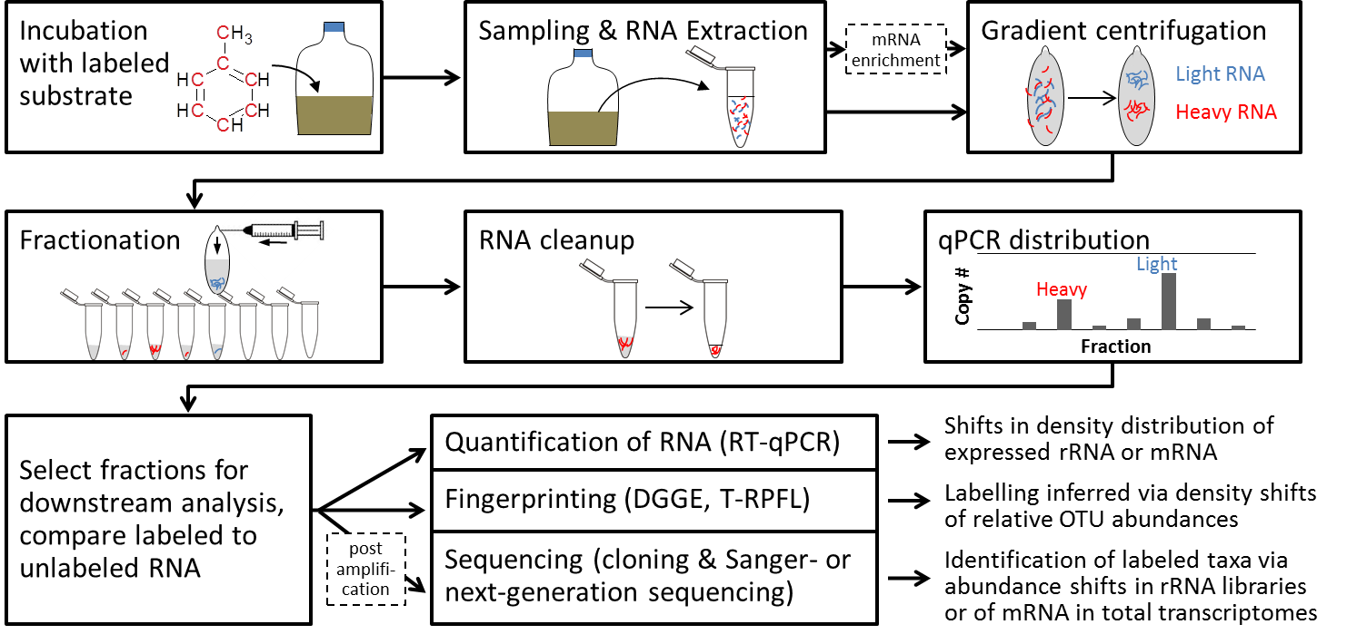

Figure 1. General workflow of RNA-SIP and downstream labelling detection approaches. Steps in dashed boxes are optional steps that may be necessary for the detection of labelled transcriptomes.

