Grip strength across the life course: normative data from twelve British studies

Richard M Dodds^{1*}, Holly E Syddall ¹, Rachel Cooper ², Michaela Benzeval ³, Ian J Deary ⁴, Elaine M Dennison ¹, Geoff Der⁵, Catharine R Gale ^{1,4}, Hazel M Inskip ¹, Carol Jagger ⁶, Thomas B Kirkwood ⁶, Debbie A Lawlor ⁷, Sian M Robinson ¹, John M Starr⁴, Andrew Steptoe⁸, Kate Tilling ⁷, Diana Kuh ², Cyrus Cooper¹, Avan Aihie Sayer ¹

¹ MRC Lifecourse Epidemiology Unit, University of Southampton, Southampton, UK
² MRC Unit for Lifelong Health and Ageing at UCL, London, UK
³ Institute for Social and Economic Research, University of Essex, Colchester, UK
⁴ Centre for Cognitive Ageing and Cognitive Epidemiology, Department of Psychology, University of Edinburgh, Edinburgh, UK
⁵ Social & Public Health Sciences Unit, Medical Research Council, Glasgow, UK
⁶ Institute for Ageing and Health, Newcastle University, Campus for Ageing and Vitality, Newcastle upon Tyne NE4 5PL, UK
⁷ MRC Integrative Epidemiology Unit, University of Bristol, Bristol, UK
⁸ Department of Epidemiology and Public Health, University College London, London, UK.

* Corresponding author
E-mail: rd@mrc.soton.ac.uk (RD)

Abstract
Introduction
Epidemiological studies have shown that weaker grip strength in later life is associated with disability, morbidity, and mortality. Grip strength is a key component of the sarcopenia and frailty phenotypes and yet it is unclear how individual measurements should be interpreted. Our objective was to produce cross-sectional centile values for grip strength across the life course. A secondary objective was to examine the impact of different aspects of measurement protocol.

Methods
We combined 60,803 observations from 49,964 participants (26,687 female) of 12 general population studies in Great Britain. We produced centile curves for ages 4 to 90 and investigated the prevalence of weak grip, defined as strength at least 2.5 SDs below the gender-specific peak mean. We carried out a series of sensitivity analyses to assess the impact of dynamometer type and measurement position (seated or standing).

Results
Our results suggested three overall periods: an increase to peak in early adult life, maintenance through to midlife, and decline from midlife onwards. Males were on average stronger than females from adolescence onwards: males' peak median grip was 51kg between ages 29 and 39, compared to 31kg in females between ages 26 and 42. Weak grip strength, defined as strength at least 2.5 SDs below the gender-specific peak mean, increased sharply with age, reaching a prevalence of 23% in males and 27% in females by age 80. Sensitivity analyses suggested our findings were robust to differences in dynamometer type and measurement position.

Conclusion
This is the first study to provide normative data for grip strength across the life course. These centile values have the potential to inform the clinical assessment of grip strength which is recognised as an important part of the identification of people with sarcopenia and frailty.

Introduction
Grip strength is associated with a variety of ageing outcomes [1–3] and forms a key component of sarcopenia [4] and frailty [5,6] phenotypes. There is considerable interest in its role as a marker of healthy ageing, as an outcome in intervention studies, and as a potential tool for clinical assessment [7–9]. The life course epidemiology framework recognises that factors which promote healthy ageing may operate both by increasing the peak grip strength obtained in early adult life as well as by attenuating decline thereafter [10]. There is therefore a requirement for normative data for grip strength which cover all stages of the life course.

Existing normative data have focussed mainly on older ages [11] with relatively few studies examining childhood, adolescence, and early adult life. Since no studies have measured grip strength at all stages of the life course, it is necessary to combine data from studies at different ages. Bohannon et al [12] have previously combined data from 12 studies in adulthood; however, these studies were predominantly modestly-sized samples drawn from the USA. Cohort and cross-sectional studies of the general population conducted in Great Britain (GB) contain a wealth of grip strength data, which in keeping with clinical practice, have been collected using a variety of measurement protocols.

The objective of this paper was to produce cross-sectional centile values for grip strength across the life course by pooling data from a range of general population studies conducted in GB. A secondary objective was to examine the impact of different aspects of measurement protocol on the centile values obtained.

Methods

Data sources
We combined data from 12 studies conducted in GB as shown in Table 1. These were all samples of the general population, with eight studies including individuals from specific regions (SWS [13], ALSPAC [14], T-07 [15], HCS [16], HAS [17], LBC1936 [18], LBC1921 [18] and N85 [19]) and four drawing from one (ELSA [20] and ADNFS [21,22]) or all three countries of GB (UKHLS [23] and NSHD [24,25]). All included males and females. When combined, studies’ grip measurements covered ages 4 to 90+ years with measurements occurring between 1990 and 2012. Three studies had prospectively recruited participants at or shortly after birth (SWS, ALSPAC and NSHD) and in SWS, grip strength measurements were also available from the mother during her pregnancy and from her partner. The majority (n=10) of studies had measured grip strength at one or two waves, with LBC1921 and N85 having data from three and four waves, respectively. All studies had received relevant ethical approval and all participants gave informed consent.

Grip strength measurement
Information on the grip strength measurement protocols is shown in Table 1. Seven studies used the Jamar dynamometer (including the second wave of HAS, which used the Harpenden dynamometer at the first wave), two studies (ELSA and UKHLS) used the Smedley dynamometer, two studies used the Nottingham electronic dynamometer (ADNFS and NSHD), and N85 used the Takei dynamometer. The majority (n=8) of studies measured grip in the seated position for all participants.

All studies took measurements from both hands except ADNFS which used the dominant hand only (except in case of injury), and LBC1921 which measured both hands but provided values from only the dominant hand for analyses. The majority of studies used three trials from each hand, except for N85 and the first wave of NSHD, which used two trials. Taken together, this meant that the total number of grip strength values we could use in analyses varied: either three (ADNFS and LBC1921), four (N85 and the first wave of NSHD) or six (the remainder). We therefore always used the maximum of these values for our analyses, since the maximum is less likely to be affected by the number of trials than the mean [26].

Statistical analyses
Our main analyses used all available data, including values for individuals who had had grip strength measured at more than one age. We produced gender-specific cross-sectional centiles for grip strength using the Box-Cox Cole and Green (BCCG) distribution (also known as the LMS method [27]) implemented in the Generalised Additive Models for Location, Scale and Shape (GAMLSS) library [28] for the statistical program, R [29]. We used restricted cubic splines to model the relationship between age and each of the three model parameters: the median, variation and skewness. We identified the optimum number of degrees of freedom for each parameter using the GAMLSS command find.hyper. We anticipated a smooth relationship with age and therefore used a maximum number of degrees of freedom of seven and increased the standard penalty. We looked for evidence of kurtosis in the grip strength values by using the Box-Cox power exponential distribution. We modelled the mean and SD of grip at each age using the normal distribution in GAMLSS.

We defined a T-score for grip strength as an individual’s value expressed as a multiple of the number of standard deviations below the peak mean value encountered in young adult life. This is the same as the approach applied to measurements of bone density in the diagnosis of osteoporosis [30], except we used gender-specific peak mean values for grip strength. We explored the gender-specific prevalence of weak grip strength in mid and late adult life in two ways. Firstly, using a T-score for grip strength of equal to or less than -2 as used previously [31], and secondly using a T-score of equal to or less than -2.5, as widely used in the diagnosis of osteoporosis.

We carried out sensitivity analyses by producing further sets of centile curves and comparing these to our main findings. We restricted the data to the first observation for each individual. We produced dynamometer-specific sets of centile curves by allowing the median, variation and skewness curves to vary by dynamometer type. Similarly we considered the impact of the position of grip strength measurement: standing or sitting, with the latter divided into those who were sitting as per protocol and those who chose to sit or were unable to stand. Finally we checked if any one study was unduly influencing the results obtained by excluding each study in turn. To compare each additional model to the main findings, we examined absolute differences for the 10th, median and 90th centiles; we considered that a 10 percent difference or less in the centile values at any given age provided evidence of acceptably similar findings. We carried out data management using Stata version 12.0 [32].

Results
We used a total of 60,803 observations of grip strength from 49,964 participants to produce the centile values for grip strength as shown in Table 2 and Figure 1. Eight of the twelve studies had measured grip strength in mid-late adult life, as reflected by the median age of the observations: 58 years (IQR 36 – 69 years).

The centile curves (Figure 1) suggested three overall periods: an increase to peak in early adult life, broad maintenance through to midlife and decline from midlife onwards. Males were stronger on average than females from adolescence onwards; by age 25, males’ median strength was 1.6 times that of females and this ratio increased slightly to 1.7 from age 50 onwards. Males reached a peak median grip of 51kg (to the nearest whole kg) between ages 29 and 39, compared to the peak female median grip of 31kg between ages 26 and 42.

The spread of grip strength values relative to the median (the sigma parameter from the BCCG model, an approximation to the coefficient of variation) increased slightly in later life, from 0.20 in the fourth decade in men and women, rising to 0.25 and 0.29 in the ninth decade in men and women, respectively. We found no evidence of skewness or kurtosis in grip strength at any age.

Estimated prevalence of weak grip strength in mid and late adult life, defined by gender-specific T-scores of less than or equal to -2 and -2.5, are shown in Figure 2. These were derived relative to the peak mean (SD) for grip strength of 51.9 (9.9) kg in males and 31.4 (6.1) kg in females, both occurring at age 32. Females and males had similar prevalence of weak grip strength during the decline phase. The prevalence of weak grip increased rapidly in late adult life; using a T-score of -2.5, our results suggested that by age 80, around a quarter had weak grip strength (23.0% of males and 26.6% of females).

Sensitivity analyses (see Figures S1-S3 in File S1) suggested that the centile curves were robust to the inclusion of repeat measurements of grip strength and protocol differences between studies. In comparison to our main results, we generally saw centile differences of less than 10 per cent when restricting the data to the first observation for each individual, and when producing centile curves stratified by dynamometer type. This was also the case for centiles stratified by whether participants were seated (as per protocol) or standing. Those who chose to sit or were unable to stand tended to be weaker and this difference became more pronounced with age until the ninth decade when their 10th centile values approached 10 per cent lower than the combined results. Finally, the centiles produced from analyses excluding each study in turn (not shown) were acceptably similar, except for ALSPAC (males only) and N85 (both males and females); this was perhaps not surprising as the exclusion of each of these studies led to sparse or absent data in the relevant age ranges.

Discussion

Main findings
We have combined data from 12 general population studies conducted in GB to produce normative data for grip strength across the life course. We have shown that grip strength increases to a peak in early adult life, and is then followed by a period of broad maintenance prior to decline with increasing age. Our study shows that the strength of males and females is similar until adolescence, after which males began to gain strength more rapidly to a higher peak median of 51kg between ages 29 and 39, compared to the peak female median grip of 31kg between ages 26 and 42. Sensitivity analyses demonstrated that the normative data produced by this study are robust to a range of dynamometer types and also to measurement in the seated or standing positions. Our normative data for grip strength across the life course will inform the clinical interpretation of grip strength measurements and will help to establish thresholds for identification of low muscle strength for use in clinical practice and the operationalization of consensus definitions of sarcopenia and frailty.

Comparison with other studies
Our study is the first to produce normative data for grip strength across the whole life course in GB (or in any other setting, as far as we are aware) so we elected to compare our results with previously published studies of grip strength in international as well as British settings, grouped by the stage(s) of the life course they addressed. We considered differences between previously published mean values and our median values for grip strength at a selection of ages, expressed as a percentage of our value. Normative data from studies identified in childhood and adolescence varied in their relationship to our findings: either broadly similar [33], consistently higher [34] (on average 27%), or similar at young ages and higher at older ages [35] (on average 9% higher overall). However the three previously published studies may not provide reliable estimates of the general population since they contained small numbers of individuals at each given age and gender: at most 43 (mean 22) in each of the ages compared.

We also compared our values to those from four studies addressing adult ages either side of the peak (ages 20-80). Three of these [12,36,37] showed agreement with our results, with average differences of around 6%. In one case [36] this is not surprising, since the article reported results from the ADNFS, a study included in our analysis. The second study was the meta-analysis by Bohannon et al [12] which combined data from a range of studies in developed country settings. The third study [37] reported normative data for male participants in the Baltimore Longitudinal Study of Ageing. The normative values from the fourth study [38], based in Switzerland, were on average 11% higher than ours.

Finally, we compared our values to those from three studies which considered age-related differences in grip strength during the decline phase. Normative values from UK Biobank were stratified into eight height groups [39]; in comparison to the average of the middle two groups, our values were on average 7% higher. The TILDA study in Ireland [11] stratified values into two height groups; our values were around 15% higher the average of the groups. Finally a study from Denmark [40] stratified values into five height groups, the middle of which were similar to our own values.

Our results expand on the range of ages as well as the contributing sample sizes of existing studies presenting normative data for grip strength. They also broadly agree with previously published results for adults from developed country settings. Fewer normative data for grip strength in children and adolescents were available for comparison.

We are not aware of any other studies which have compared the centile values obtained from general population samples using different dynamometer types. Several small studies (with 104 or fewer participants) have used comparisons of repeat measurements with two or more dynamometers to investigate whether similar readings are produced. Their findings have varied, with some reporting that readings from different dynamometers are comparable [41–44], or can be converted using an equation [45], and others concluding that the limits of agreement are too broad and the devices are not interchangeable in either way [41,46]. From our results, we conclude that the different dynamometers used produce acceptably similar normative data, albeit within the ages at which measurements were observed.

Similarly, studies investigating the role of measurement position are inconsistent, with one finding no difference [47] and another suggesting that standing produces higher values [48]. Our results show that normative data from studies using the seated and standing positions are comparable, although unsurprisingly individuals who chose not to stand or were unable to do so had weaker grip. Although our centiles appeared to be robust to differences in measurement protocol, this does not detract from the importance of recent calls for standardisation in future data collections [26,49].

Clinical relevance of findings
Our findings have confirmed that grip strength increases to a peak in early adult life and is then followed by a period of maintenance prior to decline with increasing age and that this age related decline in grip strength starts as early as the fifth decade of life in both men and women. The life course trajectory identified for grip strength in our study is similar to the well-established life course trajectory of bone mineral density (BMD) [30]. This supports the use of peak values from early adult life to define cut-offs for weak grip at subsequent ages using T-scores. We have used this approach to estimate the prevalence of weak grip based on T-scores of both -2 and -2.5. A T-score of less than or equal to -2 has previously been used by Lauretani et al [31] for grip strength, although the prevalence figures for weak strength that they report using this value, especially those for men, are considerably higher than our own. This difference may have arisen as in their sample, they include 25 men at ages 20-29 with mean (SD) grip 61.1 (10.5) kg. The cut-off for weak grip in men is not stated in their paper but we presume it is then 40 kg (61.1 less 2x10.5) – substantially higher than our own (32kg). By fitting centile curves that span all stages of the life course, we have established more informative peak values on which to base T-scores.

In our data, we still found a high prevalence of weak grip strength based on a T-score of -2 or below (equivalent to 19kg in females and 32kg in males, or weaker) with almost half of participants at or below this level at age 80. It may therefore be that a T-score of -2.5 (equivalent to 16kg in females and 27kg in males) produces a more discriminatory cut-off for weak grip – with 23.0% of males and 26.6% of females at or below this level at age 80.

It is important that any cut-off values relate to relevant outcomes. Two studies have done this in a cross-sectional fashion. Lauretani et al [31] examined the optimum grip strength values for detecting slow measured walking speed and self-reported difficulty in walking 1 km; they found that grip strength of 30kg in males and 19kg in females provided the optimum balance between sensitivity and specificity. Sallinen et al [9] looked at self-reported difficulties with mobility and found similar overall cut-off s: 37kg in males and 21kg in females. Clearly there is a need to examine similar relationships in a longitudinal fashion if individual values of grip strength are to be used as a marker of those at risk of adverse outcomes.

Strengths and limitations
This study had some limitations. First, our data contained a limited range of birth years (at most 32 years) for any given ten year age group. As such the relationships shown with age may partly represent cohort effects [45]. However as the aim of this paper was to produce normative data for current use, the recent period of data collection seems appropriate. Second, our normative data for grip are cross-sectional and are likely to underestimate individual decline; our centiles should therefore not be used for monitoring individual trajectories in grip strength [40,50,51]. Third, we have not considered the potential impact of recognised determinants of grip strength, such as height, on the centile values presented. This is an area for future research. Finally selection and loss-to-follow up biases may have influenced our centile values; however we included a wide range of population based studies from different geographical regions of GB and the centile curves were robust to the exclusion of any individual study.

Our study also had many strengths. First, we included data from many large general population studies in GB covering all stages of the life course. Second, we used a modelling approach which allowed grip strength to vary as a smooth function of age and to incorporate any non-normality in grip (skewness or kurtosis). Finally, extensive sensitivity analyses demonstrated that our centile curves for grip strength are robust to differences in the position (seated or standing) and the dynamometer used for measurement.

Conclusions
In conclusion, we have used existing data from a range of studies conducted in GB to produce centile curves for grip strength across the life course. These centile values have the potential to inform the clinical assessment of grip strength which is recognised as an important part of the identification of people with sarcopenia and frailty.

Acknowledgements
We are grateful to the participants and data collection teams of all the included studies.

We would like to thank Prof. Clive Osmond, PhD (MRC Lifecourse Epidemiology Unit, University of Southampton, Southampton, UK) for his help with the approach of using centile curves to describe the grip strength data.

Funding sources
RD is supported by a Wellcome Trust Fellowship (Grant number WT099055AIA). RC and DK are supported by the UK Medical Research Council (programme code MC_UU_12019/4). CJ is supported by the AXA Research Fund. MB is funded by the University of Essex and ESRC. DAL and KT work in a Unit that receives support from the UK Medical Research Council (MC_UU_12013/5 and MC_UU_12013/9, respectively).
Core support for the ALSPAC study is provided by the UK Medical Research Council and Wellcome Trust (092731). Acknowledgements: We are extremely grateful to all of the families who took part in this study, the midwives for recruiting them, and the whole ALSPAC team, which includes interviewers, computer and laboratory technicians, clerical workers, research scientists, volunteers, managers, receptionists and nurses.
The English Longitudinal Study of Ageing was developed by a team of researchers based at University College London, the Institute for Fiscal Studies and the National Centre for Social Research. The funding is provided by the National Institute on Aging (grants 2RO1AG7644-01A1 and 2RO1AG017644) and a consortium of UK government departments coordinated by the Office for National Statistics.
The Hertfordshire Ageing Study and the Hertfordshire Cohort Study were funded by the UK Medical Research Council, the Wellcome Trust, Arthritis Research United Kingdom and the University of Southampton.
The Lothian Birth Cohort 1921 was funded by the Biotechnology and Biological Sciences Research Council, by a Royal Society-Wolfson Research Merit Award, and by the Scottish Government’s Chief Scientist Office. The Lothian Birth Cohort 1936 was funded by Age UK (Disconnected Mind project). The work was done within the Centre for Cognitive Ageing and Cognitive Epidemiology (Mr/K026992/1); funding from the Medical Research Council and the Biotechnology and Biological Sciences Research Council is appreciated. For collating and collecting data, we thank the LBC1921 and LBC1936 research teams, and the research nurses and staff at the Wellcome Trust Clinical Research Facility at the Western General Hospital, Edinburgh.
The MRC National Survey of Health and Development is funded by the UK Medical Research Council.
The Newcastle 85+ Study was funded by grants from the UK Medical Research Council (G0500997), the Dunhill Medical Trust (R124/0509), and the Newcastle Healthcare Charity. The research was also supported by the National Institute for Health Research Newcastle Biomedical Research Centre, based at Newcastle upon Tyne Hospitals NHS Foundation Trust and Newcastle University.
The waves of the Southampton Women’s Survey included in this analysis were funded by the Medical Research Council, the University of Southampton, Dunhill Medical Trust, Arthritis Research UK and the UK Food Standards Agency.
UKHLS is funded by the Economic and Social Research Council (ESRC). The study is carried out by the Institute for Social and Economic Research and data are made available through the UK Data Service.

The funders had no role in study design, data collection and analysis, decision to
publish, or preparation of the manuscript.

References
1. Rantanen T, Guralnik JM, Foley D, Masaki K, Leveille S, et al. (1999) Midlife hand grip strength as a predictor of old age disability. JAMA 281: 558–560.
2. Cooper R, Kuh D, Cooper C, Gale CR, Lawlor DA, et al. (2011) Objective measures of physical capability and subsequent health: a systematic review. Age Ageing 40: 14–23.
3. Cooper R, Kuh D, Hardy R, Mortality Review Group (2010) Objectively measured physical capability levels and mortality: systematic review and meta-analysis. BMJ 341: c4467.
4. Aihie Sayer A, Robinson SM, Patel HP, Shavlakadze T, Cooper C, et al. (2013) New horizons in the pathogenesis, diagnosis and management of sarcopenia. Age Ageing 42: 145–150.
5. Fried LP, Tangen CM, Walston J, Newman AB, Hirsch C, et al. (2001) Frailty in Older Adults : Evidence for a Phenotype. J Gerontol A Biol Sci Med Sci 56A: M146–M156.
6. Clegg A, Young J, Iliffe S, Rikkert MO, Rockwood K (2013) Frailty in elderly people. Lancet 381: 752–762.
7. Cooper C, Fielding R, Visser M, van Loon LJ, Rolland Y, et al. (2013) Tools in the Assessment of Sarcopenia. Calcif Tissue Int 93: 201–210.
8. García-Peña C, García-Fabela LC, Gutiérrez-Robledo LM, García-González JJ, Arango-Lopera VE, et al. (2013) Handgrip strength predicts functional decline at discharge in hospitalized male elderly: a hospital cohort study. PLoS One 8: e69849.
9. Sallinen J, Stenholm S, Rantanen T, Heliövaara M, Sainio P, et al. (2011) Hand-Grip Strength Cut-Points to Screen Older Persons at Risk for Mobility Limitation. J Am Geriatr Soc 58: 1721–1726.
10. Kuh D, Ben-Shlomo Y (2004) Introduction. A life course approach to chronic disease epidemiology. Oxford: Oxford University Press. pp. 3–15.
11. Kenny RA, Coen RF, Frewen J, Donoghue OA, Cronin H, et al. (2013) Normative values of cognitive and physical function in older adults: findings from the Irish longitudinal study on ageing. J Am Geriatr Soc 61 S2: S279–90.
12. Bohannon RW, Peolsson A, Massy-Westropp N, Desrosiers J, Bear-Lehman J (2006) Reference values for adult grip strength measured with a Jamar dynamometer: a descriptive meta-analysis. Physiother 92: 11–15.
13. Inskip HM, Godfrey KM, Robinson SM, Law CM, Barker DJP, et al. (2006) Cohort profile: The Southampton Women’s Survey. Int J Epidemiol 35: 42–48.
14. Boyd A, Golding J, Macleod J, Lawlor DA, Fraser A, et al. (2013) Cohort Profile: The “Children of the 90s”--the index offspring of the Avon Longitudinal Study of Parents and Children. Int J Epidemiol 42: 111–127.
15. Benzeval M, Der G, Ellaway A, Hunt K, Sweeting H, et al. (2009) Cohort Profile: West of Scotland Twenty-07 Study: Health in the Community. Int J Epidemiol 38: 1215–1223.
16. Syddall HE, Aihie Sayer A, Dennison EM, Martin HJ, Barker DJP, et al. (2005) Cohort Profile: the Hertfordshire Cohort Study. Int J Epidemiol 34: 1234–1242.
17. Syddall HE, Simmonds SJ, Martin HJ, Watson C, Dennison EM, et al. (2010) Cohort profile: The Hertfordshire Ageing Study (HAS). Int J Epidemiol 39: 36–43.
18. Deary IJ, Gow AJ, Pattie A, Starr JM (2012) Cohort profile: the Lothian Birth Cohorts of 1921 and 1936. Int J Epidemiol 41: 1576–1584.
19. Collerton J, Davies K, Jagger C, Kingston A, Bond J, et al. (2009) Health and disease in 85 year olds: baseline findings from the Newcastle 85+ cohort study. BMJ 399: b4904.
20. Marmot M et al. (n.d.) English Longitudinal Study of Ageing: Wave 0 (1998, 1999 and 2001) and Waves 1-5 (2002-2011) [computer file]. 18th Edition. Colchester, Essex: UK Data Archive [distributor], February 2013. SN: 5050, http://dx.doi.org/10.5255/UKDA-SN-5050-4.
21. Activity and Health Research. Allied Dunbar National Fitness Survey (1992) A report on Activity Patterns and Fitness levels: Main Findings. London: Sports Council and Health Education Authority.
22. Activity and Health Research Limited (n.d.) Allied Dunbar National Fitness Survey, 1990 [computer file]. Colchester, Essex: UK Data Archive [distributor], May 1995. SN: 3303, http://dx.doi.org/10.5255/UKDA-SN-3303-1.
23. University of Essex (n.d.) Institute for Social and Economic Research and National Centre for Social Research, Understanding Society: Waves 1-2, 2009-2011 [computer file]. 4th Edition. Colchester, Essex: UK Data Archive [distributor], December 2012. SN: 6614.
24. Wadsworth M, Kuh D, Richards M, Hardy R (2006) Cohort Profile: The 1946 National Birth Cohort (MRC National Survey of Health and Development). Int J Epidemiol 35: 49–54.
25. Kuh D, Pierce M, Adams J, Deanfield J, Ekelund U, et al. (2011) Cohort profile: updating the cohort profile for the MRC National Survey of Health and Development: a new clinic-based data collection for ageing research. Int J Epidemiol 40: e1–9.
26. Roberts HC, Denison HJ, Martin HJ, Patel HP, Syddall H, et al. (2011) A review of the measurement of grip strength in clinical and epidemiological studies: towards a standardised approach. Age Ageing 40: 423–429.
27. Cole TJ, Green PJ (1992) Smoothing reference centile curves: the LMS method and penalized likelihood. Stat Med 11: 1305–1319.
28. Stasinopoulos DM, Rigby RA (2007) Generalized Additive Models for Location Scale and Shape (GAMLSS) in R. J Stat Soft 23.
29. R Core Team (2013) R: A Language and Environment for Statistical Computing. R Foundation for Statistical Computing, Vienna, Austria. URL http://www.R-project.org/.
30. Kanis J (2002) Diagnosis of osteoporosis and assessment of fracture risk. Lancet 359: 1929–1936.
31. Lauretani F, Russo CR, Bandinelli S, Bartali B, Cavazzini C, et al. (2003) Age-associated changes in skeletal muscles and their effect on mobility: an operational diagnosis of sarcopenia. J Appl Physiol 95: 1851–1860.
32. StataCorp (2011) Stata Statistical Software: Release 12.
33. Molenaar HMT, Selles RW, Zuidam JM, Willemsen SP, Stam HJ, et al. (2010) Growth diagrams for grip strength in children. Clin Orthop Relat Res 468: 217–223.
34. Mathiowetz V, Wiemer DM, Federman SM (1985) Grip and Pinch Strength: Norms for 6- to 19-Year-Olds. Am J Occ Ther 40: 705–711.
35. De Smet L, Vercammen A (2001) Grip strength in children. J Pedr Ortho B 10: 352–354.
36. Nevill AM, Holder RL (2000) Modelling handgrip strength in the presence of confounding variables: results from the Allied Dunbar National Fitness Survey. Ergonomics 43: 1547–1558.
37. Kallman D, Plato C, Tobin J (1990) The role of muscle loss in the age-related decline of grip strength: cross-sectional and longitudinal perspectives. J Gerontol 45: M82–8.
38. Werle S, Goldhahn J, Drerup S, Simmen BR, Sprott H, et al. (2009) Age- and gender-specific normative data of grip and pinch strength in a healthy adult Swiss population. J Hand Surg [Eur] 34: 76–84.
39. Spruit MA, Sillen MJH, Groenen MTJ, Wouters EFM, Franssen FME (2013) New normative values for handgrip strength: results from the UK Biobank. JAMDA 14: 775.e5–11.
40. Frederiksen H, Hjelmborg J, Mortensen J, McGue M, Vaupel JW, et al. (2006) Age trajectories of grip strength: cross-sectional and longitudinal data among 8,342 Danes aged 46 to 102. Ann Epidemiol 16: 554–562.
41. Amaral JF, Mancini M, Novo Júnior JM (2012) Comparison of three hand dynamometers in relation to the accuracy and precision of the measurements. Rev Bras Fisioter 16: 216–224.
42. Beaton DE, Driscoll SWO, Richards RR (1995) Grip Strength Testing Using the BTE Work Simulator and the Jamar Dynamometer: A Comparative Study. J Hand Surg 20A: 293–298.
43. Mathiowetz V (2002) Comparison of Rolyan and Jamar dynamometers for measuring grip strength. Occup Ther Int 9: 201–209.
44. Shechtman O, Gestewitz L, Kimble C (2005) Reliability and validity of the DynEx dynamometer. J Hand Ther 18: 339–347.
45. Nahhas RW, Choh AC, Lee M, Chumlea WMC, Duren DL, et al. (2010) Bayesian longitudinal plateau model of adult grip strength. Am J Hum Biol 22: 648–656.
46. Guerra RS, Amaral TF (2009) Comparison of hand dynamometers in elderly people. J Nutr Heal Ageing 13: 907–912.
47. Shechtman O, Mackinnon L, Locklear C (2001) Using the BTE Primus to measure grip and wrist flexion strength in physically active wheelchair users: an exploratory study. Am J Occup Ther 55: 393–400.
48. Balogun J, Akomolafe C, Amusa L (1991) Grip strength: effects of testing posture and elbow position. Arch Phys Med Rehabil 72: 280–283.
49. Reuben DB, Magasi S, McCreath HE, Bohannon RW, Wang Y-C, et al. (2013) Motor assessment using the NIH Toolbox. Neurology 80: S65–75.
50. Desrosiers J, Hébert R, Bravo G, Rochette A (1998) Comparison of cross-sectional and longitudinal designs in the study of aging of upper extremity performance. J Gerontol A Biol Sci Med Sci 53A: B362–8.
51. Kirkwood TBL (1998) Alex Comfort and the measure of ageing. Exp Gerontol 33: 135–140.
52. Dodds R, Macdonald-Wallis C, Kapasi T, Aihie Sayer A, Robinson S, et al. (2012) Grip strength at 4 years in relation to birth weight. J Devel Orig Heal Dis 3: 111–115.
53. Fentem PH, Collins MF, Tuxworth W, Walker A, Hoinville E, et al. (1994) Allied Dunbar National Fitness Survey. Technical Report. London: Sports Council.
54. McFall S, Petersen J, Kaminska O, Lynn P (2013) Understanding Society - The UK Household Longitudinal Study: Wave 2 Nurse Health Assessment, 2010 - 2012, Guide to Nurse Health Assessment. (2013). Colchester: University of Essex.
55. Der G, Batty GD, Benzeval M, Deary IJ, Green MJ, et al. (2012) Is telomere length a biomarker for aging: cross-sectional evidence from the west of Scotland? PLoS One 7: e45166.
56. Kuh D, Bassey J, Hardy R, Aihie Sayer A, Wadsworth M, et al. (2002) Birth Weight, Childhood Size, and Muscle Strength in Adult Life: Evidence from a Birth Cohort Study. Am J Epidemiol 156: 627–633.
57. Deary I, Johnson W (2011) Losing one’s grip: a bivariate growth curve model of grip strength and nonverbal reasoning from age 79 to 87 years in the Lothian Birth Cohort 1921. J Gerontol B Psych Sci 66: 699–707.

Figure 1. Cross-cohort centile curves for grip strength.
Centiles shown 10, 25th, 50th, 75th and 90th.
ADNFS Allied Dunbar National Fitness Survey, ALSPAC Avon Longitudinal Study of Parents and Children, ELSA English Longitudinal Study of Ageing, HAS Hertfordshire Ageing Study, HCS Hertfordshire Cohort Study, LBC1921 and LBC1936 Lothian Birth Cohorts of 1921 and 1936, N85 Newcastle 85+ Study, NSHD Medical Research Council National Survey of Health and Development, SWS Southampton Women’s Survey, SWSmp mothers and their partners from the SWS, T-07 West of Scotland Twenty-07 Study, UKHLS Understanding Society: the UK Household Panel Study.

Figure 2. Gender-specific prevalence of weak grip strength based on T-scores of -2 and -2.5.
Values shown in brackets are the gender-specific cut-off values calculated by subtracting the relevant number of standard deviations (2 or 2.5) from the young adult peak mean.

Table 1. Study details including protocol used for grip strength
Study (population) ref(s) | Wave* | N seen† | N with grip measure | Birth year(s) | Year(s) of data collection | Age range (years) | Device(s) used / position ref(s) | Repetitions / hands / value used
SWS (children of women in cohort study, Southampton) [13] | 1 | 1,035 | 968 | 2000 - 2005 | 2004 - 2009 | 4 - 5 | Jamar / seated [52] | Six / both / max.
 | 2 | 522 | 462 | 2000 - 2003 | 2007 - 2010 | 6 - 7
ALSPAC (children of women attending antenatal clinics in Bristol and District Health Authority) [14] | 1 | 7,159 | 6,701 | 1991 - 1992 | 2003 - 2005 | 10 - 14 | Jamar / seated | Six / both / max.
ADNFS (random sample of English population with subsample having physical appraisal) [21,22] | 1 | 3,024 | 2,602 | 1916 - 1974 | 1990 | 16 -74 | Nottingham electronic / seated [36,53] | Three (or five if third 10% above best of first two) / dominant in 97.2% (non-dominant if injured) / max.
UKHLS (nationally representative sample of UK‡) [23] | 1 | 15,591 | 14,678 | 1908 - 1996 | 2010 - 2012 | 16 - 102 | Smedley / majority (83.1%) standing [54] | Six / both / max.
SWS (partner’s grip strength at 19 week visit) [13] | 1 | 1,520 | 1,265 | 1941 - 1985 | 2002 - 2005 | 18 - 58 | Jamar / seated [52] | Six / both / max.
SWS (mother’s grip strength at 19 weeks pregnant) [13] | 1 | 1,634 | 1,563 | 1963 - 1982 | 2002 - 2005 | 21 - 40 | Jamar / seated [52] | Six / both / max.
T-07 (stratified sample from Central Clydeside, Greater Glasgow, Scotland) [15] | 1 | (i) 923 | (i) 880 | (i) 1971 - 1972 | 2007 - 2008 | (i) 35 - 37 | Jamar / majority (99.0%) standing [55] | Six / both / max.
 |  | (ii) 991 | (ii) 913 | (ii) 1945 - 1955 |  | (ii) 52 - 62
 |  | (iii) 654 | (iii) 587 | (iii) 1929 - 1933 |  | (iii) 74 - 78
ELSA (participants from HSE aged 50 or older) [20] | 1 | 7,666¶ | 7,477 | 1914§-1952 | 2004 - 2005 | 52 - 89§ | Smedley / majority (80.2%) standing | Six / both / max.
 | 2 | 8,210** | 7,965 | 1918|| - 1970 | 2008 - 2009 | 50 - 89|| | Smedley / majority (81.5%) standing
NSHD (socially stratified sample of all births in England, Scotland and Wales in one week in March 1946) [24,25] | 1 | 2,984 | 2,847 | 1946 | 1999 | 53 | Nottingham electronic / seated [56] | Four / both / max.
 | 2 | 2,229 | 2,069 |  | 2006-10 | 60 - 64 |  | Six / both / max.
HCS (those born in North, East and West Hertfordshire and still resident when traced) [16] | 1 | 2,997 | 2,987 | 1931 - 1939 | 1999 - 2004 | 59 - 73 | Jamar / seated | Six / both / max.
 | 2 (East Herts. only) | 642 | 639 |  | 2004 - 2005 | 65 - 75
HAS (as per HCS but North Hertfordshire only) [17] | 1 | 717 | 717 | 1920 - 1930 | 1994 - 1995 | 63 - 73 | Harpenden / seated | Six / both / max.
 | 2 | 294 | 292 |  | 2003 - 2005 | 72 - 83 | Jamar / seated
LBC1936 (participants of Scottish Mental Surveys in 1947 at age 11 and still resident in Lothian area of Scotland) [18] | 1 | 1,091 | 1,086 | 1936 | 2004 - 2007 | 68 - 70 | Jamar / seated | Six / both / max.
 | 2 | 866 | 865 |  | 2007 - 2010 | 72 - 73
LBC1921 (as per LBC1936 but participants in 1932 at age 11) [18] | 1 | 550 | 544 | 1921 | 1999 - 2001 | 78 - 80 | Jamar / seated [57] | Six / both (values from dominant hand used in analyses) / max.
 | 2 | 321 | 321 |  | 2003 - 2005 | 82 - 84
 | 3 | 237 | 204 |  | 2007 - 2008 | 86 - 87
N85 (those registered with a Newcastle / North Tyneside general practice) [19] | 1 | 849 | 819 | 1921 | 2006 - 2007 | 84 - 86 | Takei digital / standing | Four / both / max.
 | 2 | 632 | 603 |  | 2007 - 2009 | 85 - 88
 | 3 | 486 | 453 |  | 2009 - 2010 | 87 - 89
 | 4 | 344 | 296 |  | 2011 - 2012 | 89 - 91

Studies ordered by age at first wave of data collection, youngest first.
* With measurement of grip strength
† The number here typically refers to the number of participants seen at the stage of the study where grip strength would normally be measured (e.g. at a clinic visit).
‡ The wave 2 nurse health assessment in which grip strength was measured was only carried out in England, Scotland and Wales.
¶ In the first wave of ELSA to measure grip (wave 2), only core study members (n=8,780) were eligible to take part in the nurse visit and this was completed in the number shown.
§ 80 individuals were aged 90 or older and their exact age is not available.
** In the second wave of ELSA to measure grip strength (wave 4) only core study members (n=9,886) core members were eligible to take part in the nurse visit and this was completed in the number shown.
|| 91 individuals were aged 90 or older and their exact age is not available.

Abbreviations
ADNFS Allied Dunbar National Fitness Survey, ALSPAC Avon Longitudinal Study of Parents and Children, ELSA English Longitudinal Study of Ageing, HAS Hertfordshire Ageing Study, HCS Hertfordshire Cohort Study, HSE Health Survey for England, LBC1921 and LBC1936 Lothian Birth Cohorts of 1921 and 1936, N85 Newcastle 85+ Study, NSHD Medical Research Council National Survey of Health and Development, SWS Southampton Women’s Survey, T-07 West of Scotland Twenty-07 Study, UKHLS Understanding Society: the UK Household Panel Study.

Table 2. Normative values for grip strength, stratified by gender
 |  | Grip strength normative values at age shown (kg)
Age (years) | Observations * | Centiles |  |  |  |  | Mean (SD)
 |  | 10th | 25th | 50th | 75th | 90th
Males
5 | 730 | 6 | 7 | 8 | 9 | 10 | 7.7 | (2.9)
10 | 3222 | 12 | 15 | 17 | 20 | 22 | 17.2 | (4.1)
15 | 288 | 21 | 25 | 29 | 33 | 38 | 29.6 | (5.6)
20 | 354 | 30 | 35 | 40 | 46 | 52 | 41.5 | (7.3)
25 | 574 | 36 | 41 | 48 | 55 | 61 | 48.8 | (8.7)
30 | 984 | 38 | 44 | 51 | 58 | 64 | 51.6 | (9.6)
35 | 1380 | 39 | 45 | 51 | 58 | 64 | 51.6 | (10.1)
40 | 880 | 38 | 44 | 50 | 57 | 63 | 50.3 | (10.3)
45 | 798 | 36 | 42 | 49 | 56 | 61 | 48.8 | (10.3)
50 | 820 | 35 | 41 | 48 | 54 | 60 | 47.6 | (10.1)
55 | 3743 | 34 | 40 | 47 | 53 | 59 | 46.2 | (9.8)
60 | 2683 | 33 | 39 | 45 | 51 | 56 | 44.6 | (9.2)
65 | 3947 | 31 | 37 | 43 | 48 | 53 | 42.3 | (8.6)
70 | 3286 | 29 | 34 | 39 | 44 | 49 | 39.1 | (8.1)
75 | 1883 | 26 | 31 | 35 | 41 | 45 | 35.6 | (7.6)
80 | 1115 | 23 | 27 | 32 | 37 | 42 | 32.2 | (7.3)
85 | 1134 | 19 | 24 | 29 | 33 | 38 | 28.5 | (7.0)
90 | 431 | 16 | 20 | 25 | 29 | 33 | 24.7 | (6.8)
95+ | 5 †
(Total) | (28,257)
Females
5 | 700 | 6 | 7 | 8 | 9 | 10 | 8.0 | (3.1)
10 | 3339 | 12 | 14 | 16 | 19 | 21 | 16.7 | (3.8)
15 | 345 | 17 | 20 | 24 | 27 | 30 | 23.9 | (4.5)
20 | 463 | 21 | 24 | 28 | 32 | 36 | 28.4 | (5.1)
25 | 870 | 23 | 26 | 30 | 35 | 38 | 30.6 | (5.6)
30 | 1423 | 24 | 27 | 31 | 35 | 39 | 31.4 | (6.0)
35 | 1785 | 23 | 27 | 31 | 35 | 39 | 31.3 | (6.2)
40 | 968 | 23 | 27 | 31 | 35 | 39 | 30.7 | (6.3)
45 | 952 | 22 | 26 | 30 | 34 | 38 | 29.9 | (6.4)
50 | 1019 | 21 | 25 | 29 | 33 | 37 | 28.7 | (6.4)
55 | 4250 | 19 | 23 | 28 | 32 | 35 | 27.5 | (6.4)
60 | 2943 | 18 | 22 | 27 | 31 | 34 | 26.5 | (6.2)
65 | 4171 | 17 | 21 | 25 | 29 | 33 | 25.3 | (6.0)
70 | 3473 | 16 | 20 | 24 | 27 | 31 | 23.5 | (5.7)
75 | 2135 | 14 | 18 | 21 | 25 | 28 | 21.4 | (5.4)
80 | 1361 | 13 | 16 | 19 | 23 | 26 | 19.1 | (5.1)
85 | 1632 | 11 | 14 | 17 | 20 | 23 | 16.6 | (4.7)
90 | 702 | 9 | 11 | 14 | 17 | 20 | 14.2 | (4.4)
95+ | 15 †
(Total) | (32,546)

The centiles and mean (SD) values were derived from the GAMLSS models for the exact ages shown.
* Number of grip strength observations refers to the number of individuals at age shown ± 2.5 years (to give an indication of the sample size at different ages).
† Limited data were available in the 95+ years category so centile values are not shown.
Supplemental material: results of sensitivity analyses
In the following three sets of graphs, the shaded areas indicate the range 10 percent above and below the values for the 10th, 50th (median) and 90th centiles from the main results. The lines then indicate the same centile values from each sensitivity analysis. We considered that centile values from sensitivity analyses within 10 percent of the main results provided evidence of acceptably similar findings. We comment below each graph in instances when this was not the case.

Figure S1. Centiles from first observation per individual only
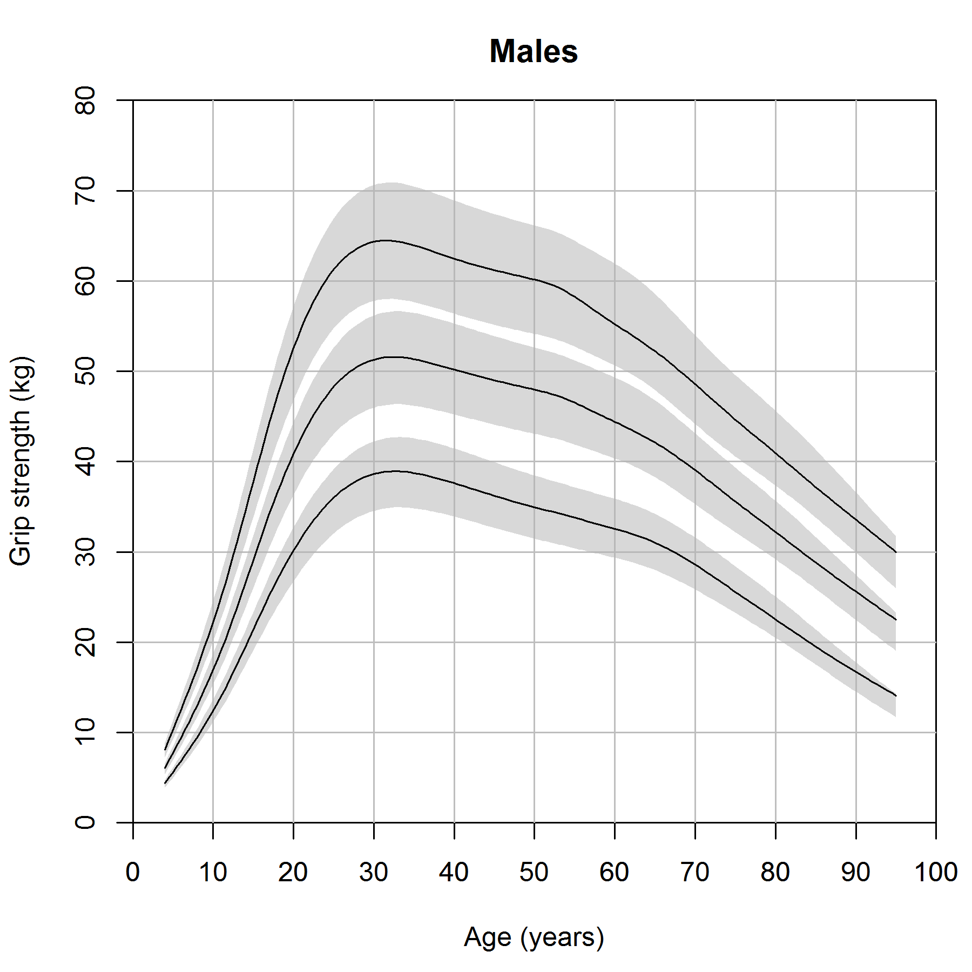 | 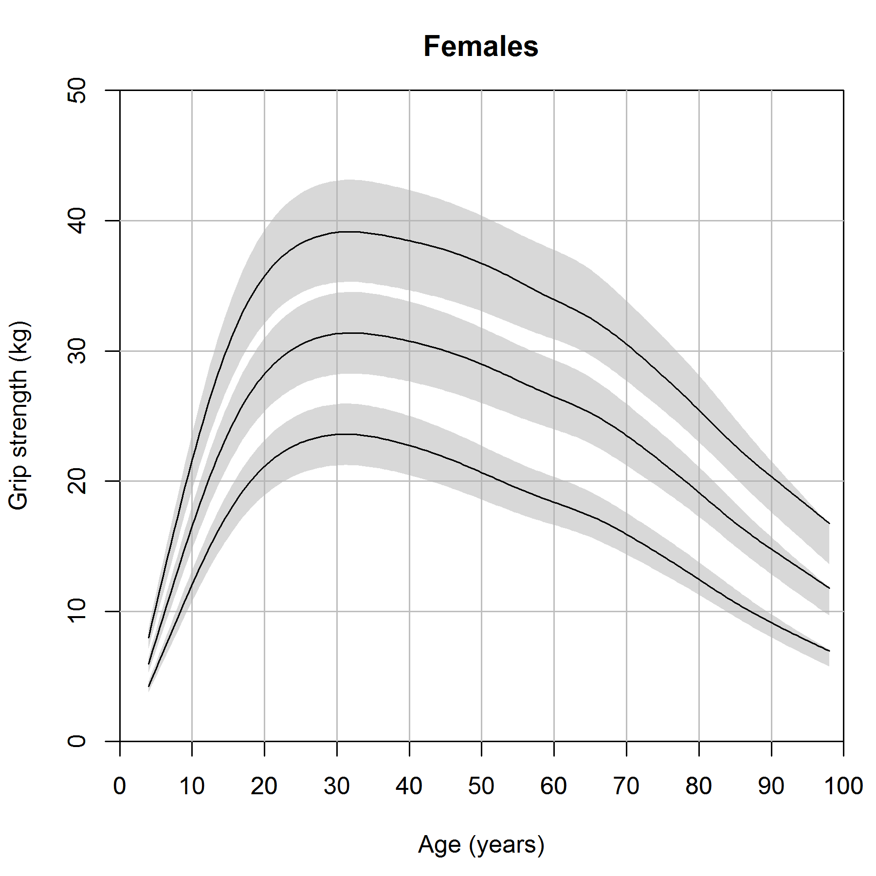
We attributed the slight differences in centile values below age 10 to the lack of data between age c. 4 (the first wave of SWS) and age c. 10 (ALSPAC) which results from the exclusion of repeat grip measurements.

Figure S2. Centiles stratified by dynamometer type
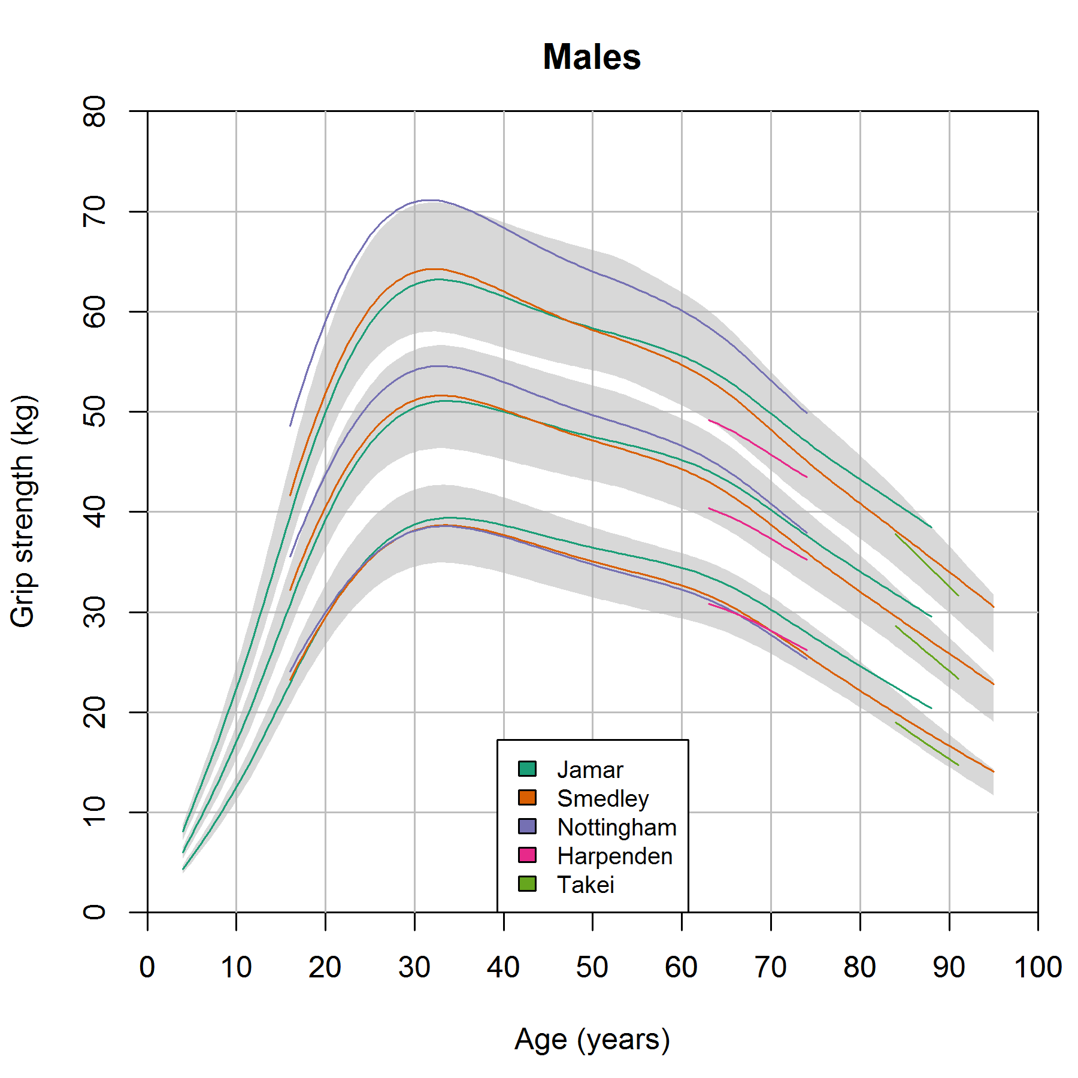 | 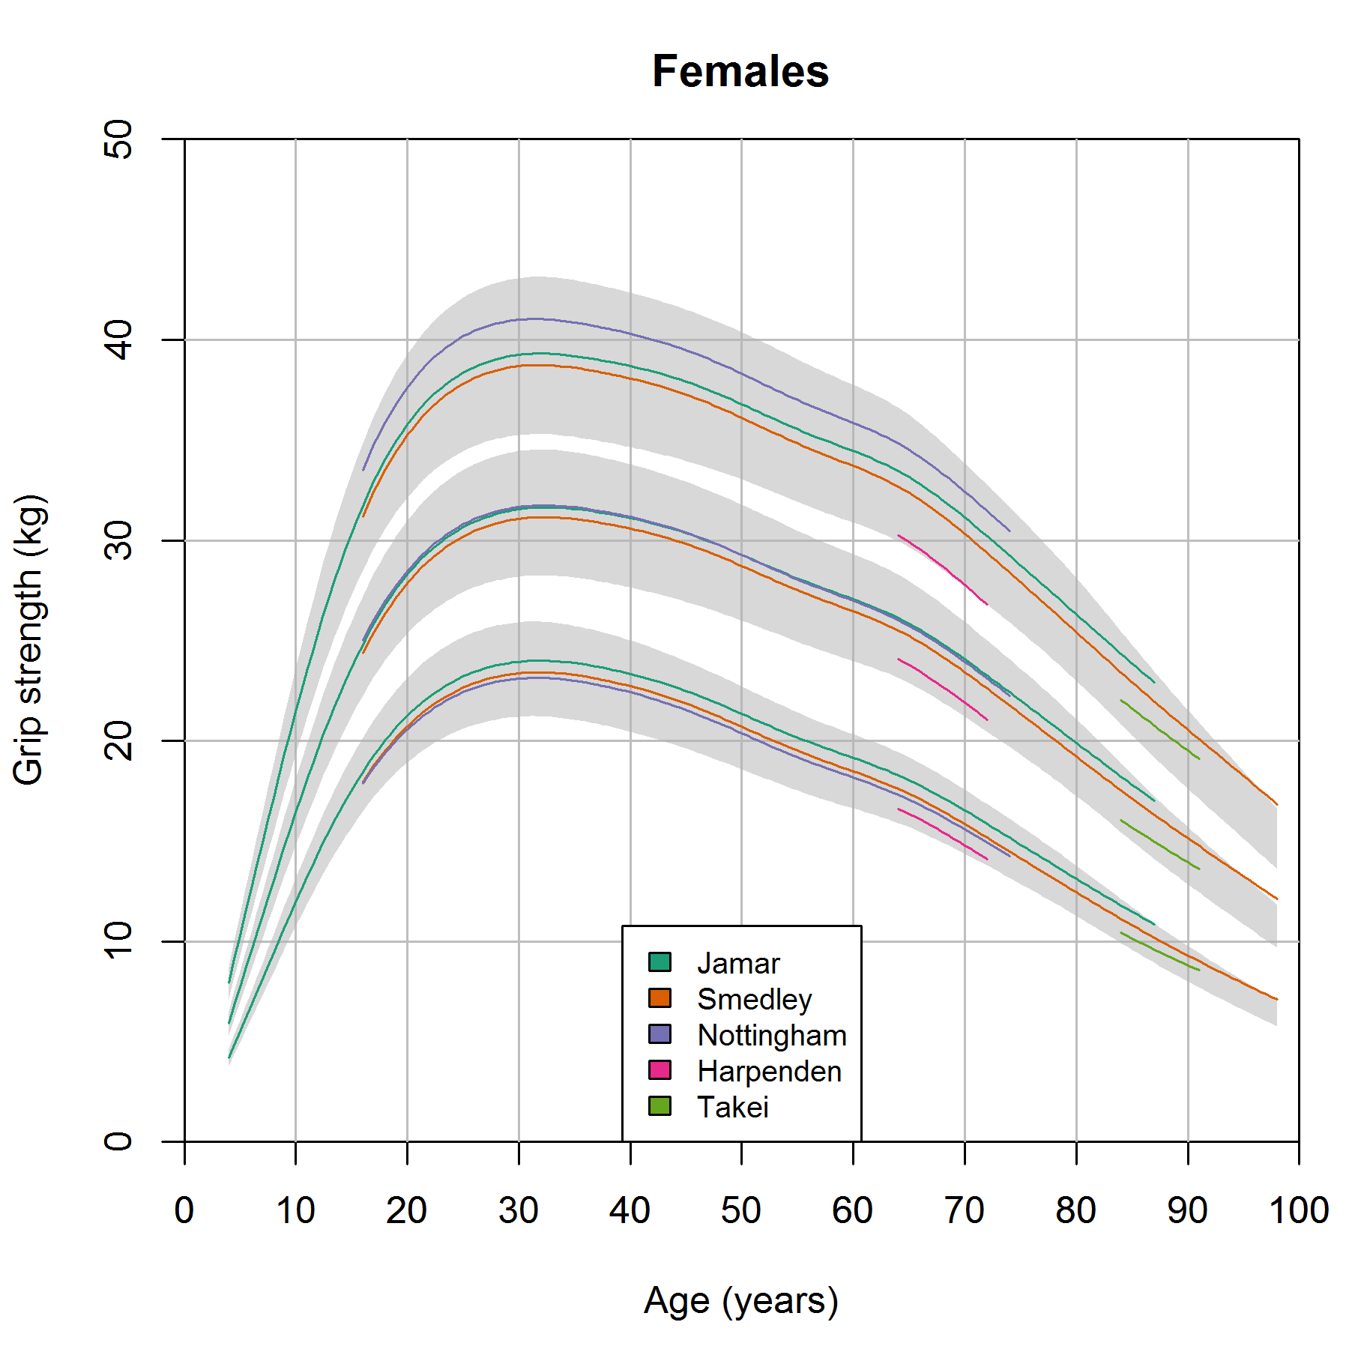
Overall we saw that the dynamometer-specific centiles were similar (to within 10 percent) to the combined results. However the 90th centile values for the Nottingham dynamometer in early adult life in males were slightly elevated. As no other study used the Nottingham dynamometer in this age range, it is unclear if these differences are due to dynamometer or other study factors.
The 10th centile values for the Jamar dynamometer were greater than 10 percent above the combined results between ages 83 and 87 in males; again this period represents observations from a single study (LBC1921) only.

Figure S3. Centiles stratified by position of measurement
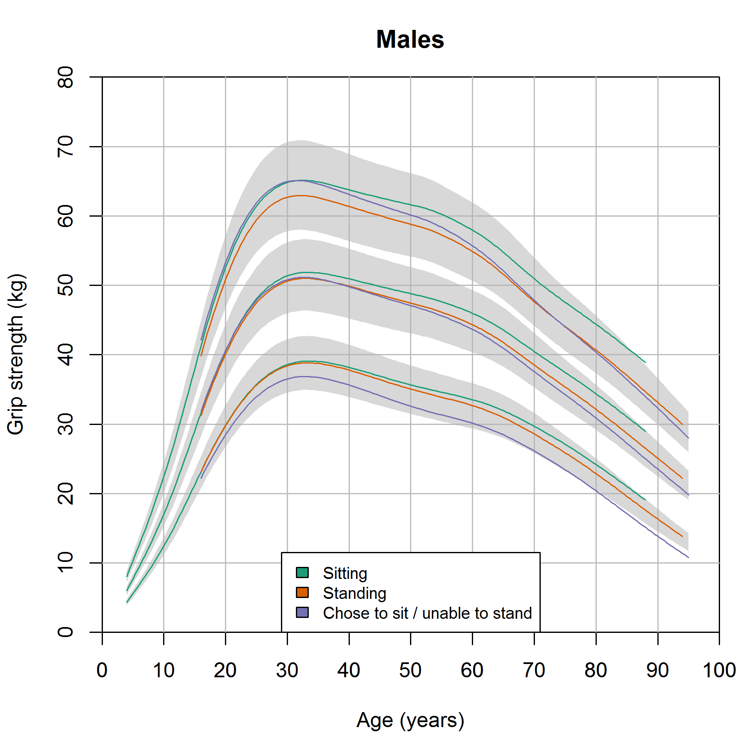 | 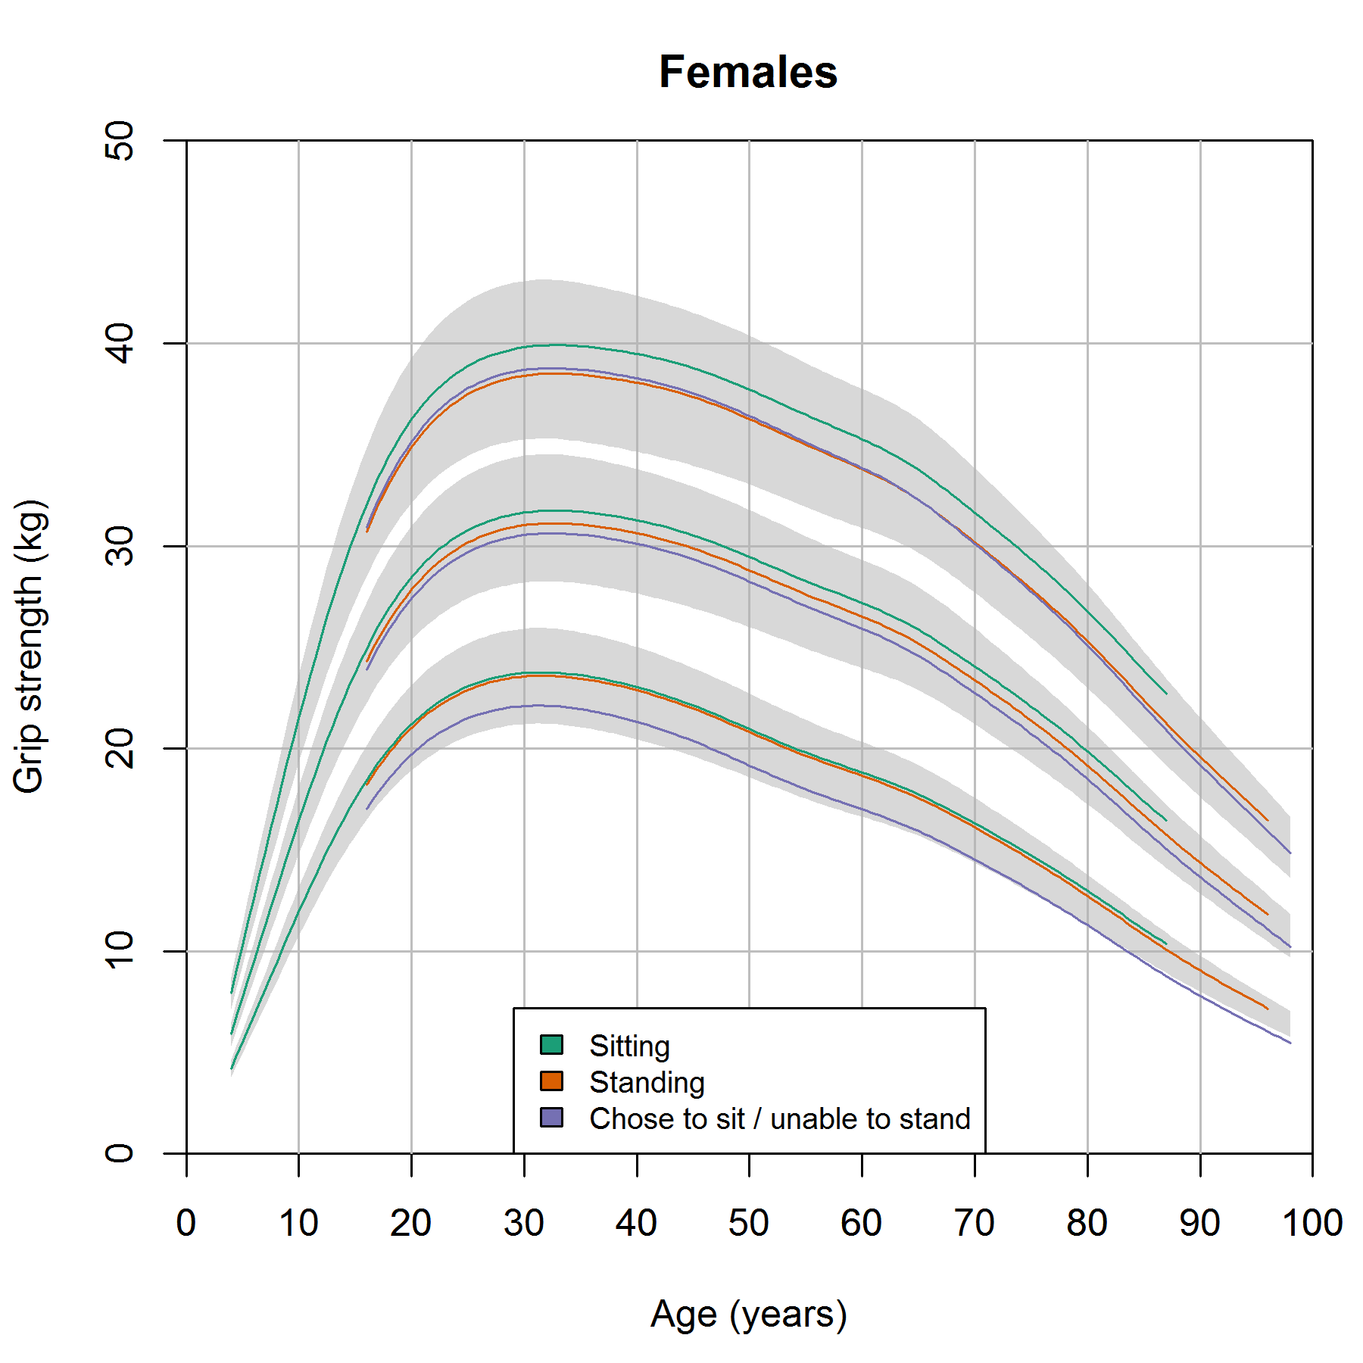
Perhaps unsurprisingly, those who chose to sit or were unable to stand tended to be weaker and this difference became more pronounced with age until the ninth decade when their 10th centile values approached 10 per cent lower than the combined results.

