High-frequency sea level variations and implications for coastal flooding: a case study of the Solent, UK
Ozgun Ozsoy^{1*}, Ivan D. Haigh¹, Matthew P. Wadey¹, Robert J. Nicholls², Neil C. Wells¹
¹ Ocean and Earth Science, University of Southampton, National Oceanography Centre Southampton, University of Southampton, Waterfront Campus, European Way, Southampton, SO14 3ZH, United Kingdom
² Engineering and the Environment, University of Southampton, Highfield, Southampton, SO17 1BJ, United Kingdom
* Corresponding author: Mr. Ozgun Ozsoy, Ocean and Earth Science, University of Southampton, National Oceanography Centre Southampton, University of Southampton, Waterfront Campus, European Way, Southampton, SO14 3ZH, United Kingdom.
o.ozsoy@soton.ac.uk
Abstract
This study examines the occurrence and characteristics of high-frequency (<6 hour) sea level variations in the Solent, UK – a mesotidal estuarine strait located in the central English Channel. A 14-year time series (2000-2013) of sea level observations sampled at 15-minute intervals from the Southampton tide gauge was analyzed. The 8 highest-energy events have a mean amplitude of approximately 0.6 m and a dominant period of around 4 hours. These events correspond with periods of enhanced meteorological activity, namely a marked reduction in air pressure and onset of strong southwesterly-southeasterly winds. Sea level observations from tide gauges around the Solent and the wider English Channel region (23 in total) were used to assess the spatial characteristics of these events. Analysis of time series and phase information indicates the occurrence of standing waves oscillating across the English Channel between southern England and northern France. This study provides a unique example of standing waves generated by extra-tropical cyclones over a large basin (the English Channel) with implications for flood inundation. The event of 28th October 2013 – the highest-amplitude (1.16 m) event in the record – was associated with minor coastal flooding at Yarmouth, Isle of Wight. This flood occurred during a neap tide, when such events are widely thought to be impossible. Hence, our findings emphasize the relevance of high-frequency sea level variability for regional sea level forecasting and flood risk management.
Keywords: sea level variability; coastal floods; seiches; meteorological tsunamis; English Channel; UK

Introduction
Globally, the sea-level variability which causes most extreme sea levels and associated coastal floods, occurs over periods from hours to days, and is associated with tropical and extra-tropical cyclones (Gönnert et al., 2001). However, higher-frequency sea level variations in the order of minutes to hours (e.g. tsunamis, ‘meteotsunamis’, infragravity waves, and seiches) can also raise sea levels beyond normal tidal levels in certain regions of the world, and may even dominate sea level extremes. For example, seiches are a major contributor to coastal floods in Venice, Italy, where they can reach amplitudes of up to 0.5 m and last several days (Vilibić, 2006). In Western Australia, meteotsunamis frequently occur and may produce up to 85% of non-tidal sea level variation (Pattiaratchi & Wijeratne, 2014). In Ciutadella (Menorca, Spain), high-frequency sea level variations, known locally as ‘Rissaga’, regularly reach amplitudes of >1 m (Jansa et al., 2007), causing coastal flooding and damage (Monserrat et al., 2006). Elsewhere, similar phenomena have been assigned local names, including ‘Abiki’ in Nagasaki Bay (Japan), ‘Milghuba’ in northern Malta, ‘Marrobbio’ in Sicily (Italy), and ‘Seebär’ in the southern Baltic Sea (c.f. Rabinovich, 2009; Pattiaratchi & Wijeratne, 2015). Increasingly, meteotsunamis are becoming recognized as an important component of sea level variation and extreme events (see Vilibić et al., 2014 and references therein). Therefore, understanding the characteristics of high-frequency sea-level variability is important for estimating sea level probabilities (i.e. return periods) and for operational forecasting and warning of extreme events.
There has been no (to our knowledge) comprehensive assessment of high-frequency (<6 hour) sea level variations for the UK, although a few previous studies have investigated the relevant processes. Historical accounts of high-frequency, large-amplitude sea level variations (interpreted as meteotsunamis) have been reported mainly for the south coast (Haslett & Bryant, 2009). Wells et al. (2001) described the role of resonant waves with periods of 2-6 hours during a prolonged period of extreme sea levels across the English Channel from 14th-18th December 1989, which were subsequently related to abrupt changes in wind patterns (Wells et al., 2005). Tappin et al. (2013) provided an assessment of unusual sea level anomalies observed across the English Channel and the coasts of France, Spain, and Portugal during 26th-27th June 2011, which were attributed to meteotsunamis. A subsequent more detailed analysis confirmed that these anomalies were caused by a thunderstorm travelling over the continental shelf (Frère et al., 2014). Despite these previous studies, the generating mechanisms of high-frequency sea level variations around the UK remain poorly understood.
In this paper we examine the occurrence and characteristics of high-frequency (<6 hour) sea level variations in the Solent (south coast, UK; Figure 1c) and assess the spatial characteristics of these fluctuations across the wider English Channel region (Figure 1b). The primary motivation for our study was the ‘St Jude’ storm (Davis, 2013) on 28th October 2013 which caused minor coastal flooding at Yarmouth, Isle of Wight (IWCP, 2013). This flood was highly unusual because it coincided with a neap tide, when coastal floods in the UK are widely thought to be impossible. During the event, uncharacteristically large non-tidal residuals were observed by the tide gauges across the Solent (Wadey et al., 2015a), including the presence of high-energy sea-level oscillations at periods of <6 hours. Our study has two main objectives: (i) to identify and characterize high-frequency sea level variations in the Solent and evaluate their contribution to coastal floods, and (ii) to provide a detailed assessment of the event of 28th October 2013 within this broader context.
The Solent is a mesotidal estuarine strait (with tributaries) from Hurst Spit (west) to Selsey Bill (east), separating the Isle of Wight from the mainland (Figure 1). Along the north coast the cities of Southampton and Portsmouth have grown together to form the third largest coastal metropolitan area in the UK, with over 1.5 million inhabitants. Over 20,000 properties (mostly in Portsmouth) are at risk of coastal flooding, and the region faces growing flood risks with sea level rise (Wadey et al., 2012; Stevens et al., 2015). Some of the largest changes in flood risk for England and Wales have been forecast along this coastline during the 21st century (Evans et al., 2004). Therefore, understanding of extreme sea levels in the Solent is vitally important.
The Solent is well-known for its complex tides (Pugh, 1987). Mean spring tidal range increases from 2 m in the west to about 4 m in the east. Storm surges rarely exceed 1 m and are usually associated with North Atlantic low-pressure systems propagating eastward over southern England (Haigh et al., 2010), although surges generated in the North Sea are occasionally transmitted into the English Channel through the Strait of Dover (Wadey et al., 2015b). The Solent has a long history of coastal flooding (Ruocco et al., 2011). Whilst some historical storm surges and resulting flood events have previously been assessed (Wells et al., 2001; Haigh et al., 2010; 2011; Wadey et al., 2013), there has been almost no consideration of the possible role of high-frequency events. The extreme sea level events of 14th-18th December 1989, which probably caused the worst coastal flooding in the Solent over the last half-century (Ruocco et al., 2011), have frequently been exceeded, but significant flooding has not occurred since due to improvements to defenses across the area (Wadey et al., 2013).
The remainder of the paper is structured as follows. The data and methods are described in Section 2. A summary of the characteristics of high-frequency sea level variations are presented in Section 3, together with a detailed assessment of the event of 28th October 2013. Section 4 provides a discussion of the results, and finally, the conclusions are given in Section 5.

Data and methods

Data
The primary dataset used in this study is a 14-year sea level record (2000-2013) for the Port of Southampton (Figure 1c), obtained from Associated British Ports (ABP), which is available at 15-minute intervals (0.25 cph). Although this tide gauge is not part of the National Tide Gauge Network, it has been maintained to a high standard, with few gaps in the record (Haigh et al., 2009). We also used sea level records from a further 23 sites to assess the spatial extent of high-frequency sea level events around the English Channel coastline (Figure 1b-c). These records were obtained from the British Oceanographic Data Centre (https://www.bodc.ac.uk/data), the Channel Coastal Observatory (http://www.channelcoast.org/), and the Service Hydrographique et Océanographique de la Marine (http://data.shom.fr), and have all been adjusted to a common sampling period of 15 minutes. All data providers subject their respective data to strict quality control. We also applied our own rigorous secondary checks for common errors and excluded spurious values from all records. Although small gaps (several hours or less) are frequent, larger data gaps are uncommon and all records are relatively complete (i.e. >80%).
Additionally, we used 14 years of meteorological data over the corresponding period from a weather station located adjacent to the tide gauge in Southampton (Figure 1c) to characterize local weather conditions. This data (also provided by ABP) includes wind speed and direction, and barometric air pressure sampled at 10-minute intervals. We have interpolated this data to 15-minute intervals to ensure consistency with the sea level time series. The synoptic conditions associated with high-frequency events were assessed using mean sea level pressure, and temperature and wind fields (850 hPa and 500 hPa isobaric levels, respectively) from the NCEP/NCAR atmospheric reanalysis, Version 1 (Kalnay et al., 1996). This data has a spatial resolution of 2.5º and a temporal resolution of 6 hours. The temperature field at 850 hPa helps distinguish air masses and associated weather fronts as the diurnal temperature variation is negligible, and the wind patterns at 500 hPa can influence surface winds. Synoptic conditions closest to the start time of each event were examined, and meteorological anomalies were estimated by removing the seasonal signal (represented as a monthly average) from the event fields. Mean conditions and mean anomalies for the highest-energy high-frequency sea level events were calculated to create composite plots and subsequently determine the typical synoptic setting.

Methods
The methods used in this study follow two main stages: (i) a procedure for data reduction to obtain a high-frequency (<6 hour) residual sea level component; and (ii) an analysis to detect high-energy variations from this residual.
First, we estimated the rate of mean sea level rise, using linear regression on monthly mean sea level values, and de-trended the observed sea level time series using the estimated rates (Figure 2a). We then used the harmonic tidal analysis toolbox T-Tide (Pawlowicz et al., 2002) to predict the astronomical tidal component for each calendar year (Figure 2b), which were then subsequently removed from the time series. Given the focus on high-frequency components of sea level, and the strong presence of the quarter and sixth-diurnal tides within the English Channel region (Pugh & Woodworth, 2014), we used 100+ tidal constituents instead of the standard set of 67 constituents. The residual sea level time series (Figure 2c) was then subjected to a 2nd order low-pass Butterworth filter with a cut-off frequency of 12 hours (Figure 2d). This low-frequency component was removed from the residual, and the remaining time series was then further reduced using an 8th order high-pass Butterworth filter with a cut off frequency of 6 hours (Figure 2e). We chose to use these cut-off intervals for simplicity having discovered that the difference (~0.01 m) was negligible when attempting the filtering process using periods which more closely match the frequencies of the M₂ and M₄ tidal constituents. As already noted, the Solent is well-known for its complex tides, and even after several steps of filtering a noticeable level of background noise remained within the high-frequency time series.
We then identified the highest-energy variations within the high-frequency residual time series. Various approaches can be used to identify high-frequency variations from sea level time series including: (i) variance or standard deviation (e.g. Candella, 2009); (ii) a threshold in amplitude or wave height (e.g. Vilibić, 2006); or (iii) a combination of both (as recommended by Monserrat et al., 2006). In this paper, we determined the spectral energy for a moving window of 5 days (480 data points) with an overlap of 1 hour (4 data points) using the high-frequency time series. (Figure 2e-f). We then determined the energy density between 0.2-0.3 cph (equivalent to 5 and 3.3 hours, respectively) and identified events with the highest energy within this frequency band. Over the 14-year period, there are 8 events (separated by a minimum of 3 days) with the highest energies that stand out from the background noise; hence, we focused our analyses on these 8 events. These do not strictly correspond to the top 8 highest-energy events because in some cases error (e.g. due to data gaps or background noise) can introduce ‘energy’ not related to the signal of interest. The advantages of our method are: (i) this band of frequencies roughly corresponds to the frequencies identified for multimodal cross-channel seiches identified by Wells et al., (2005); (ii) the increase in energy observed during these events occurs across a broad band of frequencies; and, (iii) we limit our focus on high-energy events that can contribute most towards extreme sea levels.

Results

Observed seiches
Time series of high-frequency residuals for the 8 highest-energy events that we identified over the 14-year period are shown in Figure 3. Visual inspection of these signals indicated variations of the impulse, resonance and complex types using the classification adopted by Rabinovich and Monserrat (1996). Although we recognize that 8 events represents a small sample, it is interesting to note that all events occurred during the months between October and February, which closely corresponds to the autumn/winter ‘storm surge season’ (Wadey et al., 2014).
The maximum amplitudes of the variations across the 8 events range from 0.40 to 1.16 m, with a mean amplitude of approximately 0.6 m (Table 1). A common characteristic appears to be a rapid onset and rise in amplitude followed by rapid dissipation in energy, which is best illustrated by the events of 28th October 2013 and 1st February 2004. Not all events appear to be as short-lived, with the event of 30th October 2000 exhibiting a duration of >36 hours, although it is unclear if in this case the signal was skewed by background noise. Spectral analysis indicated that the dominant periods across all 8 events were broadly in the range of 0.2-0.3 cph (5 to 3.3 hours, respectively) (Figure 4).
Whilst we acknowledge the limitations of using observations from one site, the meteorological data does reveal certain common features across all events (Figure 5). During 6 of the 8 events (when we also have meteorological data available) there was a marked reduction in air pressure, typically 20-30 hPa from mean sea level pressure (1013 hPa) over a period of 10 to 11 hours. This was most pronounced for the events of 28th October 2013 and 17th December 2004 (Figure 5a). Another common characteristic is the correspondingly rapid increase in wind speed with maxima of between 20–30 m/s (Figure 5b). The predominant wind direction during all events was southwesterly-southeasterly winds, with the most noticeable shift in direction observed during the event of 17th December 2004 (Figure 5c). Not all of the sudden changes in meteorological activity are associated with high-frequency, large-amplitude variations within the Southampton sea level record.
Another revealing feature is that the signal during each event appears in observations from many sites around the English Channel, with varying amplitude and phase. Examination of high-frequency residual sea level components from 18 sites around the English Channel for the event of 19th January 2009 clearly showed similar high-frequency signals recorded at several sites, particularly noticeable from sites in the central to western areas (Figure 6). Furthermore, the signal from sites along the English coast appeared to be in phase but these were out of phase with the signal recorded along the French coast. This would suggest the presence of a standing wave with a nodal line across the central English Channel perpendicular to the coast. Similar spatial characteristics were evident for the other 7 events (not all results shown).
Following the methods of Šepić et al. (2012; 2015), we have characterized the typical synoptic conditions associated with the observed 8 events using three parameters: mean sea level pressure, and the temperature and wind fields at 850 hPa and 500 hPa, respectively. The synoptic conditions closest to the start time of each event were used, and the features closely resemble the patterns from the previous 12 hours. The composite (i.e. across the 8 events) mean sea level pressure field reveals the presence of a low pressure system situated over the British Isles with a central pressure of 978 hPa (Figure 7a). The temperature field at 850 hPa shows two distinct air masses (Figure 7c). The absence of a noticeable gradient may be because baroclinicity is weak over the east Atlantic (compared to the west) (Dacre & Gray, 2009). However, the mean temperature anomaly for the observed events indicates a strong temperature gradient from 0ºW 40ºN to 15ºW 45ºN of approximately 7ºC (Figure 7d). The wind distribution at 500 hPa features the presence of strong westerly to southwesterly winds of up to 40 m/s over the same region (Figure 7e), with a mean anomaly of up to 27 m/s (Figure 7f).
The event-specific anomalies (shown in Figure 8 for two events) indicated notable variation from the mean synoptic conditions (Figure 7). These differences are best illustrated using the notably different high-frequency sea level signals during the events of 1st February 2004 and 28th October 2013 (Figure 3). The absence of a deep low-pressure system and temperature gradient during the 1st February 2004 (Figure 8a & c) is in contrast to mean sea level pressure and the temperature field at 850 hPa during the event of 28th October 2013 (Figure 8b & d). In both cases, the wind distribution at 500 hPa reveals strong south-westerly winds with circulation patterns corresponding to the dominant pressure centers (Figure 8e & f).

The 28th October 2013 event
The event of 28th October 2013 was the highest-energy event identified in the Southampton sea level record during the 14-year period and, as mentioned earlier, was associated with minor flooding in Yarmouth, Isle of Wight. Two features that make this a notable flood and distinct from other past events in the Solent are: (i) the relatively short duration of the flood, and (ii) its occurrence during a neap tide. The maximum amplitude recorded at Southampton was 1.16 m – the highest across the English Channel for this event (Figure 9). At other sites the amplitude ranged from approximately 0.1 m to 0.7 m. The strongest variations were observed within the Solent, where the signals appeared to be in phase.
The amplitude of the high-frequency oscillations appeared to be modulated by the water depth, as the peak in the high-frequency residual component observed at Southampton did not coincide with peak sea level (which occurred during peak tide at approximately 06:00 hours) (Figure 10a). The amplitude of the low-frequency and high-frequency components at the time of peak sea level were approximately 0.45 m and 0.1 m, respectively. The high-frequency oscillations prior to the peak sea level prolonged the duration of high water, but resulted in an unusually rapid reduction in sea level at Southampton of approximately 2 m within around 2 hours. Similarly, the high-frequency contribution to sea levels was the reason that the flooding at Yarmouth was short-lived.
Synoptic conditions over a 72-hour period from 27th-29th October 2013 were characterized by the presence of a low-pressure system (~965 hPa). This was centered at about 60ºN 0ºW, and was associated with a strong pressure gradient over the English Channel which generated strong south-southwesterly winds (Figure 11), with gusts of 26-40 m/s (Davies, 2013). Meteorological observations correspondingly showed a rapid decrease in air pressure over ~11 hours from approximately 1000-980 hPa, and winds of up to 23.5 m/s with a southwesterly direction (Figure 5b & c).
A wavelet transform of the high-frequency (<6 hour) record showed that maximum energy is found at a period of approximately 4 hours (Figure 12b). A wavelet coherence spectrum using the Southampton and Le Havre records showed that the two signals co-vary at the frequencies of highest energy (Figure 12c). The propagation speed can be determined from the difference between the timing of the peak in the two signals, which was 09:00 and 07:00 hours from Southampton and Le Havre, respectively (2 hour half-cycle). This gives a group velocity of about 26.4 m/s (although the peak for the Le Havre signal is confounded by higher-frequency variations superimposed). Peak-to-peak time differences at Southampton are not equivalent at 4, 3.75, 4.25 hours for the three consecutive peaks, which suggests that interaction with other frequencies is likely. These periods (frequencies) closely correspond to the frequency of the sixth-diurnal tide (0.25 cph) at which there is a constant level of background energy present within the time series (Figure 2e).

Discussion

Characteristics and causes
Our analysis has indicated that high-frequency (<6 hour) sea level variations occur within the English Channel, and in some cases appeared to be caused by seiches (i.e. standing waves) oscillating between the coasts of southern England and northern France. This supports previous work for this region which has assessed wind-driven seiches of similar periods (Wells et al., 2005). These variations have a dominant period of about 4 hours, and a mean amplitude of approximately 0.6 m. Comparison of individual events across different sites from around the English Channel region reveals strong spatial variability. During the event of 28th October 2013 – which contains the highest amplitude high-frequency sea level changes in our 14-year record from Southampton – the largest amplitudes were observed in the central channel at Southampton, Calshot and Le Havre (Figure 9). The timings of the peaks in both observed sea level and residual time series at Southampton correspond (Figure 10a), which does not suggest any noticeable tide-surge interaction. However, the peaks in the high-frequency signal do precede the peaks in the observed sea level, which suggests some interaction. This would explain why the amplitudes of the low-frequency and high-frequency components at the time of peak sea level do not account for the peak residual at Southampton. At Le Havre, the observations cannot be interpreted as clearly due to the presence of additional frequencies (Figure 10b).
The influence of long and narrow bays and inlets in funneling waves as they propagate into a basin is already known (Wilson, 1972). The coastline configuration, orientation, and bathymetry of the Solent could explain some of the key differences in the high-frequency residual sea level components from other English Channel sites. For example, the presence of the Isle of Wight creates two long, narrow straits. Southampton Water, with an average depth of 7.4 m, width of 2 km, length of 9.6 km, and an estimated natural period of 0.62 hours, has an amplification factor (Wilson, 1972) of around 1.5. This is in good agreement with observed wave heights for the signal recorded at the Calshot and Southampton gauges (1.5 m and 2.24 m, respectively). This supports the use of the Southampton tide gauge as the primary dataset for the analysis since it is associated with the largest high-frequency variations which can be more easily detected in the measured data.
Although we identified and focused our analysis on the highest-energy, high-frequency variations, it is possible that there are smaller-scale, higher-frequency (to the order of minutes) variations within the Solent possibly superimposed on the 4-hour period fluctuations we have described. Using Merian’s formula for a closed system (Rabinovich, 2009), the natural period for an idealized rectangular basin across the western Solent from Lymington to Yarmouth would be about 15 minutes (with an average depth of 10 m and a length of 4.5 km). Similar estimates using idealized geometries for other parts of the Solent also suggest periods in the order of minutes, which cannot be resolved using data with a sampling period of 15 minutes. The sampling interval of the data also limits our ability to distinguish between the frequency of the dominant 4-hour mode of the variations and the quarter diurnal tide which is also ~4 hours in period. Moreover, the strongest meteotsunamis globally are reported to largely occur at frequencies equivalent periods of a few 10’s of minutes (Vilibić et al., 2014), which cannot be resolved effectively with the quarter-hourly sea level data used here. However, our analysis suggested that the strongest high-frequency sea level variations in the Solent are the result of standing waves within the English Channel, and are inherently a period of approximately 4 hours. Nonetheless, our work will have benefited from sea level observations sampled at a higher frequency, as this may reveal additional processes than those considered in this study. Similar work from other regions globally have benefited from the fact that relevant tide gauge agencies now sample sea level at higher frequencies (e.g. Pattiaratchi & Wijeratne, 2014).
The 8 events we examined are associated with the passage of extra-tropical cyclones that originated from the North Atlantic (Figure 11). We did not find a clear association between the intensity of a storm (if assessed by its spatial extent and minimum air pressure), and the intensity (as based on energy) of an event. However, the temperature and wind fields (at heights of 850 hPa and 500 hPa respectively) shows that the synoptic conditions are characterized by a considerable temperature gradient and strong south-westerly winds over the region of interest (Figure 7). Similar meteorological patterns have been identified for meteotsunami events in the Mediterranean (Šepić et al., 2015). However, event-specific anomalies are variable, and not all events are characterized by similar synoptic conditions (Figure 8). The atmospheric reanalysis data provides synoptic conditions at 6-hourly intervals, and is useful for characterizing meso-scale synoptic patterns. We acknowledge that there are additional micro-scale meteorological processes such as thunderstorms that can also generate meteotsunamis (Pattiaratchi & Wijeratne, 2014). However, the strongest oscillations observed from the Southampton tide gauge do not appear related to such processes, although we acknowledge that stronger oscillations could be occurring at frequencies not resolvable with the current data.
Monserrat et al. (2006) state that the direction and speed of an atmospheric disturbance may be more important than actual energy content. Resonance phenomena such as Proudman (Proudman, 1929), Greenspan (Greenspan, 1956), and shelf resonances (Rabinovich, 2009), can also enhance the amplitude of atmospherically-generated long ocean waves. These may become further amplified in semi-enclosed coastal basins (e.g. the English Channel) and harbors with the influence of local forcing which can, for example, generate seiches (Wells et al., 2001). The role of resonance phenomena in causing meteotsunamis for the south coast of the UK has previously been discussed by Tappin et al. (2013), whom consider Proudman resonance. The wave signal for the event considered in their study is similar to at least one event documented in this paper: the event of 1st February 2004. This type of wave signal is characterized as an initial large amplitude disturbance followed by an exponential decay in amplitudes, which is a wave response more typical of meteotsunamis. Some of the events we have examined, most notably the event of 28th October 2013, are more characteristic of the effect of coastal trapping and subsequent amplification of waves (e.g. edge waves) by local forcing. Wells et al. (2005) used numerical modelling to simulate seiches within the English Channel, and investigated the relative role of both local wind forcing and an external surge (i.e. continental shelf wave propagating into the English Channel). We have presented evidence which indicates the potential role of local (basin-wide) winds, but have not considered the role of other mechanisms. Interestingly, a comparison of the synoptic conditions during these two events shows the absence of a deep low-pressure center and temperature gradient during 1st February 2004 (Figure 8). Meteorological observations also show the lack of a considerable pressure jump or local winds (Figure 5). We therefore infer that additional meteorological and oceanic mechanisms are responsible for this event, although it is interesting that the oscillations exhibit a period of about 4 hours, but the high-frequency signal does not display the same growth-decay pattern show for other events (Figure 3). We cannot examine in detail these additional processes due to the absence of high-frequency (i.e. 1-minute sampling resolution) observational data available from multiple stations, as has been used elsewhere to characterize meteotsunamis (e.g. Thomson et al., 2009).

Implications for coastal flooding
High-frequency (<6 hour) sea level variations have been shown to be an important component of extreme sea levels in the Solent for one event: 27th-28th October 2013 which saw minor flooding at Yarmouth, Isle of Wight.
Yarmouth is a small coastal town with a long history of coastal flooding: at least seven events have occurred since 1930, with an additional six events during the 2013/14 storm surge season (Wadey et al., 2015a). During the event of 28th October 2013, flooding occurred in Yarmouth between 5 to 6 am during darkness so much of the evidence is anecdotal. Photographs published in IWCP (2013) show shallow flooding of the ferry terminal and Quay Street. Wadey et al. (2015a) estimated that the maximum sea level at Yarmouth was 2.03 m OD with a skew surge of 1.4 m – the largest value observed in the Solent to date. Observations at Southampton indicate that the low-frequency residual component (i.e. storm surge) was responsible for approximately 0.45 m of the skew surge (Figure 10a). The high-frequency component contributed under 0.1 m at Southampton, but is likely to have generated a greater contribution at Yarmouth where there was a reportedly larger skew surge, and the peak sea level occurred earlier at around 05:30 hours which is closer to the timing of the peak in the high-frequency component observed at Southampton (Figure 10a). The high-frequency component also altered sea levels over a shorter period than is expected for a storm surge, which is important in terms of flood forecasting. However, the role of the high-frequency component is controlled by the timing of the oscillations, and in some cases the result may even mitigate extreme sea levels. For example, during the event of 19th January, the peak sea level was reduced as it coincided with the negative phase of the high-frequency oscillation (Figure 2).
In this paper, although our focus is on the role of high-frequency sea level variations as a contributor to sea level extremes and coastal floods, these fluctuations and the associated strong currents (even those that are relatively modest) are known to also produce severe damage and even loss of life (e.g. Hibiya & Kajiura, 1982; Jansa et al., 2007; Wilson et al., 2013). Although these represent rare examples characterized by unique combinations of intense atmospheric forcing and considerable external and local resonances, historical information suggests that past fatalities have resulted in the UK owing to high-frequency sea level fluctuations recognized as meteotsunamis (Douglas, 1929; Haslett & Bryant, 2009). In particular, these can result from summer thunderstorms that generate ocean waves of considerable height which appear unexpectedly at the shoreline and present a great hazard (Proudman, 1929; Haslett et al., 2009). We have not identified any meteotsunami events associated with summer thunderstorms, but nevertheless our work raises the importance of high-frequency sea level variability for the assessment of flood hazard.
High-frequency sea level variations (<1 hour) can be important for estimating sea level return periods (Tsimplis et al., 2009). The current practice for estimating sea level return periods around the UK coastline is based on sea level observations sampled at 15-minute and hourly intervals, which are adjusted spatially across the UK coastline using a multi-decadal hindcast from the UK’s operational storm surge forecasting model (McMillan et al., 2011). Sea level variations due to mechanisms including seiches and meteotsunamis are presently not considered within this framework (e.g. Batstone et al., 2013). In the Solent, where the tidal range and relatively low height of storm surges result in correspondingly small differences in sea level return periods, high-frequency sea level processes that could contribute a few tens of centimeters to sea level heights can be important. For example, the difference between a 1 in 10 and a 1 in 200 year sea level return period for Portsmouth is only 0.31 m (McMillan et al., 2011).
The implications for forecasting sea level extremes are also important. The UK’s current operational forecasting model (CS3X) has a spatial resolution of about 12 km, with higher-resolution (1.2 km) nested models for the Thames Estuary and the Bristol Channel. The importance of spatial resolution to better account for varying bathymetry and provide more accurate estimates of extreme sea levels was noted by Wells et al. (2001). Further, CS3X provides outputs every 15 minutes, and is forced using interpolated values from hourly meteorological data provided by MOGREPS-UK – a regional weather model with a spatial resolution of 2.2 km forced by a coarse-resolution global model (Flowerdew et al., 2013). The processes relevant for generating high-frequency sea level variations such as those identified in this paper may be better represented using coupled high-resolution (1 km) weather and storm surge/tide models, as noted by Tappin et al. (2013).

Conclusions
In this paper, we used tide gauge observations over the 14-year period from 2000-2013 to assess high-frequency (<6 hour) sea level variations at Southampton, UK. The top 8 highest-energy events were examined using a derived high-frequency residual sea level and meteorological time series. Visual examination of the records, and spectral and wavelet analyses, indicates that these variations have a mean amplitude of approximately 0.6 m, with a dominant period of around 4 hours. The similarity between the dominant frequency of these variations and the sixth-diurnal tide complicated the detection of these events and analysis of their characteristics. The highest-amplitude event within the time series, which occurred on 28th October 2013, was associated with coastal flooding at Yarmouth, Isle of Wight. Standing waves oscillating across the English Channel between southern England and northern France contributed approximately 0.1 m to the extreme non-tidal residual observed at Southampton during this event, but this contribution is likely to have been greater in Yarmouth where the skew surge was reportedly larger. Although this was the only event that we identified which was associated with coastal flooding, it is possible that high-frequency sea level variations of lower amplitude may have contributed to other extreme sea level and coastal flooding events during our 14-year record, and earlier (e.g. Wells et al., 2001).
The causal mechanisms of these processes have not been considered in detail, and there are likely to be further processes than those considered in this study. However, we note the correspondence with periods of enhanced meteorological activity, namely abrupt changes in wind patterns and air pressure. Future work should consider the use of numerical modelling to further investigate the role of variable wind stress and externally-generated long ocean waves propagating into the English Channel.
Tappin et al. (2013) acknowledge the potentially important role of meteotsunamis and remark on the need to acquire methods for better recording, as well as modelling and predicting these phenomena. We reinforce these conclusions and also suggest that consideration be given to how we may incorporate high-frequency (<6 hour) sea level variations in extreme sea level estimates. Furthermore, we emphasize the potential scientific and practical value of obtaining sea level measurements at higher frequencies (<15-minutes), as recognized by several other European national tide gauge agencies (and others globally) that have transitioned to 1-minute sampling.
Acknowledgements
The authors are grateful to William Heaps of ABP for providing the Southampton sea level and meteorological data, and to the BODC, CCO, and SHOM for providing their tide gauge data. We also acknowledge Aslak Grinsted’s wavelet analysis Matlab package (available for download at: http://noc.ac.uk/using-science/crosswavelet-wavelet-coherence), and the NCEP Reanalysis data provided by the NOAA/OAR/ESRL PSD, Boulder, Colorado, USA, from their website at: http://www.esrl.noaa.gov/psd/. Finally, we are grateful to the three reviewers for their constructive input.

References
Batstone, C., Lawless, M., Tawn, J., Horsburgh, K., Blackman, D., McMillan, A., Worth, D., Laeger, S., & Hunt, T., 2013. A UK best-practice approach for extreme sea-level analysis along complex topographic coastlines, Ocean Engineering. 71, pp.28–39.
Candella, R.N., 2009. Meteorologically induced strong seiches observed at Arraial do Cabo, RJ, Brazil. Physics and Chemistry of the Earth, 34(17-18), pp.989–997.
Dacre, H. F., & Gray, S. L., 2009. The spatial distribution and evolution characteristics of North Atlantic cyclones. Monthly Weather Review, 137(1), pp. 99-115. doi: 10.1175/2008MWR2491.1
Davis, P., 2013. Windstorm, St Jude, 28 October 2013. Met Office, Exeter, UK. Available at: http://www.metoffice.gov.uk/ [Accessed June 18, 2015].
Evans, E. & Office of Science & Technology, 2004. Foresight : scientific summary. Volume II, Managing future risks, Office of Science and Technology.
Frère, A., Daubord, C., Gailler, H. & Hèbert, H., 2014. Sea level surges of June 2011 in the NE Atlantic Ocean: observations and possible interpretation. Natural Hazards, 74, pp. 179-196.
Flowerdew, J., Mylne, K., Jones, C. & Titley, H., 2013. Extending the forecast range of the UK storm surge ensemble. Quarterly Journal of the Royal Meteorological Society, 139, pp.184–197.
Gönnert, G., 2001. Global storm surges : theory, observations and applications, Heide i. Holstein: Boyens.
Greenspan, H.P., 1956. The generation of edge waves by moving pressure distributions. Journal of Fluid Mechanics, 1(06), pp. 575-592.
Grinsted, A., Moore, J.C. & Jevrejeva, S., 2004. Application of the cross wavelet transform and wavelet coherence to geophysical time series. Nonlinear Processes in Geophysics, 11, pp.561–566. Available at: http://www.glaciology.net/Home/PDFs/Announcements/Application-of-the-cross-wavelet-transform-and-wavelet-coherence-to-geophysical-time-series-.
Hibiya, T. and Kajiura, K., 1982. Origin of ‘Abiki’ phenomenon (kind of seiches) in Nagasaki Bay, Journal of the Oceanographic Society of Japan, 38, pp. 172–182.
Haigh, I., Nicholls, R. & Wells, N., 2009. Mean sea level trends around the English Channel over the 20th century and their wider context. Continental Shelf Research, 29(17), pp. 2083-2098. doi:10.1016/j.csr.2009.07.013.
Haigh, I.D., Nicholls, R.J. & Wells, N.C., 2010. Assessing changes in extreme sea levels: Application to the English Channel, 1900–2006. Continental Shelf Research, 30, pp.1042– 1055.
Haigh, I.D., Nicholls, R.J. & Wells, N.C., 2011. Rising sea levels in the English Channel 1900 to 2100. Proceedings of the Institute of Civil Engineers - Maritime Engineering, 164, pp.81–92.
Haslett, S.K. & Bryant, E. A., 2009. Meteorological Tsunamis in Southern Britain: an Historical Review*. Geographical Review, 99(2), pp.146–163. Available at: http://doi.wiley.com/10.1111/j.1931-0846.2009.tb00424.x.
Haslett, S. K., Mellor, H. E. & Bryant, E. A., 2009. Meteo-tsunami hazard associated with summer thunderstorms in the United Kingdom. Physics and Chemistry of the Earth, Parts A/B/C, 34(17–18), pp. 1016–1022.
IWCP, 2013. St Jude storm — readers’ pictures. Isle of Wight County Press. Available at: http://www.iwcp.co.uk/news/news/st-jude-storm-readers-pictures-51473.aspx [Accessed September 17, 2014].
Jansa, A., Monserrat, S. & Gomis, D., 2007. The rissaga of 15 June 2006 in Ciutadella (Menorca), a meteorological tsunami. Advances in Geosciences, 12(1983), pp.1–4.
Kalnay, E., Kanamitsu, M., Kistler, R., Collins, W., Deavan, D., Gandil, L., Iredell, M., Saha, S., White, G., Woollen, J., Zhu, Y., Chelliah, M., Ebisuzaki, W., Higgins, W., Janowiak, J., Mo, C. K., Ropelewski, C., Wang, J., Leetmaa, A., Reynolds, R., Jenne, R. & Joseph, D., 1996. The NCEP/NCAR 40-year reanalysis project. Bulletin of the American Meteorological Society, 77(3), pp.437–471.
McMillan, A., Batstone, C., Worth, D., Tawn, J. A., Horsburgh, K. & Lawless, M., 2011. Coastal flood boundary conditions for UK mainland and islands. Project: SC060064/TR2: Design sea levels. Published by: Environment Agency, Bristol, UK.
Monserrat, S., Vilibić, I. & Rabinovich, A.B., 2006. Meteorological tsunamis: Atmospherically induced destructive ocean waves in the tsunami frequency band. Physics and Chemistry of the Earth, 34(17-18), pp.1035–1051.
Pattiaratchi, C. & Wijeratne, E.M.S., 2014. Observations of meteorological tsunamis along the south-west Australian coast. Natural Hazards, pp.281–303.
Pattiaratchi, C.B. & Wijeratne, E.M.S., 2015. Are meteotsunamis an underrated hazard? Philosophical Transactions of the Royal Society A, 373, pp.1–23.
Pawlowicz, R., Beardsley, B. & Lentz, S., 2002. Classical tidal harmonic analysis including error estimates in MATLAB using T_TIDE. Computers and Geosciences, 28(8), pp.929–937.
Proudman, F.R.S., 1929. The Effects on the Sea of Changes in Atmospheric Pressure. Geophysical Journal International, 2(4), pp.197–209.
Pugh, D.T., 1987. Tides, surges and mean sea-level. A handbook for engineers and scientists, Chichester: Wiley.
Pugh, D.T. and Woodworth, P.L., 2014. Sea-level science: Understanding Tides, Surges, Tsunamis and Mean Sea-Level Changes, Cambridge: Cambridge University Press.
Rabinovich, A.B., 2009. Seiches and Harbour Variations. In Y. C. Kim, ed. Handbook of Coastal and Ocean Engineering. Singapore: World Scientific Publishing, pp. 193–236.
Rabinovich, A.B. & Monserrat, S., 1996. Meteorological tsunamis near the Balearic and Kuril Islands: descriptive and statistical analysis. Natural Hazards, 13, pp.55–90.
Ruocco, A.C., Nicholls, R. J., Haigh, I. D., & Wadey, M. P., 2011. Reconstructing coastal flood occurrence combining sea level and media sources: a case study of the Solent, UK since 1935. Natural Hazards, 59(3), pp.1773–1796. Available at: http://link.springer.com/10.1007/s11069-011-9868-7 [Accessed March 27, 2015].
Šepic´, J., Vilibic´, I., Strelec Mahovic´, N., 2012. Northern Adriatic meteorological tsunamis: observations, link to the atmosphere, and predictability. Journal of Geophysical Research, 117, C02002. http://dx.doi.org/10.1029/2011JC007608.
Šepić, J., Vilibić, I., Lafon, A., Macheboeuf, L., Ivanović, Z., 2015. High-frequency sea level oscillations in the Mediterranean and their connection to synoptic patterns. Progress in Oceanography, 137, pp. 284-298.
Stevens, A. J., Clarke, D., Wadey, M. P., Nicholls, R. J., 2015. Estimating the long-term historic evolution of exposure to flooding of coastal populations. Natural Hazards and Earth System Sciences Discussions. 3(2), pp. 1781-1715.
Tappin, D. R., Sibley, A., Horsburgh, K., Daubord, C., Cox, D., & Long, D., 2013. The English Channel ‘tsunami’ of 27 June 2011 - A probable meteorological source. Weather, 68(6), pp.144–152.
Thomson, R. E., Rabinovich, A. B., Fine, I. V., Sinnott, D. C., McCarthy, A., Sutherland, N. A. S. & Neil, L. K., 2009. Meteorological tsunamis on the coasts of British Columbia and Washington, Journal of Physics and Chemistry of the Earth, 34(17–18), pp. 971–988.
Tsimplis, M. N., Marcos, M., Pérez, B., Challenor, P., Garcia-Fernandez, M. J., Raicich, F., 2009. On the effect to the sampling frequency of sea level measurements on return period estimate of extremes – Southern European examples. Continental Shelf Research. 29, pp.2214–2221.
Vilibić, I., 2006. The role of the fundamental seiche in the Adriatic coastal floods. Continental Shelf Research, 26(2), pp.206–216.
Vilibić, I., Monserrat, S. & Rabinovich, A.B., 2014. Meteorological tsunamis on the US East Coast and in other regions of the World Ocean. Natural Hazards, 74, pp.1–9.
Wadey, M. P., Nicholls, R. J., & Hutton, C., 2012. Coastal flooding in the Solent: an integrated analysis of defences and inundation. Water, 4(2), pp.430-459.
Wadey, M.P., Nicholls, R.J. & Haigh, I., 2013. Understanding a coastal flood event: The 10th March 2008 storm surge event in the Solent, UK. Natural Hazards, 67(2), pp.829–854.
Wadey, M.P., Haigh, I.D. & Brown, J.M., 2014. A century of sea level data and the UK’s 2013/14 storm surges: an assessment of extremes and clustering using the Newlyn tide gauge record. Ocean Science, 10(6), pp.1031–1045. Available at: http://www.ocean-sci.net/10/1031/2014/os-10-1031-2014.html [Accessed March 3, 2015].
Wadey, M. P., Cope, S. N., Nicholls, R. J., McHugh, K., Grewcock, G. & Mason, T., 2015a. Coastal flood analysis and visualisation for a small town. Ocean & Coastal Management, 116, pp.237–247.
Wadey, M. P., Haigh, I.D., Nicholls , R.J., Brown, J., Horsburgh, K, Carroll, B., Gallop, S., Mason, T., Bradshaw, E., 2015b. A comparison of the 31 January–1 February 1953 and 5–6 December 2013 coastal flood events around the UK. Frontiers in Marine Science, 2. pp.84. 10.3389/fmars.2015.00084.
Wells, N.C., Baldwin, D.J., Wang, J.Y. & Collins, M.B., 2001. Modelling of extreme storm surge events in the English Channel for the period 14-18 December 1989. The Global Atmosphere and Ocean System. Available at: http://eprints.soton.ac.uk/6078/ [Accessed March 31, 2015].
Wells, N.C., Baldwin, D. & Haigh, I.D., 2005. Seiches induced by storms in the English Channel. Journal of Atmospheric & Ocean Science, 10(1), pp.1–14. Available at: http://www.tandfonline.com/doi/abs/10.1080/17417530410001704645#.VRsFAvzF-6M [Accessed March 31, 2015].
Wilson, B., 1972. Seiches. Advances in Hydrosciences, 8, pp.1–94.
Wilson ,R., Admire, A., Borrero, J., Dengler, L., Legg, M., Lynett, P., Miller, K., Ritchie, A., Sterling, K., McCrink, T., Whitmore, P., 2013. Observations and impacts from the 2010 Chilean and 2011 Japanese tsunami in California (USA). Pure and Applied Geophysics, 170(6–8), pp. 1127–1147. doi:10.1007/s00024-012-0527-z.
Table 1 Maximum wave amplitude for the top 8 high-energy events (with amplitude defined as the difference in height between mean sea level and peak of the largest wave).
 | Event (date) | Amplitude (m)
1. | 10th October 2000 | 0.49
2. | 30th October 2000 | 0.52
3. | 27th October 2002 | 0.43
4. | 1st February 2004 | 0.66
5. | 17th December 2004 | 0.52
6. | 25th November 2006 | 0.40
7. | 19th January 2009 | 0.71
8. | 28th October 2013 | 1.16
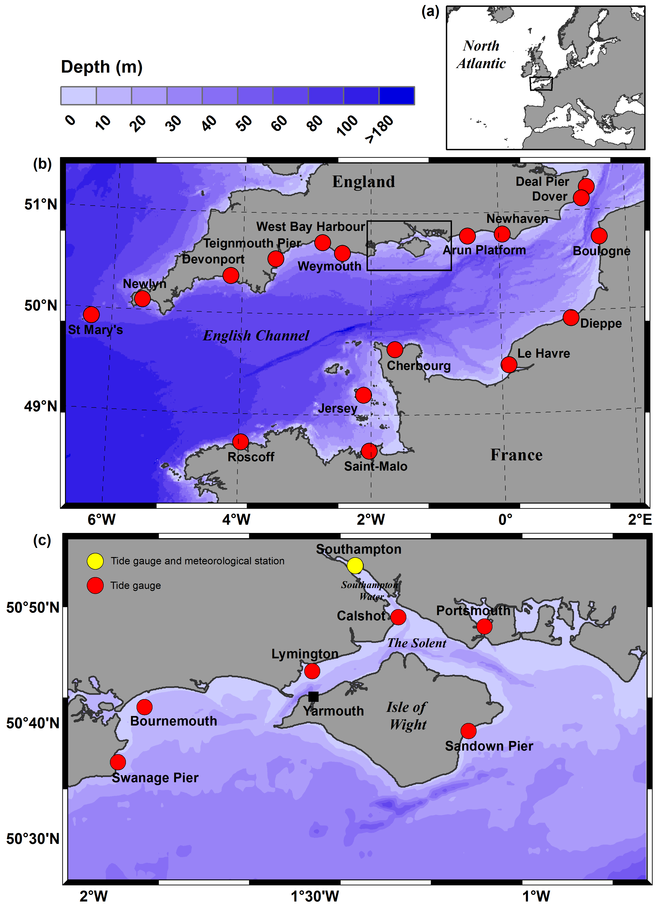
Figure 1 Location and bathymetry of the study area, with locations for tide gauges and the meteorological station, showing: (a) north-west Europe and the North Atlantic, (b) the English Channel region, and (c) the Solent case study area. Depth given in meters below mean sea level.

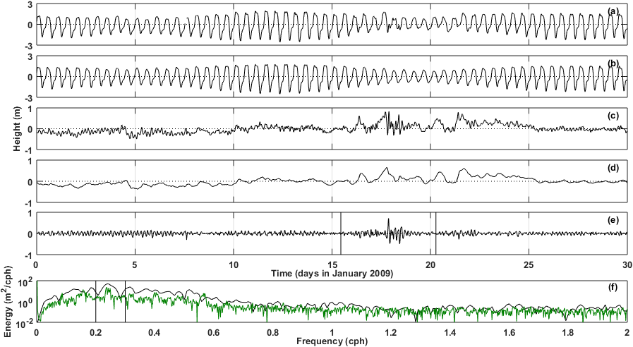
Figure 2 Data reduction procedure and identifying high-frequency variations (example using the Southampton sea level record) with (a) observed sea level, (b) predicted tide, (c) residual sea level, (d) low-frequency (< 12 hour) residual component, (e) high-frequency (< 6 hour) residual component where solid lines indicate a 5-day window span, and (f) energy spectrum for the sample period denoted in e. where solid lines indicate the 0.2-0.3 cph frequency band used to identify high-energy events. Energy spectrum for an equivalent period of calm weather is shown in green.
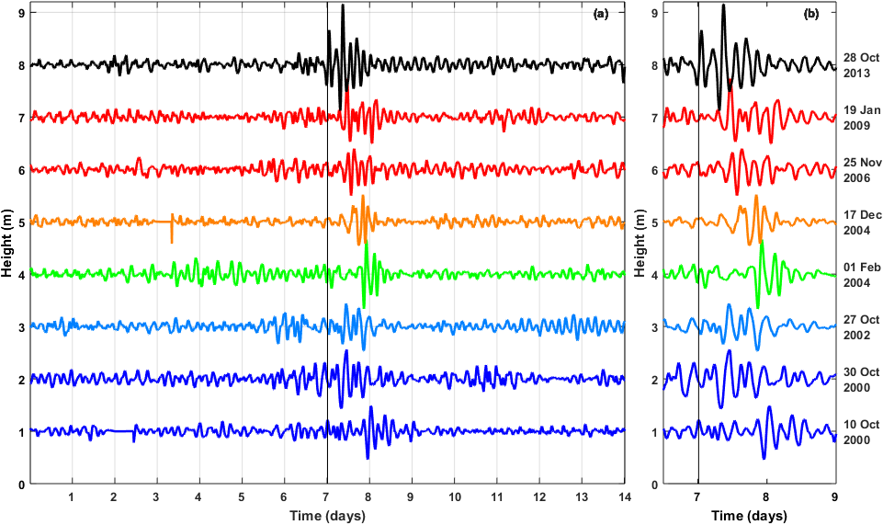
Figure 3 High-frequency (<6 hour) residual sea level components from Southampton (offset by 1 meter for illustration) with (a) 14-day record and, for clarity, (b) 2.5-day record for each of the top 8 highest energy events. Vertical lines indicate 00:00 hours on the date shown.
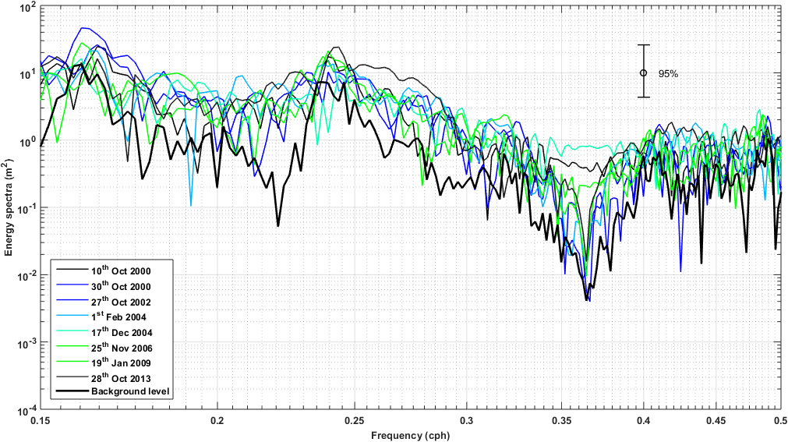Figure 4 Energy spectra for the top 8 highest energy events using the high-frequency (<6 hour) residual sea level component from the Southampton record. Residual time series have been smoothed using window averaging to increase the degrees of freedom. Spectrum for background energy levels during a period of calm weather also given for comparison.
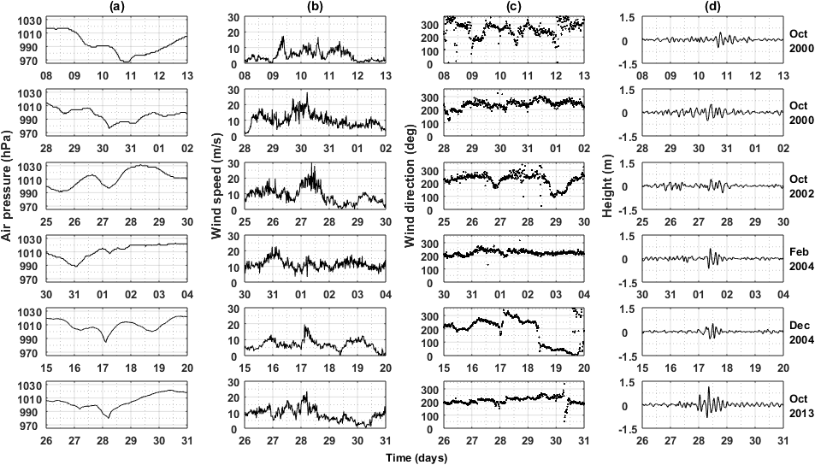Figure 5 Meteorological conditions and high-frequency (<6 hour) residual sea level component for 6 events using observations from Southampton showing: (a) air pressure; (b) wind speed; (c) wind direction; and, (d) high-frequency residual sea level over a 5-day period.
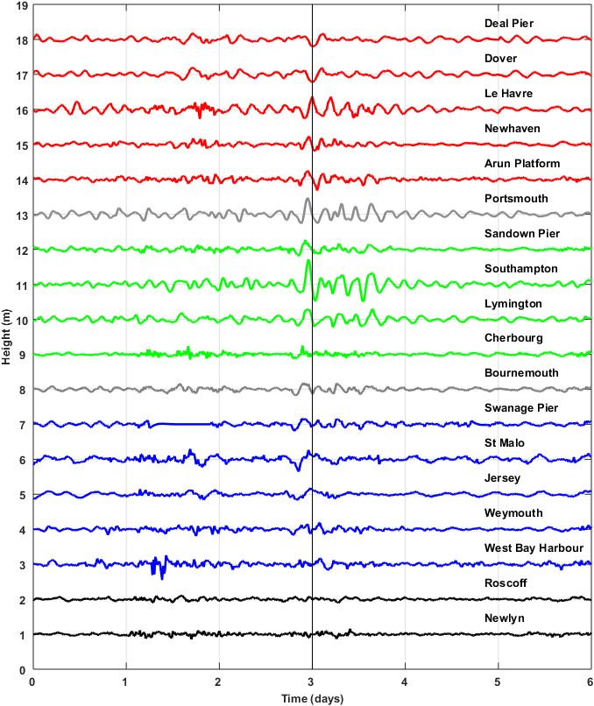
Figure 6 High-frequency (<6 hour) residual sea level components observed at 18 sites around the English Channel region over a 6-day period around the 19th January 2009 (solid line) event. Residuals offset by 1 m for illustration. Refer to Figure 1 for site locations. The color coding indicates the propagation of the surge into the English Channel from Newlyn (west) to Deal Pier (east).
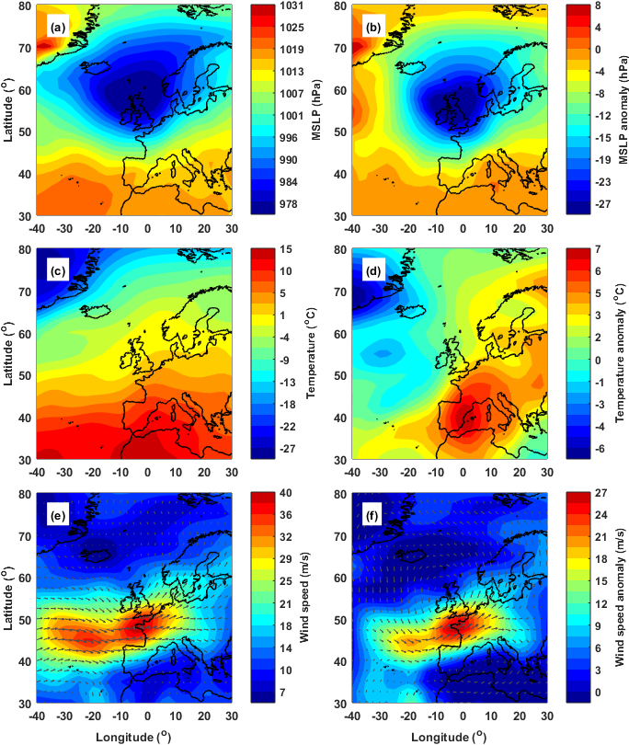
Figure 7 Mean synoptic conditions (left) and mean anomalies (right) for the observed 8 high-frequency events using (a-b) mean sea level pressure, (c-d) temperature (850 hPa), and (e-f) wind speed (500 hPa). Event fields represent conditions closest to the start time of each event, and anomalies were estimated by removing the seasonal signal (estimated as a monthly mean) from the corresponding field. Data was extracted from the NCEP / NCAR 20th Century atmospheric reanalysis, Version 1 (Kalnay et al., 1996).

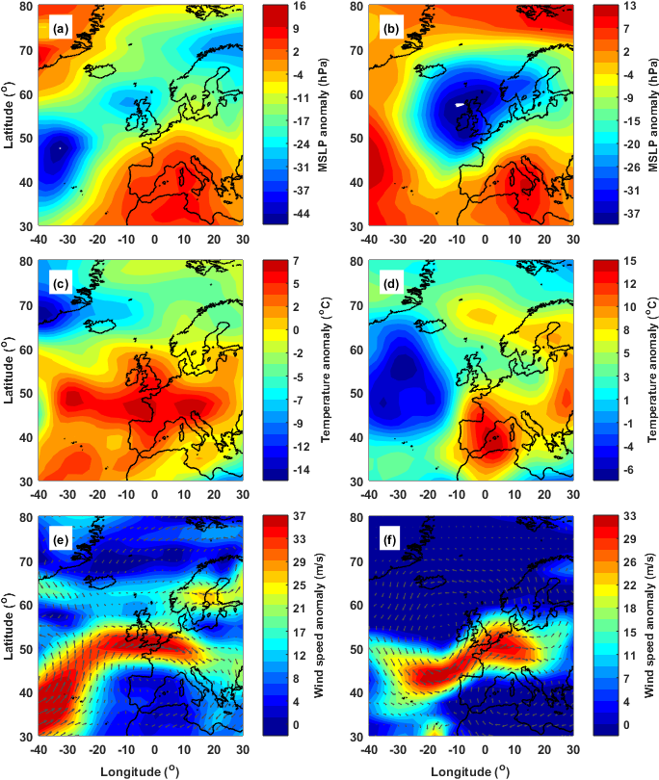
Figure 8 Meteorological anomalies for two high-frequency events: 1st February 2004 at 18:00 (left) and 28th October 2013 at 00:00 (right) using (a-b) mean sea level pressure, (c-d) temperature (850 hPa), and (e-f) wind speed (500 hPa). Anomalies were estimated by removing the seasonal signal (estimated as a monthly mean) from the corresponding field. Data was extracted from the NCEP / NCAR 20th Century atmospheric reanalysis, Version 1 (Kalnay et al., 1996).
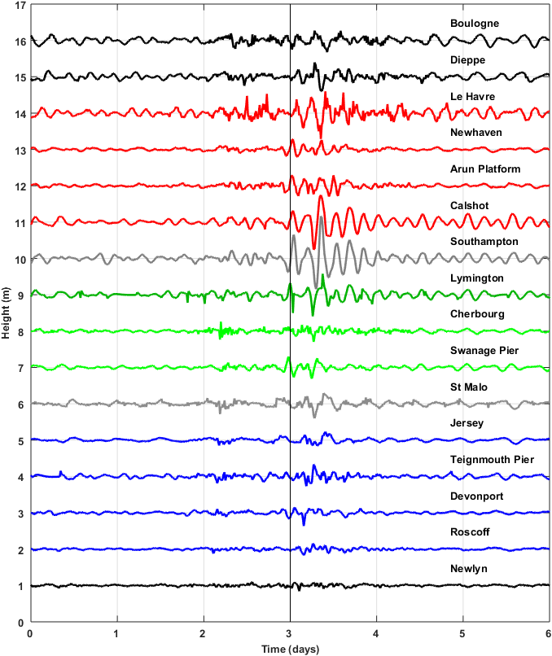
Figure 9 High-frequency (<6 hour) residual sea level components observed at 16 sites around the English Channel region over a 6-day period around the 28^{h} October 2010 (solid line) event. Residuals offset by 1 m for illustration. Refer to Figure 1 for site locations. The color coding indicates the propagation of the surge into the English Channel from Newlyn (west) to Boulogne (east).
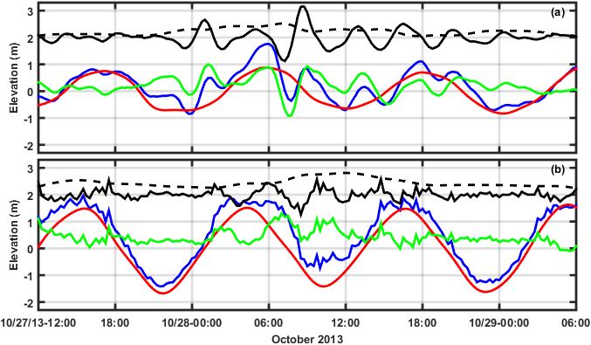
Figure 10 Sea level observations and the individual components from (a) Southampton and (b) Le Havre, showing total sea level (blue), predicted tide (red), residual sea level (green), high-frequency residual (solid black line), and low-frequency residual component (dashed line). The high-frequency and low-frequency residual components have been offset by 2 m for illustration purposes.

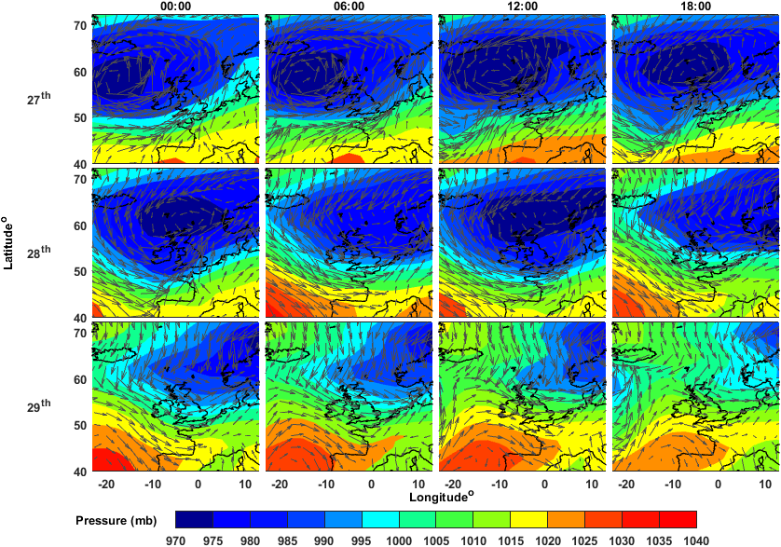
Figure 11 Atmospheric pressure and wind-field from 27th-29th October 2013 extracted from the NCEP / NCAR 20th Century reanalysis, Version 1 (Kalnay et al., 1996).
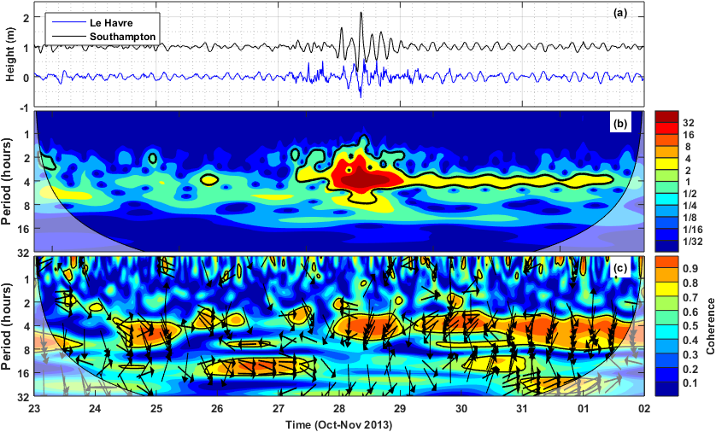
Figure 12 Frequency-power distribution and coherence analysis using high-frequency residual sea level components from the Southampton and Le Havre records (a) over a 10-day period from 23rd Oct. – 2nd Nov 2013 (offset by 1 m for illustration), (b) continuous wavelet transform (Morlet) for the Southampton record, and (c) squared wavelet coherence between the Southampton and Le Havre records. Contours outside the cone of influence (shaded area) indicate the 5% significance level against red noise. The relative phase relationship in c is given by arrows (phase) bearing right (in-phase) to left (anti-phase) (Grinsted et al., 2004).

