Combined Measures of Upper and Lower Body Strength and Subgroup Differences in Subsequent Survival Among the Older Population of England

Introduction
Population aging is typically defined as the change in a small number of quantities, such as the old age dependency ratio, the proportion of the population who are defined as old (often 60+ or 65+ years old), and the median age of the population. Estimates of these quantities and others have been published by the United Nations, for all countries at 5-year intervals, using estimates for the period 1950-2010 and projections from 2015-2100 (United Nations, 2013). Those figures provide the basis of hundreds of analyses and discussions of population aging. Nevertheless, these commonly used numbers provide a misleading and incomplete picture of population aging.

The traditional measures of population aging produce a misleading picture of population aging because of two reasons. First, they do not take differences in the age-specific characteristics of people into account. 65 year olds, for example, in 2050 will not be like 65 year olds in 2000. The life expectancy of older people has been increasing in most countries of the world (United Nations, 2015). Age-specific measures of physical and mental capacity have been increasing (Bordone, Scherbov, & Steiber, 2014; Christensen, Doblhammer, Rau, & Vaupel, 2009; Vaupel, 2010). By utilizing only a single characteristic of people, their chronological age, traditional measures ignore all those improvements and therefore disregard many changes that are important for the study of population aging.

In a number of papers, Sanderson and Scherbov have argued that if one were limited to choosing a single characteristic to summarize dimensions of aging, it would not be chronological age, but rather remaining life expectancy (Sanderson & Scherbov, 2005, 2008b, 2010, 2013). Remaining life expectancy is more highly related to how well people function both physically and cognitively than is chronological age when looking across countries and over time. Measures of population aging analogous to those produced by the United Nations using ages based on remaining life expectancy have been published and show a very different picture of population aging than the traditional measures (Sanderson & Scherbov, 2008a; Scherbov & Sanderson, 2014).

The second problem with the traditional approach to the measurement of population aging is its incompleteness. Population aging is inherently a multidimensional phenomenon. Taking this multidimensionality into account requires a methodology which recognizes and quantifies multiple aspects of aging and allows measures to be combined and analyzed within a unified framework. The traditional approach does not do this.

Sanderson and Scherbov (2013)provide a framework in which population aging can be studied on the basis of age-specific characteristics of people that can vary over time and space. It allows population aging to be studied in a multidimensional framework and for characteristics of people that are measured in different units to be transformed into a common unit, comparable years of age, called “alpha-ages”. This paper is the first attempt at applying the Sanderson and Scherbov (2013) approach in a multidimensional context.

This paper is organized as follows. In the second section, we provide a brief description of the Sanderson and Scherbov (2013) framework and show how comparable alpha-ages can be computed for characteristics of people measured in different metrics. In section 3, we provide an application of the framework using data from the English Longitudinal Study of Ageing (ELSA) (The Institute for Fiscal Studies, 2012). In particular, we compute alpha-age differentials across educational subgroups using hand-grip strength as a measure of upper body strength and chair rise speed as a measure of lower body strength. The literature shows that both are predictive of subsequent mortality (Cooper et al., 2011; Cooper, Strand, Hardy, Patel, & Kuh, 2014; Hurst et al., 2013). In section 4, we present the results of the analysis. There, we compute alpha-age differentials in subsequent survival rates for the same subgroups and show that the average of the alpha-age differentials using measures of hand-grip strength and chair rise speed predicts the subgroup differential in subsequent survival almost exactly. The advantage of combining characteristics is that the average of the two measures predicts the subgroup differential in survival better than either taken separately. Section 5 contains a concluding discussion.

The Characteristics Approach Framework
In this section, we show how alpha-ages can be computed from information on a variety of characteristics, even though those characteristics are measured in different units. Alpha-ages are constant characteristic ages. People with the same alpha-age share the same level of the characteristic. The basic element of the framework is a characteristic schedule, C(.) that maps chronological ages into levels of a specific characteristic.
, (1)
where k is the level of a characteristic, such as hand-grip strength, observed at age a in characteristic schedule r.

The index r may refer to different populations in time and space or to population subgroups. In other words, the index r is a short-hand way of referring to the group of people for whom the characteristic is measured. For example, a characteristic schedule r could refer to women 60 to 85 years old observed in the 2004 wave of ELSA who have completed upper secondary education. Another characteristic schedule, s, could refer to 60-85 year old women observed in the 2004 wave of ELSA who have not completed upper secondary education.

If the characteristic schedule is monotonic and invertible, alpha-ages can be derived from the equation
, (2)
where 𝛼 is the alpha-age corresponding to chronological age a in characteristic schedule r, using characteristic schedule s as a standard. In other words, an alpha-age is a chronological age in the standard schedule s where people have the same level of the characteristic as they have at chronological age a in schedule r.
Table 1 shows an example of how alpha-ages are computed.
Table 1 shows that people at age 65 have characteristic level 100 in schedule r. The table also shows that in the standard schedule s people have that same level of characteristic (100) at age 60. So 60 is the alpha-age of people of age 65 in schedule r using schedule s as a standard.

An important feature of the characteristics approach is that different characteristics measured in different units can all be translated into a common metric, alpha-age.

Measuring Hand-grip Strength and Chair Rise Speed Using Alpha-Ages

Measures
The physical measures in ELSA were taken during a nurse visit. For the chair rise test participants aged at least 60 years had to rise 5 times from a chair as fast as possible, without using their arms. In our analysis we are interested in the speed of chair rise, therefore we convert the variable into chair rises per minute. Hand grip strength was measured in kg by using a dynamometer. Participants performed the test twice on each hand and the maximum measure was taken. In addition to demographic details such as age, participants provided their highest completed education using one out of seven categories ranging between no qualification and higher education with a degree. We coded the seven categories into more educated (nvq2/gce or higher) and less educated (no qualification or nvq1/cse).

Data
Starting in 2002, the English Longitudinal Study of Ageing (ELSA) used a multistage, clustered, stratified sampling strategy to draw a sample with individuals aged at least 50 years and living in private households in England. The participants were followed and re-interviewed every second year (Banks, Breeze, Lessof, & Nazroo, 2006). Data were collected within a face-to-face interview using CAPI (computer-assisted personal interview) and a self-completion questionnaire. In addition, there was a nurse visit every second wave starting in 2004 to measure physical functioning (e.g., hand-grip strength and chair rise speed) and to take blood samples as well as collecting anthropometric measurements (e.g. height, weight).

For the purpose of our study, we restrict the data to people aged between 60 and 85 years, who participated in the nurse interview in the second wave (i.e. 2004) and whose living status (i.e. deceased or alive) was tracked until February 1, 2012. Only non-institutionalized older adults with complete data on individual education and survival information in 2012 are included in our study. The resulting sample was comprised of 4,520 older adults (2,143 men and 2,377 women) with an average age of 70.2 (see Table 2 for descriptive details by education and sex). The measures chair rise, grip strength, and anthropometric measures (e.g. height and weight) include missing values (chair rise: 18.5%, grip strength 1.7%, height 4.5%, weight 3.7%) due to nonresponse or refusal to participate, which are excluded from the analysis wherever necessary.

Mean hand-grip strengths by education for people 60-85 years old are shown in Figure 1. Comparable data for chair rise speed are shown in Figure 2.

Computing Characteristic Schedules
We computed characteristic schedules for hand-grip strength and chair rise speed separately for men and women using truncated regression models (Amemiya, 1973). We treated observations in the physical performance tests below the 1st percentile as outliers and coded them as missing. The resulting truncation points were 8kg for hand grip strength and 11 rises/min for chair rise. Tables 3 through 6 report the results of the truncated regressions. We tested for nonlinearity of the characteristic schedules in age by adding age-squared terms, but those terms were always statistically insignificant and insignificant in magnitude. We also tested alternative specifications in which separate truncated regressions were run for each education group. The coefficients of age were essentially the same when the education subgroups were run separately as they are in the regressions below. Intercept terms adjusted for subgroup differences in height, weight and level of education were also almost identical. We tried including height in the regressions for chair rise speed, but it was never statistically significant.

Computing Alpha-Ages
For each characteristic, hand-grip strength and chair rise speed, we obtained four characteristic schedules, two for gender and two for level of education. They are all linear in age. The computation of alpha-ages requires two characteristic schedules, the index schedule r and the standard schedule s. Here we have chosen the index schedule to refer to people with more education and the reference standard schedule to refer to people with less education. So for each characteristic, we can compute two alpha-ages, one for each gender. These alpha-ages show the effects of educational differences.

For example, let us consider the computation of the alpha-age for women for the characteristic hand-grip strength. The computation of alpha-ages begins with the selection of a chronological age in the characteristic schedule r and determining the associated level of the characteristic. From Table 5, we can see that the average hand-grip strength of women of age a with more education, , can be expressed as:
, (3)
where weight and height are the average values for women of age a, and 1.16 is the coefficient of the dummy variable indicating that this is the characteristic schedule for more educated women. Alpha-ages are constant characteristic ages. They are determined as the age in the standard schedule where the level of the characteristic is the same as the level at a particular age in the index schedule. Substituting α for a in the characteristic schedule for the less educated women, we obtain:
. (4)
Equating the levels of the characteristic yields the equation:
(5)
Holding weight and height constant, this simplifies to:
. (6)
Therefore, in the specifications we have used for the characteristic schedules, the difference between the alpha-age and the chronological age is constant. In this example, more educated women have the same average hand-grip strength as less educated women who were 4 years younger.

The differences between alpha-ages and chronological ages, using the characteristic schedules of less educated people as standards are presented in Table 7.

As described above, hand-grip strength is measured in kilograms and chair rise speed is measured in the number of chair rises per minute. In Table 7, differences in those measures across educational subgroups are translated into a common metric, years of age. We see, for example, that more educated women have average hand-grip strength of less educated women who are 4.0 years younger than they are and that they have chair rise speeds that are the same as women 3.2 years younger. Differences across educational subgroups in alpha-ages based on hand-grip strength have been also studied using US data (Sanderson & Scherbov, 2014), where it was also found that hand-grips strengths of more educated women were stronger than those for less educated women, holding age constant.

Hand-grip strength, Chair Rise Speed and Subsequent Survival
In the last section, we showed how two characteristics that are measured in different units can be expressed in a common metric. In this section, we investigate whether having multiple measures of subgroup differences in aging has an advantage in forecasting subsequent subgroup differences in survival. It is well-known that hand-grip strength, controlling for age and other covariates, is a predictor of subsequent mortality (Al Snih, Markides, Ray, Ostir, & Goodwin, 2002; Cooper et al., 2014; Innes, 1999; Koopman, van Bodegom, van Heemst, & Westendorp, 2015; Ling et al., 2010; Rantanen et al., 2003). The relationship between chair rise speed and subsequent mortality has been less frequently studied, but the literature is consistent in finding that various measures of lower body strength are also predictors of subsequent mortality (Cooper et al., 2014; Graham et al., 2009; Ostir, Kuo, Berges, Markides, & Ottenbacher, 2007; Studenski, Perera, Patel, & al, 2011). In this section, we show that having two consistently measured characteristics of aging are better than just having either one alone in forecasting subsequent subgroup differences in survival.

Age-specific probabilities of survival are a characteristic of people, just like their average hand-grip strength and their average chair rise speed, and so education differentials in alpha-ages based on survival rates can be calculated using the same methodology that we employed above. Hand-grip strengths and chair rise speeds were measured in 2004. To test how well subgroup differences in those measures predicted subsequent subgroup differences in survival, we computed characteristic schedules from ELSA based on age-specific proportions of people who survived the entire period from 2004 to 2012.

From ELSA, we only had information about whether or not a person was alive on February 1, 2012, not the person’s exact date of death within the period 2004-2012. Therefore, the available data are interval-censored. Prentice and Gloeckler (1978) showed that if the interval-censored data were generated with a continuous-time proportional hazards model, the resulting censored data would be distributed according to complementary log-log model with binary outcomes. The complementary log-log specification is:
, (7)
where is the probability of person I dying between 2004 and 2012, is a vector of covariates and is a vector of coefficients. Alternatively, equation (7) can be rewritten as:
. (8)
We estimated the coefficients using maximum likelihood based on the survival observations. The results are shown in Tables 8 and 9.

We tested whether there was an age-education interaction in the specifications for women and for men, and found that it was not statistically significant. For simplicity and comparability with our results on hand-grip strength, we use a specification where the complementary log-log function is linear in age.

The calculation of alpha-ages proceeds as above. Equating the probability of survival from 2004 to 2012 is equivalent to equating the terms on the left-hand side of equation 8. So, in equating those terms for the two education subgroups, we obtain:
, and
(9)
Although hand-grip strength in 2004, chair rise speed in 2004, and the probability of surviving from 2004 to 2012 are measured in different metrics, we can translate them all into comparable alpha-ages. We do this in Table 10, where we expand Table 7 adding the education differentials in subsequent survival measured in alpha-ages. In absolute value, the educational differential for women measured using hand grip strength is larger than the differential in subsequent survival, and the differential using chair rise speed is smaller. Those differences for men are the reverse.

Table 10 suggests that a better predictor of educational differences in subsequent survival could be obtained by averaging the differentials measured for hand-grip strength and chair rise speed. For women the average of those figures is -3.6 years, exactly the result for subsequent survival. For men, the average is 4.4 years, which is closer to the difference in subsequent survival than for either of the two measurements taken separately.

To investigate the advantage of combining characteristics further, we repeated Table 10 1,000 times using bootstrap samples from the data with replacement. Tables 11 and 12 show the 5th, 50th, and 95th percentile of alpha ages and the 5th, 50th, and 95th percentile of differences in alpha ages (mean physical performance – survival), respectively, by sex obtained from 1,000 data simulations with replacement.

The median of the distributions of the educational differentials for women and men are almost exactly the same for subsequent survival as they are for the average of the educational differentials using the two physical characteristics. The median educational differential based on the average of the characteristics predicts the median educational differential in subsequent survival better than the median educational differential in either characteristic taken separately.

In this paper, we used unweighted data. Therefore, the educational differentials presented here should not be interpreted as average differentials for all of England.

Discussion
Discussions of population aging have focused on a single characteristic of people, their chronological age. This is misleading because characteristics relevant for the study of population aging are different from place to place and change over time. Discussions of the extent of this mismeasurement and its implications appear elsewhere (Sanderson & Scherbov, 2008b, 2010, 2013, 2015a, 2015b). Not only are conventional measures of population aging inaccurate, they are also incomplete, because no single characteristic can fully encapsulate the many ways in which populations can age. In this article, we have demonstrated a methodology, based on alpha-ages, for measuring otherwise incommensurate dimensions of population aging in the same units. Using data from ELSA, we measured differences in handgrip-strength, chair rise speed, and subsequent survival across educational subgroups. We showed that the median of averages of the educational differentials for hand-grip strength and chair rise speed corresponded very closely to the median of educational differentials in subsequent survival. The paper provides an example of what could be done when characteristics are combined using alpha-ages. The same methodology can be used to study combinations of many characteristics.

In the past, there were few characteristics that could be used to study population aging. Most data came from censuses. But the situation is different now. Large scale longitudinal studies of aging currently cover more than half of the world’s population. These surveys, like ELSA, contain information on many important aspects of aging. It is now time to broaden our perspective and to make use of the new multidimensional data on population aging that are available.

References
Al Snih, S., Markides, K. S., Ray, L., Ostir, G. V., & Goodwin, J. S. (2002). Handgrip strength and mortality in older Mexican Americans. Journal of the American Geriatrics Society, 50(7), 1250–1256. http://doi.org/10.1046/j.1532-5415.2002.50312.x
Amemiya, T. (1973). Regression analysis when the dependent variable is truncated normal. Econometrica, 41(6), 997–1016. http://doi.org/10.2307/1914031
Banks, J., Breeze, E., Lessof, C., & Nazroo, J. (Eds.). (2006). Retirement, health and relationships of the older population in England: the 2004 English Longitudinal Study of Ageing. London: The Institute for Fiscal Studies.
Bordone, V., Scherbov, S., & Steiber, N. (2014). Is population ageing decelerating in terms of cognition? (Interim Report No. IR-14-015). Laxenburg, Austria: International Institute for Applied Systems Analysis. Retrieved from http://www.iiasa.ac.at/publication/more_IR-14-015.php
Christensen, K., Doblhammer, G., Rau, R., & Vaupel, J. W. (2009). Ageing populations: the challenges ahead. The Lancet, 374(9696), 1196–1208. http://doi.org/10.1016/S0140-6736(09)61460-4
Cooper, R., Hardy, R., Aihie Sayer, A., Ben-Shlomo, Y., Birnie, K., Cooper, C., … on behalf of the HALCyon study team. (2011). Age and gender differences in physical capability levels from mid-life onwards: The harmonisation and meta-analysis of data from eight UK cohort studies. PLoS ONE, 6(11), e27899. http://doi.org/10.1371/journal.pone.0027899
Cooper, R., Strand, B. H., Hardy, R., Patel, K. V., & Kuh, D. (2014). Physical capability in mid-life and survival over 13 years of follow-up: British birth cohort study. British Medical Journal, 348, g2219. http://doi.org/10.1136/bmj.g2219
Graham, J. E., Snih, S. A., Berges, I. M., Ray, L. A., Markides, K. S., & Ottenbacher, K. J. (2009). Frailty and 10-year mortality in community-living Mexican American older adults. Gerontology, 55(6), 644–651.
Hurst, L., Stafford, M., Cooper, R., Hardy, R., Richards, M., & Kuh, D. (2013). Lifetime socioeconomic inequalities in physical and cognitive aging. American Journal of Public Health, 103(9), 1641–1648. http://doi.org/10.2105/AJPH.2013.301240
Innes, E. (1999). Handgrip strength testing: A review of the literature. Australian Occupational Therapy Journal, 46(3), 120–140. http://doi.org/10.1046/j.1440-1630.1999.00182.x
Koopman, J. J. E., van Bodegom, D., van Heemst, D., & Westendorp, R. G. J. (2015). Handgrip strength, ageing and mortality in rural Africa. Age and Ageing, 44(3), 465–470. http://doi.org/10.1093/ageing/afu165
Ling, C. H. Y., Taekema, D., Craen, A. J. M. de, Gussekloo, J., Westendorp, R. G. J., & Maier, A. B. (2010). Handgrip strength and mortality in the oldest old population: the Leiden 85-plus study. Canadian Medical Association Journal, 182(5), 429–435. http://doi.org/10.1503/cmaj.091278
Ostir, G. V., Kuo, Y.-F., Berges, I. M., Markides, K. S., & Ottenbacher, K. J. (2007). Measures of lower body function and risk of mortality over 7 years of follow-up. American Journal of Epidemiology, 166(5), 599–605. http://doi.org/10.1093/aje/kwm121
Prentice, R. L., & Gloeckler, L. A. (1978). Regression analysis of grouped survival data with application to breast cancer data. Biometrics, 34(1), 57–67. http://doi.org/10.2307/2529588
Rantanen, T., Volpato, S., Luigi Ferrucci, M., Eino Heikkinen, M., Fried, L. P., & Guralnik, J. M. (2003). Handgrip Strength and Cause-Specific and Total Mortality in Older Disabled Women: Exploring the Mechanism. Journal of the American Geriatrics Society, 51(5), 636–641. http://doi.org/10.1034/j.1600-0579.2003.00207.x
Sanderson, W. C., & Scherbov, S. (2005). Average remaining lifetimes can increase as human populations age. Nature, 435(7043), 811–813. http://doi.org/10.1038/nature03593
Sanderson, W. C., & Scherbov, S. (2008a). Conventional and Prospective Measures of Population Aging, 1995, 2005, 2025, 2045. Population Reference Bureau. Retrieved from http://www.prb.org/excel08/age-ageing_table.xls
Sanderson, W. C., & Scherbov, S. (2008b). Rethinking age and aging. Washington, D.C.: Population Reference Bureau. Retrieved from http://www.prb.org/pdf08/63.4aging.pdf
Sanderson, W. C., & Scherbov, S. (2010). Remeasuring aging. Science, 329(5997), 1287–1288. http://doi.org/10.1126/science.1193647
Sanderson, W. C., & Scherbov, S. (2013). The characteristics approach to the measurement of population aging. Population and Development Review, 39(4), 673–685. http://doi.org/10.1111/j.1728-4457.2013.00633.x
Sanderson, W. C., & Scherbov, S. (2014). Measuring the speed of aging across population subgroups. PLoS ONE, 9(5), e96289. http://doi.org/10.1371/journal.pone.0096289
Sanderson, W. C., & Scherbov, S. (2015a). Are we overly dependent on conventional dependency ratios? Population and Development Review, 41(4), 687–708. http://doi.org/10.1111/j.1728-4457.2015.00091.x
Sanderson, W. C., & Scherbov, S. (2015b). Faster increases in human life expectancy could lead to slower population aging. PLoS ONE, 10(4), e0121922. http://doi.org/10.1371/journal.pone.0121922
Scherbov, S., & Sanderson, W. C. (2014). Prospective Measures of Population Aging: Version 1.0, June, 2014. Retrieved from www.reaging.org/indicators
Studenski, S., Perera, S., Patel, K., & al, et. (2011). Gait speed and survival in older adults. JAMA, 305(1), 50–58. http://doi.org/10.1001/jama.2010.1923
The Institute for Fiscal Studies. (2012). English Longitudinal Study of Ageing (ELSA). London: NatCen Social Research, University College London and Institute for Fiscal Studies. Retrieved from http://www.ifs.org.uk/ELSA
United Nations. (2013). World Population Ageing 2013 (No. ST/ESA/SER.A/348). New York, USA: Department of Economic and Social Affairs, Population Division. Retrieved from http://www.un.org/en/development/desa/population/publications/pdf/ageing/WorldPopulationAgeing2013.pdf
United Nations. (2015). World Population Prospects: The 2015 Revision. New York, NY: Department of Economic and Social Affairs, Population Division. Retrieved from http://esa.un.org/unpd/wpp/
Vaupel, J. W. (2010). Biodemography of human ageing. Nature, 464(7288), 536–542. http://doi.org/10.1038/nature08984

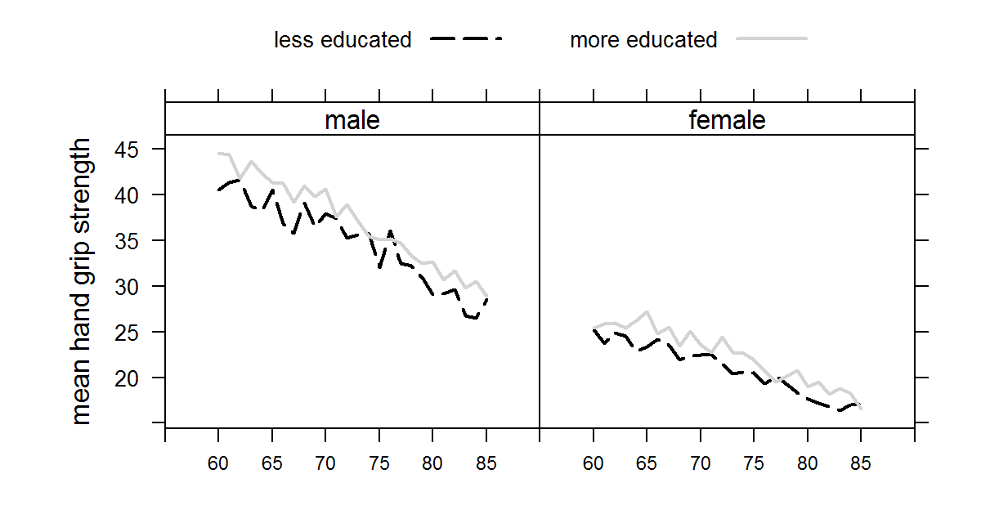
Figure 1: Mean hand grip strength by education of English males and females aged between 60 and 85 years in our sample

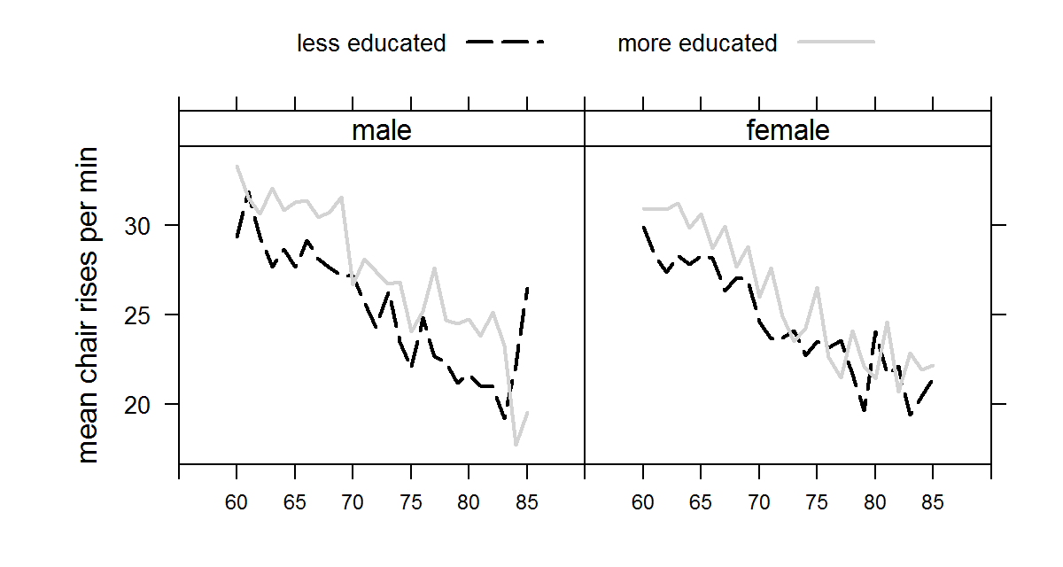
Figure 2: Mean chair rises per minute by education of English males and females aged between 60 and 85 years in our sample

Table 1: An Example of the Computation of an alpha-age
Characteristic Schedule r |  | Characteristic Schedule s
Age | Characteristic Level | Characteristic Level | Age
65 | 100 | 100 | 60

Table 2: Descriptive statistics (mean and standard deviation in brackets) of age, the physical performance measures hand grip strength and chair rise per minute, and proportion surviving from 2004 to 2012 by sex and education
 | males |  | females
 | less educated | more educated | less educated | more educated
age | 71.2 (6.8) | 68.8 (6.6) | 72.8 (7.1) | 68.6 (6.8)
grip strength | 35.5 (9.1) | 39.3 (8. 7) | 21.2 (5.9) | 23.9 (5.9)
chair rise/min | 25.8 (8.3) | 29.2 (9.3) | 25.1 (8.2) | 28.1 (8.9)
alive in 2012 | 71.9% | 83.9% | 79.7% | 89.7%
sample size | 1,046 | 1,097 | 1,359 | 1,018

Table 3: Results from truncated regression (truncation point 11) for women's chair rise
 | estimate | S.E. | t-value | Pr(>|t|)
intercept | 39.37 | 1.33 | 29.51 | < 2.2e-16 | ***
age | -0.56 | 0.04 | -15.42 | < 2.2e-16 | ***
more educated | 1.71 | 0.45 | 3.8 | 1.5E-04 | ***
weight | -0.13 | 0.02 | -7.75 | 9.10E-15 | ***
sigma | 8.63 | 0.19 | 46.06 | < 2.2e-16 | ***
Note: * p<0.05; ** p<0.01; *** p<0.001.

Table 4: Results from truncated regression (truncation point 11) for men's chair rise
 | estimate | S.E. | t-value | Pr(>|t|)
intercept | 39.45 | 1.75 | 22.59 | < 2.2e-16 | ***
age | -0.56 | 0.04 | -13.88 | < 2.2e-16 | ***
more educated | 2.94 | 0.50 | 5.88 | 4.19E-09 | ***
weight | -0.11 | 0.02 | -5.59 | 2.22E-08 | ***
sigma | 9.18 | 0.20 | 44. | < 2.2e-16 | ***
Note: * p<0.05; ** p<0.01; *** p<0.001.

Table 5: Results from truncated regression (truncation point 8) for women's hand grip strength
 | estimate | S.E. | t-value | Pr(>|t|)
intercept | -7.01 | 2.90 | -2.42 | 1.56E-02 | *
age | -0.29 | 0.02 | -17.66 | < 2.2e-16 | ***
more educated | 1.16 | 0.22 | 5.19 | 2.12E-07 | ***
weight | 0.02 | 0.01 | 2.33 | 1.98E-02 | *
height | 19.42 | 1.89 | 10.29 | < 2.2e-16 | ***
sigma | 4.89 | 0.08 | 62.35 | < 2.2e-16 | ***
Note: * p<0.05; ** p<0.01; *** p<0.001.

Table 6: Results from truncated regression (truncation point 8) for men's hand grip strength
 | estimate | S.E. | t-value | Pr(>|t|)
intercept | -11.42 | 4.45 | -2.57 | 1.02E-02 | *
age | -0.49 | 0.03 | -19.25 | < 2.2e-16 | ***
more educated | 1.72 | 0.34 | 5.11 | 3.20E-07 | ***
weight | 0.07 | 0.01 | 4.75 | 2.03E-06 | ***
height | 27.75 | 2.79 | 9.96 | < 2.2e-16 | ***
sigma | 7.23 | 0.12 | 62.83 | < 2.2e-16 | ***
Note: * p<0.05; ** p<0.01; *** p<0.001.
In Tables 3 through 6, the variable “age” is measured as chronological age minus 60,

Table 7: Alpha-age minus chronological age (see equation 6). r is the characteristic schedule for more educated people and s is the characteristic schedule for those with less education (see equation 2)
 | Women | Men
Hand-grip strength | -4.0 years | -3.5 years
Chair rise speed | -3.2 years | -5.2 years

Table 8: coefficients for women. The variable “age” is coded as age-60.
 | Estimate | S.E. | z value | Pr(>|z|)
Intercept | 1.22 | 0.06 | 19.82 | < 2e-16 | ***
age | -0.06 | 0.00 | -14.34 | < 2e-16 | ***
more educated | 0.21 | 0.06 | 3.71 | 0.00 | ***
Note: * p<0.05; ** p<0.01; *** p<0.001.

Table 9: coefficients for men. The variable “age” is coded as age-60.
 | Estimate | S.E. | z value | Pr(>|z|)
Intercept | 0.98027 | 0.063002 | 15.559 | < 2e-16 | ***
age | -0.06435 | 0.004499 | -14.303 | < 2e-16 | ***
more educated | 0.261941 | 0.057527 | 4.553 | 5.28E-06 | ***
Note: * p<0.05; ** p<0.01; *** p<0.001.

Table 10: Alpha-age minus chronological age (see equations 6 and 9)
 | Women | Men
Hand-grip strength | -4.0 years | -3.5 years
Chair rise speed | -3.2 years | -5.2 years
Subsequent Survival (2004-12) | -3.6 years | -4.1 years

Table 11: 5th, 50th, and 95th percentile of subgroup differences by sex measured in alpha ages, computed from 1,000 replications of Table 10, randomly selecting observations from the dataset with replacement.
 | males |  |  | females
 | 5th percentile | median | 95th percentile | 5th percentile | median | 95th percentile
grip strength | 2.4 | 3.5 | 4.7 | 2.6 | 4.0 | 5.4
chair rise | 3.7 | 5.3 | 7.0 | 1.7 | 3.2 | 4.8
survival | 2.5 | 4.1 | 5.8 | 2.0 | 3.6 | 5.5
average of hand-grip and chair rise | 3.4 | 4.1 | 5.5 | 2.5 | 3.6 | 4.8

