Enhanced Electro-Optic response in Domain-Engineered LiNbO₃ Channel Waveguides

G. Zisis,¹ C. Y. J. Ying,¹ P. Ganguly,² C. L. Sones,¹ E. Soergel,³ R. W. Eason¹, and S. Mailis¹

1. Optoelectronics Research Centre, University of Southampton, Highfield, Southampton, SO17 1BJ, UK
2. Advanced Technology Development Centre, Indian Institute of Technology, Kharagpur 721302, India
3. Institute of Physics, University of Bonn, Wegelerstr. 8, 53115 Bonn, Germany
sm@orc.soton.ac.uk

Abstract: Substantial enhancement (36.7%) of the intrinsic electro-optic coefficient ($r_{33})$has been observed in lithium niobate channel waveguides, which are made to overlap with a pole-inhibited ferroelectric domain. The waveguide and the overlapping ferroelectric domain are both produced by a single UV irradiation process and are thus self-aligning. The enhancement of the electro-optic coefficient effect is attributed to strain, which is associated with the ferroelectric domain boundaries that contain the channel waveguide.

Introduction

Lithium niobate (LN) is a well-known electro-optic and nonlinear material, widely used by the photonics industry primarily for the fabrication of optical modulators used in optical telecommunications and for nonlinear frequency conversion. The ferroelectric nature of LN allows for quasi-phase-matched nonlinear processes that utilize the large d₃₃ nonlinear coefficient, which can be achieved by periodic domain inversion [1,2]. Ferroelectric domain engineering has also been used to improve the performance of integrated electro-optic modulators and to limit the photorefractive damage that can occur in such devices [3]. Local domain inversion can be achieved by spatial modulation of an externally applied electric field, which can lead to local domain inversion that occurs when the amplitude of the local electric field exceeds the value of the coercive field (which is required to invert the polarity). Alternatively, spatially resolved domain inversion can be achieved by spatial modulation of the coercive field, which can be achieved by local changes of the crystal stoichiometry [4], [5].
Local change in the stoichiometry of the crystal can also be achieved by laser annealing using UV laser irradiation. Exposure of the crystal to intense UV laser radiation that is strongly absorbed by the crystal produces steep temperature gradients that affect the local concentration of lithium ions. The local modification of the lithium ion concentration changes i) the local refractive index, leading to waveguide formation [6], [7] and ii) the local coercive field, leading to spatially selective domain inversion by direct poling [8] when the irradiation occurs on the –z face or suppression of poling, also known as poling inhibition (PI), when laser irradiation occurs on the +z face [9]. A schematic illustration of the UV laser-induced waveguide formation and poling inhibition process is shown in Fig. 1. It is possible therefore to obtain a structure that consists of a channel waveguide that is collinear, and significantly overlaps a PI ferroelectric domain where both ferroelectric domain and waveguide are defined by the redistribution of lithium ions caused by the UV laser irradiation step.
Here we present experimental observations suggesting that light propagating in a photonic structure that consists of a channel waveguide overlapping a ferroelectric domain experiences a significantly larger electro-optic phase shift as compared to the intrinsic EO response of the bulk crystal. In our structures we measured electro-optic responses that correspond to a 36.7 % increase of the $r_{33}$ electro-optic coefficient. This enhanced EO response is attributed to the unique features of this composite photonic structure where, by virtue of the fabrication method, the optical mode of the channel waveguide overlaps with the PI ferroelectric domain throughout the length of the device. We attribute the observed enhancement of the electro-optic coefficient to the relatively long range (~several μm) strain that is associated with the presence of the domain walls, which have also been reported to locally modify the linear refractive index of the crystal [10].
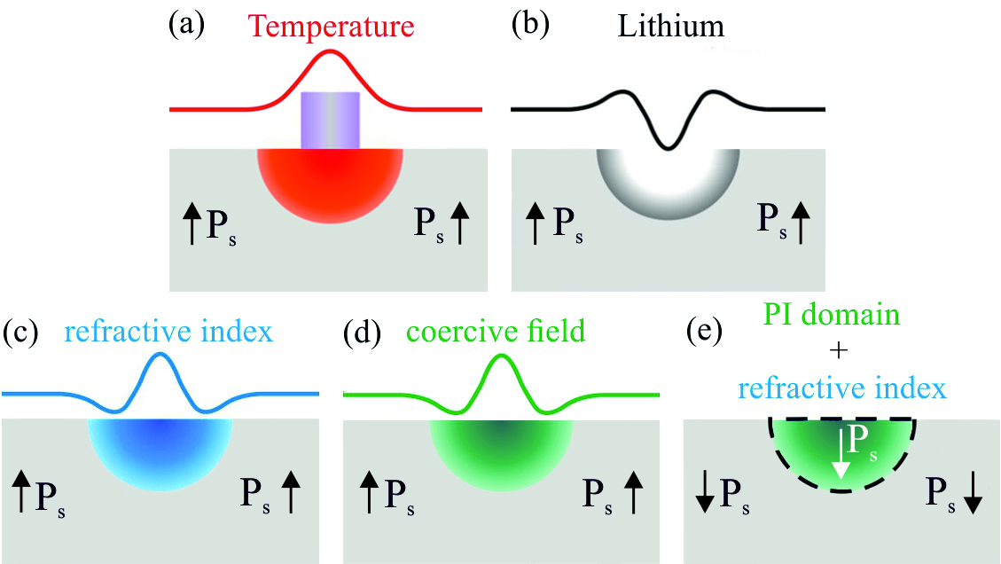
Fig. 1 Processes involved in the production of a channel waveguide overlapping a PI domain (the arrows indicate the direction of spontaneous polarization, P_{s}, in each section) : a) UV-irradiation of the +z face and formation of temperature gradient (red region), b) lithium ion re-distribution, c) refractive index (n_{e}) profile corresponding to lithium distribution profile, d) coercive field profile corresponding to lithium distribution profile and e) resulting waveguide/domain composite. The lateral distribution curves for temperature, lithium concentration, refractive index and coercive field that appear on top of each image are for illustration purpose only and are not accurate.
It is possible to fabricate optical waveguides by direct UV laser writing using a wide range of wavelengths, provided that there is strong absorption [11]. Here, we have used 244 nm from a frequency doubled argon ion laser focussed to a spot size of ~ 4 μm. The crystal sample was scanned in front of the focussed laser beam at a speed of 0.1 mm/sec. By varying the laser power it is possible to modify both the characteristics of the channel waveguides and the dimensions of the PI domains. The range of laser intensities that corresponds to the laser powers and beam spot size used here was between 0.10 MW/cm² and 0.20 MW/cm². After the fabrication of the channel waveguides the samples were subjected to electric field poling at room temperature, which is the essential step for the fabrication of a PI domain overlapping the waveguide channel. The degree of overlap between the waveguide mode and the PI domain depends mainly upon the depth of the PI domain, which is a function of the UV laser intensity that was used in the laser irradiation step. The lateral dimension of the optical mode is usually the same as the lateral dimension of the PI domain. Both the refractive index change that produces the channel waveguide and the coercive field distribution that defines the PI domain are determined by the diffusion profile of lithium ions that forms during the laser irradiation step. A theoretical analysis of the laser heating and the diffusion of lithium ions that leads to PI can be found in [12], [13]. It is therefore expected that increasing the UV laser intensity during the writing step will improve the overlap between the propagating mode and the PI domain. The optical waveguides that were used in our experiments were single mode at λ=633 nm (HeNe laser) and in many cases they were close to cut-off. Planar gold electrodes with a thickness of 20 nm and a length of 5 mm were deposited on the opposite z faces of the samples to allow the application of an electric field along the z-direction of the crystal sample in order to perform electro-optic (EO) measurements.
The EO response of the domain-engineered channel waveguides was evaluated by using a free space Mach-Zehnder interferometer with a waveguide coupling arrangement incorporated in one of the arms as shown in the schematic of the experimental arrangement in Fig. 2. The interference pattern that is formed at the exit port of the interferometer was expanded and the shift of the interference fringes as a function of the applied voltage was monitored using a Si photodiode placed behind a pinhole, as shown in the schematic. The setup was fully enclosed to improve the fringe stability and the photodiode signal was collected by a lock-in amplifier to improve the signal-to-noise ratio. A mechanical chopper (not shown in the schematic) was used to modulate the HeNe beam for lock-in detection.

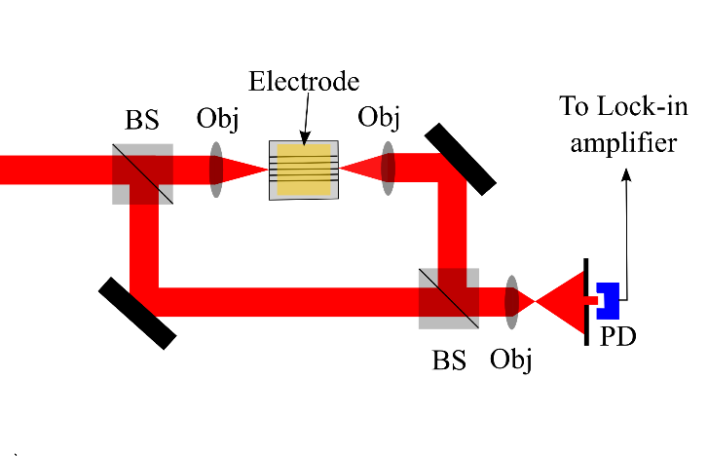
Fig. 2 Experimental setup for the measurement of electro-optic coefficient of the waveguides. BS notation indicates the beam splitters and PD the photodiode detector.
The EO response ($r_{33}$ coefficient) of the domain-engineered channel waveguides was compared to the EO response from a Ti-diffused LN channel waveguide, which is known to be the same as the intrinsic EO response of the bulk crystal [14]. The value of $r_{33}$ that was obtained from the Ti-diffused waveguides, using our experimental setup, was $r_{33}$=33.7 pm/V, which is in good agreement with values found in the literature for the unclamped crystal condition at λ= 633 nm [15]. The voltage, which was applied to the electrodes deposited on the waveguides was along the z-axis of the LN crystal and was varied at a rate of 5 Volts/sec within the range of -600 V to +600 V corresponding to a uniformly applied electric field ranging from -1.2 to +1.2 V/μm. The externally applied electric field is in the direction of the spontaneous polarization when a positive voltage is applied and opposite to the spontaneous polarization for negative voltages. The photodiode signal was monitored as a function of the voltage variation, ensuring that more than a full fringe variation, corresponding to a 2π phase shift was recorded. The experimental data were processed and the $V_{π}$ voltage was extracted from the measurements. The EO coefficient ($r_{33})$of the domain-engineered waveguides was then calculated using the expression: $r_{33}=\frac{λd}{n_{e}^{3}LV_{π}}$ where $n_{e}$ is the extraordinary refractive index, $L$ is the length of the electrode, and $d$ is the thickness of the waveguide substrate which is 500 μm.

Results and discussion
Fig. 3 shows the raw data for the variation of the optical power as measured by the monitoring photodiode that is placed behind the pinhole for (a) negative and (b) positive voltage ramps. The waveguide under test was fabricated using a laser intensity of 0.18 MW/cm² and writing speed of 0.1 mm/sec. Within the 600 V voltage range that we used in the experiments at least two fringe cycles were observed. A sinusoidal function (solid red line) was fitted to the data (black squares). From the sinusoidal fitting it is possible to calculate $V_{π}$ and consequently the corresponding $r_{33}$ coefficient. A sample consisting of Ti-diffused channel waveguides was used to provide a reference value of the EO coefficient using the same experimental setup.
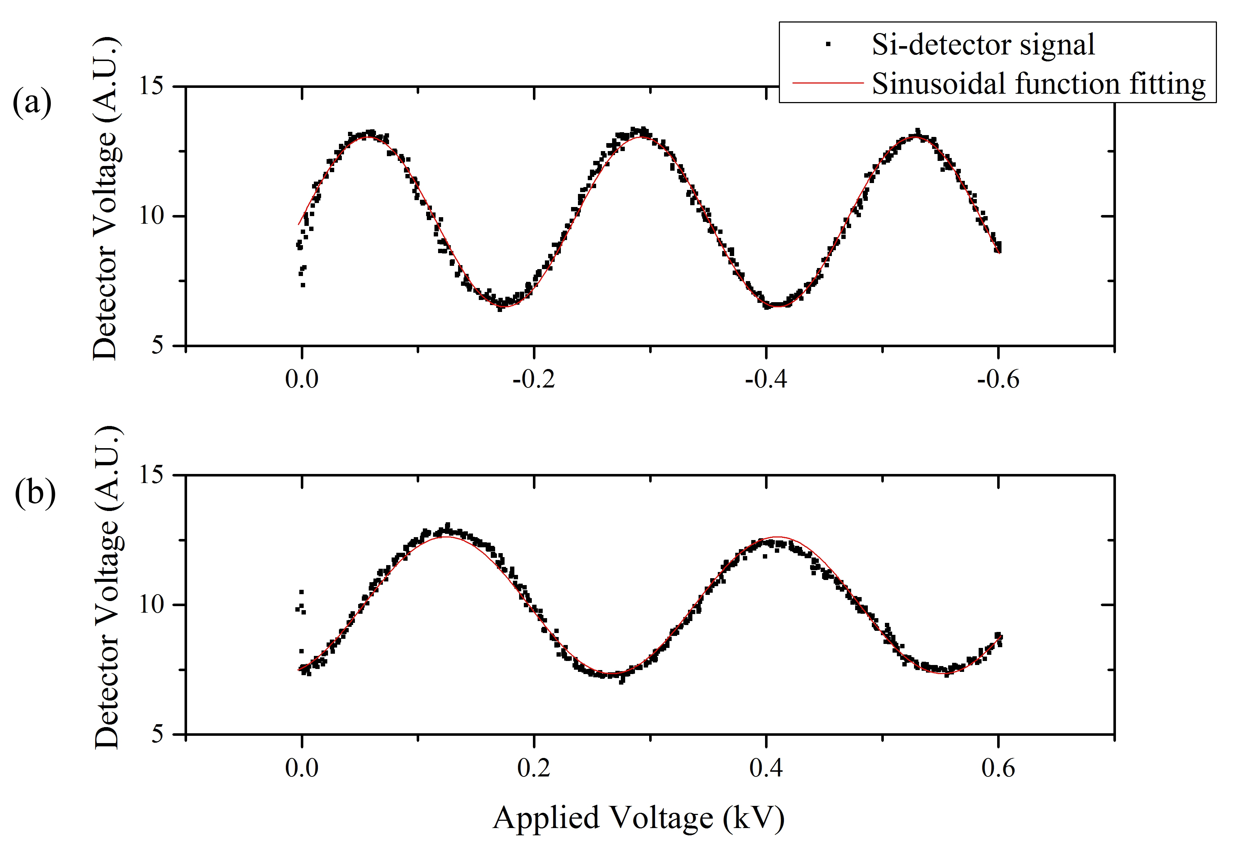
Fig. 3 Variation of normalised detector output with a) a negative and b) a positive applied voltage ramp corresponding to a waveguide that was written using laser intensity of 0.18 MW/cm² and scanning speed of 0.1 mm/sec, which overlaps with a PI domain.
Comparing the two graphs shown in Fig. 3 shows that for the same amplitude of applied voltage, the electro-optic phase change that corresponds to negative voltage is higher. The same behaviour was observed in all of the channel waveguides that were investigated. The reference (Ti diffused) waveguide however exhibited the same response irrespectively of the increase (positive ramp) or decrease (negative ramp) of voltage. For a single waveguide, the individual values for $V_{π}$ and $r_{33}$ corresponding to three different measurements for each voltage ramp direction and their average value are shown in Table 1.

Applied Voltage | V_{π} (V) | $r_{33}$ (pm/V) | Average $r_{33}$ (pm/V) | Enhancement
0 + 600V | 144.9 | 37.6 | 37.9±0.25 | 10%
 | 142.6 | 38.2
 | 143.5 | 38.0
0 - 600V | 117.6 | 46.3 | 46.1±0.17 | 36.7%
 | 118.6 | 46.0
 | 118.7 | 45.9
Table 1 Values of the $V_{π}$, and $r_{33} calculated$for six different measurements of a waveguide overlaping a PI domain, written under writing intensity of 0.18 MW/cm² and speed of 0.1 mm/sec. The values obtained are grouped depending on the direction of the applied voltage and the average value from the three measurements for $r_{33}$ has been calculated for each case.
The procedure above was repeated for a set of four waveguides fabricated using a range of writing conditions and the resulting three-measurement-average values of $r_{33}$ corresponding to negative and positive voltage ramps are illustrated in the graphs shown in Fig. 4, a) and b) respectively. These graphs again illustrate that the EO coefficient that corresponds to a positive voltage is systematically smaller when compared to that from a corresponding negative voltage. Most importantly, the values of the $r_{33}$coefficient, especially when a negative voltage ramp was used, were found to be systematically higher than the value of the $r_{33}$for the reference Ti diffused waveguide channel, which is 33.7 pm/V. It appears therefore that the EO response of this particular photonic structure that consists of an isolated domain directly overlapping a channel waveguide is significantly enhanced. The maximum enhancement that was measured in our experiments, which is not necessarily the highest possible, was 36.7%.
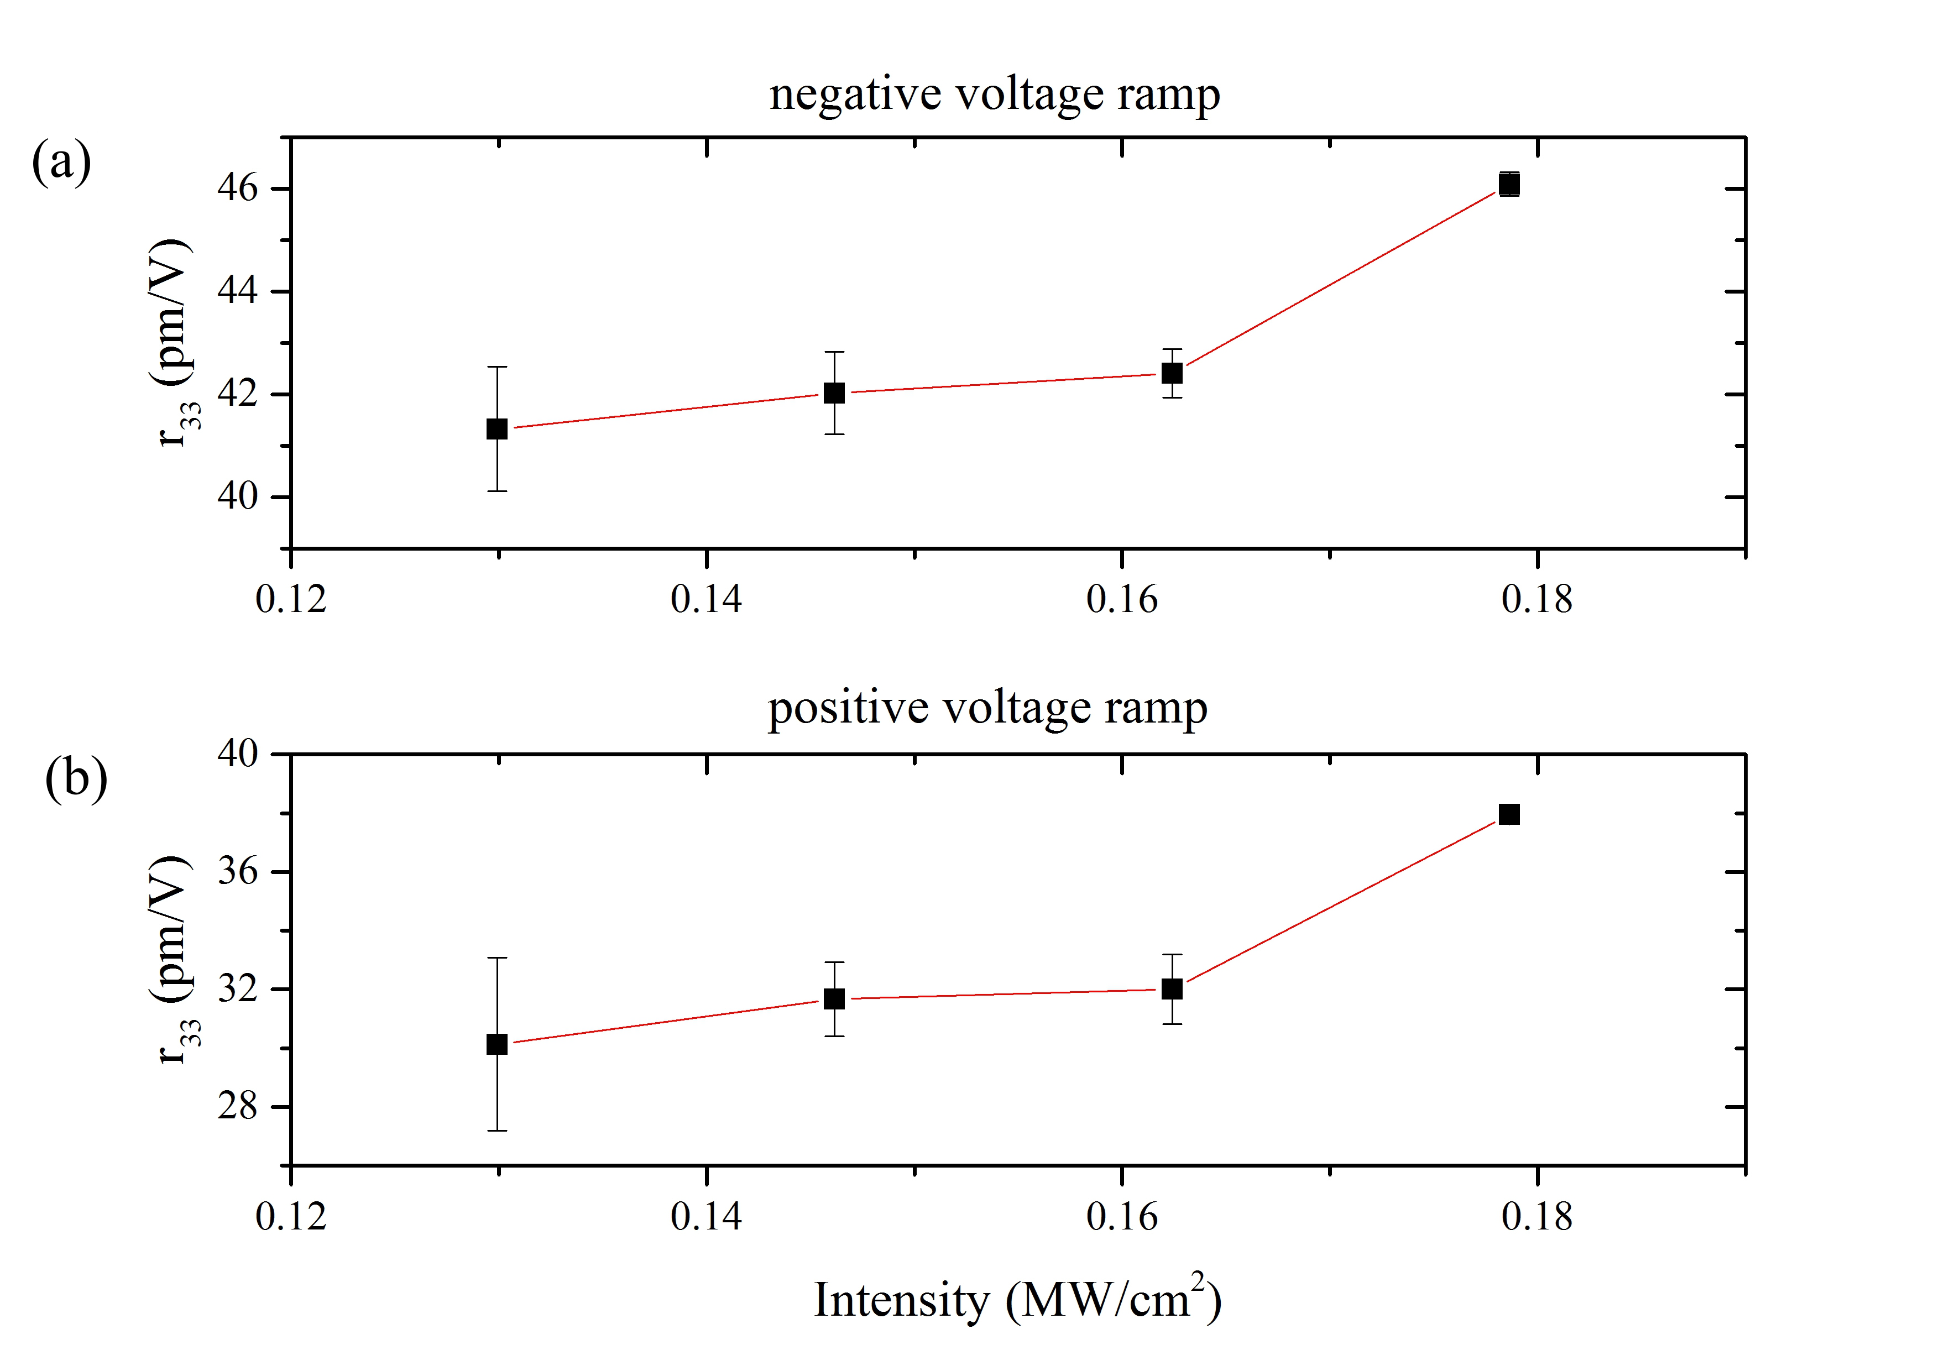
Fig. 4 Intensity of the UV laser versus the measured $r_{33}$ for: a) negative and b) positive voltage ramp. The red lines are guide to the eye.
Previous studies [16] have shown that the electro-optic response of UV-written channel waveguides is often lower or in the best case equal to the value that corresponds to bulk LN. The reduced value of the EO coefficient was attributed to laser-induced damage of the crystal so that not all the waveguide volume contributed to the EO phase shift. It was however observed in [17] that the refractive index change (Δn_{e}) of the UV written channel waveguides almost doubles after the poling step that generates the overlapping PI domains. The latter provides an indication that the formation of a PI domain produces a structural change (strain) in the part of the crystal that is contained within the volume of the channel waveguide that influences the linear refractive index within that volume. This observation is consistent with SNOM measurements, which have been reported in [10] that indicate a large, short range (~2-3 μm), refractive index change that is localized around the domain boundary. This report suggest that there is a “short range” sharp increase of the refractive index on the side of the domain wall that corresponds to the original (non-inverted) domain. In our case this corresponds to the PI domain. Furthermore a similar refractive index discontinuity was observed in the domain boundaries that were used as TIR switches/deflectors [18]. Interestingly the refractive index discontinuity, which was reported in [18] persisted after thermal annealing. There is therefore sufficient evidence in the literature suggesting that the photonic response in the vicinity of a domain wall is different as compared to the bulk crystal due to strain that is associated with the domain wall and the crystal non-stoichiometry. We suggest here that this strain that manifests itself through a change in the refractive index and which extends to several microns away from the domain wall [10], is also responsible for the increase in the nonlinear/electro-optic response that we observed in our composite structure.
Furthermore, the overlap between the domain and waveguide mode should influence significantly the degree of enhancement by varying the part of the mode that propagates within the high EO response volume. This statement is in agreement with our observation that higher EO coefficients were observed for waveguide/domain composite structures that were fabricated using higher laser intensities. In Fig. 5 the mode depth (at 1/e²) and the PI domain depth is plotted as a function of the UV laser intensity. This plot shows that the depth of the PI domain increases with the UV laser intensity approaching the mode depth at the high intensity extreme thus increasing the overlap between the domain and the waveguide mode. The corresponding EO coefficient values that are presented in Fig. 4a clearly show that the increase of the overlap between PI domain volume and mode volume correlates with the enhancement of the EO coefficient.
The overlap between the domain and mode also provides an explanation for the discrepancy between the values of the EO coefficient that correspond to positive and negative voltage ramps that was observed in the plots shown in Fig. 4. These plots illustrated that the values of the EO coefficient that were measured using a negative voltage ramp are systematically higher as compared to the values measured using a positive voltage ramp. Due to the fact that our UV written channel waveguides are close to cut-off the mode size can change significantly when the dielectric contrast is reduced with the application of the external electric field. The electro-optically induced refractive index change is given by $Δn=-\frac{1}{2}n^{3}r_{33}E$ indicating that the direction of the electric field affects the dielectric (refractive index) contrast between the waveguide/domain composite and the rest of the crystal. This is a well-known concept, which has been used for the fabrication of cut-off modulators [19]. Consequently when E is positive the refractive index contrast between the PI domain (that overlaps with the UV-written waveguide) and the surrounding area of the crystal decreases by $Δn=n^{3}r_{33}E$. This is because the n_{e} in the PI domain decreases by $\left|Δn\right|=\frac{1}{2}n^{3}r_{33}E$. However n_{e} increases by the same amount in the surrounding crystal volume that has been domain inverted. The reduction of the refractive index contrast increases the mode volume in our near cut-off waveguide channels and consequently decreases the overlap between the mode and the domain. When E is negative the refractive index contrast increases by the same amount improving the mode confinement.

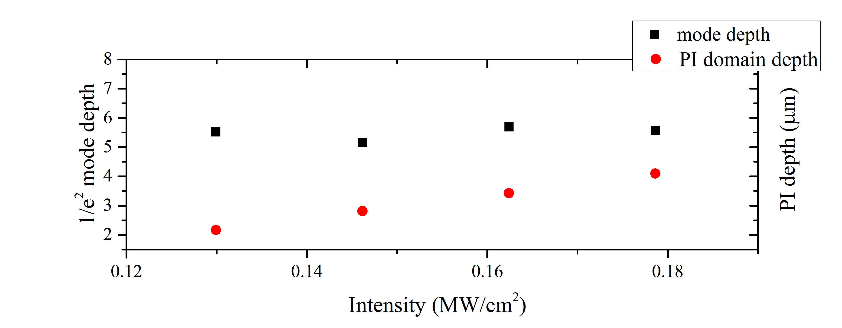

Fig. 5 Optical mode depth at 1/e² (no external electric field applied) and PI domain depth for waveguide/domain composites produced at different laser intensity.

Conclusions
A significant increase (36.7%) of the $r_{33}$ Pockels coefficient has been observed in composite lithium niobate structures consisting of a UV-written channel waveguide overlapping an isolated PI domain. Both the waveguide and PI domain are produced by a single UV laser writing process, using 244 nm c.w. laser irradiation, and are thus self-aligning. The effect is attributed to strain, which is associated with the presence of the domain walls that contains the channel waveguide. The impact of strain that occurs in the vicinity of a domain wall on the linear optical properties of the crystal is well documented in the literature. The EO coefficient enhancement becomes more pronounced for waveguide/domain composites that were fabricated using higher laser intensities, indicating that the overlap between the waveguide mode and the PI domain is a crucial factor for the effect to take place. A comparative measurement of the mode depth, domain depth and EO coefficient supports this hypothesis.
An asymmetry of the values of the electro-optic coefficient that depends upon the sign of the applied voltage ramp was also observed. This asymmetry was attributed to the electro-optically induced change in the refractive index contrast between the waveguide/domain composite and the bulk of the substrate that affects the size of the propagating mode of the near cut-off channel waveguides thus changing the mode/domain overlap refractive index.
The observed enhancement of the electro-optic coefficient in the vicinity of a domain boundary could be further increased by optimizing the overlap between the waveguide and the PI domain and exploited to produce electro-optic switches with smaller footprint and lower voltage requirements as well as more efficient non-linear optical devices.

Acknowledgments: We are grateful the Royal Society for supporting Dr Pranabendu Ganguly through the international incoming fellowship IIF-2007/R2

References

[1] M. Yamada, N. Nada, M. Saitoh, and K. Watanabe, “First-order quasi-phase matched LiNbO₃ waveguide periodically poled by applying an external field for efficient blue second-harmonic generation,” Appl. Phys. Lett., vol. 62, no. 5, pp. 435–436, 1993.
[2] L. E. Myers and W. R. Bosenberg, “Periodically poled lithium niobate and quasi-phase-matched optical parametric oscillators,” IEEE J. Quantum Electron., vol. 33, no. 10, pp. 1663–1672, 1997.
[3] M. Taya, M. C. Bashaw, and M. M. Fejer, “Photorefractive effects in periodically poled ferroelectrics.,” Opt. Lett., vol. 21, no. 12, pp. 857–859, Jun. 1996.
[4] S. Grilli, C. Canalias, F. Laurell, P. Ferraro, and P. De Natale, “Control of lateral domain spreading in congruent lithium niobate by selective proton exchange,” Appl. Phys. Lett., vol. 89, no. 3, pp. 032902–1–3, 2006.
[5] M. Manzo, F. Laurell, V. Pasiskevicius, and K. Gallo, “Electrostatic control of the domain switching dynamics in congruent LiNbO₃ via periodic proton-exchange,” Appl. Phys. Lett., vol. 98, no. 12, p. 122910, 2011.
[6] S. Mailis, C. Riziotis, I. T. Wellington, P. G. R. Smith, C. B. E. Gawith, and R. W. Eason, “Direct ultraviolet writing of channel waveguides in congruent lithium niobate single crystals.,” Opt. Lett., vol. 28, no. 16, pp. 1433–1435, Aug. 2003.
[7] P. Ganguly, C. L. Sones, Y. Ying, R. W. Eason, S. Mailis, H. Steigerwald, K. Buse, and E. Soergel, “Determination of refractive indices from the mode profiles of UV-written channel waveguides in LiNbO₃-crystals for optimization of writing conditions,” J. Light. Technol., vol. 27, no. 16, pp. 3490–3497, 2009.
[8] A. C. Muir, C. L. Sones, S. Mailis, R. W. Eason, T. Jungk, A. Hoffman, and E. Soergel, “Direct-writing of inverted domains in lithium niobate using a continuous wave ultra violet laser,” Opt. Express, vol. 16, no. 4, p. 2336, Feb. 2008.
[9] C. L. Sones, A. C. Muir, Y. J. Ying, S. Mailis, R. W. Eason, T. Jungk, A. Hoffmann, and E. Soergel, “Precision nanoscale domain engineering of lithium niobate via UV laser induced inhibition of poling,” Appl. Phys. Lett., vol. 92, no. 7, p. 72905, 2008.
[10] S. Kim and V. Gopalan, “Optical index profile at an antiparallel ferroelectric domain wall in lithium niobate,” Mater. Sci. Eng. B, vol. 120, no. 1–3, pp. 91–94, Jul. 2005.
[11] A. C. Muir, G. J. Daniell, C. P. Please, I. T. Wellington, S. Mailis, and R. W. Eason, “Modelling the formation of optical waveguides produced in LiNbO₃ by laser induced thermal diffusion of lithium ions,” Appl. Phys. A Mater. Sci. Process., vol. 83, no. 3, pp. 389–396, Feb. 2006.
[12] H. Steigerwald, M. Lilienblum, F. von Cube, Y. J. Ying, R. W. Eason, S. Mailis, B. Sturman, E. Soergel, and K. Buse, “Origin of UV-induced poling inhibition in lithium niobate crystals,” Phys. Rev. B, vol. 82, no. 21, p. 214105, Dec. 2010.
[13] C. Y. J. Ying, G. J. Daniell, H. Steigerwald, E. Soergel, and S. Mailis, “Pyroelectric field assisted ion migration induced by ultraviolet laser irradiation and its impact on ferroelectric domain inversion in lithium niobate crystals,” J. Appl. Phys., vol. 114, no. 8, p. 083101, 2013.
[14] R. J. Holmes, Y. S. Kim, C. D. Brandle, and D. M. Smyth, “Evaluation of crystals of LiNbO₃ doped with MgO or TiO₂ for electrooptic devices,” Ferroelectrics, vol. 51, no. 1, pp. 41–45, Nov. 1983.
[15] K. K. Wong, “Electro-Optic Coefficients of LiNbO₃,” in Properties of Lithium Niobate, Institution of Engineering and Technology, 2002.
[16] C. L. Sones, P. Ganguly, Y. J. Ying, F. Johann, E. Soergel, R. W. Eason, and S. Mailis, “Spectral and electro-optic response of UV-written waveguides in LiNbO₃ single crystals.,” Opt. Express, vol. 17, no. 26, pp. 23755–64, Dec. 2009.
[17] C. L. Sones, P. Ganguly, C. Y. J. Ying, E. Soergel, R. W. Eason, and S. Mailis, “Poling-inhibited ridge waveguides in lithium niobate crystals,” Appl. Phys. Lett., vol. 97, no. 15, p. 151112, 2010.
[18] A. J. Boyland, G. W. Ross, S. Mailis, P. G. R. Smith, and R. W. Eason, “Total internal reflection switching in electrooptically addressable domain-engineered LiNbO₃,” Electronics Letters, vol. 37, no. 9. pp. 585–587, 2001.
[19] D. Tulli, D. Janner, M. Garcia-Granda, R. Ricken, and V. Pruneri, “Electrode-free optical sensor for high voltage using a domain-inverted LiNbO₃ waveguide near cut-off,” Appl. Phys. B Lasers Opt., vol. 103, no. 2, pp. 399–403, 2011.

