[1]

Large Mode Area Single Trench Fiber for 2µm Operation

Deepak Jain and Jayanta K. Sahu

***Abstract*— Performance of single trench fibers has been investigated using Finite Element Method at 2μm wavelength. Numerical investigations show that an effective single mode operation for large effective area between 3,000-4,000μm2 and 2,000-3,000μm2 can be achieved at ~40cm and ~25cm bend radius respectively by exploiting high delocalization of the higher order modes. Achievement of a large effective-area can be very useful to address non-linear effects. Moreover, single trench fiber offers certain advantages such as low-cost fabrication and easy post-processing (such as cleaving and splicing) thanks to the all-solid fiber design.**

*Index Terms*—Large mode area fibers, High power fiber lasers, Non-linear effects, and Modal-Instability.

# INTRODUCTION

F

iber laser around 2μm with diffraction-limited output beam has shown great potential for various applications such as atmospheric propagation of high-power laser beam for light detection and ranging (LIDAR) and directed-energy (DE) [1-2], medical surgery [3] , gas-sensing and detection [4], pumping of mid-IR [3-5μm] optical parametric oscillators (OPO) [5], and material processing [6]. The versatile applications of 2μm can be attributed to its spectral absorption in water and atmospheric gases [7-8]. The high absorption by water at 1.94 µm makes it eye safe wavelength since it is not able to reach to retina of eye due to high absorption by fluid present before retina. This high absorption also reduces the penetration depth achieved during tissue cutting and ablation because of high presence of water in human tissue. This makes 2µm lasers extremely useful in medical surgery [3]. On the other hand, high atmospheric transparency makes it useful for application like LIDAR and DE [1-2].

All of these properties and usefulness have increased the interest to develop high power fiber lasers in this wavelength region. Some of these applications require high-power with good beam quality in continuous-wave (CW) and pulse regime. However, non-linear effects are considerable challenge in power scaling. In order to avoid non-linear effects, a fiber design offering an effective single mode (ESM) with large-mode-area (LMA) is required [9]. LMA of the FM reduces power density in core, hence threshold of non-linear effects increases. Recently, we established a definition of ESM in term of “CBE” {Criterion, Bend radius, Effective area}, which is defined as criterion of loss (or power fraction) of higher order modes (HOMs) and fundamental mode (FM), fulfilled over a range of bend radius with a range of effective area (Aeff) of the fundamental mode (FM) [10]. Several LMA fiber designs such as low numerical-aperture step-index-fiber (low NA-SIF) [11], photonic crystal fiber (PCF) [12], Bragg fiber [13], leakage channel fiber (LCF) [14], multi trench fiber (MTF) [15-18], 2D-photonic bandgap fiber (2D-PBGF) [19], and single trench fiber (STF) [10, 20] have been proposed for ESM operation at 1μm. However, due to bend-induced detrimental Aeff reduction, it is difficult to achieve Aeff larger than 1,500µm2 at a practical bend radius of lower than or equal to ~20cm at 1µm wavelength while fulfilling high suppression of the HOMs (for example, 10dB/m loss for HOMs while having 0.1dB/m for FM) as discussed in details in our previous study [10]. On the other hand, with longer wavelength of operation (~2µm) it becomes easier to achieve larger Aeff compared to shorter wavelength of operation. Moreover, at 2μm the threshold of non-linear effects is also higher by a factor of 2. Although, thermal management is a severe problem at 2μm due to high quantum defects (For example, when pumping a Tm doped fiber at 0.793μm for lasing at 2μm.). In order to avoid bend-induced reduction of Aeff, researchers have proposed rod-type fiber lasers, which are 1 to 2m long, few mm thick, and cannot be bent [21]. Rod-type fiber lasers have provided spectacular performance in terms of achieving high peak power and can provide very large Aeff [21]. At 1µm, rod-type fibers such as large pitch fiber (LPF) [21], distributed modal filtering fiber (DMF) [22], and multi trench fiber (MTF) [15, 18] have been proposed. At 2µm a rod-type LPF of 81µm core diameter having MFD around 65-70µm (an Aeff between 3,300µm2 to 3,900µm2) has been demonstrated [23-24]. However due to thermo-optic effects, which contribute to a detrimental effect known as modal-instability, power scaling in rod-type fiber lasers remains challenging [25]. One route to avoid thermo-optic effects is to use a longer length of fiber to reduce the thermal load per unit length, but increasing the length of fiber in rod-type configuration will lead to a large device size. On the other hand, it would be interesting to have a longer length of fiber in bend configuration even at relatively larger bend diameter such as ~0.5m to 1m (to avoid bend induced Aeff reduction), so that it can offer higher Aeff similar to rod-type fiber.However, an increase in fiber length can decrease the non-linear threshold level but it can improve the overall fiber laser output power level by increasing the threshold of modal instability. Therefore, a fiber laser relatively resistant to modal-instability canbe demonstrated, although a compromise with device size has to be made.

We recently demonstrated STF at 1µm and 1.55µm for LMA operation [10, 20]. STF is a simple design, which has been successfully fabricated using conventional modified chemical vapour deposition (MCVD) process in conjunction with solution doping process with good reproducibility. This ensures mass-scale production thanks to the higher refractive index of core as of cladding unlike most LMA fiber designs. The STF offers high loss and high power delocalization of the HOMs thanks to the resonant coupling of HOMs of core to ring modes. STF being an all-solid design ensures easy cleaving and splicing of fiber. In this paper, we investigate the performance of STF for mode area scaling at 2µm wavelength.

# Single-trench Fiber

Fig. 1(a) shows the schematic of refractive index profile of our proposed STF design and Fig. 1(b) shows the schematic of 2-D cross-section of fiber. Details of fiber design can be found in our earlier study [10, 20].

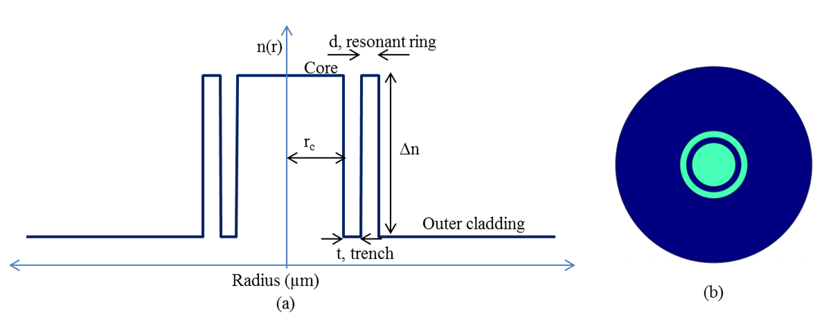

Fig. 1(a) Schematic of refractive index profile of the STF. (b) Schematic cross-section of the STF. Green and blue colours represent high and low-refractive index regions respectively.

Numerical simulations on STF have been performed using finite element method (FEM). A perfectly matched layer (PML) has been used to calculate the leakage and bending losses of optical fibers. All the calculations presented in this paper are at 2µm wavelength. Perturbations due to bending have been taken in to account using standard conformal transformation by using following equation [26].



where n(r) is the index profile of the unbent fiber, R is the bend radius, φ is the azimuthal angle, and ρ (here fixed to 1.25) has been included to take account of the stress factor [27].

# Illustration of working principle of fiber design.

STF has an additional ring waveguide, which is known as the resonant ring, surrounding the core. The refractive index of the ring is same as of core. The region between core and resonant ring is known as trench and has same refractive index as of outer cladding (region after resonant ring). The only difference between SIF and STF is an additional ring as shown in Fig. 2(a) and (d). In order to understand, the effects of additional ring and how it enhances the mode area scaling capability of fiber by offering delocalization to the HOMs, we made a comparative study of a SIF and STF at 2µm wavelength. In order to do a fair comparison, we fix core radius (rc)andindex difference between core and cladding (Δn) to 30µm and 0.001 respectively in both cases. We only add a resonant ring of thickness (d) of 14µm at a radial distance of 6µm from core (known as trench thickness (t)) in case of STF. The other computational parameters were kept same. Fig. 2(b) and Fig. 2(c) shows the normalized electric field of modes in case of SIF with their power fraction in core in unbent and bent case at 25cm bend radius respectively. This fiber is multi-moded due to significant presence of the HOMs in core in both cases. On the other hand, Fig. 2(e) and (f) shows the electric field of modes in case of STF with their power fraction in core in unbent and bent case (at 25cm bend radius) respectively. The fiber can be considered effectively single-moded in bent case as the power of HOMs dramatically delocalizes from the core, thanks to the resonant coupling between modes of core and resonant ring. In bent case at 25cm bend radius, the STF offers FM having Aeff around ~2,434µm2, while the power fractions of the FM and the HOM (having highest power fraction in core among all possible HOMs in the core) are ~84% and ~54% respectively in core.

From the perspective of STF fabrication, we investigated the performance of STF with rc=30µm, Δn=0.001 at 25cm bend radius for different thicknesses of trench t={5-7μm} and resonant ring d={11-15μm}. Fig. 3(a) shows the power fraction of the FM and the HOM (having highest power fraction in core among all the possible HOMs of fiber) in core for different trench and resonant ring thicknesses, Fig. 3(b) shows the difference of these power fractions, and Fig. 3(c) shows the Aeff of the FM for different thicknesses of trench and resonant ring. In our definition of “all the possible HOMs of fiber”, we include any possible modes in fiber other than FM, it includes modes of core, ring, and mixed modes. It is interesting to note that for t={5-7µm} and d={11-15µm}, the power fraction difference remains larger than 20%. On the other hand, for t={5-7µm} and d={13-15µm} the power fraction difference remains larger than 30% other than for one case. The Aeff is larger than 2,200µm2 (~53µm MFD) for different thicknesses mentioned here. The Aeff of the FM increases with increasing resonant ring thickness due to increasing coupling of the FM to ring. In terms of “CBE” following our definition of ESM, we can say that for a Criterion (C) of 30% power fraction difference in core at a Bend (B) radius of 25cm, an Effective (E) area larger than 2,200µm2 over a range of thicknesses of trench and resonant ring can be achieved at 2µm.

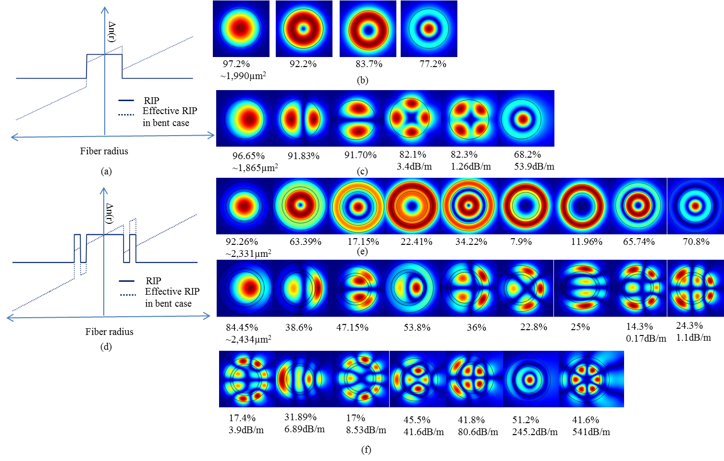

Fig. 2(a) Schematic of RIP of low NA-SIF in unbent and bent case, (b) and (c) normalized electric field of various modes in unbent and bent case with their losses and power fractions in core for 60µm core diameter SIF with Δn=0.001 at 25cm bend radius (d) Schematic of RIP of STF in unbent and bent case, (e) and (f) normalized electric field of various modes in unbent and bent case with their losses and power fractions in core for 60µm core diameter STF with Δn=0.001, t=6µm, and d=14µm at 25cm bend radius. The modes for which loss has not been mentioned have negligible loss.

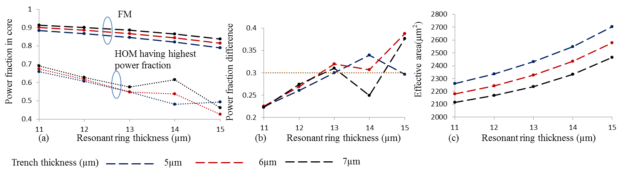

Fig. 3(a) Power fraction of the FM and the HOM (having highest power fraction in core among all possible HOMs of fiber), (b) difference in power fraction of FM and HOM shown in Fig. 3(a), and (c) Aeff of the FM of fiber for different resonant ring and trench thicknesses for 60µm core diameter STF with Δn=0.001 at 25cm bend radius.

# MODE AREA SCALING

In order to further scale the Aeff, we increased the core diameter to 70µm and reduce the core Δn to 0.0005 and use a relatively large bend radius of 40cm. It is important to note that, a core Δn of 0.0005 with respect to cladding have been achieved in our previous experiments for STF operating at ~1μm and ~1.55µm wavelength [10, 20]. The Yb and Er doped fibers were fabricated using MCVD process in conjunction with solution doping process with good reproducibility. Fig. 4(a) shows the power fraction in core for FM and HOM having highest power fraction in core among all possible HOMs (we ignore HOMs having loss larger than 29dB/m), Fig. 4(b) shows the computed loss of corresponding modes, and Fig. 4(c) shows the calculated Aeff of the FM. It is worth noting that, the power fraction difference between FM and HOM is larger than 40% for entire range of parameters t={5μm-7μm} and d={13μm-15μm} which ensures an ESM operation. For this range of resonant ring and trench thickness, the power fraction of the FM is always larger than 78% in core, on the other hand the power fraction of the HOMs (after ignoring modes which have loss higher than 29dB/m) is always lower than 44%. The Aeff of the FM remains between 3,270μm2 to 3,750μm2, corresponding to a MFD of ~64μm and ~69μm respectively.

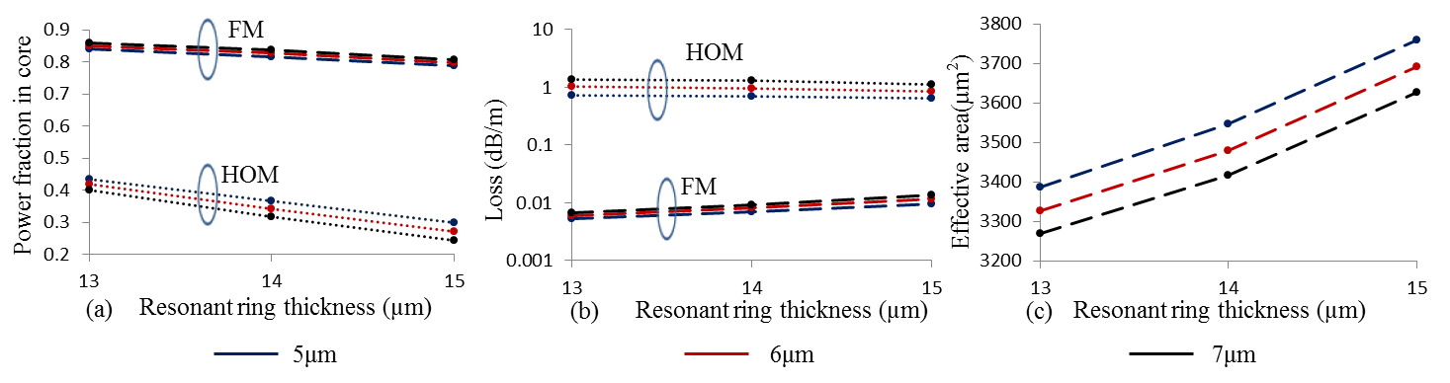

Fig. 4(a) Power fraction of the FM and the HOM (having highest power fraction in core among all possible HOMs of core after ignoring the HOM having loss larger 29dB/m) (b) loss of FM and HOM shown in Fig. 4(a), and (c) Aeff of the FM of fiber for different resonant ring and trench thicknesses for 70µm core diameter STF with Δn=0.0005 at 40cm bend radius.

It is pertinent to note here that fiber offers very high suppression to the HOMs. The HOMs of core for the entire range of thickness of trench and resonant ring have loss larger than 29dB/m. On the other hands, mode having low loss (~1dB/m) shown in Fig. 4(b) are ring modes, although the probability of their excitation is also very low. Moreover, their power content is significantly lower than the FM in core.

We also investigated 80μm core diameter STF with core Δn=0.0005 at two different bend radii namely 40cm and 30cm. Fig. 5 (a) shows the power fraction in core for FM and HOM having highest power fraction in core among all possible HOMs (we ignore HOMs having loss larger than 20dB/m), Fig. 5(b) shows their corresponding loss, and Fig. 5(c) shows the Aeff of the FM at 40cm bend radius. The difference in power fraction for FM and HOM (after ignoring HOM having loss larger than 20dB/m) is more than 30% for t={11-13μm} and d={14-15μm}, which ensures an ESM operation. The Aeff varies between 3,615 μm2 to 4,020μm2, which corresponds to a MFD of ~68μm to ~71μm. Similarly, for 30cm bend radius case, Fig. 5(d) shows the power fraction in core for FM and HOM having highest power fraction in core among all the possible HOMs of fiber (we ignore HOMs having loss larger than 20dB/m), Fig. 5(e) shows their corresponding loss, and Fig. 5(f) shows the Aeff of the FM. It is interesting to note that by reducing bend radius from 40cm to 30cm leads to dramatic increase in Aeff, on contrary to typical bend-induced detrimental Aeff reduction. The Aeff varies between ~3,895μm2 to ~4,795μm2, corresponding to ~70μm to ~78μm MFD respectively. This dramatic increase can be attributed to bend-enhanced coupling between FM to resonant ring, which leads to flatter electric field. However, this increased Aeff comes at the cost of reduced power content of the FM in core. The power content of FM varies from ~0.79 to ~0.66 in core, on the other hand the power of HOM having highest power fraction among all HOMs (we ignore HOMs having loss larger than 20dB/m) varies from ~0.42 to ~0.20. The power difference between FM and HOM is larger than

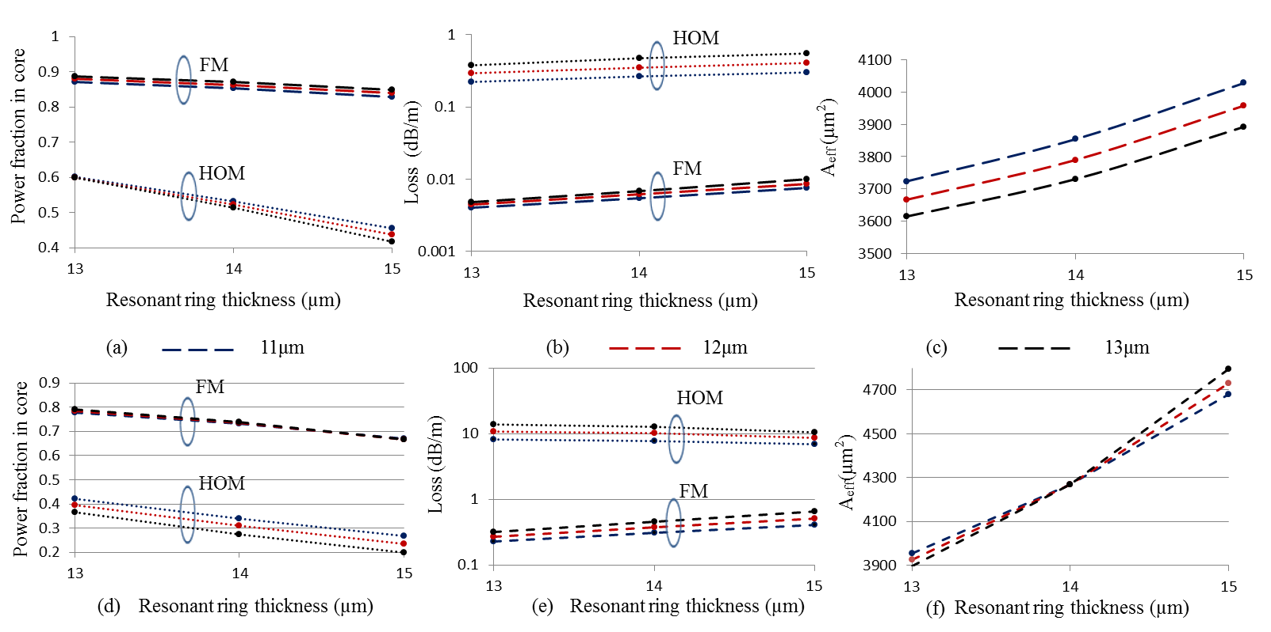

Fig. 5(a) Power fraction of the FM and the HOM (having highest power fraction in core among all possible HOMs of core after ignoring the HOM having loss larger 20dB/m) (b) loss of the FM and HOM shown in Fig. 5(a), and (c) Aeff of the FM of fiber for different resonant ring and trench thicknesses for 80µm core diameter STF at 40cm bend radius 5(d) Power fraction of the FM and the HOM (having highest power fraction in core among all possible HOMs of core) (e) loss of the FM and HOM shown in Fig. 5(d), and (f) Aeff of the FM of fiber for different resonant ring and trench thicknesses for 80µm core diameter STF at 30cm bend radius.

~35%, this ensures an ESM operation. However, reduced power content of the FM in core might influence fiber laser efficiency. Nevertheless, these 70μm and 80μm core STFs offer spectacular performance of ESM for LMA applications.

# comparison with other fiber designs

We also study the mode area scaling capability of a low NA SIF at 2μm wavelength of operation. Fig. 6 shows the maximum possible Aeff achieved for different core Δn with respect to cladding. Figure also shows the corresponding bend diameter required to maintain bend induced effective single mode operation. We fix the ESM criterion based on bend-induced losses, as there is no mechanism in case of SIF for delocalization of the HOMs. In this calculation, we fix the criterion of ESM, as 10dB/m loss for HOMs and 0.1dB/m loss for FM. A maximum Aeff of ~2264µm2 can be achieved from a 60µm core diameter SIF with Δn=0.0005 at 63cm bend diameter as shown in Fig. 7. On the other hand, a 61μm core diameter SIF is unable to fulfil the above mentioned criterion. The maximum Aeff ~2,200μm2 achievedhereby 60μm SIF with core Δn of 0.0005 is same as of 60μm STF with core Δn of 0.001. However, it is interesting to note that a 63cm bend diameter is required in case of SIF, on the other hand a 50cm bend diameter is sufficient in case of STF. Moreover, in case of a STF at a large bend diameter of ~60-80cm and low Δn of core ~0.0005, Aeff as large as 3,000μm2 to 4,500μm2 can be achieved. Single mode criterion of STF is based on power delocalization, which is highly preferred over bend-loss criterion for fiber laser applications. It can be concluded that, STF with an additional ring surrounding the core of a SIF, can dramatically enhance mode area scaling performance by improving criterion of ESM, decreasing bend diameter, and increasing Aeff of the FM, thanks to the flat electric field and delocalization of the HOMs.

On the other hand, comparing STF performance with current state of the art fiber such as rod-type PCF and LPF, we see additional advantages offered by STF. The refractive index matching of doped-core and undoped-cladding is a biggest challenge in case of LPF [28]. To avoid multi-mode behavior as a result of higher refractive index of core than cladding, typically an index depressed core with respect to cladding (~-0.0005) is used. However, this depressed core typically suffers from poor beam quality and lossy FM and requires enough heat to match the refractive index with cladding before lasing takes place. For example, a 81μm core LPF (the largest diameter fiber demonstrated so far at 2μm to the best of our knowledge) requires a 115W threshold pump power in lasing configuration due to depressed index [24]. Moreover, with increasing output power level, core refractive index increases and this thermally induced gradient leads to decrease in Aeff. For example, a 81μm core LPF provides a ~70μm MFD at threshold power level and MFD decreases to ~63μm at highest output power (merely ~52W), which is an early sign of modal-instability and further increase of pump power could lead to modal-instability [25].

On the other hand, we have demonstrated that a core Δn of 0.0005 can be achieved with MCVD process in conjunction with solution-doping process [10]. Therefore, STF unlike rod-type fiber, is free from problem of refractive index mis-matching of core and cladding. Moreover, STF is bendable while maintaining a large Aeff of the FM, and this property allows using long length of fiber as fiber can be coiled. A longer length of fiber can reduce the heat load over the length of fiber; hence can increase the threshold of modal-instability.

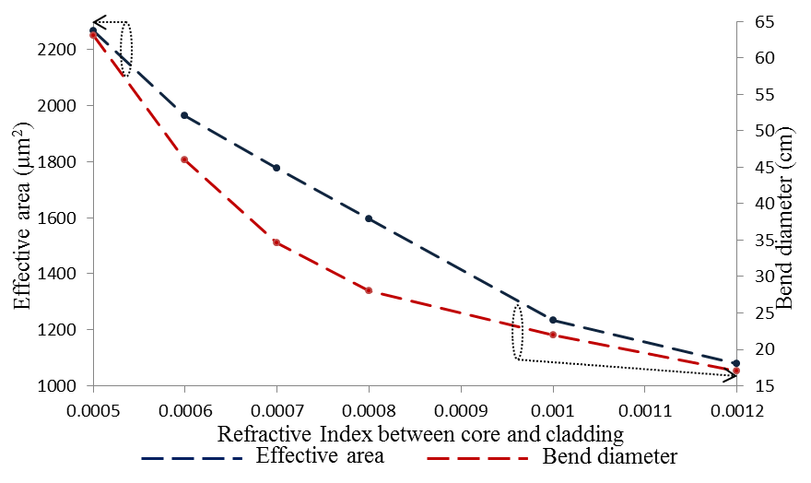

Fig. 6. The maximum scalable effective area and required bend diameter for a different core and cladding refractive index difference for SIF at 2μm.

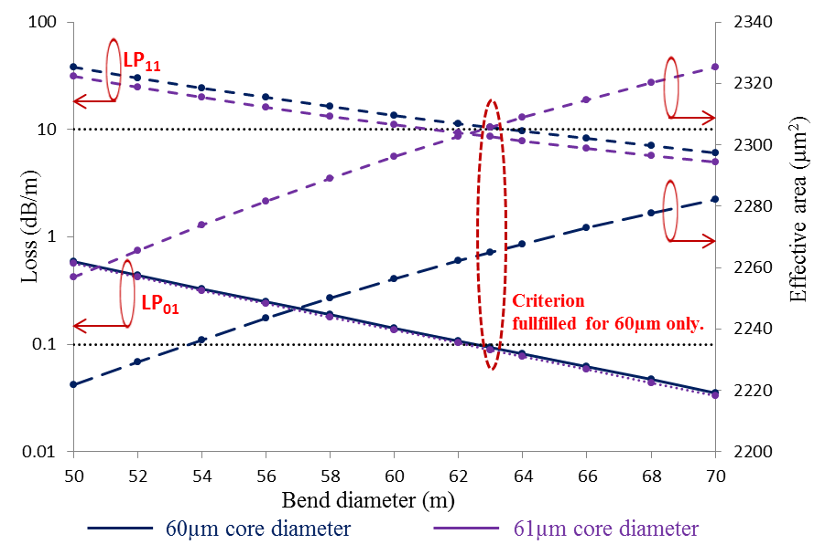Fig. 7 The loss of LP01 and LP11 modes and effective area of LP01 of SIF w.r.t. bending diameter for two different core diameters with a fixed core Δn of 0.0005 at 2μm.

# conclusion

In this investigation of STF for operation at 2μm, we found that a large Aeff can be achieved by exploiting power-delocalization of HOMs in conjunction with high bending loss of the HOMs thanks to the resonant coupling between the core and resonant ring. Moreover, it is pertinent to mention that a large Aeff in the range of 3,000μm2-4,000μm2 and 2,000μm2-3,000μm2 can be obtained at ~40cm and ~25cm bend radius respectively. STF provides a large Aeff in bend configuration, which can be useful in mitigating modal instability caused by thermo-optic effects. Bend configuration allows the use of a longer length of fiber unlike rod-type fibers to distribute heat over the length of fiber to avoid modal-instability. STF also offers advantage of easy fabrication thanks to cylindrical symmetrical design and higher refractive index of core as of cladding. It is important to understand that, refractive index matching of doped core and cladding is a critical condition to meet in most of the rod-type fiber lasers, as mismatching of refractive index leads to either a lossy FM or a multi-mode operation. STF also offers the advantages of easy cleaving and splicing. In summary, STF shows the outstanding potential at 2μm to address the challenges such as non-linear effects, modal instability, and fabrication cost due to complex fiber designs currently being faced by the fiber lasers.

References

1. S. W. Henderson, P. J. M. Suni, C. P. Hale, S. M. Hannon, J. R. Magee, D. L. Bruns, and E. H. Yuen, “Coherent Laser Radar at 2µm Using

Solid-State Lasers”, IEEE Trans. On Geo. Sci. and Remote Sens., vol. 31, no. 1, pp. 4-15, Jan. 1993.

1. P. Sprangle, A. Ting, J. Penano, R. Fischer, and B. Hafizi, “Incoherent Combining and Atmospheric Propagation of High-Power Fiber Lasers for Directed-Energy Applications”, IEEE J. of Quan. Elec., vol. 45, no. 2, pp. 138-148, Feb. 2009.
2. T. Bach, T. R. W. Herrmann, A. Haecker, M. S. Michel, and A. Gross, “Thulium: yttrium-aluminium-garnet laser prostatectomy in men with refractory urinary retention”, British J. of Urology Int., vol. 104, no. 3, pp.361-364, Nov. 2008.
3. T. F. Morse, K. Oh., and L. J. Reinhart, “Carbon dioxide detection using a co-doped Tm-Ho optical fiber”, Proc. SPIE, pp.158-164, 1995.
4. D. Creeden, P. A. Ketteridge, P. A. Budni, S. D. Setzler, Y. E. Young, J. C. McCarthy, K. Zawilski, P. G. Schunemann, T. M. Pollack, E. P. Chicklis, and M. Jiang, “ Mid-infrared ZnGeP2 parametric oscillator directly pumped by a pulsed 2 µm Tm-doped fiber laser”, Opt. Lett., vol. 33, no. 4, pp. 315-317, Feb., 2008.
5. K. Scholle, S. Lamrini, P. Koopmann, and P. Fuhrberg, “2μm Laser sources and their Possible applications”, Book Chapter 21, Frontiers in guided wave optics and optoelectronics, Edited by B. P. Pal, InTech, Feb., 2010.
6. [J. E. Bertie](javascript:searchAuthor('Bertie,%20J')) and [Z. Lan](javascript:searchAuthor('Lan,%20Z')), “Infrared Intensities of Liquids XX: The Intensity of the OH Stretching Band of Liquid Water Revisited, and the Best Current Values of the Optical Constants of H2O(l) at 25°C between 15,000 and 1 cm-1,” J. of Applied Spectroscopy, vol. 50, no. 8, pp. 1047-1057, March, 1996.
7. J. –P. Cariou, B. Augere, and M. Valla, “Laser source requirements for coherent lidars based on fiber technology”, C. R. Physique, vol. 7, no. 2 , pp. 213-2213, March 2006.
8. G. P. Agrawal, “Nonlinear Fiber optics”, 4th edition, Academic Press, 2007.
9. D. Jain, Y. Jung, M. Nunez-Velazquez, and J. K. Sahu, “Extending single mode performance of all-solid large-mode-area single trench fiber,” Opt. Exp. **22**(25), 31078-31091, Dec., 2014.
10. M.-J. Li, X. Chen, A. Liu, S. Gray, J. Wang, D. T. Walton, and L. A. Zenteno, “Limit of effective area for single-mode operation in step-index large mode area laser fibers,” J. Lightw. Technol., vol. 27, no. 15,

pp. 3010–3016, Aug. 2009.

1. J. Limpert, A. Liem, M. Reich, T. Schreiber, S. Nolte, H. Zellmer, and A. Tunnermann, “Low-nonlinearity single-transverse-mode ytterbium-doped photonic crystal fiber amplifier,” Opt. Exp., vol. 12, no. 7, pp. 1313–1319, Apr. 2004.
2. C. Baskiotis, Y. Quiquempois, M. Douay, and P. Sillard, “Extending the effective area of coiled all-solid silica single-mode Bragg fibers,” ECOC, Geneva, Switzerland, **We.10.P1.02**, 2011.
3. G. Gu, F. Kong, T. W. Hawkins, P. Foy, K. Wei, B. Samson, and L. Dong, “Impact of fiber outer boundaries on leaky mode losses in leakage channel fibers,” Opt. Exp., 21, no. 20, pp. 24039-24048, Oct. 2013.
4. D. Jain, C. Baskiotis, and J. K. Sahu, “Mode area scaling with Multi-trench rod-type fibers,” Opt. Exp., vol. 21, no. 2, pp. 1448-1455, Jan. 2013.
5. D. Jain, C. Baskiotis, and J. K. Sahu, “Bending performance of large mode area multi-trench fibers,” Opt. Exp., vol. 21, no. 22, pp. 26663–26670, Oct. 2013.
6. D. Jain, C. Baskiotis, T. C. May-Smith, J. Kim, and J. K. Sahu, “Large mode area multi-trench fiber with delocalization of higher order modes,” [Invited], IEEE JSTQE, vol. 20, no. 5, pp. 0902909–0902917, Sept./Oct. 2014.
7. D. Jain, Y. Jung, J. Kim, and J. K. Sahu, “Robust single-mode all-solid multi trench fiber with large effective mode area,” Opt. Lett., vol. 39, no. 17, pp. 5200-5203, Sept. 2014.
8. S. Saitoh, K. Saitoh, M. Kashiwagi, S. Matsuo, and Liang Dong, “Design Optimization of Large-Mode-Area All-Solid Photonic Bandgap Fibers for High-Power Laser Applications,” J. of Lightw. Technolo., vol. 32,no. 3,pp.440-449, Feb. 2014.
9. D. Jain, S. Alam, Y. Jung, P. Barua, M. N. Velazquez, and J. K. Sahu, “Highly efficient Yb-free Er-La-Al doped ultralow NA large mode area single-trench fiber laser,” Opt. Exp., vol. 23, no. 22, pp. 28282-28287 Oct. (2015).
10. J. Limpert, F. Stutzki, F. Jansen, H. J. Otto, T. Eidam, C. Jauregui, and A. Tunnermann, “Yb-doped large-pitch fibers: effective single-mode operation based on higher-order mode delocalization”, Light: Sci. & App*.*, vol. 1, pp. 1-5, March 2012.
11. M. Laurila, M. M. Jørgensen, K. R. Hansen, T. T. Alkeskjold, J. Broeng, and J. Lægsgaard, “Distributed mode filtering rod fiber amplifier delivering 292W with improved mode stability,” Opt. Exp., vol. 20, no. 5, pp. 5742-5743, Feb. 2012.
12. F. Stutzki, F. Jansen, C. Jauregui J. Limpert, and A. Tunnermann, “2.4mJ, 33W Q-switched Tm-doped fiber laser with near diffraction-limited beam quality, “ Opt. Lett., vol. 38, no. 2, pp. 97-99, Jan. 2013.
13. F. Jansen, F. Stutzki, C. Jauregui, J. Limpert, and A. Tünnermann, “High-power very large mode-area thulium-doped fiber laser,” Opt. Lett., vol. 37, no.21, pp. 4546-4548, Nov. 2012.
14. T. Eidam, C. Wirth, C. Jauregui, F. Stutzki, F. Jansen, H.-J. Otto, O. Schmidt, T. Schreiber, J. Limpert, and A. Tünnermann, “Experimental observations of the threshold-like onset of mode instabilities in high power fiber amplifiers,” Opt. Exp., vol. 19, no. 14, pp. 13218–13224, Jun. 2011.
15. D. Marcuse, “Influence of curvature on the losses of doubly clad fibers,” Appl. Opt., vol. 21, no. 23, pp. 4208-4213, Dec. 1982.
16. K. Nagano, S. Kawakani, and S. Nishida, “Change of the refractive index in an optical fiber due to external forces,” Appl. Opt., vol. 17, no. 13, pp. 2080-2085, July 1978.
17. F. Jansen, F. Stutzki, H. J. Otto, M. Baumgartl, C. Jauregui, J. Limpert, and A. Tünnermann, “The influence of index-depressions in core-pumped Yb-doped large pitch fibers,” Opt. Exp., vol. 18, no. 26, pp. 26834–26842, Dec. 2010.

**Deepak Jain** received PhD (optoelectronics) in June, 2015 from Optoelectronics Research Center, University of Southampton, UK. His PhD work involves the invention and development of large mode area trench fibers for high power applications. His research area includes fiber design, fabrication and characterization for application such as high power lasers and amplifiers and supercontinuum light sources. He has more than 45 papers in international journals and conferences. He is currently a postdoctoral fellow at DTU, Fotonik, Denmark and working over mid-infrared supercontinuum sources.

**Jayanta K. Sahu** received his Ph.D. in 1997 from the India Institute of Technology - Kharagpur, India. From 1997 to April 2000, he held a Research Engineer position at the Royal Institute of Technology, Stockholm, Sweden, before joining the Optoelectronics Research Centre, University of Southampton, U.K., where he is currently a Professor and leads the Fiber Fabrication Group. His current research interests include optical materials, development of novel geometry fibers, and fibers with special waveguiding properties for applications in high power lasers and amplifiers, optical sensors, and telecommunications. He has more than 350 publications in journals and conferences including several invited and tutorial talks.

Prof. Sahu is a senior member of the Optical Society of America and a fellow of Optical Society of India. He has been a member of several technical program committees, including CLEO-Europe, Photonics West, Photonics-India, Asia Communications and Photonics (ACP), Specialty Optical Fibers and their Applications (SOF), and Australian Conference on Optical Fibre Technology (OECC/ACOFT).

1. Manuscript received March X, 2016; revised YYYY X, 2016 and YYYY X, 2016; accepted YYYY X, 2016. Current version published YYYY X, 2016. The work is supported by the EPSRC Centre for Innovative manufacturing in Photonics EP/HO2607X/1. The data for this work is accessible through the University of Southampton Institutional Research Repository (DOI: XXXXXXXXXXXXX).

   D. Jain worked at the Optoelectronics Research Center, University of Southampton, Southampton, SO17 1BJ, UK (e-mail: opticsislife@gmail.com). D. Jain is currently with DTU Fotonik, Technical University of Denmark, Denmark. J. Sahu works at the Optoelectronics Research Center, University of Southampton, Southampton, SO17 1BJ, UK (e-mail: jks@orc.soton.ac.uk)

   Color versions of one or more of the figures in this paper are available online athttp://ieeexplore.ieee.org. Digital Object Identifier