Achieving homogeneous anodic TiO₂ nanotube layers through grain refinement of the titanium substrate
Nan Hu¹, Nong Gao^{1*}, Ying Chen² and Marco J Starink¹
1 Materials Research Group, Faculty of Engineering and the Environment, University of Southampton, SO17 1BJ, UK
2 Metal Materials, School of Materials Science and Engineering, Xiamen University of Technology, Xiamen 361024, China
KEYWORDS: Anodic titania nanotubes, High pressure torsion, Ultra-fine-grained materials, current density-time transient, wettability

ABSTRACT: In this work we used two-step electrochemical anodization to produce self-assembled layers of titanium dioxide nanotubes (TNT) on commercially pure titanium substrates with various grain sizes between 140 nm to 35 µm. The refined grain sizes were obtained using high pressure torsion (HPT). Optical microscopy, transmission electron microscopy, scanning electron microscopy and wettability testing showed that the homogeneity, morphology, thickness and wettability of TNT layers are critically dependent on the substrate grain size. With HPT processing up to ten turns, significant grain refinement was achieved with increasing dislocation density, leading to gradually thicker TNT layers up to 2 µm and improved homogeneity with decreasing standard deviation from 10 to 5 nm. HPT processing also changed the dissolution rate of oxide during anodization, which resulted in a different top morphology as well as an increased aqueous contact angle of TNT layers.
Key words: Anodic titania nanotubes, Anodization, High pressure torsion, Ultra-fine-grained titanium

Introduction
Anodic titanium dioxide nanotubes (TNTs) have promising applications for biomedical implants because they can positively affect cellular behaviours, such as migration [1], adhesion [2], proliferation [2-4] and differentiation [5, 6]. The diameter of TNTs is crucial to the vitality of cells [2] and the most widely used methods to control the diameter during formation involve changing the extrinsic electrochemical parameters, such as the applied potential [2, 7-9], while the influence of intrinsic factors in the titanium substrate, are rarely studied. However, the polycrystalline titanium substrate used in anodization usually has various crystallographic orientations in the anodized surface which have a substantial influence on the growth of titania and TNT layers [10-14]. Furthermore, the grain size of the titanium substrate has been shown to affect its corrosion behaviour [15-18], and it may be expected to also affect the anodization behaviour of titanium. Since TNTs have wide applications in other areas such as photocatalytic [19], electronic [20], solar cells [21] and sensors [22], a study of the influence of substrate microstructure with different grain sizes on the growth of TNT layers may also provide insights for a wide range of applications beyond biomedical applications.
In order to precisely control the morphology of TNTs, elucidation of the influence of grain size and texture of the substrate is required. In this work, severe plastic deformation (SPD) is employed to fabricate titanium substrates with varying grain sizes and crystallographic textures. SPD methods generally improve the mechanical properties of metallic materials, and they are thus very promising processing methods for producing a new generation of Ti implants with TNT coatings. Ultra-fine-grained (UFG) materials made by SPD processing will contain a high density of lattice defects, including vacancies, dislocations, grain boundaries as well as other types of defects [23]. Those lattice defects are usually associated with an increased electrical resistivity and enhanced atom diffusivity, which may alter electrochemical behaviour, such as corrosion and anodization. In this study, commercially pure titanium samples with a range of grain sizes are produced by annealing and high pressure torsion (HPT) processing which is one of the most efficient SPD methods for grain refinement [24].
In conventional one-step anodization, the sample preparation method has a significant influence on the morphology of TNT layers [25], rendering it difficult to observe the influence of grain size. In two-step anodization, which is applied in this work, the oxide layer formed by a first-step anodization is removed, leading to a titanium surface covered by ordered dimples, which serve as a template for TNT growth during the second anodization cycle. In addition, by removing the TNT layer produced in the “precursor” one-step anodization, the influence on TNT morphology due to sample processing and surface preparation can be minimized, which leads to more uniform and ordered TNTs [26, 27].

Experimental Methods
Commercially pure (CP) titanium (Grade 2) extruded rods with a diameter of 10 mm were cut and ground into disks with a thickness between 0.80 ~ 0.85 mm and subsequently annealed at 800 ℃ for 8 hours. These disks were processed by HPT which is schematically illustrated in Figure 1 [28]. The HPT processing was carried out under a quasi-constrained condition, using two anvils under an imposed pressure, P, and torsional straining is applied through rotation of the lower anvil. HPT processing was carried out under 3 GPa pressure with 1, 4 and 10 turns at room temperature and the samples are labelled as HPT-1T, HPT-4T and HPT-10T. These 3 samples as well as an annealed coarse-grained (CG) sample were used for TNT growth experiments, and their processing histories are summarised in Table 1.
Table 1 Sample labels and the corresponding processing history
Samples | CG | HPT-1T | HPT-4T | HPT-10T
Processing | Annealed at  800 C° for  8 h | HPT at 3  GPa for  1 turn | HPT at 3  GPa for  4 turns | HPT at 3  GPa for  10 turns

For X-ray diffraction (XRD) analysis, samples were ground and polished to 1 μm diamond paste, and XRD was conducted using a Bruker D2 PHASER diffractometer equipped with a graphite monochromator using Cu Kα radiation. For each sample 3 runs were carried out to reduce errors and improve accuracy. XRD profile broadening analysis was conducted using the Rietveld method, employing the ‘Materials Analysis using Diffraction’ (MAUD) software [29, 30]. In MAUD, appropriate parameters of incident radiation and dimensions were set: α₁ = 1.5406 µm, α₂=1.54439 µm, weight ratio = 0.5, goniometer radius = 141 µm.
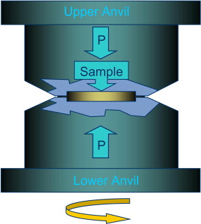
Figure 1. Schematic illustration of the HPT facility [28].

For optical microscopy (OM), samples were ground with SiC abrasive papers of 120, 800, 1200 and 4000 grit, and polished with 6 µm and 1 µm diamond paste (Struers). After grinding and polishing, etching with an acid solution containing HF, HNO₃, and H₂O in a volume ratio of 2:3:10 was conducted. The samples were observed in a BX41M-LED optical microscope equipped with a U-AN360-3 polarizer. A linear intercept method was used for measuring the average grain size and the standard deviation in OM images.
A JEM 3010 Transmission Electron Microscope (TEM) was used for TEM observation with an accelerating potential of 300 kV. TEM samples were cut from the HPT disk in the location 3 mm from the disk centre, and subsequently the TEM samples were prepared through twin-jet electropolishing with a solution containing 6% HClO₄ + 4% H₂O+ 90% ethanol under 30 V at a temperature between -30 to -25 ℃. The average grain size and the standard deviation are calculated from 100 grains in 15 random selected areas in TEM. Selected area electron diffraction (SAED) was carried out with a spot size of 360 nm.
To produce TiO₂ nanotubes on the surface of the samples, anodization was carried out using a two-electrode cell. In this work, a nonaqueous electrolyte containing 0.25 wt. % ammonium fluoride (Riedel-de Haën), 1 wt. % deionized water and 98.75 wt. % glycerol (Alfa Aesar) was used. Ti samples were anodes of the cell with a round area of a diameter of 0.6 mm exposed to the electrolyte. The dimension of those anode samples are all in the same size as the HPT sample: disk with a diameter of ~ 10 mm and thickness of ~ 0.6 mm. A constant direct current voltage of 30 V was used, with a distance of 1 cm between electrodes. For one-step anodization, samples were anodized for 16 h under 30 V. After peeling off the anodic layer formed from the first stage, a second stage 6 h anodization was carried out under 30 V on the substrate. After anodization, samples were rinsed in deionized water for 1 minute to remove the residual electrolyte. All experiments were performed at room temperature.
The morphology of TNT layers was observed on a Jeol JSM 6500F field-emission SEM in secondary electron mode. For these SEM observations, the layers were detached from the substrate and split by mechanical force. With the aid of Nano measurer 1.2 software, the diameters of 400 randomly chosen nanotubes (which have a nearly round shape) were measured, and the average, the standard deviation in the distribution and the accuracy of the measured average were determined. The average thickness and the standard deviation of TNT layers are measured from three randomly chosen cross-sections with 10 thicknesses on each cross-section measured. Aqueous contact angle measurements were performed in equilibrium conditions on a DSA100 Contact Angle Measuring Instrument (KRÜSS) (1 µL droplet volume of deionized water) based on the sessile drop method [31] and each measurement was repeated for five times to calculate the mean value as well as the standard deviation.

Results and analysis

Substrate characteristics before anodization
Figure 2 (a) shows the polarized light image of the CG sample with various colours due to different orientations of grains, revealing a mean grain size of 35 ± 3 µm. After 1 turn HPT processing, some directional flow patterns can be observed at the edge (Figure 2 (b)), while at the centre grains in the size of several microns are present (Figure 2 (c)). For the HPT-1T sample, the grain structure cannot be resolved by OM and, therefore, TEM is used to study the microstructures of the HPT-processed samples. Figure 2 (d) and (e) show bright field TEM images of the HPT-10T sample in the centre and edge areas, respectively, and Figure 2 (f) is a corresponding dark field image for Figure 2 (e). The heterogeneous contrasts detected in grain interiors in Figure 2 (f) are caused by defects such as dislocations and clusters of dislocations [32]. The in-set image is the SAED pattern with a spot size of 360 nm. It can be seen from these TEM images that after ten turns of HPT processing the microstructure is reasonably homogeneous with the centre and edge areas possessing a similar grain size of 140 ± 10 nm, whilst the extinction contours seen in the grain interior suggest significant lattice distortions associated with high internal stresses. Even with an aperture size as small as 360 nm, the diffraction pattern still presents numerous spots arranged in circles, indicating several grains with high angle grain boundaries are present in this small area [33]. In addition, the significant spreading of spots confirms the existence of high microstrains [34].
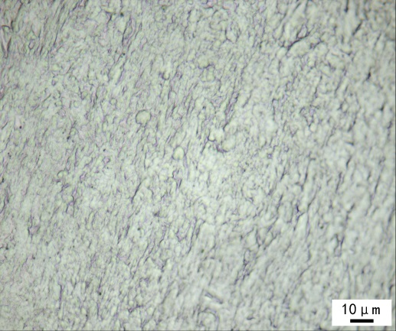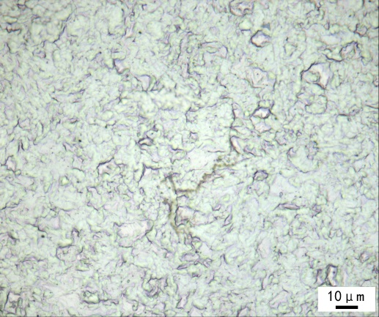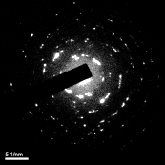
a
b
c
f
e
d
Figure 2. OM images of the titanium samples: (a) the CG sample, (b) the HPT-1T sample edge area and (c) centre area. TEM images of the HPT-10T sample: (d) bright-field image of the centre area, (e) bright-field image (SAED as an inset) and (f) the corresponding dark-field image of the edge area.

Figure 3 shows the XRD patterns of all the substrates with different grain sizes as well as the patterns of standard Ti powder sample; all peaks are from α titanium. No peaks of Ω phase, which has been reported to appear on HPT-processed Ti samples under higher pressures (6 GPa) [35], were detected. In Figure 3, the 6 main peaks due to the Ti planes ($10\overline{1}0$), ($0002)$, ($10\overline{1}1$), ($10\overline{1}2$), ($11\overline{2}0$) and ($10\overline{1}3$) are marked. The variations in relative peak intensities reveal the texture differs significantly between the CG and HPT samples and on progressing of HPT processing from 1 turn to 10 turns, the texture changes. In particular, the (0002) α plane is almost invisible in the CG sample, however at the early stage of HPT processing (1 turn), the (0002) α plane is already very obvious (Figure 3). The relative intensities of the five strongest peaks of the HPT samples are similar to the standard Ti powder sample [36].
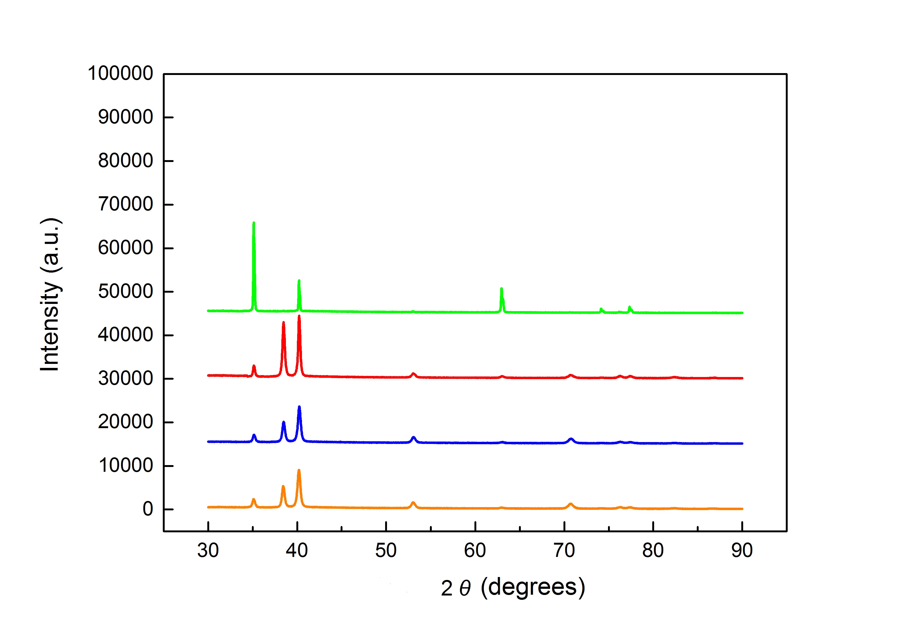Figure 3. XRD patterns of the Ti substrates with the XRD Ti powder pattern (PDF # 44-1294).
CG
HPT-1T
HPT-4T
HPT-10T
($10\overline{1}1$)
$$(0002)$$
)
($10\overline{1}0$)
($10\overline{1}3$)

($10\overline{1}2$)
($11\overline{2}0$)

PDF # 44-1294

Compared to the XRD profile of the CG sample, peak broadening was observed in all the HPT samples (Figure 3, which is due to grain refinement and internal microstrains [37]. The microstrains and crystalline sizes were calculated using the Rietveld full peak refinement method [38] and are shown in Figure 4. Figure 4 shows that with increasing deformation (from the CG sample to the HPT-10T sample), the microstrain increases while the grain size decreases. After one turn of HPT processing, the crystallite size has been significantly refined to below 100 nm. On increasing the HPT deformation (from the HPT-1T to the HPT-10T samples), the grain size continues to decrease but at a much smaller rate.
Figure 4. Microstrain and crystallite size calculated from XRD patterns of all the Ti samples with different grain size.

TNT Growth mechanisms for substrates in different grain sizes
To monitor the initiation and growth of TNT layers, Figure 5 shows the current-time, j-t, transient curves of all the samples. These curves show a three-stage behaviour [39], which is a typical feature of j-t curves during the formation of TNT layers [40, 41]. The inset image in Figure 5 shows the j-t curves in the first 2000 s of anodization with the three stages (Stage I, II and III) marked. In Stage I, a layer of compact oxide is formed following the reaction [41]:
 | Ti + 2H₂O → TiO₂ + 4H⁺ + 4e⁻ | Eq.1
As the potential U is constant, the electric field F=U/δ_{b} decreases continuously with increasing thickness of oxide δ_{b} leading to a drop of current to a minimum (j_{min}) at about 550 s (Figure 5). With the increase of d (from HPT-10T to the CG sample), j_{min} in Stage I increases (inset in Figure 5), suggesting a decreasing oxidation rate.
At Stage II there is a competition between Ti oxidation at the Ti/oxide interface and TiO₂ dissolution at the oxide/electrolyte interface due to the presence of F⁻ in the electrolyte [41]:
 | TiO₂ + 6F⁻ + 4H⁺ → [TiF₆]²⁻ + 2H₂O | Eq.2
Pores grow at the breakdown site causing the effective surface area to increase, and so j subsequently increases until it reaches a maximum as a result of the initiation of nanotube growth. In Stage II a transition from irregular to regular pores, i.e. self-organization, occurs. This is due to different pores competing for the total available current, with only pores with a sufficiently high current “surviving” [42], and thus establishing a self-organized growth of nanotubes. At Stage III, j approaches a nearly steady state. Because the rate of oxide formation at the metal/oxide interface is equal to the rate of oxide dissolution at the oxide/electrolyte interface, TNTs will grow into the Ti substrate in the vertical direction with continued anodization. The current density results show that in stage III (Figure 5), j increases with decreasing grain size, implying a rising growth rate due to the grain refinement produced by HPT.
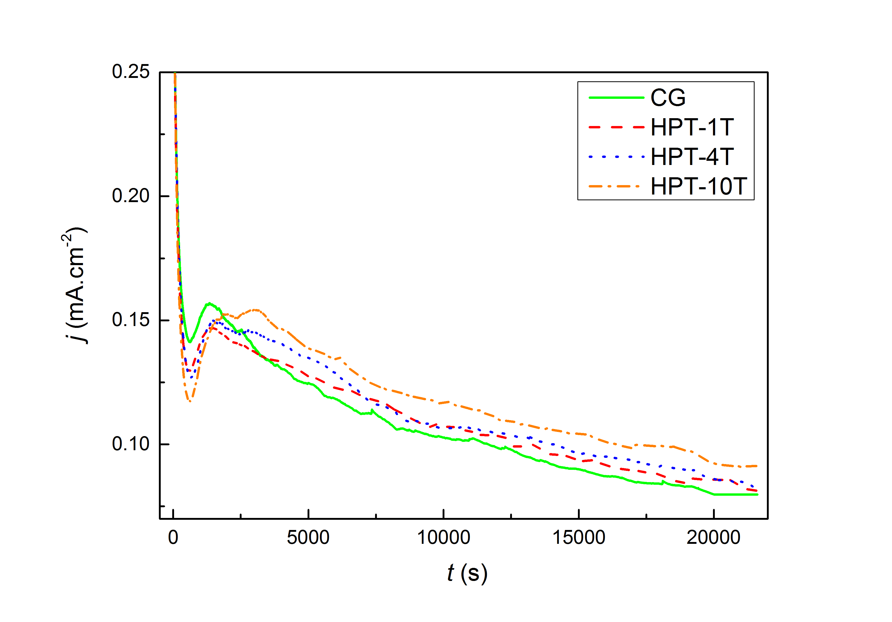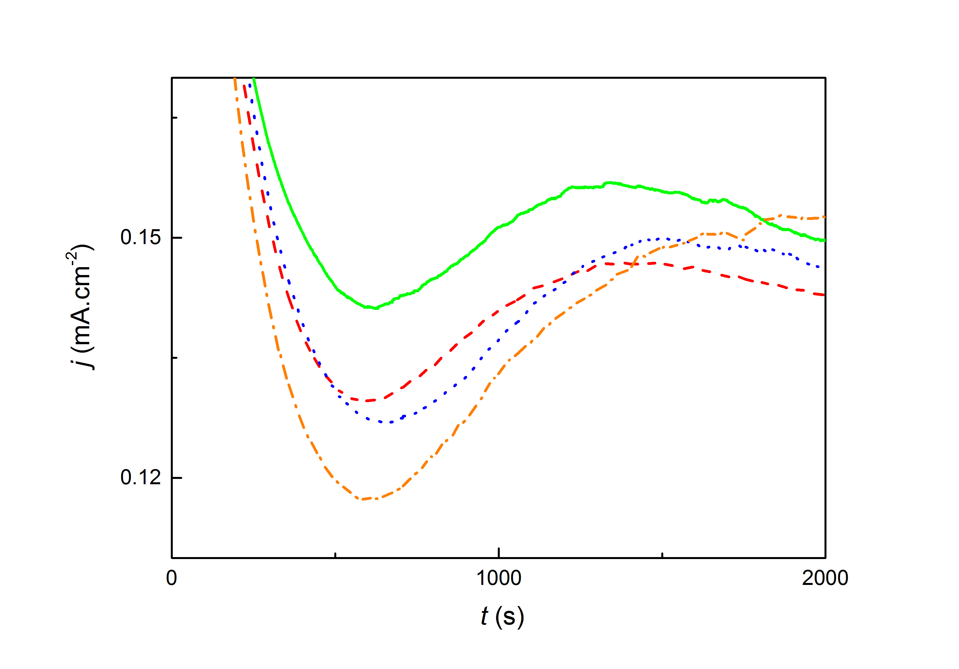Figure 5. The j-t curve for the CG and HPT samples with different grain sizes.
I
II
III
j_{min}

TNT morphologies and wettability
After the one-step anodization for 16 h and the subsequent removal of the TNT layer, the titanium substrates were anodized again in the same electrochemical setting for a 6 h second-step anodization. Figure 6 shows the top view of TNT layers on samples with different grain sizes. All the samples show hexagonally ordered imprints that are arranged in a hexagon (marked by red hexagons) left by TNTs in one-step anodization and in each imprint single or multi nanopores are contained (Figure 6 (a)). The nanopores seen in the SEM image top view (Figure 6 (a)) are openings of nanotubes. There are mainly two types of imprint patterns: Type and Type II. In the Type I pattern each imprint contains several small nanopores (mostly three in a triangle arrangement) like lotus roots. In the Type II pattern, illustrated in Figure 6 (c), each imprint contains only one comparatively large nanopore. For the CG, HPT-1T, HPT-4T and HPT-10T samples, the percentage of Type I pattern imprints are 57%, 33%, 29% and 10% respectively, which means that with the decrease of grain size induced by HPT processing, the TNT top morphologies gradually changed from Type I pattern dominating to Type II pattern dominating.

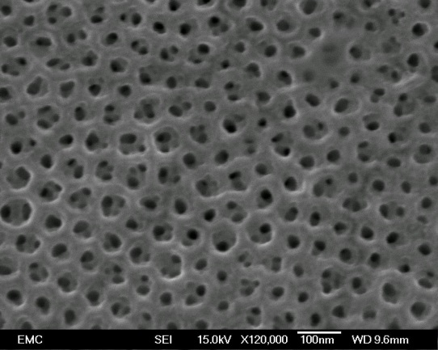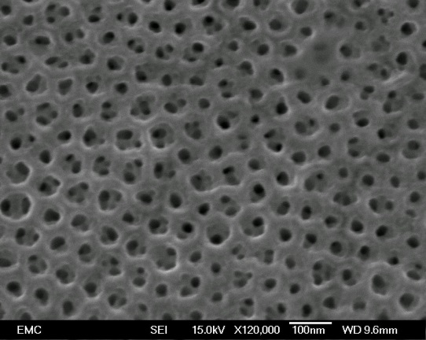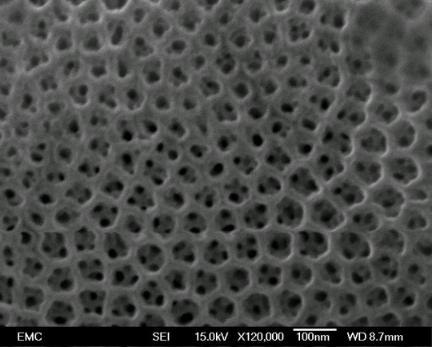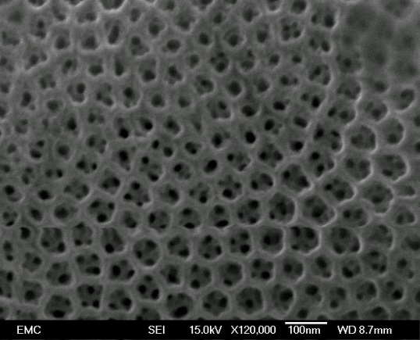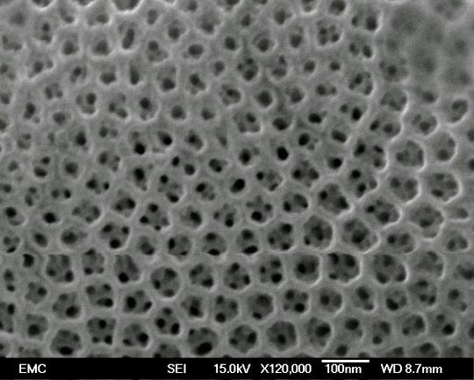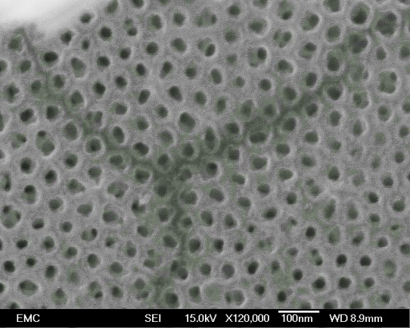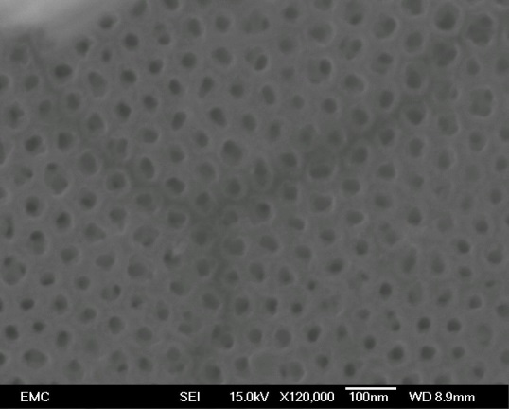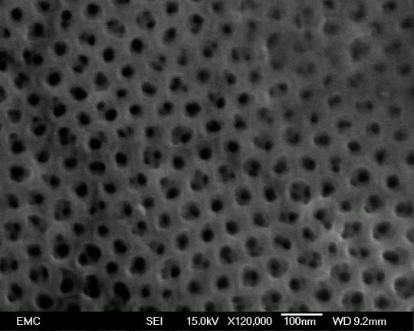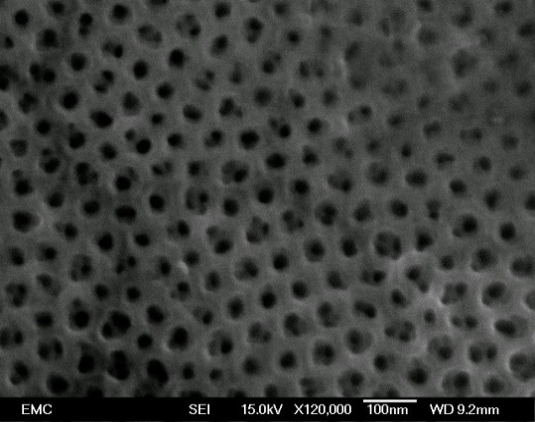
(b)

(a)

I
Imprint
Nanopore
(d)

(c)

II
Figure 6. SEM images of the top views of TNTs on Ti samples: (a) CG sample, (b) HPT-1T, (c) HPT-4T, (d) HPT-10T. Red hexagons illustrate the hexagonal arrangements of TNTs.
At the bottom of the TNT layers, TNTs are also in hexagonal arrangements as shown in Figure 7 (marked by red hexagons). The average bottom diameters of TNTs as determined from 400 analysed TNTs per sample are 56.9 ± 0.5, 48.4 ± 0.4, 52.7 ± 0.3 and 54.5 ± 0.3 nm for the CG, HPT-1T, HPT4T and HPT-10T samples, respectively. The standard deviations in the diameter distributions are 10, 8, 6 and 5 nm respectively, suggesting the homogeneity of TNT size increased with the decrease of grain size.

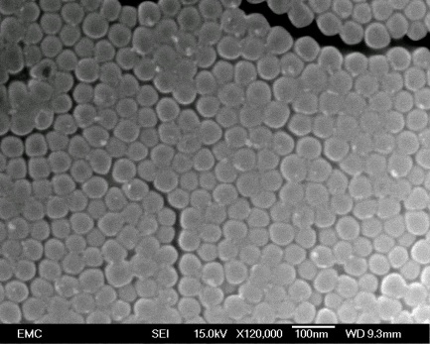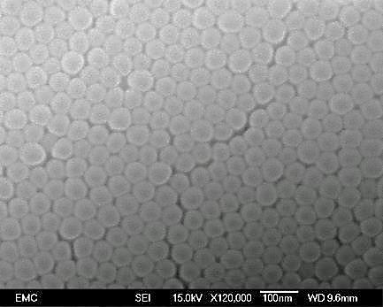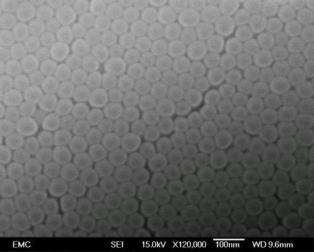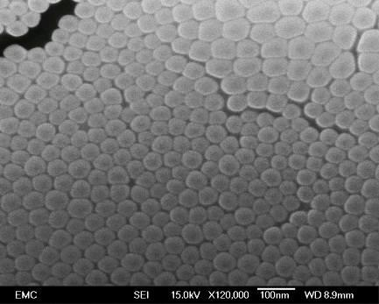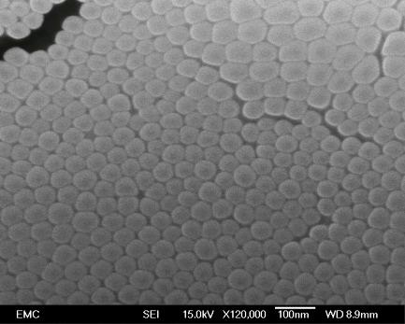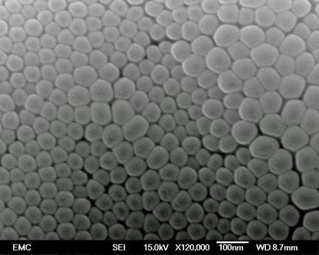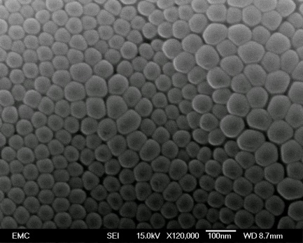
(c)

(d)

(b)

(a)

Figure 7. SEM images of the bottom views of TNTs on Ti samples: (a) CG sample, (b) HPT-1T, (c) HPT-4T, (d) HPT-10T.

The improved homogeneity can also be seen in the SEM images (Figure 7). In the TNT layers on the CG sample (Figure 7 (a)), the black arrow points at a large nanotube with diameter of ~80 nm and the white arrow points at a small nanotube with diameter of ~40 nm; in the TNT layers on the HPT-1T sample (Figure 7 (b)), the black and white arrow point at a large and a small nanotubes of ~70 nm and ~40 nm, respectively. However, the variation of nanotube size is much smaller in TNT layers on the HPT-4T sample (Figure 7 (c)) and HPT-10T sample (Figure 7 (d)), thus providing a visual confirmation of the measured trend in the standard deviations of the diameter distribution.
The SEM images in Figure 8 display cross-sectional views of TNT layers on samples with different grain sizes. From these cross-sectional views the TNT layer thickness was measured as 1.72, 1.90, 1.98 and 2.00 µm, respectively for the CG, HPT-1T, HPT4T and HPT-10T samples, i.e. the thickness of TNT layer increased with the decrease of grain size of the substrate. This corresponds with the ranking of j in Stage III (Figure 5), correlates with TNT formation rate [8, 43].
Figure 9 shows the measured aqueous contact angle, θ, of the four samples, with water droplets on the TNT layers in the measurement apparatus for selected samples shown below. These results show that the CG sample is hydrophilic (θ < 90°) while HPT samples are all hydrophobic (θ > 90°). The contact angle θ increased after one turn of HPT processing, and θ increases slightly with further HPT processing from the HPT-1T sample to the HPT-10T sample. This is thought to be related to the strong grain refinement from the CG sample to the HPT-1T sample (from 35 µm to below 100 nm), while the decrease in grain size from the HPT-1T sample to the HPT-10T sample is much weaker (Figure 4).
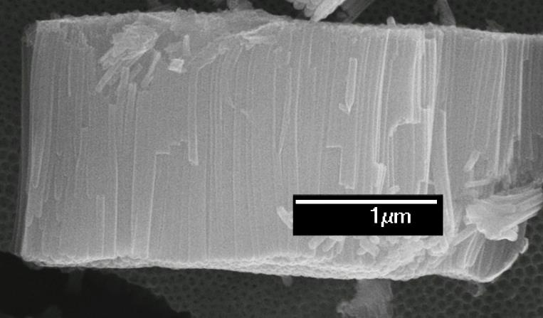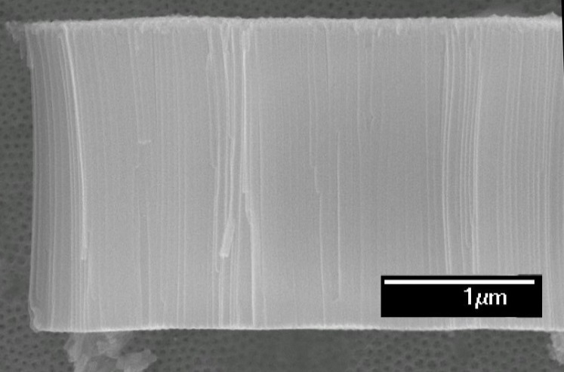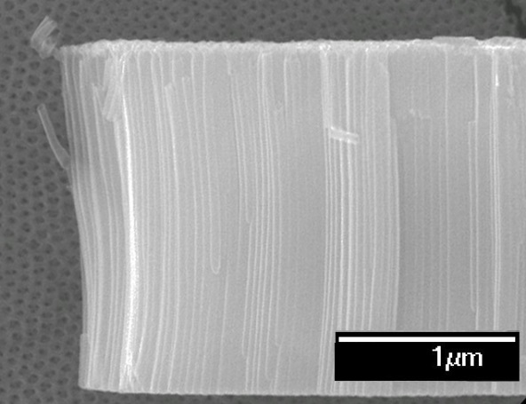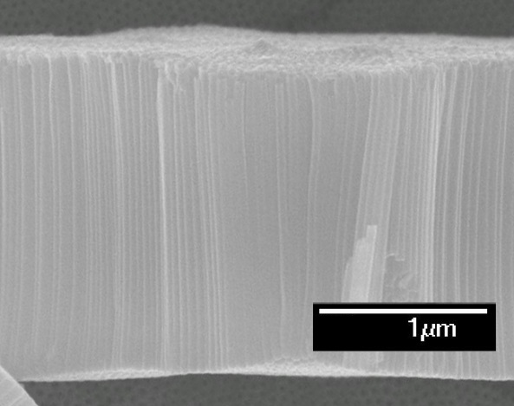
1722 ± 35 nm
(a)

2004 ± 10 nm
(d)

1977 ± 16 nm
(c)

1898 ± 45 nm
(b)

Figure 8. SEM images of the side views of TNT layers on Ti samples: (a) CG sample, (b) HPT-1T, (c) HPT-4T, (d) HPT-10T.

Discussion

The influence of HPT processing on the microstructure of CP titanium
HPT processing significantly alters the grain size, dislocation density and textures of CP Ti, and all these microstructure attributes may affect the anodization behaviour of Ti. In HPT processing, the imposed equivalent strain, $ε_{e}$, increases with increasing rotations, following the equation [44]:
 | $$ε_{e} =In (\frac{2πN⋅r⋅h_{0}}{h^{2}})$$ | Eq.3
where N is the number of rotations, r is the radius of the sample, $h_{0}$ denotes the initial thickness and h is the final thickness of the sample. The CG sample was fully annealed i.e. $ε_{e}$= 0. After one HPT rotation, $ε_{e}$ at the centre area (r = 0.1 mm) is ~ 0.4 while $ε$ at the edge area (r = 5 mm) is ~ 4.3. Due to this difference, the microstructure of the HPT-1T sample was inhomogeneous. However, after ten turns of HPT processing the centre areas have undergone a strain that is sufficient to cause substantial grain refinement and the microstructure is much more homogeneous with a grain size that is refined down to ~ 140 nm (Figure 2 (e)). Grain boundaries in our HPT-10T sample are curved and wavy, indicating the typical non-equilibrium feature of grain boundaries generated by SPD [32].
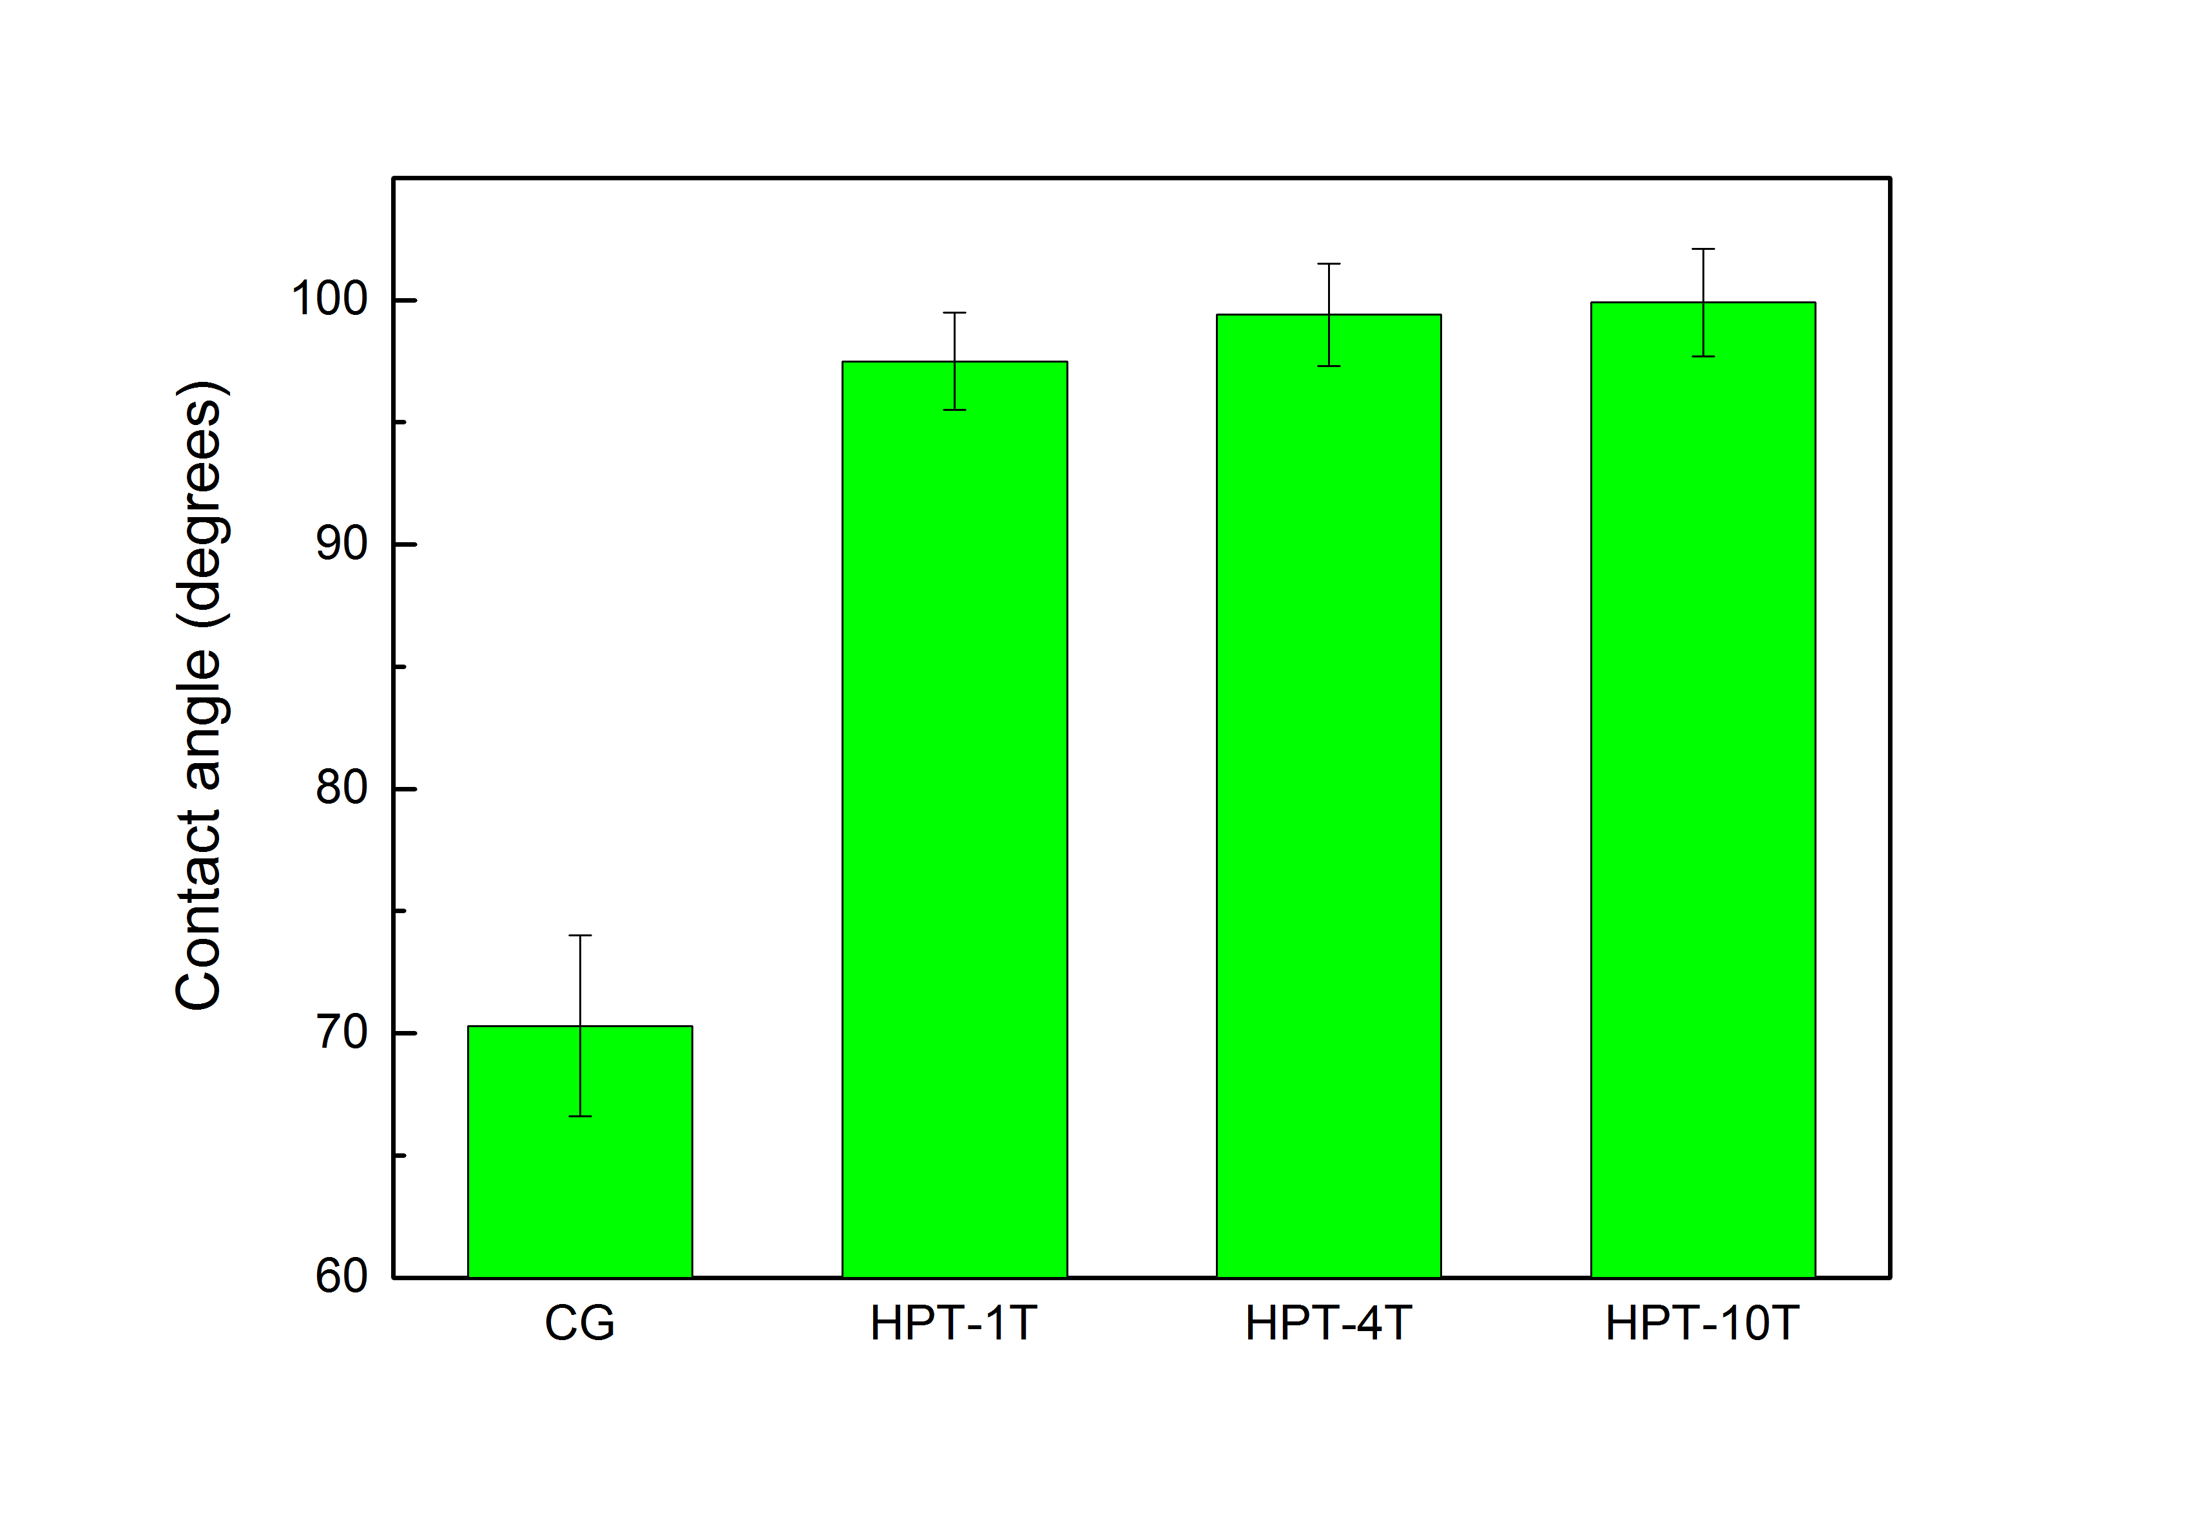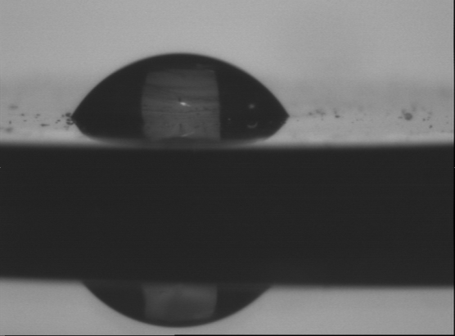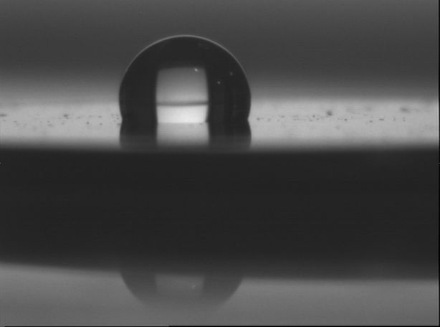
CG
HPT-10T
Figure 9. The aqueous contact angle for the TNT layers on the CG, HPT-1T, HPT-4T and HPT-10T samples after two-step anodization under 30V for 6h.
In HPT-processed Ti, the build-up of dislocations [45] occurs during deformation, and a detailed analysis of dislocation density and grain size data has shown [30] that dislocation hardening is the main factor determining the improvements in strength in many SPD-processed pure and CP metals [46, 47], including Ti. The XRD patterns of all the substrate Ti samples confirmed substantial grain refinement and the increase of microstrain during progressions of HPT processing. The dislocation density $ρ$ can be calculated from the lattice microstrain ${〈ε^{2}〉}^{\frac{1}{2}}$ and crystallite size $D$ by [48]:
 | $$ρ=\frac{2\sqrt{3}{〈ε^{2}〉}^{\frac{1}{2}}}{Db}$$ | Eq.4
where b is the Burgers vector. The latter equation combined with the present data (see Figure 4) indicates that the dislocation density increases with increasing HPT rotations, reaching a dislocation density of ~ 4.6ｘ10¹⁴ m⁻² in the HPT-10T sample. The grain size revealed by TEM is larger than those measured by the XRD line broadening analysis because the latter represents the coherent diffraction domain size, which is related to the sub-grain or dislocation cell size [32, 49].
HPT processing not only changes the grain size of Ti samples but also results in changes in the crystallographic texture and residual stress [15] and in some cases can induce a phase transformation [50]. However, no phase transformation was detected in this study. Before HPT processing, the CG sample exhibited preferred textures, while after HPT processing, the texture approaches a random texture. Particularly, whilst prior to HPT processing the (0002) peak was virtually undetectable, it becomes the second most intense peak after 10 turns (Figure 3), which is consistent with the powder pattern. Although the basal planes (0002) in Ti are not the most densely packed plane (the prism plane ($10\overline{1}0$) α is most densely packed), dislocation slip is initiated on basal plane, which is caused by the high pressure. HPT-4T and HPT-10T samples have almost identical textures, indicating the texture stabilizes after 4 turns.

The influence of HPT microstructure on the formation and growth of TNT layers
Figure 8 shows that with decreasing grain size imparted by HPT processing, the thickness of TNT layers increased, indicating HPT processing enhances TNT growth. Zhang et al. [51] carried out anodization on Ti samples with a nanocrystalline surface layer produced by surface mechanical attrition treatment (SMAT) and also found the formed TNT layers are much thicker than that on its CG counterpart surface. It is thought that the mechanisms for the enhanced growth in this and the latter work [51] relate to both HPT and SMAT substantially increasing the number of defects in the substrates which increases the free energy of the Ti. This favours the nucleation and growth of oxides due to the increased energy available. In support of this, the j-t curves in Figure 5 show that the HPT-10T sample has the thickest while the CG sample has the thinnest oxide layer at the end of Stage I. The current density j is related to the thickness of the compact oxide layer δ_{b} as [23]:
 | $$j={αe}^{β\frac{U}{δ_{b}}}$$ | Eq.5
where α and β are electrolyte and material dependent constants. From Eq. 5, it can be seen that a low j will cause a thick TiO₂ barrier layer δ_{b}. At the end of Stage I (Figure 5), j_{min} decreases in the sequence of CG, HPT-1T, HPT-4T and HPT-10T samples, and thus the thickness of the compact oxide layer is thought to increase in this order.
The present study indicates that HPT processing leads to more homogeneous TNT sizes and it is thought that the elimination of crystallographic texture plays an important role in this. It is known that grain orientations significantly influences nanotube growth, for instance, on (hkl0) planes the formation of oxide layer progresses much faster than those on (0001) planes [10, 12, 13]. As (0001) planes have the highest atomic surface density (1.6 times greater than that for the ($10\overline{1}0$) plane), which leads to an oxide layer with a high donor concentration, the O₂ evolution will govern the current density resulting in a thin oxide layer [13]. HPT processing refines a large grain (~35 µm for the CG sample) into ~250 small grains (~140 nm for the HPT-10T sample) with close to the random distribution of orientations; therefore, the influence of grain orientation on the growth of TNT layers is much reduced. In support of this proposed mechanism, it is noted that Ferreira et al. [52] found that extremely large grain size of heat treated pure Ti resulted in less regular and less homogeneous TNT layers because the large grains were nonequiaxed [52].
HPT was found to also change the top morphologies of TNT layers by increasing the percentage of Type II morphology patterns (Figure 6). It is thought that this change leads to the increase in the contact angle from the CG to the HPT-10T sample in Figure 9, mainly due to the more complex Type I pattern possessing a higher surface energy than the Type II pattern. Therefore, with the increasing percentage of Type II patterns, the surface energy of TNT layers decreases, resulting in an increasing contact angle, because surface with a lower energy has a higher contact angle. The different top morphology of TNTs is thought to be due to the HPT processing changing the dissolution rate of the oxides. Support for this suggestion can be found in Ref. [53] in which it is reported that the natural oxide layer on HPT Ti samples was quite different from that on their CG counterparts in chemical bonding structures: the XPS results for the HPT-processed substrates showed a weakening of the Ti bonding in the TiO₂ on the HPT sample [53], which may lead to the faster dissolution rate of the oxide during the formation of TNT layers. Since oxides on the HPT samples are prone to dissolution compared to those on their CG counterpart, the three triangular nanopores in Type I pattern dominating on the CG sample may further develop into one big hole, making Type II patterns.

Conclusions
In order to more accurately control the morphologies of anodic TNT layers in Ti substrates, the influence of substrate grain size is investigated by HPT processing of substrates followed by two-step anodization. After up to 10 turns of HPT processing under a 3 GPa pressure, the grains were gradually refined from ~35 µm to ~140 nm. The increase of dislocation density and grain boundaries due to HPT processing leads to TNT layers that are 14% thicker as compared to those of the counterparts. HPT processing also results in a more homogeneous distribution of TNT sizes because grain refinement reduces the influence of texture on the growth of TNT layers. Moreover, HPT processing also leads to a change in the oxide in the TNT layers, which are more prone to dissolution, so in the two-step anodization employed in the current study, HPT processing leads to a different TNT top surface patterns that are more hydrophobic.

Acknowledgements
This work was supported by a studentship from the Faculty of Engineering and the Environment at the University of Southampton and a scholarship from the China Scholarship Council (CSC). We thank Dr. John Low of the University of Warwick for his support of the anodization experiment.
References
[1] K.S. Brammer, S. Oh, J.O. Gallagher, S. Jin, Enhanced Cellular Mobility Guided by TiO2 Nanotube Surfaces, Nano Lett., 8 (2008) 786-793.
[2] J. Park, S. Bauer, K. von der Mark, P. Schmuki, Nanosize and vitality: TiO₂ nanotube diameter directs cell fate, Nano Lett., 7 (2007) 1686-1691.
[3] J. Park, S. Bauer, P. Schmuki, K. von der Mark, Narrow Window in Nanoscale Dependent Activation of Endothelial Cell Growth and Differentiation on TiO₂ Nanotube Surfaces, Nano Lett., 9 (2009) 3157-3164.
[4] L. Peng, M.L. Eltgroth, T.T.J. La, C.A. Grimes, T.A. Desai, The effect of TiO₂ nanotubes on endothelial function and smooth muscle proliferation, Biomaterials, 30 (2009) 1268-1272.
[5] J.P. Spatz, Cell–Nanostructure Interactions, Nanobiotechnology, Wiley-VCH Verlag GmbH & Co. KGaA2005, pp. 53-65.
[6] A.W. Tan, B. Pingguan-Murphy, R. Ahmad, S.A. Akbar, Review of titania nanotubes: Fabrication and cellular response, Ceram. Int., 38 (2012) 4421-4435.
[7] J. Dong, J. Han, X. Ouyang, W. Gao, How voltage dictates anodic TiO2 formation, Scripta Mater., 94 (2015) 32-35.
[8] A. Valota, M. Curioni, D.J. Leclere, P. Skeldon, P. Falaras, G.E. Thompson, Influence of Applied Potential on Titanium Oxide Nanotube Growth, J. Electrochem. Soc., 157 (2010) K243-K247.
[9] D. Regonini, A. Satka, A. Jaroenworaluck, D.W.E. Allsopp, C.R. Bowen, R. Stevens, Factors influencing surface morphology of anodized TiO2 nanotubes, Electrochim. Acta, 74 (2012) 244-253.
[10] S. Leonardi, A. Li Bassi, V. Russo, F. Di Fonzo, O. Paschos, T.M. Murray, H. Efstathiadis, J. Kunze, TiO₂ Nanotubes: Interdependence of Substrate Grain Orientation and Growth Characteristics, The Journal of Physical Chemistry C, 116 (2011) 384-392.
[11] S. Leonardi, V. Russo, A. Li Bassi, F. Di Fonzo, T.M. Murray, H. Efstathiadis, A. Agnoli, J. Kunze-Liebhauser, TiO2 nanotubes: interdependence of substrate grain orientation and growth rate, ACS Appl Mater Interfaces, 7 (2015) 1662-1668.
[12] G.A. Crawford, N. Chawla, Tailoring TiO2 nanotube growth during anodic oxidation by crystallographic orientation of Ti, Scripta Mater., 60 (2009) 874-877.
[13] U. König, B. Davepon, Microstructure of polycrystalline Ti and its microelectrochemical properties by means of electron-backscattering diffraction (EBSD), Electrochim. Acta, 47 (2001) 149-160.
[14] J.M. Macak, M. Jarosova, A. Jäger, H. Sopha, M. Klementová, Influence of the Ti microstructure on anodic self-organized TiO2 nanotube layers produced in ethylene glycol electrolytes, Appl. Surf. Sci., 371 (2016) 607-612.
[15] M. Nie, C. Wang, M. Qu, N. Gao, J. Wharton, T. Langdon, The corrosion behaviour of commercial purity titanium processed by high-pressure torsion, Journal of Materials Science, 49 (2014) 2824-2831.
[16] J.H. Gao, S.K. Guan, Z.W. Ren, Y.F. Sun, S.J. Zhu, B. Wang, Homogeneous corrosion of high pressure torsion treated Mg–Zn–Ca alloy in simulated body fluid, Materials Letters, 65 (2011) 691-693.
[17] H. Nakano, H. Yamaguchi, Y. Yamada, S. Oue, I.-J. Son, Z. Horita, H. Koga, Effects of High-Pressure Torsion on the Pitting Corrosion Resistance of Aluminum-Iron Alloys, Materials Transactions, 54 (2013) 1642-1649.
[18] A. Korchef, A. Kahoul, Corrosion Behavior of Commercial Aluminum Alloy Processed by Equal Channel Angular Pressing, International Journal of Corrosion, 2013 (2013) 11.
[19] M. Adachi, Y. Murata, I. Okada, S. Yoshikawa, Formation of Titania Nanotubes and Applications for Dye-Sensitized Solar Cells, J. Electrochem. Soc., 150 (2003) G488-G493.
[20] A.S. Arico, P. Bruce, B. Scrosati, J.M. Tarascon, W. Van Schalkwijk, Nanostructured materials for advanced energy conversion and storage devices, Nature Materials, 4 (2005) 366-377.
[21] B. O'Regan, M. Gratzel, A low-cost, high-efficiency solar cell based on dye-sensitized colloidal TiO2 films, Nature, 353 (1991) 737-740.
[22] I.D. Kim, A. Rothschild, B.H. Lee, D.Y. Kim, S.M. Jo, H.L. Tuller, Ultrasensitive chemiresistors based on electrospun TiO2 nanofibers, Nano Lett., 6 (2006) 2009-2013.
[23] R.Z. Valiev, Y. Estrin, Z. Horita, T.G. Langdon, M.J. Zehetbauer, Y.T. Zhu, Producing bulk ultrafine-grained materials by severe plastic deformation, JOM, 58 (2006) 33-39.
[24] A.P. Zhilyaev, T.G. Langdon, Using high-pressure torsion for metal processing: Fundamentals and applications, Prog. Mater Sci., 53 (2008) 893-979.
[25] N. Hu, N. Gao, M.J. Starink, The influence of surface roughness and high pressure torsion on the growth of anodic titania nanotubes on pure titanium, Appl. Surf. Sci., In press (2016).
[26] J.M. Macak, S.P. Albu, P. Schmuki, Towards ideal hexagonal self-ordering of TiO2 nanotubes, Physica Status Solidi (RRL) – Rapid Research Letters, 1 (2007) 181-183.
[27] S. Li, G. Zhang, D. Guo, L. Yu, W. Zhang, Anodization Fabrication of Highly Ordered TiO2 Nanotubes, The Journal of Physical Chemistry C, 113 (2009) 12759-12765.
[28] C. Xu, Z. Horita, T.G. Langdon, The evolution of homogeneity in an aluminum alloy processed using high-pressure torsion, Acta Mater., 56 (2008) 5168-5176.
[29] Y. Chen, N. Gao, G. Sha, S.P. Ringer, M.J. Starink, Microstructural evolution, strengthening and thermal stability of an ultrafine-grained Al–Cu–Mg alloy, Acta Mater., 109 (2016) 202-212.
[30] L. Lutterotti, S. Gialanella, X-ray diffraction characterization of heavily deformed metallic specimens, Acta Mater., 46 (1998) 101-110.
[31] A.S. Dimitrov, P.A. Kralchevsky, A.D. Nikolov, H. Noshi, M. Matsumoto, Contact angle measurements with sessile drops and bubbles, J. Colloid Interface Sci., 145 (1991) 279-282.
[32] Y.T. Zhu, J.Y. Huang, J. Gubicza, T. Ungár, Y.M. Wang, E. Ma, R.Z. Valiev, Nanostructures in Ti processed by severe plastic deformation, J. Mater. Res., 18 (2003) 1908-1917.
[33] A.V. Sergueeva, V.V. Stolyarov, R.Z. Valiev, A.K. Mukherjee, Advanced mechanical properties of pure titanium with ultrafine grained structure, Scripta Mater., 45 (2001) 747-752.
[34] R.Z. Valiev, R. Islamgaliev, I. Alexandrov, Bulk nanostructured materials from severe plastic deformation, Prog. Mater. Sci., 45 (2000) 103-189.
[35] K. Edalati, E. Matsubara, Z. Horita, Processing Pure Ti by High-Pressure Torsion in Wide Ranges of Pressures and Strain, Metallurgical and Materials Transactions A, 40 (2009) 2079-2086.
[36] Standard JCPDS Diffraction Pattern 44-1294 (hexagonal Ti), JCPDS-International Center for Diffraction Data, PDF-2 Data-base, 12 19073-13273.
[37] T. Ungár, Microstructural parameters from X-ray diffraction peak broadening, Scripta Mater., 51 (2004) 777-781.
[38] H. Rietveld, A profile refinement method for nuclear and magnetic structures, J. Appl. Crystallogr., 2 (1969) 65-71.
[39] J.M. Macak, H. Tsuchiya, A. Ghicov, K. Yasuda, R. Hahn, S. Bauer, P. Schmuki, TiO2 nanotubes: Self-organized electrochemical formation, properties and applications, Current Opinion in Solid State and Materials Science, 11 (2007) 3-18.
[40] G.K. Mor, O.K. Varghese, M. Paulose, K. Shankar, C.A. Grimes, A review on highly ordered, vertically oriented TiO2 nanotube arrays: Fabrication, material properties, and solar energy applications, Sol. Energy Mater. Sol. Cells, 90 (2006) 2011-2075.
[41] P. Roy, S. Berger, P. Schmuki, TiO2 Nanotubes: Synthesis and Applications, Angewandte Chemie-International Edition, 50 (2011) 2904-2939.
[42] L.V. Taveira, J.M. Macák, H. Tsuchiya, L.F.P. Dick, P. Schmuki, Initiation and Growth of Self-Organized TiO2 Nanotubes Anodically Formed in NH4F ∕ ( NH4 ) 2SO4 Electrolytes, J. Electrochem. Soc., 152 (2005) B405-B410.
[43] J.M. Macak, P. Schmuki, Anodic growth of self-organized anodic TiO2 nanotubes in viscous electrolytes, Electrochim. Acta, 52 (2006) 1258-1264.
[44] A.P. Zhilyaev, G.V. Nurislamova, B.K. Kim, M.D. Baró, J.A. Szpunar, T.G. Langdon, Experimental parameters influencing grain refinement and microstructural evolution during high-pressure torsion, Acta Mater, 51 (2003) 753-765.
[45] M.J. Starink, X. Cheng, S. Yang, Hardening of pure metals by high-pressure torsion: A physically based model employing volume-averaged defect evolutions, Acta Mater., 61 (2013) 183-192.
[46] X.G. Qiao, N. Gao, M.J. Starink, A model of grain refinement and strengthening of Al alloys due to cold severe plastic deformation, Philos. Mag., 92 (2012) 446-470.
[47] X.G. Qiao, M.J. Starink, N. Gao, Hardness inhomogeneity and local strengthening mechanisms of an Al1050 aluminium alloy after one pass of equal channel angular pressing, Materials Science and Engineering: A, 513–514 (2009) 52-58.
[48] G.K. Williamson, R.E. Smallman, III. Dislocation densities in some annealed and cold-worked metals from measurements on the X-ray debye-scherrer spectrum, Philos. Mag., 1 (1956) 34-46.
[49] Y.H. Zhao, X.Z. Liao, Z. Jin, R.Z. Valiev, Y.T. Zhu, Microstructures and mechanical properties of ultrafine grained 7075 Al alloy processed by ECAP and their evolutions during annealing, Acta Mater., 52 (2004) 4589-4599.
[50] Y. Todaka, H. Azuma, Y. Ohnishi, H. Suzuki, M. Umemoto, Influence of strain amount on stabilization of ω-phase in pure Ti by severe plastic deformation under high-pressure torsion, Journal of Physics: Conference Series, 240 (2010) 012113.
[51] L. Zhang, Y. Han, Effect of nanostructured titanium on anodization growth of self-organized TiO₂ nanotubes, Nanotechnology, 21 (2010) 055602.
[52] C.P. Ferreira, M.C. Gonçalves, R. Caram, R. Bertazzoli, C.A. Rodrigues, Effects of substrate microstructure on the formation of oriented oxide nanotube arrays on Ti and Ti alloys, Appl. Surf. Sci., 285, Part B (2013) 226-234.
[53] S. Faghihi, A.P. Zhilyaev, J.A. Szpunar, F. Azari, H. Vali, M. Tabrizian, Nanostructuring of a Titanium Material by High-Pressure Torsion Improves Pre-Osteoblast Attachment, Adv. Mater., 19 (2007) 1069-1073.

