UV generation in silica optical fibres: from rare earth doping to nonlinear optics in nanofibers
M.I.M. Abdul Khudus¹, Y. Wang¹, F. De Lucia¹, J. He¹, M. Beresna¹, P. Sazio¹, P. Horak¹, N. Chiodini¹², Gilberto Brambilla¹
¹Optoelectronics Research Centre, University of Southampton, Southampton, SO17 1BJ, UK
¹Università degli Studi di Milano-Bicocca,Piazza dell'Ateneo Nuovo, 1 - 20126, Milano, Italy
Email: G.Brambilla@soton.ac.uk, web site: http://www.orc.soton.ac.uk
UV generation in optical fibres has long been deemed challenging because of lack of suitable lasing ions in the UV and the poor transparency of germanosilicate fibres at wavelengths shorter than λ=400nm.
In our experiments, optical fibres with pure silica core and fluorosilicate cladding have been used, providing a loss smaller than 1dB/m at λ<300nm. Two different techniques were used to achieve light generation at λ<400nm: nonlinear optics in tapered optical fibres with sub-micrometric diameter (nanofibers) and doping with rare-earths.
Rare earth doping has been the most-successful method to generate laser light in the near-IR using Yb, Er, Ho and Tm as main dopants. Generation in the UV has been challenging because of the multitude of energy levels preset in most of the rare earths. Because of its f shell half full, Gd does not have any optical transition in the visible/near IR and shows the first excited level at λ=316nm, corresponding to a wavenumber difference >32000cm-1 for the transition ⁶P → ⁸S. Fig. 1 (a) shows the emission of Gd dopes silica at 316nm; this can be used to efficiently generate light in the UV because Gd does not present requirements for a low-phonon energy host that other rare earths have.
Modes propagating in optical nanofibers have a decreasing effective index for decreasing diameters, thus they can be effectively phase matched with higher order modes at shorter wavelengths. More generally, the tailorable dispersion of the optical nanofibers allow to phase match the propagation constant of multiple frequencies involved in a variety of nonlinear effects, including third harmonic generation (THG) and four wave mixing (FWM). While THG generation can effectively transfer energy to short wavelengths [1], its efficiency is intrinsically limited by the strict limitations on the diameter, meaning that even intrinsic surface waves are enough to mismatch the modes involved in this nonlinear process [2]. On the contrary, four wave mixing imposes a less strict limitation on the diameter [3] allowing for a fully fiberized narrowband UV source. By using a Master Oscillator Power Amplifier (MOPA) working at 1550.3 nm and a periodically poled silica fibre (PPSF) (producing a second harmonic (SH) frequency at 775.2 nm and a signal at the third harmonic (TH) frequency of 516.7 nm via degenerate FWM), the generation of the fourth harmonic (FH) at 387.6 nm and the fifth harmonic (5H) at 310nm was observed using the degenerate and non-degenerate FWM. Fig. 1(b) shows the signal generated at 310nm and its dependence on the nanofiber diameter.
(a)
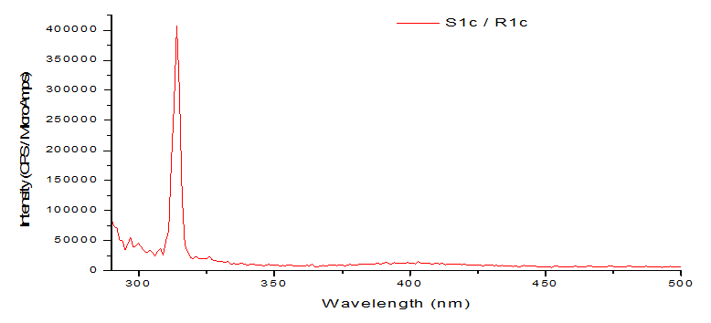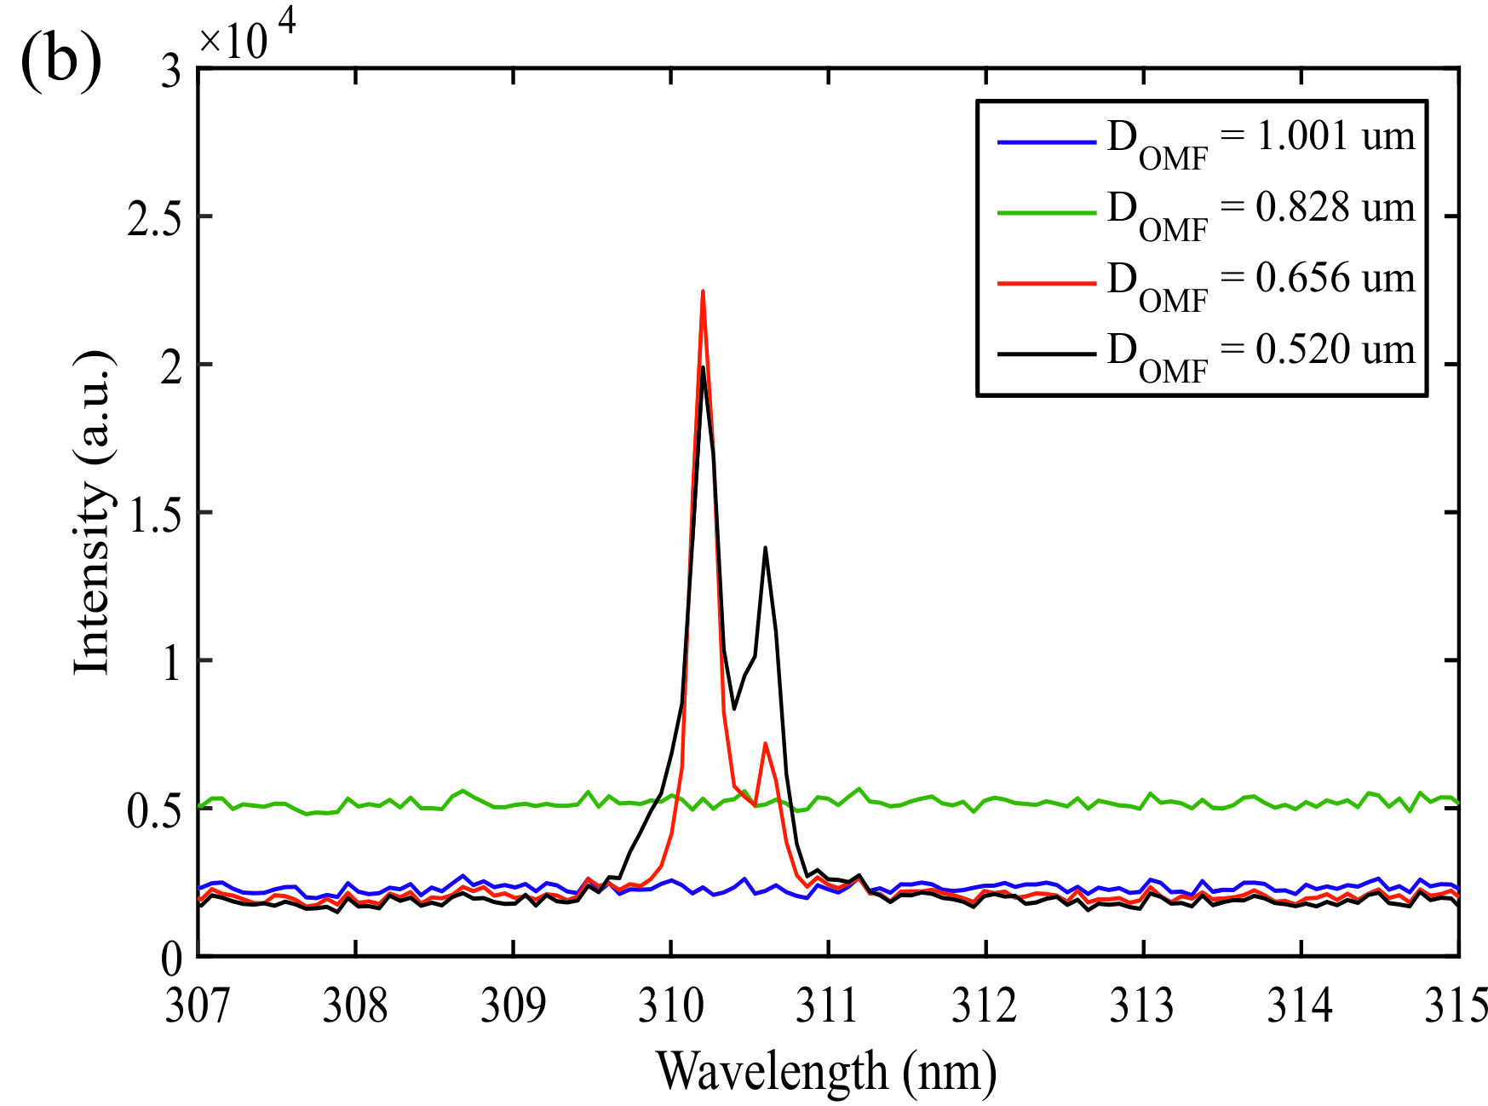
Fig1. (a) Emission of the Gd-doped silica sample. (b) Signal generated at 310nm by FWM for different optical microfiber (OMF) diameters.
- M.I.M. Abdul Khudus, T. Lee, T. Huang, X. Shao, P. P. Shum, G. Brambilla, Fiber and Integrated Optics 34(1-2), 53 (2015).
2. M.I.M.Abdul Khudus, T. Lee, P. Horak, G. Brambilla, Optics Letters 40(7), 1318 (2015).
3. M. Abdul Khudus, F. De Lucia, C. Corbari, T. Lee, P. Horak, P. Sazio, G. Brambilla, Optics Letters 41(4), 761 (2016).

Presentation Method (Invited/Regular Oral/Poster): Invited

