Lloyd’s mirror interference lithography with the EUV radiation from a high harmonic source

H. Kim1,2,*, P. Baksh1, M. Odstrcil1,2, M. Miszczak1, J. G. Frey3, L. Juschkin2, and W. S. Brocklesby1

1Optoelectronics Research Centre, University of Southampton, SO17 1BJ, United Kingdom

2Chair for Experimental Physics of Extreme ultraviolet, RWTH Aachen University and JARA FIT, Steinbachstr. 15, 52074, Aachen, Germany

3School of Chemistry, University of Southampton, SO17 1BJ, United Kingdom

4Peter Grünberg Institut (PGI-9), Forschungszentrum Jülich GmbH, JARA-FIT, 52425 Jülich, Germany

We demonstrate interference lithography using a high-harmonic source. Extreme ultraviolet (EUV) radiation is produced using high harmonic generation with 800 nm light from a femtosecond Ti:Sapphire laser (40 fs pulses, 1kHz, 2W average power) in argon gas. Interference patterns created using a Lloyd’s mirror setup and monochromatized radiation at the 27th harmonic (29nm) are recorded using ZEP-520A photoresist, producing features with < 200 nm pitch. The influence of the use of femtosecond pulsed EUV radiation on the recorded pattern is investigated. The capability of the high-harmonic source for high-resolution patterning is discussed.

Keywords: High harmonic generation, interference lithography, extreme ultraviolet, pulsed radiation

Extreme ultraviolet (EUV) interference lithography (IL) is a powerful method to fabricate high-resolution patterns over a large area without a complex imaging system. The main requirement for EUV-IL is high intensity coherent plane wave illumination in order to deliver the sufficient radiation dose to the photoresist plane. A particular issue is the availability of appropriate optical components such as beam splitters, and reflective or spectrally filtering mirrors for the particular optical wavelength used. Those components can be obtained simply in case of the use of radiation in the spectral range over deep ultra-violet, ultraviolet, and IR laser where refractive optic elements are available [1-3].

When using EUV or soft X-ray radiation, different strategies to split and recombine the parallel beam have been demonstrated such as reflective beam splitters [4-7] or multiple diffraction gratings [8, 9]. These demonstrations were performed with both a synchrotron radiation source and a plasma based EUV laser. In the demonstration performed using synchrotron radiation, monochromatized and spatially filtered light at 13.5 nm wavelength from an undulator provided the necessary temporal and spatial coherent with sufficient intensity flux [4]. The plasma based EUV laser is also a suitable radiation source for IL as it was demonstrated using a compact Ne-like Ar capillary discharge laser at wavelength of 46.9 nm producing EUV radiation of around 0.2 mJ with maximum repetition rate of several Hz [6].

Interference lithography has also been performed in the UV and IR spectral range with femtosecond pulsed lasers [3, 10, 11]. The second harmonic of femtosecond pulses (380 nm, 80 fs, 82 MHz) was split by a diffractive beam splitter and overlapped with two lenses [10]. Femtosecond laser pulse (800 nm, 90 fs) was used for lithographical laser ablation to fabricate a homogeneous nano-grating of metal [3, 11]. The EUV-IL demonstrations using a synchrotron radiation source and a plasma based EUV laser have used radiation with a pulse duration at around 1-2 ns. The effect of high-density ionization using ultra-short EUV pulsed generated by a free electron laser (FEL) on the sensitivity of a non-chemically amplified resist was investigated [12]. It was shown that the multiple reaction with the ultrahigh-brightness pulses provided by EUV-FEL radiation changes the sensitivity of the resist.

High harmonic generation (HHG) provides coherent radiation in a wide EUV spectral range (10-40 nm) with emission peaks at odd harmonics of the driving laser field, ω. The degree of temporal coherence of each individual peak is in the order of Δλ/λ ~ 10-3. The spatial coherence length depends on the HHG phase-matching process in the gas-cell based high harmonic source. High spatial coherence and low divergence of the HHG beam was already presented [13, 14].

In this work, we demonstrate Lloyd’s mirror IL with EUV radiation generated by a HHG source. The demonstration was performed with a monochromatized radiation centered around 29 nm wavelength, and the small angle of the Lloyd’s mirror allows us to achieve fringes with sub 200 nm pitch. We analyze the expected optical properties of the interference fringes on the photoresist.

The interference fringes are formed due to constructive and destructive interference between the split beams of the reflected wave and the direct wave in the Lloyd’s mirror arrangement (Fig 1.). The period (pitch) of the interference fringe is determined by the angle between two beams, and is given by:

|  |  |  |
| --- | --- | --- |
|  | pitch = λ / [2 sin(θ1+ θ2)] | (1) |

where θ1 is an angle of direct beam, and θ2 is an angle of reflected beam both to the normal of the wafer. The number of the pitches (N) in the interference field is limited by temporal coherence of the incident beam given by:

|  |  |  |
| --- | --- | --- |
|  | N ≤ λ/Δλ | (2) |

due to the phase delay of the reflected wave interacting with the direct wave. In this experiment, λ/Δλ ≈ 250 was estimated.

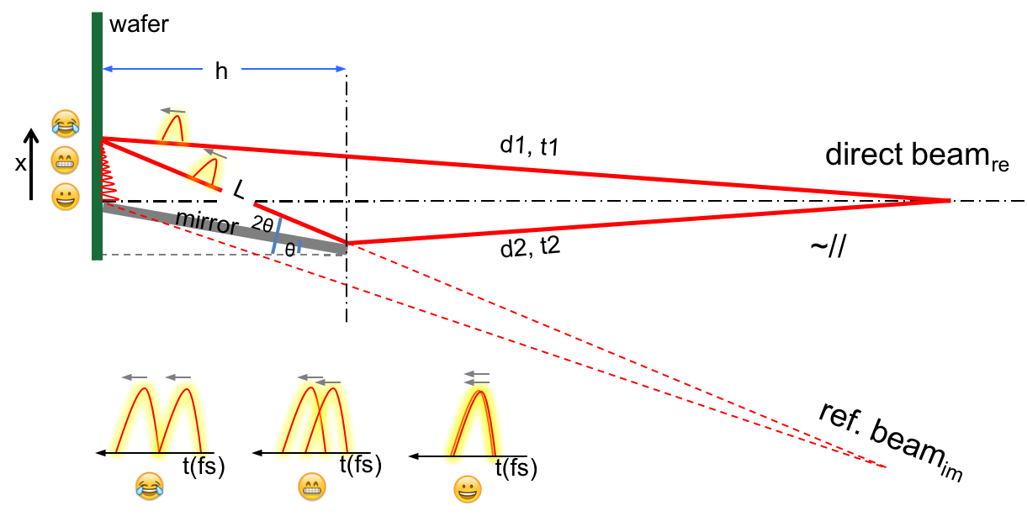

Fig. 1. Schematic of the Lloyd mirror IL with a focusing beam: reflected and direct beams having different optical paths (d) and arriving times (t) are illustrated. The angle of mirror is θ from normal. The visibility of fringes decreases away from the edge due to the optical path difference between two short pulses.

Fig. 1 illustrates the Lloyd’s mirror IL in this experimental setup. The divergence of the EUV beam after the gas cell is around 1-2 mrad, and after the spherical mirror it is around 5-15 mrad in Fig. 2. In the analysis, we assume θ1 is approximated to normal angle, and θ2 is approximated as twice of the mirror’s angle. In the Lloyd’s mirror system, a reflective mirror splits a part of incident beam and redirects the reflected part to generate a second beam. During this separation, an optical path difference (OPD) between the two beams occurs. Using fs-pulsed radiation, the OPD has to be controlled in the range of only a few micrometers. The fringe profile visibility decreases away from the edge (the line shared by photoresist plane and the mirror plane) due to the increase of the OPD.

The OPD yields time delay for the reflected beam arriving at the target plane. OPD is approximately ‘*L-h*’ as illustrated in Fig. 1, and increases with the angle (θ). In the photoresist plane, the delay increases proportionally with the distance (*x* in Fig. 1) from the edge. The field length of the fringe along the x-direction is estimated to {OPD×(tan(2θ)–tan(θ))/(1/cos(2θ)-1)} from a geometrical approximation. The time difference between the two pulses is OPD/*c* (*c*: speed of light in vacuum), and it must not exceed the pulse duration, ‘*L - h* = OPD < pulse duration × *c*’. The temporal overlap of the two pulses, which determines the interference term, decreases with the OPD. Also the interference region depends on the angle θ and the pulse duration. Rapid reduction in the visibility is expected when θ > 15°.

The intensity profile of interference fringes can be described as following:

|  |  |  |
| --- | --- | --- |
|  | I = I1 + I2 + 2√(I1I2).Re γ12(τ). | (3) |

I1 and I2 are intensities of the direct and the reflected beams respectively. γ12(τ) is the interference term, where τ is the time difference of two optical paths, which is called the degree of partial coherence [15, 16].

The visibility of interference fringes is given by:

|  |  |  |
| --- | --- | --- |
|  | . | (4) |

In the lithographic performance, the fringe visibility depends on the result of the photoresist response. The depth of the radiation induced grooves depends on the fluence (mJ/cm2).

Using EUV radiation, the interference region (*x*) is also influenced by the mirror’s reflectivity. The maximum angle is limited to around 20° with a thick Si mirror for radiation with 29 nm wavelength. We use a Si mirror at θ ≈ 3 - 4° providing reflectivity around 95% for the EUV wavelengths used in this demonstration.

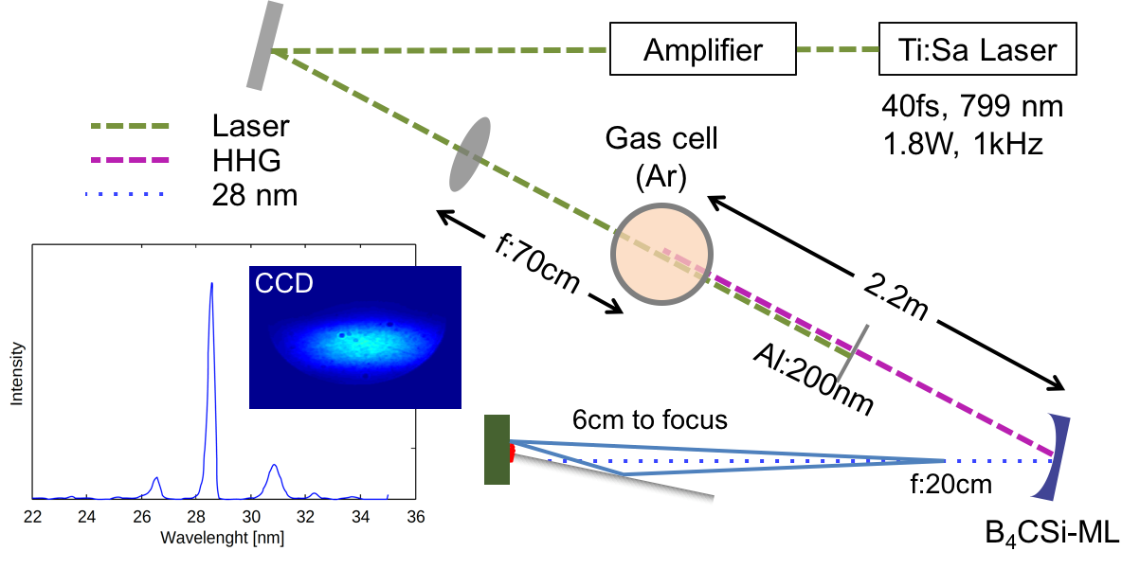

Fig. 2. Schematic of HHG and Lloyd’s mirror IL: The laser is s-polarized. The inset image is the spectrum of the EUV after the ML mirror. The CCD image of the beam is stretched by the spherical mirror.

Our experimental setup is illustrated in Fig. 2. We use a HHG system based on a Ti:Sapphire laser (780 nm, 40 fs) amplified by a regenerative chirped pulsed amplifier (CPA). The laser beam (1014 W/cm2 at gas cell position, 1.8 mJ/pulse, 1kHz repetition rate) is focused into a 3 mm long gas cell filled with 60 mbar of argon gas. The strong E-field has around 40 fs pulse duration. A single Al foil (200 nm thickness) is used to block the fundamental laser and to transmit the EUV radiation (approximately 30 % transmission). Then, in order to suppress unwanted spectral components, the beam is spectrally filtered by a curved B4C/Si multilayer (ML) mirror, which reflects and focuses the main wavelength at ~ 29 nm (27th harmonic, Δλ/λ ~ 4×10-3) and ±1 harmonics from the main wavelength with very low intensity. The spectrum after the ML mirror is shown in the inset image in Fig. 2. The Gaussian shaped illumination profile measured by an EUV-sensitive CCD camera (Andor DX-434, 1024×1024 pixels) is shown in the inset CCD image in Fig. 2. The estimated photon flux was ~1.86×109 photons/s in the whole area of the spot.[1]

Before performing the IL, we have conducted exposure tests for sampled photoresist. We used a positive-tone photoresist (dilution ratio: ZEP-520A:Anisole=1:3). The photoresist was spin coated (5000 rpm, 1 min.) on a silicon wafer for the target thickness of ~ 40-60 nm and baked for 2 min. at 180 °C on a hotplate. In the setup (vacuum chamber), the photoresist-coated wafer was mounted perpendicularly to the beam. The exposure time was varied from 0.5 to 15 second at several positions between ±5 mm from the EUV focus in order to record the cross-sectional profile of the beam. After the exposure, the wafer was developed with ZED N50 for 90 s and rinsed with 2-Propanol for 30 s. The result was investigated with an optical microscope (Nikon-Eclipse-L200) to measure the intensity profile of the beam.

The result is analyzed regarding the removed resist thickness in dependence on the radiant fluence (exposure dose), which is related to the lithographic sensitivity of the photoresist with this EUV radiation. The dependence of thickness of removed photoresist (depth from surface) on fluence is plotted in Fig. 3.

The ZEP-520A is a positive-tone photoresist, which is a modern alternative to PMMA, based on the co-polymer compound (Zeon Corp.). The molecular mechanisms of ZEP-520A are not entirely understood yet [17].

The photoresist process separates into exposure and development. Typical positive photoresists are composed of a photoactive compound, a base resin, and a suitable organic solvent system. The base resin, which is soluble with developers, is protected by the photoactive compound (inhibitor). The radiant energy delinks the inhibitor from the resin and results in an increased photoresist dissolution rate. Thus, exposure wavelength (photon energy) is an important parameter of resist sensitivity [18].

There are two issues with the use of short pulse radiation in Lloyd’s mirror IL. The first one is the arrangement for interference, as discussed. The other issue is the interaction between the resist and the short pulse radiation. The EUV pulse length from HHG sources is of the order of femto-second. This is very different from the plasma-based EUV radiation which typically yields nano-second pulses, which is quasi-CW (continuum wave) on the timescale of the exposure process.

The probability of delink decreases with increasing density of flux at an identical exposure dose. The single photon breaks the cross-link within a particular radical distance. Spatiotemporal overlap of photons reduces the effectiveness, while the high radical concentration enhances local delinks. The use of short-pulse (high-density flux) increases both competing effects and resulting in different exposure sensitivity [12]. It might be interesting to compare our result with the one from the plasma based sources or synchrotron radiations in the future.

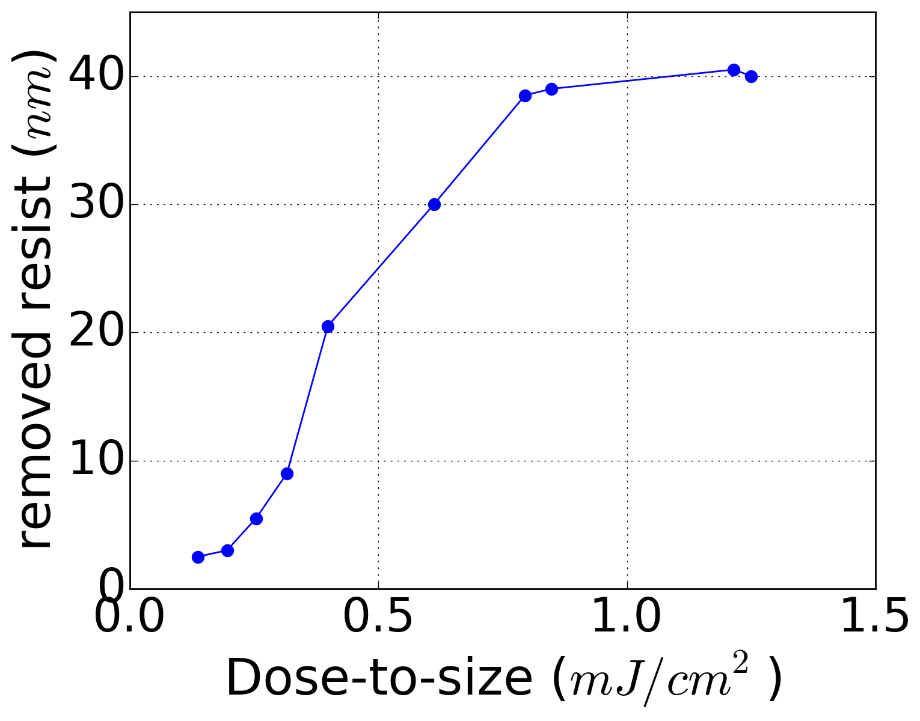

Fig. 3. The depth of removed photoresist depending the exposure dose

The Lloyd’s mirror IL was performed with the photoresist produced as described before. The ZEP-520A coated wafer was mounted on a nano-precision piezo stage (Smaract - SLC-1730) at an angle normal to the beam path. The photoresist plane was located in the z-position at around z = + 6 mm (toward photoresist) from the focal plane of ML, which is optimized location for the sufficient exposure conditions, given the field size of the beam (~200×50 µm) and the exposure time of ~ 9 s. After the exposure, the photoresist was developed with ZED N50 for 90 s and rinsed with 2-Propanol for 30 s. The resulting patterns were analyzed with an atomic force microscope (AFM, Brucker).

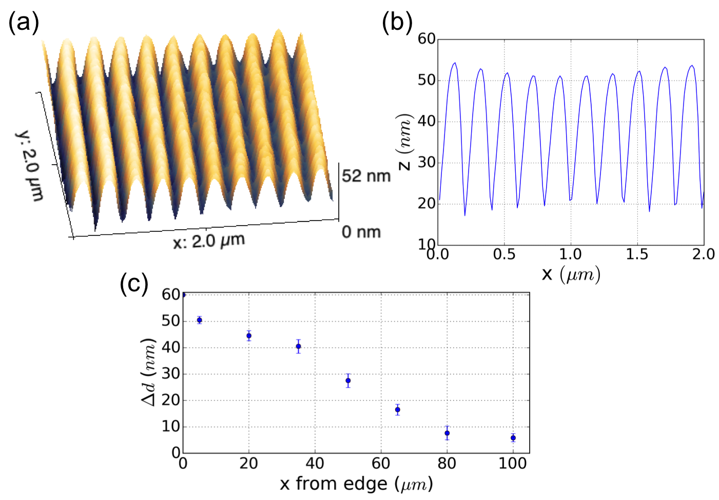

Fig. 4. (a) AFM image of the patterned photoresist, (b) the thickness profile of (a) showing a half period of 99 nm, (c) the depth of groove along x-axis.

The resulting AFM image in Fig. 4 (a) shows a pattern with period of 198 nm, corresponding to a mirror angle of 4.2°. Fig. 4 (b) is the cross-section of (a). The depth of groove (*Δd*) along the *x*-axis is measured as plotted in Fig. 4 (c), and clearly drops as a function of distance from the mirror edge. There are several reasons for the drop. Firstly, the transverse intensity profile of the Gaussian beam drops away from the edge, where the right half is flipped over the mirror with reflection of ~95 % in the Lloyd’s mirror scheme. Secondly, the time delay between reflected beam and direct beam is increased away from the edge. As the interfering time decreases, the degree of mutual coherence decreases resulting in the drop of the fringe visibility.

In photoresist, the depth (d) after lithographic process can be derived as {d = (1 – exp[-α I t]) D}, where α is lithographic factor related to the photoresist sensitivity, t is exposure time, and D is an initial thickness of photoresist. Then, the depth of groove can be given by:

|  |  |  |
| --- | --- | --- |
|  | Δd = (1-exp[-α (Imax – Imin) t]) D. | (5) |

Applying {(Imax - Imin) = 2(I1 + I2)V} to (5), we have a relationship between *Δd* and *V* as following:

|  |  |  |
| --- | --- | --- |
|  | Δd/D = 1-exp[-2α (I1 + I2) Vt]. | (6) |

Thus the fringe visibility V can be written as:

|  |  |  |
| --- | --- | --- |
|  | V = - ln (1 - Δd/D)/(2 α (I1 + I2) t) | (7) |

In principle, the intensity distribution of interference fringes is given by the time-averaged sum of two electric fields. We now have to consider the time integral over the pulse duration. For nano- or picosecond pulses, the change of the time integral is negligible along the x-axis due to the long pulse duration. However, for the pulses below 100 fs, the time integration term drops quickly away from the mirror edge. In the interference term of the fringe in equation (3), I2 is delayed. Thus, I2 can be rewritten as: {I2’ = I2×O(x)}, where O(x) is an overlap factor, which is a normalized value, shown in Fig 5 (b), which is dependent on the pulse duration.

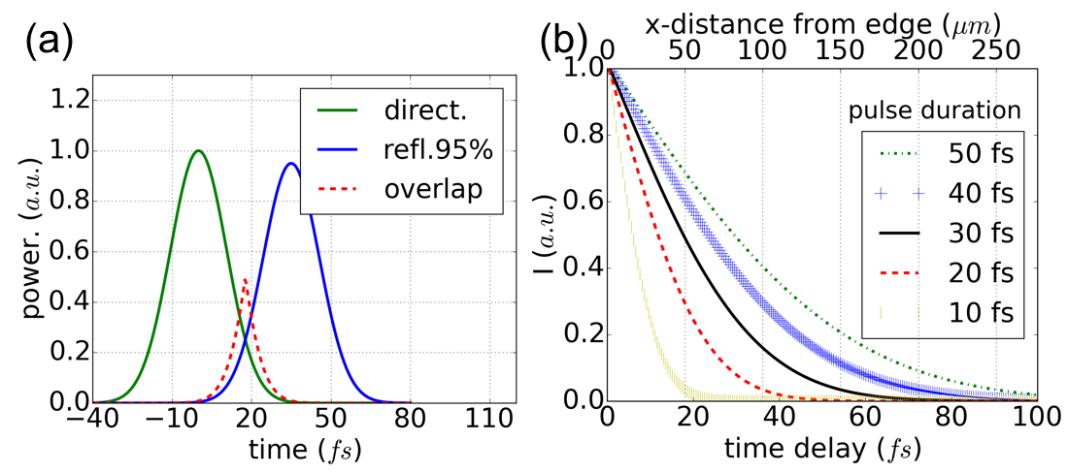

Fig. 5. (a) The pulse of the direct beam and the reflected beam with the time delay: The pulses partially overlap depending on both the OPD and the pulse duration, (b) the integration of the overlap as a function of the time delay for several pulse durations.

A typical Gaussian shape pulse is plotted in Fig. 5 (a) where the pulse length is assumed to be the full-width half maximum (FWHM) of the pulse. Fig. 5 (a) shows direct and reflected pulses with some time delay. The partial overlap of the pulses in time depends on both the OPD and the pulse duration. The overlap decreases as the OPD increases or as pulse duration decreases, as plotted in Fig. 5 (b). Pulse durations from 10 fs to 50 fs are investigated. The overlapping area drops more quickly as the pulse duration decreases.

The visibility for short pulse radiation can be written as: V(I1, I2’). In order to eliminate the unknown factor, α, we plot the visibility as following:

|  |  |  |
| --- | --- | --- |
|  | V(x)/V0 = -ln(1-Δd(x)/D)×.I0/(I(x)) | (8) |

where V0 = V(x=0), I0 = (I1,(x=0)+I2,(x=0)’), and I(x) = (I1,(x)+I2,(x)’). Fig. 6 plots the equation (8) with different distance from the edge. The visibility is > 0.55 over the investigated area. The visibility is not significantly reduced in the investigated x-range.

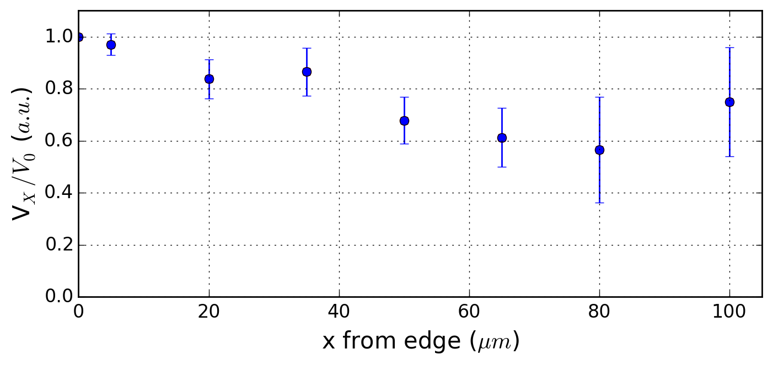

Fig. 6. Visibility over the edge region in assumption that pulse duration is 30 fs of the EUV light.

In conclusion, we have demonstrated Lloyd’s mirror interference lithography using radiation from an HHG system. The monochromatized EUV radiation generated by the HHG source can enable laboratory lithographic fabrication for high-density periodic structures. Exposure sensitivity of the ZEP-520A photoresist has been obtained for the radiation used. Fringe visibility over the field is measured and corresponds well with a model which includes the effects of the Gaussian beam profile, the optical path difference and the pulse duration. The reflectivity of the mirror, the degree of mutual coherence and the overlap of two pulses influence to the visibility. In the future, patterning with sub-30 nm pitch is expected to be possible, using Lloyd’s mirror angles up to 15° with the radiation used in this work.

**Acknowledgements** H.K, M.O and M.M acknowledge financial support by the EU FP7 Erasmus Mundus Joint Doctorate Programme EXTATIC under framework partnership agreement FPA-2012-0033. L.J acknowledges financial support by the Helmholtz Association for a Helmholtz Professorship as a part of the Initiative and Networking Fund.

1) S. Brueck, Proc. Of the IEEE **93,** 1704-1721 (2005).

2) I. Wathuthanthri et al.: Adv. Funct. Mater **23**, 608–618 (2013).

3) K. Miyazaki at al.: Appl. Phys. Lett. **107**, 071103 (2015).

4) H. H. Solak at al.: Appl. Phys. Lett. **75**, 2328 (1999).

5) A. Ritucci at al.: J. App. Phys. **102**, 034313 (2007).

6) P. W. Wachulak at al.: Opt. Express **15**, 3465-3469 (2007).

7) P. Zuppella at al.: Nanotechnology **20**, 115303 (2009).

8) H. H. Solak: J. Phys. D: Appl. Phys. **39**, R171 (2006).

9) N. Mojarad at al.: Opt. Letters **39**, 2286-2289 (2014).

10) T. Kondo at al.: App. Phys. Letters **79**, 725-727 (2001).

11) Y. Nakata at al.: Appl. Phys. A **79**, 1481-1483 (2004).

12) K. Okamoto at al.: Appl. Phys. Express **5**, 096701 (2012).

13) J. Zhou at al.: Phys. Rev. Letters **76**, 752 (1996).

14) R. A. Bartels at al.: Science **297**, 376-378 (2002).

15) B. J. Thompson, E. Wolf: J. Opt. Soc. Am. **47**, 895-902 (1957).

16) G. R. Fowles, “Introduction to Modern Optics 2nd edition”, New York (1975).

17) K. Koshelev at al.: JVST-B **29**, 06F306 (2011).

18) F. Dill at al.: IEEE Trans. Elec. Devices **22**, 445-452 (1975).

1. The number of photons per second is determined by: $N_{ph/s}=\frac{S_{CCD}∙σ}{η_{QE}∙(E_{ph}/3.65 eV)∙t_{exp}}$, where SCCD: counted signal on the CCD, σ: the CCD sensitivity in electrons per count, ηQE: quantum efficiency of the CCD, Eph: the photon energy, texp: exposure time, (σ: 2, ηQE: 0.3, Eph: 43 eV, texp: 0.05 s, SCCD = 1.6·108).