Table 1: Deaths from COPD and lung cancer in 14 countries during the year 2008 (N=5,568,827)
Country | Abbreviations | Total Number of deaths | COPD deaths  N | COPD deaths  % of all deaths | Lung cancer deaths  N | Lung cancer deaths  % of all deaths
France | FR | 541,135 | 9,274 | 1.7 | 29,221 | 5.4
Italy | IT | 578,192 | 21,356 | 3.7 | 33,004 | 5.7
Spain (Andalusia) | ES | 57,380 | 2,564 | 4.5 | 3,198 | 5.6
Belgium | BE | 102,924 | 4,751 | 4.6 | 6,491 | 6.3
The Netherlands | NL | 135,136 | 6,303 | 4.9 | 9,918 | 7.6
Czech Republic | CZ | 101,804 | 2,161 | 2.1 | 5,310 | 5.2
Hungary | HU | 130,027 | 4,875 | 3.7 | 8,330 | 6.4
England | ENG | 475,763 | 25,143 | 5.3 | 28,222 | 5.9
Wales | WAL | 32,066 | 1,730 | 5.4 | 2,032 | 6.3
New Zealand | NZ | 29,312 | 1,837 | 6.3 | 1,634 | 6.0
Canada | CA | 182,134 | 8,185 | 4.5 | 12,902 | 7.1
United States of America | USA | 2,428,343 | 12,8021 | 5.3 | 15,8889 | 6.5
Mexico | MX | 528,093 | 21,804 | 4.6 | 6,563 | 1.2
Korea | KR | 247,757 | 7,349 | 3.0 | 14,883 | 6.0
Total |  | 5,568,827 | 245,345 | 4.4 | 320,591 | 5.8
COPD, Chronic obstructive pulmonary disease

Table 2: Demographic characteristics of people with COPD or lung cancer who died during 2008 in 14 countries (N=562,151)
 |  | Number of deaths | Age (%) |  |  | Sex (%) | Marital status (%)
 |  |  | 18-64 | 65-84 | 85 or older | Female | Unmarried | Married | Widowed/divorced
France | COPD | 9,274 | 10.2 | 30.0 | 59.6 | 37.5 | 12.4 | 40.4 | 47.3
 | Lung cancer | 29,221 | 40.4 | 40.3 | 19.3 | 23.6 | 11.4 | 60.8 | 27.8
Italy | COPD | 21,356 | 3.5 | 26.2 | 70.3 | 39.3 | 10.8 | 42.5 | 46.7
 | Lung cancer | 33,004 | 22.3 | 50.7 | 27.0 | 23.4 | 8.1 | 69.3 | 22.6
Spain (Andalusia) | COPD | 2,564 | 6.0 | 38.7 | 55.2 | 20.6 | 9.1 | 53.3 | 37.6
 | Lung cancer | 3,198 | 33.1 | 47.1 | 19.8 | 13.7 | 8.5 | 71.6 | 19.9
Belgium | COPD | 4,751 | 11.5 | 37.2 | 51.2 | 36.5 | 8.2 | 43.0 | 48.8
 | Lung cancer | 6,491 | 30.9 | 47.3 | 21.8 | 23.8 | 7.1 | 61.3 | 31.7
The Netherlands | COPD | 6,303 | 9.4 | 36.8 | 53.7 | 44.2 | 59.7 | 40.3 | N/A
 | Lung cancer | 9,918 | 31.5 | 48.5 | 20.0 | 35.6 | 38.9 | 61.1 | N/A
Czech Republic | COPD | 2,161 | 21.4 | 42.4 | 36.2 | 39.7 | 8.0 | 39.9 | 52.1
 | Lung cancer | 5,31 | 39.6 | 46.7 | 13.6 | 27.4 | 5.7 | 57.2 | 37.1
Hungary | COPD | 4,875 | 15.8* | 48.4* | 35.7* | 40.9 | 9.5 | 36.3 | 54.1
 | Lung cancer | 8,33 | 33.5* | 55.5* | 10.9* | 32.8 | 7.5 | 53.6 | 38.9
England | COPD | 25,143 | 10.5 | 39.2 | 50.1 | 48.7 | 7.8 | 36.9 | 55.3
 | Lung cancer | 28,222 | 22.3 | 48.2 | 29.5 | 43.2 | 6.8 | 51.3 | 41.9
Wales | COPD | 1,73 | 9.1 | 40.8 | 50.1 | 50.8 | 6.0 | 39.0 | 54.9
 | Lung cancer | 2,032 | 22.5 | 49.2 | 28.3 | 42.4 | 6.1 | 51.8 | 42.1
New Zealand | COPD | 1,837 | 12.2 | 37.8 | 49.9 | 50.2 | † | † | †
 | Lung cancer | 1,634 | 28.8 | 47.1 | 24.1 | 45.6 | † | † | †
Canada | COPD | 8,185 | 8.5 | 34.3 | 57.1 | 46.9 | 7.7 | 36.8 | 55.6
 | Lung cancer | 12,902 | 26.7 | 47.7 | 25.7 | 46.0 | 6.8 | 55.5 | 37.7
USA | COPD | 128,021 | 14.2 | 40.2 | 45.4 | 52.1 | 6.3 | 36.2 | 57.5
 | Lung cancer | 158,889 | 28.8 | 47.1 | 24.1 | 44.3 | 6.0 | 51.0 | 43.0
Mexico | COPD | 21,804 | 11.8 | 35.9 | 51.4 | 44.5 | 11.2 | 44.6 | 44.2
 | Lung cancer | 6,563 | 31.3 | 47.3 | 21.3 | 33.7 | 10.8 | 61.8 | 27.4
Korea | COPD | 7,349 | 7.9 | 42.8 | 49,3 | 38.7 | 2.8 | 47.7 | 49.7
 | Lung cancer | 14,883 | 25.3 | 56.3 | 18.4 | 26.4 | 2.3 | 69.2 | 28.5
Percentages are row percentages.
* For age, the Hungarian file was delivered using a different aggregation: 0-17,18-59,60-79(65-84), 80 or above(85 or above)
†Variable not available not available for the country; N/A: category within variable not presented on the data file of the Netherlands; variable was dichotomized into married or not.
Note: Percentages may not add up to 100 due to rounding

Table 3: The place of death of deceased patients with COPD and lung cancer by country (N=562,151)
 |  | Number of deaths | Home (%) | Hospital (%) | Nursing home (%) | Hospice setting (%) | Others (%)
France | COPD | 9,274 | 25.6 | 60.2 | 11.2 | /* | 3.0
 | Lung cancer | 29,221 | 17.0 | 77.4 | 3.0 | /* | 2.7
Italy | COPD | 21,356 | 41.6 | 47.4 | 7.5 | /* | 3.5
 | Lung cancer | 33,004 | 44.2 | 49.5 | 2.9 | /* | 3.5
Spain (Andalusia) | COPD | 2,564 | 36.3 | 56.7 | 6.2 | /* | .8
 | Lung cancer | 3,198 | 33.1 | 64.5 | 2.1 | /* | .2
Belgium | COPD | 4,751 | 22.0 | 52.8 | 24.4 | /* | .8
 | Lung cancer | 6,491 | 28.8 | 63.9 | 6.8 | /* | .6
The Netherlands | COPD | 6,303 | 20.5 | 41.8 | 35.4 | 1.5＋ | 0.8
 | Lung cancer | 9,918 | 48.0 | 28.0 | 15.3 | 7.2＋ | 1.5
Czech Republic | COPD | 2,161 | 17.2 | 66.8 | 14.7 | /* | 1.3
 | Lung cancer | 5,31 | 17.3 | 66.4 | 15.5 | /* | .8
Hungary | COPD | 4,875 | /* | 69.8 | /* | /* | 30.2
 | Lung cancer | 8,33 | /* | 72.1 | /* | /* | 27.9
England | COPD | 25,143 | 19.8 | 67.5 | 10.8 | .9 | 1.0
 | Lung cancer | 28,222 | 28.2 | 45.8 | 9.0 | 15.3 | 1.7
Wales | COPD | 1,73 | 16.9 | 73.9 | 8.2 | .2 | .8
 | Lung cancer | 2,032 | 28.1 | 57.5 | 4.2 | 8.5 | 1.6
New Zealand | COPD | 1,837 | 15.5 | 44.7 | 34.0 | 1.9 | 4.0
 | Lung cancer | 1,634 | 29.9 | 27.5 | 22.5 | 17.6 | 2.6
Canada | COPD | 8,185 | 10.4 | 65.4 | 20.7 | /* | 3.6
 | Lung cancer | 12,902 | 16.3 | 69.0 | 9.9 | /* | 4.9
USA | COPD | 128,021 | 26.2 | 44.5 | 22.7 | 2.9 | 3.7
 | Lung cancer | 158,889 | 40.3 | 33.9 | 15.0 | 5.2 | 5.7
Mexico | COPD | 21,804 | 55.4 | 41.8 | /* | /* | 2.8
 | Lung cancer | 6,563 | 57.1 | 40.1 | /* | /* | 2.8
Korea | COPD | 7,349 | 19.4 | 78.9 | 1.5 | /* | .3
 | Lung cancer | 14,883 | 12.5 | 86.5 | .9 | /* | .1
Percentages are row percentages. Percentages may not add up to 100 due to rounding
*Category not presented on death certificate. In Hungary, the death certificate registry only coded hospital or others as the place of death and nursing home does not exist as a separate health service in Mexico.
＋In the Netherlands the category ‘other institutions’on the death certificate mostly concerns hospices in these disease groups.
Table 4: Odds ratios of COPD vs lung cancer patients (reference) stratified by place of death: binary multivariable logistic regression models of death certificates data from 14 countries during 2008(N=562,151)
Country | Home (vs all others)  N=562,151 | Home (vs Hospital)  N=447,537 | Hospital (vs all others)  N=562,151 | Nursing home (vs Hospital) N=345,463 | Hospice setting (vs others)  N=41,092
 | OR (95% CI) | OR (95% CI) | OR (95% CI) | OR (95% CI) | OR (95% CI)
France | 1.7 (1.58-1.80) | 1.8 (1.71-1.94) | 0.5 (0.52-0.58) | 2.1 (1.89-2.33) | /*
Italy | 0.9 (0.87-0.94) | 0.9 (0.88-0.96) | 1.0 (1.00-1.08) | 1.6 (1.42-1.72) | /*
Spain | 0.8 (0.75-0.96) | 0.9 (0.79-1.01) | 1.0 (0.91-1.17) | 1.9 (1.34-2.67) | /*
Belgium | 0.8 (0.77-0.93) | 0.97 (0.9-1.07) | 0.8 (0.71-0.84) | 2.4 (2.09-2.73) | /*
The Netherlands | 0.4 (0.33-0.39) | 0.3 (0.27-0.33) | 2.4 (2.23-2.59) | 0.9 (0.81-0.98) | /*
Czech Republic | 1.1 (0.96-1.26) | 1.1 (0.92-1.22) | 1.1 (0.95-1.19) | 0.8 (0.68-0.92) | /*
Hungary | /* | /* | 0.9 (0.85-1.01) | /* | /*
England | 0.7 (0.68-0.74) | 0.5 (0.50-0.54) | 2.5 (2.42-2.60) | 0.6 (0.55-0.62) | 0.1 (0.07-0.11)
Wales | 0.6 (0.49-0.68) | 0.5 (0.43-0.61) | 2.1 (1.80 -2.40) | 1.1 (0.82-1.48) | 0.1 (0.01-0.20)
New Zealand | 0.5 (0.43-0.60) | 0.3 (0.27-0.40) | 2.7 (2.28-3.10) | 0.6 (0.51-0.75) | 0.1 (0.05-0.14)
USA | 0.6 (0.56-0.58) | 0.5 (0.47-0.49) | 1.8 (1.81-1.87) | 0.8 (0.77-0.81) | 0.9 (0.87-0.98)
Canada | 0.7 (0.63-0.76) | 0.7 (0.67-0.80) | 0.98 (0.92-1.05) | 1.5 (1.40-1.66) | /*
Mexico | 0.8 (0.72-0.82) | 0.8 (0.72-0.81) | 1.3 (1.21-1.37) | /* | /*
Korea | 1.5 (1.43-1.68) | 1.6 (1.43-1.69) | 0.7 (0.60-0.71) | 1.2 (0.90-1.57) | /*
Bold denotes a significant difference between lung cancer and COPD patients.
*Category did not exist on death certificate
Variables included in model: age, sex, marital status (except NZ, where marital status was not available)

Figure 1. Crude Risk Ratios for dying at home, in hospital, in a nursing home in a palliative care institution of those dying from lung cancer versus those from COPD

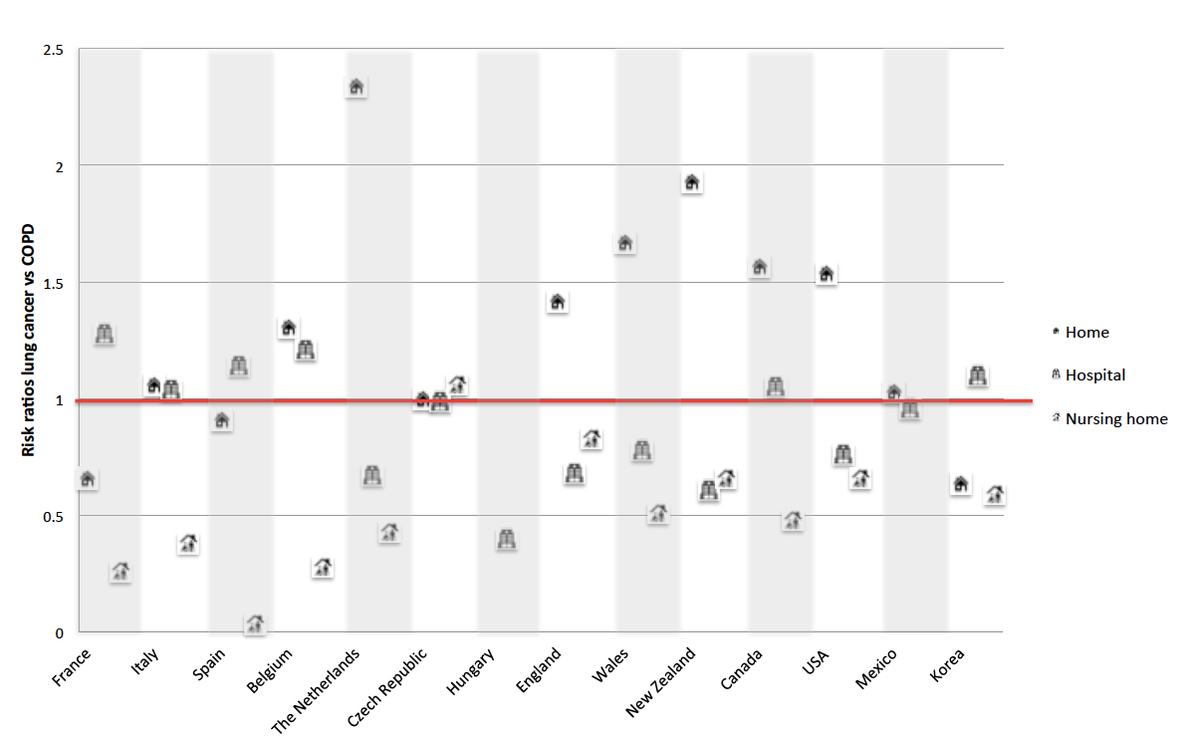
Risk ratios calculated as proportion lung cancer/proportion COPD dying in each place. A risk ration >1 indicates that those with lung cancer were relatively more likely to die in that place compared to those with COPD deaths; a risk ratio <1 means that they were less likely

