Surface and waveguide collection of Raman emission in waveguide-enhanced Raman spectroscopy

Zilong Wang,1, Michalis N. Zervas,1 Philip N. Bartlett2, James S. Wilkinson*

1Optoelectronics Research Centre, University of Southampton—University Road, Southampton, SO17 1BJ, UK

2Chemistry, University of Southampton—University Road, Southampton, SO17 1BJ, UK

*Corresponding author: jsw@orc.soton.ac.uk

Received XX Month XXXX; revised XX Month, XXXX; accepted XX Month XXXX; posted XX Month XXXX (Doc. ID XXXXX); published XX Month XXXX

We demonstrate Raman spectroscopy on a high index thin film tantalum pentoxide waveguide and compare collection of Raman emission from the waveguide end with that from the waveguide surface. Toluene was used as a convenient model analyte, and 40-fold greater signal was collected from the waveguide end. Simulations of angular and spatial Raman emission distributions showed good agreement with experiments, with the enhancement resulting from efficient collection of power from dipoles near the surface into the high-index waveguide film and substrate, combined with long interaction length. The waveguide employed was optimized at the excitation wavelength but not at emission wavelengths, and full optimization is expected to lead to enhancements comparable to SERS in robust low-cost metal-free and nanostructure-free chips. © 2016 Optical Society of America

**OCIS codes:** (130.0130) Integrated optics; (170.5660) Raman spectroscopy; (130.6010) Sensors; (290.5860) Scattering, Raman.

http://dx.doi.org

Waveguide-enhanced Raman spectroscopy (WERS) is attracting renewed interest [1-3] alongside advances in surface enhanced Raman spectroscopy (SERS). SERS substrates rely upon fragile nanostructured noble metal surfaces to achieve intensity enhancement through localized plasmons, while WERS approaches use simple, robust, broadband dielectric thin film waveguides and can achieve similar enhancements averaged over a surface, given sufficient waveguide length [2], [3]. Further, evanescent excitation and collection of Raman emission in waveguides minimizes interferences from the analyte as the input/output light paths do not pass through the potentially turbid, absorbing or fluorescent analyte. WERS shows great promise for analytical applications in sensors, where repeatable surface average enhancements are required rather than highly localized enhancements suitable for single-molecule detection.

Waveguides were first used to study Raman scattering of thin films where the thin films being studied formed the waveguide core [4–7], and this was extended to studying depth profiles of dopants within a waveguide core [8]. These were followed by studies of resonance Raman scattering from monolayers on low index contrast glass or polymer waveguides [9], and Raman spectroscopy of bacteriorhodopsin on As2S3 rib waveguides [10]. It was observed that enhancement of Raman excitation for thin films resulted from maintaining a high excitation intensity over an increased scattering volume of analyte [6]. Subsequently, an analysis of the intensity of the evanescent field at the surface of an optical waveguide emphasised that thin high index contrast waveguides yielded the greatest field enhancement for Raman excitation and this was demonstrated experimentally on an optimised ZnO waveguide on SiO2 [11]. All these studies employed collection of Raman emission from the top of waveguide surface or from beneath the substrate. Recently, collection of spontaneous Raman emission from the waveguide end has been demonstrated [2], [12]. In this letter, we experimentally compare the efficiency of Raman collection from the waveguide surface and end, including in the substrate, and simulate the Raman emission distributions to estimate the relative theoretical collection efficiency for both configurations.

110 nm thick waveguides optimized for maximum pump surface intensity [3] were fabricated by RF sputtering of Ta2O5 onto a 50 mm square, 1 mm thick, silica substrate at a temperature of 200oC from a 150 mm diameter powder-pressed pure Ta2O5 target with a power of 300 W, oxygen flow of 5 sccm and argon flow of 20 sccm. The chamber was maintained at a pressure of 10 mTorr and the film was deposited at a rate of 3.42 nm/min over 32 min. After deposition the waveguides were annealed in oxygen at 560oC for 2 hours, with a 50C/min ramp up and 20C min ramp down. Raman scattering from bulk toluene (C7H8, n = 1.49 at 637 nm) was chosen for this study, as toluene has well-known Raman cross-sections and a bulk analyte does not suffer from film thickness or coverage variations. Prism-coupling was used to excite the waveguide mode. Light from a 637 nm fiber-coupled semiconductor laser (Thorlabs LP637-SF70) was coupled into the waveguide using a microscope objective lens (Melles Griot ×10) to collimate the output from the fiber, and high-index prism (Metricon 200-P-2) as shown in Fig 1; prism coupling was chosen for experimental flexibility. 44 mW power was incident on the prism, coupling into the TM polarization, and the beam width in the waveguide was approximately 0.7 mm. The use of a low-cost semiconductor laser enables low-cost 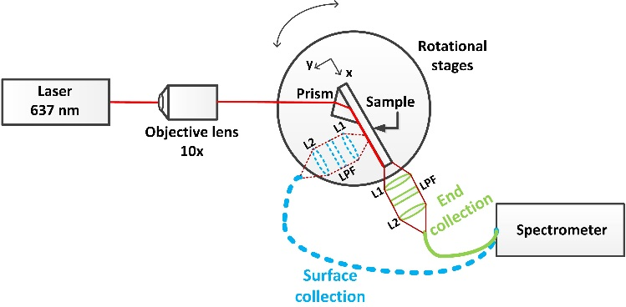portable high sensitivity Raman instrumentation, where ultimate spectral resolution is not required, and a grating could then replace the prism for ease of use. The Raman collection optics consisted of two 1 inch diameter lenses coupling via a multimode fiber (NA: 0.48, Core diameter: 1000 µm) into a compact spectrometer (Ocean Optics QE65000 Pro) with a 200 μm entrance slit. A long-pass filter (LPF, FELH0650 Thorlabs) with a band edge at 648 nm was placed between the lenses to suppress scattered pump radiation, cutting out signals with Stokes’ shifts below 300 cm-1. The spectrometer was USB interfaced to a PC for control and data processing.

**Fig 2.** Raman spectra of toluene from the waveguide end and surface. The surface spectrum has been multiplied by a factor of 10 and the end spectrum has been shifted up by 1 fW/nm for clarity. Both spectra have been background subtracted.

**Fig 1.** Experimental apparatus for waveguide enhanced Raman spectroscopy. Broken blue lines: waveguide surface collection configuration; Solid green lines: waveguide end collection configuration. L1 & 2: lenses. LPF: long pass filter. The relative dimensions have been adjusted for clarity.

A small drop (<0.15 ml) of toluene was placed on the waveguide surface and a coverslip located on top to reduce evaporation. The penetration depth of the evanescent field into the toluene is approximately 120 nm and the resulting toluene layer fills this region, in effect resulting in a bulk analyte above the waveguide surface. The collection system was focused onto the waveguide surface and the waveguide end in turn, at approximately 2.5 cm and 3 cm away from the prism coupling position, respectively. The integration times are 60 s and 5 s for waveguide surface and end collection, respectively. The shorter integration time was necessary for the end measurement to prevent saturation of the spectrometer. The recorded spectra were baseline subtracted by fitting a curve to the baseline at frequencies away from the toluene lines and subtracting this from the data, and then transformed to units of power spectral density using the corresponding integration time. The resultant spectra are shown in figure 2, giving the toluene Raman emission bands from 700 cm-1 to 3200 cm-1, covering most of the biologically-relevant Raman window (500 cm-1 – 3500 cm-1) [13]. The region below 700 cm-1 is dominated by background emission from the rutile coupling prism and fused silica substrate that masks the toluene Raman feature at around 622 cm-1. In applications where spectral information below 700 cm-1 is needed, another material such as CaF2 could be used as the substrate as it exhibits no Raman features above 322 cm-1 and the use of grating coupler could potentially eliminate the unwanted emission from the prism at around 600 cm-1. Figure 2 clearly shows that the power in the Raman emission lines collected from the waveguide end is approximately 40 times higher than that from the waveguide surface. The phenyl ring breathing mode at around 792 cm-1 can be easily distinguished using end-collection but is masked by the background using surface collection due to increased collection of a sharp Raman line from the rutile prism in this configuration.

In an earlier paper [3], we performed a power budget analysis for the waveguide surface measurement of Raman emission from toluene, calculating the total conversion efficiency relating the final detected power of the breathing mode at 1002 cm-1 to the waveguided pump power to be ~8.5×10-13 for our configuration. Here, this analysis is extended to determine the theoretical collection efficiency from the waveguide and substrate end, in comparison with the waveguide surface, to explain the factor 40 increase observed. For this analysis the Raman emission distribution of molecules near a waveguide surface and the collection of this emission in a high NA multimode fiber are presented.

The angular emission pattern from a molecule can be determined from the corresponding induced (Raman) dipole emission pattern. In free space, in the absence of a waveguide structure, the dipole emission pattern in the far field has two equal lobes, as experimentally verified by Porto *et al.* for the 994 cm-1 vibrational mode of liquid benzene [14]. However, when a waveguide is placed in the vicinity of the molecule, the far field emission distribution will change due to the influence of the

The substrate, waveguide, toluene layer and coverslip form a composite waveguide structure, bounded by the upper air-glass and lower air-silica interfaces, as shown in Figure 4. Emitted light travelling within the critical angle at the corresponding interfaces will be trapped by the composite structure and will propagate to its periphery. In addition, emitted light coupled into the thin-film waveguide mode will propagate to the waveguide end. Thus Raman emission at the Ta2O5 surface can follow three alternative routes: 1) coupling into the waveguide guided mode, 2) trapping by the composite structure, or 3) escaping the composite structure into the half-space above or below. Raman collection from the waveguide surface results from route 3, while Raman collection from the end of the structure receives contributions from routes 1 and 2. The relative power collected from the waveguide surface and from the composite waveguide end by a multimode fiber was theoretically estimated by (i) determining the proportion of total Raman emitted light for a single dipole into each of the three routes, followed by (ii) integration of the power incident on the fiber end within its NA from a uniform distribution of Raman emitters on the Ta2O5 surface, filling the entire evanescent field.

The first part of the analysis (i), is to calculate the proportion of the power emitted by one dipole coupled into each of the three routes. The proportion coupled into the thin-film Ta2O5 waveguide was calculated by using “Lumerical”, as described above, by integration around the waveguide periphery. The proportions of power emitted into the composite structure and into free-space were calculated using the far-field distributions shown in Figure 3b and the air-glass and air-silica critical angles, due to greater efficiency using analytical expressions.

**Fig 3**. Calculated dipole emission pattern a) for a y-oriented dipole, including waveguide collection and b) in the far-field for x and y oriented dipoles.

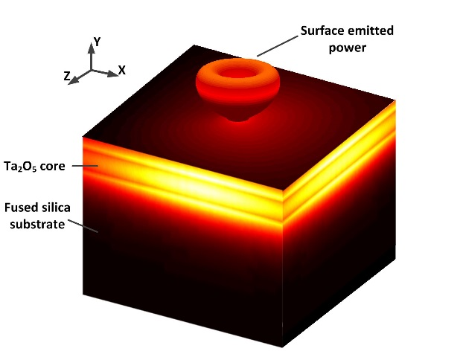

b)

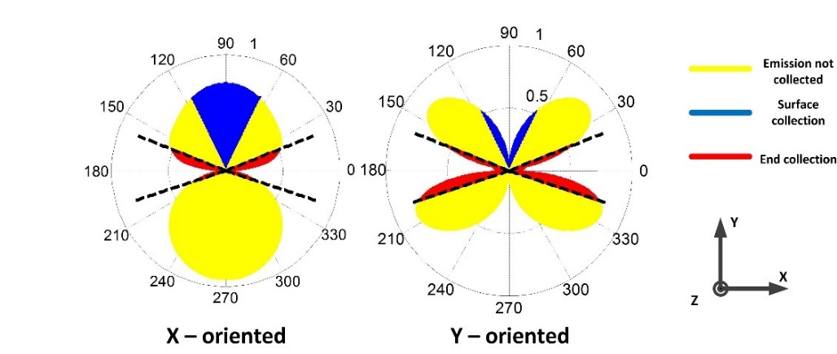

a)

Table 1. Proportion of Raman dipole power emitting into each route

|  |  |  |  |
| --- | --- | --- | --- |
| **Routes** | | **Ratio to the total emitted power** | |
| 1. Coupled into Ta2O5 waveguide | | ‖: 62.6% | Y: 76.3% |
| 1. Trapped by the substrate/cover | | ‖: 7.7% | Y: 17.8% |
| 1. Emitted out | Upward (+y) | ‖: 10.3% | Y: 3.9% |
| Downward (-y) | ‖: 19.4% | Y: 2.0% |

Table 1 summarizes the calculated proportion of power emitted into each route, for dipoles at the waveguide surface, normal to (y- oriented) or parallel to (‖≡ x,z) the waveguide surface. For a single dipole, 76.3% (62.6%) of the total power is collected in the Ta2O5 waveguide for y- (‖-) oriented dipoles. In the case of y-oriented dipoles the angular distribution in the waveguide plane will be isotropic. A further 17.8% (7.7%) is collected in the waveguide formed by the substrate and cover slip, yielding a total in the composite waveguide of 94.1% (70.3%), via routes 1 and 2 combined. The remaining power escapes the composite structure into toluene, with 3.9% (10.3%) emitted upwards and 2% (19.4%) emitted through the bottom of the substrate.

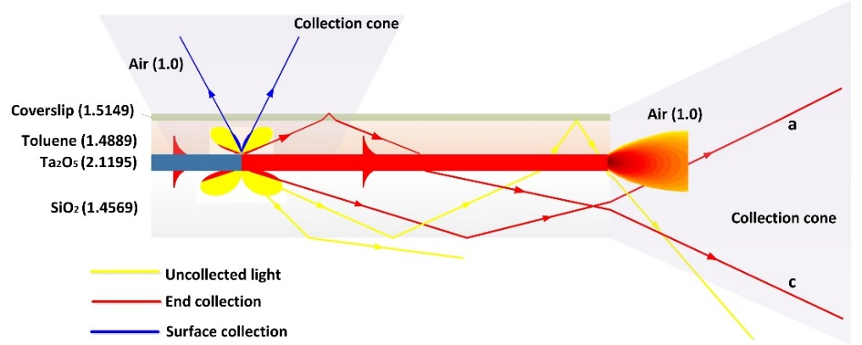

**b**

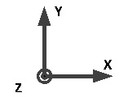

**Fig. 4**. Composite waveguide structure and ray diagrams indicating paths for dipole emission. The dipole emission shown is for y-orientated dipole. a) Downward emitted light trapped by the structure falls into the end-fiber collection cone; b) upward emitted light escapes the composite structure and falls into the surface fiber collection cone; c) upward emitted light trapped by the structure falls into the end fiber collection cone .

For WERS, the strength of dipoles along each of the axes depends upon the Raman polarizability tensor for the specific vibration, and on the direction and magnitude of the pump electric field provided by the waveguide. The 1002 cm-1 vibration of toluene possesses A1 symmetry and therefore does not depolarize. If, for TM polarization in a mode approaching cutoff, it is assumed that the x component of the pump electric field in the toluene superstrate can be neglected, then the Raman dipoles oscillating at 1002 cm-1 will be y-directed, in which case, a factor of 24.1 greater power is collected in the composite waveguide (including the tantala core) compared with emission through the top cover-slip. This is referred to as the *radiative enhancement factor*, which combines alteration in the angular emission pattern and the total radiated power of the dipole due to the dielectric structure (including evanescent tunneling). These calculations are specific for the 110 nm thick waveguides optimized for surface pump intensity and used experimentally, and vary significantly with Ta2O5 thickness. A full analysis of waveguide thickness optimization for Raman collection is underway.

The second part of the analysis (ii) is to determine the total power collected by the fiber at the waveguide surface or end by integration over the spatial and numerical aperture of the collection system, for a uniform distribution of Raman emitters on the Ta2O5 surface. The collection cone of a multimode fiber with 1 mm diameter and NA 0.48 is imaged onto the structure. For surface collection, emission from only those molecules within the imaged area and fiber NA will be collected [3]; this portion of power within the NA is shown in blue in Figure 3b and, for the configuration here, corresponds to 8% collection efficiency (wrt total dipole emission) for ‖-oriented dipoles and 0.8% collection efficiency for y-oriented dipoles. The poor efficiency in the latter case is due to the zero in emission along the axis of the dipole.

For end-collection, all excited molecules within a surface area defined by the fiber NA will contribute, though their contributions will vary depending on their distance from the waveguide end. Thus, end-collection potentially provides a further enhancement factor due to Raman collection over a larger surface area of the waveguide than the 1 mm diameter imaged spot used for surface collection; this we refer to as the *area enhancement factor*. The red regions in figure 3b represent the angles over which light collected by the substrate and cover emerges from the end of the composite waveguide and falls within the collection system NA. Integrating the collected power over the full length of the waveguide from the prism to the fiber, and over the full depth of the evanescent field, yields a total theoretical enhancement factor, the product of radiative and area enhancement factors, of 51. The discrepancy between this and the experimentally-measured enhancement factor of ~40 is believed to be due to waveguide loss. For comparison, the total theoretical enhancement factor for end collection in the TM polarization vs surface collection in the TE polarization, which is more efficiently collected from the surface, is approximately 24. If required, greater area enhancements could be obtained using channel waveguides, at the expense of greater complexity. In principle, for channel waveguides, the area enhancement factor increases linearly with length so that a 25mm waveguide would give a ~25 area enhancement factor. However, in practice, waveguide losses limit the enhancement factor achievable to approximately 10 for a waveguide with loss of order 2dB/cm, typical for high-index, surface sensitive channel waveguides [2].

To summarize, it has been demonstrated experimentally that a 40-fold stronger Raman signal is collected at a high index contrast monomode waveguide end compared with that from the surface, for dipoles oriented normal to the surface. The additional contributions are due to enhanced emission into the waveguide structure and collection from a larger area of waveguide surface. The emission patterns from dipoles have been calculated and used to determine the power collected in the composite waveguide in comparison with that emitted from the surface. Power collected in fibers at the surface and end of the structure have been calculated using these dipole emission patterns by integrating over the fiber apertures, resulting in good agreement between experiment and theory. Further optimization of combined waveguide excitation and collection is underway using this model and wide channel waveguide designs to improve efficiency are being realized. In comparison with SERS, WERS enhancement results from maintaining high surface intensity over mm lengths rather than localizing fields using plasmonic nanostructures. Further optimization may enable the realization of low cost waveguide enhanced Raman spectroscopy with sensitivity comparable to surface enhanced Raman spectroscopy, without the need for complex and delicate noble metal nanostructures.

**Funding.** European Research Council (ERC) 291216 Wideband Integrated Photonics for Accessible Biomedical Diagnostics. PNB gratefully acknowledges receipt of a Wolfson Research Merit Award.

**Acknowledgments**. We thank Dr. Senthil Ganapathy for useful discussions and Vinita Mittal for special sample preparation. We thank Shin-Sung Kim from Lumerical Solutions Inc. for his helpful technical support.

References

[1] A. Dhakal, A. Raza, F. Peyskens, A. Z. Subramanian, S. Clemmen, N. Le Thomas, and R. Baets,*Opt. Express*, vol. 23, no. 21, pp. 27391–404, 2015.

[2] A. Dhakal, A. Z. Subramanian, P. Wuytens, F. Peyskens, N. Le Thomas, and R. Baets, *Opt. Lett.*, vol. 39, no. 13, pp. 4025–4028, 2014.

[3] Z. Wang, S. J. Pearce, Y.-C. Lin, M. N. Zervas, P. N. Bartlett, and J. S. Wilkinson, *Appl. Spectrosc.*, vol. 70, no. 8, pp. 1384-1391, 2016.

[4] Y. Levy, C. Imbert, J. Cipriani, S. Racine, and R. Dupeyrat, *Opt. Commun.*, vol. 11, no. 1, pp. 66–69, 1974.

[5] J. F. Rabolt, R. Santo, and J. D. Swalen, *Appl. Spectrosc.*, vol. 33, no. 6, pp. 549–551, 1979.

[6] J. F. Rabolt, N. E. Schlotter, and J. D. Swalen, *J. Phys. Chem.*, vol. 85, no. 26, pp. 4141–4144, Dec. 1981.

[7] N. E. Schlotter and J. F. Rabolt, *J. Phys. Chem.*, vol. 16, no. 4, pp. 2062–2067, 1984.

[8] D.R. Miller and P.W. Bohn, Appl. Opt., vol. 27, no. 12, pp. 2561-2566, 1988.

[9] J. F. Rabolt, R. Santo, N. E. Schlotter, and J. D. Swalen, *IBM J. Res. Dev.*, vol. 26, no. 2, pp. 209–216, 1982.

[10] A. Pope, A. Schulte, Y. Guo, L.K. Ono, B. Roldan Cuenya, C. Lopez, K. Richardson, K. Kitanovski, and T. Winningham, Vib. Spectrosc., vol.42, pp. 249-253, 2006.

[11] J. S. Kanger, C. Otto, M. Slotboom, and J. Greve, *J. Phys. Chem.*, vol. 100, no. 8, pp. 3288–3292, 1996.

[12] A. Dhakal, F. Peyskens, A. Subramanian, N. Le Thomas, and R. G. F. Baets, *Adv. Photonics 2013*, p. ST2B.5, 2013.

[13] C. H. Camp Jr, Y. J. Lee, J. M. Heddleston, C. M. Hartshorn, A. R. H. Walker, J. N. Rich, J. D. Lathia, and M. T. Cicerone, *Nat. Photonics*, vol. 8, no. 8, pp. 627–634, 2014.

[14] P. S. Porto, *Phys. Rev. Lett.*, vol. 14, no. 1, pp. 2–4, 1965.

[15] W. L. Barnes, *J. Mod. Opt.*, vol. 45, no. 4, pp. 661–699, 1998.

[16] C. Chen, J.-Y. Li, L. Wang, D.-F. Lu, and Z.-M. Qi, *Phys. Chem. Chem. Phys.*, 2015.

References

[1] A. Dhakal, A. Raza, F. Peyskens, A. Z. Subramanian, S. Clemmen, N. Le Thomas, and R. Baets, “Efficiency of evanescent excitation and collection of spontaneous Raman scattering near high index contrast channel waveguides.,” *Opt. Express*, vol. 23, no. 21, pp. 27391–404, 2015.

[2] A. Dhakal, A. Z. Subramanian, P. Wuytens, F. Peyskens, N. Le Thomas, and R. Baets, “Evanescent excitation and collection of spontaneous Raman spectra using silicon nitride nanophotonic waveguides,” *Opt. Lett.*, vol. 39, no. 13, pp. 4025–4028, 2014.

[3] Z. Wang, S. J. Pearce, Y.-C. Lin, M. N. Zervas, P. N. Bartlett, and J. S. Wilkinson, “Power Budget Analysis for Waveguide-Enhanced Raman Spectroscopy,” *Appl. Spectrosc.*, vol. 70, no. 8, pp. 1384-1391, 2016.

[4] Y. Levy, C. Imbert, J. Cipriani, S. Racine, and R. Dupeyrat, “Raman scattering of thin films as a waveguide,” *Opt. Commun.*, vol. 11, no. 1, pp. 66–69, 1974.

[5] J. F. Rabolt, R. Santo, and J. D. Swalen, “Raman Spectroscopy of Thin Polymer Films Using Integrated Optical Techniques.,” *Appl. Spectrosc.*, vol. 33, no. 6, pp. 549–551, 1979.

[6] J. F. Rabolt, N. E. Schlotter, and J. D. Swalen, “Spectroscopic studies of thin film polymer laminates using Raman spectroscopy and integrated optics,” *J. Phys. Chem.*, vol. 85, no. 26, pp. 4141–4144, Dec. 1981.

[7] N. E. Schlotter and J. F. Rabolt, “Raman spectroscopy in polymeric thin film optical waveguides. 1. Polarized measurements and orientational effects in two-dimensional films,” *J. Phys. Chem.*, vol. 16, no. 4, pp. 2062–2067, 1984.

[8] D.R. Miller and P.W. Bohn, "Waveguide Raman scattering for recovery of arbitrary thin-film concentration distributions," Appl. Opt., vol. 27, no. 12, pp. 2561-2566, 1988.

[9] J. F. Rabolt, R. Santo, N. E. Schlotter, and J. D. Swalen, “Integrated Optics and Raman Scattering: Molecular Orientation in Thin Polymer Films and Langmuir-Blodgett Monolayers,” *IBM J. Res. Dev.*, vol. 26, no. 2, pp. 209–216, 1982.

[10] A. Pope, A. Schulte, Y. Guo, L.K. Ono, B. Roldan Cuenya, C. Lopez, K. Richardson, K. Kitanovski, and T. Winningham, "Chalcogenide waveguide structures as substrates and guiding layers for evanescent wave Raman spectroscopy of bacteriorhodopsin," Vib. Spectrosc., vol.42, pp. 249-253, 2006.

[11] J. S. Kanger, C. Otto, M. Slotboom, and J. Greve, “Waveguide Raman Spectroscopy of Thin Polymer Layers and Monolayers of Biomolecules Using High Refractive Index Waveguides,” *J. Phys. Chem.*, vol. 100, no. 8, pp. 3288–3292, 1996.

[12] A. Dhakal, F. Peyskens, A. Subramanian, N. Le Thomas, and R. G. F. Baets, “Enhancement of Light Absorption, Scattering and Emission in High Index Contrast Waveguides,” *Adv. Photonics 2013*, p. ST2B.5, 2013.

[13] C. H. Camp Jr, Y. J. Lee, J. M. Heddleston, C. M. Hartshorn, A. R. H. Walker, J. N. Rich, J. D. Lathia, and M. T. Cicerone, “High-speed coherent Raman fingerprint imaging of biological tissues,” *Nat. Photonics*, vol. 8, no. 8, pp. 627–634, 2014.

[14] P. S. Porto, “Angular Dependence of the Raman Scattering from Benzene Excited by the He-Ne cw Laser,” *Phys. Rev. Lett.*, vol. 14, no. 1, pp. 2–4, 1965.

[15] W. L. Barnes, “Fluorescence near interfaces: the role of photonic mode density,” *J. Mod. Opt.*, vol. 45, no. 4, pp. 661–699, 1998.

[16] C. Chen, J.-Y. Li, L. Wang, D.-F. Lu, and Z.-M. Qi, “Waveguide-coupled directional Raman radiation for surface analysis,” *Phys. Chem. Chem. Phys.*, 2015.