Summary of recommendations

Clinical diagnosis of SRS
  - SRS should remain primarily a clinical diagnosis. Molecular testing is useful for the confirmation and stratification of diagnosis in SRS. Lack of a positive molecular result does not exclude the diagnosis of SRS. (A+++)
1.2 The decision tree (Figure 1) based on the Netchine-Harbison clinical scoring system (NH-CSS), should be adopted for the investigation and diagnosis of SRS. (A++)
1.3 In children under two years, adolescents and adults, a reduced threshold for molecular testing may be required due to missing data. (A++)
Molecular testing
2.1 Molecular genetic testing should be performed by a health professional experienced in the field of imprinting disorders. Consistent and logical nomenclature should be adopted in publications and in test reporting. (A+++)
2.2 First-line molecular testing should include DNA methylation analysis of the H19/IGF2 IG-DMR and KCNQ1OT1 TSS DMR. (A+++)
2.3 First-line molecular testing should include analysis of DNA methylation at the GRB10 alt-TSS DMR and the MEST alt-TSS DMR. (A+++)
2.4 In case of a positive test result at either 11p15 or chr7, then a discrimination between epimutation, CNV and upd should be considered in order to estimate recurrence risk. (A+++)
2.5 After exclusion of changes in 11p15 and chr7, a clinical decision should be sought about the direction of further testing. Depending upon the clinical features and family history of the patient, further testing may include CNV analysis and DNA methylation analysis at chromosome 14q32. Testing may also be considered for very rare molecular anomalies, including upd(20)mat, upd(16)mat, CDKN1C and IGF2 mutation and analysis of further tissues to detect somatic mosaicism. (A++)
2.6 When an underlying pathogenic CNV is identified, the diagnosis should focus on this, even if features of SRS are present. (A+)

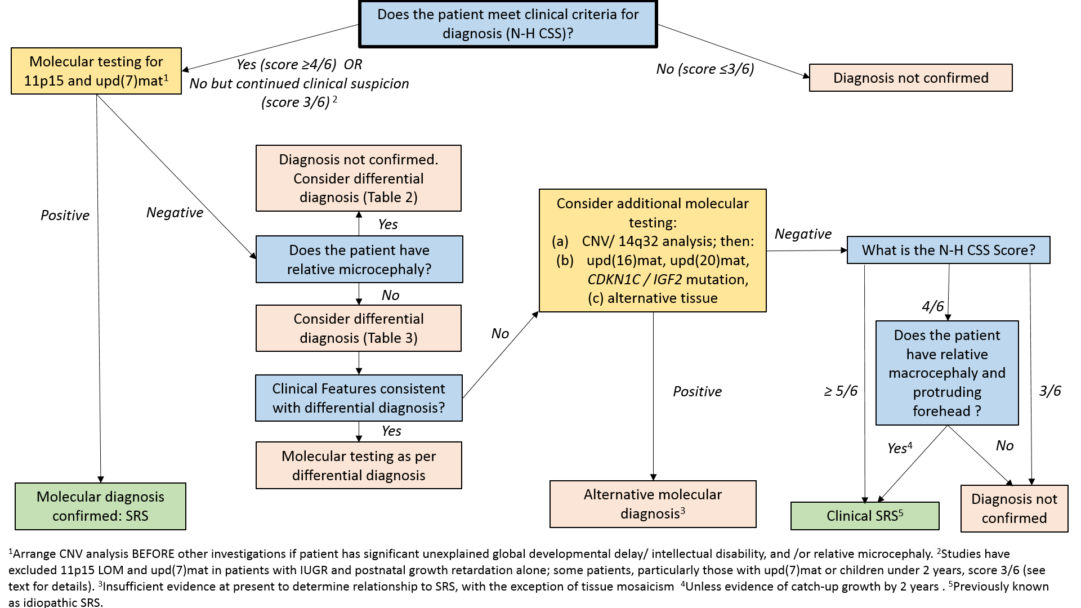
Figure1: decision tree for investigation and diagnosis of SRS

Differential diagnosis
3.1 An alternative syndromic diagnosis, and specific investigation for this, should be particularly considered in patients with any of the following: additional features atypical for SRS, family history of growth failure and/or consanguinity. (A+++)
3.2 Patients with features of SRS overlapping with OI should have a skeletal survey to look for additional evidence for OI, with consideration of COL1A1/2 gene testing. (A++)
Multidisciplinary care
4.1 Patients with SRS should receive multi-disciplinary care in a centre of expertise in SRS in co-ordination with their local centre. The multi-disciplinary team should be composed of paediatric sub-specialists such as an endocrinologist (co-ordinator), gastroenterologist, dietician, clinical geneticist, craniofacial team, orthopaedic surgeon, neurologist, speech and language therapist and psychologist. (A+++)
Early feeding and nutritional support
5.1 Nutritional goals in the first years of life: We recommend nutritional repletion* with awareness of possible hazards of rapid postnatal catch-up leading to later metabolic risk. (A +++)
5.2 Ask for and/or screen early for gut dysmotility (GER, delayed gastric emptying and constipation) in all children. (A+++)
5.3 Diagnose and treat any oromotor and/or sensory issues impacting oral intake. (A+++)
5.4 In cases of severe feeding failure unresponsive to standard care, anatomical or functional disorders of the GI tract, such as malrotation, should be excluded. (A+++)
5.5 Avoid enteral feeding by nasogastric or gastrostomy tube (GT) in a child capable of eating where there is adequate nutritional repletion. (A+++)
5.6 In cases of extreme feeding difficulties/GER, consider enteral feeding by GT (with/without fundoplication) or low profile transgastric jejunostomy as a last resort to protect against hypoglycaemia and/or malnutrition. (A+++)
5.7 In the case of enteral feeding, prevent excessive weight gain in both volitionally and non-volitionally fed children. (A++)
*Note: Low muscle mass makes typical BMI targets excessive in this population.
Targets currently used in some centres include:
      - Waterlow score 75-85% ¹
      - Weight-for-length SDS -2 to -1 in first year of life
      - BMI target SDS between -2 to -1 after first year of life

Prevention of hypoglycaemia
6.1 Monitoring for ketonuria at home is useful to determine which children need intervention for impending hypoglycaemia. (A++)*
6.2 Develop a plan with the child’s local paediatrician and emergency room for rapid admission and IV dextrose treatment when the child is ill. (A++)
6.3 Admit children with SRS to hospital early in the course of an illness associated with ketonuria/hypoglycaemia and do not discharge them until they are metabolically stable and can be adequately fed. (A++)
6.4 Glucagon is not recommended to correct hypoglycaemia, because of poor glycogen stores and limited ability for gluconeogenesis. (A+++)
6.5 Provide parents with an emergency guidance plan for illnesses. (A+++)
6.6 Teach parents how to recognize signs of hypoglycaemia, measure ketones, determine the ‘safe fasting time’ for their child, prevent hypoglycaemia using complex carbohydrates, and avoid fasting outside a controlled environment. (A+++)
6.7 In severe cases of fasting hypoglycaemia, where other causes have been excluded and if other alternatives are ineffective, consider:
- Early start of GH therapy to support glucose sources (increase in muscle mass and gluconeogenesis) (A++)
- Placement of a gastrostomy/jejunjunostomy tube. (A++)

*Note: Children with a history of hypoglycaemia who do not have appropriate ketone response will require formal fasting studies.
Surgery and anaesthesia
7.1 Review SRS-related issues with the anaesthetist and surgeon in advance. (A+++)
7.2 Consider admission the night before surgery for early administration of IV dextrose prior to surgery to avoid ketonuria and hypoglycaemia. (A++)
7.3 Schedule first on the surgical list where possible. (A++)
7.4 Monitor blood glucose and administer IV dextrose during and after surgery. Do not discharge until ketonuria is absent and the child can sustain themselves on oral/enteral feeding. (A++)
7.5 Follow the intra-operative temperature maintenance protocol appropriate for the patient’s size, not age. (A+++)
7.6 Delay elective surgery until the child is adequately nourished. (B+)
7.7 Be aware of the high risk of post-surgical malnutrition and follow appropriate guidelines. (A+)
Growth hormone treatment
8.1 Defer GH treatment until caloric deficits are addressed. (A++)
8.2 Avoid GH stimulation testing. (A++)
8.3 Goals of GH treatment are to improve body composition (especially lean body mass), psychomotor development and appetite, to reduce the risk of hypoglycaemia, and to optimise linear growth. (A++)
8.4 Treat with GH as soon as possible; starting at age 2-4 years is adequate for the majority of patients, though with due consideration of the exceptions listed below*. (A++)
8.5 Start GH at a dose of approximately 35 μg/kg/day. Use the lowest dose that results in catch-up growth. (A+++)
8.6 Terminate GH when height velocity is < 2 cm/year over a 6-month period and bone age > 14 years (females) or > 17 years (males). (A++)
8.7 If response to GH is poor, re-evaluate the underlying diagnosis, GH dose, IGF-I response, adherence to therapy and other confounding systemic problems. (A+++)
8.8 Monitor circulating IGF-I and IGFBP-3 levels at least yearly during GH treatment. (A++)

*Note: GH treatment does not have a specific indication for SRS and is prescribed under the SGA indication (height SDS -2.5; age > 2–4 years; dose 35–70 µg/kg/d)².
Exemptions from current SGA licensed indication used in some centres include starting GH therapy below the age of 2 years in case of:
- Severe fasting hypoglycaemia
- Last alternative before gastrostomy if despite nutritional support, severe malnutrition will shortly lead to gastrostomy if no improvement
- Severe muscular hypotonia

Bone age advancement
9.1 Monitor for signs of premature adrenarche, relatively early and accelerated central puberty, and insulin resistance. (A+++)
9.2 Monitor and anticipate acceleration of bone age especially from mid childhood. (A++)
9.3 Consider personalised treatment with GnRHa for at least 2 years in children with evidence of central puberty (starting no later than 12 years in girls and 13 years in boys) to preserve adult height potential. (A++)

Prevention of long-term metabolic complications
10.1 Avoid excessive or rapid weight gain to prevent increase in insulin resistance, which is associated with early and rapidly advancing adrenarche, early central puberty, and, in girls, later risk of PCOS phenotype. (A++)
10.2 Raise awareness among gastroenterologists, dieticians, neonatologists, paediatricians and primary health care providers of the importance of not overfeeding this group of children. (A+++)
10.3 Advise parents, grandparents and care-givers about the risk of insulin resistance associated with intrauterine growth retardation and overfeeding. (A+++)
10.4 Screen for physical and biochemical indicators of insulin resistance during GH treatment, especially in the child with low muscle mass and high baseline IGF-I. (A+)
10.5 In those with clinical signs of insulin resistance, consider formal assessment of insulin sensitivity with a 2-hour oral glucose tolerance test including insulin and C-peptide levels (A++)
10.6 Advocate a healthy diet and lifestyle in older children and young adults with particular emphasis on protein calorie balance and regular exercise to avoid disproportionate weight gain, particularly after discontinuation of GH treatment. (A+++)

Neurocognitive problems
11.1 Refer infants and children with SRS for a developmental assessment when necessary to ensure appropriate intervention as early as possible. (A+++)
11.2 In patients with upd(7)mat, check for symptoms of myoclonus-dystonia at each clinical appointment and refer early to a paediatric neurologist if required. (A+++)
11.3 Monitor children with upd(7)mat for signs of verbal/oromotor dyspraxia and/or signs of autistic spectrum disorders. (A+++)
11.4 Inform parents about increased risk of speech, oromotor and learning disabilities (especially in those with upd(7)mat). (A+++)
11.5 Follow school-age children for any learning difficulties, psychosocial challenges and/or cognitive delay, to allow appropriate intervention. (A+++)
Orthopaedic problems
12.1 Where necessary, refer to a paediatric orthopaedic surgeon for collaborative management of body asymmetry, limb length discrepancy and scoliosis. (A+++)
12.2 Routinely examine all patients with SRS for scoliosis. (A+++)
12.3 Prior to initiation of GH, refer patients with scoliosis to the orthopaedic team and monitor while on GH. (A+++)
12.4 Evaluate leg length asymmetry regularly and consider orthopaedic management if necessary. (A++)
Maxillofacial anomalies and sleep disordered breathing
13.1 Develop a referral relationship with a maxillofacial team or orthodontist who has experience caring for patients with SRS. (A++)
13.2 Refer patients to the maxillofacial team for assessment after eruption of primary dentition when necessary. (A++)
13.3 Encourage early orthodontic intervention and compliance with follow-up. (A+)
13.4 Screen for symptoms of sleep disordered breathing (SDB) (such as snoring, apnoeas, excessive daytime fatigue, disrupted sleep, agitation). (A++)
13.5 Refer patients with suspected SDB to the appropriate specialist for evaluation of obstructive sleep apnoea. (A++)
Other congenital anomalies
14.1 Investigate genital abnormalities in boys. (A+++)
14.2 Investigate girls with primary amenorrhoea for Mayer-Rokitansky-Kuster-Hauser syndrome. (A+++)
Adulthood
15.1 Consider medical follow-up of adolescents and young adult patients with SRS or develop collaboration with a general/internal medicine team for follow-up. (A+++)
15.2 Avoid losing contact with adult SRS patients, to facilitate their participation in and potential benefit from future clinical research. (A+++)
Genetic counselling
16.1 Genetic counselling should be performed by a health professional experienced in the field of imprinting disorders. Since the recurrence risk associated with CNVs is dependent on their size, location and parental origin, these should be taken into consideration during counselling for the family. (A+++)

References

1. Waterlow, J. C. Classification and definition of protein-calorie malnutrition. Br Med J 3, 566-9 (1972).
2. Clayton, P. E. et al. Management of the child born small for gestational age through to adulthood: a consensus statement of the International Societies of Pediatric Endocrinology and the Growth Hormone Research Society. J Clin Endocrinol Metab 92, 804-10 (2007).

