Title

Limited Health Literacy in Advanced Kidney Disease: results from the UK-wide ATTOM programme
Authors
Dominic M Taylor,^{a b} John A Bradley, ^{c} Clare Bradley, ^{d} Heather Draper, ^{e} Rachel Johnson,^{f} Wendy Metcalfe, ^{g} Gabriel Oniscu, ^{h} Matthew Robb, ^{f} Charles Tomson, ^{I} Chris Watson,^{c} Rommel Ravanan,^{b}* Paul Roderick ª*on behalf of the ATTOM investigators
*Supervising authors with equal contribution.
Affiliations
a Department of Primary Care and Population Sciences, University of Southampton, UK
b Richard Bright Renal Service, North Bristol NHS Trust, UK
c Department of Surgery, University of Cambridge, and NIHR Cambridge Biomedical Research Centre
d Royal Holloway, University of London, Health Psychology Research Unit
e University of Birmingham, Institute of Applied Health Research
f NHS Blood and Transplant
g Scottish Renal Registry
h Royal Infirmary of Edinburgh, Transplant Unit
i Department of Renal Medicine, Freeman Hospital, Newcastle-upon Tyne, UK

Corresponding Author
Dominic Taylor, Registrar and Research Fellow
Richard Bright Renal Service, Southmead Hospital, Bristol, BS10 5NB, United Kingdom.
Tel : +44 7841 038 521 email: dominic.taylor@nbt.nhs.uk

Funding
This article presents independent research funded by the National Institute for Health Research (NIHR) under the Programme Grants for Applied Research scheme (RP-PG-0109-10116). The views expressed are those of the authors and not necessarily those of the NHS, the NIHR or the Department of Health.
Running Title: Health literacy in Advanced Kidney Disease

Abstract
Limited health literacy may reduce the ability of patients with advanced kidney disease to understand their disease and treatment and take part in shared decision making. In dialysis and transplant patients, limited health literacy has been associated with low socioeconomic status, comorbidity and mortality. We investigated the prevalence and associations of limited health literacy using data from the ‘Access to Transplantation and Transplant Outcome Measures' (ATTOM) programme. Incident dialysis, incident transplant and transplant wait-listed patients aged 18-75 were recruited from 2011-2013. Data were collected from patient questionnaire and case notes. A score of >2 in the Single-Item Literacy Screener defined limited health literacy. Univariate and multivariate analyses were performed to identify patient factors associated with limited health literacy. We studied 6842 patients: 2621 incident dialysis, 1959 wait-listed and 2262 incident transplant. Limited health literacy prevalence was 20%, 15% and 12% in each group respectively. Limited health literacy was independently associated with low socioeconomic status, poor English fluency and comorbidity. Transplant wait-listing, pre-emptive transplantation and live-donor transplantation were associated with increasing health literacy.
Keywords: Health literacy, Dialysis, Kidney Transplantation, Social class, healthcare disparities.

Introduction
The term ‘health literacy’ describes patients’ ability to access, understand, interpret and use health-related information to manage and improve health.¹ As a concept, health literacy is distinct from, but influenced by general literacy and numeracy.² Limited health literacy is associated with difficulty managing medications, poorer overall health, increased mortality and less efficient use of health services in general populations.³ The existence of a ‘social gradient’ of health literacy,⁴ whereby those with low socioeconomic status also have low health literacy, may promote health inequity. Poor health literacy also appears to mediate the negative effect of non-white ethnicity on patient activation, a separate construct which enables effective decision making.^{5, 6} In this way, health literacy differences may perpetuate the effect of ethnicity on access to healthcare services.
Patients with advanced kidney disease, who may be receiving dialysis, preparing for transplantation, or living with a kidney transplant are required to cope with complex medication regimens, dietary changes, the limited flexibility of dialysis treatment schedules and frequent outpatient appointments. These activities require health navigation skills, the ability to gain health knowledge, motivation and problem-solving abilities, all of which are components of personal health literacy.⁷ Shared decision-making strategies and the promotion of self-care can improve patient satisfaction and health in kidney disease⁸, and this is reflected in national healthcare policies.^{9, 10} However, adequate health literacy is a prerequisite for patient engagement with shared decision making. ^{11, 12}
Interventions which attempt to improve health literacy or compensate for poor health literacy have become a priority in kidney disease care,^{13, 14} although such strategies could be more effective if more were known about the associations of limited health literacy and the mechanisms of any effect on outcomes. A recent systematic review of the effects of health literacy on health outcomes included no studies of kidney disease patients, and identified the need for large-sample, nationally representative data.³ In general populations, lower literacy or numeracy is associated with the presence of a long term health condition¹⁵ and with mortality in older people.¹⁶
In the USA, the prevalence of limited health literacy and its associations have been described in chronic kidney disease patients¹⁷, although there is marked heterogeneity in the reported prevalence of limited health literacy, likely to be related to relatively small sample-size, the use of different health literacy measures and the varying characteristics of the study participants. Poorer health literacy has been associated with mortality and reduced likelihood of referral for transplantation in US haemodialysis patients, and recipients of live-donor kidney transplants have been found to be more health literate than those receiving deceased-donor transplants. ¹⁸⁻²¹ In UK patients with kidney disease there has been little work undertaken to identify the scale of the health literacy problem and its associations.
In this large UK-wide study of over 6800 patients, we aimed to determine the prevalence of limited health literacy and its associations with demographics, comorbidity and socioeconomic status in patients at three different stages of treatment: at initiation of dialysis, while on the kidney transplant waiting list, and at the point of kidney transplantation, and to consider the potential implications for patients’ progress toward transplantation.

Results
A total of 6842 patients were recruited: 2621 incident dialysis patients, 1959 wait-listed patients and 2262 incident transplant patients, including 469 patients who contributed data to more than one group. The process of patient inclusion is shown in Figure 1.

Prevalence of limited health literacy
Health literacy was measured using the Single-Item Literacy Screener(SILS): : ‘How often do you need to have someone help you when you read instructions, pamphlets or other written material from your doctor or pharmacy” Options were 1-Never, 2-Rarely, 3-Sometimes, 4-Often and 5-Always. Responses ‘Sometimes’, ‘Often’ and ‘Always’ were selected to represent limited health literacy. This decision was informed by work where the SILS was validated against the Short Test of Functional Health Literacy in Adults (S-TOFHLA), a 36-item health literacy assessment tool. ^{22, 23}Responses to the (SILS) in each group are shown in Figure 2. The prevalence of limited health literacy was 20% in the incident dialysis group, 15% in the wait-listed group and 12% in the incident transplant group. The distribution of individual SILS scores and the prevalence of limited health literacy differed significantly between groups (p<0.001). Figure 3 shows the patient pathways to transplantation and the prevalence of limited health literacy among patients in each group and subgroup.

Associations with limited health literacy
Table 1 shows the patient characteristics and univariate analyses comparing patients with adequate and limited health literacy within each group. Figure 4 shows the results of fully adjusted logistic regression models identifying patient factors associated with limited health literacy.
In the incident dialysis group, fully adjusted models showed that limited health literacy was significantly associated with younger age, poorer English fluency, higher comorbidity, depression, psychosis, lower educational level, unemployment or long term disability (when compared to full time employment), the absence of car or home ownership and having more than two children. Current smoking was associated with reduced odds of limited health literacy.
Similar associations were found in the wait-listed group, although stronger associations between limited health literacy and unemployment or long-term disability were detected. Depression, absence of home ownership and number of children were not significantly associated with limited health literacy in the wait-listed group.
The incident transplant group showed similar patterns of association, except that patients of black ethnicity were significantly less likely to have limited health literacy compared to those of white ethnicity. However this association relates to a small number of observations: only 8 black patients in this group had limited health literacy.
Patients of Asian ethnicity had a significantly higher odds of limited health literacy compared to white patients, but these differences were not significant after adjustment for English fluency (see Appendix). Although lower educational level was associated with limited health literacy in all three groups, education did not predict health literacy entirely: between 3 and 10% of patients with university-level qualifications had limited health literacy.
After multiple imputation to account for missing data, the prevalence of limited health literacy in each group remained the same. Pooled estimates of logistic regression models from 20 imputed datasets in each group showed no major differences compared to the models including complete cases only. Results from these models are shown in the Appendix.

Comparison of patient groups
Figure 3 shows the patient groups and subgroups and relative prevalence of limited health literacy. Table 2 and Table 3 show univariate and multivariate analyses comparing the prevalence of limited health literacy between patient subgroups. Incident dialysis patients had a significantly higher prevalence of limited health literacy compared to wait-listed patients on dialysis (Figure 3, point A). This difference was statistically significant until adjustment for socioeconomic status, and adding adjustment for comorbidity further reduces the effect of group on the likelihood of limited health literacy.
By univariate analysis, there were no significant differences in limited health literacy prevalence between patients wait-listed on dialysis and recipients who underwent deceased-donor transplantation, excluding patients transplanted pre-emptively (point B) or between patients wait-listed pre-emptively and those who received a deceased-donor pre-emptive transplant (point C).
Pre-emptive live-donor transplant recipients had a significantly lower prevalence of limited health literacy than live-donor recipients transplanted after starting dialysis. In multivariate models, adding adjustment for socioeconomic status had the largest effect on the magnitude of this difference. Live-donor transplant recipients had a significantly lower prevalence of limited health literacy than deceased-donor recipients until adjustment for socioeconomic status, in both pre-emptively transplanted patients and those transplanted after starting dialysis.

Discussion
This is the first UK-wide research to examine the prevalence and associations of limited health literacy among patients with kidney disease, and to compare prevalence between dialysis and transplanted groups in a single population. This large nationwide study of over 6800 patients aged under 75 from every renal unit in the UK showed that limited health literacy was common with a prevalence of limited health literacy of 20% among incident dialysis patients, 15% among transplant wait-listed patients and 12% among incident transplant patients. It was associated with lower employment, lower educational level, absence of car and home ownership, lower English fluency and higher comorbidity.
The prevalence of limited health literacy reduced during the process of selection for transplantation. The most health-literate groups were live-donor transplant recipients and patients listed or transplanted pre-emptively, and this health literacy difference appears to be related to higher socioeconomic status and lower comorbidity. When live-donor and pre-emptively transplanted patients are excluded, significant differences in health literacy remain between incident dialysis and wait-listed patients, until adjustment for socioeconomic status and comorbidity.
Patients of Asian ethnicity were more likely to have limited health literacy before adjustment for English fluency. We also found that transplanted patients of black ethnicity had significantly higher health literacy than transplanted patients of white ethnicity. This contrasts with data from the USA, where black ethnicity is strongly associated with limited health literacy, even in transplanted patients.^{18, 24, 25} This intriguing finding based on a small number of observations warrants further prospective investigation in our future work.
The prevalence of limited health literacy reported here is similar to values published previously: 16% to 32% in dialysis patients^{18-20, 24, 26} and 2.4% to 14% in transplanted patients. ^{21, 25, 27} The significant heterogeneity of previous measurements reflects the smaller sample size in many studies, potential for selection bias resulting from the selection methods used, heterogeneity of patient characteristics, and the use of different health literacy measures. Live donor transplant recipients have been shown elsewhere to have higher health literacy,²⁵ although higher health literacy among patients wait-listed or transplanted pre-emptively has not been reported previously.
Our study confirms an association between limited health literacy, low socioeconomic status and increased comorbidity in patients with advanced kidney disease.^{18, 20, 24, 25} The explanation for these associations is likely to be complex. Theoretical models of disease complexity describe the competing factors which affect patients’ success in managing chronic disease in terms of ‘burden of disease’²⁸, and ‘patient capacity’ to cope.²⁹ Capacity is influenced by several factors including health literacy, financial and social support and functional effects of illness such as mobility and cognition. Limited health literacy therefore affects a group of patients with both impaired capacity and higher burden of disease. This imbalance between capacity and disease burden is likely to impair patients’ success in navigating healthcare services, and may impede access to kidney transplantation. We detected higher health literacy in wait-listed patients compared with incident dialysis patients, in live-donor transplant recipients compared to deceased-donor transplant recipients, and in pre-emptively listed or transplanted patients compared with those listed or transplanted after starting dialysis. In part, these differences may be explained by the exclusion of comorbid patients on the basis of poor fitness for transplantation, who may have lower health literacy as a result of cognitive impairment or from shared risk factors. However, socioeconomic status also appeared important in explaining the health literacy gap between transplanted patients and those on dialysis. Lower socioeconomic status³⁰ and limited health literacy²⁰ are known to be associated with reduced likelihood of transplant listing, and we hypothesise that limited health literacy may act as one mediating factor in the effect of low socioeconomic status on patient outcomes including access to transplantation. However, there is an established strong association between multimorbidity and low socioeconomic status³¹ which could lead to residual confounding after adjustment for modified Charlson index, and augment the apparent association between socioeconomic status, health literacy and access to transplantation.
Our study benefits from nationwide coverage and the use of a simple, validated health literacy measure to report on a large number of patients. We approached patients from all centres, nationwide, reducing the risk of selection bias. Our sample of patients was broadly representative of the population³², though the number of peritoneal dialysis patients was under-represented in the incident dialysis group, which would be expected to result in an overestimate of the true prevalence of limited health literacy among incident dialysis patients. The granularity of our socioeconomic status data has allowed us to identify associations between specific markers of poor socioeconomic status and health literacy and to differentiate between the effects of deprivation and the effect of educational level. We have also been able to adjust for an extensive list of comorbidities.
Our study has limitations. First, we recognise the limitations of the SILS. As a complex, multifaceted construct, no measure can capture all elements of individual health literacy, although comprehension-based measures do attempt to assess directly different health literacy elements, which cannot be addressed by a single question. For example, the SILS does not directly measure numeracy skills, which are independently associated with the prevalence of chronic diseases.¹⁵ The SILS has been validated against other health literacy measures. In a primary care study of 999 adults with diabetes, the SILS was validated against S-TOFHLA (a 36-question health literacy evaluation tool). A threshold for limited health literacy of >2 (as in this study) detected limited health literacy with a sensitivity of 54% and specificity of 83%.²² A study of 227 haemodialysis patients reported similar results: 39% sensitivity and 93% specificity.²³ Our results are therefore limited by the sensitivity of the SILS. More sensitive health literacy measures such as REALM (Rapid Estimate of Adult Literacy in Medicine) or S-TOFHLA may have addressed this limitation, but maybe at the cost of longer surveys increasing the burden on patients, resulting in a reduced response rate. We therefore took a pragmatic approach: accept the limitations of the SILS in order to achieve a higher response rate. The result was a 93% response to the SILS. We accept that use of the SILS to define limited health literacy may over- or under-estimate its true prevalence, although comparisons between the three treatment groups are likely to remain valid.
Secondly, we excluded patients over 75 and those unable to give informed consent, so our results cannot necessarily be applied to elderly patients or those with significant cognitive impairment. Our results show that a large proportion of patients without overt cognitive impairment remain in need of help to understand health-related information.
Thirdly, patients who were enrolled in more than one group were not reassessed for health literacy when re-enrolled, so any improvement in health literacy during patients’ progression towards transplantation could not be assessed. Finally given the cross-sectional design, the influence of limited health literacy on individual patients’ progress to transplantation cannot be directly evaluated. However, our data raises the possibility of inequity in the process of wait-listing for deceased-donor transplantation, and access to live-donor transplantation, whereby differences in socioeconomic status and associated limited health literacy appear to reduce access to transplantation. We will investigate these processes further in future prospective analysis.
‘Limited health literacy’ refers to a level of understanding equivalent to US 6th-grade or below: that expected of a child under 12. We should recognise that patients identified as having limited health literacy represent only the most severely affected by a global problem: a gap between the complexity of the health information we provide and patients’ understanding.³³ For many, current communication methods in nephrology practice may not be effective, as reported in qualitative studies where patients report wanting more information about their condition but feel bewildered by its complexity.³⁴ Our work suggests that poor health literacy disproportionately affects patients with lower socioeconomic status and higher comorbidity, and that poor understanding may perpetuate the effect of these factors on access to transplantation and outcomes by further reducing capacity to cope with disease and treatment.
When implementing strategies to improve patient outcomes by promoting self-management and shared-decision making, we must recognise that limited health literacy is common in patients with kidney disease, and that patients with limited health literacy have coexisting barriers to success in the form of reduced capacity to cope and increased burden of illness.³⁵ These patients may benefit from enhanced communication methods and patient advocacy to help them to navigate the pathway to transplantation. There may be a role for health literacy screening to identify patients most likely to benefit, using the SILS or other tools.³⁶ For those patients of Asian ethnicity whose first language isn’t English, language is the most important factor in reducing understanding, so increasing the availability of communication in patients’ first language may be the most effective way to improve engagement in the growing population of Asian patients with kidney disease in the UK.³⁷ Our future prospective analyses will aim to identify the effect of limited health literacy on patients’ adherence to dialysis treatment, use of healthcare services, access to transplantation and survival. Targeted interventions may be needed to reduce the effect of health literacy on inequity of treatment for patients with kidney disease.

Methods

Design, setting and participants
A cross-sectional study was undertaken using baseline data from the ATTOM programme, which included a prospective, multicentre cohort study of patients with advanced kidney disease aged 18-75 years from all 72 renal units in the UK between December 2011 and September 2013. Patients were enrolled at three different stages in treatment: within 90 days of starting dialysis (incident dialysis), while on the transplant waiting-list (wait-listed) and within 90 days of transplantation (incident transplant). The wait-listed patients were selected as matched controls 1:1 to the incident transplant group, and data were collected within 90 days of their enrolment. Some patients transferred between groups during the study period, for instance wait-listed patients who were transplanted. In this situation, patients were recruited again and added as a separate patient record, contributing data to more than one group. Recipients of simultaneous pancreas and kidney transplants were included. Detailed methods for the ATTOM programme have been published separately.³²
Analysis of patients recruited to ATTOM versus non-recruited patients during 2012 showed that there were no significant differences in age, gender or ethnicity, after correction for missing ethnicity data in the UK Renal Registry record (data not shown).

Measures
Comorbidities were recorded from a structured review of case notes by a team of designated research nurses. Patients completed a questionnaire which elicited demographic information, individual-level markers of socioeconomic status and responses to the SILS, a single-question measure of health literacy.²² The questionnaire was self-completed except in cases of physical disability where help was given. The provision of non-English interpretation was provided if required. For patients who were included in more than one group, case notes were reviewed again to record any change in comorbidities, but the patient questionnaire was not repeated.
The outcome of interest was limited health literacy, defined by the response to the SILS.^{22, 23}The exposure variables of interest were demographics, comorbidities and individual-level markers of socioeconomic status. To quantify comorbidity, we used a modified Charlson index based on an index validated in populations with End-stage Renal Disease.^{38, 39} Details of the score are provided in the Appendix.

Statistical analysis
We aimed to test the null hypothesis that limited health literacy is independent of demographics, comorbidity and socioeconomic status in patients within 90 days of dialysis initiation, while on the transplant waiting list, and within 90 days of transplantation. In descriptive statistics, continuous variables are described as median (interquartile range) and binary variables as frequency (percentage) unless otherwise specified. The prevalence of limited health literacy and associated factors were analysed within each group. Univariate analyses were performed, using Mann-Whitney U tests for continuous variables, χ² or Fisher’s Exact tests for binary variables as appropriate.
To examine the associations between patient-specific factors and health literacy, we fitted logistic regression models for each group, with limited health literacy as the dependent variable. Age (as a continuous variable), gender and ethnicity were included as independent variables in all models. A backwards-stepwise approach was used to select other variables for inclusion in the final model from those which we hypothesised to be associated with health literacy. These covariates were defined a priori and removed from the model if they failed to reach statistical significance (p<0.05). During the model-building process, the effect of adding the English fluency term on the relationship between ethnicity and health literacy was examined in each group. Interaction terms for Ethnicity/English fluency and Ethnicity/Car ownership and modified Charlson score/Car ownership were added to each model but removed from final models as they failed to reach statistical significance.
A small proportion (5-9%) of patients who agreed to participate in the ATTOM programme did not complete all or part of the patient survey, and around 1% of patients had missing comorbidity data because of inability to access case notes. Initially, regression models included data from complete cases only, so 628 cases (9%) were excluded. Patients with missing data were found to be significantly more likely to have diabetes or non-white ethnicity. To investigate the effect of these missing data, we performed multiple imputation, using ‘imputation by chained equations’ to produce 20 imputed datasets per group. These were used to fit regression models by the same backwards-stepwise approach, using data from all cases. Full details of this analysis are in the Appendix.
To compare the prevalence of limited health literacy between patients at different stages of treatment with adjustment for demographics, comorbidities and socioeconomic status, wait-listed patients were subdivided into those wait-listed pre-emptively (before starting dialysis) and those already on dialysis at the time of wait-listing. Transplanted patients were subdivided by pre-emptive transplantation versus transplantation after dialysis start and live- versus deceased-donor status. The prevalence of limited health literacy in these subgroups was then compared by univariate analysis. Where significant differences in limited health literacy prevalence were found, further logistic regression models were fitted, with limited health literacy as the dependent variable and patient subgroup as an independent variable. Sequential adjustment for factors shown to be associated with limited health literacy in the individual group analyses was then performed. Cases with missing data were excluded from these models, and where a model compared the prevalence of limited health literacy between two groups, patients recruited to both groups were excluded from the model.
All hypothesis tests were two-tailed. A p-value of <0.05 was deemed statistically significant. All statistical analyses were performed using Stata 12.1 (StataCorp LP, College station, TX, USA).

Disclosure
This manuscript presents research from the ATTOM (Access to Transplantation and Transplant Outcome Measures) study commissioned by the National Institute for Health Research (NIHR) under the Programme Grant for Applied Research (RP-PG-0109-10116).

Supplementary information (Appendix) is available at Kidney International’s website

References
1. Sorensen K, Van den Broucke S, Fullam J, et al. Health literacy and public health: a systematic review and integration of definitions and models. BMC Public Health 2012; 12: 80.

2. Baker DW. The meaning and the measure of health literacy. J Gen Intern Med 2006; 21: 878-883.

3. Berkman ND, Sheridan SL, Donahue KE, et al. Low health literacy and health outcomes: an updated systematic review. Ann Intern Med 2011; 155: 97-107.

4. Sorensen K, Pelikan JM, Rothlin F, et al. Health literacy in Europe: comparative results of the European health literacy survey (HLS-EU). Eur J Public Health 2015; 25: 1053-1058.

5. Smith SG, Curtis LM, Wardle J, et al. Skill set or mind set? Associations between health literacy, patient activation and health. PLoS One 2013; 8: e74373.

6. Gwynn KB, Winter MR, Cabral HJ, et al. Racial disparities in patient activation: Evaluating the mediating role of health literacy with path analyses. Patient Educ Couns 2016.

7. Paasche-Orlow MK, Wolf MS. The causal pathways linking health literacy to health outcomes. Am J Health Behav 2007; 31 Suppl 1: S19-26.

8. Laitner S, Tomson C, Elias R, et al. Shared decision-making in renal care: a call to action. British Journal of Renal Medicine 2012; 17: 8.

9. Expert Patients Programme. http://www.nhs.uk/NHSEngland/AboutNHSservices/doctors/Pages/expert-patients-programme.aspx Accessed 2016

10. Shafir A, Rosenthal J. Shared Decision Making: Advancing Patient-Centered Care through State and Federal Implementation. National Academy for State Health Policy 2012.

11. Barton JL, Trupin L, Tonner C, et al. English language proficiency, health literacy, and trust in physician are associated with shared decision making in rheumatoid arthritis. J Rheumatol 2014; 41: 1290-1297.

12. Mackey LM, Doody C, Werner EL, et al. Self-Management Skills in Chronic Disease Management: What Role Does Health Literacy Have? Med Decis Making 2016.

13. Tuot DS, Diamantidis CJ, Corbett CF, et al. The last mile: translational research to improve CKD outcomes. Clin J Am Soc Nephrol 2014; 9: 1802-1805.

14. Campbell Z, Stevenson J, McCaffery K, et al. Interventions for improving health literacy in people with chronic kidney disease. Cochrane Database of Systematic Reviews 2016 2016.

15. Moon G, Aitken G, Roderick P, et al. Towards an understanding of the relationship of functional literacy and numeracy to geographical health inequalities. Soc Sci Med 2015; 143: 185-193.

16. Bostock S, Steptoe A. Association between low functional health literacy and mortality in older adults: longitudinal cohort study. BMJ 2012; 344: e1602.

17. Fraser SD, Roderick PJ, Casey M, et al. Prevalence and associations of limited health literacy in chronic kidney disease: a systematic review. Nephrol Dial Transplant 2013; 28: 129-137.

18. Cavanaugh KL, Wingard RL, Hakim RM, et al. Low health literacy associates with increased mortality in ESRD. J Am Soc Nephrol 2010; 21: 1979-1985.

19. Cavanaugh KL, Wang M, Wallston K, et al. International Variation of Characteristics of Health Literacy and Its Association with Mortality in Dialysis. J Am Soc Nephrol 2015; 26: 316A.

20. Grubbs V, Gregorich SE, Perez-Stable EJ, et al. Health literacy and access to kidney transplantation. Clin J Am Soc Nephrol 2009; 4: 195-200.

21. Dageforde LA, Petersen AW, Feurer ID, et al. Health literacy of living kidney donors and kidney transplant recipients. Transplantation 2014; 98: 88-93.

22. Morris NS, MacLean CD, Chew LD, et al. The Single Item Literacy Screener: evaluation of a brief instrument to identify limited reading ability. BMC Fam Pract 2006; 7: 21.

23. Brice JH, Foster MB, Principe S, et al. Single-item or two-item literacy screener to predict the S-TOFHLA among adult hemodialysis patients. Patient Educ Couns 2014; 94: 71-75.

24. Green JA, Mor MK, Shields AM, et al. Associations of health literacy with dialysis adherence and health resource utilization in patients receiving maintenance hemodialysis. Am J Kidney Dis 2013; 62: 73-80.

25. Gordon EJ, Wolf MS. Health literacy skills of kidney transplant recipients. Prog Transplant 2009; 19: 25-35.

26. Adeseun GA, Bonney CC, Rosas SE. Health literacy associated with blood pressure but not other cardiovascular disease risk factors among dialysis patients. Am J Hypertens 2012; 25: 348-353.

27. Weng FL, Chandwani S, Kurtyka KM, et al. Prevalence and correlates of medication non-adherence among kidney transplant recipients more than 6 months post-transplant: a cross-sectional study. BMC Nephrol 2013; 14: 261.

28. May CR, Eton DT, Boehmer K, et al. Rethinking the patient: using Burden of Treatment Theory to understand the changing dynamics of illness. BMC Health Serv Res 2014; 14: 281.

29. Shippee ND, Shah ND, May CR, et al. Cumulative complexity: a functional, patient-centered model of patient complexity can improve research and practice. J Clin Epidemiol 2012; 65: 1041-1051.

30. Udayaraj U, Ben-Shlomo Y, Roderick P, et al. Social deprivation, ethnicity, and access to the deceased donor kidney transplant waiting list in England and Wales. Transplantation 2010; 90: 279-285.

31. Barnett K, Mercer SW, Norbury M, et al. Epidemiology of multimorbidity and implications for health care, research, and medical education: a cross-sectional study. Lancet 2012; 380: 37-43.

32. Oniscu G, Ravanan R, Wu D, et al. Access to Transplantation and Transplant Outcome Measures (ATTOM): Study protocol of a UK wide, in-depth, prospective cohort analysis BMJ open 2016 (In press).

33. Rowlands G, Protheroe J, Winkley J, et al. A mismatch between population health literacy and the complexity of health information: an observational study. Br J Gen Pract 2015; 65: e379-e386.

34. Lopez-Vargas PA, Tong A, Phoon RK, et al. Knowledge deficit of patients with stage 1-4 CKD: a focus group study. Nephrology (Carlton) 2014; 19: 234-243.

35. Paasche-Orlow MK, Schillinger D, Greene SM, et al. How health care systems can begin to address the challenge of limited literacy. J Gen Intern Med 2006; 21: 884-887.

36. Cavanaugh KL, Osborn CY, Tentori F, et al. Performance of a brief survey to assess health literacy in patients receiving hemodialysis. Clin Kidney J 2015; 8: 462-468.

37. Udayaraj U, Pruthi R, Casula A, et al. UK Renal Registry 16th annual report: chapter 6 demographics and outcomes of patients from different ethnic groups on renal replacement therapy in the UK. Nephron Clin Pract 2013; 125: 111-125.

38. Hemmelgarn B, Manns B, Quan H, et al. Adapting the Charlson Comorbidity index for use in patients with ESRD. Am J Kidney Dis 2003; 42: 125-132.

39. Charlson ME, Pompei P, Ales KL, et al. A new method of classifying prognostic comorbidity in longitudinal studies: development and validation. J Chronic Dis 1987; 40: 373-383.

Titles and Legends
Figure 1: Patient Inclusion process.
* The proportion of patients recruited to the incident dialysis group is difficult to quantify because of differing start- and end-times of the research nursing contracts at each centre, although a comparison between patients recruited to ATTOM during 2012 and data from the UK Renal Registry showed that more than 50% of incident dialysis patients under 75 years were enrolled to ATTOM during that year.
† Includes 74% of patients transplanted in the UK during the study period.
‡ Includes 91% of wait-listed patients who were approached for inclusion.
Figure 2: Responses to the Single-item literacy screener by patient group. Percentages indicate the prevalence of limited health literacy in each group. The distribution of responses was significantly different between groups by χ² test, p<0.001.
Figure 3: Patient pathways to transplantation and the point prevalence of limited health literacy (HL) among patients at each stage. Markers A-C indicate points in patient pathways influenced by the deceased donor transplant wait-listing and selection process. Although deceased donor wait-listing isn’t necessary to achieve a live donor transplant, most live donor recipients would have been added to the waiting list at the time of transplantation. LD: Live donor; DD: Deceased donor; ESRD: End-Stage Renal Disease; CKD: Chronic Kidney Disease.
Figure 4: Results of multivariate logistic regression models for the odds of Limited health literacy by patient group. Markers are shown for variables included in each model. Filled markers indicate statistical significance (p< 0.05). Error bars indicate 95 confidence intervals. “+” indicates upper bound of confidence interval is >50. Absent markers indicate variables which didn’t reach statistical significance, so were excluded from the model. There were no students with limited health literacy in the wait-listed group.
Table 1: Patient characteristics by group and health literacy status. Results displayed as frequency (percentage) unless otherwise specified. p-values indicate the results of univariate analyses comparing those with adequate vs limited health literacy. Group percentages may not exactly equal 100% because of rounding.
Table 2: Comparison of limited health literacy prevalence in patient groups, univariate analyses. A-C refer to points in patient pathways indicated in Figure 3. Groups with statistically significant differences by univariate analysis are included in multivariate analyses in Table 3.
*Excluding patients recruited into more than one group.
Table 3: Sequentially fitted logistic regression models reporting odds ratios for limited health literacy between patient groups.
*Excluding patients recruited into both incident dialysis and wait-listed groups.

Acknowledgements
Many thanks to Retha Steenkamp for help with multiple imputation methods, to the research nurses involved and to the patients who participated in the study.

Figures and Tables
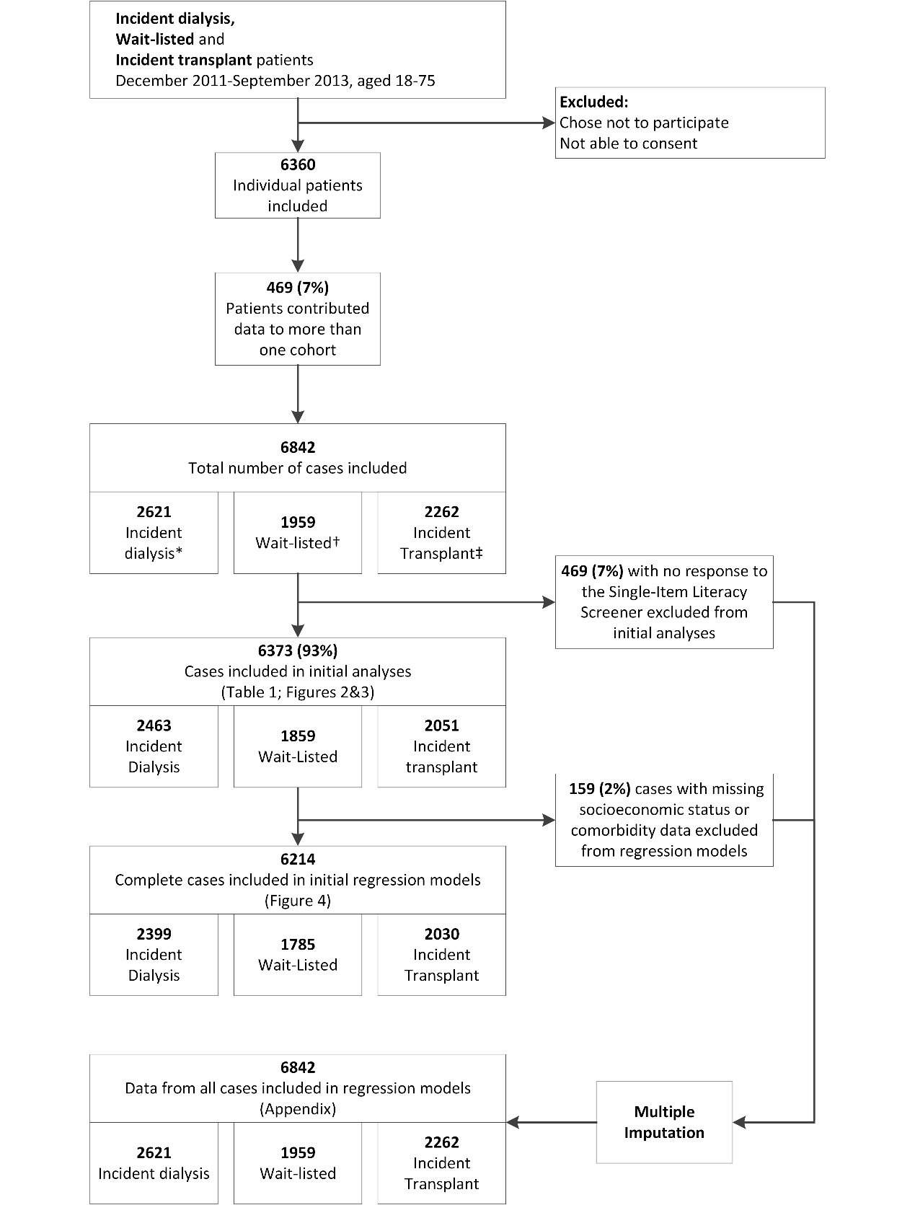
Figure 1
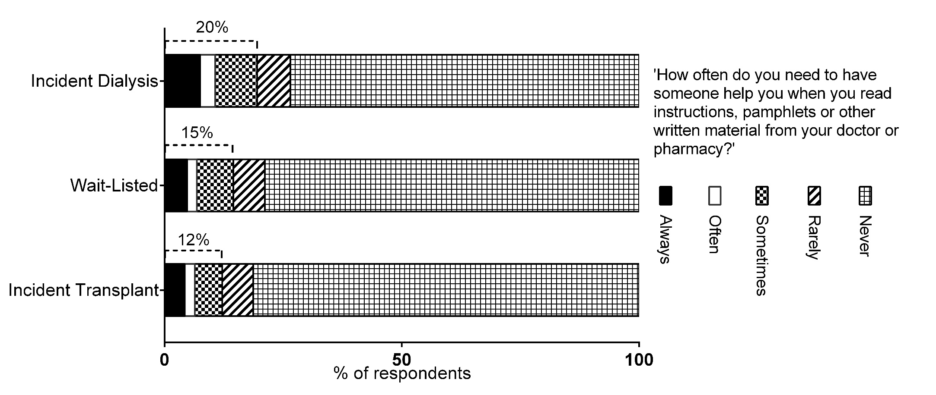
Figure 2
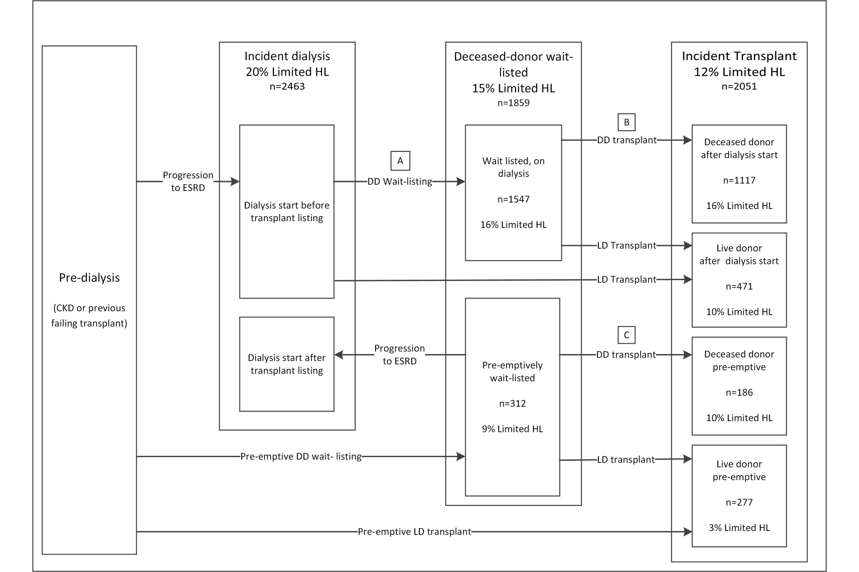
Figure 3
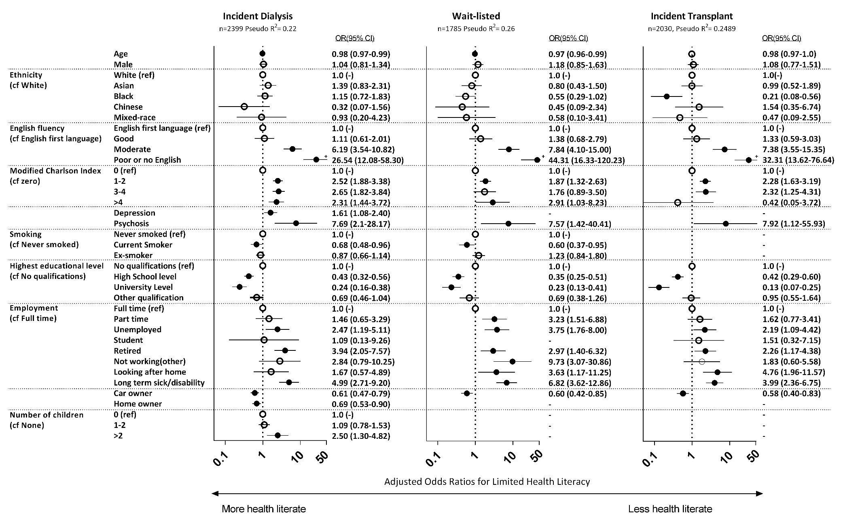
Figure 4
 | Incident dialysis, n=2463 |  |  |  |  | Wait listed, n=1859 |  |  |  |  | Incident transplant, n=2051
 |  | Heath literacy |  |  |  |  | Heath literacy |  |  |  |  | Heath literacy
 | Adequate |  | Limited |  |  | Adequate |  | Limited |  |  | Adequate |  | Limited
 | 1982(80%) |  | 481 (20%) |  | p | 1589 (85%) |  | 270 (15%) |  | p | 1801 (88%) |  | 250 (12%) |  | p
Male | 1294 (65) |  | 311 (65) |  | 0.795 | 917 (58) |  | 160 (59) |  | 0.633 | 1128 (63) |  | 152 (61) |  | 0.575
Median age (IQR) | 58 (47-67) |  | 58 (47-66) |  | 0.636 | 51 (41-61) |  | 48 (39-58) |  | 0.008 | 50 (39-60) |  | 49.5 (41-58) |  | 0.812
Ethnicity:
White | 1661 (84) |  | 322 (67) |  | <0.001 | 1223 (77) |  | 166 (61) |  | <0.001 | 1510 (84) |  | 178 (71) |  | <0.001
Asian | 140 (7) |  | 107 (22) |  |  | 153 (10) |  | 68 (25) |  |  | 137 (8) |  | 52 (21)
Black | 140 (7) |  | 39 (8) |  |  | 173 (11) |  | 26 (9) |  |  | 118 (7) |  | 8 (3)
Chinese | 15 (1) |  | 6 (1) |  |  | 20 (1) |  | 7 (3) |  |  | 11 (1) |  | 8 (3)
Mixed-race | 25 (1) |  | 7 (1) |  |  | 19 (1) |  | 3 (1) |  |  | 24 (1) |  | 4 (1)
Language:
English First Language | 1800 (91) |  | 338 (70) |  | <0.001 | 1390 (88) |  | 168 (62) |  | <0.001 | 1647 (92) |  | 167 (67) |  | <0.001
Other first language, self-reported English Fluency:
Good | 114 (6) |  | 21 (4) |  |  | 144 (9) |  | 16 (6) |  |  | 103 (6) |  | 10 (4)
Moderate | 54 (3) |  | 58 (12) |  |  | 45 (3) |  | 39 (14) |  |  | 39 (2) |  | 31 (12)
Poor or no English | 13 (1) |  | 64 (13) |  |  | 7 (0.4) |  | 47 (17) |  |  | 11 (1) |  | 42 (17)
Modified Charlson Comorbidity index:
0 | 913 (46) |  | 124 (26) |  | <0.001 | 1108 (70) |  | 152 (56) |  | <0.001 | 1281 (71) |  | 130 (52) |  | <0.001
1-2 | 692 (35) |  | 230 (48) |  |  | 400 (25) |  | 95 (35) |  |  | 422 (23) |  | 99 (40)
3-4 | 240 (12) |  | 89 (19) |  |  | 60 (4) |  | 16 (6) |  |  | 76 (4) |  | 20 (8)
>4 | 137 (7) |  | 38 (8) |  |  | 21 (1) |  | 7 (3) |  |  | 22 (1) |  | 1 (0.4)
Individual comorbidities
Myocardial infarction | 185 (9) |  | 58 (12) |  | 0.072 | 65 (4) |  | 15 (6) |  | 0.273 | 55 (3) |  | 9 (4) |  | 0.642
Heart failure | 120 (6) |  | 35 (7) |  | 0.301 | 34 (2) |  | 10 (4) |  | 0.116 | 34 (2) |  | 6 (2) |  | 0.587
Peripheral vascular disease | 159 (8) |  | 58 (12) |  | 0.004 | 55 (3) |  | 12 (5) |  | 0.413 | 50 (3) |  | 15 (6) |  | 0.007
Cerebrovascular disease | 142 (7) |  | 62(13) |  | <0.001 | 76 (5) |  | 20 (8) |  | 0.070 | 75 (4) |  | 22 (9) |  | 0.001
Dementia | 4 (0.2) |  | 0 |  | 1.0 | 3 (0.2) |  | 0 |  | 1.0 | 1 (0.06) |  | 0 |  | 1.0
Respiratory disease | 214 (11) |  | 59(13) |  | 0.317 | 99 (6) |  | 16 (6) |  | 0.870 | 127 (7) |  | 14 (6) |  | 0.391
Diabetes | 690 (35) |  | 301(64) |  | <0.001 | 242 (15) |  | 72 (27) |  | <0.001 | 293 (16) |  | 88 (35) |  | <0.001
Diabetic nephropathy | 417 (21) |  | 216(46) |  | <0.001 | 156 (10) |  | 59 (22) |  | <0.001 | 210 (12) |  | 75 (30) |  | <0.001
Cirrhotic liver disease | 23 (1) |  | 4(1) |  | 0.806 | 2 (0.1) |  | 0 (0) |  | 1.0 | 10 (1) |  | 1 (0.4) |  | 1.0
Leukaemia | 5 (0.25) |  | 1(0.2) |  | 1.0 | 2 (0.1) |  | 1 (0.4) |  | 0.376 | 2 (0.1) |  | 0 |  | 1.0
Lymphoma | 20 (1) |  | 2(0.4) |  | 0.286 | 11 (0.7) |  | 2 (0.7) |  | 1.0 | 9 (0.5) |  | 0 |  | 0.611
Psychosis | 4 (0.2) |  | 9(2) |  | <0.001 | 2 (0.1) |  | 8 (3) |  | <0.001 | 2 (0.1) |  | 5 (2) |  | <0.001
Depression | 113 (6) |  | 48(10) |  | 0.001 | 89 (6) |  | 18 (7) |  | 0.5 | 74 (4) |  | 15 (6) |  | 0.118
Malignancy | 263 (13) |  | 41(9) |  | 0.006 | 110 (7) |  | 11 (4) |  | 0.084 | 109 (6) |  | 11 (4) |  | 0.294
Primary Renal Disease
Diabetes | 417 (21) |  | 216 (45) |  | <0.001 | 156 (10) |  | 59 (22) |  | <0.001 | 210 (12) |  | 75 (30) |  | <0.001
Glomerulonephritis or SLE | 389 (20) |  | 63 (13) |  |  | 450 (28) |  | 42 (16) |  |  | 522 (29) |  | 46 (18)
Polycystic Kidney Disease | 185 (9) |  | 23 (5) |  |  | 272 (17) |  | 36 (13) |  |  | 286 (16) |  | 25 (10)
Pyelonephritis or TIN | 144 (7) |  | 23 (5) |  |  | 179 (11) |  | 32 (12) |  |  | 204 (11) |  | 19 (8)
Hypertensive, renovascular or ischaemic nephropathy | 188 (9) |  | 35 (7) |  |  | 104 (7) |  | 17 (6) |  |  | 113 (6) |  | 18 (7)
Other | 659 (33) |  | 121 (25) |  |  | 428 (27) |  | 84 (31) |  |  | 466 (26) |  | 67 (27)
Smoking:
Never smoked | 1103 (56) |  | 282 (59) |  | 0.481 | 1005 (63) |  | 175 (65) |  | 0.773 | 1187 (66) |  | 164 (66) |  | 0.670
Ex-smoker | 567 (29) |  | 126 (26) |  |  | 238 (15) |  | 36 (13) |  |  | 482 (27) |  | 64 (26)
Current Smoker | 310 (16) |  | 73 (15) |  |  | 345 (22) |  | 59 (22) |  |  | 131 (7) |  | 22 (9)
Median BMI (IQR) | 27 (23-32) |  | 27(24-33) |  | 0.022 | 26 (23-29) |  | 26 (23-30) |  | 0.210 | 26 (23-29) |  | 25 (23-29) |  | 0.606
Highest Educational level:
None | 568 (30) |  | 245(51) |  | <0.001 | 331 (21) |  | 125 (47) |  | <0.001 | 311 (17) |  | 112 (45) |  | <0.001
High-school level | 858 (43) |  | 156(33) |  |  | 805 (51) |  | 95 (35) |  |  | 925 (52) |  | 96 (39)
University level | 355 (18) |  | 39(8) |  |  | 340 (22) |  | 25 (9) |  |  | 436 (24) |  | 14 (6)
Other | 193 (10) |  | 40(8) |  |  | 104 (7) |  | 23 (9) |  |  | 122 (7) |  | 26 (10)
Car owner | 1479 (75) |  | 272(57) |  | <0.001 | 1268 (80) |  | 174 (65) |  | <0.001 | 1543 (86) |  | 178 (71) |  | <0.001
Home owner | 1135 (58) |  | 191(40) |  | <0.001 | 934 (59) |  | 106 (39) |  | <0.001 | 1163 (65) |  | 125 (50) |  | <0.001
Marital status
Married | 1101 (56) |  | 244(51) |  | 0.001 | 801 (51) |  | 128 (48) |  | 0.770 | 957 (53) |  | 127 (51) |  | 0.595
Living with partner | 135 (7) |  | 22(5) |  |  | 131 (8) |  | 20 (7) |  |  | 162 (9) |  | 17 (7)
Divorced or separated | 240 (12) |  | 85(18) |  |  | 226 (14) |  | 38 (14) |  |  | 190 (11) |  | 32 (13)
Widowed | 108 (5) |  | 39(8) |  |  | 55 (3) |  | 10 (4) |  |  | 52 (3) |  | 7 (3)
Single | 388 (20) |  | 89(19) |  |  | 369 (23) |  | 72 (27) |  |  | 435 (24) |  | 65 (26)
Employment
Full time | 293 (15) |  | 15 (3) |  | <0.001 | 399 (25) |  | 15 (6) |  | <0.001 | 509 (28) |  | 22 (9) |  | <0.001
Part time | 163 (8) |  | 18 (4) |  |  | 206 (13) |  | 23 (9) |  |  | 192 (11) |  | 15 (6)
Unemployed | 145 (7) |  | 35 (7) |  |  | 125 (8) |  | 36 (13) |  |  | 140 (8) |  | 27 (11)
Long-term sickness/disability | 542 (27) |  | 228 (48) |  |  | 395 (25) |  | 140 (52) |  |  | 455 (25) |  | 121 (49)
Student | 19 (1) |  | 1 (0.2) |  |  | 28 (2) |  | 0 |  |  | 38 (2) |  | 2 (1)
Retired | 741 (38) |  | 166 (35) |  |  | 363 (23) |  | 41 (15) |  |  | 370 (21) |  | 39 (16)
Not working (other) | 28 (1) |  | 5 (1) |  |  | 23 (1) |  | 6 (2) |  |  | 50 (3) |  | 7 (3)
Looking after home | 44 (2) |  | 12 (3) |  |  | 43 (3) |  | 8 (3) |  |  | 43 (2) |  | 15 (6)
Number of children
0 | 1575 (80) |  | 360 (75) |  | 0.001 | 1165 (74) |  | 189 (71) |  | 0.016 | 1319 (73) |  | 188 (75) |  | 0.153
1-2 | 345 (17) |  | 91 (19) |  |  | 370 (23) |  | 60 (22) |  |  | 407 (23) |  | 47 (19)
>2 | 53 (3) |  | 29 (6) |  |  | 50 (3) |  | 18 (7) |  |  | 71 (4) |  | 15 (6)

Table 1
 |  | Unadjusted Odds ratio for limited health literacy  (95% CI) | p
A: Wait-listed on dialysis compared to incident dialysis * | Incident dialysis (ref) | 1 | 0.003
 | Wait-listed, on dialysis | 0.77 (0.64-0.92)
B: Incident Deceased Donor transplant compared to deceased donor wait-listed * | Wait listed, on dialysis (ref) | 1 | 0.677
 | Deceased donor transplant after dialysis start | 0.95 (0.75-1.20)
C: Pre-emptive deceased-donor transplant compared to pre-emptively wait-listed * | Pre-emptively wait-listed (ref) | 1 | 0.561
 | Pre-emptive deceased donor transplant | 1.18 (0.68-2.06)
Pre-emptive listing or transplant compared to listing or transplant after dialysis start | Wait listed, on dialysis (ref) | 1 | 0.001
 | Pre-emptively wait-listed | 0.51 (0.32-0.78)
 | Deceased donor transplant after dialysis start (ref) | 1 | 0.057
 | Pre-emptive deceased donor transplant | 0.62 (0.35-1.03)
 | Live donor transplant after dialysis start (ref) | 1 | 0.001
 | Pre-emptive live donor transplant | 0.30 (0.13-0.62)
Live donor transplant compared to deceased donor | Deceased donor transplant after dialysis start (ref) | 1 | 0.005
 | Live donor transplant after dialysis start | 0.61 (0.43-0.87)
 | Deceased donor pre-emptive transplant (ref) | 1 | 0.002
 | Live donor pre-emptive transplant | 0.30 (0.12-0.71)
Table 2

 | Odds Ratios for limited health literacy (95% CI)
 | Wait-listed on dialysis compared to incident dialysis * |  | Pre-emptively wait listed compared to wait-listed on dialysis |  | Pre-emptive live donor transplant compared to live donor transplant after dialysis start |  | Live donor transplant after dialysis start compared to deceased donor transplant after dialysis start |  | Live donor pre-emptive transplant compared to deceased donor
 | n=3698 |  | n=1783 |  | n=704 |  | n=1566 |  | n=373
 |  | p |  | p |  | p |  | p |  | p
Model 1  Age, gender. | 0.74  (0.62-0.89) | 0.001 | 0.50  (0.33-0.77) | 0.002 | 0.32  (0.15-0.67) | 0.002 | 0.57  (0.40-0.82) | 0.002 | 0.34  (0.15-0.78) | 0.011
Model 2a (Ethnicity, Language)  As model 1 plus Ethnicity and Language | 0.71  (0.58-0.86) | 0.001 | 0.48  (0.30-0.77) | 0.002 | 0.35  (0.16-0.77) | 0.009 | 0.55  (0.38-0.81) | 0.002 | 0.33  (0.14-0.82) | 0.016
Model 2b (SES)  As model 1 plus Employment, car and home ownership and education. | 0.84  (0.69-1.01) | 0.070 | 0.81  (0.51-1.28) | 0.368 | 0.46  (0.21-1.00) | 0.049 | 0.72  (0.49-1.04) | 0.084 | 0.47  (1.88-1.15) | 0.097
Model 3 (Ethnicity, Language, SES)  As model 1 plus factors in models 2a and 2b | 0.79  (0.64-0.97) | 0.027 | 0.75  (0.46-1.25) | 0.272 | 0.55  (0.24-1.23) | 0.146 | 0.69  (0.46-1.03) | 0.068 | 0.53  (0.20-1.42) | 0.205
Model 4 (Comorbidity)  As model 3 plus modified Charlson index, smoking and psychosis | 0.92  (0.74-1.14) | 0.439 | 0.79  (0.48-1.31) | 0.355 | 0.55  (0.25-1.27) | 0.163 | 0.78  (0.52-1.17) | 0.225 | 0.53  (0.20-1.45) | 0.218
Table 3

Appendix

Modified Charlson comorbidity Index
The modified Charlson index used to quantify comorbidity in this study was adapted from Hemmelgarn et al¹ 2003, who adapted the original Charlson index² to more accurately predict outcomes in patients in End-Stage Renal Disease. This index was further adapted to allow for the data available from the ATTOM study. Presence of Rheumatological or peptic ulcer disease were not recorded in the ATTOM study, so were excluded from the scoring. Score weightings were unchanged from the Hemmelgarn modified Charlson index. Some definitions were altered to allow for subtle differences in the way comorbidities were recorded. The small number of patients (92; 1.3%) with missing data for one or more diagnoses included in the Charlson index were scored at ‘zero’ for that diagnosis, but their total score was still included in the initial analyses.
The index weightings, compared to those from Hemmelgarn’s modified Charlson index are shown in Table A1.

Effect of language on ethnicity-related differences in health literacy
Adding adjustment for English fluency to each model was found to reduce the effect of Ethnicity on the likelihood of limited health literacy to non-significance. This is shown in table A2.

Multiple imputation of missing data
We were concerned about the potential for non-response bias arising from exclusion of patients without complete data, most of whom had an incomplete record because of non-response to questions relating to socioeconomic status and the SILS. The proportions of missing data for key variables in each group are shown in Table A3. We compared demographics and comorbidities of patients with complete and incomplete records (see Table A4). Patients with incomplete records were significantly older and more likely to be Asian or diabetic. There were other differences in individual comorbidities. The missing data were therefore deemed to be ‘Missing at Random’ (MAR).³
To investigate the effect of these missing data on the results of logistic regression models, data were imputed for each group of patients (ID/WL/IT). Imputation by chained equations (ICE) was performed using STATA 12 (StataCorp LP, College station, TX, USA). 20 imputed datasets were generated per group. Variables used in the imputation models included all variables considered for inclusion in multivariate models (SILS score, age, gender, ethnicity, individual comorbidities, smoking, qualifications, employment, accommodation, car ownership, marital status, number of children and birth in the UK). Rate of Limited health literacy and modified Charlson indices were then recalculated using the imputed comorbidities and SILS scores.
Regression models were re-fitted using the same backwards-stepwise approach as described in the Methods section. Pooled estimates of logistic regression models from all 20 imputed datasets were compared to the original models (see Table A5).No additional dependent variables reached statistical significance in any group, so the final regression models for the imputed data included no new variables. The patterns observed in regression models from imputed data were largely similar to those using complete cases only. In all groups, patients who achieved ‘other’ qualifications (mostly vocational qualifications) were significantly less likely to have limited health literacy (OR 0.34). In the wait-listed group, there were some changes in the effect of comorbidity and employment status on the likelihood of limited health literacy- including loss of significance for ‘current’ smoking status.

Tables
Table A1 : Score weightings for modified Charlson index based on Hemmelgarn et al.¹
Comorbidity variables from Hemmelgarn et al | Weight | Corresponding variable from ATTOM | Weight
Myocardial infarction | 2 | Myocardial infarction | 2
Congestive heart failure | 2 | Heart failure | 2
Peripheral vascular disease  (includes Aortic aneurysm >6cm) | 1 | Peripheral vascular disease or aortic aneurysm repair | 1
Cerebrovascular disease | 2 | Cerebrovascular disease | 2
Dementia | 1 | Dementia | 1
Chronic lung disease | 1 | Respiratory disease | 1
Rheumatological /Connective tissue disease | 1 | Excluded | -
Peptic ulcer disease | 1 | Excluded | -
Diabetes without complications | 2 | Diabetes, excluding those with diabetes as primary renal disease | 2
Diabetes with complications | 1 | Diabetes as primary renal disease | 1
Leukaemia | 2 | Leukaemia | 2
Lymphoma (includes myeloma) | 5 | Lymphoma or myeloma | 5
Moderate/severe liver disease | 2 | Liver cirrhosis | 2
Metastatic cancer | 10 | Metastatic cancer | 10
TOTAL SCORE | 33 |  | 31

Odds of limited health literacy in patients of Asian ethnicity (ref: White ethnicity)
 | Incident Dialysis |  | Wait-listed |  | Incident Transplant
 | OR | 95% CI | OR | 95% CI | OR | 95% CI
Unadjusted | 3.81 | 2.90-5.00 | 3.01 | 2.24-4.29 | 3.34 | 2.35-4.76
After adjustment for English Fluency | 1.32 | 0.86-2.03 | 0.80 | 0.46-1.39 | 0.91 | 0.51-1.61
Table A2: The effect of adding adjustment for English fluency on the odds of limited health literacy in patients of Asian ethnicity

Table A3: Proportion of missing data for each variable by patient group
 | Missing values by group (%)
 | Incident Dialysis  n=2621 | Wait Listed  n=1959 | Matched Controls  n=2262
Single-Item Literacy Screener | 158 (6.0) | 211 (9.3) | 100 (5.1)
Gender | 0 | 0 | 0
Ethnicity | 10 (0.4) | 9 (0.4) | 6 (0.3)
Language | 157 (6.0) | 206 (9.1) | 97(5.0)
Comorbidities (examples)
Heart Failure | 33 (1.3) | 10 (0.4) | 28 (1.4)
Diabetes | 25 (1) | 7 (0.3) | 25 (1.3)
Respiratory disease | 33 (1.3) | 10 (0.4) | 27 (1.4)
Cirrhotic liver disease | 35 (1.3) | 13 (0.6) | 27 (1.4)
Smoking | 68 (2.6) | 65 (2.9) | 50 (2.6)
Qualifications | 166 (6.3) | 214 (9.5) | 106 (5.4)
Car Ownership | 162 (6.2) | 208 (9.2) | 99 (5.0)
Home ownership | 166 (6.3) | 211 (9.3) | 100 (5.1)
Marital Status | 170 (6.5) | 213 (9.4) | 104 (5.3)
Employment | 165 (6.3) | 211 (9.3) | 103 (5.3)
Number of Children | 167 (6.4) | 210 (9.3) | 102 (5.2)

Table A4: Comparison of demographics and comorbidity between patients with complete data and those with missing data
 | Complete cases  n=6217(91%) | Incomplete cases  n=625(9%) | p
Median age(IQR) | 53(43-63) | 52(41-62) | 0.049
Male | 3858(62) | 399(64) | 0.380
Ethnicity
White | 4986(80) | 440(73) | 0.001
Asian | 657(11) | 91(15)
Black | 484(8) | 54(9)
Chinese | 44(0.7) | 9(1.5)
Mixed-race | 46(0.7) | 1(6)
Modified Charlson index
0 | 3598(58) | 370(59) | 0.197
1-2 | 1900(31) | 200(32)
3-4 | 495(8) | 40(6)
>_5 | 224(4) | 15(2)
Diagnoses included in modified Charlson index
Myocardial infarction | 381(6) | 24(4) | 0.021
Heart failure | 239(4) | 21(3) | 0.915
Peripheral vascular disease | 343(6) | 33(5) | 0.728
Cerebrovascular disease | 393(6) | 34(6) | 0.819
Dementia | 8(0.13) | 2(0.36) | 0.177
Respiratory disease | 526(8) | 33(6) | 0.036
Diabetes | 1652(27) | 192(34) | <0.001
Diabetic nephropathy | 1105(18) | 140(25) | <0.001
Cirrhotic liver disease | 40(1) | 6(1) | 0.235
Leukaemia | 10(0.16) | 2(0.32) | 0.365
Lymphoma | 99(2) | 3(0.5) | 0.029

Table A5: Comparison of regression models using imputed data and models using data from complete cases only. Bold type indicates statistical significance.
 |  | Incident Dialysis |  |  |  | Wait-Listed |  |  |  | Incident Transplant
 | Complete records only  n=2399 |  | Pooled Imputed data  n=2621 |  | Complete records only  n=1785 |  | Pooled imputed data  n=1959 |  | Complete records only  n=2030 |  | Pooled imputed data  n=2262
Age | 0.98 (0.97-0.99) |  | 0.98 (0.97-1) |  | 0.97 (0.96-0.99) |  | 0.98 (0.96-0.99) |  | 0.98 (0.97-1) |  | 0.99 (0.97-1)
Male gender | 1.04 (0.81-1.34) |  | 1.04 (0.81-1.34) |  | 1.18 (0.85-1.63) |  | 1.18 (0.85-1.64) |  | 1.08 (0.77-1.51) |  | 1.07 (0.77-1.5)
Ethnicity (Ref: White)
Asian | 1.39 (0.83-2.31) |  | 1.52 (0.91-2.52) |  | 0.8 (0.43-1.5) |  | 0.84 (0.46-1.54) |  | 0.99 (0.52-1.89) |  | 1 (0.5-1.99)
Black | 1.15 (0.72-1.83) |  | 1.13 (0.71-1.8) |  | 0.55 (0.29-1.02) |  | 0.63 (0.35-1.14) |  | 0.21 (0.08-0.56) |  | 0.23 (0.09-0.59)
Chinese | 0.32 (0.07-1.56) |  | 0.46 (0.11-1.93) |  | 0.45 (0.09-2.34) |  | 0.53 (0.11-2.5) |  | 1.54 (0.35-6.74) |  | 1.27 (0.29-5.58)
Mixed-race | 0.93 (0.2-4.23) |  | 1.08 (0.26-4.49) |  | 0.58 (0.1-3.41) |  | 0.54 (0.1-3.07) |  | 0.47 (0.09-2.55) |  | 0.53 (0.1-2.88)
English Fluency
(Ref: English 1st Language)
Good | 1.11 (0.61-2.01) |  | 1.07 (0.59-1.96) |  | 1.38 (0.68-2.79) |  | 1.21 (0.61-2.38) |  | 1.33 (0.59-3.03) |  | 1.21 (0.53-2.75)
Moderate | 6.19 (3.54-10.82) |  | 5.71 (3.27-9.96) |  | 7.84 (4.1-15) |  | 7.36 (3.9-13.88) |  | 7.38 (3.55-15.35) |  | 7.3 (3.43-15.53)
Poor or no English | 26.54 (12.08-58.3) |  | 19.25 (9.13-40.61) |  | 44.31 (16.33-120.23) |  | 50.2 (18.89-133.4) |  | 32.31 (13.62-76.64) |  | 35.79 (14.79-86.57)
Modified Charlson Index (Ref: 0)
1-2 | 2.52 (1.88-3.38) |  | 2.37 (1.78-3.16) |  | 1.87 (1.32-2.63) |  | 1.59 (1.13-2.23) |  | 2.28 (1.63-3.19) |  | 2.11 (1.5-2.95)
3-4 | 2.65 (1.82-3.84) |  | 2.51 (1.73-3.64) |  | 1.76 (0.89-3.5) |  | 1.49 (0.77-2.9) |  | 2.32 (1.25-4.31) |  | 2.06 (1.13-3.77)
>4 | 2.31 (1.44-3.72) |  | 2.31 (1.45-3.68) |  | 2.91 (1.03-8.23) |  | 2.37 (0.85-6.61) |  | 0.42 (0.05-3.72) |  | 0.55 (0.07-4.41)
Depression | 1.61 (1.08-2.4) |  | 1.62 (1.09-2.39)
Psychosis | 7.69 (2.1-28.17) |  | 7.11 (2.01-25.11) |  | 7.57 (1.42-40.41) |  | 6.93 (1.36-35.43) |  | 7.92 (1.12-55.93) |  | 7.43 (1.09-50.72)
Smoking status
(ref: Never)
Current Smoker | 0.68 (0.48-0.96) |  | 0.69 (0.49-0.96) |  | 0.6 (0.37-0.95) |  | 0.64 (0.4-1.01)
Ex-smoker | 0.87 (0.66-1.14) |  | 0.85 (0.65-1.12) |  | 1.23 (0.84-1.8) |  | 1.21 (0.83-1.77)
Highest educational level
(Ref: None)
High School level | 0.43 (0.32-0.56) |  | 0.55 (0.41-0.73) |  | 0.35 (0.25-0.51) |  | 0.43 (0.3-0.62) |  | 0.42 (0.29-0.6) |  | 0.45 (0.31-0.65)
University Level | 0.24 (0.16-0.38) |  | 0.25 (0.16-0.4) |  | 0.23 (0.13-0.41) |  | 0.21 (0.11-0.38) |  | 0.13 (0.07-0.25) |  | 0.12 (0.06-0.25)
Other qualification | 0.69 (0.46-1.04) |  | 0.34 (0.22-0.54) |  | 0.69 (0.38-1.26) |  | 0.37 (0.22-0.63) |  | 0.95 (0.55-1.64) |  | 0.4 (0.24-0.65)
Employment (Ref: Full time)
Part time | 1.46 (0.65-3.29) |  | 1.45 (0.64-3.29) |  | 3.23 (1.51-6.88) |  | 2.81 (1.35-5.84) |  | 1.62 (0.77-3.41) |  | 1.67 (0.8-3.5)
Unemployed | 2.47 (1.19-5.11) |  | 2.21 (1.06-4.63) |  | 3.75 (1.76-8) |  | 3.32 (1.59-6.91) |  | 2.19 (1.09-4.42) |  | 2.37 (1.2-4.69)
Student | 1.09 (0.13-9.26) |  | 0.91 (0.12-7.14) |  |  |  |  |  | 1.51 (0.32-7.15) |  | 1.67 (0.36-7.71)
Retired | 3.94 (2.05-7.57) |  | 3.44 (1.79-6.59) |  | 2.97 (1.4-6.32) |  | 2.53 (1.24-5.17) |  | 2.26 (1.17-4.38) |  | 2.26 (1.17-4.38)
Not working(other) | 2.84 (0.79-10.25) |  | 2.44 (0.68-8.8) |  | 9.73 (3.07-30.86) |  | 2.72 (0.92-8.07) |  | 1.83 (0.6-5.58) |  | 2.01 (0.67-6.02)
Looking after home | 1.67 (0.57-4.89) |  | 1.75 (0.62-4.93) |  | 3.63 (1.17-11.25) |  | 3.08 (0.99-9.56) |  | 4.76 (1.96-11.57) |  | 5.16 (2.1-12.68)
Long term sick/disability | 4.99 (2.71-9.2) |  | 4.52 (2.46-8.29) |  | 6.82 (3.62-12.86) |  | 6.24 (3.43-11.38) |  | 3.99 (2.36-6.75) |  | 4.2 (2.51-7.02)
Car owner | 0.61 (0.47-0.79) |  | 0.61 (0.47-0.8) |  | 0.6 (0.42-0.85) |  | 0.63 (0.44-0.89) |  | 0.58 (0.40-0.83) |  | 0.58 (0.40-0.84)
Home owner | 0.69 (0.53-0.9) |  | 0.68 (0.52-0.88)
Number of Children (Ref: None)
1-2 | 1.09 (0.78-1.53) |  | 1.08 (0.76-1.52)
>2 | 2.50 (1.30-4.82) |  | 2.50 (1.30-4.82)

References (Appendix)
1. Hemmelgarn B, Manns B, Quan H, et al. Adapting the Charlson Comorbidity index for use in patients with ESRD. Am J Kidney Dis 2003; 42: 125-132.

2. Charlson ME, Pompei P, Ales KL, et al. A new method of classifying prognostic comorbidity in longitudinal studies: development and validation. J Chronic Dis 1987; 40: 373-383.

3. Sterne JAC, White IR, Carlin JB, et al. Multiple imputation for missing data in epidemiological and clinical research: potential and pitfalls. BMJ (Clinical research ed) 2009; 338: b2393.

