Model for the adoption of telemedicine in Sri Lanka
Dayani Jayasinghe, Richard Crowder and Gary Wills
Abstract
We report the results of study that explored the factors characterising the introduction of telemedicine to the rural areas of Sri Lanka. A model was developed from the analysis of the literature, expert review and a field study conducted in three districts of Sri Lanka, which involved clinicians, hospital staff and the general public from both rural and urban areas. Health Ministry officials, medical directors and consultants from urban areas were also consulted. Quantitative data from the questionnaires, and qualitative data from the interviews, were analysed to investigate the impact on culture, technology and infrastructure when adopting a telemedicine system in rural areas of Sri Lanka. The TeleMedicine in Sri Lanka model (TMSL) is presented, which expresses the factors that hinder the acceptance of telemedicine in Sri Lanka. A key finding is that an understanding of the culture of Sri Lanka is essential in implementing a telemedicine system in the rural areas of the country. In addition, the lack of computer skills in the rural population, and of hospital staff, will be the major issue hindering the implementation and acceptance a telemedicine system.
Keywords
E-health, Rural health, Technology Acceptance Model, Telemedicine, Theory of Planned Behaviour

Introduction
In many countries the quality of health care available to the rural population is lower than that accessible by the urban population. This disparity is caused by a range of factors including a lack of public transport and the concentration of specialist service in urban areas. While this problem is common worldwide, it is particularly acute in Less Economically Developed Countries (LEDCs). It is widely recognised that the most cost-effective solution to this problem is the introduction of telemedicine. Telemedicine would allow the rural population the same access to resources as is available to the patient in urban areas without the need to travel (Bandara, 2011). However, the successful introduction of telemedicine is a complex socio-technical problem that has far-reaching implications for both staff and patients. To assist with the adoption process, we have developed a model that identifies the factors that impact successful introduction of telemedicine in the rural areas of an LEDC.
This paper considers the case of Sri Lanka, where the rural-urban split of healthcare resources is recognised by the government and attempts have been made to resolve these issues through the introduction of telemedicine, with varying success (Chapman and Arunatileka, 2010). Sri Lanka’s population is approximately 20.2 million (Department of Census and Statistics, 2012), 85% of whom live in rural areas (Trading Economics, 2012). This leads to significant challenges in the provision of uniform health care. Sri Lanka is widely recognised as having a healthcare system of significantly higher standard compared with many other LEDCs (Edirippulige et al., 2007). In particular, in the state sector, a healthcare is free at the point of delivery.
Additional financial support from the Sri Lankan government, and donor organisations, towards staffing and equipment have resulted in a healthcare system of higher quality compared to other LEDCs (Pole, 2010). By maintaining control of community health in rural and urban areas under individual Medical Health Officers, Sri Lanka has a low level of communicable diseases, a good life expectancy rate and good maternal and childcare survival rates compared with similar LEDCs (Bandara, 2011).
One of the methods used to solve the challenges of uneven provision of healthcare in the LEDC is to provide access to medical support through the use of telemedicine. We define telemedicine as the use of ICT to transfer medical information between sites (e.g. rural clinics, major hospitals) to assist with the improvement of the patients’ clinical health. As with the introduction of any new technology, there is a range of socio-technical challenges to be overcome. The work reported here is the development of a model that will enable key stakeholders to recognise the major challenges.
In order to develop a model that would identify the factors that impede the introduction of telemedicine, a study was conducted using questionnaires together with fieldwork, based on the triangulation approach described by Rogers et al. (2011). Their approach starts with a detailed literature review is firstly undertaken to identify previously reported problems faced by governments and other organisations when introducing a telemedicine system. Following this, an expert review and fieldwork using questionnaires and interviews were undertaken. A model was developed from these surveys that comprehensively covered the challenges faced when telemedicine is introduced. In this work the underlying question is “What is an appropriate model for the adoption of telemedicine system in the rural areas of Sri Lanka?”
Literature Review
To help develop the questionnaires, the literature review addressed the current state of telemedicine and understanding the problems associated with healthcare provision in Sri Lanka. We concentrated on identifying the cultural, technology and infrastructure challenges.
Telemedicine uses digital information and communication to enhance healthcare by supporting the diagnosis, treatment and prevention of diseases, and is becoming a major part of global health policy (Marasinghe, 2011; Rampatige et al., 2010). Pavlovskaya (2013) reports that Telemedicine has made the life of the healthcare worker easier and more effective by employing a range of healthcare applications including tele-conferencing, tele-health, tele-surgery and tele-care.
Telemedicine is becoming increasingly important in LEDCs, with Sri Lanka, India, Indonesia, Bangladesh and Pakistan having adopted successful small-scale systems (Nishantha et al., 2005; Gunawardhana, 2004; Elder and Clarke, 2007; Vassallo et al., 2001), though the scale is still smaller than in Europe and the United States (Peabody et al., 2006). Some applications are summarised below.
- A telemedicine system was implemented in 2001 for medical experts at Saga University in Japan to help clinicians in Sri Lanka with training, research and surgical care, in the fields of oral cancer, maxillofacial trauma and maxillofacial deformities, at the Department of Oral and Maxillofacial Surgery in the Faculty of Dental Sciences at the University of Peradeniya. Medical information was exchanged by email while experts from Japan visited Sri Lanka to deal with medical emergencies. The system reduced the cost and time spent by the experts travelling from Japan to Sri Lanka. This system also sent real-time high quality images and interactive voice messages using peer-to-peer collaboration. The system functioned well (Nishantha et al., 2005).
- An Indian telemedicine project used a rural kiosk to transfer medical information from rural areas to urban centres. Though this was initially successful, a drop in the number of patient visits to the kiosk was caused by a lack of acceptance by the villagers, a lack of awareness of the service, and the availability of competing services (Elder and Clarke, 2007).
- Indonesia developed a telemedicine system for primary community healthcare that introduced local PC-based medical stations at each referring hospital, health office and test laboratory. The project was not very successful because of underestimating the investment required to staff it. This project identified the importance of developing the users’ technical skills when implementing telemedicine systems in developing countries (Elder and Clarke, 2007).
- A telemedicine link was established between the Centre for the Rehabilitation of the Paralyzed in Dhaka, Bangladesh, and medical consultants at the Swinfen Charitable Trust based in the UK. This system used email to transfer digital images. It was successful since it resulted in lower costs and reduced stress compared with travelling overseas for a second opinion (Vassallo et al., 2001).
- In Pakistan, a telemedicine project was launched in conjunction with the State Department, IBM and other organisations, to facilitate the treatment of patients in the north of the country. Virtual clinics for Ear, Nose and Throat, dermatology and radiology, were introduced (Anon, 2008).
Chapman and Arunatileka (2010) reported significant challenges with the implementation of a telemedicine solution in Sri Lanka. We identified the following questions that require further investigation:
- What problems are faced by rural area patients in obtaining health facilities only offered by urban hospitals?
- What problems are faced by the government in introducing the system?
- What perception do doctors and hospital staff have to the provision of an e-healthcare solution in the rural areas of an LEDC?
We identified the following areas that challenge the adoption of telemedicine system in the rural areas of an LEDC:
- The shortage of rural health professionals is a critical issue, with most consultants being employed by urban hospitals since they employ the latest technologies and facilities (Edirippulige et al., 2006).
- Poor infrastructure has become a major issue for the rural population when travelling from rural areas to urban hospitals for consultations (Dinusha et al., 2011).
- The low disposable income of the rural population limits the number of computer users compared with the urban population (Oak, 2007).
Computer usage at work is a factor that governments should consider when planning to implement a telemedicine programme. The cost of equipment, computer literacy of users, internet service providers and coverage, are some of the barriers governments will face in implementing any telemedicine system. One survey indicated that about 1% of clinicians in the rural areas of Sri Lanka used computers at their place of work (Marasinghe, 2010).
Following this consideration of telemedicine in general, we considered the challenges faced within Sri Lanka. The digital divide in Sri Lanka is connected to a range of socio-economic variables including educational attainment, age, income and gender. As a consequence, only 30% of the rural population have adequate access to ICT (Gamage and Halpin, 2007).
In Sri Lanka, just 28.7% men and 25.1% women have basic and intermediate computer literacy (Department of Census and Statistics, 2015). To improve computer literacy among the general public, training is carried out by private institutes, schools and universities in the rural and estate sectors, as well as by government training centres. This covers basic, intermediate and advanced skills. Basic and intermediate skills are being able to use operating system functions, using application software such as Microsoft Office and using the internet and email. Advanced skills include resolving software and hardware problems and programming (Vassallo et al., 2001).

Table 1. Computer Awareness and Computer Literacy rate in the Residential and Provincial Sectors
 |  | Awareness |  | Literacy
 |  | 2006 | 2009 | 2006 | 2009 | 2014 | 2015
Country Average |  | 37.1 | 43.8 | 16.1 | 20.3 | 25.1 | 26.8
Sector | Urban | 47.4 | 60.0 | 25.1 | 31.1 | 34.6 | 40.3
 | Rural | 36.9 | 43.0 | 15.1 | 19.3 | 23.8 | 24.9
 | Estate | 10.3 | 15.8 | 4.3 | 8.4 | 6.2 | 7.8
Province | Western | 47.9 | 50.7 | 23.2 | 27.7 | 34.3 | 38.3
 | Central | 31.0 | 34.8 | 14.8 | 18 | 24.3 | 25.7
 | Southern | 43.2 | 45 | 15.6 | 19.6 | 25.4 | 26.8
 | Eastern | 31.5 | 46.6 | 11.4 | 12.9 | 15.9 | 12.8
 | North Western | 31.8 | 42.1 | 12.6 | 16.5 | 22.6 | 24.1
 | North Central | 27.5 | 40.4 | 8.9 | 14.1 | 15.3 | 21.2
 | Uva | 22.3 | 29.3 | 9.9 | 14.7 | 17.1 | 17.1
 | Sabaragamuwa | 30.2 | 44.6 | 12.3 | 19.1 | 22.6 | 20.7
After Department of Census and Statistics (2012) and Department of Census and Statistics (2015)

Table 1 summarises the literacy figures for Sri Lanka. While literacy is growing, it is still significantly low among the rural and estate population. If maintained, the increase over the years will ensure that the rural population will be able to understand and use telemedicine if provided.
The majority of screen interfaces is currently provided in English and not Sinhalese. Thus, improving the English of rural people will help them use the internet and computers to increase their educational attainment and access specialised applications, including telemedicine (Zhou et al., 2011).
In 2009, the government approved the delivery of government services electronically. This policy did not address the specific needs of the health sector, but does provide for the Ministry of Health to create its own policy within the defined framework (Ministry of Health Sri Lanka, 2013).
Some of the major problems faced by the government when developing the infrastructure to implement the e-health facility are basic physical needs such as up to date hospital equipment, computer equipment, and transportation to rural areas. Internet connectivity and translation of information into a local language are also significant challenges (Marasinghe, 2010). This, together with a lack of expertise, technical knowledge and skills in ICT across health sector employees, has made it difficult to adopt telemedicine (Wootton et al., 2009).
Table 2 shows a detailed analysis of the factors identified here, which allows a number of themes to be grouped together.
Methodology
Sri Lanka consists of nine provinces divided into 25 districts. The districts of Kandy, Matale and Colombo were selected as distinct, with Kandy having a moderately dense population, Matale less dense and more rural, while Colombo has the highest population density in Sri Lanka. This enabled us to compare the rural populations and their interactions with the urban centres. The work undertaken in Colombo was used to gather the expert reviews for the study, in particular government officials and clinicians at the major hospitals.
To understand the issues faced by the rural population in having an e-health solution, interviews and questionnaires were conducted in several parts of both rural and urban areas within the three districts.
The questions were based on the factors earlier identified, using infrastructure, culture, and technology as the variables. The main aim was to determine people’s opinions on a telemedicine system which would allow the development of an appropriate model for the adoption of a telemedicine system for the rural areas of Sri Lanka. The questionnaires, using a four point Likert scaling, covered the following areas.
- Benefits for the clinician and general public
- Time, cost, training and funding
- Attitudes of the people using the system
- Technology
- Infrastructure
- Policies and procedures
Questions related to attitude, perceived ease of use, perceived usefulness and the intention to use, were given to both hospital staff and the general public in the selected rural and urban areas. The question “Doctor’s perception towards the e-healthcare solution in the rural areas” was given to clinicians from rural and urban areas to assess their attitude, subjective norms, perceived behavioural control and intention to use.

Table 2. The factors identified that could influence the adoption of a telemedicine system in Sri Lanka
Component | Factor | Reference
Acceptance of Technology | Attitude to learning (G) | Armitage and Conner, 2001; Chapman and Arunatileka, 2010; Oak, 2007; Vassallo et al., 2001.
 | Attitude to learning (C) | Armitage and Conner, 2001; Chapman and Arunatileka, 2010; Ajzen, 2011; Zhou et al., 2011.
 | Education of general public (G) | Chapma and Arunatileka, 2010; Oak, 2007; Vassallo et al., 2001; Zhou et al., 2011.
 | Awareness of hospital staff (H) | Marasinghe, 2011; Pavlovskaya, 2013; Rampatige et al., 2010; Vassallo et al., 2001.
Acceptance of Infrastructure | Connectivity (C,H) | Edirippulige et al., 2006; Gamage and Halpin, 2007; Marasinghe, 2010.
 | Ease of use of equipment (C,H) | Djamasbi et al., 2009; Marasinghe, 2010;
 | Equipment (C,H) | Dinusha et al., 2011; Marasinghe, 2010; Oak, 2007.
Staff involvement | Incentives (C) | Edirippulige et al., 2007.
 | IT literacy of staff (C) | Gamage and Halpin, 2007; Wootton et al., 2009; Zhou et al., 2011.
 | Job relevance (H) | Edirippulige et al., 2007; Edirippulige et al., 2006; Vassallo et al., 2001.
 | Perceived use of telemedicine (C,H) | Chapman and Arunatileka, 2010; Elder and Clarke, 2007; Gunawardhana, 2004; Nishantha et al., 2005; Vassallo et al., 2001; Zhou et al., 2011.
 | Training for hospital staff (H) | Gamage and Halpin, 2007; Trading Economics, 2012.
Policy and Standards | Hospital policies (C,H) | Ministry of Health Sri Lanka, 2013.
 | Software Standards (C,H) | Ministry of Health Sri Lanka, 2013; Wootton et al., 2009.
 | Government Policies (C,H) | Chapman and Arunatileka, 2010; Ministry of Health Sri Lanka, 2013.
C: Clinicians, H: Hospital staff, G: General Public

The quantitative questionnaires were based on the Theory of Planned Behaviour (Armitage and Conner, 2001) and the Technology Acceptance Model (Legris et al., 2003). They were addressed to the clinicians, where a clinician is defined as a staff member who holds a licence to practice medicine.
The Theory of Planned Behaviour is concerned with individual behaviour, and can be used to determine the clinician’s intention to use telemedicine according to their skills and resources. This approach is a way of explaining the positive or negative attitudes, behavioural controls and subjective norms, opportunities, perception and attitudes of the clinician using the technology (Ajzen, 2011). Attitude and the subjective norm, such as happiness, unhappiness, like and dislikes, can directly influence the behaviour of a person. Perceived behavioural control helps to predict a person’s intention to use information technology in healthcare. The Technology Acceptance Model is designed to confirm the relevance of IT to a particular activity and how it can be used for that particular activity by the user. We excluded the attitudes of the user and analysed only the degree to which the user believes that the technology will help improve their performance of the task. We also determine how far the subject believes that using the system will be effortless (Holden et al., 2010; Venkatesh and Davis, 2006) and (Djamasbi et al. 2009).The minimum sample size of 13 for the questionnaires was calculated with conventional G*Power calculations (Faul et al., 2007), using the parameters shown in Table 3 (Banerjee et al. 2009).
Table 3. Parameters used to determine the minimum sample size using the G*Power calculations (Faul et al., 2007)
Tails | 2
Effect size | 1
Type I error rate α | 0.05
Probability of type 2 error. (β) | 0.1
Power (1 – β ) | 0.9
Degree of freedoms | 12
Minimum sample size | 13

An effect size of 1 was adopted as a measure of the strength of a phenomenon (Ellis, 2009). The effect size is obtained by calculating the difference between the Mean of the control group and the Mean of the experimental group divided by the standard deviation (Banerjee et al., 2009).
The 12 degrees of freedom measures how restricted the data are in reaching a certain level of prediction (Hair et al., 2009). The degree of freedom was calculated from the total number of predictions minus the number of estimated parameters.
The hypothesis was tested using t-test calculations. The null hypothesis H0 means there is no effect from the predictions, while the alternative hypothesis H1 means there will be an effect presented from the predictions. The Null hypothesis will be rejected if and only if the probability p < 0.05.
The minimum sample size was determined to be 13 participants per group, with a sample size per district of 26 drawn from both the rural and the urban areas of the district. The total sample size for the study was 72 from the three districts.
A four-point Likert scale was used to allow only for definite choices of opinion to be made by respondents, so avoiding a neutral answer. The questionnaires were given to 13 clinicians and 15 hospital staff from rural hospitals, and 11 clinicians and 19 hospital staff from urban hospitals. Also addressed were 13 members of the general public from rural areas and 13 from urban areas. The questions were presented in both Sinhalese and English. The questions were developed in English, translated into Sinhalese, and then translated back into English, to ensure no meaning was lost. The interviews were designed using semi-structured questions whose main advantage is that they provide more detailed information than is available through from data collection methods.
We interviewed 24 participants drawn from across the health sector at a time and venue suitable for each. These included clinicians, administrative staff, nurses, and technicians, from both rural and urban hospitals, to identify the appropriate model for adopting telemedicine. Before each interview, the researcher explained its purpose and its process. Most interviews were conducted in Sinhalese, the remainder being in English.
Results
Fieldwork was conducted by distributing questionnaires to the general public, clinicians and hospital staff in both rural and urban areas. The expert reviews were obtained by interviewing several ministry officials, medical directors and clinicians from both rural and urban areas of Colombo and Kandy.
Questionnaire data was analysed with SPSS and the hypothesis tested using a One-Sample t-test. A test value of 2.5 was assumed, from a four-point Likert-type scale ranging from 1 (strongly agree) to 4 (strongly disagree). Clinicians from both rural and urban hospitals gave a mean score less than 2.5 which indicated that everyone agreed on all the questions. The answers were all significant except for the following:
- I feel confident in using information through video conferencing to make health decisions, where p = 0.11 and greater than 0.05.
- Telemedicine will maintain the confidentiality of medical information of the patient, where p = 0.381 and less than 0.05.
- Telemedicine will protect patients’ privacy, where p = 0.862 and less than 0.05.
- Telemedicine will protect patient data, where p = 0.143 and less than 0.05.
Confidentiality, patients’ privacy and patient data are viewed differently in Sri Lanka. Possibly this is due to how the information gathered, reasons for gathering the information, the parties involved in the gathering, and using the same information for other purposes (Ratnayake, 2013). This may be the reason for the different p values. Though the results of the above four questions suggest that they could have been obtained by chance, it does not follow that clinicians disagree on those questions where the mean score was below 2.5.
An identical method was used in calculating the mean scores for the hospital staff, which included nurses, technicians and the administrative staff, from rural and urban hospitals. Hospital staff gave a mean score less than 2.5 and agreed on all the answers except for the following:
- I have participated in video conferencing, where the mean = 2.8 and is greater than 2.5.
- I have had formal training in computers in how to use telemedicine system, where the mean = 2.9 and is greater than 2.5.
The same method was used to measure the mean and the p value for the general public in the rural and the urban areas. The general public gave a mean score lower than 2.5 and agreed on all the answers except for the following:
- I accept the online consultation to physical contact with the consultant, where the mean = 2.6, greater than 2.5.
- I feel confident in using information from telemedicine to make health decisions, where the mean = 2.6, greater than 2.5.
The quantitative data from the fieldwork are presented in Tables 4, 5 and 6. There were mixed responses to the adoption of telemedicine. Though most of the participants agreed on adopting telemedicine, some issues were raised regarding their attitude towards accepting the change, availability of resources, staff involvement and health policies and standards.
There was no disagreement among the clinicians over using telemedicine as beneficial for their profession, that telemedicine would save time, improve access to healthcare facilities, and that a second opinion is important when making medical decisions.
Clinicians disagreed over specific issues. 4% did not believe that telemedicine can improve quality of care, with 8% not having the skills needed to evaluate health resources on the internet. 21% were not confident in using video conferencing to make health decisions, while 3% disagreed on the need to get expert opinion faster. 4% did not believe that telemedicine would help in treating and diagnosing the patient faster, and 1% said they could get a second opinion about the patient illness from a consultant and were not willing to have the telemedicine system affiliated with a public care centre. The results showed that 10% challenged the view that telemedicine would maintain the confidentiality of the patient’s medical information and 11% disbelieved the claim that telemedicine would protect patients’ privacy. 2% said that telemedicine would not help reduce consultant travel to distant sites, 3% did not agree that telemedicine can improve healthcare in the rural areas, and 5% did not agree that telemedicine would protect patient data.
Likewise, hospital staff diverged in each category, with 79% of them having experience of working with computers, while 85% use general computer applications at work. 70% knew how to use the internet to obtain health information, while 82% knew about telemedicine. 85% of staff believed that using telemedicine for patient care is a good idea, with 88% believing that telemedicine can improve patient care. 20% have participated in video conferencing, 23% have had formal training in using telemedicine, and 82% believed that telemedicine can improve healthcare in rural areas of Sri Lanka.

Table 4. The results from the clinician questionnaire
Question | N | Mean | Std. Deviation | Significance  (p Value)
Using telemedicine is beneficial for my profession | 23 | 1.7 | 0.4 | < .001*
Telemedicine saves time | 22 | 1.7 | 0.5 | < .001*
Telemedicine can improve the quality of care | 22 | 1.7 | 0.6 | < .001*
Video conferencing is beneficial when using telemedicine | 22 | 1.5 | 0.5 | < .001*
Telemedicine can improve access to healthcare facilities | 23 | 1.7 | 0.5 | < .001*
Second opinion is important when making medical decisions | 22 | 1.3 | 0.5 | < .001*
I have the skills I need to evaluate the health resources I find on the internet | 21 | 2.0 | 0.7 | < .001*
I feel confident in using information through video conferencing to make health decisions | 23 | 2.3 | 0.7 | 0.110
Introducing telemedicine will help me to get expert opinions faster | 23 | 1.7 | 0.7 | < .001*
Telemedicine will help me to treat and diagnose the patient faster | 23 | 2.0 | 0.6 | < .001*
I like to have a second opinion about the patient’s illness from a consultant | 21 | 1.6 | 0.6 | < .001*
I prefer to have a telemedicine system affiliated with a public care centre | 21 | 1.9 | 0.5 | <.001*
Telemedicine will maintain the confidentiality of medical information of the patient | 23 | 2.4 | 0.6 | 0.381
Telemedicine will protect patient’s privacy | 23 | 2.5 | 0.6 | 0.86
Telemedicine will help reduce consultants travelling to distant sites | 20 | 1.7 | 0.7 | <.001*
Telemedicine can improve the healthcare in the rural areas | 20 | 1.8 | 0.7 | <.001*
Telemedicine will protect patient data | 21 | 2.3 | 0.6 | 0.143
* indicates a statistically significant result
Table 5. The results from the hospital staff questionnaire
Question | N | Mean | Std. Deviation | Significance  (p Value)
I have previous computer experience | 34 | 2.0 | 0.7 | <.001*
I use general computer applications at work | 34 | 1.8 | 0.7 | <.001*
I know how to use the internet in obtaining health information | 34 | 2.0 | 0.8 | <.001*
I know what telemedicine means | 31 | 2.0 | 0.5 | <.001*
Using telemedicine in patient care is a good idea | 33 | 1.8 | 0.7 | <.001*
Using telemedicine technology can improve patient care | 34 | 1.9 | 0.6 | <.001*
I have participated in video conferencing | 32 | 2.8 | 1.0 | 0.05
I have had formal training in computers in how to use a telemedicine system | 34 | 2.9 | 0.8 | 0.005
I don’t have the knowledge to make use of telemedicine technology | 33 | 2.6 | 0.8 | 0.445
Telemedicine can improve the healthcare in the rural areas | 33 | 2.0 | 0.8 | <.001*
* indicates a statistically significant result

Table 6. The results from the general public questionnaire
Question | N | Mean | Std. Deviation | Significance  (p Value)
Using the internet to find information on healthcare is a good idea | 26 | 1.7 | 0.6 | <.001*
I know the meaning of telemedicine | 26 | 2.0 | 2.0 | <.001*
Telemedicine will reduce my cost of travelling to the city for consultation | 26 | 1.7 | 0.5 | <.001*
Telemedicine will reduce my travelling time to the city for consultation | 25 | 1.6 | 0.6 | <.001*
I can obtain the best health services using telemedicine | 25 | 2.5 | 0.8 | 0.898
I am comfortable with clinicians using telemedicine technology | 25 | 2.4 | 0.6 | 0.446
I accept the online consultation to physical contact with the consultant | 25 | 2.6 | 0.5 | 0.166
I feel confident in using information from telemedicine to make health decisions | 25 | 2.6 | 0.6 | 0.395
I can get medical information faster using telemedicine | 26 | 1.7 | 0.6 | <.001*
* indicates a statistically significant result

The results show that 92% of the general public from both rural and urban areas agree that using the internet to obtain healthcare information is a good idea. Everyone knew the meaning of telemedicine, 96% concurred that telemedicine could reduce the cost of their travel, while 92% said that they could reduce the time travelling to the city if they used telemedicine. 50% thought that they could obtain the best health services using telemedicine. 50% were comfortable with clinicians using telemedicine technology, and 92% were confident with the clinicians using information from telemedicine to make health decisions. 92% of the general public believe that they can get medical information faster using telemedicine.The interviews made it clear that the results from the questionnaires were supported. For example, hospital staff and the clinicians both commented:
“Patients prefer physical examination. GPs refer to the Consultant because they are unable to come to a final decision. Therefore, the patient might not like telemedicine because the Consultant is not physically examining the patient.”
“There are no computers and the internet facilities in the rural hospitals.”
“We need more training. I can use the internet but I am not an expert.”
“The confidentiality of the patient information will depend on the legal system of Sri Lanka.”
One factor which influenced the attitude to telemedicine was the lack of transport in rural areas and the low wages earned by the rural population. Uneven deployment of consultants means rural patients have to visit urban areas to see a consultant. The cost and time of travelling to urban hospitals is high for the rural population.
Another factor which influenced the attitudes was the lack of knowledge of the internet among hospital staff. A lack of internet facilities in rural hospitals, and a lack of knowledge about how the internet can be used, as well as the language barrier are some of these aspects.
The study highlighted a problem with protecting patient data, insufficient infrastructure facilities in Sri Lankan rural hospitals, and the allocation of funds to rural hospitals.
Understanding the culture of Sri Lanka is absolutely essential in implementing a telemedicine system. Improving the confidence of the rural population, and of hospital staff, will be the key issue.
Discussion
The key factors determined by this study were: confidence in using information through video conferencing, protecting patients’ privacy, protecting patients’ data, training hospital staff, provision of internet facilities, and having a consultant online. From these the Telemedicine Model in Sri Lanka (Figure 1) was developed.
The model consists of four components: acceptance to change, availability, staff involvement and policies and standards. Each consists of several sub-components.
- Acceptance to change. Focuses on how the hospital staff, the clinicians and the general public, will accept the new technology. This component requires investigations into attitudes to learning of the general public, and attitudes to learning of the clinicians. The education level of the general public must encompass the internet. The component also requires awareness about the new technology by hospital staff.
- Staff Involvement. This focuses on whether there is sufficient infrastructure available in the rural hospitals to introduce telemedicine. This include availability of telecommunications in rural hospitals, including the internet, and how the government can improve it. Also the ease of use of equipment by hospital staff, and what new equipment must be provided to rural hospitals when introducing telemedicine.
- Staff Involvement. This focuses on how the hospital staff will be involved after the introduction of the new technology. The component requires investigations into what incentives management is going to introduce for clinicians and consultants to use the new technology. The current level of IT literacy by hospital staff and the training needed for them when introducing telemedicine need to be investigated. This also covers job relevance and the perceived use of telemedicine by the hospital staff and clinicians.
- Policies and standards. This component of the model encompasses the policies and standards needed when introducing telemedicine to the rural areas. This component requires investigations into the new policies that should be introduced to hospitals and how current standards can be improved when introducing the new technology. What new government policies, such as data protection, should be included when introducing telemedicine to rural hospitals?
Since the data was collected separately using different questionnaires for the clinicians, hospital staff and the general public, the TMSL model can be divided in to three sub-models as shown in Figures 2, 3 and 4.

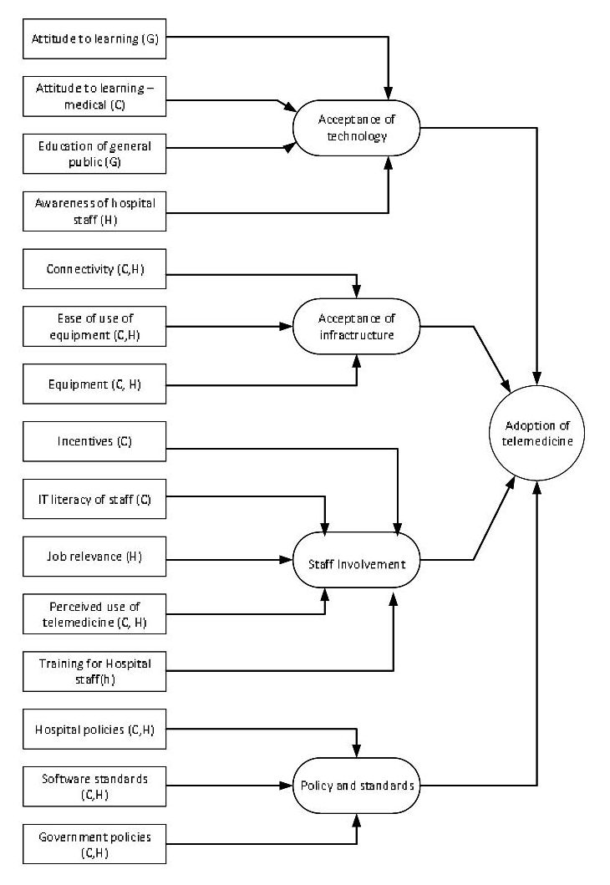
Figure 1. Telemedicine Model in Sri Lanka
C: Clinicians, H: Hospital staff and G: General Public

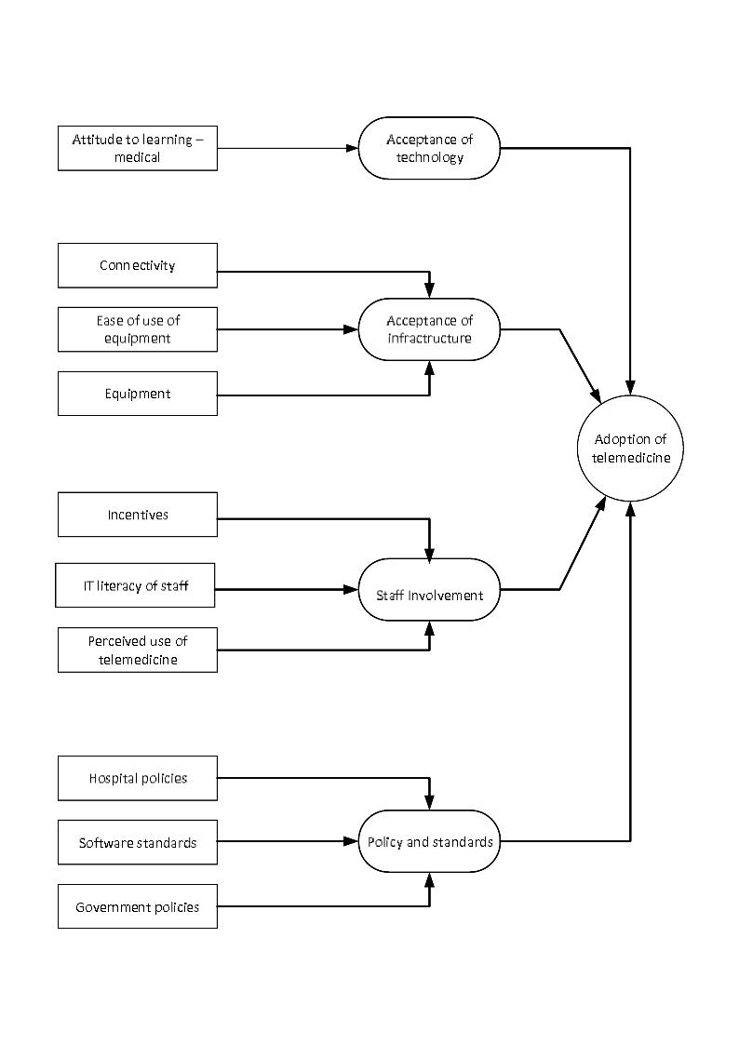
Figure 2. Telemedicine Model in Sri Lanka showing the factors for Clinicians

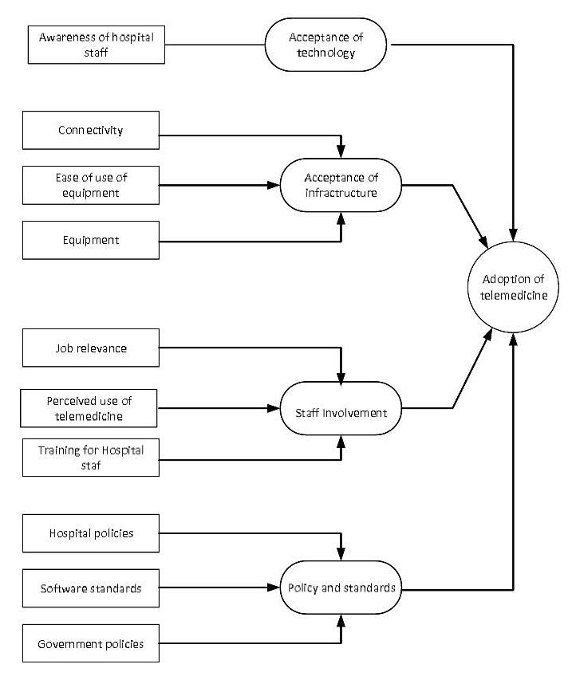
Figure 3. Telemedicine Model in Sri Lanka showing the factors for Hospital staff

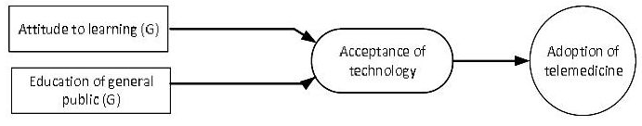
Figure 4. Telemedicine Model in Sri Lanka showing the factors the General Public

Conclusion
Many e-health applications can be employed in the healthcare environment, for example: Electronic Health Records (EHR), Hospital Information Systems (HIS), telemedicine and tele-care. Of these, telemedicine has become the most acceptable and affordable solution for the Less Economically Developed Countries (LEDCs) (Tan et al., 2005).
In comparison with the developed world, where hospitals are equipped with the latest IT solutions and equipment, LEDCs lack the necessary IT infrastructure, knowledge of applications and the usefulness of e-technology, and also lack a national policy and legal framework to introduce e-health solutions. Research is thus needed to find a new technological solution for introducing e-healthcare that will be both affordable to and supportive of rural patients.
Compared with other LEDCs, Sri Lanka has a high standard of healthcare nationwide (Edirippulige et al., 2007). Even though healthcare provision at urban hospitals is good, they have more up-to-date facilities and professional care than the rural hospitals who serve 70% of the population.
The reasons for the lack of adopting an e-health solution in Sri Lanka are the challenges faced by the healthcare sector in delivering the latest professional care and facilities to the rural population.
The three primary issues faced by Sri Lanka’s rural population in the current healthcare system are:
- Patients travel long distances from the rural areas where they live to the urban hospitals to obtain better health facilities, which involves high costs for transport and long hours of travelling.
- Inadequate infrastructure in the rural hospitals and uneven distribution of healthcare professionals.
- Inadequate health policies and procedures that are not well-defined in the rural areas.
Understanding the culture of Sri Lanka is essential in implementing a telemedicine system in the rural areas. Improving the confidence of the rural population, and of hospital staff, will be the key issue in implementing a telemedicine system.
This work concentrated on solutions to the e-healthcare system in Sri Lanka and has proposed a suitable model. To resolve these issues, introducing a telemedicine system will be beneficial to both the rural and urban populations.
Quantitative data from the questionnaires, and the qualitative data from the interviews, were analysed to investigate the adoption of a telemedicine system.
The major issues raised during the study were cultural effects when using new technology, availability of resources, involvement of hospital staff, training and clear policies. The factors that influenced the adoption of telemedicine were:
- Lack of transport in rural areas and the wages earned by the rural population. Uneven deployment of consultants means the rural public have to visit urban areas to see a consultant. The cost and time of travelling to urban hospitals is high for the rural population.
- Lack of knowledge of the internet among hospital staff; a lack of internet facilities in rural hospitals; a lack of knowledge about how to use the internet, and the language barrier, are some of the factors.
- Problems with protecting patient data, insufficient infrastructure facilities in the rural hospitals, and allocation of funds to rural hospitals.
The results of the survey led to the development of TMSL model. The model shows the reaction of the general public and the hospital staff, including the clinicians, to the new technology. The model also shows how the hospital staff can be involved in the new technology. The other major task identified in the model is how the government will improve the infrastructure of the rural areas to facilitate the adoption of telemedicine.
Ethics and Funding
This study received no specific grant from any funding agency in any public, commercial or non-profit-sectors.
The research reported in this paper was conducted under the University of Southampton Ethics policy, and received approval under application number 4371.
Data Access
All data supporting this study is available from the University of Southampton repository at http://dx.doi.org/10.5258/ SOTON/clinicians p value.xls, hos staff p value.xls, gen pub means and p value.xls,
References
Ajzen, I. (2011). The theory of planned behaviour: Reactions and reflections, Psychology & Health, 26:9, 1113-1127.
Anon. (2008). Telemedicine Project Targets Rural Areas in Northern Pakistan. iHealthBeat. Retrieved 10 May 2015 from http://www.ihealthbeat.org/articles/2008/10/9/telemedicine-project-targets-rural-areas-in-northern-pakistan.
Armitage, C. J. and Conner, M. (2001). Efficacy of the Theory of Planned Behaviour: A meta-analytic review. British Journal of Social Psychology, 40:471-499.
Bandara, S. (2011). Emerging Health Challenges in Sri Lanka: More money for health and more health for the money. Retrieved on 23 April 2015 from http://www.ips.lk/talkingeconomics/2011/04/18/emerging-health-challenges-in-sri-lanka-more-money-for-health-and-more-health-for-the-money/.
Banerjee, A., Chitnis, U. B., Jadhav, S. L., Bhawalkar, J. S. and Chaudhury, S. (2009). Hypothesis testing, type i and type ii errors. Industrial Psychiatry Journal. 18:127-131.
Chapman, K. R. P. and Arunatileka, S. M. (2010). Teleconsultation Roadmap – The Path to Telemedicine. In 12th IEEE International Conference on e-Health Networking Applications and Services (Healthcom), pp 74-80. IEEE.
Cresswell, J. W. (2006). Understanding Mixed Method Research. Los Angeles, CA Sage Publications.
Department of Census and Statistics. (2012). Computer Literacy Statistics. Department of Census and Statistics. Retrieved on 10 June 2015 from http://www.statistics.gov.lk/.
Department of Census and Statistics. (2015). Computer Literacy Statistics. Department of Census and Statistics. January-June 2015. Retrieved on 20 December 2015 from http://www.statistics.gov.lk/samplesurvey/ComputerLiteracy-2015Q1-Q2-final%20.pdf
Dinusha, V., Arunatilake, S. M. K. D., Chapman, K. R. P., Saatviga, S. and Abeywardhana, C. S. (2011). eClinics Integration Techniques to Clinical Information Systems moving into a National Network. Sri Lanka Journal of Bio-Medical Informatics. 1(0):S22.
Djamasbi, S., Fruhling, A. L. and Loiacono, E. T. (2009). The influence of affect, attitude and usefulness in the acceptance of telemedicine systems. Journal of Information Technology Theory and Application, 10: 2009; 10:41-58.
Edirippulige, S., Marasinghe, R. B., Smith, A. C., Fujisawa, Y., Jiffry, M. T. M. and Wootton, R. (2007). Medical students’ knowledge in e-health in developing countries: A survey in Sri Lanka. In 9th International Conference on e-Health Networking, Application and Services, pp 95-99. IEEE.
Edirippulige, S., Marasinghe, R. B., Smith, A. C., Fujisawa, Y., Herath, W. B., Jiffry, M. T. and Wootton, R. (2006). Knowledge and Perceptions of e-Health: Results of a survey of medical students in Sri Lanka. In 2006 International Conference on Information and Automation, p. 437-439. IEEE.
Elder, L. and Clarke, M. (2007). Past, present and future experiences and lessons from telehealth projects. Open Medicine, 1:166-170.
Ellis, P.D. (2009). Thresholds for interpreting effect sizes Retrieved on 30 May 2016 from http://www.polyu.edu.hk/mm/effectsizefaqs/thresholds_for_interpreting_effect_sizes2.html.
Faul, F., Erdfelder, E., Lang, A. and Buchner, A. (2007). G*power 3: A flexible statistical power analysis program for the social, behavioral, and biomedical sciences. Behavior Research Methods, 30:175191.
Gamage, P. and Halpin, E. F. (2007). E-Sri Lanka: Bridging the digital divide. The International Journal for the applications of technology in information environments, 25:693-710.
Gunawardhana, P. (2004). Telemedicine implementation experience in Sri Lanka. Technical report, Kandy: Centre for Telemedicine – General Hospital.
Hair, J. F., Black, W. C., Babin, B. J. and Anderson, R. E. (2009). Multivariate Data Analysis. Upper Saddle River, NJ: Prentice Hall.
Holden, R. J. and Karsh, B.-T. (2010). The Technology Acceptance Model: Its past and its future in health care. Journal of Biomedical Informatics, 43(1), 159.
Legris, P., Ingham, J. and Collerette, P. (2003). Why do people use information technology? A critical review of the technology acceptance model. Information & Management, 40:191-204.
Marasinghe, R. (2010). Telehealth – Bringing healthcare to one’s doorstep: how ready is Sri Lanka? Sri Lanka Journal of Bio-Medical Informatics, 1(3):125-139.
Marasinghe, R. B. (2011). Telemedicine today: Can late adopters leapfrog? Sri Lanka Journal of Bio-Medical Informatics, 2(4):116-117.
Ministry of Health Sri Lanka. (2013). eHealth Policy, Strategy, Guidelines and Standards: Regional High Level Meeting on eHealth. Ministry of Health Sri Lanka
Nishantha, D., Hayashida, Y., Weerasinghe, J., Wijekoon, P., Ihara, K., Shigematsu, M. and Goto, M. (2005). A unified collaboration groupware to support telemedicine among Sri Lanka, Japan, and other Asian countries. In 2005 International Conference on Information and Automation, Colombo, Sri Lanka. pp 192-196.
Oak, M. R. (2007). A review on barriers to implementing health informatics in developing countries. Journal of Health Informatics in Developing Countries, 1:19-22.
Pavlovskaya, O. (2013). E-healthcare system coming to Kazakhstan. Technical report, USCENTCOM.
Peabody, J. W., Taguiwalo, M. M., Robalino, D. A. and Frenk, J. (2006). Improving the quality of care in developing countries. In Jamison, D. T. and Measham, A. R., eds., Disease Control Priorities in Developing Countries, 2nd ed.
Pole, D. (2010). Electronic patient records in Sri Lankan hospitals. Sri Lanka Journal of Bio-Medical Informatics, 1(1):43-45.
Rampatige, R., Abusayeed, M. H. and Galappaththi, H. (2010). Global Observatory for ehealth (GOe) survey in Sri Lanka. Sri Lanka Journal of Bio-Medical Informatics, 1(1):49-52.
Ratnayake, H. M. (2013). Negotiating privacy, confidentiality and security issues pertaining to electronic medical records in Sri Lanka: A comparative legal analysis. Sri Lanka Journal of Bio-Medical Informatics, 4(2):32-39.
Rogers, Y., Sharp, H. and Preece, J. (2011). Interaction design: Beyond computer-human interaction. John Wiley & Sons Ltd.
Tan, J., Kifle, M., Mbarika, V. and Okoli, C. (2005). Diffusion of E-Medicine in developed and developing Countries. In J. Tan, E-Healthcare information systems-an introduction for students and professionals (p. 231-266). San Francisco, CA: Jossey-Bass.
Trading Economics. (2012). Trading Economics World Bank Indicators – Sri Lanka – Density and Urbanization. Retrieved on 2 April 2015 from http://www.tradingeconomics.com/sri-lanka/urban-population-wb-data.html.
Vassallo, D., Hoque, F., Roberts, M. F., Patterson, V., Swinfen, P. and Swinfen, R. (2001). An evaluation of the first years’ experience with the low-cost telemedicine link in Bangladesh. Journal of Telemedicine and Telecare, 7:125-138.
Venkatesh, V. and Davis, F. D. (2006). A theoretical extension of the technology acceptance model four longitudinal field studies. Management Science, 46:186-204.
Wootton, R., Scott, R. E., Patil, N. G. and Ho, K. (2009). Telehealth in the Developing World. London, UK: Royal Society of Medicine Press Ltd.
Zhou, Y., Singh, N. and Kaushik, P. D. (2011). The digital divide in rural South Asia: Survey evidence from Bangladesh, Nepal and Sri Lanka. IIMB Management Review, 23:15-29.

