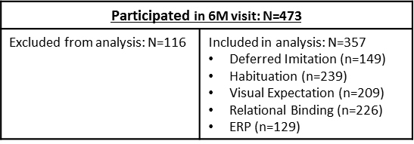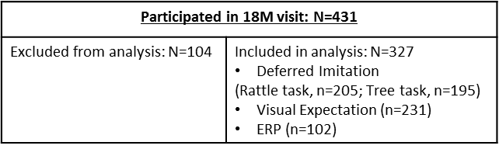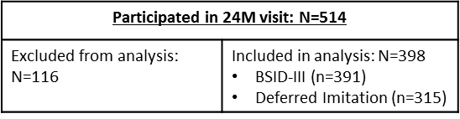

Recruited into GUSTO study: n=1247

No available slots

Lack of interest

Busy schedules

Other reasons

n=99

Busy schedules

Uncontactable

Dropped out (n=5)

n=374

n=376

n=55

Busy schedules

Uncontactable

Participants included for analysis

N=243 completed all 3 visits

N= 32 completed 6 and 18 months visits

N= 56 completed 6 and 24 months visits

N= 35 completed 18 and 24 months visits

NON-PARTICIPATION

n=473

n=57

n=138

n=774