Wear Resistance for Dry Sliding and Electroconductivity of Cu-0.3Cr-0.5Zr Alloy Processed by ECAP

A.P. Zhilyaev^{1, 2 , 3*}, A. Morozova⁴, J.M. Cabrera⁵, R. Kaibyshev⁴, T.G. Langdon⁶

¹ Institute for Metals Superplasticity Problems, Khalturina 39, Ufa, 450001, Russia
² Fundació CTM Centre Tecnològic, Plaça de la Ciencia 2, Manresa, Barcelona, 08242, Spain
³ Research Laboratory for Mechanics of New Nanomaterials St. Petersburg State Polytechnical University, Polytechnicheskaya 29 St. Petersburg, 195251, Russia
⁴ Belgorod State University, Pobeda 85, Belgorod, 308015, Russia
⁵ Departamento de Ciencia de los Materiales e Ingeniería Metalúrgica, ETSEIB – Universitat Politècnica de Catalunya, Av. Diagonal 647, Bacelona, 08028, Spain
⁶ Materials Research Group, Faculty of Engineering and the Environment, University of Southampton,
Southampton SO17 1BJ, UK

* Corresponding author: Alexander P. Zhilyaev, E-mail: AlexZ@anrb.ru

Abstract. The ultrafine-grained microstructures and functional properties (wear resistance for dry sliding and electrical conductivity) of a Cu-0.3%Cr-0.5%Zr alloy subjected to equal channel angular pressing (ECAP) at a temperature of 400 °C to a total strain of 1, 2, and 4 were investigated. Severe plastic deformation by ECAP to a total strain of ~1 led to a significant decrease of the wear resistance because of the rapid surface damage to both solution treated (ST) and aged (AT) samples, where a high density of dislocations was arranged in stochastic low-angle subboundaries by brittle fracture. Further deformation by subsequent ECAP passes promoted the subdivision of the shear bands by the geometrically necessary boundaries. Correspondingly, the number of fine crystallites outlined by HABs increased, and the wear rate decreased. After 4 ECAP passes, the wear rate decreased to the level of the initial state of the alloy and equaled 1.68×10⁻⁵ (mm³/(N·m) and 1.40×10⁻⁵ mm³/(N·m) for ST and AT samples, respectively. The damage mechanism is the controlling factor of the wear resistance of a Cu-Cr-Zr bronze hardened by intense plastic straining.
Keywords: Cu-Cr-Zr alloy, wear, electroconductivity, grain refinement, solid solution, ageing, ECAP

- Introduction
The combination of grain refinement and precipitation hardening is a well-established technique for improving mechanical and functional properties, such as yield strength and wear resistance. Currently, the design of highly conductive materials for fusion, high-speed railroad or generation IV reactors is of extreme importance to accomplish industrial requirements [1-3, , ]. For example, there is a demand to improve the strength and conductivity performance of the contact wire in the electric railways of high-speed trains [4-6, , ]. The target for the new material of contact wires is an alloy with a tensile strength greater than 530 MPa and an electrical conductivity of over 78 pct of International Annealed Copper Standard (IACS). In addition, a high wear resistance is a critical issue. According to the commonly used relationship [7, 8, ] the wear rate is reciprocal to the hardness of the contact materials:
Q = K∙F∙L/H_{V}, (1)
where Q is the total volume of the wear debris produced, K is a dimensionless constant, F is the total normal load, L is the sliding distance, H_{V} is the hardness of the softest contacting surfaces. Wear rate, W, follows from (1) as
W=Q/( F∙L)= K/Hv (2)
In order to accomplish the above specifications, CuCrZr alloy is being considered one of the best candidates for industrial application. This material can be subjected through thermo-mechanical processes to achieve the desirable properties. Recently, some approaches for the strengthening of Cu–Cr–Zr alloys while retaining their electric conductivity at a sufficiently high level of 80% IACS have been suggested [9-13, , , , ]. The processes involve intense plastic deformation at an elevated temperature, which enables a good combination of strength and electroconductivity [14]. However, the wear properties have not been investigated. This report focuses on the wear resistance of the Cu-0.3Cr-0.5Zr alloy subjected to ECAP. Particular attention is paid to the significance of near surface microstructure in the wear process [15]. As has been shown earlier [16] for copper, there is no unambiguous relation between the hardness of the contact materials and the wear rate.

- Experimental
An alloy of Cu-0.35Cr-0.5Zr (wt.%) subjected to two treatments (solution treated (ST) and age hardened (AT)) was subjected to equal channel angular pressing (ECAP) under an isothermal condition at 400 °C to total strains of ~ 1, 2, and 4. The billets with starting dimensions of 14×14×90 mm³ were preheated during 30 min and then pressed through a die with an angle of 90° via route Bc (a 90° anticlockwise rotation of the specimens after each pass). The processed samples were cooled in water after reaching the required total strain. The full details on the sample’s preparation for microstructural investigations can be found elsewhere [14Error: Reference source not found]. The electrical conductivities of the investigated samples were measured using the four-point probe method. The wear resistance of the samples was estimated using a high-temperature CSM tribometer oscillating friction and wear tester with a ball-on-disk contact configuration. The surface of the investigated samples was mechanically polished by using a diamond suspension with a final particle size of 3 μm. The sliding tests were carried out at the ambient temperature with a load of 1.5 N, a sliding speed of 0.04 m/s, and a sliding distance of 100 m using ∅6 mm steel balls. After completing the wear tests, a precision contact profilometer from SURTRONIC was used to acquire the profiles of the wear tracks at selected points on the specimens.

- Results and Discussion
Table 1 summarizes all of the experimental data acquired in the present report. The mean friction coefficient and the Kernel average misorientation (KAM) decrease with increasing numbers of ECAP passes for both ST and AT treatments. The wear rate demonstrates a non-monotonic behavior for both ST and AT treatments, increasing for the samples processed by one pass, and it nearly decreases to the initial value with increasing numbers of ECAP passes. The Taylor factor possesses a stability of approximately 3.2±0.1 for the ST specimen and 3.3±0.1 for the AT specimen of the CuCrZr alloy. The electro-conductivity decreases with increasing accumulated strain stabilizing at a level of 2.0×10⁷ (Ω∙m)⁻¹, which is 34.5% of the electro-conductivity for the International Annealed Copper Standard (IACS). The mean grain (sub-grain) size decreases and the dislocation density rises with an increase in the number of ECAP passes.
Fig. 1 depicts the EBSD maps (first and second columns) and the SEM micrographs of wear tracks of the solution-treated CuCrZr alloy for different numbers of passes of the ECAP. The EBSD maps consist of a kernel average misorientation (KAM) map and a map of the Taylor factor. Correspondingly, Fig. 2 shows the same types of maps and SEM micrographs for the aged CuCrZr alloy. Black lines in the EBSD maps separate grains with high-angle boundaries (HAB). The EBSD maps for samples subjected to both treatments appear to be rather similar with some shear bands revealed in the microstructure. Some typical shear bands with a mean width of 2-5 μm are demarked by light dash lines (yellow in the on-line version). Commonly, the density of HAB and the number of the fine highly misoriented crystallites, especially those located within the shear bands, increases during ECAP. The wear tracks in the right columns of Figs. 1 and 2 possess some specific strands that apparently correlate with the shear bands highlighted in the EBSD maps. Moreover, the worn surfaces of the ST and AT specimens evolve in a similar way for the initial specimen and the ECAP samples processed by 1, 2 and 4 passes. No significant amount of debris is found on the wear tracks of the initial specimens (Figs. 1 and 2). On the contrary, the SEM micrographs for the specimens processed by one ECAP pass demonstrate heavily damaged surfaces, which occupied nearly the whole area of the micrographs for both ST and AT samples. The fracture surfaces are of a considerably brittle appearance. The specimens subjected to 2 and 4 passes of ECAP possess moderately damaged areas with noticeably decreased areas of worn strands (Figs. 1 and 2). Moreover, it is apparent that after four ECAP passes, the AT specimen undergoes a transition from brittle to ductile behavior, whereas the ST specimen retains the brittle fracture surface. The appearance of worn surfaces is in good correlation with the measured wear rates (Table 1).

Fig. 3 shows the friction coefficient (upper row) and the friction force (lower row) recorded for the ECAP AT and ST samples as a function of the sliding distance. The friction coefficients of all ST specimens apparently saturate at a level of 0.6-0.65, although, the friction coefficients of the AT samples saturate at a level of 0.7-0.75. The friction forces have a tendency to saturate at a level on the order of ∼0.9 N for the ST specimens and at a level of 1.1 N for the AT samples, after a sliding distance of approximately 30 m.
Fig. 4 shows the experimental parameters (the mean friction coefficient, wear rate, electro-conductivity and Vickers microhardness) and derivatives of some parameters (the rate of dislocation accumulation and rate of microhardness change) of the ST and AT CuCrZr alloy samples as a function of the number of ECAP passes or the accumulated strain. The upper row of Fig. 4 depicts the mean friction coefficients (Fig. 4a) and the wear rates (Fig. 4b) for the ST and AT CuCrZr alloy samples as a function of the number of ECAP passes. There is a clear trend showing a decrease in the mean friction coefficient with an increase in the accumulated strain for both ST and AT samples. The wear rate possesses a maximum for samples processed for one ECAP pass. This is correlates well with the heavily worn surfaces shown in Figs. 1 and 2 (second row). The second row of Fig. 4 (c and d) shows the change in electro-conductivity as a function of the accumulated strain (Fig. 4c) and the rate of dislocation accumulation calculated on the basis of the data in Table 1 (Fig. 4d). As expected, there is a significant drop in conductivity after the alloy is deformed by ECAP for one pass. Additional ECAP straining gives a slight increase in the electro-conductivity with increasing numbers of passes. The rate of dislocation accumulation (Fig, 4d) follows the same trend as the wear rate does (Fig. 4b). The last row of Fig. 4 shows the microhardness evolution with the number of ECAP passes (Fig. 4e) and its changing rate (Fig. 4f).
From all of the dependencies shown in Fig. 4, one may conclude that the electro-conductivity follows an inverse law with microhardness (σ_{C} ≈ 1/Hv). However, the wear rate does not obey Eq. 1. Apparently, the wear rate is dictated not by the hardness but rather by the type of damage. The initial material exhibits damage dominated by shear fracture (Fig. 1c) that is attributed to a low material hardness (Fig. 4e). The first pass provides more than a four-fold increase in the wear rate of the samples from both treatments (Table 2), despite an increase in hardness. This phenomenon is attributed to the replacement of shear fracture as the dominant damage mechanism by brittle fracture and the crumbling of relatively large material areas along shear bands. As straining by ECAP progresses to 2 passes, the microstructure of the CuCrZr alloys alters to thin lamellas separated by high-angle (>15°) or medium-angle (>5°) boundaries. As a result, the brittle fracture damage occurs through the crumbling of relatively thin areas (Fig. 1c). In addition, the dislocation density increases with the accumulating strain that leads to an increase in the hardness (Fig. 4e). An approximately three-fold decrease in the wear rate takes place (Table 1). It is evident that the change from the crumbling of large areas to one of thin bands strongly contributes to the decreased wear rate. After 4 ECAP passes, the lamellas were subdivided by transverse boundaries to crystallites of a nearly rectangular shape, and the mixing of thin layers that is responsible for decrease in the wear rate (Table 1) is rarely observed (Fig. 1c).
Definitely the extended plastic deformation leads to further refining of the microstructure of the CuCrZr alloy with moderate and high-angle boundaries, which decrease the wear rate to the level of the initial state of the alloy. There is no clear difference in the wear properties of the ST and AT samples processed to the same strain by ECAP. The wear rate seems to sensitively depend on the character of the dislocation substructure. The shear bands involve a high density of stochastic dislocation subboundaries, which were brought out by a moderate ECAP strain (i.e., one ECAP pass), result in a drastic degradation of the wear resistance. In contrast, the dislocation rearrangement leading to the subdivision of the shear bands into new fine grains during subsequent ECAP passes remarkably improves the wear resistance. Therefore, extensive grain refinement is a necessity for the enhancement of the wear resistance of the Cu-Cr-Zr bronze with increased hardness that is attributed to deformation hardening. Merely hardening this material by intense plastic straining may deteriorate the wear resistance if coarse shear bands evolve.

- Conclusions
- The severe plastic deformation by ECAP to a total strain of ~1 led to a significant decrease of the wear resistance in dry sliding experiments because of the rapid surface damage to both ST and AT samples, where a high density of dislocations was arranged in stochastic low-angle subboundaries by brittle fracture.
- Further deformation by subsequent ECAP passes promoted the subdivision of the shear bands by the geometrically necessary boundaries. Correspondingly, the number of fine crystallites outlined by HABs increased, and the wear rate decreased. After 4 ECAP passes, the wear rate of dry sliding decreased to the level of the initial state of the alloy and equaled 1.68×10⁻⁵ (mm³/(N·m) and 1.40×10⁻⁵ (mm³/(N·m) for ST and AT samples, respectively.
- The damage mechanism is the controlling factor of the wear resistance of a Cu-Cr-Zr bronze hardened by intense plastic straining.

Acknowledgments
AM and RK acknowledge the financial support received from the Ministry of Science and Education, Russia under grant No. 14.Y31.16.8446-NSH. APZ acknowledges a TECNIOSPRING grant financed by Generalitat de Catalunya and co-funded by the 7th Framework program of the EU and
TGL acknowledges

References:
- Topuz AI (2015) Enabling microstructural changes of FCC/BCC alloys in 2D dislocation dynamics. Mater Sci Eng A 627: 381-390
- Correia JB, Davies HA, Sellars CM (1997) Strengthening in rapidly solidified age hardened Cu-Cr and Cu-Cr-Zr alloys. Acta Mater 45: 177-190
- ITER Joint Central Team (1994) The impact of materials selection on the design of the International Thermonuclear Experimental Reactor (ITER). J Nucl Mater 212-215: 3-10
- Liu Q, Zhang X, Ge Y, Wang J, Cui JZ (2006) Effect of processing and heat treatment on behavior of Cu-Cr-Zr alloys to railway contact wire. Metal Mater Trans A 37: 3233-3238
- Batra IS, Dey GK Kulkarni UD, Banerjee S (2001) Microstructure and properties of a Cu-Cr-Zr alloy. J Nucl Mater 299: 91-100
- Ghosh G, Miyake J, Fine ME (1997) The systems-based design of high strength, high-conductivity alloys. JOM 49: 56-60
- Archard JF (1953) Contact and rubbing of flat surfaces. J Appl Phys 24: 981-988
- Archard JF, Hirst W (1956) The wear of metals under unlubricated conditions. Proc Royal Soc A 236: 397-410
- Belyakov A, Murayama M, Sakai Y, Tsuzaki K, Okubo M, Eto M, Kimura T (2006) Development of a high-strength high-conductivity Cu-N-P alloy. Part II: Processing by severe deformation. J Electr Mater 35: 2000-2008
- Wei KX, Wei W, Wang F, Dua QB, Alexandrov IV, Hu J (2011) Microstructure, mechanical properties and electrical conductivity of industrial Cu-0.5% Cr alloy processed by severe plastic deformation. Mater Sci Eng A 528: 1478-1484
- Vinogradov A, Patlan V, Suzuki Y, Kitagawa K, Kopylov VI (2002) Structure and properties of ultra-fine grain Cu-Cr-Zr alloy produced by equal-channel angular pressing. Acta Mater 50: 1639-1651.
- Shakhova I, Yanushkevich Z, Fedorova I, Belyakov A, Kaibyshev R (2014) Grain refinement in a Cu-Cr-Zr alloy during multidirectional forging. Mater Sci Eng A 606: 380-389
- Mishnev R, Shakhova I, Belyakov A, Kaibyshev R (2015) Deformation microstructures, strengthening mechanisms, and electrical conductivity in a Cu–Cr–Zr alloy. Mater Sci Eng A 629: 29-40
- Zhilyaev AP, Shakhova I, Morozova A, Belyakov A, Kaibyshev R (2016) Grain refinement kinetics and strengthening mechanisms in Cu–0.3Cr–0.5Zr alloy subjected to intense plastic deformation. Mater Scie Eng A 654: 131-142
- Rigney DA, Glaeser WA (1978) The significance of near surface microstructure in the wear process. Wear 45: 241-250
- Zhilyaev AP, Shakhova I, Belyakov A, Kaibyshev R, Langdon TG (2013) Wear resistance and electroconductivity in copper processed by severe plastic deformation. Wear 305: 89-99

Figure Captions:

Fig. 1. (a) EBSD-KAM map, b) EBSD-Taylor map and (c) SEM micrographs of worn surfaces of ECAP CuCrZr alloys in solution treated condition as a function of a number of ECAP passes.

Fig. 2. (a) EBSD-KAM map, b) EBSD-Taylor map and (c) SEM micrographs of worn surfaces of ECAP CuCrZr alloys in aged condition as a function of a number of ECAP passes.

Fig. 3. Friction coefficient (upper row) and friction force (lower row) as a function of the sliding distance for the ECAP CuCrZr alloys in (a) solution treated condition and (b) aged condition.

Fig. 4. Averaged friction coefficient (a), wear rate (b), (c) electroconductivity; rate of dislocation accumulation (d) and Vickers microhardness (e), rate of Hv changing (f) of ECAP CuCrZr alloys in solution treated and aged conditions as a function of accumulated strain or number of ECAP passes.

 |  | EBSD: KAM map |  | EBSD: Taylor map |  | SEM
Initial |  | 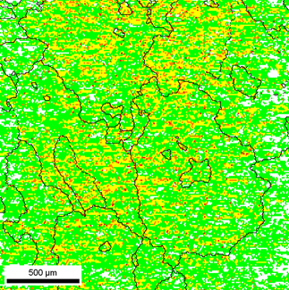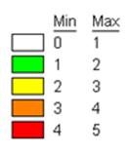  1.75 |  | 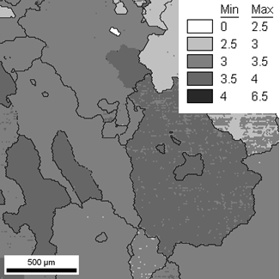  3.30 |  | 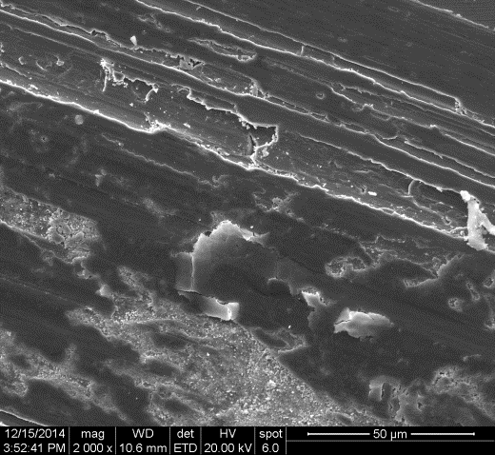
One pass |  | 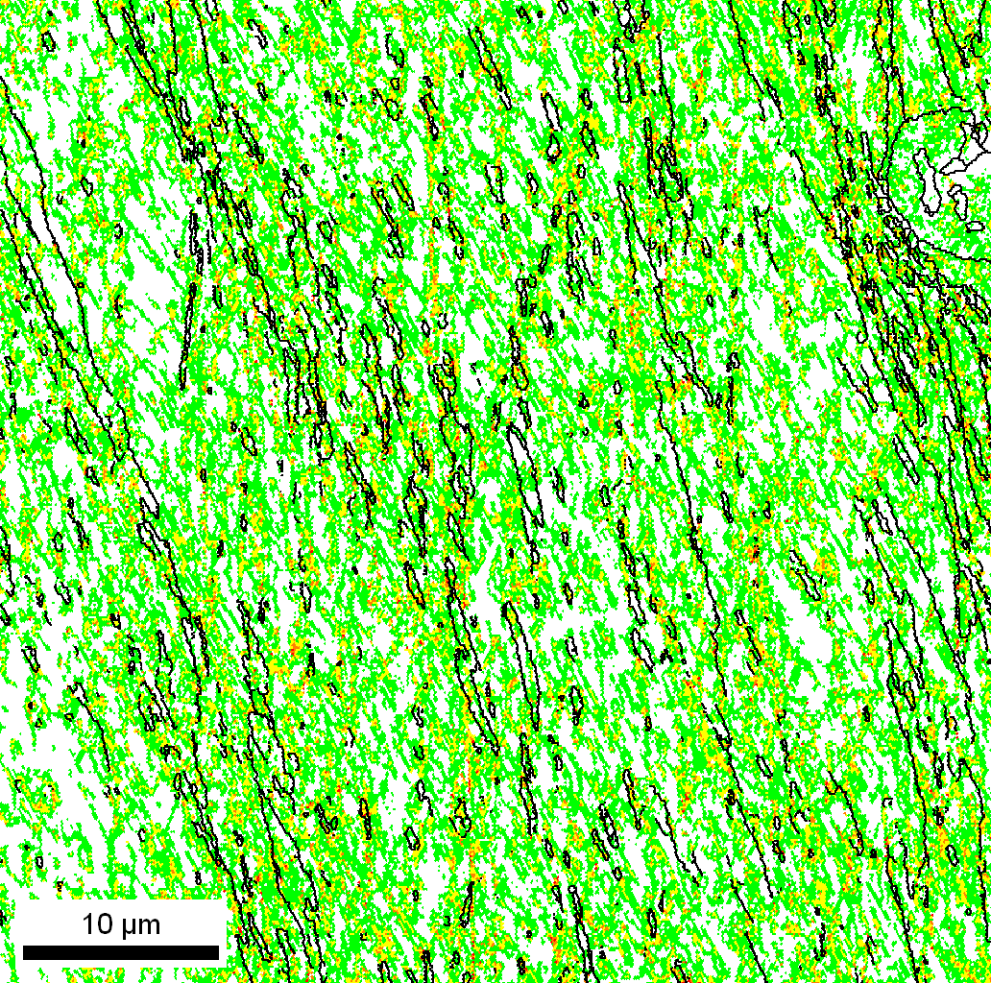  1.28 |  | 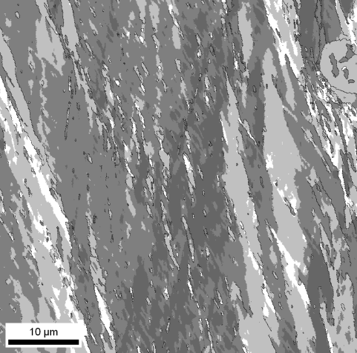  3.12 |  | 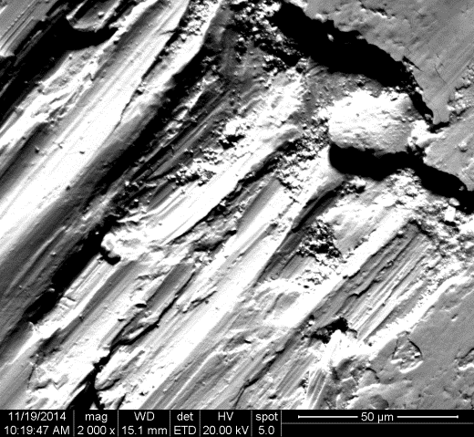
Two passes |  | 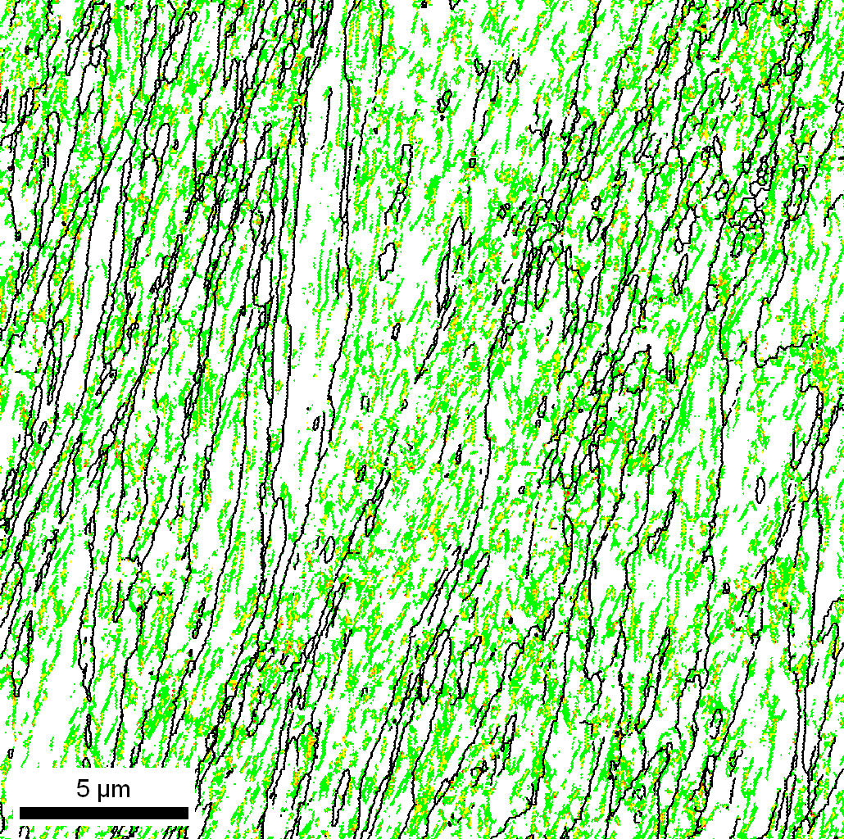  0.91 |  | 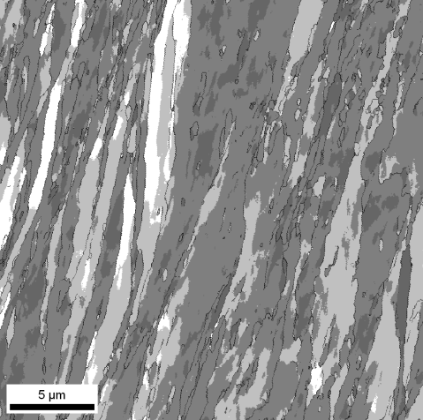  3.14 |  | 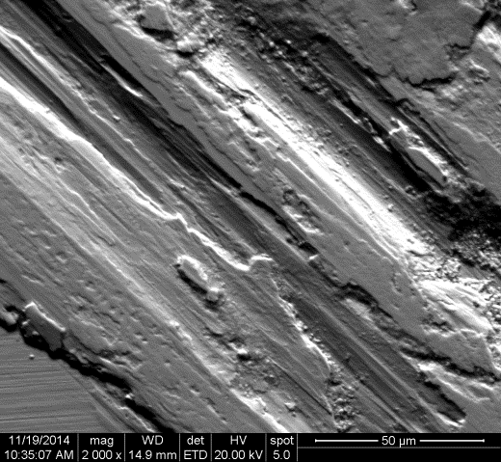
Four passes |  | 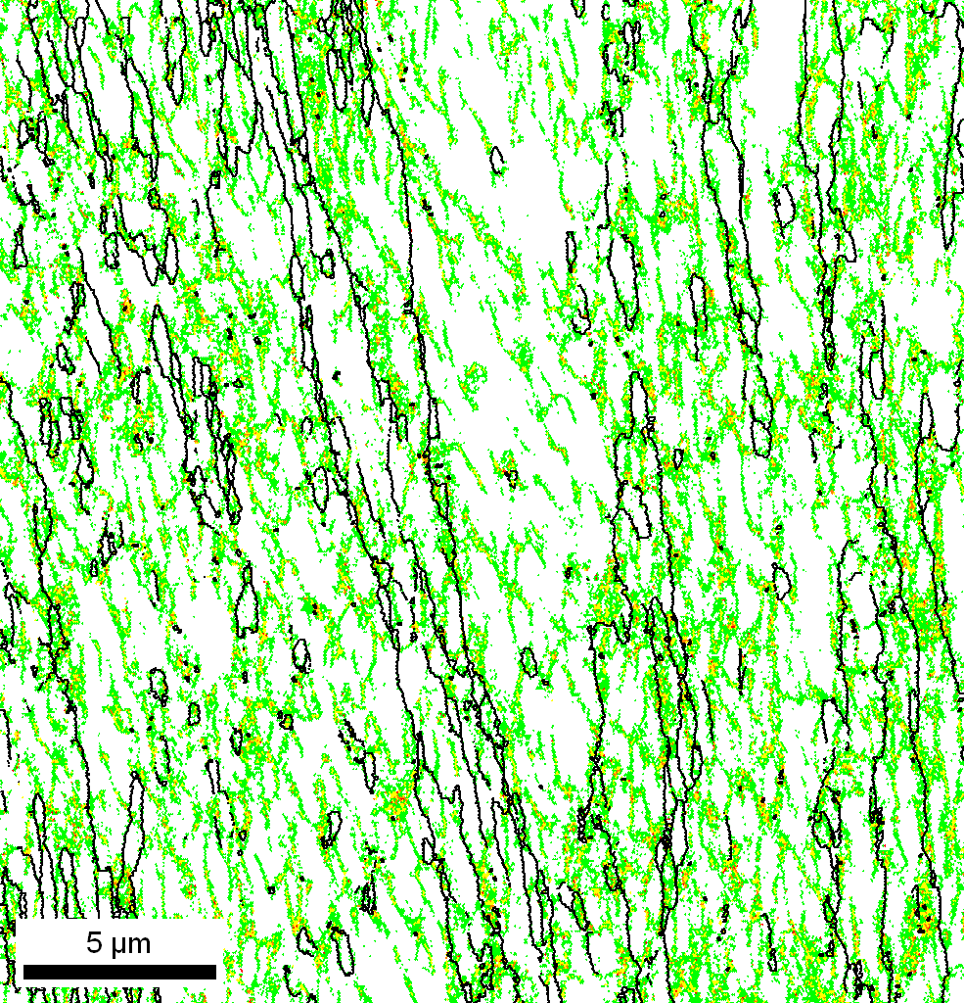  0.91 |  | 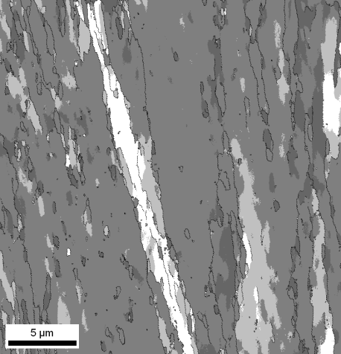  3.20 |  | 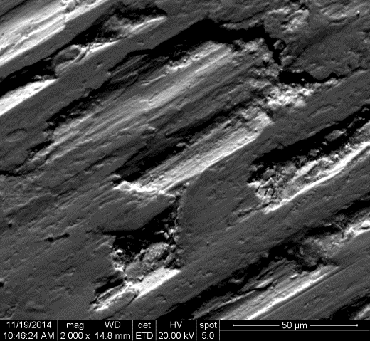
 |  | a) |  | b) |  | c)
Fig. 1. (a) EBSD-KAM map, b) EBSD-Taylor map and (c) SEM micrographs of worn surfaces of ECAP CuCrZr alloys in solution treated condition as a function of a number of ECAP passes.
 | EBSD: KAM map |  | EBSD: Taylor map |  | SEM
Initial | 1.75 |  | 3.30 |  | 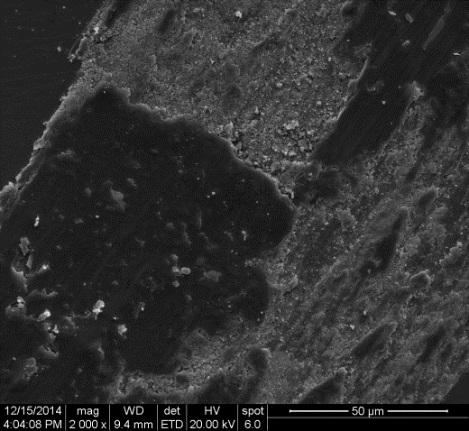
One pass | 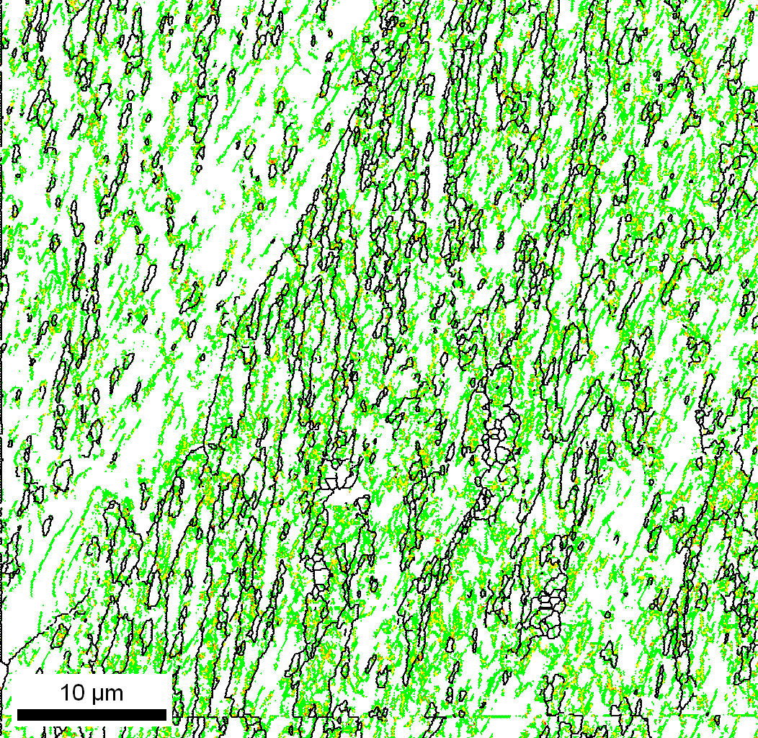  0.93 |  | 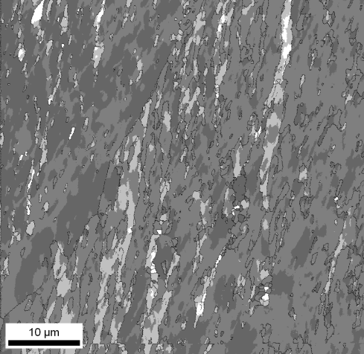  3.34 |  | 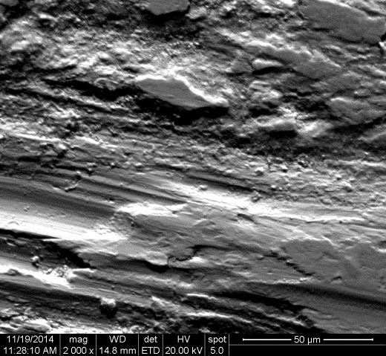
Two passes | 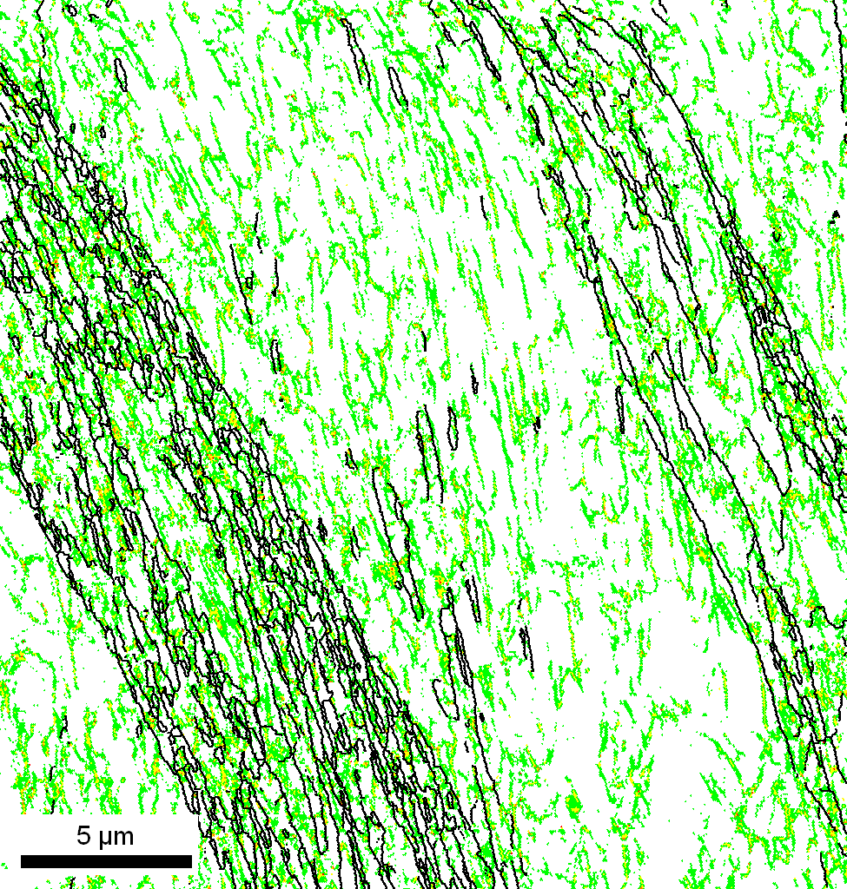  0.923 |  | 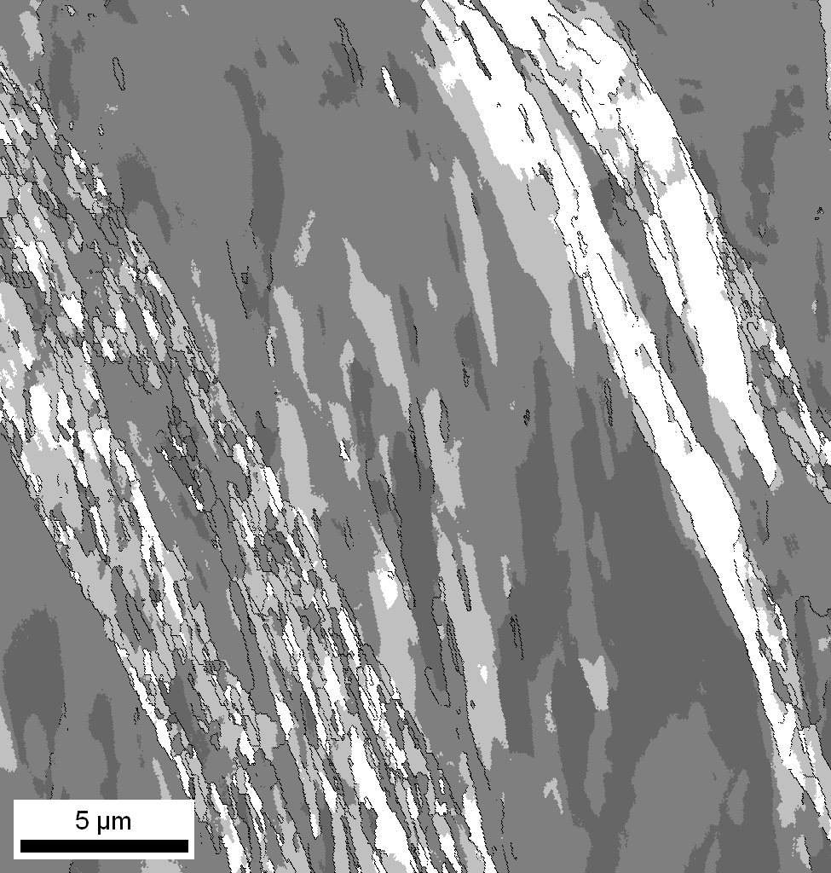  3.38 |  | 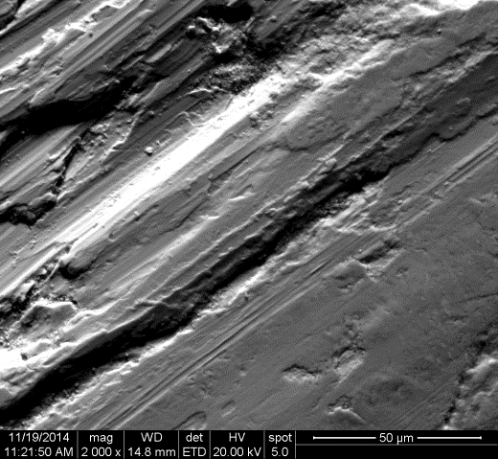
Four passes | 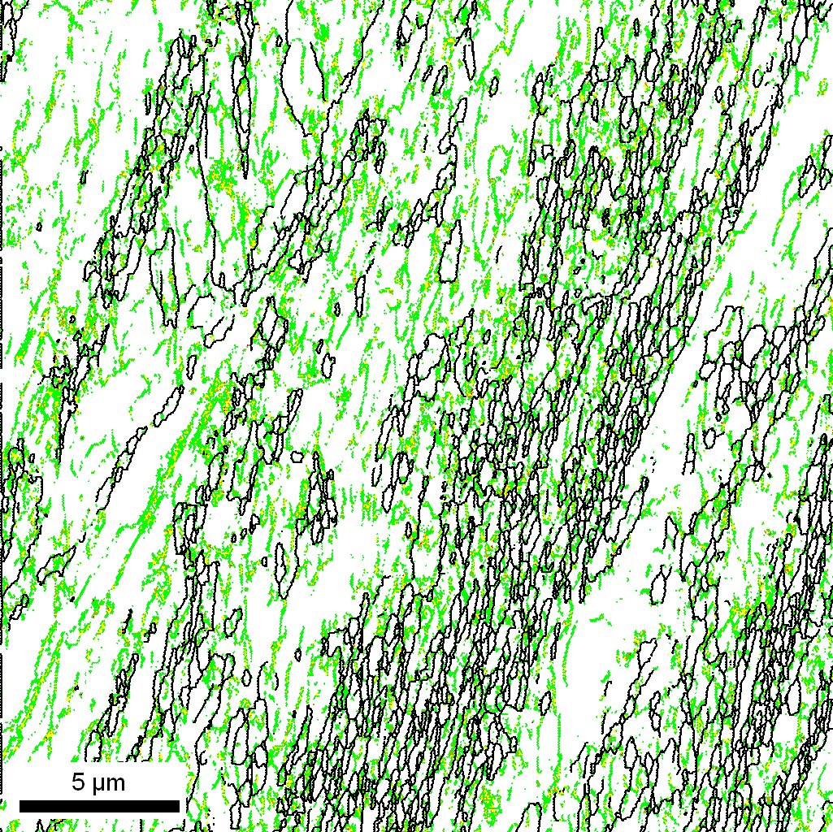  0.803 |  | 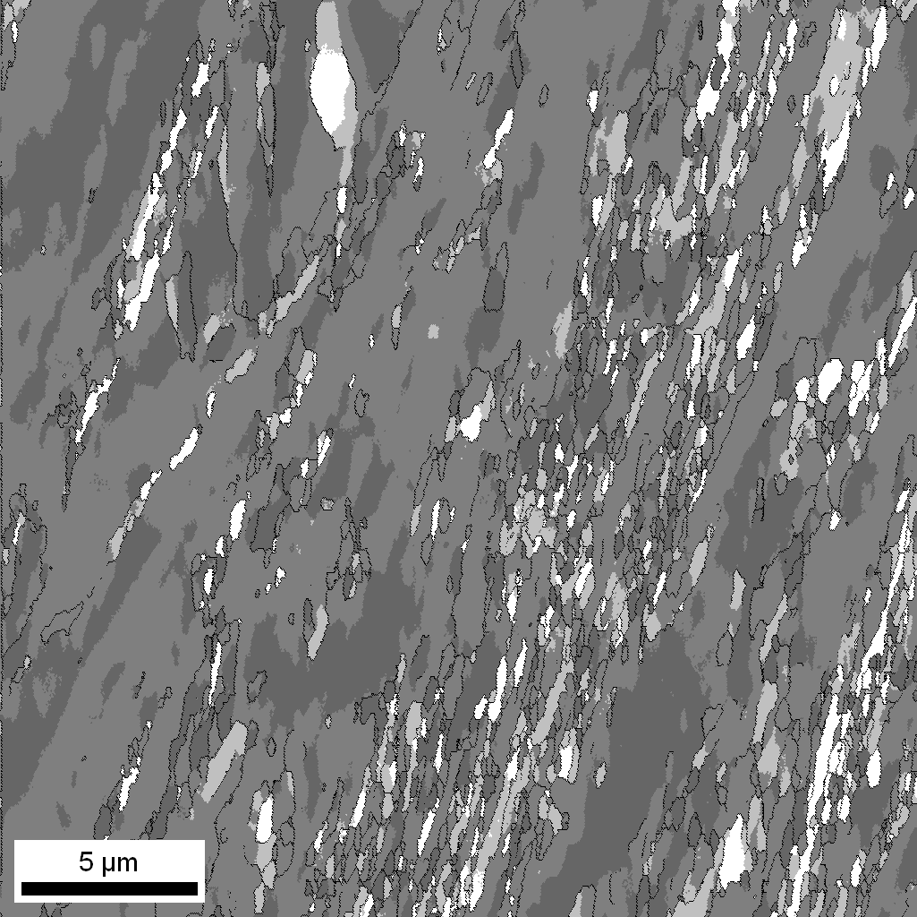  3.26 |  | 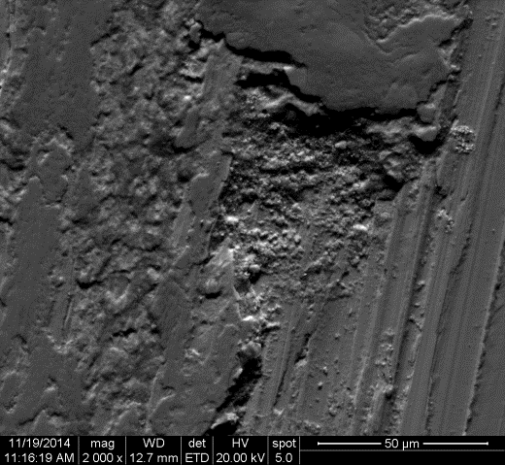
 | a) |  | b) |  | c)
Fig. 2. (a) EBSD-KAM map, b) EBSD-Taylor map and (c) SEM micrographs of worn surfaces of ECAP CuCrZr alloys in aged condition as a function of a number of ECAP passes.

a) | b)
Fig. 3. Friction coefficient (upper row) and friction force (lower row) as a function of the sliding distance for the ECAP CuCrZr alloys in (a) solution treated condition and (b) aged condition.

a) | b)
c) | d)
e) | f)
Fig. 4. Averaged friction coefficient (a), wear rate (b), (c) electroconductivity; rate of dislocation accumulation (d) and Vickers microhardness (e), rate of Hv changing (f) of ECAP CuCrZr alloys in solution treated and aged conditions as a function of accumulated strain or number of ECAP passes.

Table 1. Experimental data
Number of  ECAP passes | Mean friction coefficient |  | Wear rate, ×10⁻⁵  (mm³/(N·m) |  | KAM (°) |  | Taylor Factor |  | Electro-conductivity*,  ×10⁷ (Ω·m)⁻¹ |  | (Sub) grain size (nm) |  | Dislocation density, ×10¹⁴ (m⁻²)
Number of  ECAP passes | ST | AT | ST | AT | ST | AT | ST | AT | ST | AT | ST | AT | ST | AT
0 | 0.80 | 0.80 | 1.79 | 1.30 | 1.75 | 1.75 | 3.30 | 3.30 | 2.00 | 2.84 | >1000 | >1000 | 0.1 | 0.1
1 | 0.70 | 0.72 | 7.86 | 7.09 | 1.28 | 0.93 | 3.12 | 3.34 | 1.53 | 2.00 | 420 | 570 | 8.3 | 7.3
2 | 0.65 | 0.70 | 2.77 | 2.82 | 0.91 | 0.92 | 3.14 | 3.38 | 1.66 | 2.00 | 340 | 350 | 13.0 | 13.4
4 | 0.62 | 0.66 | 1.68 | 1.40 | 0.91 | 0.80 | 3.20 | 3.26 | 1.81 | 2.00 | 330 | 340 | 14.0 | 12.6
* IACS =5.8×10⁷ (Ω·m)⁻¹

References

[?] A.I. Topuz, Enabling microstructural changes of FCC/BCC alloys in 2D dislocation dynamics. Materials Science Engineering A 627 (2015) 381-390.
[?] J.B. Correia, H.A. Davies, C.M. Sellars. Strengthening in rapidly solidified age hardened Cu-Cr and Cu-Cr-Zr alloys. Acta Materialia 45 (1997) 177-190.
[?] ITER Joint Central Team, The impact of materials selection on the design of the International Thermonuclear Experimental Reactor (ITER). Journal of Nuclear Materials 212–215 (1994) 3-10.
[?] Q. Liu, X. Zhang, Y. Ge, J. Wang, J.Z. Cui. Effect of processing and heat treatment on behavior of Cu-Cr-Zr alloys to railway contact wire. Metallurgical and Materials Transactions A 37 (2006) 3233-3238.
[?] I.S. Batra, G.K. Dey, U.D, Kulkarni, S. Banerjee. Microstructure and properties of a Cu-Cr-Zr alloy. Journal of Nuclear Materials 299 (2001) 91-100.
[?] G. Ghosh, J. Miyake, M.E. Fine, The Systems-Based Design of High Strength, High-Conductivity Alloys. Journal of Metals 49 (1997) 56-60.
[?] J.F. Archard. Contact and rubbing of flat surfaces Journal of Applied Physics 24 (1953) 981.
[?] J.F. Archard, W. Hirst. The Wear of Metals under Unlubricated Conditions. Proceedings of the Royal Society A 236 (1956) 397-410.
[?] A. Belyakov, M. Murayama, Y. Sakai, K. Tsuzaki, M. Okubo, M. Eto, T. Kimura. Development of a high-strength high-conductivity Cu-N-P alloy. Part II: Processing by severe deformation. Journal of Electronic Materials 35 (2006) 2000-2008.
[?] K.X. Wei, W. Wei, F. Wang, Q. B. Dua, I.V. Alexandrov, J. Hu. Microstructure, mechanical properties and electrical conductivity of industrial Cu-0.5% Cr alloy processed by severe plastic deformation. Materials Science Engineering A 528 (2011) 1478-1484.
[?] A. Vinogradov, V. Patlan, Y. Suzuki, K. Kitagawa, V. I. Kopylov. Structure and properties of ultra-fine grain Cu-Cr-Zr alloy produced by equal-channel angular pressing. Acta Materialia 50 (2002) 1639-1651.
[?] I. Shakhova, Z. Yanushkevich, I. Fedorova, A. Belyakov, R. Kaibyshev. Grain refinement in a Cu-Cr-Zr alloy during multidirectional forging. Materials Science Engineering A 606 (2014) 380-389.
[?] R. Mishnev, I. Shakhova, A. Belyakov, R. Kaibyshev, Deformation microstructures, strengthening mechanisms, and electrical conductivity in a Cu–Cr–Zr alloy. Materials Science Engineering A 629 (2015) 29-40.
[?] A.P. Zhilyaev, I. Shakhova, A. Morozova, A. Belyakov, R. Kaibyshev. Grain refinement kinetics and strengthening mechanisms in Cu–0.3Cr–0.5Zr alloy subjected to intense plastic deformation. Materials Science Engineering A 654 (2016) 131-142.
[?] D.A. Rigney, W.A. Glaeser, The significance of near surface microstructure in the wear process. Wear 45 (1978) 241-250.
[?] A.P. Zhilyaev, I. Shakhova, A. Belyakov, R. Kaibyshev, T.G. Langdon. Wear resistance and electroconductivity in copper processed by severe plastic deformation. Wear 305 (2013) 89-99.

