**Title**

Functional trait changes in the floras of 11 cities across the globe in response to urbanization

**Authors**

Estibaliz Palma1, Jane A. Catford2, Richard T. Corlett3, Richard P. Duncan4, Amy K. Hahs5, Michael A. McCarthy6, Mark J. McDonnell7, Ken Thompson8, Nicholas S.G. Williams9 and Peter A. Vesk10

1School of BioSciences, The University of Melbourne, Vic 3010, Australia

[epalma@student.unimelb.edu.au](mailto:epalma@student.unimelb.edu.au)

Corresponding author

Tel.: +613 8344 1606

2School of BioSciences, The University of Melbourne, Vic 3010, Australia;

Fenner School of Environment and Society, The Australian National University, Canberra, ACT 2601, Australia;

Department of Ecology, Evolution and Behavior, University of Minnesota, Saint Paul, MN 55108, USA.

[catfordj@unimelb.edu.au](mailto:catfordj@unimelb.edu.au)

3Center for Integrative Conservation, Xishuangbanna Tropical Botanical Gardens, Chinese Academy of Sciences, Menglun, Yunnan 666303, China.

[corlett@xtbg.org.cn](mailto:corlett@xtbg.org.cn)

4Institute for Applied Ecology, University of Canberra, ACT 2617, Australia.

[richard.duncan@canberra.edu.au](mailto:richard.duncan@canberra.edu.au)

5Australian Research Centre for Urban Ecology, Royal Botanical Gardens Victoria, Vic 3141, Australia;

School of BioSciences, The University of Melbourne, Vic 3010, Australia.

[hahsa@unimelb.edu.au](mailto:hahsa@unimelb.edu.au)

6School of BioSciences, The University of Melbourne, Vic 3010, Australia

[mamcca@unimelb.edu.au](mailto:mamcca@unimelb.edu.au)

7Australian Research Centre for Urban Ecology, Royal Botanical Gardens Victoria, Vic 3141, Australia;

School of BioSciences, The University of Melbourne, Vic 3010, Australia.

[markmc@unimelb.edu.au](mailto:markmc@unimelb.edu.au)

8Department of Animal and Plant Sciences, University of Sheffield, Sheffield S10 2TN, United Kingdom.

[ken.thompson@sheffield.ac.uk](mailto:ken.thompson@sheffield.ac.uk)

9School of Ecosystem and Forest Sciences, The University of Melbourne, Vic 3121, Australia;

Australian Research Centre for Urban Ecology, Royal Botanical Gardens Victoria, Vic 3141, Australia.

[nsw@unimelb.edu.au](mailto:nsw@unimelb.edu.au)

10School of BioSciences, The University of Melbourne, Vic 3010, Australia

[pvesk@unimelb.edu.au](mailto:pvesk@unimelb.edu.au)

**Reference**

Palma, E., Catford, J. A., Corlett, R. T., Duncan,R. P., Hahs, A. K., McCarthy, M. A., McDonnell, M. J., Thompson, K., Williams, N. S. G. and Vesk, P. A. 0000. Functional trait changes in the floras of 11 cities across the globe in response to urbanization. – Ecography 000: 000–000.

**ABSTRACT**

Urbanization causes major environmental changes globally, which can potentially homogenize biota across cities through the loss and gain of particular types of species. We examine whether urban environments consistently select for plants with particular traits and the implications of such changes on the functional composition of urban floras.We classified plant recorded in 11 cities around the globe as species that have either invaded (arrived and naturalized), persisted or been lost (become locally extinct) following urbanization. We analyzed how 10 traits previously linked with plant responses to environmental conditions explained membership of these three groups, by comparing invaders with persistent and extinct plants through individual city-level Bayesian models. Then, we used meta-analysis to assess consistency of traits across urban areas. Finally, we explored several possible scenarios of functional change using these results.

On average, urban invaders had heavier seeds, unspecialised nutrient requirements, were taller and more often annual species, especially when compared to locally extinct plants. Common trends of functional change in urban plant communities include shifts towards taller and heavier- seeded plants, and an increased prevalence of the short-lived species, and plants without mutualistic nutritional strategies.Our results suggest that plant traits influence the species that succeed in urban environments worldwide. Different species use different ecological strategies to live in urban environments, as suggested by the importance of several traits that may appear as trait constellations. Plant height and seed mass were the only traits associated with both invader and extinct plant status in urban environments. Predicting invasion in urban environments may be easier than identifying extinction-prone plants; albeit some regional variation, invasions seem strongly driven by environmental conditions common to most cities (e.g. altered disturbance regimes), whereas extinction may depend more on processes that vary across cities.

**Keywords**

Functional change; Plant traits; Biotic homogenization; Meta-analysis; Bayesian models; Species invasion; Extinction; Urbanization

**INTRODUCTION**

Human-driven ecosystem degradation and habitat loss alter species distributions worldwide (Vitousek, et al. 1997). These processes are particularly intense in urban areas, where environments are heavily modified to suit human needs and desires. Cities share common environmental features regardless of their geographical location (including microclimates, high levels of disturbance and fragmentation, elevated concentration of nitrogen in soils, and water stress; Grimm, et al. (2008)) and can thus exert similar pressures on biological communities. As a consequence, urban environments around the world are expected to favour species with similar biological and ecological characteristics that allow them to persist in these highly modified habitats (McKinney and Lockwood 1999).

According to ecological filtering theory (Keddy 1992), only some species will persist in a given area following environmental change (Williams, et al. 2009). Urbanization is a strong driver of environmental change, and plant species respond to it in different ways (Olden and Poff 2003). Depending on the ability of plants to cope with the altered conditions, some species will become locally extinct while others will persist. Urbanization will also offer opportunities for plants not previously part of the local flora to invade the community through e.g. competitive advantage to exploit increased and continuous resource pulses (Grimm, Faeth, Golubiewski, Redman, Wu, Bai and Briggs 2008, Shochat, et al. 2006). Plant responses to urbanization-driven changes depend on individual species traits (Lavorel, et al. 2007, McGill, et al. 2006). For example, Williams, et al. (2015) found that seed mass, height and annual life-history increase in response to urban stressors, McKinney (2002) concluded that wind dispersal is a common attribute of plants adapted to urban disturbance, and Duncan, et al. (2011) determined that short-stature, small-seeded plants are more likely to go extinct in urban areas. Comparison of traits among species that respond differently to urbanization-driven environmental change can increase understanding of changes in species distribution patterns (Díaz, et al. 2004, Olden and Rooney 2006). Traits consistently shared by plants that have been lost from, have persisted in, or have entered urban plant communities may point to the ecological strategies that species use to cope with environmental constraints and the mechanisms underlying responses to urbanization. A simultaneous assessment of extinct, persistent and invading species untangles changes that occur exclusively due to environmental change, buffering issues related to introduction bias - a challenging problem for trait-oriented invasion studies (Colautti, et al. 2006). Such an approach also assists in creating a clear picture of the changes that occur and their consequences for the flora composition.

By selecting for species with certain traits, urbanization can result in biological homogenization where communities lose their distinctiveness and become more genetically, taxonomically or functionally similar (Olden and Rooney 2006). The taxonomic composition of urban floras is known to be slowly converging worldwide (La Sorte, et al. 2014), but the magnitude and nature of changes in the functional composition of urban floras is still unclear (Olden 2006). We expect that urbanization will alter the functional composition of local plant communities in a consistent manner across cities, with successful plants being those able to deal with highly disturbed environments (Thompson and Davis 2011, Williams, Schwartz, Vesk, McCarthy, Hahs, Clemants, Corlett, Duncan, Norton, Thompson and McDonnell 2009). However, functional homogenization is multifaceted; the floristic similarity among cities around the world will depend on the original local flora, the strength of different urban stressors and the functional characteristics of both resident and newly arriving plants (Olden and Poff 2003). Depending on these elements, urbanization-caused plant extinction and invasions will drive different scenarios of functional composition change (Fig. 1). In this paper, we use the term invasion (or invaders) to refer to new plants that successfully enter and establish in the community. We use invasion in the broadest sense of the word, and do not consider species’ biogeographic origin or their abundance, geographic extent or impact within cities. Invaders may have similar characteristics to plants that have been able to persist under altered environmental conditions (Fig. 1a); this may partially result from human-driven non-random habitat transformation within cities, leading to the disappearance of particular types of species, and would represent a narrowing of community functional composition. If invaders show more extreme values for characteristics that promote persistence (Fig. 1b), it would suggest that there has been a shift in the types of species that succeed in cities (McKinney and Lockwood 1999), which would strongly point to habitat filtering as the main driver of functional change. Alternatively, traits of invaders may be more similar to those of extinct plants than to those of persisting plants (Fig. 1c), potentially resulting in no change to community functional composition. This would occur if invaders directly displace the (now extinct) plants or due to direct human-driven replacement. Finally, invaders may show a particular characteristic for which persistent and extinct plants are similar (Fig. 1d); this may partially result from an advantage given by human to particular types of species (i.e. introduction bias) and would suggest that the functional composition of the plant community has widened.

Using data from 11 cities in North America, Oceania and Asia, we investigate whether urban environments consistently select for particular types of plants by comparing the traits of species that have invaded to those that have persisted (to test niche overlap) or gone extinct (to test functional replacement) in urban environments. Based on these results, we reconcile the four scenarios of functional change (Fig. 1) by determining whether community-level trait distributions in these 11 cities are shrinking, shifting, remaining similar or expanding. We use data from the same cities as Duncan, Clemants, Corlett, Hahs, McCarthy, McDonnell, Schwartz, Thompson, Vesk and Williams (2011) who compared the traits of locally extinct and extant plant species. Although Duncan, Clemants, Corlett, Hahs, McCarthy, McDonnell, Schwartz, Thompson, Vesk and Williams (2011) were able to characterise species that are typically lost from urban environments, they were unable to show whether these losses were part of a systematic functional change at the community level (Fig 1). Our approach examines the characteristics of species that are both lost and gained from urban environments, which is critical for ascertaining whether urbanization is selecting for similar floras around the world. It allows us to infer whether particular traits are similarly (but oppositely) involved in extinction and invasion, whether they are involved in invasion or extinction only, or whether invaders are replacing functionally similar extinct urban plants. This work offers the opportunity to improve understanding of how assembly rules of plant communities have changed through urbanization and represents a step forward in the study of functional homogenization in human-dominated habitats. Given the growing rates of urbanization around the world (Cohen 2003), this work has the potential to improve the knowledge of processes that are expected to become increasingly prevalent.

**METHODS**

**Cities and urban flora**

This study includes plant records from 11 cities in North America (Chicago, Los Angeles, New York, San Diego, San Francisco and Worcester), Oceania (Adelaide, Auckland and Melbourne) and Asia (Hong Kong and Singapore). All of them were founded after 1800 AD, with the exception of New York (1624 AD) and Worcester (1722 AD) (see Duncan, Clemants, Corlett, Hahs, McCarthy, McDonnell, Schwartz, Thompson, Vesk and Williams (2011) for more details). Although the size of the cities and the proportion of their areas surveyed differ, every city is represented by a gradient of urban development, from highly urbanized core areas to semi-urban environments. Over the last few centuries, urbanization has altered the composition of flora that was historically associated with these regions. We collected information about the floristic composition of the regions, before and after city establishment, from peer-reviewed papers, unpublished herbarium reports and agency databases. The original sources showed variation in the methods used to define the city boundary, with some closely aligned with the extent of the built-up area and others including nearby natural areas. For each city, plant species were classified into one of the following categories: persistent – recorded in initial surveys shortly after city establishment and still present today; extinct – recorded in initial surveys shortly after city establishment but currently determined locally extinct by the study authors; or invader – absent in initial surveys of the local area under consideration for each city but recorded in subsequent surveys after city establishment. As far as it was possible, the last category only included plants able to produce reproductive offspring (naturalized, *sensu* Richardson, et al. (2000)), excluding plants whose populations can only be maintained through cultivation.

The dataset included a total of 10,258 species with 1,711 extinct species, 7,091 persistent species and 2,353 invader species recorded in one or more cities (Fig. 2a).The total number of species varied markedly among cities, ranging from 869 records in Los Angeles to 2,402 in Singapore. The proportion of species in each group – extinct, persistent or invader – also varied greatly among cities (Fig. 2b). Of the total species recorded at city-level, invaders contributed between 9% (in Singapore) to 74% (in Auckland) of the records, and extinct plants contributed from 1% (in San Diego) to 25% (in Singapore). We followed the Angiosperm Phylogeny Group (Angiosperm Phylogeny Group, 2003) for taxonomy, and merged subspecies and varieties to species level.

**Trait information**

We selected 10 plant traits thought to relate to plant extinction risk, invasion success and response to urbanization (see Table 1 for references): dispersal syndrome, growth form, longevity, clonality, nutrient uptake strategy, photosynthetic pathway, spinescence, pollination syndrome, plant height and seed mass. We compiled information for each species from published works, trait databases, and expert knowledge. Pollination syndrome was defined as abiotic or biotic. The rest of the traits were initially categorised following protocols formalised by Cornelissen, et al. (2003) and subsequently grouped into broader categories to meet analytical requirements. Table 1 includes categories of qualitative traits and, if any, the assumptions made when assigning specific categories or values to species.

**Data analysis**

This paper is divided in two sections. First, we identified whether urban environments consistently select for and against particular traits by comparing the traits of invader, persistent and extinct plants. Then, we used our results to explore possible scenarios of functional change within urban plant communities, as shown in Fig. 1.

*Traits associated with invader, persistent and extinct plants in urban environments*

We used the same two-step modelling approach - based on Duncan, Clemants, Corlett, Hahs, McCarthy, McDonnell, Schwartz, Thompson, Vesk and Williams (2011) - to compare invaders with persistent plants and invaders with extinct plants. The former comparison is based on 9,101 species and 14,800 records; the latter comparison is based on 4,020 species and 6,588 records. More details about the datasets can be found in the Supplementary material, Table S3. For each comparison, we first conducted independent analyses for each of the 11 cities, and then used meta-analysis to combine and summarize the results at city-level and assess consistency of the observed patterns.

1. Independent analysis of each city

We assessed whether traits of invaders differ from 1) persistent or 2) extinct plants using hierarchical logistic regressions of the form:

Yi ~ Bernoulli (pi)

logit (pi) = α + Σ ( βk * Xik ) + γf

where Yi is the observed binary state of urban species, being either invader or persistent/extinct. The probability of being an invader (pi) is modelled as a linear logistic function, with intercept α, regression coefficients β for traits X, and plant family effects γ. The intercept α represents the estimated probability of being an invader for species belonging to the reference class of all categorical traits and having average values of height and seed mass (Table 1). Xik refers to the value of explanatory trait *k* for species *i*. Continuous traits were log-transformed and standardized to a standard deviation of 0.5 (Gelman and Hill 2007). Multicategorical traits with *n* categories were coded as *n*-1 binary traits (dummy variables) and compared to the reference category (Table 1). The regression coefficient βk stands for the estimated effect of trait *k* on the probability of a species being an invader. Traits with β values different from zero point to a correlation between invaders and the trait and, therefore, these traits are useful to distinguish them from persistent/extinct plants. The term γf stands for the effect of plant family *f* on the probability of being an invader and accounts for taxonomic relatedness. The estimated effects of traits and family on the probability of being an invader are conditional on the other explanatory variables, meaning that each of them accounts for the effect of the rest. Further details of the statistical models can be found on the Supplementary material, Appendix S1.

1. Meta-analysis across cities

Meta-analysis comprises a set of tools that combine the magnitude or effect of several outcomes from primary studies addressing the same research question with different datasets but a comparable scale (Koricheva, et al. 2013). These statistical methods weight the varying precision of effect estimates, therefore accounting for the unequal statistical power of studies and improving control of Type II error rates (Arnqvist and Wooster 1995).

Using results from the analysis of individual cities, we modelled the effect of the previously assessed ten traits on the probability of species being invaders as drawn from a normal distribution with a common mean:

βjk ~ Normal (вk, sqrt(σ2βk + σ2jβk))

where вk is the average effect of trait *k* on invader prevalence within urban environments. The standard deviation includes two parameters: σβk and σjβk, which represent the variation of the effect β of trait *k* among cities, and its associated uncertainty for each city *j*, respectively. City was treated as a random effect. The meta-analysis dealing with invader and persistent plants used the estimates yielded from all the eleven previous city-level models; the meta-analysis dealing with invaders and extinct plants used the estimates yielded from eight of the previous city-level models (San Diego, San Francisco and Los Angeles were excluded due to convergence issues; Supplementary material, Appendix S1).

Given that cities included in this work were not randomly selected across the globe, we explored whether the effect of traits on extinction and invasion patterns were more similar among cities belonging to the same biogeographic region than from other regions. To do so, we ran the same meta-analyses, this time including a random effect accounting for the fact that cities belong to one of the following biogeographic regions: East coast of the United States, West coast of the United States, Asia, and Oceania. Given the limited number of cities and biogeographic regions in our dataset, the trends found by this approach are highly uncertain, and we do not present the estimated effects of traits under this analytical scenario in the main body of the paper (but see Supplementary material, Appendix S1). However, this assessment does suggest that factors that vary at the region-level mediate the way in which plant traits affect species’ responses to urbanization.

*Exploration of plant community functional change in urban environments*

We explored changes in the functional composition of urban floras after species extinction and invasion by simultaneously inspecting the model coefficients estimated from the previous two meta-analyses. Plotting the results of both comparisons (invaders versus persistent, and invaders versus extinct plants) allowed us to ascertain the types of changes that have occurred in the functional composition of the 11 urban floras (Fig. 1). If we found consistent positive or negative effects of traits only for one of the comparisons, we can infer that the trait distribution at community-level is shrinking (Fig. 1a) or has not changed (Fig. 1c). If we find consistent effects of traits for both comparisons, we can infer that the community-level trait distribution is shifting (Fig. 1b; if the effect between invaders and extinct plants is larger than the effect between invaders and persistent plants) or is becoming wider (Fig. 1d; if both effects show similar magnitude). Other possible combinations of the meta-analytical results exist, but we do not take them into account because they would not help elucidate how traits may affect plant success in urban environments; in general, they suggest that both extinction and invasion processes are favoured by a particular trait in the same direction (i.e. both extinct plants and invaders show either smaller or larger values than persistent plants for a particular trait).

**RESULTS**

**Do traits of invading and persistent plants differ?**

Several traits appeared to influence the presence of invaders versus persistent plants across urban areas (Figs 3a and 4a). Taller and heavy-seeded species were more likely to be invaders, as indicated by positive effect sizes where 95% confidence intervals do not overlap zero. The city-level median height for invaders and persistent plants was around 0.85 m, while it was 0.5 m for extinct plants; the city-level median seed mass for invaders, persistent and extinct groups was 1.41, 0.82 and 0.55 g, respectively. Annuals, spiny plants and species that rely on biotic pollination were also more likely to be invaders (i.e. perennials, non-spiny plants and species that rely on abiotic pollination were more likely to be persistent plants). Despite large uncertainty, plants with specific strategies of nutrient acquisition (nitrogen fixation, mycorrhizal associations or other strategies) were underrepresented among invaders. Woody plants were the only growth form underrepresented among invaders, although the effect shows some uncertainty, which may point to variation among cities. Dispersal strategies based on wind and external seed attachment on animals, and clonal reproduction based on rhizomes (but not aboveground organs) also reduced the presence of invaders in urban areas. We found no consistent effect of the remaining traits or trait categories on the presence of invaders and persistent plants across urban areas. Refer to the Supplementary material, Appendix S1, for results at city-level.

**Do traits of invading and extinct plants differ?**

In general, the patterns found in the previous comparison held for the comparison between invaders and extinct plants, although the uncertainty for the latter estimates was generally greater (Figs 3b and 4b; city-level results in Appendix S1). The effects of most traits were similar in direction and magnitude: taller, heavy-seeded and annual plants were consistently more likely to be invaders across urban areas. Equally, spiny species and plants relying on biotic pollination were more likely to be invaders. Wind-dispersed species, and plants with nitrogen fixing ability, mycorrhizal associations or other strategy for nutrient uptake were more frequently found among extinct plants. No consistent effect was found for the remaining traits.

The effect of traits on invasion compared with both persistence and extinction in urban floras depends on city-level specific processes, as well as regional biogeographic features (Fig. 5).

**How do invasion and extinction influence the trait distribution of urban plant communities?**

Figure 6 shows the results from both meta-analyses simultaneously. We found that high values of height and seed mass are positively associated with both persistence and invasion, and negatively associated with extinction (Fig. 6b), pointing to a shift in the functional composition of urban communities towards taller and heavier-seeded plants. Annual life-history, spinescence and biotic pollination are positively associated with invasion, whereas wind dispersal and nutrient uptake strategies such as nitrogen fixation and mycorrhizae are negatively associated with it (Fig. 6d). However, none of these traits affect the probability of local extinction. This means that, after extinction and invasion, the urban community composition has broadened to include more plants with annual longevity, spines, unspecialised dispersal and nutrient requirements, and relying on biotic pollination. Succulent plants tend to persist in urban environments (Fig. 6a), but they do not show a higher proportion among invaders compared to the reference growth form (i.e. herbs). For plants that are clonal, animal dispersed and rely on C4 or CAM photosynthetic pathways, we found that invaders replaced functionally similar extinct plants (Fig. 6c); therefore, functional space characterized by these traits remains unchanged before and after urbanization. Remaining trait categories showed no consistent effects on invasion or extinction patterns.

**DISCUSSION**

Our results suggest that plant traits influence the types of species that fail and succeed in urban environments around the world. Some of the traits we investigated (plant height and seed mass) were associated with both plant extinction and invasion processes in urban environments. Other traits appeared to relate to only one of these processes: for example, plant longevity and nutrient acquisition strategy appeared to be associated with invasion but unrelated to extinction. The varying influence of different plant traits on extinction and invasion (Fig. 6) leads to a variety of functional changes in the flora (e.g. shift towards novel trait values, shrinking of existing trait distributions) in response to urbanization. Our results indicate that plants in urban environments can follow different pathways to successfully persist in the local flora (Hodkinson and Thompson 1997). For the limited number of traits and cities included in this work, more traits were found to be related to invasion than extinction in urban areas (Jeschke and Strayer 2008). This suggests that invasion is a stronger force than extinction in altering the functional composition of urban floras in a consistent manner across the urban areas under investigation, and that explaining and predicting why certain plants invade urban environments, more generally, may be easier than explaining why certain plants go extinct. Extinction may be more strongly driven by local processes that vary across cities, whereas invasion may be strongly related to characteristics shared by many cities around the world, such as altered disturbance regimes and deliberate introduction of plants with traits that appeal to humans (e.g. fast growth rates, showy flowers).

In this paper, we investigate whether urban environments consistently select for particular types of plants and investigate its implications for the functional composition of the flora of 11 cities. We investigated these patterns in the same cities where Duncan, Clemants, Corlett, Hahs, McCarthy, McDonnell, Schwartz, Thompson, Vesk and Williams (2011) found that seed mass and height can be used to characterize extinction-prone plants in urban environments. In the current paper, we examined the characteristics of plants that are both lost and gained from urban environments, which allows the definition and exploration of different scenarios of biotic change (Olden and Poff 2003). Our results showed that, in addition to seed mass and height, which are driving a shift on urban floras, other traits such as longevity, which only relate to either extinction or invasion processes, are also driving some consistent changes in urban floras’ functional composition. Our study provides the means to identify the different patterns of functional change that are happening in human-dominated habitats, and their relationship with extinction and invasion processes, which is of pivotal importance to start disentangling the underlying mechanisms in operation for those changes.

**Traits influence invasion and extinction**

Consistent with previous work (Thompson and McCarthy 2008), our results point to seed mass and plant height as key traits influencing species success in urban floras (Fig. 6b). They are consistently involved in extinction and invasion in urban areas, a result also reported in a synthesis of the urban plant trait literature by Williams, Hahs and Vesk (2015). Invaders and extinct plants have previously been hypothesised to occupy opposite extremes of the trait spectrum, with persistent plants pooled at some middle point between those extremes (McKinney and Lockwood 1999); a theory that has received some support from studies of the Fabaceae family at global level (Bradshaw, et al. 2008) and riparian communities in Australia (Kyle and Leishman 2009). Although we found similar patterns for seed mass and plant height, none of the remaining traits included in the study supported this hypothesis. In regards to seed mass and plant height, our results suggest that invaders in urban areas are not only mimicking the strategies used by persistent plants, but they further show more extreme trait values that may confer them the ability to fill novel niche space created through urbanization, shifting the community functional composition towards taller and heavier-seeded species. Because these traits are implicated in extinction as well as invasion, these patterns do not appear to arise from an introduction bias of invaders (Colautti, Grigorovich and MacIsaac 2006), but rather suggest a causal link between these traits and success in urban environments.

Our work suggests that short life-history and unspecialised nutrient acquisition strategies promote invasion, but do not influence extinction, in urban areas (Fig. 6d). In line with our results, Pyšek and Richardson (2007) found that naturalized species have different (though not necessarily shorter) longevity than the communities they invade. Given the high levels of nutrients in urban soils, specialised nutrient acquisition mechanisms, such as nitrogen fixation, would offer little advantage and may even be detrimental if they involve an unnecessary investment of energy that otherwise could be used to increase individual fitness. We found some uncertainty on the effects of nutrient acquisition strategies, which is likely related to a preferential use of mycorrhiza associations by plants in comparison to other strategies, regardless of being invaders (Bunn, et al. 2015). Finally, our results suggest that wind dispersal does not promote invasion, which contradicts previous work reporting greater frequency of wind dispersal for naturalized plants (Gassó, et al. 2009, Lake and Leishman 2004). This contradiction may be explained by the fact that we examined the effect of wind dispersal versus no specialised dispersal features (Table 1), and not wind dispersal versus specialised dispersal vectors other than wind.

Environmental changes from urbanization appear to have altered the types of species that can persist in these areas (Fig. 6b, d), thereby shifting the functional composition of local plant communities toward species with one or more of the following traits: tall stature, heavy seeds, short life-history, and unspecialised nutrient uptake strategies and dispersal vector. Our results suggest that plants rely on different ecological strategies and mechanisms to occupy urban environments: plants taller than their neighbours have a competitive advantage through preferential light capture and further dispersal (Westoby, et al. 2002); heavier seeds have shown higher probability of establishment under harsh conditions (e.g. light or water shortage; Moles and Westoby (2002)); a short life-cycle allows fast growth rates and colonisation of disturbed patches with high resource availability; unspecialised nutrient and dispersal strategies allow plants to save the energetic investment of specialised organs, which may be used for other purposes (e.g. reproduction). This paper focuses on plant traits associated with success in urban environments rather than traits linked with the invasiveness of non-native species. Nonetheless, there seem to be some commonalities between the two, suggesting that similar processes and plant adaptations are important. Research in invasion ecology has shown that success of invasive, compared to non-invasive, non-native plants is also related to individual size (Van Kleunen, et al. 2010), seed mass, clonal ability (Lake and Leishman 2004) and high rates of nutrient uptake under elevated nutrient concentrations (Matzek 2012).

We also found that spinescence and animal-driven pollination promote invasion, but do not affect extinction. These patterns may result from a biased introduction of plants due to human preferences towards species with particular traits (Knapp, et al. 2010), or in the case of spiny plants, due to lower probability of trampling or hand removal after establishment.

**Replacement of extinct urban plants**

For some traits, we found that invaders are more similar to extinct than persistent urban plants (Fig. 6c), a fact that may be understood as invaders replacing functionally similar extinct species (Fig. 1c). Some of these findings were unexpected. For example, clonality has been previously reported to be higher in naturalized species in Australia and several European countries (Thompson, et al. 1995), which may result from a climatic mismatch affecting the production of viable seeds and sexual reproduction.

The fact that invaders and extinct urban species share functional characteristics points to little or no change on some aspects of the functional composition of the urban plant community regardless of taxonomic changes in urban floras. Whether this replacement results from competition (based on traits different than resource acquisition strategy) or is a consequence of introduction of new species after removal of previously established plants remains to be investigated.

**Differences among cities**

The influence of local characteristics of urban areas (e.g. initial plant community composition and functional diversity) became obvious when effects of traits were compared across city-level analyses (Olden and Poff 2003). Cities belonging to Oceania (Adelaide, Melbourne and Auckland) and tropical Asian cities (Hong Kong and Singapore) showed clustered and, in some cases, extreme main effects for some traits (Supplementary material, Tables S4 and S5). One example is the diverse city-level effects of seed mass in the comparison between invaders and persistent species (Supplementary material, Fig. S2a). The strength of the relationship between this trait and invaders varies between clusters of Asian, North American and Oceanian cities. High seed mass seems to be a distinctive characteristic of invaders in Adelaide, Melbourne and Auckland. However, in Singapore and Hong Kong, invaders and persistent species do not show differences in seed mass. As the latter are tropical cities, it is possible that their original plant community comprises species with heavier seeds than those in temperate regions, such as North America and Oceania (Moles, et al. (2007); but see Chicago). The variability among cities may partially reflect the different socio-economic backgrounds of the studied cities and the varying definition of city boundaries - and, therefore, local plant communities -, as different parts of the landscape (e.g. highly urbanized patch vs vegetation remanent) support different assemblages of traits. The importance of regional differences was reinforced by our exploration of sources of variability on trait effects (Fig. 5). With only 11 cities, we did not have sufficient power to determine precise relationships between traits and extinction/invasion across different regions of the world; such an exploration was beyond the scope of this paper requiring a larger number of cities per biogeographic region. Determining how biogeography, climate and urban history may modulate the functional composition of urban floras presents an exciting research opportunity. By accounting for regional variation, a hierarchical investigation of both region- and city-level trait effects in urban floras would likely reduce uncertainty in estimated relationships. As such, our estimations of global effects presented here should be understood as conservative quantifications, since the uncertainty associated with them still allows some variability between regions and cities.

**Caveats of this work**

Multiple processes determine the types of species able to occupy urban environments: human preferences and species dispersal opportunities will influence the types of species able to invade cities, while human choices about the types and locations of remaining vegetation within cities will partially shape extinction patterns. Positive/negative effects of traits do not imply that they affect species’ success at every step, or consistently across or the landscape. We are aware of the potential limitations of working with unstandardized city boundaries since cities including nearby natural areas (e.g. San Diego) may potentially show lower rates of extinction. However, Hahs, et al. (2009) found that development history and the extent of original vegetation remaining within 22 cities were important determinants of plant extinction rates. We acknowledge that phylogenetic relatedness could have been accounted for using different approaches. We decided to use family as a surrogate of relatedness because it provided a balanced allocation of trait variations between evolution and present-day ecology (Westoby 1998). While our approach enables correct estimation of the effects of interest, it may poorly predict estimates using species with different phylogenetic relationships. Finally, the stronger relationship we found between traits and invasion rather than extinction firmly relates to the specific set of traits we chose to include in the study, and future studies including a different set of traits may shed distinct results. In addition, the high stochasticity associated with a small sample size (i.e. 11 cities) could have prevented us from distinguishing general relationships between traits and extinction and invasion processes from local patterns (Niemelä, et al. 2009).

In this work we present average effects of traits (not predictions of trait distributions), we assume that benefits gained from having particular traits are consistent through time, and we do not consider local adaptation or evolution in urban environments as possible mechanisms contributing to local plant survival. There is a chance our data set contains some misclassifications, in the form of false persistents (i.e. plants on the path to extinction, but still remaining in small populations; the extinction debt, Tilman, et al. (1994)), and false invaders (i.e. persistent plants that went undetected by early surveys). The extinction debt may explain why we found woody growth forms to be negatively associated with extinction (Fig. 4), when other studies have found that many urban invaders are long-lived woody plants (Williams, Hahs and Vesk 2015). The presence of false invaders would bias our inference only for traits correlated with an increased probability of plant detection, such as height (Garrard, et al. 2013) . Since we found invaders were in fact the tallest plants, we are confident invader misclassifications did not affect our results. Finally, we have not formally accounted for the spatial and temporal grain of the plant surveys in our analyses, which can influence the biotic change output (Olden and Poff 2003). However, a simple exploration of their effects on the rates of extinction and invasion of our 11 cities shows that, in our case, these elements are not likely to affect our results (Appendix S2).

**ACKNOWLEDGEMENTS**

The database used for this analysis was initially compiled by the “Plant traits and urbanization” working group funded by the ARC-NZ Network for Vegetation Function. E.P. would like to thank Maud Bernard-Verdier for stimulating conversations on functional change. E.P. was supported by a Melbourne International Research Scholarship and a Melbourne International Fee Remission Scholarship, granted by the University of Melbourne. J.A.C., M.A.M. and P.A.V. were supported by the ARC Centre of Excellence for Environmental Decisions. A.K.H. and M.J.M. would like to acknowledge funding from the Baker Foundation and J.A.C. from the ARC (DE120102221).

**REFERENCES**

Angiosperm Phylogeny Group (2003) An update of the Angiosperm Phylogeny Group classification for the orders and families of flowering plants: APG II. Botanical Journal of the Linnean Society, 141, 399-436.

Arnqvist, G. and Wooster, D. 1995. Meta-analysis: synthesizing research findings in ecology and evolution. - Trends in Ecology & Evolution 10: 236-240.

Bradshaw, C. J. A., et al. 2008. Threat or invasive status in legumes is related to opposite extremes of the same ecological and life-history attributes. - Journal of Ecology 96: 869-883.

Bunn, R. A., et al. 2015. Do native and invasive plants differ in their interactions with arbuscular mycorrhizal fungi? A meta-analysis. - Journal of Ecology 103: 1547-1556.

Cohen, J. E. 2003. Human population: The next half century. - Science 302: 1172-1175.

Colautti, R. I., et al. 2006. Propagule pressure: a null model for biological invasions. - Biol Invasions 8: 1023-1037.

Cornelissen, J. H. C., et al. 2003. A handbook of protocols for standardised and easy measurement of plant functional traits worldwide. - Aust. J. Bot. 51: 335-380.

Díaz, S., et al. 2004. The plant traits that drive ecosystems: Evidence from three continents. - Journal of Vegetation Science 15: 295-304.

Duncan, R. P. and Young, J. R. 2000. Determinants of plant extinction and rarity 145 years after European settlement of Auckland, New Zealand. - Ecology 81: 3048-3061.

Duncan, R. P., et al. 2011. Plant traits and extinction in urban areas: a meta-analysis of 11 cities. - Global Ecology and Biogeography 20: 509-519.

Gallagher, R. V., et al. 2013. Species loss and gain in communities under future climate change: consequences for functional diversity. - Ecography 36: 531-540.

Garrard, G. E., et al. 2013. A general model of detectability using species traits. - Methods in Ecology and Evolution 4: 45-52.

Gassó, N., et al. 2009. Exploring species attributes and site characteristics to assess plant invasions in Spain. - Diversity and Distributions 15: 50-58.

Gelman, A. and Hill, J. 2007. Data analysis using regression and multilevel/hierarchical models. - Cambridge University Press.

Grimm, N. B., et al. 2008. Global change and the ecology of cities. - Science 319: 756-760.

Hahs, A. K., et al. 2009. A global synthesis of plant extinction rates in urban areas. - Ecology Letters 12: 1165-1173.

Hodkinson, D. J. and Thompson, K. 1997. Plant dispersal: The role of man. - Journal of Applied Ecology 34: 1484-1496.

Jeschke, J. M. and Strayer, D. L. 2008. Are threat status and invasion success two sides of the same coin? - Ecography 31: 124-130.

Keddy, P. A. 1992. Assembly and response rules: Two goals for predictive community ecology. - Journal of Vegetation Science 3: 157-164.

Knapp, S., et al. 2010. Changes in the functional composition of a Central European urban flora over three centuries. - Perspectives in Plant Ecology, Evolution and Systematics 12: 235-244.

Koricheva, J., et al. 2013. Handbook of meta-analysis in ecology and evolution. - Princeton University Press.

Kyle, G. and Leishman, M. R. 2009. Functional trait differences between extant exotic, native and extinct native plants in the Hunter River, NSW: a potential tool in riparian rehabilitation. - River Research and Applications 25: 892-903.

La Sorte, F. A., et al. 2014. Beta diversity of urban floras among European and non-European cities. - Global Ecology and Biogeography 23: 769-779.

Lake, J. C. and Leishman, M. R. 2004. Invasion success of exotic plants in natural ecosystems: the role of disturbance, plant attributes and freedom from herbivores. - Biological Conservation 117: 215-226.

Lavorel, S., et al. 2007. Plant functional types: are we getting any closer to the Holy grail? - In: J. Canadell, et al. (eds), Terrestrial Ecosystems in a Changing World. Springer Berlin Heidelberg, pp. 149-164.

Leach, M. K. and Givnish, T. J. 1996. Ecological determinants of species loss in remnant prairies. - Science 273: 1555-1558.

Matzek, V. 2012. Trait Values, Not Trait Plasticity, Best Explain Invasive Species' Performance in a Changing Environment. - PLoS ONE 7: 1-10.

McGill, B. J., et al. 2006. Rebuilding community ecology from functional traits. - Trends in Ecology & Evolution 21: 178-185.

McKinney, M. L. and Lockwood, J. L. 1999. Biotic homogenization: a few winners replacing many losers in the next mass extinction. - Trends in Ecology & Evolution 14: 450-453.

McKinney, M. L. 2002. Urbanization, biodiversity, and conservation. - BioScience 52: 883-890.

Moles, A. T. and Westoby, M. 2002. Seed addition experiments are more likely to increase recruitment in larger-seeded species. - Oikos 99: 241-248.

Moles, A. T., et al. 2007. Global patterns in seed size. - Global Ecology and Biogeography 16: 109-116.

Niemelä, J., et al. 2009. Comparative urban ecology: challenges and possibilities. - In: M. J. McDonnell, et al. (eds), Ecology of cities and towns: A comparative approach. Cambridge University Press, pp. 9-24.

Olden, Julian D. and Poff, N. L. 2003. Toward a mechanistic understanding and prediction of biotic homogenization. - The American Naturalist 162: 442-460.

Olden, J. D. 2006. Biotic homogenization: a new research agenda for conservation biogeography. - J. Biogeogr. 33: 2027-2039.

Olden, J. D. and Rooney, T. P. 2006. On defining and quantifying biotic homogenization. - Global Ecology and Biogeography 15: 113-120.

Ozinga, W. A., et al. 2009. Dispersal failure contributes to plant losses in NW Europe. - Ecology Letters 12: 66-74.

Pyšek, P. and Richardson, D. M. 2007. Traits associated with invasiveness in alien plants: where do we stand? - In: W. Nentwig (ed) Biol Invasions. Springer Berlin Heidelberg, pp. 97-125.

Rejmanek, M. 2011. Invasiveness. - In: D. Simberloff and M. Rejmanek (eds), Encyclopedia of biological invasions. University of California Press, pp. 379-385.

Richardson, D. M., et al. 2000. Naturalization and invasion of alien plants: concepts and definitions. - Diversity and Distributions 6: 93-107.

Shochat, E., et al. 2006. From patterns to emerging processes in mechanistic urban ecology. - Trends Ecol. Evol. 21: 186-191.

Sodhi, N. S., et al. 2008. Correlates of extinction proneness in tropical angiosperms. - Diversity and Distributions 14: 1-10.

Sutherland, S. 2004. What makes a weed a weed: Life history traits of native and exotic plants in the USA. - Oecologia 141: 24-39.

Thompson, K., et al. 1995. Native and alien invasive plants: more of the same? - Ecography 18: 390-402.

Thompson, K. and McCarthy, M. A. 2008. Traits of British alien and native urban plants. - Journal of Ecology 96: 853-859.

Thompson, K. and Davis, M. A. 2011. Why research on traits of invasive plants tells us very little. - Trends in Ecology & Evolution 26: 155-156.

Tilman, D., et al. 1994. Habitat destruction and the extinction debt. - Nature 371: 65-66.

Van Kleunen, M., et al. 2010. A meta-analysis of trait differences between invasive and non-invasive plant species. - Ecology Letters 13: 235-245.

Vitousek, P. M., et al. 1997. Human domination of Earth's ecosystems. - Science 277: 494-499.

Westoby, M. 1998. Generalization in functional plant ecology: the species sampling problem, plant ecological strategy schemes, and phylogeny. - In: F. Pugnaire and F. Valladares (eds), Handbook of functional plant ecology. Marcel Dekker.

Westoby, M., et al. 2002. Plant ecological strategies: some leading dimensions of variation between species. - Annual Review of Ecology and Systematics 33: 125-159.

Williams, N. S. G., et al. 2005. Plant traits and local extinctions in natural grasslands along an urban-rural gradient. - Journal of Ecology 93: 1203-1213.

Williams, N. S. G., et al. 2009. A conceptual framework for predicting the effects of urban environments on floras. - Journal of Ecology 97: 4-9.

Williams, N. S. G., et al. 2015. Urbanisation, plant traits and the composition of urban floras. - Perspectives in Plant Ecology, Evolution and Systematics 17: 78-86.

**Table 1**. Traits used in the analyses, references of previous works investigating their implications for extinction and/or invasion, and the categories we used for categorical traits. Species were assigned a single value/category of each trait. *reference class of categorical trait for analytical purposes.

**Trait References Categories Assumptions**

Dispersal syndrome McKinney (2002) (1) No specialised structures*; (2) wind-driven (anemochory);

Ozinga, et al. (2009) (3) animal consumption; (endozoochory); (4) animal external

attachment (epizoochory); (5) water-driven(hydrochory)

Growth form Bradshaw, Giam, Tan, Brook and Sodhi (2008) (1) Herb*; (2) tussock; (3) woody; (4) succulent;

Williams, et al. (2005) (5) epiphyte; (6) climber; (7) aquatic; (8) parasite; (9) other

Longevity McKinney (2002) (1) Perennial*; (2) annual

Sutherland (2004)

Clonality Rejmanek (2011) (1) Non-clonal*; (2) clonal aboveground; (3) clonal

belowground

Nutrient uptake strategy Bradshaw, Giam, Tan, Brook and Sodhi (2008) (1) No specialised mechanism*; (2) Nitrogen fixation; Families Orchidaceae, Ericaceae: mycorrhizal associations

Leach and Givnish (1996) (3) mycorrhizal association; (4) other strategy Familiy Fabaceae: nitrogen-fixer

(parasite, carnivore…)

Photosynthetic pathway Cornelissen, Lavorel, Garnier, Díaz, Buchmann, Gurvich, Reich, ter Steege, Morgan, van der Heijden, Pausas and Poorter (2003) (1) C3*; (2) C4 or CAM All species C3, unless family known to be otherwise

Spinescence Cornelissen, Lavorel, Garnier, Díaz, Buchmann, Gurvich, Reich, ter Steege, Morgan, van der Heijden, Pausas and Poorter (2003) (1) No spines*; (2) spines

Pollination syndrome Sodhi, et al. (2008) (1) Abiotic pollination (anemophily, hydrophily)*; Ferns, gymnosperms and families Cyperaceae, Poaceae:

(2) biotic pollination (animal-driven) abiotic pollination

Plant height (m) Duncan and Young (2000) *continuous trait* Floating, submerged aquatic plants: 0.01 m

Leach and Givnish (1996) If multiple values available, mean was used

Seed mass (g) Gallagher, et al. (2013) *continuous trait* Ferns and family Orchidaceae: 0.001 mg

(Thompson and McCarthy (2008)) If multiple values available, median was used.

**FIGURES**

**Figure 1.** Possible scenarios of functional change after extirpation and colonization occur. (a) Colonizers are functionally similar to persistent plants: community trait distribution narrows. (b) Colonizers and extirpated plants occupy opposite extremes of the trait gradient: community trait distribution shifts. (c) Colonizers are functionally similar to extirpated plants: community trait distribution does not change. (d) Colonizers are functionally different from extirpated and persistent plants (which are functionally similar to each other); community trait distribution widens. First row represents the trait distribution for extirpated (E, grey lines), persistent (P, black lines) and colonizer (C, dashed lines) plants. Second row includes the trait distribution of the plant community before (black line) and after (grey shadow) extirpation and colonization occur for each scenario. Third and fourth lines represent the particular combination of meta-analysis results that points to a given scenario; ticks symbolize a consistent difference between plant groups for a given trait across cities; crosses indicate the lack of such a pattern. In scenario (b) the difference between colonizers and persistent plants is smaller than the difference between colonizers and extirpated plants, whereas in scenario (d) both differences are of similar magnitude.

**Figure 2.** Number of plants recorded as extirpated (*grey*), persistent (*black*) and colonizer (*white*) for (a) all cities combined and (b) each city. Some species belong to different categories in different cities.

**Figure 3.** Estimated global effect of traits on the prevalence of colonizers over (a) persistent across 11 cities and (b) extirpated urban plants across 8 cities. Black dots represent mean effects and lines represent 95% credible intervals. Large positive and negative effects indicate traits that strongly characterise colonizers compared to persistent or extirpated plants. The x axis scale in the bottom represents the effect of the traits on the log odds of colonizers over persistent/extirpated plants: an effect of one means that colonizers are 2.7 times more likely to occur than the other group if they have that particular trait. The lower limit of the credible interval for the effect of “*Nutrient uptake strategy: others*” in panel (a) is -7.2. The upper x axis represents the maximum change in the probability of being an colonizer given a change of one unit in the trait under consideration (for continuous traits) or belonging to the category under consideration compared to the reference category (for categorical traits), assuming that species with average traits, or belonging to the reference category, have the same probability of being colonizer or persistent/extirpated.

**Figure 4.** Predicted prevalence of colonizers over (a) persistent and (b) extirpated in urban plants across trait values or categories, based on estimated effects of traits for the meta-analysis. Black dots and lines represent mean effects and grey lines represent 95% credible intervals. Horizontal grey dashed lines represent the estimated ratio of colonizers and persistent/extirpated for plants belonging to the reference category of categorical traits. Dots above the horizontal line mean an increase in the proportion of colonizers, compared to the reference category; dots below the horizontal line mean an increase in the proportion of persistent (a) or extirpated (b) plants, compared to the reference category. Plots are based on eleven (a) and eight cities (b). * indicates traits with consistent effects. Codes for categorical traits: AN= annual longevity, SP= spines, BP= biotic pollination, C4= C4 or CAM photosynthetic pathway, NF=Nitrogen fixer, MY=mycorrhizae, ON= other nutrient uptake strategy, TU= tussock, WO= woody, SU= succulent, EP= epiphyte, CL= climber, AQ= aquatic, PA= parasite, OG=other growth form, CA= clonal aboveground, CB= clonal belowground, WI= wind dispersal, AI= animal dispersal (consumption), AE= animal dispersal (external), WA= water dispersal.

**Figure 5.** Partitioning of variance sources in the effect of traits on the log odds of colonizers over (a) persistent and (b) extirpated plants. Variability due to biogeographic region is shown in the y axis; variability due to individual city features within biogeographic regions is shown in the x axis. The effect of traits above the dashed line show most of their variation at regional level. Traits below the dashed line show more variation among cities within regions than among regions. Codes for traits: SM= seed mass, HE= height, AN= annual longevity, SP= spines, BP= biotic pollination, C4= C4 or CAM photosynthetic pathway, NF=Nitrogen fixer, MY=mycorrhizae, ON= other nutrient uptake strategy, TU= tussock, WO= woody, SU= succulent, EP= epiphyte, CL= climber, AQ= aquatic, PA= parasite, OG=other growth form, CA= clonal aboveground, CB= clonal belowground, WI= wind dispersal, AI= animal dispersal (consumption), AE= animal dispersal (external), WA= water dispersal.

**Figure 6.** Estimated effect of traits on the log odds of colonizers over persistent plants (x axis) and estimated effect of traits on the log odds of colonizers over extirpated plants (y axis), based on effects estimated from the meta-analyses. Black dots represent mean effects and lines represent 95% credible interval. Subplots represent different scenarios of functional change, based on the inferred distributions of trait values, following Fig. 1; the community-level trait distribution narrows (a), shifts (b), remains (c), or becomes wider (d). Traits not displayed in the figure did not show any consistent pattern concerning our hypotheses of functional change (i.e. laid outside the plot space of interest, shaded in grey for each scenario). Codes for traits: SM= seed mass, HE= height, AN= annual longevity, SP= spines, BP= biotic pollination, C4= C4 or CAM photosynthetic pathway, NF=Nitrogen fixer, MY=mycorrhizae, SU= succulent, CB= clonal belowground, WI= wind dispersal.

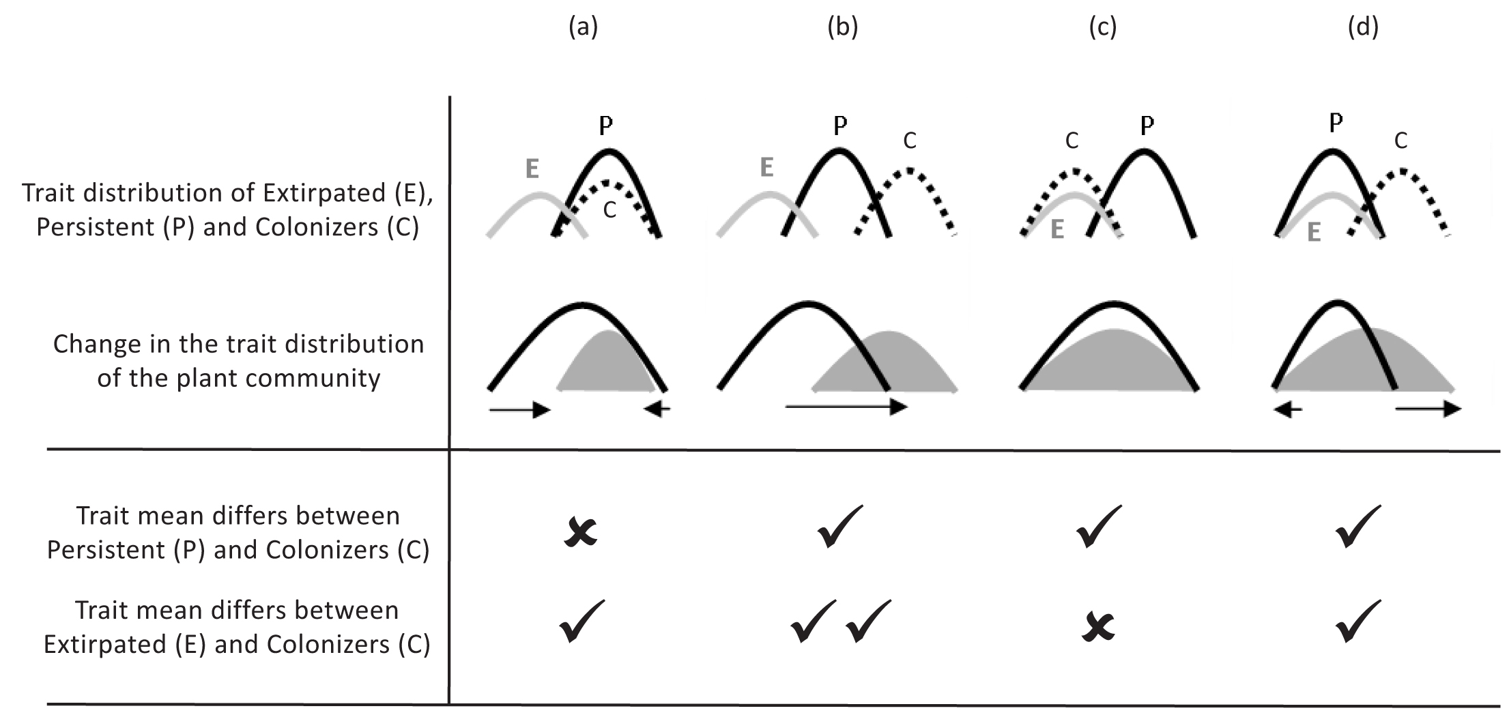

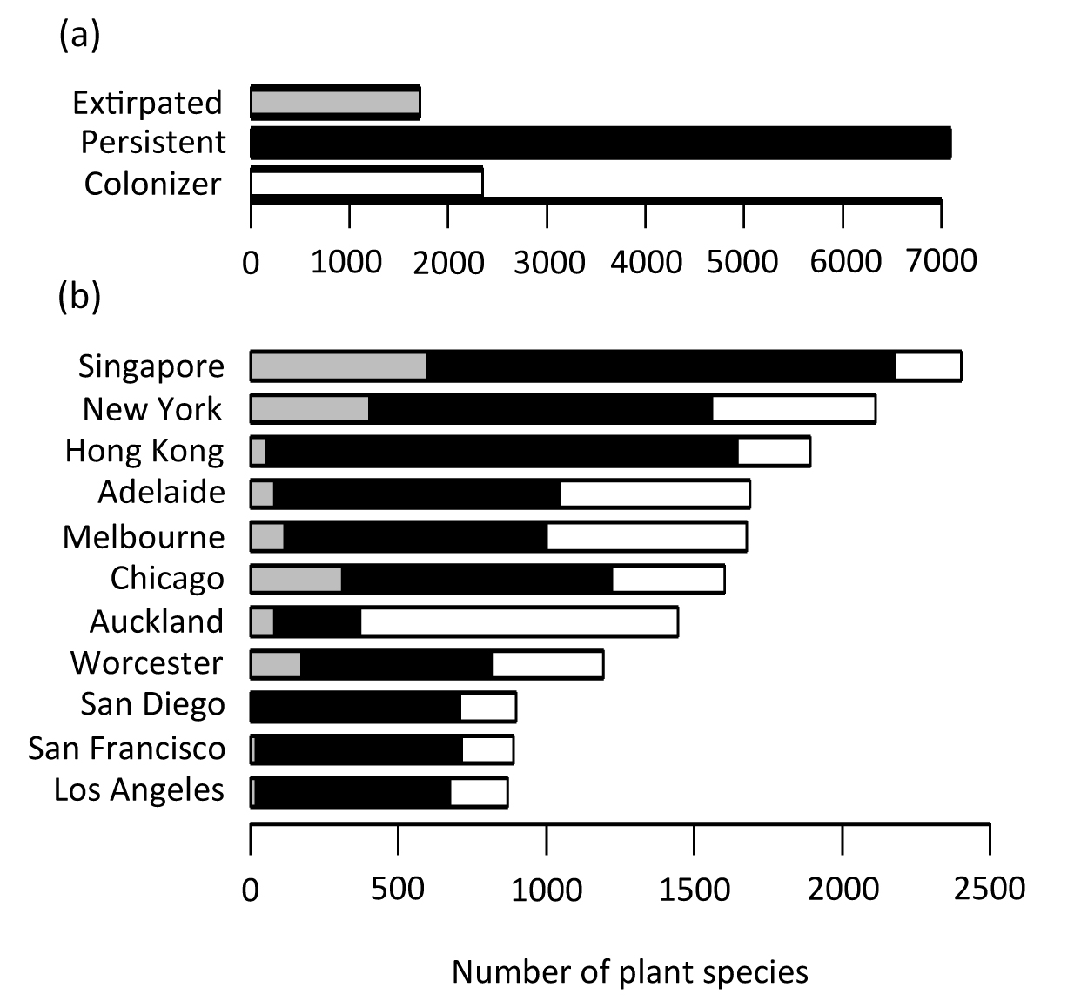

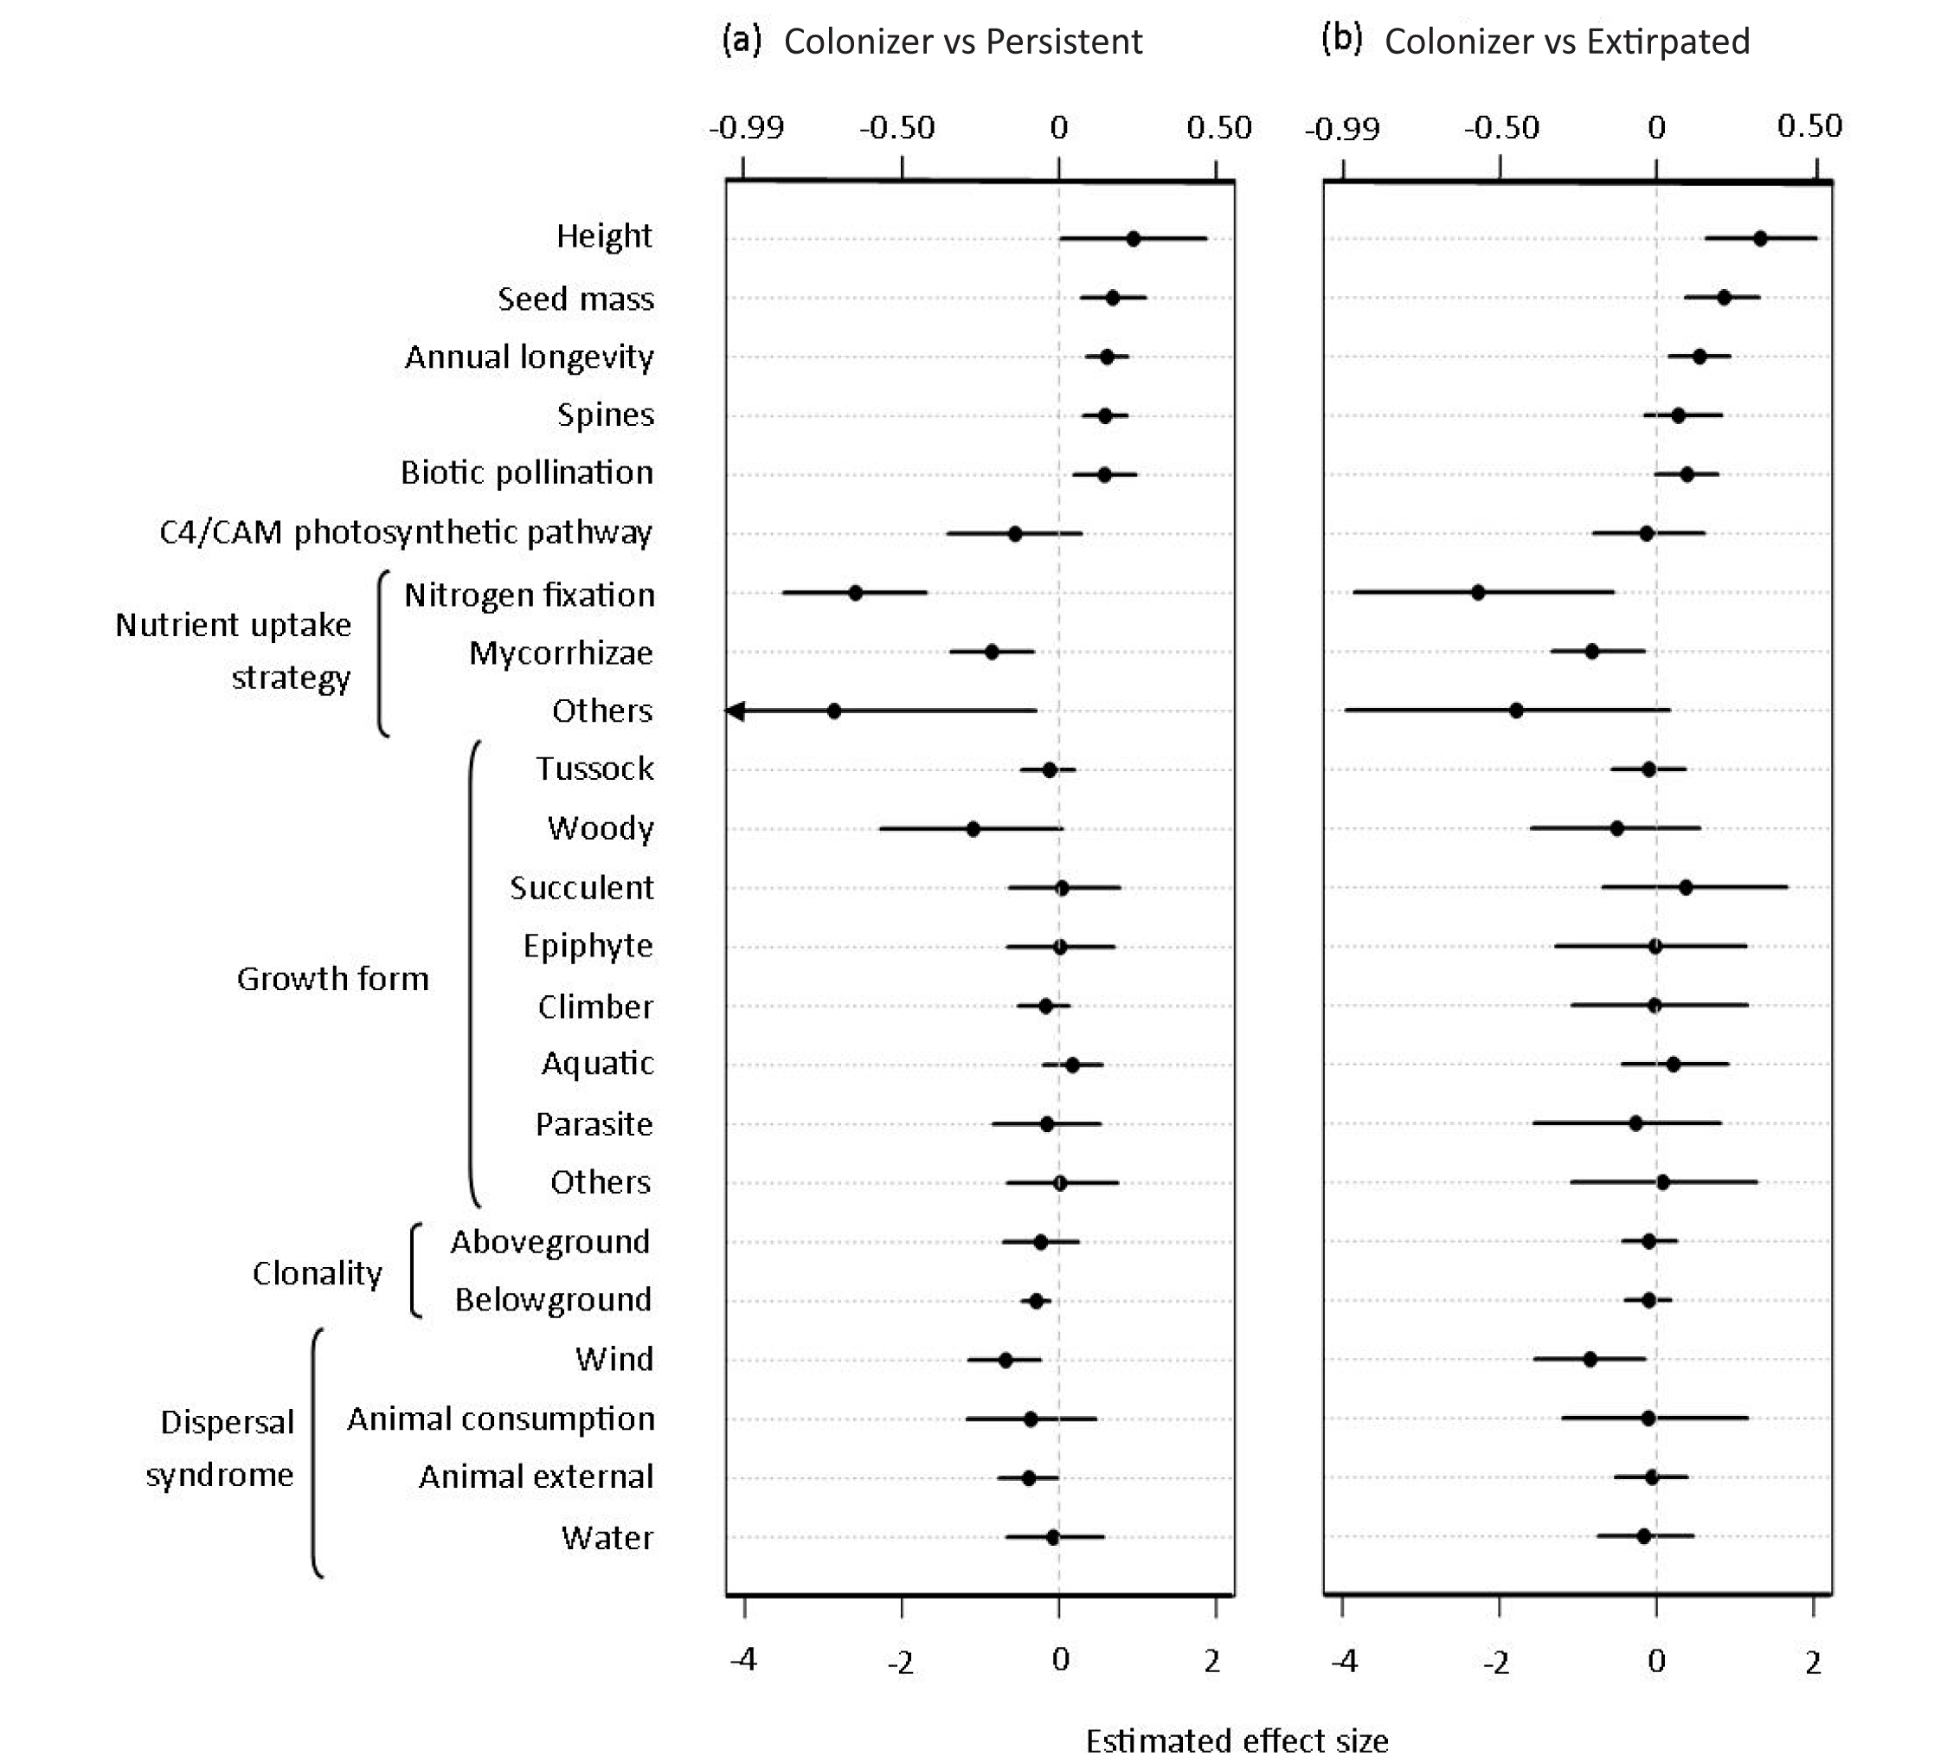

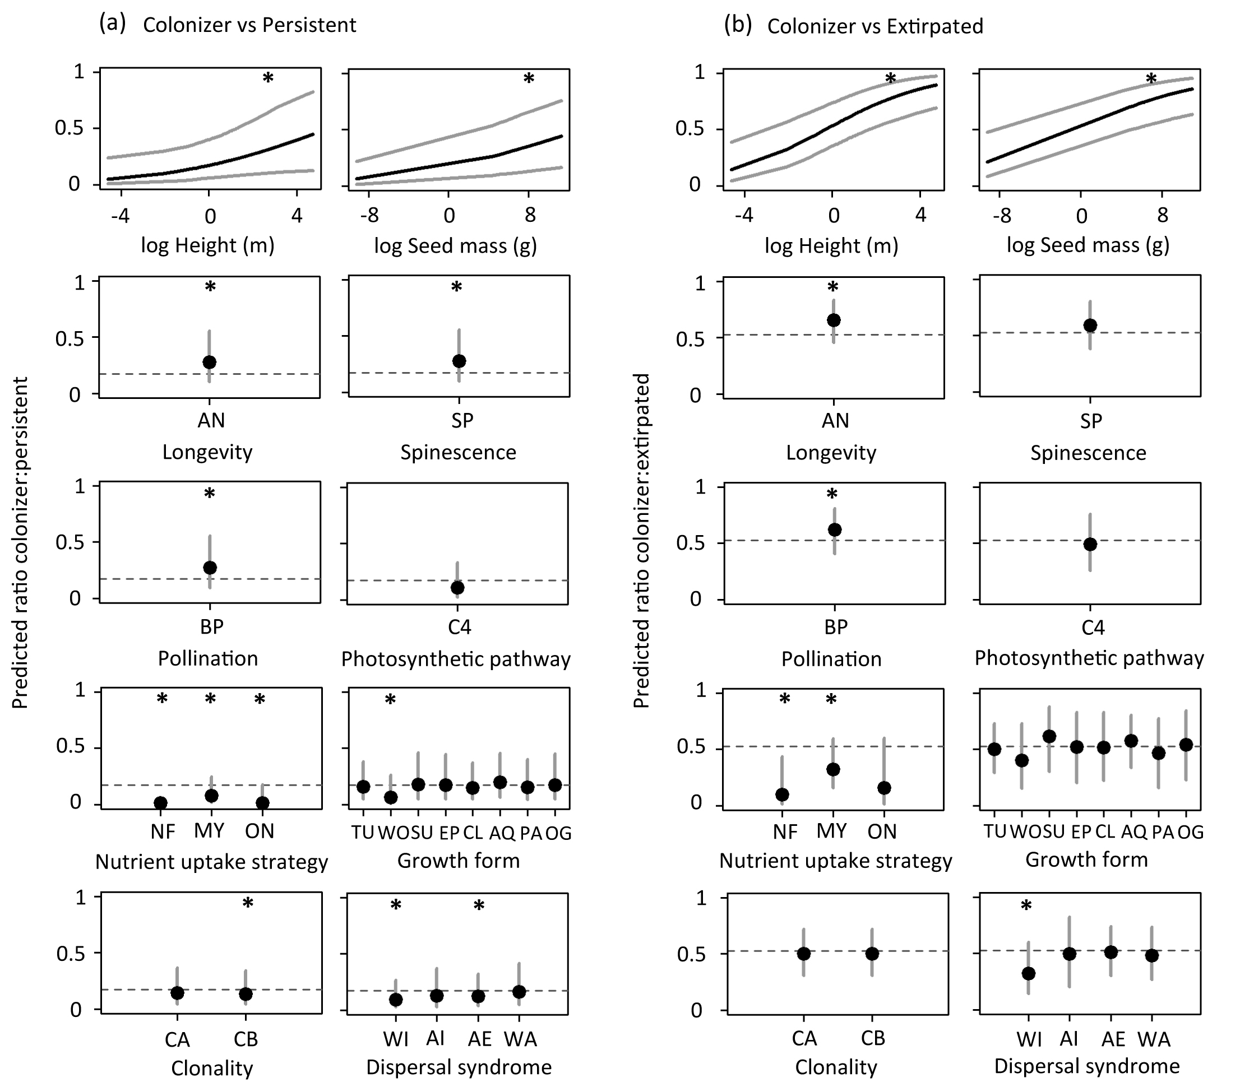

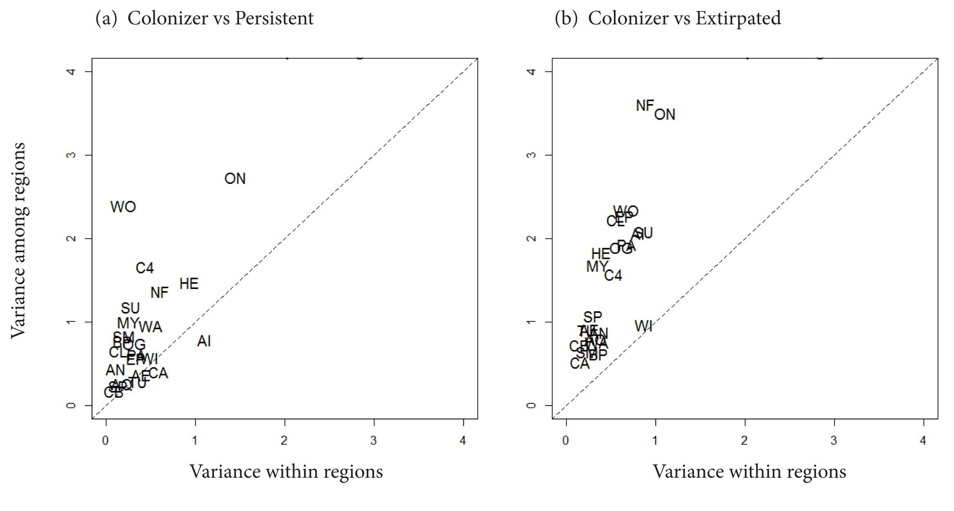

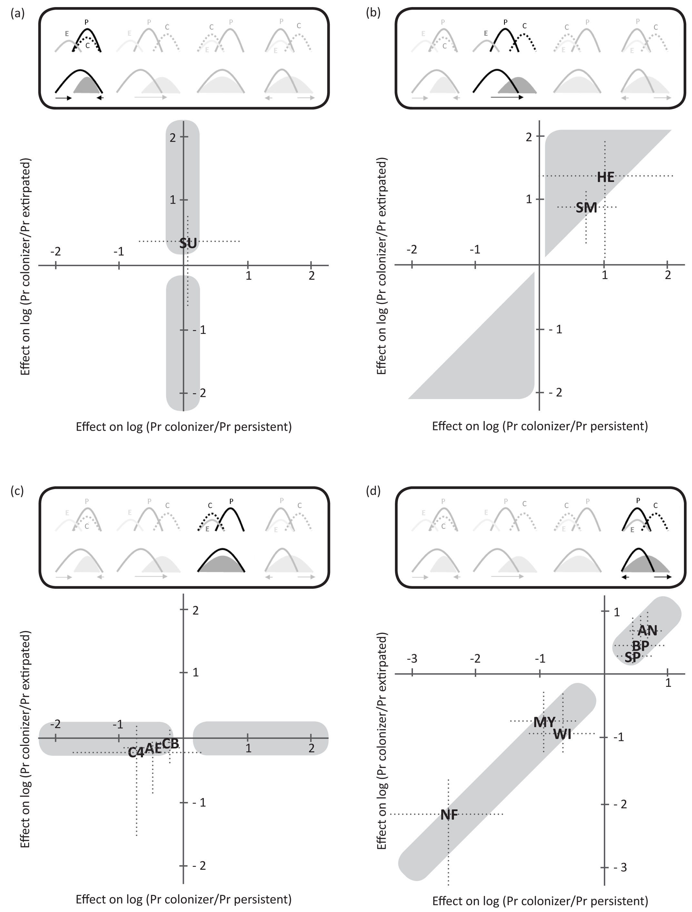

**SUPPORTING INFORMATION**

**Appendix S1: Details of statistical models**

1. Independent analysis of each city

We evaluated the correlation of traits with colonization and extirpation through two separate logistic regressions instead of a single multinomial analysis because 1) an ordinal multinomial model (three responses: extirpated, persistent, colonizer) assumes that the processes of extirpation and colonization are similar (i.e. they select for/against the same traits), thereby preventing us from testing that hypothesis directly, and 2) a multinomial model without ordinal responses does not produce regression coefficients that can be examined in a meta-analysis. The size and complexity of the datasets, and the assumption that cities may show different patterns prevented the use of a single hierarchical model.

We maintained the same model structure throughout all the city-based analyses and did not use any form of variable selection because we are interested in the effect of all ten traits in each of the eleven cities. No quadratic terms were included in the final models because such models did not yield evidence of unimodal behaviour, and their inclusion hampered appropriate model convergence in some cities. Our analyses did not include interactions between the effects. Unlike Duncan *et al.* (2011), we did not incorporate information about the habitat preference of species as a predictor: its effect may be confounded by habitat destruction and/or the fact that species may occupy different habitats when they expand their range.

All the analyses were carried out within a Bayesian inference framework, using Markov Chain Monte Carlo (MCMC) implementation in JAGS software, called from R version 3.1.3 (R Core Team, 2015) through the R2jags package (Su & Yajima, 2014). We specified weakly informative prior distributions for all the estimated parameters and standard deviations (Gelman, 2006; Gelman *et al.*, 2008). Categories within multicategorical traits, and families were treated as random effects and assumed to follow a normal distribution with mean zero and standard deviation estimated from the data.

Data availability varied among traits and species. Missing information ranged from 7% to 40% of the trait records, depending on the particular city and analysis (Table S1). We dealt with missing data by modelling traits as a function of plant family, using all the plant species included in our data sets. We assumed that categorical traits followed a categorical distribution, with the probability of each category depending on the family that a species belongs to, and that standardized quantitative traits followed a normal distribution, where the mean and standard deviation of parameters varied with plant family.

We ran each model for 50,000 iterations, with the first 20,000 discarded as burn-in, which was sufficient to achieve convergence in the estimation of most parameters. Some convergence issues arose due to unbalanced data sets (the proportion of extirpated plants in San Diego, San Francisco and Los Angeles was very low) or traits showing some degree of separation (e.g. no epiphytes were categorized as colonizers). These issues prevented us from using estimates from all cities when comparing colonizers and extirpated plants across urban areas (see *Meta-analysis across cities* section); however, this did not affect the average estimated effects of traits in the subsequent meta-analysis. The Area Under the Curve (AUC) criterion was used to measure model discrimination between groups of plants (Hosmer & Lemeshow, 2000).

1. *Traits associated with invasive and persistent plants in urban environments*

Table S2 (columns 1-11) shows the estimated values for all the parameters included in the city-levels logistic regressions comparing colonizers and persistent plants. Figures S1(a) to S10(a) represent the predicted probability of being a urban colonizer in each of the eleven cities, along with predictions drawn from the meta-analysis for ease of comparison between estimates. For categorical traits, the probability of occurrence of the reference class has been represented by plotting the estimated intercept value of each city (dashed line). These lines show that Adelaide, Auckland, Melbourne and Singapore have a proportion of colonizers higher than 25% for those plants with reference class categorical traits (Table 1).

The effect of continuous and categorical traits varied among cities. For example, species dispersed by animal external attachment in Adelaide are more often colonizers, while the same trait in Auckland is strongly related to persistent plants (Fig. S10a). Plants with heavier seeds are more prevalent amongst colonizers in Melbourne; however, this trait has no effect on the prevalence of colonizers in Singapore (Fig. S2a).

1. *Traits associated with invasive and extirpated plants in urban environments*

As for the previous comparison, the estimated effects of traits in the probability of being an urban colonizer in each of the eleven cities are included in Table S3 (columns 1-11). The predicted occurrence of colonizers in each urban flora, along with predictions drawn from the meta-analysis, is represented in Figures S1(b) to S10(b). For all the cities, colonizers represent a proportion of the species larger than for the previous comparison, at least for the reference categories. This is especially noteworthy for Adelaide.

The uncertainty associated with some estimates was high for Los Angeles, San Diego and San Francisco, because relatively few species are recorded as extirpated in those areas (less than 20 species in each city, which stands for less than 10% of the total species in the city-level data set; Fig. 2b). For this reason, these three cities were excluded from the corresponding meta-analysis.

All the city-level models achieved AUC values larger than 0.8; therefore, we assume accurate ability to assign probabilities that correctly discriminate between groups of plant species.

1. Meta-analysis across cities

Like the city-based analyses, the meta-analyses were run through JAGS software using weakly informative prior distributions (Gelman, 2006; Gelman *et al.*, 2008).

Cities were not randomly selected for this work, which may affect our results because some cities can exhibit clustered patterns of extirpation and colonization due to shared biotic and climatic factors. Fig S11 shows the similarity between pairs of cities on their pre-urbanization flora (a) and the introduced flora (b), making clear that some clusters do exist. When the meta-analyses include an extra random effect accounting for non-independence of cities within the same biogeographic regions, the uncertainty associated to the estimated effects of traits highly increases (however, the trends represented by the average values remain more or less similar). The effects of the traits on the log odds of colonizers over persistent and extirpated plants for each of the biogeographic regions have been included in Figs. S12 and S13, respectively.

Despite the large credible intervals shown in the previous two figures, the average effects of some traits seem to vary among regions, including woody forms, several nutrient uptake strategies, photosynthetic pathway and height. Figure 5 shows how the variability among regions appears to be larger (or at least of similar magnitude) than the variability among cities [within regions] for most of the traits we have analyzed. These results point to the fact that regions may have a considerable influence in extirpation and colonization patterns of urban floras. They also suggest that variability can be broken down to quantify accurate effects of different levels of factors (in this case specific features of cities, and biogeographic regional features), if a more comprehensive data set was used to answer questions similar to the ones we present in this paper.

The code used for all the analyses is provided in Appendix S3.

References:

Duncan, R. P. et al. 2011. Plant traits and extinction in urban areas: a meta-analysis of 11 cities. - Global Ecol Biogeogr 20: 509-519.

Gelman, A. 2006. Prior distributions for variance parameters in hierarchical models. - Bayesian anal 1: 515–533.

Gelman, A. et al. 2008. A weakly informative default prior distribution for logistic and other regression models. - Ann Appl Stat 2: 1360–1383.

Hosmer, J. D. W. and Lemeshow, S. 2000. Applied logistic regression, 2nd edn - John Wiley & Sons, Inc., New York.

R Core Team 2015. R: A language and environment for statistical computing. - R Foundation for Statistical Computing, Vienna, Austria. URL http://www.R-project.org/.

Su, Y.-S. and Yajima, M. 2014. R2jags: A package for running jags from R. R package version 0.04-01. In: http://CRAN.R-project.org/package=R2jags.

**Table S1**. Sources of plant records in each city, and summaries of extirpation and colonization rates.



**Table S2**. Sources of trait records.

**PUBLISHED LITERATURE**

**1. Books**

Walsh N and Entwistle T (1999) Flora of Victoria: Oligaceae to Asteraceae. Inkata Press, Melbourne.

Walsh N G and Entwisle T J (1994) Flora of Victoria: ferns and allied plants, conifers and monocotyledons. Inkata Press, Melbourne.

Gray M & Knight J (eds.) (2001) Flora of Melbourne: A Guide to the Indigenous Plants of the Greater Melbourne Area. S.G.A.P. Maroondah Inc.

Cunningham G H, Mulham W E, Milthorpe P L & Leigh J H (1981) Plants of Western New South Wales. CSIRO Publishing.

Bishop A (2000) Field Guide to the Orchids of New South Wales and Victoria, 2nd edition. University of New South Wales Press.

Burbidge N T (1970) Australian Grasses, Volume 3. Angus and Robertson, Sydney.

Lamp C, Forber S J & Cade J W (2001) Grasses of Temperate Australia - A field Guide. Jerram & Bloomings Books, Australia.

Costermans L (1996) Native trees and shrubs of South-Eastern Australia. Lansdowne publishing.

van der Cingel NA (2001) An atlas of Orchid Pollination: America, Africa, Asia and Australia. A.A. Balkema, Rotterdam.

Fernald M L (1970) 1950Gray's manual of botany. American Book Co., New York.

Gleason H A & Cronquist A (1991) Manual of vascular plants of northeastern United States and adjacent Canada, 2nd edition. New York Botanical Garden.

Baskin J M, Baskin C C & Chester E W (1999) The big barrens region of Kentucky and Tennessee. In: Savannas, barrens and roch outcrop plant communities of North America (ed. Anderson R C, Fralish J S & Baskin J M). Cambridge University Press.

Watson L & Dallwitz M J (1992) The grass genera of the world. CAB international.

Bertin R I (2000) Vascular Flora of Worcester, Massachusetts. New England Botanical Club, Cambridge.

Jepson W L (1993) The Jepson manual: higher plants of California. University of California Press. Available online: http://ucjeps.berkeley.edu/eflora/

Hill M O, Preston C D & Roy D B (2004) Plantatt - Attributes of British and Irish Plants: status, size, life history, geography and habitats. NERC Centre for Ecology and Hydrology.

Chong K Y, Tan H T W & Corlett R T (2009) A checklist of the total vascular plant flora of singapore: native, naturalised and cultivated species. Raffles Museum of Biodiversity Research, National University of Singapore, Singapore.

**2. Peer-reviewed papers**

de Lange P J, Gardner R O, Sykes W R, Crowcroft G M, Cameron E K, Stalker F, Christian M L & Braggins J E (2005) Vascular flora of Norfolk Island: some additions and taxonomic notes. New Zealand Journal of Botany 43: 563–596.

Harley J L & Harley E L (1987) A checklist of Mycorrhiza in the British Flora. New Phytologist 105(supp): 1-102.

Warcup J H & McGee P A (1983) The mycorrhizal associations of some Australian Asteraceae. New Phytologist 95: 667-672.

Warcup J H (1980) Ectomycorrhizal associations of Australian Indigenous Plants. New Phytologist 85: 531-535.

Ragupathy S & Mahadevan A (1993) Distribution of vesicular-arbuscular mycorrhizae in the plants and rhizosphere soils of the tropical plains, Tamil Nadu, India. Mycorrhiza 3: 123-136.

Muthukumar T, Sha L, Yand X, Cao M, Tang J & Zheng Z (2003) Mycorrhiza of plants in different vegetation types in tropical ecosystems of Xishuangbanna, southwest China. Mycorrhiza 13: 289-297.

Senguptan A & Chaudhuri S (2002) Arbuscular mycorrhizal relations of mangrove plant community at the Ganges river estuary in India. Mycorrhiza 12: 169-174.

Cornelissen J H C, Lavorel S, Garnier E, Diaz S, Buchmann N, Gurvich D E, Reich P B, ter Steege H, Morgan H D, van der Heijden M G A, Pausas J G & Poorter H (2003) A handbook of protocols for standardised and easy measurement of plant functional traits worldwide. Australian Journal of Botany 51: 335-380.

Duncan R P & Young J R (2000) Determinants of plant extinction and rarity 145 years after European settlement of Auckland, New Zealand. Ecology 81: 3048-3061.

Gibson D (1961) Life-forms of Kentucky flowering plants. The American Midland Naturalist 66: 1-60.

McDonald E S (1937) The life-forms of the flowering plants of Indiana. The American Midland Naturalist 18: 687-773.

Cain M L, Damman H & Muir A (1998) Seed dispersal and the Holocene migration of woodland herbs. Ecological monographs 68: 325-347.

Nilsson S G & Nilsson I N (1978) Species richness and dispersal of vascular plants to islands in Lake Mockeln, sputhern Sweden. Ecology 59: 473-480.

Wang B & Qiu Y-L (2006) Phylogenetic distribution and evolution of mycorrhizas in land plants. Mycorrhiza 16: 299-363.

Kadereit G, Borsch T, Weising K & Freitag H (2003) Phylogeny of Amaranthaceae and Chenopodiaceae and the evolution of C4 photosynthesis. International Journal of Plant Sciences 164: 959-986.

Tait C J, Daniels C B & Hill R S (2005) Changes in species assemblages within the Adelaide Metropolitan Area, Australia, 1836-2002. Ecological Applications 15: 346-359.

Ennis B P (1928) Life forms of Connecticut plants and their significance in relation to climate. Connecticut State Geology and Natural History Survey Bulletin 43: 1-100.

Corlett R T, Xing F, Ng S C, Chau K C & Wong L M Y (2000) Hong Kong vascular plants: distribution and status. Memoirs of the Hong Kong Natural History Society 23: 1-157.

**ONLINE RESOURCES**

Australian National Herbarium Specimen Information Register (ANHSIR). URL: https://www.anbg.gov.au/cpbr/program/hc/hc-ANHSIR.html

Seed information database (SID), KEW Royal Botanic Gardens. URL: http://data.kew.org/sid/

PLANTS database, United States Department of Agriculture (USDA). URL: http://plants.usda.gov/

Mycorrhizae database, Commonwealth Scientific and Industrial Research Organisation (CSIRO). URL: www.ffp.csiro.au/research/mycorrhiza

FloraBase - the Western Australian flora, Western Australian Herbarium, Department of Parks and Wildlife. URL: https://florabase.dpaw.wa.gov.au/

Weldy T & Werier D (2005) New York flora atlas, New York Flora Association, Albany, New York. URL: http//atlas.nyflora.org/

The vPlants Project: A Virtual Herbarium of the Chicago Region. URL: http://www.vplants.org

eFloraSA - Electronic flora of South Australia. URL: http://www.flora.sa.gov.au/

Calflora - Information on Californian plants for education, research and conservation. The Calflora Database [a non-profit organization]. URL: http://www.calflora.org/

California Native Plant Society (CNPS). URL: http://cnps.org/

Rare and endangered plant inventory, California Native Plant Society (CNPS). URL: http://www.rareplants.cnps.org/

Jepson Flora Project (2006) Ecological Flora of California. URL: http://ucjeps.berkeley.edu/efc/index.html

The ISM Herbarium Collection online, The Illinois Satet Museum. URL: http://www.museum.state.il.us/ismdepts/botany/herbarium/

**OTHERS**

Meers T L (2006) The role of Plant functional traits in determining the response of vegetation to land-use change on the Delatite Peninsula, Victoria. PhD Thesis, The University of Melbourne, Australia.

Viers J H, Thorne J H & Quinn J F (2006) CalJep: A spatial distribution database of CalFlora and Jepson plant species. San Francisco Estuary and Watershed Science 4: Article 1. The CalJep Geodatabase is available at http://cain.ice.ucdavis.edu/regional/caljep/CalJepGeoV1.zip

The authors measured some traits from herbarium specimens in the National Herbarium of Victoria (Hahs A & Williams N S G W) and in the wild (Vesk P).

Some information came from unpublished datasets and expert opinion of the members of the "Urbanization and Plant Functional Traits working group of the ARC-NZ Network for Vegetation Function", including Steven Clemants and Mark Schwartz, and other botanists with knowledge of the flora in particular areas, including, but not limited to, Catherine Tait, Monique Hallet, Andrew Hipp and Myla Aronson.

**Table S3**. Information of the data sets used in the city-level logistic regression models. a: each species may have been recorded in more than one city. b: species have been categorized as colonizer in at least one city.

**Colonizers and persistent Colonizers and extirpated**

**plants data set plants data set**

Total City-level Total City-level

Records 14,800 6,588

Number of species 9,101a Adelaide 1607 4,020a Adelaide 724

Auckland 1363 Auckland 1153

Chicago 1291 Chicago 690

Hong Kong 1835 Hong Kong 301

Los Angeles 851 Los Angeles 214

Melbourne 1559 Melbourne 791

New York 1711 New York 953

San Diego 891 San Diego 196

San Francisco 869 San Francisco 193

Singapore 1804 Singapore 824

Worcester 1019 Worcester 549

Species categorized as colonizer 25%b Adelaide 40% 58%b Adelaide 89%

Auckland 79% Auckland 93%

Chicago 29% Chicago 55%

Hong Kong 13% Hong Kong 81%

Los Angeles 23% Los Angeles 92%

Melbourne 43% Melbourne 85%

New York 32% New York 58%

San Diego 21% San Diego 96%

San Francisco 20% San Francisco 90%

Singapore 13% Singapore 27%

Worcester 37% Worcester 68%

Missing trait records 19% Adelaide 21% 27% Adelaide 40%

Auckland 37% Auckland 40%

Chicago 8% Chicago 7%

Hong Kong 14% Hong Kong 9%

Los Angeles 11% Los Angeles 10%

Melbourne 21% Melbourne 38%

New York 8% New York 8%

San Diego 11% San Diego 9%

San Francisco 10% San Francisco 8%

Singapore 20% Singapore 22%

Worcester 7% Worcester 6%

**Table S4**. Estimated coefficients of city-level logistic regression models (columns 1-11) and meta-analysis across cities (columns 12-13) for the comparison between colonizer and persistent plants.



**Table S5**. Estimated coefficients of city-level logistic regression models (columns 1-11) and meta-analysis across cities (columns 12-13) for the comparison between colonizer and extirpated plants. For the meta-analysis, estimates of San Diego, San Francisco and Los Angeles were excluded.



**Figures S1-S10.** Predicted prevalence of colonizers over persistent (a) and extirpated (b) urban plants across trait values or categories, based on estimated effects of traits for city-level models and the meta-analysis. Black dots and lines represent mean effects and grey lines represent 95% credible intervals. Horizontal grey dashed lines represent the intercept value estimated for the model in question. Predictions drawn from meta-analysis are based on eleven (a) and eight cities (b). The range of x values over which the predictions of individual cities were made is similar to the range of values covered by species recorded in that particular city. Legend for categorical traits: AN= annual longevity, SP= spines, BP= biotic pollination, C4= C4 or CAM photosynthetic pathway, NF= Nitrogen fixer, MY=mycorrhizae, ON= other nutrient uptake strategy, TU= tussock, WO= woody, SU= succulent, EP= epiphyte, CL= climber, AQ= aquatic, PA= parasite, OG= other growth form, CA= clonal aboveground, CB= clonal belowground, WI= wind dispersal, AI= animal dispersal (consumption), AE= animal dispersal (external), WA= water dispersal.

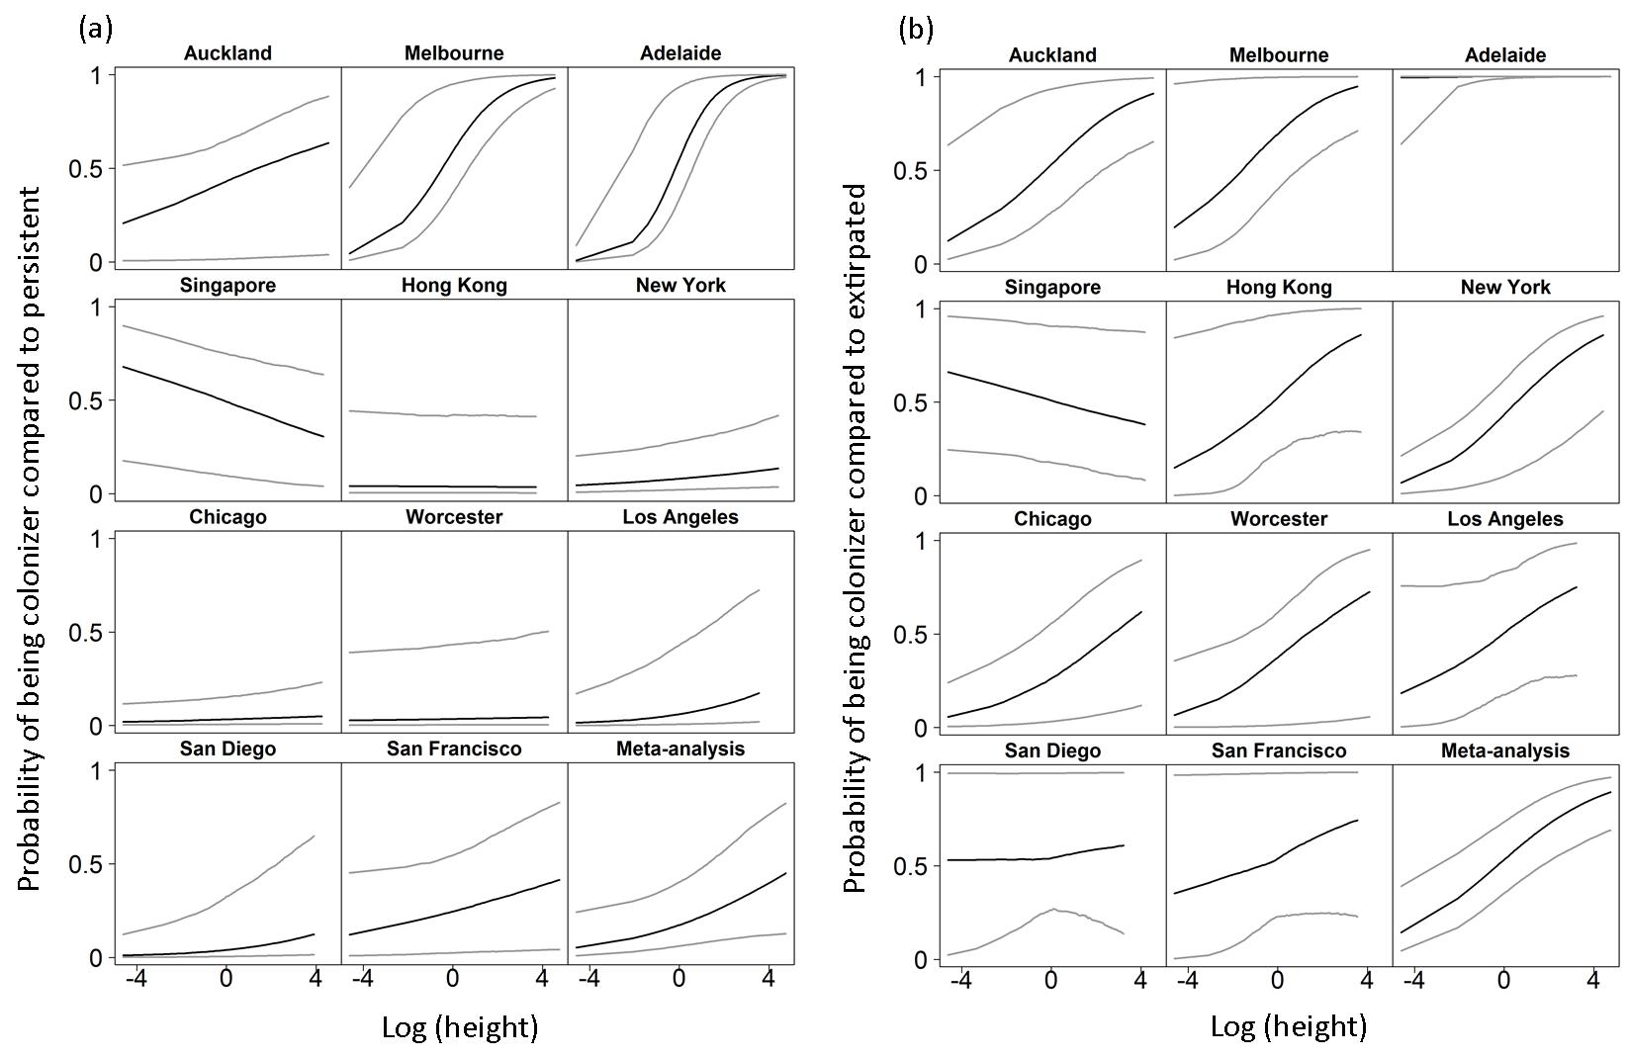**Figure S1.**

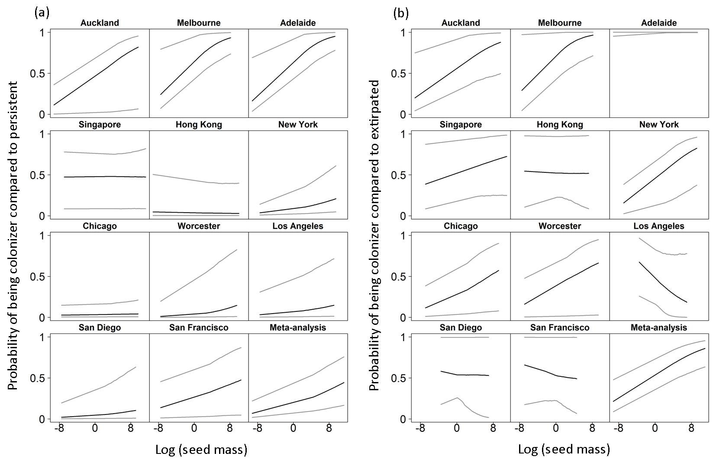**Figure S2.**

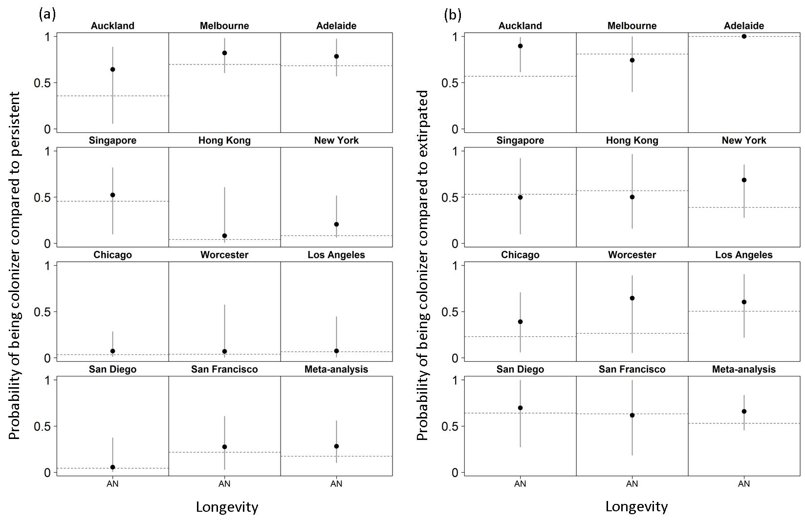**Figure S3.**

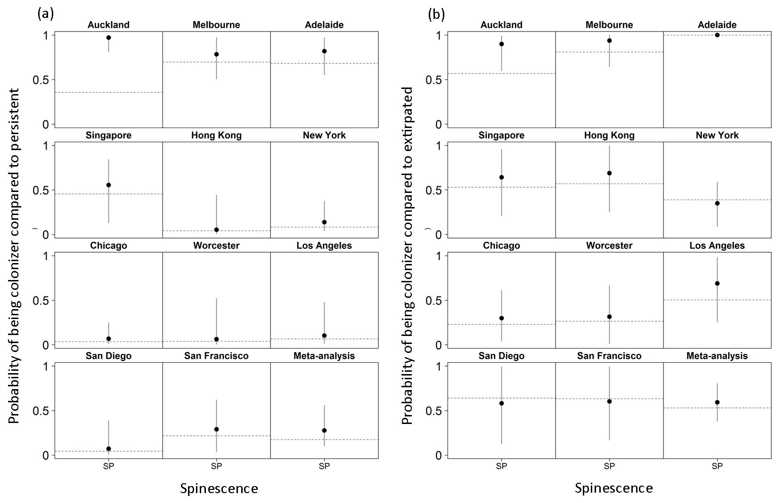**Figure S4.**

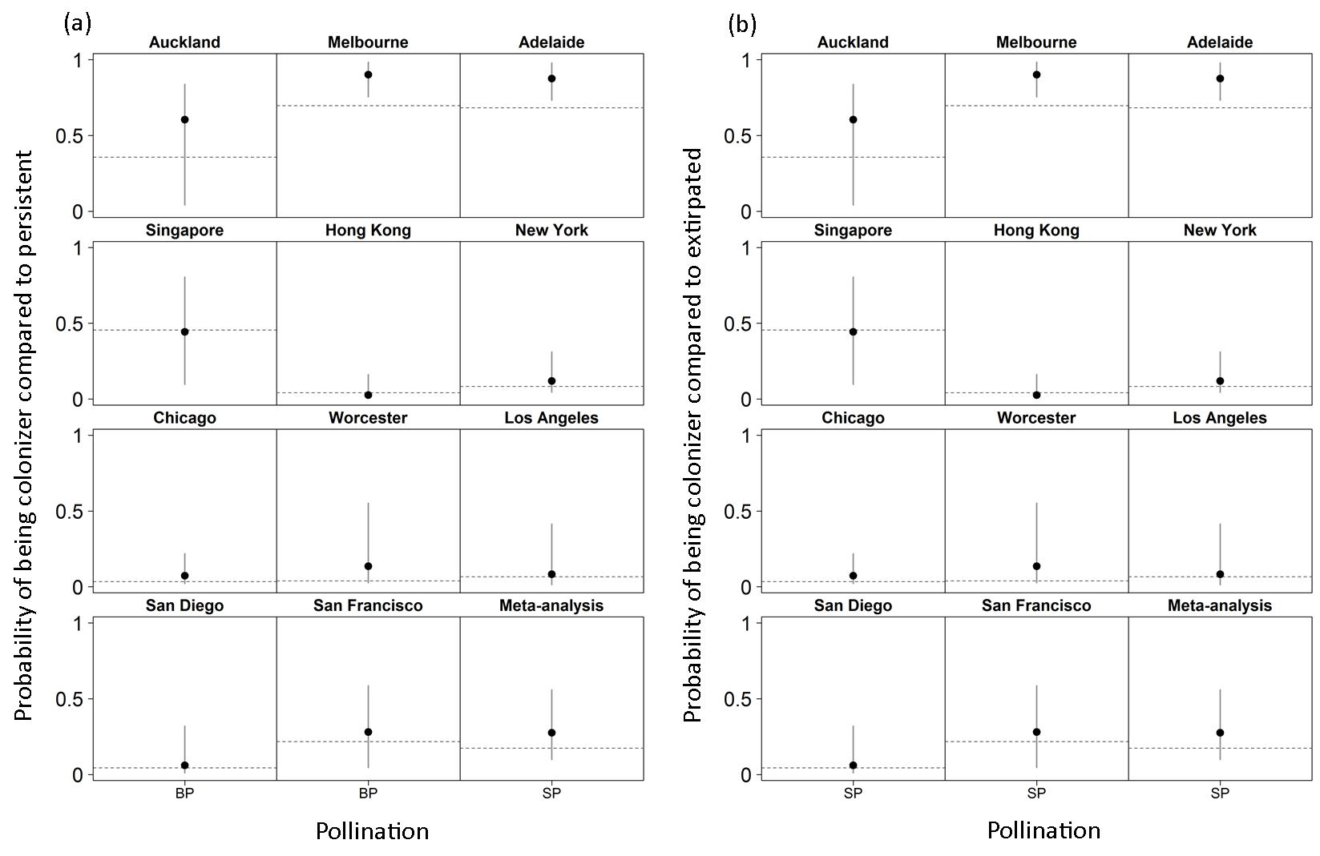**Figure S5.**

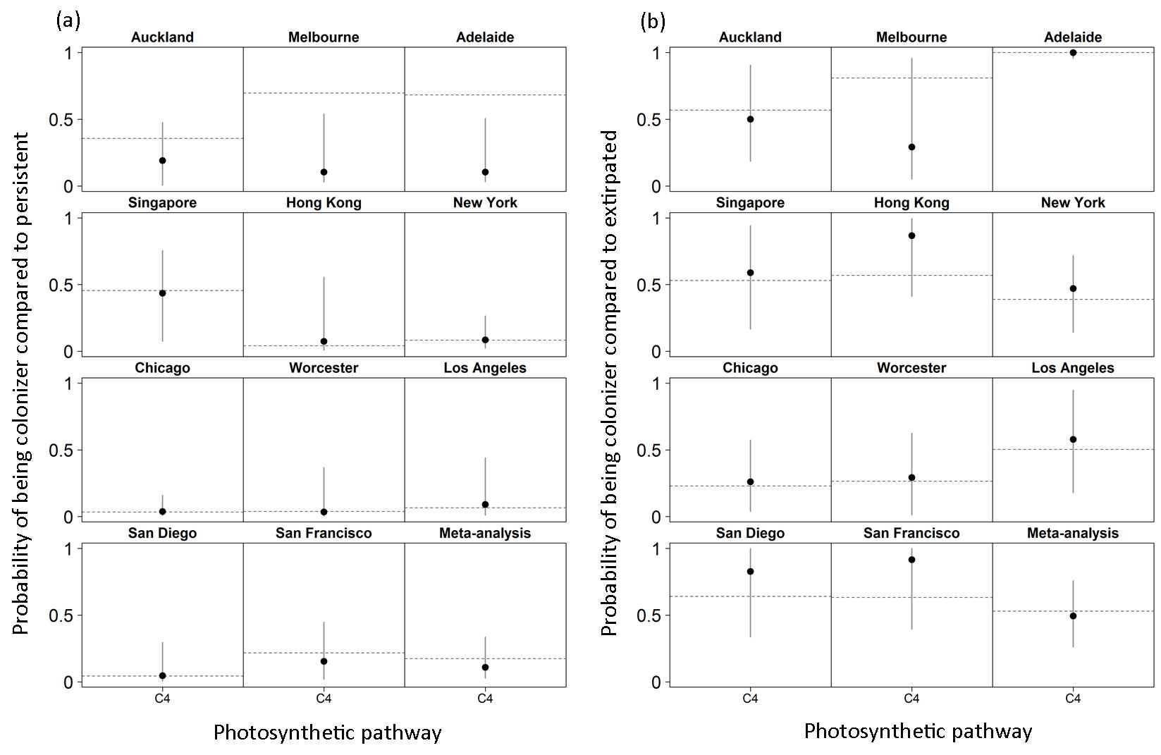**Figure S6.**

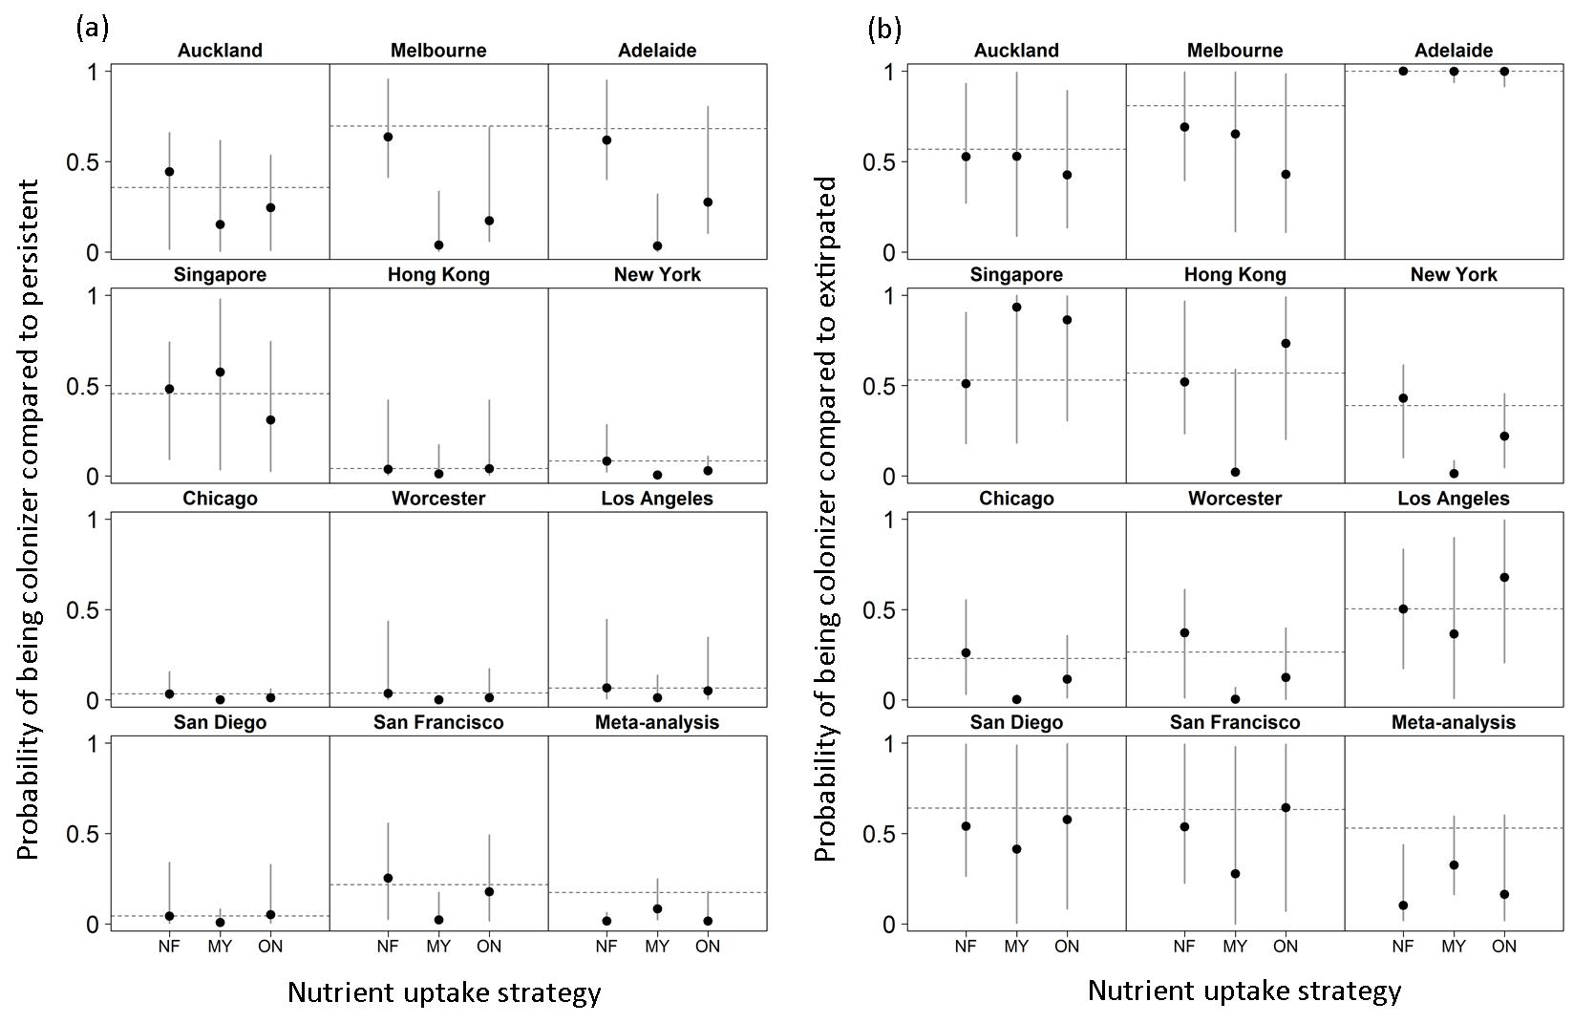**Figure S7.**

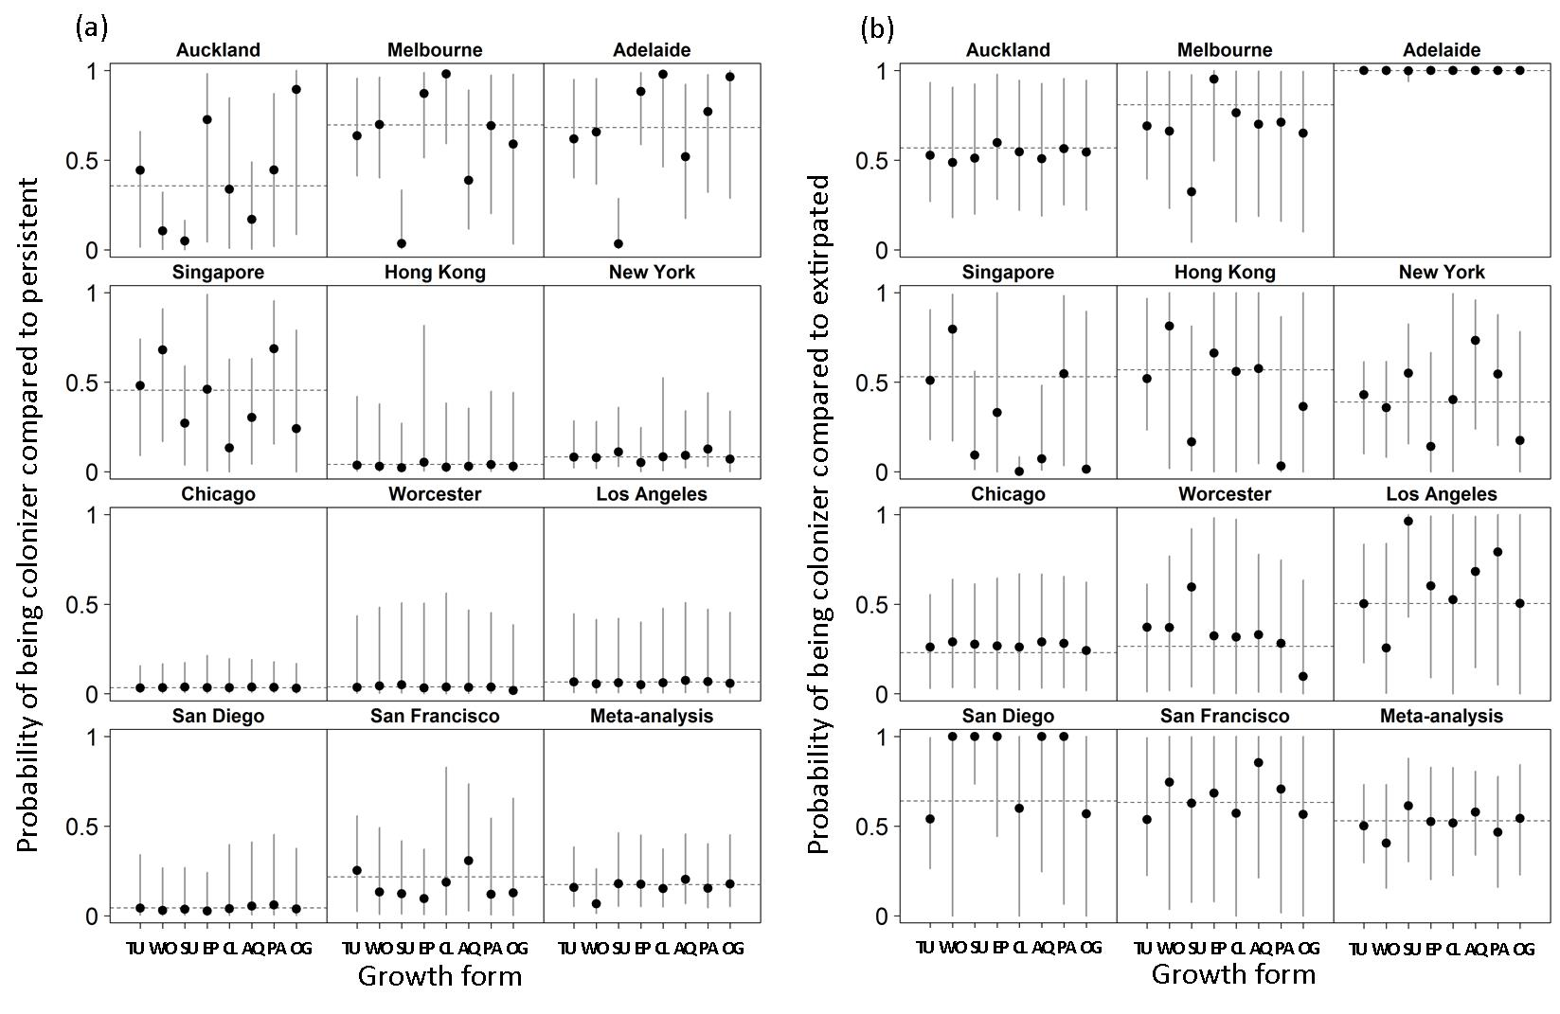**Figure S8.**

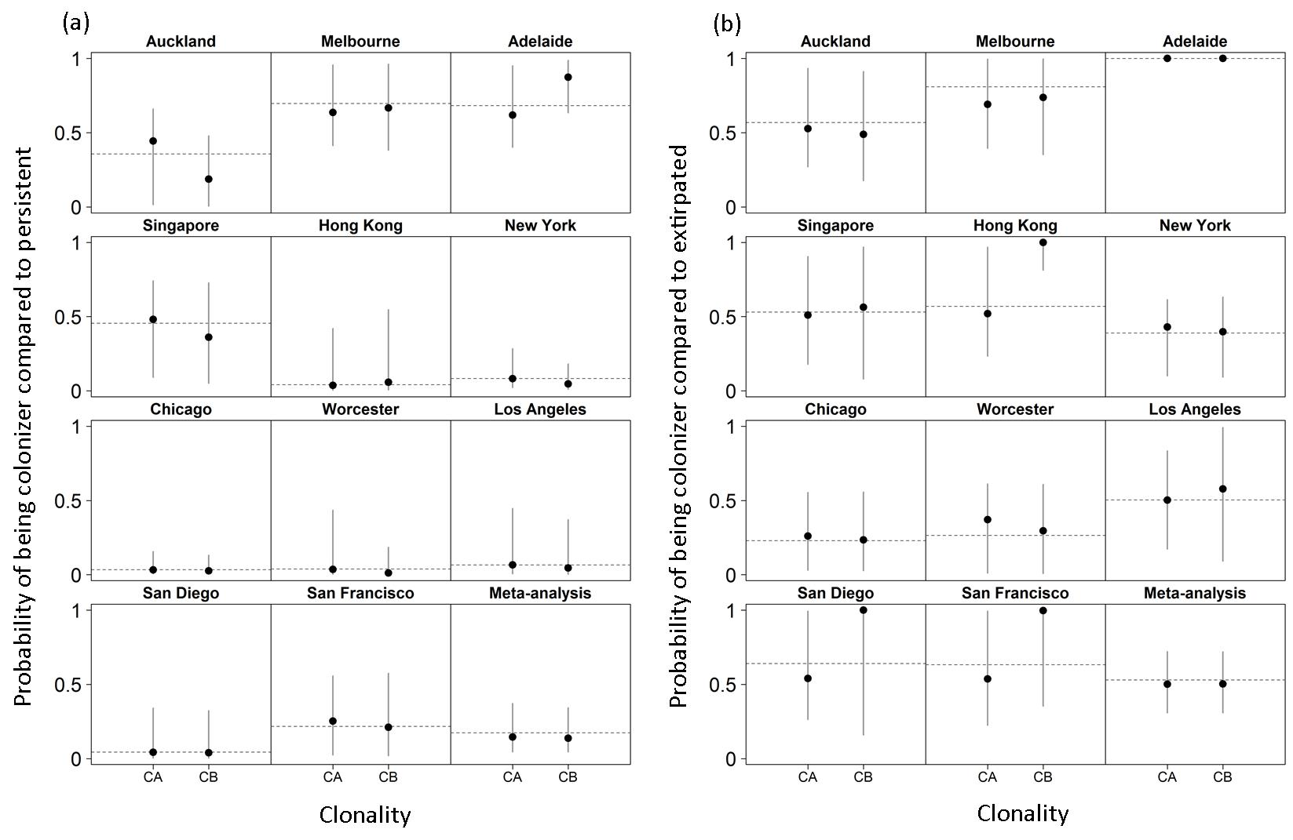**Figure S9.**

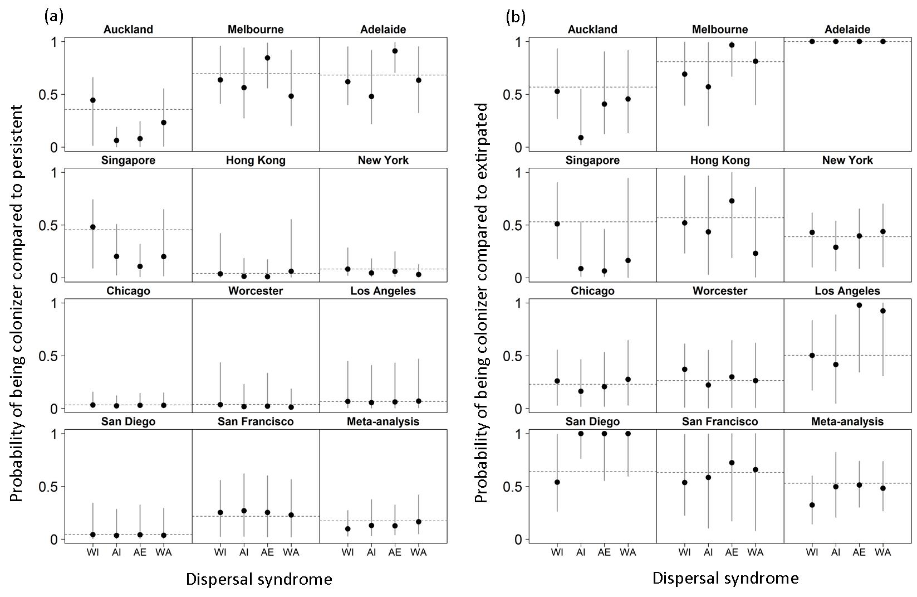**Figure S10**

**Figure S11**. Floral similarity among cities included in the study, based on paired comparisons using the Jaccard’s index; larger points represent larger similarities between two cities for their pre-urbanization (a) or introduced flora (b). Codes for cities as follows: LA= Los Angeles, SD= San Diego, SF= San Francisco, WO= Worcester, CH= Chicago, NY= New York, HK= Hong Kong, SI= Singapore, AD= Adelaide, ME= Melbourne, AU= Auckland.

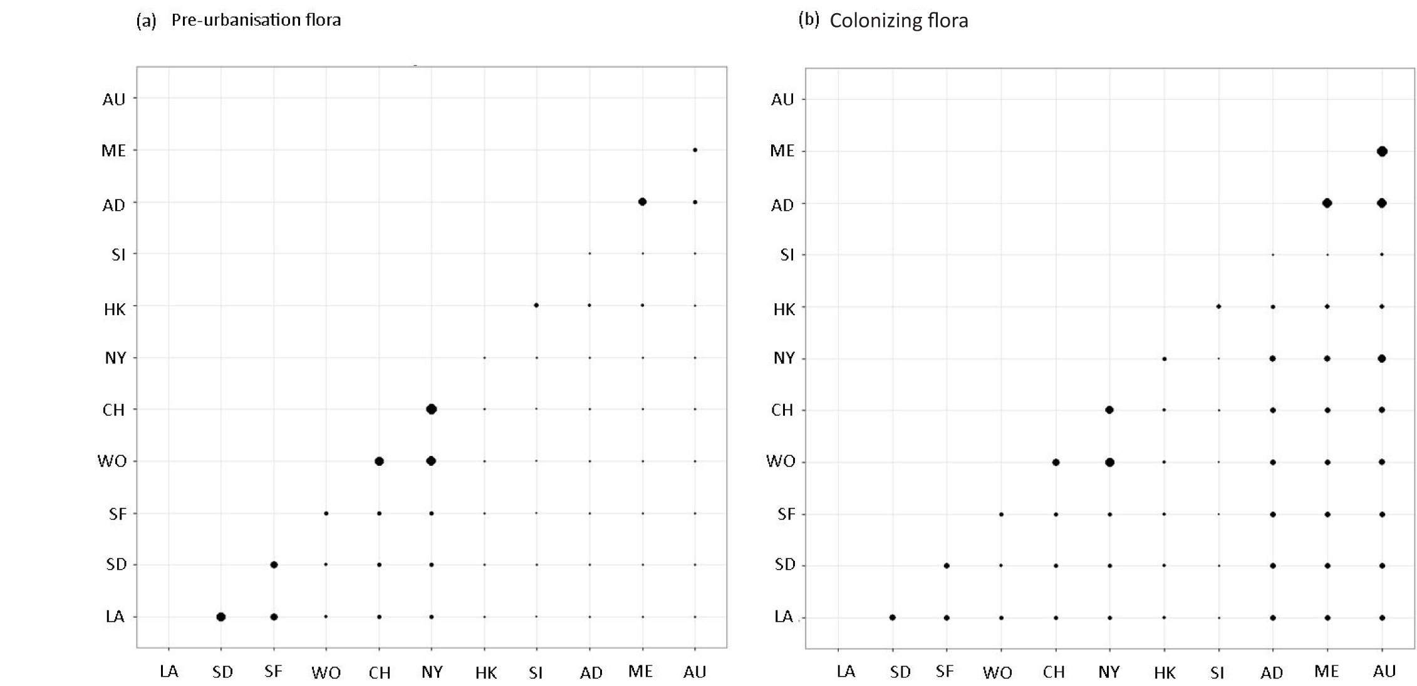

**Figure S11**

**Figures S12-S13.** Estimated effect of traits on the prevalence of colonizers over persistent (Fig. S12) and extirpated (Fig. S13) urban plants, within four biogeographic regions. Black dots represent mean effects and grey lines represent 95% credible intervals. Credible intervals over 10 or under -10 not represented.

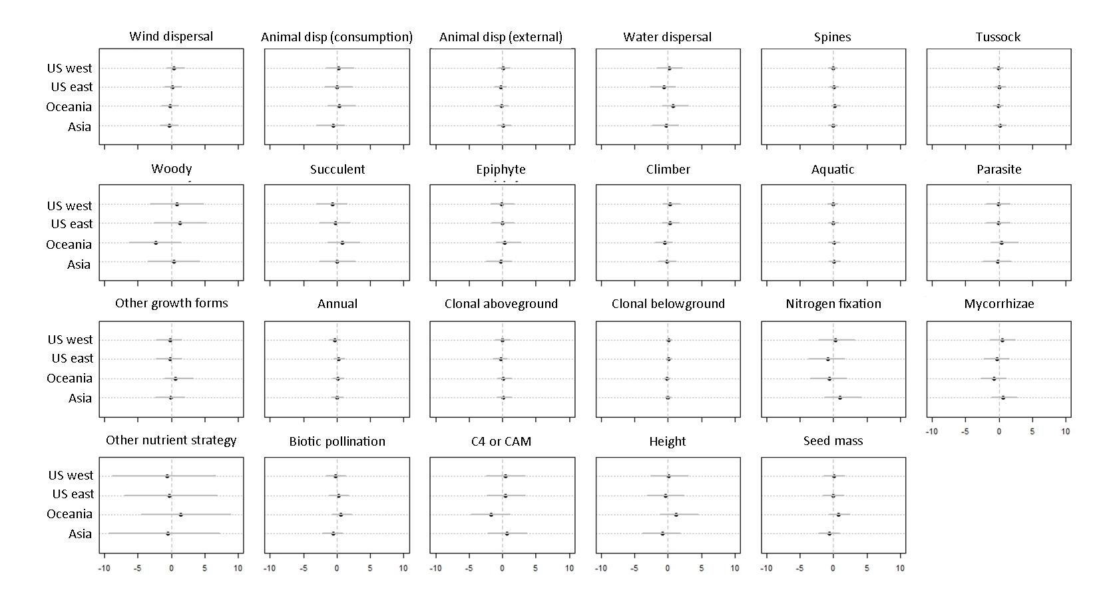**Figure S12**

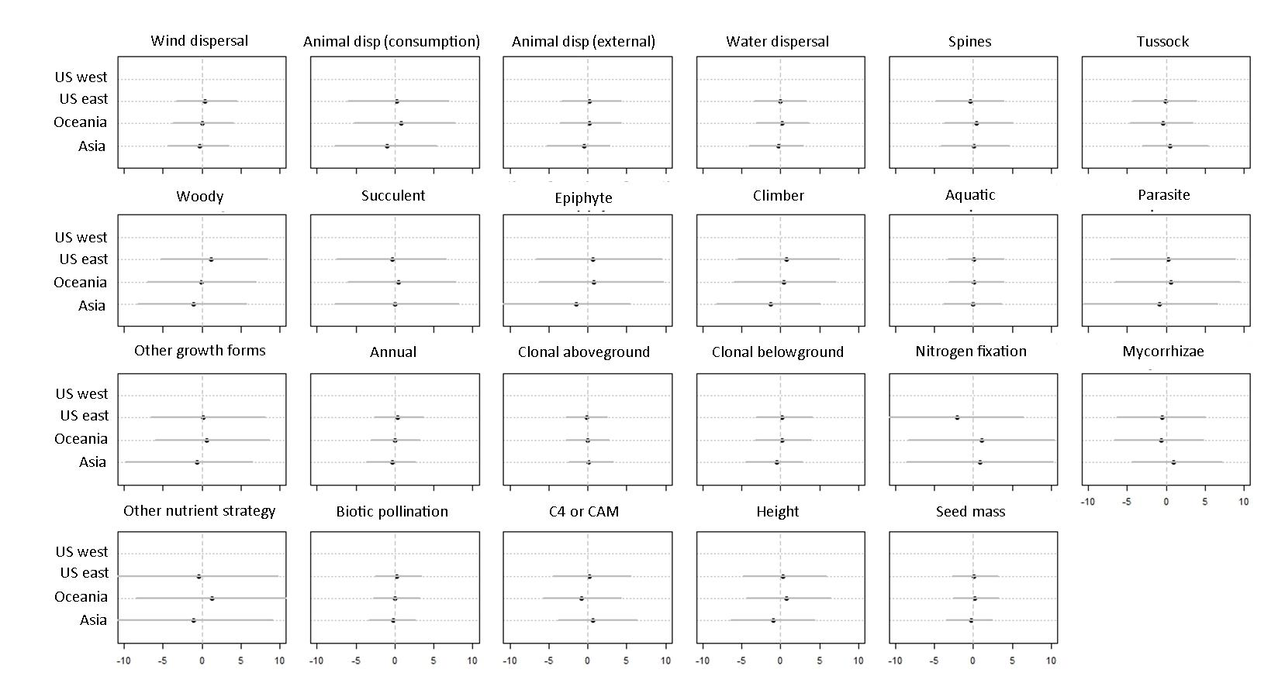**Figure S13**

**Appendix S2: Sampling bias –temporal and spatial grain of plant surveys**

Olden and Poff (2003) state that our inference on the biotic change occurring in plant communities will depend on both the spatial and temporal scale of the data we use to analyse those changes. To check if these elements could have affected our results, we analysed their effect in the annual rates of extirpation and colonization found in the 11 cities under consideration. Specific values of the aforementioned rates can be found in Table S1.

Regarding the temporal scale, we checked how time elapsed between initial and final surveys in each city (refer to Table S1 for details) correlated with their annual rates of extirpation and colonization. To do so, we run a simple linear model where the annual rate was a function of survey length.

Regarding the spatial scale, we checked how urban surface (as reported in Demographia (April 2016) Demographia World Urban Areas (12th ed.); URL: http://demographia.com/db-worldua.pdf) affects the same rates. We have used urban surface as a surrogate of the area surveyed in each city. Unfortunately there is no accurate information as to how exactly the urban boundaries were delimited for the surveys. However, the current surrogate allows us to investigate the possible effect of the spatial extent of the surveys, as pointed out by Olden and Poff (2003).

None of the reported effects are significant (Fig S14, the 95% credible intervals cross zero). Therefore, we conclude that, in the present work, survey length and urban area have non consistent effect on the annual rates of extirpation and colonization and they do not affect the inference we drew on biotic change across urban areas.

**Figure S14**. Effects of survey length and urban area on the annual extirpation and colonization rate reported for the 11 cities. Black dots represent mean effects and grey lines represent 95% credible intervals.

**Figure S14**

**Appendix S3: Code used for modelling.**

1. **City-level logistic regressions**

‘DATA’ includes the classification of species recorded in each city as colonizer or persitent/extirpated and trait characterization for each species

*Load dataset and call for the packages*

DATA <- read.csv("~/dataset.csv")

library(R2jags)

*Choose city*

city.list <- levels(DATA $city)

acity <- city.list[1] # Adelaide – Repeat for the rest of the cities

*Create data set for city*

int <- DATA [DATA $city==acity, ]

int.miss <- int # make an additional city data frame with missing values

int.miss$ne <- rep(NA, length(int.miss$ne))

int <- rbind(int, int.miss) # duplicates the rows with the same info, except for the response (which contains NAs)

rest <- DATA [DATA $city!=acity, ] # takes all records except those for the city under consideration

rest <- rest[duplicated(rest$sci)==F, ] # remove species duplicates

ny <- rbind(int, rest)

rm(rest)

*Set response variable*

ne <- int$ne # 0=persistent or extirpated, 1=colonizer, NA=for prediction

*Set predictors and other variables*

height <- log(ny$height)

height <- (height - mean(height, na.rm=T)) / (2*sd(height, na.rm=T))

seed.mass <- log(ny$seed.mass)

seed.mass <- (seed.mass - mean(seed.mass, na.rm=T)) / (2*sd(seed.mass, na.rm=T))

growth.form <- as.numeric(ny$growth.form)

annual <- as.numeric(ny$annual)

clonal <- as.numeric(ny$clonal)

dispersal <- as.numeric(ny$dispersal)

nutrient <- as.numeric(ny$nutrient)

pollination <- as.numeric(ny$pollination)

photo.path <- as.numeric(ny$photo.path)

spines <- as.numeric(ny$spines)

N <- dim(ny)[1]

fam <- as.numeric(ny$family)

N.fam <- max(fam)

CN <- length(ne)

Cfam <- as.numeric(int$family)

CN.fam <- max(Cfam)

ncat.growth.form <- length(table(growth.form))

ncat.annual <- length(table(annual))

ncat.clonal <- length(table(clonal))

ncat.dispersal <- length(table(dispersal))

ncat.nutrient <- length(table(nutrient))

ncat.pollination <- length(table(pollination))

ncat.photo.path <- length(table(photo.path))

ncat.spines <- length(table(spines))

*Run model*

cat(' model {

# model to impute missing values (uncertainty at family level is propagated when imputing missing values)

for(i in 1:N) {

# continuous variables

height[i] ~ dnorm(m.height[fam[i]], t.height[fam[i]])

seed.mass[i] ~ dnorm(m.seed.mass[fam[i]], t.seed.mass[fam[i]])

# categorical variables

growth.form[i] ~ dcat(p.growth.form[fam[i], 1:ncat.growth.form])

annual[i] ~ dcat(p.annual[fam[i], 1:ncat.annual])

clonal[i] ~ dcat(p.clonal[fam[i], 1:ncat.clonal])

dispersal[i] ~ dcat(p.dispersal[fam[i], 1:ncat.dispersal])

nutrient[i] ~ dcat(p.nutrient[fam[i], 1:ncat.nutrient])

pollination[i] ~ dcat(p.pollination[fam[i], 1:ncat.pollination])

photo.path[i] ~ dcat(p.photo.path[fam[i], 1:ncat.photo.path])

spines[i] ~ dcat(p.spines[fam[i], 1:ncat.spines])

}

# family level

for(j in 1:N.fam) {

m.height[j] ~ dnorm(fmm.height, pow(fms.height, -2))

t.height[j] ~ dgamma(pow(fsm.height, -2), pow(fst.height, -2))

m.seed.mass[j] ~ dnorm(fmm.seed.mass, pow(fms.seed.mass, -2))

t.seed.mass[j] ~ dgamma(pow(fsm.seed.mass, -2), pow(fst.seed.mass, -2))

p.growth.form[j, 1:ncat.growth.form] ~ ddirch(alpha1[1:ncat.growth.form])

p.annual[j, 1:ncat.annual] ~ ddirch(alpha2[1:ncat.annual])

p.clonal[j, 1:ncat.clonal] ~ ddirch(alpha3[1:ncat.clonal])

p.dispersal[j, 1:ncat.dispersal] ~ ddirch(alpha4[1:ncat.dispersal])

p.nutrient[j, 1:ncat.nutrient] ~ ddirch(alpha5[1:ncat.nutrient])

p.pollination[j, 1:ncat.pollination] ~ ddirch(alpha6[1:ncat.pollination])

p.photo.path[j, 1:ncat.photo.path] ~ ddirch(alpha7[1:ncat.photo.path])

p.spines[j, 1:ncat.spines] ~ ddirch(alpha8[1:ncat.spines])

}

# priors; missing values for height

fmm.height ~ dnorm(0, 0.0001)

fms.height ~ dunif(0, 10)

fsm.height ~ dunif(0, 10)

fst.height ~ dunif(0, 10)

# proirs; missing values for seed mass

fmm.seed.mass ~ dnorm(0, 0.0001)

fms.seed.mass ~ dunif(0, 10)

fsm.seed.mass ~ dunif(0, 10)

fst.seed.mass ~ dunif(0, 10)

# model response

for(i in 1:CN) {

ne[i] ~ dbern(p[i])

logit(p[i]) <- min(max(b0 + b1[dispersal[i]] + b2[growth.form[i]] + b3*annual[i]

+ b4[clonal[i]] + b5[nutrient[i]] + b6*pollination[i] + b7*photo.path[i]

+ b8*height[i] + b9*seed.mass[i] + b10*spines[i] + ran.fam[Cfam[i]], -999), 999)

}

# family random effect

for(j in 1:CN.fam) {

ran.fam[j] ~ dnorm(0,pow(s.fam, -2))

}

# priors; explanatory variables

b0 ~ dt(0, 10, 1)

b1[1] <- 0

for(i in 2:ncat.dispersal) {b1[i] ~ dnorm(0, pow(sigma.b1, -2))}

b2[1] <- 0

for(i in 2:ncat.growth.form) {b2[i] ~ dnorm(0, pow(sigma.b2, -2))}

b3 ~ dt(0, 2.5, 1)

b4[1] <- 0

for(i in 2:ncat.clonal) {b4[i] ~ dnorm(0, pow(sigma.b4, -2))}

b5[1] <- 0

for(i in 2:ncat.nutrient) {b5[i] ~ dnorm(0, pow(sigma.b5, -2))}

b6 ~ dt(0, 2.5, 1)

b7 ~ dt(0, 2.5, 1)

b8 ~ dt(0, 2.5, 1)

b9 ~ dt(0, 2.5, 1)

b10 ~ dt(0, 2.5, 1)

sigma.b1 ~ dt(0, 0.0016, 1)T(0,)

sigma.b2 ~ dt(0, 0.0016, 1)T(0,)

sigma.b4 ~ dt(0, 0.0016, 1)T(0,)

sigma.b5 ~ dt(0, 0.0016, 1)T(0,)

# priors; random effect for family

s.fam ~ dt(0, 0.0016, 1)T(0,)

} '

, file=(modelfile <- tempfile()))

# Bundle data

jags.data <- list(ncat.dispersal=ncat.dispersal, ncat.growth.form=ncat.growth.form,

ncat.annual=ncat.annual, ncat.clonal=ncat.clonal,

ncat.nutrient=ncat.nutrient, ncat.pollination=ncat.pollination,

ncat.photo.path=ncat.photo.path, ncat.spines=ncat.spines, N=N, ne=ne,

N.fam=N.fam, fam=fam, CN=CN, Cfam=Cfam, CN.fam=CN.fam, height=height,

seed.mass=seed.mass, growth.form=growth.form, annual=annual, clonal=clonal,

dispersal=dispersal, nutrient=nutrient, pollination=pollination,

photo.path=photo.path, spines=spines,

alpha1=rep(1,ncat.growth.form), alpha2=rep(1,ncat.annual),

alpha3=rep(1,ncat.clonal), alpha4=rep(1,ncat.dispersal),

alpha5=rep(1,ncat.nutrient), alpha6=rep(1,ncat.pollination),

alpha7=rep(1,ncat.photo.path), alpha8=rep(1,ncat.spines))

# Inits function

n.ch=1

b1<-rep(NA,times=ncat.dispersal)

for(i in 2:ncat.dispersal) {b1[i]=rnorm(n.ch)}

b2<-rep(NA,times=ncat.growth.form)

for(i in 2:ncat.growth.form) {b2[i]=rnorm(n.ch)}

b4<-rep(NA,times=ncat.clonal)

for(i in 2:ncat.clonal) {b4[i]=rnorm(n.ch)}

b5<-rep(NA,times=ncat.nutrient)

for(i in 2:ncat.nutrient) {b5[i]=rnorm(n.ch)}

inits <- function() list(fmm.height=rnorm(n.ch), fms.height=runif(n.ch),

fsm.height=runif(n.ch), fst.height=runif(n.ch), fmm.seed.mass=rnorm(n.ch),

fms.seed.mass=runif(n.ch), fsm.seed.mass=runif(n.ch),

fst.seed.mass=runif(n.ch), b0=rnorm(n.ch), b1=b1, b2=b2, b3=rnorm(n.ch),

b4=b4,b5=b5,b6=rnorm(n.ch),b7=rnorm(n.ch),b10=rnorm(n.ch),

sigma.b1=runif(n.ch), sigma.b2=runif(n.ch), sigma.b4=runif(n.ch),

sigma.b5=runif(n.ch), b8=rnorm(n.ch), b9=rnorm(n.ch), s.fam=runif(n.ch))

# Parameters to estimate

parameters <- c("b0", "b1", "b2", "b3", "b4", "b5", "b6", "b7", "b8", "b9", "b10", "s.fam", "ran.fam", "sigma.b1", "sigma.b2", "sigma.b4", "sigma.b5", "ne")

n.chains=3

n.iter=50000

n.burnin=20000

# Start Gibbs sampling

OUT<- jags(data = jags.data, inits = inits, parameters.to.save = parameters, model.file = modelfile, n.chains=n.chains, n.iter=n.iter, n.burnin=n.burnin)

1. **Meta-analysis**

‘MEAN’ includes the average estimated effect for each trait (rows) and city (columns) - represented by βk in the Methods section

‘SD’ includes the standard deviations estimated for the effect of each trait (rows) and city (columns) - represented by σβk in the Methods section.

* 1. **Without spatial correction**

*Set some variables*

Ncity <- ncol(MEAN)

Nvar <- nrow(MEAN)

*Run model*

cat(' model {

for(j in 1:Ncity) { # for each data set

for(i in 1:Nvar) {

m[i,j] ~ dnorm(gm[i], tau[i,j]) # observed estimate drawn from a distribution of estimates

tau[i,j] <- 1 / (gv[i] + s[i,j]*s[i,j]) # variances are additive

}

}

for(i in 1:Nvar) {

gm[i] ~ dnorm(0,0.0001) # mean effect size of all possible data sets

gv[i] <- sd[i]*sd[i] # between dataset variance in effect size

sd[i] ~ dunif(0,100)

}

}'

, file=(modelfile <- tempfile()))

# Bundle data

jags.data <- list(Ncity=Ncity, Nvar=Nvar, m=MEAN, s=SD)

# Inits function

inits <- function() list(gm=rnorm(Nvar), sd=runif(Nvar))

# Parameters to estimate

parameters <- c("gm","gv")

n.chains=3

n.iter=50000

n.burnin=20000

n.thin=10

# Start Gibbs sampling

META <- jags(data = jags.data, inits = inits, parameters.to.save = parameters, model.file = modelfile, n.chains=n.chains, n.iter=n.iter, n.burnin=n.burnin, n.thin=n.thin)

* 1. **Including a random effect to correct for spatial autocorrelation**

*Set some variables*

Ncity <- ncol(MEAN)

Nvar <- nrow(MEAN)

region <- as.factor(c("Oceania", "Oceania", "USeast", "Asia", "USwest", "Oceania", "USeast", "USwest", "USwest", "Asia", "USeast"))

Nregions <- max(as.numeric(region))

*Run model*

cat(' model {

for(i in 1:Nvar) {

for(j in 1:Ncity) {

m[i,j] ~ dnorm(city.m[i,j], tau[i,j]) # observed estimate drawn from a distribution of estimates, where city.m is the real city-level mean

city.m[i,j] <- gm[i] + beta[i,region[j]] # gm is the mean effect across cities, and beta the regional level effect

tau[i,j] <- 1 / (gv[i] + s[i,j]*s[i,j]) # variances are additive

}

}

for(i in 1:Nvar) {

gm[i] ~ dnorm(0,0.001)

for (j in 1:Nregions){

beta[i,j] ~ dnorm(0, pow(s.beta[i], -2))

}

s.beta[i] ~ dt(0,0.0016,1)T(0,) # variance in effect size among regions

gv[i] <- sd[i] * sd[i] # between cities variance in effect size (within regions)

sd[i] ~ dt(0,0.0016,1)T(0,)

}

}'

, file=(modelfile <- tempfile()))

## Bundle data

jags.data <- list(Ncity=Ncity, Nvar=Nvar, m=IP.MEAN, s=IP.SD, region=as.numeric(region), Nregions=Nregions)

## Inits function

inits <- function() list(gm=rnorm(Nvar), s.beta=runif(Nvar), sd=runif(Nvar))

## Parameters to estimate

parameters <- c("city.m", "gm", "beta", "gv", "s.beta", "sd")

n.chains=3

n.iter=100000

n.burnin=50000

n.thin=10

## Start Gibbs sampling

META <- jags(data = jags.data, inits = inits, parameters.to.save = parameters, model.file = modelfile, n.chains=n.chains, n.iter=n.iter, n.burnin=n.burnin, n.thin=n.thin)