AEM 2016

Screen Printed Dye-Sensitized Solar Cells (DSSCs) on Woven Polyester Cotton Fabric for Wearable Energy Harvesting Applications

J. Liu[1], Y. Li,S. Arumugam, J. Tudor and S. Beeby

*Printed Electronics and Materials Laboratory, Electronics and Computer Science, University of Southampton,   
UK, SO17 1BJ*

Abstract

Recently, the demand for lightweight, flexible and wearable dye-sensitized solar cells has been increased rapidly. One driver for this is to meet the challenge of supplying power in e-textiles applications. Integrating this functionality in the textile will result in an improved feel of the fabric compared to the current approach of the integration of conventional plastic solar patches. A low temperature processed TiO2 paste was used in this work to develop a fabrication method based on screen printing and spray coating to obtain photovoltaic textiles. The fabrication method used is low temperature and is compatible with Kapton and standard woven 65/35 polyester cotton fabrics. Comparing to the latest literatures, [1-3] our results show an improved PV efficiency of 7.03% and 2.78% on Kapton and fabric respectively when using a platinum coated fluorine tin oxide (FTO) glass as the top electrode.

© 2016 Elsevier Ltd. All rights reserved.

Selection and Peer-review under responsibility of 1st International Conference on Advanced Energy Materials and 8th International Conference on Advanced Nanomaterials.

*Keywords:* dye sensitised solar cells (DSSCs), textile solar cells, wearable solar cells, wearable technology, smart fabrics and printed electronics.

1. Introduction

Flexible dye sensitized solar cells (DSSCs) have received considerable attention for a wide range of potential commercial applications, such as, mobile devices or wearable electronics. Solar energy has become a ubiquitous renewable energy source converting solar energy directly into electrical power with no negative environmental impact when in use.[4] Monocrystalline silicon and polycrystalline silicon solar cells are the first generation of solar cell pioneering the solar cell market in the photovoltaic industry. However, the high material cost, and the high level of energy consumption in their manufacturing process has led to the development of second generation solar cells. Second generation solar cells are mainly thin film based such as copper indium gallium selenide (CIGS) and cadmium tellurium (CdTe) solar cells. Both of the first two generations of solar cell have demonstrated high efficiencies of over 20%.[5] These materials reduce the production cost in compared to first generation solar cells but their manufacture requires high temperature processing. Also, the toxicity of the materials used is a major concern in the second generation of solar cell. However, both generations suffer from high cost of raw materials, complex manufacturing process materials toxicity. Therefore, recent research has focused on third generation solar cells based on polymer organic, perovskite and dye-sensitized solar cells. Third generation solar cells use low cost materials and manufacturing and can be adapted for flexible applications.[6]

A standard DSSC consists of a fluorine tin oxide (FTO) coated substrate, a nano-crystalline porous TiO2 film, a dye sensitizer, a liquid electrolyte and a platinum coated counter electrode on another FTO substrate. The conventional process for obtaining an efficient photo anode is high-temperature sintering of the nano-crystalline TiO2 film. Since this process requires high temperature annealing it precludes the majority of potential flexible substrates such as plastic and wearable textiles. The state of the art in the low temperature processed TiO2 DSSCs offer a power conversion efficiency (PCE) of 5.76%.[7] Approaches to the fabric DSSCs have replaced one of the two FTO coated glass slides with conductive fabrics, for example, carbon nanotube coated fabrics,[1] nickel coated woven polyester fabrics[3] and graphene coated cotton fabrics[2] and polypyrrole coated cotton fabrics.[3] Recent studies show an increasing interest in fabricating flexible DSSCs for on plastic films and fabric substrates.[1-3, 8, 9] Therefore, the development of a low temperature processed TiO2 layer on a flexible substrate is an important step to enable the realization of DSSCs on the plastic and fabric substrates.

1. Experimental Methods
   1. Materials

Two different flexible substrates are used in this research: a polyimide film (Kapton) supplied by Dupont and a standard woven 65/35 polyester cotton fabrics. The approach described in detail below uses a screen printable polyurethane based interface paste (Fabink-UV-IF1, supplied by Smart Fabric Ink Ltd.) to smooth the fabric surface. Dupont 5000 screen printable conductive silver paste is used for the bottom electrode acting as the photo anode conductive layer. Titanium oxide (TiO2, Aeroxide P25) nanoparticles of primary particle size 21 nm supplied by Sigma Aldrich is used to formulate the electron transporting layer (ETL) in the DSSCs. The non-ionic surfactant binder is Triton X-100 and the particle stabilizer is acetylacetone both supplied by Sigma Aldrich. De-ionised water was used as the solvent for low temperature annealing of TiO2. A FTO pre-coated glass slide is used for the counter cathode, supplied by Solaronix (TCO 22-7); this offers a high transmittance in the range of 400 nm to 700 nm. Ruthenizer 535-bisTBA an N719 dye is supplied by Solaronix. Platisol-T is used as the precursor to make the platinum layer for the counter cathode and iodine/iodide solution (*I-/I3-*) is used as the liquid electrolyte both supplied by Solaronix. All the above materials were used as supplied with no further modifications for functional ink formulation and fabrication. In addition, alumina tiles, supplied by Hybrid Laser Tech Ltd. are used to hold the fabric and Kapton substrate flat during processing.

* 1. Fabrication of fabric DSSCs

The construction of the fabric solar cell begins by screen printing (Figure 1(a)) an interface layer onto the fabric substrate (Figure 1(b)). The purpose of the interface layer is to reduce the surface roughness of the fabric and present a smooth layer to support the subsequent screen printed functional films. The screen design ensures that the interface layer is only printed where subsequent layers are required thereby maintaining the fabric’s flexibility and maximising breathability when compared to commercial pre-coated fabrics. The printer squeegee pressure setting was 6 kg and the printing gap was 0.8 to 1 mm. The film is cured with a UV dose of 1500 mJ/cm2 thereby avoiding a thermal curing process that would release potentially harmful volatile organic compounds. The printed interface layer has a surface free energy of ~35 mN/m measured using a Kruss DSA30B tensiometer. This value confirms that the surface promotes the wettability of the majority of solvent based functional electronic inks.

The interface layer coated fabric substrate (IF fabric) has good thermal resistance and can withstand processing temperatures of 150oC for up to 45 minutes in a conventional thermal oven without degradation. This is important since the maximum temperature constrains the materials and processes that can be used in subsequent film depositions. The 65/35 polyester cotton fabric is a commonly used standard textile in clothing. The structure used in both the Kapton and fabric based DSSCs is shown in figure 1(c), which is the standard DSSCs structure. The screen printable interface paste is not required for the Kapton substrate since it is sufficiently smooth for subsequent layer deposition.

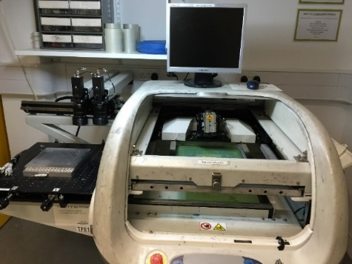  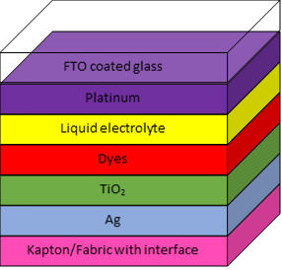

(a) (b) (c)

Figure 1. (a) The front view of the DEK 204 automated screen printer (b) Cross-sectional view of the fabrication of the screen printed interface layer on woven polyester cotton fabric, (c) The standard dye sensitised solar cells (DSSCs) structure used on the flexible substrates.

The solar cells were prepared using a screen printable conductive silver paste (Ag, Dupont 5000) as the bottom electrode. The silver ink was screen printed onto the Kapton/fabric on top of the interface coated substrate. A low temperature processed TiO2 paste formulation from our previous research was used and the focus of this paper is the development of the screen printed DSSCs on fabrics.[10] The screen printing was used as the main fabrication method to fabricate DSSCs on the Kapton and woven polyester cotton fabric substrates. The TiO2 paste was prepared by mixing the TiO2 nanoparticles (Aeroxide P25) with a combination of solvent, stabilizer and binder system, as described in the following paste formulation. The TiO2 screen printing paste was formulated using TiO2 powder (6 g) + acetyl acetone (0.2 mL) + de-ionised water (4 mL) + Triton X-100 (0.1 mL). The TiO2 paste was deposited on top of the silver layer using the screen printer. The TiO2 films were then annealing at 150oC in the oven for half an hour, and then immersed into the dye solution (100mg of Ruthenizer 535-bisTBA dissolved in 10ml of ethanol) for 4 hours. The Platisol-T was drop casted onto the FTO glass substrate and then annealed at 450oC for half an hour to convert to platinum. This high platinum annealing temperature is applied to the glass substrate only and will not affect the Kapton/fabric substrates. The platinum coated FTO glass substrate is used as the top electrode. The two electrodes were clipped together with the injected liquid electrolyte I-/I3- in between. The structure in this experiment was half flexible and half rigid glass which is an intermediate stage towards the final objective of fabricating the fully DSSCs on a fully flexible substrate with a solid state electrolyte.

* 1. Characterization and Measurement

Prior to dye loading and assembly, the morphology of the prepared sample photo anodes were analysed using field emission scanning electron microscopy (FESEM). After dye loading and assembly, photocurrent and voltage measurements were performed on the assembled sample cells using a Keithley 2400 source meter under an ABET 1 Sun Simulator with 1.5 AM radiation for the fabricated DSSCs. The DSSCs photovoltaic characteristics were analysed using equation (1).

$${ η}_{max}=\frac{V_{OC}.I_{SC}.FF}{{ P}_{in}} (1)$$

where VOC is the open-circuit voltage, ISC is the short circuit current, FF is the fill factor, Pin is the power of the incident light and ηmax is the PCE. Transmittance measurements were examined using Bentham PVE 300 PV instrumentation.

1. Results and Discussions

Figure 2 (a, b) shows the top view images of the screen printed TiO2 and silver layers on Kapton and interface coated fabric substrates. Figure 3 (c) shows the SEM cross sectional view of the interface coated fabrics with a smooth top layer. Figure 3 (d) shows the FESEM cross sectional view of the screen printed TiO2 and silver layers on the Kapton and interface coated fabric substrates, indicating that the thickness of the screen printed TiO2 is around 15 - 20 µm. Both FESEM images were taken before the dye loading process. Both indicate a film thicknesses above the ideal thickness of 10-12 µm [11, 12] and hence cracks are observed on the screen printed films. Moreover, the printed TiO2 films on the fabric substrate bulged up due to deformation of the interface layer after annealing and demonstrated fragility and poor uniformity. However, a good quality flat printed TiO2 film is observable on the Kapton substrate after annealing.

Table 1 summarises the measured and characterised results of the both screen printed DSSCs on Kapton and the interface coated fabric substrates following the low temperature process. Both types of DSSCs were measured under the same conditions with the cell area of 0.04cm2 for Kapton and 0.02cm2 for fabric substrates. Kapton based DSSCs achieve the highest PCE of 7.03% with a VOC of 0.6V, a FF of 0.36 and a JSC of 32.85 mA/cm2. Interface coated fabric based DSSCs have a PCE of 2.78%, with a VOC of 0.3V, a FF of 0.25 and a JSC of 36.56 mA/cm2. Figure 3 (a) shows the J/V curve of the screen printed DSSCs following the low temperature process on both Kapton and interface coated fabric substrates. It can be seen from the J/V curves that the fabric DSSC shows a linear behaviour but with a current offset. It is believed the TiO2 layer was damaged as a result of the fabric substrate deformation caused by the annealing and dye loading stages. The dye loading in particular significantly changes the fabric interface uniformity as the entire fabric rolled up resulting in delamination and flake-off of the printed TiO2 layer which suffers from the weak bonding forces to the substrate. Alternative approaches need to be investigated to avoid the interface coated fabric substrate deformation as a result of annealing.

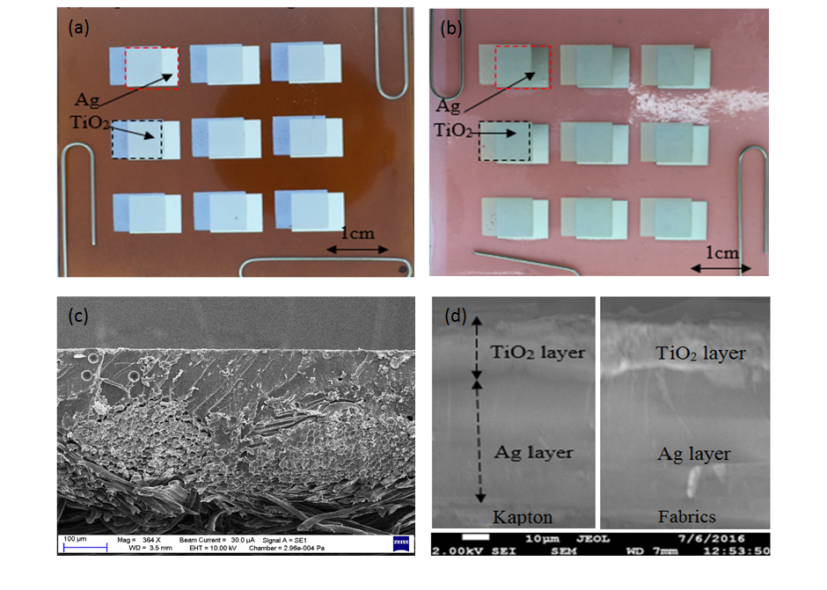

Figure 2. Plan view of the screen printed photo anodes on (a) Kapton and (b) interface coated fabrics, Cross sectional SEM view of (c) the standard woven 65/35 polyester cotton fabric and (d) the screen printed TiO2 and Ag layers on Kapton (left) and interface coated fabric (right) substrates.

|  |  |  |  |  |  |
| --- | --- | --- | --- | --- | --- |
| Device substrates | VOC, V | FF | JSC, mA/cm2 | PCE, % | Area, cm2 |
| Kapton | 0.60 | 0.36 | 32.85 | 7.03 | 0.04 |
| Fabric | 0.30 | 0.25 | 36.56 | 2.78 | 0.02 |

Table 1. Summary of the measured results on the Kapton and interface coated fabric based DSSCs with Ag as the conductive bottom electrode.

 Figure 3. (a) J/V characteristics of the screen printed DSSCs following the low temperature process on both Kapton and fabric substrates and (b) Transmittance spectra of glass/FTO and Glass/FTO/platinum substrates.

The transmittance spectra plot of the platinum coated FTO glass substrate is shown in figure 3(b) alongside a standard counter electrode FTO glass substrate for reference. Topside illumination is used through the platinum/FTO glass substrates. It can be seen that the platinum coated electrode shows high transmittance characteristics in the visible region of 450-750 nm.

4. Conclusions

In this work, screen printed DSSCs on Kapton and fabrics have been fabricated and achieved PCEs of 7.03% and 2.78%, respectively. The Kapton based devices showed good printed layer quality and uniformity due to the high chemical and temperature resistance of the polyimide Kapton film. However, the interface coated fabric based devices suffer from interface deformation after printing the functional layer on top during the annealing stage. However, both screen printed DSSCs on Kapton and fabric have been demonstrated using a low temperature process. This fabrication method is suitable for the majority of plastic substrates and offers a low cost process for DSSC manufacturing. However, future research is needed to overcome the interface deformation in order to increase and optimise the PCE of fabric based DSSCs.

Acknowledgements

This work was supported by Sensor Platform for HEalthcaRE in a Residential Environment (SPHERE) project (EPSRC Reference: EP/K031910/1). Professor Steve Beeby acknowledges EPSRC support through his Fellowship ‘Energy Harvesting Materials for Smart Fabrics and Interactive Textiles’ (EP/I005323/1). All data supporting this study are openly available from the University of Southampton repository at <http://eprints.soton.ac.uk/401570/>

References

[1] A.A. Arbab, K.C. Sun, I.A. Sahito, M.B. Qadir, S.H. Jeong, Multiwalled carbon nanotube coated polyester fabric as textile based flexible counter electrode for dye sensitized solar cell, Physical Chemistry Chemical Physics 17(19) (2015) 12957-12969.

[2] I.A. Sahito, K.C. Sun, A.A. Arbab, M.B. Qadir, S.H. Jeong, Graphene coated cotton fabric as textile structured counter electrode for DSSC, Electrochimica Acta 173 (2015) 164-171.

[3] J. Xu, M. Li, L. Wu, Y. Sun, L. Zhu, S. Gu, L. Liu, Z. Bai, D. Fang, W. Xu, A flexible polypyrrole-coated fabric counter electrode for dye-sensitized solar cells, Journal of Power Sources 257 (2014) 230-236.

[4] M.B. Schubert, J.H. Werner, Flexible solar cells for clothing, Materials Today 9(6) (2006) 42-50.

[5] M.A. Green, K. Emery, Y. Hishikawa, W. Warta, E.D. Dunlop, Solar cell efficiency tables (version 48), Progress in Photovoltaics: Research and Applications 24(7) (2016) 905-913.

[6] S. Arumugam, Y. Li, S. Senthilarasu, R. Torah, A.L. Kanibolotsky, A.R. Inigo, P.J. Skabara, S.P. Beeby, Fully spray-coated organic solar cells on woven polyester cotton fabrics for wearable energy harvesting applications, Journal of Materials Chemistry A 4(15) (2016) 5561-5568.

[7] X. Yin, Z. Xue, L. Wang, Y. Cheng, B. Liu, High-Performance Plastic Dye-sensitized Solar Cells Based on Low-Cost Commercial P25 TiO2 and Organic Dye, ACS Applied Materials & Interfaces 4(3) (2012) 1709-1715.

[8] H.C. Weerasinghe, F. Huang, Y.-B. Cheng, Fabrication of flexible dye sensitized solar cells on plastic substrates, Nano Energy 2(2) (2013) 174-189.

[9] L. Chen, W. Tan, J. Zhang, X. Zhou, X. Zhang, Y. Lin, Fabrication of high performance Pt counter electrodes on conductive plastic substrate for flexible dye-sensitized solar cells, Electrochimica Acta 55(11) (2010) 3721-3726.

[10] Y. Li, J. Liu, S. Arumugam, S.P. Beeby, Investigation of Low Temperature Processed Titanium Dioxide (TiO2) Films for Printed Dye Sensitized Solar Cells (DSSCs) for Flexible Large Area Applications, 1st international conference on advanced energy materials, AEM (2016).

[11] V. Baglio, M. Girolamo, V. Antonucci, A.S. Aricò, Influence of TiO2 Film Thickness on the Electrochemical Behaviour of Dye-Sensitized Solar Cells, International Journal of Electrochemical Science 6 (2011) 3375 - 3384.

[12] J.M.K.W. Kumari, N. Sanjeevadharshini, M.A.K.L. Dissanayake, G.K.R. Senadeera, C.A. Thotawatthage, The effect of TiO2 photoanode film thickness on photovoltaic properties of dye-sensitized solar cells, Ceylon Journal of Science 45 (1) (2016) 33-41.

1. * Corresponding author. Tel.: +44(0)23-8059-3234

   *E-mail address:* [jl3g12@ecs.soton.ac.uk](mailto:jl3g12@ecs.soton.ac.uk)