Figure 1: Systematic study of different low temperature processed titanium oxide formulations in relation to the curing temperature and the deposition methods.

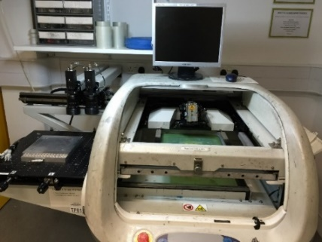
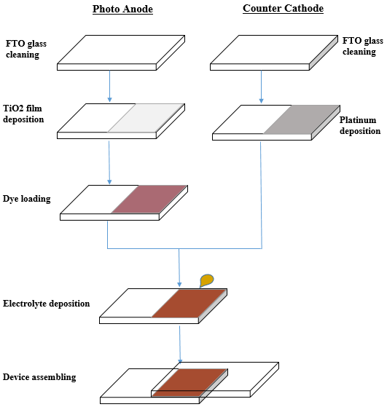

(b)
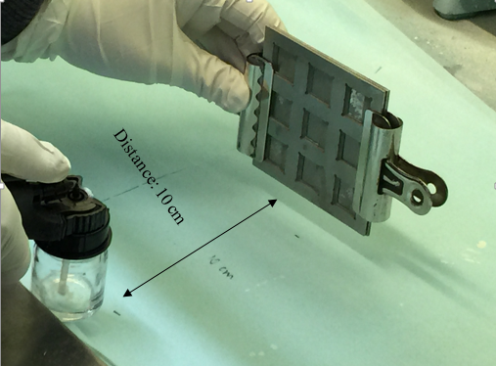

- (c)
Figure 2: (a) The flow diagram of the fabrication process DSSCs on the FTO coated glass substrates, (b) screen printer, DEK 248 and (c) Spraycraft airbrush spray coating system.

(a)
(b)
(c)
(d)
Figure 3: Cross-sectional SEM image of screen printed titanium oxide layer on FTO glass substrates, (a) de-ionised water based with Triton X-100, annealed at 150 ºC for 30 minutes, (b) de-ionised water based without binder, annealed at 150 ºC for 30 minutes, (c) tert-butanol based with Triton X-100, annealed at 150 ºC for 30 minutes and (d) tert-butanol based without binder, annealed at 150 ºC for 30 minutes.

(a)
(b)
(c)
(d)
Figure 4: Cross-sectional SEM image of spray coated titanium oxide layer on glass substrates, (a) de-ionised water based with binder system, annealed at 150ºC for 30 minutes, (b) de-ionised water based without binder system, annealed at 150ºC for 30 minutes, (c) tert-butanol based with binder system, annealed at 150ºC for 30 minutes and (d) tert-butanol based without binder system, annealed at 150ºC for 30 minutes.

- (b)
Figure 5: J/V curves of the screen printed DSSCs processed at temperature of (a) 150ºC and (b) 450ºC, respectively.

- (b)
Figure 6: J/V curves of the spray coated DSSCs processed at temperature of (a) 150ºC and (b) 450ºC, respectively.

 |  | Solvent | TiO₂ Paste | Annealing T, ºC | V_{OC}, V | FF | J_{SC}, mA/cm² | PCE, % | Area, cm²
Screen printing | 1 | A | With binder | 450°C | 0.71 | 0.54 | 6.04 | 2.36 | 0.31
 | 2 |  | Without binder | 450°C | 0.72 | 0.54 | 19.63 | 7.41 | 0.21
 | 3 | A | With binder | 150°C | 0.74 | 0.54 | 1.91 | 0.77 | 0.33
 | 4 |  | Without binder | 150°C | 0.74 | 0.59 | 9.72 | 4.30 | 0.21
 | 5 | B | With binder | 450°C | 0.76 | 0.42 | 11.50 | 3.70 | 0.18
 | 6 |  | Without binder | 450°C | 0.71 | 0.46 | 4.41 | 1.14 | 0.26
 | 7 | B | With binder | 150°C | 0.65 | 0.57 | 1.09 | 0.41 | 0.36
 | 8 |  | Without binder | 150°C | 0.77 | 0.56 | 2.40 | 1.04 | 0.29
Spray coating | 9 | A | With binder | 450°C | 0.71 | 0.57 | 16.18 | 6.65 | 0.30
 | 10 |  | Without binder | 450°C | 0.73 | 0.49 | 9.74 | 3.52 | 0.30
 | 11 | A | With binder | 150°C | 0.73 | 0.57 | 6.16 | 2.58 | 0.28
 | 12 |  | Without binder | 150°C | 0.74 | 0.44 | 3.92 | 1.29 | 0.4
 | 13 | B | With binder | 450°C | 0.76 | 0.45 | 17.54 | 6.10 | 0.12
 | 14 |  | Without binder | 450°C | 0.74 | 0.53 | 9.02 | 3.61 | 0.42
 | 15 | B | With binder | 150°C | 0.67 | 0.38 | 7.40 | 1.89 | 0.21
 | 16 |  | Without binder | 150°C | 0.62 | 0.34 | 4.92 | 1.06 | 0.24

Table 1: The summary of open circuit voltage (V_{OC}), short circuit current density (J_{SC}), fill factor (FF) and power conversion efficiency (PCE) of the screen printed and spray coated dye sensitised solar cells on FTO coated glass substrates, in relation to the formulation binder system, solvent used and its curing temperature. (A: de-ionised water and B: Tert-butanol)

