AEM 2016

**Investigation of Low Temperature Processed Titanium Dioxide (TiO2) Films for Printed Dye Sensitized Solar Cells (DSSCs) for Large Area Flexible Applications**

J. Liu, Y. Li[1], S. Arumugam, J. Tudor and S. Beeby

Printed Electronics and Materials Laboratory, Electronics and Computer Science, University of Southampton, UK, SO17 1BJ

Abstract

This paper reports a systematic study of the effect of nano-crystalline titanium dioxide (TiO2) formulations and annealing temperature conditions on the performance of dye sensitized solar cells (DSSCs) realized on fluorine tin oxide (FTO) glass substrates. DSSC fabrication is restricted to high temperature (>150 oC) process-compatible materials by the nano-crystalline process of the TiO2. DSSCs benefit from the use of lower cost materials and offer higher efficiency than organic solar cells but high processing temperatures limit their application on, for example, textile substrates. The aim of this study is to develop and optimize a low temperature processable TiO2 formulation suitable for both screen printing and spray coating. The results from this paper can be applied in future fabrication processes on flexible plastic and fabric substrates. The challenge of this research work is to achieve the smooth deposition and processing at 150 oC of TiO2 layers on glass substrates. We report a maximum DSSC efficiency of 4.3 % achieved by screen printing and 2.5 % achieved by spray coating on a glass substrate using the new low temperature process.

© 2016 Elsevier Ltd. All rights reserved.

Selection and Peer-review under responsibility of 1st International Conference on Advanced Energy Materials and 8th International Conference on Advanced Nanomaterials.

*Keywords:* Dye sensitized solar cells, low temperature TiO2, flexibe solar cells

1. Introduction

Flexible dye sensitized solar cells (DSSCs) have received considerable attention for a wide range of potential commercial applications, such as, mobile devices or wearable electronics, as well as for integrated photovoltaic modules.[1] The solar cell is one of the most successful renewable energy sources to date and is the most widely deployed renewable energy source across the world.[2] The first and second generation of crystalline silicon and inorganic solar cells that occupy the majority of the commercial market today are currently supplying only a small fraction of the world's energy needs. This is largely because of their high cost and the high energy consumption of the manufacturing process. Consequently, a significant research effort has been directed towards the development of third generation photovoltaics such as thin film solar cells, dye sensitized solar cells (DSSCs) and organic solar cells (OSCs). Of these, the efficiencies of organic based photovoltaic cells are far below those obtained with inorganic and silicon solar cells. However, since the pioneering work of O’Regan and Gratzel[3] who invented DSSCs in 1991 and the recent invention of high performance hybrid dye molecules,[4] DSSCs have emerged as the more promising energy source. This is mainly due to their low production cost, ease of fabrication and potential mechanical flexibility offering their realization and integration in printed electronics. These attractions have led to many refinements in both functional materials and fabrication processes which have improved the power conversion efficiencies (PCE) of DSSCs to 13 % to date.[4, 5]

A standard DSSC consists of a fluorine tin oxide (FTO) coated substrate, a nano-crystalline porous TiO2 film, a dye sensitizer, a liquid electrolyte and a platinum coated counter electrode on another FTO substrate. The conventional process for obtaining an efficient photo anode is high-temperature sintering of the nano-crystalline TiO2 film. Since this process requires high temperature annealing it rules out the majority of potential flexible substrates such as plastics and wearable textiles. Therefore, the development of a low temperature processable TiO2 layer is of great interest for the realization of DSSCs on flexible substrates. The state of the art in low temperature processed TiO2 DSSCs show less than half the PCE of that delivered by conventional high temperature processed DSSCs. Recently, several approaches have been investigated and reported to achieve a low temperature processed TiO2 layer in DSSCs: low temperature annealing of spin coated TiO2 films,[6] hydrothermal crystallization,[7] chemical vapor deposition,[8] microwave irradiation,[9] room temperature compressing,[10, 11] chemical bath deposition,[12] electro-spraying[13] and electrophoretic deposition.[14] However, none of these methods can be adapted for large area DSSCs for the interest of commercialization. There are few low temperature processes with the potential to deposit a suitable TiO2 layer in large areas, without needing an inert atmosphere, high temperature annealing and vacuum evaporation techniques.

Potential large areas processes at suitable low temperatures are doctor blading, spray coating and screen printing. Low temperature treated plastic DSSCs were reported by Malekshahi et al.[15] The TiO2 ink was applied by doctor blading on an indium tin oxide/polyethylene terephthalate (ITO/PET) substrate and annealed at 120 °C for 24 hours achieving an efficiency of 1.26 %. Lu et al reported the annealing conditions of TiO2 films at various temperatures from 120 °C to 450 °C using both binder and binder free TiO2 paste deposited on a highly flexible titanium foil substrates by doctor blading.[16] The results showed that the devices sintered at 120 °C for 30 minutes, for both the binder and binder free TiO2 systems, obtained a PCE of 0.22 % and 3.40 % respectively. Janne et al reported DSSCs on ITO/PET substrates in which TiO2 films were spray coated using a 100 °C substrate platen temperature, followed by room temperature compression of the films, achieving a solar cell PCE of 2.3 %.[17] Shungo et al developed screen printed plastic DSSCs on an ITO coated plastic substrate using a conventional TiO2 paste with binders, annealed at 150 °C, that achieved a PCE of 0.1 % and additional hot UV treatment which achieved 3.1 %.[18] A doctor blade processed TiO2 layer which is air dried at room temperature has also been reported with 1.2 % PCE.[19]

This paper systematically investigates low temperature (150 oC) processed TiO2 formulations, with and without a binder system, in two different solvents and the use of a nano particle stabiliser. The study applies to and benefits both screen printing and spray coating techniques which are considered as the promising large area electronics fabrication methods. Screen printing is the most widely studied printing technique within printing electronics research due to the wide commercially availability of functional materials in printable pastes and can scale up for volume manufacturing. Among the various solution process techniques, spray coating can accept a much wider range of rheological properties than the alternatives of inkjet printing and doctor blading. Other solution based processes such as spin coating are not compatible with large area fabrication and generate a large amount of material waste when processing. For this work, 150 oC has been set as the temperature limit to be compatible with the majority of wearable textiles and flexible plastics. This paper reports an optimised formulation for the screen printable paste and the spray coating ink of the TiO2 materials for large area DSSC fabrication at low temperature.

1. Materials and Experimental methods
   1. Materials

Pre-coated FTO coated glass substrates (TCO 22-7, supplied by Solaronix) were used for the photo anode and cathode and has high transmittance in the range of 400 nm to 700 nm. Aeroxide TiO2 P25 nanoparticles with a primary particle size of 21 nm was supplied by Sigma Aldrich. The non-ionic surfactant binder used was Triton X-100 and the particle stabiliser was acetylacetone, both supplied by Sigma Aldrich and used to prevent the nanoparticles aggregating in the complex suspension system. De-ionised water or tert-butanol were used as the solvent for the different formulations. The Ruthenizer 535-bisTBA an N719 dye was supplied by Solaronix. Platisol-T from Solaronix was used as the precursor of the platinum layer for the counter cathode. Iodide/Iodine (I-/I3-) redox solution was used as the liquid electrolyte, supplied by Solaronix. All these above materials were used as supplied with no further modifications.

* 1. TiO2 formulation study



Figure 1. Systematic study of different low temperature processed titanium oxide formulations in relation to the curing temperature and the deposition methods.

This work investigated 8 formulations of low temperature TiO2 evaluated at an annealing temperature of 150 oC. These formulations used de-ionised water or tert-butanol as the solvent with no binder or with a Triton X-100 binder. The solvents water and tert-butanol were chosen as a rich oxygen provider; while annealing the TiO2, they can contribute oxygen to prevent any TiO2 oxygen loss. Both formulations were prepared with the same concentration of acetyl acetone as the particle stabiliser, as described in the following paste formulation. Formulations were then made suitable for screen printing and spray coating by varying the viscosity. The formulations used in this experiment are as follows. The TiO2 screen printing paste was formulated using TiO2 powder (6 g) + acetyl acetone (0.2 mL) + de-ionised water or tert-butanol (4 mL) + Triton X-100 (0.1 mL). The TiO2 spray coating ink was obtained from TiO2 powder (6 g) + acetyl acetone (0.2 mL) + de-ionised water or tert-butanol (10 mL) + Triton X-100 (0.1 mL). When deposited, these films were processed at 150 oC and compared with samples processed at 450 oC, as shown in the Figure 1. Other processes and the device architecture remained unchanged. The TiO2 powder is mixed with the solvent of de-ionised water or tert-butanol, and acetyl acetone as stabiliser, plus the binder Triton X-100 or without a binder. Triton X-100 was chosen since it influences TiO2 clusters towards a uniform size with well-defined particles. In addition, Triton X-100 increases the surface area which helps dye molecules to attach to the TiO2 film.[20]

* 1. Fabrication of DSSCs

Figure 2 (a) shows the flow diagram of the fabrication process, comprising both photo and counter electrode glass substrates with liquid electrolyte deposition in a sandwich structure assembly. The FTO glass substrates were cleaned in acetone and de-ionised water for 5 minutes and plasma cleaned using a TEPLA Plasma 300 machine for 5 minutes in a cleanroom environment. The TiO2 formulation was either screen printed (Figure 2 (b)) or spray coated (Figure 2 (c)) onto the FTO coated glass substrates and cured at 150 oC and 450 oC for 30 minutes, respectively. The 450oC process is carried out for comparison to the low temperature process. Then the dye loading process is carried out by immersing the samples into the pre-mixed dye solution for 24 hours. The last stage is to assemble the device by depositing the liquid electrolyte and sandwiching the two electrodes for testing.



Figure 2. (a) The flow diagram of the fabrication process DSSCs on the FTO coated glass substrates, (b) screen printer, DEK 248 and (c) Spraycraft airbrush spray coating system.

* 1. Characterization and measurements

Prior to dye loading and assembly, the morphology of the prepared sample photo anodes were analysed using field emission scanning electron microscopy (FESEM). After dye loading and assembly, photocurrent and voltage measurements were performed on the assembled sample cells using a Keithley 2400 source meter under an ABET 1 Sun Simulator with 1.5 AM radiation for the fabricated DSSCs. The DSSCs photovoltaic characteristics were analysed using the equation (1).

$${ η}_{max}=\frac{V_{OC}.I_{SC}.FF}{{ P}_{in}} (1)$$

where VOC is the open-circuit voltage, ISC is the short circuit current, FF is the fill factor, Pin is the power of the incident light and ηmax is the PCE.

1. Results and discussions

Surface and film morphologies of different photo anodes are shown in figures 3 and 4. Figure 3 (a, b) shows the FESEM images of the screen printed water based TiO2 films with and without a binder system on FTO glass substrates. In both cases a maximum film thicknesses of ~10µm is used in order to avoid film cracking.[21] These films were found to be uniform, crack-free and well adhered on the FTO glass substrates. Figure 3 (c, d) shows the FESEM images of screen printed tert-butanol based TiO2 films with and without a binder system on FTO glass substrates. Both indicate a film thicknesses of around 30µm which is above the ideal thickness and hence cracks are observed on the screen printed films. Moreover, these films demonstrated a high degree of fragility and poor uniformity as shown at the top in figure 3 (c, d). In the case of the spray coated TiO2 films on FTO glass substrates, a similar trend occurs as shown in the FESEM images in figure 4 (a, b) with water as the solvent and in figure 4 (c, d) with tert-butanol as the solvent. Non-uniform films occur due to the high melting point (25 oC ± 1) and low boiling point (82 oC ± 1) of the tert-butanol solvent. As the deposition process was carried out at room temperature, the tert-butanol solvent can be frozen or, at a slightly higher temperature, begin to evaporate with both conditions preventing the printed TiO2 paste settling and forming a uniform layer. In essence, it is clearly seen that the de-ionised water based system with and without binder improves the film uniformity and the interconnected TiO2 nanoparticle layer.

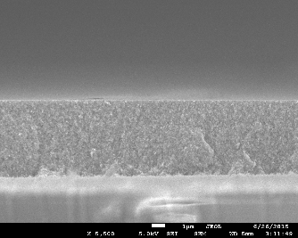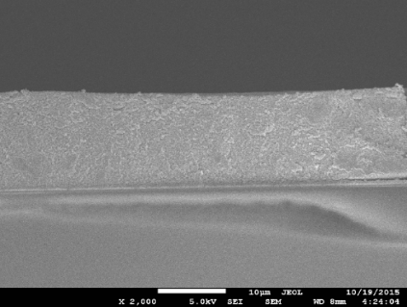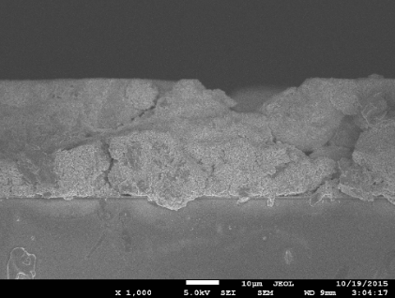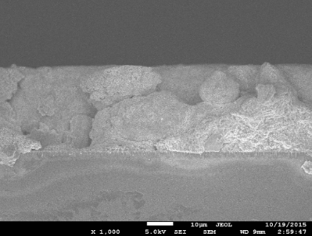

(a)

(b)

(c)

(d)

Figure 3. Cross-sectional SEM image of screen printed titanium oxide layer on FTO glass substrates, (a) de-ionised water based with Triton X-100, annealed at 150 oC for 30 minutes, (b) de-ionised water based without binder, annealed at 150 oC for 30 minutes, (c) tert-butanol based with Triton X-100, annealed at 150 oC for 30 minutes and (d) tert-butanol based without binder, annealed at 150 oC for 30 minutes.

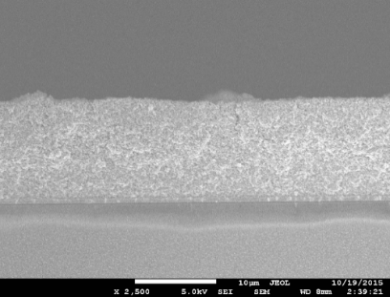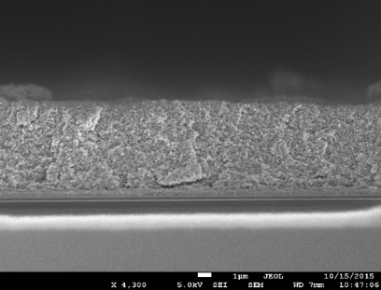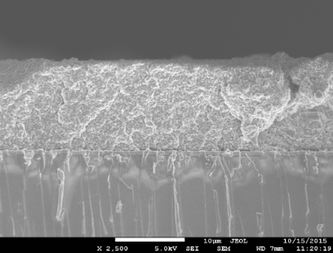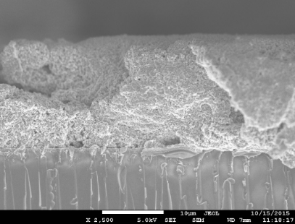

(a)

(b)

(c)

(d)

Figure 4. Cross-sectional SEM image of spray coated titanium oxide layer on glass substrates, (a) de-ionised water based with binder system, annealed at 150oC for 30 minutes, (b) de-ionised water based without binder system, annealed at 150oC for 30 minutes, (c) tert-butanol based with binder system, annealed at 150oC for 30 minutes and (d) tert-butanol based without binder system, annealed at 150oC for 30 minutes.

**

1. (b)

Figure 5. J/V curves of the screen printed DSSCs processed at temperature of (a) 150 oC and (b) 450 oC, respectively.

The J/V curves of the DSSCs in which TiO2 films were screen printed and annealed at 150 °C and at 450 °C for comparison are shown in figure 5 (a, b) respectively. The measured results for the DSSCs studied are summarised in Table 1. At 150 °C, a PCE of 0.77 % and 4.3 % was obtained from the water solvent with and without binder systems respectively, whereas a PCE of 0.41 % and 1.04 % was obtained from the tert-butanol solvent with and without binder systems. In the above cases, the formulation with the binder system delivered lower efficiencies when compared to the without binder system which indicates the binder, Triton X-100 may remain in the dried TiO2 film, acting as an insulator and blocking the movement of charge. The maximum efficiency of 4.3 % was obtained from the TiO2 formulation without binder which indicates good uniformity and TiO2 particle interconnection, as shown in figure 4b, even at the low temperature used for annealing. However, the PCE of 1.04 % obtained from the formulation with the tert-butanol as the solvent without binder system may reflect the film non-uniformity as can be seen in the FESEM image in figure 4d. As a whole, the lower efficiencies obtained by tert-butanol, with and without binders, can also be explained by the thickness of TiO2 films being over 30µm.



1. (b)

Figure 6. J/V curves of the spray coated DSSCs processed at temperature of (a) 150 oC and (b) 450 oC, respectively.

|  |  |  |  |  |  |  |  |  |  |
| --- | --- | --- | --- | --- | --- | --- | --- | --- | --- |
|  |  | Solvent | TiO2 Paste | Annealing T, oC | VOC, V | FF | JSC, mA/cm2 | PCE, % | Area, cm2 |
| Screen printing | 1 | A | With binder | 450°C | 0.71 | 0.54 | 6.04 | 2.36 | 0.31 |
| 2 | Without binder | 450°C | 0.72 | 0.54 | 19.63 | 7.41 | 0.21 |
| 3 | A | With binder | 150°C | 0.74 | 0.54 | 1.91 | 0.77 | 0.33 |
| 4 | Without binder | 150°C | 0.74 | 0.59 | 9.72 | 4.30 | 0.21 |
| 5 | B | With binder | 450°C | 0.76 | 0.42 | 11.50 | 3.70 | 0.18 |
| 6 | Without binder | 450°C | 0.71 | 0.46 | 4.41 | 1.14 | 0.26 |
| 7 | B | With binder | 150°C | 0.65 | 0.57 | 1.09 | 0.41 | 0.36 |
| 8 | Without binder | 150°C | 0.77 | 0.56 | 2.40 | 1.04 | 0.29 |
| Spray coating | 9 | A | With binder | 450°C | 0.71 | 0.57 | 16.18 | 6.65 | 0.30 |
| 10 | Without binder | 450°C | 0.73 | 0.49 | 9.74 | 3.52 | 0.30 |
| 11 | A | With binder | 150°C | 0.73 | 0.57 | 6.16 | 2.58 | 0.28 |
| 12 | Without binder | 150°C | 0.74 | 0.44 | 3.92 | 1.29 | 0.4 |
| 13 | B | With binder | 450°C | 0.76 | 0.45 | 17.54 | 6.10 | 0.12 |
| 14 | Without binder | 450°C | 0.74 | 0.53 | 9.02 | 3.61 | 0.42 |
| 15 | B | With binder | 150°C | 0.67 | 0.38 | 7.40 | 1.89 | 0.21 |
| 16 | Without binder | 150°C | 0.62 | 0.34 | 4.92 | 1.06 | 0.24 |

Table 1. The summary of open circuit voltage (VOC), short circuit current density (JSC), fill factor (FF) and power conversion efficiency (PCE) of the screen printed and spray coated dye sensitised solar cells on FTO coated glass substrates, in relation to the formulation binder system, solvent used and its curing temperature. (A: de-ionised water and B: Tert-butanol)

The J/V curves of DSSCs in which the TiO2 films were spray coated and annealed at 150 °C, and the corresponding devices annealed at 450 °C for comparison, are shown in figure 6 (a, b) respectively. At 150 °C, PCEs of 2.58 % and 1.29 % were obtained from the formulation using a water solvent, with and without a binder system, whereas PCEs of 1.89 % and 1.06 % were obtained from the formulation with the tert-butanol solvent, with and without a binder system. In this case, the with binder system delivered higher efficiencies when compared to the without binder system and this contradicts the results obtained when screen printed. This could be explained by the spray coating ink having a lower viscosity and lower concentration of the Tinder X-100 binder than the screen printing paste. The lower concentration of binder leads to a high porosity of the spray coated TiO2 film resulting in more dye molecules attaching onto the TiO2 nanoparticles and hence a higher efficiency for the with binder system Triton X-100 using water and tert-butanol solvents. By comparing the cells performances across different processing temperatures in the same formulation and deposition method, the PCE obtained from the high temperature processed TiO2 cells exhibits around double the PCE obtained from the low temperature processed cells, as shown in Table 1. The high temperature processed DSSCs were achieved with a PCE of 7.41 % via screen printing and 6.65 % via spray coating based on the formulated TiO2 paste/ink. The reason can be caused by the binder burning off and the further nano-crystallization of the TiO2 film under the higher temperature which benefits the dye loading and charge transport. Based on the PCE results obtained from screen printing and spray coating in the low temperature process, the following statements can be made. Screen printing offers the best performance devices as it uses higher viscosity TiO2 paste for printing which may help to attach more dye molecules than spray coating. Therefore, the screen printed cells without binder system in a water solvent exhibit better performance than the spray coated cells but lower performance than the screen printed cells with a binder system. However, the spray coating benefits from a lower concentration of the functional ink, leading to higher film porosity and better control over the film thickness down to sub 10 µm scale.

**Conclusions**

In summary, different formulations of a low temperature processed TiO2 film have been developed and investigated in this study using both screen printing and spray coating techniques. The high temperature processed DSSCs were successfully achieved with a PCE of 7.41 % based on the formulated TiO2 paste/ink via screen printing and 6.65 % via spray coating, at the same time, low temperature processed DSSCs has been achieved with a PCE of 4.3 % via screen printing and 2.58 % via spray coating. Both screen printed and spray coated DSSCs on glass substrates have been demonstrated using a low temperature annealing processing. This optimized formulation is suitable for mass production and can provide low cost processing photo anode materials suitable for a wide range of potential flexible substrates, such as flexible plastics and wearable textiles.

**Acknowledgements**

This work was supported by Sensor Platform for HEalthcaRE in a Residential Environment (SPHERE) project (EPSRC Reference: EP/K031910/1). Professor Steve Beeby acknowledges EPSRC support through his Fellowship ‘Energy Harvesting Materials for Smart Fabrics and Interactive Textiles’ (EP/I005323/1). All data supporting this study are openly available from the University of Southampton repository at <https://eprints.soton.ac.uk/401524/>

References

[1] H.-G. Han, H.C. Weerasinghe, K. Min Kim, J. Soo Kim, Y.-B. Cheng, D.J. Jones, A.B. Holmes, T.-H. Kwon, Ultrafast Fabrication of Flexible Dye-Sensitized Solar Cells by Ultrasonic Spray-Coating Technology, Scientific Reports 5 (2015) 14645.

[2] M. Wang, C. Gratzel, S.M. Zakeeruddin, M. Gratzel, Recent developments in redox electrolytes for dye-sensitized solar cells, Energy & Environmental Science 5(11) (2012) 9394-9405.

[3] B. O'Regan, M. Gratzel, A low-cost, high-efficiency solar cell based on dye-sensitized colloidal TiO2 films, Nature 353(6346) (1991) 737-740.

[4] S. Mathew, A. Yella, P. Gao, R. Humphry-Baker, F.E. CurchodBasile, N. Ashari-Astani, I. Tavernelli, U. Rothlisberger, K. NazeeruddinMd, M. Grätzel, Dye-sensitized solar cells with 13% efficiency achieved through the molecular engineering of porphyrin sensitizers, Nat Chem 6(3) (2014) 242-247.

[5] M.A. Green, K. Emery, Y. Hishikawa, W. Warta, E.D. Dunlop, Solar cell efficiency tables (version 48), Progress in Photovoltaics: Research and Applications 24(7) (2016) 905-913.

[6] S. Ito, T. Takeuchi, T. Katayama, M. Sugiyama, M. Matsuda, T. Kitamura, Y. Wada, S. Yanagida, Conductive and Transparent Multilayer Films for Low-Temperature-Sintered Mesoporous TiO2 Electrodes of Dye-Sensitized Solar Cells, Chemistry of Materials 15(14) (2003) 2824-2828.

[7] D. Zhang, T. Yoshida, H. Minoura, Low-Temperature Fabrication of Efficient Porous Titania Photoelectrodes by Hydrothermal Crystallization at the Solid/Gas Interface, Advanced Materials 15(10) (2003) 814-817.

[8] T.N. Murakami, Y. Kijitori, N. Kawashima, T. Miyasaka, Low temperature preparation of mesoporous TiO2 films for efficient dye-sensitized photoelectrode by chemical vapor deposition combined with UV light irradiation, Journal of Photochemistry and Photobiology A: Chemistry 164(1–3) (2004) 187-191.

[9] J.N. Hart, D. Menzies, Y.-B. Cheng, G.P. Simon, L. Spiccia, A comparison of microwave and conventional heat treatments of nanocrystalline TiO2, Solar Energy Materials and Solar Cells 91(1) (2007) 6-16.

[10] H. Lindström, A. Holmberg, E. Magnusson, L. Malmqvist, A. Hagfeldt, A new method to make dye-sensitized nanocrystalline solar cells at room temperature, Journal of Photochemistry and Photobiology A: Chemistry 145(1–2) (2001) 107-112.

[11] H. Santa-Nokki, J. Kallioinen, T. Kololuoma, V. Tuboltsev, J. Korppi-Tommola, Dynamic preparation of TiO2 films for fabrication of dye-sensitized solar cells, Journal of Photochemistry and Photobiology A: Chemistry 182(2) (2006) 187-191.

[12] Z.A. Garmaroudi, M. Abdi-Jalebi, M.R. Mohammadi, R.H. Friend, A facile low temperature route to deposit a TiO2 scattering layer for efficient dye-sensitized solar cells, RSC Advances 6(75) (2016) 70895-70901.

[13] H. Lee, D. Hwang, S.M. Jo, D. Kim, Y. Seo, D.Y. Kim, Low-Temperature Fabrication of TiO2 Electrodes for Flexible Dye-Sensitized Solar Cells Using an Electrospray Process, ACS Applied Materials & Interfaces 4(6) (2012) 3308-3315.

[14] T. Miyasaka, Y. Kijitori Low-Temperature Fabrication of Dye-Sensitized Plastic Electrodes by Electrophoretic Preparation of Mesoporous TiO2 Layers, Journal of The Electrochemical Society 151(11) (2004) A1767-A1773.

[15] M.M. Byranvand, M.H. Bazargan, A.N. Kharat, Fabrication and investigation of flexible dye sensitized nanocrystalline solar cell utilizing natural sensitizer operated with gold coated counter electrode, Digest Journal of Nanomaterials & Biostructures (DJNB) 5(3) (2010) 645-650.

[16] L.-Y. Lin, C.-P. Lee, K.-W. Tsai, M.-H. Yeh, C.-Y. Chen, R. Vittal, C.-G. Wu, K.-C. Ho, Low-temperature flexible Ti/TiO2 photoanode for dye-sensitized solar cells with binder-free TiO2 paste, Progress in Photovoltaics: Research and Applications 20(2) (2012) 181-190.

[17] J. Halme, J. Saarinen, P. Lund, Spray deposition and compression of TiO2 nanoparticle films for dye-sensitized solar cells on plastic substrates, Solar Energy Materials and Solar Cells 90(7–8) (2006) 887-899.

[18] S. Zen, Y. Ishibashi, R. Ono, Low-temperature sintering for plastic dye-sensitized solar cells using conventional TiO2 paste containing organic binders, Applied Physics Letters 104(21) (2014) 213904.

[19] S.-S. Kim, J.-H. Yum, Y.-E. Sung, Flexible dye-sensitized solar cells using ZnO coated TiO2 nanoparticles, Journal of Photochemistry and Photobiology A: Chemistry 171(3) (2005) 269-273.

[20] N.A. Al-Omair, S.M. Reda, F.M. Al-Hajri, Triton Facilitated Spherical TiO&lt;sub&gt;2&lt;/sub&gt; Nanoparticles and Their Advantage in a Dye-Sensitized Solar Cell, Advances in Materials Physics and Chemistry 04(02) (2014) 29-32.

[21] V. Baglio, M. Girolamo, V. Antonucci, A.S. Aricò, Influence of TiO2 Film Thickness on the Electrochemical Behaviour of Dye-Sensitized Solar Cells, Internation journal of electrochemcial science 6 (2011) 3375 - 3384.

1. * Corresponding author. Tel.: +44(0)23-8059-2353

   *E-mail address:* yi.li@soton.ac.uk