“Choose to be optimistic, it feels better?” Evidence of optimism on employment utility

Chris Dawson†, Tim Hinks‡ and Michail Veliziotis*

Abstract
Individual’s expected wages exceed predicted market wages. Rational expectations imply the divergence should be zero. If individuals over-estimate the return from their attributes and view the paid-employment return distribution too favourably, then conditional on market wages, subsequent employment utility is likely to be low through disappointment.

Keywords: Optimism, expectations, employment utility
JEL Classification: D84, J28, J64

- Introduction and background
Expectations play a crucial role in determining individual decision making in economics. More recently, increasing attention has focused on unrealistic expectations, with an ever expanding literature on the influences of optimism on aspects of decision making, such as, stock market investments (Puri and Robinson, 2007) and occupational choice (Arabsheibani et al., 2000).

Despite this emerging literature few, if any, studies within the economics discourse have analysed the role of optimism on individual utility. This paper tests the hypothesis that employment utility depends not only on current earnings, but upon an individual’s optimistic bias concerning earnings expectations prior to becoming employed. In the context of this study, optimism is the extent to which wage expectations are upwardly biased, which conforms to the formal definition of optimism used in economics whereby there are systematically biased beliefs in the probability of favourable outcomes (Hey, 1984).

Under rational expectations agents’ predictions are equal to statistically derived true expected values, therefore within labour markets, wage expectations are a perfect reflection of the distribution of market wages and, therefore, an accurate representation of the value the labour market places on individual characteristics. However, this requires that workers possess accurate private information concerning their attributes. For humans, this is problematic as almost everyone overestimates their own ability (Weinstein, 1980). When individuals hold homogenous optimistic beliefs about their abilities, they view an upwardly biased distribution of market wages which stochastically dominates the true market distribution. On the one hand, the anticipation of positive future financial outcomes allows individuals to take immediate pleasure in their future success. In this view, Brunnermeier and Parker (2005) argue that people choose to be optimistic because the anticipatory utility outweighs any cost in realized outcomes. Alternatively, optimists in entering the labour market are more likely to suffer a discrepancy between actual and expected earnings, influencing job satisfaction through disappointment (Bell, 1985). In line with the latter prediction, the results provided in this paper suggest that optimism substantially reduces employment utility, especially satisfaction with pay.

- Data and methodology
The British Household Panel Survey (BHPS) is a nationally-representative annual survey of more than 5,000 households containing approximately 10,000 individuals aged 16 or over and has been used extensively for applied longitudinal research. Households are re-interviewed annually, and 18 annual waves of data are available from 1991 to 2008. Within the BHPS if the respondent ‘is not currently working but has looked for work or has not looked for work in last four weeks but would like a job’, he/she is asked: ‘About how many hours in a week do you think you would be able to work?’ Individuals are then asked about expected wages: ‘What weekly take-home pay would you expect to get (for that)?’ From these responses, we construct an hourly expected wage,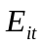. Given the reference to ‘take home pay’, and in the spirit of Brown and Taylor (2013), it is assumed that responses refer to the net expected wage. Out of the final sample around 40% of respondents are unemployed with the remainder being classified as economically inactive. We include the economically inactive in the sample if they report an expected wage as this is interpreted as a signal of labour market attachment. In order to derive our optimism measure we also construct for this sample of unemployed or economically inactive individuals (denoted by a superscript), a predicted market wage, .The predicted market wage is constructed following Prasad (2003) and Hogan (2004) by estimating a pooled OLS log of net hourly earnings equation for all employees (denoted by an E superscript) in the dataset who have one or less than one year of current job tenure. The wage equation is formally shown in equation (1), where is the log of net hourly wages of employees, is a vector of employee characteristics and is the usual random error term.

(1)

The estimated coefficients are then used to predict the market wage for our group of unemployed or economically inactive individuals based upon their vector of characteristics,, such that The expected wage and the predicted wage are then used to construct our measure of optimism. As individual responses concerning wage expectations are likely to be noisy estimates and influenced by the individual’s environment, to increase the precision in estimating optimism, the panel feature of the data is exploited. The procedure is formally illustrated in equation (2), which is estimated as a linear fixed-effects regression, where is a vector of demographic and other person specific characteristics that influence, is the individual fixed effect and is a random error term.

(2)

Optimism is the individual fixed-effect extracted from equation (2), which provides individual-varying estimates of the forecast error between an individual’s subjective expected wage and their corresponding predicted market wage, averaged over a number of periods and excluding the marginal impact of any time-varying environmental influences that cannot be directly controlled for in the second-stage job satisfaction equations. Optimistic individuals have higher subjective wage expectations than they should, therefore conditional on the predicted market wage control, optimists will have a correspondingly higher fixed-effect. Our optimism measure is constructed for individuals who are classified as economically inactive or unemployed but who subsequently become employees later in the panel. This gives us a total of 7,298 responses from 4,077 individuals on which our optimism variable is constructed. Figure 1 illustrates the kernel probability density function of the natural logarithm of expected and predicted market wages for our sample. The mean log expected wage (1.46) is larger than the mean predicted market wage (1.42), suggesting wage expectations are in the main optimistic. Table 1 reports the results from our optimism equation. Briefly, expectations are qualitatively rational in the sense that those with the highest predicted market wages are more likely to expect higher wages. Also, age is inversely related to optimism.

[INSERT FIGURE 1 HERE]
[INSERT TABLE 1 HERE]

To explore the association between optimism and utility, job satisfaction equations are estimated for this pooled sample of paid-employees who were unemployed or economically inactive when their optimism was estimated. Responses for the job satisfaction questions for employees within the BHPS are given on a 7-point Likert scale ranging from ‘not satisfied at all’ to ‘completely satisfied’. We focus our analysis on job satisfaction with pay and overall job satisfaction, as optimism in this context is capturing an upwardly biased perception of labour market returns, which is likely to primarily impact upon satisfaction with pay and subsequently spill-over into overall job satisfaction. In total we have 10,289 paid-employed observations from 1,937 individuals. Formal tests of optimism and utility are described in the second-stage regression equation presented in equation (3), where is utility, is our optimism scale which corresponds to the standardised fixed-effects extracted from equation (2), is the employees individual hourly wage in log form and is a vector of demographic and other personal or job specific characteristics of individual at time . Therefore, we test for a negative .

(3)

It could be argued that under rational expectations is simply capturing unobserved private information about earnings power. Prior optimism will therefore be positively correlated with subsequent employee earnings. Given rational expectations, it follows that conditional on current earnings in paid-employment, is zero. All job satisfaction models are estimated as linear correlated random effects models (following Mundlak, 1978) which include the individual means of the time-varying covariates to account for other sources of time invariant individual heterogeneity.

- Results

Table 2 reports the job satisfaction equations. Columns 1 and 2 present the key coefficients for overall job satisfaction and with satisfaction with pay. As hypothesised, optimism is strongly and negatively associated with both dimensions of paid-employment utility at the 1% level. These effects are not small. The most optimistic of employees (+2.5 standard deviations from the mean) have a satisfaction with pay score some 9.5% less than the least optimistic (-2.5 standard deviations from the mean). For overall job satisfaction the corresponding effect is smaller at approximately 5.5%. Importantly though, if optimists had the same job satisfaction with pay as everyone else, would optimism have any real effect on overall job satisfaction? To test this hypothesis we include satisfaction with pay as a control in an overall job satisfaction equation. The results in column 3 of Table 2 show that the optimism coefficient is no longer statistically significant, suggesting that optimists’ dissatisfaction with pay drives the overall job satisfaction effect.

[INSERT TABLE 2 HERE]

- Conclusion

While traditional economic theory assumes rational or even pseudo-rational human behaviour, a growing mass of behavioural economists continue to note substantial human divergences from rationality, including optimism. Our empirical investigation reveals that such divergences can actually be harmful to an individual’s employment utility. In particular, individuals who are excessively optimistic about their abilities and as such view the paid-employment return distribution too favourably are more likely to have lower job satisfaction once a wage-earner, with the optimism effect being especially large for job satisfaction with pay. Future research should analyse the effects of excessively optimistic beliefs on other, broader measures of subjective well-being, as these results imply - counter to the predictions of Brunnermeier and Parker (2005) - that any anticipatory utility derived from being an optimist is likely to be outweighed by disappointment.

References

Arabsheibani, G., de Meza, D., Maloney, J. and Pearson, B., (2000). And a vision appeared unto them of a great profit: Evidence of self-deception among the self-employed, Economics Letters, 67(1): 35-41.

Bell, D. E., (1985). Disappointment in decision making under uncertainty, Operations Research, 33(1): 1-27.

Brown, S., and Taylor, K., (2013). Reservation wages, expected wages and unemployment. Economics Letters, 119(3): 276-279.

Brunnermeier, M. K., & Parker, J. A. (2005). Optimal Expectations. American Economic Review, 95(4): 1092-1118.

Hey. J.D., (1984). The economics of optimism and pessimism, Kyklos, 37(2): 181-205.

Hogan, V. (2004). Wage aspirations and unemployment persistence. Journal of Monetary
Economics, 51(8), 1623-1643.

Mundlak, Y., (1978). On the Pooling of Time Series and Cross-Section Data, Econometrica, 46(1): 69-85.

Prasad, E. S. (2003). What determines the reservation wages of unemployed workers? New
evidence from German micro data. IZA Discussion Paper, No: 694.

Puri, M. and Robinson, D.T., (2007). Optimism and economic choice, Journal of Financial Economics, 86(1): 71-99.

Weinstein N., (1980). Unrealistic optimism about future life events, Journal of Personality and Social Psychology, 36(5): 806–820.

Figure 1: Kernel density estimation of log wage expectations and log predicted market wages
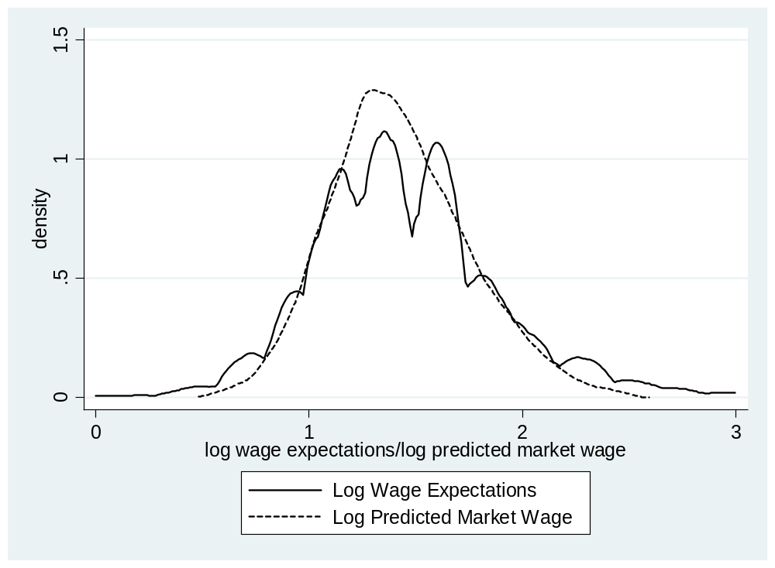

Table 1: Fixed effects model for log of expected hourly wage
Variables | Coefficients
Predicted market wage (Log) | 0.593***
Age (base: 15-24)
25-34 | -0.063*
35-44 | -0.144***
45-54 | -0.241***
55-64 | -0.245***
Education (base: no qualifications)
Degree | -0.159
Further Education | -0.112
A Levels | -0.137*
O Levels | -0.074
Other Qualifications | 0.060
Married or Cohabiting | -0.053**
Number of children | 0.026*
Household Size | -0.006
Mental Health Condition | 0.058**
Physical Health Condition | 0.027
Type of status (base: unemployed)
Family care | -0.022
FT student | -0.051
LT sick | 0.051
Other inactivity status | -0.017
Years in status | 0.002
Years in status sq. | 0.00003
Household Labour Income (log) | -0.002
Household Investment Income (log) | -0.002
Household Benefit Income (log) | 0.002
Rent/Mortgage Costs (log) | -0.0003
Observations | 7,298
Number of persons | 4,077
R-squared (within) | 0.177
R-squared (overall) | 0.192
Notes: Models also include dummies for region and survey year; *** p<0.01, ** p<0.05, * p<0.1; standard errors are obtained via clustered bootstrapping.

Table 2: Correlated random effects models of job satisfaction
 | Overall job satisfaction | Satisfaction with pay | Overall job satisfaction
Optimism | -0.061*** | -0.094*** | -0.025
 | [0.022] | [0.029] | [0.017]
Satisfaction with pay |  |  | 0.371***
 |  |  | [0.010]
Female | 0.113** | 0.146** | 0.063
 | [0.056] | [0.068] | [0.046]
White | 0.129 | 0.260*** | 0.018
 | [0.098] | [0.101] | [0.081]
Age | -0.011 | -0.020 | -0.003
 | [0.019] | [0.024] | [0.018]
Age squared | 0.037 | 0.072** | 0.010
 | [0.024] | [0.029] | [0.021]
Number of cigarettes per day | 0.002 | 0.001 | 0.002
 | [0.004] | [0.005] | [0.004]
Married or cohabiting | -0.003 | 0.056 | -0.023
 | [0.050] | [0.060] | [0.045]
Number of children | 0.070** | 0.087** | 0.038
 | [0.030] | [0.034] | [0.025]
Household Size | 0.022 | 0.029 | 0.011
 | [0.021] | [0.025] | [0.019]
Mental Health Condition | -0.129 | 0.111 | -0.170**
 | [0.084] | [0.082] | [0.074]
Physical Health Condition | 0.002 | -0.004 | 0.004
 | [0.038] | [0.045] | [0.033]
Education (Ref: No qualifications)
Degree | -0.783*** | -0.410 | -0.632**
 | [0.291] | [0.293] | [0.251]
Further Education | -0.446*** | -0.261 | -0.351**
 | [0.168] | [0.171] | [0.140]
A Levels | -0.393** | -0.312 | -0.277*
 | [0.186] | [0.201] | [0.159]
O Levels | -0.334 | -0.041 | -0.319*
 | [0.209] | [0.233] | [0.164]
Other Qualifications | -0.425* | -0.346 | -0.297
 | [0.250] | [0.323] | [0.201]
Weekly usual hours | -0.011 | -0.013 | -0.007
 | [0.007] | [0.009] | [0.006]
Weekly usual hours squared | 0.000 | 0.000 | 0.000
 | [0.000] | [0.000] | [0.000]
Paid overtime hours | 0.007* | 0.028*** | -0.003
 | [0.004] | [0.005] | [0.003]
Unpaid overtime hours | -0.000 | -0.013*** | 0.004
 | [0.004] | [0.004] | [0.004]
Manager/Foreman/Supervisor | 0.036 | 0.057 | 0.015
 | [0.040] | [0.042] | [0.035]
Holding second job | -0.097* | 0.020 | -0.105**
 | [0.058] | [0.071] | [0.051]
Permanent contract | 0.054 | -0.145** | 0.108*
 | [0.061] | [0.072] | [0.056]
Promotion opportunities | 0.386*** | 0.251*** | 0.293***
 | [0.038] | [0.038] | [0.033]
Pay includes bonus or profit share | 0.036 | 0.094** | 0.001
 | [0.036] | [0.041] | [0.033]
Member of employer pension scheme | 0.115** | 0.117** | 0.072
 | [0.050] | [0.052] | [0.047]
Pay includes annual increments | 0.170*** | 0.149*** | 0.115***
 | [0.032] | [0.036] | [0.028]
Shift work | -0.116* | 0.055 | -0.136**
 | [0.066] | [0.082] | [0.067]
Tenure in years | -0.094*** | -0.075*** | -0.066***
 | [0.012] | [0.012] | [0.010]
Tenure squared | 0.337*** | 0.272*** | 0.236***
 | [0.075] | [0.087] | [0.058]
Log of Hourly Net Wage | 0.160** | 1.016*** | -0.216***
 | [0.063] | [0.073] | [0.055]
Wage in previous employment | 0.003 | -0.004 | 0.004
 | [0.004] | [0.006] | [0.004]
Trade union status (Ref: Not covered)
Covered non-member | -0.023 | 0.132** | -0.072
 | [0.049] | [0.055] | [0.050]
Covered member | -0.042 | -0.009 | -0.038
 | [0.063] | [0.074] | [0.061]
Work location (Ref: employer’s premises)
Work Location - Home | 0.104 | 0.496*** | -0.080
 | [0.161] | [0.191] | [0.177]
Work Location - Other | 0.032 | -0.006 | 0.035
 | [0.065] | [0.080] | [0.059]
Work Location - Driving/Travel | -0.060 | -0.126 | -0.013
 | [0.067] | [0.086] | [0.061]
Workplace size (Ref: 500+)
Workplace Size 1-50 | 0.126** | -0.011 | 0.131**
 | [0.063] | [0.076] | [0.059]
Workplace Size 50-499 | 0.103* | -0.046 | 0.119**
 | [0.060] | [0.071] | [0.057]
Sector (Ref: Private firm)
Civil service | 0.123 | -0.082 | 0.154
 | [0.168] | [0.169] | [0.144]
Local government | 0.118 | 0.044 | 0.102
 | [0.092] | [0.125] | [0.084]
Other public | 0.019 | -0.035 | 0.032
 | [0.122] | [0.136] | [0.110]
Non-profit | 0.299*** | 0.301** | 0.188*
 | [0.112] | [0.129] | [0.102]
Observations | 10,289 | 10,289 | 10,289
Number of persons | 1,937 | 1,937 | 1,937
Notes: The models also include controls for occupation category, industry, and a set of regional and year controls; the individual means of all the above listed time-varying covariates are also included in all models; standard errors obtained via clustered bootstrapping in brackets; *** p<0.01, ** p<0.05, * p<0.1.

† Corresponding author: Chris Dawson, School of Management, University of Bath, Claverton Down, Bath BA2 7AY, United Kingdom; email: c.g.dawson@bath.ac.uk.
‡ Department of Accounting, Economics and Finance, Bristol Business School, University of West of England, Frenchay Campus, Coldharbour Lane, Bristol BS16 1QY, United Kingdom; email: Timothy.hinks@uwe.ac.uk. * Southampton Business School, University of Southampton, Highfield Campus, University Road, Southampton SO17 1BJ; email: M.Veliziotis@soton.ac.uk.
Major inactive groups are those in family care, those that are full-time students and those classified as long-term sick/disabled.
The vector of employee characteristics for the wage equation includes age, age squared, gender, a set of highest educational attainment dummies, ethnicity, marital status, dummies for physical and mental health condition and also a set of regional and year controls. Sample selection into employment is controlled for by estimating equation (1) using a Heckman selection model and including an inverse Mills ratio in the equation, where the over-identifying instruments are the number of children in household and whether the respondent’s partner is employed. The results are consistent with standard findings in the earnings literature: we observe a substantial gender pay gap (around 13% lower pay for women) and an ethnicity pay gap, while better educated employees earn significantly higher wages. The same is the case for married employees compared to non-married ones. Finally, adverse health conditions are associated with substantially lower pay.
See Table 1 for the complete set of control variables in the model.
A possible argument is that the predicted wage may give biased estimates of the likely distribution of wages facing our sample of unemployed or economically inactive individuals. For example, our sample of individuals who have one or less than one year of current job tenure will include people who were never unemployed and have simply moved from one job to another. In this instance our predicted wage will be upwardly biased. The real interest however is in relative optimism between individuals and a general bias in the predicted wage does not affect this property.
To deal with multiple transitions out of inactivity/unemployment and into employment per individual, we focus our analysis only on the first observable transition to ensure optimism is constructed for individuals prior to entry into paid-employment.
See Table 2 for the complete set of control variables in the model.
A further test to eliminate the concern that under rational expectations measured optimism is simply capturing private information about earnings power and, specifically, that measured optimism may proxy for earnings below what the individual’s characteristics justify, is to include the residual from equation (1) in the job satisfaction equations. Following this procedure leads to no change in the estimate of and the imputed residual from equation (1) is statistically insignificant in the regressions.
Optimism measured as from equation (2) allows us to capture an individual’s underlying tendency to overestimate their prospects net of any time-varying environmental factors. One possible objection to this procedure is that by removing the impact of environmental factors we may lose useful information on how wage expectations are formed, information which is potentially relevant for subsequent job-satisfaction. As a robustness check we repeat the analysis using two additional optimism measures which do not exclude the impact of time-varying environmental influences. Firstly, we construct an optimism measure which is the raw difference between the individuals expected wage and the predicted market wage. Secondly, we construct an optimism measure which is the fixed effect from equation (2) with the inclusion of the fitted values. These measures of optimism produce results which are wholly consistent with those presented in Table 2.

