Note: this is a draft of the journal article:

Peter R. Worsley, Beth Parsons, Dan L. Bader (2016) “An evaluation of fluid immersion therapy for the prevention of pressure ulcers.”

Clinical Biomechanics, in press
The final, fully proofed and peer-reviewed journal article is available from the publisher online, via
10.​1016/​j.​clinbiomech.​2016.​10.​010

Clinical Biomechanics
The effects of fluid immersion mattresses

Title: An Evaluation of Fluid Immersion Therapy for the Prevention of Pressure Ulcers
Worsley P.R. PhD, Parsons B. MSc, and Bader D.L. DSc
Clinical Academic Facility, Faculty of Health Sciences, University of Southampton, Southampton, SO16 6QY, UK

Acknowledgements
The prototype mattress and funding support was provided by Joerns and Medstrom. Research was supported by the EPSRC-NIHR Medical Device and Vulnerable Skin Network (ref EP/M000303/1). There were no conflicts of interest in this study.

Corresponding Author:
Dr Peter Worsley
Mail Point11, Southampton General Hospital, Southampton, SO16 6YD. Email: p.r.worsley@soton.ac.uk. Tel: 023 81208957
Clinical Trial Number: FOHS-17598
Word Count: Abstract – 250 words, Manuscript 3184
Abstract:
Background: Individuals with impaired mobility can spend prolonged periods on support surfaces, increasing their risk of developing pressure ulcers. Manufacturers have developed mattresses to maximise contact area. The present study evaluated both the biomechanical and physiological responses to lying postures on a Fluid Immersion Simulation mattress.

Methods: Seventeen healthy participants were recruited to evaluate the mattress during three prescribed settings of immersion (high, medium and low). Parameters reflecting biomechanical and physiological responses, and the microclimate were monitored during three postures (supine, lateral and high-sitting) over a 90 minute test session. Transcutaneous oxygen and carbon dioxide gas responses were categorised according to three criteria and data were compared between each condition.

Findings: Results indicated that interface pressures remained consistent, with peak sacral values ranging from 21-27mmHg across all immersion settings and postures. The majority of participants (82%) exhibited minimal changes in gas tensions at the sacrum during all test conditions. By contrast, three participants exhibited decreased oxygen with increased carbon dioxide tensions for all three immersion settings. Supine and high sitting sacral microclimate values ranged between 30.1-30.6°C and 42.3-44.5% for temperature and relative humidity respectively. During lateral tilt there was a reduction of 1.7-2.5°C and 3.3-5.3% in these values. The majority of participants reported high comfort scores, although a few experienced bottoming out during the high-sitting posture at the high immersion setting.

Interpretation: Fluid Immersion Simulation provides an intelligent approach to increase the support area. Further research is required to provide evidence based guidance on the use of personalised support surfaces.

Keywords: Pressure ulcers, immersion therapy, biomechanical and physiological responses, tissue viability.

Abbreviations
Fluid Immersion Therapy System (FIS); Pressure Ulcers (PUs); transcutaneous oxygen (TcPO₂); transcutaneous carbon dioxide (TcPCO₂);

- Introduction:

Pressure ulcers (PUs) are caused by sustained pressure, or pressure in combination with shear, and commonly occur adjacent to body prominences (European Pressure Ulcer Advisory Panel, 2014). Several risk factors have been recently identified in the development of PUs, in particular reduced mobility/activity, a history of pressure ulcers and perfusion (Coleman et al., 2013). In the last few years the condition has been recognised as both a Patient Safety and Quality of Care indictator for health care providers in both the acute and community settings (Department of Health, 2010). Although there is a strong focus on prevention within health services, the incidence of PUs remains unexceptably high with associated treament costs estimated at £4 billion annually in the United Kingdom (National Patient Safety Agency, 2010).

In order to reduce the risk of developing PUs, frequent repositioning is advised in internaitonal guidelines (European Pressure Ulcer Advisory Panel, 2014). In practice, this involves the periodic redistribution of pressure through postural change, which enables relief of previously loaded tissue areas. In individuals with impaired mobility this process often requires the assistance of a clinician which can be time-consuming and expensive for the healthcare provider (Moore et al., 2013). Hence, with limited healthcare resources, this may not be strictly adhered to, particularly in busy hospital or community settings (Defloor et al., 2005). As an alternative to manual repositioning, advanced air mattress systems have been introduced to periodically relieve support pressures. However, their benefits over more economical foam or static hybrid systems have not been fully demonstrated (McInnes et al., 2015).

A number of measurements have been used to examine the performance of support surfaces. As an example, interface pressure measurements between the individual and the support surface have been extensively used in both lab-based and clinical studies (Stinson and Crawford, 2009). These studies have demonstrated how postural change can have a significant effect on interface pressures (Defloor and Grypdonck, 1999). However, interface pressure values alone do not provide clinicians with indications of when and where pressure ulcers are likely to develop (Reenalda et al., 2009). This has motivated a number of recent studies which have examined the temporal effects of applied pressures on a range of measures indicative of physiological tissue status (Chai and Bader, 2013; Kim et al., 2012). These have indicated that changes in transcutaneous gas tensions (TcPO₂ and T_{c}PCO₂) can reflect the physiological response of skin tissues to altering posture (Woodhouse et al., 2015). In addition, there is increasing evidence that thermodynamic conditions in skin tissues strongly influence the susceptibility to PUs. This has led to the an interest in the control of the microclimate, namely temperature and humidity, at the loaded-skin support interface (Clark et al., 2010).

An alternative recommended means of managing the support surface conditions involves immersion and envelopment of the individual, thereby maximising the contact area ¹. One such system, the Fluid Immersion Simulation (FIS) has been reported to provide benefits in a small clinical study (Fletcher et al., 2014). However, its performance in terms of its management of the biomechanics and microclimate at the interface has not been evaluated. This motivated the present study which is designed to evaluate a range of FIS settings and postures, in a cohort of participants employing a biomechanical and physiological measurement approaches at critical tissue locations (Woodhouse et al., 2015).

- Material and Methods:

The present study adopted a prospective randomised cross-over design in a cohort of healthy participants.

  - Description of Support Surface and Immersion Settings

The Dolphin Fluid Immersion Simulation Therapy (FIS) mattress (Joerns, Texas, US) was employed in the present study. The reactive therapy system is designed to displace the patient’s weight throughout a simulated fluid medium. The system has a series of user defined settings, which change the immersion characteristics of the mattress. The present study applied three settings to assess the effects of these immersion properties, namely; low, medium and high. The lower the immersion setting, the less the individual was displaced into the support surface and the high the internal pressure of the mattress. The mattress was placed on a standard bed frame (VersaCare, Hill-Rom, USA) and was evaluated in both the horizontal position and at a head of bed angle of 40∘.

2.2 Participants
Participants were recruited from the local community if they had no history of skin-related conditions, no history of neurological or vascular pathologies which could affect tissue health and were able to lie or sit for a period of 90 minutes. Institutional ethics was granted for the study (ERGO-FOHS-17598) and informed consent was obtained from each participant prior to testing.

2.3 Test Equipment
Physiological measures of transcutaneous oxygen and carbon dioxide tensions (T_{c}PO_{2,} T_{c}PCO₂) were monitored at the sacrum using a transcutaneous gas tension electrode (Model 841, Radiometer A/S, Denmark) heated to 43.5°C to ensure maximum vasodilation (Bogie et al., 1995) and attached to a separate monitor (TCM4, Radiometer, Denmark). Interface pressures were recorded via a thin sheet incorporating a total of 96 sensors placed on top surface of the mattress and attached to an interface pressure monitoring system (Talley Pressure Monitoring TPM Mk III, UK). The total included one separate 12-sensor array, located under the sacrum, at a corresponding spatial resolution of 30 mm in both directions. The remaining 84 sensors were positioned along the body with a spatial resolution of 50 mm across the body width and 120 mm along the body length.
Two digital temperature and humidity sensors (SHT7x, Sensirion, Switzerland) were positioned externally (one at each end of the bed) and two were positioned at the interface between the participant and the mattress (under the sacrum and thorax). A manometer (Digitron, UK) was used to measure the internal pressure of the immersion mattress and the angle at which each participant was tilted during the high-sitting and lateral postures was measured by a hand held inclinometer (SOAR, Digital Level meter 1700). In addition, comfort scores were recorded for each participant using a 5 point verbal rating scale, with 0 representing the lowest score and 5 representing the highest score.

2.4 Test Protocol
All test procedures were performed in a laboratory where room temperature was maintained at 20°C. Participants who wore loose fitting clothing during data collection, were asked to lie in a prone position for a 15 minute period to establish baseline unloaded TcPO₂ and TcPCO₂ levels. Each participant was then carefully positioned in a supine posture on the immersion mattress. The mattress was then configured to one of three randomly assigned immersion settings and maintained for three randomly allocated postures (supine, high sitting and lateral tilt), each of which lasted 10 minutes. Supine and high sitting postures were established using the bed frame controls. During the lateral tilt, postures were maintained with pillow support at the back and lengthways under the legs using a standard protocol (Moore, 2012) (Figure 1). The process was then repeated for the other two immersion settings, with a total of nine test conditions lasting a period of 90 minutes. Transcutaneous blood gas measurements were continuously recorded at the sacrum throughout the test period. Three cycles of interface pressures were recorded at the mid-point of each test condition and single measures of internal mattress pressures, postural tilt angles and comfort scores were also recorded.

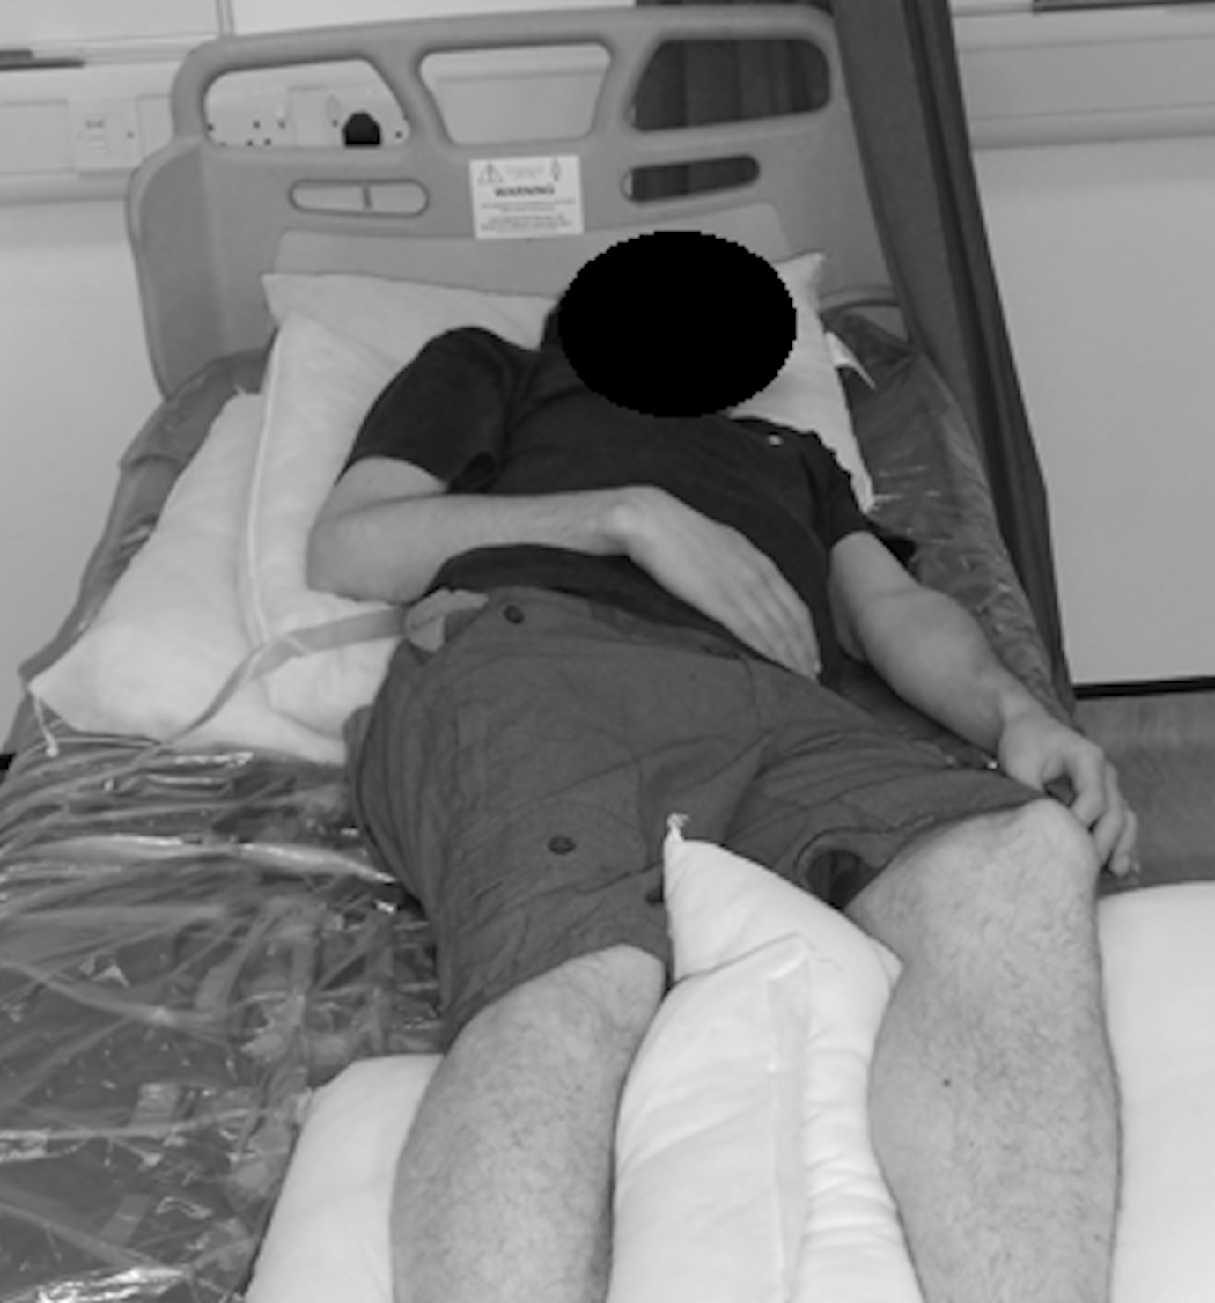
Figure 1: Participant lying in the 30° tilt position support by pillows under the back and legs.

2.5 Data Analysis
Values of interface pressures, transcutaneous gas tension and internal mattress pressures were processed and analysed using Matlab (MathWorks, US). Peak and mean interface pressures were estimated from the three cycles of recordings under both the sacrum and the body. The transcutaneous gas data were normalised to baseline unloaded values, measured in the prone lying position and then categorised according to the following established characteristic responses (Chai and Bader, 2013); Category 1 (minimal changes in both TcPO₂ and TcPCO₂ values), Category 2 (>25% decrease in TcPO₂ with minimal change in TcPCO₂) and Category 3 (>25% decrease in TcPO₂ associated with a >25% increase in TcPCO₂).

All data were examined for normal distribution prior to analysis using the Shapiro-Wilk test. Subsequently parametric statistics (mean, standard deviation) were used for inclinometer tilt angles and microclimate measures (temperature and humidity). Non-parametric analyses were conducted for interface pressure measures (median, range). Inferential statistics suitable for categorical and interval data were applied for the transcutaneous category responses and the comfort scores. Trends within the data were explored using Pearson’s chi-squared test (Χ²). The effects of postural change and immersion settings on interface pressures were examined using Friedman's test. A level of 5% was considered statistically significant (p≤0.05).

- Results:
Seventeen healthy participants (7 male and 10 female) were recruited aged between 24-81 years of age (mean = 60 years) with an average height and weight of 1.69m (standard deviation = 0.1m) and 73.9kg (standard deviation = 11.1kg), respectively. The resulting BMIs ranged between 20.3-32.5kg/m².

3.1 Monitoring physiological parameters
The average baseline unloaded values were 60.7mmHg (standard deviation = 6.8mmHg) and 42.1mmHg (standard deviation = 3.6mmHg) for TcPO2 and TcPCO2 respectively. The category responses from the participants during each test condition are summarised in Table 1. The majority of participants (14/17) exhibited a category 1 or 2 response at the sacrum during all test conditions. By contrast, three participants exhibited a category 3 response during testing, which occurred for all three mattress immersion settings in each case. However, in only one case of lateral lying was a Category 3 response observed associated with the low immersion setting (Participant 11). For these Category 3 responses the transcutaneous data revealed that TcPO2 levels had significantly reduced (range 1-12mmHg), with an associated increase in TcPCO2 values (range 53-104mmHg).

Table 1. Summary of the transcutaneous Category responses from the 17 participants, according to Chai and Bader 2013 criteria
Category Responses according to Chai and Bader, (2013)
Participant | High Immersion |  |  | Medium Immersion |  |  | Low Immersion
 | Supine | Lateral | High Sitting | Supine | Lateral | High Sitting | Supine | Lateral | High Sitting
1 | 2 | 1 | 2 | 1 | 1 | 2 | 1 | 1 | 2
2 | 2 | 1 | 2 | 1 | 1 | 1 | 1 | 1 | 1
3 | 1 | 2 | 1 | 1 | 1 | 1 | 1 | 1 | 1
4 | 1 | 1 | 1 | 1 | 1 | 1 | 1 | 1 | 1
5 | 1 | 1 | 1 | 1 | 1 | 1 | 1 | 1 | 1
6 | 3 | 2 | 1 | 2 | 1 | 1 | 3 | 2 | 1
7 | 2 | 2 | 3 | 2 | 2 | 3 | 3 | 2 | 3
8 | 1 | 1 | 1 | 1 | 1 | 1 | 1 | 1 | 1
9 | 1 | 1 | 1 | 1 | 1 | 1 | 1 | 1 | 1
10 | 1 | 1 | 1 | 1 | 1 | 1 | 1 | 1 | 1
11 | 3 | 1 | 1 | 3 | 2 | 2 | 3 | 3 | 1
12 | 1 | 1 | 1 | 1 | 1 | 1 | 1 | 1 | 1
13 | 1 | 1 | 1 | 1 | 1 | 1 | 1 | 1 | 1
14 | 1 | 1 | 1 | 1 | 1 | 1 | 1 | 1 | 1
15 | 1 | 1 | 1 | 1 | 1 | 1 | 1 | 1 | 1
16 | 1 | 1 | 1 | 1 | 1 | 1 | 1 | 1 | 1
17 | 1 | 1 | 1 | 1 | 1 | 1 | 1 | 1 | 1

Furthermore, the temporal changes in the data indicated that movement between postures clearly influenced the transcutaneous gas response. There was considerable difference in the changes between individuals. As an example, Figure 2a reveals a typical participant with no significant changes in the transcutaneous tissue gas tensions (Category 1), regardless of immersion setting or posture. By contrast, the response of the participant in Figure 2b revealed a Category 2 response i.e. in the lateral posture on medium immersion setting and a Category 3 response i.e. in the supine posture on medium immersion setting. It is interesting to note that in subsequent postures TcPO₂ and TcPCO₂ values recovered to a Category 1 response, for example in both high sitting and lateral postures associated with the high immersion setting, although this recovery was not sustained (Figure 2b).

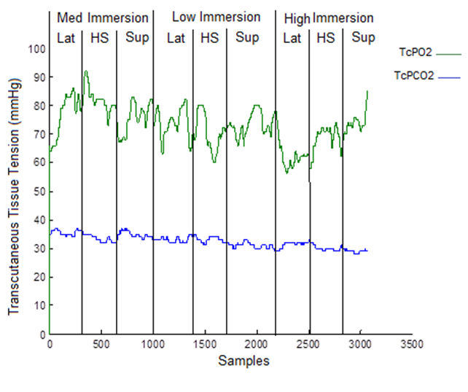
Figure 2: Transcutaneous tissue gas tensions from (a) Participant 16 who exhibited a Category 1 response throughout the test session (b) Participant 11 who exhibited a Category 2 and 3 response during the test session

3.2 Biomechanical Assessment
Table 2 summarises the results from the interface pressure data. The results revealed that peak pressure values from the cells under the sacral region were significantly lower than the peak values from the body (p=0.12), with associated median pressures of 21-27 mmHg and 19-112mmHg for the sacrum and body, respectively (across all test conditions). Differences with respect to either the mattress immersion settings or postures were not statistically significant (p>0.05).

Table 2. Summary of Peak Pressure data (mmHg) for all 17 participants during the three immersions settings and three postures
 | IP peaks (mmHg)
Body Part | Immersion setting | Posture | Median | Min | Max
Peak sacral* | High | Supine | 22 | 17 | 70
 |  | Lateral | 23 | 20 | 48
 |  | High Sit | 27 | 20 | 75
 | Medium | Supine | 22 | 19 | 65
 |  | Lateral | 22 | 20 | 61
 |  | High Sit | 21 | 20 | 66
 |  | Supine | 24 | 18 | 86
 | Low | Lateral | 23 | 22 | 64
 |  | High Sit | 22 | 19 | 72
Peak body** | High | Supine | 57 | 31 | 85
 |  | Lateral | 57 | 43 | 84
 |  | High Sit | 62 | 43 | 81
 | Medium | Supine | 67 | 53 | 104
 |  | Lateral | 66 | 49 | 97
 |  | High Sit | 72 | 50 | 112
 |  | Supine | 63 | 18 | 78
 | Low | Lateral | 56 | 35 | 93
 |  | High Sit | 55 | 19 | 82
* Estimated over the 12 sensor array, ** estimated over an 84 sensor array

The results from the inclinometer indicated that there was no significant difference between immersion settings during high sitting or lateral tilt (p>0.05), with average trunk (high sitting) and pelvic (lateral tilt) angles of 43°and 38° respectively. The internal pressures within the mattress consistently decreased with immersion, with average internal pressures of 24.4mmHg, 18.4mmHg and 10.3mmHg for the low, medium and high immersion settings, respectively.

3.3 Interface Microclimate
Ambient conditions in the laboratory were kept constant, with an average of 20.1°C (standard deviation = 1.2°C) and 37.1% (standard deviation = 6.5%), for temperature and relative humidity respectively. Table 3 summarises the temperature and humidity changes for each immersion and posture condition. The results reveal a statistically significant decrease (p<0.05) in sacral temperatures during lateral tilt posture compared to supine and high sitting (mean reduction range 1.7-2.5°C). There was also an associated decrease in RH values during lateral tilt, with mean reductions ranging from 3.3-5.3% RH, although these differences were not statistically significant (p>0.05). Temperature values at the thorax were significantly higher (p=0.01) than the sacrum (differences ranged between 1.4-3.5°C). Temperature values at the thorax were consistent across postures and immersion settings (temperature ranges 30.8-32.2°C). The relative humidity values at the thorax revealed reductions during the lateral tilt posture, with mean values deceasing by 4.1-5.9% RH compared to the supine and high sitting postures. It is interesting to note that during data collection sessions, regardless of immersion setting and posture both temperature (Figure 3a) and humidity (Figure 3b) values increased with time.

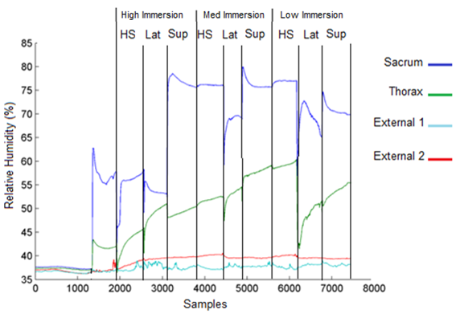
Figure 3: a) Temperature measurements of four sensors from Participant 13 during all phases of the experiment. b) Relative humidity measurements of four sensors from Participant 11 during all phases of the experiment

Table 3. Summary of the temperature and humidity data for all 17 participants during the three immersions settings and three postures.
 | Immersion Setting | High |  |  | Medium |  |  | Low
 | Posture | Supine | Lateral | High Sit | Supine | Lateral | High Sit | Supine | Lateral | High Sit
Sacrum | Temp °C (Mean ±Stand. Dev.) | 30.1  ± 2.1 | 28.1  ± 2.5 | 30.6  ± 1.6 | 30.2  ± 1.8 | 27.7  ± 2.8 | 30.1  ± 2.1 | 30.5  ± 1.5 | 28.6  ± 3.1 | 30.3  ± 1.7
 | Humid %RH (Mean ±Stand. Dev.) | 43.6  ± 11.4 | 40.3  ± 13.5 | 44.5  ± 12.1 | 43.9±  8.5 | 39.6  ± 9.8 | 43.5  ± 8.6 | 42.3  ± 9.2 | 37.0  ± 10.3 | 42.9  ± 9.1
Thorax | Temp °C (Mean ±Stand. Dev.) | 32.3  ± 1.4 | 31.6  ± 1.0 | 32.0  ± 1.5 | 31.9  ± 1.6 | 30.8  ± 1.5 | 32.2  ± 1.1 | 32.3  ± 1.3 | 31.9  ± 1.2 | 32.0  ± 1.4
 | Humid %RH (Mean ±Stand. Dev.) | 47.6  ± 10.1 | 40.3  ± 13.5 | 44.5  ± 12.1 | 43.9±  8.5 | 39.6  ± 9.8 | 43.5  ± 8.6 | 42.3  ± 9.2 | 37.0  ± 10.3 | 42.9  ± 9.1

3.4 Comfort Scores
The results from the comfort survey suggested that during low and medium immersion settings, participants were reported to be ‘comfortable’ or ‘very comfortable’ in the majority of cases (71%). During the high immersion setting, scores were significantly lower (p<0.05) and this was particularly evident during the high-sitting posture with 35% of participants reporting to be ‘uncomfortable’ or ‘very uncomfortable’. It was noted that some of the participants experienced ‘bottoming out’ when the mattress was set to the high immersion setting during the high-sitting posture (Figure 4).
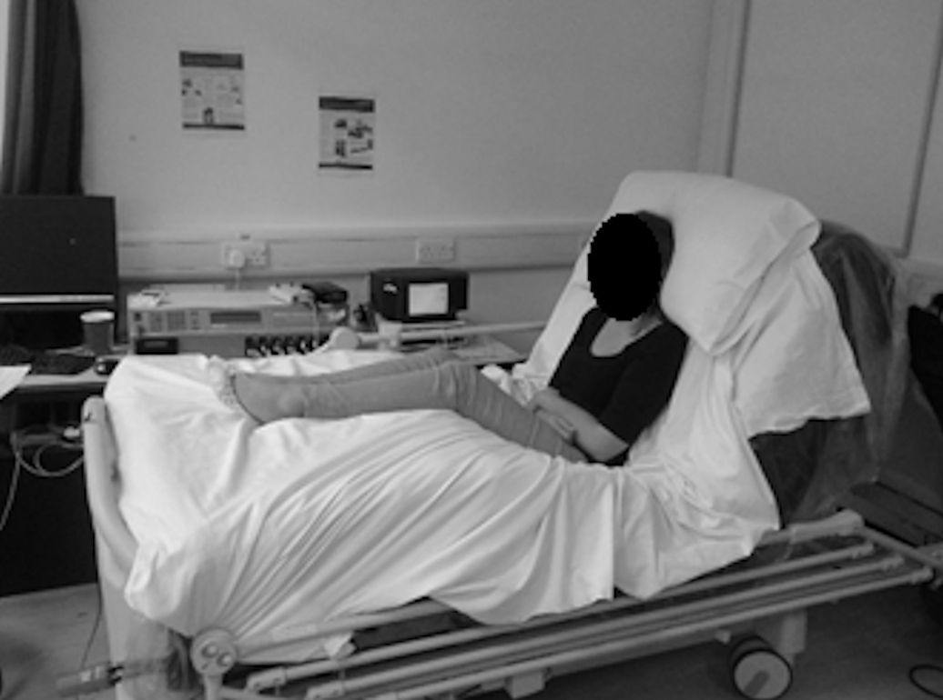
Figure 4: Participant in the high sitting posture with the Fluid Immersion setting on ‘High’, evidence of bottoming out observed.

- Discussion

The present study employed a range of measures to assess the effects of a fluid immersion mattress in terms of its management of the biomechanics and microclimate at the human-support surface interface and its relative effects on tissue physiology. The study revealed that for three different postures the fluid immersion system was able to redistribute pressures across the body and maintain minimal pressures on key bony prominences, namely the sacrum. In addition, in the majority of cases (14/17 or 82%), the physiological response at the sacrum was minimally affected by sustained postures. However, in three individuals a reduction in transcutaneous oxygen tensions was observed, implying a degree of local ischemia, associated, in some cases, with an increase in carbon dioxide (Figure 2b). These were observed regardless of mattress immersion settings. These findings are similar to that recently reported in prototype alternating pressure (Chai and Bader, 2013) and a lateral rotation air mattresses(Woodhouse et al., 2015). A recent review article has highlighted that carbon dioxide gas tensions might be indicative of early tissue damage during both mechanical-induced ischaemia and subsequent reperfusion (Mirtaheri et al., 2015). Therefore, robust monitoring carbon dioxide tensions in loaded tissues may provide some prognostic value in determining pressure ulcer risk.

Immersion therapy has been identified as a potential technological solution to minimise interface pressure between the individual and the support surface (European Pressure Ulcer Advisory Panel, 2014). The interface pressure values reported in the present study support this assertion with median sacral pressures <30mmHg for all test conditions. These values are comparable to recent literature revealing supine sacral interface pressures between 35-66mmHg (Kim et al., 2012; Woodhouse et al., 2015). Indeed, the results showed that immersion settings yielded little effect on the interface pressure or microclimate. However, when combined with the high sitting posture, with correspondingly reduced support areas, some of the participants exhibited bottoming out when the mattress was prescribed at high immersion setting (mean internal pressures of 10.3mmHg). Bottoming out refers to the contact of skin over the bony prominence to the frame of the support surface and can lead to elevation of interface pressure and can potentially increase the risk of developing pressure ulcers (Jay, 1995). Accordingly, a critical internal mattress pressure should be prescribed to minimise the risk of bottoming out in air filled support surfaces.

The present study has shown that for some individuals there is a physiological reaction of reduced oxygen and increase carbon dioxide in the local sacral tissues whilst maintaining postures commonly employed in clinical settings (Table 1). This occurred regardless of the immersion setting in the mattress, although some recovery of tissue gas tensions was observed during postural changes (Figure 2b). Interestingly, the individuals who showed such a physiological response all presented with a relatively low Body Mass Index (range 20.3-25.0 kg/m²). This may be indicative of the reduced tissue coverage over the bony prominences, which could increase the risk of tissue ischemia, as reflected in changes in transcutaneous gas tensions i.e. Category 3 response. Recent studies have shown that individuals with low BMI (<19) have a much greater likelihood of a hospital-acquired pressure ulcer (Gardiner et al., 2014; Kottner et al., 2011). In addition, anatomical factors such as tissue composition (skin, fat, muscle) and bony prominence shape can influence the translation of support pressures to internal strains within the intervening soft tissues (Levy et al., 2014). More research is needed to look at individual anthropometric characteristics and their relative risk of mechanically induced ischemia.

The present study has also shown that the interface microclimate changes significantly during sustained postures, with an increase in both temperature and humidity. These changes were maintained for supine and high sitting postures, but were relieved during periods of lateral tilt. Recent studies have described theoretical models highlighting the impact of temperature and moisture on superficial skin damage (Gefen, 2011), a finding that has recently been confirmed with empirical data studies on patients with and without pressure ulcers (Yusuf et al., 2015). This has motivated a recent interest in manufacturers targeting the management of microclimate for pressure ulcer prevention (Reger et al., 2014). However, further research is needed to quantify the relative effects of mattress cover, surface and bulk material properties and air flow designs in controlling microclimate at the interface.

The predominant limitation of the current study was in the use of a cohort of able-bodied individuals, which limits the ability to generalise the results to specific sub-populations deemed to be at risk of developing pressure ulcers. We did, however, purposefully sample a range of both young and elderly volunteers (age range of 24-81 years) to reflect a diverse aged population. The time each posture was adopted was also relatively short and further physiological changes may have occurred with more sustained periods. In addition, the international guidelines recommend regular skin checks performed by a trained healthcare professional (European Pressure Ulcer Advisory Panel, 2014), which will minimise the possibility of individuals being exposed to harmful postures, such as occurs in bottoming out.

The provision of advanced intelligent support surfaces must be put in the context of budgetary demands of health care providers. It is inevitable that provision of an intelligent mattress will represent a larger initial cost compared to a conventional support surface. However, it offers the potential to reduce the long-term financial burden, provided it delivers an enhanced performance in terms of pressure relief to compromised soft tissues when compared to standard clinical practice. Such devices may further enable personalised immersion settings, thus providing optimal levels of management for individuals with particularly vulnerable soft tissues.

5. Conclusions
The present study has revealed that the Fluid Immersion Therapy mattress provides a high level of pressure redistribution, with low peak pressures over the body in all postures. There was little control of the microclimate with increases in both temperature and humidity during supine and high sitting postures. The subsequent physiological effects revealed that the majority of individuals retained high perfusion over sacral tissues. Nonetheless a few participants with relatively low BMI demonstrated an ischemic response was evident at the sacrum which was present regardless of immersion setting. More research is required to establish a personalised care strategy for individuals who present with vulnerable skin tissues, where intelligent support surfaces could provide optimal protection against pressure ulcer formation.

References

Bogie, K.M., Nuseibeh, I., Bader, D.L., 1995. Early progressive changes in tissue viability in the seated spinal cord injured subject. Paraplegia 33, 141-147.
Chai, C.Y., Bader, D.L., 2013. The physiological response of skin tissues to alternating support pressures in able-bodied subjects. Journal of the Mechanical Behavior of Biomedical Materials.
Clark, M., Romanelli, M., Reger, S., Ranganathan, V., Black, J., Dealey, C., 2010. Microclimate in context. International guidelines. Pressureulcer prevention: pressure, shear, friction and microclimate in context. A consensus document. Wounds International, 19-25.
Coleman, S., Gorecki, C., Nelson, A., Closs, J.S., Defloor, T., Halfens, R., Farrin, A., Brown, J., Schoonhoven, L., Nixon, J., 2013. Patient Risk Factors for pressure ulcer development: Systematic Review. Int. J. Nurs. Stud. 50, 974-1003.
Defloor, T., De Bacquer, D., Grypdonck, M., 2005. The effect of various combinations of turning and pressure reducing devices on the incidence of pressure ulcers. Int. J. Nurs. Stud. 42, 37-46.
Defloor, T., Grypdonck, M., 1999. Sitting Posture and Prevention of Pressure Ulcers. Appl. Nurs. Res. 12, 136-142.
Department of Health, 2010. Essence of Care 2010; Benchmarks for Prevention and Management of Pressure Ulcers, in: Department of Health (Ed.). The Stationery Office, United Kingdom,.
European Pressure Ulcer Advisory Panel, 2014. Pressure Ulcers Treatment: Quick Reference Guide. EPUAP-NPUAP.
Fletcher, J., Harris, C., Mahoney, K., Crook, H., Moore, J., 2014. A small-scale evaluation of the Dolphin Fluid Immersion Simulation® Mattress. Wounds UK 10, 97-100.
Gardiner, J.C., Reed, P.L., Bonner, J.D., Haggerty, D.K., Hale, D.G., 2014. Incidence of hospital-acquired pressure ulcers – a population-based cohort study. International Wound Journal, n/a-n/a.
Gefen, A., 2011. How do microclimate factors affect the risk for superficial pressure ulcers: A mathematical modelling study. Journal of Tissue Viability 20, 81-88.
Jay, R., 1995. Pressure and shear: their effects on support surface choice. Ostomy Wound Management 41, 40-42.
Kim, J.H., Wang, X.L., Ho, C.H., Bogie, K.M., 2012. Physiological measurements of tissue health; implications for clinical practice. International Wound Journal 9, 656-664.
Kottner, J., Gefen, A., Lahmann, N., 2011. Weight and pressure ulcer occurrence: A secondary data analysis. Int. J. Nurs. Stud. 48, 1339-1348.
Levy, A., Kopplin, K., Gefen, A., 2014. An air-cell-based cushion for pressure ulcer protection remarkably reduces tissue stresses in the seated buttocks with respect to foams: Finite element studies. Journal of Tissue Viability 23, 13-23.
McInnes, E., Jammali-Blasi, A., Bell, S.S., Dumville, J., Middleton, V., Cullum, N., 2015. Support surfaces for pressure ulcer prevention (Review). Cochrane Database of Systematic Reviews.
Mirtaheri, P., Gjøvaag, T., Worsley, P., Bader, D., 2015. A Review of the Role of the Partial Pressure of Carbon Dioxide in Mechanically Loaded Tissues: The Canary in the Cage Singing in Tune with the Pressure Ulcer Mantra. Ann. Biomed. Eng. 43, 336-347.
Moore, Z., 2012. Using the 30º tilt to reduce pressure ulcers. Nurs. Times 108, 22-24.
Moore, Z., Cowman, S., Posnett, J., 2013. An economic analysis of repositioning for the prevention of pressure ulcers. J. Clin. Nurs. 22, 2354-2360.
National Patient Safety Agency, 2010. npsa.nhs.uk, in: Health, D.o. (Ed.).
Reenalda, J., Jannink, M., Nederhand, M., Ijzerman, M., 2009. Clinical Use of Interface Pressure to Predict Pressure Ulcer Development: A Systematic Review. Assist. Technol. 21, 76-85.
Reger, S., Ranganathan, V., McNulty, A.K., 2014. Use of a powered coverlet for moisture removal, skin temperature reduction, odor, and bacteria control. Journal of Wound and Ostomy Continence Nursing 41, 35-39.
Stinson, M., Crawford, S., 2009. Optimal Positioning: Wheelchair Seating Comfort and Pressure Mapping. International Handbook of Occupational Therapy Interventions 2, 83-90.
Woodhouse, M., Worsley, P.R., Voegeli, D., Schoonhoven, L., Bader, D.L., 2015. The physiological response of soft tissue to periodic repositioning as a strategy for pressure ulcer prevention. Clinical Biomechanics 30, 166-174.
Yusuf, S., Okuwa, M., Shigeta, Y., Dai, M., Luchi, T., Rahman, S., Usman, A., Kasim, S., Sugama, J., Nakatani, T., Sanada, H., 2015. Microclimate and development of pressure ulcers and superficial skin changes. International Wound Journal 12, 40-46.

