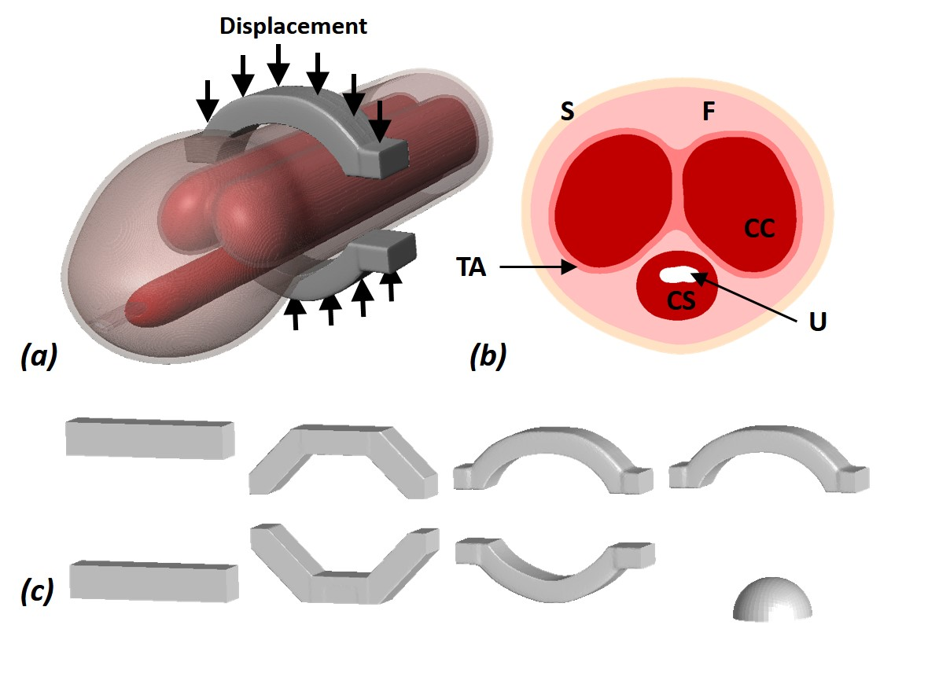
Figure 1
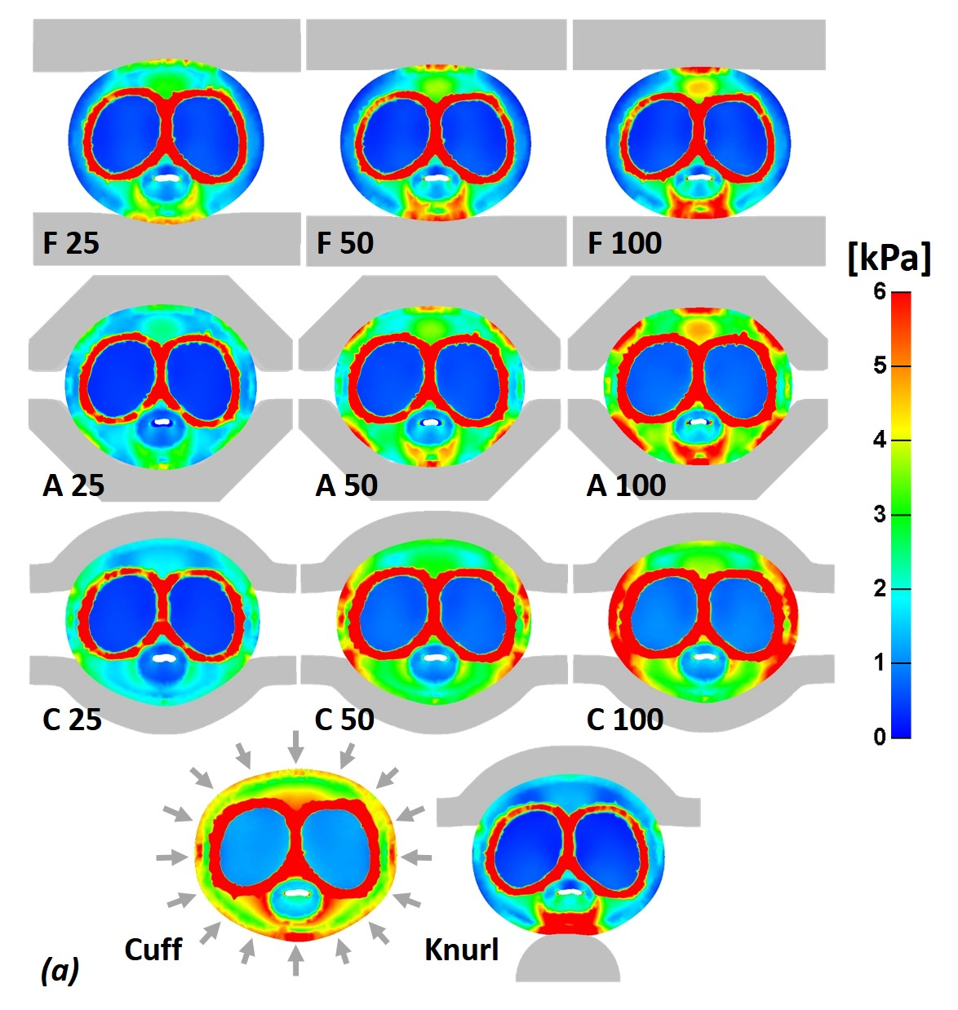
Figure 2

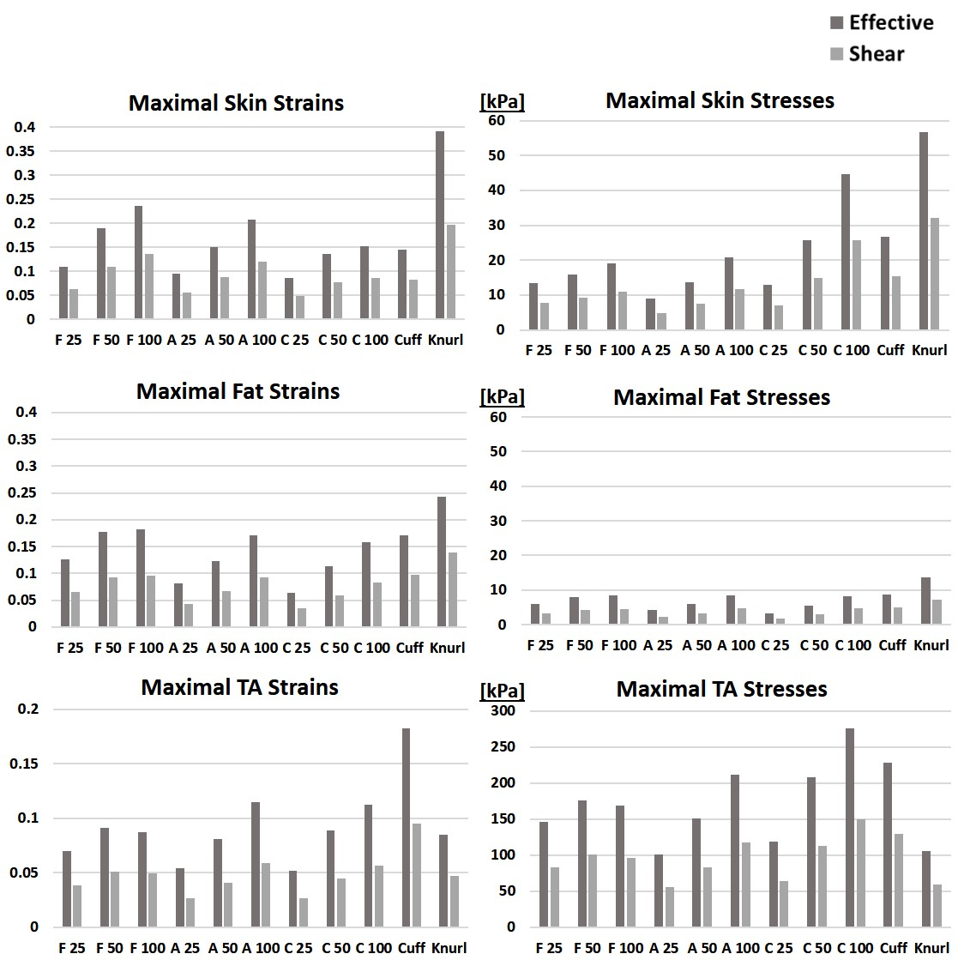
Figure 3

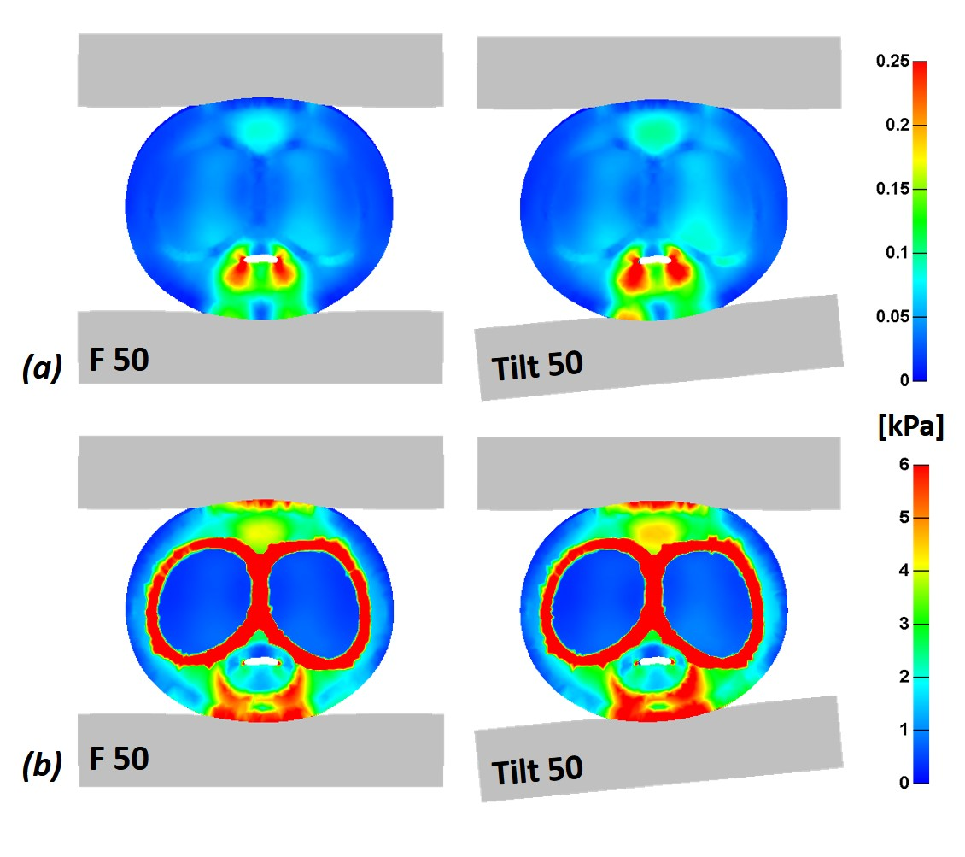 Figure 4
Figure Captions
Computational finite element modeling of the penis and penile compression clamps: (a) A three-dimensional (3D) model of the penis, with one example of a contoured compression clamp and corresponding loading configuration. (b) An axial cut through the penis, showing the skin (S), fat (F), tunica albuginea (TA), corpus cavernosum (CC), corpus spongiosum (CS) and urethra (U). (c) The flat, angled, contoured and contoured with knurl clamps, which were modeled in this work (left to right). | Figure 1
Distributions of effective tissue stresses in an axial cut through the penis, while using different penile clamps, at 50% closure of the urethra. F 25, F 50 and F 100 are flat clamps with stiffnesses of 25, 50 and 100 kPa; A 25, A 50 and A 100 are angled clamps with stiffnesses of 25, 50 and 100 kPa; C 25, C 50 and C 100 are contoured clamps with stiffnesses of 25, 50 and 100 kPa; Cuff is a cuff-type clamp and Knurl is a contoured clamp (50 kPa) with knurl (100 kPa). | Figure 2
Comparison of maximal effective and shear strains and stresses in skin, fat and tunica albuginea, while using different penile clamps, at 50% closure of the urethra. F 25, F 50 and F 100 are flat clamps with stiffnesses of 25, 50 and 100 kPa; A 25, A 50 and A 100 are angled clamps with stiffnesses of 25, 50 and 100 kPa; C 25, C 50 and C 100 are contoured clamps with stiffnesses of 25, 50 and 100 kPa; Cuff is a cuff-type clamp and Knurl is a contoured clamp (50 kPa) with knurl (100 kPa). | Figure 3
Distributions of (a) effective tissue strains and (b) effective tissue stresses, in an axial cut through the penis, while properly using a flat 50 kPa penile clamp (F 50) and with a 5˚ tilt of the bottom half of the clamp (Tilt 50), representing misuse or malfunction of the clamp. | Figure 4

