Having a LAFF with Anthracoidea

Stewart Taylor and Paul A. Smith

The Lost and Found Fungi (LAFF) project (http://fungi.myspecies.info/content/lost-found-fungi-project) has been enthusing people to go out and find fungi. Amongst its target species there are several smuts, and although we were both already looking for smuts (see Box), LAFF has provided an added incentive. One target has been examination of potential hosts in the Cyperaceae for ovary smuts in the genus Anthracoidea, which make reasonably obvious smutty balls which replace the utricles, mainly in Carex species, but also some related genera.

17 species of Anthracoidea have been recorded from Britain (FRDBI 10/9/16; excludes A. liroi which has been reported but not substantiated) and only one for Ireland (A. subinclusa). Most Anthracoidea species are specific to one or a small number of closely related host species. 18 species and 2 hybrids are therefore known as hosts of Anthracoidea from British records, though more species act as hosts for this range of Anthracoidea in the rest of Europe (Vanky 1994).

Getting smutty
Stewart Taylor
A long association with expert Mycologist Peter Orton (1983 – 2002) during visits to my previous place of employment, RSPB Abernethy Forest Reserve, introduced me to the world of fungi. Sadly, I was a finder not an identifier. However, a five-year study of populations of tooth fungi on the reserve (2007 – 2011) and a developing interest in fungi on land plants via links to the Highland Biological Recording Group (HBRG) prepared me for the world of Anthracoidea. My first find though came via another survey, the annual count of lesser butterfly and small white orchids in a nationally important UK meadow near to my home, and as I walked the transects in June 2013 I became aware of groups of unusual round black balls on the flower heads of Carex caryophyllea (Spring sedge). Intrigued, I took a couple of plants home and out of curiosity checked part of one of the black balls under the microscope to reveal masses of generally roundish dark brown spores, I then knew I was dealing with a fungus. Querying my find with local expert mycologist Liz Holden informed me that I was dealing with an Anthracoidea smut, but with the addition that little was known about this group. Martyn Ainsworth at Kew gave me the name Anthracoidea caryophyllea, and suggested I might carry out checks of other sedges in my local area to help with our knowledge of this probably under-recorded group. Thankfully, sedges are a group that I have had an interest in over the years, a big help with what was to follow. Re-visiting the orchid field the smut was found on Carex panicea (Anthracoidea paniceae) and during my last BTO survey that year I got quite excited as I found the fungus on Carex echinata (Anthracoidea karii). As other surveys came to an end in 2013 I targeted sedge rich areas locally and when Anthracoidea inclusa was found on Carex rostrata and A. lasiocarpae on Carex lasiocarpa, and Martyn informed me that both were new to Britain, I realised that I had stumbled into what would develop into my next long-term survey. Unbeknown to me at that time staff at Kew were developing, with funding assistance from the Esmée Fairbairn Foundation, The Lost & Found Fungi Project, which included two of the species covered in this article.
Paul Smith
I had been a botanist for many years when Arthur Chater introduced him to rust fungi. It took a bit of encouragement, but I eventually started collecting my own specimens, and then, with the help particularly of Nigel Stringer, to identify them. Most of my recording takes place in the Outer Hebrides (for which I am the botanical recorder), and it was a small step to add smuts, including Anthracoidea which are relatively obvious in moorland habitats with few plant species and which can enliven a recording trip. Rusts and smuts are being systematically recorded alongside the plants for an eventual new flora.

In this paper we give pen portraits based on our experiences of these species, both the relatively common ones and the more unusual ones that have been the subject of LAFF’s attentions (Table 1 summarises our finds). Then we look at the other British and Irish Anthracoidea, and at the end we briefly consider the species of Anthracoidea not yet found in Britain and Ireland, but whose hosts do occur here – maybe they are waiting to be discovered.

Table 1 ST and PAS total records as of October 2016
Anthracoidea species | Sedge | ST nos | PAS nos
Anthracoidea bigelowii | Carex bigelowii | 1
Anthracoidea caricis | Carex pilulifera | 1
Anthracoidea caryophylleae | Carex caryophyllea | 3
Anthracoidea hostianae | Carex hostiana | 3
Anthracoidea inclusa | Carex rostrata | 13
Anthracoidea inclusa | Carex vesicaria | 1
Anthracoidea inclusa | Carex x involuta | 1
Anthracoidea karii | Carex echinata | 75 | 29
Anthracoidea lasiocarpae | Carex lasiocarpa | 2
Anthracoidea limosa | Carex limosa | 2 | 1
Anthracoidea paniceae | Carex panicea | 56 | 22
Anthracoidea pratensis | Carex flacca | 12 | 3
Anthracoidea pseudirregularis | Carex pallescens | 2
Anthracoidea pulicaris | Carex pulicaris | 5
Anthracoidea scirpi | Trichophorum x foersteri | 5 | 9
13 smut species | 15 plant species | 182 | 64

Introduction to Anthracoidea

Anthracoidea spp. infect the ovaries of members of the Cyperaceae, with the sorus forming around the ovary, which can be seen in the centre (see Fig. 2 below, and Scholler et al. (2003) Fig. 2A). At maturity the whole sorus falls to the ground where it overwinters (sometimes for more than one year (Ingvarsson & Ericson 2000)), and when conditions are right the teliospores germinate, forming short hyphae bearing basidia with (unusually for Ustilaginales) two basidiospores each. These spores infect the flowers of the next generation of the host plant. Anthracoidea are not systemic, and rely on reinfection from year to year.

Originally all the ovary smuts on Carex were lumped together under the name Anthracoidea caricis, but small morphological differences led to some species being separated, and later a narrower species concept led to separation of species more along host differentiation lines. This narrow view has been largely corroborated by DNA work (Hendrichs et al. 2005).

The life cycle of some Anthracoidea is entwined with that of the beetle Phalacrus substriatus, which feeds on the teliospores and basidiospores, as well as on pollen. In A. heterospora, Phalacrus substriatus appears to act as a vector for transmission between host plants (Ingvarsson & Ericson 1998). The beetle is widely scattered across Britain (Telfer 2013), and also recorded for Ireland, which might suggest that there are more Anthracoidea to be recorded there.

Details of our recent finds

A. bigelowii
First record, 07/08/19XX, near Braemar, South Aberdeen, followed by a single find on Carex bigelowii (Stiff sedge) July 2013 by ST below Central Gully Coire an t’Sneachda (NH99309 03044) in the Cairngorms, at 970m. These are the only two British records of A. bigelowii.

A. caricis
A. caricis is the type species for Anthracoidea, and originally acted as a general name for all ovary smuts in Carex. Different segregates have gradually been split off, and now only smuts on Carex pilulifera (and C. montana, though it has not (yet) been recorded on this host in Britain) are included here. In FRDBI this name has, in the past, acted as a ‘bucket category’, which needs tidying up by re-determining specimens in line with modern nomenclature. Until 2016 there was just a single record on C. pilulifera, from South Aberdeen (VC92) in August 1844. Whilst plant recording near Duthil, Carrbridge (VC95) on 19 July 2016 ST found the plant/smut combination on moorland close to the B9007 road (NH93201 27936) with the corresponding Anthracoidea spp. also present on Carex pulicaris and C. panicea close by.

A. caryophylleae
First record from a specimen on Carex caryophyllea (Spring sedge) collected by Dave Batty from Morrone, Braemar, Aberdeenshire (VC92) 31 July 1980 during SNH Grassland Survey and identified by Roy Watling. The next records were two finds made by ST at an orchid count site near Boat of Garten (NH94019 16223, VC96) 27 June 2013 and 22 June 2016, and near Lurg, Nethybridge (NJ04147 16706, VC95) 15 July 2015.

A. hostianae
First British record by ST during a plant survey near Tomintoul (NJ1711 2037, VC94) 28 July 2015. Targeted surveys of Carex hostiana (Tawny sedge) sites later that year found the smut near Grantown on Spey 11 August (VC95), and near Drumnadrochit (VC96) 2 September whilst searching (unsuccessfully) for the smuts on Carex buxbaumii (Club Sedge).

A. inclusa
First British record was found by ST on Carex rostrata (Bottle sedge) via targeted searching at RSPB Insh Marshes (VC96) whilst checking a Carex chordorrhiza (String Sedge) site on 4 August 2013. This is a species with multiple hosts, and not long after ST followed up with the first UK record from Carex vesicaria (Bladder sedge) from sedge-beds by the River Spey close to Kincraig VC96, on 4 September 2013, and then a further UK first from the hybrid Carex × involuta (rostrata × vesicaria, host det. Andy Amphlett) from a pool in RSPB Abernethy Forest near Nethybridge (VC96).

Several Anthracoidea species have been found to have their heaviest infections on hybrid sedges (Ericson et al. 1993 for A. heterospora, McIntire & Waterway 2002 for A. limosa), and in some cases are thought to persist because of the presence of hybrids. In species with multiple hosts, smut infections might even be worth considering as an indicator of hybridity. In A. inclusa however, the evidence so far is for most infections on C. rostrata, with ST making fourteen observations at nine locations between 4 August and 15 September 2013. The smut was found again at some of these locations in 2014 plus at one new site. Three new sites were found in 2015 when none of the previous locations were re-visited.

A. karii
A. karii infects a range of species, but we have found it only on Carex echinata (Star sedge), which it appears to infect quite commonly. This appears to be the commonest Anthracoidea amongst those we have recorded to date, with PAS having seen it in 29 tetrads (2 x 2 km sq) and ST in 35. At several of our sites many sedge heads have been seen covered with the smut.

A. lasiocarpae
A. lasiocarpae is apparently a rare species, and ST found it new for Britain in two locations on 4 & 15 September 2013 at Kincraig (VC96), in an area west of the River Spey outflow from Loch Insh, NH833054 and NH833560. It was still present at the first location 16 September 2016. Its host, Carex lasiocarpa (Slender sedge), is widespread, but often occurs in small quantity, and is also a shy-flowering species, so it is quite likely that the smut is overlooked. Carex lasiocarpa is actually host to two other species of Anthracoidea, A. intercedens which is not yet known from Britain and Ireland and A. subinclusa with two records on this host (one as C. ?lasiocarpa).

A. limosa LAFF species
This species parasitises Carex limosa (Mud sedge), a species of the wettest parts of bogs and flushes. A. limosa is a LAFF top 100 species, and before the project began was known only from Rannoch Moor (VC88) and one site in West Sutherland (VC108). There are two locations linked to Rannoch Moor, one close to Rannoch Station where it was first found in 1920 and last reported in 2010, and the other near Loch Ba on the Glen Coe side of the moor and last recorded in 1943. ST made lots of efforts to find it from known C. limosa sites in his local area but without success, so on 2 August 2016 he made a visit to Rannoch Station where it was found in the same area where it was first recorded in 1920 (NN4202 5756). It is clearly persistent here. A second new location was also found about 500m from the original (NN4242 5744). At both sites many of the flowering spikes were infected. A later visit to
the Loch Ba area failed to find either sedge or smut, though the information on location was very vague, and there was a lot of suitable habitat to search. A check of several small populations of C. limosa 5km north of Loch Ba failed to find the smut. PAS meanwhile came across it just a few days later at Loch na Beiste Moire, a loch with floating mats of vegetation in an unexceptional part of the Lewis peatlands near Stornoway (NB3627 3462, VC110). Most flowering spikes of Carex limosa here were infected.
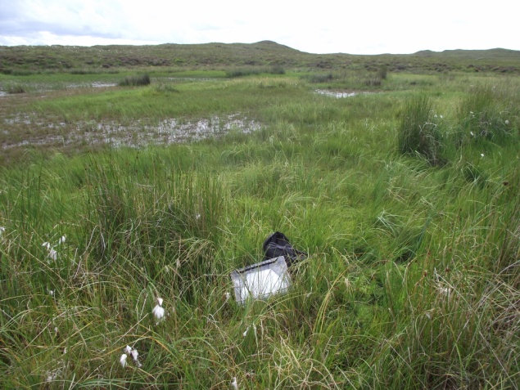
Fig. 1: Habitat of A. limosa at Loch na Beiste Moire, Lewis, VC110. © Paul A. Smith

A. paniceae
A. paniceae infects Carex panicea (Carnation sedge) (and C. vaginata, though it has not yet been found on this host in Britain), the former being a very common sedge of moorland and wetland habitats. The smut is also relatively common with PAS making records from 22 tetrads in VC110 2007-2016. Although it is found regularly, PAS found it to be particularly frequent during fieldwork on Lewis in 2016, and it is possible that it has bumper years when conditions are just right for infection. Similarly, this is the second commonest species found by ST over many locations in the north of Scotland (Western Isles to Deeside) comprising 31 tetrads and 56 locations. At some sites many sedge heads were found to be infected.

A. pratensis
A parasite of Carex flacca (Glaucous sedge). Despite the commonness of its host, not so frequently reported as other Anthracoidea species. ST has found the smut in 10 tetrads
comprising 12 locations and PAS in three locations. At several sites many sedges were infected. At one site on Kinrara Estate near Aviemore (VC96) a beetle was seen in one of the fungal balls and identified by Richard Lyszkowski as Phalacrus substriatus. This species is known to frequent Anthracoidea spore masses, which it eats, but it is also an important vector for the spread of Anthracoidea infections (Ingvarsson & Ericson 1998, 2000).
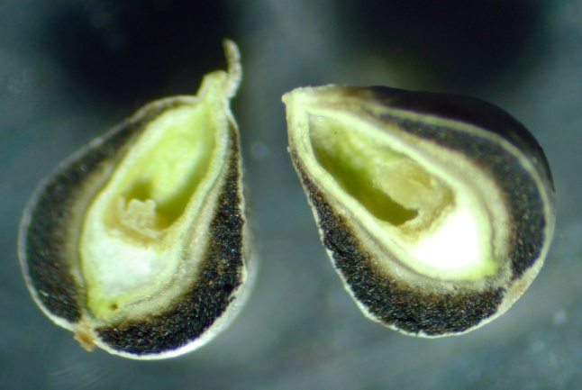
Fig. 2: Section through utricle of Carex flacca infected by Anthracoidea pratensis. © Stewart Taylor

A. pseudirregularis
Several large populations of the sedge Carex pallescens (Pale sedge) were found during a plant recording visit to the Spey Dam area west of Laggan (NN5587 9236, VC96) by ST on 5 September 2015. The smut was found on two populations of the sedge providing just the second British record. The first record occurred on the Isle of Mull (VC103) in August 1966.

A. pulicaris LAFF species
A. pulicaris is also a LAFF top 100 species. During an Anthracoidea search by ST of Carex hostiana locations near Dulnain Bridge on 3 August 2015 (NH99140 26257, VC95), several heads of Carex pulicaris (Flea sedge) were found infected by the smut. This was the third British location for the smut following the first find in East Norfolk (VC27) in July 1932, and on the Isle of Skye (VC104) in August 1932. ST found a further four sites in 2016.

A. scirpi
This is one of two European Anthracoidea species which has a host which is not a sedge – it parasitises a deergrass species (Trichophorum), and its distribution in Britain was reviewed by Smith (2010) following a year when it was abundant over a wide area of moorland in Lewis (Outer Hebrides, VC110). Despite extensive botanical fieldwork in moorland habitats in the Outer Hebrides each year since then, it did not turn up again until 2016, when it was again widespread (in a different area, though the original sites were not re-checked). This suggests that it may have occasional bumper years when conditions are just right and it produces heavy infections. There is some evidence that teliospores may persist for more than one year (Ingvarsson & Ericson 2000), which suggests a mechanism for persistence over years when no infections are apparent.

ST’s experience, in contrast, is that the smut is generally rare in VCs96 and 95, but that the same plants at one site are infected each year (this also accords with observations on other species, eg A. heterospora, where the correlation of infection incidence is high (Ingvarsson & Ericson 1998)). Perhaps this reflects a difference in conditions in the east and west of Scotland, or perhaps more observations are needed to suggest a pattern. During plant recording by ST in August 2016 large populations were found on moorland west of Carrbridge (VC95) and a single infected plant was found near Rannoch Station (VC88) in August 2016 but where the deergrass species wasn’t identified.

However, both of us find that A. scirpi occurs preferentially on the hybrid deergrass Trichophorum × foersteri, a situation apparently in contrast to the observations of Kukkonen in Finland (Smith 2010) who reports it exclusively from habitats typical for T. cespitosum s.s.. This association is interesting as T. × foersteri is a sterile hybrid; the sterility clearly does not hinder the smut in infecting the ovary – indeed the sorus in Anthracoidea is formed round it (see Fig. 2, and Scholler et al. 2003). This situation may be analogous to the hybrid infections described above for A. limosa and A. heterospora (see under A. inclusa), with the hybrid being more susceptible and potentially helping the parasite to persist (McIntire & Waterway 2001).

Because a relatively large number of records has been made since Smith (2010), an updated distribution map for A. scirpi is shown in Fig. 3. It seems likely that further records will continue to be added. On moorland in both our recording areas Trichophorum species are very common mostly T. germanicum.

Fig. 3: Known British distribution of A. scirpi. White circles = pre-1970, grey circles = 1970-99, black circles = 2000+. (Plotted using DMAP).

Other British species

Other species of Anthracoidea that have been recorded in Britain are listed below. We haven’t found these in our searches, in most cases because we have not targeted the particular hosts.

A. arenariae
This parasite of Carex arenaria (and Carex leporina outside Britain) is relatively frequently recorded, with 22 distinct records (including some repeat collections in different years) on FRDBI.

A. capillaris
This species infects Carex capillaris (Hair sedge), and is known from a single record from South Aberdeen in 1844 with a specimen in K(M) (FRDBI). However, it is not a LAFF target species, and we haven’t searched specifically for it. But in view of the finds of other species made so far, it’s probably out there somewhere, and worth looking out for if you are near the host (which has a restricted, mainly northern, range in Britain).

A. heterospora
A. heterospora is a parasite of species in the Carex nigra group. FRDBI has two records, but both on unlikely hosts; however, one of the FRDBI records under A. karii is on Carex recta, originally identified as A. hetersopora, and this seems likely to be correct and therefore should be maintained on the British list, although confirmation would be nice. Clearly FRDBI records for some Anthracoidea spp. need more work!

A. subinclusa
The principal host of A. subinclusa is Carex vesicara (Vanky 1994), but it has a wide host range, and none of the British records are from this species. Instead they are from Carex hirta, C. lasiocarpa, C. riparia and C. rostrata. A. subinclusa differs in it spores, which are more spiny than A. inclusa, so it is important to check the spores on this range of hosts.

Species waiting to be found?
There are 16 species of Anthracoidea (angulata, aspera, atratae, buxbaumii, caricis-pauciflorae, echinospora, fischeri, humilis, intercedens, irregularis, lindebergiae, misandrae, rupestris, tomentosae, turfosa, vankyi) where the hosts are present in Britain and Ireland, but the smut itself has not yet been recorded. So maybe the female flowers are awaiting infections, or maybe these smuts are already present but have not yet been detected.

Rather than try to list all the associations, which are rather complicated as several hosts have multiple smuts and several smuts are polyphagous, we list the Cyperaceae (excluding hybrids unless already recorded as hosts in Britain) that it’s worth looking closely at (in fact almost the whole British list of Carex!), derived from Vanky (1994). The ones in bold already have British records for at least one Anthracoidea, and the ones marked * are potential hosts for Anthracoidea not yet recorded for Britain (so it is worth checking any specimens on these hosts carefully):

*Carex acuta
Carex acutiformis
*Carex appropinquata
Carex aquatilis
Carex arenaria
*Carex atrata
*Carex atrofusca
Carex bigelowii
*Carex buxbaumii
*Carex canescens
Carex capillaris
Carex caryophyllea
Carex cespitosa
*Carex chordorrhiza
*Carex diandra
*Carex digitata
*Carex dioica
*Carex disticha
*Carex divulsa
Carex echinata
*Carex elata
Carex ericetorum
Carex flacca
*Carex hirta
Carex hostiana
*Carex humilis
Carex × involuta
Carex lachenalii
*Carex lasiocarpa
Carex lepidocarpa
Carex limosa
Carex magellanica
Carex montana
*Carex muricata
*Carex nigra
*Carex ornithopoda
Carex ovalis
Carex pallescens
Carex panicea
*Carex pauciflora
Carex pilulifera
Carex pseudocyperus
Carex pulicaris
Carex rariflora
Carex riparia
Carex rostrata
*Carex rupestris
Carex salina
Carex saxatilis
*Carex spicata
*Carex tomentosa
Carex vaginata
Carex vesicaria
*Carex vulpina
*Kobresia simpliciuscula
Trichophorum germanicum
Trichophorum x foersteri

There are keys to Anthracoidea in Vanky (1994, 2012), but the earlier one is out of print, and the later one ridiculously expensive. The recent (and excellent) Klenke &Scholler (2015) is a more reasonable (though still expensive) id guide. Earlier works do not cover the splitting up of A. caricis s.l. into many segregates.

Impostors
Not all ovary parasites on Cyperaceous hosts belong to Anthracoidea. Another LAFF top 100 fungus infecting Rhynchospora alba (White Beak-sedge), Ustanciosporium gigantosporum has so far evaded recapture since its last British appearance in 1959. Several species of Carex are hosts to Farysia species, which generally form much messier (and generally paler) infections.

Acknowledgements
Huge thanks are due to Martyn Ainsworth whose help with identifying ST’s initial finds was invaluable and whose encouragement to look for more made this article possible. Thanks also to Andy Amphlett for help with identifying some sedge species that were collected late in the season and had lost key identification features and to Ian Green for recording his smut finds whilst undertaking plant surveys. Brian Douglas (Kew LAFF Project) has provided support and guidance, and suggested writing this article.

References
Ericson, L., Burdon, J.J. & Wennström, A. (1993) Interspecific host hybrids and phalacrid beetles implicated in the local survival of host pathogens. Oikos 68 393–400.
Hendrichs, M., Begerow, D., Bauer, R. & Oberwinkler, F. (2005) The genus Anthracoidea (Basidiomycota, Ustilaginales): a molecular phylogenetic approach using LSU rDNA sequences. Mycological Research 109 31-40
Ingvarsson, P.K. & Ericson, L. (1998) Spatial and temporal variation in disease levels of a floral smut Anthracoidea heterospora on Carex nigra. Journal of Ecology 86 53-61.
Ingvarsson, P.K. & Ericson, L. (2000) Exploitative competition between two seed parasites on the common sedge, Carex nigra. Oikos 91 362–370.
Klenke, F. & Scholler, M. (2015) Pflanzenparasitische Kleinpilze. Springer Spektrum, Berlin & Heidelberg.
Mcintire, E.J.B. & Waterway, M.J. (2002) Clonal structure and hybrid susceptibility to a smut pathogen in microscale hybrid zones of Northern wetland Carex (Cyperaceae). American Journal of Botany 89 642–654.
Scholler, M., Schnittler, M. & Piepenbring, M. (2003) Species of Anthracoidea (Ustilaginales, Basidiomycota) on Cyperaceae in Arctic Europe. Nova Hedwigia 76 415-428.
Smith, P.A. (2010) Anthracoidea scirpi on the Isle of Lewis. Field Mycology 11 105-107.
Telfer, M.G. (2013) Keys to British Phalacridae. Available from https://docs.google.com/file/d/0BxY4LbM806l5RTRwWTBxcHpjQVE/edit (accessed 9 Oct 2016).
Vánky, K. (1994) European smut fungi. Gustav Fischer Verlag, Stuttgart.
Vánky, K. (2012) Smut fungi of the world. APS Press, St. Paul, Minnesota.

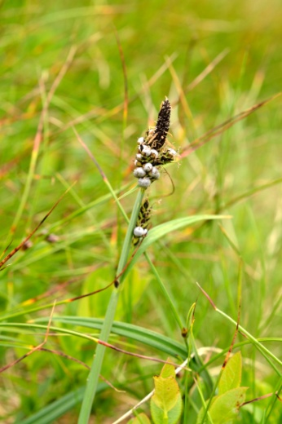 | 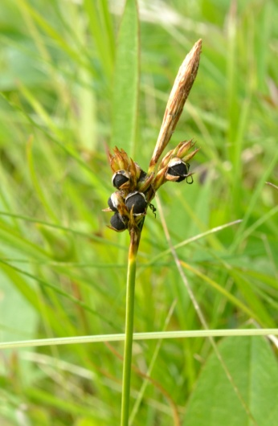 | 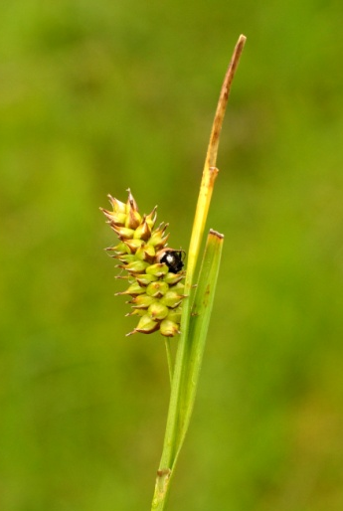 | 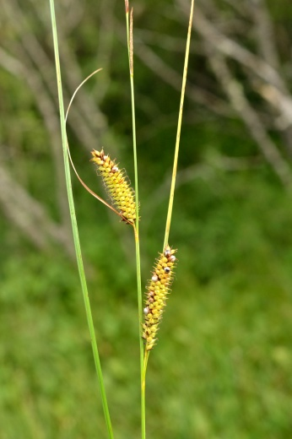
a) A. bigelowii | b) A. caryophylleae | c) A. hostianae | d) A. inclusa
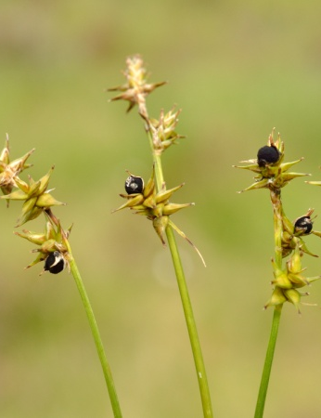 | 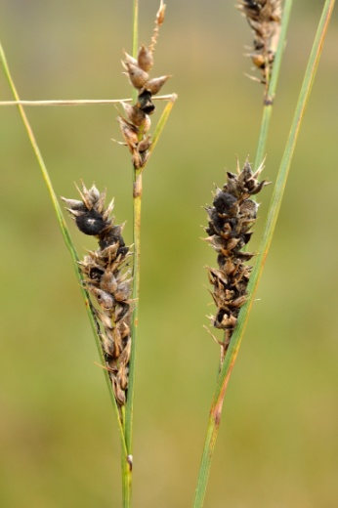 | 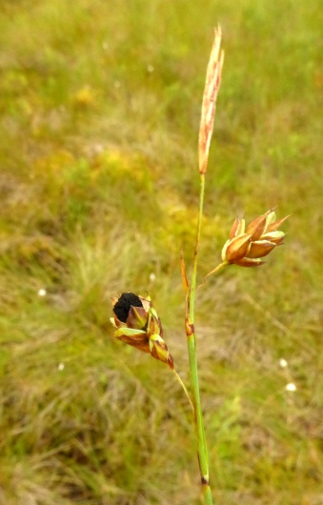
e) A. karii | f) A. lasiocarpae | g) A. limosa on Carex limosa | h) A. paniceae on Carex panicea, nr Creagan Bheiceamair, Lewis, vc110
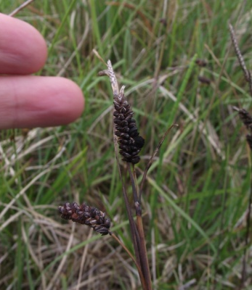 | 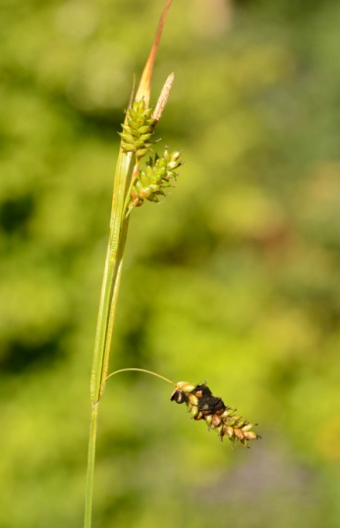 | 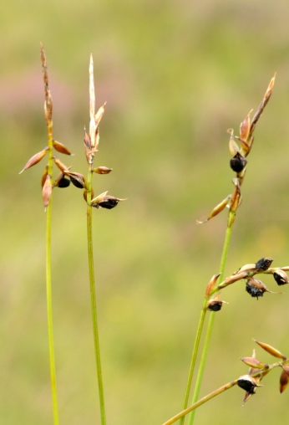
i) A. pratensis on Carex flacca, Dail bho Deas, Lewis, vc110 | j) A. pseudirregularis | k) A. pulicaris | l) A. scirpi on Trichophorum ×foersteri, Tom Mor Eimasgro, Lewis, vc110
Fig. 4: Recent Anthracoidea finds in Scotland. a-g, j, k © Stewart Taylor, h, i, l © Paul A. Smith.

