Supplemental Information
Supplemental Table 1
Population/ region | n = (take from current numbers) | Recruitment strategy | Inclusion criteria | Exclusion criteria
Birmingham, Middlesborough, Glasgow | 1537 | Advertisement in schools and colleges | Children aged 5-18 years. Ability to give verbal assent and for those over 16 written consent | 1) inability to give informed consent,  (2) height or weight outside the 0.4th and 99.6th centiles on current growth reference curves  (3) history of recurrent low trauma fractures or any fracture in the past 12 months,  (4) prolonged periods of immobilisation in the past 12 months, (5) systemic disease,  (6) any condition, or use of any drugs known to affect bone health (children were included if they used inhaled corticosteroids because of evidence suggesting that these drugs do not adversely affect BMD)  (7) participation in research involving ionising radiation in the past 12 months,
London | 372 | Advertisement in schools and colleges, GP practices and hospital advert | Children aged 5-18 years. Ability to give verbal assent and for those over 16 written consent | 1) inability to give informed consent,  2) prolonged periods of immobilisation in the past 12 months, 3) systemic disease,  4) any condition, or use of any drugs known to affect bone health (children were included if they used inhaled corticosteroids because of evidence suggesting that these drugs do not adversely affect BMD)
Sheffield | 830 | - Advertisement in schools and colleges, GP practices and hospital advert  - Healthy children with moderate or high trauma fracture recruited as part of a study from Emergency Department and age-matched controls without fractures | White Caucasian children aged 5-18 years. Ability to give verbal assent and for those over 16 written consent | 1) inability to give informed consent,  2) prolonged periods of immobilisation in the past 12 months, 3) systemic disease,  4) any condition, or use of any drugs known to affect bone health (children were included if they used inhaled corticosteroids because of evidence suggesting that these drugs do not adversely affect BMD)
Leeds | 171 | Healthy controls recruited as part of a cystic fibrosis study using a ‘buddy’ approach | White Caucasian children aged 5-18 years. Ability to give verbal assent and for those over 16 written consent | 1) inability to give informed consent,  2) prolonged periods of immobilisation in the past 12 months, 3) systemic disease,  4) any condition, or use of any drugs known to affect bone health (children were included if they used inhaled corticosteroids because of evidence suggesting that these drugs do not adversely affect BMD)
Manchester | 587 | Advertisement in schools and colleges, GP practices, healthcare centres, University of Manchester staff and student lists. | White Caucasian children aged 5-18 years. Ability to give verbal assent and for those over 16 written consent | 1) inability to give informed consent,  (2) height or weight outside the 0.4th and 99.6th centiles on current growth reference curves  (3) history of recurrent low trauma fractures or any fracture in the past 12 months,  (4) prolonged periods of immobilisation in the past 12 months, (5) systemic disease,  (6) any condition, or use of any drugs known to affect bone health (children were included if they used inhaled corticosteroids because of evidence suggesting that these drugs do not adversely affect BMD)  (7) participation in research involving ionising radiation in the past 12 months,  (8) first-degree relative with primary osteoporosis  (9) in females, current or past pregnancy

Supplemental Table 2a
In-vivo cross-calibrations equations between GE Lunar DPX-L and a GE Prodigy
GE Lunar DPX-L → GE Lunar Prodigy | r² | SEE | SEE (%)
L1L4BMD_{GEProdigy} = 0.013 + [1.014 x BMD_{GEDPX-L}] | 0.99 | 0.02 | 2.5
L1L4BMAD_{GEProdigy} = 0.002 + [1.029 x L1L4BMAD_{GEDPX-L}] | 0.96 | 0.01 | 3.1
TBBMD_{GEProdigy} = 0.017+ [0.985 x TBBMD_{GEDPX-L}] | 0.99 | 0.02 | 1.5
TBLHBMD_{GEProdigy} = 0.034 + [0.976 x TBLHBMD_{GEDPX-L}] | 0.99 | 0.02 | 1.4
TBLHBMC_{GEProdigy} = -63 + [1.078 x TBLHBMC_{GEDPX-L}] | 0.99 | 87 | 6.0
TBLEAN_{GEProdigy} = 510 + [0.984 x TBLEAN_{GEDPX-L}] | 0.99 | 753 | 2.3
TBFAT_{GEProdigy} = -54 + [1.019 x TBFAT_{GEDPX-L}] | 0.99 | 736 | 5.7
GE Lunar DPX-L → GE Lunar Prodigy Enhanced | r² | SEE | SEE (%)
TBBMD_{GE GEProdigyE} = -0.288 + [1.240 x TBBMD_{GEDPX-L}] | 0.99 | 0.02 | 2.1
TBLHBMD_{GEProdigEy}= -0.165 + [1.140 x TBLHBMD_{GEDPX-L}] | 0.99 | 0.02 | 2.2
TBLHBMC_{GEProdigyE}= 115+ [0.915 x TBLHBMC_{GEDPX-L}] | 0.99 | 63.97 | 4.6
TBLEAN_{GEProdigEy}= -1783 + [1.022 x TBLEAN_{GEDPX-L}] | 0.99 | 1351.71 | 4.2
TBFAT_{GEProdigyE}= 3009 + [0.899 x TBFAT_{GEDPX-L}] | 0.98 | 1042.16 | 7.2

Data previously published but re-analysed using contemporary software (Crabtree Ref), DPX-L Data analysed using software 4.6 & GE Prodigy data analysed using Encore version 15.

Supplemental Table 2b
In-vivo cross-calibrations equations between GE Lunar Prodigy and a GE Lunar iDXA
GE Lunar Prodigy → GE Lunar iDXA | r² | SEE | SEE (%)
L1L4BMD_{GE iDXA} = -0.008 + [0.999 x BMD_{GEProdigy}] | 0.99 | 0.02 | 2.0
L1L4BMAD_{GE iDXA} = -0.003 + [1.002 x BMAD_{GEProdigy}] | 0.98 | 0.01 | 2.2
TBBMD_{GE iDXA} = -0.322 + [1.256 x TBBMD_{GEProdigy}] | 0.97 | 0.02 | 2.7
TBLHBMD_{GE iDXA} = -0.175 + [1.111 x TBLHBMD_{GEProdigy}] | 0.98 | 0.02 | 3.1
TBLHBMC_{GE iDXA} = 110 + [0.898 x TBLHBMC_{GEProdigy}] | 0.99 | 54.74 | 5.1
TBLEAN_{GE iDXA} = -523 + [0.991 x TBLEAN_{GEProdigy}] | 0.99 | 223.89 | 3.6
TBFAT_{GE iDXA} = 2303 + [0.945 x TBFAT_{GEProdigy}] | 0.99 | 732.35 | 5.2
GE Lunar Prodigy Enhanced → GE Lunar iDXA | r² | SEE | SEE (%)
TBBMD_{GE iDXA} = -0.003 + [0.989 x TBBMD_{GEProdigy}] | 0.98 | 0.02 | 2.2
TBLHBMD_{GE iDXA} = -0.024 + [1.018 x TBLHBMD_{GEProdigyE}] | 0.99 | 0.02 | 2.3
TBLHBMC_{GE iDXA} = -46 + [1.021 x TBLHBMC_{GEProdigyE}] | 0.99 | 28.84 | 2.7
TBLEAN_{GE iDXA} = 521 + [1.001 x TBLEAN_{GEProdigyE}] | 0.99 | 387.25 | 1.4
TBFAT_{GE iDXA} = -159 + [0.992 x TBFAT_{GEProdigyE}] | 0.99 | 358.69 | 2.6

Data currently unpublished, based on in-vivo cross-calibration of 70 children aged 5-20 years. Both GE Lunar Prodigy and iDXA data analysed using Encore version 15.

Supplemental Table 2c
In-vitro Cross-calibrations equations between GE Lunar iDXA and a Hologic Discovery
Hologic Discovery → GE Lunar iDXA | r² | SEE | SEE (%)
L1L4BMD_{GEiDXA} = 0.050 + [1.126 x L1L4BMD_{Hologic}] | 0.99 | 0.01 | 1.0
L1L4BMC_{GEiDXA} = 0.025 + [1.120 x L1L4BMC_{Hologic}] | 0.99 | 0.14 | 1.4
L1L4Area_{GEiDXA} = -3.463+ [1.286x L1L4BMC_{Hologic}] | 0.98 | 0.11 | 1.1
L1L4BMAD_{GEiDXA}= 0.026 + [1.119 x L1L4BMAD_{Hologic}] | 0.99 | 0.01 | 1.3

Cross-calibration equations calculated using the European Spine Phantom, Hologic Discovery Apex 4.1 and GE Lunar iDXA Encore version 15.0.

Supplemental Table 3a Age scale and EDF’s Used to Fit GE Lunar Prodigy Lumbar Spine BMAD LMS Curves
 | BMAD – Girls |  |  | BMAD – Boys
 | White | Asian | Black | White | Asian | Black
Age Scale | Rescaled | Rescaled | Original | Rescaled | Rescaled | Original
EDF for L | 1 | 1 | 1 | 0 | 0 | 0
EDF for M | 5 | 5 | 5 | 5 | 5 | 5
EDF for S | 1 | 2 | 1 | 1 | 1 | 1

Supplemental Table 3b Age scale and EDF’s Used to Fit GE Lunar iDXA Lumbar Spine BMAD LMS Curves
 | BMAD – Girls |  |  | BMAD – Boys
 | White | Asian | Black | White | Asian | Black
Age Scale | Rescaled | Rescaled | Rescaled | Rescaled | Rescaled | Original
EDF for L | 1 | 0 | 0 | 0 | 0 | 0
EDF for M | 5 | 4 | 4 | 5 | 5 | 4
EDF for S | 1 | 1 | 1 | 1 | 1 | 0

Supplemental Table 3c Age scale and EDF’s Used to Fit Hologic Lumbar Spine BMAD LMS Curves
 | BMAD – Girls | BMAD – Boys
 | White | White
Age Scale | Rescaled | Rescaled
EDF for L | 0 | 0
EDF for M | 4 | 4
EDF for S | 1 | 2

Supplemental Table 3d Age scale and EDF’s Used to Fit GE Lunar Prodigy Lumbar Spine BMD LMS Curves
 | L1L4BMD – Girls |  |  | L1L4BMD – Boys
 | White | Asian + White | Black | White | Asian + White | Black
Age Scale | Rescaled | Rescaled | Rescaled | Rescaled | Rescaled | Rescaled
EDF for L | 1 | 1 | 0 | 0 | 1 | 0
EDF for M | 5 | 5 | 5 | 5 | 5 | 4
EDF for S | 3 | 3 | 1 | 1 | 2 | 1

Supplemental Table 3e Age scale and EDF’s Used to Fit GE Lunar iDXA Lumbar Spine BMD LMS Curves
 | L1L4BMD – Girls |  |  | L1L4BMD – Boys
 | White | Asian + White | Black | White | Asian + White | Black
Age Scale | Rescaled | Rescaled | Rescaled | Rescaled | Rescaled | Rescaled
EDF for L | 1 | 1 | 0 | 0 | 1 | 0
EDF for M | 5 | 5 | 5 | 5 | 5 | 4
EDF for S | 3 | 3 | 1 | 1 | 1 | 1

Supplemental Table 3f Age scale and EDF’s Used to Fit Hologic Lumbar Spine BMD LMS Curves
 | L1L4BMD – Girls | L1L4BMD – Boys
 | White | White
Age Scale | Rescaled | Rescaled
EDF for L | 0 | 0
EDF for M | 4 | 4
EDF for S | 1 | 1

Supplemental Table 3g Age scale and EDF’s Used to Fit GE Lunar Prodigy TBLH BMD LMS Curves
 | TBLH BMD – Girls |  |  | TBLH BMD – Boys
 | White | Asian + White | Black | White | Asian + White | Black
Age Scale | Rescaled | Rescaled | Rescaled | Rescaled | Rescaled | Rescaled
EDF for L | 1 | 1 | 0 | 0 | 0 | 0
EDF for M | 5 | 5 | 5 | 5 | 5 | 5
EDF for S | 3 | 3 | 2 | 2 | 2 | 2

Supplemental Table 3h Age scale and EDF’s Used to Fit GE Lunar Prodigy Enhanced TBLH BMD LMS Curves
 | TBLH BMD – Girls |  |  | TBLH BMD – Boys
 | White | Asian + White | Black | White | Asian + White | Black
Age Scale | Rescaled | Rescaled | Rescaled | Rescaled | Rescaled | Rescaled
EDF for L | 1 | 1 | 0 | 0 | 0 | 0
EDF for M | 5 | 5 | 5 | 5 | 5 | 5
EDF for S | 1 | 1 | 1 | 2 | 2 | 2

Supplemental Table 3i Age scale and EDF’s Used to Fit GE Lunar iDXA Lumbar Spine BMD LMS Curves
 | TBLH BMD – Girls |  |  | TBLH BMD – Boys
 | White | Asian + White | Black | White | Asian + White | Black
Age Scale | Rescaled | Rescaled | Rescaled | Rescaled | Rescaled | Rescaled
EDF for L | 1 | 1 | 0 | 1 | 0 | 0
EDF for M | 5 | 5 | 5 | 5 | 5 | 5
EDF for S | 3 | 3 | 1 | 2 | 2 | 2

Supplemental Table 3j Age scale and EDF’s Used to Fit Hologic Lumbar Spine BMD LMS Curves
 | TBLH BMD – Girls | TBLH BMD – Boys
 | White | White
Age Scale | Rescaled | Rescaled
EDF for L | 0 | 0
EDF for M | 4 | 5
EDF for S | 1 | 1

Supplemental Table 4a LMS values for Lumbar Spine BMAD – GE LUNAR PRODIGY Encore versions 10.0 -15.0
 | GE Lunar Prodigy - Girls |  |  |  |  |  |  |  |  | GE Lunar Prodigy - Boys
 | White |  |  | Asian |  |  | Black |  |  | White |  |  | Asian |  |  | Black
Age (years) | L | M | S | L | M | S | L | M | S | L | M | S | L | M | S | L | M | S
4 | -0.01 | 0.265 | 0.10 |  |  |  |  |  |  | 1.00 | 0.256 | 0.10
4.5 | -0.01 | 0.266 | 0.10 |  |  |  |  |  |  | 1.00 | 0.256 | 0.10
5 | -0.01 | 0.266 | 0.10 | 0.04 | 0.257 | 0.09 |  |  |  | 1.00 | 0.256 | 0.10 | 1.00 | 0.262 | 0.10 | 1.00 | 0.258 | 0.09
5.5 | -0.01 | 0.266 | 0.10 | 0.04 | 0.260 | 0.09 | 0.10 | 0.270 | 0.12 | 1.00 | 0.256 | 0.10 | 1.00 | 0.262 | 0.10 | 1.00 | 0.259 | 0.09
6 | -0.01 | 0.266 | 0.10 | 0.04 | 0.262 | 0.09 | 0.10 | 0.272 | 0.12 | 1.00 | 0.256 | 0.10 | 1.00 | 0.262 | 0.10 | 1.00 | 0.261 | 0.09
6.5 | -0.01 | 0.266 | 0.10 | 0.04 | 0.265 | 0.09 | 0.10 | 0.274 | 0.12 | 1.00 | 0.256 | 0.10 | 1.00 | 0.262 | 0.10 | 1.00 | 0.262 | 0.09
7 | -0.01 | 0.266 | 0.10 | 0.04 | 0.267 | 0.09 | 0.10 | 0.275 | 0.12 | 1.00 | 0.256 | 0.10 | 1.00 | 0.262 | 0.10 | 1.00 | 0.264 | 0.09
7.5 | -0.01 | 0.266 | 0.10 | 0.04 | 0.270 | 0.09 | 0.10 | 0.277 | 0.12 | 1.00 | 0.256 | 0.10 | 1.00 | 0.262 | 0.10 | 1.00 | 0.266 | 0.09
8 | -0.01 | 0.266 | 0.10 | 0.04 | 0.274 | 0.09 | 0.10 | 0.278 | 0.12 | 1.00 | 0.256 | 0.10 | 1.00 | 0.262 | 0.10 | 1.00 | 0.267 | 0.09
8.5 | -0.01 | 0.266 | 0.10 | 0.04 | 0.277 | 0.09 | 0.10 | 0.279 | 0.12 | 1.00 | 0.256 | 0.10 | 1.00 | 0.262 | 0.10 | 1.00 | 0.268 | 0.09
9 | -0.01 | 0.267 | 0.10 | 0.04 | 0.280 | 0.09 | 0.10 | 0.280 | 0.12 | 1.00 | 0.256 | 0.10 | 1.00 | 0.262 | 0.10 | 1.00 | 0.270 | 0.09
9.5 | -0.01 | 0.267 | 0.10 | 0.04 | 0.282 | 0.09 | 0.10 | 0.283 | 0.12 | 1.00 | 0.256 | 0.10 | 1.00 | 0.261 | 0.10 | 1.00 | 0.271 | 0.09
10 | -0.01 | 0.268 | 0.10 | 0.04 | 0.285 | 0.09 | 0.10 | 0.286 | 0.12 | 1.00 | 0.256 | 0.10 | 1.00 | 0.261 | 0.10 | 1.00 | 0.272 | 0.09
10.5 | -0.01 | 0.270 | 0.10 | 0.04 | 0.287 | 0.09 | 0.10 | 0.290 | 0.12 | 1.00 | 0.256 | 0.10 | 1.00 | 0.261 | 0.10 | 1.00 | 0.273 | 0.09
11 | -0.01 | 0.273 | 0.10 | 0.04 | 0.288 | 0.09 | 0.10 | 0.295 | 0.12 | 1.00 | 0.256 | 0.10 | 1.00 | 0.261 | 0.10 | 1.00 | 0.274 | 0.09
11.5 | -0.01 | 0.277 | 0.10 | 0.04 | 0.290 | 0.09 | 0.10 | 0.301 | 0.12 | 1.00 | 0.257 | 0.10 | 1.00 | 0.261 | 0.10 | 1.00 | 0.275 | 0.09
12 | -0.01 | 0.282 | 0.10 | 0.04 | 0.294 | 0.09 | 0.10 | 0.307 | 0.12 | 1.00 | 0.257 | 0.10 | 1.00 | 0.262 | 0.10 | 1.00 | 0.277 | 0.09
12.5 | -0.01 | 0.287 | 0.10 | 0.04 | 0.300 | 0.09 | 0.10 | 0.315 | 0.12 | 1.00 | 0.257 | 0.10 | 1.00 | 0.263 | 0.10 | 1.00 | 0.278 | 0.09
13 | -0.01 | 0.295 | 0.10 | 0.04 | 0.307 | 0.09 | 0.10 | 0.322 | 0.12 | 1.00 | 0.259 | 0.10 | 1.00 | 0.266 | 0.10 | 1.00 | 0.279 | 0.09
13.5 | -0.01 | 0.304 | 0.10 | 0.04 | 0.314 | 0.09 | 0.10 | 0.330 | 0.12 | 1.00 | 0.263 | 0.10 | 1.00 | 0.269 | 0.10 | 1.00 | 0.280 | 0.09
14 | -0.01 | 0.312 | 0.10 | 0.04 | 0.320 | 0.09 | 0.10 | 0.337 | 0.12 | 1.00 | 0.269 | 0.10 | 1.00 | 0.274 | 0.10 | 1.00 | 0.281 | 0.09
14.5 | -0.01 | 0.317 | 0.10 | 0.04 | 0.324 | 0.08 | 0.10 | 0.343 | 0.12 | 1.00 | 0.276 | 0.10 | 1.00 | 0.281 | 0.10 | 1.00 | 0.283 | 0.09
15 | -0.01 | 0.320 | 0.10 | 0.04 | 0.328 | 0.08 | 0.10 | 0.347 | 0.12 | 1.00 | 0.282 | 0.10 | 1.00 | 0.290 | 0.10 | 1.00 | 0.287 | 0.09
15.5 | -0.01 | 0.322 | 0.10 | 0.04 | 0.330 | 0.08 | 0.10 | 0.350 | 0.12 | 1.00 | 0.288 | 0.10 | 1.00 | 0.298 | 0.10 | 1.00 | 0.291 | 0.09
16 | -0.01 | 0.324 | 0.10 | 0.04 | 0.332 | 0.08 | 0.10 | 0.352 | 0.12 | 1.00 | 0.292 | 0.10 | 1.00 | 0.303 | 0.10 | 1.00 | 0.296 | 0.09
16.5 | -0.01 | 0.325 | 0.10 | 0.04 | 0.332 | 0.08 | 0.10 | 0.355 | 0.12 | 1.00 | 0.295 | 0.10 | 1.00 | 0.306 | 0.10 | 1.00 | 0.301 | 0.09
17 | -0.01 | 0.326 | 0.10 | 0.04 | 0.332 | 0.08 | 0.10 | 0.358 | 0.12 | 1.00 | 0.297 | 0.10 | 1.00 | 0.307 | 0.10 | 1.00 | 0.306 | 0.09
17.5 | -0.01 | 0.327 | 0.10 | 0.04 | 0.332 | 0.08 | 0.10 | 0.361 | 0.12 | 1.00 | 0.299 | 0.10 | 1.00 | 0.308 | 0.10 | 1.00 | 0.312 | 0.09
18 | -0.01 | 0.328 | 0.10 | 0.04 | 0.333 | 0.08 | 0.10 | 0.365 | 0.12 | 1.00 | 0.301 | 0.10 | 1.00 | 0.308 | 0.10 | 1.00 | 0.317 | 0.09
18.5 | -0.01 | 0.328 | 0.10 | 0.04 | 0.333 | 0.08 | 0.10 | 0.369 | 0.12 | 1.00 | 0.302 | 0.10 | 1.00 | 0.308 | 0.10
19 | -0.01 | 0.328 | 0.10 |  |  |  | 0.10 | 0.374 | 0.12 | 1.00 | 0.303 | 0.10 | 1.00 | 0.308 | 0.10
19.5 | -0.01 | 0.329 | 0.10 |  |  |  | 0.10 | 0.378 | 0.12 | 1.00 | 0.304 | 0.10 | 1.00 | 0.307 | 0.10
20 | -0.01 | 0.329 | 0.10 |  |  |  | 0.10 | 0.382 | 0.12 | 1.00 | 0.304 | 0.10

Supplemental Table 4b LMS values for Lumbar Spine BMAD – GE LUNAR iDXA Encore versions 10.0 -15.0
 | GE Lunar iDXA - Girls |  |  |  |  |  |  |  |  | GE Lunar iDXA - Boys
 | White |  |  | Asian |  |  | Black |  |  | White |  |  | Asian |  |  | Black
Age (years) | L | M | S | L | M | S | L | M | S | L | M | S | L | M | S | L | M | S
4 | -0.01 | 0.263 | 0.11 |  |  |  |  |  |  | 1.00 | 0.254 | 0.11
4.5 | -0.01 | 0.263 | 0.11 |  |  |  |  |  |  | 1.00 | 0.254 | 0.11
5 | -0.01 | 0.264 | 0.11 | 1.00 | 0.259 | 0.09 |  |  |  | 1.00 | 0.254 | 0.11 | -0.05 | 0.259 | 0.10 | 1.00 | 0.256 | 0.10
5.5 | -0.01 | 0.264 | 0.11 | 1.00 | 0.261 | 0.09 | 1.00 | 0.268 | 0.12 | 1.00 | 0.254 | 0.11 | -0.05 | 0.258 | 0.10 | 1.00 | 0.257 | 0.10
6 | -0.01 | 0.264 | 0.11 | 1.00 | 0.263 | 0.09 | 1.00 | 0.270 | 0.12 | 1.00 | 0.254 | 0.11 | -0.05 | 0.258 | 0.10 | 1.00 | 0.259 | 0.10
6.5 | -0.01 | 0.264 | 0.11 | 1.00 | 0.265 | 0.09 | 1.00 | 0.272 | 0.12 | 1.00 | 0.255 | 0.11 | -0.05 | 0.258 | 0.10 | 1.00 | 0.260 | 0.10
7 | -0.01 | 0.265 | 0.11 | 1.00 | 0.267 | 0.09 | 1.00 | 0.273 | 0.12 | 1.00 | 0.255 | 0.11 | -0.05 | 0.258 | 0.10 | 1.00 | 0.262 | 0.10
7.5 | -0.01 | 0.265 | 0.11 | 1.00 | 0.269 | 0.09 | 1.00 | 0.275 | 0.12 | 1.00 | 0.255 | 0.11 | -0.05 | 0.258 | 0.10 | 1.00 | 0.263 | 0.10
8 | -0.01 | 0.265 | 0.11 | 1.00 | 0.272 | 0.09 | 1.00 | 0.276 | 0.12 | 1.00 | 0.256 | 0.11 | -0.05 | 0.258 | 0.10 | 1.00 | 0.264 | 0.10
8.5 | -0.01 | 0.266 | 0.11 | 1.00 | 0.274 | 0.09 | 1.00 | 0.278 | 0.12 | 1.00 | 0.256 | 0.11 | -0.05 | 0.258 | 0.10 | 1.00 | 0.266 | 0.10
9 | -0.01 | 0.266 | 0.11 | 1.00 | 0.277 | 0.09 | 1.00 | 0.280 | 0.12 | 1.00 | 0.256 | 0.11 | -0.05 | 0.257 | 0.10 | 1.00 | 0.267 | 0.10
9.5 | -0.01 | 0.267 | 0.11 | 1.00 | 0.279 | 0.09 | 1.00 | 0.282 | 0.12 | 1.00 | 0.256 | 0.11 | -0.05 | 0.257 | 0.10 | 1.00 | 0.268 | 0.10
10 | -0.01 | 0.269 | 0.11 | 1.00 | 0.282 | 0.09 | 1.00 | 0.285 | 0.12 | 1.00 | 0.256 | 0.11 | -0.05 | 0.257 | 0.10 | 1.00 | 0.269 | 0.10
10.5 | -0.01 | 0.270 | 0.11 | 1.00 | 0.285 | 0.09 | 1.00 | 0.288 | 0.12 | 1.00 | 0.256 | 0.11 | -0.05 | 0.256 | 0.10 | 1.00 | 0.270 | 0.10
11 | -0.01 | 0.273 | 0.11 | 1.00 | 0.287 | 0.09 | 1.00 | 0.293 | 0.12 | 1.00 | 0.256 | 0.11 | -0.05 | 0.256 | 0.10 | 1.00 | 0.271 | 0.10
11.5 | -0.01 | 0.276 | 0.11 | 1.00 | 0.290 | 0.09 | 1.00 | 0.298 | 0.12 | 1.00 | 0.256 | 0.11 | -0.05 | 0.257 | 0.10 | 1.00 | 0.273 | 0.10
12 | -0.01 | 0.281 | 0.11 | 1.00 | 0.294 | 0.09 | 1.00 | 0.305 | 0.12 | 1.00 | 0.257 | 0.11 | -0.05 | 0.257 | 0.10 | 1.00 | 0.274 | 0.10
12.5 | -0.01 | 0.287 | 0.11 | 1.00 | 0.299 | 0.09 | 1.00 | 0.314 | 0.12 | 1.00 | 0.258 | 0.11 | -0.05 | 0.260 | 0.10 | 1.00 | 0.276 | 0.10
13 | -0.01 | 0.295 | 0.11 | 1.00 | 0.304 | 0.09 | 1.00 | 0.322 | 0.12 | 1.00 | 0.259 | 0.11 | -0.05 | 0.263 | 0.10 | 1.00 | 0.277 | 0.10
13.5 | -0.01 | 0.303 | 0.11 | 1.00 | 0.310 | 0.09 | 1.00 | 0.331 | 0.12 | 1.00 | 0.262 | 0.11 | -0.05 | 0.267 | 0.10 | 1.00 | 0.279 | 0.10
14 | -0.01 | 0.311 | 0.11 | 1.00 | 0.315 | 0.09 | 1.00 | 0.339 | 0.12 | 1.00 | 0.267 | 0.11 | -0.05 | 0.272 | 0.10 | 1.00 | 0.281 | 0.10
14.5 | -0.01 | 0.317 | 0.11 | 1.00 | 0.320 | 0.09 | 1.00 | 0.345 | 0.12 | 1.00 | 0.274 | 0.11 | -0.05 | 0.279 | 0.10 | 1.00 | 0.284 | 0.10
15 | -0.01 | 0.320 | 0.11 | 1.00 | 0.324 | 0.09 | 1.00 | 0.350 | 0.12 | 1.00 | 0.281 | 0.11 | -0.05 | 0.288 | 0.10 | 1.00 | 0.287 | 0.10
15.5 | -0.01 | 0.322 | 0.11 | 1.00 | 0.327 | 0.09 | 1.00 | 0.353 | 0.12 | 1.00 | 0.286 | 0.11 | -0.05 | 0.294 | 0.10 | 1.00 | 0.290 | 0.10
16 | -0.01 | 0.323 | 0.11 | 1.00 | 0.329 | 0.09 | 1.00 | 0.356 | 0.12 | 1.00 | 0.291 | 0.11 | -0.05 | 0.298 | 0.10 | 1.00 | 0.294 | 0.10
16.5 | -0.01 | 0.324 | 0.11 | 1.00 | 0.331 | 0.09 | 1.00 | 0.358 | 0.12 | 1.00 | 0.295 | 0.11 | -0.05 | 0.301 | 0.10 | 1.00 | 0.299 | 0.10
17 | -0.01 | 0.325 | 0.11 | 1.00 | 0.332 | 0.09 | 1.00 | 0.361 | 0.12 | 1.00 | 0.297 | 0.11 | -0.05 | 0.303 | 0.10 | 1.00 | 0.303 | 0.10
17.5 | -0.01 | 0.325 | 0.11 | 1.00 | 0.333 | 0.09 | 1.00 | 0.364 | 0.12 | 1.00 | 0.299 | 0.11 | -0.05 | 0.303 | 0.10 | 1.00 | 0.308 | 0.10
18 | -0.01 | 0.326 | 0.11 | 1.00 | 0.334 | 0.09 | 1.00 | 0.366 | 0.12 | 1.00 | 0.300 | 0.11 | -0.05 | 0.303 | 0.10 | 1.00 | 0.312 | 0.10
18.5 | -0.01 | 0.326 | 0.11 | 1.00 | 0.334 | 0.09 | 1.00 | 0.370 | 0.12 | 1.00 | 0.301 | 0.11 | -0.05 | 0.304 | 0.10
19 | -0.01 | 0.326 | 0.11 |  |  |  | 1.00 | 0.373 | 0.12 | 1.00 | 0.301 | 0.11 | -0.05 | 0.304 | 0.10
19.5 | -0.01 | 0.326 | 0.11 |  |  |  | 1.00 | 0.376 | 0.12 | 1.00 | 0.302 | 0.11 | -0.05 | 0.304 | 0.10
20 | -0.01 | 0.326 | 0.11 |  |  |  | 1.00 | 0.379 | 0.12 | 1.00 | 0.302 | 0.11

Supplemental Table 4c LMS values for Lumbar Spine BMAD – HOLOGIC DISCOVERY versions 12 -Apex 4
 | Hologic - Girls |  |  | Hologic - Boys
 | White |  |  | White
Age (years) | L | M | S | L | M | S
4
4.5 | 1.00 | 0.178 | 0.11
5 | 1.00 | 0.178 | 0.11 | 1.00 | 0.173 | 0.15
5.5 | 1.00 | 0.180 | 0.11 | 1.00 | 0.174 | 0.14
6 | 1.00 | 0.182 | 0.11 | 1.00 | 0.175 | 0.14
6.5 | 1.00 | 0.183 | 0.11 | 1.00 | 0.175 | 0.14
7 | 1.00 | 0.185 | 0.11 | 1.00 | 0.176 | 0.14
7.5 | 1.00 | 0.187 | 0.11 | 1.00 | 0.177 | 0.14
8 | 1.00 | 0.189 | 0.11 | 1.00 | 0.178 | 0.14
8.5 | 1.00 | 0.191 | 0.11 | 1.00 | 0.179 | 0.14
9 | 1.00 | 0.193 | 0.11 | 1.00 | 0.180 | 0.14
9.5 | 1.00 | 0.196 | 0.11 | 1.00 | 0.182 | 0.14
10 | 1.00 | 0.198 | 0.11 | 1.00 | 0.183 | 0.14
10.5 | 1.00 | 0.202 | 0.11 | 1.00 | 0.185 | 0.13
11 | 1.00 | 0.206 | 0.11 | 1.00 | 0.187 | 0.13
11.5 | 1.00 | 0.212 | 0.11 | 1.00 | 0.190 | 0.13
12 | 1.00 | 0.217 | 0.11 | 1.00 | 0.193 | 0.13
12.5 | 1.00 | 0.223 | 0.11 | 1.00 | 0.197 | 0.12
13 | 1.00 | 0.229 | 0.11 | 1.00 | 0.203 | 0.12
13.5 | 1.00 | 0.234 | 0.11 | 1.00 | 0.209 | 0.12
14 | 1.00 | 0.238 | 0.11 | 1.00 | 0.215 | 0.11
14.5 | 1.00 | 0.242 | 0.11 | 1.00 | 0.222 | 0.11
15 | 1.00 | 0.245 | 0.11 | 1.00 | 0.228 | 0.10
15.5 | 1.00 | 0.248 | 0.11 | 1.00 | 0.234 | 0.10
16 | 1.00 | 0.250 | 0.11 | 1.00 | 0.238 | 0.10
16.5 | 1.00 | 0.252 | 0.11 | 1.00 | 0.242 | 0.09
17 | 1.00 | 0.254 | 0.11 | 1.00 | 0.244 | 0.09
17.5 | 1.00 | 0.255 | 0.11 | 1.00 | 0.246 | 0.09
18 | 1.00 | 0.256 | 0.11 | 1.00 | 0.248 | 0.09
18.5 | 1.00 | 0.258 | 0.11 | 1.00 | 0.249 | 0.09
19 | 1.00 | 0.259 | 0.11 | 1.00 | 0.250 | 0.09
19.5 | 1.00 | 0.260 | 0.11 | 1.00 | 0.250 | 0.08
20 | 1.00 | 0.261 | 0.11 | 1.00 | 0.251 | 0.08

Supplemental Table 5a LMS values for L1L4 BMD– GE LUNAR PRODIGY Encore versions 10.0 -15.0
 | GE Lunar Prodigy - Girls |  |  |  |  |  |  |  |  | GE Lunar Prodigy - Boys
 | White |  |  | Asian + White |  |  | Black |  |  | White |  |  | Asian + White |  |  | Black
Age | L | M | S | L | M | S | L | M | S | L | M | S | L | M | S | L | M | S
4 | -0.16 | 0.613 | 0.09 | -0.05 | 0.607 | 0.10 |  |  |  | 1.00 | 0.609 | 0.12 | 0.52 | 0.606 | 0.11
4.5 | -0.16 | 0.625 | 0.09 | -0.05 | 0.619 | 0.10 |  |  |  | 1.00 | 0.615 | 0.12 | 0.52 | 0.612 | 0.11
5 | -0.16 | 0.636 | 0.09 | -0.05 | 0.631 | 0.10 |  |  |  | 1.00 | 0.626 | 0.12 | 0.52 | 0.623 | 0.11 | 1.00 | 0.638 | 0.10
5.5 | -0.16 | 0.648 | 0.09 | -0.05 | 0.643 | 0.10 | 1.00 | 0.654 | 0.12 | 1.00 | 0.636 | 0.12 | 0.52 | 0.634 | 0.11 | 1.00 | 0.655 | 0.10
6 | -0.16 | 0.659 | 0.10 | -0.05 | 0.656 | 0.10 | 1.00 | 0.676 | 0.12 | 1.00 | 0.647 | 0.12 | 0.52 | 0.645 | 0.11 | 1.00 | 0.671 | 0.10
6.5 | -0.16 | 0.670 | 0.10 | -0.05 | 0.668 | 0.10 | 1.00 | 0.697 | 0.12 | 1.00 | 0.659 | 0.12 | 0.52 | 0.657 | 0.11 | 1.00 | 0.688 | 0.10
7 | -0.16 | 0.681 | 0.10 | -0.05 | 0.680 | 0.11 | 1.00 | 0.715 | 0.12 | 1.00 | 0.670 | 0.12 | 0.52 | 0.669 | 0.11 | 1.00 | 0.706 | 0.10
7.5 | -0.16 | 0.693 | 0.10 | -0.05 | 0.692 | 0.11 | 1.00 | 0.732 | 0.12 | 1.00 | 0.682 | 0.12 | 0.52 | 0.681 | 0.11 | 1.00 | 0.724 | 0.10
8 | -0.16 | 0.705 | 0.11 | -0.05 | 0.705 | 0.11 | 1.00 | 0.749 | 0.12 | 1.00 | 0.693 | 0.12 | 0.52 | 0.692 | 0.11 | 1.00 | 0.741 | 0.10
8.5 | -0.16 | 0.717 | 0.11 | -0.05 | 0.720 | 0.11 | 1.00 | 0.767 | 0.12 | 1.00 | 0.705 | 0.12 | 0.52 | 0.704 | 0.11 | 1.00 | 0.758 | 0.10
9 | -0.16 | 0.732 | 0.11 | -0.05 | 0.735 | 0.11 | 1.00 | 0.788 | 0.12 | 1.00 | 0.717 | 0.12 | 0.52 | 0.716 | 0.11 | 1.00 | 0.776 | 0.10
9.5 | -0.16 | 0.748 | 0.11 | -0.05 | 0.752 | 0.12 | 1.00 | 0.811 | 0.12 | 1.00 | 0.729 | 0.12 | 0.52 | 0.728 | 0.11 | 1.00 | 0.793 | 0.10
10 | -0.16 | 0.767 | 0.12 | -0.05 | 0.773 | 0.12 | 1.00 | 0.839 | 0.12 | 1.00 | 0.742 | 0.12 | 0.52 | 0.740 | 0.12 | 1.00 | 0.811 | 0.10
10.5 | -0.16 | 0.791 | 0.12 | -0.05 | 0.797 | 0.12 | 1.00 | 0.875 | 0.12 | 1.00 | 0.755 | 0.12 | 0.52 | 0.752 | 0.12 | 1.00 | 0.828 | 0.10
11 | -0.16 | 0.819 | 0.12 | -0.05 | 0.825 | 0.12 | 1.00 | 0.915 | 0.12 | 1.00 | 0.769 | 0.12 | 0.52 | 0.766 | 0.12 | 1.00 | 0.847 | 0.10
11.5 | -0.16 | 0.853 | 0.13 | -0.05 | 0.857 | 0.12 | 1.00 | 0.959 | 0.12 | 1.00 | 0.784 | 0.12 | 0.52 | 0.781 | 0.12 | 1.00 | 0.866 | 0.10
12 | -0.16 | 0.891 | 0.13 | -0.05 | 0.895 | 0.13 | 1.00 | 1.008 | 0.12 | 1.00 | 0.802 | 0.12 | 0.52 | 0.800 | 0.12 | 1.00 | 0.887 | 0.10
12.5 | -0.16 | 0.932 | 0.13 | -0.05 | 0.936 | 0.13 | 1.00 | 1.059 | 0.12 | 1.00 | 0.825 | 0.12 | 0.52 | 0.823 | 0.12 | 1.00 | 0.908 | 0.10
13 | -0.16 | 0.978 | 0.13 | -0.05 | 0.981 | 0.12 | 1.00 | 1.110 | 0.12 | 1.00 | 0.854 | 0.12 | 0.52 | 0.852 | 0.12 | 1.00 | 0.930 | 0.10
13.5 | -0.16 | 1.023 | 0.12 | -0.05 | 1.024 | 0.12 | 1.00 | 1.158 | 0.12 | 1.00 | 0.892 | 0.12 | 0.52 | 0.887 | 0.12 | 1.00 | 0.953 | 0.10
14 | -0.16 | 1.063 | 0.12 | -0.05 | 1.062 | 0.12 | 1.00 | 1.200 | 0.12 | 1.00 | 0.936 | 0.12 | 0.52 | 0.929 | 0.12 | 1.00 | 0.977 | 0.10
14.5 | -0.16 | 1.095 | 0.12 | -0.05 | 1.092 | 0.12 | 1.00 | 1.233 | 0.12 | 1.00 | 0.983 | 0.12 | 0.52 | 0.975 | 0.12 | 1.00 | 1.004 | 0.10
15 | -0.16 | 1.121 | 0.11 | -0.05 | 1.116 | 0.11 | 1.00 | 1.256 | 0.12 | 1.00 | 1.027 | 0.12 | 0.52 | 1.019 | 0.12 | 1.00 | 1.033 | 0.10
15.5 | -0.16 | 1.140 | 0.11 | -0.05 | 1.135 | 0.11 | 1.00 | 1.271 | 0.12 | 1.00 | 1.066 | 0.12 | 0.52 | 1.059 | 0.12 | 1.00 | 1.064 | 0.10
16 | -0.16 | 1.154 | 0.11 | -0.05 | 1.149 | 0.11 | 1.00 | 1.281 | 0.12 | 1.00 | 1.097 | 0.12 | 0.52 | 1.092 | 0.12 | 1.00 | 1.098 | 0.10
16.5 | -0.16 | 1.165 | 0.10 | -0.05 | 1.159 | 0.11 | 1.00 | 1.290 | 0.12 | 1.00 | 1.120 | 0.12 | 0.52 | 1.118 | 0.12 | 1.00 | 1.134 | 0.10
17 | -0.16 | 1.173 | 0.10 | -0.05 | 1.167 | 0.11 | 1.00 | 1.299 | 0.12 | 1.00 | 1.138 | 0.12 | 0.52 | 1.138 | 0.13 | 1.00 | 1.172 | 0.10
17.5 | -0.16 | 1.178 | 0.10 | -0.05 | 1.173 | 0.10 | 1.00 | 1.306 | 0.12 | 1.00 | 1.153 | 0.12 | 0.52 | 1.154 | 0.13 | 1.00 | 1.210 | 0.10
18 | -0.16 | 1.182 | 0.10 | -0.05 | 1.177 | 0.10 | 1.00 | 1.314 | 0.12 | 1.00 | 1.166 | 0.12 | 0.52 | 1.167 | 0.13 | 1.00 | 1.241 | 0.10
18.5 | -0.16 | 1.185 | 0.10 | -0.05 | 1.181 | 0.10 | 1.00 | 1.321 | 0.12 | 1.00 | 1.177 | 0.12 | 0.52 | 1.178 | 0.13
19 | -0.16 | 1.187 | 0.10 | -0.05 | 1.183 | 0.10 | 1.00 | 1.328 | 0.12 | 1.00 | 1.188 | 0.12 | 0.52 | 1.189 | 0.13
19.5 | -0.16 | 1.188 | 0.10 | -0.05 | 1.185 | 0.10 | 1.00 | 1.336 | 0.12 | 1.00 | 1.197 | 0.12 | 0.52 | 1.199 | 0.13
20 | -0.16 | 1.189 | 0.10 | -0.05 | 1.187 | 0.10 | 1.00 | 1.343 | 0.12 | 1.00 | 1.207 | 0.12 | 0.52 | 1.208 | 0.13

Supplemental Table 5b LMS values for L1L4 BMD– GE LUNAR iDXA Encore versions 10.0 -15.0
 | GE Lunar iDXA - Girls |  |  |  |  |  |  |  |  | GE Lunar iDXA - Boys
 | White |  |  | Asian + White |  |  | Black |  |  | White |  |  | Asian + White |  |  | Black
Age | L | M | S | L | M | S | L | M | S | L | M | S | L | M | S | L | M | S
4 | 0.15 | 0.604 | 0.09 | 0.19 | 0.598 | 0.10 |  |  |  | 1.00 | 0.595 | 0.12 | 0.54 | 0.591 | 0.12
4.5 | 0.15 | 0.616 | 0.09 | 0.19 | 0.611 | 0.10 |  |  |  | 1.00 | 0.602 | 0.12 | 0.54 | 0.599 | 0.12
5 | 0.15 | 0.628 | 0.09 | 0.19 | 0.623 | 0.10 |  |  |  | 1.00 | 0.614 | 0.12 | 0.54 | 0.611 | 0.12 | 1.00 | 0.629 | 0.10
5.5 | 0.15 | 0.640 | 0.10 | 0.19 | 0.636 | 0.10 | 1.00 | 0.646 | 0.12 | 1.00 | 0.626 | 0.12 | 0.54 | 0.624 | 0.12 | 1.00 | 0.646 | 0.10
6 | 0.15 | 0.652 | 0.10 | 0.19 | 0.648 | 0.10 | 1.00 | 0.668 | 0.12 | 1.00 | 0.639 | 0.12 | 0.54 | 0.636 | 0.12 | 1.00 | 0.663 | 0.10
6.5 | 0.15 | 0.664 | 0.10 | 0.19 | 0.661 | 0.11 | 1.00 | 0.688 | 0.12 | 1.00 | 0.653 | 0.12 | 0.54 | 0.650 | 0.12 | 1.00 | 0.680 | 0.10
7 | 0.15 | 0.676 | 0.10 | 0.19 | 0.674 | 0.11 | 1.00 | 0.706 | 0.12 | 1.00 | 0.667 | 0.12 | 0.54 | 0.664 | 0.12 | 1.00 | 0.697 | 0.10
7.5 | 0.15 | 0.688 | 0.11 | 0.19 | 0.687 | 0.11 | 1.00 | 0.723 | 0.12 | 1.00 | 0.680 | 0.12 | 0.54 | 0.677 | 0.12 | 1.00 | 0.715 | 0.10
8 | 0.15 | 0.701 | 0.11 | 0.19 | 0.701 | 0.11 | 1.00 | 0.741 | 0.12 | 1.00 | 0.694 | 0.12 | 0.54 | 0.691 | 0.12 | 1.00 | 0.732 | 0.10
8.5 | 0.15 | 0.715 | 0.11 | 0.19 | 0.716 | 0.11 | 1.00 | 0.759 | 0.12 | 1.00 | 0.707 | 0.12 | 0.54 | 0.704 | 0.12 | 1.00 | 0.750 | 0.10
9 | 0.15 | 0.731 | 0.12 | 0.19 | 0.732 | 0.12 | 1.00 | 0.779 | 0.12 | 1.00 | 0.720 | 0.12 | 0.54 | 0.717 | 0.12 | 1.00 | 0.767 | 0.10
9.5 | 0.15 | 0.748 | 0.12 | 0.19 | 0.750 | 0.12 | 1.00 | 0.803 | 0.12 | 1.00 | 0.732 | 0.12 | 0.54 | 0.729 | 0.12 | 1.00 | 0.784 | 0.10
10 | 0.15 | 0.768 | 0.12 | 0.19 | 0.771 | 0.12 | 1.00 | 0.831 | 0.12 | 1.00 | 0.744 | 0.12 | 0.54 | 0.740 | 0.12 | 1.00 | 0.802 | 0.10
10.5 | 0.15 | 0.791 | 0.13 | 0.19 | 0.794 | 0.12 | 1.00 | 0.866 | 0.12 | 1.00 | 0.755 | 0.12 | 0.54 | 0.751 | 0.12 | 1.00 | 0.819 | 0.10
11 | 0.15 | 0.819 | 0.13 | 0.19 | 0.822 | 0.13 | 1.00 | 0.906 | 0.12 | 1.00 | 0.768 | 0.12 | 0.54 | 0.764 | 0.12 | 1.00 | 0.838 | 0.10
11.5 | 0.15 | 0.852 | 0.13 | 0.19 | 0.855 | 0.13 | 1.00 | 0.950 | 0.12 | 1.00 | 0.781 | 0.12 | 0.54 | 0.778 | 0.12 | 1.00 | 0.857 | 0.10
12 | 0.15 | 0.890 | 0.13 | 0.19 | 0.892 | 0.13 | 1.00 | 0.999 | 0.12 | 1.00 | 0.798 | 0.12 | 0.54 | 0.795 | 0.12 | 1.00 | 0.878 | 0.10
12.5 | 0.15 | 0.931 | 0.13 | 0.19 | 0.933 | 0.13 | 1.00 | 1.050 | 0.12 | 1.00 | 0.819 | 0.12 | 0.54 | 0.817 | 0.12 | 1.00 | 0.899 | 0.10
13 | 0.15 | 0.977 | 0.13 | 0.19 | 0.978 | 0.13 | 1.00 | 1.101 | 0.12 | 1.00 | 0.848 | 0.12 | 0.54 | 0.845 | 0.12 | 1.00 | 0.921 | 0.10
13.5 | 0.15 | 1.021 | 0.13 | 0.19 | 1.021 | 0.13 | 1.00 | 1.149 | 0.12 | 1.00 | 0.884 | 0.12 | 0.54 | 0.880 | 0.12 | 1.00 | 0.944 | 0.10
14 | 0.15 | 1.060 | 0.12 | 0.19 | 1.058 | 0.12 | 1.00 | 1.191 | 0.12 | 1.00 | 0.927 | 0.12 | 0.54 | 0.922 | 0.12 | 1.00 | 0.968 | 0.10
14.5 | 0.15 | 1.092 | 0.12 | 0.19 | 1.088 | 0.12 | 1.00 | 1.224 | 0.12 | 1.00 | 0.975 | 0.12 | 0.54 | 0.968 | 0.12 | 1.00 | 0.995 | 0.10
15 | 0.15 | 1.116 | 0.12 | 0.19 | 1.112 | 0.12 | 1.00 | 1.247 | 0.12 | 1.00 | 1.021 | 0.12 | 0.54 | 1.014 | 0.12 | 1.00 | 1.024 | 0.10
15.5 | 0.15 | 1.135 | 0.11 | 0.19 | 1.130 | 0.11 | 1.00 | 1.262 | 0.12 | 1.00 | 1.062 | 0.12 | 0.54 | 1.055 | 0.12 | 1.00 | 1.055 | 0.10
16 | 0.15 | 1.149 | 0.11 | 0.19 | 1.143 | 0.11 | 1.00 | 1.272 | 0.12 | 1.00 | 1.094 | 0.12 | 0.54 | 1.090 | 0.12 | 1.00 | 1.089 | 0.10
16.5 | 0.15 | 1.159 | 0.11 | 0.19 | 1.154 | 0.11 | 1.00 | 1.281 | 0.12 | 1.00 | 1.119 | 0.12 | 0.54 | 1.116 | 0.12 | 1.00 | 1.125 | 0.10
17 | 0.15 | 1.167 | 0.11 | 0.19 | 1.162 | 0.11 | 1.00 | 1.289 | 0.12 | 1.00 | 1.137 | 0.12 | 0.54 | 1.136 | 0.12 | 1.00 | 1.163 | 0.10
17.5 | 0.15 | 1.173 | 0.10 | 0.19 | 1.167 | 0.11 | 1.00 | 1.297 | 0.12 | 1.00 | 1.152 | 0.12 | 0.54 | 1.151 | 0.12 | 1.00 | 1.201 | 0.10
18 | 0.15 | 1.177 | 0.10 | 0.19 | 1.171 | 0.11 | 1.00 | 1.304 | 0.12 | 1.00 | 1.165 | 0.12 | 0.54 | 1.163 | 0.12 | 1.00 | 1.232 | 0.10
18.5 | 0.15 | 1.179 | 0.10 | 0.19 | 1.175 | 0.10 | 1.00 | 1.311 | 0.12 | 1.00 | 1.175 | 0.12 | 0.54 | 1.174 | 0.12
19 | 0.15 | 1.181 | 0.10 | 0.19 | 1.177 | 0.10 | 1.00 | 1.319 | 0.12 | 1.00 | 1.185 | 0.12 | 0.54 | 1.184 | 0.12
19.5 | 0.15 | 1.183 | 0.10 | 0.19 | 1.179 | 0.10 | 1.00 | 1.326 | 0.12 | 1.00 | 1.194 | 0.12 | 0.54 | 1.193 | 0.12
20 | 0.15 | 1.184 | 0.10 | 0.19 | 1.181 | 0.10 | 1.00 | 1.333 | 0.12 | 1.00 | 1.203 | 0.12 | 0.54 | 1.202 | 0.12

Supplemental Table 5c LMS values for L1L4 BMD– HOLOGIC DISCOVERY versions 12 -Apex 4
 | Hologic - Girls |  |  | Hologic - Boys
 | White |  |  | White
Age | L | M | S | L | M | S
4
4.5 | 1.00 | 0.480 | 0.12 | 1.00 | 0.495 | 0.12
5 | 1.00 | 0.482 | 0.12 | 1.00 | 0.500 | 0.12
5.5 | 1.00 | 0.495 | 0.12 | 1.00 | 0.508 | 0.12
6 | 1.00 | 0.508 | 0.12 | 1.00 | 0.516 | 0.12
6.5 | 1.00 | 0.521 | 0.12 | 1.00 | 0.525 | 0.12
7 | 1.00 | 0.535 | 0.12 | 1.00 | 0.533 | 0.12
7.5 | 1.00 | 0.549 | 0.12 | 1.00 | 0.541 | 0.12
8 | 1.00 | 0.563 | 0.12 | 1.00 | 0.551 | 0.12
8.5 | 1.00 | 0.578 | 0.12 | 1.00 | 0.561 | 0.12
9 | 1.00 | 0.594 | 0.12 | 1.00 | 0.572 | 0.12
9.5 | 1.00 | 0.612 | 0.12 | 1.00 | 0.585 | 0.12
10 | 1.00 | 0.632 | 0.12 | 1.00 | 0.599 | 0.12
10.5 | 1.00 | 0.655 | 0.12 | 1.00 | 0.616 | 0.12
11 | 1.00 | 0.682 | 0.12 | 1.00 | 0.636 | 0.12
11.5 | 1.00 | 0.711 | 0.12 | 1.00 | 0.660 | 0.12
12 | 1.00 | 0.743 | 0.12 | 1.00 | 0.688 | 0.12
12.5 | 1.00 | 0.776 | 0.12 | 1.00 | 0.721 | 0.12
13 | 1.00 | 0.809 | 0.12 | 1.00 | 0.758 | 0.12
13.5 | 1.00 | 0.839 | 0.12 | 1.00 | 0.798 | 0.12
14 | 1.00 | 0.865 | 0.12 | 1.00 | 0.838 | 0.12
14.5 | 1.00 | 0.887 | 0.12 | 1.00 | 0.877 | 0.12
15 | 1.00 | 0.906 | 0.12 | 1.00 | 0.911 | 0.12
15.5 | 1.00 | 0.922 | 0.12 | 1.00 | 0.940 | 0.12
16 | 1.00 | 0.935 | 0.12 | 1.00 | 0.965 | 0.12
16.5 | 1.00 | 0.947 | 0.12 | 1.00 | 0.984 | 0.12
17 | 1.00 | 0.957 | 0.12 | 1.00 | 1.000 | 0.12
17.5 | 1.00 | 0.967 | 0.12 | 1.00 | 1.014 | 0.12
18 | 1.00 | 0.976 | 0.12 | 1.00 | 1.026 | 0.12
18.5 | 1.00 | 0.984 | 0.12 | 1.00 | 1.037 | 0.12
19 | 1.00 | 0.992 | 0.12 | 1.00 | 1.048 | 0.12
19.5 | 1.00 | 1.000 | 0.12 | 1.00 | 1.058 | 0.12
20 | 1.00 | 1.008 | 0.12

Supplemental Table 6a LMS values for Total Body Less Head BMD– GE LUNAR PRODIGY Encore versions 10.0 -15.0
 | GE Lunar Prodigy - Girls |  |  |  |  |  |  |  |  | GE Lunar Prodigy - Boys
 | White |  |  | White +Asian |  |  | Black |  |  | White |  |  | White + Asian |  |  | Black
Age | L | M | S | L | M | S | L | M | S | L | M | S | L | M | S | L | M | S
4 | 0.00 | 0.587 | 0.05 | -0.07 | 0.584 | 0.05 |  |  |  | 1.00 | 0.604 | 0.06 | 1.00 | 0.596 | 0.06
4.5 | 0.00 | 0.604 | 0.05 | -0.07 | 0.600 | 0.05 |  |  |  | 1.00 | 0.613 | 0.06 | 1.00 | 0.606 | 0.06
5 | 0.00 | 0.620 | 0.05 | -0.07 | 0.617 | 0.06 |  |  |  | 1.00 | 0.628 | 0.06 | 1.00 | 0.623 | 0.06 | 1.00 | 0.656 | 0.05
5.5 | 0.00 | 0.636 | 0.06 | -0.07 | 0.633 | 0.06 | 1.00 | 0.668 | 0.06 | 1.00 | 0.643 | 0.06 | 1.00 | 0.639 | 0.06 | 1.00 | 0.679 | 0.05
6 | 0.00 | 0.652 | 0.06 | -0.07 | 0.649 | 0.06 | 1.00 | 0.683 | 0.06 | 1.00 | 0.658 | 0.06 | 1.00 | 0.656 | 0.06 | 1.00 | 0.701 | 0.06
6.5 | 0.00 | 0.667 | 0.06 | -0.07 | 0.665 | 0.06 | 1.00 | 0.699 | 0.06 | 1.00 | 0.673 | 0.06 | 1.00 | 0.672 | 0.07 | 1.00 | 0.721 | 0.06
7 | 0.00 | 0.682 | 0.06 | -0.07 | 0.680 | 0.06 | 1.00 | 0.715 | 0.06 | 1.00 | 0.688 | 0.06 | 1.00 | 0.687 | 0.07 | 1.00 | 0.740 | 0.06
7.5 | 0.00 | 0.696 | 0.06 | -0.07 | 0.695 | 0.07 | 1.00 | 0.732 | 0.06 | 1.00 | 0.702 | 0.07 | 1.00 | 0.702 | 0.07 | 1.00 | 0.759 | 0.06
8 | 0.00 | 0.711 | 0.07 | -0.07 | 0.711 | 0.07 | 1.00 | 0.750 | 0.06 | 1.00 | 0.717 | 0.07 | 1.00 | 0.717 | 0.07 | 1.00 | 0.775 | 0.06
8.5 | 0.00 | 0.727 | 0.07 | -0.07 | 0.726 | 0.07 | 1.00 | 0.770 | 0.07 | 1.00 | 0.733 | 0.07 | 1.00 | 0.733 | 0.07 | 1.00 | 0.792 | 0.06
9 | 0.00 | 0.743 | 0.07 | -0.07 | 0.743 | 0.07 | 1.00 | 0.792 | 0.07 | 1.00 | 0.750 | 0.07 | 1.00 | 0.749 | 0.07 | 1.00 | 0.809 | 0.06
9.5 | 0.00 | 0.761 | 0.07 | -0.07 | 0.761 | 0.07 | 1.00 | 0.814 | 0.07 | 1.00 | 0.767 | 0.07 | 1.00 | 0.766 | 0.07 | 1.00 | 0.827 | 0.07
10 | 0.00 | 0.781 | 0.07 | -0.07 | 0.781 | 0.08 | 1.00 | 0.840 | 0.07 | 1.00 | 0.785 | 0.07 | 1.00 | 0.782 | 0.07 | 1.00 | 0.847 | 0.07
10.5 | 0.00 | 0.802 | 0.08 | -0.07 | 0.802 | 0.08 | 1.00 | 0.868 | 0.07 | 1.00 | 0.803 | 0.07 | 1.00 | 0.800 | 0.07 | 1.00 | 0.867 | 0.07
11 | 0.00 | 0.825 | 0.08 | -0.07 | 0.825 | 0.08 | 1.00 | 0.897 | 0.07 | 1.00 | 0.822 | 0.07 | 1.00 | 0.818 | 0.07 | 1.00 | 0.887 | 0.07
11.5 | 0.00 | 0.848 | 0.08 | -0.07 | 0.848 | 0.08 | 1.00 | 0.925 | 0.08 | 1.00 | 0.842 | 0.08 | 1.00 | 0.839 | 0.08 | 1.00 | 0.908 | 0.07
12 | 0.00 | 0.872 | 0.08 | -0.07 | 0.872 | 0.08 | 1.00 | 0.955 | 0.08 | 1.00 | 0.864 | 0.08 | 1.00 | 0.861 | 0.08 | 1.00 | 0.931 | 0.07
12.5 | 0.00 | 0.896 | 0.08 | -0.07 | 0.896 | 0.08 | 1.00 | 0.985 | 0.08 | 1.00 | 0.888 | 0.08 | 1.00 | 0.886 | 0.08 | 1.00 | 0.953 | 0.07
13 | 0.00 | 0.920 | 0.08 | -0.07 | 0.919 | 0.08 | 1.00 | 1.015 | 0.08 | 1.00 | 0.915 | 0.08 | 1.00 | 0.913 | 0.08 | 1.00 | 0.974 | 0.08
13.5 | 0.00 | 0.942 | 0.08 | -0.07 | 0.941 | 0.08 | 1.00 | 1.044 | 0.08 | 1.00 | 0.944 | 0.08 | 1.00 | 0.942 | 0.08 | 1.00 | 0.994 | 0.08
14 | 0.00 | 0.962 | 0.08 | -0.07 | 0.960 | 0.08 | 1.00 | 1.069 | 0.09 | 1.00 | 0.974 | 0.08 | 1.00 | 0.973 | 0.08 | 1.00 | 1.013 | 0.08
14.5 | 0.00 | 0.979 | 0.08 | -0.07 | 0.976 | 0.08 | 1.00 | 1.088 | 0.09 | 1.00 | 1.003 | 0.09 | 1.00 | 1.002 | 0.09 | 1.00 | 1.031 | 0.08
15 | 0.00 | 0.993 | 0.07 | -0.07 | 0.989 | 0.08 | 1.00 | 1.102 | 0.09 | 1.00 | 1.030 | 0.09 | 1.00 | 1.029 | 0.09 | 1.00 | 1.049 | 0.08
15.5 | 0.00 | 1.004 | 0.07 | -0.07 | 1.000 | 0.08 | 1.00 | 1.112 | 0.09 | 1.00 | 1.053 | 0.09 | 1.00 | 1.052 | 0.09 | 1.00 | 1.069 | 0.08
16 | 0.00 | 1.012 | 0.07 | -0.07 | 1.008 | 0.07 | 1.00 | 1.118 | 0.09 | 1.00 | 1.073 | 0.09 | 1.00 | 1.073 | 0.09 | 1.00 | 1.091 | 0.09
16.5 | 0.00 | 1.018 | 0.07 | -0.07 | 1.014 | 0.07 | 1.00 | 1.123 | 0.09 | 1.00 | 1.091 | 0.09 | 1.00 | 1.090 | 0.09 | 1.00 | 1.118 | 0.09
17 | 0.00 | 1.022 | 0.07 | -0.07 | 1.018 | 0.07 | 1.00 | 1.128 | 0.09 | 1.00 | 1.107 | 0.09 | 1.00 | 1.105 | 0.09 | 1.00 | 1.149 | 0.09
17.5 | 0.00 | 1.025 | 0.07 | -0.07 | 1.021 | 0.07 | 1.00 | 1.132 | 0.09 | 1.00 | 1.121 | 0.09 | 1.00 | 1.118 | 0.09 | 1.00 | 1.182 | 0.09
18 | 0.00 | 1.026 | 0.07 | -0.07 | 1.023 | 0.07 | 1.00 | 1.135 | 0.09 | 1.00 | 1.133 | 0.09 | 1.00 | 1.130 | 0.09 | 1.00 | 1.210 | 0.09
18.5 | 0.00 | 1.026 | 0.07 | -0.07 | 1.023 | 0.07 | 1.00 | 1.139 | 0.09 | 1.00 | 1.145 | 0.10 | 1.00 | 1.141 | 0.09
19 | 0.00 | 1.026 | 0.07 | -0.07 | 1.024 | 0.07 | 1.00 | 1.142 | 0.09 | 1.00 | 1.156 | 0.10 | 1.00 | 1.151 | 0.10
19.5 | 0.00 | 1.027 | 0.07 | -0.07 | 1.024 | 0.07 | 1.00 | 1.145 | 0.09 | 1.00 | 1.167 | 0.10 | 1.00 | 1.161 | 0.10
20 | 0.00 | 1.028 | 0.07 | -0.07 | 1.024 | 0.07 | 1.00 | 1.148 | 0.09 | 1.00 | 1.177 | 0.10 | 1.00 | 1.171 | 0.10

Supplemental Table 6b LMS values for Total Body Less Head BMD– GE LUNAR PRODIGY ENHANCED Encore versions 14.0 -15.0
 | GE Lunar Prodigy Enhanced - Girls |  |  |  |  |  |  |  |  | GE Lunar Prodigy Enhanced- Boys
 | White |  |  | White +Asian |  |  | Black |  |  | White |  |  | White +Asian |  |  | Black
Age | L | M | S | L | M | S | L | M | S | L | M | S | L | M | S | L | M | S
4 | 0.17 | 0.495 | 0.09 | 0.12 | 0.487 | 0.09 |  |  |  | 1.00 | 0.508 | 0.08 | 1.00 | 0.503 | 0.08
4.5 | 0.17 | 0.511 | 0.09 | 0.12 | 0.505 | 0.09 |  |  |  | 1.00 | 0.518 | 0.08 | 1.00 | 0.510 | 0.08
5 | 0.17 | 0.528 | 0.09 | 0.12 | 0.522 | 0.09 |  |  |  | 1.00 | 0.533 | 0.08 | 1.00 | 0.527 | 0.08 | 1.00 | 0.562 | 0.07
5.5 | 0.17 | 0.544 | 0.09 | 0.12 | 0.539 | 0.09 | 1.00 | 0.573 | 0.09 | 1.00 | 0.549 | 0.08 | 1.00 | 0.545 | 0.08 | 1.00 | 0.589 | 0.07
6 | 0.17 | 0.561 | 0.09 | 0.12 | 0.557 | 0.09 | 1.00 | 0.592 | 0.09 | 1.00 | 0.564 | 0.08 | 1.00 | 0.562 | 0.08 | 1.00 | 0.614 | 0.07
6.5 | 0.17 | 0.577 | 0.09 | 0.12 | 0.574 | 0.09 | 1.00 | 0.610 | 0.09 | 1.00 | 0.580 | 0.08 | 1.00 | 0.579 | 0.08 | 1.00 | 0.638 | 0.07
7 | 0.17 | 0.593 | 0.09 | 0.12 | 0.591 | 0.09 | 1.00 | 0.630 | 0.09 | 1.00 | 0.597 | 0.08 | 1.00 | 0.596 | 0.08 | 1.00 | 0.661 | 0.07
7.5 | 0.17 | 0.609 | 0.09 | 0.12 | 0.607 | 0.09 | 1.00 | 0.650 | 0.09 | 1.00 | 0.613 | 0.08 | 1.00 | 0.613 | 0.08 | 1.00 | 0.683 | 0.08
8 | 0.17 | 0.625 | 0.09 | 0.12 | 0.625 | 0.09 | 1.00 | 0.671 | 0.09 | 1.00 | 0.629 | 0.09 | 1.00 | 0.630 | 0.09 | 1.00 | 0.703 | 0.08
8.5 | 0.17 | 0.642 | 0.09 | 0.12 | 0.642 | 0.09 | 1.00 | 0.694 | 0.09 | 1.00 | 0.647 | 0.09 | 1.00 | 0.648 | 0.09 | 1.00 | 0.722 | 0.08
9 | 0.17 | 0.660 | 0.09 | 0.12 | 0.661 | 0.09 | 1.00 | 0.719 | 0.09 | 1.00 | 0.666 | 0.09 | 1.00 | 0.666 | 0.09 | 1.00 | 0.743 | 0.08
9.5 | 0.17 | 0.680 | 0.09 | 0.12 | 0.681 | 0.09 | 1.00 | 0.745 | 0.09 | 1.00 | 0.686 | 0.09 | 1.00 | 0.685 | 0.09 | 1.00 | 0.766 | 0.08
10 | 0.17 | 0.702 | 0.09 | 0.12 | 0.703 | 0.09 | 1.00 | 0.775 | 0.09 | 1.00 | 0.706 | 0.09 | 1.00 | 0.704 | 0.09 | 1.00 | 0.789 | 0.08
10.5 | 0.17 | 0.726 | 0.09 | 0.12 | 0.727 | 0.09 | 1.00 | 0.808 | 0.09 | 1.00 | 0.727 | 0.09 | 1.00 | 0.724 | 0.09 | 1.00 | 0.811 | 0.08
11 | 0.17 | 0.752 | 0.09 | 0.12 | 0.752 | 0.09 | 1.00 | 0.842 | 0.09 | 1.00 | 0.749 | 0.09 | 1.00 | 0.745 | 0.09 | 1.00 | 0.832 | 0.08
11.5 | 0.17 | 0.779 | 0.09 | 0.12 | 0.778 | 0.09 | 1.00 | 0.875 | 0.09 | 1.00 | 0.773 | 0.10 | 1.00 | 0.769 | 0.10 | 1.00 | 0.855 | 0.09
12 | 0.17 | 0.807 | 0.09 | 0.12 | 0.806 | 0.09 | 1.00 | 0.909 | 0.09 | 1.00 | 0.798 | 0.10 | 1.00 | 0.795 | 0.10 | 1.00 | 0.880 | 0.09
12.5 | 0.17 | 0.836 | 0.09 | 0.12 | 0.835 | 0.09 | 1.00 | 0.946 | 0.09 | 1.00 | 0.827 | 0.10 | 1.00 | 0.824 | 0.10 | 1.00 | 0.905 | 0.09
13 | 0.17 | 0.865 | 0.09 | 0.12 | 0.864 | 0.09 | 1.00 | 0.983 | 0.09 | 1.00 | 0.860 | 0.10 | 1.00 | 0.857 | 0.10 | 1.00 | 0.931 | 0.09
13.5 | 0.17 | 0.892 | 0.09 | 0.12 | 0.891 | 0.09 | 1.00 | 1.018 | 0.09 | 1.00 | 0.895 | 0.10 | 1.00 | 0.892 | 0.10 | 1.00 | 0.955 | 0.09
14 | 0.17 | 0.917 | 0.09 | 0.12 | 0.914 | 0.09 | 1.00 | 1.048 | 0.09 | 1.00 | 0.930 | 0.11 | 1.00 | 0.927 | 0.11 | 1.00 | 0.978 | 0.09
14.5 | 0.17 | 0.937 | 0.09 | 0.12 | 0.933 | 0.09 | 1.00 | 1.072 | 0.09 | 1.00 | 0.965 | 0.11 | 1.00 | 0.961 | 0.11 | 1.00 | 1.000 | 0.10
15 | 0.17 | 0.953 | 0.09 | 0.12 | 0.949 | 0.09 | 1.00 | 1.089 | 0.09 | 1.00 | 0.997 | 0.11 | 1.00 | 0.993 | 0.11 | 1.00 | 1.021 | 0.10
15.5 | 0.17 | 0.966 | 0.09 | 0.12 | 0.962 | 0.09 | 1.00 | 1.099 | 0.09 | 1.00 | 1.025 | 0.11 | 1.00 | 1.020 | 0.11 | 1.00 | 1.044 | 0.10
16 | 0.17 | 0.976 | 0.09 | 0.12 | 0.971 | 0.09 | 1.00 | 1.106 | 0.09 | 1.00 | 1.049 | 0.11 | 1.00 | 1.044 | 0.11 | 1.00 | 1.070 | 0.10
16.5 | 0.17 | 0.982 | 0.09 | 0.12 | 0.978 | 0.09 | 1.00 | 1.112 | 0.09 | 1.00 | 1.070 | 0.12 | 1.00 | 1.065 | 0.11 | 1.00 | 1.100 | 0.10
17 | 0.17 | 0.987 | 0.09 | 0.12 | 0.983 | 0.09 | 1.00 | 1.117 | 0.09 | 1.00 | 1.089 | 0.12 | 1.00 | 1.083 | 0.12 | 1.00 | 1.136 | 0.10
17.5 | 0.17 | 0.989 | 0.09 | 0.12 | 0.986 | 0.09 | 1.00 | 1.122 | 0.09 | 1.00 | 1.106 | 0.12 | 1.00 | 1.099 | 0.12 | 1.00 | 1.175 | 0.11
18 | 0.17 | 0.990 | 0.09 | 0.12 | 0.988 | 0.09 | 1.00 | 1.126 | 0.09 | 1.00 | 1.121 | 0.12 | 1.00 | 1.114 | 0.12 | 1.00 | 1.207 | 0.11
18.5 | 0.17 | 0.991 | 0.09 | 0.12 | 0.988 | 0.09 | 1.00 | 1.131 | 0.09 | 1.00 | 1.136 | 0.12 | 1.00 | 1.128 | 0.12
19 | 0.17 | 0.992 | 0.09 | 0.12 | 0.989 | 0.09 | 1.00 | 1.135 | 0.09 | 1.00 | 1.149 | 0.12 | 1.00 | 1.142 | 0.12
19.5 | 0.17 | 0.993 | 0.09 | 0.12 | 0.989 | 0.09 | 1.00 | 1.139 | 0.09 | 1.00 | 1.162 | 0.12 | 1.00 | 1.155 | 0.12
20 | 0.17 | 0.995 | 0.09 | 0.12 | 0.990 | 0.09 | 1.00 | 1.142 | 0.09 | 1.00 | 1.175 | 0.12 | 1.00 | 1.168 | 0.12

Supplemental Table 6c LMS values for Total Body Less Head BMD– GE LUNAR iDXA Encore versions 10.0 -15.0
 | GE Lunar iDXA - Girls |  |  |  |  |  |  |  |  | GE Lunar iDXA - Boys
 | White |  |  | White +Asian |  |  | Black |  |  | White |  |  | White +Asian |  |  | Black
Age | L | M | S | L | M | S | L | M | S | L | M | S | L | M | S | L | M | S
4 | 0.08 | 0.478 | 0.07 | 0.10 | 0.472 | 0.07 |  |  |  | 0.29 | 0.490 | 0.08 | 1.00 | 0.486 | 0.08
4.5 | 0.08 | 0.496 | 0.07 | 0.10 | 0.490 | 0.07 |  |  |  | 0.29 | 0.497 | 0.08 | 1.00 | 0.493 | 0.08
5 | 0.08 | 0.513 | 0.07 | 0.10 | 0.507 | 0.08 |  |  |  | 0.29 | 0.514 | 0.08 | 1.00 | 0.511 | 0.08 | 1.00 | 0.548 | 0.07
5.5 | 0.08 | 0.530 | 0.07 | 0.10 | 0.525 | 0.08 | 1.00 | 0.559 | 0.10 | 0.29 | 0.531 | 0.08 | 1.00 | 0.530 | 0.08 | 1.00 | 0.575 | 0.07
6 | 0.08 | 0.548 | 0.08 | 0.10 | 0.543 | 0.08 | 1.00 | 0.578 | 0.10 | 0.29 | 0.548 | 0.08 | 1.00 | 0.548 | 0.08 | 1.00 | 0.601 | 0.07
6.5 | 0.08 | 0.565 | 0.08 | 0.10 | 0.561 | 0.08 | 1.00 | 0.597 | 0.10 | 0.29 | 0.566 | 0.08 | 1.00 | 0.566 | 0.09 | 1.00 | 0.625 | 0.08
7 | 0.08 | 0.581 | 0.08 | 0.10 | 0.579 | 0.08 | 1.00 | 0.617 | 0.10 | 0.29 | 0.583 | 0.09 | 1.00 | 0.585 | 0.09 | 1.00 | 0.649 | 0.08
7.5 | 0.08 | 0.598 | 0.08 | 0.10 | 0.596 | 0.09 | 1.00 | 0.638 | 0.10 | 0.29 | 0.601 | 0.09 | 1.00 | 0.603 | 0.09 | 1.00 | 0.671 | 0.08
8 | 0.08 | 0.615 | 0.08 | 0.10 | 0.614 | 0.09 | 1.00 | 0.659 | 0.10 | 0.29 | 0.619 | 0.09 | 1.00 | 0.622 | 0.09 | 1.00 | 0.691 | 0.08
8.5 | 0.08 | 0.633 | 0.09 | 0.10 | 0.632 | 0.09 | 1.00 | 0.683 | 0.10 | 0.29 | 0.639 | 0.09 | 1.00 | 0.640 | 0.09 | 1.00 | 0.711 | 0.08
9 | 0.08 | 0.651 | 0.09 | 0.10 | 0.651 | 0.09 | 1.00 | 0.708 | 0.10 | 0.29 | 0.658 | 0.09 | 1.00 | 0.659 | 0.09 | 1.00 | 0.733 | 0.08
9.5 | 0.08 | 0.671 | 0.09 | 0.10 | 0.671 | 0.09 | 1.00 | 0.735 | 0.10 | 0.29 | 0.678 | 0.09 | 1.00 | 0.678 | 0.09 | 1.00 | 0.756 | 0.08
10 | 0.08 | 0.693 | 0.09 | 0.10 | 0.693 | 0.10 | 1.00 | 0.765 | 0.10 | 0.29 | 0.697 | 0.09 | 1.00 | 0.697 | 0.09 | 1.00 | 0.779 | 0.08
10.5 | 0.08 | 0.716 | 0.10 | 0.10 | 0.717 | 0.10 | 1.00 | 0.799 | 0.10 | 0.29 | 0.717 | 0.09 | 1.00 | 0.716 | 0.09 | 1.00 | 0.801 | 0.09
11 | 0.08 | 0.741 | 0.10 | 0.10 | 0.742 | 0.10 | 1.00 | 0.833 | 0.10 | 0.29 | 0.737 | 0.10 | 1.00 | 0.736 | 0.10 | 1.00 | 0.823 | 0.09
11.5 | 0.08 | 0.768 | 0.10 | 0.10 | 0.768 | 0.10 | 1.00 | 0.866 | 0.10 | 0.29 | 0.759 | 0.10 | 1.00 | 0.758 | 0.10 | 1.00 | 0.846 | 0.09
12 | 0.08 | 0.795 | 0.10 | 0.10 | 0.796 | 0.10 | 1.00 | 0.902 | 0.10 | 0.29 | 0.783 | 0.10 | 1.00 | 0.783 | 0.10 | 1.00 | 0.871 | 0.09
12.5 | 0.08 | 0.824 | 0.10 | 0.10 | 0.825 | 0.10 | 1.00 | 0.939 | 0.10 | 0.29 | 0.810 | 0.10 | 1.00 | 0.812 | 0.10 | 1.00 | 0.898 | 0.09
13 | 0.08 | 0.853 | 0.10 | 0.10 | 0.854 | 0.10 | 1.00 | 0.977 | 0.10 | 0.29 | 0.841 | 0.10 | 1.00 | 0.844 | 0.10 | 1.00 | 0.923 | 0.09
13.5 | 0.08 | 0.881 | 0.10 | 0.10 | 0.881 | 0.10 | 1.00 | 1.012 | 0.10 | 0.29 | 0.875 | 0.10 | 1.00 | 0.879 | 0.10 | 1.00 | 0.948 | 0.09
14 | 0.08 | 0.905 | 0.10 | 0.10 | 0.904 | 0.10 | 1.00 | 1.043 | 0.10 | 0.29 | 0.911 | 0.11 | 1.00 | 0.915 | 0.11 | 1.00 | 0.972 | 0.10
14.5 | 0.08 | 0.926 | 0.10 | 0.10 | 0.924 | 0.10 | 1.00 | 1.067 | 0.10 | 0.29 | 0.946 | 0.11 | 1.00 | 0.951 | 0.11 | 1.00 | 0.994 | 0.10
15 | 0.08 | 0.943 | 0.09 | 0.10 | 0.940 | 0.09 | 1.00 | 1.084 | 0.10 | 0.29 | 0.980 | 0.11 | 1.00 | 0.984 | 0.11 | 1.00 | 1.016 | 0.10
15.5 | 0.08 | 0.956 | 0.09 | 0.10 | 0.953 | 0.09 | 1.00 | 1.095 | 0.10 | 0.29 | 1.010 | 0.11 | 1.00 | 1.014 | 0.11 | 1.00 | 1.039 | 0.10
16 | 0.08 | 0.967 | 0.09 | 0.10 | 0.963 | 0.09 | 1.00 | 1.102 | 0.10 | 0.29 | 1.037 | 0.11 | 1.00 | 1.039 | 0.11 | 1.00 | 1.065 | 0.10
16.5 | 0.08 | 0.975 | 0.09 | 0.10 | 0.971 | 0.09 | 1.00 | 1.108 | 0.10 | 0.29 | 1.061 | 0.12 | 1.00 | 1.061 | 0.11 | 1.00 | 1.096 | 0.10
17 | 0.08 | 0.980 | 0.09 | 0.10 | 0.976 | 0.09 | 1.00 | 1.113 | 0.10 | 0.29 | 1.082 | 0.12 | 1.00 | 1.081 | 0.12 | 1.00 | 1.132 | 0.11
17.5 | 0.08 | 0.983 | 0.09 | 0.10 | 0.980 | 0.09 | 1.00 | 1.118 | 0.10 | 0.29 | 1.101 | 0.12 | 1.00 | 1.098 | 0.12 | 1.00 | 1.172 | 0.11
18 | 0.08 | 0.985 | 0.09 | 0.10 | 0.982 | 0.09 | 1.00 | 1.123 | 0.10 | 0.29 | 1.118 | 0.12 | 1.00 | 1.114 | 0.12 | 1.00 | 1.204 | 0.11
18.5 | 0.08 | 0.986 | 0.09 | 0.10 | 0.984 | 0.09 | 1.00 | 1.127 | 0.10 | 0.29 | 1.134 | 0.12 | 1.00 | 1.128 | 0.12
19 | 0.08 | 0.986 | 0.09 | 0.10 | 0.984 | 0.09 | 1.00 | 1.131 | 0.10 | 0.29 | 1.149 | 0.12 | 1.00 | 1.142 | 0.12
19.5 | 0.08 | 0.987 | 0.09 | 0.10 | 0.984 | 0.09 | 1.00 | 1.135 | 0.10 | 0.29 | 1.163 | 0.12 | 1.00 | 1.156 | 0.12
20 | 0.08 | 0.987 | 0.09 | 0.10 | 0.984 | 0.09 | 1.00 | 1.138 | 0.10 | 0.29 | 1.177 | 0.12 | 1.00 | 1.169 | 0.12

Supplemental Table 6d LMS values for Total Body Less Head BMD – HOLOGIC DISCOVERY versions 12 -Apex 4
 | Hologic - Girls |  |  | Hologic - Boys
 | White |  |  | White
Age | L | M | S | L | M | S
4
4.5 | 1.00 | 0.501 | 0.08
5 | 1.00 | 0.505 | 0.08 | 1.00 | 0.541 | 0.08
5.5 | 1.00 | 0.525 | 0.08 | 1.00 | 0.552 | 0.08
6 | 1.00 | 0.545 | 0.08 | 1.00 | 0.569 | 0.08
6.5 | 1.00 | 0.565 | 0.08 | 1.00 | 0.587 | 0.08
7 | 1.00 | 0.586 | 0.08 | 1.00 | 0.604 | 0.08
7.5 | 1.00 | 0.606 | 0.08 | 1.00 | 0.622 | 0.08
8 | 1.00 | 0.626 | 0.08 | 1.00 | 0.641 | 0.08
8.5 | 1.00 | 0.647 | 0.08 | 1.00 | 0.661 | 0.08
9 | 1.00 | 0.668 | 0.08 | 1.00 | 0.681 | 0.08
9.5 | 1.00 | 0.690 | 0.08 | 1.00 | 0.699 | 0.08
10 | 1.00 | 0.712 | 0.08 | 1.00 | 0.717 | 0.08
10.5 | 1.00 | 0.734 | 0.08 | 1.00 | 0.734 | 0.08
11 | 1.00 | 0.756 | 0.08 | 1.00 | 0.751 | 0.08
11.5 | 1.00 | 0.778 | 0.08 | 1.00 | 0.768 | 0.08
12 | 1.00 | 0.800 | 0.08 | 1.00 | 0.786 | 0.08
12.5 | 1.00 | 0.822 | 0.08 | 1.00 | 0.807 | 0.08
13 | 1.00 | 0.842 | 0.08 | 1.00 | 0.833 | 0.08
13.5 | 1.00 | 0.860 | 0.08 | 1.00 | 0.863 | 0.08
14 | 1.00 | 0.876 | 0.08 | 1.00 | 0.896 | 0.08
14.5 | 1.00 | 0.890 | 0.08 | 1.00 | 0.930 | 0.08
15 | 1.00 | 0.902 | 0.08 | 1.00 | 0.961 | 0.08
15.5 | 1.00 | 0.913 | 0.08 | 1.00 | 0.990 | 0.08
16 | 1.00 | 0.921 | 0.08 | 1.00 | 1.015 | 0.08
16.5 | 1.00 | 0.929 | 0.08 | 1.00 | 1.036 | 0.08
17 | 1.00 | 0.937 | 0.08 | 1.00 | 1.053 | 0.08
17.5 | 1.00 | 0.943 | 0.08 | 1.00 | 1.068 | 0.08
18 | 1.00 | 0.950 | 0.08 | 1.00 | 1.080 | 0.08
18.5 | 1.00 | 0.956 | 0.08 | 1.00 | 1.091 | 0.08
19 | 1.00 | 0.962 | 0.08 | 1.00 | 1.102 | 0.08
19.5 | 1.00 | 0.969 | 0.08 | 1.00 | 1.112 | 0.08
20 | 1.00 | 0.975 | 0.08 | 1.00 | 1.123 | 0.08

Supplemental Table 7a Percentage of values above select centiles for GE Lunar Prodigy BMAD
Centile | Expected % Above | Observed % Above
 |  | Girls |  |  |  |  | Boys
 |  | White | Asian (White referent) | Asian | Black (White Referent) | Black | White | Asian (White Referent) | Asian | Black (White Referent) | Black
 |  | n=906 |  | n=183 |  | n=148 | n=847 |  | n=190 |  | n=128
95 | 5 | 5.0 | 3.8 | 4.4 | 2.0 | 5.4 | 4.6 | 1.1 | 5.8 | 2.3 | 3.9
90 | 10 | 9.4 | 4.4 | 9.3 | 5.4 | 11.5 | 10.3 | 5.8 | 8.4 | 3.1 | 8.6
75 | 25 | 23.8 | 13.7 | 25.7 | 14.9 | 24.3 | 25.1 | 18.9 | 26.7 | 11.7 | 20.3
50 | 50 | 50.2 | 37.7 | 49.2 | 29.1 | 50.7 | 49.6 | 43.2 | 51.8 | 29.7 | 58.6
25 | 75 | 75.2 | 69.9 | 75.4 | 52.7 | 75.0 | 76.3 | 67.4 | 75.9 | 60.2 | 74.2
10 | 90 | 89.3 | 85.2 | 87.4 | 71.6 | 87.8 | 90.4 | 85.3 | 88.5 | 81.3 | 90.6
5 | 95 | 94.8 | 94.5 | 93.4 | 80.4 | 93.9 | 94.8 | 90.5 | 94.8 | 91.4 | 95.3
Z-Score |  | NS | P<0.0001 | NS | P<0.0001 | NS | NS | P=0.0001 | NS | P<0.0001 | NS

Supplemental Table 7b Percentage of values above select centiles for GE Lunar iDXA BMAD
Centile | Expected % Above | Observed % Above
 |  | Girls |  |  |  |  | Boys
 |  | White | Asian (White Referent) | Asian | Black (White Referent) | Black | White | Asian (White Referent) | Asian | Black (White Referent) | Black
 |  | n=1101 |  | n=183 |  | n=148 | n=1012 |  | n=190 |  | n=128
95 | 5 | 4.9 | 3.8 | 4.9 | 2.7 | 4.1 | 4.6 | 1.1 | 6.8 | 2.3 | 4.7
90 | 10 | 9.2 | 4.4 | 8.2 | 5.4 | 9.5 | 9.8 | 6.8 | 7.9 | 3.1 | 8.6
75 | 25 | 24.0 | 14.2 | 26.2 | 14.9 | 24.3 | 25 | 21.1 | 26.3 | 11.7 | 21.1
50 | 50 | 50.7 | 39.9 | 51.9 | 31.8 | 52.0 | 49.7 | 45.3 | 49.5 | 31.3 | 57.8
25 | 75 | 75.4 | 71.6 | 74.9 | 56.8 | 77.0 | 76.7 | 68.4 | 74.7 | 64.8 | 75.0
10 | 90 | 88.7 | 86.9 | 85.2 | 75.7 | 87.8 | 90.3 | 86.3 | 89.5 | 82.0 | 89.8
5 | 95 | 94.7 | 96.2 | 93.4 | 82.4 | 93.9 | 94.8 | 91.6 | 94.7 | 92.2 | 94.5
Z-Score |  | NS | P=0.002 | NS | P<0.0001 | NS | NS | P=0.013 | NS | P<0.0001 | NS

Supplemental Table 7c Percentage of values above select centiles for Hologic Discovery Lumbar Spine BMAD

Centile | Expected % Above | Observed % Above
 |  | Girls | Boys
 |  | n=262 | n=325
95 | 5 | 4.6 | 5.5
90 | 10 | 10.3 | 9.5
75 | 25 | 24.5 | 255
50 | 50 | 46.7 | 49.2
25 | 75 | 75.1 | 73.8
10 | 90 | 90.0 | 89.8
5 | 95 | 94.3 | 96.6
Z-Score |  | NS | NS

Supplemental Table 7d Percentage of values above select centiles for GE Lunar Prodigy Lumbar Spine BMD
Centile | Expected % Above | Observed % Above
 |  | Girls |  |  |  |  | Boys
 |  | White | Asian (White Referent) | Asian (Asian + white referent) | Black (White Referent) | Black | White | Asian (White Referent) | Asian (Asian + white referent) | Black (White Referent) | Black
 |  | n=905 | n=183 |  | n=148 |  | n=849 | n=190 |  | n=128
95 | 5 | 4.8 | 7.7 | 4.1 | 2.7 | 4.1 | 4.7 | 4.2 | 6.3 | 0.8 | 5.5
90 | 10 | 9.3 | 10.4 | 10.4 | 5.4 | 10.8 | 9.4 | 8.4 | 8.9 | 2.3 | 10.2
75 | 25 | 25.9 | 25.7 | 26.8 | 13.5 | 24.3 | 24.6 | 24.2 | 24.2 | 11.7 | 22.7
50 | 50 | 49.4 | 51.9 | 51.9 | 25.0 | 51.4 | 50.4 | 48.9 | 48.4 | 27.3 | 53.9
25 | 75 | 74.6 | 72.7 | 73.8 | 52.7 | 73.6 | 75.3 | 73.2 | 72.6 | 54.7 | 73.4
10 | 90 | 89.9 | 89.6 | 90.2 | 69.6 | 87.8 | 90.5 | 91.1 | 91.1 | 74.2 | 91.4
5 | 95 | 94.4 | 95.6 | 95.6 | 77.0 | 92.6 | 94.2 | 94.7 | 95.3 | 89.1 | 93.0
Z-Score |  | NS | NS | NS | P<0.0001 | NS | NS | NS | NS | P<0.0001 | NS
Supplemental Table 7e Percentage of values above select centiles for GE Lunar iDXA Lumbar Spine BMD
Centile | Expected % Above | Observed % Above
 |  | Girls |  |  |  |  | Boys
 |  | White | Asian (White Referent) | Asian (Asian + white referent) | Black (White Referent) | Black | White | Asian (White Referent) | Asian (Asian + white referent) | Black (White Referent) | Black
 |  | n=1005 | n=183 |  | n=148 |  | n=1014 | n=190 |  | n=128
95 | 5 | 4.5 | 7.7 | 4.6 | 2.7 | 4.1 | 4.8 | 5.8 | 6.9 | 1.6 | 5.5
90 | 10 | 9.2 | 10.4 | 9.5 | 4.7 | 10.8 | 9.8 | 9.5 | 9.5 | 2.3 | 10.2
75 | 25 | 25.7 | 26.8 | 24.5 | 14.2 | 24.3 | 24.1 | 26.8 | 25.4 | 11.7 | 22.7
50 | 50 | 49.5 | 53.6 | 49.5 | 27.7 | 51.4 | 50.2 | 53.2 | 52.4 | 27.3 | 53.9
25 | 75 | 75.3 | 75.4 | 75.1 | 52.7 | 73.6 | 75.9 | 74.7 | 73.5 | 57.8 | 73.4
10 | 90 | 89.2 | 91.3 | 89.2 | 70.9 | 87.8 | 90.3 | 92.1 | 92.6 | 78.1 | 91.4
5 | 95 | 94.4 | 95.6 | 94.2 | 79.1 | 92.6 | 94.2 | 94.7 | 94.7 | 89.8 | 93.0
Z-Score |  | NS | NS | NS | P<0.0001 | NS | NS | NS | NS | P<0.0001 | NS

Supplemental Table 7f Percentage of values above select centiles for Hologic Discovery Lumbar Spine BMD

Centile | Expected % Above | Observed % Above
 |  | Girls | Boys
 |  | n=261 | n=325
95 | 5 | 4.2 | 5.8
90 | 10 | 9.2 | 10.8
75 | 25 | 23.4 | 23.1
50 | 50 | 50.2 | 48.6
25 | 75 | 76.6 | 77.5
10 | 90 | 88.9 | 89.5
5 | 95 | 93.1 | 95.1
Z-Score |  | NS | NS

Supplemental Table 7g Percentage of values above select centiles for GE Lunar Prodigy TBLHBMD
Centile | Expected % Above | Observed % Above
 |  | Girls |  |  |  |  | Boys
 |  | White | Asian (White Referent) | Asian (Asian + white referent) | Black (White Referent) | Black | White | Asian (White Referent) | Asian (Asian + white referent) | Black (White Referent) | Black
 |  | n=960 | n=184 |  | n=147 |  | n=904 | n=191 |  | n=128
95 | 5 | 4.9 | 7.6 | 6.0 | 0.0 | 4.8 | 5.0 | 7.3 | 6.8 | 0.8 | 3.9
90 | 10 | 9.5 | 16.3 | 15.8 | 0.7 | 12.9 | 10.0 | 14.1 | 13.6 | 2.3 | 8.6
75 | 25 | 24.8 | 31.0 | 29.9 | 6.1 | 24.5 | 23.1 | 29.3 | 28.3 | 5.5 | 25.0
50 | 50 | 50.8 | 59.2 | 57.6 | 19.7 | 49.7 | 49.8 | 55 | 54.5 | 21.1 | 46.9
25 | 75 | 74.3 | 74.5 | 74.5 | 36.7 | 70.7 | 74.3 | 79.1 | 79.1 | 38.3 | 74.2
10 | 90 | 89.8 | 90.8 | 90.8 | 57.8 | 89.8 | 89.5 | 91.6 | 91.6 | 60.9 | 87.5
5 | 95 | 95.0 | 96.2 | 96.2 | 70.1 | 95.2 | 94.2 | 97.4 | 96.9 | 77.3 | 94.5
Z-Score |  | NS | NS | NS | P<0.0001 | NS | NS | NS | NS | P<0.0001 | NS

Supplemental Table 7h Percentage of values above select centiles for GE Lunar Prodigy Enhanced TBLHBMD
Centile | Expected % Above | Observed % Above
 |  | Girls |  |  |  |  | Boys
 |  | White | Asian (White Referent) | Asian (Asian + white referent) | Black (White Referent) | Black | White | Asian (White Referent) | Asian (Asian + white referent) | Black (White Referent) | Black
 |  | n=853 | n=183 |  | n=147 |  | n=780 | n=190 |  | n=124
95 | 5 | 4.7 | 7.7 | 6.6 | 0.0 | 5.4 | 4.9 | 6.8 | 6.3 | 0 | 4.0
90 | 10 | 9.1 | 15.8 | 14.2 | 0.0 | 12.9 | 9.7 | 13.2 | 12.6 | 0.8 | 8.9
75 | 25 | 24.4 | 29.0 | 28.4 | 5.4 | 25.2 | 23.6 | 28.9 | 26.8 | 5.6 | 27.4
50 | 50 | 49.0 | 58.5 | 57.9 | 18.4 | 50.3 | 51.2 | 53.7 | 53.7 | 20.2 | 46.8
25 | 75 | 75.5 | 74.9 | 74.3 | 37.4 | 70.7 | 75.6 | 77.9 | 77.4 | 37.9 | 73.4
10 | 90 | 89.9 | 91.3 | 91.3 | 58.5 | 88.4 | 89.7 | 91.1 | 90.5 | 58.9 | 87.1
5 | 95 | 94.3 | 95.6 | 95.6 | 68.0 | 94.6 | 94.5 | 97.9 | 96.8 | 74.2 | 95.2
Z-Score |  | NS | NS | NS | P<0.0001 | NS | NS | NS | NS | P<0.0001 | NS
Supplemental Table 7i Percentage of values above select centiles for GE Lunar iDXA TBLHBMD
Centile | Expected % Above | Observed % Above
 |  | Girls |  |  |  |  | Boys
 |  | White | Asian (White Referent) | Asian (Asian + white referent) | Black (White Referent) | Black | White | Asian (White Referent) | Asian (Asian + white referent) | Black (White Referent) | Black
 |  | n=1049 | n=183 |  | n=147 |  | n=946 | n=190 |  | n=124
95 | 5 | 4.9 | 9.3 | 8.7 | 0 | 5.4 | 5.2 | 7.4 | 6.8 | 0.0 | 4.0
90 | 10 | 9.4 | 17.5 | 15.8 | 0.7 | 12.9 | 10.4 | 13.2 | 13.2 | 0.8 | 8.9
75 | 25 | 24.6 | 30.1 | 28.4 | 6.1 | 25.9 | 22.6 | 27.9 | 27.4 | 4.8 | 27.4
50 | 50 | 48.8 | 58.5 | 57.4 | 18.4 | 49.7 | 49.7 | 52.1 | 52.6 | 19.4 | 46.8
25 | 75 | 75.6 | 74.3 | 73.8 | 36.7 | 70.7 | 74.7 | 77.9 | 77.9 | 37.1 | 73.4
10 | 90 | 89.2 | 91.3 | 91.3 | 57.8 | 88.4 | 89.7 | 91.6 | 90.0 | 58.9 | 87.1
5 | 95 | 94.5 | 96.2 | 96.2 | 66.7 | 93.9 | 94.9 | 97.4 | 93.3 | 75.0 | 95.2
Z-Score |  | NS | NS | NS | P<0.0001 | NS | NS | NS | NS | P<0.0001 | NS

Supplemental Table 7j Percentage of values above select centiles for Hologic Discovery TBLHBMD

Centile | Expected % Above | Observed % Above
 |  | Girls | Boys
 |  | n=262 | n=323
95 | 5 | 3.8 | 5.0
90 | 10 | 8.8 | 9.3
75 | 25 | 24.4 | 22.6
50 | 50 | 5.1 | 51.7
25 | 75 | 77.9 | 78.6
10 | 90 | 89.3 | 88.9
5 | 95 | 95.0 | 92.9
Z-Score |  | NS | NS

Supplemental Figure 1 Bone Densitometer Differences using the European Spine Phantom. Mean (± 95%CI) A - Bone Density (g/cm²)
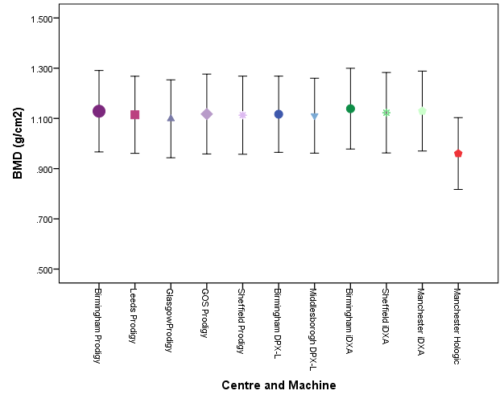
B - Bone Mineral Content (g)

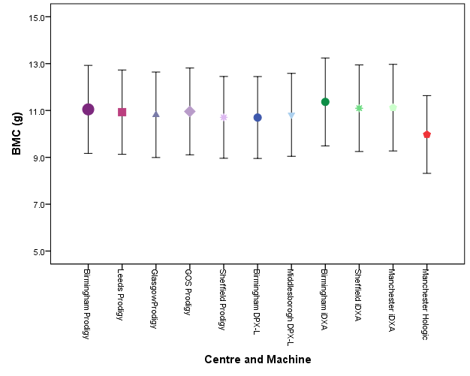

C - Bone Area (cm²)
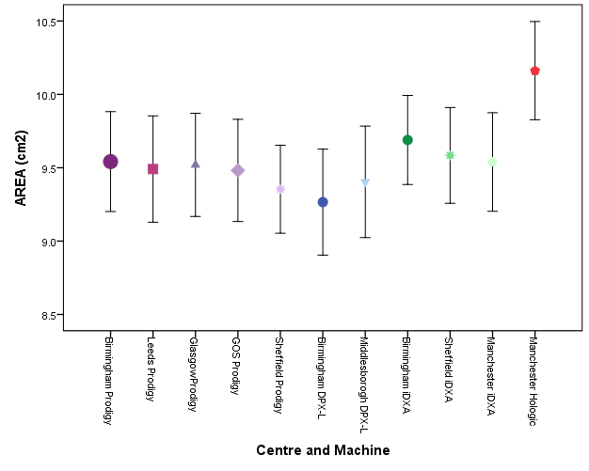
No Significant differences were detected between GE scanners, Hologic scanner estimated significantly higher bone area (p= 0.010).
Supplemental Figure 2 Differences between GE Lunar Encore Basic and Enhanced (version 14.0 and above)
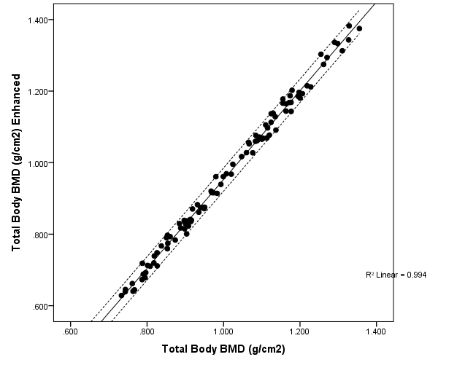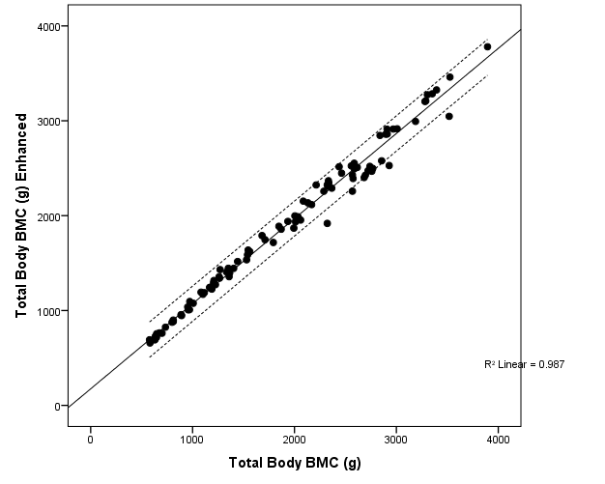

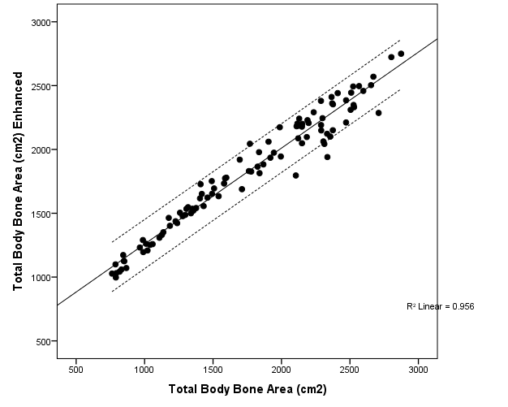

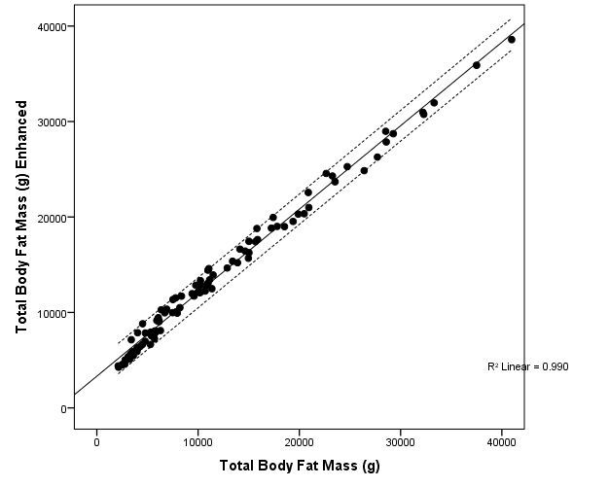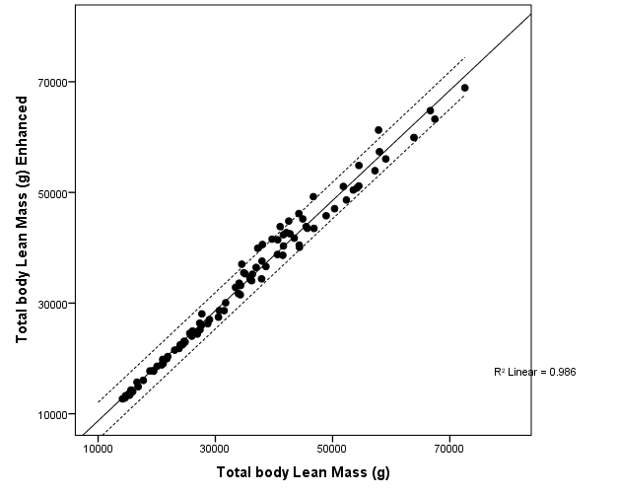

Supplemental Figure 3a Lumbar Spine BMAD LMS Reference Curves for the GE Lunar Prodigy™
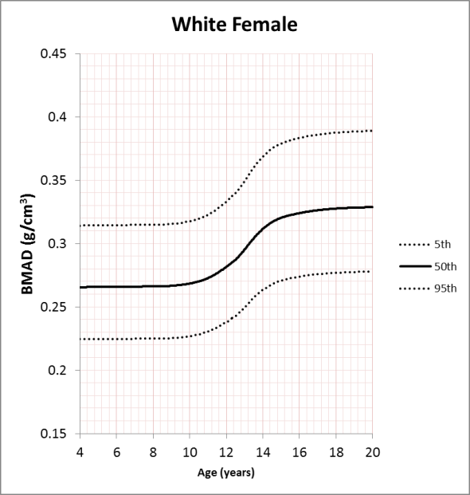 | 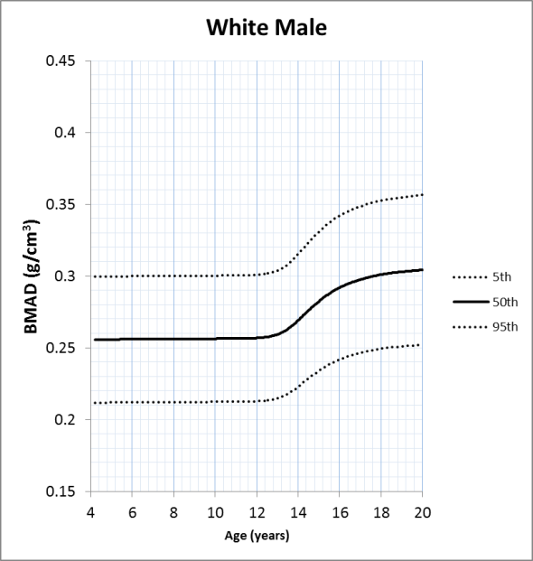
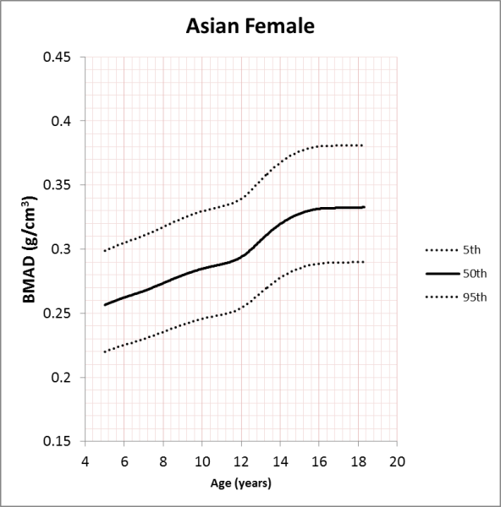 | 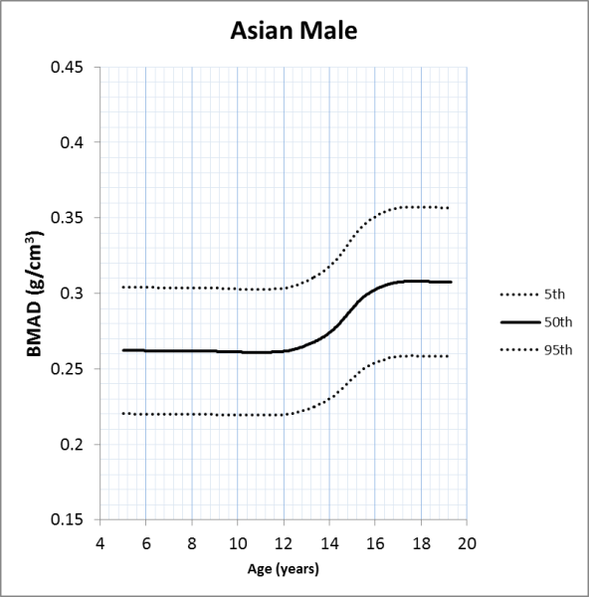
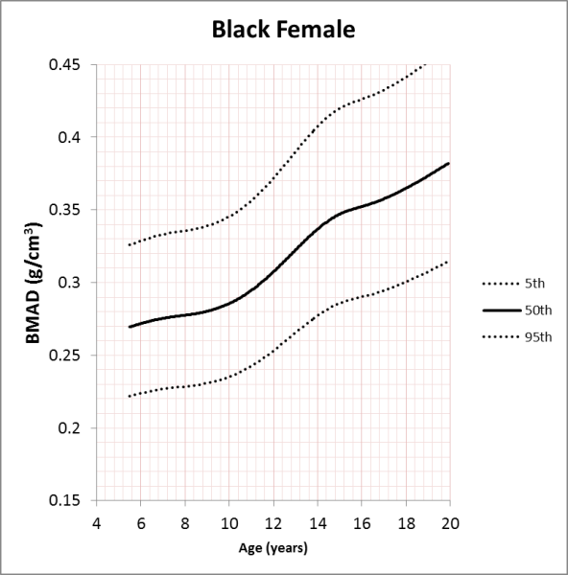 | 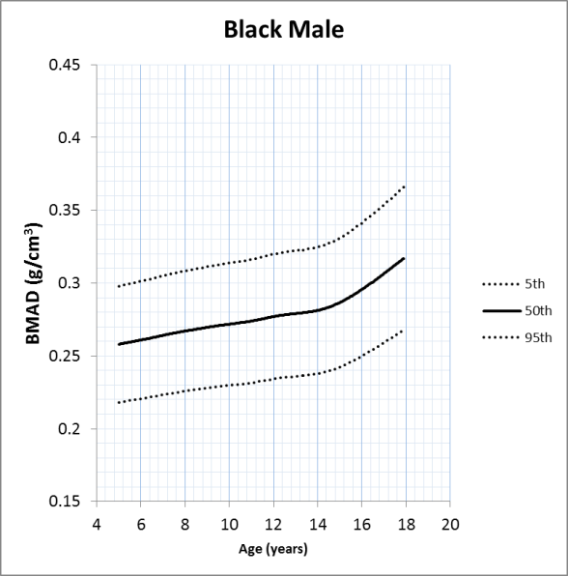

Supplemental Figure 3b Lumbar Spine BMAD LMS Reference Curves for GE Lunar iDXA™
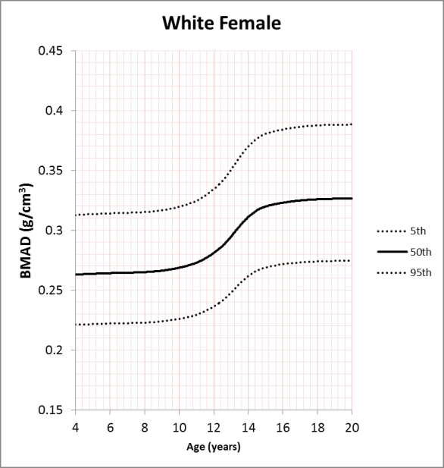 | 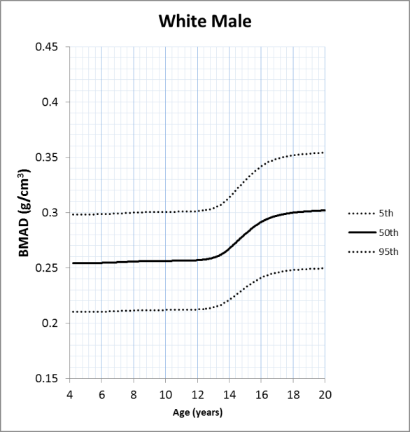
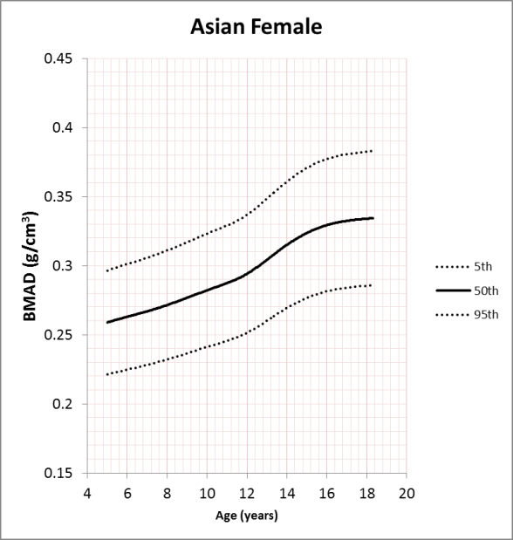 | 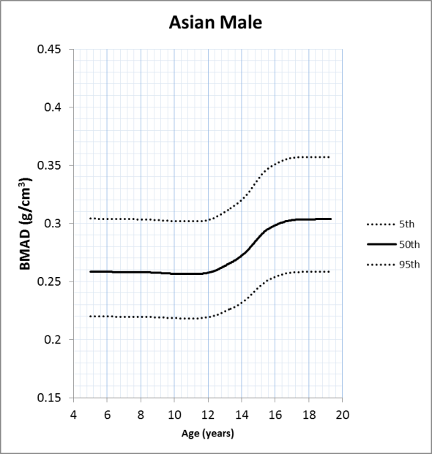
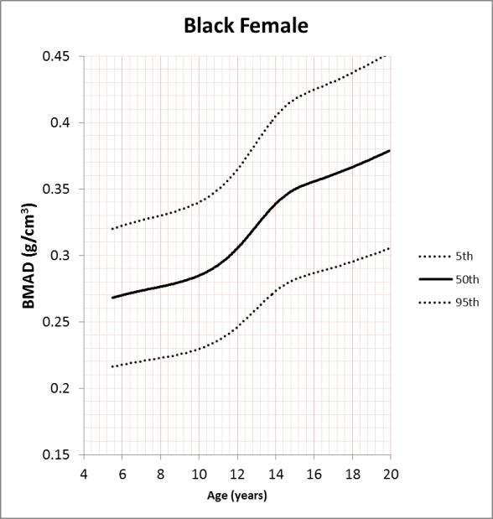 | 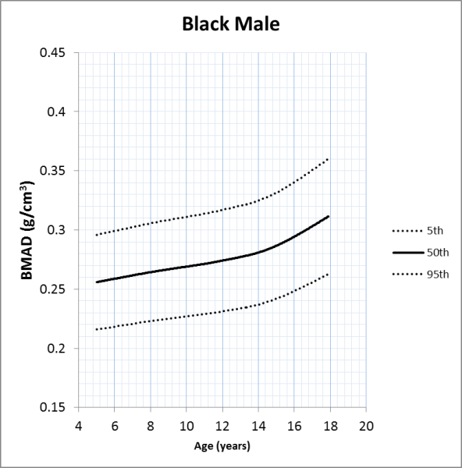

Supplemental Figure 3c Lumbar Spine BMAD LMS Reference Cures for Hologic Discovery
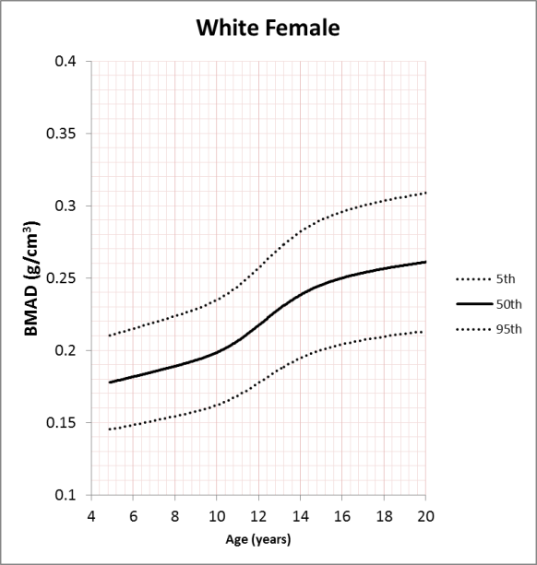 | 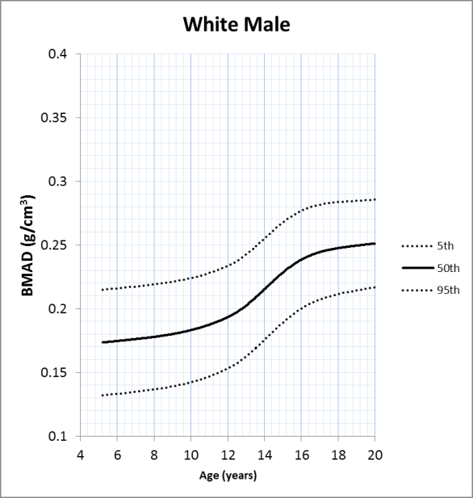

Supplemental Figure 4a Lumbar Spine L1-L4 BMD LMS Reference Curves for the GE Lunar Prodigy™
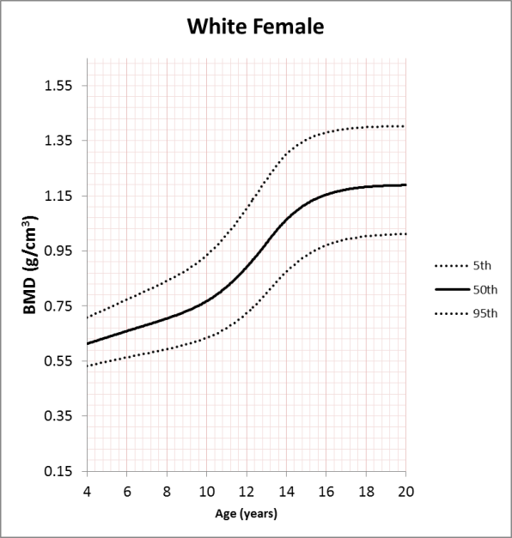 | 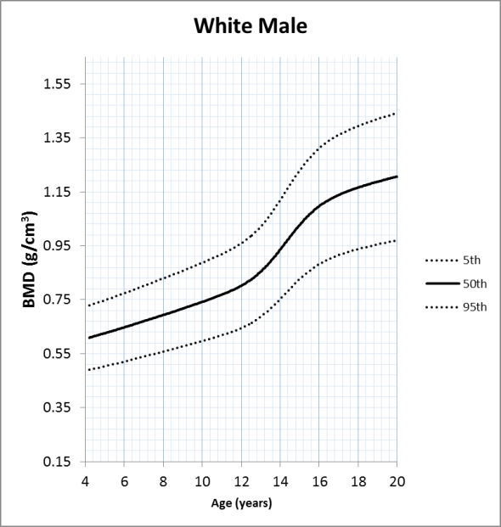
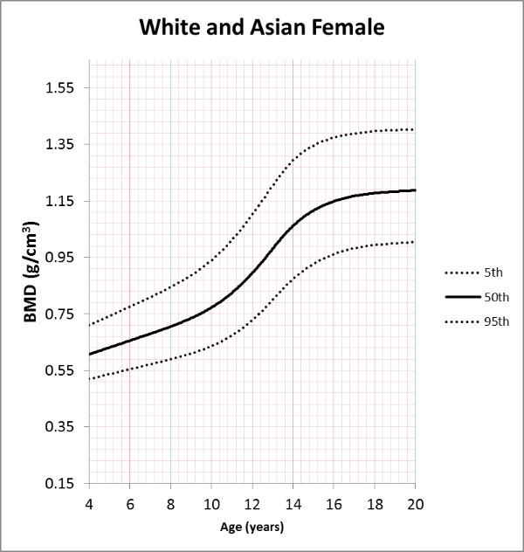 | 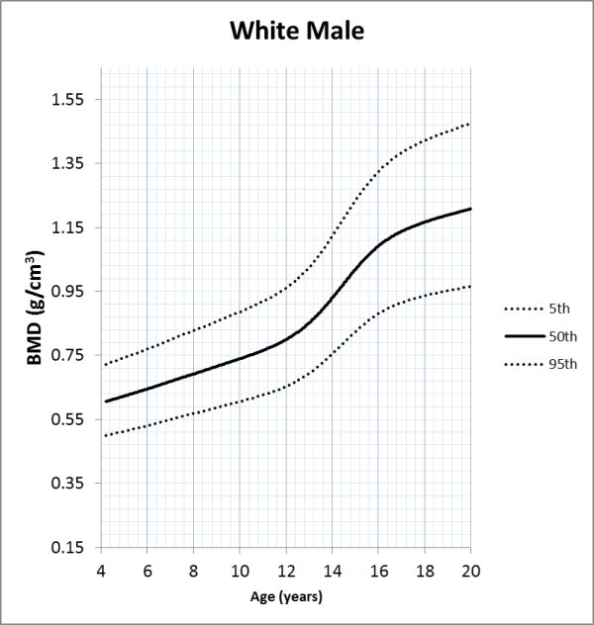
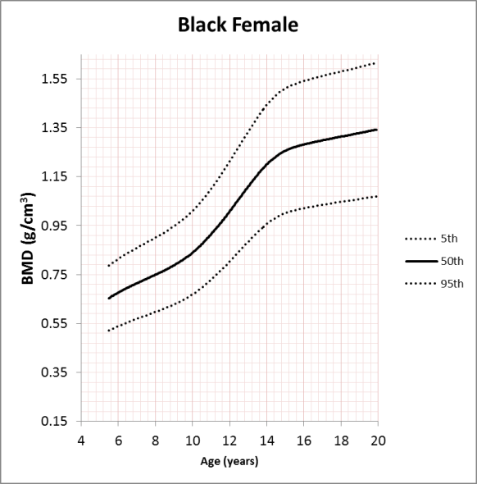 | 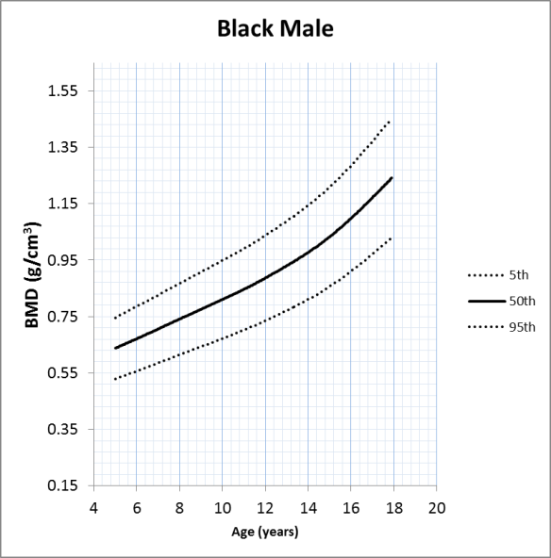

Supplemental Figure 4b Lumbar Spine L1-L4 BMD LMS Reference Curves for GE Lunar iDXA™
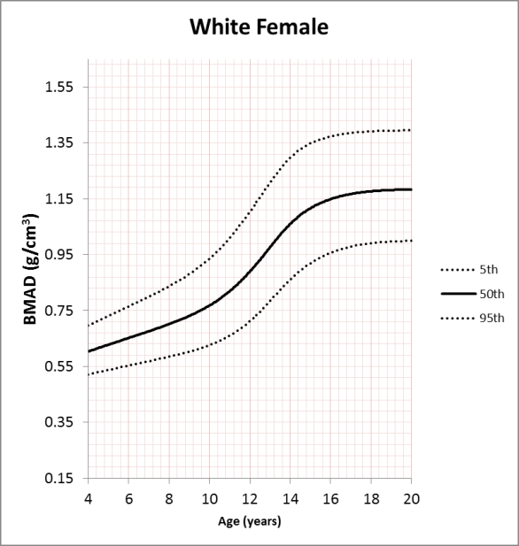 | 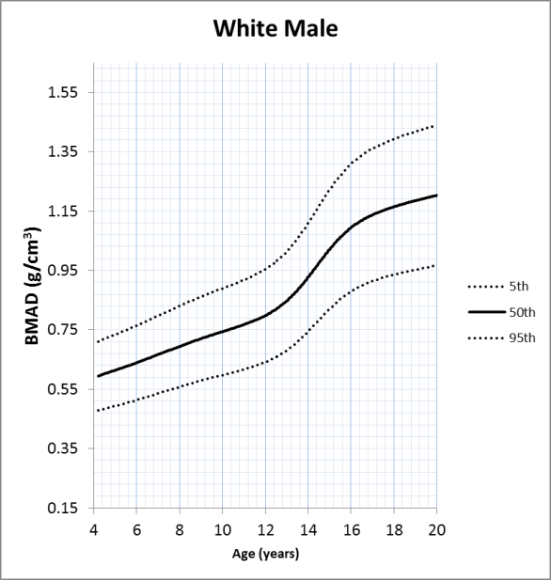
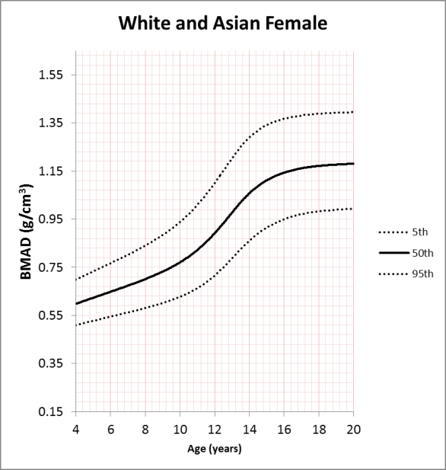 | 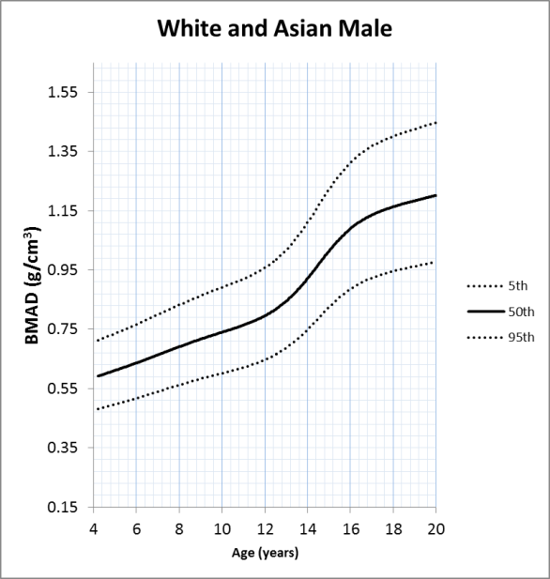
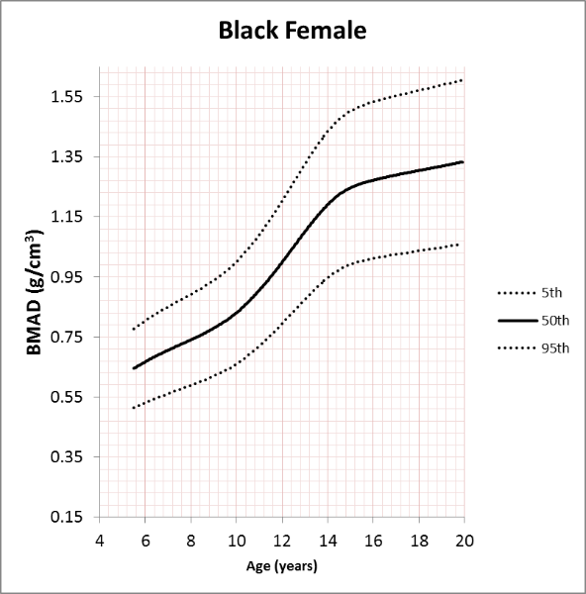 | 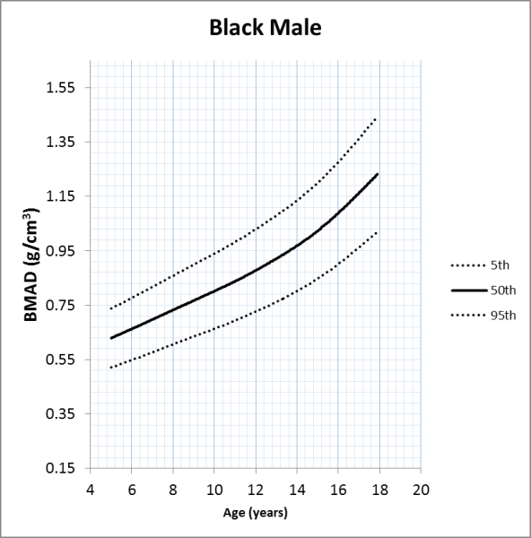

Supplemental Figure 4c Lumbar Spine L1-L4 BMD LMS Reference Cures for Hologic Discovery
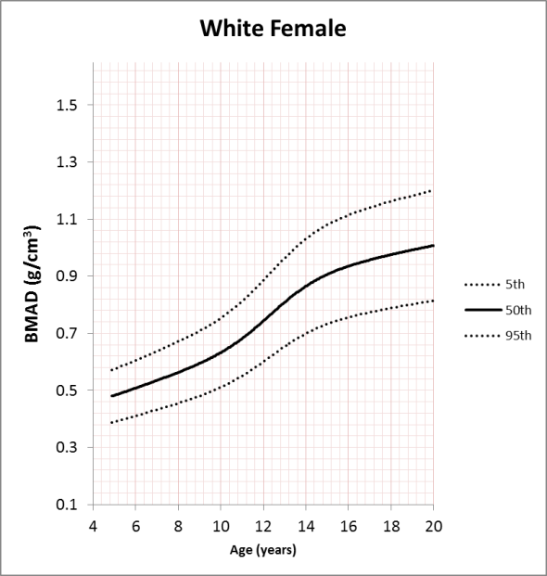 | 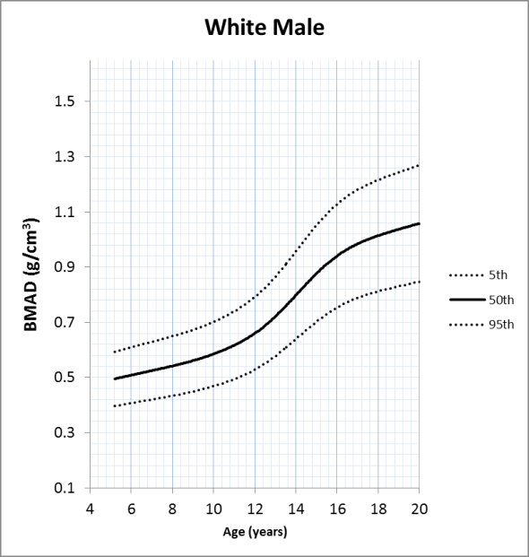

Supplemental Figure 5a Total Body Less Head BMD LMS Reference Curves for the GE Lunar Prodigy™
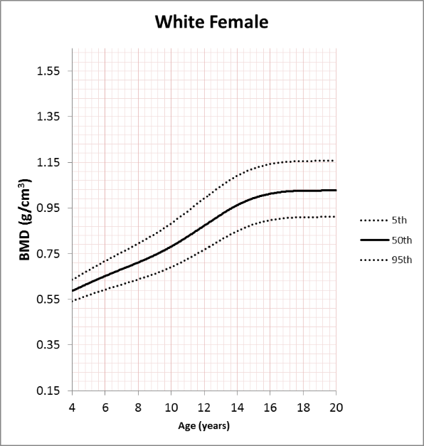 | 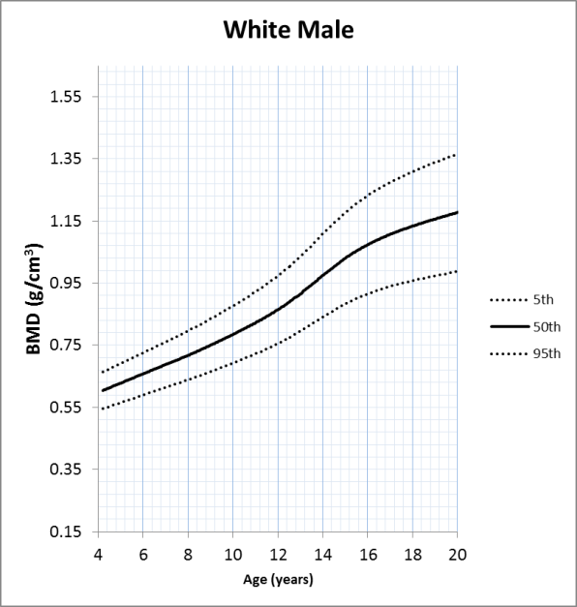
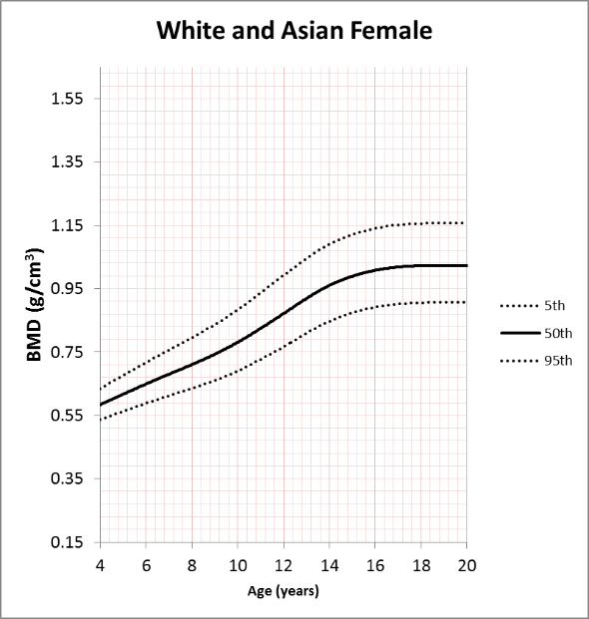 | 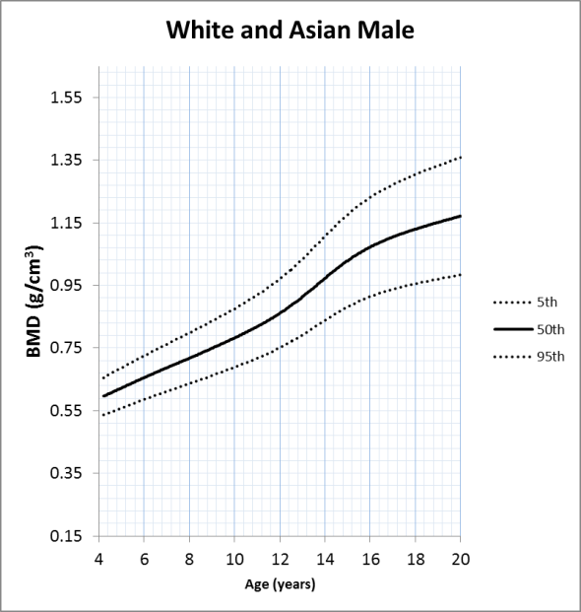
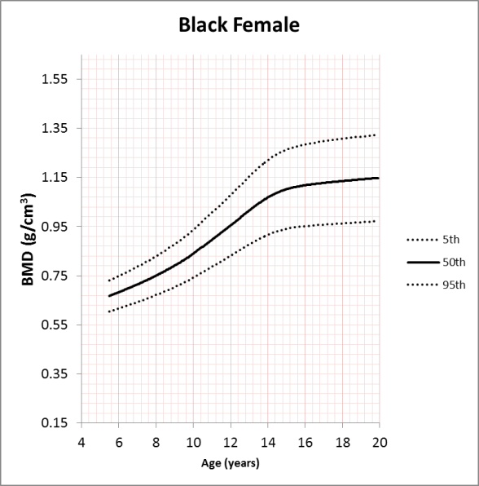 | 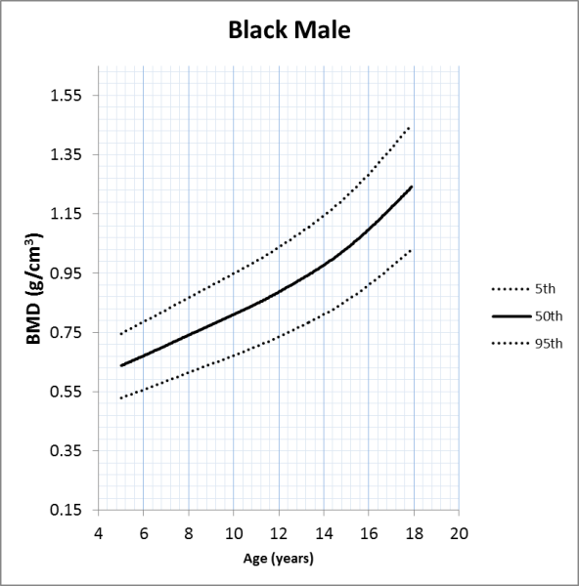

Supplemental Figure 5b Total Body Less Head BMD LMS Reference Curves for GE Lunar Prodigy™ Enhanced Mode
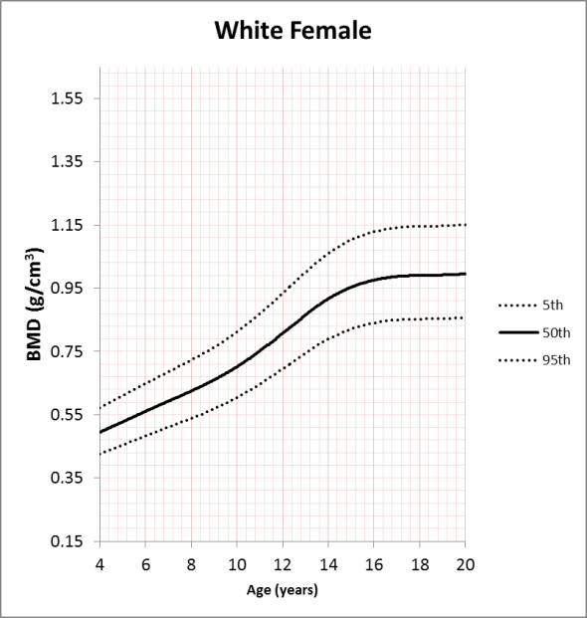 | 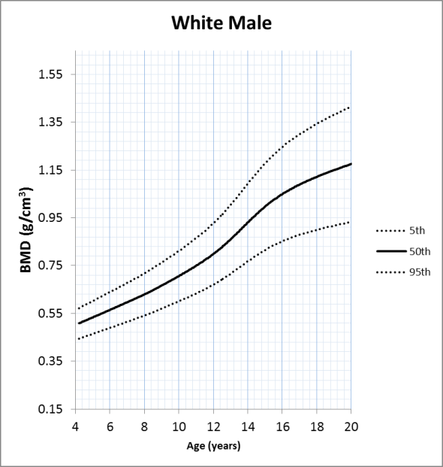
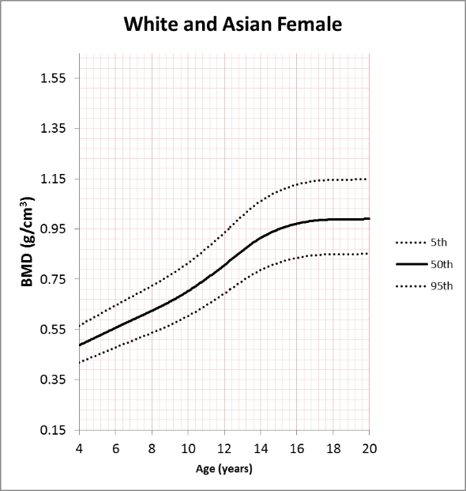 | 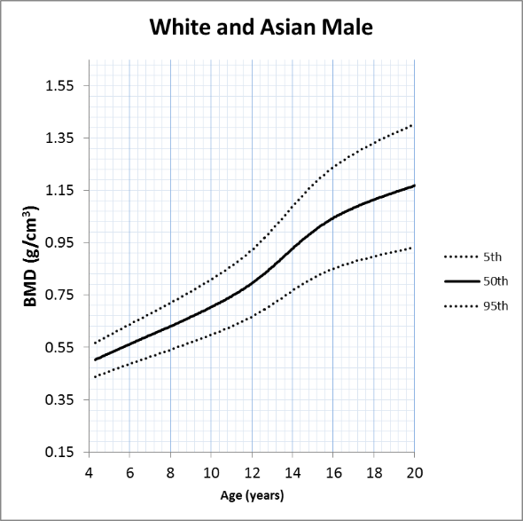
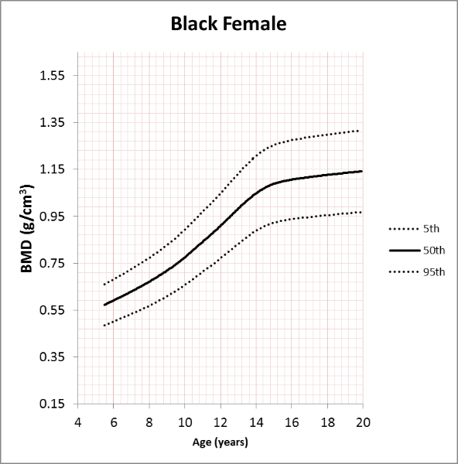 | 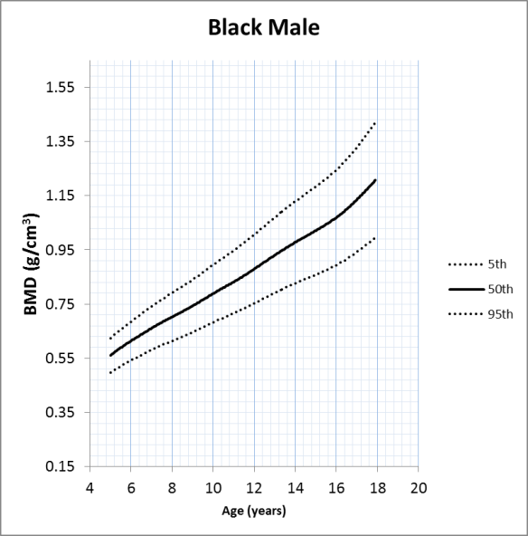

Supplemental Figure 5c Total Body Less Head BMD LMS Reference Curves for GE Lunar iDXA™
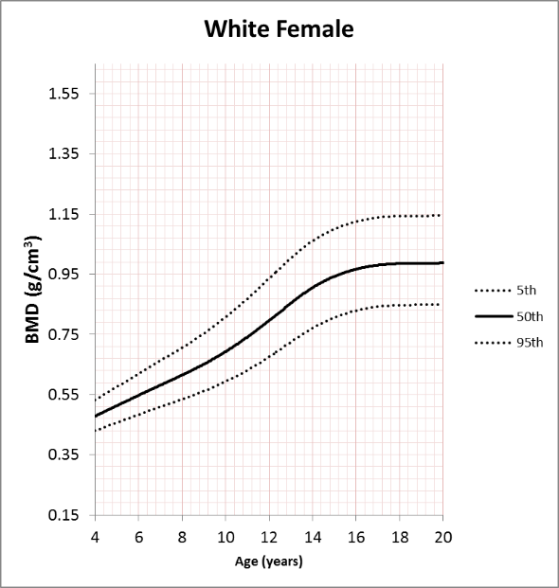 | 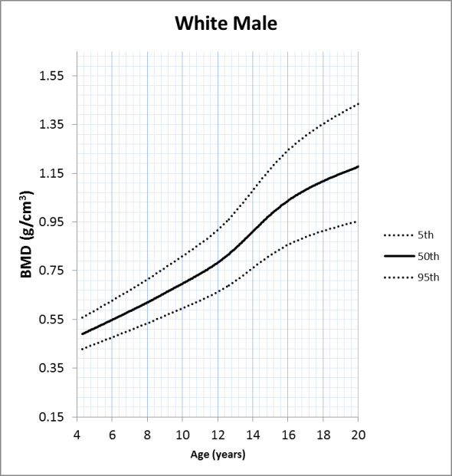
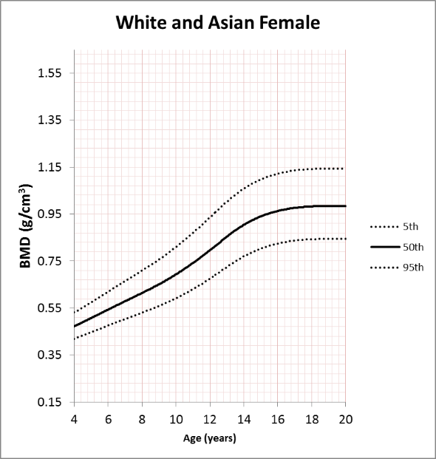 | 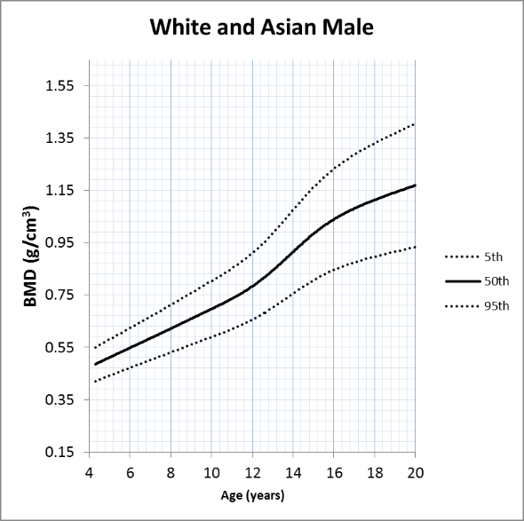
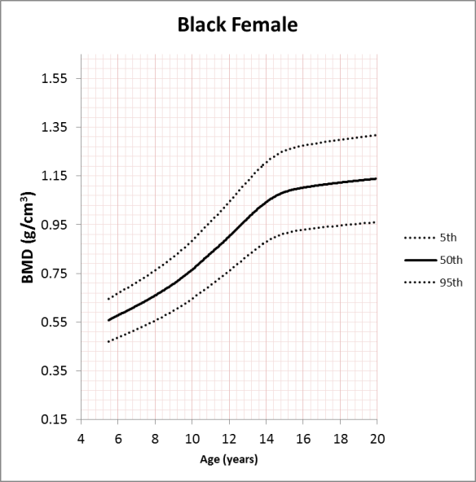 | 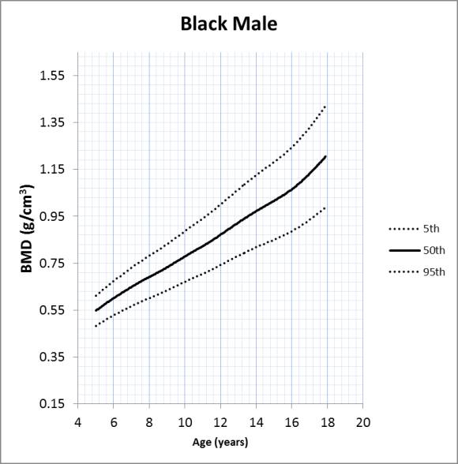

Supplemental Figure 5d Total Body Less Head LMS Reference Cures for Hologic Discovery
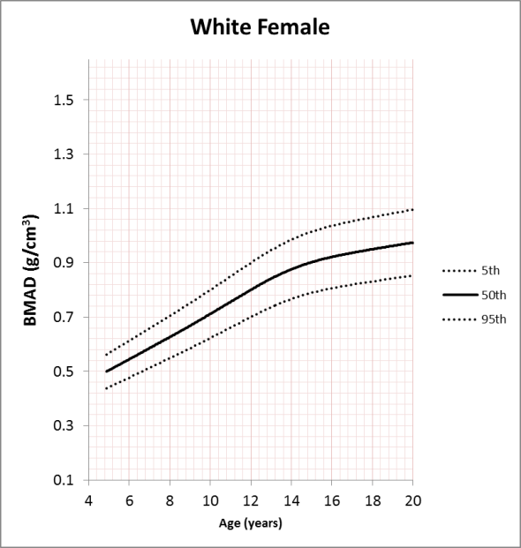 | 