Shankar Pidishety, Balaji Srinivasan and Gilberto Brambilla
All-Fiber Fused Coupler for Stable Generation of Radially and Azimuthally Polarized beams

Abstract—The stable generation of TE₀₁ and TM₀₁ beams is demonstrated through a novel all-fiber fused coupler fabricated from a standard single mode fiber (SMF) and a custom air-core fiber. The fundamental mode in the SMF is directly coupled to the TM₀₁ or TE₀₁ mode by appropriately phase matching the modes in the fibers resulting in efficiency of ~67% and ~85%, and polarization purity of 70% and 82%, respectively. The phase matching is achieved through pre-tapering the SMF with precise control of the tapering ratio. The air-core fiber ensures selective excitation of the desired modes, thereby improving propagation stability and polarization quality of the TE₀₁ and TM₀₁ beams.

Index Terms— All optical devices, fiber optics, fiber couplers, optical vortices.
I. INTRODUCTION

A specific class of cylindrical vector beams (CVBs), i.e. radially (TM₀₁) and azimuthally (TE₀₁) polarized beams have been an intense subject of research for the past few years for their unique properties, including tight focusing ability and spatial polarization distribution [1]. Such properties are attractive for a variety of applications, including high-resolution microscopy [2], atom guiding [3], particle trapping and optical tweezers [4], material processing or micro/nanofabrication [5], surface plasmon excitation [6] and STED imaging [7]. A renewed interest recently has been the investigation of CVBs for mode division multiplexing to achieve high-capacity optical communications [8]. Various passive [9], [10] and active [11], [12] techniques have been proposed and demonstrated for generating CVBs. However, CVBs generated via free space techniques are unsuitable for most of the applications, where a fiber based technique is desirable.
In optical fibers, the excitation of TM₀₁ and TE₀₁ modes which are eigenmodes of a waveguide with cylindrical symmetry, has been investigated via various techniques[13]–[16]. However, the critical dependence of the vector mode -

Manuscript received xxxxxxxx; revised xxxxxxxxx; accepted xxxxxxx. Date of publication xxxxxxxx; date of current version xxxxxxxx. This work was supported by IRSES grant (PIRSES-GA-2012-318941) and authors thank Siddharth Ramachandran, Patrick Gregg and Asher from Boston University, USA as well as Poul Kristensen from OFS, Denmark for providing the air-core fiber and fruitful discussions.

Shankar Pidishety and Balaji Srinivasan are with the Department of Electrical Engineering, Indian Institute of Technology Madras, Chennai-600036, India (e-mail: pd.shankara@gmail.com ; balajis@ee.iitm.ac.in ).
Shankar Pidishety and Gilberto Brambilla are with Optoelectronics Research Centre, University of Southampton, Southampton, SO171BJ, United Kingdom (e-mail: pd.shankara@gmail.com; gb2@orc.soton.ac.uk ).

Color versions of one or more of the figures in this letter are available online at xxxxxxxxxx.
Digital Object Identifier xxxxxxxxxx

-excitation on the external light coupling condition limits the practical use of such techniques. To avoid such issues, in-fiber techniques developed based on the intermodal coupling within the fiber to generate CVBs by applying external perturbations in the form of mechanical [15]-[18], and acoustic waves [19]. Nevertheless, these techniques find limited applications because of complexity and/or low response time.
Recently, mode selective fiber couplers (MSCs) have been investigated as an efficient method to control the excitation, separation and coupling of individual guided higher order modes (HOMs) in a few mode fiber (FMF) [20]–[23]. Such evanescent wave couplers, typically fabricated using a single mode fiber (SMF) and a FMF have been demonstrated to excite HOMs in FMFs with high efficiency (97%) and low insertion loss (< 0.1 dB) [24]. MSCs have been demonstrated for the efficient excitation of HOMs: LP₁₁, LP₂₁, and LP₀₂ modes in standard weakly guiding fibers with increased bandwidth [20], [21] and for polarization mode selectivity [25], but not for the excitation of CVBs. Also, an important aspect often ignored in the excitation of CVBs in fibers is the selection of an appropriate fiber geometry for the stable propagation of the generated HOM beams [15], [17], [18], [26]. If the selected fiber has a low NA (weakly guiding), the CVBs are guided with nearly the same effective refractive index, i.e. they are degenerate [17]. Consequently, the HOMs/CVBs cannot be individually excited (or only with extreme constraints) using conventional techniques. Additionally, mode coupling can easily occur at any imperfection and, as a result, the purity of the radially or azimuthally polarized modes degrades [15], [17], [18], [27], [28]. However, CVBs (TE₀₁ and TM₀₁ in particular) can be supported by special, modal-degeneracy-lifted and strongly guiding fibers, known as vortex fibers [15], [17], [26], [27]. Hence, it is highly desirable to investigate the use of MSCs based on such vortex fibers for generating stable as well as high quality TM₀₁ and TE₀₁ beams while providing power scalability.

In this paper, we demonstrate a technique for the highly stable and efficient generation of TM₀₁ and TE₀₁ beams using weakly-fused fiber couplers [20], [22], [23]. We replaced the FMF with air-core fiber in traditional MSCs to lift the degeneracy between the CVBs and propagate them without intermodal coupling. This technique minimizes the power transfer to the unwanted mode by making use of both the phase mismatch as well as the smaller modal overlap between the two selected modes, thus substantially improves the quality of generated CVBs [15], [17], [26], [27]. Unlike previous techniques [13], [29], the fabricated fused fiber coupler does not use any external mode selecting element and the air-core fiber addresses the degeneracy problem. As such, it provides the first realistic efficient way to generate TM₀₁ and TE₀₁ beams with high quality and good stability. In addition, this all-fiber device is highly suitable for power scalability, as it could be used as seed in a master oscillator power amplifier (MOPA) system [30].
II. PRINCIPLE
For a coupler formed using two dissimilar fibers, the power coupling between two coupled modes is given by the coupled mode theory [20], [24], [31]:
(1)
where P_{c} is the power of the desired mode in the coupled arm, P₀ is the launched power in the input mode, ϕ = (β₁-β₂)/2 is the phase mismatch factor, β₁ and β₂ are the propagation constants (β = (2π/λ) n_{eff}) of the modes in two fiber arms of the coupler device, n_{eff} the effective index, k is the coupling coefficient per unit length, and L is the coupling/interaction length. According to Eq. (1), the maximum power that can be coupled into the target air-core fiber mode requires that the mismatch between the n_{eff} of the CVB in the air-core fiber and that of HE₁₁ mode in the SMF should be minimized. In the weakly fused technique (our case), the coupler may be treated as two touching circular fibers facilitating index matching between the two modes. The coupling coefficient and the resultant efficiency were studied in our previous report [23] and the same may be extended to the present device as both rely on the same physical mechanism.
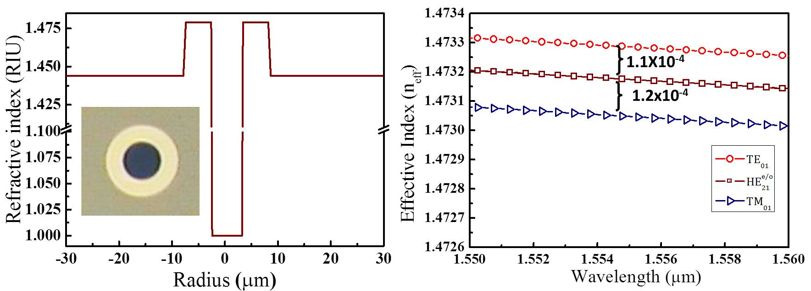
Fig. 1. Simulation results: (a): Index profile and cross-section image of air-core fiber. (b): Effective index (n_{eff}) of different vectorial modes (TE₀₁, HE₂₁^{even/odd}, TM₀₁) in the air-core fiber as a function of the wavelength.
The index profiles of the air-core fiber is shown in Fig. 1. (a). The air-core fiber has an air-core radius of ~3 µm, an annular guiding region with radius ~8.25 µm and an index difference of ~0.035 with respect to the adjacent silica cladding [32]. The high index contrast and the annular ring guiding structure enable for the propagation of vectorial modes, which are usually degenerate in the weakly guiding fibers, with high effective index separation in the order of Δn_{eff}~10⁻⁴) at λ=1550nm [32], as shown in Fig. 1. (b). Since the degeneracy between the different polarized modes is removed, selective excitation and stable propagation of the excited TM₀₁ and TE₀₁ are achieved in our SMF-air-core fiber device as presented here.
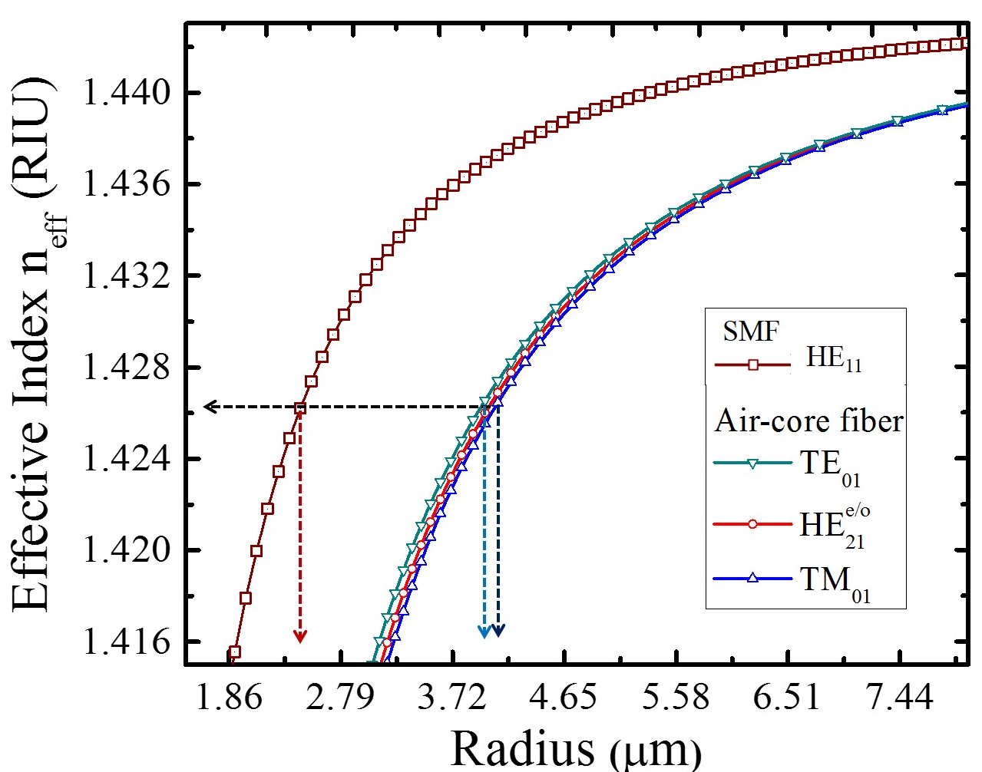
Fig. 2. Effective index (neff) of different modes in the SMF (HE₁₁) and air-core fiber (TE₀₁, HE₂₁^{even/odd}, TM₀₁) fiber as a function of fiber (cladding) radius. The phase matching points are indicated with dotted lines.

n_{eff} or β of the HE₁₁ in the SMF is different from that of CVBs in the air-core fiber. Yet, in order to efficiently couple light from the HE₁₁ mode in the SMF to the CVBs in the air-core fiber, it is essential [20], [22]–[24] that modes have the same n_{eff} (Eq. (1)). In addition, since the different modes in the fiber have a different overlap with the core, the diameter of the SMF fiber should be manipulated to match the n_{eff} of the targeted modes. This is achieved by pre-tapering the SMF until the value of the n_{eff} of the HE₁₁ in the SMF equals that of the CVBs in the air-core fiber. The phase matching condition was studied using COMSOL Multiphysics® eigenmode solver to estimate the ratio between the cladding radii of the SMF and the air-core fiber, as shown in Fig. 2. A three-layer system consisting of the coupler cores, cladding and air regions was adopted in the simulations as the core guided mode could still be influenced by the surrounding environment at the smaller tapering diameters [22], [23]. In Fig 2, n_{eff} of the HE₁₁ mode in the SMF and those of the TM₀₁ and TE₀₁ modes in the air-core fiber are mapped as a function of radius (r) of both fibers in order to determine the ratio of fiber radii needed to achieve phase matching between the selected modes [20], [22], [23]. Fig. 2 shows that the HE₁₁ in the SMF has n_{eff} = 1.425 at a radius of r_{SMF}~2.43μm, while the CVBs in the air-core fiber shows the same n_{eff} at radius of r_{air-core} ~4.12 μm for TM₀₁ mode, and r_{air-core} ~3.928 μm for TE₀₁ mode. This means that the radius of the SMF should be reduced by the corresponding ratio (ρ = r_{SMF}/r_{air-core}). The pre-tapered radii of SMF required for generating the TM₀₁ and TE₀₁ modes were calculated to be r_{TM01}=36.80 μm and r_{TE01}=38.60 μm, respectively.
III. EXPERIMENT, RESULTS AND DISCUSION
Based on the above analysis and the simulations shown in Fig. 2, a conventional telecom-grade SMF (Elliot Scientific, SMF-1300/1500 core/cladding diameter = 8.2/125 μm, NA = 0.14) was adiabatically pre-tapered at ~1400ºC to a radius of r_{TE01}~ 38.6±0.1 µm for exciting the TE₀₁ mode, and to r_{TM01}~ 36.8±0.1 µm for exciting the TM₀₁ using a custom-built fiber tapering rig consisting of a ceramic micro heater (NTT-AT, Japan) and high resolution translation stages [33]. The insertion loss of the pre-tapered fiber was measured to be smaller than ~0.1dB. The pre-tapered SMF was longitudinally aligned with the un-tapered, straight air-core fiber without any twist and fixed together using a UV-curable glue. The coupler was fabricated using the modified flame brushing technique [33] by using the same tapering rig. During pulling, the fibers fuse weakly and the HE₁₁ mode in the SMF couples into either the TE₀₁ or the TM₀₁ mode of the air-core fiber to which it is phase matched, depending on the corresponding ratio (ρ) of radii of the two fibers. The tapering and fusing was stopped when the power measured out of the air-core fiber was maximized. Two different couplers, labeled as TM₀₁-coupler and TE₀₁-coupler were fabricated with appropriate ρ to individually excite TE₀₁ and TM₀₁ beams in the air-core fiber. The fabricated coupler was fixed onto a stable supporting base plate and packed in a plastic box to ensure the excitation conditions are unchanged. Subsequently, the output beam from the air-core fiber was subjected to Stokes polarization analysis using the characterization setup shown in Fig. 3.
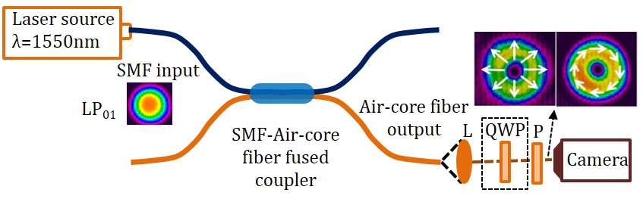
Fig. 3. Experimental setup used to characterize the generated TM₀₁ and TE₀₁ beams. Solid and dashed lines represent the propagation path of light in fibers and free space, respectively. L-collimating lens and P-polarization analyzer. QWP-quarter wave plate (shown in dotted box) is used only when Stokes parameters are measured. Insets: CVBs intensity profiles and their polarization designation out of the air core fiber.
Unpolarized light from a 1550-nm laser source was launched into the SMF input port of the coupler. The SMF was subjected to circular bends to strip out if any higher order mode present before the fused region of the device. The output beam from the air-core fiber was collimated using an appropriate lens and the field patterns were imaged using a CCD camera (MicronViewer-7290A). Fig. 4 (a1, a2) shows a clear doughnut pattern out of the air-core fiber when the polarizer is not present in the beam path before the camera, for both couplers. The absence of LP₀₁ mode intensity patterns in the observed output beam and the clear doughnut intensity distribution qualitatively suggests that the input LP₀₁ mode substantially coupled to the selected CVBs.
A polarization analyser was inserted in the path of the free-space collimated beam to analyse its polarization state. The appearance of the dark line across the beam cross section, after passing through the polarizer suggests that the polarization state of the generated beams is inhomogeneous [16]. To understand the polarization structure of the output beam further, the polarizer axis was rotated through 0-135º at selected discrete angles. As the polarization axis was rotated, the two-lobed field pattern on the CCD also rotated along the same rotation direction.
The intensity patterns as a function of different polarization azimuths is shown in Fig. 4 (b1-e1). The observed pattern for the TM₀₁-coupler confirms that the generated beam is of TM₀₁ polarized, as the dark line appears at 90⁰ offset angle with respect to the polarizer axis. A similar set of measurements is carried out for the TE₀₁-coupler. Such measurements confirmed that the generated beam is TE₀₁ polarized, as dark lines appeared along the polarization axis for every angle of rotation, as shown in Fig. 4 (b2-e2). The complete state of polarization of both beams, deduced from the above measurement is presented in Fig. 4 (f1, f2).
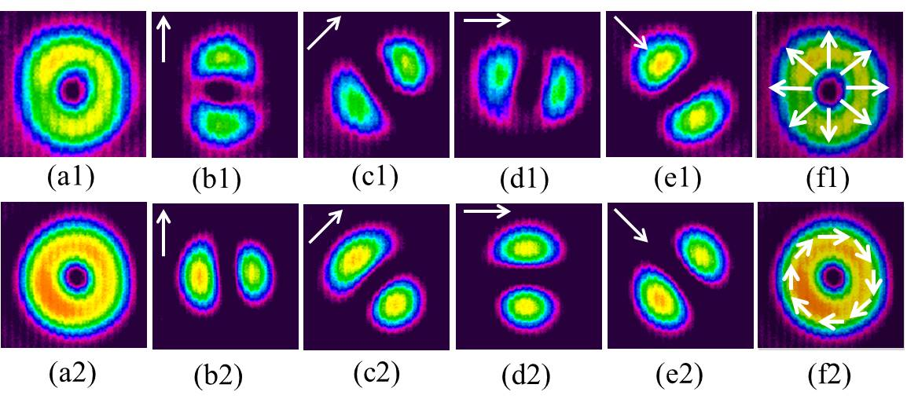
Fig. 4. Mode profile at the output of the air-core fiber for TM₀₁ (top) and TE₀₁ (bottom) modes, respectively. (a1, a2): without polarization analyzer. (b1, b2)-(e1, e2): with a polarization analyzer oriented in the direction of the arrow. (f): State of Polarization deduced from the polarization analysis measurement, drawn on top of the TM₀₁ (f1) and TE₀₁ (f2) beams.
To estimate the polarization purity of the generated beams, the spatial polarization distribution was analyzed from the spatial Stokes polarization measurements obtained using the CCD camera [34], [6]. The polarization ellipse at each CCD camera pixel (size ~14x14µm) was deduced by post-processing the images using a MATLAB [6]. Such polarization ellipse map is superimposed on top of the corresponding spatial coordinate of the CCD image, as shown in Fig. 5. (c) and (d) for the couplers optimised for the TM₀₁ and TE₀₁ modes respectively. Fig. 5 (c) and (d) show that the spatial state of polarization for the TM₀₁ and the TE₀₁ beams are well matched with that of simulation results shown in Fig. 5. (a) and (b), respectively. These results support the high purity of excited TE₀₁ and TM₀₁ modes even after propagation through ~50 cm of air-core fiber with moderated bends. Similarly, the polarization ellipticity of the generated beams is calculated across the beam cross-section form the Stokes parameters as shown in Fig. 5 (e) and (f). Purity of the polarization is estimated from the polarization ellipticity of the generated beams. The polarization purity is measured to be 70% (~93% in non-averaged mode) for the TM₀₁ mode and 82% (~98% in non-averaged mode) for the TE₀₁ mode, demonstrating the high purity of generated beams compared to previously reported values [10], [12], [13], [18].
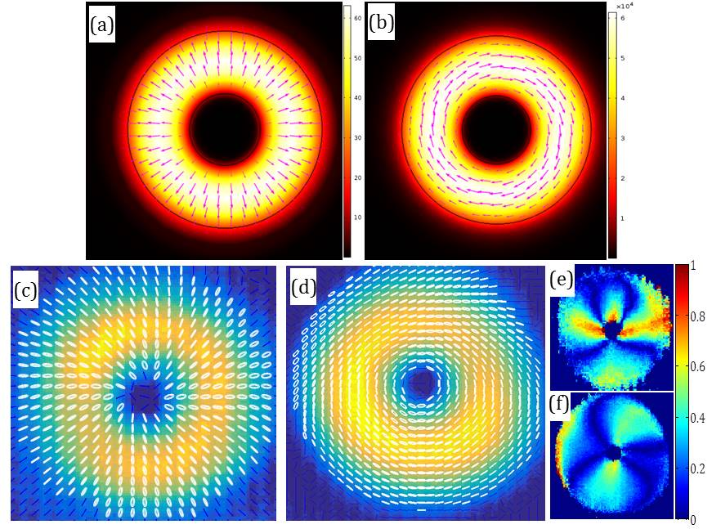
Fig. 5. Polarization state (arrows) overlapped on top of the field patterns of TM₀₁ and TE₀₁ modes. (a), (b) simulation results and (c), (d) experimental results. (e), (f): Hue plots representing the polarization ellipticity of the TM₀₁ and TE₀₁ beams respectively. The purity of modes was estimated along the indicated circle in (e) and (f).
The difference in polarization purities between TE₀₁ and TM₀₁ modes is attributed to the polarization dependent coupling coefficient, which favours the TE₀₁ mode in our case [25]. Moreover, since the air-core fiber used in this work is designed for supporting many higher order modes the index separation between the lower order modes may not be quite enough to preserve the TM₀₁ polarized mode [32]. The above problem may be addressed by using a vortex fiber [15], [17], [18], [32], which is more suitable to support the CVBs. The efficiencies for the TM₀₁-coupler and for the TE₀₁-coupler, measured to be ~67% and ~85%, respectively, are comparable with similar type of techniques in recent reports [20]. This difference may be partially attributed to deviation in pre-taper radius of SMF from its optimum value during the coupler fabrication process.
The insertion loss is measured to be 11% (~0.5 dB) for both TE/TM couplers and is comparable with previous results [23]. Only a very small (~3%) variation of the spatial intensity distribution of the generated modes is measured even after 2 hours, indicating the high stability of the device.
IV. CONCLUSION

In summary, we report for the first time the stable generation of pure TE₀₁ and TM₀₁ beams through an all-fiber fused coupler technique. The device reported here exploits the relatively large degeneracy between the above modes in an air-core fiber to minimize the power transfer to undesired modes. The polarization purity and efficiency of generated beams, ~70% and ~67% for TM₀₁, and ~82% and ~85% for TE₀₁ respectively not only validates our approach but also provides scope for further improvement. Since this is an all-fiber side coupling technique which does not depend on the power/temperature sensitive external mode selector, it is expected to be highly suitable for mode power scalability for laser machining and tweezers applications.
REFERENCES

[1] Q. Zhan, “Cylindrical vector beams: from mathematical concepts to applications,” Adv. Opt. Photonics, vol. 1, no. 1, p. 1, Jan. 2009.
[2] M. Gu, H. Kang, and X. Li, “Breaking the diffraction-limited resolution barrier in fiber-optical two-photon fluorescence endoscopy by an azimuthally-polarized beam,” Sci. Rep., vol. 4, Jan. 2014.
[3] F. K. Fatemi, M. Bashkansky, E. Oh, and D. Park, “Efficient excitation of the TE_01 hollow metal waveguide mode for atom guiding,” Opt. Express, vol. 18, no. 1, p. 323, Jan. 2010.
[4] F. Peng, B. Yao, S. Yan, W. Zhao, and M. Lei, “Trapping of low-refractive-index particles with azimuthally polarized beam,” J. Opt. Soc. Am. B, vol. 26, no. 12, p. 2242, Dec. 2009.
[5] M. Meier, V. Romano, and T. Feurer, “Material processing with pulsed radially and azimuthally polarized laser radiation,” Appl. Phys. A, vol. 86, no. 3, pp. 329–334, Dec. 2006.
[6] S. Pidishety, V. Kumar, and N. K. Viswanathan, “Plasmon-mediated vectorial topological dipole: formation and annihilation,” Opt. Lett., vol. 37, no. 20, pp. 4233–4235, 2012.
[7] S. Deng, L. Liu, R. Li, and Z. Xu, “STED microscopy with the azimuthally-polarized depletion beam,” 2007, vol. 6826, pp. 682621–682621–7.
[8] G. Milione et al., “4 × 20 Gbit/s mode division multiplexing over free space using vector modes and a q-plate mode (de)multiplexer,” Opt. Lett., vol. 40, no. 9, p. 1980, May 2015.
[9] M. Stalder and M. Schadt, “Linearly polarized light with axial symmetry generated by liquid-crystal polarization converters,” Opt. Lett., vol. 21, no. 23, p. 1948, Dec. 1996.
[10] Z. Bomzon, G. Biener, V. Kleiner, and E. Hasman, “Radially and azimuthally polarized beams generated by space-variant dielectric subwavelength gratings,” Opt. Lett., vol. 27, no. 5, p. 285, Mar. 2002.
[11] D. Pohl, “Operation of a Ruby Laser in the Purely Transverse Electric Mode TE01,” Appl. Phys. Lett., vol. 20, no. 7, pp. 266–267, Apr. 1972.
[12] K. Yonezawa, Y. Kozawa, and S. Sato, “Generation of a radially polarized laser beam by use of the birefringence of a c-cut Nd:YVO4 crystal,” Opt. Lett., vol. 31, no. 14, p. 2151, Jul. 2006.
[13] D. Lin et al., “Efficient, high-power, and radially polarized fiber laser,” Opt. Lett., vol. 35, no. 13, p. 2290, Jul. 2010.
[14] L. Zou, Y. Yao, and J. Li, “High-power, efficient and azimuthally polarized ytterbium-doped fiber laser,” Opt. Lett., vol. 40, no. 2, p. 229, Jan. 2015.
[15] S. Ramachandran and P. Kristensen, “Optical vortices in fiber,” Nanophotonics, vol. 2, no. 5–6, pp. 455–474, 2013.
[16] G. Volpe and D. Petrov, “Generation of cylindrical vector beams with few-mode fibers excited by Laguerre–Gaussian beams,” Opt. Commun., vol. 237, no. 1–3, pp. 89–95, Jul. 2004.
[17] S. Ramachandran et al., “Lifting polarization degeneracy of modes by fiber design: a platform for polarization-insensitive microbend fiber gratings,” Opt. Lett., vol. 30, no. 21, p. 2864, 2005.
[18] S. Ramachandran, P. Kristensen, and M. F. Yan, “Generation and propagation of radially polarized beams in optical fibers,” Opt. Lett., vol. 34, no. 16, p. 2525, Aug. 2009.
[19] W. Zhang et al., “Cylindrical vector beam generation in fiber with mode selectivity and wavelength tunability over broadband by acoustic flexural wave,” Opt. Express, vol. 24, no. 10, p. 10376, May 2016.
[20] K. J. Park, K. Y. Song, Y. K. Kim, J. H. Lee, and B. Y. Kim, “Broadband mode division multiplexer using all-fiber mode selective couplers,” Opt. Express, vol. 24, no. 4, p. 3543, Feb. 2016.
[21] J. D. Love and N. Riesen, “Mode-selective couplers for few-mode optical fiber networks,” Opt. Lett., vol. 37, no. 19, p. 3990, Oct. 2012.
[22] S. Pidishety, M. I. . . Abdul Khudus, P. Gregg, S. Ramachandran, B. Srinivasan, and G. Brambilla, “OAM Beam Generation using All-fiber Fused Couplers,” 2016, p. STu1F.2.
[23] R. Ismaeel, T. Lee, B. Oduro, Y. Jung, and G. Brambilla, “All-fiber fused directional coupler for highly efficient spatial mode conversion,” Opt. Express, vol. 22, no. 10, p. 11610, May 2014.
[24] M. S. Whalen and T. H. Wood, “Effectively nonreciprocal evanescent-wave optical-fibre directional coupler,” Electron. Lett., vol. 21, no. 5, pp. 175–176, Feb. 1985.
[25] J. Yu et al., “High performance micro-fiber coupler-based polarizer and band-rejection filter,” Opt. Express, vol. 20, no. 15, p. 17258, Jul. 2012.
[26] C. Brunet, B. Ung, P.-A. Bélanger, Y. Messaddeq, S. LaRochelle, and L. A. Rusch, “Vector Mode Analysis of Ring-Core Fibers: Design Tools for Spatial Division Multiplexing,” J. Light. Technol., vol. 32, no. 23, pp. 4046–4057, Dec. 2014.
[27] A. W. Snyder and J. D. Love, Optical Waveguide Theory. Boston, MA: Springer US, 1984.
[28] B. Ndagano, R. Brüning, M. McLaren, M. Duparré, and A. Forbes, “Fiber propagation of vector modes,” Opt. Express, vol. 23, no. 13, p. 17330, Jun. 2015.
[29] M. Fridman, M. Nixon, M. Dubinskii, A. A. Friesem, and N. Davidson, “Fiber amplification of radially and azimuthally polarized laser light,” Opt. Lett., vol. 35, no. 9, p. 1332, May 2010.
[30] G. Pelegrina-Bonilla et al., “Analysis of the Coupling Mechanism in Asymmetric Fused Fiber Couplers,” J. Light. Technol., vol. 32, no. 13, pp. 2382–2391, Jul. 2014.
[31] W.-P. Huang, “Coupled-mode theory for optical waveguides: an overview,” J. Opt. Soc. Am. A, vol. 11, no. 3, p. 963, Mar. 1994.
[32] P. Gregg, P. Kristensen, and S. Ramachandran, “Conservation of orbital angular momentum in air-core optical fibers,” Optica, vol. 2, no. 3, p. 267, Mar. 2015.
[33] G. Brambilla, “Optical fibre nanowires and microwires: a review,” J. Opt., vol. 12, no. 4, p. 043001, 2010.
[34] D. Goldstein and D. H. Goldstein, Polarized Light, Revised and Expanded. CRC Press, 2003.

