Optimal trim control of a high-speed craft by trim tabs/interceptors

Part I: Pitch and surge coupled dynamic modelling using sea trial data

**Melek Ertogana,b,[1], Philip A. Wilsonb, Gokhan Tansel Tayyarc, Seniz Ertugruld**

a Maritime Faculty-Marine Engineering, Istanbul Technical University, Turkey

b Faculty of Engineering and the Environment, University of Southampton, U.K.

c Naval Architecture and Marine Engineering, Istanbul Technical University, Turkey

d Mechanical Engineering, Istanbul Technical University, Turkey

**ABSTRACT**

A pitch and surge coupled dynamic model of a high-speed craft is not available for dynamic trim control applications in the literature. The existing fluid-structure interaction models of a high-speed craft are not adequate for simulations and control applications, since they require a great deal of computation time, for example more than 20-40 sec. depending on a vessel particulars. Hence, in this work, we aimed to obtain a dynamic model of a high-speed craft for surge and pitch motions. Then the obtained model will be utilized to design an automatic controller which adjust the command signal on a high-speed craft to increase fuel efficiency, safety and comfort of passengers in a vessel. The coupled pitch and surge motion of a high-speed craft with trim tabs/interceptors was modelled by using full scale sea trial data. The linear parametric modelling using System Identification (SI) Methods and Artificial Neural Network (ANN) modelling were carried out and the comparisons of both the training and validation results are given. High correlation coefficients and low average values of absolute errors in surge and pitch dynamics were obtained by using ANN Method. The ANN model can be improved for further control designs on a marine vessel’s operations.

**Keywords:** high speed craft dynamics, trim tabs/interceptors, linear/nonlinear modelling, full-scale experiments, system identification (SI), artificial neural network (ANN).

**1. INTRODUCTION**

Marine vessels’ motions are generally determined by experimental tests, and direct numerical solutions based on Navier-Stokes Equations by Computational Fluid Dynamics (CFD) (ITTC, 2011). There are many publications in the field of dynamic modelling for displacement type of a ship. The dynamics of a high-speed craft are different from displacement ships. It has displacement, semi-displacement, and planing characteristics according to Froude numbers (Faltinsen, 2005; Fossen, 2011). In this study, it is aimed to model surge and pitch motions of a high speed craft to be able to design dynamic trim controller during planing or semi-planing hull motion using existing trim tabs/interceptors which controlled manually.

Initial studies of a hydrodynamic model for prismatic form of a high speed craft was done with experimental tests for smooth and rough sea conditions (Savitsky, 1964; Savitsky and Brown, 1976). The linearized and empirical equations of a high-speed craft in wave conditions were presented in detail (Lewandowski, 2003; Faltinsen, 2005). A numerical analysis on vertical dynamics of a planing craft in calm sea and in waves was studied (Blake, 2000; Blake and Wilson, 2001). A numerical simulation algorithm based on the finite volume discretisation was presented for analysing 3D nonlinear high-speed vessels motion, and the steady-state forward motion of it was investigated (Panahi, et al., 2009). An interceptor’s effectiveness on the hydrodynamic performance for a high-speed craft was investigated (Karimi et al., 2013). The other hydrodynamic designs of interceptor/trim tabs were studied (Tasi and Hwang, 2004; Luca and Pensa, 2012; Mansoori and Fernandes, 2016). Furthermore, an autonomous planning watercraft test bed was developed to improve the controller technologies for a planning craft (Woelfel, et al., 2004; Blank and Bishop, 2008).

In this study, even it is possible to achieve a dynamic model via CFD analysis, generating a dynamic model from sea trials is preferred since it is more suitable for real time controller design. Therefore, the dynamic model in the form of linear and nonlinear identifications are obtained from full scale sea trials that represent nonlinear, coupled surge and pitch motion depending on the engine speed, trim tab/interceptor position and heave acceleration.

Modelling studies by SI in multidisciplinary area have shown a good level of accuracy according to empirical and theoretical methods (Ljung, 1999). The studies on modelling by (SI) methods of marine vessels for controller design purposes are limited. Early studies on identification of a ship’s steering dynamics were presented in detail (Aström and Kallström, 1976). Manoeuvring motions of container ships were determined by SI methods afterward. Grey-box modelling (Blanke and Knudsen, 2006), genetic algorithm (Sutulo and Soares, 2014), support vector regression (Wang et al., 2015) and ANN (Simsir and Ertugrul, 2009) methods were used for identification of manoeuvring motions. Identification for a heading autopilot of an autonomous in-scale fast ferry was studied (Velasco, et al., 2013). An adaptive autopilot was designed to govern steering of a high speed unmanned personal watercraft by using a grey-box identification model (Svendsen et al., 2012).

The parametric modelling of heave and pitch motions of fast ferries in the frequency domain was done by using a simulator (Pintelon and Schoukens, 2004). The partial differential equation’s parameters of the coupled heave-pitch motion of an icebreaker ship were identified by ANN (Haddara and Xu, 1999). Heave and pitch motions of a planing craft with a transom flap in calm sea was modelled as steady-state method by using experimental data and Savitsky’s method, and a controller was designed for reduction of porpoising instability in simulation studies (Handa and Jing, 2006). A parametric model of heave, pitch and roll dynamics of a high-speed craft were defined in the frequency domain according to wave excitations with different incidence angles between ${90}^{°}$ and ${180}^{°}$ by using a simulator (Munoz-Mansilla et al., 2009). Then, the parametric model was utilized for stabilization control to reduce motion sickness associated with heave, pitch and roll accelerations (Munoz-Mansilla et al., 2010).

The purpose of controller design may be to convert a manual trim system to an automatic controller, or to improve an existing controller. The model should represent the dynamic behaviour of a high speed craft and be useful for these control applications. This paper focuses on dynamic modelling of pitch and surge motion of a high-speed craft so that an optimal trim controller could be designed based on the obtained model. The purposes of dynamic trim control are fuel efficiency, safety, comfort of passenger in a vessel. Dynamic modelling of a high speed craft was studied by SI, and ANN methods with sea trial data of Volcano71, in length 10.86m. The particulars of Volcano71 and experimental system setup are presented in Appendix A.

**2. MOTIVATION**

In a previous project, an advanced controller design of active fins for ship roll motion reduction was studied. Sea trials in the coastal sea in Tuzla-Istanbul were done to collect data for experimental parameter identification to establish a realistic roll motion equation for Marti, 16.5m in length. The advanced controller design was tested on the Marti, as a full-scale application, after the real-time computer control was carried out for position control of the hydraulic system. High performances were obtained from the real time tests. Considerable amount of experience has been gained during these projects regarding data acquisition, signal processing, instrumentation, modelling and real time control (Ertogan et al., 2015, 2016; Zihnioglu et al., 2015).

The optimal trim control of a high speed craft in nearly calm water is being studied in the current project. The purpose of the automatic trim control is to improve fuel efficiency, safety and comfort of passengers in a marine vessel. Devices such as trim tabs, interceptors, and sterndrive engines can be used to control the trim of a high speed craft. These devices may be fixed or the system may be manually controlled and position of trim tabs/interceptor can be changed by the captain based on experience. But it is difficult to control both longitudinal and lateral motions of the high speed craft and manipulate the position of trim tabs/interceptors at the same time manually. Therefore, an advanced algorithm is needed to automatically adjust the position of trim tabs/interceptor to maximize the speed for a given throttle position. To be able to develop such advanced, reliable control algorithm, a model representing coupled surge and pitch motions of the craft is required for simulation purposes. The aim of this study is to investigate linear and nonlinear modelling techniques to find an adequate model to study the optimal trim controller design which will increase the fuel efficiency.

Modelling methods are defined as three types; white-box modelling, grey-box modelling, and black-box modelling. White-box modelling solves a series of combined differential equations. Grey-box modelling represents a known plant system, but with limits to the possible excitation. Different parameterizations give significantly different model quality for grey-box modelling, because some parameters may not be identifiable. Black-box modelling estimates required variables based on the collected input-output data (Blanke and Knudsen, 2006; Wang et al., 2015).

In the literature, an article directly subjected on optimal trim control of a high speed craft could not be found. As nearly related to our project topic, there are few articles which are generally about simulation studies on heave motions’ reduction control, and manoeuvring control of a planing craft (Velasco et al., 2003; Handa and Jing, 2006; Svendsen et al., 2012). Generally, a high speed craft was modelled as parametric identification from collecting scaled-model test data for control purposes (Munoz-Mansilla et al., 2010).

In this project, the full-scale studies were preferred, because model test results suffer from scale effects (Woelfel et al., 2004; Blanke and Knudsen, 2006). Intelligent, nonlinear methods for modelling were investigated for simulation purposes, since designing and tuning of a controller algorithm via simulations requires less time, cost and effort compared to real time sea trials.

**3. EXPERIMENTAL MODELLING**

The discrete-time non-linear model from sea trial data was desired. The Multi-Input-Multi-Output (MIMO) model includes the three input signals as engine speed, interceptors/trim tabs’ position, and heave acceleration for each sea-state condition, and the output signals as ship speed, and pitch motions, shown in Fig. 1.

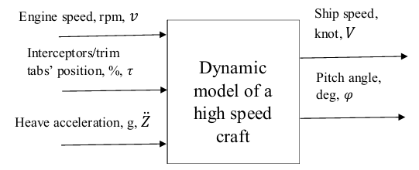

Fig. 1. The input and output signals for a dynamic model of surge and pitch motions of a high-speed craft.

If an acceptable linear model could be obtained for the ship’s speed ranges standing for a high-speed craft, it would be very useful for simulation purposes in controller design. Therefore, an attempt has been made to obtain linear parametric models such as State-Space (SS) and ARX using well-established SI theory. However, it is known that ship dynamics involve nonlinearities. Therefore, a non-linear modelling technic such as Neural Network needs to be utilized. A decision should be made about the type of model depending on the results of both linear and non-linear models.

In this paper, the full scale modelling of surge and pitch motions were studied by using the linear parametric models of State-Space and ARX. In order to model the surge and pitch motions of a high-speed craft with the interceptors/trim tabs by these methods, input signals should be persistently exciting. Collecting the sea trial data, the linear parametric modelling and the nonlinear modelling methods are described in the following subtitles.

**3.1 PERSISTENTLY EXCITING INPUT SIGNAL, AND SEA TRIAL DATA**

Determining of proper input/ output signals for a physical system is significant, in order to use SI methods. The input signals must be persistently exciting, so as to collect data that are sufficiently informative (Ljung, 1999).

One of the input signals for the dynamic model is a driver’s signal of a trim adjustment actuator. The interceptor and the trim tab systems are operated with the PWM drivers. The PWM drivers were excited within the range of 10%-100% duty cycle for the identification of the dynamic model. The trim adjustment actuators should be driven periodically at approximately mid-PWM speeds for the identification, according to the experiences on the full-scale experiments.

Other input signal for the experiments is the engine speed of the craft. The sea trials were done in increasing and decreasing engine speeds at approximately in the range of 800-4000 rpm, according to setting the engine drivers’ commands, on condition that Volcano71 was on a straight course.

One of the trim adjustment actuators, the interceptors or the trim tabs, were operated periodically as mentioned above in the sea trials. The sea states were recorded from the local meteorology. The sea states are determined according to the World Meteorological Organisation (WMO) sea state code.

The order of excitation given with covariance matrix was calculated and it was verified that input signals were persistently exciting to find models up to 50th order. The output signals are the ship’s speed, and the surge and pitch motions, measured by the GPS and the IMU. In addition to the engine speed and the interceptors/trim tabs’ position were chosen as inputs, the heave acceleration had to be added as the input signal to achieve a more reliable model.

The ship speed, pitch motion, acceleration of heave motion, manual command signal of the interceptors and the engine speed, in sea state 1, 0 to 0.1m wave height, wave characteristics as ripples, are shown in Fig. 2. It can be observed that the ship’s speed increases because of the interceptors in these conditions at the constant throttle condition, engine speed at approx. 2600 rpm as shown in Fig. 3. It should be noted that variables are scaled to be shown on the same figure.

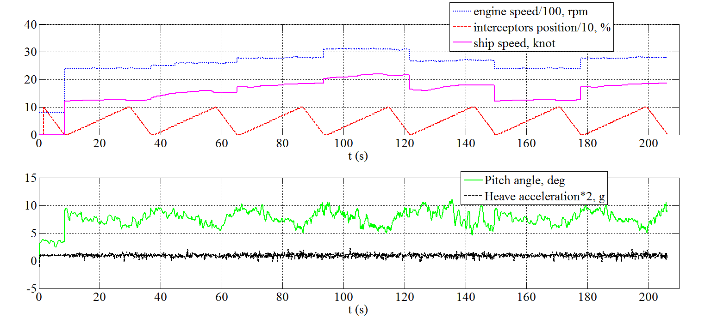

Fig. 2. The ship speed, pitch angle, acceleration of heave motion, the interceptors’ position, the engine speed, in sea state 1.

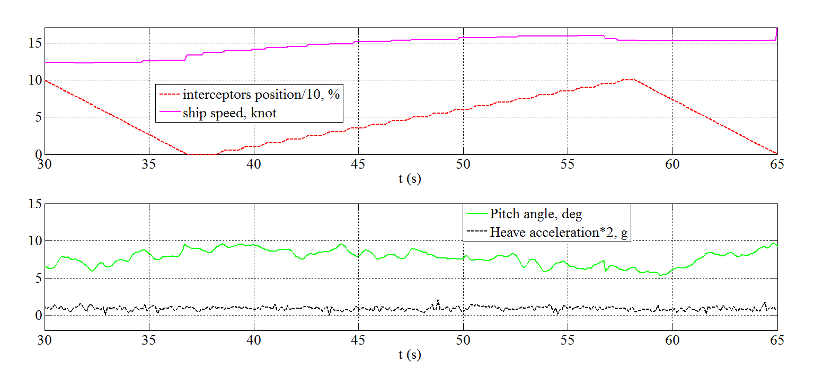

Fig. 3. The ship speed, pitch angle, heave acceleration, the interceptors’ position, in sea state 1, at the engine speed approx. 2600 rpm.

The input and output signals from another sea trial, in sea state 2, 0.1 to 0.5m wave height, wave characteristics as wavelets, and character of the sea swell as short, are illustrated in Fig. 4.

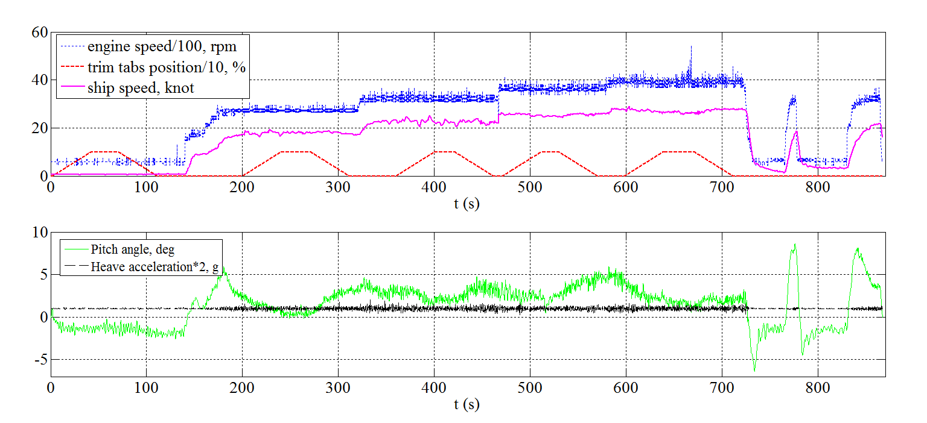

Fig. 4. The ship speed, pitch angle, heave acceleration according to the trim tabs’ position, the engine speed, and waves in sea state 2.

**3.2 MODELLING WITH SYSTEM IDENTIFICATION (SI) METHODS**

In the first of phase of the modelling, two linear system identification methods were studied to obtain a linear approximation of the nonlinear dynamics of a high speed craft. The state-space, and the autoregressive with exogenous inputs (ARX), identifying input-output polynomial model structures were used for the dynamic modelling.

The state-space structure represents the relationship between the input, output, and noise signals as a system of first-order differential or difference equations using a state vector $x$. State variables $x(t)$ can be reconstructed from the measured input-output data, but they are not necessarily correspond to physical inputs measured during an experiment. The discrete state-space equation is given in (1), where $t$ represents integer time steps. Here $A, B,$ and $C$ are matrices of appropriate dimensions (*ns* x *ns*, *n*s x *mu*, and *my* x *ns*, respectively, for an *ns*-dimensional state, an *mu*-dimensional input, and an *my*-dimensional output). $Θ$ is a vector of parameters that typically correspond to unknown values of physical coefficients, and the like. The modelling is usually carried out in terms of state variables $x(t)$ that have physical significance, and then the measured outputs, $y(t)$ will be known combinations of the states. Moreover, $u(t)$, $we(t)$, and $ve(t)$ are the measured input data, the measurement noise, and the process noise respectively. $x_{0}$ represents the initial conditions (Ljung, 1999).

$$x\left(t+1\right)=A\left(Θ\right)x\left(t\right)+B\left(Θ\right)u\left(t\right)+we\left(t\right)$$

$$y\left(k\right)=C\left(Θ\right)x\left(k\right)+ve(k)$$

$x\left(0\right)=x_{0}$ (1)

The state-space model structure requires to be specified the model order, $ns$, the model structure configuration, and the estimation options (Ljung, 2013). Some types of the model structure configuration are free parameterization, and canonical parameterization. The free parameterization method estimates all constants of the system matrices. The canonical parameterization method constructs a state-space system in a reduced parameter form where many entries of the system matrices are fixed to zeros and ones. The free parameters are located in only a few the rows and columns in the system matrices for the canonical parameterization method. The free parameters can be identified by the companion form, the modal decomposition form, and the observability canonical form. The characteristic of polynomial structure represents in the rightmost column of the A matrix for the companion form. The modal form has a symmetry in the block diagonal elements of the state matrix A. The free parameters are located in the selected rows of the system matrices for the observability canonical form.

The other types of the model structure configuration are structured parameterization, and completely arbitrary mapping methods. Which entries of the system matrices to be estimated and which entries to be specified as fixed can be chosen in the structured parameterization method. The structured estimation method is also referred to as grey-box modelling. However, the relationships among state-space coefficients cannot be indicated for the structured estimation approach. The grey-box modelling method permits to calculate dependencies among the parameters of the system matrices.

In this study, the free parameterization, and the canonical parametrization methods were simulated as the modal structures. In addition to these, the non-iterative, subspace method (Van Overschee and De Moor, 1996), and the iterative, prediction error minimization estimation (Ljung, 1999) methods were chosen for the black-box modelling.

In addition to this, the polynomial ARX model was studied as another linear system identification method. The discrete-time designation of the ARX model given in (2) is composed of a linear differential equation and error term. In addition to these, it has model parameters to be determined. ARX model parameters were estimated from the experimental data using the Least Squares Estimation (LSE) (Soderstrom and Stoica, 1989). In the ARX model, the output of the system at a specific time is assumed to be linear combinations of the previous outputs and inputs, and the current input. The multivariable ARX model with *mu* inputs and *my* outputs is given in (2) (Ljung, 1999, 2013).

$Q\left(z^{-1}\right)y\left(t\right)=R\left(z^{-1}\right)u\left(t\right)+e(t)$ (2)

where $y$ is the output, $u$ is the input, $e(t)$ is the modelling error, $t$ represents integer time steps, $Q(z^{-1})$ and $R(z^{-1})$ are model parameters to be estimated using the experimental data. $Q(z^{-1})$ is an *my* x *my* matrix whose entries are polynomials in the delay operator $z^{-1}$. It can be represented as given in (3). The matrix form of $Q(z^{-1})$ is given in (4).

$Q\left(z^{-1}\right)=I_{my}+Q_{1}\left(z^{-1}\right)+…+Q_{na}(z^{-na})$ (3)

$Q\left(z^{-1}\right)=\left[\begin{matrix}q_{11}(z^{-1}) & ⋯ & q_{1my}(z^{-1}) \\ ⋮ & ⋱ & ⋮ \\ q_{my1}(z^{-1}) & ⋯ & q_{mymy}(z^{-1})\end{matrix}\right]$ (4)

The entries $q_{kj}$ are polynomials in the delay operator $z^{-1}$ represented as

$q_{kj}\left(z^{-1}\right)=δ_{kj}+q_{kj}^{1}\left(z^{-1}\right)+…+q_{kj}^{{na}_{kj}}(z^{-{na}_{kj}})$ (5)

The polynomial given in (5) describes how old values of output number j affect output number k. Where $δ_{kj}$ is the kronecker-delta which equals 1 when *k*=*j*, otherwise, it is 0. Similarly, $R(z^{-1})$ is an *my* x *mu* matrix given in (6), or (7) with (8).

$R\left(z^{-1}\right)=R_{0}+R_{1}\left(z^{-1}\right)+…+R_{nb}(z^{-nb})$ (6)

$R\left(z^{-1}\right)=\left[\begin{matrix}r_{11}(z^{-1}) & ⋯ & r_{1mu}(z^{-1}) \\ ⋮ & ⋱ & ⋮ \\ q_{my1}(z^{-1}) & ⋯ & q_{mymu}(z^{-1})\end{matrix}\right]$ (7)

$r_{ki}\left(z^{-1}\right)=r_{ki}^{1}\left(z^{-{nk}_{ki}}\right)+…+r_{ki}^{{nb}_{ki}}(z^{-{nk}_{ki}-{nb}_{ki}+1})$ (8)

The delay from input number *i* to output number *k* is ${nk}_{ki}$. $na, nb and nk$ are the orders of the output, input and input-output delay, respectively. *na* is a matrix whose *kj*-element ${na}_{kj}$, while the ki-elements of *nb* an *nk* are ${nb}_{ki}$ and ${nk}_{ki}$, respectively.

The results of the state-space, and the ARX models’ simulations are described in detail in Section 5.

**3.3 NEURAL NETWORK MODELLING**

Artificial Neural Networks (ANN), with ability to learn complicated relations from Multi-Input and Multi-Output (MIMO) imprecise data, can be used to model non-linear system dynamics. ANN can be preferred to apply because of its advantages: to learn, and generalize from training data then, it estimates from the given data, and makes associations between the validation data and the training data (Hagan et al., 2014; Demuth et al., 2013).

ANN consists of simple processors called neurons. A simple neuron has three sections; synapses, collector, and activation functions. It receives its input signal through other neurons. Each input signal, ‘ $x$’ is weighted by a weight ‘ $w$’, and the weight is updated with synaptic learning. The weighted total is calculated by using the weights, and the input signals, given in (9), where, $x$ is input signal, $w$ is weight, $θ=x_{0}w_{0}$ is bias value, and $net$ is weighted sum.

$net=\sum{x_{i}w_{i}=}θ+x_{1}w_{1}+…+x_{m}w_{m}$ (9)

The two most used activation functions are logistic function, and hyperbolic tangent function, and both are sigmoidal functions. The sigmoidal function limits the domain of output to (-1, 1) or (0, 1). The output of the activation function is given (10), where $f\left(.\right)$ is the activation function, $y$ is the output signal (Du and Swamy, 2006).

$y=f(net)$ (10)

A multi-layer feed-forward ANN structure is illustrated in Fig. 5. The layers are placed as an input layer, hidden layers, an output layer. The hidden layers represent the non-linear structure of the ANN. In each layer, there may be more than one neuron. The neurons pass the inputs of the neurons from each previous layer, but they do not have connections within the neurons in the same layer. Assume that there are $M$ layers, each layer having $L_{m}, m=1,2,…,M$, neurons. The weights from the *(m-1)*th layer to *m*th layer are defined by *W*m-1. In addition to these, the bias, output, and activation function of the *i*th neuron in the *m*th layer are denoted $θ_{i}^{m}, o_{i}^{m}$, and $f_{i}^{m}(.)$ respectively. The relations from Fig. 5 are given (11), and (12) (Du and Swamy, 2006).

${net}_{d}^{m}={\left[W^{m-1}\right]}^{T}o_{d}^{m-1}+θ^{m}$ (11)

$o_{d}^{m}=f^{m}\left({net}_{d}^{m}\right)$ (12)

for $m=2,3,…,M$, where the subscript *d* corresponds to the *d*th example, ${net}_{d}^{m}={\left({net}_{d,1}^{m},…,{net}_{d,L_{m}}^{m}\right)}^{T}$, *W*m-1 is a $L_{m-1}-by-L_{m}$ matrix, $o_{d}^{m-1}={\left(o_{d,1}^{m-1},…,o_{d,L_{m-1}}^{m-1}\right)}^{T}$, $θ^{m}={\left(θ_{1}^{m},…,θ_{L_{m}}^{m}\right)}^{T}$ is the bias vector. $f^{m}(.)$ applies $f_{i}^{m}(.)$ to the *i*th component of the vector.

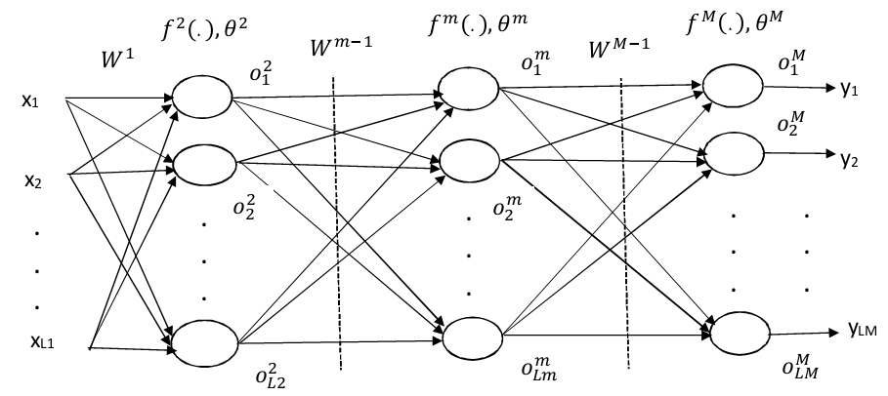

Fig. 5. Multilayer ANN structure

The Backpropagation (BP) algorithm is a learning method, known as the Least Mean Square (LMS) algorithm, which needs both the inputs and the targets to compute optimum weights and biases. An error is calculated by the comparisons between the outputs and the targets in the training process. This error signal is propagated backward the network while the BP algorithm utilizes a gradient descent technique to minimize an objective function. The objective function is the Mean Square Error (MSE) between the network outputs, ${\hat{y}}_{d}$ and the targets, $y_{d}$ for all the training data pairs $\left(x_{d},y_{d}\right)∈S$, given in (13) where *N* is the size of the sample data.

$E=\frac{1}{2N}\sum_{d∈S}{{\left\|{\hat{y}}_{d}-y_{d}\right\|}^{2}=}\frac{1}{2N}\sum_{d∈S}{ε^{2}}$ (13)

The error function *E* is minimized by the gradient descent method, given in (14). Hence, the weights, and the biases can be updated.

$∆W=-ζ\frac{∂E}{∂W}$ (14)

Where the matrix W includes all the weights, $W^{m-1}$ and the biases, $θ^{m}$. The degree of influence of the gradient on the weights and biases at each iteration is determined by learning rate, $ζ$. In practice, $ζ$ is usually chosen to be $0<ζ<1$, so the weight updates do not overshoot the minimum of the error surface.

There are generally two training styles for the ANN structure as the incremental (online), and the batch (offline) methods. The network weights and biases are updated after each presented sample data, in the incremental training. However, the weights and biases are updated after all the training data is presented for the batch training. In this study, the batch training method was preferred to model the couple of surge and pitch dynamics of a high speed craft, so a comprehensive model could be obtained by taking into consideration all the training data for each sea state.

The BP can be performed using different types of optimization techniques. In this paper, the gradient descent with momentum and adaptive learning rate backpropagation, and Levenberg-Marquardt, which is proposed to solve non-linear least-square problem, methods were applied to model a nonlinear dynamics of a high speed craft.

The standard steepest descent algorithm is the simplest but the slowest in convergence to train the ANN model, so two modifications called adaptive learning rate and momentum are also applied to improve the performance of steepest descent method. If the learning rate, $ζ$ is too small, the algorithm takes a long time to converge, while a too large learning rate makes the algorithm unstable. An adaptive learning rate is used for a solution to this problem. In the adaptive learning method, the learning rate is not a constant, it updates according to a new error in each iteration. In addition to this, a momentum term is added to improve the BP algorithm, given in (15).

$ΔW\left(t\right)=-ζ\frac{∂E}{∂W}+ϱ∆W(t-1)$ (15)

where $ϱ$ is the momentum factor, is usually $0<ϱ≤1$. The momentum term provides to reduce the sensitivity of the network to fast changes of the error surface. It effectively smoothes oscillations and accelerates convergence.

The BP algorithm is slow to converge when the error surface is flat along a weight dimension. Second-order optimization techniques have a strong theoretical basis and provide faster convergence. Second-order methods make use of the Hessian matrix *H*, given in (16).

$H\left(t\right)=\frac{∂^{2}E}{∂{\vec{w}}^{2}}|_{t}$ (16)

Where H is the second-order derivative of the error E with respect to the $D_{w}$– dimensional weight vector $\vec{w}$. The weight vector is obtained by concatenating all the weights and biases of a network. The Hessian matrix, $D_{w}xD_{w}$ contains information as to how the gradient changes in different directions of the weight space. It can be applied to the BP algorithm.

The Levenberg-Marquardt (LM) method provides to eliminate the possible singularity of *H* by adding a small identity matrix to it. The method is derived by minimizing the quadratic approximation to $E\left(\vec{w}\right)$ subject to the constraint that the search step length $\left\|d(t)\right\|$ is within a trust region at step t. The second-order Taylor approximation of $E\left(\vec{w}\right)$ is given in (17). The gradient vector is given by $g\left(t\right)=∇E(\vec{w}\left(t\right))$ (Du and Swamy, 2006).

$\hat{E}\left(\vec{w}\left(t\right)+d\left(t\right)\right)=E\left(\vec{w}\left(t\right)\right)+{g\left(t\right)}^{T}d\left(t\right)+\frac{1}{2}d^{T}\left(t\right)H\left(t\right)d(t)$ (17)

Therefore, the LM method is represented by (18).

$∆\vec{w}(t)=-{\left(H\left(t\right)+ξ\left(t\right)I\right)}^{-1}J^{T}\left(t\right)ε(t)$ (18)

where $ξ(t)$ is a small positive value. It controls the size of the trust region. The Jacobian matrix is defined as $J\left(\vec{w}\right)={∂ε(\vec{w)}}/{∂\vec{w}}$.

The implementations of the linear system identification methods as the State-Space (SS) and ARX, and Neural Network modelling are described in detail, and the results of the modelling process are given in Section 4.

**4. PERFORMANCE EVALUATION OF MODELS**

The sea trial data collected with 0.1 s sampling period in calm sea condition as sea state 1, and in small irregular wave sea condition as sea state 2 were used for the modelling studies. The input variables; the trim tabs/interceptor position, the engine speed and heave motion acceleration, the output variables; ship speed and surge motion were recorded during the sea trials with Volcano71. The heave motion acceleration as an input signal was added to increase the pitch motion prediction performance after initial attempts. The experimental data was revised taking into account the delay time of the GPS receiver. The delay time of the GPS was determined as 2 s empirically. The dynamic models of a high speed craft were obtained by using the SS and ARX as linear parametric models, and ANN nonlinear model. After the models had been identified by the training data sets, these models were validated using another set of data. There are total of 3150 samples of data collected during the same sea trail for the sea state 1. Then 2050 data were used for training and 1100 were used for validation. Also, there are total of 13580 samples of data collected during the same sea trail for the sea state 2. Then 8600 data were used for training and 4980 were used for validation.

The performance of each model was evaluated by using Mean Absolute Error (MAE), and correlation coefficient, *R*. The MAE is the average of the absolute errors, $\left|e_{i}\right|$ as given in (19). The correlation coefficient, *R,* is calculated according to (20).

$MAE=\frac{1}{n}\sum_{i=1}^{n}{\left|{\hat{y}}_{i}-y_{i}\right|}=\frac{1}{n}\sum_{i=1}^{n}{e_{i}}$ (19)

$R=\frac{\left(\sum{{\hat{y}}_{i}}y_{i}\right)nμ_{\hat{y}}μ_{y}}{(n-1)σ_{\hat{y}}σ_{y}}$ (20)

where ${\hat{y}}_{i}$ is the prediction, and $y_{i}$ the real value, the subscript *i* denotes the number of data, *n* in the variable signifies the total number of sampled data. $μ$ denotes the arithmetic mean, $σ$ denotes the standard deviation.

In the SS modelling study, the free parameterization, and the canonical parametrization methods were simulated as the model structures. In addition to these, the non-iterative, subspace method, and the iterative, prediction error minimization estimation methods were practised for the linear parametric modelling. Moderately good results from the SS model was obtained by using the free parametrization model structure, and the subspace method for the both of the sea conditions, but the *ns* orders of the SS models for the sea state 1, and the sea state 2 were determined as 4 and 5, respectively.

Different model orders were tried for the sea state 1 and 2 conditions in the ARX modelling studies. The model for the sea state 1 condition with orders ${na}_{kj}=3$ for all the outputs, and ${nb}_{ki}=2$ for all the inputs was obtained, and it reasonably well fitted to the real data. Another model for the sea state 2 condition with order ${na}_{kj}=5$ for all the outputs, and ${nb}_{ki}=3$ for all the inputs produced successful results in predicting the dynamics of the high speed craft. The delay time ${nk}_{ki}=1$ for both of the sea conditions was determined, because the experimental data was revised taking into account the delay time of the GPS receiver. The structures of the dynamic models will be called ARX321 for the sea state 1, and ARX531 for the sea state 2 conditions.

However, the best performances were attained by ANN models. The accuracy of the prospective model is essential, because small trim angles of high speed craft will be important for the implementations of optimal trim control design. The ANN model was used for both of the sea conditions, and its structure is illustrated Fig. 6.a and 6.b. In this figure, *nout* represents the past values’ number of the outputs as a ship speed signal *V*, a pitch motion angle signal $φ$, and *nin* stands for the past values’ number of the inputs as an engine speed signal *v*, a trim tabs/interceptor’ position signal $τ$, a heave acceleration signal $\ddot{Z}$. The sampling time as $∆t$ was taken 0.1 s in the applications. The input and output signals are scaled to the interval [-1, 1].

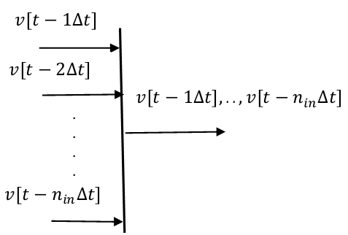 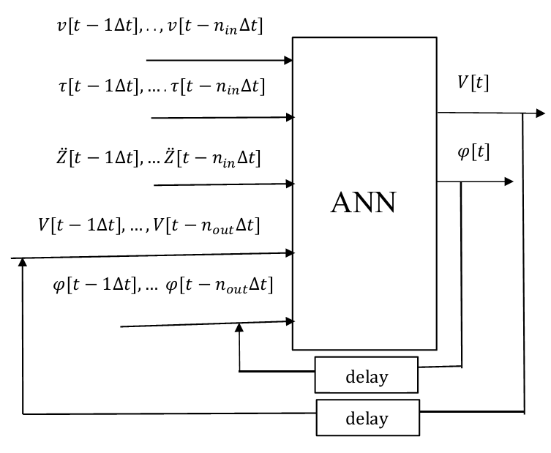

Fig. 6.a Notation for input vectors Fig. 6.b Input/output configuration of ANN

In the studies of ANN modelling for the sea state 1 condition, *nout and nin* were determined as 5 and 3 respectively, so 19 inputs, and 2 outputs ANN model was used. This model includes two hidden layers. The neurons’ number of the first, and the second hidden layers are 5, and 4, respectively. As a result of practices, the log- sigmoid activation function was chosen for both of the hidden layers, and the gradient descent with momentum and adaptive learning rate backpropagation algorithm was used for training of the ANN model. The ship’s speed, and the pitch motion angle comparisons of the linear parametric models as the SS and the ARX, and the ANN as non-linear model are illustrated for both of the training and the validation data sets in Fig. 7, and 8, respectively. In addition to this, the ship speed error results’ graphics of these models is shown in Fig. 9. The best performance results for both the ship speeds, and the pitch motions were obtained from the ANN model for the sea state 1 condition according to these figures.

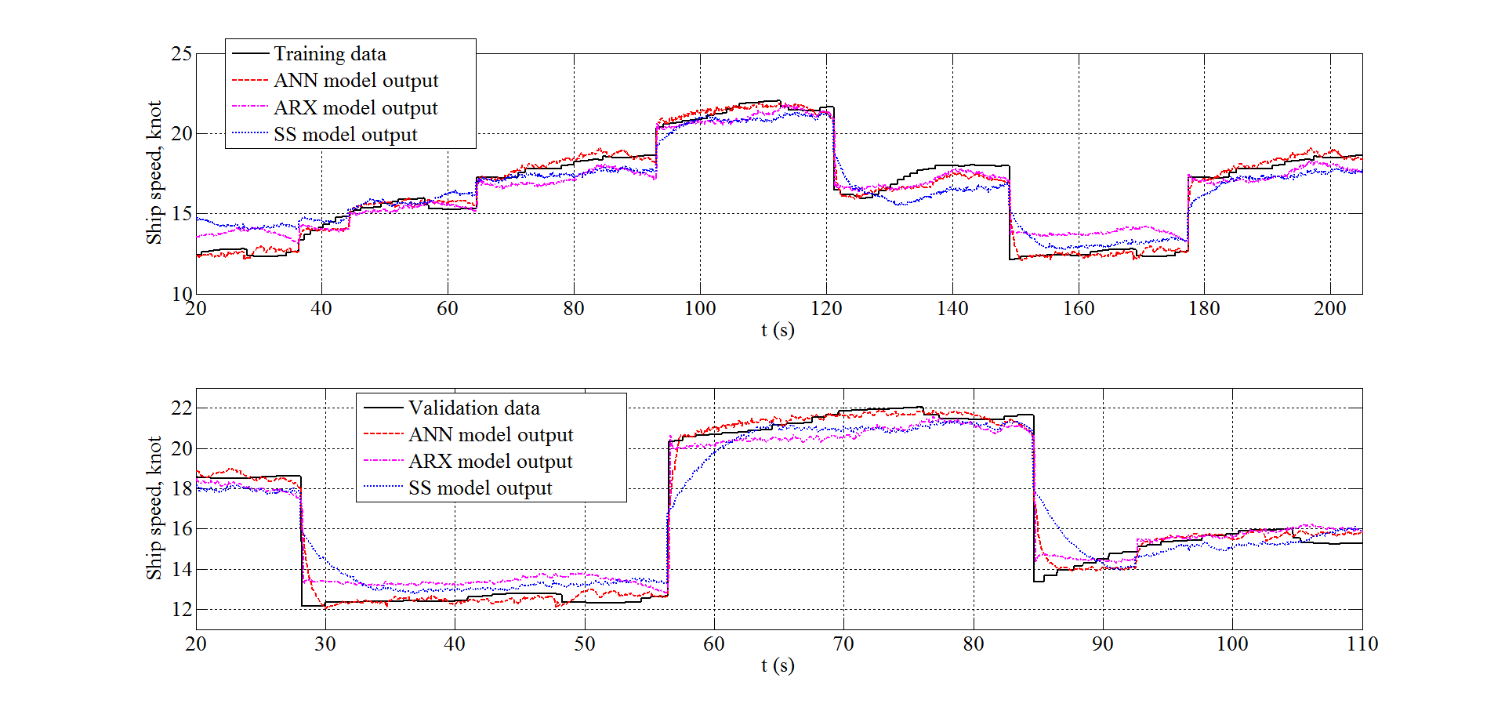

Fig. 7. The ship speed estimation of the ANN, the ARX, and the SS models for the training and the validation data in sea state 1 condition.

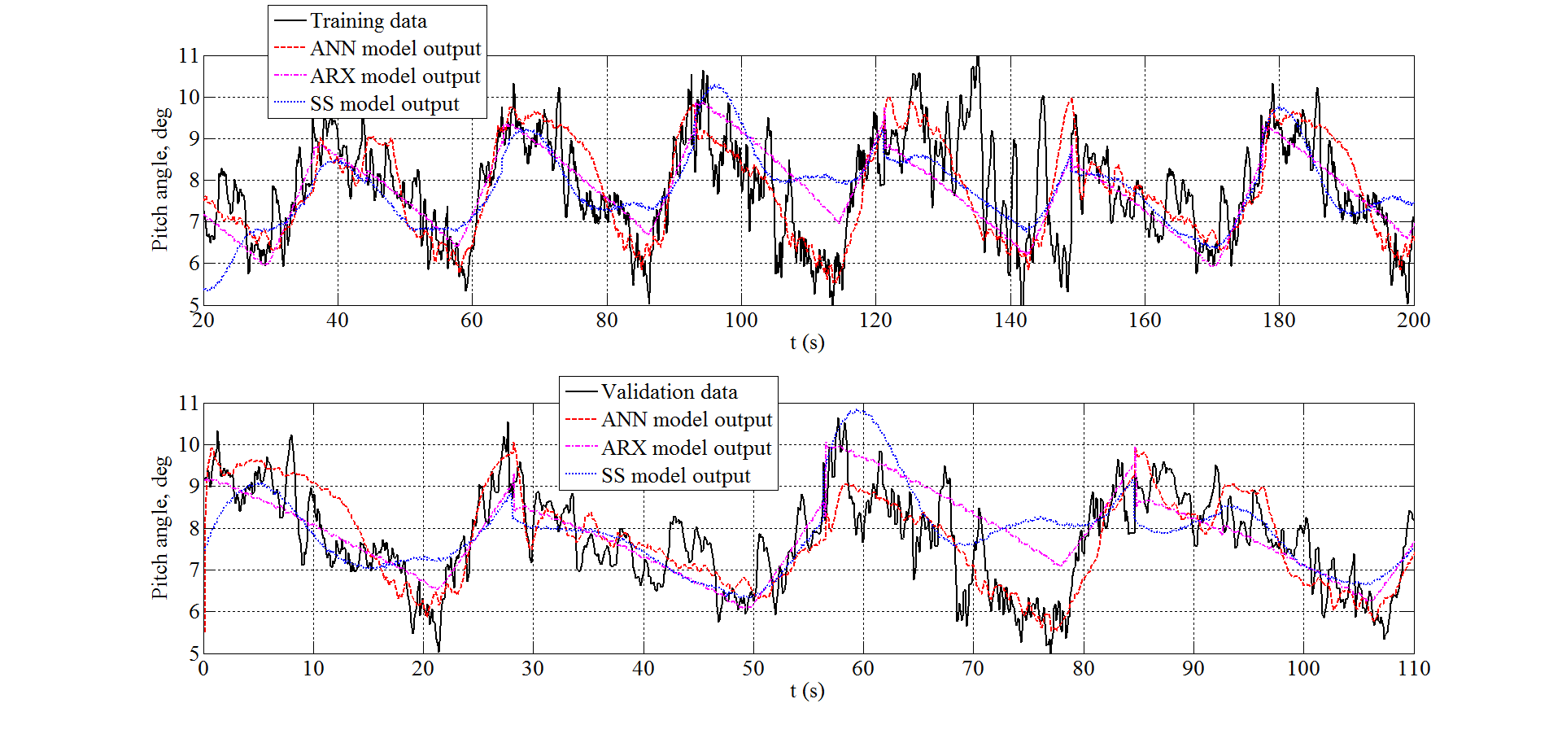

Fig. 8. The pitch angle estimation of the ANN, the ARX, and the SS models for the training and the validation data in sea state 1 condition.

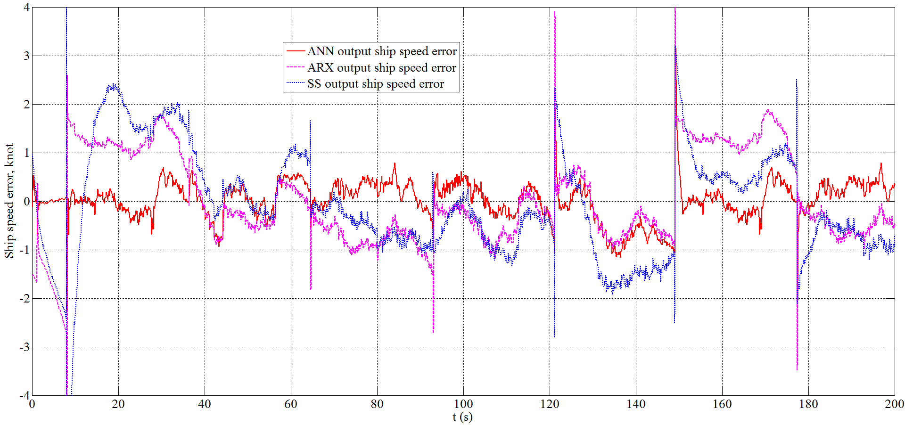

Fig. 9. The ship speed estimation error of the ANN, the ARX, and the SS models for the training in sea state 1 condition.

In the ANN modelling applications for the sea state 2 condition, the same as the sea state 1 condition, the ANN model consists of two hidden layers. The neurons’ number of the first, and the second hidden layers are 5, and 4, respectively. This ANN model was trained by the Levenberg-Marquardt algorithm. *nout* =7, *nin* =5 were selected, so 29 inputs, and 2 outputs ANN model was used. The log- sigmoid activation function was used for both of the hidden layers. The ship’s speed, and the pitch motion angle results of the linear parametric models as the SS and the ARX, and the ANN non-linear model are shown for both of the training and the validation data sets in Fig. 10, and 11, respectively for the sea state condition 2. The outputs as the ship speed, and the pitch motion angle from the ARX model resulted with better fitting values than the SS model. The best performance results for both the ship speeds, and the pitch motions were obtained from the ANN model according to these figures.

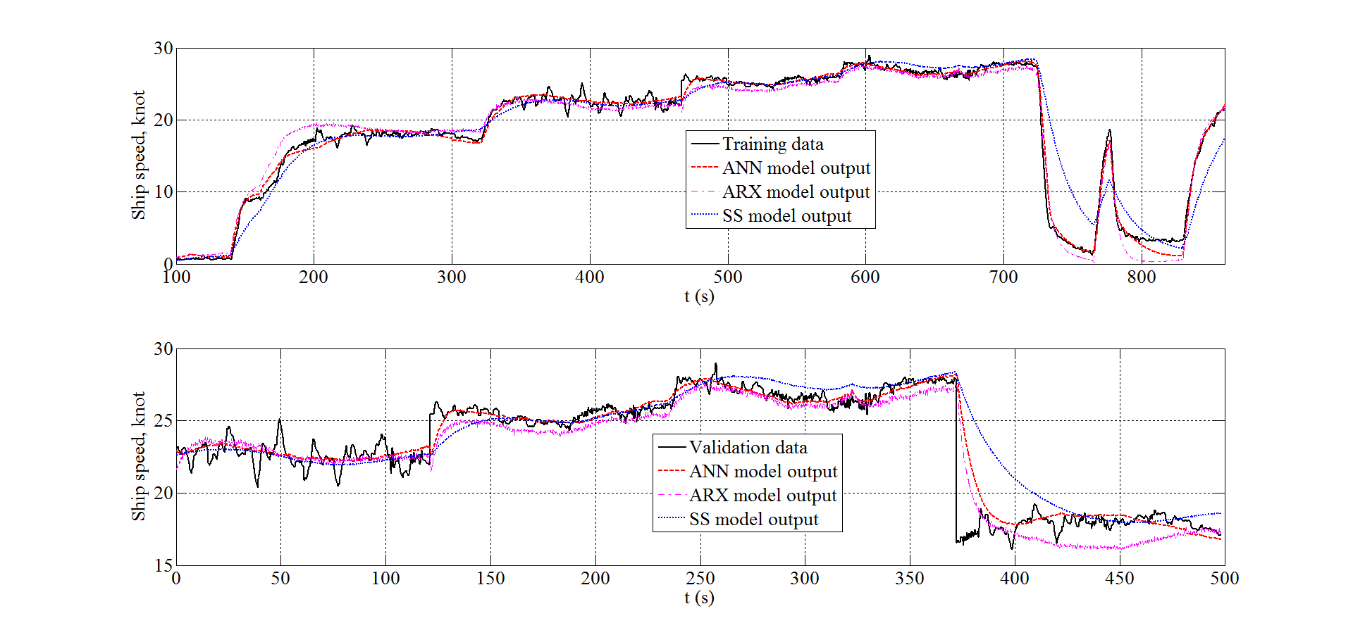

Fig. 10. The ship speed estimation of the ANN, the ARX, and the SS models for the training and the validation data in sea state 2 condition.

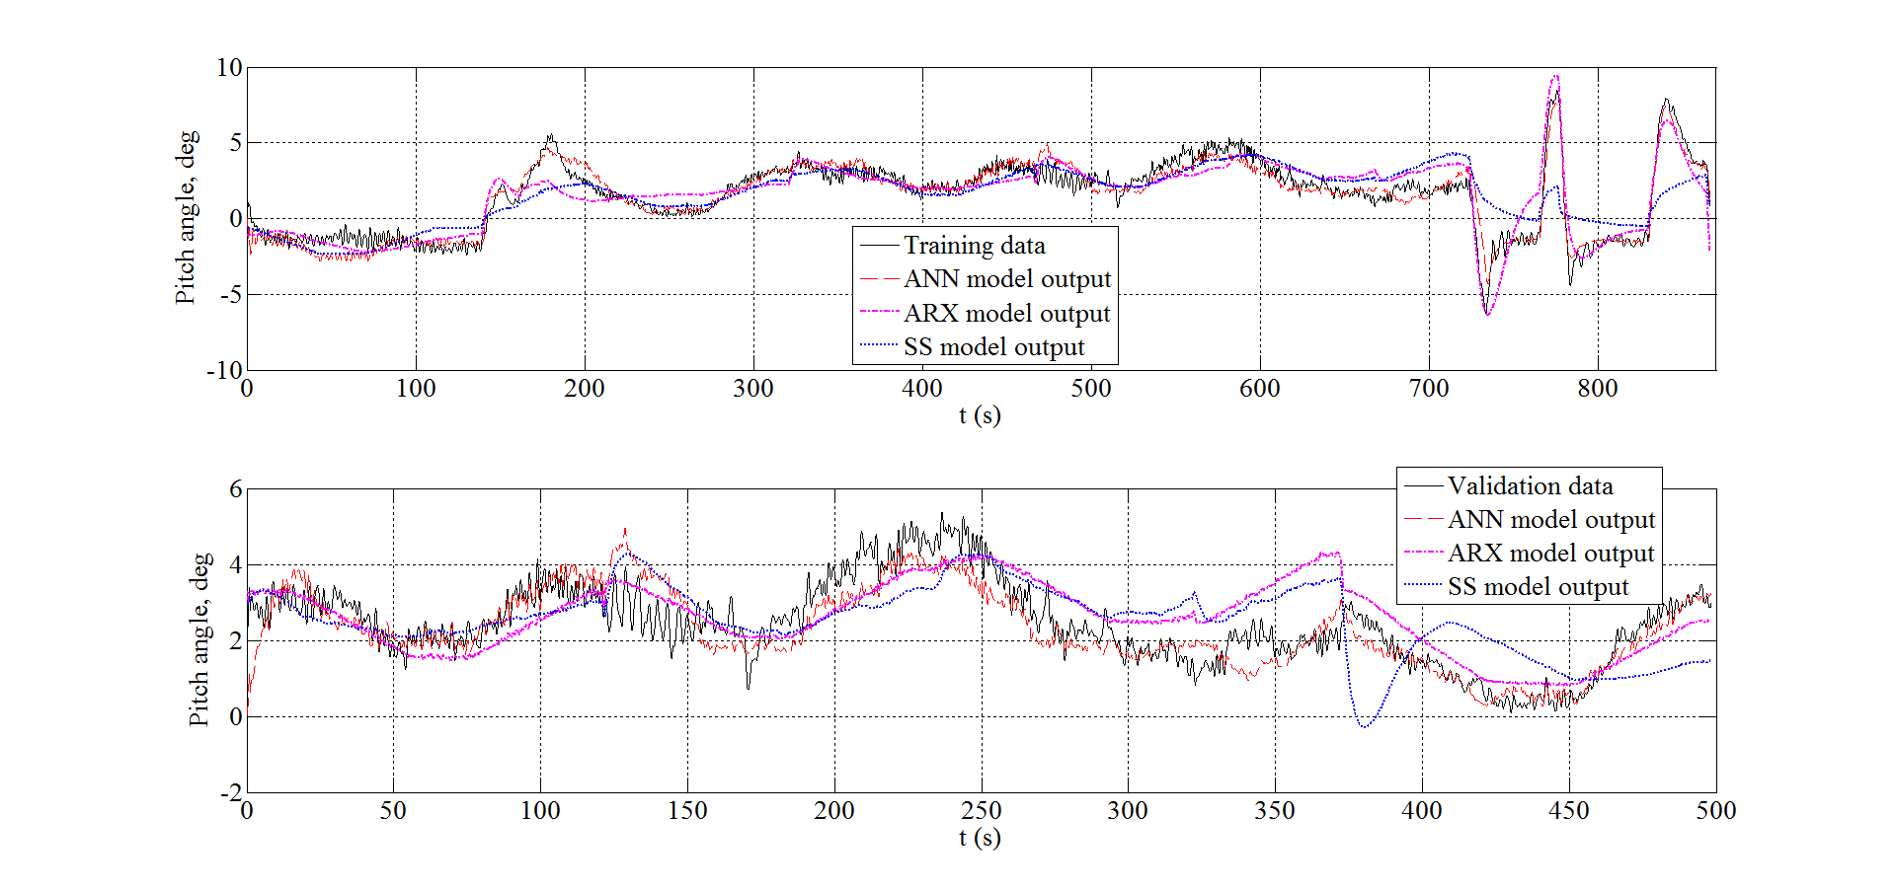

Fig. 11. The pitch motion angle estimation of the ANN, the ARX, and the SS models for the training and the validation data in sea state 2 condition.

The performance values for both of the sea state conditions were also analysed by the correlation coefficient R, and the average absolute value *MAE*, these values are given in Table 1 and 2, respectively. In the ANN model studies, the average values of absolute errors *MAE* for the ship speed were calculated approximately 0.3 knot for both of the testing and validation data in the calm sea condition as sea state 1. In the irregular sea condition as the sea state 2, the *MAE* values of the ship speed outputs of the ANN model were obtained as approximately 0.5 knot. In addition these, the MAE values of the pitch motion outputs of the ANN model in the both of the sea conditions are approximately ${ 0.5}^{0}$. These *MAE* values, and the correlation coefficients R of the ANN model are acceptable to develop an optimal trim controller via simulations.

Table 1: The correlation coefficients (R) of the ship speed and pitch motion angle for the SS, the ARX, and the ANN models in sea state 1 and sea state 2 conditions.

|  |  |  |  |  |  |  |  |  |
| --- | --- | --- | --- | --- | --- | --- | --- | --- |
|  | Sea state 1 | | | | Sea state 2 | | | |
|  | Ship speed, knot | | Pitch Angle, deg. | | Ship speed, knot | | Pitch angle, deg. | |
|  | Training data | Validation data | Training data | Validation data | Training data | Validation data | Training data | Validation data |
| SS | 0.93 | 0.94 | 0.68 | 0.57 | 0.89 | 0.85 | 0.73 | 0.48 |
| ARX | 0.95 | 0.97 | 0.75 | 0.68 | 0.92 | 0.93 | 0.88 | 0.66 |
| ANN | 0.99 | 0.99 | 0.83 | 0.80 | 0.99 | 0.96 | 0.96 | 0.87 |

Table 2: The average of absolute errors (*MAE)* of the ship speed and pitch motion angle outputs of the SS, the ARX, and the ANN models in sea state 1 and sea state 2 conditions.

|  |  |  |  |  |  |  |  |  |
| --- | --- | --- | --- | --- | --- | --- | --- | --- |
|  | Sea state 1 | | | | Sea state 2 | | | |
|  | Ship speed, knot | | Pitch angle, deg. | | Ship speed, knot | | Pitch angle, deg. | |
|  | Training data | Validation data | Training data | Validation data | Training data | Validation data | Training data | Validation data |
| SS | 0.94 | 0.70 | 0.88 | 0.78 | 1.4 | 1.1 | 1.2 | 0.85 |
| ARX | 0.85 | 0.51 | 0.75 | 0.67 | 0.96 | 0.88 | 0.83 | 0.66 |
| ANN | 0.30 | 0.32 | 0.58 | 0.56 | 0.52 | 0.56 | 0.47 | 0.45 |

**5. CONCLUSIONS AND FUTURE STUDIES**

In this research, three different dynamic models were obtained representing surge and pitch motions of a high-speed craft for simulation and control design purposes. Experimental data were collected from an instrumented high speed craft. Inputs and outputs of the model were carefully selected, orders and delays were determined to obtain a reliable model using the System Identification Theory. The trim tap/interceptor position and ship speed have been manually changed so that the system dynamics were excited. By utilizing experimental data ARX and SS models were identified and compared with ANN models. When figures are examined closely, all models well represent the system’s dynamic behaviour. As can be seen from the Figures and Tables, ANN achieved smaller errors than ARX and SS in all cases. Therefore, the ANN model can be used for the simulation and the controller design purposes such as optimal trim control which will the next step and explained in a follow up paper, as Part II.

These modelling approach can be extended to include other motions such as manoeuvring or heave motion reduction control purposes.

**ACKNOWLADGEMENTS**

Authors would like to thank I.T.U. Scientific Research Funds for partial support (project number: 37491) and The Republic of Turkey Ministry of Industry and Trade, 1507 - SME RDI (Research, Development & Innovation) Grant Programme for the support provided for the project numbered 7141282.

The author is also grateful to the University of Southampton for facilitating the research.

**7. REFERENCES**

Aström, K.J., Kallström, C.G., 1976. Identification of ship steering dynamics. Automatica, Vol. 12, pp. 9-22.

Blake, J.I.R., 2000. Investigation into the vertical motions of high speed planing craft in calm water and in waves. PhD thesis, Faculty of Applied Science and Engineering School of Engineering Sciences, University of Southampton.

Blake, J.I.R., Wilson, P.A., 2001. An analysis of planning craft vertical dynamics in calm water and waves. Royal Institution of Naval Architects, UK, Vol. 1, pp. 77-90.

Blank, J., Bishop, B.E., 2008. In-Situ modeling of a high-speed autonomous surface vessel. 40th Southeastern Symposium on System Theory, 2008.

Blanke, M., Knudsen, M., 2006. Efficient parameterization for grey-box model identification of complex physical systems. 14th IFAC Symposium on Identification and System Parameter Estimation, Newcastle, Australia, Vol. 39, pp. 338-343.

Demuth, H.B., Beale, M.H., Hagan, M.T., 2013. Neural Network ToolboxTM, Version 8.0.1, The MathWorks, Inc.

Du, K.-L., Swamy, 2006. Neural networks in a softcomputing framework, Springer-Verlag London Ltd.

Ertogan, M., Tayyar, G.T., Karakas, S., Ertugrul, S., 2015. Review of measurement and real-time control systems for marine applications. The 4th International Conference on Advanced Model Measurement Technologies for the Maritime Industry, Istanbul, Turkey, pp. 72-p.1-p.20.

Ertogan, M., Ertugrul, S., Taylan, M., 2016. Application of particle swarm optimized PDD2 control for ship roll motion with active fins. IEEE-ASME Transactions on Mechatronics, Vol. 21, pp. 1004-1014.

Faltinsen, O.M., 2005. Hydrodynamics of high-speed marine vehicles, Cambridge University Press, Cambridge, UK.

Fossen, T.I., 2011. Handbook of marine craft hydrodynamics and motion control, First Edition. John Wiley & Sons Ltd.

Haddara, M.R., Xu, J., 1999. On the identification of ship coupled heave-pitch motions using neural networks. Ocean Engineering, Vol. 26, pp. 381-400.

Hagan, M.T., Demuth, H.B., Beale, M.H., De Jesus, O., 2014. Neural Network Design, Martin Hagan, 2nd edition, ebook.

Handa X., Jing S., 2006. Feedback stabilization of high-speed planing vessels by a controllable transom flap. IEEE Journal of Oceanic Engineering, Vol. 31, No:2, pp. 421-431.

International Towing Tank Conference (ITTC), 2011. The seakeeping committee on final report and recommendations to the 26th ITTC. In: Proceedings of the 26th ITTC, vol. 1, pp. 183–245

International Towing Tank Conference (ITTC), 2011a. The specialist committee on computational fluid dynamics—final report and recommendations to the 26th ITTC. In: Proceedings of the 26th ITTC, vol. 2, pp. 337–377.

Karimi, M.H., Seif, M.S., Abbaspoor, M., 2013. An experimental study of interceptor’s effectiveness on hydrodynamic performance of high-speed planning craft. Polish Maritime Research, Vol. 20, pp. 21-29.

Lewandowski, E.M., 2003. The dynamics of marine craft: maneuvering and seakeeping, Advanced Series on Ocean Engineering, Vol.22.

Ljung, L., 1999. System identification: theory for the user. Prentice Hall, Second Edition.

Ljung, L., 2013. System identifiction toolboxTM for use with MATLAB. User’s Guide Version 8.3, The MathWorks, Inc.

Luca, D., and Pensa, F., 2012. Experimental Investigation on Conventional and Unconventional Interceptors. The Transactions of the Royal Institution of Naval Architects. Part B, International Journal of Small Craft Technology, Vol. 154, pp. 65-72.

Mansoori, M., and Fernandes, A. C., 2016. The Interceptor Hydrodynamic Analysis for Controlling the Porpoising Instability in High Speed Crafts. Journal of Applied ocean research, Vol. 57:40-51.

Munoz-Mansilla, R., Aranda, J., Manuel Diaz, J., De La Cruz, J., 2009. Parametric model identification of high-speed craft dynamics. Ocean Engineering, Vol. 36, pp. 1025-1038.

Munoz-Mansilla, R., Aranda, J., Diaz, D.C., 2010. Robust control for high-speed using QFT and eigenstructure assignment. IET Control Theory & Applications, Vol. 4, pp. 1265-1276.

Panahi, R., Jahanbakhsh, E., Seif, M.S., 2009. Towards simulation of 3D nonlinear high-speed vessels motion. Ocean Engineering, Vol. 36, pp. 256-265.

Pintelon, R., Schoukens, J., 2004. Discussion on: “identification of multivariable models of fast ferries”. European Journal of Control, Vol. 10, pp. 199-202.

Savitsky, D., 1964. Hydrodynamic design of planing hulls. Marine Technology, Vol. 1, pp. 71-95.

Savitsky, D., Brown, P. W., 1976. Procedures for hydrodynamic evaluation of planning hulls in smooth and rough Water. Marine Technology, Vol. 13, No.4, pp. 381-400.

Simsir, U., Ertugrul, S., 2009. Prediction of manually controlled vessels’ position and course navigating in narrow waterways using artificial neural networks. Applied Soft Computing, Vol. 9, No. 1217-1224.

Soderstrom, T., Stoica, P., 1989. System identification. Prentice-Hall, Hertfordshire, UK.

Sutulo, S., Soares, C.G., 2014. An algorithm for offline identification of ship manoeuvring mathematical models from free-running tests. Ocean Engineering, Vol. 79, pp. 10-25.

Svendsen, C.H., Holck, N.O., Galeazzi, R., Blanke, M., 2012. L1 adaptive manoeuvring control of unmanned high-speed water craft. Proceedings of the 9th IFAC Conference on Manoeuvring and Control of Marine Crafts, pp. 144-151.

Tasi, F. J., and Hwang, J. L., 2004. Study on the Compound Effects of Interceptor with Stern Flap for Two Fast Monohulls. IEEE Xplore Conference: Oceans '04. MTTS/IEEE Techno-Ocean '04, Taiwan, Vol. 2, pp. 1023 - 1028.

Van Overschee, P., B. De Moor, 1996. Subspace identification of linear systems: theory, implementation, applications. Springer Publishing.

Velasco, F.J., Lopez, E., Rueda, T.M., Moyano, E., 2003. Classical controllers to reduce the vertical acceleration of a high-speed craft. European Control Conference, Cambridge, UK, pp. 1923-1927.

Wang X., Zou Z., Hou X., Xu F., 2015. System identification modeling of ship manoeuvring motion based on – support vector regression. Journal of Hydrodynamics, 27(4), 502-512.

Woelfel, G.A., Ehrhardt, B.J., Bishop, B.E., 2004. Development of an autonomous planning watercraft test bed. Proceedings of the Thirty-Sixth Southeastern Sysmposium, pp. 285-289.

Zihnioglu, A., Ertogan, M., Tayyar, G.T., Karakas, C.S., Ertugrul, S., 2015. Modelling, simulation and controller design for hydraulically actuated ship fin stabilizer system. The 3rd International Conference on Control, Mechatronics and Automation, Bercelona, Spain, ICCMA, Vol. 42, pp. 01003-p.1-p.6.

**APPENDIX A. EXPERIMENTAL SYSTEM SETUP**

Volcano71 is a high speed craft with a deep V form. Its profile view is given in Fig. A.1. The interceptor, and the trim tab systems were installed for the real-time applications, as shown in Fig. A.2. The trim of the sterndrive systems of the gasoline engines can be manually controlled by a hydraulic assisted system. These manual systems can be controlled by an algorithm when the trim system becomes automatic.

The other particulars of Volcano71 are as follows: length overall LOA=10.86m, length on the waterline LWL=9.4m, beam B=3.3 m, depth D=1.15 m, deadrise angle β= ${16}^{°}$. Hydrostatic characteristics of it are displacement ∆=5.35 tons, draft T=0.45 m, metacentric height $\overline{GM}$ =0.64 m, natural period $w_{0}$ =3 s. Volcano71 has a 2x385 BHP sterndrive twin engine reaching a speed up to 40 knots with the installed propellers.

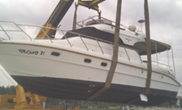

Fig. A.1. Profile view of Volcano71.

The blade size and stroke of the interceptor’s are 430mm, and 50mm, respectively. The size of the trim tab’s plate of the each engine is 450mm x 250mm. The Pulse Width Modulation (PWM) drivers were provided for the interceptor, trim tab systems, and sterndrive systems.

a) 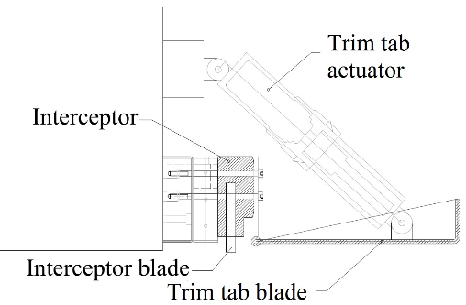 b) 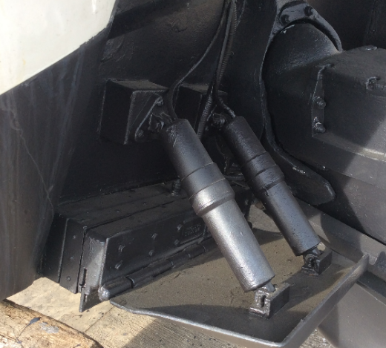

Fig. A.2. a) The technical drawing of the interceptor, and the trim tab systems, b) they were mounted on Volcano71 having the sterndrive engines.

A computer having a quad-core, 3.2 GHz processor, and 8 GB RAM has been used for laboratory and sea trial works. An industrial embedded microprocessor unit with I/O electronic cards has been used for measurement and control. An inertial measurement unit (IMU), including triaxial accelerometer, gyroscope, magnetometer, was chosen to measure the ship’s 3-axis rotational and linear motions. The measurement range of the IMU’s outputs are ±4 g with 12-bit reading per axis, and $±{{250}^{°}}/s$ with 16-bit reading per axis. . Also, a GPS was used, and its data output rate is 1 Hz to 10 Hz. The GPS and the IMU have been used for data acquisition for modelling, and designing the controller.

The GPS was utilized and considered as sole sensor for final prototype. A pair of electronic sensors for measuring fuel flow and, a flow meter were also installed on the ship during experimental stage. The communication interface of these sensors is with NMEA 2000 protocol.

Volcano71 was launched, after the experimental equipment setup was completed. The data was collected from sea trials in Tuzla-Istanbul in order to obtain a coupled pitch and surge dynamic model. The next subsection describes the data acquisition stage.

1. Corresponding author at: Marine Engineering Faculty, Istanbul Technical University, Tuzla, Istanbul, Turkey.

   Phone: +90-533-3408113, fax: 90-216-3954500.

   E-mail addresses: ertogan@ itu.edu.tr , [melekertogan@gmail.com](mailto:melekertogan@gmail.com) (M. Ertogan),

   [Philip.Wilson@soton.ac.uk](mailto:Philip.Wilson@soton.ac.uk) (P.A. Wilson), [tayyargo@itu.edu.tr](mailto:tayyargo@itu.edu.tr) (G.T. Tayyar),

   [seniz@itu.edu.tr](mailto:seniz@itu.edu.tr) (S. Ertugrul)