[1]

Finite Element Contact Modeling of Rough Surfaces Applied to Au-coated Carbon Nanotube Composites

Hong Liu, John W. McBride, Senior Member, *IEEE*

*Abstract*—Multi-walled carbon nanotubes (MWCNTs) have been used to improve the lifetime of electrical contact of MEMS switches. The surface, usually gold-coated, demonstrates a complex structure. Due to the lateral gaps between nanotubes, the sputtered gold penetrates into the top part of CNT at a limited thickness, and supported by the rest of CNT.The surface presents a much higher roughness than metal surfaces. Based on the nano-indentation test, a finite element smooth contact model has been developed and it was shown that the surface was best modeled as a bi-layered structure. In this study, roughness is considered in contact modeling. It is shown, that the roughness plays an important role in contact behavior, and that the material properties such as the Young’s modulus and hardness estimated from the nano-indentation tests need to be re-evaluated. It was also shown with FEM that the force-displacement behavior of the composite depends on the location of the indentation test.

*Index Terms*—contact mechanics, roughness, finite element, bi-layered structure, Au/MWCNT composite.

# Introduction

I

t has been shown that a composite of gold-coated multi-walled carbon nanotubes (Au/MWCNTs) used as a contact surface can prolong the lifetime of low current electrical contacts compared to Au-Au contact, in MEMS switching applications [1, 2] [3] [Adam’s paper]. The reason is assumed to be the high elasticity of the MWCNT [18], which provides a compliant support to the conductive Au layer, and increases the contact area, thus reduce the impact damage compared to Au-Au contact [3] [13-14]. Different structure of nanotubes have been used for contact surfaces. [Yaglioglu_2006] used high quality tangled films, whereas [Stilson_2013] has been encapsulated within Au structure. The vertically aligned multi-walled carbon nanotubes (MWCNT) are used in the study, and the gold layer is coated on the top of the MWCNT forest to form the gold-coated MWCNT composite [1]. To investigate the mechanical behavior of the Au/MWCNT composite, nano-indentation tests were performed [3] and the material properties were calculated using the Olive-Pharr model [4], which considers the composite as a single material, and no roughness included on the surface. The results show a significant degree of variability in the force-displacement curves over the surface area, as a result of the non-uniformity of the Au/MWCNT composite. The lateral gaps between carbon nanotubes, causes the gold to penetrate into the MWCNT, and therefore create a non-uniform layer. SEM images have shown that the penetration depth of Au below the topmost layer of CNTs can vary between 1~10 µm, depending on the thickness of sputtering [1, 3]. It is also noted that the penetration of gold is limited, and the mixed Au-CNT is supported by the rest of pure CNT. It was shown in previous finite element (FE) modeling, based on a smooth contact between the Au/MWCNT surface and a spherical surface (Radius 200 µm), that the composite was best modeled as a bi-layered structure [5, 6]. The top layer is modeled as elastic-plastic gold and CNT mixed material, while the under layer is pure elastic CNT.

Although the nanotubes are vertically aligned along the length, the heights to which the nanotubes grow are not uniform and the top surface of the MWCNT forest is comparatively rough. The roughness of the Au/MWCNT composite, is *Ra* ≈ 0.1-0.3µm, this is much larger than same gold film sputtered on a silicon substrate, where *Ra* ≈ 30 nm [2].

The contact force in MEMS switches is usually from tens of µN’s up to 10 mN [7], and only the highest asperities make actual contact, therefore the roughness plays an important role in contact mechanics and electrical contact resistance. For the composite with 500 nm Au coated on 50 µm CNT, the indentation depth with a 0.25 mN load is about 700 nm, which is comparable to the surface roughness. The surface roughness, in this case, can be expected to make a significant contribution to the indentation response.

A number of recent studies have investigated the FE modeling of rough surfaces, linked to nano-indentation tests. In [8], the rough surface was simulated using a 2D sinusoid function. In [9], simulated rough surfaces, with *Ra* values 2-42 nm, has been developed using an established FFT method [10]. In a previous paper [11], AFM data has been used to develop a FE modeling of a rough surface, for the application of MEMS switches with metallic (Ohmic) contact, the surface roughness was of the order of *Ra* =10-20 nm. This paper develops the FE model further, as it is applied to a bi-layered complex structure, and the surface roughness is more than 10 times larger than in [11]; and this causes a major challenge in rough surface contact modeling.

An initial FE contact model of the rough surface of the bi-layered Au/MWCNT composite has been developed in a previous study [12], where real surface data measured from a laser profiler were used. The paper showed that the minimum substrate size should be 0.2 mm × 0.2 mm to remove the effect of boundary conditions on the vertical surfaces of the substrate, and obtain accurate results, for the 200 µm spherical indenter. It was also shown that the deformation in rough contact modeling was larger than the smooth contact model at a given force. When only few asperities are in contact, it results in higher contact pressure and smaller contact area than the smooth model.

In this paper the rough contact model is developed with improved surface data, following the same modeling methodology described in [12]. The geometry of the interfacial surface of the bi-layered structure is investigated, as well as the impact of the data spacing and the indentation position. The impact of roughness on the contact mechanics is investigated, and the material properties adjusted from the smooth model. In addition, the contact area is evaluated, and from this using the standard method for evaluation contact resistance we will be able to compare the predicted contact resistance with measured values [13].

# Sample Fabrication and Characterization

## Sample Fabrication

The fabrication of the Au/MWCNT composite is reported in [3], and as shown in Fig. 1. A 1.5 nm layer of Al2O3 and a 10 nm catalyst layer of Fe are initially sputtered on a silicon wafer. Vertical aligned MWCNTs are grown using thermal chemical vapor deposition (CVD), and ethylene is used as carbon source gas. The growth temperature is 875°C, and the growth time is used to control the height of MWCNT. The last step is sputtering a gold layer onto the nanotubes forest. In this paper, a composite with 500 nm Au sputtered on 50 μm CNT is investigated, as it shows good electrical performance in switching tests [13-15].

The SEM image of MWCNT in Fig. 1 shows that the MWCNT are vertically aligned, and apparently uniform. Fig. 2 shows TEM images of the composite, used to investigate the penetration of Au into the CNT. It is shown that the penetration depth varies from sample to sample; and is 2 μm and 6 μm for the two samples presented.

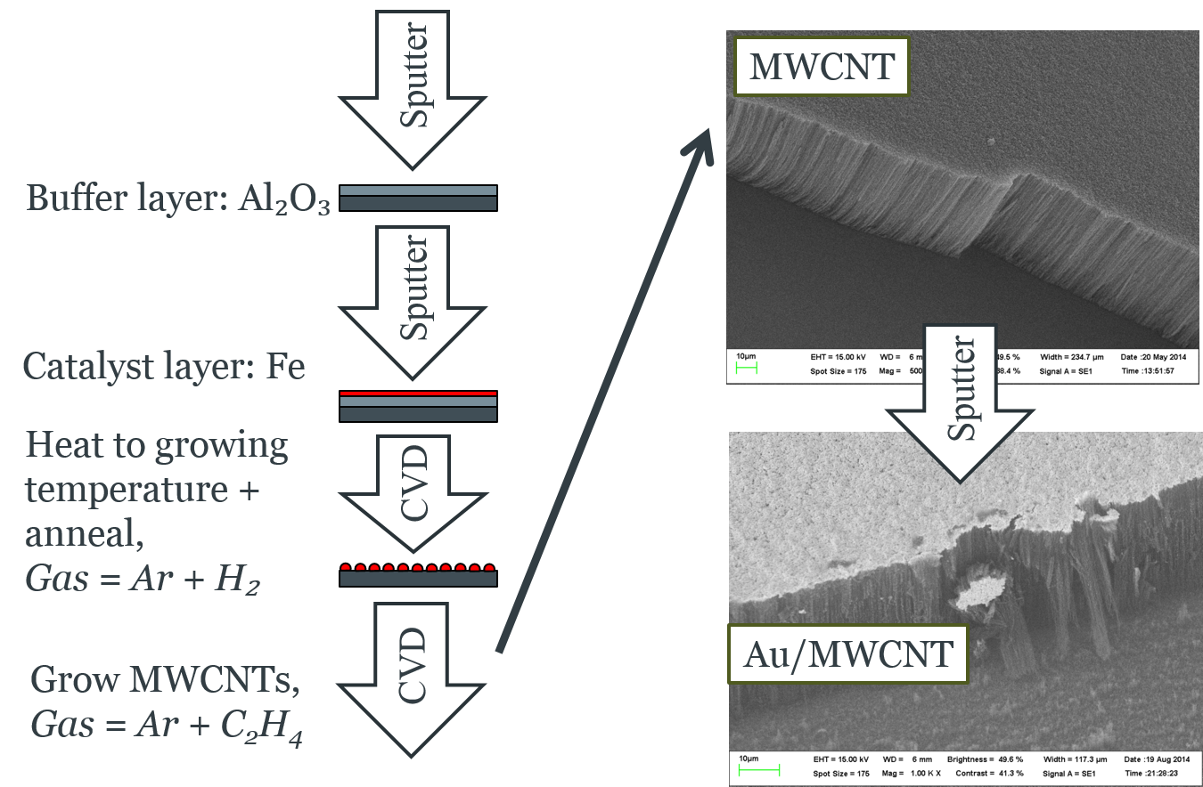

Fig. 1. Fabrication process of Au/MWCNT composite.

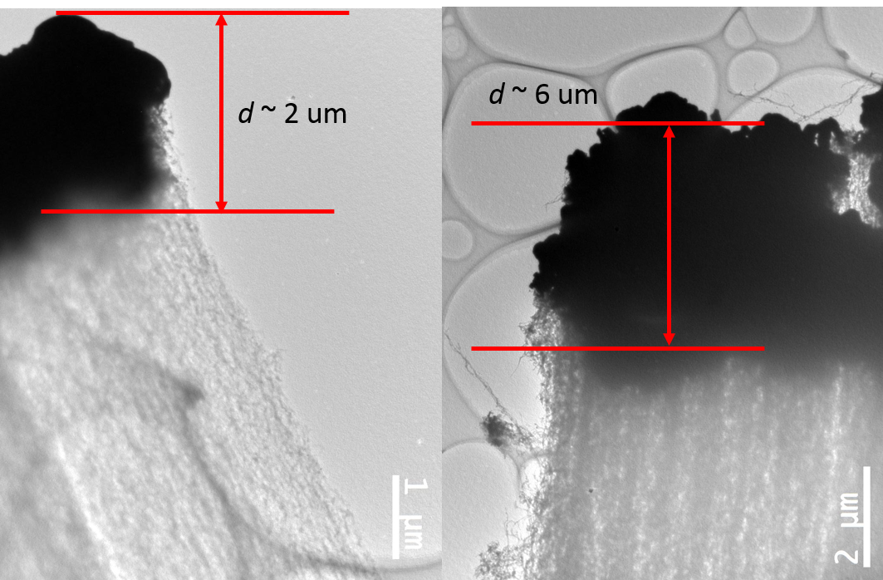

Fig. 2. TEM images of a nominal 500 nm gold coated on 50 μm CNT surface. *d* represents the penetration depth.

## Surface Characterization

The surface of the Au/MWCNT composite was measured using TaiCaan® confocal laser (CL) profiler XYRIS 4000CL in the previous study [12]. To gain more detailed information about the surface, an atomic force microscopy (AFM) Park XE7 has been used. The scan range of the Park XE7 is 50 ×50 µm2 in X-Y direction, and 12 µm in Z direction. A series of scans have been performed over 40 µm × 40 µm scan area at different positions, and they present similar topography of the surface, with the peak-valley values about *Rpv~* 1.9 -2.3 µm, and roughness *Ra*~ 0.18-0.19 µm, which *Ra* is the arithmetic average of absolute values from the mean line . [Chen_2015] also used the AFM to measure the surface roughness of vertically aligned MWCNT. The roughness value *Ra*, measured over a scan area of 50 × 50 µm, is from 0.09 – 0.27 µm for a large number of samples.

Further examinations were then performed with a TaiCaan® XYRIS 4000WL white light (WL) sensor. The resolution of the WL sensor is 10 nm. Fig. 3 (a) shows a 3-D view and cross-section view of a scanned image over scan area of 40 µm × 40 µm, with 201×201 data points. The TaiCaan® system allows for much larger area to be characterized and measured, when compared to the AFM, allowing the full surface characteristics to be evaluated. A scan over a larger scan area of 1 mm × 1 mm with 501 × 501 data points is plotted in Fig. 3 (c), providing a larger view of the surface. Compared to the image with small area (Fig. 3 (b)), the surface presents a much larger wavelength, shown as green curves in Fig. 3 (d), implying the non-uniform heights of the MWCNT forest. The roughness of the surface (Fig. 3 (c)), is *Ra* ~0.34 µm with Gauss filter cutoff of 0.25 mm, which is slightly larger than that of small scan area (Fig. 3 (a)), where *Ra* =0.22 µm. It was also shown that the size of the asperities on the surface is normally 2-5 µm, as shown in Fig. 3(b).

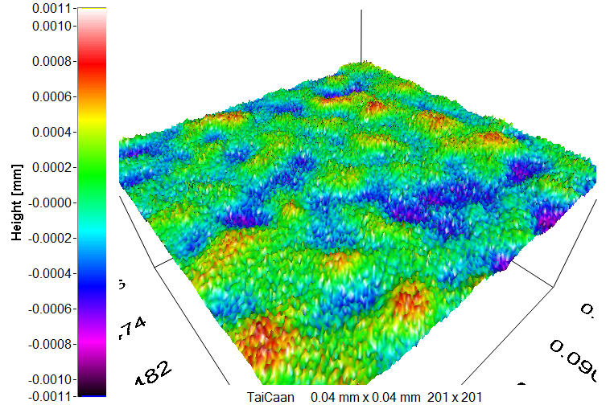

Size of asperities: 2- 5 um

(a)

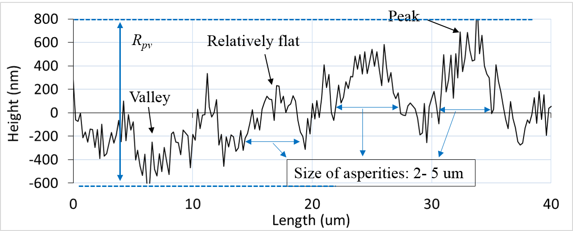

(b)

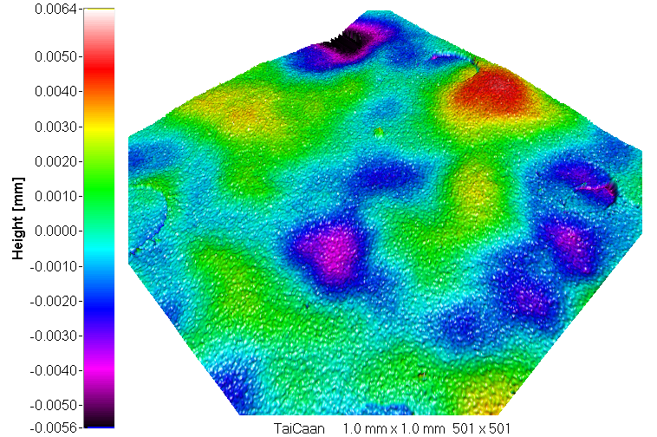

(d)

(c)

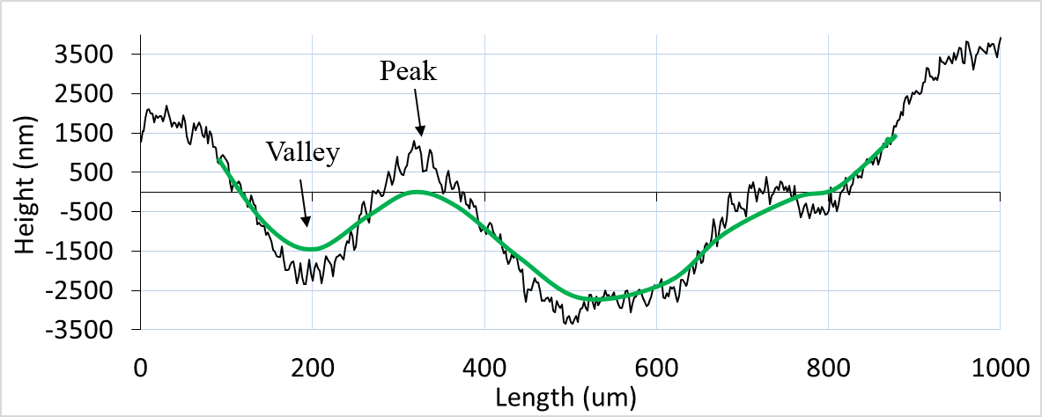

Fig. 3 TaiCaan images of a sample 500 nm Au/50 um CNT: (a)-(b) 3-D view and cross-section view of the data over scan area of 40 µm × 40 µm, with data points of 201 × 201; (c)-(d) 3-D view and cross-section view of the data over scan area of 1mm × 1 mm, data points of 501×501. The green line in (d) is the waviness curve with Gauss cut-off of 0.25 mm.

## Nano-indentation Tests

Nano-indentation has been used to investigate the mechanical behavior of the Au/MWCNT composite. A Nanotest Vantage system from Micro Materials® was used. The indentation was with a 200 μm radius spherical diamond tip because the Berkovich tip would pierce into the surface. Each sample was subjected to four loads, 0.25, 0.5, 0.75 and 1 mN, with each load repeated 10 times, at a new location on the surface. Unfortunately, the sample 500 nmAu/50um CNT failed at 0.75 mN and above, and only the results with 0.25 mN are used in this paper. The loading and unloading rate was 0.01 mN/s, with 30s dwell at the maximum load, which can help to minimize the effect of the creep, as CNT is known for its visco-elastic behavior [3].

The hardness and the elastic modulus were calculated automatically by the system after the creep, and using the Olive-Pharr model [4].

The hardness was calculated with:

 (1)

 (2)

where *H* is the hardness and *P*max is the maximum load. *A* is the projected contact area, and can be expressed as a function of contact depth *hc*, as *A*(*hc*). *hc* can be calculated by (2), where *S* is the slope of the curve during the initial stages of unloading, also referred to as contact stiffness, and *ε* is a constant depending on the geometry of the indenter, and *ε*=0.75 for spherical indenter. The inset figure in Fig. 4 illustrates the important parameters in an indentation test. In the study, *A* is calculated with area function as described in [16], where no roughness is included.

The effective elastic modulus *Er* and the elastic modulus of the composite *E* can be then calculated by (3-4).

 (3)

 (4)

where *β* is the correction factor, *E* and *ν* are the Young’s modulus and Poisson’s ratio for the specimen, and *E*i and *ν*i are the values for the indenter.

Fig. 4 shows repeated force-depth curves at different locations on the same surface, for 50-μm CNT coated with a nominal 500-nm Au, with an applied load of 0.25 mN. During indentation the indenter occasionally encountered a void or pocket in the CNT forest where the CNT’s did not grow, the indenter data showed apparently very different curves from others, the whole data of these curves are removed in the calculation of average curve [3]. The data, with anomaly curves removed, show the depth of indentation to be variable from 400 to 1000 nm. The value of *S* appears to be repeatable. The properties are calculated based on the averaged curve, plotted as a thick line in Fig. 4, ~~with the anomalies removed,~~ and assuming a single continuum material. The evaluated elastic modulus at 0.25 mN is 0.0219 GPa, and the hardness is 0.2815 MPa [3]. The evaluated hardness and the elastic modulus from the individual tests are plotted in Fig. 5, this shows a large range of variation, with the standard deviation of 0.25 MPa for hardness, and 0.0156 GPa for the elastic modulus. 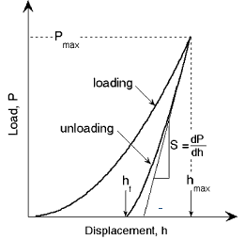

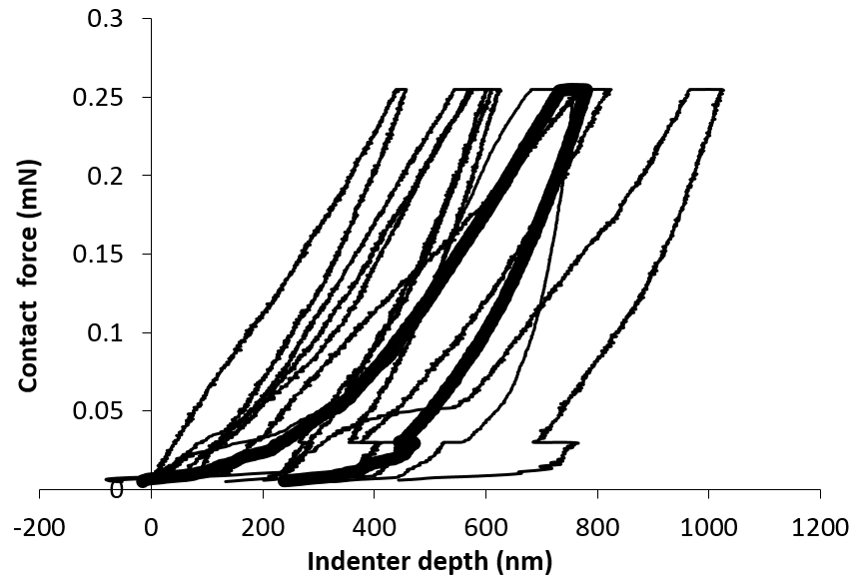

Fig. 4. Nanoindentation results for the composite 500-nm gold coated on 50-μm CNT surface, with the maximum load force of 0.25 mN. The thin lines are the individual experimental results, and the thick line is the averaged curve. The inset figure shows the schematic illustration of indentation load–displacement data showing important measured parameters (after [4])

.

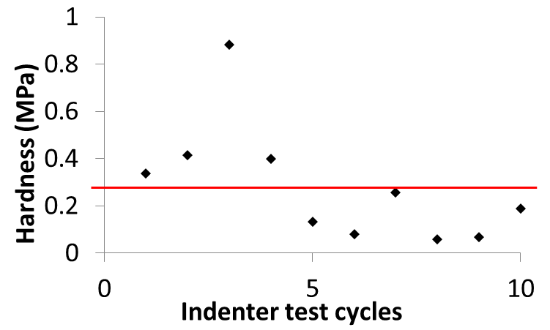 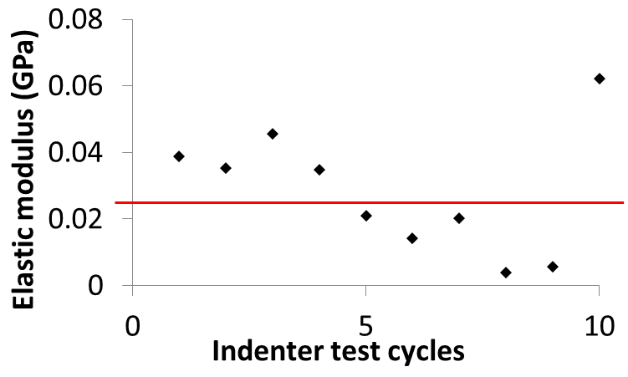

Fig. 5. Hardness and the elastic modulus evaluation from individual nano-indentation tests, the red lines represent the values from the averaged curve.

# Finite Element Modeling

## Finite Element Contact Model

A finite element contact model is developed using ANSYS14.5 to investigate the mechanical behavior of Au/MWCNT and to compare the predicted force-displacement curves with the nano-indentation test data, e.g. Fig. 4. The model consists of a 200-μm radius diamond hemisphere, making contact with a gold-coated MWCNT composite on a silicon substrate, as shown in Fig. 6. The elements are the same as in previous studies [5, 6]. The top surface of the Au/MWCNT composite is modeled as a contact surface, and is meshed with the 3D surface-to-surface contact element CONTA174, and the spherical surface of the diamond ball is modeled as a target surface, and meshed with the target element TARGE170. The substrate and the ball are modeled using 3D tetrahedral solid element SOLID187. The augmented Lagrange method is used to seek the contact and large deformation is activated in the calculation.

The base surface of the substrate is fixed. For all nodes of the top surface of the hemispherical ball, the degree of freedom (DOF) UZ is coupled and no displacement in the *X* and *Y* plane allowed. For a smooth contact model, a uniform pressure is applied vertically on the top surface of the hemisphere, whereas the displacement load is applied for a rough contact model, as it is easier to converge with displacement load [17]. A loading-unloading cycle is applied for both loading methods, with 10 steps for loading and 10 steps for unloading. For the rough contact model, the maximum displacement load is set as 800 nm, and the minimum is 300 nm, these values are chosen based on the average curve of the experimental results (Fig. 4).

Contact modeling with a rough surface is a non-linear problem, requiring a high computation overhead, to reduce the processing time a small data size is preferred. In a previous study [12], the size of substrate was reduced, to reduce the data points in the modeling. Three types of models were proposed, depending on the geometry of substrate, namely as whole-sized model, quarter-sized model and a small rough area surrounded by a large smooth substrate. For a rough contact model of Au/MWCNT composite, due to the random location of the contacting asperities and the very soft material properties of Au/MWCNT composite, the whole-sized model is the best. It was also shown that the size of the substrate should be at least 0.2 mm to remove the boundary effect [12] (as shown in Fig. 6).

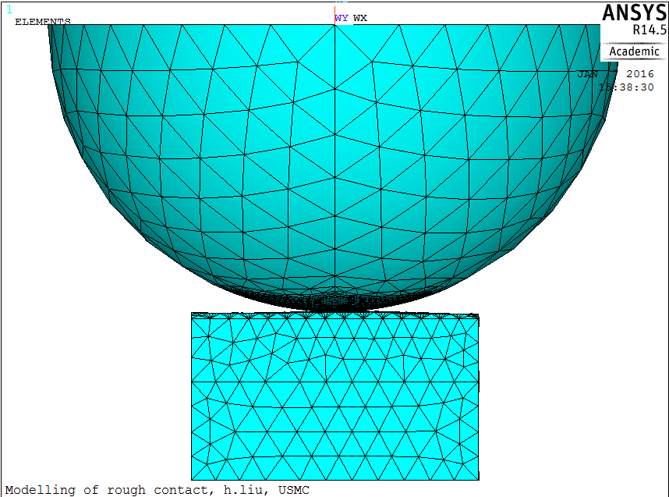

Fig. 6. 3D contact FEM of a hemisphere making contact with a composite 500 nm Au/50 μm CNTs.

.

## Bi-layered Structure Assumption for Au/MWCNT Composite

A smooth contact model was developed and it has been shown that the surface was best modeled as a bi-layered structure [5, 6], as shown in Fig. 7. The penetration of the Au into the MWCNT, i.e. the top layer, is modeled as a mixed material, labeled as ‘AuCNT’, and the under layer is modeled as pure CNT. For the composite 500nm Au/50µm CNTs, the thickness of the top layer, according to the SEM images, is assumed to be *x* = 6±1.5 µm, and the thickness of under layer is changed correspondingly with the total thickness of the composite kept constant as 50 µm.

The material properties of the bi-layered structure were based on nano-indentation tests [3, 6]. The reference material properties for the top layer are from the indentation test of a sample 800 nm Au/30 µm CNT at 0.25 mN. Under this condition the indenter depth is 148 nm, so that the measurement captured mostly the features of the top layer. The reference material properties for the CNT forest under layer are from a sample 300 nm Au/80 µm CNT at 0.75 mN. The indenter depth is up to 8 µm, which is the largest depth among the tests [3], and can provide the initial estimation for the CNT properties. The top layer is modeled as an elastic-plastic material, assuming yield strength of *H*/2.8 as defined by Tabor [Tabor, 1951], where *H* is the hardness used in the modeling. The under layer was modeled as pure elastic material matching to the high elasticity of MWCNT’s [18]. For the composite 500nm Au/50µm CNTs, it has been shown that the setting of material properties ‘C7-T1.4’ matched the experimental results [5], where ‘C7’ implies that the reference material properties of the under layer (elastic modulus *E*) are multiplied by 7, and ‘T1.4’ means the reference material properties of the top layer (*E* and *H*) are multiplied by 1.4. The materials properties used in the modeling are listed in Table I. It should be noted that the properties are defined from a smooth surface model, while the real experiments are on rough surfaces.

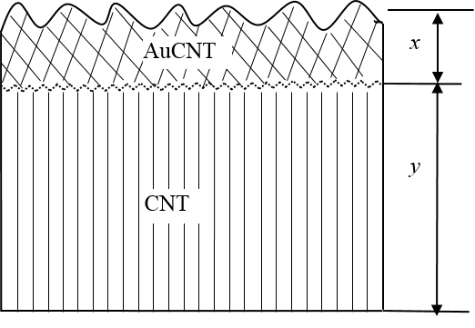

Fig. 7. Illustration of a bi-layered structure of a Au-coated CNT composite, where *x* and *y* are the thickness of the top and under layer respectively.

TABLE I

Material Properties in FEM for the Composite 500 nm Au/50 um MWCNT.

|  |  |  |
| --- | --- | --- |
| Layer/Material | Elastic Modulus *E* (GPa) | Poisson’s Ratio *ν* |
| Top layer (AuCNT) | 1.242 | 0.21 [6] |
| Under layer (CNT) | 5.082E-3 | 0 [19-20] |
| Si | 162.5 | 0.223 |
| Diamond | 1140 | 0.07 |

Only the top layer of the composite is modeled as elasto-plastic material, and the hardness is 4.05 MPa.

## Rough Surface Modeling

### *Outermost surface topography*

Real surface data measured using the TaiCaan® white light sensor is used in the modeling. The data are imported to ANSYS as key points, which are then joined to generate surfaces using a non-planar area code (Coons patches) [12]. A meshing of a rough contact model is shown in Fig. 6, and the meshing at the center of the top surface of the substrate, which is the predicted contact area when the indenter ball is located above the center of the surface, is refined to model the contact accurately. The meshing refining area is changed correspondingly to the position of the indenter ball.

### *Interfacial surface topography*

It has been shown (see Fig. 1-Fig. 2) that the gold penetrates into MWCNT, but the topography of the interface between the top AuCNT layer and the under MWCNT layer is difficult to measure. Three approaches to model the interfacial surface geometry have been summarized in [21] for different applications, as shown in Fig. 8, and the interfacial surface is assumed to have:

* (a) The same roughness as the outermost surface;
* (b) A flat surface;
* (c) Different roughness and topography.

In a previous study [12], the interface was modeled as a flat surface. However, for the surfaces of the Au/MWCNT composite, the peak-to-valley value can be 3-6 μm, which is the same scale as the default thickness of the top layer (6 μm). Assuming the interface as a flat surface, the thickness of the top layer is not uniform, and varied at different asperities (see Fig. 8(b)). Also, the depth of nano-indentation is about 700 nm, and the thickness of the top layer has considerable effect on the force-displacement results. In this study, two assumptions for the interfacial surface are suggested, and the results are compared.

* A, assume the interfacial surface has the same roughness as the outermost surface, noted as ‘Parallel’ in this paper.
* B, assume the interfacial surface as an ideal flat surface, noted as ‘Flat’ in this paper.

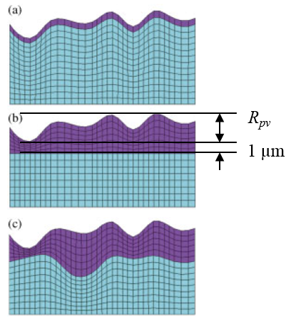

Fig. 8. FE models of layered rough surface, the interfacial surface was assumed to: (a) Have the same roughness as the outermost surface; (b) Be an ideal flat interface, (c), Have different roughness. (after [21]).

### *Other parameters in the modeling*

Real surface data can provide the most relevant description to the surface geometry, but it is computationally expensive. As a consequence, a small number of data points are preferred. To investigate the influence of the data size, the data points in the modeling are varied from 68×68, 41×41, 34×34 to 21×21, corresponding to the grid spacing from 3 µm, 5µm, 6 µm to 10 µm for an area over 0.2 mm × 0.2 mm.

It is shown by the experiments and the numerical modeling that the surface roughness has a significant influence on the force-displacement data when the indentation depth is comparable to the height of the surface asperities [8]. For the composite 500 nm Au/50 μm CNT, the indentation depth at 0.25 mN is about 700 nm, which is comparable to the height of the asperities (see Fig. 3(b)). The high roughness will cause a significant variation in the force-displacement curves of the nano-indentation tests, depending on where the indentation is located [22]. Fig. 3(b) and (d) show that the surface presents a multi-scale wavelength and roughness, and larger view shows a larger wavelength than the smaller view.

In the modeling, two scales of roughness are considered, as shown in Fig. 3(b) and (d), and simulations are launched in two steps. The first step is to choose different zone of the surface, i.e. peak or valley (see Fig. 3(d)). The data at chosen zone are then imported to ANSYS to generate the contacting surface, and the indenter ball is located at the center of the surface. In the second step, the simulations are developed to locate the ball at different positions of a given surface, namely peak, valley and a relatively flat position (see Fig. 3(b)).

It is addressed here again that in the modeling of rough surface, to reduce the computational time, we model the force deflection of the surface to a fixed deflection of 800 nm, and then compare the resulting curves and maximum force with a range of parameters. In addition, all initial results use the same adjustments to the hardness and elastic modulus as in the previous study on smooth surfaces, ‘C7-T1.4’ [6].

# Results and Discussion

## Influence of Interfacial Surface Geometry

The simulations in Section IV. A-B were performed using a set of data from a peak zone (see Fig. 3(d)), and the contact is made at the center of the surface. The simulation results with the grid spacing of 10 µm are presented in Fig. 9. The interfacial surface is modeled as a flat surface or parallel to the top surface. For the Flat model, due to the roughness of the outermost surface, the thickness of the top layer is not uniform, and varied in a range of 1- 5.251 µm. A volume of 1 µm thick is added beneath the surface of the lowest key point to generate the volume of the top layer, as illustrated in Fig. 8 [12]. For the Parallel model, the thickness of the top layer is set as 2 µm, 4.66 µm and 6 µm. 4.66 µm is chosen as this is the height of the asperity located at the center of the surface in Flat model.

As expected, because the top layer is much harder than the under layer, with the top layer becoming thicker in the Parallel model, the simulated force-displacement (F-D) curve becomes stiffer. The Parallel model with the top layer of 4.66 µm thick predicts almost identical results as the Flat model. The reason is that the contact is localized in an area of 20×20 µm (not shown in the paper) at the center of the surface, and the thickness of the contacting asperities dominates the F-D behavior of the composite. It is very interesting to see that the Parallel model with the top layer of 6 µm thick results in the F-D curve close to the smooth model, which has the same thickness of the top layer, this implies that the surface with 21 ×21 data points is relatively smooth.

By comparing the Flat model and the Parallel model, it is shown that the thickness of the top layer at the position of contacting asperities is important for the contact behavior. Given the thickness of the top layer of a Parallel model equaling to the height of the contacting asperities of a Flat model, the two models predict similar F-D curves.

The advantage of the Parallel model is that the thickness of the top layer is uniform and controllable. However, the gird spacing of 10 µm is not fine enough to predict the contact behavior of the composite correctly (as shown in IV. B), and a model with more data points fails to provide a computational solution, thus only the Flat model is used in the following sections.

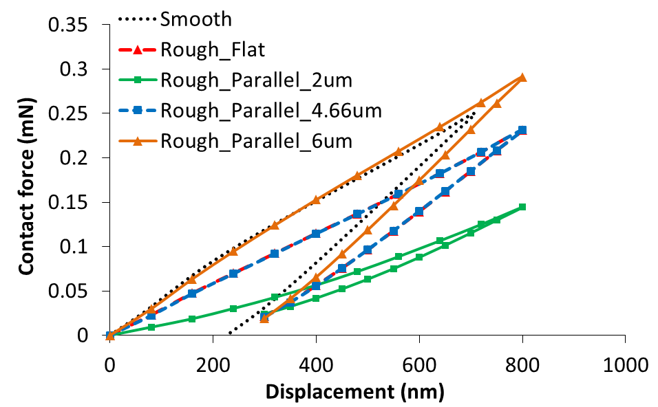

Fig. 9. Comparison of the FE model with different types of interfacial surface model: Flat vs. Parallel, along with the smooth model, and experimental results. The thickness of top layer in Parallel model is varied from 2 µm to 6 µm.

## Influence of the Grid Spacing

This section investigate the influence of the grid spacing in the modeling, and all the simulations are done assuming a flat interface. Fig. 10 shows the force-displacement curves with the grid spacing from 3 to 10 µm. Please note that the model ‘Peak_10um’ is the same as the ‘Rough_Flat’ model in Fig. 9. The size of asperities, as shown in Fig. 3(b), is about 2-5 µm, and it is best to have the grid spacing smaller than 2 µm to capture all the asperities. However, the model with 2 µm failed to compute a solution, and thus 3 µm is the finest spacing used in the modeling. As the gird spacing becomes smaller, the surface will be visually appear rougher and the deformation is expected to be higher at the same force [23], as shown in Fig. 10.

The force-contact area (F-Ac) results are shown in Fig. 11. The contact area increases linearly at the loading process, this implies that the contact pressure reaches the plastic yield value of the material rapidly at the beginning of loading process. The contact area of the rough model at 0.25 mN can be deduced from the F-Ac curves, and the values are plotted in Fig. 12(a). The rough contact model predicts a smaller contact area for a given force than the smooth model, and the contact area decreases with the grid spacing becomes smaller. The contact stiffness are also calculated from the F-D curves in Fig. 10, and plotted in Fig. 12(b). It is shown that the rough contact model exhibits a smaller contact stiffness than the smooth model.

It is noted that the contact area and the stiffness are used to calculate the material properties (*H*, *E*) (see (1-2)), and because the Olive-Pharr model assumes a smooth surface for the calculation of *H* and *E*, their values should be adjusted for a rough contact problem.

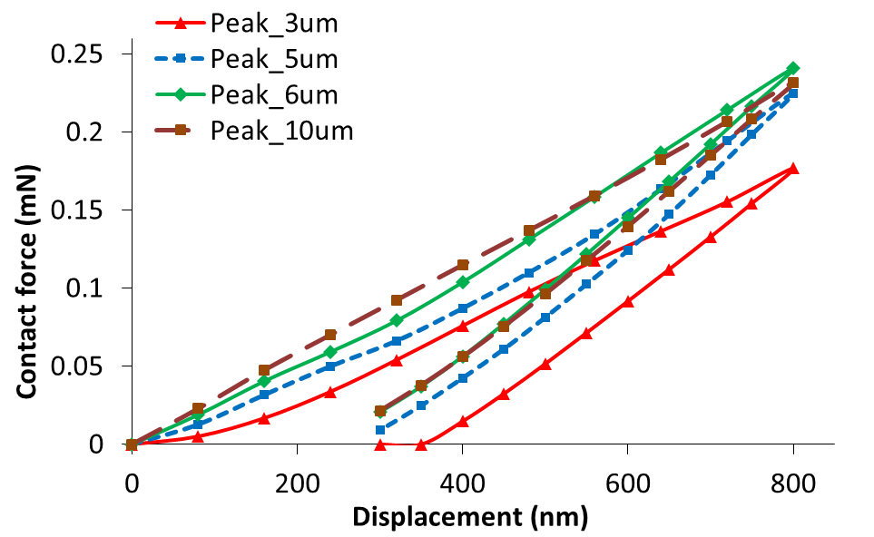

Loading

Unloading

Fig. 10. FE simulation results of force-displacement. The simulations were done at a peak zone, over substrate size of 0.2 mm× 0.2mm, and with different data points.

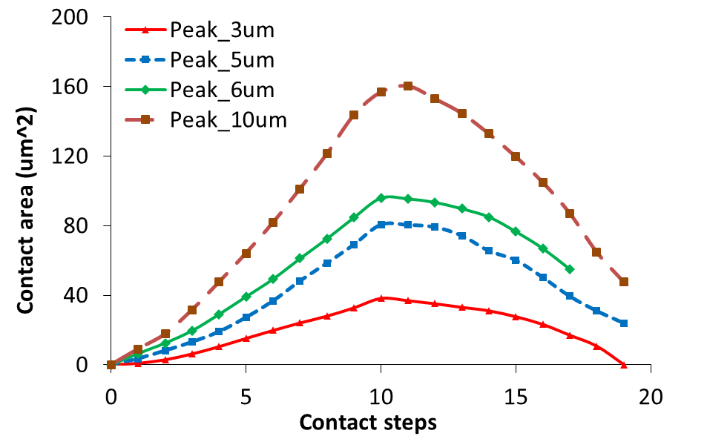

Fig. 11. FE simulation results of force-contact area. The simulation were done at a peak zone, over substrate size of 0.2 mm× 0.2mm, and with different data points, compared with smooth contact results.

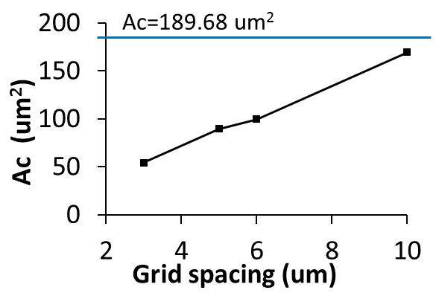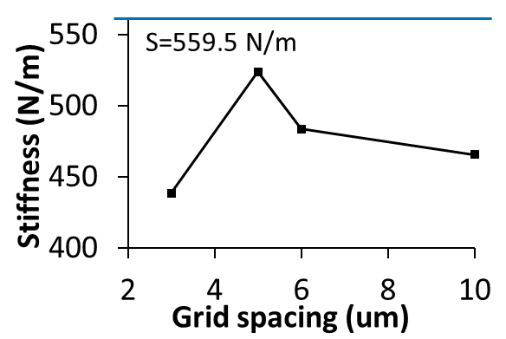

Fig. 12. Contact area and the contact stiffness calculated from the FE rough contact modeling. The solid line represents the results from the smooth model.

## Influence of Indentation Positions

Fig. 13 shows the distribution of the contact pressure for the rough contact model with grid spacing of 5 µm (same model as ‘Peak_5um’ in Fig. 10), and the indenter ball is located at the center of the surface. It is shown that the default contact position, i.e. center of the surface, is between two peak asperities. To investigate the influence of the indentation position, another two simulations were launched with same surface data, but the indenter ball is located at different positions. As suggested in [8], a valley and a peak positions are chosen, which is the valley position P2, 5µm away in *Y* direction from the center, and the peak position P3, 10µm away in *X* direction (see Fig. 13). The simulations in this section are done with 41× 41 data points.

Fig. 14 compares the force-displacement results at three positions. The simulation at the valley position (P2) predicts the highest force level, whereas the one at the peak position (P3) predicts the smallest force level, at 800 nm displacement load, and this matches the results in [8, 22]. It was suggested in [8] that an indentation test at a position between valley and peak was able to provide the F-D curve presenting the average curve. In this case, it is ‘Peak_Center’.

The results imply the importance of the indentation position. Also, for a rough surface of a bi-layered structure, assuming the interfacial surface as a flat, the thickness of the top layer is not consistent, which also influence the F-D curves.

Further modeling was developed with another set of surface data centered in a valley zone (see Fig. 3(d)). The simulation was also with grid spacing of 5 µm, over area of 0.2 mm× 0.2mm. The simulated F-D results are plotted in Fig. 15, along with the results at the center of the peak zone (‘Peak_5µm’ in Fig. 10). The simulation at the valley zone predicts a much lower contact force at 800 nm displacement load compared to the one at peak zone, which is contrary to the results in Fig. 14. This is because of the thickness of the top layer at contact area. The thickness of the top layer at the center of valley zone, is only 1.57 µm, much smaller than that of the peak zone, i.e. 4.66 µm. An extra thickness of 3 µm is added to the top layer, and the simulated F-D results are also plotted in Fig. 15 (labelled as ‘Valley_Center_T3um’), and they are close to the results of the valley position in the peak zone, i.e. ‘P2_Valley’ in Fig. 14, labeled as ‘Peak_Valley’ in Fig. 15.

The results verify again the importance of the thickness of the top surface at the contacting asperity position for the contact behavior of Au/MWCNT composite. It can be also deduced that, because the contacting zone is localized at a 20 -30 µm radius area, the position of the peak or valley zone is not important providing the thickness of the top layer at the contacting position is the same. For a Au/MWCNT composite, the penetration of the gold into MWCNT is not uniform, which adds the scattering of the F-D curves in nano-indentation tests as shown in Fig. 4.

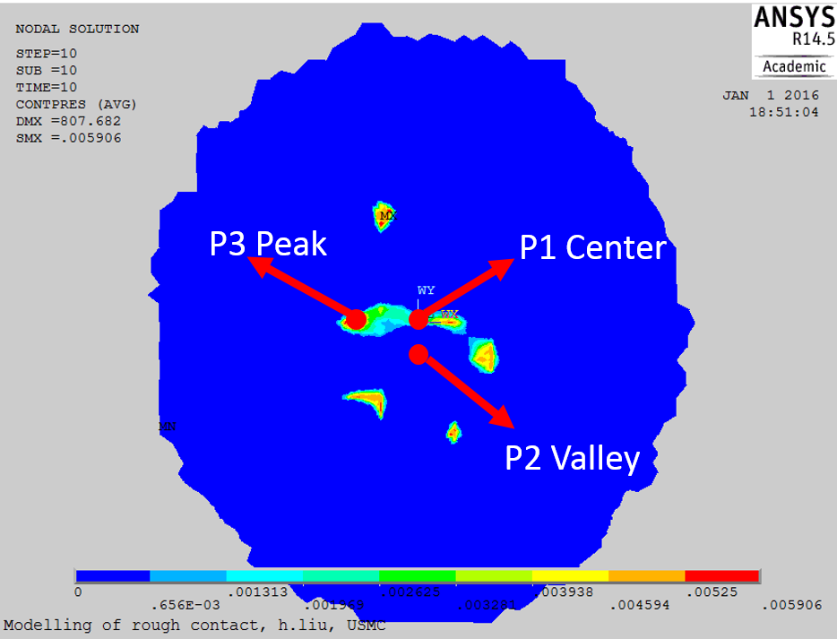

Fig. 13 Contour plot of the contact pressure at maximum displacement load (800 nm). The simulation were done at a peak zone, over substrate size of 0.2 mm× 0.2mm, and 41× 41 data points. Three dots represents three different indentation positions in the FE modeling, and the results shown here is with ‘P1 Center’.

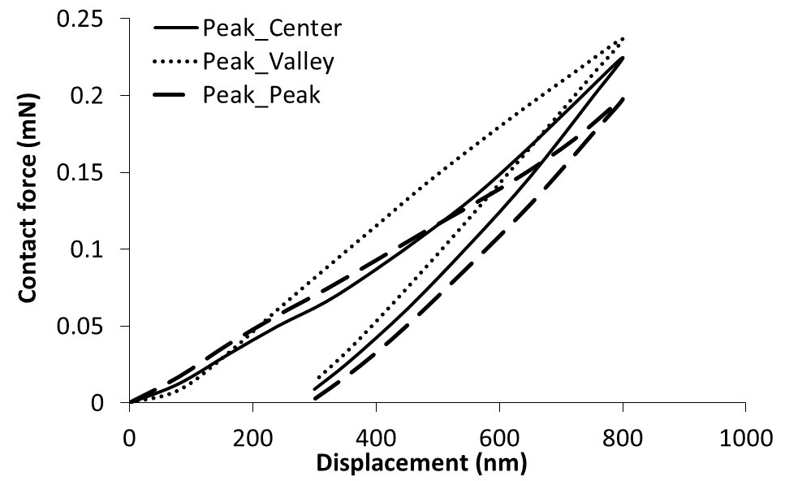

Fig. 14. Comparison of simulated force-displacement results at different contact positions. In the legend, the first Peak/Valley means the type of zone, and the second Peak/Valley means the type of the asperity, see Fig. 3 (b, d).

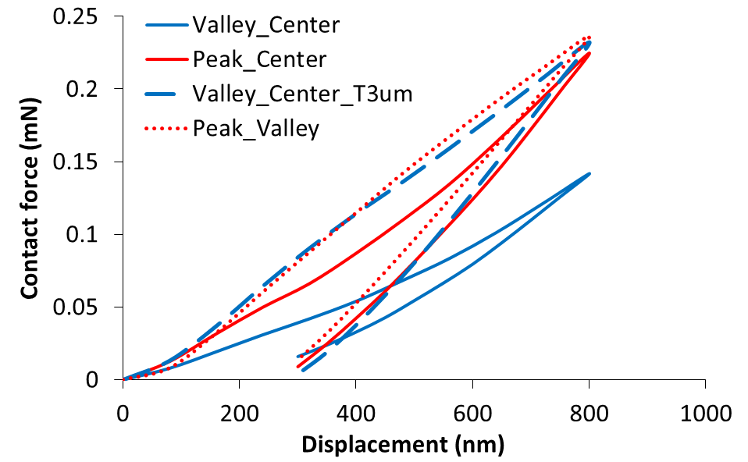

Fig. 15. Comparison of simulated force-displacement results at different contact positions. In the legend, the first Peak/Valley means the type of zone, and the second Peak/Valley means the type of the asperity, see Fig. 3 (b, d). ‘Valley_Center_T3um’ means 3 µm is added to the thickness of top volume.

## Adjustment of the Material Properties to a Rough Contact Model

It was shown in Fig. 12 that the rough contact model predicts smaller contact area and different contact stiffness than the smooth model with same input material properties. For the rough surface model to simulate the experimental results in Fig. 4, further adjustments are considered on the input material properties to the model (C7-T1.4).

By comparing the simulation results of the rough contact model of 5 µm grid spacing (‘Peak_5um’ in Fig. 10) and the smooth contact model, it is found that the hardness and the elastic modulus are underestimated by 2 and 1.4 respectively. Simulations with adjusted material properties are then performed with same geometry and data input as the model ‘Peak_5um’, and the results are plotted in Fig. 16. E0, H0 means the material properties of the smooth contact model, as listed in Table I. which is ‘C7T1.4’. The adjustment factors in this section are taking ‘C7T1.4’ as reference values. It is shown that the model with only the elastic modulus multiplied by 1.4, i.e. C9.8T(E2H1.4), matches well with the experiments, whereas the model with E0×1.4, H0×2 predicts the F-D curve too stiff.

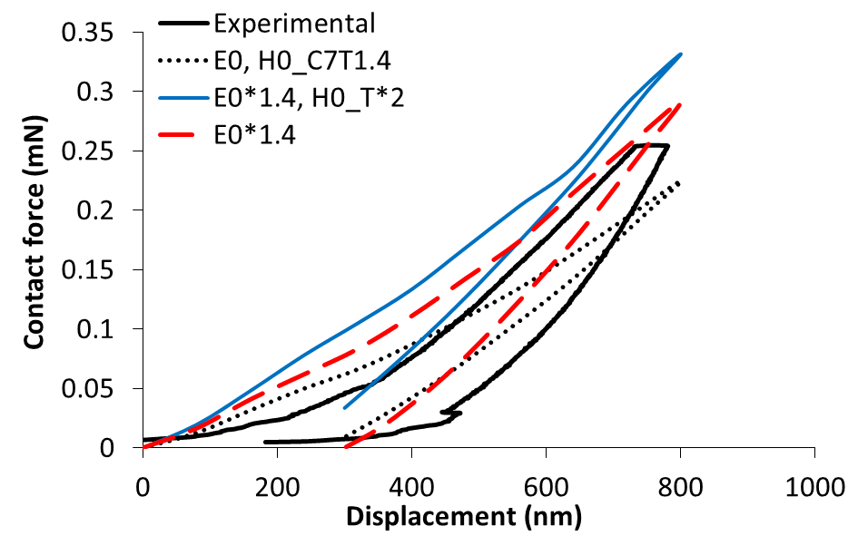

Fig. 16. Comparison of simulated force-displacement results with different material properties, compared to the experimental results. The simulation were done over substrate size of 0.2 mm× 0.2mm, and 41× 41 data points.

# Conclusion

A finite element contact model of rough surface has been developed for a bi-layered Au/MWCNT composite, to link to the nano-indentation test results. The top surface of the Au/MWCNT composite exhibits a high level of roughness compared to normal metallic surface, adding complexity to the previous bi-layered smooth contact model.

Two models are proposed for the interfacial surface, Flat and Parallel. Though the Parallel model can provide a uniform layer thickness, it is computationally difficult for a large number of surface data points; hence, the Flat model is thus adopted. Different indentation positions are investigated at two roughness scales, and it is shown that the thickness of the top layer at contacting asperities is very important for the contact behaviors. The influence of the grid spacing is also investigated, and a model with smaller gird spacing predicts smaller contact area. The grid spacing is better to be less than 2 µm to capture all asperities, however, 3 µm is the finest spacing in the study due to the computational problem. Adjusted material properties are suggested by comparing the smooth and rough contact model, and the rough model with the adjusted material properties are matching better with the experimental results than the previous ones.

Acknowledgment

The authors express their gratitude to Dr. M.Z Zamri and Prof. M. Tanemura from Nagoya Institute of Technology, Japan for providing the use of the Nanotechnology form, and to perform the TEM scan.

References

[1] J. W. McBride, C. Chianrabutra, L. Jiang, and S. H. Pu, “The contact resistance performance of gold coated carbon-nanotube surfaces under low current switching,” *IEICE Trans. Electron.*, vol. E96–C, no. 9, pp. 1097–1103, Nov. 2012.

[2] E. M. Yunus, S. M. Spearing, and J. W. McBride, “The Relationship Between Contact Resistance and Contact Force on Au-Coated Carbon Nanotube Surfaces Under Low Force Conditions,” *IEEE Trans. Compon. Packag. Technol.*, vol. 32, no. 3, pp. 650–657, Sep. 2009.

[3] M. P. Down, R. Cook, L. Jiang, and J. W. McBride, “Mechanical Characterisation and Optimisation of Carbon Nanotube Composite Surfaces for Electrical Contact,” in *Proceeding of 27th International Conference on Electrical Contacts (ICEC2014)*, Dresden, Germany, 2014, pp. 1–6.

[4] W. Oliver and G. Pharr, “Measurement of hardness and elastic modulus by instrumented indentation: Advances in understanding and refinements to methodology,” *J. Mater. Res.*, vol. 19, no. 01, pp. 3–20, Jan. 2004.

[5] H. Liu, M. P. Down, J. W. McBride, S. H. Pu, and L. Jiang, “Mechanical Characterization of a Au Coated Carbon Nanotube Multi-layered Structure,” in *60th IEEE Holm Conference on Electrical Contacts (Holm)*, New Orleans, LA, 2014.

[6] H. Liu, J. W. McBride, M. P. Down, and S. H. Pu, “Finite Element Model of a Bilayered Gold-Coated Carbon Nanotube Composite Surface,” *IEEE Trans. Compon. Packag. Manuf. Technol.*, vol. 5, no. 6, pp. 779–787, Jun. 2015.

[7] B. F. Toler, R. A. Coutu, and J. W. McBride, “A review of micro-contact physics for microelectromechanical systems (MEMS) metal contact switches,” *J. Micromechanics Microengineering*, vol. 23, no. 10, p. 103001, Oct. 2013.

[8] Z. Chen and S. Diebels, “Modelling and parameter re-identification of nanoindentation of soft polymers taking into account effects of surface roughness,” *Comput. Math. Appl.*, vol. 64, no. 9, pp. 2775–2786, Nov. 2012.

[9] L. Chen, A. Ahadi, J. Zhou, and J.-E. Ståhl, “Numerical and Experimental Study of the Roughness Effects on Mechanical Properties of AISI316L by Nanoindentation,” *Model. Numer. Simul. Mater. Sci.*, vol. 04, no. 04, pp. 153–162, 2014.

[10] J.-J. Wu, “Simulation of rough surfaces with FFT,” *Tribol. Int.*, vol. 33, no. 1, pp. 47–58, Jan. 2000.

[11] H. Liu, D. Leray, S. Colin, P. Pons, and A. Broué, “Finite Element Based Surface Roughness Study for Ohmic Contact of Microswitches,” in *58th IEEE Holm Conference on Electrical Contacts (Holm)*, Portland, OR, 2012, pp. 1–10.

[12] H. Liu, J. W. McBride, M. P. Down, and S. H. Pu, “The development of a finite element contact model of a rough surface applied to a Au-coated carbon nanotube composite,” in *2015 IEEE 61st Holm Conference on Electrical Contacts (Holm)*, 2015, pp. 214–221.

[13] M. P. Down, A. P. Lewis, L. Jiang, and J. W. McBride, “A nano-indentation study of the contact resistance and resistivity of a bi-layered Au/multi-walled carbon nanotube composite,” *Appl. Phys. Lett.*, vol. 106, no. 10, p. 101911, Mar. 2015.

[14] M. P. Down, L. Jiang, and J. W. McBride, “Investigating the benefits of a compliant gold coated multi-walled carbon nanotube contact surface in micro-electro mechanical systems switching,” *Appl. Phys. Lett.*, vol. 107, no. 7, p. 071901, Aug. 2015.

[15] A. P. Lewis, J. W. McBride, and L. Jiang, “Evolution of Voltage Transients During the Switching of a MEMS Relay With Au/MWCNT Contacts,” *IEEE Trans. Compon. Packag. Manuf. Technol.*, vol. 5, no. 12, pp. 1747–1754, Dec. 2015.

[16] [Online] available [www.microstartech.com/index/ConicalIndenters2.pdf](http://www.microstartech.com/index/ConicalIndenters2.pdf)?

[17] R. L. Jackson and I. Green, “A Finite element study of elasto-plastic hemispherical contact against a rigid flat,” *J. Tribol.*, vol. 127, pp. 343–354, Apr. 2005.

[18] A. Cao, P. L. Dickrell, W. G. Sawyer, M. N. Ghasemi-Nejhad, and P. M. Ajayan, “Super-Compressible Foamlike Carbon Nanotube Films,” *Science*, vol. 310, no. 5752, pp. 1307–1310, Nov. 2005.

[19] Y. Gao, T. Kodama, Y. Won, S. Dogbe, L. Pan, and K. E. Goodson, “Impact of nanotube density and alignment on the elastic modulus near the top and base surfaces of aligned multi-walled carbon nanotube films,” *Carbon*, vol. 50, no. 10, pp. 3789–3798, Aug. 2012.

[20] M. R. Maschmann, Q. Zhang, F. Du, L. Dai, and J. Baur, “Length dependent foam-like mechanical response of axially indented vertically oriented carbon nanotube arrays,” *Carbon*, vol. 49, no. 2, pp. 386–397, Feb. 2011.

[21] M. K. Thompson and J. M. Thompson, “Considerations for the incorporation of measured surfaces in finite element models,” *Scanning*, vol. 32, no. 4, pp. 183–198, Aug. 2010.

[22] P. Berke and T. J. Massart, “Coupled Friction and Roughness Surface Effects in Shallow Spherical Nanoindentation,” in *Trends in Computational Contact Mechanics*, G. Zavarise and P. Wriggers, Eds. Springer Berlin Heidelberg, 2011, pp. 269–289.

[23] P. Sahoo and N. Ghosh, “Finite element contact analysis of fractal surfaces,” *J. Phys. Appl. Phys.*, vol. 40, pp. 4245–4252, 2007.

**Hong Liu** was awarded her Ph.D. degree in mechanical engineering and material mechanics from INSA Toulouse, France in 2013. She received the B.Sc. and M. Sc degree in mechanical engineering from Shandong University, China (2006) and South China University of Technology, China (2009) respectively.

She is currently a research fellow at the University of Southampton Malaysia Campus. Her current research interests include MEMS switches, carbon nanotubes composites, contact mechanics and tribology, and she is now the project leader of a Ministry of Education Malaysia grant ‘Contact mechanics of gold coated carbon nanotube microswitches’.



**John W. McBride** is the CEO of the University of Southampton Malaysia Campus and a member of the electro-mechanical research group at the University of Southampton.

He was previously the Associate Dean for Research in the Faculty of Engineering and the Environment (2010-11) and the Chair of the electro-mechanical research group (1995-2010). He is an expert on electrical contact physics and surface characterisation; he has published over 200 papers, 3 patents, and is an associate editor of the IEEE Transactions on CPMT. In 2006 he was awarded the IEEE Holm Scientific Achievement Award, an international award recognizing outstanding scientists and engineers in the field of electrical contacts and related technologies. In 2008 he was team leader for the award of the international James A. Lindner Prize for research on the “Sound Archive Project”.

1. Paper submitted for review on 31/01/2016. This work was supported by the Ministry of High Education, Malaysia, under Grant FRGS-12014-TK01-USMC-1.

   H. Liu is with the University of Southampton-Malaysia Campus, Johor Bahru 79200, Malaysia (e-mail: hong.liu@soton.ac.uk);

   J. W. McBride is with the University of Southampton-Malaysia Campus, Johor Bahru 79200, Malaysia, and also with the Faculty of Engineering and the Environment, University of Southampton, Southampton SO17 1BJ, U.K. (e-mail: j.w.mcbride@soton.ac.uk).

   Color versions of one or more of the figures in this paper are available online at [http://ieeexplore.ieee.org.](http://ieeexplore.ieee.org/)