Children with developmental coordination disorder (DCD) can adapt to perceptible and subliminal rhythm changes but are more variable

Renuka Rocheª, Priya Viswanathan^{b}, Jane E. Clark^{c} and Jill Whitall^{b,d}

ª Occupational Therapy Program, Eastern Michigan University, Ypsilanti, MI

^{b} Department of Physical Therapy and Rehabilitation Science, University of Maryland School of Medicine. Baltimore, MD

^{c} Department of Kinesiology and Neurosciences and Cognitive Science Program, School of Public Health, University of Maryland, College Park, MD

^{d} Faculty of Health Sciences, University of Southampton, Hampshire, UK

Corresponding author: Renuka Roche, PhD., MS., OTR/L
Address : Eastern Michigan University, School of Health Sciences
313 Everett L. Marshall Building Ypsilanti, MI 48197
Phone : 443-827-2479
Email : renukaroche@gmail.com
ABSTRACT
Children with DCD demonstrate impairments in bimanual finger tapping during self-paced tapping and tapping in synchrony to different frequencies. In this study, we investigated the ability of children with DCD to adapt motorically to perceptible or subliminal changes of the auditory stimuli without a change in frequency, and compared their performance to typically developing controls (TDC). Nineteen children with DCD between ages 6-11 years (mean age + SD = 114 + 21 months) and 17 TDC (mean age + SD = 113 + 21 months) participated in this study. Auditory perceptual threshold was established. Children initially tapped bimanually to an antiphase beat and then to either a perceptible change in rhythm or to gradual subliminal changes in rhythm. Children with DCD were able to perceive changes in rhythm similar to TDC. They were also able to adapt to both perceptible and subliminal changes in rhythms similar to their age- and gender- matched TDC. However, these children were significantly more variable compared with TDC in all phasing conditions. The results suggest that the performance impairments in bilateral tapping are not a result of poor conscious or sub-conscious perception of the auditory cue. The increased motor variability may be associated with cerebellar dysfunction but further behavioral and neurophysiological studies are needed.

Keywords: Developmental Coordination Disorder; Bimanual tapping; Timing; Auditory perceptual threshold; Motor skills; Motor Adaptation;

1. INTRODUCTION
Individuals with developmental coordination disorder (DCD) have impairment of motor coordination and performance severe enough to affect activities of daily living and their academic performance, which cannot be explained by their age, IQ or any neurological condition (APA, 2000). DSM IV estimates that as many as 6% of children between ages 5-13 years have DCD. The motor difficulties often result in depression (Lingam et al., 2012), social isolation (Schoemaker & Kalverboer, 1994) and long-term health consequences from an inactive life (Green et al., 2011). These children have gross motor deficits including balance deficits, awkward running patterns, and difficulty in catching and throwing, (Blank, Smits-Engelsman, Polatajko, & Wilson, 2011; Geuze, 2005; Zwicker, Harris, & Klassen, 2012) as well as fine motor deficits including poor handwriting and shoelace tying (Smits-Engelsman, Niemeijer, & van Galen, 2001). Tasks, such as dancing, require coordination between the various body segments and synchronization of the movement to auditory stimuli. In previous studies, we and others have shown deficits of coordination, motor timing and auditory motor coordination, in this population (Roche, Wilms-Floet, Clark, & Whitall, 2011; Volman & Geuze, 1998; Volman, Laroy, & Jongmans, 2006; Whitall et al., 2008; Whitall et al., 2006). Here we extend this work by investigating auditory-motor adaptation to rhythmic change.

The ability to adapt motorically in response to a changing sensory cue requires integration between the sensory input or information and the motor output or performance. Children with DCD are less accurate and more variable in maintaining coordination between limbs when synchronizing to an auditory cue during a gross motor coordination task (Volman, Laroy, & Jongmans, 2006; Whitall et al., 2006) or a tapping task (Whitall et al., 2008). In these studies, only the stable inphase (0° or limbs move together) or antiphase (180° or limbs alternating) patterns of coordination were investigated. Patterns of coordination that are known to be less stable in adults (i.e., those between inphase and antiphase) (Tuller & Kelso, 1989; Yamanishi, Kawato, & Suzuki, 1980), have not been examined. It is not known, for example, if children with DCD can perceive changes in rhythms and if that ability develops with age. Furthermore, we do not know if children with DCD who can perceive uneven rhythm changes can adapt motorically to the auditory stimuli.

Additionally, it is not known if children with and without DCD adapt their motor performance when the auditory stimulus is not consciously perceived (subliminal, gradual changes) as adults are able to do (Repp, 2000, 2001a, 2001b). Neuroimaging studies of finger tapping in adults have suggested the role of two key subcortical networks, the cerebellum and basal ganglia, in the ability to tap to rhythms that are or are not consciously perceived. In studies using unilateral finger movements and visuomotor adaptation during discrete arm movements, it has been suggested that the cerebellum mediates adaptation to small subliminal changes to either auditory or visual modalities (Bijsterbosch, et al., 2011; Kagerer, Contreras-Vidal, & Stelmach, 1997; Robertson & Miall, 1999; Shadmehr, Smith, & Krakauer, 2010; Wu et al., 2011). On the other hand, it has been suggested that adaptation to a large perceptible change in sensory stimuli is mediated by the basal ganglia (Contreras-Vidal & Buch, 2003; Diekhof et al., 2009; Harrington, Haaland, & Knight, 1998; Venkatakrishnan, Banquet, Burnod, & Contreras-Vidal, 2011). During an auditory deviancy detection task, Diekhof et al. (2009) found that the putamen is associated with supraliminal or perceptible changes, in addition to the anterior cingulate cortex (ACC) and middle temporal lobe (brain areas thought to be associated with audition).

Given the above findings in adults, and the fact that many have speculated that DCD is a result of cerebellar dysfunction (Cantin, Polatajko, Thach, & Jaglal, 2007; Ivry, 2003; Zwicker, Missiuna, & Boyd, 2009), it is plausible that children with DCD would show a differential tendency to adapt to perceptible changes better than to subliminal changes in rhythmic stimuli which would support a role of the cerebellum in the symptomatology of the condition. Additional evidence for this idea comes from findings that children with DCD are more similar to typically developing children in adapting to easily perceptible visual changes during a visuomotor adaptation task (Kagerer et al., 2006) and to auditory changes of frequency during bilateral finger tapping (Whitall et al., 2008).

The general conceptual framework of our study is based on a dynamic pattern approach where coupling between two finger taps, modeled as limit-cycle oscillators, is characterized by relative phasing between the fingers; and variability of that phasing, which is one indicator of the stability of that coordination (Haken, Kelso, & Bunz, 1985; Schöner, Haken, & Kelso, 1986). Here, we add to this framework by first investigating the ability to perceive a rhythmic change to an asymmetric coordination, and, second, by manipulating the ability to perceive the change and act/react to it. We aim to provide a more complete behavioral description of auditory-perceptual and auditory-motor abilities of children with DCD as well as provide insights into the neuro-developmental basis of atypical processes that underlie these children’s performance.

The primary purpose of this study, then, was to determine and compare the abilities of children with and without DCD to perceive auditory changes in rhythm, and to modulate bimanual finger tapping in response to changing rhythms that are either perceptible or subliminal. We hypothesized that children with DCD would have higher perceptual thresholds compared with their typically developing (TD) peers since they appeared less able to use this information to synchronize their fingers to a beat (Whitall et al., 2008). For the reasons given above, we hypothesized that children with DCD would have a decreased ability to modulate bilateral finger tapping in response to subliminal changes in auditory rhythms compared with TD children but respond better to the abrupt rhythmic change than the subliminal. Finally, as seen in previous tapping studies (Roche, Wilms-Floet, Clark, & Whitall, 2011; Volman & Geuze, 1998; Whitall et al., 2008), we expected that children with DCD would exhibit increased variability in their performance of these tasks compared with TD children.

2. Methods
2.1 Participants
Data from 24 children with DCD and 22 age- and gender-matched typically developing (TD) controls were used for the perceptual component of the study. The ages ranged from 6 to 11 years with the mean age + SD in years for the DCD group being 9.29 + 1.75 and for the control group being 9.22 + 1.79 (Table 1a). Data from 19 children with DCD and 17 age- and gender-matched TD controls were analyzed for the perceptual-motor component in this study. The ages ranged from 6 to 11 years of age with the mean age + SD in years for the DCD group being 9.53 + 1.78 and for the control group being 9.47 + 1.83 (Table 1b).

To identify children with DCD, 74 children with potential motor deficits were screened. They were recruited through local occupational therapy clinics, flyers in the community, advertisements in local newspapers, and referrals by two area pediatricians or by parents of children who had participated earlier in the study. TD children were identified from previous studies, flyers in the community and through word of mouth. Potential participants were screened for DCD using the following tests: a) Movement Assessment Battery for Children (MABC) (Henderson & Sudgen, 1992) administered by trained testers to screen for motor problems; b) Physical and Neurological Examination of Subtle Signs (PANESS) (Denckla, 1985) and a clinical neurological exam by the study pediatrician; and c) the Woodcock-Johnson Psycho-Educational Battery (WJ III) (Woodcock, McGrew, & Mather, 2001) administered by an education specialist. The Annett handedness questionnaire (Annett, 1991) was administered to determine hand dominance. Inclusion criteria for the DCD group were: 1) ages between 5-11 years; 2) no neurological disorder present including pervasive developmental disorder; 3) an independent diagnosis of DCD from the study pediatrician; 4) MABC total impairment scores less than or equal to the 5th percentile; and, 5) no cognitive impairment as assessed by the WJ III. Twenty-nine participants matched all five of our inclusion criteria. Five children dropped out because either they could not complete the experimental task (n = 2) or they did not come back for the research study after the initial screening. Twenty-four participants finished the research study. Data from this group were analyzed for the perceptual component of the study along with data from 22 age- and gender-matched TD children. Furthermore, five children with and five without DCD with auditory thresholds below the 20° were excluded from the perceptual-motor analysis because they could consciously perceive the signal in the subliminal condition, where they were not expected to consciously perceive the change. The final data set, therefore, included 19 children with DCD for the auditory-motor component of the study. Seventeen age- and gender-matched typically TD controls were also included. The Institutional Review Board of the University of Maryland, Baltimore (UMB) approved this study. Parents or legal guardians of the children gave informed consent while the children provided their assent to participate.

2.2 Apparatus and Procedure
2.2.1 Determination of the auditory threshold
Prior to the tapping experiment, we established a child’s auditory perceptual threshold. This is the lowest phasing difference between the two auditory signals that a child can perceive consistently. We used a modified psychophysical staircase method (Cornsweet, 1962; Treutwein, 1995). In this method, the tester starts with a stimulus intensity considerably higher than threshold, gradually decreasing the phasing difference until the change is not perceived.

The child was fitted with a set of headphones through which auditory stimuli with frequency of 1.4 Hz (0.7 Hz per ear), generated using a customized waveform generator, were provided. Participants received two successive sets of auditory stimuli, each 10 seconds in duration. The first set of stimuli was always evenly spaced and remained at a constant phasing of 180º (reference stimulus). The second set of stimuli was unevenly spaced and was the set that always changed (test stimulus). The test stimuli started with a large phasing difference (70°) and the phasing difference was reduced in steps of 5º. After the test stimulus was given, participants were asked if they perceived the reference and test stimuli to be “same” or “different.” A forced choice paradigm was used, where the participant was asked to make the best possible guess and choose between “same” and “different”. If correctly perceived, the phasing difference was reduced by 5º; if not, the phasing difference was increased by 5º. At this point, the participant had to correctly perceive the signals at that level as being different two consecutive times before reducing the phasing difference. The experiment concluded when the subject could not identify the difference between the two sets of rhythms, three times at a particular phasing difference. The threshold was determined as the lowest phasing difference between the two sets of rhythms that the participant could perceive consistently. “Catch” trials were given where the second set was the same as the first to ensure that the child’s attention was maintained.

2.2.2 Tapping Experiment
The participants sat with their forearms resting on the plexiglass armrests (Fig. 1). The hands were strapped snuggly to the armrest at the forearm and along the metacarpals to reduce associated movements. Sensors were attached dorsally to the tip of the index finger bilaterally. An ear swab was taped laterally to the finger to restrict movement only to the metacarpophalangeal joint. The positional data of the sensors were captured by a 3D magnetic tracking system (Minibirds^{TM,} Ascension system, Burlington, VT) at the sampling rate of 100 Hz. The participant wore headphones attached to the custom-made waveform generator. The frequency of the auditory stimuli was kept constant at 1.4Hz (0.7 Hz per side). For consistency, the stimuli presented on the non-dominant side remained constant while the stimuli presented on the dominant side changed according to the set phasing difference. The auditory stimulus, and therefore the tap, always began on the non-dominant side.

The participants were asked to tap their index fingers alternately in time to the auditory signals presented via headphones. They were also instructed to lift their fingers to about 1 inch above the surface. The experiment was videotaped for subsequent verification that the participant performed the task as instructed. The participants were tested under two conditions: gradual/subliminal and abrupt/perceptible. In the gradual/subliminal condition, the auditory stimuli were gradually ramped up in steps of 11 º (3.05 % change) from 180º out-of-phase up to 225º (12.5% change from 180º) out-of-phase with each other while in the abrupt/perceptible condition the auditory stimuli were abruptly ramped 45º (12.5 % change) from 180º (baseline) to 225º. The stimulus phasing change of 45º was chosen, a priori, because preliminary work had established that most children could perceive this difference.

The testing session consisted of two conditions of 12 trials each. Each trial was 30 seconds long with the first 5 seconds removed from the analysis to avoid start-up effects. The trial was limited to 30 seconds to minimize loss of attention or fatigue. In both conditions, the first and last two trials had auditory signals with alternate beats that were 180º out-of-phase (baseline) with each other. In the abrupt/perceptible condition, the middle eight trials had auditory signals that were 225º out-of-phase. In the gradual/subliminal condition, the middle eight trials had two trials each that had a phasing relationship of 192º, 203º, 214º and 225º (with a phasing change from the baseline in percentage of 3.33 %, 6.38 %, 9.44 % and 12.5 % respectively). In order to eliminate carry over effects, subjects with even identification numbers were presented with the abrupt/perceptible followed by the gradual/subliminal condition while subjects with odd identification numbers were presented in the reverse order. The two sets were separated by a 5-minute break. Rewards (e.g. stickers) were given intermittently in order to sustain motivation. Prizes and a small financial compensation were given at the completion of the study.

3. DATA ANALYSIS
3.1 Data processing of finger tapping:
The data were filtered using a recursive low pass 4th order Butterworth filter with a cut off frequency of 10 Hz and then processed using a customized Matlab™ program. The dependent measures were the mean relative phasing difference between the two fingers (RP) and the standard deviation of the mean relative phase between the two fingers (SD). Relative phase between the two fingers was taken as the ratio of the time between the non-dominant finger’s touchdown and the touch down of the dominant finger to the total time between the first and second touchdowns of the left finger. The following formula was used to calculate the relative phase between the fingers:
100

t^{ND}
-
t^{ND}

t^{D}
-
t^{ND}
n
1
n
n
n
×
=
+
RP
where t^{ND}_{n} indicates the times of the finger tap of non-dominant hand and t^{D}_{n} indicates the times of the finger tap of dominant hand for the nth cycle in the time series. If the participant taps in perfect antiphase then the dominant finger touchdown would occur when the non-dominant side is at 180º (or 50%) of its cycle and vice versa. The phasing relationship was expressed as a percentage of the absolute deviation from baseline (180˚). Therefore, each increment of 11˚ would have a phasing change of 3.05%. The SD is the standard deviation of the mean relative phasing within a trial. SD is a method of expressing the variability (and therefore the linear stability) of coupling between the fingers (Tuller & Kelso, 1989; Yamanishi, Kawato, & Suzuki, 1980).

3.2 Statistical Analysis
Prior to statistical analyses, the two trials with same auditory signal were averaged to improve stability of the values. Therefore, the data analysis was carried out on 6 trial blocks rather than 12 trials. Statistical analyses were performed using SAS (SAS Institute, Cary, NC, USA; version 9.2). Two-way repeated measures analyses of variance (ANOVA) were used to compare the dependent variables across the different trial blocks (6 levels) and between the two groups (DCD and TD) with the trial blocks being the repeated measure. Separate analyses were carried out for the abrupt/perceptible and gradual/subliminal conditions. Post hoc analysis (Tukey HSD adjustment) was performed when main or interaction effects were found. The overall alpha level was set at 0.05.

4. RESULTS
4.1 Perceptual Threshold (PT)
The perceptual threshold analysis included all children with DCD regardless of their perceptual threshold. A visual examination of DCD data showed two age group clusters: a younger group between ages 6-8 years (n= 9; mean PT + SD = 33.33 + 10.89) and an older group between ages 9-11 years (n= 15; mean PT + SD = 25.33 + 3.89). A two-way ANOVA (Group X age group) showed an age group (younger vs. older group) effect (F (1, 37) = 5.58, p = 0.02). Post hoc analysis found that the younger group (mean PT = 30.23) had a higher mean PT than the older group (mean PT = 24.67). However, no group or interaction effect was seen. Therefore, as age increased the perceptual threshold decreased similarly in both groups.

4.2 Mean phase relationship between the two index fingers (RP)
4.2.1 Perceptible condition
The two-way ANOVA showed a trial effect (F (5, 150) = 74.80, p < 0.0001) but no group or interaction effects (Fig. 2A). Post hoc analysis found that across groups, there was no difference between blocks 1 and 6 but these were different from blocks 2-5. Blocks 2-5 were not different from each other. Thus, both the DCD and TD groups were to adapt to the abrupt change in phasing.

4.2.2 Subliminal condition
The two-way ANOVA showed a trial effect (F (5, 150) =214.57, p < 0.0001) but no group or interaction effects (Fig. 2B). Post hoc analysis showed that means of each block were different from the others (p < 0.0001) except baseline blocks 1 and 6.

4.3 Standard deviation of relative phasing (SDrp) within a trial
4.3.1 Perceptible condition
The two-way ANOVA showed a group effect (p = 0.02) but no trial or interaction effects (Fig 3A). The DCD group was more variable than TD.

4.3.2 Subliminal condition
The two-way ANOVA showed a group effect (F (1,150) = 11.11, p < 0.001) (Fig. 3B). The DCD group was more variable than TD. There was also a trend for trial effect (p = 0.053). The unadjusted post hoc analysis showed that there was a difference between blocks 1 and 5 and between trial blocks 5 and 6 with the SDrp in block 5 being higher than both baseline blocks; however, this effect was lost with the Tukey adjustment. There was no interaction effect.

5. DISCUSSION
In this study, we compared children with and without DCD in their ability to perceive and to adapt motorically to both perceptible and subliminal phasing changes in the auditory stimuli. Most children (21 / 24) in this DCD cohort were below the first percentile on MABC, suggesting they had significant gross and fine motor deficits. Despite the fact that this cohort has more severely affected children with DCD than is generally studied (Gueze, Jongmans, Schoemaker, & Smits-Engelsman, 2001; Wilson, Ruddock, Smits-Engelsman, Polatajko, & Blank, 2012), we found no difference in the perceptual thresholds between the children with and without DCD, and both groups improved with age. In addition, both groups of children were able to modulate to perceptible and subliminal changes in phasing difference in the rhythm of the auditory stimuli. Children with DCD had greater variability within trials than TD children during both conditions.

5. 1 Children with DCD can perceive changes in rhythm and show improvement across age similar to TD children
Contrary to our hypothesis, children with DCD were able to perceive changes in rhythm and showed a developmental trend similar to TD children. To our knowledge, this is the first examination of auditory perceptual abilities in this population where no motor task was required. Most studies of visual perception (de Castelnau, Albaret, Chaix, and Zanone, 2007; Gomez and Sirigu, 2015; Sigmundsson, 2003; Van Waelvelde, De Weerdt, De Cock, & Smits-Engelsman, 2004) and auditory perception (O’brien, Williams, Bundy, Lyons & Mittal, 2008), in children with DCD, make inferences about perceptual deficits in this population when using perceptual motor tests that required a motor component rather than a pure perceptual test. Hence, it is difficult to assess if children with DCD have a perceptual deficit or only a motor deficit or both a perceptual and a motor deficit. Our results suggest that children with DCD do not have an auditory perceptual deficit at least for detecting a change of rhythm. The ability we tested does improve with age, however, as demonstrated by our results here and the lower perceptual threshold found in adults using the same paradigm (Kagerer, Viswanathan, Contreras-Vidal & Whitall, 2014).

5.2 Children with DCD can adapt to a perceptible change in auditory stimulus
Children with DCD adapt to perceptible changes as well as TD children and this is consistent with a few other studies where visual-motor paradigms were used. For example, Cantin, Polatajko, Thach, & Jaglal (2007) found that children with DCD were able to adapt during prism adaptation. Others have found that they can adapt to an abrupt perturbation of the reach angle during a visuomotor distortion task (Kagerer, Contreras-Vidal, Bo, & Clark, 2006; King, Clark, & Oliveira, 2012).

Despite these findings, and from a different conceptual framework, it has been suggested that children with DCD have difficulty creating or using feedforward estimates of body positions to correct errors instantaneously, reflected in the fact that there are still significant differences between DCD and TD groups in some of the visual-motor adaptation studies (Bair, Kiemel, Jeka, & Clark, 2012; Wilson et al., 2004). This would imply that children with DCD would have difficulty with learning a new asymmetric phasing pattern as required in the present paradigm. An explanation for the lack of group difference found in this study may be a result of the sensorimotor task used in our paradigm.

First, there could be a difference in the nature of auditory vs. visual information and how it is processed in these children. It is known that auditory information results in quicker reaction times than visual information (Galton, 1899; Woodworth and Schlosberg, 1954; Fieandt, Huhtala, Kullberg & Saarl, 1956; Welford, 1980) and that auditory processing develops earlier than visual processing (Gottleib, 1971; Turkewitz & Kenney, 1982). It is plausible that auditory information provides more “focused” sensory input, by using different neural networks, that is more readily usable by children who may have processing difficulties with visual information. Against this argument is the fact that children with DCD as a group do not have either auditory acuity (Hill, 2001) or visual acuity (Wilson & McKenzie, 1998) problems beyond TD children. However, while our data indicate that children with DCD do not have auditory perceptual processing problems for detecting rhythmic change, the visuomotor studies mentioned earlier have not tested the visual processing needed for their particular paradigm independent of the motor response. Indeed, studies of children with DCD have shown visual deficits when tested on the non-motor Test of Visual Perceptual Skills (Tsai & Wu, 2008; Tsai, Wilson & Wu, 2008) although another study found that children with DCD did not have visual processing deficits unless they had at least one co-morbidity (Crawford & Dewey, 2008). Thus, one explanation for a lack of group difference in responding to a change of rhythm is that visual information is harder for children with DCD to process compared with auditory information.

A second explanation is in the difference between a discrete task such as a visual-motor reach adaptation, which has an inter-stimulus response interval usually in the order of seconds, and the more continuous task (or series of discrete tasks) of bilateral tapping where auditory signals are less than a second. In a discrete task, it is assumed that a deficit in feedforward processing does not allow instantaneous corrections (Hyde and Wilson, 2011; Wilson et al., 2013; Wolpert, 1997). Therefore, if a child with DCD relies primarily on feedback information for each subsequent discrete trial, it would be harder for them to change their motor response as quickly as a child that uses feedforward processing. However, in a repetitive series of tasks like tapping, the probable error of the initial taps become less important since each subsequent tap during a trial becomes attracted to a “sensorimotor well” formed by the auditory information that is constantly provided. The taps then, may well be scattered around the asymmetric phasing of the cue but the mean over multiple taps ends up relatively near the actual desired asymmetric coordination. This explanation is behaviorally consistent with why children with DCD were good at matching their mean bilateral tapping to different frequencies (except the slowest frequency where they had problems inhibiting their taps) but they were still more variable than peers and with less synchronicity (Whitall et al., 2008). This explanation is also supported behaviorally by the known entrainment of motor and auditory systems that occurs when these two oscillatory systems are both working at the same time (Thaut, Kenyon, Schauer & McIntosh, 1999; Thaut, McIntosh & Hoemberg, 2014).

5.3 Children with DCD can adapt to a subliminal change in auditory stimulus
Contrary to our hypothesis, we found that children with or without DCD were equally able to adapt to an auditory change in rhythm despite not having the ability to perceive that change. To our knowledge, this ability to bypass perceptual awareness of auditory cues has not been previously demonstrated in children with or without DCD.

Several studies in adults have shown the presence of motor awareness without perceptual awareness (Goodale, Pelisson, & Prablanc, 1986; Johnson & Haggard, 2005; Pelisson, Prablanc, Goodale, & Jeannerod, 1986; Repp, 2000, 2001a, 2001b). For example, Goodale et al. (1986) noticed successful visuomotor adjustment in adults in a pointing experiment in which the target occasionally jumped several degrees while the jump itself remained unnoticed by the participants. More pertinent to our repetitive tapping paradigm, Repp (2000, 2001a) found that adult musical amateurs unilaterally tapping to a rhythm were able to compensate to subliminal changes to the inter-onset intervals of the auditory stimulus, which they could not explicitly detect.

In children with DCD, Kagerer et al. (2006) had found that exposure to an abrupt visuomotor perturbation caused a more effective update of the online correction (in their terms “internal model”) compared with exposure to a gradual visuomotor perturbation in children with DCD where the visuomotor perturbation was assumed to be undetectable (although this was not tested). Our results do not support this differential effect and similar arguments to those above regarding the perceptible cues can be used to explain the lack of group difference. That is, either the salience of auditory cues or the repetitive nature of the task or both together are plausible explanations. We speculate that it is the sub-conscious entrainment mechanism of repetitive auditory signals and motor responses that is responsible for both sets of children having a similar and relatively rapid response to the subliminal information.

Since we found no deficits in children with DCD in their ability to modulate to both abrupt and gradual changes in auditory stimuli, neurophysiologically, it could be because the cerebellum may differentially process visual and auditory stimuli ( Jancke et al.,2000). Exactly, how the different areas of the cerebellum are related to sensorimotor adaptation, especially gradual changes, is only beginning to be understood and should be further explored along with a developmental trajectory.

Also, the basal ganglia may mediate features of the temporal motor coordination that are common to both perceptible and subliminal conditions such as shaping of the motor response or maintenance of a regular beat (Jahanshahi et al., 2010; Ullen, Forssberg, & Ehrsson, 2003) . Thus, modulation to both perceptible and subliminal conditions may be dependent on the basal ganglia as well as the cerebellum. Overall, our behavioral findings do not support a specific role of the cerebellum in the symptomology of DCD regarding the ability to use subliminal cues to modulate bilateral tapping behavior over a series of taps. However, a different picture emerges when considering the variability of the phasing.

5.4 Children with DCD are more variable in motor coordination than TD children, regardless of whether change in the auditory stimulus was perceptible or gradual.
As predicted, children with DCD were more variable compared with their TD counterparts in both conditions. They also showed large variability in their performance between individuals. This is consistent with previous studies of tapping coordination in children with DCD (Roche, Wilms-Floet, Clark, & Whitall, 2011; Volman & Geuze, 1998; Volman, Laroy, & Jongmans, 2006; Whitall et al., 2008). The increase in variability of relative phase during the abrupt/perceptible condition suggests that these children are able to broadly tune into the required parameter but have difficulty exactly repeating or fine-tuning their response. Indeed, variability of response appears to be a hallmark of DCD regardless of the motor task (Bo, Bastian, Kagerer, Contreras-Vidal, & Clark, 2008; King, Clark, & Oliveira, 2012; Sekaran, Reid, Chin, Ndiaye, & Licari, 2012; Smits-Engelsman, Westenberg, & Duysens, 2008).

Several research groups have suggested that movement timing variability could be related to deficits in the cerebellum (Bo, Block, Clark, & Bastian, 2008; Ivry, Keele, & Diener, 1988; Schlerf, Spencer, Zelaznik, & Ivry, 2007). In adults with disruption of cerebellar function, either due to lesions or transmagnetic stimulation, there is an increase in variability during both externally paced as well as self-paced tapping (Franz, Ivry & Helmuth, 1996; Ivry & Keele, 1989; Johansson, Jirenhed, Rasmussen, Zucca & Hesslow, 2014; Theoret et al., 2001). However, this increase in variability is not seen in patients with basal ganglia lesions (Claasen et al., 2013). Therefore, these adult studies all lend weight to the argument for cerebellar involvement in children with DCD. Research groups also have suggested that cerebellum or corticocerebellar pathways may be affected in children with DCD (Cantin, Polatajko, Thach, & Jaglal, 2007; Wilson, Ruddock, Smits-Engelsman, Polatajko, & Blank, 2013; Zwicker, Missiuna, Harris, & Boyd, 2010, 2011). Therefore, this increase in variability seen in children with DCD could be secondary to a cerebellar dysfunction.

Regardless of the task or available sensory input, the children with DCD seem to be variable suggesting that the neural systems of these children could be fundamentally “noisy”. The specific sources of this noise are still unexplored. Noise in the central nervous system can be present at every level of circuitry including synaptic (interneuronal), cellular (intraneuronal), electric, sensory, and motor noises (Faisal, Selen, & Wolpert, 2008; Masquelier, 2013; Smits-Engelsman & Wilson, 2013). However, not all levels of variability suggest pathology or a novice skill. Variability at the behavioral level is often greater when task constraints are loose and being variable does not affect the task outcome. This is reflected in the concept of an uncontrolled manifold where “good” variability does not change the task outcome and “bad” variability does (Scholz & Schöner, 1999). For example, combining bilateral finger forces to produce a certain combined force (e.g., 20N) but allowing each finger to vary from 10N as long as the goal of 20N is met would be an example of good variability (cf. Scholz, Danion, Latash & Schöner, 2002). In the present study, however, the task constraints are quite tight and the scope for “good” variability more limited; therefore the increase in variability of the children with DCD suggests that they may be worse at controlling their “bad” variability. This hypothesis needs to be tested in a subsequent study. Another related viewpoint on variability suggests that there is an optimal variability for any particular task and that a decrease in this optimal amount of variability would make the biological system’s behavior more rigid, while an increase beyond optimal variability will make the system more noisy and unstable (Stergiou & Decker, 2011; Stergiou, Harbourne, & Cavanaugh, 2006). In future research, a logical step towards further understanding might be to determine the structure of the variability of tapping in children with and without DCD.

Summary
This cohort of children with DCD had significant gross and fine motor deficits, but they were able to perceive changes in rhythm and show a developmental trend comparable to TD children. They were also able to modulate their finger tapping to both perceivable abrupt and subliminal gradual changes in stimuli. In agreement with other studies of different sensori-motor paradigms, children with DCD were more variable in their motor performance than their typically developing peers. Based on previous pathological and neurophysiological studies, this increase in variability could be indicative of a cerebellar dysfunction. Taken together, our results suggest that the performance impairments observed in tapping are likely not a result of poor conscious or subconscious perception of the rhythmic auditory cues but may be the result of excessive motor “noise” at a behavioral level from a lack of fine-tuning of the motor response. Further experimentation is required to understand the nature of this noise.
Acknowledgements

This research was supported by NIH Grant RO1 HD 42527 (PI: JE Clark) and UMB Graduate School Assistantship (Renuka Roche). The authors wish to thank the children and parents who generously gave of their time and effort. We also thank Tzu-Yun Chang McDowell, PhD for her assistance with data collection and processing and Dr. Anna Maria Wilms-Floet, MD., for her assistance with the screening process.
REFERENCES
Annett, M. (1991). Hand preference test, Annett handedness questionnaire. In O. Spreen & E. Strauss (Eds.), A Compendium of neuropsychological tests: Administration, norms, and commentary (pp. 373-376). New York: Oxford University Press.
APA. (2000). Diagnostic and statistical manual of mental disorders (4th ed., text rev ed.). Washington, DC.
Bair, W. N., Kiemel, T., Jeka, J. J., & Clark, J. E. (2012). Development of multisensory reweighting is impaired for quiet stance control in children with developmental coordination disorder (DCD). PLoS One, 7(7), e40932.
Bijsterbosch, J. D., Lee, K. H., Hunter, M. D., Tsoi, D. T., Lankappa, S., Wilkinson, I. D., et al. (2011). The role of the cerebellum in sub- and supraliminal error correction during sensorimotor synchronization: evidence from fMRI and TMS. Journal of Cognitive Neuroscience, 23(5), 1100-1112.
Blank, R., Smits-Engelsman, B., Polatajko, H., & Wilson, P. (2011). European Academy for Childhood Disability (EACD): recommendations on the definition, diagnosis and intervention of developmental coordination disorder (long version). Developmental Medicine and Child Neurology, 54(1), 54-93.
Bo, J., Bastian, A. J., Kagerer, F. A., Contreras-Vidal, J. L., & Clark, J. E. (2008). Temporal variability in continuous versus discontinuous drawing for children with Developmental Coordination Disorder. Neuroscience Letters, 431(3), 215-220.
Bo, J., Block, H. J., Clark, J. E., & Bastian, A. J. (2008). A cerebellar deficit in sensorimotor prediction explains movement timing variability. Journal of Neurophysiology, 100(5), 2825-2832.
Cantin, N., Polatajko, H. J., Thach, W. T., & Jaglal, S. (2007). Developmental coordination disorder: exploration of a cerebellar hypothesis. Human Movement Science, 26(3), 491-509.
Chauvigné, L., Gitau, K. and Brown S. (2014). The neural basis of audiomotor entrainment: An ALE meta-analysis. Frontiers in Human Neuroscience, 8 (776), 1-18.
Claassen, D. O., Jones, C. R., Yu, M., Dirnberger, G., Malone, T., Parkinson, M., et al. (2013). Deciphering the impact of cerebellar and basal ganglia dysfunction in accuracy and variability of motor timing. Neuropsychologia, 51(2), 267-274.
Contreras-Vidal, J. L., & Buch, E. R. (2003). Effects of Parkinson's disease on visuomotor adaptation. Experimental Brain Research, 150(1), 25-32.
Cornsweet, T. N. (1962). The staircrase-method in psychophysics. American Journal of Psychology, 75, 485-491.
Crawford, S. G., & Dewey, D. (2008). Co-occurring disorders: A possible key to visual
perceptual deficits in children with developmental coordination disorder? Human Movement Science, 27, 154-169.
Galton, F. 1899. On instruments for (1) testing perception of differences of tint and for (2)
determining reaction time. Journal of the Anthropological Institute, 19, 27-29.
de Castelnau, P., Albaret, J-M., Chaix, Y., & Zanone, P-G. (2007). Developmental coordination
disorder pertains to a deficit in perceptuo-motor synchronization independent of
attentional capacities. Human Movement Science, 26, 477–490.
Denckla, M. B. (1985). Revised Neurological Examination for Subtle Signs (1985). Psychopharmacology Bulletin, 21(4), 773-800.
Diekhof, E.K., Biedermann, F., Ruebsamen, R., & Gruber, O. (2009). Top-down and bottom-up modulation of brain structures involved in auditory discrimination. Brain Research, 10 (1297), 118 –123.
Faisal, A.A., Selen, L.P.J., & Wolpert, D.M. (2008).Noise in the nervous system, Nature Reviews Neuroscience,9, 292-303.
Fieandt, K., Huhtala, A., Kullberg, P. & Saarl, K. (1956). Personal tempo and phenomenal
time at different age levels. Reports from the Psychological Institute, No. 2. University of
Helsinki.
Franz, E.A., Ivry, R.B., & Helmuth, L.L. (1996). Reduced timing variability in patients with
unilateral cerebellar lesions during bimanual movements. Journal of Cognitive Neuroscience, 8, 107-118.
Geuze, R. H. (2005). Postural control in children with developmental coordination disorder. Neural Plasticity, 12(2-3), 183-196; discussion 263-172.
Geuze, R. H., Jongmans, M. J., Schoemaker, M. M., & Smits-Engelsman, B. C. (2001). Clinical and research diagnostic criteria for developmental coordination disorder: a review and discussion. Hum Mov Sci, 20(1-2), 7-47.
Gomez, A., & Sirigu, A. (2015). Developmental Coordination Disorder: Core Sensori-motor deficits, neurobiology and etiology, Neuropsychologia, doi.org/10.1016/j.neuropsychologia.2015.09.032
Goodale, M. A., Pelisson, D., & Prablanc, C. (1986). Large adjustments in visually guided reaching do not depend on vision of the hand or perception of target displacement. Nature, 320(6064), 748-750.
Green, D., Lingam, R., Mattocks, C., Riddoch, C., Ness, A., & Emond, A. (2011). The risk of reduced physical activity in children with probable Developmental Coordination Disorder: a prospective longitudinal study. Research in Developmental Disabilities, 32(4), 1332-1342.
Haken, H., Kelso, J.A.S., & Bunz, H. (1985). A theoretical model of phase transitions in human hand movements. Biological Cybernetics, 51, 347-356.
Harrington, D. L., Haaland, K. Y., & Knight, R. T. (1998). Cortical networks underlying mechanisms of time perception. Journal of Neuroscience, 18(3), 1085-1095.
Henderson, S., & Sudgen, D. (1992). Movement Assessment Battery for Children. . London: The Psychological Corporation.
Hill, E. L. (2001). Non-specific nature of specific language impairment: a review of the literature with regard to concomitant motor impairments. International Journal of Language and . Communication Disorders, 36, 149–171.
Hyde, C., & Wilson, P. H. (2011). Dissecting online control in Developmental Coordination Disorder: a kinematic analysis of double-step reaching. Brain and Cognition, 75(3), 232-241.
Ivry, R. B. (2003). Cerebellar involvement in clumsiness and other developmental disorders. Neural Plasticity, 10(1-2), 141-153.
Ivry, R.B., & Keele, S.W. (1989). Timing functions of the cerebellum. Journal of Cognitive
Neuroscience, 1, 136–52.
Ivry, R. B., Keele, S. W., & Diener, H. C. (1988). Dissociation of the lateral and medial cerebellum in movement timing and movement execution. Experimental Brain Research, 73(1), 167-180.
Ivry, R. B., Spencer, R. M., Zelaznik, H. N. & Diedrichsen, J. (2002), The Cerebellum and Event Timing. Annals of the New York Academy of Sciences, 978, 302–317.
Jahanshahi, M., Jones, C. R., Zijlmans, J., Katzenschlager, R., Lee, L., Quinn, N., et al. (2010). Dopaminergic modulation of striato-frontal connectivity during motor timing in Parkinson's disease. Brain, 133(Pt 3), 727-745.
Jancke, L., Loose, R., Lutz, K., Specht, K., & Shah, N. J. (2000). Cortical activations during paced finger-tapping applying visual and auditory pacing stimuli. Brain Research, Cognitive Brain Research, 10(1-2), 51-66.
Jenkins, I.H., Jahanshahi, M., Jueptner, M., Passingham, R.E., & Brooks, D.J. (2000) Self-initiated versus externally triggered movements II. The effect of movement predictability on regional cerebral blood flow. Brain, 123, 1216–1228
Johansson, F., Jirenhed, D.-A., Rasmussen, A., Zucca, R., & Hesslow, G. (2014). Memory trace and timing mechanism localized to cerebellar Purkinje cells. Proceedings of the National Academy of Sciences of the United States of America, 111(41), 14930–14934.
Johnson, H., & Haggard, P. (2005). Motor awareness without perceptual awareness. Neuropsychologia, 43(2), 227-237.
Kagerer, F. A., Contreras-Vidal, J. L., Bo, J., & Clark, J. E. (2006). Abrupt, but not gradual visuomotor distortion facilitates adaptation in children with developmental coordination disorder. Human Movement Science, 25(4-5), 622-633.
Kagerer, F. A., Contreras-Vidal, J. L., & Stelmach, G. E. (1997). Adaptation to gradual as compared with sudden visuo-motor distortions. Experimental Brain Research, 115(3), 557-561.
Kagerer FA, Viswanathan P, Contreras -Vidal JL, & Whitall J. (2014). Auditory motor
integration of subliminal phase shifts in tapping: better than auditory discrimination
would predict. Experimental Brain Research.232: 1207-18.
King, B. R., Clark, J. E., & Oliveira, M. A. (2012). Developmental delay of finger torque control in children with developmental coordination disorder. Developmental Medicine and Child Neurology, 54(10), 932-937.
King, B. R., Kagerer, F. A., Harring, J. R., Contreras-Vidal, J. L., & Clark, J. E. (2011). Multisensory adaptation of spatial-to-motor transformations in children with developmental coordination disorder. Exp Brain Res, 212(2), 257-265.
Lingam, R., Jongmans, M. J., Ellis, M., Hunt, L. P., Golding, J., & Emond, A. (2012). Mental health difficulties in children with developmental coordination disorder. Pediatrics, 129(4), e882-891.
Masquelier, T . (2013) Neural variability, or lack thereof. Frontiers in Computational Neuroscience. 7, 7.
O'Brien, J. C., Williams, H. G., Bundy, A., Lyons, J., & Mittal, A. (2008). Mechanisms that underlie coordination in children with developmental coordination disorder. Journal of Motor Behavior, 40(1), 43-61.
Pelisson, D., Prablanc, C., Goodale, M. A., & Jeannerod, M. (1986). Visual control of reaching movements without vision of the limb. II. Evidence of fast unconscious processes correcting the trajectory of the hand to the final position of a double-step stimulus. Experimental Brain Research, 62(2), 303-311.
Penhune, V.B., Zatorre, R.J., and Evans, A.E. (1998). Cerebellar contributions to motor timing: A PET study of auditory and visual rhythm reproduction. Journal of Cognitive Neuroscience, 10(6), 752-765.
Pereira, H. S., Landgren, M., Gillberg, C., & Forssberg, H. (2001). Parametric control of fingertip forces during precision grip lifts in children with DCD (developmental coordination disorder) and DAMP (deficits in attention motor control and perception). Neuropsychologia, 39(5), 478-488.
Repp, B. H. (2000). Compensation for subliminal timing perturbations in perceptual-motor synchronization. Psychological Research, 63(2), 106-128.
Repp, B. H. (2001a). Phase correction, phase resetting, and phase shifts after subliminal timing perturbations in sensorimotor synchronization. Journal of Experimental Psychology:Human Perception & Performance, 27(3), 600-621.
Repp, B. H. (2001b). Processes underlying adaptation to tempo changes in sensorimotor synchronization. Human Movement Science, 20(3), 277-312.
Robertson, E. M., & Miall, R. C. (1999). Visuomotor adaptation during inactivation of the dentate nucleus. Neuroreport, 10(5), 1029-1034.
Roche, R., Wilms-Floet, A. M., Clark, J. E., & Whitall, J. (2011). Auditory and visual information do not affect self-paced bilateral finger tapping in children with DCD. Human Movement Science, 30(3), 658-671.
Schlerf, J. E., Spencer, R. M., Zelaznik, H. N., & Ivry, R. B. (2007). Timing of rhythmic movements in patients with cerebellar degeneration. Cerebellum, 6(3), 221-231.
Schoemaker, M. M., & Kalverboer, A. F. (1994). Social and affective problems of children who are clumsy: how early do they begin. Adapted Physical Activity Quarterly, 11(2), 130-140.
Scholz, J.P., Danion, F., Latash, M.L., & Schöner, G. (2002). Understanding finger coordination
through analysis of the structure of force variability. Biological Cybernetics, 86, 29-39.
Scholz, J.P., & Schöner, G. (1999). The uncontrolled manifold concept: Identifying control
variables for a functional task. Experimental Brain Research, 126, 289-306.
Schöner, G., Haken, H., & Kelso, J.A.S. (1986). A stochastic theory of phase transitions in human hand movement. Biological Cybernetics, 53, 247-257.
Sekaran, S. N., Reid, S. L., Chin, A. W., Ndiaye, S., & Licari, M. K. (2012). Catch! Movement kinematics of two-handed catching in boys with Developmental Coordination Disorder. Gait Posture, 36(1), 27-32.
Shadmehr, R., Smith, M. A., & Krakauer, J. W. (2010). Error correction, sensory prediction, and adaptation in motor control. Annual Review of Neuroscience 33, 89-108.
Sigmundsson, H. (2003). Perceptual Deficits in Clumsy Children: Inter- and Intra-Modal Matching Approach—A Window into Clumsy Behavior. Neural Plasticity, 10(1-2), 27–38.
Smits-Engelsman, B. C., Niemeijer, A. S., & van Galen, G. P. (2001). Fine motor deficiencies in children diagnosed as DCD based on poor grapho-motor ability. Human Movement Science, 20(1-2), 161-182.
Smits-Engelsman, B. C., Westenberg, Y., & Duysens, J. (2008). Children with developmental coordination disorder are equally able to generate force but show more variability than typically developing children. Human Movement Science, 27(2), 296-309.
Smits-Engelsman, B.C. & Wilson, P.H. (2013). Noise, variability, and motor performance in
developmental coordination disorder. Developmental Medicine and Child Neurology, 55 (4), 69–72.
Stergiou, N., & Decker, L.M.(2011) Human movement variability, nonlinear dynamics, and
pathology: is there a connection? Human Movement Science, 30(5),869–88.
Stergiou, N., Harbourne, R., & Cavanaugh, J. (2006). Optimal movement variability: a new
perspective for neurologic physical therapy. Journal of Neurologic Physical Therapy, 30,120–129.
Thaut, M. H., Kenyon, G. P., Schauer, M. L., and McIntosh, G. C. (1999). The connection
between rhythmicity and brain function. IEEE Eng. Med. Biol., 18,101–108.
Thaut, M. H., McIntosh, G. C., & Hoemberg, V. (2014). Neurobiological foundations of
neurologic music therapy: rhythmic entrainment and the motor system. Frontiers in Psychology, 5, 1185.
Theoret, H., Haque, J., & Pascual-Leone, A. (2001). Increased variability of paced finger tapping accuracy following repetitive magnetic stimulation of the cerebellum in humans. Neuroscience Letters, 306(1-2), 29-32.
Treutwein, B. (1995). Adaptive psychophysical procedures. Vision Research, 35(17), 2503-2522.
Tsai, C. L., Wilson, P. H., & Wu, S. K. (2008) Role of visual-perceptual skills (non-motor) in children with developmental coordination disorder. Human Movement Science, 27, 649–664.
Tsai, C. L., & Wu, S. K. (2008) Relationship of visual perceptual deficit and motor impairment
in children with Developmental Coordination Disorder. Perceptual and Motor Skills,
107, 457-472.
Tuller, B., & Kelso, J. A. (1989). Environmentally-specified patterns of movement coordination in normal and split-brain subjects. Experimental Brain Research, 75(2), 306-316.
Ullen, F., Forssberg, H., & Ehrsson, H. H. (2003). Neural networks for the coordination of the hands in time. Journal of Neurophysiology, 89(2), 1126-1135.
Van Waelvelde, H., De Weerdt,W., De Cock,P.,& Smits-Engelsman, B. C. (2004). Association between visual perceptual deficits and motor deficits in children with developmental coordination disorder. Developmental Medicine & Child Neurology, 661-666.
Venkatakrishnan, A., Banquet, J. P., Burnod, Y., & Contreras-Vidal, J. L. (2011). Parkinson's disease differentially affects adaptation to gradual as compared to sudden visuomotor distortions. Human Movement Science, 30(4), 760-769.
Volman, M. J., & Geuze, R. H. (1998). Stability of rhythmic finger movement in children with a developmental coordination disorder. Motor Control, 2(1), 34-60.
Volman, M. J., Laroy, M. E., & Jongmans, M. J. (2006). Rhythmic coordination of hand and foot in children with Developmental Coordination Disorder. Child Care Health Dev, 32(6), 693-702.
Welford, A. T. (1980). Choice reaction times: Basic concepts. In A. T. Welford (Ed). Reaction
times (pp. 73-128), New York: Academic Press.
Whitall, J., Chang, T. Y., Horn, C. L., Jung-Potter, J., McMenamin, S., Wilms-Floet, A., et al. (2008). Auditory-motor coupling of bilateral finger tapping in children with and without DCD compared to adults. Human Movement Science, 27(6), 914-931.
Whitall, J., Getchell, N., McMenamin, S., Horn, C., Wilms-Floet, A., & Clark, J. E. (2006). Perception-action coupling in children with and without DCD: Frequency locking between task-relevant auditory signals and motor responses in a dual-motor task. Child: Care, Health and Development, 32(6), 679-692.
Wilson, P. H., Maruff, P., Butson, M., Williams, J., Lum, J., & Thomas, P. R. (2004). Internal representation of movement in children with developmental coordination disorder: a mental rotation task. Developmental Medicine and Child Neurology, 46(11), 754-759.
Wilson, P. H., & McKenzie, B. E. (1998). Information processing deficits associated with
developmental coordination disorder: A meta-analysis of research findings. Journal of Child Psychology and Psychiatry, 39, 829-840.
Wilson, P. H., Ruddock, S., Smits-Engelsman, B., Polatajko, H., & Blank, R. (2013). Understanding performance deficits in developmental coordination disorder: a meta-analysis of recent research. Developmental Medicine and Child Neurology, 55(3), 217-228.
Wolpert, D.M. (1997). Computational approaches to motor control. Trends in Cognitive Science,
1(6), 209–216.
Woodcock, R. W., McGrew, K. S., & Mather, N. (2001). Woodcock-Johnson III. Itasca, IL: Riverside Publishing
Woodworth, R. S. & Schlosberg, H. (1954). Experimental psychology. New York: Henry Holt.
Wu, X., Ashe, J., & Bushara, K. O. (2011). Role of olivocerebellar system in timing without awareness. Proceedings of the National Academy of Science of the U S A, 108(33), 13818-13822.
Yamanishi, J., Kawato, M., & Suzuki, R. (1980). Two coupled oscillators as a model for the coordinated finger tapping by both hands. Biological Cybernetics, 37(4), 219-225.
Zwicker, J. G., Harris, S. R., & Klassen, A. F. (2012). Quality of life domains affected in children with developmental coordination disorder: a systematic review. Child: Care, Health, and Development.
Zwicker, J. G., Missiuna, C., & Boyd, L. A. (2009). Neural correlates of developmental coordination disorder: a review of hypotheses. Journal of Child Neurology, 24(10), 1273-1281.
Zwicker, J. G., Missiuna, C., Harris, S. R., & Boyd, L. A. (2010). Brain activation of children with developmental coordination disorder is different than peers. Pediatrics, 126(3), e678-686.
Zwicker, J. G., Missiuna, C., Harris, S. R., & Boyd, L. A. (2011). Brain activation associated with motor skill practice in children with developmental coordination disorder: an fMRI study. International Journal of Developmental Neuroscience, 29(2), 145-152.

Table 1a. Subject characteristics of children with DCD and typically developing children whose data were analyzed for the perceptual component

Group | Sample size | Mean age (years) | Males: Females
DCD | 24 | 9.29 + 1.75 | 17 : 7
TD | 22 | 9.22 + 1.79 | 17 : 5

Table 1b. Subject characteristics of children with DCD and typically developing children whose data were analyzed for the perceptual motor component

Group | Sample size | Mean age (years) | Males: Females
DCD | 19 | 9.53 + 1.78 | 13 : 6
TD | 17 | 9.47 + 1.83 | 13 : 4

Figure Captions
Fig. 1 Experimental set-up and apparatus

Fig. 2
- The mean relative phasing change (in percentage) + SD between the fingers in the
abrupt condition of all children across trialblocks
- The mean relative phasing change (in percentage) + SD between the fingers in the
gradual condition of all children across trial blocks. Please note, each test trial block is also significantly different from the other test trials.

Fig. 3
- The standard deviation (SDrp) + SD of between finger phasing within a trial in the abrupt condition between DCD and TD groups.
- The standard deviation (SDrp) + SD of between finger phasing within a trial in the gradual condition between DCD and TD groups.

Fig. 1

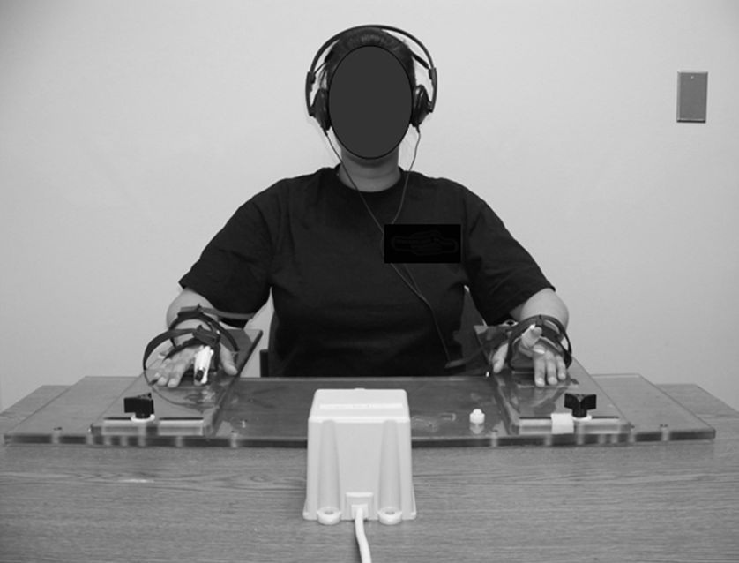
Fig. 2
A.
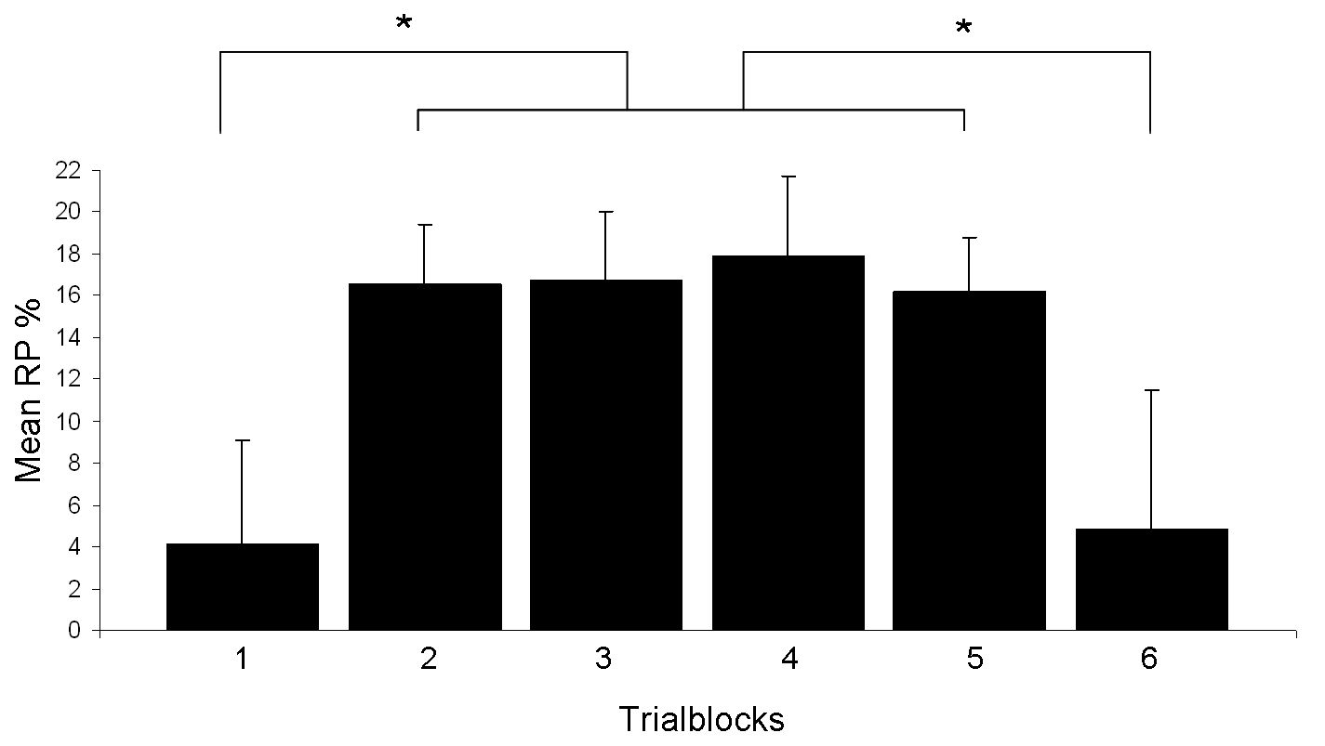
B.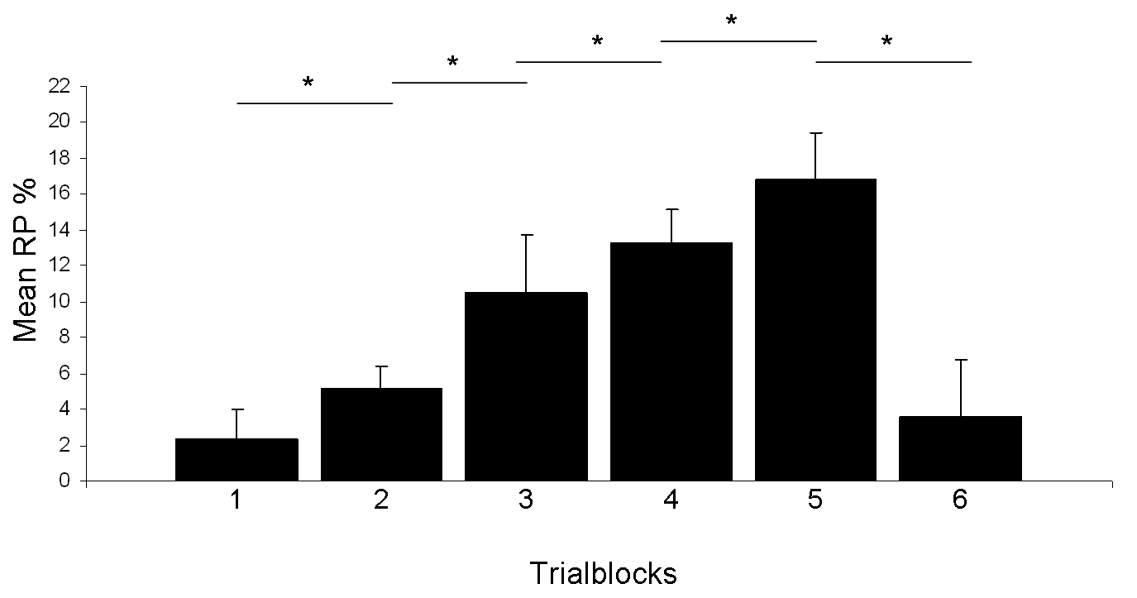
Fig. 3

A.

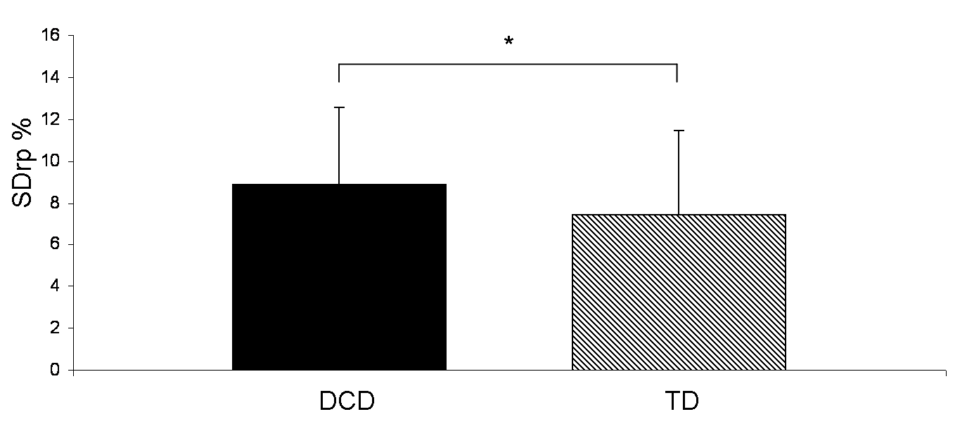

B.

