Urea – the gold standard ingredient for emollients?
Ivan Bristow PhD MChS

Introduction

The many benefits of urea as a topical treatment for skin conditions have long been known - particularly as an additive to emollient preparations. In podiatry, we have observed a renaissance with an increase in new products coming to market promoted as containing urea. Recent research has begun to unravel its biochemical benefits in treating dry skin conditions. This article reviews the chemical effects of this molecule and looks at some of the useful properties and applications of urea in managing common skin conditions affecting the foot.

Urea Physiology
Urea (also known as carbamide) [chemical formula (NH₂)2CO] is a natural by-product created predominantly in the liver through the metabolism of protein in the urea or ornithine cycle. The chemical is a stable and of low toxicity and is a useful means of eliminating nitrogen safely from the body in urine. As a chemical it is highly water soluble, pH neutral and is produced by combining ammonia molecules (NH₃) with carbon dioxide (CO₂).
The human epidermis is the main barrier between the body and the external world with the outermost layer, the stratum corneum, playing a significant role in preventing water loss and limiting the ingress of toxic chemicals, allergens and potential pathogens. The stratum corneum behaves much like a brick wall with the bricks being the keratinocytes (made from a protein complex containing loricrin and involucrin) which are interlinked, giving a rigid envelope-like structure. The bricks are surrounded by the mortar – a complex of lipids rich in ceramides, cholesterol and free fatty acids which add the waterproofing layering to the epidermis.
These surface cells eventually desquamate but are constantly replenished with new keratinocytes ascending from the lower strata below namely the basale, spinosum and granulosum respectively reaching the outermost layers of the corneum in around 28 days. During that migration, the keratinocytes undergo a range of complex changes that see them become cornified developing a protein rich envelope. Within the stratum granulosum, keratohyalin granules can be seen to develop. These granules are rich in filaggrin, a histidine rich protein complex genetically coded which is subsequently degraded in the stratum corneum into shorter amino-acids which are vital for maintaining the barrier function within this outer layer [1].
Although urea is considered to be a waste product it also occurs naturally within the epidermis as part of normal skin physiology. Keratinocytes in the lower epidermal layers express specific urea transporters and other channels known as aquaporins. Importing urea into the keratinocytes creates a humectant effect hydrating the cell and drawing in water through channels in the cell wall from the underlying dermis, maintaining cell turgidity and shape. Latterly, urea is also produced in the stratum corneum. A change from the neutral pH in the lower layers to a drier, acidic environment in the stratum corneum, promotes filaggrin breakdown into amino-acids and arginine. The latter being subsequently converted to ornithine, from which further urea is produced.

The effects of urea on human skin
Urea has been used topically for many years [2]. It properties as a hydrating agent have been established [3] but other effects have been less well researched. Grether-Beck and colleagues [4] investigated the properties of urea undertaking a range of experiments which highlighted some additional and previously unreported effects. In a urea versus placebo cream trial on normal skin they demonstrated that application of a urea based cream, within hours, reduced trans-epidermal water loss, thus improving the skin barrier function. The effect was probably due to increased levels of filaggrin, involucrin and loricrin, particularly evident when a 20% urea formulation was used. In addition, they demonstrated how urea application stimulated expression of two anti-microbial peptides - cathelicidin (LL-37) and Beta-defensin 2. The final part of their analysis also discovered that urea application upregulated the production of natural skin lipids – following urea application they were able to measure increases in the enzymes responsible for lipid synthesis after just 48 hours of exposure to the chemical increasing waterproofing in the outer layers of the epidermis.
The hydrating effects of urea have been observed – as a humectant it is able to attract and hold water within the epidermis giving it excellent emollient properties. Urea, as a small molecule also has the ability to cause conformational change in skin protein structures, effectively unfolding them making them more vulnerable to degradation and exfoliation – clinically this is seen as an epidermal thinning effect [5] without affecting normal skin physiology and integrity. This particular function being evident in lower strength formulations (less than 20%).
Above 25%, its action becomes more keratolytic than hydrating [6]. The higher percentage formulations frequently are used in the treatment of hyperkeratotic disorders of the skin. Moreover at this concentration urea, under occlusion, is able to dissolve the harder keratin of nails and has been used as a means of debriding diseased nail in combination with an antifungal treatment [7] or as a direct means of removing infected nail [8].

Antimicrobial action
Reduces trans-epidermal water loss
Skin moisturiser & humectant effect
Thinning of hyperkeratotic skin
Dissolution of nail
Promotion and stimulation of skin repair

Summary of main properties of urea on the skin

Clinical Use of Urea creams
Products containing urea are used for a wide range of skin diseases which have dry skin as part of their symptoms. Clinical conditions treated have included icthyosis, atopic dermatitis and eczema, contact dermatitis, seborrheic dermatitis, psoriasis and onychomycosis [9]. The positive benefits of urea based emollients on the diabetic foot have also been reviewed and discussed [10, 11].
Based on the research presented, it could be suggested that urea should be a first line in the treatment for dry skin conditions affecting the feet owing to its list of physiological advantages. In a recent systematic review of moisturisers for atopic dermatitis this was suggested but the authors concluded that further head-to-head studies of urea with non-urea containing products are required to fully qualify this proposal [12]. Furthermore, as the “Best Practice in Emollient Therapy” guidelines suggest, emollient selection should be down to patient choice as this ensures greatest compliance [13]. Generally, adverse reactions to urea are uncommon, with stinging or smarting after application being the most frequently reported especially when applied to broken/irritated skin [14]. In a recent overview of urea product studies, few adverse reaction were reported across 75 studies [9]. Typically, most reactions to emollients arise as a result of added excipients rather than the urea itself. Heavier, ointment based products (such as heel balm) generally contain fewer excipients and so are less likely to cause irritation or skin reactions.

Clinical Preparations
A range of urea containing products are currently marketed to podiatrists and patients within the United Kingdom. The majority of products have a urea content of somewhere between 10-25%, with many ranges having a “standard” 10% treatment and a “heel balm” formula at 25%. Higher concentrations are available as skin treatments (LCN 40% Chapped Skin Cream®, Flexitol Platinum® [30% urea]) but also as a nail avulsion agent for onychomycosis, (Canespro®) at a 40% concentration.

Product | Company | Concentration  of urea
Allpresan® Diabetic Foam Basic  Allpresan® Diabetic Foam Intensive | Neubourg | 5%  10%
Aquadrate cream® | Alliance | 10%
Canespro® Fungal Nail Treatment Set | Bayer | 40%
CCS® Foot Care Cream  CCS® Heel Balm | CCS | 10%  25%
Cuplex Cracked Heel Repair Cream® | Crawford | 25%
Dermatonics® Once Heel Balm | Dermatonics | 25%
Flexitol® moisturising foot cream  Flexitol® Heel Balm  Flexitol® Platinum | Thornton-Ross | 10%  25%  30%
LCN® Urea 10% Foot Cream  LCN® Urea Chapped Skin | LCN | 10%  40%
Simply Feet Foot Cream | Canonbury Healthcare | 10%
Ureka® 10% Urea Cream  Ureka® 25% Urea foot care Cream | Ureka | 10%  25%

Common Urea Preparations used on the foot

Clinical Case Study
A 60-year-old male with a 10-year history of type II diabetes presented with hyperkeratosis affecting his feet, particularly his heels which frequently fissured and bled. Pain associated with the fissuring had meant the patient had been unable to walk any distance affecting his quality of life as he was unable to walk his dog and he had gained a lot of weight. To date the callus had been treated with monthly debridement by his previous podiatrist which had a limited effect as the callus returned rapidly (figures 1a &1b).
Following assessment, the patient was advised to apply 25% urea under occlusion, overnight for three nights week as follows using the wet wrapping technique for the foot [15]:
- After a bath or shower, in the evening, the patient applied a generous amount 25% urea product to the heels and across the plantar surface.
- A clean, DAMP sock was then applied to both feet.
- A clean, DRY sock was then applied over the top.
- The patient was asked to leave this on overnight before removing the socks in the morning and washing his feet as normal.
The patient was subsequently reviewed at roughly monthly intervals and photographed. No scalpel debridement was used during this period. At week 4 (figure 2a & 2b), the patient was issued with heel cups to hold the heel in a position which would reduce mechanical spread and reduce the risk of further heel fissures. After 16 weeks the hyperkeratosis had virtually disappeared and the patient had been able to increase his exercise and happily began to lose weight (figures 3a-3b). Following this he has subsequently reduced to wet wrapping once a week as required with 10% urea applied to his feet during the daytime as a maintenance treatment. He has not required any scalpel debridement since.

Summary

The use of emollients for dry skin is a widely accepted treatment. Studies have investigated urea based emollient products and these have been shown to have distinct advantages beyond simple moisturisation, such as hyperkeratosis reduction (through epidermal thinning), antimicrobial activity and improving skin barrier function through upregulation of skin repair mechanisms. Essentially, patient’s choice should be the first step in emollient selection but the use of a urea based product for dry feet shows benefits over those without. Intense moisturisation of the feet can be achieved safely through the use of wet wrapping for particularly for patients with stubborn hyperkeratosis.

References
1. McGrath, J.A., Profilaggrin, dry skin, and atopic dermatitis risk: size matters. J Invest Dermatol, 2012. 132(1): p. 10-1.
2. Kuzmina, N., L. Hagströmer, and L. Emtestam, Urea and Sodium Chloride in Moisturisers for Skin of the Elderly – A Comparative, Double-Blind, Randomised Study. Skin Pharmacology and Physiology, 2002. 15(3): p. 166-174.
3. Cork, M.J. and S. Danby, Skin barrier breakdown: a renaissance in emollient therapy. British Journal of Nursing, 2009. 18(14): p. 872, 874, 876-7.
4. Grether-Beck, S., et al., Urea uptake enhances barrier function and antimicrobial defense in humans by regulating epidermal gene expression. J Invest Dermatol, 2012. 132(6): p. 1561-72.
5. Fluhr, J.W., C. Cavallotti, and E. Berardesca, Emollients, moisturizers, and keratolytic agents in psoriasis. Clinics in Dermatology, 2008. 26(4): p. 380-386.
6. Vidal, I., et al., Using Urea at high concentrations: clinical cases, in Poster presentation,, EADV September Meeting, Editor. 2008: Paris, France.
7. Baran, R. and F. Coquard, Combination of fluconazole and urea in a nail lacquer for treating onychomycosis. J Dermatolog Treat, 2005. 16(1): p. 52-5.
8. Baran, R. and A. Tosti, Chemical avulsion with urea nail lacquer. J Dermatolog Treat, 2002. 13(4): p. 161-4.
9. Pan, M., et al., Urea: a comprehensive review of the clinical literature. Dermatology Online Journal, 2013. 19(11).
10. Bristow, I.R., Emollients in the care of the diabetic foot. Diabetic Foot Journal, 2013. 16: p. 63-66.
11. Locke, J., S. Baird, and G. Hendry, The use of urea-based creams in the prevention of diabetic ulceration. Dermatological Nursing, 2012. 11(2): p. 26-32.
12. Lindh, J.D. and M. Bradley, Clinical Effectiveness of Moisturizers in Atopic Dermatitis and Related Disorders: A Systematic Review. Am J Clin Dermatol, 2015. 16(5): p. 341-59.
13. Ersser, S., et al., Best Practice in Emollient Therapy. 2012, British Dermatological Nursing Group.
14. Loden, M., et al., A double-blind study comparing the effect of glycerin and urea on dry, eczematous skin in atopic patients. Acta Derm Venereol, 2002. 82(1): p. 45-7.
15. Bristow, I.R., Emollients and the foot. Podiatry Now, 2012: p. S1-S8.

Figures
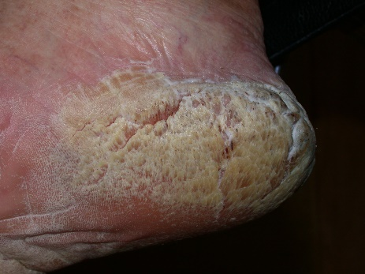 | 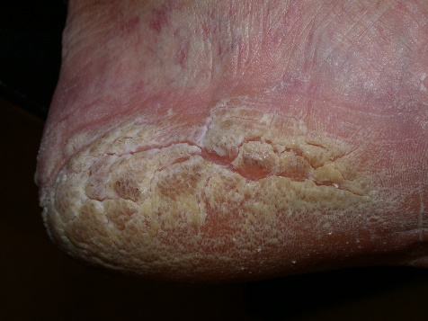
Figure 1a & 1b: Heels at presentation
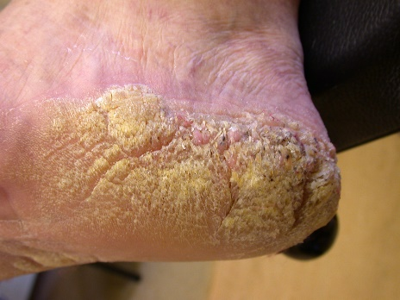 | 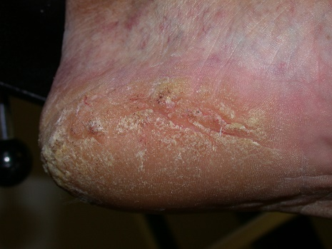
Figure 2a & 2b: After four weeks
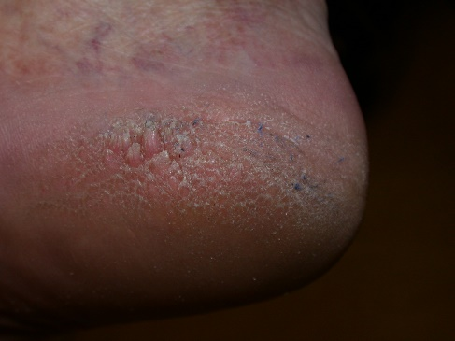 | 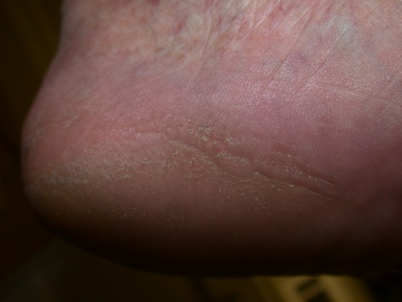
Figure 3a & 3b: At 16 weeks

