Article title: Electronic prescribing system design priorities for antimicrobial stewardship: a cross-sectional survey of 142 UK infection specialists

Authors:
Kieran S. Hand^{1,2}*, Debbie Cumming³, Susan Hopkins⁴, Sean Ewings⁵, Andy Fox^{1,2}, Sandya Theminimulle⁶, Robert J. Porter⁷, Natalie Parker⁸, Joanne Munns⁹, Adel Sheikh¹⁰, Taryn Keyser¹¹,
Richard Puleston¹²

Addresses:
1. Southampton Pharmacy Research Centre, University Hospital Southampton NHS Foundation Trust, Tremona Road, Southampton, SO16 6YD
2. Faculty of Health Sciences, University of Southampton, Southampton, UK, SO17 1BJ.
3. Pharmacy Department, St Mary’s Hospital, Parkhurst Road, Newport, Isle of Wight, PO31 7QJ
4. Department of Infectious Diseases & Microbiology, Royal Free London NHS Foundation Trust, Pond St, London, NW3 2QG
5. Southampton Statistical Sciences Research Institute, University of Southampton, University Road, Southampton, SO17 1BJ
6. Microbiology Department, St Mary’s Hospital, Parkhurst Road, Newport, Isle of Wight, PO31 7QJ
7. Department of Microbiology, Royal Devon and Exeter NHS Foundation Trust, Church lane, Heavitree, Exeter, EX2 5AD, UK
8. Pharmacy Department, Hampshire Hospitals NHS Foundation Trust, Royal Hampshire County Hospital, Romsey Road, Winchester, Hampshire, SO22 5DG
9. Pharmacy Department, Western Sussex Hospitals NHS Foundation Trust, St Richards Hospital, Chichester, PO19 6SE
10. Pharmacy Department, Queen Alexandra Hospital, Portsmouth Hospitals’ NHS Trust, Southwick Hill Road, Portsmouth, PO6 3LY, UK
11. Pharmacy Department, Hampshire Hospitals NHS Foundation Trust, Basingstoke and North Hampshire Hospital, Aldermaston Road, Basingstoke, Hampshire, RG24 9NA
12. Institute of Public Health, City Hospital, Nottingham, NG5 1PB
*Corresponding author (telephone, fax and e-mail contact details): Kieran S. Hand, telephone 02381205117, fax 02381203237, e-mail K.Hand@soton.ac.uk

Short running title: E-prescribing software features for antimicrobial stewardship

3-5 keywords (very general terms such as 'bacteria' and 'human' and terms already present in the title should be avoided, as should non-standard abbreviations): CPOE, prescription, Clinical Decision Support Systems

Synopsis
The implementation of electronic prescribing and medication administration systems (EPMAs) is a priority for hospitals and a potential component of antimicrobial stewardship (AMS).
Objectives
This study aimed to identify software features within EPMAs that could potentially facilitate AMS and to survey practising UK infection specialist healthcare professionals in order to assign priority to these software features.
Methods
A questionnaire was developed using nominal group technique and transmitted via email links through professional networks. The questionnaire collected demographic data, information on priority areas and anticipated impact of EPMA. Responses from different respondent groups were compared using the Mann Whitney U test.
Results
Responses were received from 164 individuals (142 analysable). Respondents were predominantly specialist infection pharmacists (48%) or medical microbiologists (37%). 59% of pharmacists had experience of EPMA in their hospitals compared to 35% of microbiologists. Pharmacists assigned higher priority to: indication prompt (p<0.001), allergy checker (p=0.003) treatment protocols (p=0.003), drug-indication mismatch alerts (p=0.031) and prolonged course alerts (p=0.041); and lower priority to a dose checker for adults (p=0.02) and an interaction checker (p<0.05), than microbiologists. A “soft stop” functionality was rated essential or a high priority by 89% of respondents. Potential EPMA software features were expected to have the greatest impact on stewardship, treatment efficacy and patient safety outcomes with lowest impact on Clostridium difficile infection (CDI), antimicrobial resistance and drug expenditure.
Conclusions
The survey demonstrates key differences in health professionals’ opinions of different healthcare benefits of EPMA but a consensus of anticipated positive impact on patient safety and antimicrobial stewardship.
INTRODUCTION
Antimicrobial resistance (AMR) is a major threat to public health and a significant resource and cost burden on the United Kingdom (UK) National Health Service (NHS).¹ The Chief Medical Officer’s 2013 report on infections and the rise of AMR called for action to preserve the effectiveness of existing antimicrobials through antimicrobial stewardship (AMS).¹ The 2013 UK Five Year Antimicrobial Resistance Strategy from the Department of Health (DH) also highlights AMS as one of seven key areas for action and NHS England has subsequently introduced antimicrobial prescribing reduction goals for English hospitals through the Commissioning for Quality and Innovation (CQUIN) programme for 2016/17.^{2, 3}

In 2012, the UK Department of Health commissioned a study of the potential benefits to staff and patients of greater use of digital and information technology in the NHS and social care.⁴ The study report identified four priority actions, one of which was to drive the rollout and use of electronic prescribing (e-prescribing) in secondary care. Implementation of e-prescribing systems in hospitals presents a unique opportunity to improve the quality of antimicrobial prescribing and to facilitate AMS.⁵⁻¹⁰ Evidence for the benefits of AMS functionality within e-prescribing systems comes from published research studies demonstrating positive impact on outcomes including increased guideline adherence^{11, 12} and effective initial therapy¹³ or reductions in antimicrobial prescribing,^{14, 15} resistance,^{16, 17} dosing errors,⁸ length of hospital or ICU stay^{14, 18} and mortality.^{12, 13, 19} However, many of these information systems were created on a small scale in individual hospitals or groups of institutions and few reports cover the full potential range of software features that enable AMS. Moreover there does not appear to be a recognised standard to guide the specification and commissioning of an optimal e-prescribing system that includes the required AMS functionality appropriate for the challenges that health systems currently face worldwide.²⁰

This report presents results from a cross-sectional survey of UK infection specialist health professionals. The specific objectives of this study were: to identify, using a convenience sample of local infection experts (the nominal group technique), software features within NHS hospital e-prescribing systems that could potentially facilitate antimicrobial stewardship; to assign a priority to these software features according to the opinions of practising infection specialist healthcare professionals; to identify any differences in priority setting according to professional group, hospital status (teaching or district general) or previous experience of e-prescribing systems; and to communicate research findings to e-prescribing software manufacturers and healthcare policy makers.

MATERIALS AND METHODS
Two focus group meetings of experienced infection health professionals from a local network of hospitals in the south central region of England were convened in order firstly, to identify software features within existing e-prescribing and medicines administration (EPMA) systems that facilitate AMS and secondly, to identify additional software features with the potential to facilitate AMS. The focus groups had representation from six infection hospital pharmacists (three with experience of EPMA systems), two consultant medical microbiologists (one with experience of EPMA systems) and one EPMA analyst. The focus group meeting output was a list of software features to be included in a questionnaire for wider circulation among UK infection specialist health professionals. Following the focus groups, two infection pharmacists designed a questionnaire using SurveyMonkey® software. The questionnaire included 42 questions, which were divided into 4 domains. The first domain collected respondent demographic data including professional group, experience in a specialist role, hospital setting and EPMA experience. In the remaining three domains, respondents were asked to assign a priority to individual software features grouped according to the categories of prescribing alerts/prompts (12 features), active prescription surveillance (11 features) and prescribing trend surveillance (8 features). At the end of each domain, respondents were asked to express their opinion of the anticipated collective impact of the software features from each domain on a number of clinical, microbiological and process outcomes. For the prescribing trend surveillance domain, respondents were asked to prioritise a number of technical aspects of the proposed surveillance reports. Finally, the questionnaire provided a freetext narrative section inviting respondents to suggest additional software features with potential to facilitate AMS, not mentioned earlier in the survey. The questionnaire was piloted in the local region, predominately with infection pharmacists and one medical microbiologist in October 2014. Feedback from the pilot led to the incorporation of one additional category (work efficiency) to the list of process outcomes. A copy of the finalised questionnaire and covering letter to respondents is available as an online Supplement (S1).

Respondents were advised that participation was voluntary and anonymous, that the questionnaire would take approximately 10-12 minutes to complete and that the results would be disseminated to e-prescribing software manufacturers, policy makers and the clinical infection community. The research team took the decision not to collect personal details of respondent names and employers in order to elicit candid responses; although respondent internet protocol (IP) addresses were collected, identifying responses from the same healthcare organisations. A hyperlink to the online questionnaire was distributed via health professional networks including the UK Clinical Pharmacy Association, the Royal College of Pathologists, the British Society for Antimicrobial Chemotherapy and Public Health England. The online questionnaire was closed in July 2015, 7 months from launch. Table 1 presents a glossary of key terms used in the questionnaire that will be referred to throughout this report.

Analysis methods
Questionnaire data were summarised with descriptive statistics and analysed using IBM SPSS v.22 with priority ranking of software features by different groups of respondents compared using the Mann Whitney U test. The respondent groups compared were: specialist pharmacists versus medical microbiologists (the number of respondents from other professional groups was too few for statistical analysis); respondents from hospitals with EPMA experience versus those without; and respondents from teaching hospitals versus district general hospitals (DGHs). A p-value of <0.05 was considered statistically significant. Finally, the freetext narrative comments were analysed by using a summative approach to qualitative content analysis, grouping responses into common themes according to frequency of reporting.²¹

This research did not require NHS Research Ethics Committee approval for sites in England, Scotland, Wales or Northern Ireland according to the Health Research Authority online decision tool (http://www.hra-decisiontools.org.uk/ethics/).

RESULTS
Respondent accountability
Responses were received from 164 individuals from 79 unique IP addresses. Twenty-two response sets were removed from the dataset (11 pharmacists, 6 medical microbiologists, one ID physician, 4 nurses and one trainee) due to failure to complete responses to survey questions beyond demographics. Responses from the remaining 142 individuals from 68 unique IP addresses were included in the analysis. Eleven of these 142 did not complete all sections of the questionnaire and missing data were ignored as they comprised less than 10% of responses.

Respondent demographics
The demographic profile of the 142 respondents included in the analysis is presented in Figure1. Infection pharmacists comprised almost half of respondents (48%; 68/142) from 39 IP addresses and the majority had at least 5 years’ experience in a specialist infection role (47/68). Medical microbiologists represented over one-third of respondents (37%; 53/142) from 35 IP addresses and most had at least 5 years’ experience (48/53). Six infectious diseases (ID) physicians responded to the survey and a further six respondents were grouped as other healthcare professionals (medical virologist, epidemiologist, junior doctor, infection prevention nurse, surveillance nurse and a consultant in public health).

Fifty-two per cent of respondents were from DGHs (71/136 responses) and 45% from teaching hospitals (61/136 responses). Figure 2 illustrates the distribution of experience of EPMA and e-prescribing systems amongst the questionnaire respondents. Half of respondents (49%; 68/139) reported experience of EPMA or e-prescribing; 59% of 68 infection pharmacists had experience of EPMA in their hospitals compared to 35% of 52 microbiologists. Forty per cent (56/139) expected implementation of EPMA within 5 years (25 from teaching hospitals and 29 from district general hospitals) but 11% (15/139) did not expect EPMA within 5 years (5 from teaching hospitals and 9 from district general hospitals).

Prescribing Prompt Software Features
Table 2 presents survey response data for priority attributed by respondents to 12 software features of EPMA systems grouped within the Prescribing Prompt category. With the exception of restriction features, all prescribing prompt software features were considered essential or high-priority by the majority (>50%) of respondents. The features considered essential by more than 50% of respondents were: an allergy checking function and a prompt to prescribers to record the clinical indication for prescribing an antimicrobial.

In comparison with medical microbiologists, specialist pharmacists assigned higher priority to: indication prompt (p<0.001); allergy checker (p=0.003); and treatment protocols (p=0.003) (Table 3). Medical microbiologists assigned higher priority to a dose checker for adults (p=0.023) and an interaction checker (p<0.05). Respondents from hospitals with EPMA experience assigned higher priority to an indication prompt (p=0.049); whereas respondents from hospitals without EPMA experience assigned higher priority to: restricted antimicrobial block (p=0.011); dose checker for children (p=0.024); and blood level monitoring alert (p=0.033). When responses from teaching hospitals were compared with responses from DGHs, there were no statistically significant differences in opinions of priority for any of the prescribing prompt software features. The majority of respondents considered that both patient safety (60%; 84/140) and ability to deliver antimicrobial stewardship (64%; 89/140) were extremely likely to be improved (Figure 3).

Active Prescription Surveillance Software Features
Table 4 presents survey response data for priority attributed by respondents to 11 software features of EPMA systems grouped within the Active Prescription Surveillance category. All but two of the 11 features (daily reports of new or ongoing prescriptions of all antimicrobials) were considered essential or high priority by the majority (>50%) of respondents. Only one feature was considered essential by more than 50% of respondents: daily report of new prescriptions for critical antimicrobials.

Specialist pharmacists assigned higher priority to a daily report of mismatch between prescribed antimicrobial and associated indication (p=0.031) and long IV/oral courses (p=0.041) in comparison to medical microbiologists (Table 3). Respondents from hospitals with EPMA experience (in comparison to those without) assigned higher priority to: a daily report of newly-prescribed critical antimicrobials (p=0.015); and a daily report of any newly-prescribed antimicrobial (p=0.024). When responses from teaching hospitals were compared with responses from DGHs, there were no statistically significant differences in opinions of priority for any of the active prescription surveillance software features. The majority (>50%) of respondents considered that both patient safety (53%; 71/135) and ability to deliver antimicrobial stewardship (60%; 80/134) were extremely likely to be improved (Figure 4). Two respondents expressed the view that an improvement in outcomes was extremely unlikely: one for reduction in expenditure on drugs; and one for reduction in risk of Clostridium difficile.

Prescribing Trend Surveillance Software Features
Prescribing trend surveillance reports as a software feature were generally considered by respondents to be of lower priority compared with prescribing prompts and active prescription surveillance, with no trend surveillance software feature rated as essential by more than 50% of respondents (Table 5). However, the majority of respondents did consider all of the proposed trend surveillance features to be at least high priority. There were no statistically significant differences in opinions of priority for prescribing trend surveillance software features between specialist pharmacists and medical microbiologists, nor between respondents with or without EPMA experience. Respondents from DGHs assigned a higher priority to the report of trends in proportion of stat doses where administration was delayed software feature (p=0.034) (Table 3). The majority of respondents considered that the prescribing trend surveillance group of software features would be likely or extremely likely to have a positive impact on all of the listed clinical, microbiological and process outcomes (Figure 5). More than 90% of respondents anticipated a positive impact on their ability to deliver AMS.

Respondent opinions of selected technical aspects of prescribing trend surveillance reporting are summarised in Table 6. Respondents expressed equal preference for patient days or patient admissions as an activity denominator. A preference for annual and quarterly reporting intervals rather than more frequent reports was evident. Surveillance reports for the whole hospital and by clinical speciality or hospital department were rated more highly than reports by hospital ward or individual responsible consultant physician. Finally, surveillance reports of prescribing and administration of individual antimicrobials, by antimicrobial drug class and by locally defined drug groups such as broad-spectrum agents were rated most highly by respondents with reports grouped by route of administration considered of lesser importance.

Freetext narrative responses
Thirty-five respondents recorded narrative responses when prompted to submit suggestions for additional software features not included in the questionnaire and 69 unique statements were identified and grouped into nine common themes, presented in Table 7. Eighteen respondents suggested an interface with other electronic systems for previous and current microbiology investigations and results and for drug and clinical information to guide prescribing. There was an apparent demand for flexibility in reporting software to allow reports to be customised locally but also to generate a standard set of reports for reporting to Public Health England in accordance with antimicrobial stewardship guidance for English Hospitals: Start Smart – Then Focus.²²

DISCUSSION
This is the first survey of UK infection specialist healthcare professionals evaluating opinions of the potential for e-prescribing software to facilitate antimicrobial stewardship. The two largest health professional groups responsible for AMS are represented and the majority of respondents were experienced in a specialist role. We estimate an approximate response rate of 24% of NHS hospital specialist infection pharmacists and at least 8% of practising UK medical microbiologists.^{23, 24} Responses were included from 68 unique IP addresses representing up to 36% (68/188) of NHS hospital trusts/boards if the questionnaire was completed from the employing hospital’s IP address.²⁵⁻²⁸ Teaching hospitals are proportionately over-represented compared with DGHs but there was a good balance of respondents with experience of EPMA systems and those without.

The prescribing prompt software features ranked of highest priority by respondents were allergy checker, interaction checker and dose checker, which are already incorporated as standard functionality in a number of existing EPMA systems in NHS hospitals.²⁹ The response data suggest an unmet need for AMS-relevant features such as recording of indication and “soft stop” functionality; that are not routinely incorporated into existing EPMA systems. The responses suggest relatively little appetite among UK infection specialists for software features to support restriction of prescribing of selected antimicrobials, possibly reflecting the inter-speciality conflict inherent in such policies, resource implications and the lack of longer-term superiority over persuasive interventions.³⁰ Priorities for active prescription surveillance software features were divided between an emphasis on patient safety (drug-indication mismatch and missed doses) and stewardship (prescriptions for critical antimicrobials and long course lengths). Reports of new or ongoing prescriptions of any antimicrobial were considered lower priority, potentially reflecting the limited resources available to AMS teams to review these prescriptions.³¹ Opinions of the expected impact of the proposed prescribing prompt and active prescription surveillance software features on patient outcomes, public health outcomes and resource use outcomes were overwhelmingly positive. It is particularly striking that more than 90% of respondents considered prescribing prompt software features and active prescription surveillance features either likely or extremely likely to improve patient safety, corroborated by an expectation of improved treatment efficacy and reduced Clostridium difficile infection. An improvement in ability to deliver stewardship and more efficient deployment of stewardship resources was also anticipated.

We found that pharmacists were more likely to prioritise a prescribing prompt to record indication, which may reflect the uncertainty faced by hospital pharmacists when validating new prescriptions for antimicrobials (for safety and effectiveness) prior to authorising dispensing; and the requirement to audit antimicrobial prescribing for adherence to local treatment guidelines.^{22, 32} Pharmacists also prioritised the treatment protocol software feature, consistent with their preference for daily reports of drug-indication mismatch in contrast to medical microbiologists. We found that medical microbiologists were more likely to prioritise prescribing prompts for dose checking and interaction checking in comparison to pharmacists, perhaps indicating differences in undergraduate teaching and endorsing the value of a multi-disciplinary approach to infection management. Respondents from hospitals with experience of EPMA systems ranked the indication prompt feature as relatively more important in comparison to those without, suggesting an unmet need amongst existing software systems.

When technical aspects of surveillance reports were considered, it is of interest that reports by individual responsible consultant physician were considered of lesser importance than reports by clinical speciality or hospital department. This finding suggests a lack of willingness to employ a “name-and-shame” approach to stewardship and may represent a preference for promoting a sense of collective responsibility amongst clinician colleagues. Freetext comments identified strong user demand for an interface with the microbiology laboratory software system to support selection of effective therapy and de-escalation and to facilitate prompt intervention when patients are prescribed potentially ineffective therapy.

This cross-sectional survey was designed in accordance with recommended principles of health professional survey design as far as possible within the available resources.^{33, 34} However, a shorter questionnaire may have improved the response rate.³³ The exclusion of data relating to address or employer means that we cannot rule out the possibility that multiple responses may have been submitted by the same individuals and it is likely that multiple respondents from the same Trust had an effect on our findings. We were also unable to collect information on non-responders so the respondent sample is likely to be biased towards more motivated individuals who are engaged with quality improvement and/or information technology. Approximately half of respondents reported experience of EPMA or e-prescribing and this suggests a potential bias towards hospitals with such systems when compared with a survey carried out by Public Health England in 2014 which reported only 17/76 (22%) of respondent hospitals with e-prescribing for at least one inpatient area.³⁵ The questionnaire did not specifically elicit a description of the existing software features of EPMA systems currently installed in NHS hospitals but anecdotal evidence from the research team and from professional networks in the UK suggests that software features to support AMS are extremely limited. Some of the software features proposed in this survey may not be technically possible for existing e-prescribing systems and separate data-mining software may be required, particularly for prescribing trend surveillance. Finally, the present questionnaire was primarily distributed by e-mail to members of professional organisations and therefore may not represent the views of non-members.

The target audience for this survey – consultant medical microbiologists and specialist pharmacists – was deliberate, to focus on individuals most likely to be responsible for stewardship within an NHS hospital organisation. However, other healthcare workers also play an important role in AMS at the individual patient level including junior and senior doctors, nurses, non-medical prescribers and ward pharmacists.³⁶⁻⁴¹ Inclusion of these professional groups in user-testing at the design stage of EPMA implementation is likely to be critical to the success of the proposed software features. Future surveys focussing on front-line prescribers and medication administrators are critical.

The advent of e-prescribing to NHS hospitals represents a unique new opportunity to engage with healthcare professionals to promote safe, effective and proportionate antimicrobial prescribing and to refresh the antimicrobial stewardship message. It must be acknowledged however that with this opportunity also comes new threats to patient safety from prescribing and administration errors as well as potential de-skilling of healthcare professionals.⁴²⁻⁴⁴ The judicious use of educational prompts may facilitate a sustained change in prescribing behaviour but this must be balanced against the recognised risk of “alert fatigue” and competing priorities for e-prescribing system functionality from other medical and surgical specialities.⁴⁵ Successful implementation of the proposed antimicrobial stewardship software features into e-prescribing systems will likely be contingent upon a variety of sociotechnical considerations including seamless integration into the prescribing workflow with minimal time penalties for end-users and full compatibility with existing NHS information technology hardware and software.^{43, 46}

This survey represents the first attempt to canvas opinion of infection specialists in the UK on the potential for e-prescribing software to support antimicrobial stewardship. The findings illustrate fundamental principles that are equally relevant to health systems in other countries. The survey results reveal considerable demand for additional software features expressed by the healthcare professionals charged with promoting rational use of antimicrobials and a consensus of anticipated positive impact on patient safety and efficiency outcomes. The survey demonstrates key differences in health professionals’ opinions of different healthcare benefits of EPMA and underscores the need for a multi-disciplinary approach to the development of EPMA system specifications. We trust this information will prove valuable to software manufacturers currently developing e-prescribing systems when prioritising software functionality and systems interface development and potentially to healthcare commissioners when drafting e-prescribing system specifications. Finally, we commend this topic to research funders with a view to funding research into the potential benefits and unintended consequences of e-prescribing system functionality designed to support antimicrobial stewardship.

ACKNOWLEDGEMENTS
The authors would like to thank all of the questionnaire respondents, Daniel Hinchley for EPMA expertise and the support of the Royal College of Pathologists and the UK Clinical Pharmacy Association for questionnaire distribution.

Some of the findings of this research have been published previously in abstract and poster form at the Federation of Infection Societies annual conference in 2015 (Abstract number 0221).

FUNDING
This study was carried out as part of our routine work. KH is partially funded by a Health Education Wessex post-doctoral clinical-academic fellowship.

TRANSPARENCY DECLARATIONS
None to declare.

REFERENCES
1. Davies SC. Annual Report of the Chief Medical Officer, Volume Two, 2011, Infections and the rise of antimicrobial resistance. London: Department of Health, 2013.
2. Department of Health, Department for Environment Food & Rural Affairs 2013. UK Five Year Antimicrobial Resistance Strategy 2013 to 2018. https://www.gov.uk/government/publications/uk-5-year-antimicrobial-resistance-strategy-2013-to-2018
3. NHS England 2016. Commissioning for Quality and Innovation (CQUIN) - Guidance Technical Annex for 2016/17: Gateway Reference 04225. https://www.england.nhs.uk/nhs-standard-contract/cquin/
4. Department of Health, PricewaterhouseCoopers 2013. A review of the potential benefits from the better use of information and technology in health and social care. https://www.gov.uk/government/publications/study-on-the-impact-of-digital-technology-in-health-and-social-care
5. Baysari MT, Oliver K, Egan B, et al. Audit and feedback of antibiotic use: utilising electronic prescription data. Appl Clin Inform 2013; 4: 583-95.
6. Jahansouz F, Lee J, James CL. Enforcement of antimicrobial policy through restrictions built into system for computerized prescriber order entry. Am J Health Syst Pharm 2012; 69: 1191.
7. Lesprit P, Duong T, Girou E, et al. Impact of a computer-generated alert system prompting review of antibiotic use in hospitals. J Antimicrob Chemother 2009; 63: 1058-63.
8. Wang HY, Lu CL, Wu MP, et al. Effectiveness of an integrated CPOE decision-supporting system with clinical pharmacist monitoring practice in preventing antibiotic dosing errors. Int J Clin Pharmacol Ther 2012; 50: 375-82.
9. Webber EC, Warhurst HM, Smith SS, et al. Conversion of a single-facility pediatric antimicrobial stewardship program to multi-facility application with computerized provider order entry and clinical decision support. Appl Clin Inform 2013; 4: 556-68.
10. Westphal JF, Jehl F, Javelot H, et al. Enhanced physician adherence to antibiotic use guidelines through increased availability of guidelines at the time of drug ordering in hospital setting. Pharmacoepidemiol Drug Saf 2011; 20: 162-8.
11. Filice GA, Drekonja DM, Thurn JR, et al. Use of a computer decision support system and antimicrobial therapy appropriateness. Infect Control Hosp Epidemiol 2013; 34: 558-65.
12. Nachtigall I, Tafelski S, Deja M, et al. Long-term effect of computer-assisted decision support for antibiotic treatment in critically ill patients: a prospective 'before/after' cohort study. BMJ Open 2014; 4: e005370.
13. Paul M, Andreassen S, Tacconelli E, et al. Improving empirical antibiotic treatment using TREAT, a computerized decision support system: cluster randomized trial. J Antimicrob Chemother 2006; 58: 1238-45.
14. Sintchenko V, Iredell JR, Gilbert GL, et al. Handheld computer-based decision support reduces patient length of stay and antibiotic prescribing in critical care. J Am Med Inform Assoc 2005; 12: 398-402.
15. Thursky KA, Buising KL, Bak N, et al. Reduction of broad-spectrum antibiotic use with computerized decision support in an intensive care unit. Int J Qual Health Care 2006; 18: 224-31.
16. Yong MK, Buising KL, Cheng AC, et al. Improved susceptibility of Gram-negative bacteria in an intensive care unit following implementation of a computerized antibiotic decision support system. J Antimicrob Chemother 2010; 65: 1062-9.
17. Buising KL, Thursky KA, Robertson MB, et al. Electronic antibiotic stewardship--reduced consumption of broad-spectrum antibiotics using a computerized antimicrobial approval system in a hospital setting. J Antimicrob Chemother 2008; 62: 608-16.
18. Evans RS, Pestotnik SL, Classen DC, et al. A computer-assisted management program for antibiotics and other antiinfective agents. N Engl J Med 1998; 338: 232-8.
19. Chow AL, Lye DC, Arah OA. Mortality Benefits of Antibiotic Computerised Decision Support System: Modifying Effects of Age. Sci Rep 2015; 5: 17346.
20. Bright TJ. Transforming user needs into functional requirements for an antibiotic clinical decision support system: explicating content analysis for system design. Appl Clin Inform 2013; 4: 618-35.
21. Hsieh HF, Shannon SE. Three approaches to qualitative content analysis. Qual Health Res 2005; 15: 1277-88.
22. Public Health England 2015. Antimicrobial Stewardship: "Start Smart - Then Focus". https://www.gov.uk/government/publications/antimicrobial-stewardship-start-smart-then-focus
23. Wickens HJ, Farrell S, Ashiru-Oredope DA, et al. The increasing role of pharmacists in antimicrobial stewardship in English hospitals. J Antimicrob Chemother 2013; 68: 2675-81.
24. Royal College of Pathologists 2015. First Annual Medical Workforce Report 2015. https://www.rcpath.org/resourceLibrary/first-annual-medical-workforce-report--2015.html
25. Health and Social Care Northern Ireland 2016. Directory of Health and Social Care Trusts. http://online.hscni.net/hospitals/health-and-social-care-trusts/
26. Department of Health 2016. Directory of Authorities and Trusts. http://www.nhs.uk/servicedirectories/pages/acutetrustlisting.aspx
27. NHS Scotland 2016. Directory of Organisations. http://www.show.scot.nhs.uk/organisations/
28. NHS Wales 2016. Directory of Services. http://www.wales.nhs.uk/ourservices/directory/
29. Ahmed Z, McLeod MC, Barber N, et al. The use and functionality of electronic prescribing systems in english acute NHS trusts: a cross-sectional survey. PLoS One 2013; 8: e80378.
30. Davey P, Brown E, Charani E, et al. Interventions to improve antibiotic prescribing practices for hospital inpatients. Cochrane Database Syst Rev 2013; 4: CD003543.
31. Hermsen ED, VanSchooneveld TC, Sayles H, et al. Implementation of a clinical decision support system for antimicrobial stewardship. Infect Control Hosp Epidemiol 2012; 33: 412-5.
32. Thakkar K, Gilchrist M, Dickinson E, et al. A quality improvement programme to increase compliance with an anti-infective prescribing policy. J Antimicrob Chemother 2011; 66: 1916-20.
33. Burns KE, Duffett M, Kho ME, et al. A guide for the design and conduct of self-administered surveys of clinicians. CMAJ 2008; 179: 245-52.
34. Kelley K, Clark B, Brown V, et al. Good practice in the conduct and reporting of survey research. Int J Qual Health Care 2003; 15: 261-6.
35. ESPAUR 2014. English surveillance programme for antimicrobial utilisation and resistance (ESPAUR) report 2014. https://www.gov.uk/government/publications/english-surveillance-programme-antimicrobial-utilisation-and-resistance-espaur-report
36. Ansari F, Gray K, Nathwani D, et al. Outcomes of an intervention to improve hospital antibiotic prescribing: interrupted time series with segmented regression analysis. J Antimicrob Chemother 2003; 52: 842-8.
37. Charani E, Castro-Sanchez E, Sevdalis N, et al. Understanding the determinants of antimicrobial prescribing within hospitals: the role of "prescribing etiquette". Clin Infect Dis 2013; 57: 188-96.
38. Edwards R, Drumright L, Kiernan M, et al. Covering more Territory to Fight Resistance: Considering Nurses' Role in Antimicrobial Stewardship. J Infect Prev 2011; 12: 6-10.
39. Latter S, Smith A, Blenkinsopp A, et al. Are nurse and pharmacist independent prescribers making clinically appropriate prescribing decisions? An analysis of consultations. J Health Serv Res Policy 2012; 17: 149-56.
40. Mattick K, Kelly N, Rees C. A window into the lives of junior doctors: narrative interviews exploring antimicrobial prescribing experiences. J Antimicrob Chemother 2014; 69: 2274-83.
41. Wentzel J, van VL, van LM, et al. Participatory eHealth development to support nurses in antimicrobial stewardship. BMC Med Inform Decis Mak 2014; 14: 45.
42. Ash JS, Sittig DF, Dykstra RH, et al. Categorizing the unintended sociotechnical consequences of computerized provider order entry. Int J Med Inform 2007; 76 Suppl 1: S21-S27.
43. Harrison MI, Koppel R, Bar-Lev S. Unintended consequences of information technologies in health care--an interactive sociotechnical analysis. J Am Med Inform Assoc 2007; 14: 542-9.
44. Strom BL, Schinnar R, Aberra F, et al. Unintended effects of a computerized physician order entry nearly hard-stop alert to prevent a drug interaction: a randomized controlled trial. Arch Intern Med 2010; 170: 1578-83.
45. Cash JJ. Alert fatigue. Am J Health Syst Pharm 2009; 66: 2098-101.
46. Zaidi ST, Marriott JL. Barriers and Facilitators to Adoption of a Web-based Antibiotic Decision Support System. South Med Rev 2012; 5: 42-50.
47. Polk RE, Hohmann SF, Medvedev S, et al. Benchmarking risk-adjusted adult antibacterial drug use in 70 US academic medical center hospitals. Clin Infect Dis 2011; 53: 1100-10.

Table 1. Glossary of key terms used in the survey of opinions of infection specialists on electronic prescribing and antimicrobial stewardship
Term | Explanation
Prescribing alert / prompt | The prescriber will be alerted via a “pop-up” message – an “alert or prompt” – e.g. if attempting to prescribe an antimicrobial which is contra-indicated because of an allergy or a drug interaction
Active prescription surveillance | Active prescription surveillance refers to the application of surveillance data in real-time for identification of patients currently prescribed antimicrobial therapy. Software features allow prioritisation of patients for intervention by the antimicrobial stewardship team (AST).
 | Active prescription surveillance reports would typically include: patient name, date of birth, hospital number, inpatient location in the hospital, drug name, drug dose, start date, stop date (if specified), prescriber and responsible senior physician.
Prescribing trend surveillance | Prescribing trend surveillance refers to the review of retrospective data relating to antimicrobial prescribing and administration – typically as trends over time. Prescribing trend surveillance allows continuous monitoring of performance for the purposes of controls assurance and for evaluating the impact of stewardship interventions.
Order Sets | This software feature allows the prescriber to select an infection (e.g. pneumonia, community-acquired, severe) and the system will automatically populate the prescription with the locally pre-defined treatment regimen (single drug or combination of drugs) at standard doses.
Critical antimicrobial | An antimicrobial may be designated “critical” by a hospital AST according to local priorities – for example, broad-spectrum antimicrobials such as carbapenems or antimicrobials with a narrow therapeutic range such as colistin. A prescriber may be alerted when prescribing a critical antimicrobial with an appropriate locally-defined message containing details of actions required when prescribing.
Restricted antimicrobial | An antimicrobial may be designated “restricted” by a hospital AST on grounds of financial cost, propensity to predispose to Clostridium difficile infection or local decision to reserve for multidrug-resistant infections. Prescribing of restricted antimicrobials requires pre-authorisation by a medical microbiologist or infectious diseases physician (“restricted antimicrobial authorisation”) or prescribing is limited by the prescribing software to senior clinicians (“restricted antimicrobial block”).
Soft Stops | This software feature allows the prescriber to nominate a date when the antimicrobial prescription should be reviewed with a view to stopping, changing treatment or switching route of administration to oral. After the review date has passed, the drug will remain visible and available to nursing staff to administer but will be prominently highlighted as being past the review (soft stop) date
Blood level monitoring order set | When a relevant drug is prescribed, the EPMA system will automatically pair the drug prescription with an order for a blood specimen to be taken at an appropriate time post-dose.
Drug-indication mismatch | A mismatch occurs when a prescribed antimicrobial is not appropriate or unauthorised for the recorded indication/provisional diagnosis.
Days of Therapy (DOTs) | One DOT represents the administration of a single systemic antimicrobial on a given day regardless of the number of doses administered or dosage strength. For example, administration of ceftriaxone as 4g once-daily or as 2g twice-daily for one day would both represent 1 DOT. A single patient receiving both vancomycin and ceftazidime during the same day would be recorded as receiving 2 DOTs (1 of vancomycin and 1 of ceftazidime).⁴⁷
Length of Therapy (LOT) | LOT refers to antimicrobial course length and is the number of sequential days that a patient receives any systemic antimicrobial drug(s), irrespective of the number of different drugs.⁴⁷ A prescription of intravenous piperacillin-tazobactam and vancomycin for 2 days followed by oral co-amoxiclav for 5 days corresponds to a LOT of 7 days.
Point Prevalence | Point prevalence is the proportion of hospital patients active on the EPMA system that are prescribed any antimicrobial at a specific point in time (for example at noon on the first day of each month).

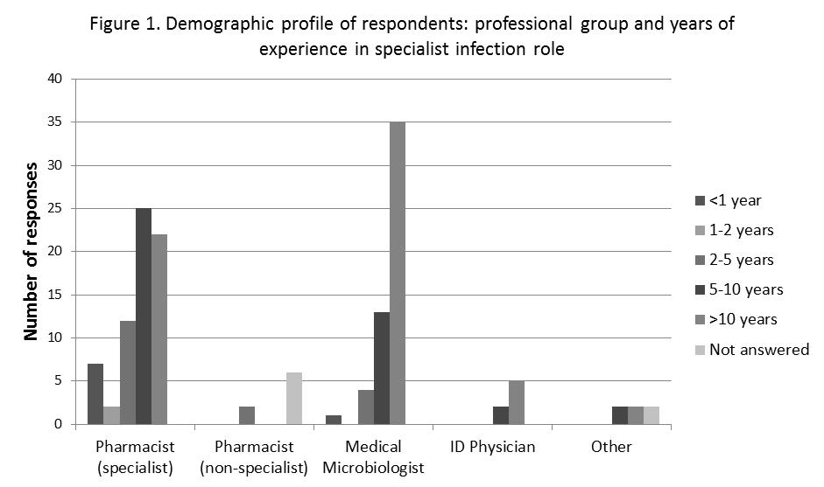

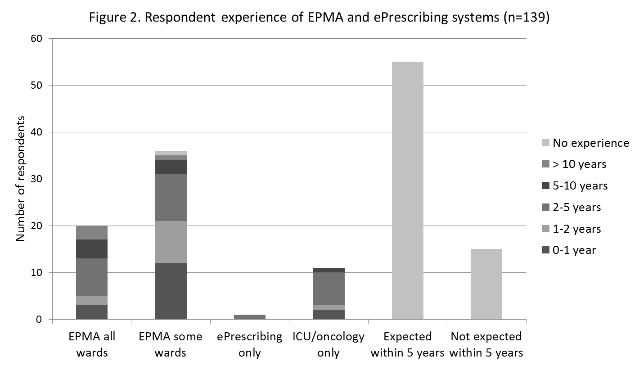
Table 2. Prescribing Prompt software features ranked in order of respondent-assigned priority
Software feature | Number of responses | Essential | High priority | Medium priority | Low priority | Not a priority
Allergy checker | 142 | 80.3% | 14.8% | 3.5% | 1.4% | 0.0%
Indication prompt | 139 | 56.8% | 30.9% | 10.8% | 1.4% | 0.0%
Interaction checker | 143 | 45.5% | 35.7% | 14.7% | 4.2% | 0.0%
Soft stop | 141 | 38.3% | 51.1% | 7.1% | 2.8% | 0.7%
Blood level prompt | 140 | 35.0% | 46.4% | 15.7% | 2.9% | 0.0%
Dose checker (children) | 142 | 33.8% | 44.4% | 19.0% | 2.1% | 0.7%
Dose checker (adults) | 141 | 25.5% | 48.2% | 22.0% | 3.5% | 0.7%
Critical antimicrobial prompt | 141 | 24.1% | 48.2% | 21.3% | 4.3% | 2.1%
Indication order set | 143 | 21.7% | 45.5% | 25.2% | 4.9% | 2.8%
Blood level order set | 140 | 21.4% | 39.3% | 29.3% | 9.3% | 0.7%
Restricted antimicrobial require authorisation | 142 | 18.3% | 25.4% | 30.3% | 17.6% | 8.5%
Restricted antimicrobial block by prescriber | 140 | 15.7% | 31.4% | 26.4% | 16.4% | 10.0%

Table 3. Differences in software feature priority assignment between respondent groups found to be statistically significant
Domain / Respondent group | Software feature | Respondent group (% of responses rated essential) |  | Mann-Whitney U test p-value
Professional group |  | Pharmacists | Medical microbiologists
Prescribing prompts | Allergy checker | 90% | 69% | p=0.003 (n=68, 52)
 | Indication prompt | 73% | 39% | p<0.001 (n=67, 51)
 | Treatment protocols | 28% | 15% | p=0.003 (n=68, 53)
 | Dose checker (adults) | 16% | 34% | p=0.023 (n=68, 53)
 | Interaction checker | 34% | 51% | p=0.047 (n=68, 53)
Active prescription surveillance | Drug-indication mismatch | 35% | 25% | p=0.031 (n=65, 49)
 | Long IV/oral course | 31% | 24% | p=0.041 (n=65, 50)
EPMA experience |  | EPMA-experienced | Non EPMA-experienced
Prescribing prompts | Indication prompt | 66% | 47% | p=0.049 (n=68, 68)
 | Restricted antimicrobial block | 12% | 17% | p=0.011 (n=67, 70)
 | Dose checker (children) | 26% | 39% | p=0.024 (n=68, 70)
 | Blood level monitoring alert | 24% | 44% | p=0.033 (n=67, 70)
Active prescription surveillance | Daily report of newly-prescribed critical antimicrobials | 64% | 40% | p=0.015 (n=64, 68)
 | Daily report of any newly-prescribed antimicrobial | 23% | 16% | p=0.024 (n=64, 68)
Hospital type |  | Teaching | District General
Prescribing trend surveillance | Report of trends in proportion of stat doses where administration was delayed | 28% | 18% | p=0.034 (n=55, 65)

Figure 3. Respondent opinions of the likely impact of Prescribing Prompt software features
on clinical, microbiological and process outcomes
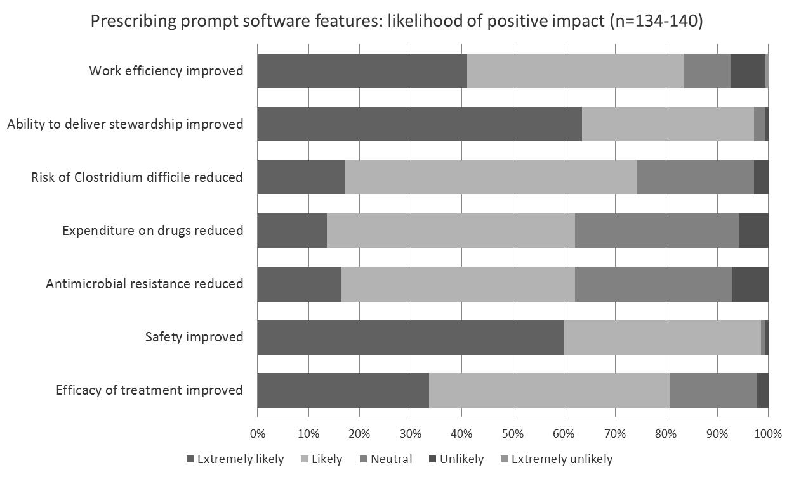

Table 4. Active Prescription Surveillance software features ranked in order of respondent-assigned priority
Software feature | Number of responses | Essential | High priority | Medium priority | Low priority | Not a priority
New Rx of critical drug | 135 | 51.9% | 41.5% | 6.7% | 0.0% | 0.0%
Ongoing Rx of critical drug | 135 | 42.2% | 42.2% | 15.6% | 0.0% | 0.0%
Drug-indication mismatch | 134 | 31.3% | 47.8% | 17.9% | 3.0% | 0.0%
Long IV/oral course | 135 | 28.9% | 54.8% | 14.8% | 0.7% | 0.7%
Missed Abx doses | 132 | 26.5% | 43.9% | 22.7% | 6.1% | 0.8%
Long IV course | 132 | 25.0% | 59.8% | 14.4% | 0.8% | 0.0%
High-dose aminoglycoside | 133 | 23.3% | 40.6% | 25.6% | 9.0% | 1.5%
New Rx for sepsis of unknown origin | 134 | 20.1% | 57.5% | 19.4% | 1.5% | 1.5%
New Rx of any antibiotic | 136 | 19.1% | 27.9% | 33.1% | 17.6% | 2.2%
Ongoing Rx of any antibiotic | 133 | 13.5% | 30.8% | 36.1% | 15.0% | 4.5%
New Rx for diagnosis of interest | 135 | 13.3% | 51.9% | 30.4% | 3.0% | 1.5%

Figure 4. Respondent opinions of the likely impact of Active Prescription Surveillance software features on clinical, microbiological and process outcomes
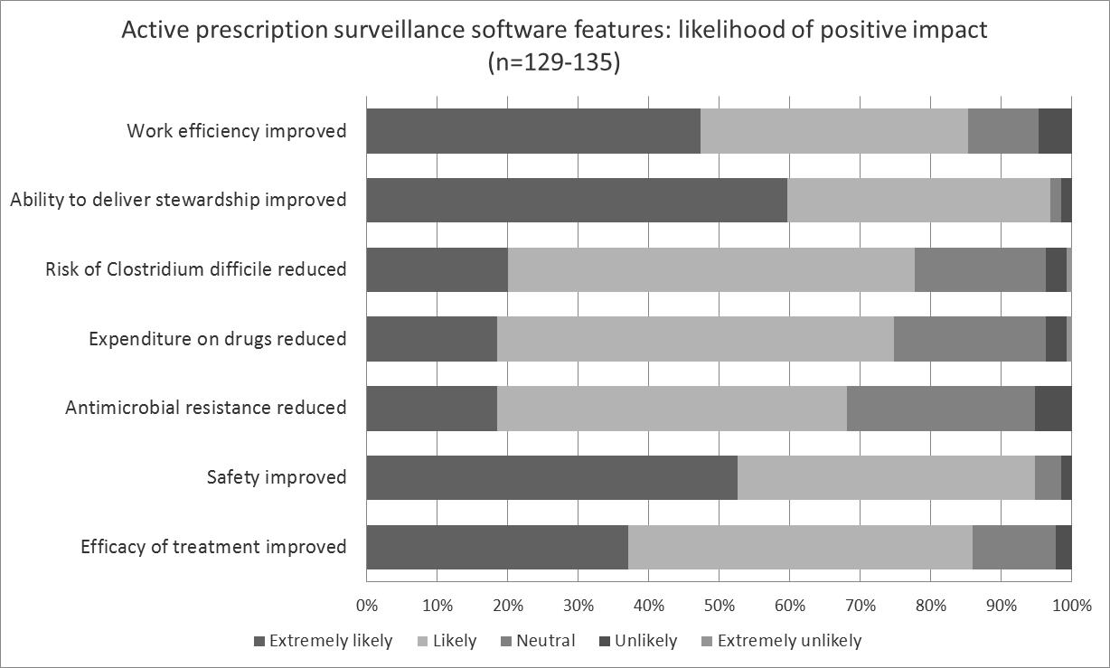

Table 5. Prescribing Trend Surveillance software features ranked in order of respondent-assigned priority
Software feature | Number of responses | Essential | High priority | Medium priority | Low priority | Not a priority
Trends in point prevalence | 130 | 29.2% | 44.6% | 23.1% | 2.3% | 0.8%
Trends in missed doses | 130 | 26.9% | 45.4% | 24.6% | 2.3% | 0.8%
Trends in delayed stat doses | 130 | 23.1% | 53.8% | 19.2% | 3.8% | 0.0%
Trends in total days of therapy (DOTs) | 130 | 13.1% | 39.2% | 37.7% | 7.7% | 2.3%
Trends in average length of therapy (LOT) | 131 | 13.0% | 53.4% | 29.0% | 3.8% | 0.8%

Figure 5: Respondent opinions of the likely impact of Prescribing Trend Surveillance software features on clinical, microbiological and process outcomes
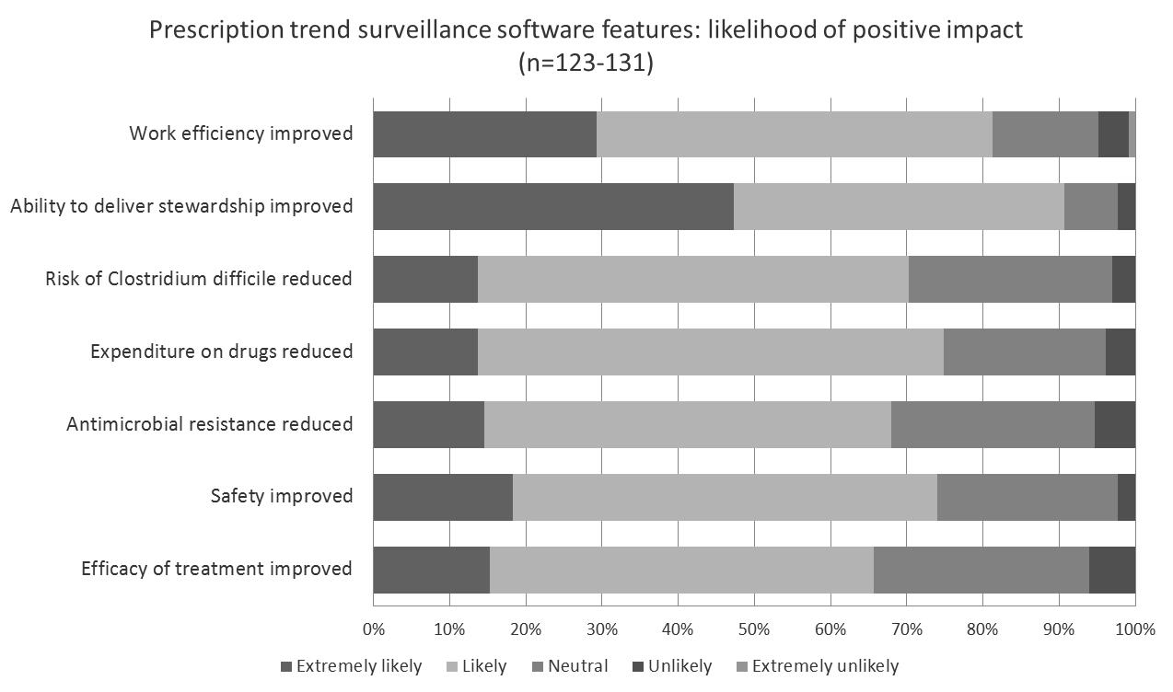

Table 6: Respondent opinions of technical aspects of prescribing trend surveillance reporting software features ranked in order of respondent-assigned priority
 | Response Count | Importance attributed by respondents
 |  | Very high | High | Moderate | Some | None
ACTIVITY DENOMINATOR
EPMA patient days (total number of patients multiplied by number of days) | 130 | 16.2% | 40.0% | 31.5% | 10.8% | 1.5%
EPMA admissions (new patients) | 130 | 13.8% | 38.5% | 36.2% | 10.8% | 0.8%
REPORT TIME INTERVALS
Annually | 130 | 48.5% | 31.5% | 13.1% | 3.8% | 3.1%
Quarterly | 130 | 40.0% | 42.3% | 13.8% | 2.3% | 1.5%
Monthly | 130 | 24.6% | 36.9% | 29.2% | 6.9% | 2.3%
Weekly | 129 | 7.8% | 20.9% | 27.9% | 28.7% | 14.7%
Daily | 130 | 4.6% | 15.4% | 22.3% | 26.2% | 31.5%
HOSPITAL SUBDIVISIONS
Whole hospital | 129 | 49.6% | 38.8% | 6.2% | 4.7% | 0.8%
Clinical speciality | 128 | 42.2% | 41.4% | 11.7% | 3.9% | 0.8%
Hospital departments | 128 | 40.6% | 36.7% | 16.4% | 4.7% | 1.6%
Wards | 128 | 32.8% | 39.1% | 21.1% | 5.5% | 1.6%
Responsible consultant physician | 129 | 32.6% | 37.2% | 20.2% | 9.3% | 0.8%
DRUG GROUPINGS
Individual drugs | 129 | 48.8% | 36.4% | 10.9% | 2.3% | 1.6%
Drug class (e.g. macrolides) | 128 | 41.4% | 41.4% | 13.3% | 3.9% | 0.0%
Locally-defined drug group (e.g. broad-spectrum, narrow-spectrum) | 130 | 40.0% | 38.5% | 16.9% | 4.6% | 0.0%
Antibacterials, antifungals, antivirals, antiparasitics | 127 | 33.9% | 37.0% | 15.7% | 13.4% | 0.0%
All antimicrobials | 130 | 30.0% | 36.9% | 19.2% | 11.5% | 2.3%
By route of administration | 129 | 24.0% | 40.3% | 24.8% | 8.5% | 2.3%

Table 7. Thematic analysis of freetext narrative responses to the question: “Do you have any other suggestions for potential functionality for electronic prescribing and medicines administration systems?”
Theme | Frequency | Details of additional user requirements
Microbiology laboratory system interface | 13 | - Susceptibility testing – prescription conflict (“drug-bug mismatch”)
 |  | - Previous microbiology including healthcare-associated infections
Reporting functions | 9 | - Flexibility of reporting – capacity to customise reports locally
 |  | - Reporting to national standard (Start Smart – Then Focus)
 |  | - Defined daily doses in addition to DOTs
Clinical information system interface | 5 | - Link to guidelines
 |  | - Drug information: adverse effects, drug administration, drug monitoring
 |  | - Disease severity scoring systems
Restriction systems | 5 | - Authorisation codes
 |  | - Authorisation by named specialist
 |  | - System access restricted to trained prescribers
 |  | - Compulsory recording of indication
Additional narrative fields | 5 | - Infection specialist advice
 |  | - Justification for off-guideline prescribing
 |  | - Precise nature of drug allergy
 |  | - Reasons for missed doses
Soft stops / review dates | 4 | - Block administration until review
 |  | - Patient safety of automatic prescription stop
Dosing support | 3 | - Dosing by age, weight and renal function
Drug history | 3 | - Primary care and previous hospital admissions
Stat doses | 3 | - Automatic associated stat dose and appropriately spaced maintenance dose
 |  | - Stat dose remains visible if delayed
Miscellaneous | 19

