Making SDGs work for climate change hotspots

Sylvia Szabo¹, Robert J. Nicholls², Barbara Neumann³, Fabrice G. Renaud⁴, Zoe Matthews¹, Zita Sebesvari⁴, Amir AghaKouchak⁵, Roger Bales⁶, Corrine Warren Ruktanonchai⁷, Julia Kloos⁴, Efi Foufoula-Georgiou^{5,8}, Philippus Wester⁹, Marc New¹⁰, Jakob Rhyner⁴, Craig Hutton⁷

¹ Social Statistics and Demography, University of Southampton, Southampton SO17 1BJ, United Kingdom
² Engineering and the Environment, University of Southampton, Southampton SO17 1BJ, United Kingdom
³ Institute of Geography, University of Kiel, Germany
⁴ United Nations University Institute for Environment and Human Security, Bonn, Germany
⁵ Department of Civil & Environmental Engineering, University of California, Irvine, USA
⁶ Sierra Nevada Research Institute, University of California, Merced, USA
⁷ Geography and Environment, University of Southampton, Southampton SO17 1BJ, United Kingdom
⁸ Department of Civil, Environmental and Geo- Engineering, National Center for Earth-surface Dynamics, University of Minnesota, Minneapolis, USA
⁹ International Centre for Integrated Mountain Development (ICIMOD), Kathmandu, Nepal
¹⁰ African Climate and Development Initiative (ACDI), University of Cape Town, South Africa

- Introduction
The impacts of climate change on people’s livelihoods have been widely documented [1]. It is expected that climate and environmental change will hamper poverty reduction, or even exacerbate poverty in some or all of its dimensions. Changes in the biophysical environment, such as droughts, flooding, water quantity and quality, and degrading ecosystems, are expected to affect opportunities for people to generate income. These changes, combined with a deficiency in coping strategies and innovation to adapt to particular climate change threats, are in turn likely to lead to increased economic and social vulnerability of households and communities, especially amongst the poorest.

The impacts on communities and housholds will vary among social-ecological systems. De Souza et al. [2] identify three main types of climate change hotspots, which they define as a combination of areas where climate change signals overlap with vulnerable communities. The climate change hotspots are often inter-connected and affect socio-economic development. De Souza et al. [2] identified: 1) deltas in Africa and South Asia, 2) semi-arid regions in Africa and parts of Asia, and 3) glaciers and snowpack-dependent river basins in the Himalayas. We consider these typologies as being relevant globally, covering a large portion of the world (Fig. 1). These hotspots are areas that often cut across administrative boundaries and have limited political representation. As a result, they are not a focus of direct policy action, which has important implications for sustainable development and the well-being of local populations. In this commentary we propose climate change hotspot indicators that have a regional scope and should complement sub-national and national indicators. In doing so, this paper contributes towards the requirements of the Sustainable Development Goals (SDG), the Paris Agreement of the United Nations Framework Convention on Climate Change (UNFCCC) and the Sendai Framework for Disaster Risk Reduction (SFDRR) of the United Nations Office for Disaster Risk Reduction (UNISDR). The United Nations’ 2030 Agenda for Sustainable Development [9], the Paris Agreement of the UNFCCC [10] and SFDRR of the UNISDR [11] all acknowledge the imminent challenges and threats that climate change poses to human societies and recognize the interlinkages between resilience to climate change and sustainable development [12].

Deltas, the first category of climate change hospots, cover only 1% of the Earth’s area, but are home to over 500 million people [3]. Deltas are dynamic systems that are characterised by low elevation, frequent flooding and high biodiversity; and they benefit from high agricultural and fisheries productivity, contributing to regional and global food security [4]. Climate change is leading to higher sea levels, to changes in major river discharge and likely to increases in the frequency of cyclones and coastal storms in many susceptible areas. Collectively, this increases the risk of floods and salinization, often intensified by natural and human-induced land subsidence, and will affect coastal ecosystems and the services they provide [5, 6]. Semi-arid regions are home to more than 2 billion people, most of them living in developing countries (see ref. 2). These regions are sensitive to climate change due to the harsh climatic conditions already experienced, and are particularly vulnerable to degradation and desertification [7], with African dryland populations being most at risk due to the high population density in some localities and low input farming systems [8]. Most dryland areas are projected to warm faster and experience greater relative increases in aridity than more-humid regions, exacerbating these existing climatic sensitivities. Finally, glaciers and snowpack-dependent river basins are home to more than one sixth of the world’s population, or over 1.2 billion people (see ref. 2). They face severe challenges in a warmer climate, including declines in both seasonal snowpacks and glaciers, changes in glacier and snowpack melting, and thus water release, putting additional pressure on dams and groundwater resources. Together, the threats to all three of these climate hotspots are exacerbated by projected high levels of population growth, directly affecting the lives of local people, and triggering the potential for increased population movement. The climatic impact on these hotspots calls for a substantial investment towards their integrated socio-ecological management, grounded on a better understanding of the biophysical and socio-ecological processes and trade offs underpinning their dynamic ecosystem-service provision and sustainability.

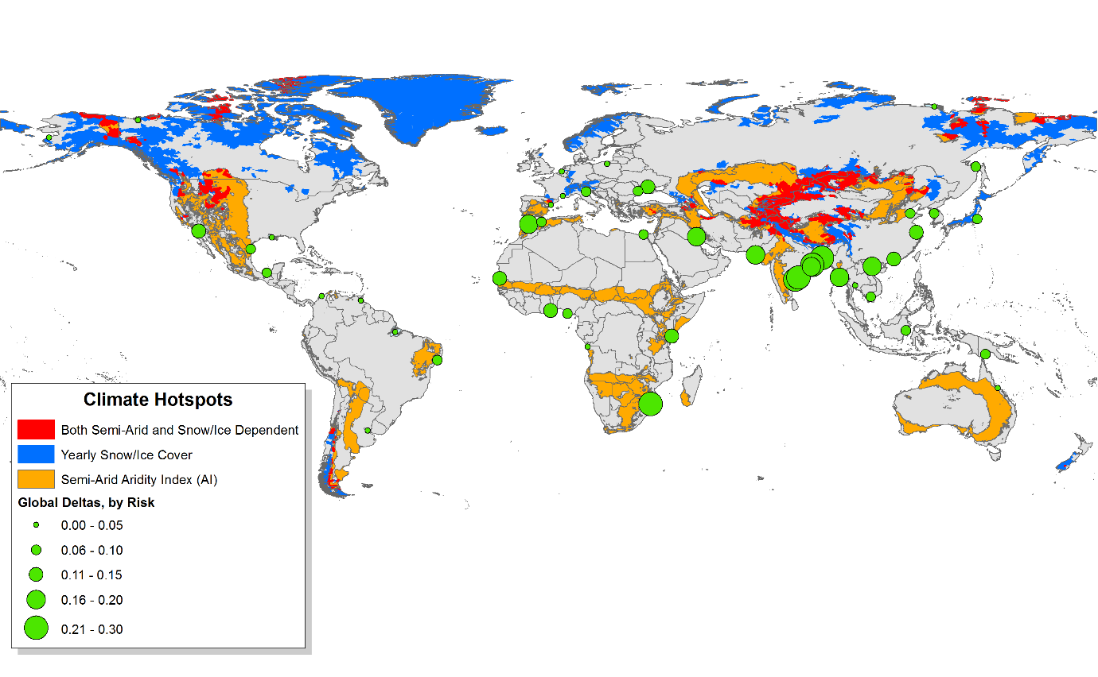
Given the importance of climate hotspots to societal and ecological well-being, failing to adequately monitor the environment of these regions may impede their developmental progress, and also hamper the achievement of wider SDGs. It is also likely to hamper the SDG accountability framework, which requires monitoring not only at the global level, but also at national, regional and local scales. The choice of key environmental indicators will reflect climate and environmental priorities for 2030, and has direct implications for financing for development. Here, we show the limitations of, and the gaps within, the currently proposed SDG relevant-indicator framework, and offer a complementary approach that enables better tracking of development progress in these key climate hotspots, focusing on environmental indicators. Hence, this piece contributes to progress in achieving the SDGs and improving people’s well-being.
Figure 1 Climate change hotspots requiring focused attention using the SDG indicator framework. The three major types of climate hotspots used in the SDG framework are shown, including: (1) major global delta locations (green dots) [4], varied according to contemporary risk due to sea-level rise and anthropomorphic factors as outlined by Tessler et al. [13]; (2) semi-arid regions (orange) where an Aridity Index (AI) falls between 0.2 and 0.5; (3) snow and ice runoff-dependent basins (blue), defined as basins with average yearly snow/ice cover >25%; and (4) overlapping areas with both semi-arid AI and snow/ice runoff dependency (red).
- A multiscale SDG indicator framework
The human-development challenges in climate hotspots are addressed in a number of ways under the recently endorsed 2030 Agenda for Sustainable Development [9] and accompanying indicator framework [14]. First, there is a specific goal on climate change – SDG 13 – that aims to “take urgent action to combat climate change and its impacts”. This broad goal is sub-divided into five specific targets, each focusing on different responses to climate-induced challenges. Additionally, targets and indicators relevant to climate hotspots are included under other “non-climate” goals, particularly covering different social and economic dimensions. The proposed indicator framework has a number of potential pitfalls [15]. Politically, a failure to specifically recognise the importance of investing in geographically explicit climate hotspots carries a risk of downplaying the significance and developmental impacts of these regions. Operationally, while the priorities and implementation practices of local authorities, national governments and regional organisations are likely to differ, ensuring coordinated strategies between all institutions at all levels is key to effective programme execution. The current approach fails to explicitly consider the overall regional risks faced by climate change hotspots that cross political boundaries and require accountability mechanisms at different implementation scales. The current approach outlined by the United Nations can be strengthened by ensuring that localised indicator sets are relevant and available to broader policy frameworks as well as the SDGs. Stratifying indicators into groups of high-level political and detailed technical indicators as proposed by Davis et al. [16] could be part of a solution, but would need to be complemented by an integrated framework that would incorporate indicators specifically relevant to key regions, such as climate hotspots.

A potentially powerful solution to avoid a development impasse resulting from omitting indicators critical to regions such as climate hotspots is to translate the existing SDG framework into an integrated multi-scale indicator framework, which would: 1) reflect the key developmental challenges found in all of these climate hotspots, and 2) allow monitoring of change at different levels of analysis, including for cross-boundary regions (Fig 2). At the global level, the main indicators would reflect the key international priorities in terms of combating world-wide consequences of climate change; and at the sub-national level the framework would be tailored to the requirements of the country. Here, in addition to measuring such climatic and environmental phenomena as temperature rise, precipitation change and sea-level rise, the developmental priorities should encompass the needs of the Least Developed Countries (LDCs) and allow for tracking of resources for development. National indicators should be linked directly to countries’ poverty-reduction strategies and tie up with the SDG targets by either adding to the existing list of indicators or replacing some of the lower-ranked indicators. Cross-boundary regional indicators should mirror the developmental priorities in the climate hotspots, which have critical implications beyond the areas where they are located. The development and monitoring of these indicators could be coordinated by regional intergovernmental organizations, such as the East African Community and the South Asian Association for Regional Cooperation.
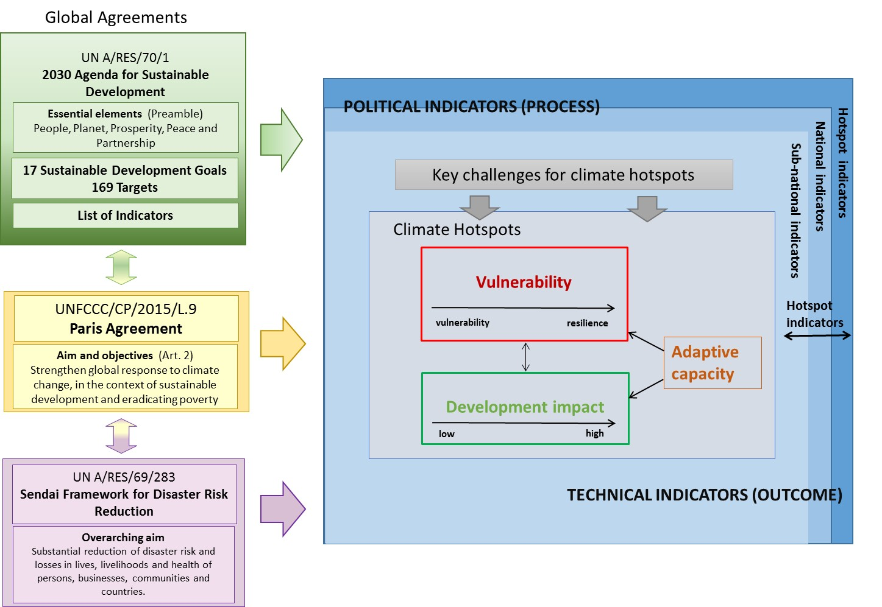
Figure 2: Proposed multi-scale SGD framework for climate hotspots that aligns objectives of the UN 2030 Agenda for Sustainable Development, and the UNFCCC’s Paris Agreement and the Sendai Framework for Disaster Risk Reduction. Key developmental challenges of climate hotspots and development progress are monitored through additional cross-boundary indicators. Political (process) indicators and technical (outcome) indicators are applied for measuring progress and developmental outcomes at different levels of analysis.

- Filling the indicator gaps
In order to fill the indicator gaps with regard to links and synergies between adaptation and resilience to climate change and sustainable development, we propose a maximum of five technical indicators that focus specifically on measuring environmental impacts for each of the three categories of climate change hotspots. These are indicators that are more detailed, than some proposed for the SDGs [14], or address new dimensions altogether. A suggested classification and proposed impact indicators are presented in Table 1. Thus, for populations living in delta regions, for example, the main threats are associated with relative sea-level rise reflecting a combination of a loss of elevation (subsidence) and climate-induced global sea-level rise. Subsidence, mainly due to human activities such as groundwater pumping, oil extraction, oxidation of drained organic soils and reduction of sediment from upstream, is in some areas more important than climate-induced sea-level rise [4]. The specific human-development challenges resulting from relative sea-level rise include salinity intrusion (soil and freshwater salinisation), land erosion, increased risk of flooding and increased incidence of waterborne diseases. For semiarid areas, changes in temperature are likely to lead to increased atmospheric evaporative losses, as well as heat stress; and together with changes in precipitation will result in greater land degradation and loss of water supply. For glacier- and snowpack-dependent river basins, a decline in both the amounts of seasonal snowpacks and glaciers, and faster melting, drive changes in the seasonality of essentially all components of the terrestrial water cycle. This includes earlier runoff and a longer growing season in mountins, potentially driving more evapotranspiration and less runoff. Modifications of current indices to account for the different time scales of seasonal water

Climate hotspots | Key challenge | Developmental impacts and proposed impact indicators
Deltas | Global warming-induced sea-level rise  Compaction and vertical land movement (loss of land elevation – subsidence)  Changes in water and sediment flows | Inundation by coastal storms  Indicators: % of delta inundated in a 1-in-100 year coastal flood event – under consideration of different adaptation levels and options  Inundation by river floods  Indicators: % of delta inundated in a 1-in-100 year river flood event – under consideration of different adaptation levels and options  Salinity intrusion  Indicators: % of delta area within the 4 ppt surface salinity isohaline [17, 18]  Erosion  Indicators: % of delta affected or threatened by riverbank and coastal erosion (allowing for accretion and deposition)  Water quality for aquatic ecosystems (many parameters are typically proposed, here we suggest only one):  % of delta area with dissolved oxygen < 3 mg/L [19]
Semi-arid areas | Rainfall variability and uncertainty  Temperature rise | Increased drought risks  Indicators: Drought risk index measured as percent change in future precipitation relative to the past; Palmer Drought Severity Index, Standardised Precipitation and Evaporation Index (SPEI)  Increased flood risk  Indicators: Area affected by a 1-in-100 year flood events (%), percent change in precipitation intensity-duration-frequency curves, percent change in runoff relative to the past.  Changing water supply/resources  Indicators: Relative magnitude of water supply and demand (including human and environmental needs), Multivariate Standardized Reliability and Resilience Index (MSRRI)  Land degradation  Indicator: Area (km²) and % of land area affected by land degradation  Heat stress index – such at those used by the ETCCDMI or Alexander et al. (2006) [20]
Glaciers & snowpack-dependent river basins | Decline in glacier extent and thickness  Shifts in precipitation patterns  Decline in seasonal snowpack extent and water content  Changes in streamflow seasonality and flood frequency | Insecure water supply  Indicators: Depletion indices for mass balance of glaciers, shifts in composition of total precipitation from snowfall to rainfall; monsoon onset, duration and intensity  Seasonality of river runoff  Indicators: Shifts in streamflow hydrographs and in monthly and annual total flows; increases/decreases in runoff from increased glacial melt  Glacier melt related risks  Indicators: Growth in number and extent of Glacial Lakes and occurrence of Glacial Lake Outburst Floods (GLOFs)  Increased flood risk  Indicators: Area affected by a 1-in-100 year flood events (%), percent change in precipitation intensity-duration-frequency curves

storage in snowpacks and behind dams, versus longer-term storage in glaciers and groundwater can be used to capture changes. For all three types of hotspots, a composite checklist covering institutional, infrastructure and informed decision making is needed to assess the overall water security of a region [13].

For multiple climate change hotspots, such as mountainous semi-arid areas, a combination of relevant indicators should be adopted. In regions where local populations may be affected by a range of hazards, analysts should examine which indicators are most relevant for the compound effects, and combine the indicators by applying appropriate weighting systems. Because the environmental impacts affecting climate hotspots are directly and indirectly associated with socio-economic development, for example through changes in occupational structure and impacts on livelihoods and human health, it is critical to develop and adapt an approach that acknowledges the coupled climate-socio-ecological changes. Countries and regional organisations that focus on tackling developmental impacts of climate and environmental change, such as the Mekong River Commission and the International Centre for Integrated Mountain Development, should take leadership in coordinating efforts for monitoring and evaluating the developmental progress of their regions.

In addition, as some of the proposed indicators in the SDG framework are still flagged as ‘tier III’ at the time of publication (i.e. in need of further development), we call for the international community of experts in climate, water resources, and environmental assessment who focus on quantifying change, and the Inter-agency and Expert Group on SDG Indicators, to work together to ensure that the indicators for climate hotspots reflect the cross-boundary challenges ahead. As some of the climate hotspots are interconnected (e.g. deltas belonging to glaciers and snowpack-dependent river basins which might also contain a semi-arid region), it is essential to monitor indicators beyond national boundaries. Incorporating the challenges and priorities raised in climate hotspots within the wider SDG agenda and aligning the different global agreements will be criticial to enabling inclusive human development and sustainable economic growth in the face of unprecedented climate and environmental change.

Acknowledgements
This work draws on the Collaborative Adaptation Research Initiative in Africa and Asia (CARIAA) with financial support from the UK Government’s Department for International Development and the International Development Research Centre, Ottawa, Canada. This work was also supported by the Belmont Forum DELTAS project (Grant No. NE/L008726/1 in the U.K, DFG Grant AOBJ: 604933 / GZ: RE 3554/1-1 in Germany and NSF Grant EAR-1342944 in the U.S). The Belmont Forum DELTAS project is co-funded by the Natural Environment Research Council (NERC). Additional financial support was provided by the German Research Foundation (DFG) via the Cluster of Excellence ‘The Future Ocean’ in Kiel, Germany, and by the U.S. National Science Foundation.

Disclaimer: The views expressed in this work are those of the authors and do not necessarily represent those of the UK Government’s Department for International Development, the International Development Research Centre, Canada or its Board of Governors, the United Nations University, and are not necessarily attributable to their organizations.

References:

- IPCC, Managing the Risks of Extreme Events and Disasters to Advance Climate Change Adaptation. A Special Report of Working Groups I and II of the Intergovernmental Panel on Climate Change [Field, C.B., V. Barros, T.F. Stocker, D. Qin, D.J. Dokken, K.L. Ebi, M.D. Mastrandrea, K.J. Mach, G.-K. Plattner, S.K. Allen, M. Tignor, and P.M. Midgley (eds.)]. Cambridge University Press (Cambridge, UK, and New York, NY, USA, 2012).
- De Souza, K., et al. Vulnerability to climate change in three hot spots in Africa and Asia: key issues for policy-relevant adaptation and resilience-building research. Regional Environmental Change, 15, no. 5 (2015): 747-753.
- Ericson, J.P., et al. Effective sea-level rise and deltas: Causes of change and human dimension implications. Global and Planetary Change, 50, no.1-2 (2006): 63-82.
- Szabo, S., et al. Sustainable Development Goals Offer New Opportunities for Tropical Delta Regions. Environment: Science and Policy for Sustainable Development 57, no. 4 (2015): 16-23.
- Syvitski, J.P.M., et al. Sinking deltas due to human activities. Nature Geoscience, 2, no. 10 (2009): 681-686.
- Wong, P.P et al. Coastal systems and low-lying areas. In: Climate Change 2014: Impacts, Adaptation, and Vulnerability. Part A: Global and Sectoral Aspects. Contribution of Working Group II to the Fifth Assessment Report of the Intergovernmental Panel on Climate Change [Field, C.B., V.R. Barros, D.J. Dokken, K.J. Mach, M.D. Mastrandrea, T.E. Bilir, M. Chatterjee, K.L. Ebi, Y.O. Estrada, R.C. Genova, B. Girma, E.S. Kissel, A.N. Levy, S. MacCracken, P.R. Mastrandrea, and L.L. White (eds.)]. Cambridge University Press (Cambridge, United Kingdom and New York, NY, USA, 2014).
- AghaKouchak, A., et al., Recognize anthropogenic drought. Nature, 524, no. 7566 (2015): 409-411.
- World Meteorological Organization (WMO), Climate and Land Degradation, WMO (Geneva, 2005).
- United Nations, Resolution adopted by the General Assembly on 25 September 2015 70/1. Transforming our world: the 2030 Agenda for Sustainable Development, in A/RES/70/1, General Assembly, Editor. 2015.
- United Nations, Adoption of the Paris Agreement, in FCCC/CP/2015/L.9/Rev.1, Framework Convention on Climate Change, Editor. 2015.
- United Nations Office for Disaster Risk Reduction (UNISDR), Sendai Framework for Disaster Risk Reduction 2015-2030, UNISDR (2015).
- Roberts, E. et al. Resilience synergies in the post-2015 development agenda. Nature Climate Change, 5, no. 12 (2015): 1024-1025.
- Tessler, Z. et al. Profiling risk and sustainability in coastal deltas of the world. Science, 349, no. 6248 (2015): 638-643.
- United Nations, Provisional Proposed Tiers for Global SDG Indicators, 2016, 59 pp. URL: http://unstats.un.org/sdgs/files/meetings/iaeg-sdgs-meeting-03/Provisional-Proposed-Tiers-for-SDG-Indicators-24-03-16.pdf [last accessed 2016-06-06]
- Rickels, W., Dovern, J., Hoffmann, J., Quaas, M. F., Schmidt, J. O. and Visbeck, M. (2016). Indicators for Monitoring Sustainable Development Goals: An Application to Oceanic Development in the European Union. Earth's Future, 4, doi:10.1002/2016EF000353.
- Davis, A. et al. Measuring the SDGs: a two-track solution. The Lancet, 5, no. 8 (2015).
- Hutton, P., Rath, J., Chen, L., Ungs, M., and Roy, S. (2015). Nine Decades of Salinity Observations in the San Francisco Bay and Delta: Modeling and Trend Evaluations. Journal of Water Resources Planning and Management, 142, no. 3 (2015): 04015069-1-0401506911, doi: 10.1061/(ASCE)WR.1943-5452.0000617.
- Clarke, D., Williams, S., Jahiruddin, M., Parks, K., Salehin, M. 2015 Projections of on-farm salinity in coastal Bangladesh. Environmental Science: Processes & Impacts, 17, no. 6 (2015): 1127-36. doi: 10.1039/c4em00682h.
- UNECE (United Nations Economic Commission for Europe). Standard Statistical Classification of Surface Freshwater Quality for the Maintenance of Aquatic Life. In: Readings in International Environmental Statistics, (New York and Geneva, 1994).
- Alexander, L. et al. Global Observed Changes in Daily Climate Extremes of Temperature and Precipitation. Journal of Geophysical Research-Atmospheres, 111, no. D05109 (2006), doi:10.1029/2005JD006290.

