ABSTRACT
Objectives
This fourteen-centre project used professional rating scales and parent questionnaires to assess longitudinal outcomes in a large non-selected population of children receiving simultaneous and sequential bilateral cochlear implants .
Methods
This was an observational non-randomised service evaluation. Data were collected at four time points: before bilateral cochlear implants or before the sequential implant, one year, two years and three years after. The measures reported are Categories of Auditory Performance II (CAPII), Speech Intelligibility Rating (SIR), Bilateral Listening Skills Profile (BLSP) and Parent Outcome Profile (POP).
Results
1001 children aged from 8 months to almost 18 years were involved, although there were many missing data. In children receiving simultaneous implants after one, two, and three years respectively, median CAP scores were 4, 5, and 6; median SIR were 1, 2, and 3. Three years after receiving simultaneous bilateral cochlear implants, 61% of children were reported to understand conversation without lip-reading and 66% had intelligible speech if the listener concentrated hard. Auditory performance and speech intelligibility were significantly better in female children than males.
Parents of children using sequential implants were generally positive about their child’s well-being and behaviour since receiving the second device; those who were less positive about well-being changes also generally reported their children less willing to wear the second device.
Conclusion
Data from 78% of paediatric cochlear implant centres in the United Kingdom provide a real-world picture of outcomes of children with bilateral implants in the UK. This large reference data set can be used to identify children in the lower quartile for targeted intervention.

KEYWORDS
Cochlear implant
Bilateral cochlear implant
Binaural hearing
Paediatric service evaluation
INTRODUCTION
In the United Kingdom (UK) before 2009, National Health Service (NHS) funding was mainly only available for children and adults to receive unilateral cochlear implants. In 2009 the National Institute for Health and Care Excellence, NICE, published guidance for cochlear implantation following a review . These guidelines recommend that all suitable children who meet eligibility criteria receive simultaneous bilateral cochlear implants. In addition they recommend that a sequential bilateral cochlear implant can be offered only if the first implant was received before the guidelines were published.
This 14-centre longitudinal observational service evaluation aimed to answer the questions:
- What is the range of outcomes achieved by children receiving bilateral cochlear implants in the UK?
- Do two implants result in better outcomes than one?
Background to the project is detailed in Cullington et al .

This paper describes only professional rating scales and parent questionnaires and aims to only show the range of results, thus addressing Question 1 above. A companion paper describes the performance measures of localisation and speech perception . The surgical outcomes were reported by Broomfield et al . A new quality of life measure, Brief Assessment of Parental Perception (BAPP), is described in Samuel et al .

Professional rating scales
Many children receiving cochlear implants are very young at the time of surgery (around 12 months of age); they often cannot participate in performance measures until they are substantially older. Information about their progress is therefore assessed using professional rating scales and parent-report measures. These allow a holistic view of the child’s development, and can highlight issues that may not become apparent with performance testing. Two professional rating scales commonly used in the UK were included in this project: Categories of Auditory Performance, CAP and the Speech Intelligibility Rating, SIR.

Categories of Auditory Performance II
Categories of Auditory Performance (CAP) is a widely-used global outcome measure of developing auditory skills in deaf children . It is conducted using observation by a teacher or rehabilitation professional and assesses the function of the child in everyday situations at home and school. The CAP has seven categories, ranging from 0 (No awareness of environmental sounds or voice) to 7 (Use of telephone with known speaker); it is a non-linear hierarchical scale. For the purposes of this project two new categories were added representing more complex skills (Gilmour, 2010): 8 (Follows group conversation in a reverberant room or where there is some interfering noise, such as a classroom or restaurant) and 9 (Use of telephone with an unknown speaker in unpredictable context) . The new version is described as CAPII and is shown in Table 1. Both CAP and CAPII scores have been found to have good inter-observer reliability.

Research from Govaerts et al suggested that all normally-hearing children achieved a CAP score of 5 to 7 by the age of 2.5 years (it is assumed that the study only included typically-developing children). Five years after receiving a unilateral cochlear implant, the average CAP score is generally 6 . CAP scores tend to increase faster in those who receive cochlear implants at a younger age , with those implanted under one year of age all achieving a CAP score of 3 within 6 months of surgery , although these figures were for a selected small group (n = 10) with normal cochleovestibular nerves and no additional difficulties. Scherf et al showed improvement in CAP scores after children with high cochlear implant performance with the first device received a sequential implant, although the absolute values were not given and of course the children had also got older so their improvement could be attributed to normal development. When assessing predictors of outcome after at least 6 months in a large sample of non-selected children , the median CAP in 61 bilaterally-implanted children was 8 compared to 6 in 132 unilaterally-implanted children.

Speech Intelligibility Rating
Speech intelligibility refers to the degree to which a speaker’s intended message can be decoded by other listeners. A speech intelligibility rating scale in deaf children using a five-point hierarchical scale was developed by Dee Dyar of the Nottingham Auditory Implant Programme . The categories range from Category 1 (No intelligible speech or recognisable words but the child may be capable of verbalisation. The child’s primary mode of everyday communication may be manual.) to Category 5 (Connected speech is intelligible with little or no concentration on the part of the listener. The child is understood easily in interaction with an adult.) as shown in Table 2. The measure is performed by a speech and language therapist or rehabilitation professional, and has been found to be reliable between observers . Children with cochlear implants generally have an average SIR of 3 to 4 after five years of listening with one cochlear implant , with a higher SIR in children who received implants at a younger age . There is some evidence of SIR being higher in bilaterally-implanted children when compared to those with unilateral implants . The median SIR in 65 bilaterally-implanted children was 5 compared to 3 in 148 unilaterally-implanted children .

Parent questionnaires
Parents or carers are key people in a young child’s life, and their views and experiences can be paramount to shaping the child’s development. Although the benefits of bilateral cochlear implantation have been demonstrated in terms of speech perception and localisation, it can be argued that from a patient or parent’s perspective, quality of life is more important. Parental perception was used to assess the child’s progress after implantation using three measures: the Bilateral Listening Skills Profile (BLSP), the Parent Outcome Profile (POP) and the Brief Assessment of Parental Perception (BAPP) - a newly-designed measure of quality of life . Some measures have been used to assess quality of life in people using cochlear implants , but few studies have evaluated changes in quality of life after receiving bilateral cochlear implants. Summerfield et al did not find a significant improvement in quality of life in adults receiving a second cochlear implant, but other authors did find an improvement independent of their speech perception scores . Smulders et al used a randomised controlled trial and compared cost-utility in unilateral versus simultaneous bilateral cochlear implantation in adults with postlingual deafness and found that bilateral implantation became cost effective after a period of 5–10 years based on the Visual Analog Scale (VAS) on hearing and 10–25 years based on the Health Utilities Index-3 (HUI3) and time trade-off method. Harkonen et al (2015) also assessed adults (that were currently working) and found that provision of a sequential bilateral cochlear implant increased working performance and quality of life. In children, Sparreboom et al (2012) demonstrated an improvement in quality of life after receiving a second cochlear implant, although only on disease-specific measures; they found no influence of age at second implant.

Bilateral Listening Skills Profile
The BLSP is a 12-item questionnaire for parents to complete, based on the Speech Spatial Qualities (SSQ) (adapted for paediatric users by Reeder and Firszt, Washington University, 2006) and the Infant Toddler Meaningful Auditory Integration Scale (IT-MAIS) . It was devised by The Ear Foundation, Nottingham with support from the Royal National Institute for Deaf People (RNID, now Action on Hearing Loss). The parent is asked to provide a rating of their child’s ability to perform certain tasks, ranging from 0 (Not at all) to 5 (Perfectly). An example question is ‘Your child is standing on the pavement of a busy street. Can your child hear right away which direction a bus or lorry is coming from before seeing it?’.

Parent Outcome Profile
The POP (also known as the Children with Cochlear Implants: Parental Perspectives, or the Parents’ views and experiences with paediatric cochlear implant questionnaire, PVECIQ) was developed by the Nottingham Auditory Implant Programme and the University of Southampton, supported by Action on Hearing Loss. In addition to assessing speech and hearing outcomes, it is important to assess the child’s use of the device and a parent’s view of the stressors, efforts and benefits related to the implant .

The questionnaire consists of 74 statements that parents score on a five-point Likert scale (strongly agree to strongly disagree). The questionnaire has been found to be robust and repeatable . Some questions in the POP ask for a snapshot assessment of the child’s abilities. Other questions ask for a comparison of the child’s status compared with before they had their first implant (at the pre-implant interval) or before they had the second implant (at the post intervals). Further questions ask the parent to recollect their feelings or the child’s situation before receiving their implant/the second implant.

Brief Assessment of Parental Perception
The child’s quality of life was assessed using a brief four-item questionnaire developed by clinical psychologists at UK cochlear implant centres . The four questions covered the child’s use of their processors, their willingness to wear them, their behaviour, contentment, communication, learning and getting on with friends. The parents were then asked if they would recommend bilateral cochlear implantation to another family in a similar situation. Two versions of the questionnaire were used: one for simultaneous bilateral implantation, and one for sequential implantation. More information and results can be found in Samuel et al (2016).

Aims
This paper aimed to answer the question:
- What is the range of outcomes achieved by children receiving bilateral cochlear implants in the UK?
This paper reports only professional rating scales and parent questionnaires.
MATERIALS AND METHODS
This longitudinal observational non-randomised service evaluation involved 14 UK cochlear implant centres. Please see Cullington et al (2016) for further details. Measures were made before surgery, and at one, two and three years following bilateral implantation in the child’s usual listening condition.

Professional rating scales
CAPII and SIR
Outcome variables were ordinal data (CAPII: between 0 and 9; SIR: between 1 and 5).

Parent questionnaires
BLSP
The simultaneously-implanted children were not assessed at the pre-implant interval because UK candidacy criteria dictated that they were likely to have little hearing before receiving their implants. A factor analysis was performed to determine the structure and relationship between the questions using data from 229 sequentially-implanted children at the pre-implant interval (the largest dataset).

The rotated factor matrix obtained after varimax rotation suggested three factors as shown in Table 3. Due to the content of the constituent questions, they were termed BLSP speech recognition, BLSP localisation and BLSP music. Reliability analysis was acceptable (Cronbach’s α = 0.86 for BLSP speech recognition, 0.76 for BLSP localisation and 0.73 for BLSP music).

Factor 1 BLSP speech recognition is made up of eight questions; the parents were required to answer six (75%) of these in order to have their data included. Both factors 2 BLSP localisation and factor 3 BLSP music are made up of two questions; both questions needed to be answered in order for data to be included. Question 12 is somewhat problematic in that it asks the question ‘When your child is a passenger in the car, can s/he easily hear what the driver is saying?’ and then there follows the text [from which position in the car?]. Some parents gave one answer to the question without specifying the car position, others answered and specified (either front or back). Yet other parents answered the original question and then gave another answer for front and/or back. If the parent had given a score for the original question, this was used – even if they had also given scores for front and/or back – as it was considered that they had answered the question for the child’s usual car position. If parents had not answered the original question but had answered for the back position, this score was used, as it was considered most likely that a child would be positioned in the back of the car. The score for the front position was only used if this was the only part the parent had answered. The outcome variables were BLSP speech recognition, BLSP localisation and BLSP music scores; constituent question data were averaged. Although the individual BLSP data were ordinal, the combination of several questions into factors were treated as continuous data that ranged from 0 to 5. BLSP localisation data were included in the companion paper as it was felt more appropriate to compare these data with the localisation performance measure.

POP
The POP questionnaire was used to assess the parent perspective regarding cochlear implantation; two versions are available – for a female and a male child. A second pair (female and male) of the questionnaire (POP2) was used for those children having a second cochlear implant sequentially. This asked parents to think about their child now, compared to when he or she had one cochlear implant. The original protocol specified that the POP should be completed by the parents at the one and two year post-implant intervals, and at the pre-implant interval for sequentially-implanted children. However, centres found that the questionnaire was long and time-consuming and difficult for families without English as a first language, so the POP was removed from the modified protocol.

In common with Nunes et al , 23 questions (8, 13, 21, 24, 25, 31, 34, 36, 40, 42, 43, 44, 46, 48, 49, 52, 54, 56, 58, 60, 66, 68, 73) were excluded from the analysis because they were not considered relevant to parents’ view and experiences of bilateral cochlear implantation. The omitted questions related to attitude to support services, concern about the physical functioning of the implant, attitudes towards oral and sign language, and parents’ reasons for choosing a cochlear implant. In common with Damen et al , the two domains ‘Process of implantation’ and ‘Decision to implant’ were excluded as these items were difficult to numerically code (10, 13, 21, 22, 24, 25, 28, 29, 34, 36, 38, 40, 42, 43, 44, 46, 49, 52, 54, 55, 56, 57, 58, 60, 63, 68). Those items referring to the period before or immediately after implantation were excluded (2, 4, 11, 30, 33). Two items not referring to their own child were excluded (19, 62).

Factor analysis was run with the remaining 36 questions using data from sequentially-implanted children at the pre-implant interval as it was the largest dataset. Two factors emerged which together accounted for 31% of the variance. Reliability analysis indicated acceptable internal consistency (Cronbach’s α = 0.89 for factor 1 and 0.51 for factor 2). When items 37 and 69 were deleted, this increased α for factor 2 to 0.74.

Table 4 shows the constituent questions of the two factors extracted from POP. For the purpose of this paper, the first factor (average of 19 items) was termed POP well-being, and the second factor (average of three items) was termed POP behaviour. The parents were required to answer 14 out of 19 (74%) of POP well-being and 3 out of 4 (75%) of POP behaviour questions in order for data to be included. The factors POP well-being, POP2 well-being, POP behaviour and POP2 behaviour were treated as continuous outcome variables ranging from 1 to 5.

Statistical analyses
The aim of this project was to show the range of outcomes achieved; data were therefore shown as boxplots. There were no a priori hypotheses. The majority of the analyses are descriptive, with statistics only used to assess the likelihood that differences seen on graphs occurred by chance. Without null hypotheses to test and with the p value set at 0.05, there is a 5% chance that a significant difference will be seen by chance, and of course this must be considered when post hoc testing only is done. When comparisons are made at different intervals (i.e. pre, one year etc.), it should be noted that the data are not entirely independent; in some cases scores at different intervals are measured on the same participants. However, since it is not all the same participants, independent statistical tests were used. Exact two-tailed p values are given for all analyses. Normality assumptions were tested using the Kolmogorov-Smirnov test in each group for each group for each analysis. Where normality assumptions were violated, non-parametric statistics were used. When assessing a variable at different time intervals, the Jonckheere-Terpstra test was used. This performs the same function as the non-parametric Kruskal-Wallis test (looks at differences between medians), but incorporates information about whether the order of the groups (interval) is meaningful.

Ethical considerations are covered in the companion paper .

RESULTS
One thousand and one children were included: 465 were implanted simultaneously and 536 were implanted sequentially. In simultaneously-implanted children, the age at implant ranged from 0.7 years to 17.9 years with a median of 2.1 years. In sequentially-implanted children, the age at first implant ranged from 0.4 years to 17.2 years with a median of 2.6 years. The time interval between implants ranged from 0.1 to 14.5 years with a median of 4.9 years. More information on demographics is included in the companion paper .

Question. What is the range of outcomes achieved by children receiving bilateral cochlear implants in the UK?

Professional rating scales
CAPII and SIR
Figures 1 and 2 show CAPII and SIR scores, respectively, at each interval. There is an increase in scores on both measures over the first three years following implantation in the simultaneously-implanted children. The sequentially-implanted children already had one cochlear implant at the pre-implant interval, so the rapid increase had generally already occurred. The range of results is large in both simultaneously- and sequentially-implanted children and there are many outliers. Most simultaneously-implanted children had a SIR of 1 at the pre-implant interval, although there were several outliers with very good speech intelligibility prior to receiving implants. These children are likely to have experienced a progressive or sudden hearing loss rather than being profoundly deaf from birth. As this project aimed to evaluate the range of outcome data achieved by an unselected population, predictive data such as age at deafness were not collected. The sequentially-implanted children (and the simultaneously-implanted children at the three-year interval) showed ceiling effects, suggesting that SIR may not be a good measure once children have had their implants for a few years.

A small effect of sex was seen in that female children showed significantly better CAPII and SIR scores at almost all intervals in both simultaneously- and sequentially-implanted children, even before receiving cochlear implants (see Table 5 for statistical parameters of Mann-Whitney U tests and effect sizes).

A further analysis was conducted using a repeated measures comparison of 239 sequentially-implanted children who had scores for CAPII at the pre and one-year intervals. The median CAPII score before receiving the second implant was 6; it increased to 7 after receipt of the second device (although of course another year of listening had also passed). The difference was significant (Wilcoxon Signed Ranks Test T = 7030, p = 0.000). The effect size was medium (r = 0.34). One hundred and five children had a higher CAPII score at the one-year interval; 112 had an unchanged score. Twenty-two children had a worse CAPII score one year after receiving their second device.

Repeated measures SIR analysis of 246 sequentially-implanted children showed no change in the median (4), although there was a significant increase (Wilcoxon Signed Ranks Test T = 3455.5, p = 0.000). The effect size was small (r = 0.25). Seventy-three children had a higher SIR at the one-year interval; 154 had an unchanged score. Nineteen children had a worse SIR one year after receiving their second implant.

Parent questionnaires
BLSP
Results of BLSP localisation are reported in the companion paper . Figures 3 and 4 show BLSP speech recognition and music scores, respectively, plotted against interval. The variable BLSP speech recognition was significantly affected by interval in both simultaneously-implanted and sequentially-implanted children: as the interval increased, the median score increased (simultaneous: Kruskal-Wallis H(2) = 9.606, p = 0.008, Jonckeere-Terpstra J = 12,609.5, Z = 3.10, p = 0.002; sequential: Kruskal-Wallis H(3) = 88.58, p = 0.000, Jonckeere-Terpstra J = 117742, Z = 8.53, p = 0.000). The variable BLSP music was also significantly affected by interval in both simultaneously-implanted and sequentially-implanted children: as the interval increased, the median score increased (simultaneous: Kruskal-Wallis H(2) = 7.51, p = 0.02, Jonckeere-Terpstra J = 10412, Z = 2.73, p = 0.006; sequential: Kruskal-Wallis H(3) = 47.77, p = 0.000, Jonckeere-Terpstra J = 100070, Z = 6.72, p = 0.000). However, there were many outliers. The variable BLSP speech recognition for sequentially-implanted children was significantly higher than for simultaneously-implanted children at only the one-year interval (Mann-Whitney U = 19410, Z = -3.73, p = 0.000). The effect size was small ( r = -0.12). It is worth noting that the sample size was large and it is possible that statistical significance does not translate to clinical significance. Indeed, the clinical significance of a small change in BLSP speech recognition is unknown. No differences were seen between children with simultaneous and sequential implants for BLSP music score. Scores of BLSP music showed ceiling effects.

Repeated measures comparison of 152 sequentially-implanted children who had scores for BLSP speech recognition at the pre and one-year intervals showed a significant increase (Wilcoxon signed ranks test T = 9642.5, p = 0.000). The effect size was medium (r = 0.47). One hundred and twenty-two children had improved; 5 had an unchanged score. Twenty-five children had a worse score one year after receiving the second device. Repeated measures comparison of 137 sequentially-implanted children for BLSP music at the pre and one-year intervals showed a significant increase (Wilcoxon signed ranks test T = 5007.5, p = 0.000). The effect size was medium ( r = 0.31). Eighty-four children had improved; 24 had an unchanged score. Twenty-nine children had a worse BLSP music score at the one-year interval.

POP
The scores of the POP cannot be plotted like the other measures as two different versions were used. The standard POP was used in children with simultaneous implants at all intervals, and those with sequential implants at the pre-implant interval. After receiving a second implant, children with sequential implants were evaluated using POP2, which asked for a comparison of their status compared to when they had only one implant. Figures 5a and 5b show POP well-being and POP2 well-being change since second implant in children with simultaneous and sequential implants, respectively. Parents generally felt positive about their child’s well-being. Figures 6a and 6b show POP behaviour and POP2 behaviour change since second implant in children with simultaneous and sequential implants, respectively. Parents of those with sequential cochlear implants generally felt less positive about behaviour change since the second implant.

Figure 7 shows POP2 well-being change since the second implant at the one-year interval plotted against willingness to wear the second implant (from BAPP questionnaire) for sequentially-implanted children. POP2 well-being change became more positive as parents reported that children were more willing to wear the second cochlear implant (Kruskal-Wallis excluding ‘very reluctant’ category with one participant: H(3) = 22.14, p = 0.000). A similar analysis was not done for POP2 behaviour due to limitations of this factor (see Discussion).

Missing data
Ascertainment figures (shown in Cullington et al, 2016) suggested that just over 50% of children with bilateral implants in the UK within the study period were included. Throughout the service evaluation, attempts were made to minimise missing data including providing frequent feedback to data collectors by email and regular meetings. However, there were still extensive missing data (see Cullington et al, 2016, for missing data discussion). The professional rating scales (CAPII and SIR) represented the largest dataset, perhaps because these are quick to perform and were generally familiar to staff.
DISCUSSION

Professional rating scales
CAPII
Data from the simultaneously-implanted children provide reference CAPII values for the progress expected from children receiving simultaneous bilateral cochlear implants, with the median being 4, 5, and 6 at one, two and three years, respectively. Excepting two outliers, all children had CAPII scores of 3 to 8 after three years of use of simultaneous bilateral cochlear implants. This represents a large range in listening ability: from identifying only environmental sounds to following group conversation in a noisy place. In this group CAPII appears to be a useful measure with no ceiling effects seen up to three years after implantation.

SIR
The simultaneously-implanted children generally showed improvements in speech intelligibility after implantation; however, the full range was still seen three years after implantation (from ‘no intelligible speech’ to ‘child easily understood by an adult’). Median values were 1, 2, and 3 at one, two, and three years, respectively. Little change was seen in SIR data in sequentially-implanted children, with ceiling effects evident. This is not unexpected; learning to speak occurs with unilateral hearing, and the provision of bilateral devices is unlikely to show an effect. The SIR is a gross measure of speech intelligibility and is not sensitive enough to show subtle changes in speech; it may be improved by the use of sub levels, although it serves its purpose as a quick and easily-understandable measure of speech intelligibility. Ceiling effects were evident by three years post-implantation.

As professional rating scales do not rely on patient cooperation, the results are not biased in favour of good performers and can be assumed to include children with widely varying auditory, cognitive and developmental levels. However there are significant limitations of proxy rating scales (see end of Discussion), and no test-retest with different professionals was done.

Both CAPII and SIR ratings were better at almost all intervals in female compared to male children in both simultaneously-implanted and sequentially-implanted children. Female children were rated higher on auditory abilities and speech production even when they used no implants (pre implant interval in simultaneously-implanted). This agrees with the findings of previous researchers who found better language skills in girls with cochlear implants than boys . Female children exhibiting superior language to males also exists in normally-hearing children . However, it is worth noting that this project only collected data up to three years after implantation, and it is entirely possible that this difference between male and female children would disappear at a later stage.

Parent questionnaires
BLSP
An improvement over time was seen in both BLSP speech recognition and BLSP music in the years following the receipt of bilateral implants, suggesting that the parents perceived an improvement in the child’s bilateral listening skills. However, there are still many children whose parents perceive that their child has poor skills in these areas. Ceiling effects were evident in BLSP music at all intervals.

POP
The POP well-being factor was made up of 19 questions exploring many issues such as communication, speech production, education, frustration, independence, listening progress, friendship, family relationships, confidence and happiness. The POP behaviour factor consisted of four items related to family relationships, behaviour and frustration. Parents of children with simultaneous bilateral cochlear implants generally felt positive about both these aspects of their child.

Children with sequential bilateral cochlear implants were assessed with the POP2 which asked parents to compare to when they only had one implant. Parents generally felt positive about changes in their child’s well-being and behaviour after receiving a second device. All the questions in the POP2 behaviour factor were specific about comparing to before the child had the second implant e.g. ‘She is less frustrated than before she had the second implant’ (Table 4). However, many of the other POP2 questions appeared to ask for a snapshot of the child’s current state e.g. ‘I find it easier to communicate with him by speaking than by signing’. Agreeing or strongly agreeing with a statement in the POP2 behaviour factor indicates that there has been an improvement. However, disagreeing or strongly disagreeing with a statement may indicate no change in that behaviour regardless of what the starting point was before the second implant. For example, if the child had never been frustrated, parents may be confused whether to indicate ‘Neither agree nor disagree’ or ‘Disagree’ with the statement that frustration has lessened. Thus, only a positive score is meaningful.

Those parents who felt more positive about their child’s well-being after receiving a second implant also reported that their children were more willing to wear the second device (Figure 7). There may have been issues of frustration and behaviour related to the child not wanting to wear the second device. There is no directionality implied here; it is not possible to say whether the children wore their devices more willingly and so their behaviour improved or vice versa. Indeed, there is no causality implied either; the two factors of behaviour and willingness to wear the second device are clearly related but may be caused by another factor. There may also be problems with recall error or bias: as the time since bilateral implantation increased, the parents’ memory of the period before bilateral implants may fade or distort.

“Where will my child be in that range?”
All measures show a large range of outcomes after receipt of bilateral cochlear implants. It is well known in all cochlear implant centres worldwide that there is an enormous variation in outcomes . Varying outcomes after cochlear implantation are likely to be due to a number of factors including age at onset of deafness, age at implantation, extent of residual hearing before implantation, communication mode ; environmental stimulation, caregiver interaction, attention, learning, memory, sensory-motor coordination, visual-spatial processing, cognitive control ; in addition to aetiology and device differences . Varying outcomes in binaural skills additionally relate to interimplant interval . Parents and children considering bilateral cochlear implantation will naturally question likely outcomes for their individual child. After implantation parents, patients and professionals will also wish to establish if their child is performing to expectation. This project did not intend to answer questions related to outcome predictions; this is poorly understood and further prospective work is required. However, data from this project may assist professionals in flagging children in the lowest quartile of results for targeted rehabilitation or other interventions.

This project has limitations and some unique strengths. One important factor is that the results discussed are all proxy reports from parents or professionals. While proxy reporting may indicate a child’s listening abilities, it has been found to be flawed when ascertaining well-being . This is further complicated by the wide age range represented in this project. The simultaneously-implanted children were generally younger than the sequentially-implanted children, and were often babies. Proxy reporting for babies relies solely on the reporter’s perception, while proxy reporting for older children will naturally include the child’s expression of their well-being. Further limitations are discussed in the companion paper .

CONCLUSIONS

This fourteen-centre project collected outcome data on 1001 non-selected children receiving bilateral cochlear implants both simultaneously and sequentially.
This paper provides a large reference data set for auditory performance (CAPII) and speech intelligibility (SIR) in children with bilateral implants. In children receiving simultaneous implants after one, two, and three years respectively, median CAP scores were 4, 5, and 6; median SIR were 1, 2, and 3. Three years after receiving simultaneous bilateral cochlear implants, 61% of children were reported to understand conversation without lip-reading, and 66% of children had intelligible speech if the listener concentrated hard. Auditory performance and speech intelligibility were significantly better in female children than males at almost all stages. Parents of children receiving two implants noticed improvements in speech understanding in challenging situations and music as time with two implants increased.

The majority of sequentially-implanted children showed improvement in auditory performance, speech intelligibility, speech recognition in challenging situations and music one year after receipt of the second device. Parents who were less positive about behaviour changes in their sequentially-implanted child after the second device were generally the same parents that reported their children less willing to wear the second device.
ACKNOWLEDGMENTS
The authors wholeheartedly express thanks to clinicians and patients at the following cochlear implant centres: Belfast Regional Cochlear Implant Centre; The Midlands Children's Hearing Implant Programme, Birmingham; West of England Paediatric Hearing Implant Programme, Bristol; Emmeline Centre, Cambridge; Cardiff Paediatric Cochlear Implant Programme; Great Ormond Street Cochlear Implant Programme, London; St Thomas' Hospital Hearing Implant Centre, London; The Richard Ramsden Centre for Hearing Implants, Manchester; North East Cochlear Implant Programme, Middlesbrough; Nottingham Auditory Implant Programme; The Oxford Cochlear Implant Programme; Royal National Throat Nose and Ear Cochlear Implant Programme, London; University of Southampton Auditory Implant Service and St George’s Hospital Auditory Implant Service, London.

The project was supported by the Healthcare Quality Improvement Partnership (HQIP).

The authors gratefully acknowledge the support and contributions of Tricia Kemp, Cochlear Implanted Children’s Support group Coordinator and Erasmus students Ellen Joos and Robin Gransier.
References

Allen, C., Nikolopoulos, T. P., Dyar, D., & O'Donoghue, G. M. (2001). Reliability of a rating scale for measuring speech intelligibility after pediatric cochlear implantation. Otol Neurotol, 22(5), 631-633
Allen, M. C., Nikolopoulos, T. P., & O'Donoghue, G. M. (1998). Speech intelligibility in children after cochlear implantation. Am J Otol, 19(6), 742-746
Archbold, S., Lutman, M. E., & Marshall, D. (1995). Categories of Auditory Performance. In M. Clark & R. C. S. Cowan (Eds.), International Cochlear Implant, Speech and Hearing Symposium (Vol. 104 Suppl 166, pp. 312-314). Melbourne: Ann Otol Rhinol Laryngol.
Archbold, S., Lutman, M. E., & Nikolopoulos, T. (1998). Categories of auditory performance: inter-user reliability. Br J Audiol, 32(1), 7-12
Beadle, E. A., McKinley, D. J., Nikolopoulos, T. P., Brough, J., O'Donoghue, G. M., & Archbold, S. M. (2005). Long-term functional outcomes and academic-occupational status in implanted children after 10 to 14 years of cochlear implant use. Otol Neurotol, 26(6), 1152-1160
Bichey, B. G., & Miyamoto, R. T. (2008). Outcomes in bilateral cochlear implantation. Otolaryngol Head Neck Surg, 138(5), 655-661
Broomfield, S. J., Murphy, J., Wild, D. C., Emmett, S. R., O'Donoghue, G. M., & Writing for the, U. K. N. P. C. I. S. A. G. (2014). Results of a prospective surgical audit of bilateral paediatric cochlear implantation in the UK. Cochlear Implants Int, 15(5), 246-253. doi: 10.1179/1754762813Y.0000000041
Cohen, S. M., Labadie, R. F., Dietrich, M. S., & Haynes, D. S. (2004). Quality of life in hearing-impaired adults: the role of cochlear implants and hearing aids. Otolaryngol. Head Neck. Surg., 131(4), 413-422
Colletti, L., Mandala, M., Zoccante, L., Shannon, R. V., & Colletti, V. (2011). Infants versus older children fitted with cochlear implants: performance over 10 years. Int J Pediatr Otorhinolaryngol, 75(4), 504-509. doi: 10.1016/j.ijporl.2011.01.005
Colletti, V., Carner, M., Miorelli, V., Guida, M., Colletti, L., & Fiorino, F. G. (2005). Cochlear implantation at under 12 months: report on 10 patients. Laryngoscope, 115(3), 445-449. doi: 10.1097/01.mlg.0000157838.61497.e7
Cullington, H. E., Bele, D., Brinton, J. C., Cooper, S., Daft, M., Harding, J., . . . Wilson, K. (2016). United Kingdom National Paediatric Bilateral Project: Demographics and results of localisation and speech perception testing. Cochlear Implants International, submitted
Cummins, R. A. (2002). Proxy responding for subjective well-being: A review International Review of Research in Mental Retardation (Vol. Volume 25, pp. 183-207): Academic Press.
Damen, G. W., Beynon, A. J., Krabbe, P. F., Mulder, J. J., & Mylanus, E. A. (2007). Cochlear implantation and quality of life in postlingually deaf adults: long-term follow-up. Otolaryngol Head Neck Surg, 136(4), 597-604. doi: 10.1016/j.otohns.2006.11.044
Damen, G. W., Krabbe, P. F., Archbold, S. M., & Mylanus, E. A. (2007). Evaluation of the Parental Perspective instrument for pediatric cochlear implantation to arrive at a short version. Int J Pediatr Otorhinolaryngol, 71(3), 425-433. doi: 10.1016/j.ijporl.2006.11.008
De Raeve, L. (2010). A longitudinal study on auditory perception and speech intelligibility in deaf children implanted younger than 18 months in comparison to those implanted at later ages. Otol Neurotol, 31(8), 1261-1267. doi: 10.1097/MAO.0b013e3181f1cde3
Fenson, L., Pethick, S., Renda, C., Cox, J. L., Dale, P. S., & Reznick, J. S. (2000). Short-form versions of the MacArthur Communicative Development Inventories. Applied Psycholinguistics, 21, 95-116
Gatehouse, S., & Noble, W. (2004). The Speech, Spatial and Qualities of Hearing Scale (SSQ). Int J Audiol, 43(2), 85-99
Geers, A. E., Moog, J. S., Biedenstein, J., Brenner, C., & Hayes, H. (2009). Spoken language scores of children using cochlear implants compared to hearing age-mates at school entry. J Deaf Stud Deaf Educ, 14(3), 371-385. doi: 10.1093/deafed/enn046
Gilmour, L. (2010). The Inter-Rater Reliability of Categories of Auditory Performance-II (CAP)-II. (MSc), University of Southampton.
Gordon, K. A., & Papsin, B. C. (2009). Benefits of short interimplant delays in children receiving bilateral cochlear implants. Otol Neurotol, 30(3), 319-331. doi: 10.1097/MAO.0b013e31819a8f4c
00129492-200904000-00011 [pii]
Govaerts, P. J., De Beukelaer, C., Daemers, K., De Ceulaer, G., Yperman, M., Somers, T., . . . Offeciers, F. E. (2002). Outcome of cochlear implantation at different ages from 0 to 6 years. Otol Neurotol, 23(6), 885-890
Hinderink, J. B., Krabbe, P. F., & Van Den Broek, P. (2000). Development and application of a health-related quality-of-life instrument for adults with cochlear implants: the Nijmegen cochlear implant questionnaire. Otolaryngol Head Neck Surg, 123(6), 756-765. doi: 10.1067/mhn.2000.108203
King, N., Nahm, E. A., Liberatos, P., Shi, Q., & Kim, A. H. (2014). A new comprehensive cochlear implant questionnaire for measuring quality of life after sequential bilateral cochlear implantation. Otol Neurotol, 35(3), 407-413. doi: 10.1097/mao.0000000000000229
Kirk, K. I. (2000). Challenges in the Clinical Investigation of Cochlear Implant Outcomes. In J. Niparko, K. I. Kirk, N. K. Mellon, A. M. Robbins, D. L. Tucci & B. S. Wilson (Eds.), Cochlear Implants: Principles & Practices (pp. 225-267). Philadelphia: Lippincott Williams & Wilkins.
Lazard, D. S., Vincent, C., Venail, F., Van de Heyning, P., Truy, E., Sterkers, O., . . . Blamey, P. J. (2012). Pre-, per- and postoperative factors affecting performance of postlinguistically deaf adults using cochlear implants: a new conceptual model over time. PLoS One, 7(11), e48739. doi: 10.1371/journal.pone.0048739
le Roux, T., Vinck, B., Butler, I., Cass, N., Louw, L., Nauta, L., . . . Swanepoel de, W. (2016). Predictors of pediatric cochlear implantation outcomes in South Africa. Int J Pediatr Otorhinolaryngol, 84, 61-70. doi: 10.1016/j.ijporl.2016.02.025
Moog, J. S., & Geers, A. E. (2003). Epilogue: major findings, conclusions and implications for deaf education. Ear Hear, 24(1 Suppl), 121s-125s. doi: 10.1097/01.aud.0000052759.62354.9f
NICE. (2009). NICE Technology Appraisal Guidance 166. Cochlear implants for children and adults with severe to profound deafness: National Health Service National Institute for Health and Care Excellence.
Nunes, T., Pretzlik, U., & Ilicak, S. (2005). Validation of a parent outcome questionnaire from pediatric cochlear implantation. J Deaf Stud Deaf Educ, 10(4), 330-356. doi: eni027 [pii]
10.1093/deafed/eni027 [doi]
O'Neill, C., Lutman, M. E., Archbold, S. M., Gregory, S., & Nikolopoulos, T. P. (2004). Parents and their cochlear implanted child: questionnaire development to assess parental views and experiences. Int J Pediatr Otorhinolaryngol, 68(2), 149-160
Olze, H., Grabel, S., Haupt, H., Forster, U., & Mazurek, B. (2012). Extra benefit of a second cochlear implant with respect to health-related quality of life and tinnitus. Otol Neurotol, 33(7), 1169-1175. doi: 10.1097/MAO.0b013e31825e799f
Phillips, L., Hassanzadeh, S., Kosaner, J., Martin, J., Deibl, M., & Anderson, I. (2009). Comparing auditory perception and speech production outcomes: non-language specific assessment of auditory perception and speech production in children with cochlear implants. Cochlear Implants Int, 10(2), 92-102. doi: 10.1002/cii.396
10.1179/cim.2009.10.2.92
Pisoni, D. B., Conway, C. M., Kronenberger, W. G., Horn, D. L., Karpicke, J., & Henning, S. C. (2008). Efficacy and Effectiveness of Cochlear Implants in Deaf Children. In M. Marschark & P. C. Hauser (Eds.), Deaf cognition: Foundations and outcomes (pp. 52-101). New York: Oxford University Press.
Samuel, V., Gamble, C., Cullington, H., Bathgate, F., Bennett, E., Coop, N., . . . Edwards, L. (2016). Brief Assessment of Parental Perception (BAPP): Development and validation of a new measure for assessing paediatric outcomes after bilateral cochlear implantation. Int J Audiol, 55(11), 699-705. doi: 10.1080/14992027.2016.1204669
Sarant, J., Harris, D., Bennet, L., & Bant, S. (2014). Bilateral Versus Unilateral Cochlear Implants in Children: A Study of Spoken Language Outcomes. Ear Hear. doi: 10.1097/aud.0000000000000022
Scherf, F. W., van Deun, L., van Wieringen, A., Wouters, J., Desloovere, C., Dhooge, I., . . . Van de Heyning, P. H. (2009). Functional outcome of sequential bilateral cochlear implantation in young children: 36 months postoperative results. Int J Pediatr Otorhinolaryngol, 73(5), 723-730. doi: 10.1016/j.ijporl.2009.01.009
Smulders, Y. E., van Zon, A., Stegeman, I., van Zanten, G. A., Rinia, A. B., Stokroos, R. J., . . . Grolman, W. (2016a). Cost-Utility of Bilateral Versus Unilateral Cochlear Implantation in Adults: A Randomized Controlled Trial. Otol Neurotol, 37(1), 38-45. doi: 10.1097/mao.0000000000000901
Smulders, Y. E., van Zon, A., Stegeman, I., van Zanten, G. A., Rinia, A. B., Stokroos, R. J., . . . Grolman, W. (2016b). Cost–Utility of Bilateral Versus Unilateral Cochlear Implantation in Adults: A Randomized Controlled Trial: Erratum. Otology & Neurotology, 37(5), 610. doi: 10.1097/mao.0000000000001008
Summerfield, A. Q., Barton, G. R., Toner, J., McAnallen, C., Proops, D., Harries, C., . . . Pringle, M. (2006). Self-reported benefits from successive bilateral cochlear implantation in post-lingually deafened adults: randomised controlled trial. Int J Audiol, 45 Suppl 1, S99-107
Wilkinson, A. S., & Brinton, J. C. (2003). Speech intelligibility rating of cochlear implanted children: inter-rater reliability. Cochlear Implants Int, 4(1), 22-30. doi: 10.1002/cii.62
10.1179/cim.2003.4.1.22
Zimmerman-Phillips, S., Robbins, A. M., & Osberger, M. J. (2000). Assessing cochlear implant benefit in very young children. Ann Otol Rhinol Laryngol Suppl, 185, 42-43

Table 1. Categories of Auditory Performance II (CAPII)
Category
0 | No awareness of environmental sounds or voice
1 | Awareness of environmental sounds
2 | Response to speech sounds
3 | Identification of environmental sounds
4 | Discrimination of speech sounds without lip reading
5 | Understanding of common phrases without lip reading
6 | Understanding of conversation without lip reading
7 | Use of telephone with known speaker
8 | Follows group conversation in a reverberant room or where there is some interfering noise, such as a classroom or restaurant.
9 | Use of telephone with an unknown speaker in unpredictable context.
Table 2. Speech Intelligibility Rating (SIR) categories

Category
1 | No intelligible speech or recognisable words but the child may be capable of  verbalisation. The child’s primary mode of everyday communication may be manual.
2 | Phrases/sentences (connected speech) unintelligible. Intelligible speech has  developed for single words only. The listener may need to use lip-reading/  contextual cues.
3 | Connected speech is intelligible only if the listener concentrates hard. The listener  may need to make use of lip-reading/contextual cues.
4 | Connected speech is intelligible but there may be some difficulty to a listener with no  experience of a deaf person’s speech. Some concentration may be required on  the part of the listener.
5 | Connected speech is intelligible with little or no concentration on the part of the  listener. The child is understood easily in interaction with an adult.
Table 3. Factors extracted from BLSP

Factor 1 – speech recognition

- You and your child are in a room alone and the TV is on in the same room.
Without turning the TV down, can your child understand you?
- Your child is in a group of about five people, sitting around a table or in a circle on the floor. It is an otherwise quiet place. Your child can see everyone else in the group. Can your child understand what each person is saying?
- You and your child are in a quiet carpeted room. Can your child understand you?
- Your child is in a group of about five people in a busy place e.g. a nursery,
restaurant or shop. Your child can see everyone else around them. Can your child understand what each person is saying?
- You and your child are talking to each other in a room where there are many
other people talking. Can your child understand you?
- Does your child produce well-formed syllables and syllable sequences that are
recognised as ‘speech’.
- Can your child listen to someone or something without having to concentrate?
- When your child is a passenger in the car, can s/he easily hear what the driver is saying? [from which position in the car?]

Factor 2 – localisation

- Your child is sitting between two people. One of them starts to speak. Can your child tell right away whether it is the person on the left or right, without having to look?
- Your child is standing on the pavement of a busy street. Can your child hear right away which direction a bus or lorry is coming from before seeing it?

Factor 3 – music

- Does your child find it easy to distinguish different songs that s/he is familiar with?
- When your child sings a familiar song/tune, would you be able to recognise a
familiar song and join in the actions?
Table 4. Factors extracted from POP
Factor 1 – well-being

1. Communication is difficult even with people
she knows well.
9. She is unable to cope with mainstream schooling.
16. She still shows signs of frustration in her
behaviour.
18. The quality of her speech gives me cause for
concern.
20. I get more time to myself because of her
increased independence.
23. She is keeping up well with children of her own
age at school.
26. Progress after implantation has exceeded my
expectations.
27. We can now chat even when she cannot see my
face (for example in the car or in the dark).
32. A significant change has been improvement in
her confidence.
35. She can now amuse herself listening to music or
watching TV or playing games.
39. She does not make friends easily outside the family.
47. She is as independent as most other children of
her age.
50. I am happy about her progress at school.
51. I can now let her play outside as she is aware of
the sound of traffic.
53. She is still unable to cope in new situations.
65. She takes part in family relationships on an
equal footing with other members.
70. She continues to be a happy child and good fun
to be with.
71. Her use of spoken language has developed greatly.
72. Now she is talkative and engages others in
conversation.
Factor 2 - behaviour

45. She shares in family situations more than before
implantation.
59. Her behaviour has improved since she had her
implant.
64. She is less frustrated than before she had the
implant.
74. Her relationship with brothers and sisters has
improved.
Table 5. Results of non-parametric Mann-Whitney U test to examine the effect of sex on CAPII and SIR scores at each interval in simultaneously and sequentially-implanted children. Those shown in bold reached statistical significance. Where there is a significant effect. The effect size is denoted by r (r = 0.10 can be considered to represent a small effect; r = 0.30 can be considered to represent a medium effect)

Interval |  | Pre | 1 year | 2 years | 3 years
CAPII | sim | U = 14215, Z = -2.02, p = 0.04, r = -0.11 | U = 683, Z = -3.67, p = 0.000, r = -0.22 | U = 1238.5, Z = -2.73, p = 0.006, r = -0.25 | U = 207, Z = -0.84, p = 0.40
CAPII | seq | U = 18884, Z = -2.07, p = 0.04, r = -0.10 | U = 9952, Z = -2.23, p = 0.03, r = -0.13 | U = 2968, Z = -0.96, p = 0.34 | U = 148, Z = -2.41, p = 0.02, r = -0.36
SIR | sim | U = 14093.5, Z = -2.90, p = 0.004, r = -0.15 | U = 6985, Z = -2.67, p = 0.008, r = -0.17 | U = 1121, Z = -2.67, p = 0.008, r = -0.25 | U = 179.5, Z = -1.51, p = 0.13
SIR | seq | U = 18826.5, Z = -3.29, p = 0.001, r = -0.16 | U = 9719, Z = -2.24, p = 0.03, r = -0.13 | U = 2789.5, Z = -1.22, p = 0.22 | U = 240, Z = -0.48, p = 0.63

Figure 1. Boxplot of CAPII scores plotted against interval in simultaneously- and sequentially-implanted children. The box represents the portion of the distribution falling between the 25th and 75th percentiles (lower and upper quartiles). The horizontal line represents the median. The vertical lines outside the box (whiskers) contain the largest and smallest values that are not categorised as outliers or extreme values. Outliers (more than 1.5 box lengths above or below the box) are shown as circles; extreme outliers (more than 3 box lengths above or below the box) are shown as diamonds. The numbers by the markers represent individual case identifiers. (Simultaneous n = 359, 270, 119, 44; sequential n = 413, 305, 161, 45)

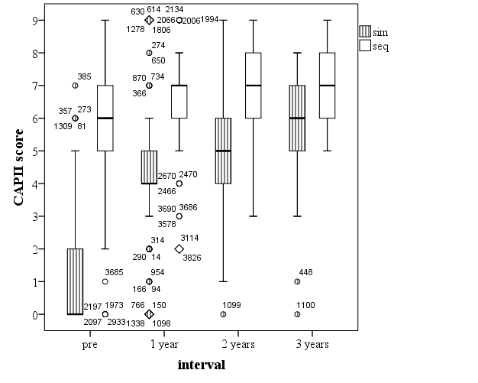

Figure 2. Boxplot of SIR against interval in simultaneously- and sequentially-implanted children. (Simultaneous n = 359, 261, 113, 44; sequential n = 428, 301, 158, 46)
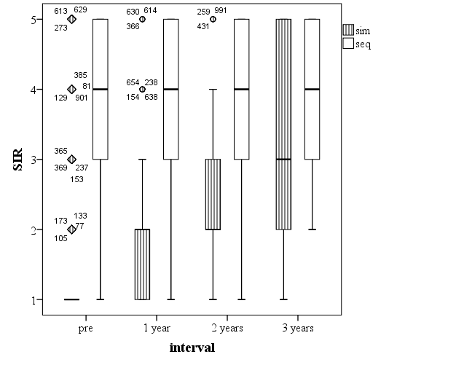

Figure 3. Boxplot of BLSP speech recognition score plotted against interval for all children who were tested (simultaneous and sequential). (Simultaneous n = 186, 81, 22; sequential n = 308, 263, 137, 32). In simultaneously-implanted children (p = 0.008) and sequentially-implanted children (p = 0.000) there was a significant effect of interval, p = 0.000). In this and subsequent figures, statistical significance is indicated as follows: * p < 0.05; ** p < 0.01; *** p < 0.001.

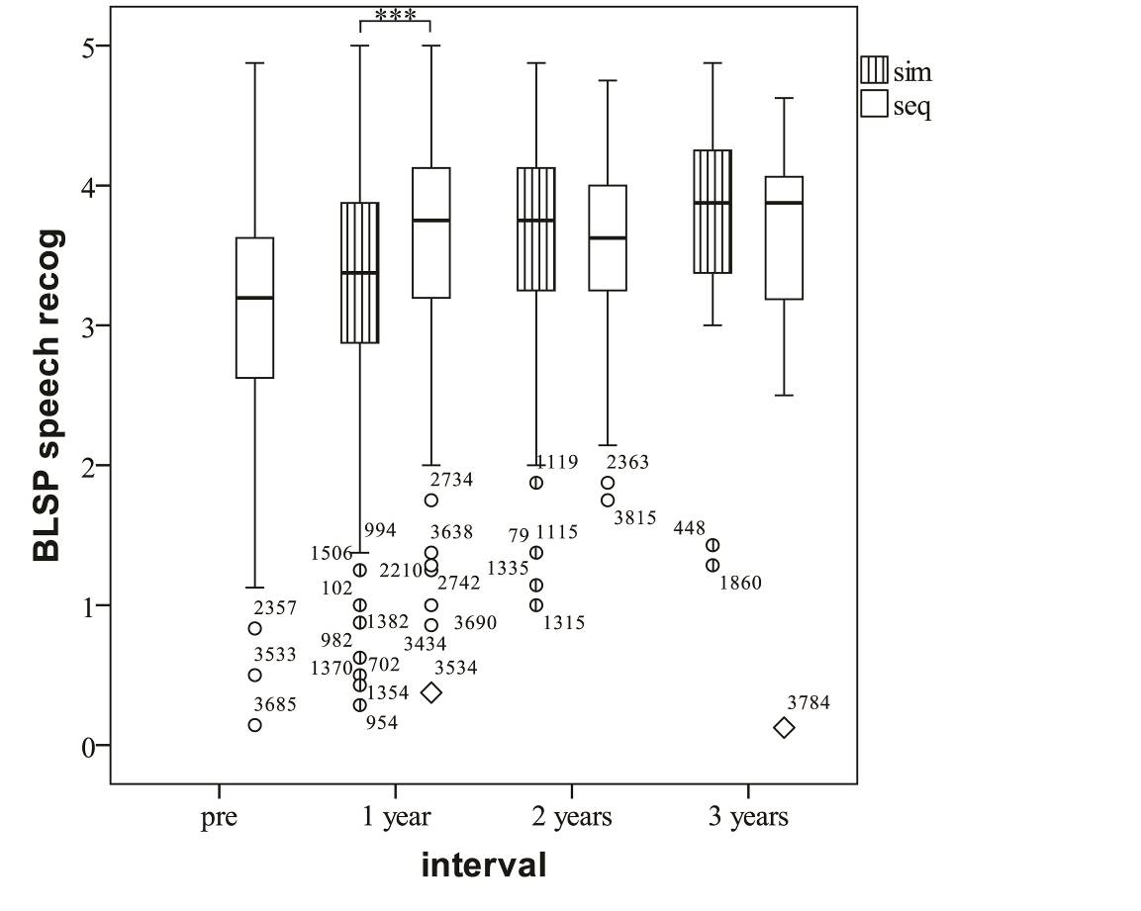

Figure 4. Boxplot of BLSP music score plotted against interval for all children who were tested (simultaneous and sequential). (Simultaneous n = 171, 74, 20; sequential n = 292, 246, 130, 30). In simultaneously-implanted children (p = 0.023) and sequentially-implanted children (p = 0.000) there was a significant effect of interval, p = 0.000.

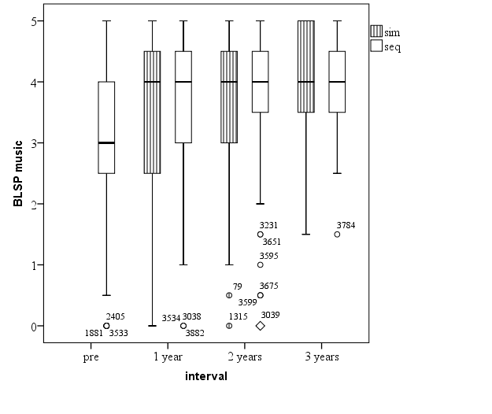
Figure 5a. Boxplot of POP well-being score plotted against interval for all children with simultaneous implants who were tested (n = 113, 33). The dotted line represents a neutral parent opinion

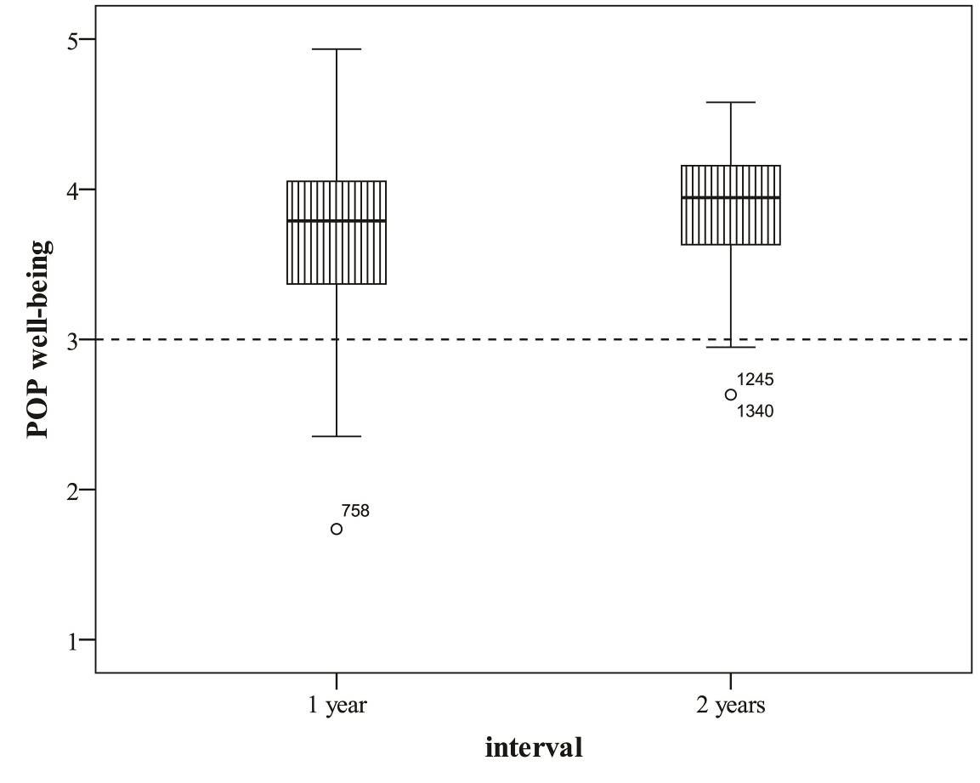

Figure 5b. Boxplot of POP2 well-being change score since second implant plotted against interval for all children with sequential implants who were tested (n = 159, 28). Points above the dotted line indicate agreement that there has been a positive change

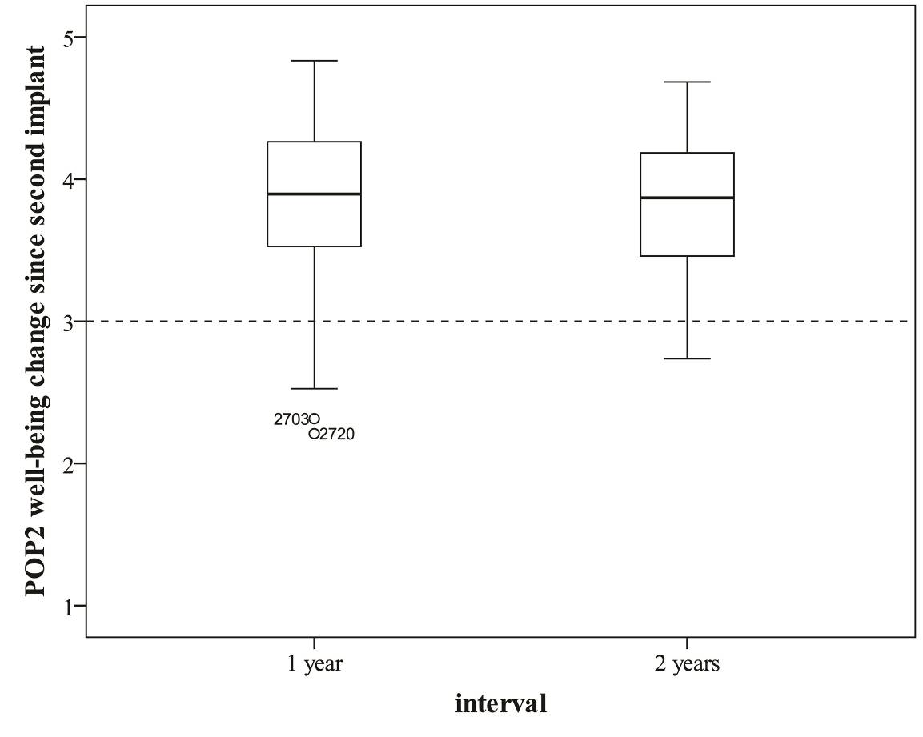

Figure 6a. Boxplot of POP behaviour score plotted against interval for all children with simultaneous implants who were tested (n = 113, 30)

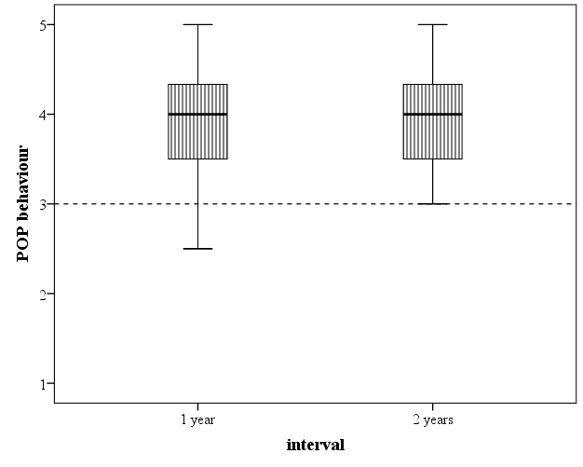

Figure 6b. Boxplot of POP2 behaviour change score plotted against interval for all children with sequential cochlear implants who were tested (n = 158, 28)

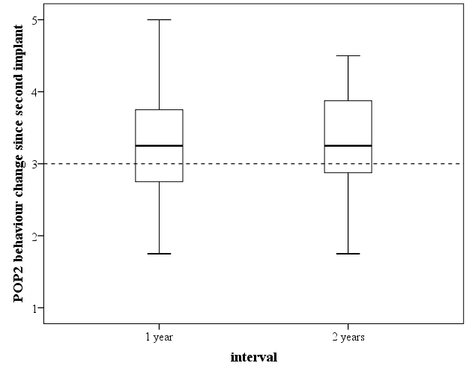

Figure 7. Boxplot of POP2 well-being change score one year after receiving the second implant plotted against BAPP willingness to wear second implant for sequentially-implanted children (n = 1, 8, 18, 36, 81). The change in POP2 well-being was significant (p = 0.000)

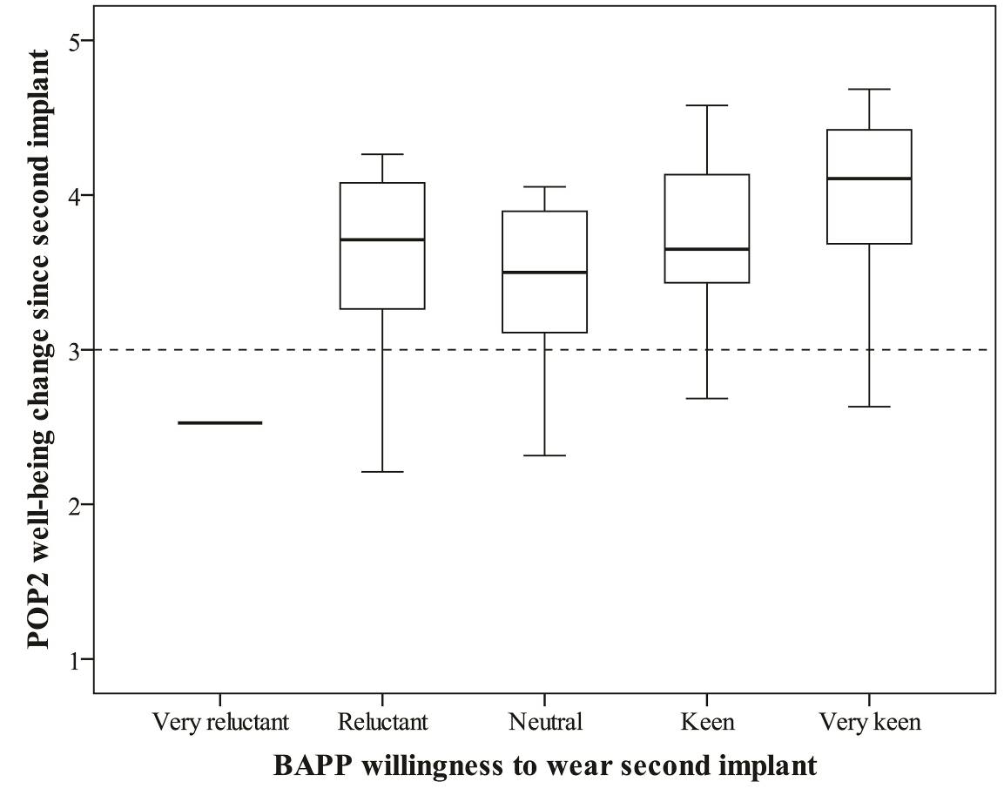
Figure captions
Figure 1. Boxplot of CAPII scores plotted against interval in simultaneously- and sequentially-implanted children. The box represents the portion of the distribution falling between the 25th and 75th percentiles (lower and upper quartiles). The horizontal line represents the median. The vertical lines outside the box (whiskers) contain the largest and smallest values that are not categorised as outliers or extreme values. Outliers (more than 1.5 box lengths above or below the box) are shown as circles; extreme outliers (more than 3 box lengths above or below the box) are shown as diamonds. The numbers by the markers represent individual case identifiers. (Simultaneous n = 359, 270, 119, 44; sequential n = 413, 305, 161, 45)

Figure 2. Boxplot of SIR against interval in simultaneously- and sequentially-implanted children. (Simultaneous n = 359, 261, 113, 44; sequential n = 428, 301, 158, 46)

Figure 3. Boxplot of BLSP speech recognition score plotted against interval for all children who were tested (simultaneous and sequential). (Simultaneous n = 186, 81, 22; sequential n = 308, 263, 137, 32). In simultaneously-implanted children (p = 0.008) and sequentially-implanted children (p = 0.000) there was a significant effect of interval, p = 0.000. ). In this and subsequent figures, statistical significance is indicated as follows: * p < 0.05; ** p < 0.01; *** p < 0.001.

Figure 4. Boxplot of BLSP music score plotted against interval for all children who were tested (simultaneous and sequential). (Simultaneous n = 171, 74, 20; sequential n = 292, 246, 130, 30). In simultaneously-implanted children (p = 0.023) and sequentially-implanted children (p = 0.000) there was a significant effect of interval, p = 0.000.

Figure 5a. Boxplot of POP well-being score plotted against interval for all children with simultaneous implants who were tested (n = 113, 33). The dotted line represents a neutral parent opinion

Figure 5b. Boxplot of POP2 well-being change score since second implant plotted against interval for all children with sequential implants who were tested (n = 159, 28). Points above the dotted line indicate agreement that there has been a positive change

Figure 6a. Boxplot of POP behaviour score plotted against interval for all children with simultaneous implants who were tested (n = 113, 30)

Figure 6b. Boxplot of POP2 behaviour change score plotted against interval for all children with sequential cochlear implants who were tested (n = 158, 28)

Figure 7. Boxplot of POP2 well-being change score one year after receiving the second implant plotted against BAPP willingness to wear second implant for sequentially-implanted children (n = 1, 8, 18, 36, 81). The change in POP2 well-being was significant (p = 0.000)

